
BUSINESS PLAN

2023


YouTube Business Plan

Explore, Entertain, Subscribe

John Doe

10200 Bolsa Ave, Westminster, CA, 92683

- 359-3153 info@example.com http://www.example.com

Information provided in this business plan is unique to this business and confidential; therefore, anyone reading this plan agrees not to disclose any of the information in this business plan without prior written permission of the company.
Table of Contents

Executive Summary | 6
Market Opportunity | 6
Niche | 6
Video Production | 7
Marketing Strategies | 7
Financial Highlights | 7
Units Sold v/s Revenue | 8

Company Overview | 9
Ownership | 9
Mission Statement | 10
Business History | 10
Future Goals | 11

Market Analysis | 12
Target Audience | 12
Market size and growth potential | 12
Market Size | 13
Competitive Analysis | 13
MKBHD (Marques Brownlee) | 13
Linus Tech Tips (LTT) | 14
Unbox Therapy | 14
Market Trends | 14
Regulatory Environment | 15

Content Strategy | 16
Type of Content List | 16
Tutorial Videos | 16
Product Reviews | 17
Tech Vlogs | 17
Q&A Sessions | 17
Comparative Analyses | 18
Highlight the Advantage | 18

Sales And Marketing Strategies | 19
Unique Selling Proposition (USP) | 19
Marketing Strategies | 20
Online | 20
Advertising Strategies | 21
Monetization Strategy | 22
List title | 22
Analytics and Metrics | 22

Operations Plan | 23
Content Creation and Publication | 23
Operational Process | 23
Engagement with the Audience | 24
Content Calendar | 24

Management Team | 25
Key Managers | 25
John Doe | 25
Jane Doe | 26
Alice Brown | 26
Robert Brown | 26
Organizational Structure | 27
Organization chart | 27
Compensation Plan | 27
Advisors/Consultants | 28
Prof. Michael Green | 28
Dr. Emily White | 28
Financial Plan
Financial Plan | 29

Profit & loss statement 29

Cash flow statement | 32
Balance sheet | 34
Break-even Analysis | 36
Financing needs | 38
Appendix
Appendix | 40
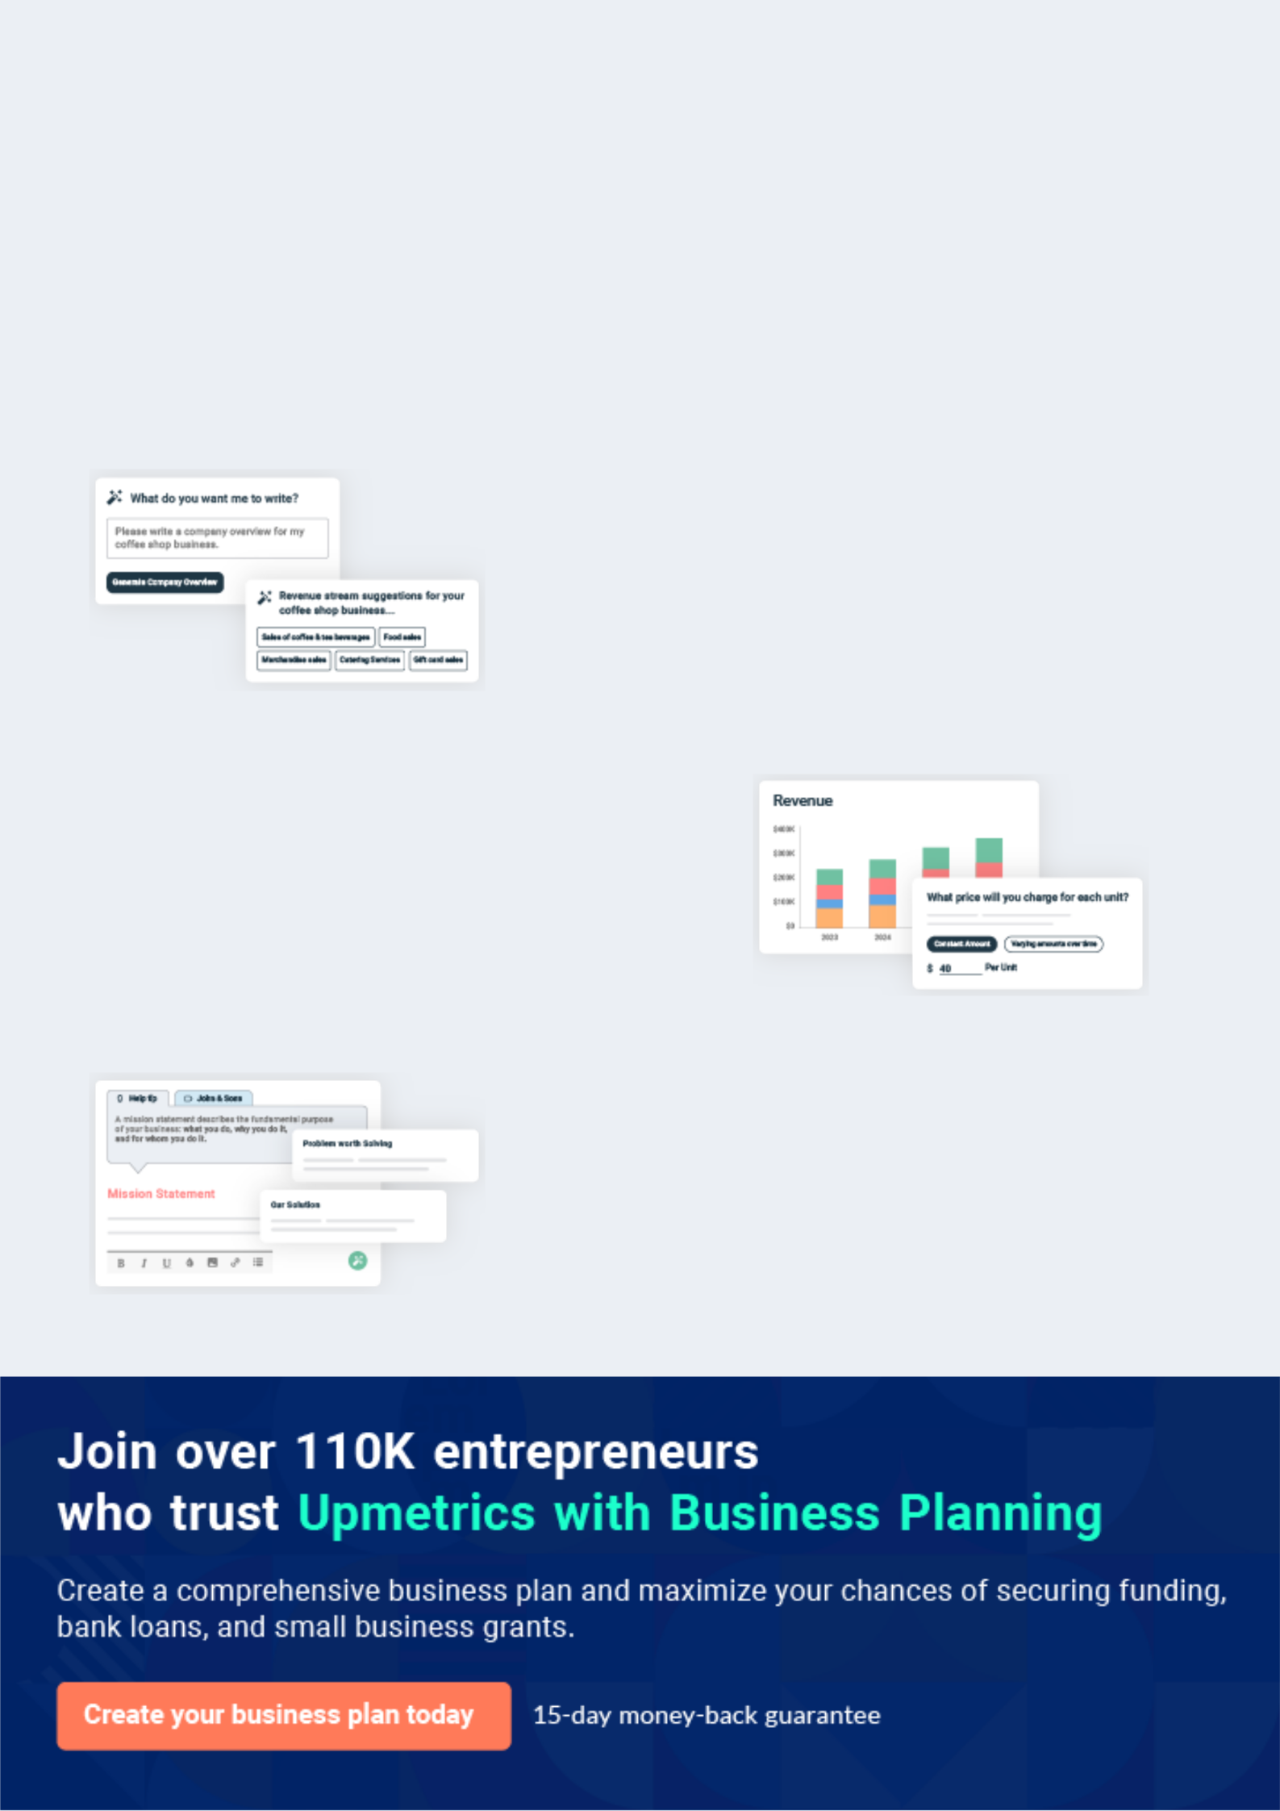
Business planning that’s simpler and faster than you think

Creating a business plan using Upmetrics to start and grow a business is literally the easiest thing in the World. Simply read the instructions and fill in the blanks. It’s as simple as that.

❛ | Upmetrics has everything you need to create a | ❜
❛ | comprehensive business plan. | ❜

AI-powered Upmetrics Assistant

AI-powered insights to streamline your plan

Not sure where to start? Upmetrics’ AI Assistant will automatically generate ideas for each section of your plan and offer improved versions of your writing, adjusting for tone, voice, and grammar or spelling errors.

Financial Forecasting Tool

All the financials are calculated for you

Forget the complex formulas and clumsy spreadsheets — with automatic financials and drag-and-drop forecasting, you can finish your plan faster and be confident that your numbers are accurate.

Business Plan Builder

Guides you like a business mentor

Upmetrics’ step-by-step instructions, prompts, and the library of 400+ sample business plans will guide you through each section of your plan as a business mentor.
Executive Summary


An executive summary is the first section of the business plan intended to provide an overview of the whole business plan.
To unlock help try Upmetrics! 

 Help tip  YouTube Business Plan


Describe your YouTube channel, its niche, and the type of content that will be available on your channel. Also, do not forget to include the name of your channel in this section.
To unlock help try Upmetrics! 

Start writing here..

Market Opportunity

 Help tip  YouTube Business Plan


Provide a high level of understanding concisely about your target audience along with their
demographics and behavioral pattern. Also, explain how you will meet the needs of your target
audience.
 |  |  |  | To unlock help try Upmetrics! 
Start writing here..
Niche
 Help tip |  |  YouTube Business Plan
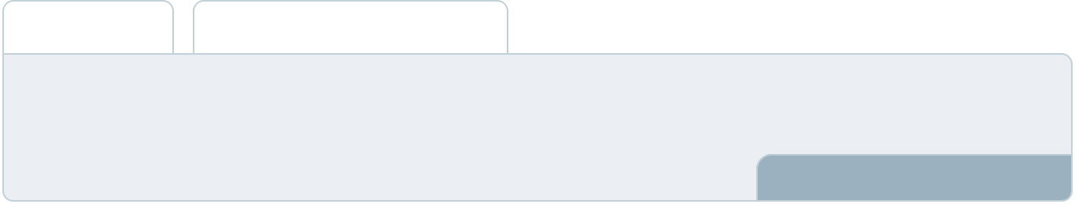

Are your videos going to be academic, giving investment tips, fully comic, giving the knowledge of the latest tech, or into fashion? Mention the genre of your videos in this section.
To unlock help try Upmetrics! 

Start writing here..

Video Production

 Help tip  YouTube Business Plan

Here mention the procedure of how will you shoot and where will you shoot the videos that you will update.
To unlock help try Upmetrics! 

Start writing here..

Marketing Strategies

 Help tip  YouTube Business Plan

List the strategies you will use to attract new viewers and promote your channel. You can do it through collaborating with other creators, advertising, boasting it on social media, etc.
To unlock help try Upmetrics! 

Start writing here..

Financial Highlights

 Help tip  YouTube Business Plan

Provide a summary of your financial projections for the company’s initial years of operation.

Include any capital or investment requirements, startup costs, projected revenues, and profits.
To unlock help try Upmetrics! 

Start writing here..
Units Sold v/s Revenue

 |  | Units Sold | Revenue
15.00k
10.00k
5.00k
0
Year 1 | Year 2 | Year 3
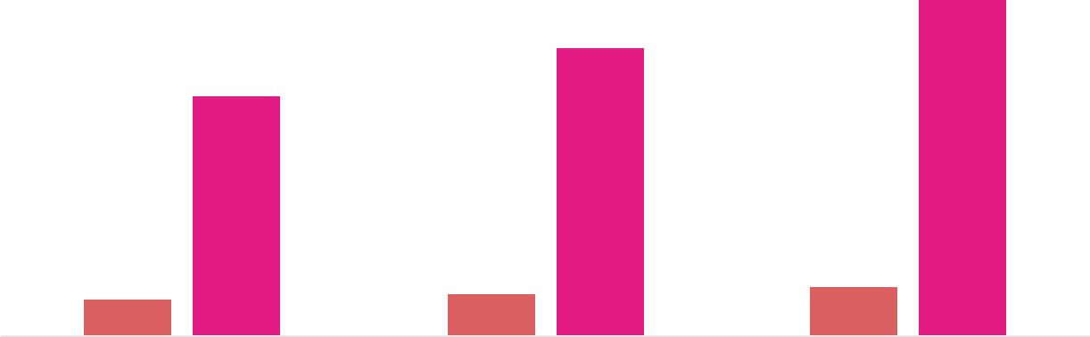

Financial Year |  |  | Units Sold | Revenue
Year 1 | 1,550 |  |  | $10,000
Year 2 | 1,800 |  |  | $12,000
Year 3 | 2,050 |  |  | $14,000
 Help tip |  |  YouTube Business Plan

End your executive summary with a call to action, it can be a further meeting, a partnership proposal, or inviting another influence onboard with your channel.
To unlock help try Upmetrics! 

Write a call to action for your business plan.
Company Overview

Depending on what details of your business are essential, you’ll need different elements in your business overview.
To unlock help try Upmetrics! 

 Help tip  YouTube Business Plan

Provide all the basic information about your business in this section like:

The name of your channel and the type of content you might be producing, as in you might run
To unlock help try Upmetrics! 

Start writing here..

Ownership

 Help tip  YouTube Business Plan

Describe the owners of your channel and mention their roles in running it.

To unlock help try Upmetrics! 

Start writing here..
Mission Statement

 Help tip  YouTube Business Plan

Add a mission statement that sums up the objectives and core principles of your channel. This statement needs to be memorable, clear, and brief.
To unlock help try Upmetrics! 

❛ At [TechTalks], our mission is to educate, entertain, and inform our audience about the [latest technology trends, providing them with the knowledge and tools they need to navigate the ever-evolving world of technology].

We are committed to delivering high-quality content that simplifies [complex tech topics] and empowers our viewers to make informed decisions.

❜

Business History

 Help tip  YouTube Business Plan

If you’ve already started a business, then you might have a story to tell about how you got the idea to start it and who helped in building your YouTube business back then.
To unlock help try Upmetrics! 

Start writing here..
Future Goals

 Help tip  YouTube Business Plan

It’s essential to communicate your goals and vision. Include your goals for your channel’s future, as well as any plans you may have to launch a new channel.
To unlock help try Upmetrics! 

Start writing here..
Market Analysis


 |  | Market analysis provides a clear understanding of the market in which your
 |  | printing business will run along with the target market, competitors, and
 |  | growth opportunities.
 |  |  |  | To unlock help try Upmetrics! 
 Help tip |  |  YouTube Business Plan

To write the introduction section of your market analysis, start by clearly identifying your primary target market.
To unlock help try Upmetrics! 

Start writing here..

Target Audience

 Help tip  YouTube Business Plan

Who are the people you want to attract to your channel? For instance, if you are teaching science on YouTube, your target audience will be science students.
To unlock help try Upmetrics! 

Start writing here..

Market size and growth potential

 Help tip  YouTube Business Plan

Provide an outline of the industry, and the growth potential it has for upcoming years. Also, provide information about the number of potential viewers, their categories, etc.
To unlock help try Upmetrics! 

Start writing here..

Market Size

Available Market

All individuals interested in tech 250M content on YouTube

Served Market
Individuals seeking in-depth tech 150M reviews and tutorials.

Target Market
Tech enthusiasts aged 18-45 looking 75M for quality content.

 Help tip  YouTube Business Plan

Identify and explore all other YouTube channels for a better understanding, including direct and indirect competitors.
To unlock help try Upmetrics! 

Competitive Analysis

MKBHD (Marques Brownlee)

Marques Brownlee, known by his channel name MKBHD, is one of the most influential tech YouTubers globally. He started his channel in 2008 and has since amassed millions of subscribers, reviewing everything from smartphones to electric cars.

Features | Strengths | Weaknesses
In-depth gadget reviews | Extensive experience and | Focused mostly on high-end
Interviews with tech industry | credibility in the tech | gadgets, leaving out budget-
Interviews with tech industry | community | friendly options
leaders | community | friendly options

High production quality
Overview of tech trends
Broad audience reach with
High-quality 4K video
millions of subscribers
production

Collaborations with prominent

tech brands

Limited in terms of DIY tech or software tutorial content

Linus Tech Tips (LTT)
To unlock help try Upmetrics!

Linus Tech Tips is a tech-centric channel founded by Linus Sebastian in 2008. The channel offers a wide variety of content, ranging from unboxings, reviews, and build logs to more complex projects and industry event coverage.

Features

Computer hardware builds and tutorials

Gadget reviews and unboxings

Coverage of tech events and expos

"Techquickie" – quick tech explanation videos

Strengths

Diverse content that appeals to both tech novices and professionals

Engaging presentation style

Regular content updates with multiple videos per week

Strong community engagement

Weaknesses

Content might be too technical for some viewers

Limited focus on mobile gadgets compared to other tech channels

Unbox Therapy

Unbox Therapy, hosted by Lewis Hilsenteger, is a YouTube channel centered on unboxing and reviewing tech products. The channel has gained popularity due to its entertaining approach to tech.

Features

Unboxing videos for a variety of tech products

Product comparison videos Gadget giveaways

"Later Clips" – short clips from their podcast

Strengths Weaknesses

Entertaining and unique Less technical depth compared

approach to tech reviews to channels like MKBHD and LTT

Broad range of products Some criticisms for perceived

reviewed, from mainstream to brand biases

obscure

High viewer engagement

Market Trends

 Help tip  YouTube Business Plan

Examine current and developing trends in your industry, such as involving live streaming, influencer collaboration, and video quality. Describe how your company will adapt to all the current trends.



Start writing here..

Regulatory Environment

 Help tip  YouTube Business Plan

Describe any regulations or licensing requirements that affect the YouTube channel, such as copyright laws, data protection laws, child protection laws, etc.
To unlock help try Upmetrics! 

Start writing here..
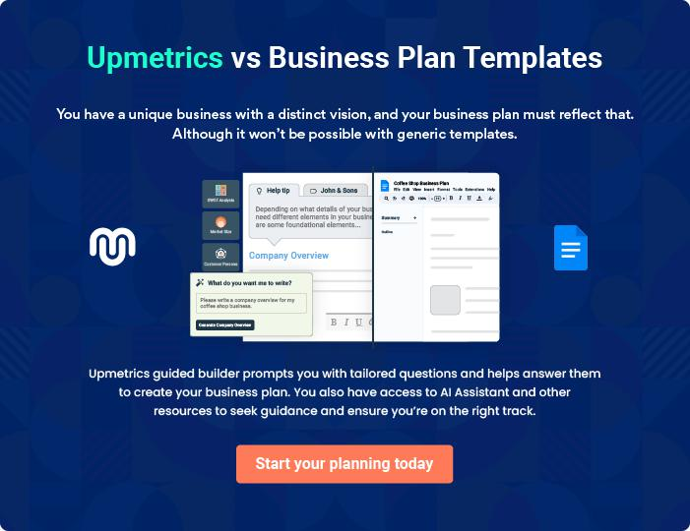
Content Strategy

 |  | The content strategy section of YouTube business plan should describe the
 |  | specific type of content list that will be offered to customers. To write this
 |  | section should include the following:
 |  |  |  | To unlock help try Upmetrics! 
 Help tip |  |  YouTube Business Plan

To craft the introduction for your "Products and Services" chapter, begin by positioning your business within its industry, emphasizing its unique strengths or value proposition.
To unlock help try Upmetrics! 

Start writing here..

 Help Tip


Explain in detail the type of content viewers can expect from your channel as tutorials, reviews, vlogs, etc. Avoid using complex technical terms or jargon in this section especially.
To unlock help try Upmetrics! 

Type of Content List

Tutorial Videos


Price: Free

Step-by-step instructional videos that guide viewers on how to use specific tech products, software, and tools.

Specifications

- Duration: 5-15 minutes

- Quality: 1080p HD

- Frequency: Weekly
Product Reviews

Price: Free

Unbiased and comprehensive reviews of the latest tech gadgets, software, and services, providing viewers with clear insights for informed purchasing decisions.

Specifications

- Duration: 10-20 minutes

- Quality: 4K HD

- Frequency: Bi-weekly

Tech Vlogs

Price: Free

A behind-the-scenes look at various tech events, conventions, and new product launches, offering viewers an immersive experience into the tech world.

Specifications

- Duration: 15-30 minutes

- Quality: 4K HD

- Frequency: Monthly

Q&A Sessions

Price: Free

A session where we answer the most pressing tech-related questions from our community, ensuring our viewers are well-informed and updated.

Specifications

- Duration: 10-15 minutes

- Quality: 1080p HD

- Frequency: Monthly
Comparative Analyses

Price: Free

A comparison of different tech products or services in a specific category, helping viewers make the best choice based on their needs.

Specifications

- Duration: 20-30 minutes

- Quality: 4K HD

- Frequency: Monthly

Highlight the Advantage

 Help tip  YouTube Business Plan

Describe how your content will help your target audience. Draw attention to the advantages your content has over those of your rivals.
To unlock help try Upmetrics! 

Start writing here..
Sales And Marketing Strategies

Writing the sales and marketing strategies section means a list of strategies you will use to attract and retain your clients.
To unlock help try Upmetrics! 

 Help Tip  YouTube Business Plan


To create an effective introduction for your "Sales and Marketing Strategies" chapter, start by setting the stage within your specific industry or market.
To unlock help try Upmetrics! 

Start writing here..

Unique Selling Proposition (USP)

 Help tip  YouTube Business Plan

Mention how your content will be different from the rest, also add the USP of your channel if you have any.
To unlock help try Upmetrics! 

Start writing here..
 Help tip  YouTube Business Plan

Create a marketing plan that includes online marketing strategies. Think of email marketing, content marketing, social media, and other channels.
To unlock help try Upmetrics! 

Marketing Strategies

Online


Social Media

Leverage platforms such as Twitter, Facebook, and Instagram to share content, engage with viewers, and participate in tech-related conversations.

Content Marketing

Blog posts and articles that supplement our video content, optimizing SEO and driving traffic to our channel.

Email Marketing

Regular newsletters highlighting our latest content and tech news.

Collaborations

Partnering with other tech YouTube creators and influencers to cross-promote content.

 Help tip  YouTube Business Plan

Provide information about advertisements you will run such as paid advertisements, hoardings, banners, etc.
To unlock help try Upmetrics! 

Advertising Strategies

Paid Advertisements

Google AdWords and YouTube ads to target specific demographics

Banners and Hoardings

In tech expos and conventions, placing banners to increase brand awareness.

Sponsored Content

Partnering with tech brands to

feature their products in our

videos.

 Help tip  YouTube Business Plan
To unlock help try Upmetrics!

Describe your monetization strategy, which outlines how you plan to make money. Will you sell to clients directly or through middlemen? Which sales strategies will you employ? What is the flow of your sales? How will you evaluate sales results?



Monetization Strategy

List title

Direct Sales

Offering consultancy services and personalized tech solutions to viewers and clients.

Indirect Sales

Revenue generated through YouTube ad monetization and affiliate marketing.

Merchandise Sales Evaluation

Selling [TechTalks] branded merchandise such as T-shirts, mugs, and more.

Regular analysis of sales results to understand what works best and optimize accordingly.

 Help tip  YouTube Business Plan

Define the metrics and analytics that will be used to measure the success of the channel’s sales and marketing efforts, such as views, engagement rates, and revenue.
To unlock help try Upmetrics! 

Analytics and Metrics

Views and Engagement Rates Revenue

Analyzing which content is Tracking the revenue generated

resonating with the audience. from various streams.

Subscriber Growth Social Media Metrics

Monitoring the growth of our subscriber base as an indicator of our channel's popularity.

Evaluating the performance of our content on social media platforms.

Operations Plan

 |  | When writing the operations plan section, it’s important to consider the
 |  | various aspects of your business operations.
 |  |  |  | To unlock help try Upmetrics! 
 Help tip |  |  YouTube Business Plan
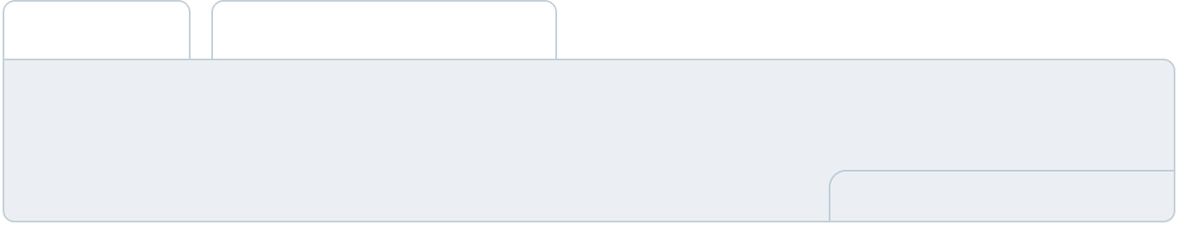

To create an effective introduction for your "Operational Plan" chapter, start by emphasizing the
pivotal role of efficient operations in the success of your business, underscoring how they
directly impact the quality of services delivered.
 |  |  |  | To unlock help try Upmetrics! 
Start writing here..
Content Creation and Publication
 Help tip |  |  YouTube Business Plan

Describe your plan for producing and releasing videos on your channel. Include details about
any software or tool you’ll be using, your plan for producing and uploading content, and how
you’ll edit and publish movies.
 |  |  |  | To unlock help try Upmetrics! 
Start writing here..
Operational Process
 Help tip |  |  YouTube Business Plan

Describe the methods and practices you’ll employ to manage your YouTube channel. Mention your day-to-day plans and plans to achieve long-term goals.
To unlock help try Upmetrics! 

Start writing here..

Engagement with the Audience

 Help tip  YouTube Business Plan

Describe your strategy for interacting with your audience, including your plans for responding to
comments, hosting Q&A sessions, developing polls or surveys, and promoting audience
participation.
 |  |  |  | To unlock help try Upmetrics! 
Start writing here..
Content Calendar
 Help tip |  |  YouTube Business Plan

Create a schedule for your content that specifies when you’ll make and publish new videos.

Take into account the time needed to plan, write, record, edit, and upload each video.
To unlock help try Upmetrics! 

Start writing here..
Management Team

The management team section provides an overview of the individuals responsible for running your business plan.
To unlock help try Upmetrics! 

 Help tip  YouTube Business Plan

To craft an introduction for your "Management Team" chapter, begin by emphasizing the crucial role of leadership in the success of any business.
To unlock help try Upmetrics! 

Start writing here..

Key Managers

 Help tip  YouTube Business Plan

Describe your management team’s key members, roles, and responsibilities. It should include the senior management with their relevant experience in the industry.
To unlock help try Upmetrics! 

Start writing here..


JOHN DOE

Founder & CEO of [TechTalks] - john.doe@example.com

John Doe is a visionary leader with a Bachelor’s Degree in Computer Science and over 7 years of professional experience in the tech industry.

Prior to founding [TechTalks], John worked at leading tech firms such as Google and IBM, where he honed his skills in technology analysis and content creation.


His passion for making tech knowledge accessible drove him to create [TechTalks], with the mission of simplifying complex tech concepts for a general audience.

JANE DOE

Content Production Manager - jane.doe@example.com

Jane Doe holds a Master’s Degree in Media Production and has over 5 years of experience in the film and media industry.

She has worked on various documentary films and online content platforms, which has equipped her with the skills necessary to produce engaging and high-quality content.


Jane's expertise lies in her ability to manage multiple projects simultaneously while ensuring each video meets the channel’s standard of excellence.


ALICE BROWN

Marketing & Engagement Manager - alice.brown@example.com

Alice Brown graduated with a degree in Marketing and has 6 years of experience in digital marketing and audience engagement.

Prior to joining [TechTalks], Alice worked at major marketing agencies where she led successful online campaigns that significantly increased audience engagement.

Her strong analytical skills, coupled with a creative mindset, make her an asset to the [TechTalks] team.


ROBERT BROWN

Operations & Analytics Manager - robert.brown@example.com

Robert Brown holds a Bachelor’s Degree in Business Administration and has a professional background in operations and data analysis.

He has worked for various startups, helping them streamline their operations and use data analytics to make informed decisions.

His analytical approach to operations ensures that [TechTalks] runs smoothly and continues to grow efficiently.
Organizational Structure

 Help tip  YouTube Business Plan

Describe the organizational structure of the management team, including reporting lines and how decisions will be made.
To unlock help try Upmetrics! 

Start writing here..

Organization chart


John Doe

Founder & CEO




Alice Brown Jane Doe

Marketing & Content Production

Engagement Manager Manager
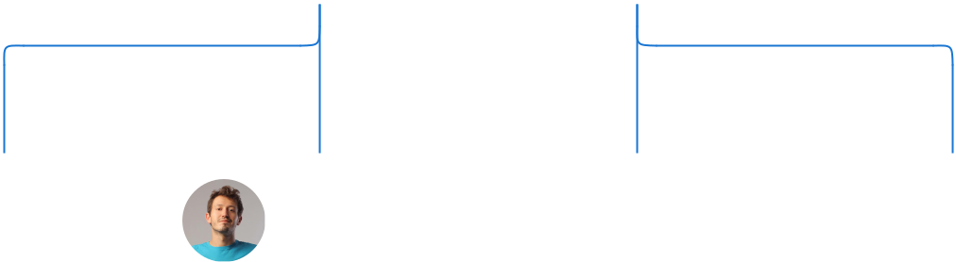

Olivia Smith | Michael | Emma Taylor | Robert Brown
Olivia Smith | Johnson | Emma Taylor | Robert Brown
Graphic | Johnson | Emma Taylor | Operations &
Graphic | Social Media | Video Editor | Operations &
Designer | Social Media | Video Editor | Analytics Manage
Designer | Manager |  | Analytics Manage






Compensation Plan

 Help tip  YouTube Business Plan

Describe your compensation plan for the management team and staff, including bonuses, and other benefits.
To unlock help try Upmetrics! 

Start writing here..

 Help tip  YouTube Business Plan

Mentioning advisors or consultants in your business plans adds credibility to your business idea.
To unlock help try Upmetrics! 

Advisors/Consultants


PROF. MICHAEL GREEN

Media expert

Prof. Michael Green provides guidance on content optimization and audience engagement.


DR. EMILY WHITE

Prominent tech consultant

Dr. Emily White offers insights into the latest technological advancements.
Financial Plan

When writing the financial plan section of a business plan, it’s important to provide a comprehensive overview of your financial projections for the first few years of your business, You may provide the following:
To unlock help try Upmetrics! 

 Help tip  YouTube Business Plan


To create an effective introduction for your "Financial Plan" chapter, begin by stressing the critical role of a well-structured financial plan in the success of your venture.
To unlock help try Upmetrics! 

Start writing here..

 Help tip  YouTube Business Planxample title..


It should display the expected revenues and costs.

To unlock help try Upmetrics! 

Profit & loss statement

Revenue

Cost Of Sales

General Costs

Revenue Specific Costs

Personnel Costs (Direct

Labor)

Gross Margin

Gross Margin (%)

Operating Expense

Payroll Expense

(Indirect Labor)

General Expense

Bad Debt

Amortization of Current

Assets

2023-24 | 2024-25 | 2025-26 | 2026-27 | 2027-28
$0 | $0 | $0 | $0 | $0

$0 | $0 | $0 | $0 | $0
$0 | $0 | $0 | $0 | $0
$0 | $0 | $0 | $0 | $0
$0 | $0 | $0 | $0 | $0

$0 | $0 | $0 | $0 | $0
0% | 0% | 0% | 0% | 0%

$0 | $0 | $0 | $0 | $0
$0 | $0 | $0 | $0 | $0
$0 | $0 | $0 | $0 | $0
$0 | $0 | $0 | $0 | $0
$0 | $0 | $0 | $0 | $0

EBITDA

Additional Expense

Long Term

Depreciation

Gain or loss from Sale

of Assets

EBIT

Interest Expenses

EBT

Income Tax Expense

Total Expense

Net Income

Net Income (%)

2023-24 | 2024-25 | 2025-26 | 2026-27 | 2027-28
$0 | $0 | $0 | $0 | $0
$0 | $0 | $0 | $0 | $0
$0 | $0 | $0 | $0 | $0
$0 | $0 | $0 | $0 | $0
$0 | $0 | $0 | $0 | $0
$0 | $0 | $0 | $0 | $0
$0 | $0 | $0 | $0 | $0
$0 | $0 | $0 | $0 | $0
$0 | $0 | $0 | $0 | $0
$0 | $0 | $0 | $0 | $0
0% | 0% | 0% | 0% | 0%
 |  |  | 2023-24 |  | 2024-25 | 2025-26 | 2026-27 | 2027-28
Retained Earning |  |  | $0 |  | $0 | $0 | $0 | $0
Opening
Owner's Distribution |  |  | $0 |  | $0 | $0 | $0 | $0
Retained Earning |  |  | $0 |  | $0 | $0 | $0 | $0
Closing
 Help tip |  |  |  YouTube Business Plan
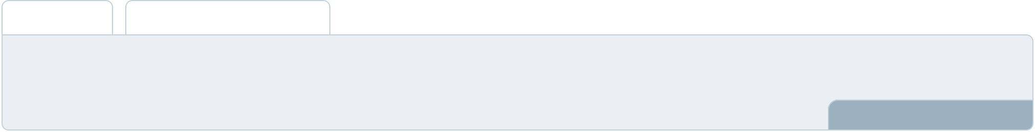

Estimate your cash inflows and outflows for the first few years of operation. As in incorporate cash receipts, and cash outflow to make your content, loan, or any cash-related inflows or outflows.
To unlock help try Upmetrics! 

Cash flow statement

 | 2023-24 | 2024-25 | 2025-26 | 2026-27 | 2027-28
Cash Received | $0 | $0 | $0 | $0 | $0
Cash Paid | $0 | $0 | $0 | $0 | $0
COS & General Expenses | $0 | $0 | $0 | $0 | $0
Salary & Wages | $0 | $0 | $0 | $0 | $0
Interest | $0 | $0 | $0 | $0 | $0

Sales Tax

Income Tax

Net Cash From

Operations

Assets Sell

Assets Purchase

Net Cash From

Investments

Amount Received

Loan Received

Common Stock

Preferred Stock

Owner's Contribution

Amount Paid

2023-24 | 2024-25 | 2025-26 | 2026-27 | 2027-28
$0 | $0 | $0 | $0 | $0
$0 | $0 | $0 | $0 | $0
$0 | $0 | $0 | $0 | $0

$0 | $0 | $0 | $0 | $0
$0 | $0 | $0 | $0 | $0
$0 | $0 | $0 | $0 | $0

$0 | $0 | $0 | $0 | $0
$0 | $0 | $0 | $0 | $0

$0 | $0 | $0 | $0 | $0
$0 | $0 | $0 | $0 | $0
$0 | $0 | $0 | $0 | $0

Loan Capital $0 $0 $0 $0 $0

 |  |  | 2023-24 | 2024-25 | 2025-26 | 2026-27 | 2027-28
Dividends & Distributions |  |  | $0 | $0 | $0 | $0 | $0
Net Cash From |  |  | $0 | $0 | $0 | $0 | $0
Financing
Summary
Starting Cash |  |  | $0 | $0 | $0 | $0 | $0
Cash In |  |  | $0 | $0 | $0 | $0 | $0
Cash Out |  |  | $0 | $0 | $0 | $0 | $0
Change in Cash |  |  | $0 | $0 | $0 | $0 | $0
Ending Cash |  |  | $0 | $0 | $0 | $0 | $0
 Help tip |  |  YouTube Business Plan

The balance sheet should show the assets and liabilities of your YouTube channel.

To unlock help try Upmetrics! 

Balance sheet

 | 2023-24 | 2024-25 | 2025-26 | 2026-27 | 2027-28
Assets | $0 | $0 | $0 | $0 | $0
Current Assets | $0 | $0 | $0 | $0 | $0
Cash | $0 | $0 | $0 | $0 | $0
Accounts Receivable | $0 | $0 | $0 | $0 | $0
Inventory | $0 | $0 | $0 | $0 | $0
Other Current Assets | $0 | $0 | $0 | $0 | $0
Long Term Assets | $0 | $0 | $0 | $0 | $0
Gross Long Term Assets | $0 | $0 | $0 | $0 | $0
Accumulated Depreciation | $0 | $0 | $0 | $0 | $0

Liabilities & Equity | $0 | $0 | $0 | $0 | $0
Liabilities | $0 | $0 | $0 | $0 | $0
Current Liabilities | $0 | $0 | $0 | $0 | $0
Accounts Payable | $0 | $0 | $0 | $0 | $0
Income Tax Payable | $0 | $0 | $0 | $0 | $0
Sales Tax Payable | $0 | $0 | $0 | $0 | $0
Short Term Debt | $0 | $0 | $0 | $0 | $0
 | 2023-24 | 2024-25 | 2025-26 | 2026-27 | 2027-28
Long Term Liabilities | $0 | $0 | $0 | $0 | $0
Long Term Debt | $0 | $0 | $0 | $0 | $0
Equity | $0 | $0 | $0 | $0 | $0
Paid-in Capital | $0 | $0 | $0 | $0 | $0
Common Stock | $0 | $0 | $0 | $0 | $0
Preferred Stock | $0 | $0 | $0 | $0 | $0
Owner's Contribution | $0 | $0 | $0 | $0 | $0
Retained Earnings | $0 | $0 | $0 | $0 | $0

Check | $0 |  |  | $0 | $0 | $0 | $0
 Help tip |  |  YouTube Business Plan

Find a point where your costs and revenue will be equal. This way one will get to know about the point from which a company might start making profits.
To unlock help try Upmetrics! 

Break-even Analysis

 | 2023-24 | 2024-25 | 2025-26 | 2026-27 | 2027-28
Starting Revenue | $0 | $0 | $0 | $0 | $0
Net Revenue | $0 | $0 | $0 | $0 | $0
Closing Revenue | $0 | $0 | $0 | $0 | $0

Starting Expense | $0 | $0 | $0 | $0 | $0
Net Expense | $0 | $0 | $0 | $0 | $0
Closing Expense | $0 | $0 | $0 | $0 | $0

Is Break Even? | 0 | 0 | 0 | 0 | 0
Break Even Month | 0 | 0 | 0 | 0 | 0
Days Required | 0 | 0 | 0 | 0 | 0
Break Even Revenue | $0 | $0 | $0 | $0 | $0
Break Even Units
Financing needs

 Help tip  YouTube Business Plan

Estimate your financing need to launch, operate, or grow your channel. Do not miss out on including both short-term and long-term financial needs.
To unlock help try Upmetrics! 

Start writing here..
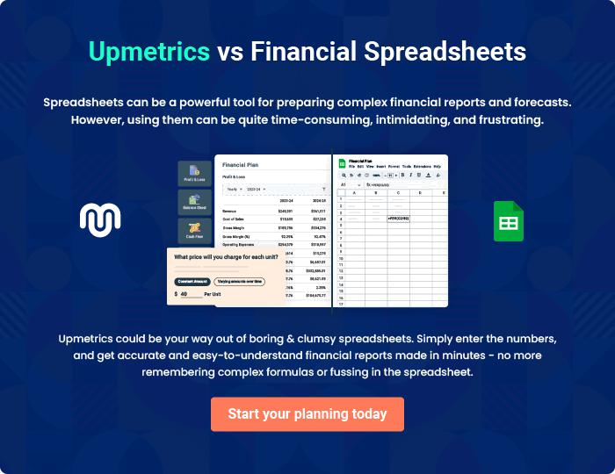
Appendix

When writing the appendix section, you should include any additional information that supports the main content of your plan. This may include financial statements, market research data, legal documents, and other
To unlock help try Upmetrics! 
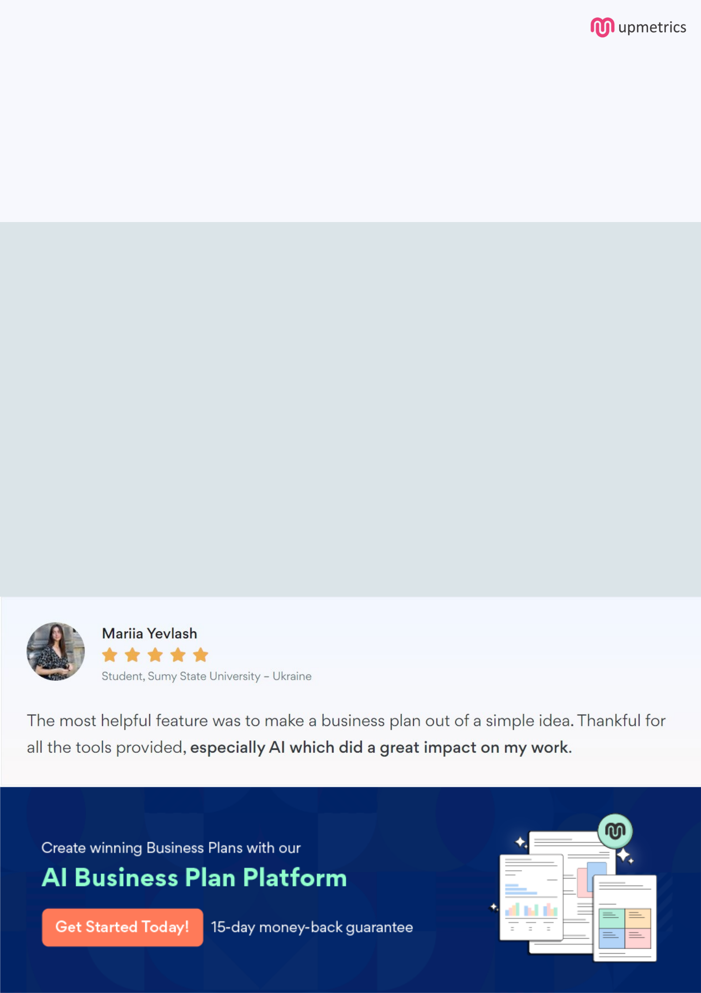
Create a winning business plan that gets you funded

Creating a stunning and investment-ready plan requires no writing, graphic designing, or financial planning expertise.

Upmetrics has all the features required to help you create a comprehensive business plan—from start to finish. Make no mistakes, it’s the modern way of planning to structure ideas, make plans, and create stunning pitch decks to awe investors.

Pitch decks that impress investors

Create pitch decks that provide a visual representation of your business, engage investors, and make them want to invest in your business idea.

Interactive plans in no time

Import business plan sections like—SWOT analysis, comparison tables, and others to create an interactive business plan. No designing skills are required.

Stunning cover page designs

With Upmetrics, you have the liberty to choose from multiple stunning cover page designs. Choose a creative design and make your plan stand out.

Online sharing made simple

Upmetrics makes online sharing quick and easier for users. Easily share your business plans with a link while tracking reader activity.

500+ sample business plans

Simply import a template from our library of sample plans into the editor and start customizing it to make it yours. It takes only a few clicks to get started.

Collaborate with team in real-time

Invite team members, initiate conversations, discuss ideas & strategies, share feedback, and work on a business plan in real-time.

