
Wine Shop Business Plan

Wine Delights Await

BUSINESS PLAN

2023

John Doe | 10200 Bolsa Ave, Westminster, CA, 92683 | (650) 359-3153 | info@example.com
http://www.example.com

Information provided in this business plan is unique to this business and confidential; therefore, anyone reading this plan agrees not to disclose any of the information in this business plan without prior written permission of the company.
Table of Contents

Executive Summary | 6
Market opportunity | 6
Services Offered | 6
Marketing & Sales Strategies | 7
Financial Highlights | 7
Units Sold v/s Revenue | 8

Company Overview | 9
Ownership | 9
Mission statement | 10
Business history | 10
Future goals | 10

Market Analysis | 11
Target Market | 11
Market size and growth potential | 11
Market Size | 12
Competitive analysis | 12
Total Wine & More | 12
Wine.com | 13
K&L Wine Merchants | 13
Market trends | 14
Regulatory environment | 14

Products and Services | 16
Products | 16
Premium Red Wines | 16
Champagne and Sparkling Wines | 17
Wine Accessories | 17
Wine Tasting Events | 17
Gourmet Cheese Pairings | 18
Personal Wine Consulting | 18
Customized Gift Boxes | 18
Gourmet Food Items | 19
Exclusive Wine Club Membership | 19
Wine Storage Solutions | 19
Quality Measures | 20
Additional Services | 20

Sales And Marketing Strategies | 21
Unique Selling Proposition (USP) | 21
Pricing Strategy | 21
Marketing strategies | 22
Online | 22
Offline | 22
Sales strategies | 23
Customer retention | 23

Operations Plan | 24
Staffing & Training | 24
Operational Process | 24
Equipment & Machinery | 25

Management Team | 26
Key managers | 26
John Doe | 27
Jane Doe | 28
Alice Brown | 28
Robert Brown | 29
Organizational structure | 29
Organization chart | 30
Compensation plan | 30
Advisors/Consultants | 31
Michael Green | 31
Sarah Johnson | 31
Financial Plan | 32
Profit & loss statement | 32
Cash flow statement | 35
Balance sheet | 37
Break-even Analysis | 39
Financing needs | 41
Appendix
Appendix | 43
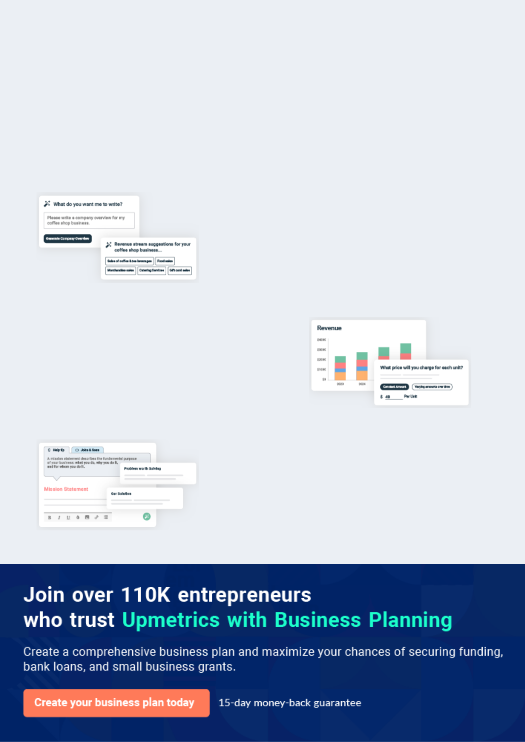
Business planning that’s simpler and faster than you think

Creating a business plan using Upmetrics to start and grow a business is literally the easiest thing in the World. Simply read the instructions and fill in the blanks. It’s as simple as that.

❛ | Upmetrics has everything you need to create a | ❜
❛ | comprehensive business plan. | ❜

AI-powered Upmetrics Assistant

AI-powered insights to streamline your plan

Not sure where to start? Upmetrics’ AI Assistant will automatically generate ideas for each section of your plan and offer improved versions of your writing, adjusting for tone, voice, and grammar or spelling errors.

Financial Forecasting Tool

All the financials are calculated for you

Forget the complex formulas and clumsy spreadsheets — with automatic financials and drag-and-drop forecasting, you can finish your plan faster and be confident that your numbers are accurate.

Business Plan Builder

Guides you like a business mentor

Upmetrics’ step-by-step instructions, prompts, and the library of 400+ sample business plans will guide you through each section of your plan as a business mentor.
Executive Summary


An executive summary is the first section of the business plan intended to provide an overview of the whole business plan.
To unlock help try Upmetrics! 

 Help tip  Wine Shop Business Plan
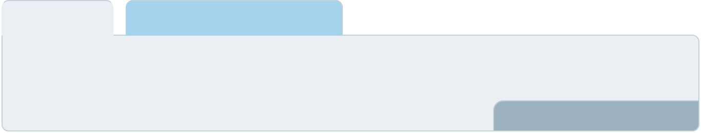

Start your executive summary by briefly introducing your business to your readers.

This section may include the name of your wine shop business, its location, when it was
To unlock help try Upmetrics! 

Start writing here..

Market opportunity

 Help tip  Wine Shop Business Plan

Summarize your market research, including market size, growth potential, and marketing trends. Highlight the opportunities in the market and how your business will fit in to fill the gap.
To unlock help try Upmetrics! 

Start writing here..

Services Offered

 Help tip  Wine Shop Business Plan

Highlight the wine shop products you offer your clients. The USPs and differentiators you offer are always a plus.
To unlock help try Upmetrics! 

Start writing here..

Marketing & Sales Strategies
To unlock help try Upmetrics!

 Help tip  Wine Shop Business Plan

Outline your sales and marketing strategies—what marketing platforms you use, how you plan on acquiring customers, etc.
To unlock help try Upmetrics! 

Start writing here..

Financial Highlights

 Help tip  Wine Shop Business Plan

Briefly summarize your financial projections for the initial years of business operations. Include any capital or investment requirements, associated startup costs, projected revenues, and profit forecasts.



Start writing here..
Units Sold v/s Revenue

 |  | Units Sold | Revenue
15.00k
10.00k
5.00k
0
Year 1 | Year 2 | Year 3
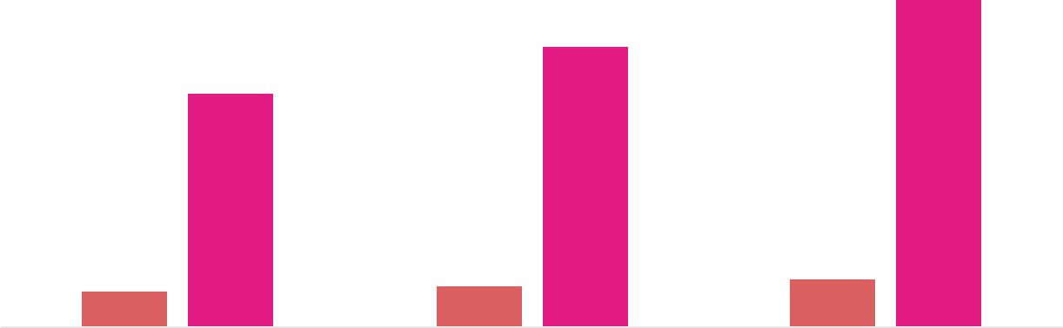

Financial Year |  |  | Units Sold | Revenue
Year 1 | 1,550 |  |  | $10,000
Year 2 | 1,800 |  |  | $12,000
Year 3 | 2,050 |  |  | $14,000
 Help tip |  |  Wine Shop Business Plan
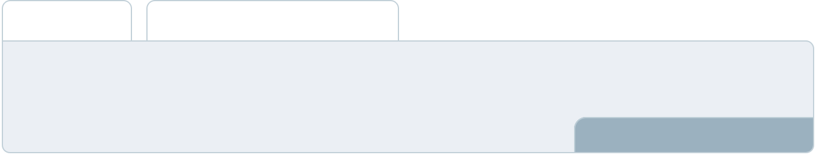

Summarize your executive summary section with a clear CTA, for example, inviting angel investors to discuss the potential business investment.
To unlock help try Upmetrics! 

Write a call to action for your business plan.
Company Overview

Depending on what details of your business are essential, you’ll need different elements in your business overview.
To unlock help try Upmetrics! 

 Help tip  Wine Shop Business Plan

Describe your business in this section by providing all the basic information:

Describe what kind of wine shop you run and the name of it. You may specialize in one of the
To unlock help try Upmetrics! 

Start writing here..

Ownership

 Help tip  Wine Shop Business Plan

List the names of your wine shop’s founders or owners. Describe what shares they own and their responsibilities for efficiently managing the business.
To unlock help try Upmetrics! 

Start writing here..
Mission statement

 Help tip  Wine Shop Business Plan

Summarize your business’ objective, core principles, and values in your mission statement. This statement needs to be memorable, clear, and brief.
To unlock help try Upmetrics! 

❛ Our mission at [Wine Lover's Haven] is to provide an unparalleled
wine-buying experience, offering expertly curated selections paired with comprehensive educational materials.

We strive to foster a community of wine enthusiasts who value quality, variety, and the rich history behind each bottle.

❜

Business history

 Help tip  Wine Shop Business Plan

If you’re an established wine shop, briefly describe your business history, like—when it was founded, how it evolved over time, etc.
To unlock help try Upmetrics! 

Start writing here..

Future goals

 Help tip  Wine Shop Business Plan

It’s crucial to convey your aspirations and vision. Mention your short-term and long-term goals; they can be specific targets for revenue, market share, or expanding your services.
To unlock help try Upmetrics! 

Start writing here..

Market Analysis
To unlock help try Upmetrics!


 |  | Market analysis provides a clear understanding of the market in which your
 |  | printing business will run along with the target market, competitors, and
 |  | growth opportunities.
 |  |  |  | To unlock help try Upmetrics! 
 Help tip |  |  Wine Shop Business Plan

To write the introduction section of your market analysis, start by clearly identifying your primary target market.
To unlock help try Upmetrics! 

Start writing here..

Target Market

 Help tip  Wine Shop Business Plan

Start this section by describing your target market. Define your ideal customer and explain what types of services they prefer. Creating a buyer persona will help you easily define your target market to your readers.



Start writing here..

Market size and growth potential

 Help tip  Wine Shop Business Plan

Describe your market size and growth potential and whether you will target a niche or a much broader market.
To unlock help try Upmetrics! 

Start writing here..

Market Size

Available Market

All individuals who consume alcoholic 200M beverages.

Served Market | 50M
Wine drinkers in the United States. | 50M

Target Market
Wine enthusiasts seeking premium 15M products.

 Help tip  Wine Shop Business Plan

Identify and analyze your direct and indirect competitors. Identify their strengths and weaknesses, and describe what differentiates your wine shop from them.
To unlock help try Upmetrics! 

Competitive analysis

Total Wine & More

Total Wine & More is one of the largest wine retail chains in the U.S. It boasts a massive selection of wines, spirits, and beers across various price points, catering to a wide consumer base.

Features Strengths Weaknesses

Broad product range, from affordable wines to premium selections

Regular promotional deals and discounts

Wine education classes and tasting events

Membership program with loyalty points

Economies of scale due to vast network

Strong online and offline presence

Knowledgeable staff and in-house experts

Overwhelming selection can be daunting for casual buyers

Less emphasis on curated, rare, or unique wines

Wine.com

Wine.com is a dominant online wine retailer offering a vast array of wines, from everyday brands to rare finds. The platform provides detailed information about each wine, including reviews, ratings, and tasting notes.

Features

User-friendly website with intuitive search and filter options

Wine club memberships with curated selections delivered monthly

Virtual wine tastings and online wine courses

Gift services, including personalized messages and wrapping

K&L Wine Merchants

Strengths

Extensive online reach and convenience for consumers

Robust customer review system

Wide variety of wines from multiple regions and countries

Weaknesses

Lack of physical presence for in-person experiences

Dependent on shipping, leading to potential delivery issues or delays

K&L Wine Merchants is a boutique wine retailer with a focus on curated selections from renowned wineries worldwide. With a few physical locations and a robust online store, K&L emphasizes quality over quantity.

Features | Strengths | Weaknesses
Hand-picked wines with | Emphasis on high-quality, | Higher price points compared to
detailed descriptions | curated selections | bulk retailers
Exclusive wine auctions for rare | Strong relationships with | Limited number of physical
and vintage bottles | winemakers and vineyards | stores
Personalized | Knowledgeable staff with a
recommendations based on | passion for wine education
customer preferences
Frequent wine-tasting events
and producer spotlights

Market trends
To unlock help try Upmetrics!

 Help tip  Wine Shop Business Plan

Analyze emerging trends in the industry, such as technology disruptions, changes in customer behavior or preferences, etc. Explain how your business will cope with all the trends.
To unlock help try Upmetrics! 

Start writing here..

Regulatory environment

 Help tip  Wine Shop Business Plan

List regulations and licensing requirements that may affect your wine shop company, such as licensing & permits, age verification, sales restrictions & hours, compliance with health and safety standards, etc.



Start writing here..
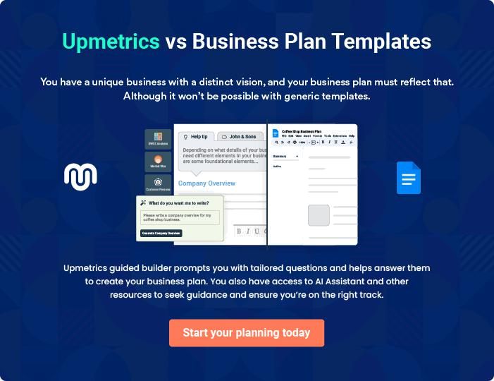
Products and Services
To unlock help try Upmetrics!

The product and services section of a wine shop business plan should describe the specific services and products that will be offered to customers. To write this section should include the following:



 Help tip  Wine Shop Business Plan

To craft the introduction for your "Products and Services" chapter, begin by positioning your business within its industry, emphasizing its unique strengths or value proposition.
To unlock help try Upmetrics! 

Start writing here..

 Help tip


Mention the wine shop products your business will offer. This list may include products like,

• Wines
To unlock help try Upmetrics! 

Products

Premium Red Wines


Price: [$20 - $500] per bottle

A curated selection of the finest red wines from renowned vineyards worldwide.

Specifications

- Varietals: Cabernet Sauvignon, Merlot, Pinot Noir, Syrah, and more.

- Regions: Napa Valley, Bordeaux, Tuscany, and others.
Champagne and Sparkling Wines

Price: [$30 - $1000] per bottle

A range of exquisite champagnes and sparkling wines to celebrate life's significant moments.

Specifications

- Brands: Dom Perignon, Moet & Chandon, Veuve Clicquot, and others.

- Types: Brut, Extra Brut, Demi-Sec, and more.

Wine Accessories

Price: [$5 - $200] per item

Essential and luxury accessories for an enhanced wine-drinking experience.

Specifications

- Items: Wine glasses, decanters, corkscrews, wine racks, and more.

- Brands: Riedel, Spiegelau, Le Creuset, and others.

Wine Tasting Events

Price: [$50 - $150] per person

Join us for an educational and sensory exploration of various wine types and flavors.

Specifications

- Duration: 2 hours.

- Includes: 6-8 wine samples, expert guidance, and complementary snacks.
Gourmet Cheese Pairings

Price: $15 - $50 per serving

Handpicked cheeses paired perfectly with our wine selection.

Specifications

- Cheese Types: Brie, Gouda, Cheddar, Blue Cheese, and others.

- Pairings: Suggested wines for each cheese are provided.

Personal Wine Consulting

Price: [$100 - $500] per session

Our expert sommeliers will guide you in choosing wines that suit your taste and preference.

Specifications

- Duration: 1 hour.

- Includes: Personalized wine selections, food pairing suggestions, and storage advice.

Customized Gift Boxes

Price: [$50 - $300] per box

Personalized wine gift boxes, ideal for celebrations and corporate gifts.

Specifications

- Components: Wine bottles, glasses, cheese, chocolates, and more.

- Customization: Option to add personalized messages and branding.
Gourmet Food Items

Price: [$5 - $100] per item

A selection of gourmet food items that perfectly complement our wine offerings.

Specifications

- Items: Olive oils, vinegars, pastas, sauces, and more.

- Brands: Local and international gourmet brands.

Exclusive Wine Club Membership

Price: [$200 - $1000] per year

Membership offers exclusive access to rare wines, member-only events, and more.

Specifications

- Benefits: Early access to new wines, discounts, and invitations to members-only events.

- Levels: Different membership levels are available.

Wine Storage Solutions

Price: [$100 - $2000]

Offering a range of wine storage solutions from wine racks to climate-controlled cabinets.

Specifications

- Types: Wooden racks, metal racks, climate-controlled cabinets, and more.

- Brands: Eurocave, Vintec, Transtherm, and others.
Quality Measures

 Help tip  Wine Shop Business Plan

This section should explain how you maintain quality standards and consistently provide the highest quality.
To unlock help try Upmetrics! 

Start writing here..

Additional Services

 Help tip  Wine Shop Business Plan

Mention if your wine shop company offers any additional services. You may include services like wine tasting & events, wine education & consulting, special events or offerings, etc.
To unlock help try Upmetrics! 

Start writing here..
Sales And Marketing Strategies

Writing the sales and marketing strategies section means a list of strategies you will use to attract and retain your clients.
To unlock help try Upmetrics! 

 Help Tip  Wine Shop Business Plan
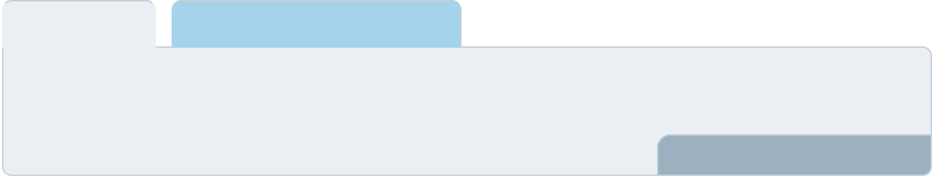

To create an effective introduction for your "Sales and Marketing Strategies" chapter, start by setting the stage within your specific industry or market.
To unlock help try Upmetrics! 

Start writing here..

Unique Selling Proposition (USP)

 Help tip  Wine Shop Business Plan

Define your business’s USPs depending on the market you serve, the equipment you use, and the unique services you provide. Identifying USPs will help you plan your marketing strategies.
To unlock help try Upmetrics! 

Start writing here..

Pricing Strategy

 Help tip  Wine Shop Business Plan

Describe your pricing strategy—how you plan to price your services and stay competitive in the local market. You can mention any discounts you plan on offering to attract new customers.
To unlock help try Upmetrics! 

Start writing here..

 Help tip  Wine Shop Business Plan
To unlock help try Upmetrics!

Discuss your marketing strategies to market your services. You may include some of these marketing strategies in your business plan—social media marketing, brochures, content marketing, and print marketing.



Marketing strategies

Online


Social Media

Utilizing platforms like Instagram, Facebook, and Twitter to share our latest offerings, events, and promotions.

Email Marketing

Sending regular newsletters to our subscribers with exclusive discounts and updates

Content Marketing

Maintaining a blog that provides

valuable content on wine selection,

pairing, and storage.

Offline

Brochures & Print Marketing

Distributing brochures and flyers in local communities and relevant events.

 Help tip  Wine Shop Business Plan

Outline the strategies you’ll implement to maximize your sales. Your sales strategies may include partnering with other businesses, offering referral programs, etc.
To unlock help try Upmetrics! 

Sales strategies

Partner with Businesses In-Store Promotions

Collaborating with local Running promotions in-store to

restaurants and event organizers boost impulse purchases.

to become their preferred wine supplier.

Referral Programs Online Sales

Encouraging customer referrals by offering discounts to both referrer and referee.

Offering our products through an online store to cater to customers beyond our physical location.

 Help tip  Example title..
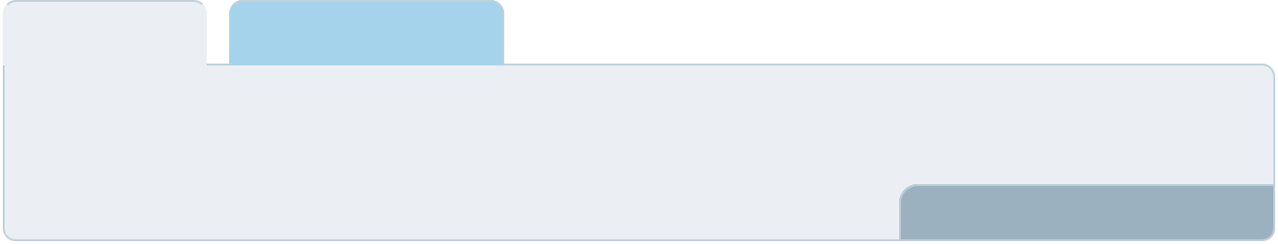

Describe your customer retention strategies and how you plan to execute them. For instance, introducing loyalty programs, discounts on bulk orders, personalized service, etc.
To unlock help try Upmetrics! 

Customer retention

Loyalty Programs

Rewarding regular customers with points that can be redeemed for discounts.

Feedback Mechanism

Regularly collecting customer feedback to improve our offerings and service.

Personalized Service Exclusive Offers

Ensuring every customer receives tailored recommendations and exceptional service

Providing special promotions and early access to events for our loyal customers.

Operations Plan
To unlock help try Upmetrics!

 |  | When writing the operations plan section, it’s important to consider the
 |  | various aspects of your business operations.
 |  |  |  | To unlock help try Upmetrics! 
 Help tip |  |  Wine Shop Business Plan
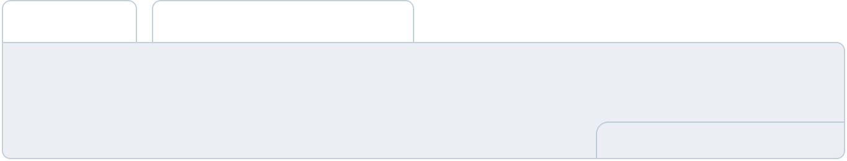

To create an effective introduction for your "Operational Plan" chapter, start by emphasizing the
pivotal role of efficient operations in the success of your business, underscoring how they
directly impact the quality of services delivered.
 |  |  |  | To unlock help try Upmetrics! 
Start writing here..
Staffing & Training
 Help tip |  |  Wine Shop Business Plan

Mention your business’s staffing requirements, including the number of employees, wine
consultants or support staff needed. Include their qualifications, the training required, and the
duties they will perform.
 |  |  |  | To unlock help try Upmetrics! 
Start writing here..
Operational Process
 Help tip |  |  Wine Shop Business Plan

Outline the processes and procedures you will use to run your wine shop business. Your operational processes may include inventory management, storage, cellar management, wine tasting & events, etc.



Start writing here..

Equipment & Machinery

 Help tip  Wine Shop Business Plan

Include the list of equipment and machinery required for the wine shop, such as wine racks & shelving, wine dispensing systems, point of sale system, etc.
To unlock help try Upmetrics! 

Start writing here..
Management Team

The management team section provides an overview of the individuals responsible for running your business plan.
To unlock help try Upmetrics! 

 Help tip  Wine Shop Business Plan

To craft an introduction for your "Management Team" chapter, begin by emphasizing the crucial role of leadership in the success of any business.
To unlock help try Upmetrics! 

Start writing here..

Key managers

 Help tip  Wine Shop Business Plan

Introduce your management and key members of your team, and explain their roles and responsibilities.
To unlock help try Upmetrics! 

Start writing here..

JOHN DOE

CEO - john.doe@example.com

John Doe holds an MBA in Business Administration from Harvard University. With over 15 years of experience in the wine industry, John brings a wealth of knowledge and expertise to [Wine Lover's Haven].


Prior to starting the wine shop, he worked with some of the top wine retailers and distributors in the country. His roles included operations management, wine procurement, and customer service.

Responsibilities:

- As CEO, John oversees the overall strategy, direction, and operation of [Wine Lover's Haven].

- He works closely with the management team to ensure that the company meets its objectives and delivers exceptional value to its customers.

JANE DOE

Chief Operating Officer (COO) - jane.doe@example.com

Jane Doe has a Bachelor's degree in Business Management and over 10 years of experience in the retail industry.

She has previously worked as an operations manager for a leading wine retailer, where she was responsible for managing the day-to-day operations of the store, as well as training and supervising staff.

Responsibilities:

- As COO, Jane manages the daily operations of [Wine Lover's Haven].

- She ensures that the store runs smoothly and efficiently and that the staff is well-trained and provides exceptional service to customers.


ALICE BROWN

CMO - alice.brown@example.com

Alice Brown has a Master's degree in Marketing and over 8 years of experience in the wine industry.

She has a strong background in digital marketing and has worked with several top wine brands to increase their online presence and sales.

Responsibilities:

- As CMO, Alice is responsible for developing and implementing the marketing strategy for [Wine Lover's Haven].

- She works closely with the sales team to promote the store and attract new customers.

ROBERT BROWN

Operations Manager - robert.brown@example.com

Robert Brown holds a Bachelor's degree in Business Administration and has over 5 years of experience in retail operations.

He has a strong background in inventory management and customer service.

Responsibilities:

- As Operations Manager, Robert ensures that the wine shop operates efficiently and meets the needs of its customers.

- He manages inventory, maintains relationships with suppliers, and ensures that customers receive excellent service.

Organizational structure

 Help tip  Wine Shop Business Plan

Explain the organizational structure of your management team. Include the reporting line and decision-making hierarchy.
To unlock help try Upmetrics! 

Start writing here..
Organization chart


John Doe

CEO


Jane Doe Alice Brown

COO CMO


Emily Smith

Robert Brown Customer Service Manager

Operations Manager



Daniel Johnson

Wine Manager

Compensation plan

 Help tip  Wine Shop Business Plan

Describe your compensation plan for the management and staff. Include their salaries, incentives, and other benefits.
To unlock help try Upmetrics! 

Start writing here..

 Help tip

Mentioning advisors or consultants in your business plans adds credibility to your business idea.
To unlock help try Upmetrics! 

Advisors/Consultants


MICHAEL GREEN

Business Advisor - michael.green@example.com

Michael Green has over 20 years of experience in business development and has helped several small businesses grow and succeed. He holds an MBA from Stanford University.


Responsibilities:

- As a business advisor, Michael provides strategic advice to help [Wine Lover's Haven] achieve its business objectives.

- He works closely with John Doe and the management team to develop strategies for growth and success.


SARAH JOHNSON

Marketing Consultant - sarah.johnson@example.com

Sarah Johnson has over 15 years of experience in marketing, with a focus on the wine industry. She has helped several wine retailers increase their sales and market share.

Responsibilities:

- As a marketing consultant, Sarah provides expert advice on marketing strategies and campaigns to help [Wine Lover's Haven] attract more customers and increase its revenue.
Financial Plan

When writing the financial plan section of a business plan, it’s important to provide a comprehensive overview of your financial projections for the first few years of your business, You may provide the following:
To unlock help try Upmetrics! 

 Help tip  Wine Shop Business Plan
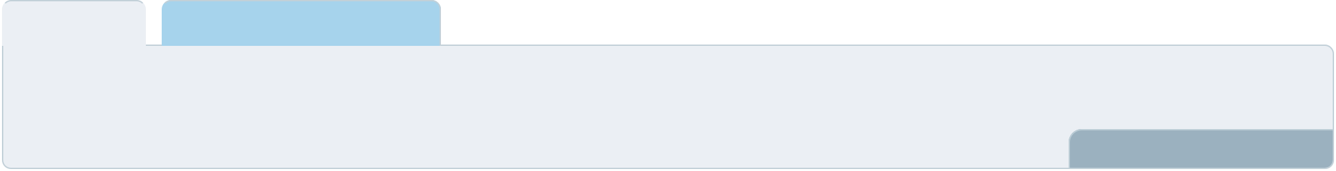

To create an effective introduction for your "Financial Plan" chapter, begin by stressing the critical role of a well-structured financial plan in the success of your venture.
To unlock help try Upmetrics! 

Start writing here..

 Help tip  Wine Shop Business Plan

Describe details such as projected revenue, operational costs, and service costs in your projected profit and loss statement.

Make sure to include your business’s expected net profit or loss.
To unlock help try Upmetrics! 

Profit & loss statement

Revenue

Cost Of Sales

General Costs

Revenue Specific Costs

Personnel Costs (Direct

Labor)

Gross Margin

Gross Margin (%)

Operating Expense

Payroll Expense

(Indirect Labor)

General Expense

Bad Debt

Amortization of Current

Assets

2023-24 | 2024-25 | 2025-26 | 2026-27 | 2027-28
$0 | $0 | $0 | $0 | $0

$0 | $0 | $0 | $0 | $0
$0 | $0 | $0 | $0 | $0
$0 | $0 | $0 | $0 | $0
$0 | $0 | $0 | $0 | $0

$0 | $0 | $0 | $0 | $0
0% | 0% | 0% | 0% | 0%

$0 | $0 | $0 | $0 | $0
$0 | $0 | $0 | $0 | $0
$0 | $0 | $0 | $0 | $0
$0 | $0 | $0 | $0 | $0
$0 | $0 | $0 | $0 | $0

EBITDA

Additional Expense

Long Term

Depreciation

Gain or loss from Sale

of Assets

EBIT

Interest Expenses

EBT

Income Tax Expense

Total Expense

Net Income

Net Income (%)

2023-24 | 2024-25 | 2025-26 | 2026-27 | 2027-28
$0 | $0 | $0 | $0 | $0
$0 | $0 | $0 | $0 | $0
$0 | $0 | $0 | $0 | $0
$0 | $0 | $0 | $0 | $0
$0 | $0 | $0 | $0 | $0
$0 | $0 | $0 | $0 | $0
$0 | $0 | $0 | $0 | $0
$0 | $0 | $0 | $0 | $0
$0 | $0 | $0 | $0 | $0
$0 | $0 | $0 | $0 | $0
0% | 0% | 0% | 0% | 0%

 |  |  | 2023-24 |  | 2024-25 | 2025-26
Retained Earning |  |  | $0 |  | $0 | $0
Opening |  |  |  |  | $0 | $0
Owner's Distribution |  |  | $0 |  | $0 | $0
Retained Earning |  |  | $0 |  | $0 | $0
Closing |  |  |  |  | $0 | $0
 Help tip |  |  |  Wine Shop Business Plan
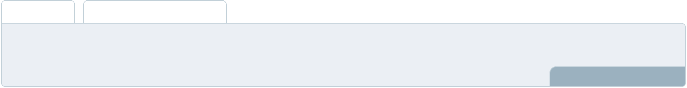

The cash flow for the first few years of your operation should be estimated and described in this section.

This may include billing invoices, payment receipts, loan payments, and any other cash flow statements.
2026-27 2027-28

$0 $0

$0 $0

$0 $0

To unlock help try Upmetrics! 

Cash flow statement

 | 2023-24 | 2024-25 | 2025-26 | 2026-27 | 2027-28
Cash Received | $0 | $0 | $0 | $0 | $0
Cash Paid | $0 | $0 | $0 | $0 | $0
COS & General Expenses | $0 | $0 | $0 | $0 | $0
Salary & Wages | $0 | $0 | $0 | $0 | $0
Interest | $0 | $0 | $0 | $0 | $0

Sales Tax

Income Tax

Net Cash From

Operations

Assets Sell

Assets Purchase

Net Cash From

Investments

Amount Received

Loan Received

Common Stock

Preferred Stock

Owner's Contribution

Amount Paid

2023-24 | 2024-25 | 2025-26 | 2026-27 | 2027-28
$0 | $0 | $0 | $0 | $0
$0 | $0 | $0 | $0 | $0
$0 | $0 | $0 | $0 | $0

$0 | $0 | $0 | $0 | $0
$0 | $0 | $0 | $0 | $0
$0 | $0 | $0 | $0 | $0

$0 | $0 | $0 | $0 | $0
$0 | $0 | $0 | $0 | $0

$0 | $0 | $0 | $0 | $0
$0 | $0 | $0 | $0 | $0
$0 | $0 | $0 | $0 | $0

Loan Capital $0 $0 $0 $0 $0

 |  |  | 2023-24 | 2024-25 | 2025-26 | 2026-27 | 2027-28
Dividends & Distributions |  |  | $0 | $0 | $0 | $0 | $0
Net Cash From |  |  | $0 | $0 | $0 | $0 | $0
Financing
Summary
Starting Cash |  |  | $0 | $0 | $0 | $0 | $0
Cash In |  |  | $0 | $0 | $0 | $0 | $0
Cash Out |  |  | $0 | $0 | $0 | $0 | $0
Change in Cash |  |  | $0 | $0 | $0 | $0 | $0
Ending Cash |  |  | $0 | $0 | $0 | $0 | $0
 Help tip |  |  Wine Shop Business Plan

Create a projected balance sheet documenting your wine shop business’s assets, liabilities, and equity.

To unlock help try Upmetrics! 

Balance sheet

 | 2023-24 | 2024-25 | 2025-26 | 2026-27 | 2027-28
Assets | $0 | $0 | $0 | $0 | $0
Current Assets | $0 | $0 | $0 | $0 | $0
Cash | $0 | $0 | $0 | $0 | $0
Accounts Receivable | $0 | $0 | $0 | $0 | $0
Inventory | $0 | $0 | $0 | $0 | $0
Other Current Assets | $0 | $0 | $0 | $0 | $0
Long Term Assets | $0 | $0 | $0 | $0 | $0
Gross Long Term Assets | $0 | $0 | $0 | $0 | $0
Accumulated Depreciation | $0 | $0 | $0 | $0 | $0

Liabilities & Equity | $0 | $0 | $0 | $0 | $0
Liabilities | $0 | $0 | $0 | $0 | $0
Current Liabilities | $0 | $0 | $0 | $0 | $0
Accounts Payable | $0 | $0 | $0 | $0 | $0
Income Tax Payable | $0 | $0 | $0 | $0 | $0
Sales Tax Payable | $0 | $0 | $0 | $0 | $0
Short Term Debt | $0 | $0 | $0 | $0 | $0
 | 2023-24 | 2024-25 | 2025-26 | 2026-27 | 2027-28
Long Term Liabilities | $0 | $0 | $0 | $0 | $0
Long Term Debt | $0 | $0 | $0 | $0 | $0
Equity | $0 | $0 | $0 | $0 | $0
Paid-in Capital | $0 | $0 | $0 | $0 | $0
Common Stock | $0 | $0 | $0 | $0 | $0
Preferred Stock | $0 | $0 | $0 | $0 | $0
Owner's Contribution | $0 | $0 | $0 | $0 | $0
Retained Earnings | $0 | $0 | $0 | $0 | $0

Check | $0 |  |  | $0 | $0 | $0 | $0
 Help tip |  |  Wine Shop Business Plan

Determine and mention your business’s break-even point—the point at which your business costs and revenue will be equal.

This exercise will help you understand how much revenue you need to generate to sustain or be profitable.
To unlock help try Upmetrics! 

Break-even Analysis

 | 2023-24 | 2024-25 | 2025-26 | 2026-27 | 2027-28
Starting Revenue | $0 | $0 | $0 | $0 | $0
Net Revenue | $0 | $0 | $0 | $0 | $0
Closing Revenue | $0 | $0 | $0 | $0 | $0

Starting Expense | $0 | $0 | $0 | $0 | $0
Net Expense | $0 | $0 | $0 | $0 | $0
Closing Expense | $0 | $0 | $0 | $0 | $0

Is Break Even? | 0 | 0 | 0 | 0 | 0
Break Even Month | 0 | 0 | 0 | 0 | 0
Days Required | 0 | 0 | 0 | 0 | 0
Break Even Revenue | $0 | $0 | $0 | $0 | $0
Break Even Units
Financing needs

 Help tip  Wine Shop Business Plan

Calculate costs associated with starting a wine shop business, and estimate your financing needs and how much capital you need to raise to operate your business.
To unlock help try Upmetrics! 

Start writing here..
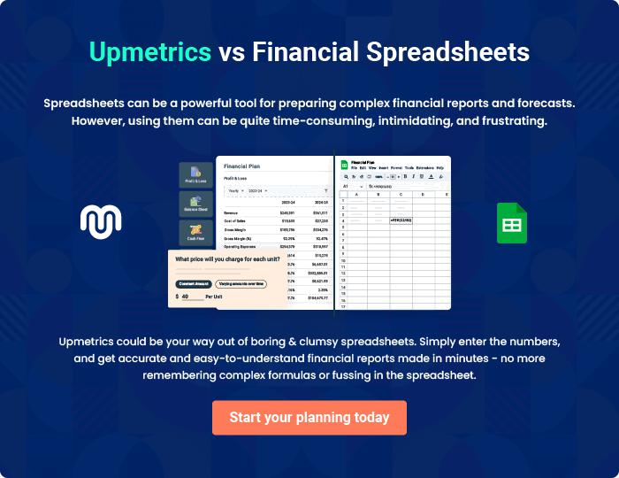
Appendix

When writing the appendix section, you should include any additional information that supports the main content of your plan. This may include financial statements, market research data, legal documents, and other
To unlock help try Upmetrics! 

Create a winning business plan that gets you funded

Creating a stunning and investment-ready plan requires no writing, graphic designing, or financial planning expertise.

Upmetrics has all the features required to help you create a comprehensive business plan—from start to finish. Make no mistakes, it’s the modern way of planning to structure ideas, make plans, and create stunning pitch decks to awe investors.

Pitch decks that impress investors

Create pitch decks that provide a visual representation of your business, engage investors, and make them want to invest in your business idea.

Interactive plans in no time

Import business plan sections like—SWOT analysis, comparison tables, and others to create an interactive business plan. No designing skills are required.

Stunning cover page designs

With Upmetrics, you have the liberty to choose from multiple stunning cover page designs. Choose a creative design and make your plan stand out.

Online sharing made simple

Upmetrics makes online sharing quick and easier for users. Easily share your business plans with a link while tracking reader activity.

500+ sample business plans

Simply import a template from our library of sample plans into the editor and start customizing it to make it yours. It takes only a few clicks to get started.

Collaborate with team in real-time

Invite team members, initiate conversations, discuss ideas & strategies, share feedback, and work on a business plan in real-time.

