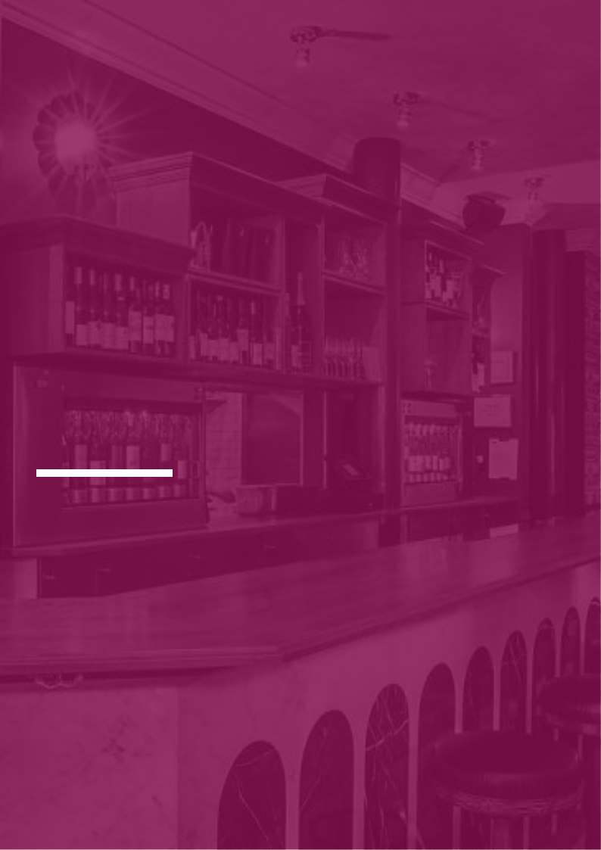
Wine Bar Business Plan

Sip, Savor, Cheers!

BUSINESS PLAN

2023

John Doe | 10200 Bolsa Ave, Westminster, CA, 92683 | (650) 359-3153 | info@example.com
http://www.example.com

Information provided in this business plan is unique to this business and confidential; therefore, anyone reading this plan agrees not to disclose any of the information in this business plan without prior written permission of the company.
Table of Contents

Executive Summary | 6
Market opportunity | 6
Services Offered | 6
Marketing & sales strategies | 7
Financial Highlights | 7
Units Sold v/s Revenue | 8

Company Overview | 9
Ownership | 9
Business Owners | 9
Mission statement | 10
Business history | 10
Future goals | 11

Market Analysis | 12
Target Market | 12
Market size and growth potential | 12
Market Size | 13
Competitive analysis | 13
Vino Locale | 13
The Wine Room | 14
Barrel & Vine | 14
Market trends | 14
Regulatory environment | 15

Products and Services | 16
Wine selection | 16
Red Wine | 16
White Wine | 17
Rosé Wine | 17
Fortified Wine | 17
Beverage Menu | 18
Craft Beers | 18
Vodka-based Cocktails | 18
Ciders | 19
Non-alcoholic Beverages | 19
Food menu | 20
Cheese Platters | 20
Charcuterie Board | 20
Mediterranean Tapas | 21
Locally-Sourced Seafood Dishes | 21
Ambiance & Atmosphere | 22
Additional Services | 22

Sales And Marketing Strategies | 23
Unique Selling Proposition (USP) | 23
Pricing Strategy | 23
Marketing strategies | 24
Online | 24
Sales strategies | 25
Customer retention | 26

Operations Plan | 27
Staffing & Training | 27
Operational Process | 27
Equipment & Supplies | 28

Management Team | 29
Key managers | 29
John Doe | 29
Jane Doe | 30
Alice Brown | 30
Robert Brown | 30
Organizational structure | 30

Organization chart 31

Compensation plan | 31
Advisors/Consultants | 32
Emma Taylor | 32
David Smith | 32

Financial Plan | 33
Profit & loss statement | 33
Cash flow statement | 36
Balance sheet | 38
Break-even Analysis | 40
Financing needs | 42
Appendix
Appendix | 44
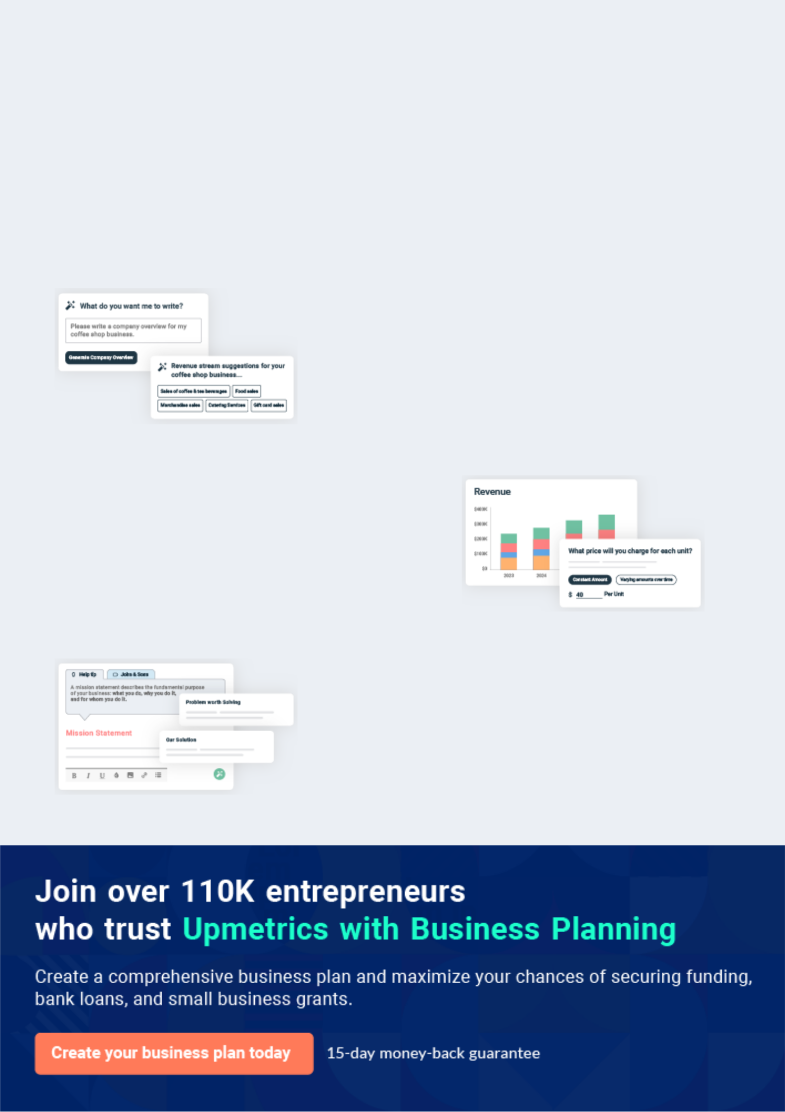
Business planning that’s simpler and faster than you think

Creating a business plan using Upmetrics to start and grow a business is literally the easiest thing in the World. Simply read the instructions and fill in the blanks. It’s as simple as that.

❛ | Upmetrics has everything you need to create a | ❜
❛ | comprehensive business plan. | ❜

AI-powered Upmetrics Assistant

AI-powered insights to streamline your plan

Not sure where to start? Upmetrics’ AI Assistant will automatically generate ideas for each section of your plan and offer improved versions of your writing, adjusting for tone, voice, and grammar or spelling errors.

Financial Forecasting Tool

All the financials are calculated for you

Forget the complex formulas and clumsy spreadsheets — with automatic financials and drag-and-drop forecasting, you can finish your plan faster and be confident that your numbers are accurate.

Business Plan Builder

Guides you like a business mentor

Upmetrics’ step-by-step instructions, prompts, and the library of 400+ sample business plans will guide you through each section of your plan as a business mentor.
Executive Summary


An executive summary is the first section of the business plan intended to provide an overview of the whole business plan.
To unlock help try Upmetrics! 

 Help tip  Wine Bar Business Plan
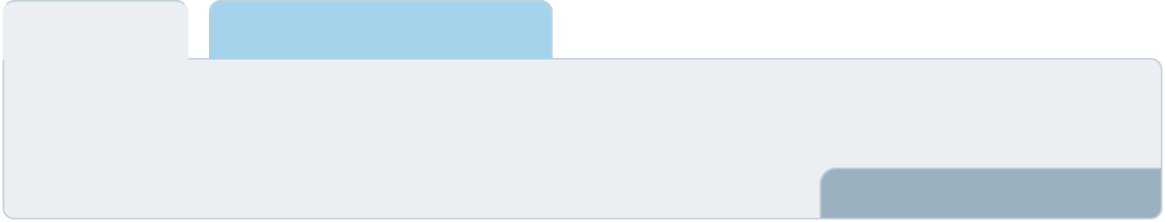

Start your executive summary by briefly introducing your business to your readers.

This section may include the name of your wine bar, its location, when it was founded, the type
To unlock help try Upmetrics! 

Start writing here..

Market opportunity

 Help tip  Wine Bar Business Plan

Summarize your market research, including market size, growth potential, and marketing trends. Highlight the opportunities in the market and how your business will fit in to fill the gap.
To unlock help try Upmetrics! 

Start writing here..

Services Offered

 Help tip  Wine Bar Business Plan

Highlight your wine bar’s products and services to your clients. Describe any specific types of wines or services you offer.
To unlock help try Upmetrics! 

Start writing here..

Marketing & sales strategies
To unlock help try Upmetrics!

 Help tip  Wine Bar Business Plan

Outline your sales and marketing strategies—what marketing platforms you use, how you plan on acquiring customers, etc.
To unlock help try Upmetrics! 

Start writing here..

Financial Highlights

 Help tip  Wine Bar Business Plan

Briefly summarize your financial projections for the initial years of business operations. Include any capital or investment requirements, associated startup costs, projected revenues, and profit forecasts.



Start writing here..
Units Sold v/s Revenue

 |  | Units Sold | Revenue
15.00k
10.00k
5.00k
0
Year 1 | Year 2 | Year 3
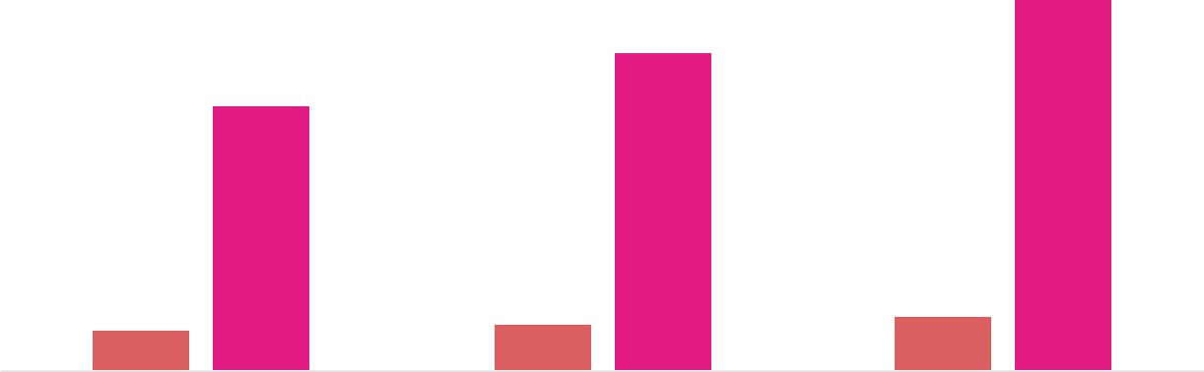

Financial Year |  |  | Units Sold | Revenue
Year 1 | 1,550 |  |  | $10,000
Year 2 | 1,800 |  |  | $12,000
Year 3 | 2,050 |  |  | $14,000
 Help tip |  |  Wine Bar Business Plan
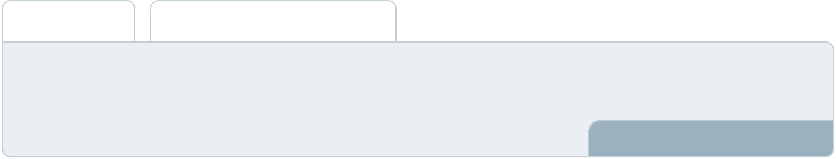

Summarize your executive summary section with a clear CTA, for example, inviting angel investors to discuss the potential business investment.
To unlock help try Upmetrics! 

Write a call to action for your business plan.
Company Overview

Depending on what details of your business are essential, you’ll need different elements in your business overview.
To unlock help try Upmetrics! 

 Help tip  Wine Bar Business Plan

Describe your business in this section by providing all the basic information:

Describe what kind of wine bar you run and the name of it. Here are some of the most common
To unlock help try Upmetrics! 

Start writing here..

Ownership

 Help tip  Wine Bar Business Plan

List the founders of your wine bar. Describe what shares they own and their responsibilities for efficiently managing the business.
To unlock help try Upmetrics! 

Start writing here..

Business Owners



50% John Doe



50% Jane Doe
Mission statement

 Help tip  Wine Bar Business Plan

Summarize your business’ objective, core principles, and values in your mission statement. This statement needs to be memorable, clear, and brief.
To unlock help try Upmetrics! 

❛ At [The Vintage Vino], our mission is to provide an immersive wine-tasting experience that combines enjoyment with learning. We are committed to offering an extensive range of fine wines, expertly paired with delicious food, in a warm and inviting atmosphere.

Our core values include quality, integrity, and customer satisfaction, as we strive to create lasting relationships with our patrons.

❜

Business history

 Help tip  Wine Bar Business Plan

If you’re an established wine bar, briefly describe your business history, like—when it was founded, how it evolved over time, etc.
To unlock help try Upmetrics! 

Start writing here..
Future goals

 Help tip  Wine Bar Business Plan

It’s crucial to convey your aspirations and vision. Mention your short-term and long-term goals; they can be spewcific targets for revenue, market share, or expanding your services.
To unlock help try Upmetrics! 

Start writing here..
Market Analysis
To unlock help try Upmetrics!


 |  | Market analysis provides a clear understanding of the market in which your
 |  | printing business will run along with the target market, competitors, and
 |  | growth opportunities.
 |  |  |  | To unlock help try Upmetrics! 
 Help tip |  |  Wine Bar Business Plan

To write the introduction section of your market analysis, start by clearly identifying your primary target market.
To unlock help try Upmetrics! 

Start writing here..

Target Market

 Help tip  Wine Bar Business Plan

Start this section by describing your target market. Define your ideal customer and explain what types of services they prefer. Creating a buyer persona will help you easily define your target market to your readers.



Start writing here..

Market size and growth potential

 Help tip  Wine Bar Business Plan

Describe your market size and growth potential and whether you will target a niche or a much broader market.
To unlock help try Upmetrics! 

Start writing here..

Market Size


Available Market | 10M
All wine consumers in the region. | 10M

Served Market
Patrons seeking premium wine 2M experiences.

Target Market
Wine enthusiasts seeking quality and 500k education.

 Help tip  Wine Bar Business Plan

Identify and analyze your direct and indirect competitors. Identify their strengths and weaknesses, and describe what differentiates your services from them.
To unlock help try Upmetrics! 

Competitive analysis

Vino Locale

Situated in the heart of the city, Vino Locale is a wine bar that emphasizes local wines, specifically those that are organically and sustainably produced.

Features

Extensive range of locally-produced wines.

Regular wine tasting events with local vintners.

A farm-to-table menu, focusing on sustainable and organic ingredients

Strengths

Strong relationships with local wineries.

Reputation for promoting sustainable practices.

Cozy ambiance with rustic decor that attracts a specific clientele.

Weaknesses

Limited selection of international wines.

Slightly higher pricing due to organic offerings.

Relatively smaller venue, which can get crowded during peak hours.

The Wine Room

The Wine Room is a modern, tech-driven wine bar that integrates technology to enhance the wine tasting experience.

Features

Digital menus with detailed descriptions of each wine.

Self-service wine dispensing system.

Self-service wine dispensing system. Wine pairing suggestions via an interactive app.

Strengths

Unique technological integration appeals to a younger, tech-savvy audience.

Efficient self-service system reduces wait times.

Regularly updated wine list, keeping the selections fresh and dynamic.

Weaknesses

Impersonal experience; lacks the traditional charm of classic wine bars.

Dependency on technology can alienate certain customer segments.

Occasional technical glitches can disrupt the overall experience.

Barrel & Vine

Barrel & Vine combines the traditional wine bar concept with live music, offering a holistic entertainment experience.

Features

Regular live music nights featuring local artists.

Wine flights, allowing patrons to sample multiple wines in one sitting.

A rotating menu of small plates and appetizers.

Strengths

Live music nights attract a steady flow of patrons.

The diverse range of wines, including both local and international varieties

Strategic partnerships with local musicians and artists.

Weaknesses

Noise levels on live music nights might deter those looking for a quiet experience.

The need to constantly manage event schedules.

Occasionally, the emphasis on music overshadows the wine experience.

Market trends

 Help tip  Wine Bar Business Plan

Analyse emerging trends in the industry, such as technology disruptions, changes in customer behavior or preferences, etc. Explain how your business will cope with all the trends.
To unlock help try Upmetrics! 

Start writing here..

Regulatory environment

 Help tip  Wine Bar Business Plan

List regulations and licensing requirements that may affect your wine bars, such as business registration, liquor license, health and safety regulations, zoning regulations, etc.
To unlock help try Upmetrics! 

Start writing here..
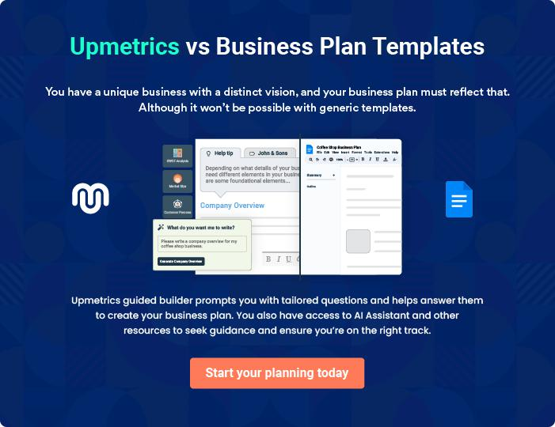
Products and Services
To unlock help try Upmetrics!

The product and services section of a wine bar business plan should describe the specific services and products that will be offered to customers. To write this section should include the following:



 Help tip  Wine Bar Business Plan

To craft the introduction for your "Products and Services" chapter, begin by positioning your business within its industry, emphasizing its unique strengths or value proposition.
To unlock help try Upmetrics! 

Start writing here..

 Help Tip


Start this section by offering an overview of the wines that will be served at your wine bar. For instance, you may mention red, white, rose, and fortified wine.
To unlock help try Upmetrics! 

Wine selection

Red Wine


Price: [$10 - $100] per glass

Our selection of red wines includes options from renowned wine regions such as Napa Valley and Bordeaux.

Specifications

Varieties include Cabernet Sauvignon, Merlot, and Pinot Noir.
White Wine

Price: [$8 - $90] per glass

Our white wines are sourced from top vineyards and include popular options such as Chardonnay and Sauvignon Blanc.

Specifications

Options include dry, semi-sweet, and sweet wines to suit all palates.

Rosé Wine

Price: [$9 - $85] per glass

Our rosé wines are perfect for those who prefer a lighter option, with flavors ranging from dry to sweet.

Specifications

Includes varieties such as Grenache Rosé and Sangiovese Rosé.

Fortified Wine

Price: [$12 - $110] per glass

Our fortified wines are rich and flavorful, with options including Port, Sherry, and Madeira.

Specifications

Available in both sweet and dry options.
 Help Tip

Besides the wine selection, mention if your wine bar serves any other alcoholic or non-alcoholic drinks. E.g., beer, vodka, cider, non-alcoholic beverages.
To unlock help try Upmetrics! 

Beverage Menu

Craft Beers

Price: [$5 - $15] per pint

Our selection of craft beers includes local and international options.

Specifications

Varieties include IPA, Stout, and Ale.

Vodka-based Cocktails

Price: [$8 - $20] per glass

Our cocktail menu features a range of vodka-based options, from classics like the Moscow Mule to unique creations by our mixologists.

Specifications

Made with premium vodka and fresh ingredients.
Ciders

Price: [$6 - $14] per bottle

Our ciders are sourced from top producers and include both traditional and flavored options

Specifications

Available in dry and sweet options.

Non-alcoholic Beverages

Price: [$3 - $10]

Our non-alcoholic options include mocktails, fresh juices, and artisanal sodas

Specifications

Made with fresh ingredients and free from artificial additives.
 Help Tip

Wine bars also serve food to complement the wines they serve, so outline your food menu including any dishes you specialize in.
To unlock help try Upmetrics! 

Food menu

Cheese Platters

Price: [$15 - $30]

Our cheese platters feature a selection of fine cheeses, crackers, and accompaniments.

Specifications

Options include domestic and international cheeses, with gluten-free crackers available.

Charcuterie Board

Price: [$18 - $35]

Our charcuterie boards include a range of cured meats, cheeses, and accompaniments.

Specifications

Options include domestic and international meats, with gluten-free crackers available.
Mediterranean Tapas

Price: [$10 - $25]

Our tapas menu features a range of Mediterranean-inspired dishes, perfect for sharing.

Specifications

Options include vegetarian, vegan, and gluten-free dishes.

Locally-Sourced Seafood Dishes

Price: [$20 - $45]

Our seafood dishes are made with locally-sourced ingredients and feature a range of options including fish, shellfish, and more.

Specifications

Options include grilled, fried, and baked dishes, with gluten-free and dairy-free options available.
Ambiance & Atmosphere

 Help tip  Wine Bar Business Plan

Describe the ambiance and atmosphere of your bar; you may include details about lighting, decor, music, and overall vibe.
To unlock help try Upmetrics! 

Start writing here..

Additional Services

 Help tip  Wine Bar Business Plan

Mention if your wine bar provides any additional services. You may include services like retail wine sales, tasting events, and classes to educate customers about wines.
To unlock help try Upmetrics! 

Start writing here..
Sales And Marketing Strategies

Writing the sales and marketing strategies section means a list of strategies you will use to attract and retain your clients.
To unlock help try Upmetrics! 

 Help Tip  Wine Bar Business Plan
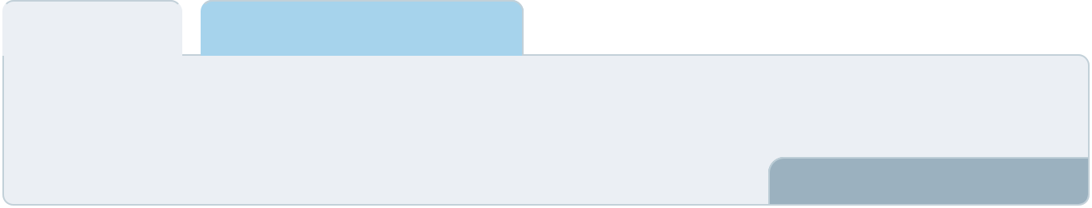

To create an effective introduction for your "Sales and Marketing Strategies" chapter, start by setting the stage within your specific industry or market.
To unlock help try Upmetrics! 

Start writing here..

Unique Selling Proposition (USP)

 Help tip  Wine Bar Business Plan
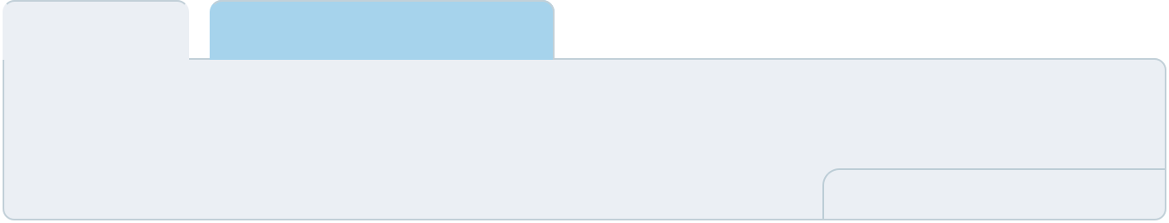

Define your business’s USPs depending on the wines you serve, the ambiance and atmosphere
of your bar, and the personalized services you provide. Identifying USPs will help you plan your
marketing strategies.
 |  |  |  | To unlock help try Upmetrics! 
Start writing here..
Pricing Strategy
 Help tip |  |  Wine Bar Business Plan

Describe your pricing strategy—how you plan to price your servings and stay competitive in the local market.
To unlock help try Upmetrics! 

Start writing here..

 Help tip  Wine Bar Business Plan
To unlock help try Upmetrics!

Discuss your marketing strategies to market your services. Your marketing strategies may include building a strong brand identity, utilizing social media for promotions and interacting with customers, and hosting events to attract local media coverage.



Marketing strategies

Online


Brand Identity

Establish a strong brand presence, incorporating our USPs into every touchpoint, from menus to interior decor.

Local Media Outreach

Hosting events and inviting local influencers and media will ensure coverage and heightened visibility within [City/Region].

Social Media Engagement

Utilize platforms like Instagram, Twitter, and Facebook to not only promote events and offers but also to engage and interact with our community. A monthly [Wine Spotlight] feature could engage followers and educate them about unique wines.

 Help tip  Wine Bar Business Plan
To unlock help try Upmetrics!

Outline the strategies you’ll implement to maximize your sales. Your sales strategies may include hosting wine-tasting events, collaborating with local businesses, encouraging positive word-of-mouth, etc.



Sales strategies

Wine-Tasting Events

Regularly hosting themed wine-tasting evenings, drawing in both groups and individuals.

Word-of-Mouth

Encourage satisfied patrons to spread the word, perhaps through a referral program with benefits for both the referrer and referee.

Local Collaborations

Partnering with local businesses, from artisanal cheese producers to local musicians, creating a web of shared clientele.

 Help tip  Wine Bar Business Plan

Describe your customer retention strategies and how you plan to execute them. For instance, introducing loyalty programs, focusing on personalized service, offering promotions, etc.
To unlock help try Upmetrics! 

Customer retention

Loyalty Programs

Introducing a [Vino Rewards] program where customers accumulate points for every purchase, redeemable during future visits.

Personalized Service

Ensuring that our staff remembers regulars, their preferences, and any special occasions, making every visit personal.

Promotions & Events

Offering exclusive promotions or first-access to events for our most loyal patrons

Operations Plan
To unlock help try Upmetrics!

 |  | When writing the operations plan section, it’s important to consider the
 |  | various aspects of your business operations.
 |  |  |  | To unlock help try Upmetrics! 
 Help tip |  |  Wine Bar Business Plan
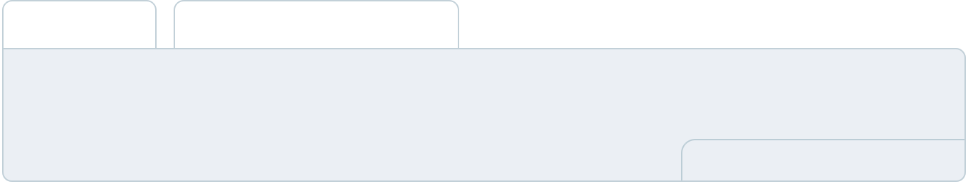

To create an effective introduction for your "Operational Plan" chapter, start by emphasizing the
pivotal role of efficient operations in the success of your business, underscoring how they
directly impact the quality of services delivered.
 |  |  |  | To unlock help try Upmetrics! 
Start writing here..
Staffing & Training
 Help tip |  |  Wine Bar Business Plan

Mention your wine bar’s staffing requirements, including the number of employees, bartenders,
chefs, and servers needed. Include their qualifications, the training required, and the duties they
will perform.
 |  |  |  | To unlock help try Upmetrics! 
Start writing here..
Operational Process
 Help tip |  |  Wine Bar Business Plan

Outline the processes and procedures you will use to run your wine bar. Your operational processes may include inventory management, cleaning & maintenance, customer service, wine selection, marketing & promotions, etc.



Start writing here..

Equipment & Supplies

 Help tip  Wine Bar Business Plan

Include the equipment and supplies required for a wine bar, such as wine glasses, corkscrews, refrigerators, and other equipment.
To unlock help try Upmetrics! 

Start writing here..
Management Team

The management team section provides an overview of the individuals responsible for running your business plan.
To unlock help try Upmetrics! 

 Help tip  Wine Bar Business Plan

To craft an introduction for your "Management Team" chapter, begin by emphasizing the crucial role of leadership in the success of any business.
To unlock help try Upmetrics! 

Start writing here..

Key managers

 Help tip  Wine Bar Business Plan

Introduce your management and key members of your team, and explain their roles and responsibilities.
To unlock help try Upmetrics! 

Start writing here..


JOHN DOE

CEO & Co-founder - john.doe@example.com

John holds an MBA from the University of California, Berkeley, and has over 15 years of experience in the hospitality industry.

His vision for [The Vintage Vino] stems from his passion for fine wines and exquisite dining experiences.


JANE DOE

General Manager - jane.doe@example.com

Jane has a Bachelor's degree in Hospitality Management from Cornell University.

With 10 years of experience in managing high-end restaurants and bars, she ensures the smooth operation of [The Vintage Vino].



ALICE BROWN

Wine Director - alice.brown@example.com

Alice, a certified sommelier, completed her education at the Culinary Institute of America.

She has 8 years of experience in curating exquisite wine lists and has a keen eye for sourcing the best local and international wines.


ROBERT BROWN

Master Chef - robert.brown@example.com

Robert graduated from Le Cordon Bleu and has since worked in various Michelin-starred restaurants.

With his culinary expertise, he creates dishes that perfectly complement our selection of wines.

Organizational structure

 Help tip  Wine Bar Business Plan

Explain the organizational structure of your management team. Include the reporting line and decision-making hierarchy.
To unlock help try Upmetrics! 

Start writing here..

Organization chart


Alice Brown

Wine Director

John Doe

CEO


Jane Doe

General

Manager
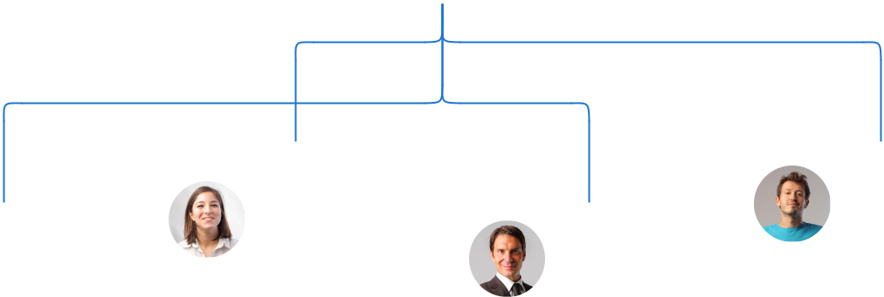

Emma White |  | William
Emma White |  | Johnson
Marketing | Robert Brown | Johnson
Marketing | Robert Brown | Finance
Manager | Robert Brown | Finance
Manager | Master Chef | Manager

Compensation plan

 Help tip  Wine Bar Business Plan

Describe your compensation plan for the management and staff. Include their salaries, incentives, and other benefits.
To unlock help try Upmetrics! 

Start writing here..

 Help tip


Mentioning advisors or consultants in your business plans adds credibility to your business idea.
To unlock help try Upmetrics! 

Advisors/Consultants


EMMA TAYLOR

Marketing Advisor - emma.taylor@example.com

Emma holds an MBA in Marketing from Harvard University and has been advising businesses in the hospitality sector for over 12 years.

Her strategies have helped numerous bars and restaurants to establish a strong brand presence.


DAVID SMITH

Financial Consultant - david.smith@example.com

David is a certified public accountant and a financial expert with 15 years of experience.

His financial advice and strategies have guided several businesses in the wine industry to achieve financial stability and growth.
Financial Plan

When writing the financial plan section of a business plan, it’s important to provide a comprehensive overview of your financial projections for the first few years of your business, You may provide the following:
To unlock help try Upmetrics! 

 Help tip  Wine Bar Business Plan
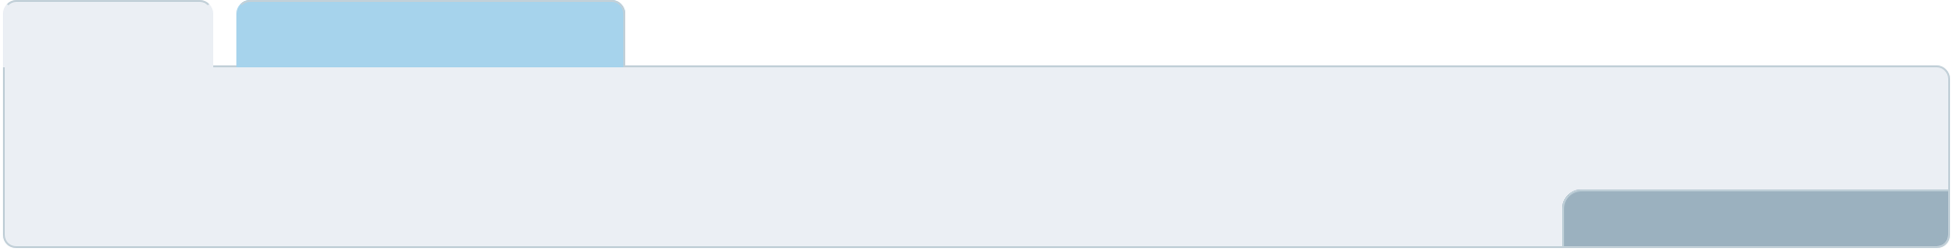

To create an effective introduction for your "Financial Plan" chapter, begin by stressing the critical role of a well-structured financial plan in the success of your venture.
To unlock help try Upmetrics! 

Start writing here..

 Help tip  Wine Bar Business Plan

Describe details such as projected revenue, operational costs, and service costs in your projected profit and loss statement. Make sure to include your business’s expected net profit or loss.
To unlock help try Upmetrics! 

Profit & loss statement

Revenue

Cost Of Sales

General Costs

Revenue Specific Costs

Personnel Costs (Direct

Labor)

Gross Margin

Gross Margin (%)

Operating Expense

Payroll Expense

(Indirect Labor)

General Expense

Bad Debt

Amortization of Current

Assets

2023-24 | 2024-25 | 2025-26 | 2026-27 | 2027-28
$0 | $0 | $0 | $0 | $0

$0 | $0 | $0 | $0 | $0
$0 | $0 | $0 | $0 | $0
$0 | $0 | $0 | $0 | $0
$0 | $0 | $0 | $0 | $0

$0 | $0 | $0 | $0 | $0
0% | 0% | 0% | 0% | 0%

$0 | $0 | $0 | $0 | $0
$0 | $0 | $0 | $0 | $0
$0 | $0 | $0 | $0 | $0
$0 | $0 | $0 | $0 | $0
$0 | $0 | $0 | $0 | $0

EBITDA

Additional Expense

Long Term

Depreciation

Gain or loss from Sale

of Assets

EBIT

Interest Expenses

EBT

Income Tax Expense

Total Expense

Net Income

Net Income (%)

2023-24 | 2024-25 | 2025-26 | 2026-27 | 2027-28
$0 | $0 | $0 | $0 | $0
$0 | $0 | $0 | $0 | $0
$0 | $0 | $0 | $0 | $0
$0 | $0 | $0 | $0 | $0
$0 | $0 | $0 | $0 | $0
$0 | $0 | $0 | $0 | $0
$0 | $0 | $0 | $0 | $0
$0 | $0 | $0 | $0 | $0
$0 | $0 | $0 | $0 | $0
$0 | $0 | $0 | $0 | $0
0% | 0% | 0% | 0% | 0%
 |  |  | 2023-24 |  | 2024-25 | 2025-26 | 2026-27 | 2027-28
Retained Earning |  |  | $0 |  | $0 | $0 | $0 | $0
Opening
Owner's Distribution |  |  | $0 |  | $0 | $0 | $0 | $0
Retained Earning |  |  | $0 |  | $0 | $0 | $0 | $0
Closing
 Help tip |  |  |  Wine Bar Business Plan
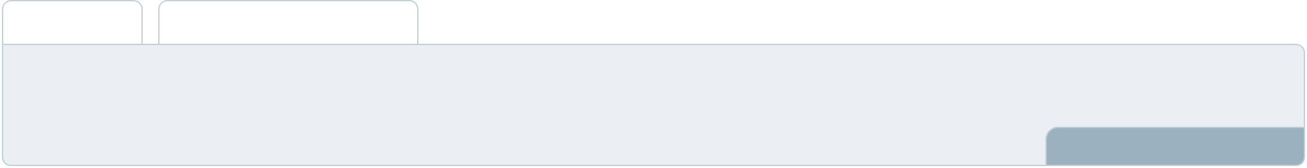

The cash flow for the first few years of your operation should be estimated and described in this section. This may include billing invoices, payment receipts, loan payments, and any other cash flow statements.
To unlock help try Upmetrics! 

Cash flow statement

 | 2023-24 | 2024-25 | 2025-26 | 2026-27 | 2027-28
Cash Received | $0 | $0 | $0 | $0 | $0
Cash Paid | $0 | $0 | $0 | $0 | $0
COS & General Expenses | $0 | $0 | $0 | $0 | $0
Salary & Wages | $0 | $0 | $0 | $0 | $0
Interest | $0 | $0 | $0 | $0 | $0

Sales Tax

Income Tax

Net Cash From

Operations

Assets Sell

Assets Purchase

Net Cash From

Investments

Amount Received

Loan Received

Common Stock

Preferred Stock

Owner's Contribution

Amount Paid

2023-24 | 2024-25 | 2025-26 | 2026-27 | 2027-28
$0 | $0 | $0 | $0 | $0
$0 | $0 | $0 | $0 | $0
$0 | $0 | $0 | $0 | $0

$0 | $0 | $0 | $0 | $0
$0 | $0 | $0 | $0 | $0
$0 | $0 | $0 | $0 | $0

$0 | $0 | $0 | $0 | $0
$0 | $0 | $0 | $0 | $0

$0 | $0 | $0 | $0 | $0
$0 | $0 | $0 | $0 | $0
$0 | $0 | $0 | $0 | $0

Loan Capital $0 $0 $0 $0 $0

 |  |  | 2023-24 | 2024-25 | 2025-26 | 2026-27 | 2027-28
Dividends & Distributions |  |  | $0 | $0 | $0 | $0 | $0
Net Cash From |  |  | $0 | $0 | $0 | $0 | $0
Financing
Summary
Starting Cash |  |  | $0 | $0 | $0 | $0 | $0
Cash In |  |  | $0 | $0 | $0 | $0 | $0
Cash Out |  |  | $0 | $0 | $0 | $0 | $0
Change in Cash |  |  | $0 | $0 | $0 | $0 | $0
Ending Cash |  |  | $0 | $0 | $0 | $0 | $0
 Help tip |  |  Wine Bar Business Plan

Create a projected balance sheet documenting your business’s assets, liabilities, and equity

To unlock help try Upmetrics! 

Balance sheet

 | 2023-24 | 2024-25 | 2025-26 | 2026-27 | 2027-28
Assets | $0 | $0 | $0 | $0 | $0
Current Assets | $0 | $0 | $0 | $0 | $0
Cash | $0 | $0 | $0 | $0 | $0
Accounts Receivable | $0 | $0 | $0 | $0 | $0
Inventory | $0 | $0 | $0 | $0 | $0
Other Current Assets | $0 | $0 | $0 | $0 | $0
Long Term Assets | $0 | $0 | $0 | $0 | $0
Gross Long Term Assets | $0 | $0 | $0 | $0 | $0
Accumulated Depreciation | $0 | $0 | $0 | $0 | $0

Liabilities & Equity | $0 | $0 | $0 | $0 | $0
Liabilities | $0 | $0 | $0 | $0 | $0
Current Liabilities | $0 | $0 | $0 | $0 | $0
Accounts Payable | $0 | $0 | $0 | $0 | $0
Income Tax Payable | $0 | $0 | $0 | $0 | $0
Sales Tax Payable | $0 | $0 | $0 | $0 | $0
Short Term Debt | $0 | $0 | $0 | $0 | $0
 | 2023-24 | 2024-25 | 2025-26 | 2026-27 | 2027-28
Long Term Liabilities | $0 | $0 | $0 | $0 | $0
Long Term Debt | $0 | $0 | $0 | $0 | $0
Equity | $0 | $0 | $0 | $0 | $0
Paid-in Capital | $0 | $0 | $0 | $0 | $0
Common Stock | $0 | $0 | $0 | $0 | $0
Preferred Stock | $0 | $0 | $0 | $0 | $0
Owner's Contribution | $0 | $0 | $0 | $0 | $0
Retained Earnings | $0 | $0 | $0 | $0 | $0

Check | $0 |  |  | $0 | $0 | $0 | $0
 Help tip |  |  Wine Bar Business Plan

Determine and mention your business’s break-even point—the point at which your business costs and revenue will be equal.

This exercise will help you understand how much revenue you need to generate to sustain or be profitable.
To unlock help try Upmetrics! 

Break-even Analysis

 | 2023-24 | 2024-25 | 2025-26 | 2026-27 | 2027-28
Starting Revenue | $0 | $0 | $0 | $0 | $0
Net Revenue | $0 | $0 | $0 | $0 | $0
Closing Revenue | $0 | $0 | $0 | $0 | $0

Starting Expense | $0 | $0 | $0 | $0 | $0
Net Expense | $0 | $0 | $0 | $0 | $0
Closing Expense | $0 | $0 | $0 | $0 | $0

Is Break Even? | 0 | 0 | 0 | 0 | 0
Break Even Month | 0 | 0 | 0 | 0 | 0
Days Required | 0 | 0 | 0 | 0 | 0
Break Even Revenue | $0 | $0 | $0 | $0 | $0
Break Even Units
Financing needs

 Help tip  Wine Bar Business Plan

Calculate costs associated with starting a wine bar, and estimate your financing needs and how much capital you need to raise to operate your business.
To unlock help try Upmetrics! 

Start writing here..
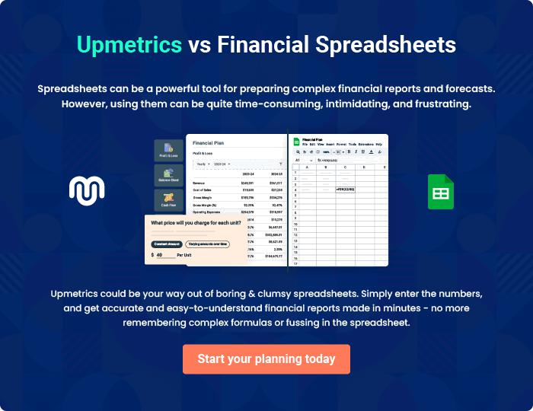
Appendix

When writing the appendix section, you should include any additional information that supports the main content of your plan. This may include financial statements, market research data, legal documents, and other
To unlock help try Upmetrics! 
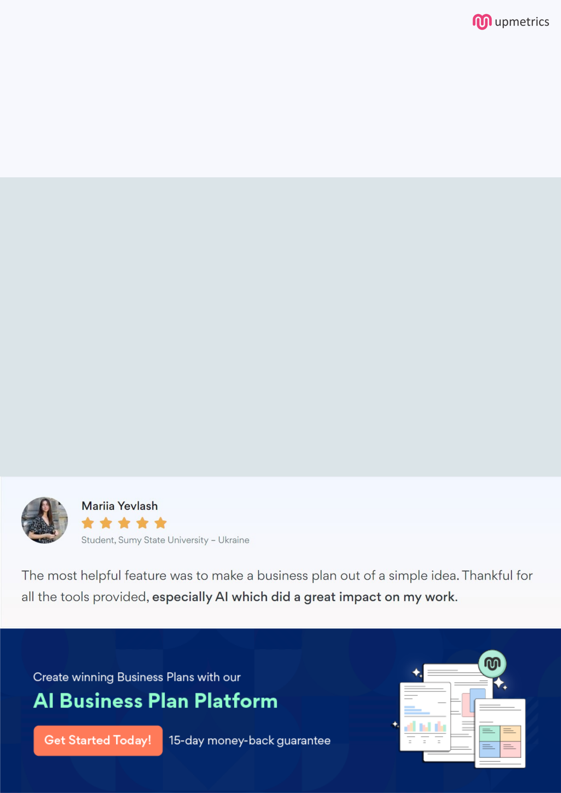
Create a winning business plan that gets you funded

Creating a stunning and investment-ready plan requires no writing, graphic designing, or financial planning expertise.

Upmetrics has all the features required to help you create a comprehensive business plan—from start to finish. Make no mistakes, it’s the modern way of planning to structure ideas, make plans, and create stunning pitch decks to awe investors.

Pitch decks that impress investors

Create pitch decks that provide a visual representation of your business, engage investors, and make them want to invest in your business idea.

Interactive plans in no time

Import business plan sections like—SWOT analysis, comparison tables, and others to create an interactive business plan. No designing skills are required.

Stunning cover page designs

With Upmetrics, you have the liberty to choose from multiple stunning cover page designs. Choose a creative design and make your plan stand out.

Online sharing made simple

Upmetrics makes online sharing quick and easier for users. Easily share your business plans with a link while tracking reader activity.

500+ sample business plans

Simply import a template from our library of sample plans into the editor and start customizing it to make it yours. It takes only a few clicks to get started.

Collaborate with team in real-time

Invite team members, initiate conversations, discuss ideas & strategies, share feedback, and work on a business plan in real-time.

