
BUSINESS PLAN

2023


Wellness Center Business Plan

Your Path to Wellness

John Doe

10200 Bolsa Ave, Westminster, CA, 92683

- 359-3153 info@example.com http://www.example.com

Information provided in this business plan is unique to this business and confidential; therefore, anyone reading this plan agrees not to disclose any of the information in this business plan without prior written permission of the company.
Table of Contents

Executive Summary | 6
Market opportunity | 6
Services Offered | 6
Marketing & Sales Strategies | 7
Financial Highlights | 7
Units Sold v/s Revenue | 8

Company Overview | 9
Ownership | 9
Business Owners | 9
Mission statement | 10
Business history | 10
Future goals | 10

Market Analysis | 11
Target Market | 11
Market size and growth potential | 11
Market Size | 12
Competitive analysis | 12
Equinox | 12
Life Time Fitness | 13
Canyon Ranch | 13
Market trends | 13
Regulatory environment | 14

Products and Services | 15
Products and Services list | 15
Fitness Classes | 15
Acupuncture Yoga | 16
Nutrition Counseling | 16
Massage Therapy | 16
Supplements | 17
Essential Oils | 17
Wellness Books | 17
Skin-Care Services | 18
Quality Measures | 18
Additional Services | 18

Sales And Marketing Strategies | 19
Unique Selling Proposition (USP) | 19
Pricing Strategy | 19
Marketing strategies | 20
Online | 20
Offline | 20
Sales strategies | 21
Customer retention | 22

Operations Plan | 23
Staffing & Training | 23
Operational Process | 23
Equipment & Machinery | 24

Management Team | 25
Key managers | 25
John Doe | 25
Jane Doe | 26
Alice Brown | 26
Robert Brown | 26
Organizational structure | 27
Organization chart | 27
Compensation plan | 27
Advisors/Consultants | 28
Mr. Michael Smith | 28
Dr. Emily Johnson | 28
Financial Plan | 29
Profit & loss statement | 29
Cash flow statement | 32
Balance sheet | 34
Break-even Analysis | 36
Financing needs | 38
Appendix
Appendix | 40
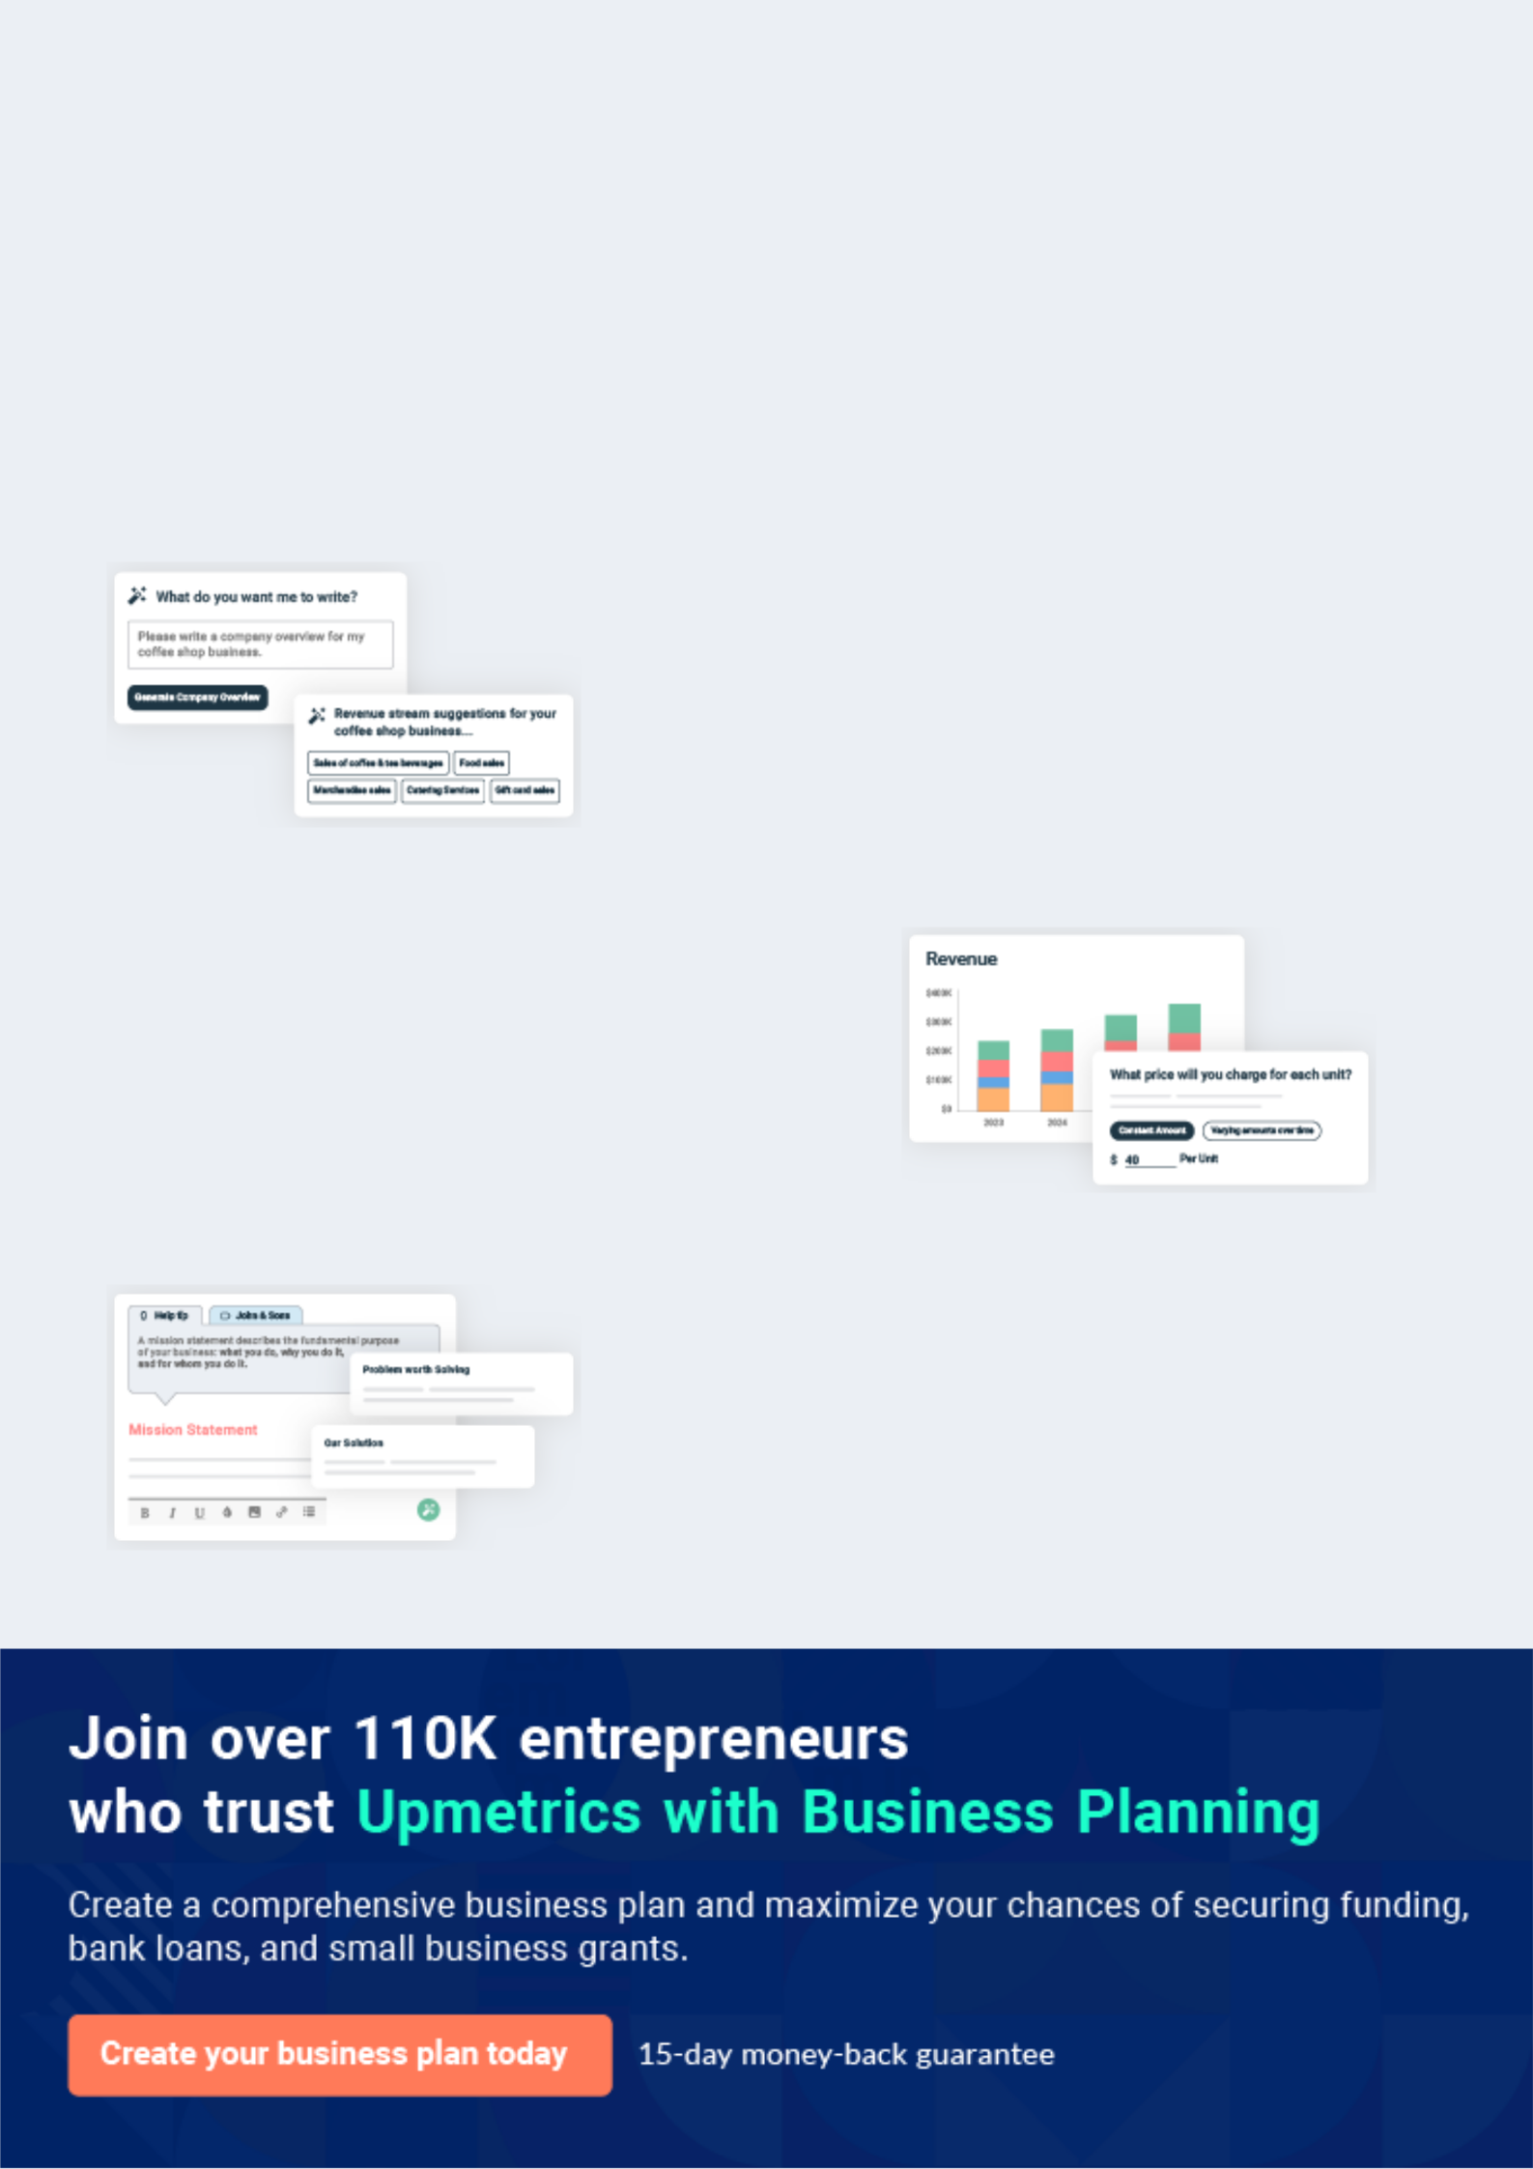
Business planning that’s simpler and faster than you think

Creating a business plan using Upmetrics to start and grow a business is literally the easiest thing in the World. Simply read the instructions and fill in the blanks. It’s as simple as that.

❛ | Upmetrics has everything you need to create a | ❜
❛ | comprehensive business plan. | ❜

AI-powered Upmetrics Assistant

AI-powered insights to streamline your plan

Not sure where to start? Upmetrics’ AI Assistant will automatically generate ideas for each section of your plan and offer improved versions of your writing, adjusting for tone, voice, and grammar or spelling errors.

Financial Forecasting Tool

All the financials are calculated for you

Forget the complex formulas and clumsy spreadsheets — with automatic financials and drag-and-drop forecasting, you can finish your plan faster and be confident that your numbers are accurate.

Business Plan Builder

Guides you like a business mentor

Upmetrics’ step-by-step instructions, prompts, and the library of 400+ sample business plans will guide you through each section of your plan as a business mentor.
Executive Summary


An executive summary is the first section of the business plan intended to provide an overview of the whole business plan.
To unlock help try Upmetrics! 

 Help tip  Wellness Center Business Plan


Start your executive summary by briefly introducing your business to your readers.

This section may include the name of your wellness center, its location, when it was founded,
To unlock help try Upmetrics! 

Start writing here..

Market opportunity

 Help tip  Wellness Center Business Plan

Summarize your market research, including market size, growth potential, and marketing trends. Highlight the opportunities in the market and how your business will fit in to fill the gap.
To unlock help try Upmetrics! 

Start writing here..

Services Offered

 Help tip  Wellness Center Business Plan

Highlight the wellness services you offer your clients. The USPs and differentiators you offer are always a plus.
To unlock help try Upmetrics! 

Start writing here..

Marketing & Sales Strategies
To unlock help try Upmetrics!

 Help tip  Wellness Center Business Plan

Outline your sales and marketing strategies—what marketing platforms you use, how you plan on acquiring customers, etc.
To unlock help try Upmetrics! 

Start writing here..

Financial Highlights

 Help tip  Wellness Center Business Plan

Briefly summarize your financial projections for the initial years of business operations. Include any capital or investment requirements, associated startup costs, projected revenues, and profit forecasts.



Start writing here..
Units Sold v/s Revenue

 |  | Units Sold | Revenue
15.00k
10.00k
5.00k
0
Year 1 | Year 2 | Year 3
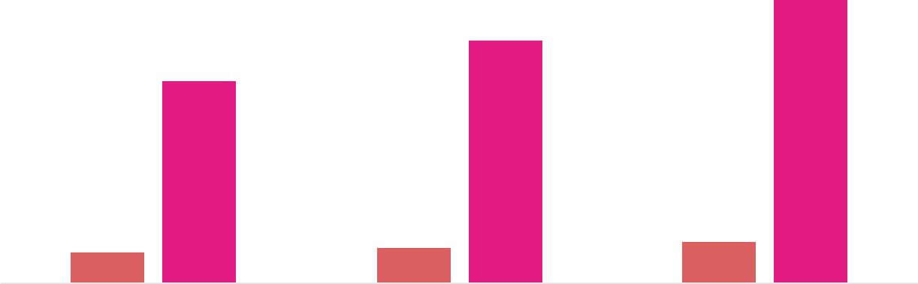

Financial Year |  |  | Units Sold | Revenue
Year 1 | 1,550 |  |  | $10,000
Year 2 | 1,800 |  |  | $12,000
Year 3 | 2,050 |  |  | $14,000
 Help tip |  |  Wellness Center Business Plan


Summarize your executive summary section with a clear CTA, for example, inviting angel investors to discuss the potential business investment.
To unlock help try Upmetrics! 

Write a call to action for your business plan.
Company Overview

Depending on what details of your business are essential, you’ll need different elements in your business overview.
To unlock help try Upmetrics! 

 Help tip  Wellness Center Business Plan

Describe your business in this section by providing all the basic information:

Describe what kind of wellness center you run and the name of it. For instance, here are some
To unlock help try Upmetrics! 

Start writing here..

Ownership

 Help tip  Wellness Center Business Plan

List the founders of your wellness center. Describe what shares they own and their responsibilities for efficiently managing the business.
To unlock help try Upmetrics! 

Start writing here..

Business Owners



60% John Doe



40% Jane Doe
Mission statement

 Help tip  Wellness Center Business Plan

Summarize your business’ objective, core principles, and values in your mission statement. This statement needs to be memorable, clear, and brief.
To unlock help try Upmetrics! 

❛ Our mission at [Harmony Wellness Center] is to empower individuals to take control of their health and well-being by providing holistic and personalized wellness programs.

We are committed to fostering a supportive and tranquil environment that promotes healing, relaxation, and balance.

❜

Business history

 Help tip  Wellness Center Business Plan

If you’re an established wellness center, briefly describe your business history, like—when it was founded, how it evolved over time, etc.
To unlock help try Upmetrics! 

Start writing here..

Future goals

 Help tip  Wellness Center Business Plan

It’s crucial to convey your aspirations and vision. Mention your short-term and long-term goals; they can be specific targets for revenue, market share, or expanding your services.
To unlock help try Upmetrics! 

Start writing here..

Market Analysis
To unlock help try Upmetrics!


 |  | Market analysis provides a clear understanding of the market in which your
 |  | printing business will run along with the target market, competitors, and
 |  | growth opportunities.
 |  |  |  | To unlock help try Upmetrics! 
 Help tip |  |  Wellness Center Business Plan

To write the introduction section of your market analysis, start by clearly identifying your primary target market.
To unlock help try Upmetrics! 

Start writing here..

Target Market

 Help tip  Wellness Center Business Plan

Start this section by describing your target market. Define your ideal customer and explain what types of services they prefer. Creating a buyer persona will help you easily define your target market to your readers.



Start writing here..

Market size and growth potential

 Help tip  Wellness Center Business Plan

Describe your market size and growth potential and whether you will target a niche or a broader market.
To unlock help try Upmetrics! 

Start writing here..

Market Size

Available Market

Individuals seeking holistic health 50M services globally.

Served Market | 15M
Global users of holistic wellness centers. | 15M

Target Market
Health-conscious adults aged 18-34 5M globally.

 Help tip  Wellness Center Business Plan

Identify and analyze your direct and indirect competitors. Identify their strengths and weaknesses, and describe what differentiates your wellness center services from them.
To unlock help try Upmetrics! 

Competitive analysis

Equinox

Equinox is a high-end fitness and wellness brand, with clubs located across the U.S. and internationally. They offer a combination of gym facilities, group classes, spa treatments, and personal training sessions.

Features | Strengths | Weaknesses
State-of-the-art fitness | Extensive brand recognition | Premium pricing may not be
equipment | and established customer | accessible to everyone
A variety of group fitness | loyalty | Limited locations, primarily in
classes, from yoga to high- | Wide range of facilities and | upscale neighborhoods or cities
intensity interval training | classes
Luxury spa services | Luxurious ambiance and top-
Personal training sessions | tier amenities
tailored to individual needs

Life Time Fitness

Life Time Fitness is a chain of health clubs in the U.S. and Canada. They provide a comprehensive range of health and wellness services, including fitness classes, indoor and outdoor pools, racquet sports, and more.

Features

Broad spectrum of fitness classes

Family-friendly amenities, including childcare

Athletic events and leagues to encourage community and competition

Strengths

Diverse range of facilities appealing to families and individual fitness enthusiasts alike

Open for long hours, catering to early risers and night owls

Frequent promotional offers for new members

Weaknesses

Some complaints about contract terms and cancellation policies

Due to the broad offering, some services might not match the specialized quality of niche providers

Canyon Ranch

Canyon Ranch is an integrative wellness resort with locations in several parts of the U.S. They focus on holistic wellness, offering services like spa treatments, medical evaluations, spiritual wellness, and fitness classes.

Features

Medical and health experts on-site for consultations

Programs tailored to stress management, weight loss, spiritual wellness, and more

Luxurious spa treatments and amenities

Strengths

Comprehensive holistic approach to wellness, touching on physical, mental, and spiritual aspects

Retreat-like ambiance provides a complete escape from daily life

Expert staff in various wellness disciplines

Weaknesses

Considered a luxury offering with higher pricing

Being a destination resort, it's not as accessible for regular visits unless residing nearby

Market trends

 Help tip  Wellness Center Business Plan

Analyse emerging trends in the industry, such as technology disruptions, changes in customer behavior or preferences, etc. Explain how your business will cope with all the trends.
To unlock help try Upmetrics! 

Start writing here..

Regulatory environment
To unlock help try Upmetrics!

 Help tip  Wellness Center Business Plan

List regulations and licensing requirements that may affect your wellness centers, such as business registration, health and safety regulations, compliance and privacy laws, zoning and building codes, liability insurance, etc.



Start writing here..
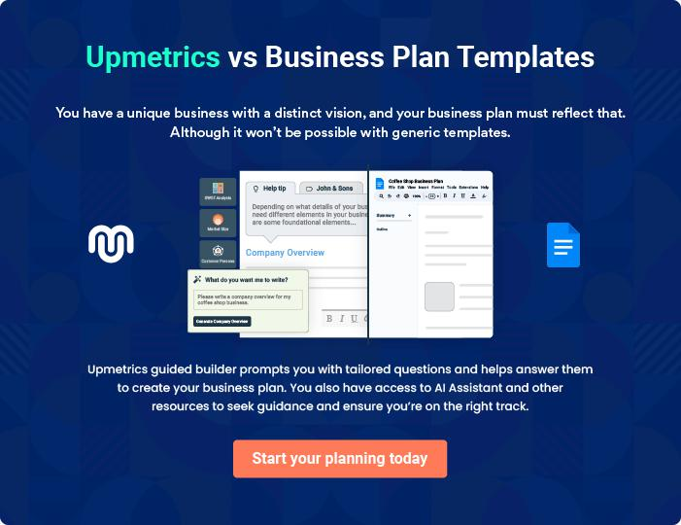
Products and Services
To unlock help try Upmetrics!

The product and services section of a wellness center business plan should describe the specific services and products that will be offered to customers. To write this section should include the following:



 Help tip  Wellness Center Business Plan

To craft the introduction for your "Products and Services" chapter, begin by positioning your business within its industry, emphasizing its unique strengths or value proposition.
To unlock help try Upmetrics! 

Start writing here..

 Help tip


Mention your services: Mention and describe the wellness services your business will offer. This list may include services like,
To unlock help try Upmetrics! 

Products and Services list

Fitness Classes


Price: [$15] per class / [$120] monthly membership

Tailored fitness sessions for all age groups and fitness levels.

Specifications

- Duration: 60 minutes per class.

- Equipment: State-of-the-art machines, weights, and resistance bands.

- Types: Cardio, Strength training, HIIT, Flexibility classes.
Acupuncture Yoga

Price: [$50] per session

A blend of acupuncture and yoga techniques designed for energy balance and relaxation.

Specifications

- Duration: 75 minutes per session.

- Equipment: Yoga mats, acupuncture needles, sanitized equipment.

- Instructor: Certified in both yoga instruction and acupuncture.

Nutrition Counseling

Price: [$80] for an initial consultation / [$40] for follow-ups

Personalized dietary advice from certified nutritionists.

Specifications

- Duration: 45 minutes for initial, 30 minutes for follow-ups.

- Includes: Dietary assessment, personalized meal planning, dietary supplement recommendations.

Massage Therapy

Price: [$100] per 60-minute session

Massages for relaxation, muscle relief, and stress reduction.

Specifications

- Types: Deep tissue, Swedish, hot stone, reflexology.

- Equipment: Professional massage tables, essential oils, sanitized linens.

- Therapist: Certified with a minimum of 5 years of experience.
Supplements

Price: Ranges from [$10 to $50] based on product

Dietary supplements including vitamins, minerals, and herbal concoctions.

Specifications

- Types: Multivitamins, probiotics, herbal supplements.

- Brand: [Brand Name], a trusted name in holistic health.

- Certification: FDA approved, Non-GMO, Organic.

Essential Oils

Price: [$15] per 10ml bottle

Therapeutic-grade essential oils for aromatherapy and relaxation.

Specifications

- Types: Lavender, eucalyptus, tea tree, peppermint, and more.

- Use: Diffusers, massage, inhalation.

- Purity: 100% natural, no additives or diluents.

Wellness Books

Price: Ranges from [$10 to $30] based on title Curated selection of books on diverse wellness topics.

Specifications

- Topics: Nutrition, mental health, fitness, holistic health.

- Authors: Renowned experts in the field of wellness.

- Format: Paperback, hardcover, e-books.
Skin-Care Services

Price: [$70] per facial treatment

Organic, hypoallergenic skincare treatments.

Specifications

- Types: Moisturizing, exfoliating, anti-aging, brightening.

- Products: Organic, cruelty-free, dermatologically tested.

- Duration: 60 minutes per session.

Quality Measures

 Help tip  Wellness Center Business Plan

This section should explain how you maintain quality standards and consistently provide the highest quality service.
To unlock help try Upmetrics! 

Start writing here..

Additional Services

 Help tip  Wellness Center Business Plan

Mention if your wellness center offers any additional services. You may include services like health coaching, skin-care services, mental health services, etc.
To unlock help try Upmetrics! 

Start writing here..

Sales And Marketing Strategies
To unlock help try Upmetrics!

Writing the sales and marketing strategies section means a list of strategies you will use to attract and retain your clients.
To unlock help try Upmetrics! 

 Help Tip  Wellness Center Business Plan


To create an effective introduction for your "Sales and Marketing Strategies" chapter, start by setting the stage within your specific industry or market.
To unlock help try Upmetrics! 

Start writing here..

Unique Selling Proposition (USP)

 Help tip  Wellness Center Business Plan


Define your business’s USPs depending on the market you serve, your experience in the domain,
and the unique services you provide. Identifying USPs will help you plan your marketing
strategies.
 |  |  |  | To unlock help try Upmetrics! 
Start writing here..
Pricing Strategy
 Help tip |  |  Wellness Center Business Plan

Describe your pricing strategy—how you plan to price your wellness services and stay competitive in the local market. You can mention any discounts you plan on offering to attract new clients to your wellness services.



Start writing here..

 Help tip  Wellness Center Business Plan

Discuss your marketing strategies to market your services. You may include some of these

marketing strategies in your business plan—social media marketing, public relations, Google
ads, brochures, email marketing, content marketing, and print marketing._{To unlock help try Upmetrics!} 

Marketing strategies

Online


Social Media

Leveraging platforms like Instagram and Facebook, showcasing testimonials, live sessions, and health tips.

Content Marketing

Blog posts and articles on health and wellness topics, establishing our center as an industry authority.

Email Marketing

Regular newsletters featuring health tips, updates, and exclusive offers for subscribers.

Google Ads

Targeted advertisements to reach potential clients actively searching for wellness solutions.

Public Relations

Engaging with local media for coverage on our special events or new launches.

Offline

Brochures

Distributed at strategic locations, providing information on our services and offers.

Print Marketing

Ad placements in local magazines, newspapers, and community bulletins.

 Help tip  Wellness Center Business Plan
To unlock help try Upmetrics!

Outline the strategies you’ll implement to maximize your sales. Your sales strategies may include offering introductory packages, partnering with other businesses, offering referral programs, discounts for first-time clients, etc.



Sales strategies

Introductory Packages Business Partnerships

Affordable packages for new Collaborations with local

clients to experience a range of our businesses, offering their

services. employees special discounts or

sessions.

Referral Programs

Existing clients can refer friends and earn discounts on their next visit.

First-Time Client Offers

Exclusive offers for clients trying our services for the first time.

 Help tip  Wellness Center Business Plan
Personalized Communication
Birthday and anniversary wishes, personalized offers, and health check reminders.
To unlock help try Upmetrics!

Describe your customer retention strategies and how you plan to execute them. For instance, your customer retention strategies may include providing high-quality services, communicating in a personalized manner, and introducing loyalty programs.



Customer retention

High-Quality Services

Ensuring our services are top-notch and meet client expectations.

Loyalty Programs

Points for every dollar spent, which

can be redeemed for services.
Operations Plan
To unlock help try Upmetrics!

 |  | When writing the operations plan section, it’s important to consider the
 |  | various aspects of your business operations.
 |  |  |  | To unlock help try Upmetrics! 
 Help tip |  |  Wellness Center Business Plan


To create an effective introduction for your "Operational Plan" chapter, start by emphasizing the
pivotal role of efficient operations in the success of your business, underscoring how they
directly impact the quality of services delivered.
 |  |  |  | To unlock help try Upmetrics! 
Start writing here..
Staffing & Training
 Help tip |  |  Wellness Center Business Plan

Mention your business’s staffing requirements, including the number of certified practitioners,
administrative support, marketing, or maintenance staff needed. Include their qualifications, the
training required, and the duties they will perform.
 |  |  |  | To unlock help try Upmetrics! 
Start writing here..
Operational Process
 Help tip |  |  Wellness Center Business Plan

Outline the processes and procedures you will use to run your wellness center. Your operational processes may include appointment scheduling, staff management, financial management, data management, and facility management.



Start writing here..

Equipment & Machinery
To unlock help try Upmetrics!

 Help tip  Wellness Center Business Plan

Include the list of equipment and machinery required for the wellness center, such as massage tables, yoga mats and props, acupuncture supplies, nutrition and cooking equipment, saunas and steam rooms, etc.



Start writing here..
Management Team

The management team section provides an overview of the individuals responsible for running your business plan.
To unlock help try Upmetrics! 

 Help tip  Wellness Center Business Plan

To craft an introduction for your "Management Team" chapter, begin by emphasizing the crucial role of leadership in the success of any business.
To unlock help try Upmetrics! 

Start writing here..

Key managers

 Help tip  Wellness Center Business Plan

Introduce your management and key members of your team, and explain their roles and responsibilities.
To unlock help try Upmetrics! 

Start writing here..


JOHN DOE

Founder & CEO - john.doe@example.com

As the founder and CEO, John plays a crucial role in strategic planning, financial management, and overall operations of [Harmony Wellness Center].

His vision is to create a center that not only promotes physical well-being but also fosters a community of health-conscious individuals.


- Education: Master's in Health and Wellness, [University Name].

- Professional Background: Over 15 years of experience in managing wellness centers in California.

JANE DOE

Wellness Program Manager - jane.doe@example.com

Jane oversees the development and implementation of various wellness programs and classes offered at the center.

She works closely with fitness instructors, yoga teachers, and other wellness professionals to ensure our programs meet the needs of our diverse clientele.


- Education: Bachelor's in Health Education, [University Name].

- Professional Background: 10 years of experience as a wellness coach and program coordinator.


ALICE BROWN

Marketing Manager - alice.brown@example.com

Alice leads the marketing team in promoting the center's services.

She is responsible for designing and executing marketing strategies, managing social media campaigns, and handling public relations to increase the center's visibility and client base.

- Education: Bachelor's in Marketing, [University Name].

- Professional Background: 7 years of marketing experience, with a focus on wellness and fitness industries.


ROBERT BROWN

HR Manager - robert.brown@example.com

Robert is responsible for managing the human resources functions at the center, including recruitment, training, and employee relations.

He ensures that the center has a skilled and motivated team to provide the best services to our clients.

- Education: Master's in Human Resources Management, [University Name].

- Professional Background: 5 years of HR experience in the health and wellness industry.
Organizational structure

 Help tip  Wellness Center Business Plan

Explain the organizational structure of your management team. Include the reporting line and decision-making hierarchy.
To unlock help try Upmetrics! 

Start writing here..

Organization chart


John Doe

CEO


 | Jane Doe
Alice Brown | Wellness Program | Robert Brown
Marketing Manager | Manager | HR Manager




Lucy Davis | Emma Smith | Mike Johnson
Social Media | Emma Smith | Mike Johnson
Social Media | Yoga Instructor | Fitness Trainer
Specialist | Yoga Instructor | Fitness Trainer



Compensation plan

 Help tip  Wellness Center Business Plan

Describe your compensation plan for the management and staff. Include their salaries, incentives, and other benefits.
To unlock help try Upmetrics! 

Start writing here..

 Help tip  Wellness Center Business Plan

Mentioning advisors or consultants in your business plans adds credibility to your business idea.
To unlock help try Upmetrics! 

Advisors/Consultants


MR. MICHAEL SMITH

Business Development Consultant

Experience: [15] years of experience in business growth strategies for wellness centers.


DR. EMILY JOHNSON

Medical Advisor

Experience: [20] years of experience as a holistic health practitioner.
Financial Plan

When writing the financial plan section of a business plan, it’s important to provide a comprehensive overview of your financial projections for the first few years of your business, You may provide the following:
To unlock help try Upmetrics! 

 Help tip  Wellness Center Business Plan


To create an effective introduction for your "Financial Plan" chapter, begin by stressing the critical role of a well-structured financial plan in the success of your venture.
To unlock help try Upmetrics! 

Start writing here..

 Help tip  Wellness Center Business Plan

Describe details such as projected revenue, operational costs, and service costs in your projected profit and loss statement. Make sure to include your business’s expected net profit or loss.
To unlock help try Upmetrics! 

Profit & loss statement

Revenue

Cost Of Sales

General Costs

Revenue Specific Costs

Personnel Costs (Direct

Labor)

Gross Margin

Gross Margin (%)

Operating Expense

Payroll Expense

(Indirect Labor)

General Expense

Bad Debt

Amortization of Current

Assets

2023-24 | 2024-25 | 2025-26 | 2026-27 | 2027-28
$0 | $0 | $0 | $0 | $0

$0 | $0 | $0 | $0 | $0
$0 | $0 | $0 | $0 | $0
$0 | $0 | $0 | $0 | $0
$0 | $0 | $0 | $0 | $0

$0 | $0 | $0 | $0 | $0
0% | 0% | 0% | 0% | 0%

$0 | $0 | $0 | $0 | $0
$0 | $0 | $0 | $0 | $0
$0 | $0 | $0 | $0 | $0
$0 | $0 | $0 | $0 | $0
$0 | $0 | $0 | $0 | $0

EBITDA

Additional Expense

Long Term

Depreciation

Gain or loss from Sale

of Assets

EBIT

Interest Expenses

EBT

Income Tax Expense

Total Expense

Net Income

Net Income (%)

2023-24 | 2024-25 | 2025-26 | 2026-27 | 2027-28
$0 | $0 | $0 | $0 | $0
$0 | $0 | $0 | $0 | $0
$0 | $0 | $0 | $0 | $0
$0 | $0 | $0 | $0 | $0
$0 | $0 | $0 | $0 | $0
$0 | $0 | $0 | $0 | $0
$0 | $0 | $0 | $0 | $0
$0 | $0 | $0 | $0 | $0
$0 | $0 | $0 | $0 | $0
$0 | $0 | $0 | $0 | $0
0% | 0% | 0% | 0% | 0%

 |  |  | 2023-24 |  | 2024-25 | 2025-26
Retained Earning |  |  | $0 |  | $0 | $0
Opening |  |  |  |  | $0 | $0
Owner's Distribution |  |  | $0 |  | $0 | $0
Retained Earning |  |  | $0 |  | $0 | $0
Closing |  |  |  |  | $0 | $0
 Help tip |  |  |  Wellness Center Business Plan


The cash flow for the first few years of your operation should be estimated and described in this section.

This may include billing invoices, payment receipts, loan payments, and any other cash flow statements.
2026-27 2027-28

$0 $0

$0 $0

$0 $0

To unlock help try Upmetrics! 

Cash flow statement

 | 2023-24 | 2024-25 | 2025-26 | 2026-27 | 2027-28
Cash Received | $0 | $0 | $0 | $0 | $0
Cash Paid | $0 | $0 | $0 | $0 | $0
COS & General Expenses | $0 | $0 | $0 | $0 | $0
Salary & Wages | $0 | $0 | $0 | $0 | $0
Interest | $0 | $0 | $0 | $0 | $0

Sales Tax

Income Tax

Net Cash From

Operations

Assets Sell

Assets Purchase

Net Cash From

Investments

Amount Received

Loan Received

Common Stock

Preferred Stock

Owner's Contribution

Amount Paid

2023-24 | 2024-25 | 2025-26 | 2026-27 | 2027-28
$0 | $0 | $0 | $0 | $0
$0 | $0 | $0 | $0 | $0
$0 | $0 | $0 | $0 | $0

$0 | $0 | $0 | $0 | $0
$0 | $0 | $0 | $0 | $0
$0 | $0 | $0 | $0 | $0

$0 | $0 | $0 | $0 | $0
$0 | $0 | $0 | $0 | $0

$0 | $0 | $0 | $0 | $0
$0 | $0 | $0 | $0 | $0
$0 | $0 | $0 | $0 | $0

Loan Capital $0 $0 $0 $0 $0

 |  |  | 2023-24 |  | 2024-25 | 2025-26 | 2026-27 | 2027-28
Dividends & Distributions |  |  | $0 |  | $0 | $0 | $0 | $0
Net Cash From |  |  | $0 |  | $0 | $0 | $0 | $0
Financing
Summary
Starting Cash |  |  | $0 |  | $0 | $0 | $0 | $0
Cash In |  |  | $0 |  | $0 | $0 | $0 | $0
Cash Out |  |  | $0 |  | $0 | $0 | $0 | $0
Change in Cash |  |  | $0 |  | $0 | $0 | $0 | $0
Ending Cash |  |  | $0 |  | $0 | $0 | $0 | $0
 Help tip |  |  Wellness Center Business Plan

Create a projected balance sheet documenting your wellness center’s assets, liabilities, and equity.

To unlock help try Upmetrics! 

Balance sheet

 | 2023-24 | 2024-25 | 2025-26 | 2026-27 | 2027-28
Assets | $0 | $0 | $0 | $0 | $0
Current Assets | $0 | $0 | $0 | $0 | $0
Cash | $0 | $0 | $0 | $0 | $0
Accounts Receivable | $0 | $0 | $0 | $0 | $0
Inventory | $0 | $0 | $0 | $0 | $0
Other Current Assets | $0 | $0 | $0 | $0 | $0
Long Term Assets | $0 | $0 | $0 | $0 | $0
Gross Long Term Assets | $0 | $0 | $0 | $0 | $0
Accumulated Depreciation | $0 | $0 | $0 | $0 | $0

Liabilities & Equity | $0 | $0 | $0 | $0 | $0
Liabilities | $0 | $0 | $0 | $0 | $0
Current Liabilities | $0 | $0 | $0 | $0 | $0
Accounts Payable | $0 | $0 | $0 | $0 | $0
Income Tax Payable | $0 | $0 | $0 | $0 | $0
Sales Tax Payable | $0 | $0 | $0 | $0 | $0
Short Term Debt | $0 | $0 | $0 | $0 | $0
 | 2023-24 | 2024-25 | 2025-26 | 2026-27 | 2027-28
Long Term Liabilities | $0 | $0 | $0 | $0 | $0
Long Term Debt | $0 | $0 | $0 | $0 | $0
Equity | $0 | $0 | $0 | $0 | $0
Paid-in Capital | $0 | $0 | $0 | $0 | $0
Common Stock | $0 | $0 | $0 | $0 | $0
Preferred Stock | $0 | $0 | $0 | $0 | $0
Owner's Contribution | $0 | $0 | $0 | $0 | $0
Retained Earnings | $0 | $0 | $0 | $0 | $0

Check | $0 |  |  | $0 | $0 | $0 | $0
 Help tip |  |  Wellness Center Business Plan

Determine and mention your business’s break-even point—the point at which your business costs and revenue will be equal.

This exercise will help you understand how much revenue you need to generate to sustain or be profitable.
To unlock help try Upmetrics! 

Break-even Analysis

 | 2023-24 | 2024-25 | 2025-26 | 2026-27 | 2027-28
Starting Revenue | $0 | $0 | $0 | $0 | $0
Net Revenue | $0 | $0 | $0 | $0 | $0
Closing Revenue | $0 | $0 | $0 | $0 | $0

Starting Expense | $0 | $0 | $0 | $0 | $0
Net Expense | $0 | $0 | $0 | $0 | $0
Closing Expense | $0 | $0 | $0 | $0 | $0

Is Break Even? | 0 | 0 | 0 | 0 | 0
Break Even Month | 0 | 0 | 0 | 0 | 0
Days Required | 0 | 0 | 0 | 0 | 0
Break Even Revenue | $0 | $0 | $0 | $0 | $0
Break Even Units
Financing needs

 Help tip  Wellness Center Business Plan

Calculate costs associated with starting a wellness center, and estimate your financing needs and how much capital you need to raise to operate your business.
To unlock help try Upmetrics! 

Start writing here..
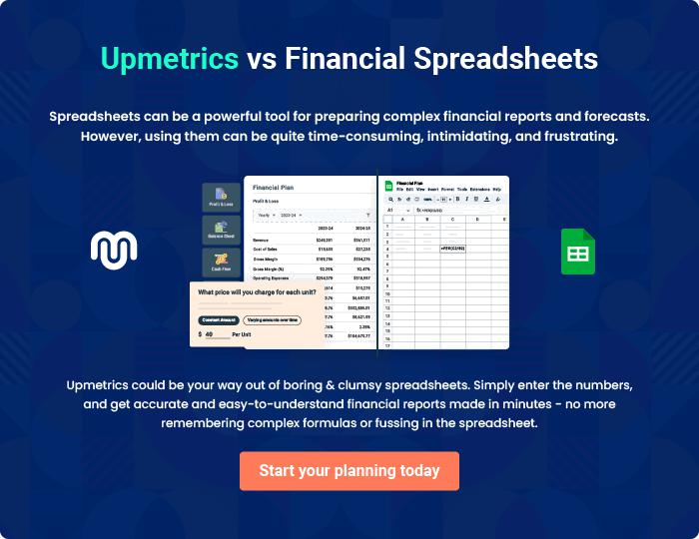
Appendix

When writing the appendix section, you should include any additional information that supports the main content of your plan. This may include financial statements, market research data, legal documents, and other
To unlock help try Upmetrics! 
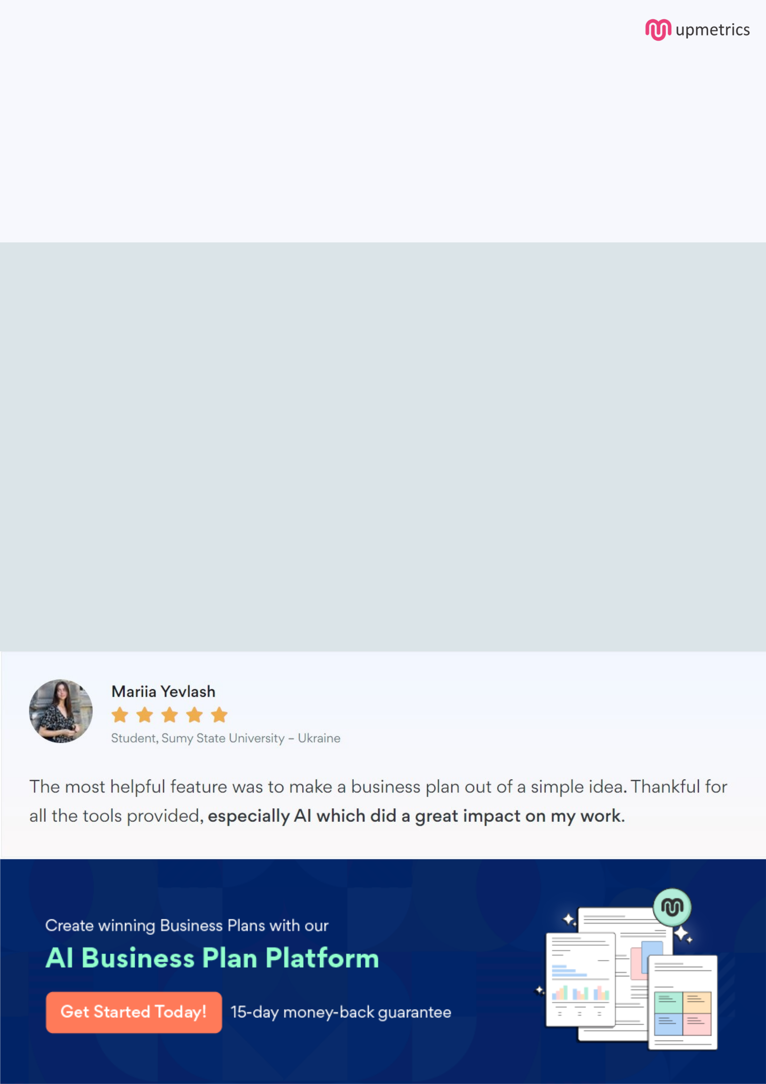
Create a winning business plan that gets you funded

Creating a stunning and investment-ready plan requires no writing, graphic designing, or financial planning expertise.

Upmetrics has all the features required to help you create a comprehensive business plan—from start to finish. Make no mistakes, it’s the modern way of planning to structure ideas, make plans, and create stunning pitch decks to awe investors.

Pitch decks that impress investors

Create pitch decks that provide a visual representation of your business, engage investors, and make them want to invest in your business idea.

Interactive plans in no time

Import business plan sections like—SWOT analysis, comparison tables, and others to create an interactive business plan. No designing skills are required.

Stunning cover page designs

With Upmetrics, you have the liberty to choose from multiple stunning cover page designs. Choose a creative design and make your plan stand out.

Online sharing made simple

Upmetrics makes online sharing quick and easier for users. Easily share your business plans with a link while tracking reader activity.

500+ sample business plans

Simply import a template from our library of sample plans into the editor and start customizing it to make it yours. It takes only a few clicks to get started.

Collaborate with team in real-time

Invite team members, initiate conversations, discuss ideas & strategies, share feedback, and work on a business plan in real-time.

