

Welding Business Plan

Welding, Strength, Form

Business

Plan

2023

John Doe

10200 Bolsa Ave, Westminster, CA, 92683

- 359-3153 info@example.com http://www.example.com

CONFIDENTIAL

Table of Contents

Executive Summary | 6
Market opportunity | 6
Services Offered | 6
Marketing & Sales Strategies | 7
Financial Highlights | 7
Units Sold v/s Revenue | 8

Company Overview | 9
Ownership | 9
Mission statement | 10
Business history | 10
Future goals | 11

Market Analysis | 12
Target Market | 12
Market size and growth potential | 12
Market Size | 13
Competitive analysis | 13
XYZ Welding Inc. | 13
WeldTech Solutions | 14
Reliable Welds LLC | 14
Market trends | 14
Regulatory environment | 15

Products and Services | 16
Welding services | 16
Metal Fabrication | 16
Welding & Repair Services | 17
On-Site Welding Services | 17
Structural Steel & Pipe Welding | 17
Specialty Welding Services | 18
Quality Measures | 18
Additional Services | 18

Sales And Marketing Strategies | 19
Unique Selling Proposition (USP) | 19
Pricing Strategy | 19
Marketing strategies | 20
Online | 20
Offline | 20
Sales strategies | 21
Customer retention | 21

Operations Plan | 22
Staffing & Training | 22
Operational Process | 22
Equipment & Machinery | 23

Management Team | 24
Key managers | 24
John Doe | 24
Jane Doe | 25
Alice Brown | 25
Robert Brown | 25
Organizational structure | 26
Organization chart | 26
Compensation plan | 27
Advisors/Consultants | 27
[ADVISOR NAME] | 27
[CONSULTANT NAME] | 27

Financial Plan | 28
Profit & loss statement | 28
Cash flow statement | 31
Balance sheet | 33
Break-even Analysis | 35
Financing needs | 37
Appendix
Appendix | 39
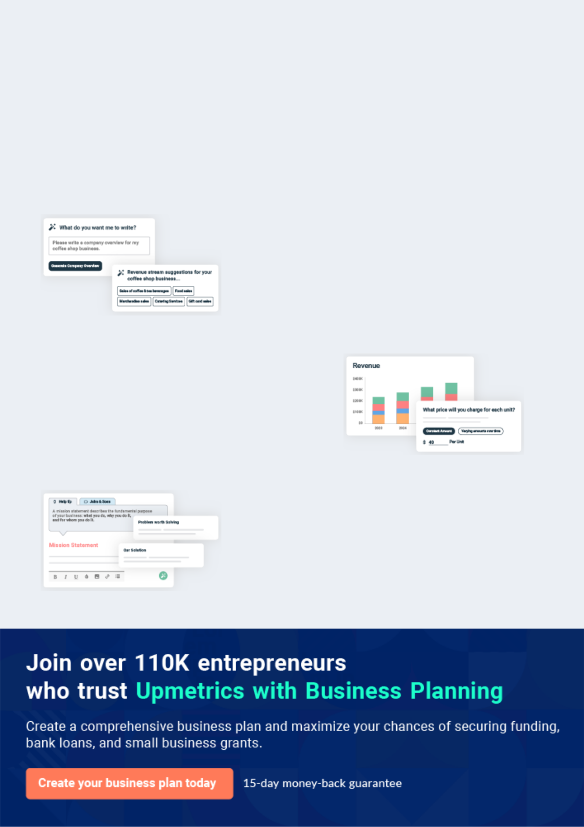
Business planning that’s simpler and faster than you think

Creating a business plan using Upmetrics to start and grow a business is literally the easiest thing in the World. Simply read the instructions and fill in the blanks. It’s as simple as that.

❛ | Upmetrics has everything you need to create a | ❜
❛ | comprehensive business plan. | ❜

AI-powered Upmetrics Assistant

AI-powered insights to streamline your plan

Not sure where to start? Upmetrics’ AI Assistant will automatically generate ideas for each section of your plan and offer improved versions of your writing, adjusting for tone, voice, and grammar or spelling errors.

Financial Forecasting Tool

All the financials are calculated for you

Forget the complex formulas and clumsy spreadsheets — with automatic financials and drag-and-drop forecasting, you can finish your plan faster and be confident that your numbers are accurate.

Business Plan Builder

Guides you like a business mentor

Upmetrics’ step-by-step instructions, prompts, and the library of 400+ sample business plans will guide you through each section of your plan as a business mentor.
Executive Summary


An executive summary is the first section of the business plan intended to provide an overview of the whole business plan.
To unlock help try Upmetrics! 

 Help tip  Welding Business Plan


Start your executive summary by briefly introducing your business to your readers.

This section may include the name of your welding business, its location when it was founded,
To unlock help try Upmetrics! 

Start writing here..

Market opportunity

 Help tip  Welding Business Plan

Summarize your market research, including market size, growth potential, and marketing trends. Highlight the opportunities in the market and how your business will fit in to fill the gap.
To unlock help try Upmetrics! 

Start writing here..

Services Offered

 Help tip  Welding Business Plan

Highlight the welding services you offer your clients. The USPs and differentiators you offer are always a plus.
To unlock help try Upmetrics! 

Start writing here..

Marketing & Sales Strategies
To unlock help try Upmetrics!

 Help tip  Welding Business Plan

Outline your sales and marketing strategies—what marketing platforms you use, how you plan on acquiring customers, etc.
To unlock help try Upmetrics! 

Start writing here..

Financial Highlights

 Help tip  Welding Business Plan

Briefly summarize your financial projections for the initial years of business operations. Include any capital or investment requirements, associated startup costs, projected revenues, and profit forecasts.



Start writing here..
Units Sold v/s Revenue

 |  | Units Sold | Revenue
15.00k
10.00k
5.00k
0
Year 1 | Year 2 | Year 3
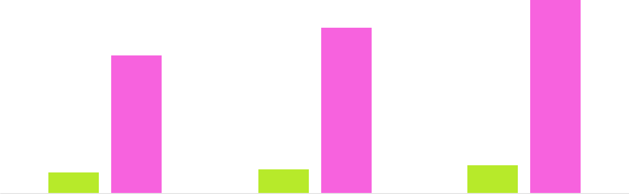

Financial Year |  |  | Units Sold | Revenue
Year 1 | 1,550 |  |  | $10,000
Year 2 | 1,800 |  |  | $12,000
Year 3 | 2,050 |  |  | $14,000
 Help tip |  |  Welding Business Plan
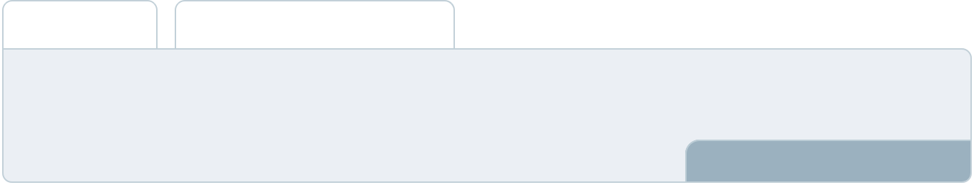

Summarize your executive summary section with a clear CTA, for example, inviting angel investors to discuss the potential business investment.
To unlock help try Upmetrics! 

Write a call to action for your business plan.
Company Overview

Depending on what details of your business are essential, you’ll need different elements in your business overview.
To unlock help try Upmetrics! 

 Help tip  Welding Business Plan

Describe your business in this section by providing all the basic information:

Describe what kind of welding company you run and the name of it. You may specialize in one
To unlock help try Upmetrics! 

Start writing here..

Ownership

 Help tip  Welding Business Plan

List the names of your welding company’s founders or owners. Describe what shares they own and their responsibilities for efficiently managing the business.
To unlock help try Upmetrics! 

Start writing here..
Mission statement

 Help tip  Welding Business Plan

Summarize your business’ objective, core principles, and values in your mission statement. This statement needs to be memorable, clear, and brief.
To unlock help try Upmetrics! 

❛ At [Unbreakable Bonds] Welding, we are dedicated to forging lasting relationships through exceptional welding services. Our mission is to exceed expectations, maintain the highest standards of quality, and continuously innovate to meet the evolving needs of our clients.

We are committed to integrity, excellence, and fostering a culture of continuous learning and improvement.

❜

Business history

 Help tip  Welding Business Plan

If you’re an established welding service provider, briefly describe your business history, like— when it was founded, how it evolved over time, etc.
To unlock help try Upmetrics! 

Start writing here..
Future goals

 Help tip  Welding Business Plan

It’s crucial to convey your aspirations and vision. Mention your short-term and long-term goals; they can be specific targets for revenue, market share, or expanding your services.
To unlock help try Upmetrics! 

Start writing here..
Market Analysis
To unlock help try Upmetrics!


 |  | Market analysis provides a clear understanding of the market in which your
 |  | printing business will run along with the target market, competitors, and
 |  | growth opportunities.
 |  |  |  | To unlock help try Upmetrics! 
 Help tip |  |  Welding Business Plan

To write the introduction section of your market analysis, start by clearly identifying your primary target market.
To unlock help try Upmetrics! 

Start writing here..

Target Market

 Help tip  Welding Business Plan

Start this section by describing your target market. Define your ideal customer and explain what types of services they prefer. Creating a buyer persona will help you easily define your target market to your readers.



Start writing here..

Market size and growth potential

 Help tip  Welding Business Plan

Describe your market size and growth potential and whether you will target a niche or a much broader market.
To unlock help try Upmetrics! 

Start writing here..

Market Size

Available Market

Total market demand for welding services 30M in the region

Served Market
A portion of TAM we can capture with our 10M services

Target Market
Market segment we aim to capture in the 5M near term

 Help tip  Welding Business Plan

Identify and analyze your direct and indirect competitors. Identify their strengths and weaknesses, and describe what differentiates your welding services from them.
To unlock help try Upmetrics! 

Competitive analysis

XYZ Welding Inc.

XYZ Welding Inc. has been operating in the market for over 15 years, providing a wide range of welding services primarily to the industrial and manufacturing sectors.

Features

Extensive Metal Fabrication Services

On-site Welding Support Customized Welding Solutions

Equipment and Machinery Installation

Strengths

Being in the industry for over a decade, they have a strong customer base.

Their team comprises highly skilled and certified welders.

They offer a wide range of services, catering to various industries.

Weaknesses

Their services are priced at a premium, potentially alienating small businesses or budget-conscious customers.

There has been minimal investment in adopting newer technologies or innovative techniques.

WeldTech Solutions

WeldTech Solutions is a newer entrant in the market, known for their innovative approaches and use of advanced technology in welding.

Features Strengths

Weaknesses

Advanced Welding

Technologies

Specialty Welding Services Quick Turnaround Times

Strong Online Presence and Marketing

They are at the forefront of adopting new welding technologies and techniques.

Their strong online presence helps in attracting younger demographics and tech-savvy clients.

They offer competitive pricing, making their services attractive to a wide array of customers.

Being relatively new in the market, they lack the extensive experience and portfolio that older companies have.

Their team is smaller, which could impact their ability to take on larger or multiple projects simultaneously.

Reliable Welds LLC

Reliable Welds LLC focuses on providing welding services to the local residential and commercial sectors, with a strong reputation for reliability.

Features

Residential Welding Services Commercial Welding Projects Emergency Welding Services Personalized Customer Service

Strengths

They have a strong understanding and presence in the local market.

Their emphasis on emergency services means they have a quick response time

They have built strong relationships with their local customer base.

Weaknesses

Their focus on the local market limits their ability to expand or diversify.

They have limited experience in industrial and manufacturing sectors.

Market trends

 Help tip  Welding Business Plan

Analyze emerging trends in the industry, such as technology disruptions, changes in customer behavior or preferences, etc. Explain how your business will cope with all the trends.
To unlock help try Upmetrics! 

Start writing here..

Regulatory environment
To unlock help try Upmetrics!

 Help tip  Welding Business Plan

List regulations and licensing requirements that may affect your welding company, such as safety & health administration, American Welding Society standards, environmental protection agency, licensing & registration, etc.



Start writing here..
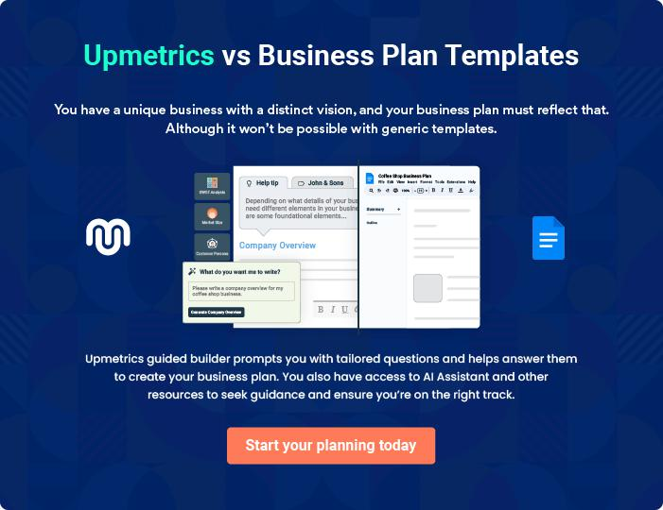
Products and Services
To unlock help try Upmetrics!

The product and services section of the welding business plan should describe the specific services and products that will be offered to customers. To write this section should include the following:



 Help tip  Welding Business Plan

To craft the introduction for your "Products and Services" chapter, begin by positioning your business within its industry, emphasizing its unique strengths or value proposition.
To unlock help try Upmetrics! 

Start writing here..

 Help tip


Mention the welding services your business will offer. This list may include services like,

• Metal fabrication
To unlock help try Upmetrics! 

Welding services

Metal Fabrication


Price: Starting at $[Amount] per hour or $[Amount] per project (depending on complexity and materials)

Transforming raw materials into precise, predefined shapes and sizes, ready for assembly. Ideal for creating custom components for machinery, construction, and various other applications.

Specifications

Utilizing a range of materials including steel, aluminium, and brass. Capable of handling projects of up to [X] tons. Precision cutting, bending, and assembling to tolerances of ±[X] mm.
Welding & Repair Services

Price: $[Amount] per hour (minimum [X] hours) or a flat rate of $[Amount] for specific repairs

Comprehensive repair and maintenance welding services to extend the life of machinery, structures, and equipment.

Specifications

On-site and in-shop services are available. Certified technicians with expertise in MIG, TIG, and Stick welding. Capable of welding materials including steel, stainless steel, and aluminium.

On-Site Welding Services

Price: $[Amount] per hour (minimum [X] hours) + travel fee if applicable

Providing convenient and efficient welding services directly at your location, minimizing downtime and ensuring rapid response for urgent needs.

Specifications

Fully equipped mobile welding units, ready to handle a variety of on-site welding challenges. Available for emergency calls 24/7.

Structural Steel & Pipe Welding

Price: Project-based pricing, starting at $[Amount]

Specialized welding services for the construction of stable and robust structures, ensuring safety and longevity.

Specifications

Certified to [Specific Standards], with capabilities to handle large-scale structural projects. Expertise in welding high-strength steels and other specialized materials.
Specialty Welding Services
To unlock help try Upmetrics!

Price: Starting at $[Amount] per hour or project-based pricing

Catering to unique and specific client needs, offering tailored welding solutions for specialized applications.

Specifications

Ability to work with a variety of exotic materials and challenging welding scenarios. Offering unique techniques such as underwater welding, aerospace welding, etc.

Quality Measures

 Help tip  Welding Business Plan

This section should explain how you maintain quality standards and consistently provide the highest quality service.
To unlock help try Upmetrics! 

Start writing here..

Additional Services

 Help tip  Welding Business Plan

Mention if your welding company offers any additional services. You may include services like consultation & design services, metal fabrication & prototyping, equipment & machinery installation, emergency services, etc.



Start writing here..
Sales And Marketing Strategies

Writing the sales and marketing strategies section means a list of strategies you will use to attract and retain your clients.
To unlock help try Upmetrics! 

 Help Tip  Welding Business Plan
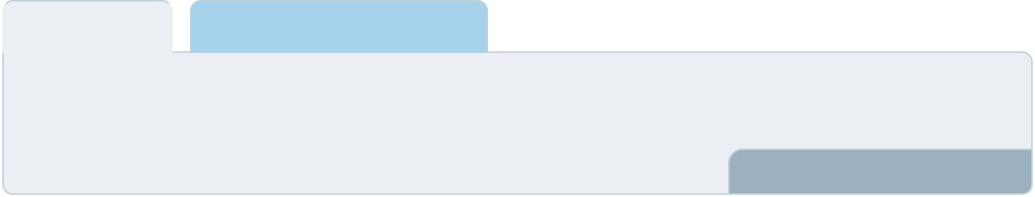

To create an effective introduction for your "Sales and Marketing Strategies" chapter, start by setting the stage within your specific industry or market.
To unlock help try Upmetrics! 

Start writing here..

Unique Selling Proposition (USP)

 Help tip  Welding Business Plan

Define your business’s USPs depending on the market you serve, the equipment you use, and the unique services you provide. Identifying USPs will help you plan your marketing strategies.
To unlock help try Upmetrics! 

Start writing here..

Pricing Strategy

 Help tip  Welding Business Plan

Describe your pricing strategy—how you plan to price your services and stay competitive in the local market. You can mention any discounts you plan on offering to attract new customers.
To unlock help try Upmetrics! 

Start writing here..

 Help tip  Welding Business Plan
To unlock help try Upmetrics!

Discuss your marketing strategies to market your services. You may include some of these marketing strategies in your business plan—social media marketing, Google ads, email marketing, content marketing, and print marketing.



Marketing strategies

Online


Social Media

Leveraging platforms like [Facebook, Instagram, and LinkedIn] to showcase our work, share customer testimonials, and engage with our community.

Content Marketing

Sharing informative and educational content on our blog, demonstrating our expertise and providing value to our audience.

Email Marketing

Sending out newsletters, promotional offers, and updates to our subscriber base, keeping them informed and engaged.

Google Ads

Utilizing targeted advertising to reach potential clients actively searching for welding services.

Offline

Print Marketing

Utilizing local newspapers, magazines, and direct mail to reach a broader audience, especially those who may not be active online.

 Help tip  Welding Business Plan

Outline the strategies you’ll implement to maximize your sales. Your sales strategies may include partnering & collaborating with other businesses, offering referral programs, etc.
To unlock help try Upmetrics! 

Sales strategies

Partner with Businesses

Forming alliances with local contractors, construction companies, and suppliers to create a referral network.

Referral Programs

Encouraging satisfied customers to refer new clients, rewarded with discounts or other incentives.

 Help tip  Welding Business Plan

Describe your customer retention strategies and how you plan to execute them. For instance, introducing loyalty programs, discounts on bulk orders, personalized service, etc.
To unlock help try Upmetrics! 

Customer retention

Loyalty Programs

Offering rewards for repeat business, ensuring that our existing clients feel valued and appreciated.

Personalized Service

Tailoring our services to meet individual client needs, ensuring satisfaction and fostering loyalty.

Follow-Up Services

Providing after-service follow-ups to ensure customer satisfaction and address any potential issues promptly

Operations Plan
To unlock help try Upmetrics!

 |  | When writing the operations plan section, it’s important to consider the
 |  | various aspects of your business operations.
 |  |  |  | To unlock help try Upmetrics! 
 Help tip |  |  Welding Business Plan
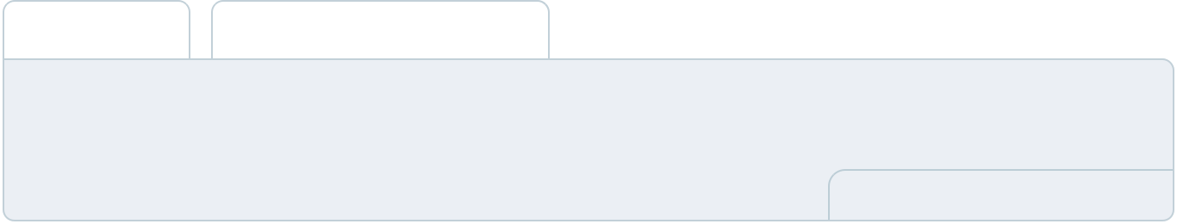

To create an effective introduction for your "Operational Plan" chapter, start by emphasizing the
pivotal role of efficient operations in the success of your business, underscoring how they
directly impact the quality of services delivered.
 |  |  |  | To unlock help try Upmetrics! 
Start writing here..
Staffing & Training
 Help tip |  |  Welding Business Plan

Mention your business’s staffing requirements, including the number of employees or welders needed. Include their qualifications, the training required, and the duties they will perform.
To unlock help try Upmetrics! 

Start writing here..

Operational Process

 Help tip  Welding Business Plan

Outline the processes and procedures you will use to run your welding business. Your operational processes may include client engagement & project assessment, project planning & scheduling, welding execution, etc.



Start writing here..

Equipment & Machinery

 Help tip  Welding Business Plan

Include the list of equipment and machinery required for welding, such as welding machines, welding tools & accessories, welding consumables & accessories, cutting equipment, etc.
To unlock help try Upmetrics! 

Start writing here..
Management Team

The management team section provides an overview of the individuals responsible for running your business plan.
To unlock help try Upmetrics! 

 Help tip  Welding Business Plan

To craft an introduction for your "Management Team" chapter, begin by emphasizing the crucial role of leadership in the success of any business.
To unlock help try Upmetrics! 

Start writing here..

Key managers

 Help tip  Welding Business Plan

Introduce your management and key members of your team, and explain their roles and responsibilities.
To unlock help try Upmetrics! 

Start writing here..


JOHN DOE

CEO - john.doe@example.com

Overseeing the entire operation, setting strategic direction, and ensuring financial stability.

[X years] in the welding industry, with extensive experience in [specific welding techniques or sectors]. Holds a [relevant degree or certification].


JANE DOE

Chief Operating Officer (COO) - jane.doe@example.com

Jane brings over 15 years of experience in operational excellence and project management within the welding industry.

She holds a Bachelor’s degree in Mechanical Engineering and an MBA in Operations Management.


Prior to joining [Unbreakable Bonds] Welding, Jane held senior roles in prominent welding and fabrication companies, where she streamlined operations and led numerous successful projects.


ALICE BROWN

CMO - alice.brown@example.com

Alice is a dynamic marketing professional with over 12 years of experience in branding, digital marketing, and strategic planning in the manufacturing sector.

She holds a Bachelor’s degree in Marketing and a Master's in Business Administration. Alice has a proven track record of driving brand awareness and sales through innovative marketing strategies.


ROBERT BROWN

Operations Manager - robert.brown@example.com

With a decade of experience in welding operations and project management, Robert ensures that our projects are completed efficiently and to the highest quality standards.

He holds a Bachelor’s degree in Industrial Management and a certification in Project Management.

Robert's expertise lies in optimizing workflows, resource allocation, and ensuring client satisfaction.
Organizational structure

 Help tip  Welding Business Plan

Explain the organizational structure of your management team. Include the reporting line and decision-making hierarchy.
To unlock help try Upmetrics! 

Start writing here..

Organization chart


John Doe

CEO
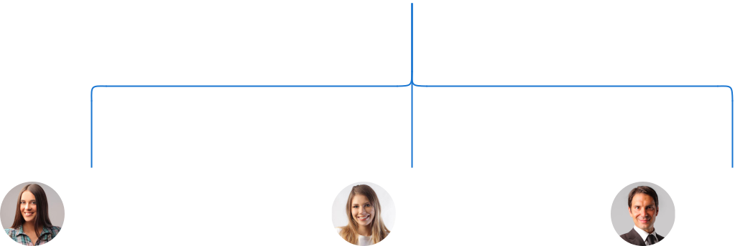

Alice Brown

Jane Doe

Robert Brown

CMO


COO


Operations Manager

Emily Clark | John Smith
Customer Service | John Smith
Customer Service | Project Manager
Manager | Project Manager


Compensation plan

 Help tip  Welding Business Plan

Describe your compensation plan for the management and staff. Include their salaries, incentives, and other benefits.
To unlock help try Upmetrics! 

Start writing here..

 Help tip  Welding Business Plan

Mentioning advisors or consultants in your business plans adds credibility to your business idea.
To unlock help try Upmetrics! 

Advisors/Consultants


[ADVISOR NAME]

Advisor

Having worked in the industry for over [30] years, [Advisor Name] brings a wealth of knowledge on [specific topic or area].


[CONSULTANT NAME]

Consultant

[Consultant Name] offers specialized advice on [specific topic], ensuring that our operations are aligned with industry best practices.
Financial Plan

When writing the financial plan section of a business plan, it’s important to provide a comprehensive overview of your financial projections for the first few years of your business, You may provide the following:
To unlock help try Upmetrics! 

 Help tip  Welding Business Plan


To create an effective introduction for your "Financial Plan" chapter, begin by stressing the critical role of a well-structured financial plan in the success of your venture.
To unlock help try Upmetrics! 

Start writing here..

 Help tip  Welding Business Plan

Describe details such as projected revenue, operational costs, and service costs in your projected profit and loss statement. Make sure to include your business’s expected net profit or loss.
To unlock help try Upmetrics! 

Profit & loss statement

Revenue

Cost Of Sales

General Costs

Revenue Specific Costs

Personnel Costs (Direct

Labor)

Gross Margin

Gross Margin (%)

Operating Expense

Payroll Expense

(Indirect Labor)

General Expense

Bad Debt

Amortization of Current

Assets

2023-24 | 2024-25 | 2025-26 | 2026-27 | 2027-28
$0 | $0 | $0 | $0 | $0

$0 | $0 | $0 | $0 | $0
$0 | $0 | $0 | $0 | $0
$0 | $0 | $0 | $0 | $0
$0 | $0 | $0 | $0 | $0

$0 | $0 | $0 | $0 | $0
0% | 0% | 0% | 0% | 0%

$0 | $0 | $0 | $0 | $0
$0 | $0 | $0 | $0 | $0
$0 | $0 | $0 | $0 | $0
$0 | $0 | $0 | $0 | $0
$0 | $0 | $0 | $0 | $0

EBITDA

Additional Expense

Long Term

Depreciation

Gain or loss from Sale

of Assets

EBIT

Interest Expenses

EBT

Income Tax Expense

Total Expense

Net Income

Net Income (%)

2023-24 | 2024-25 | 2025-26 | 2026-27 | 2027-28
$0 | $0 | $0 | $0 | $0
$0 | $0 | $0 | $0 | $0
$0 | $0 | $0 | $0 | $0
$0 | $0 | $0 | $0 | $0
$0 | $0 | $0 | $0 | $0
$0 | $0 | $0 | $0 | $0
$0 | $0 | $0 | $0 | $0
$0 | $0 | $0 | $0 | $0
$0 | $0 | $0 | $0 | $0
$0 | $0 | $0 | $0 | $0
0% | 0% | 0% | 0% | 0%
 |  |  | 2023-24 |  | 2024-25 | 2025-26 | 2026-27 | 2027-28
Retained Earning |  |  | $0 |  | $0 | $0 | $0 | $0
Opening
Owner's Distribution |  |  | $0 |  | $0 | $0 | $0 | $0
Retained Earning |  |  | $0 |  | $0 | $0 | $0 | $0
Closing
 Help tip |  |  |  Welding Business Plan
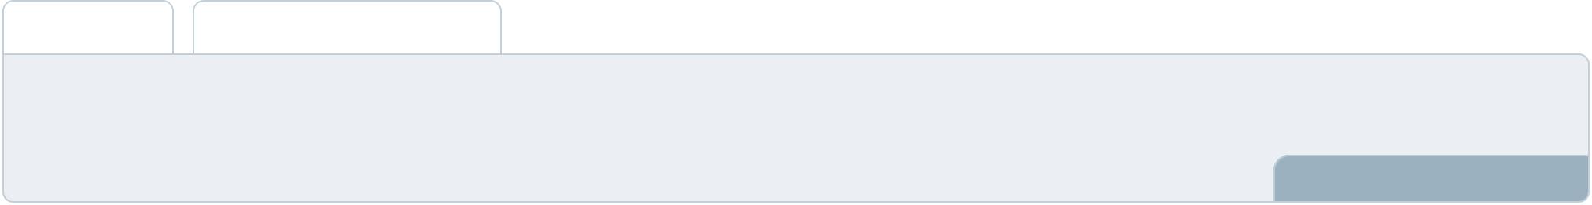

The cash flow for the first few years of your operation should be estimated and described in this section. This may include billing invoices, payment receipts, loan payments, and any other cash flow statements.
To unlock help try Upmetrics! 

Cash flow statement

 | 2023-24 | 2024-25 | 2025-26 | 2026-27 | 2027-28
Cash Received | $0 | $0 | $0 | $0 | $0
Cash Paid | $0 | $0 | $0 | $0 | $0
COS & General Expenses | $0 | $0 | $0 | $0 | $0
Salary & Wages | $0 | $0 | $0 | $0 | $0
Interest | $0 | $0 | $0 | $0 | $0

Sales Tax

Income Tax

Net Cash From

Operations

Assets Sell

Assets Purchase

Net Cash From

Investments

Amount Received

Loan Received

Common Stock

Preferred Stock

Owner's Contribution

Amount Paid

2023-24 | 2024-25 | 2025-26 | 2026-27 | 2027-28
$0 | $0 | $0 | $0 | $0
$0 | $0 | $0 | $0 | $0
$0 | $0 | $0 | $0 | $0

$0 | $0 | $0 | $0 | $0
$0 | $0 | $0 | $0 | $0
$0 | $0 | $0 | $0 | $0

$0 | $0 | $0 | $0 | $0
$0 | $0 | $0 | $0 | $0

$0 | $0 | $0 | $0 | $0
$0 | $0 | $0 | $0 | $0
$0 | $0 | $0 | $0 | $0

Loan Capital $0 $0 $0 $0 $0

 |  |  | 2023-24 | 2024-25 | 2025-26 | 2026-27 | 2027-28
Dividends & Distributions |  |  | $0 | $0 | $0 | $0 | $0
Net Cash From |  |  | $0 | $0 | $0 | $0 | $0
Financing
Summary
Starting Cash |  |  | $0 | $0 | $0 | $0 | $0
Cash In |  |  | $0 | $0 | $0 | $0 | $0
Cash Out |  |  | $0 | $0 | $0 | $0 | $0
Change in Cash |  |  | $0 | $0 | $0 | $0 | $0
Ending Cash |  |  | $0 | $0 | $0 | $0 | $0
 Help tip |  |  Welding Business Plan

Create a projected balance sheet documenting your welding business’s assets, liabilities, and equity.

To unlock help try Upmetrics! 

Balance sheet

 | 2023-24 | 2024-25 | 2025-26 | 2026-27 | 2027-28
Assets | $0 | $0 | $0 | $0 | $0
Current Assets | $0 | $0 | $0 | $0 | $0
Cash | $0 | $0 | $0 | $0 | $0
Accounts Receivable | $0 | $0 | $0 | $0 | $0
Inventory | $0 | $0 | $0 | $0 | $0
Other Current Assets | $0 | $0 | $0 | $0 | $0
Long Term Assets | $0 | $0 | $0 | $0 | $0
Gross Long Term Assets | $0 | $0 | $0 | $0 | $0
Accumulated Depreciation | $0 | $0 | $0 | $0 | $0

Liabilities & Equity | $0 | $0 | $0 | $0 | $0
Liabilities | $0 | $0 | $0 | $0 | $0
Current Liabilities | $0 | $0 | $0 | $0 | $0
Accounts Payable | $0 | $0 | $0 | $0 | $0
Income Tax Payable | $0 | $0 | $0 | $0 | $0
Sales Tax Payable | $0 | $0 | $0 | $0 | $0
Short Term Debt | $0 | $0 | $0 | $0 | $0
 | 2023-24 | 2024-25 | 2025-26 | 2026-27 | 2027-28
Long Term Liabilities | $0 | $0 | $0 | $0 | $0
Long Term Debt | $0 | $0 | $0 | $0 | $0
Equity | $0 | $0 | $0 | $0 | $0
Paid-in Capital | $0 | $0 | $0 | $0 | $0
Common Stock | $0 | $0 | $0 | $0 | $0
Preferred Stock | $0 | $0 | $0 | $0 | $0
Owner's Contribution | $0 | $0 | $0 | $0 | $0
Retained Earnings | $0 | $0 | $0 | $0 | $0

Check | $0 |  |  | $0 | $0 | $0 | $0
 Help tip |  |  Welding Business Plan

Determine and mention your business’s break-even point—the point at which your business costs and revenue will be equal.

This exercise will help you understand how much revenue you need to generate to sustain or be profitable.
To unlock help try Upmetrics! 

Break-even Analysis

 | 2023-24 | 2024-25 | 2025-26 | 2026-27 | 2027-28
Starting Revenue | $0 | $0 | $0 | $0 | $0
Net Revenue | $0 | $0 | $0 | $0 | $0
Closing Revenue | $0 | $0 | $0 | $0 | $0

Starting Expense | $0 | $0 | $0 | $0 | $0
Net Expense | $0 | $0 | $0 | $0 | $0
Closing Expense | $0 | $0 | $0 | $0 | $0

Is Break Even? | 0 | 0 | 0 | 0 | 0
Break Even Month | 0 | 0 | 0 | 0 | 0
Days Required | 0 | 0 | 0 | 0 | 0
Break Even Revenue | $0 | $0 | $0 | $0 | $0
Break Even Units
Financing needs

 Help tip  Welding Business Plan

Calculate costs associated with starting a welding business, and estimate your financing needs and how much capital you need to raise to operate your business.
To unlock help try Upmetrics! 

Start writing here..
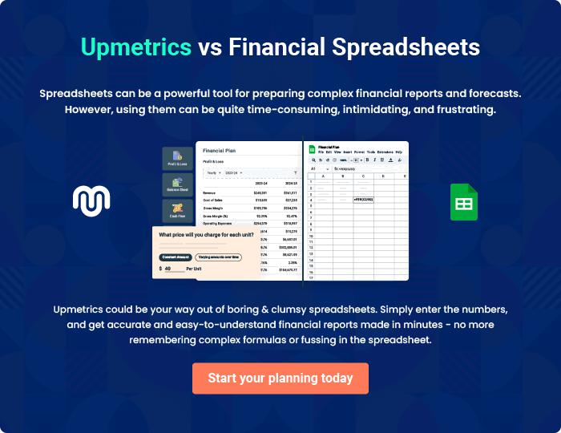
Appendix

When writing the appendix section, you should include any additional information that supports the main content of your plan. This may include financial statements, market research data, legal documents, and other
To unlock help try Upmetrics! 
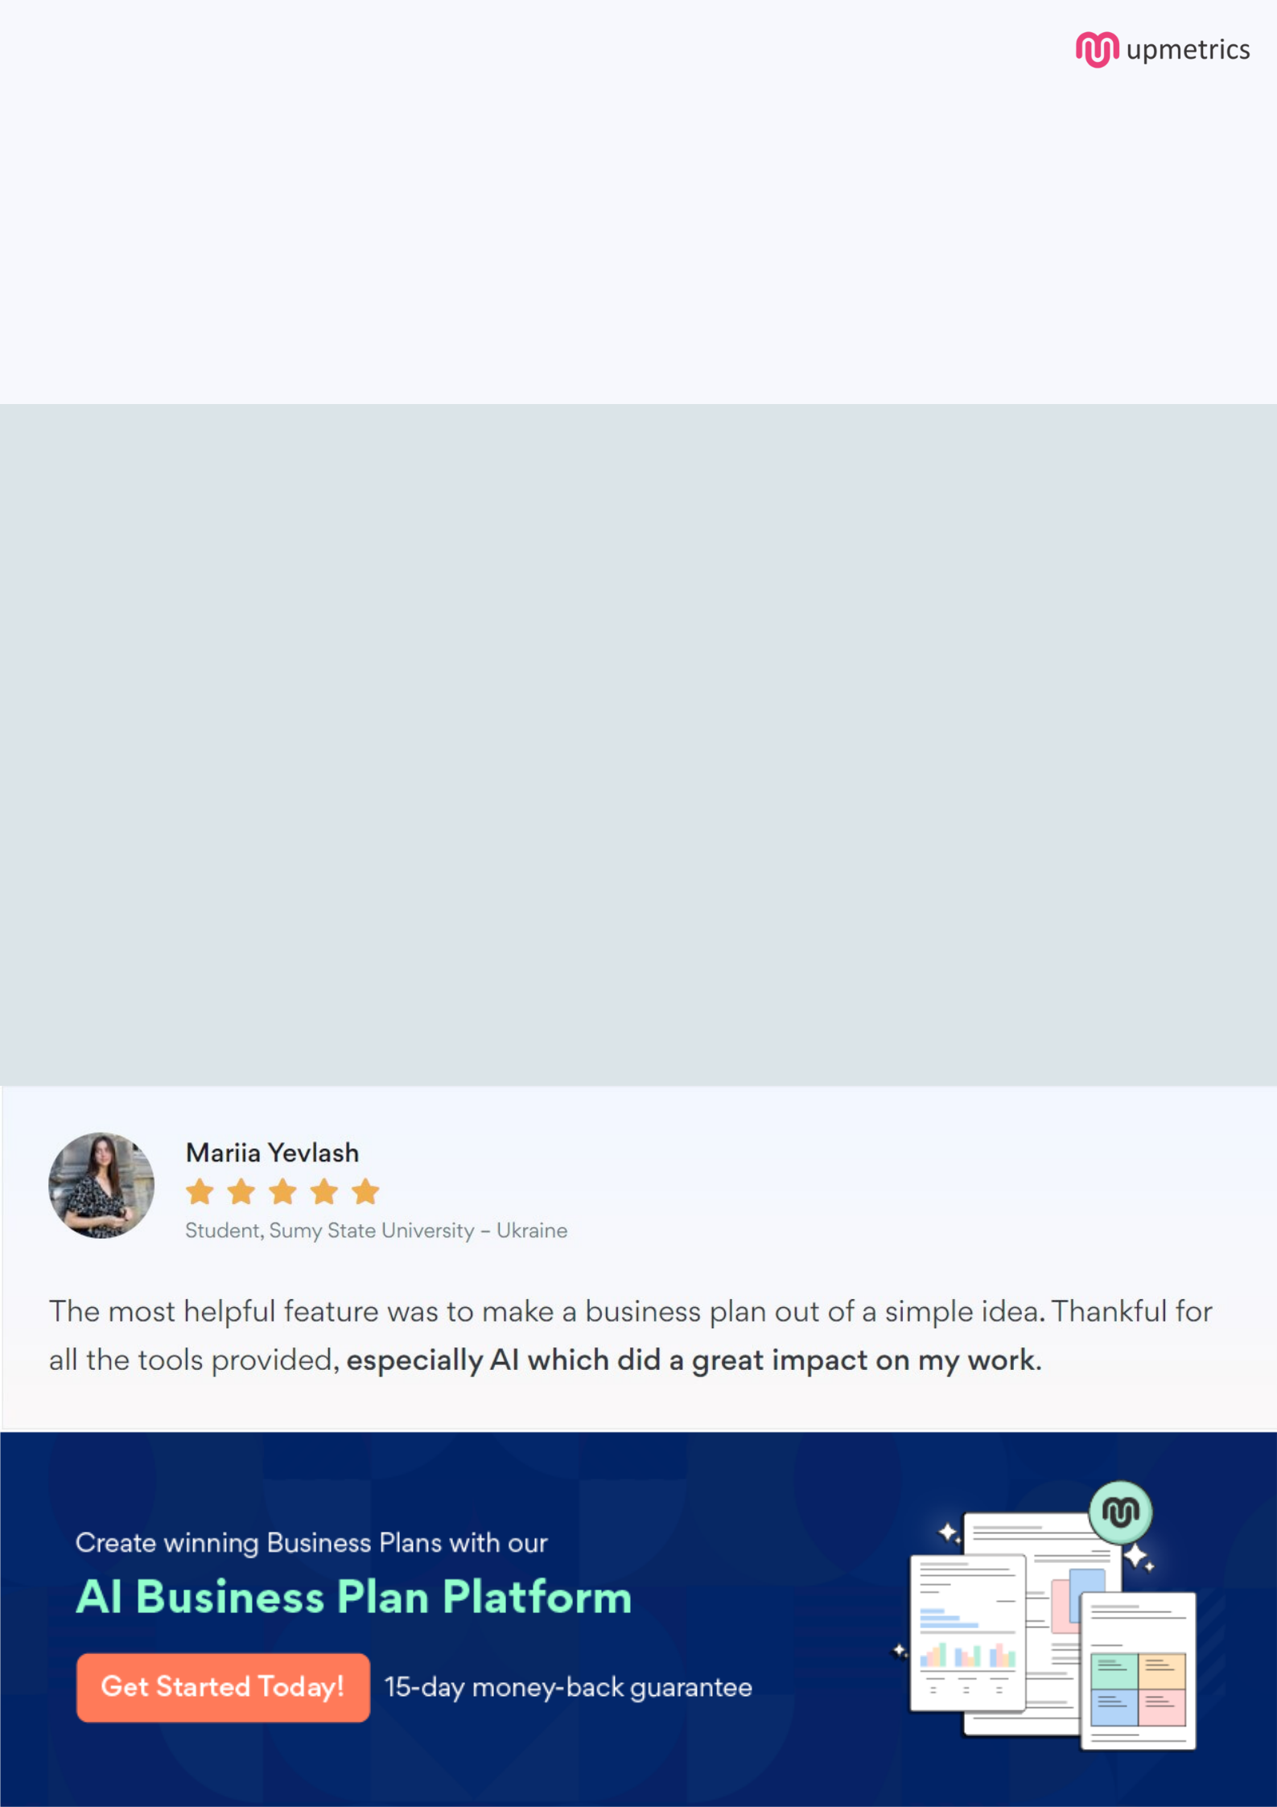
Create a winning business plan that gets you funded

Creating a stunning and investment-ready plan requires no writing, graphic designing, or financial planning expertise.

Upmetrics has all the features required to help you create a comprehensive business plan—from start to finish. Make no mistakes, it’s the modern way of planning to structure ideas, make plans, and create stunning pitch decks to awe investors.

Pitch decks that impress investors

Create pitch decks that provide a visual representation of your business, engage investors, and make them want to invest in your business idea.

Interactive plans in no time

Import business plan sections like—SWOT analysis, comparison tables, and others to create an interactive business plan. No designing skills are required.

Stunning cover page designs

With Upmetrics, you have the liberty to choose from multiple stunning cover page designs. Choose a creative design and make your plan stand out.

Online sharing made simple

Upmetrics makes online sharing quick and easier for users. Easily share your business plans with a link while tracking reader activity.

500+ sample business plans

Simply import a template from our library of sample plans into the editor and start customizing it to make it yours. It takes only a few clicks to get started.

Collaborate with team in real-time

Invite team members, initiate conversations, discuss ideas & strategies, share feedback, and work on a business plan in real-time.

