
BUSINESS PLAN

2023


Waste Management Business Plan

Managing Waste, Preserving Tomorrow

John Doe

10200 Bolsa Ave, Westminster, CA, 92683

- 359-3153 info@example.com http://www.example.com

Information provided in this business plan is unique to this business and confidential; therefore, anyone reading this plan agrees not to disclose any of the information in this business plan without prior written permission of the company.
Table of Contents

Executive Summary | 6
Market opportunity | 6
Services Offered | 6
Marketing & Sales Strategies | 7
Financial Highlights | 7
Units Sold v/s Revenue | 8

Company Overview | 9
Ownership | 9
Mission statement | 10
Business history | 10
Future goals | 10

Market Analysis | 11
Target Market | 11
Market size and growth potential | 11
Market Size | 12
Competitive analysis | 12
Waste Management Inc. | 12
Republic Services | 13
Clean Harbors | 13
Market trends | 13
Regulatory environment | 14

Products and Services | 15
Services | 15
Waste Collection Services | 16
Recycling Services | 16
Hazardous Waste Management | 17
Composting Services | 17
Waste-to-Energy | 18
Quality Measures | 18
Additional Services | 18

Sales And Marketing Strategies | 19
Unique Selling Proposition (USP) | 19
Pricing Strategy | 19
Marketing strategies | 20
Online | 20
Offline | 20
Sales strategies | 21
Customer retention | 21

Operations Plan | 22
Staffing & Training | 22
Operational Process | 22
Equipment & Machinery | 23

Management Team | 24
Key managers | 24
John Doe | 24
Jane Doe | 25
Alice Brown | 25
Robert Brown | 25
Organizational structure | 25
Organization chart | 26
Compensation plan | 26
Advisors/Consultants | 27
Mr Michael Johnson | 27
Dr. Emily Smith | 27

Financial Plan | 28
Profit & loss statement | 28
Cash flow statement | 31
Balance sheet | 33
Break-even Analysis | 35
Financing needs | 37
Appendix
Appendix | 39
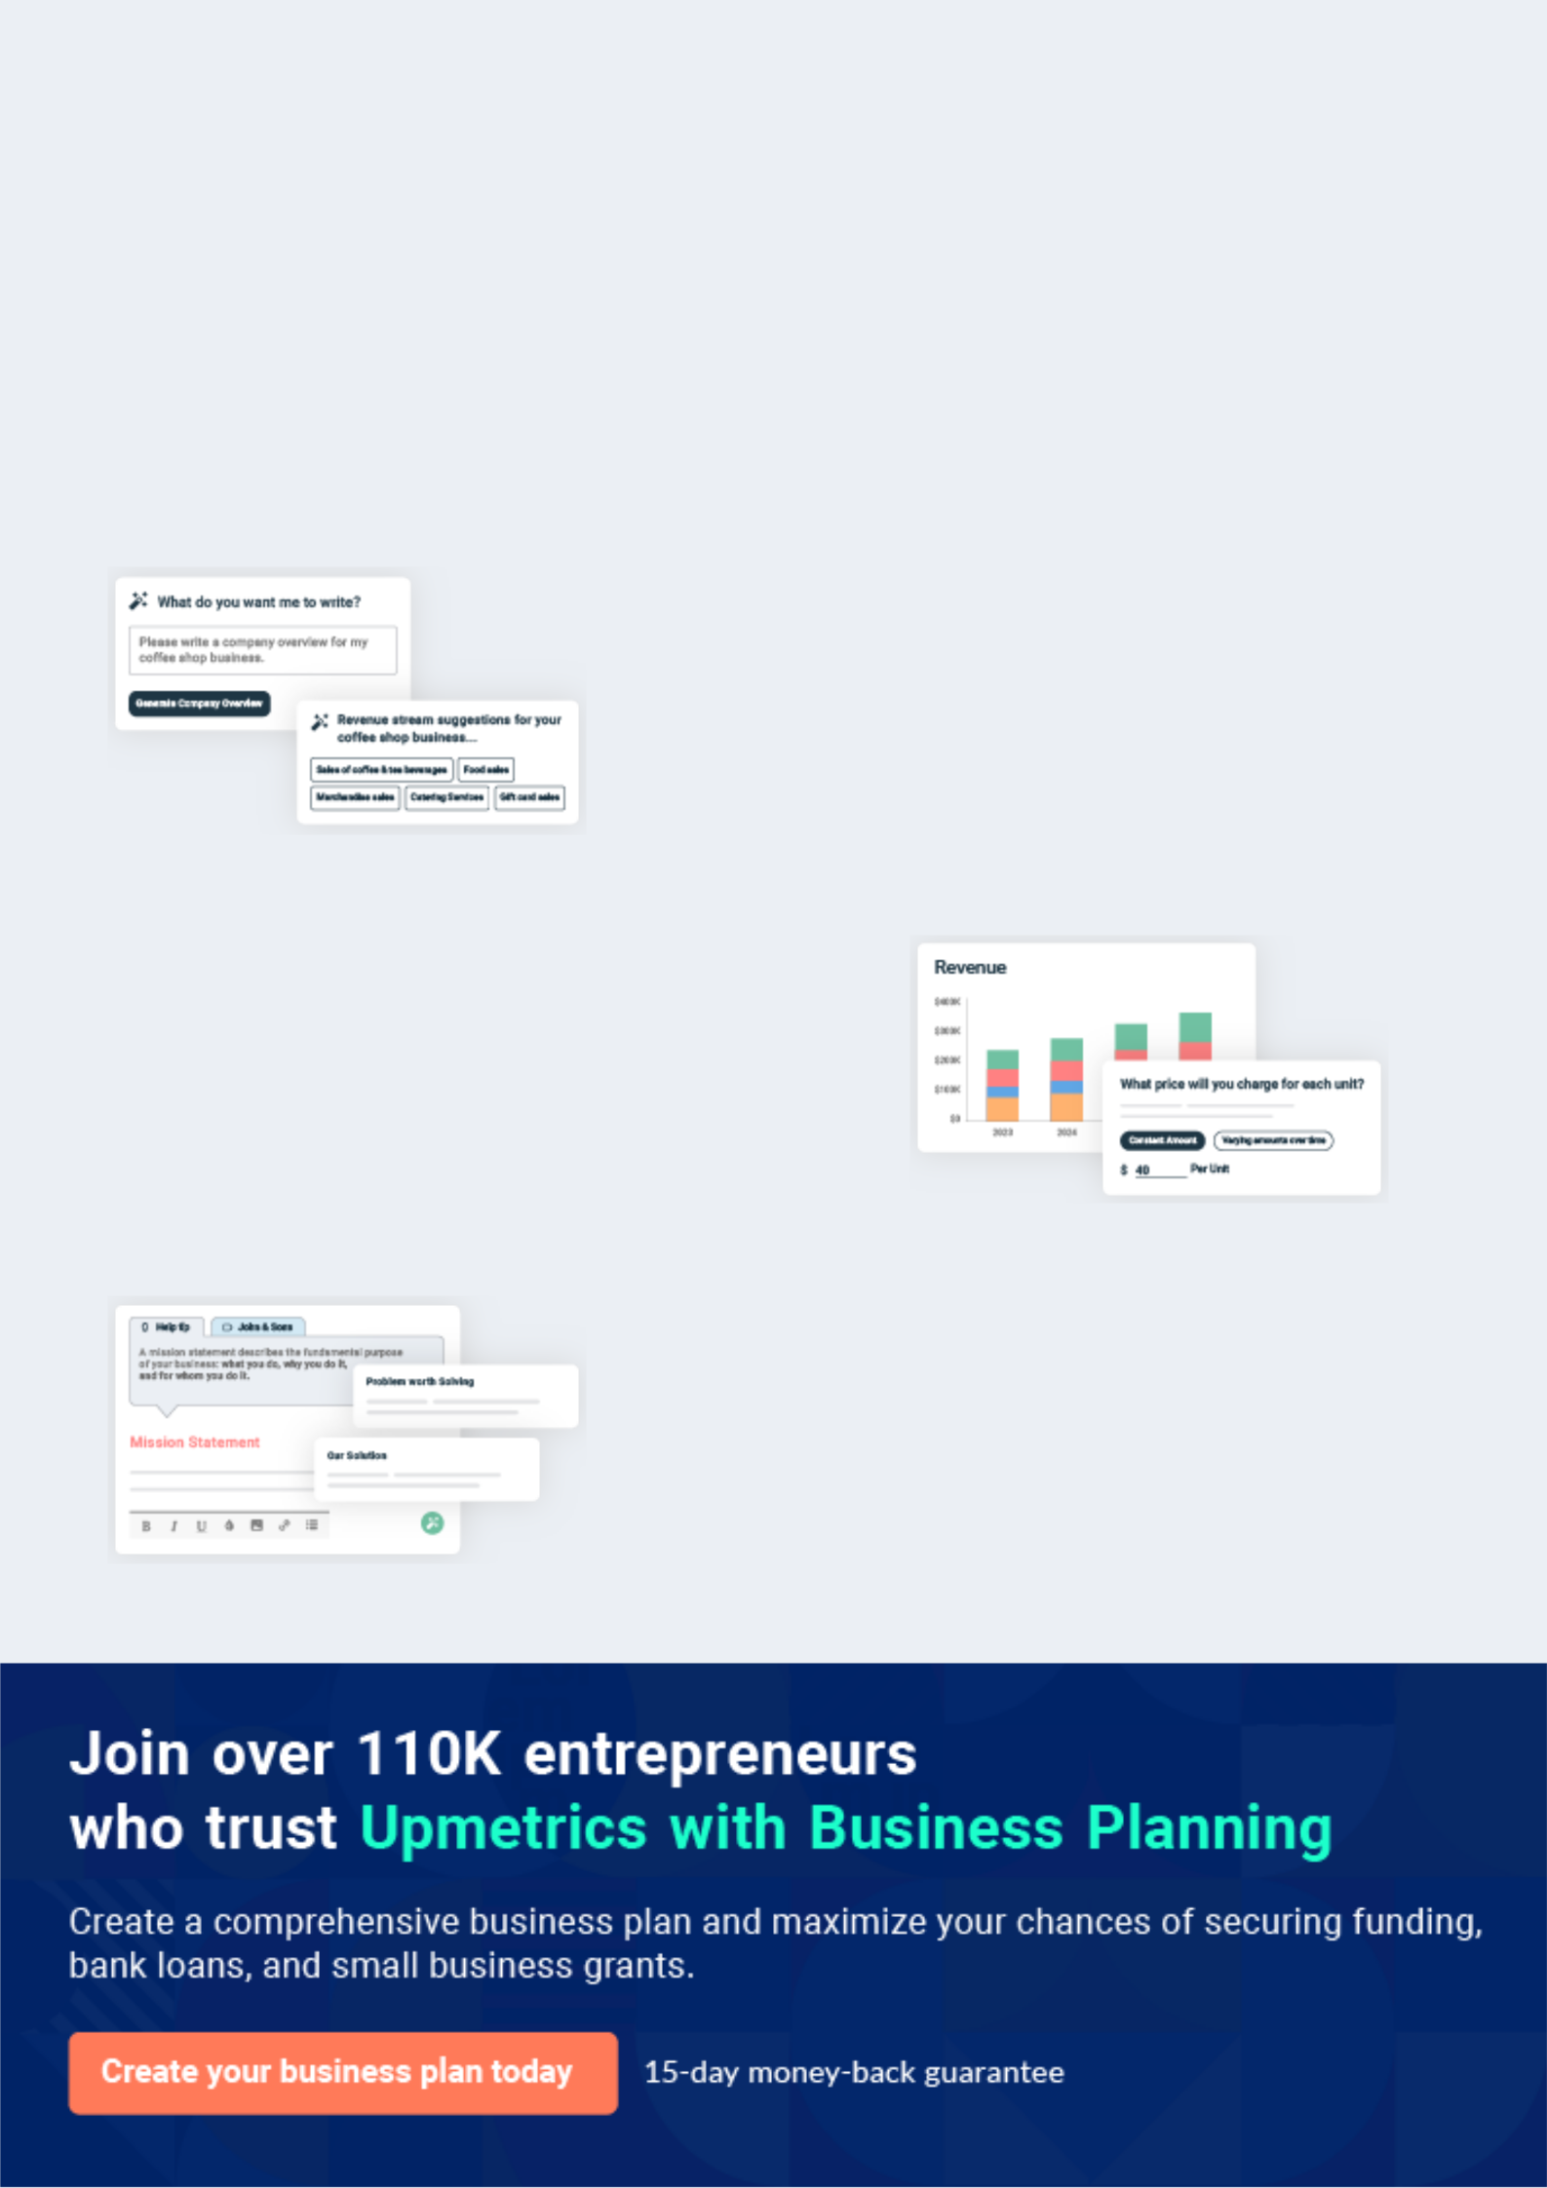
Business planning that’s simpler and faster than you think

Creating a business plan using Upmetrics to start and grow a business is literally the easiest thing in the World. Simply read the instructions and fill in the blanks. It’s as simple as that.

❛ | Upmetrics has everything you need to create a | ❜
❛ | comprehensive business plan. | ❜

AI-powered Upmetrics Assistant

AI-powered insights to streamline your plan

Not sure where to start? Upmetrics’ AI Assistant will automatically generate ideas for each section of your plan and offer improved versions of your writing, adjusting for tone, voice, and grammar or spelling errors.

Financial Forecasting Tool

All the financials are calculated for you

Forget the complex formulas and clumsy spreadsheets — with automatic financials and drag-and-drop forecasting, you can finish your plan faster and be confident that your numbers are accurate.

Business Plan Builder

Guides you like a business mentor

Upmetrics’ step-by-step instructions, prompts, and the library of 400+ sample business plans will guide you through each section of your plan as a business mentor.
Executive Summary


An executive summary is the first section of the business plan intended to provide an overview of the whole business plan.
To unlock help try Upmetrics! 

 Help tip  Waste Management Business Plan


Start your executive summary by briefly introducing your business to your readers.

This section may include the name of your waste management business, its location, when it
To unlock help try Upmetrics! 

Start writing here..

Market opportunity

 Help tip  Waste Management Business Plan

Summarize your market research, including market size, growth potential, and marketing trends. Highlight the opportunities in the market and how your business will fit in to fill the gap.
To unlock help try Upmetrics! 

Start writing here..

Services Offered

 Help tip  Waste Management Business Plan

Highlight the waste management services you offer your clients. The USPs and differentiators you offer are always a plus.
To unlock help try Upmetrics! 

Start writing here..

Marketing & Sales Strategies
To unlock help try Upmetrics!

 Help tip  Waste Management Business Plan

Outline your sales and marketing strategies—what marketing platforms you use, how you plan on acquiring customers, etc.
To unlock help try Upmetrics! 

Start writing here..

Financial Highlights

 Help tip  Waste Management Business Plan

Briefly summarize your financial projections for the initial years of business operations. Include any capital or investment requirements, associated startup costs, projected revenues, and profit forecasts.



Start writing here..
Units Sold v/s Revenue

 |  | Units Sold | Revenue
15.00k
10.00k
5.00k
0
Year 1 | Year 2 | Year 3
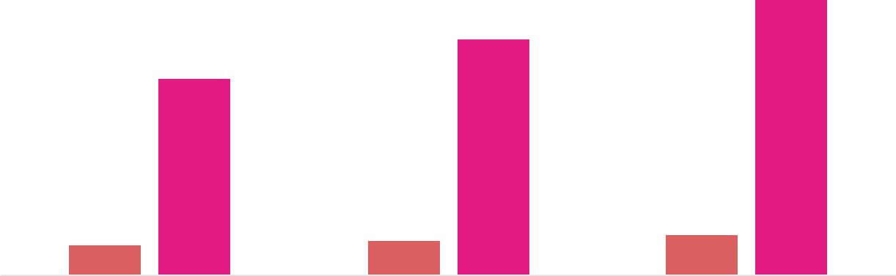

Financial Year |  |  | Units Sold | Revenue
Year 1 | 1,550 |  |  | $10,000
Year 2 | 1,800 |  |  | $12,000
Year 3 | 2,050 |  |  | $14,000
 Help tip |  |  Waste Management Business Plan


Summarize your executive summary section with a clear CTA, for example, inviting angel investors to discuss the potential business investment.
To unlock help try Upmetrics! 

Write a call to action for your business plan.
Company Overview

Depending on what details of your business are essential, you’ll need different elements in your business overview.
To unlock help try Upmetrics! 

 Help tip  Waste Management Business Plan

Describe your business in this section by providing all the basic information:

Describe what kind of waste management company you run and the name of it. You may
To unlock help try Upmetrics! 

Start writing here..

Ownership

 Help tip  Waste Management Business Plan

List the names of your waste management company’s founders or owners. Describe what shares they own and their responsibilities for efficiently managing the business.
To unlock help try Upmetrics! 

Start writing here..
Mission statement

 Help tip  Waste Management Business Plan

Summarize your business’ objective, core principles, and values in your mission statement. This statement needs to be memorable, clear, and brief.
To unlock help try Upmetrics! 

- Our mission at [GreenSolutions Waste Management] is to provide innovative and sustainable waste management solutions that contribute to a cleaner and healthier environment.

We are committed to exceeding our clients' expectations through exceptional service, compliance with environmental regulations, and continuous improvement of our practices.

Business history

 Help tip  Waste Management Business Plan

If you’re an established waste management service provider, briefly describe your business history, like—when it was founded, how it evolved over time, etc.

❜

To unlock help try Upmetrics! 

Start writing here..

Future goals

 Help tip  Waste Management Business Plan

It’s crucial to convey your aspirations and vision. Mention your short-term and long-term goals; they can be specific targets for revenue, market share, or expanding your services.
To unlock help try Upmetrics! 

Start writing here..

Market Analysis
To unlock help try Upmetrics!


 |  | Market analysis provides a clear understanding of the market in which your
 |  | printing business will run along with the target market, competitors, and
 |  | growth opportunities.
 |  |  |  | To unlock help try Upmetrics! 
 Help tip |  |  Waste Management Business Plan

To write the introduction section of your market analysis, start by clearly identifying your primary target market.
To unlock help try Upmetrics! 

Start writing here..

Target Market

 Help tip  Waste Management Business Plan

Start this section by describing your target market. Define your ideal customer and explain what types of services they prefer. Creating a buyer persona will help you easily define your target market to your readers.



Start writing here..

Market size and growth potential

 Help tip  Waste Management Business Plan

Describe your market size and growth potential and whether you will target a niche or a much broader market.
To unlock help try Upmetrics! 

Start writing here..

Market Size

Available Market

Total market for waste management 500M services.

Served Market
Market segments addressed by 300M industry players.

Target Market | 100M
Focus market for [GreenSolutions]. | 100M

 Help tip  Waste Management Business Plan

Identify and analyze your direct and indirect competitors. Identify their strengths and weaknesses, and describe what differentiates your waste management business from them.
To unlock help try Upmetrics! 

Competitive analysis

Waste Management Inc.

Waste Management Inc. is one of the largest waste management companies in the United States, providing comprehensive waste solutions, including collection, disposal, recycling, and composting services to residential, commercial, and industrial clients.

Features

Comprehensive waste collection and disposal services.

Advanced recycling facilities.

Specialized services for hazardous waste management.

Innovative solutions such as waste-to-energy projects.

Strengths | Weaknesses
Extensive service network | High operating costs due to the
covering a wide geographic | large scale of operations.
area. | Potential for regulatory
Strong brand recognition and | compliance issues due to the
reputation in the industry. | complexity of services offered.
Significant resources and
capabilities for innovation and
technology adoption.

Republic Services

Republic Services is a prominent player in the waste management industry, offering a range of services including waste collection, recycling, and landfill management to various customer segments.

Features

Robust waste collection and transportation services.

Recycling facilities with a focus on sustainable practices.

Landfill management and environmental remediation services.

Customized solutions for specific waste management needs.

Strengths

Well-established infrastructure for waste collection and disposal.

Strong commitment to sustainability and environmental compliance.

Diversified service offerings catering to various customer needs.

Weaknesses

Limited presence in some geographic areas.

Dependency on landfill operations, which may be subject to regulatory changes.

Clean Harbors

Clean Harbors is a specialized waste management company that focuses on hazardous waste disposal and environmental services for industries such as manufacturing, chemical, and healthcare.

Features

Specialized hazardous waste disposal services.

Environmental remediation and emergency response services.

Industrial cleaning and maintenance services.

Waste recycling and treatment solutions.

Strengths | Weaknesses
Expertise in handling | Limited offerings for non-
hazardous and complex waste | hazardous waste management.
streams. | High costs associated with
Comprehensive environmental | specialized services and
services beyond waste | compliance.
disposal.
Strong focus on safety and
compliance with regulatory
requirements.

Market trends

 Help tip  Waste Management Business Plan

Analyze emerging trends in the industry, such as technology disruptions, changes in customer behavior or preferences, etc. Explain how your business will cope with all the trends.
To unlock help try Upmetrics! 

Start writing here..

Regulatory environment

 Help tip  Waste Management Business Plan

List regulations and licensing requirements that may affect your waste management company, such as federal laws & regulations, state & local regulations, state & local regulations, etc.
To unlock help try Upmetrics! 

Start writing here..
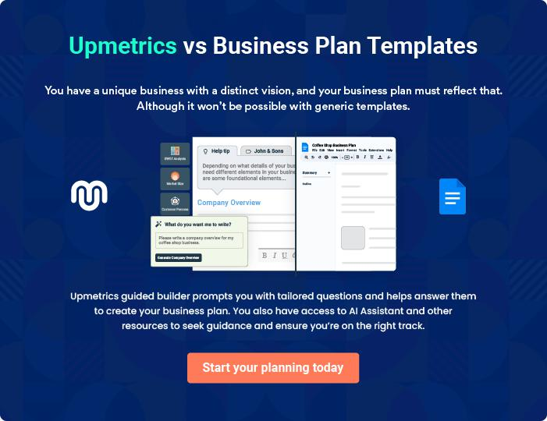
Products and Services

The product and services section of a waste management business plan should describe the specific services and products that will be offered to customers. To write this section should include the following:
To unlock help try Upmetrics! 

 Help tip  Waste Management Business Plan

To craft the introduction for your "Products and Services" chapter, begin by positioning your business within its industry, emphasizing its unique strengths or value proposition.
To unlock help try Upmetrics! 

Start writing here..

 Help tip


Mention the waste management services your business will offer. This list may include services like,
To unlock help try Upmetrics! 

Services
Waste Collection Services


Price: Varies depending on location, frequency, and volume. Typical range from [$50 to $200] per month.

Our waste collection services include regular pickups for residential, commercial, and industrial clients.

We handle all types of non-hazardous waste, ensuring that it is disposed of properly and in compliance with local regulations.

Specifications

- Frequency: Weekly, bi-weekly, monthly.

- Types of waste accepted: General non-hazardous waste.

- Locations served: All locations within [Service Area].

Recycling Services

Price: Prices vary based on the type and volume of recyclable materials. Average pricing ranges from [$30 to $150] per month.

We offer comprehensive recycling services, collecting and processing a variety of recyclable materials such as paper, glass, metal, and plastic.

Our facilities adhere to the highest standards of recycling, ensuring that materials are processed responsibly.

Specifications

- Types of materials accepted: Paper, glass, metal, plastic, and more.

- Recycling procedure: Collection, sorting, cleaning, and processing.

- Certifications: [List of certifications].
Hazardous Waste Management

Price: Pricing varies based on the type, volume, and handling requirements of the hazardous waste. Estimates range from [$100 to $500] per ton.

We specialize in the safe and compliant handling, treatment, and disposal of hazardous waste.

Our team of trained experts follows strict safety and environmental protocols to manage various types of hazardous waste.

Specifications

- Types of hazardous waste handled: [List of hazardous waste types].

- Safety and environmental protocols: [List of protocols].

- Compliance: Adherence to federal, state, and local regulations.

Composting Services

Price: Prices range from [$30 to $100] per ton, depending on the volume and type of organic waste.

Our composting services turn organic waste into valuable compost that can be used to enrich soil.

We use efficient composting techniques that meet the highest quality standards.

Specifications

- Types of organic waste accepted: Food waste, yard waste, and more.

- Composting techniques: [List of composting techniques].

- Quality of compost: Meets [Specify standards].
Waste-to-Energy

Price: Pricing varies based on the type and volume of waste, with estimates ranging from [$50 to $200] per ton.

Our waste-to-energy services convert waste into usable energy, contributing to sustainable energy solutions and reducing landfill waste.

Specifications

- Types of waste converted: Non-recyclable waste.

- Energy production method: Incineration, gasification, or other.

- Environmental impact: Reduces landfill waste and produces clean energy.

Quality Measures

 Help tip  Waste Management Business Plan

This section should explain how you maintain quality standards and consistently provide the highest quality service.
To unlock help try Upmetrics! 

Start writing here..

Additional Services

 Help tip  Waste Management Business Plan

Mention if your waste management company offers any additional services. You may include services like e-waste recycling, waste audits, consulting, etc.
To unlock help try Upmetrics! 

Start writing here..

Sales And Marketing Strategies

Writing the sales and marketing strategies section means a list of strategies you will use to attract and retain your clients.
To unlock help try Upmetrics! 

 Help Tip  Waste Management Business Plan


To create an effective introduction for your "Sales and Marketing Strategies" chapter, start by setting the stage within your specific industry or market.
To unlock help try Upmetrics! 

Start writing here..

Unique Selling Proposition (USP)

 Help tip  Waste Management Business Plan

Define your business’s USPs depending on the market you serve, the equipment you use, and the unique services you provide. Identifying USPs will help you plan your marketing strategies.
To unlock help try Upmetrics! 

Start writing here..

Pricing Strategy

 Help tip  Waste Management Business Plan

Describe your pricing strategy—how you plan to price your services and stay competitive in the local market. You can mention any discounts you plan on offering to attract new customers.
To unlock help try Upmetrics! 

Start writing here..

 Help tip  Waste Management Business Plan
To unlock help try Upmetrics!

Discuss your marketing strategies to market your services. You may include some of these marketing strategies in your business plan—social media marketing, Google ads, content marketing, and print marketing.



Marketing strategies

Online


Social Media

Content Marketing

[Details about your social media marketing strategy].

[Details about your content marketing strategy].

Google Ads

[Details about your Google ads

strategy].

Offline

Print Marketing

[Details about your print marketing strategy].

 Help tip  Waste Management Business Plan

Outline the strategies you’ll implement to maximize your sales. Your sales strategies may include partnering with other businesses, offering referral programs, etc.
To unlock help try Upmetrics! 

Sales strategies

Partner with Businesses

Referral Programs

[Details about how you plan to partner with other businesses].

[Details about your referral program].

 Help tip  Waste Management Business Plan

Describe your customer retention strategies and how you plan to execute them. For instance, introducing loyalty programs, discounts & offers, personalized service, etc.
To unlock help try Upmetrics! 

Customer retention

Loyalty Programs

Discounts and Offers

[Details about your loyalty program].

[Details about any discounts or offers you plan to provide to repeat customers].

Personalized Service

[Details about how you will offer

personalized service to retain

customers].

Operations Plan
To unlock help try Upmetrics!

 |  | When writing the operations plan section, it’s important to consider the
 |  | various aspects of your business operations.
 |  |  |  | To unlock help try Upmetrics! 
 Help tip |  |  Waste Management Business Plan


To create an effective introduction for your "Operational Plan" chapter, start by emphasizing the
pivotal role of efficient operations in the success of your business, underscoring how they
directly impact the quality of services delivered.
 |  |  |  | To unlock help try Upmetrics! 
Start writing here..
Staffing & Training
 Help tip |  |  Waste Management Business Plan

Mention your business’s staffing requirements, including the number of employees, drivers, or
other staff needed. Include their qualifications, the training required, and the duties they will
perform.
 |  |  |  | To unlock help try Upmetrics! 
Start writing here..
Operational Process
 Help tip |  |  Waste Management Business Plan

Outline the processes and procedures you will use to run your waste management business. Your operational processes may include waste assessment & planning, waste collection, sorting & segregation, recycling & recovering, waste disposal, etc.



Start writing here..

Equipment & Machinery
To unlock help try Upmetrics!

 Help tip  Waste Management Business Plan

Include the list of equipment and machinery required for waste management, such as waste collecting vehicles, waste sorting & processing equipment, recycling equipment, hazardous waste handling equipment, landfill equipment, etc.



Start writing here..
Management Team

The management team section provides an overview of the individuals responsible for running your business plan.
To unlock help try Upmetrics! 

 Help tip  Waste Management Business Plan

To craft an introduction for your "Management Team" chapter, begin by emphasizing the crucial role of leadership in the success of any business.
To unlock help try Upmetrics! 

Start writing here..

Key managers

 Help tip  Waste Management Business Plan

Introduce your management and key members of your team, and explain their roles and responsibilities.
To unlock help try Upmetrics! 

Start writing here..


JOHN DOE

CEO - john.doe@example.com

John holds a Bachelor’s degree in Environmental Science and an MBA from Harvard Business School.

With over 20 years of experience in the waste management industry, he has developed a keen understanding of the market and the challenges it faces.


His leadership and strategic planning skills are crucial in driving the company towards its mission of providing eco-friendly waste management solutions.

JANE DOE

Operations Manager - jane.doe@example.com

Jane graduated with a degree in Business Administration and has over 15 years of experience in operations management.

Her expertise lies in streamlining processes to increase efficiency and productivity. She is responsible for overseeing the day-to-day operations of the company and ensuring that all processes run smoothly.



ALICE BROWN

Customer Service Manager - alice.brown@example.com

Alice has a degree in Communications and has worked in customer service for over 10 years. She is passionate about delivering excellent customer service and is responsible for managing the customer service team.

Her excellent communication and problem-solving skills are crucial in addressing any customer complaints or issues promptly.


ROBERT BROWN

General Manager - robert.brown@example.com

Robert holds a degree in Environmental Engineering and has 15 years of experience in the waste management industry.

He has a strong background in project management and is responsible for ensuring that the company meets its financial and operational goals.

He plays a key role in business development and client relationship management.

Organizational structure

 Help tip  Waste Management Business Plan

Explain the organizational structure of your management team. Include the reporting line and decision-making hierarchy.
To unlock help try Upmetrics! 

Start writing here..

Organization chart


John Doe

CEO
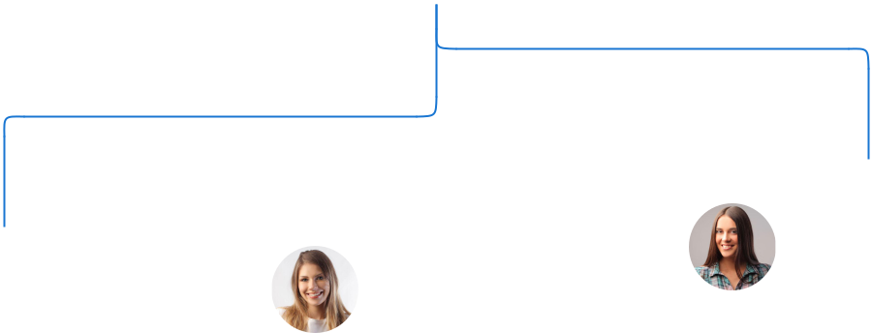

 |  |  | Alice Brown
Robert Brown | Jane Doe |  | Customer Service
General Manager | Operations Manager |  | Manager





Emma White

Mike Lee

HR Manager

Logistics Manager

Compensation plan

 Help tip  Waste Management Business Plan

Describe your compensation plan for the management and staff. Include their salaries, incentives, and other benefits.
To unlock help try Upmetrics! 

Start writing here..

 Help tip

Mentioning advisors or consultants in your business plans adds credibility to your business idea.
To unlock help try Upmetrics! 

Advisors/Consultants


MR MICHAEL JOHNSON

Legal Advisor - michael.johnson@example.com

Michael is a qualified lawyer with over 25 years of experience in corporate law.

He provides legal advice to the company and ensures that all business practices comply with the relevant laws and regulations.


DR. EMILY SMITH

Environmental Consultant - emily.smith@example.com

Dr. Smith has a Ph.D. in Environmental Science and over 20 years of experience as an environmental consultant.

She provides valuable insights and advice on the environmental impact of waste management practices and helps the company to stay compliant with environmental regulations and standards.

Financial Plan

When writing the financial plan section of a business plan, it’s important to provide a comprehensive overview of your financial projections for the first few years of your business, You may provide the following:
To unlock help try Upmetrics! 

 Help tip  Waste Management Business Plan


To create an effective introduction for your "Financial Plan" chapter, begin by stressing the critical role of a well-structured financial plan in the success of your venture.
To unlock help try Upmetrics! 

Start writing here..

 Help tip  Waste Management Business Plan

Describe details such as projected revenue, operational costs, and service costs in your projected profit and loss statement. Make sure to include your business’s expected net profit or loss.
To unlock help try Upmetrics! 

Profit & loss statement

Revenue

Cost Of Sales

General Costs

Revenue Specific Costs

Personnel Costs (Direct

Labor)

Gross Margin

Gross Margin (%)

Operating Expense

Payroll Expense

(Indirect Labor)

General Expense

Bad Debt

Amortization of Current

Assets

2023-24 | 2024-25 | 2025-26 | 2026-27 | 2027-28
$0 | $0 | $0 | $0 | $0

$0 | $0 | $0 | $0 | $0
$0 | $0 | $0 | $0 | $0
$0 | $0 | $0 | $0 | $0
$0 | $0 | $0 | $0 | $0

$0 | $0 | $0 | $0 | $0
0% | 0% | 0% | 0% | 0%

$0 | $0 | $0 | $0 | $0
$0 | $0 | $0 | $0 | $0
$0 | $0 | $0 | $0 | $0
$0 | $0 | $0 | $0 | $0
$0 | $0 | $0 | $0 | $0

EBITDA

Additional Expense

Long Term

Depreciation

Gain or loss from Sale

of Assets

EBIT

Interest Expenses

EBT

Income Tax Expense

Total Expense

Net Income

Net Income (%)

2023-24 | 2024-25 | 2025-26 | 2026-27 | 2027-28
$0 | $0 | $0 | $0 | $0
$0 | $0 | $0 | $0 | $0
$0 | $0 | $0 | $0 | $0
$0 | $0 | $0 | $0 | $0
$0 | $0 | $0 | $0 | $0
$0 | $0 | $0 | $0 | $0
$0 | $0 | $0 | $0 | $0
$0 | $0 | $0 | $0 | $0
$0 | $0 | $0 | $0 | $0
$0 | $0 | $0 | $0 | $0
0% | 0% | 0% | 0% | 0%

 |  |  | 2023-24 |  | 2024-25 | 2025-26
Retained Earning |  |  | $0 |  | $0 | $0
Opening |  |  |  |  | $0 | $0
Owner's Distribution |  |  | $0 |  | $0 | $0
Retained Earning |  |  | $0 |  | $0 | $0
Closing |  |  |  |  | $0 | $0
 Help tip |  |  |  Waste Management Business Plan


The cash flow for the first few years of your operation should be estimated and described in this section.

This may include billing invoices, payment receipts, loan payments, and any other cash flow statements.
2026-27 2027-28

$0 $0

$0 $0

$0 $0

To unlock help try Upmetrics! 

Cash flow statement

 | 2023-24 | 2024-25 | 2025-26 | 2026-27 | 2027-28
Cash Received | $0 | $0 | $0 | $0 | $0
Cash Paid | $0 | $0 | $0 | $0 | $0
COS & General Expenses | $0 | $0 | $0 | $0 | $0
Salary & Wages | $0 | $0 | $0 | $0 | $0
Interest | $0 | $0 | $0 | $0 | $0

Sales Tax

Income Tax

Net Cash From

Operations

Assets Sell

Assets Purchase

Net Cash From

Investments

Amount Received

Loan Received

Common Stock

Preferred Stock

Owner's Contribution

Amount Paid

2023-24 | 2024-25 | 2025-26 | 2026-27 | 2027-28
$0 | $0 | $0 | $0 | $0
$0 | $0 | $0 | $0 | $0
$0 | $0 | $0 | $0 | $0

$0 | $0 | $0 | $0 | $0
$0 | $0 | $0 | $0 | $0
$0 | $0 | $0 | $0 | $0

$0 | $0 | $0 | $0 | $0
$0 | $0 | $0 | $0 | $0

$0 | $0 | $0 | $0 | $0
$0 | $0 | $0 | $0 | $0
$0 | $0 | $0 | $0 | $0

Loan Capital $0 $0 $0 $0 $0

 |  |  | 2023-24 |  | 2024-25 | 2025-26 | 2026-27 | 2027-28
Dividends & Distributions |  |  | $0 |  | $0 | $0 | $0 | $0
Net Cash From |  |  | $0 |  | $0 | $0 | $0 | $0
Financing
Summary
Starting Cash |  |  | $0 |  | $0 | $0 | $0 | $0
Cash In |  |  | $0 |  | $0 | $0 | $0 | $0
Cash Out |  |  | $0 |  | $0 | $0 | $0 | $0
Change in Cash |  |  | $0 |  | $0 | $0 | $0 | $0
Ending Cash |  |  | $0 |  | $0 | $0 | $0 | $0
 Help tip |  |  Waste Management Business Plan

Create a projected balance sheet documenting your waste management business’s assets, liabilities, and equity.

To unlock help try Upmetrics! 

Balance sheet

 | 2023-24 | 2024-25 | 2025-26 | 2026-27 | 2027-28
Assets | $0 | $0 | $0 | $0 | $0
Current Assets | $0 | $0 | $0 | $0 | $0
Cash | $0 | $0 | $0 | $0 | $0
Accounts Receivable | $0 | $0 | $0 | $0 | $0
Inventory | $0 | $0 | $0 | $0 | $0
Other Current Assets | $0 | $0 | $0 | $0 | $0
Long Term Assets | $0 | $0 | $0 | $0 | $0
Gross Long Term Assets | $0 | $0 | $0 | $0 | $0
Accumulated Depreciation | $0 | $0 | $0 | $0 | $0

Liabilities & Equity | $0 | $0 | $0 | $0 | $0
Liabilities | $0 | $0 | $0 | $0 | $0
Current Liabilities | $0 | $0 | $0 | $0 | $0
Accounts Payable | $0 | $0 | $0 | $0 | $0
Income Tax Payable | $0 | $0 | $0 | $0 | $0
Sales Tax Payable | $0 | $0 | $0 | $0 | $0
Short Term Debt | $0 | $0 | $0 | $0 | $0
 | 2023-24 | 2024-25 | 2025-26 | 2026-27 | 2027-28
Long Term Liabilities | $0 | $0 | $0 | $0 | $0
Long Term Debt | $0 | $0 | $0 | $0 | $0
Equity | $0 | $0 | $0 | $0 | $0
Paid-in Capital | $0 | $0 | $0 | $0 | $0
Common Stock | $0 | $0 | $0 | $0 | $0
Preferred Stock | $0 | $0 | $0 | $0 | $0
Owner's Contribution | $0 | $0 | $0 | $0 | $0
Retained Earnings | $0 | $0 | $0 | $0 | $0

Check | $0 |  |  | $0 | $0 | $0 | $0
 Help tip |  |  Waste Management Business Plan

Determine and mention your business’s break-even point—the point at which your business costs and revenue will be equal.

This exercise will help you understand how much revenue you need to generate to sustain or be profitable.
To unlock help try Upmetrics! 

Break-even Analysis

 | 2023-24 | 2024-25 | 2025-26 | 2026-27 | 2027-28
Starting Revenue | $0 | $0 | $0 | $0 | $0
Net Revenue | $0 | $0 | $0 | $0 | $0
Closing Revenue | $0 | $0 | $0 | $0 | $0

Starting Expense | $0 | $0 | $0 | $0 | $0
Net Expense | $0 | $0 | $0 | $0 | $0
Closing Expense | $0 | $0 | $0 | $0 | $0

Is Break Even? | 0 | 0 | 0 | 0 | 0
Break Even Month | 0 | 0 | 0 | 0 | 0
Days Required | 0 | 0 | 0 | 0 | 0
Break Even Revenue | $0 | $0 | $0 | $0 | $0
Break Even Units
Financing needs

 Help tip  Waste Management Business Plan

Calculate costs associated with starting a waste management business, and estimate your financing needs and how much capital you need to raise to operate your business.
To unlock help try Upmetrics! 

Start writing here..
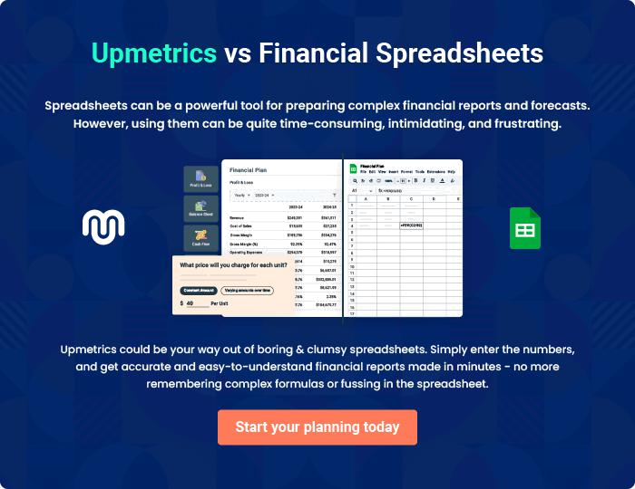
Appendix

When writing the appendix section, you should include any additional information that supports the main content of your plan. This may include financial statements, market research data, legal documents, and other
To unlock help try Upmetrics! 
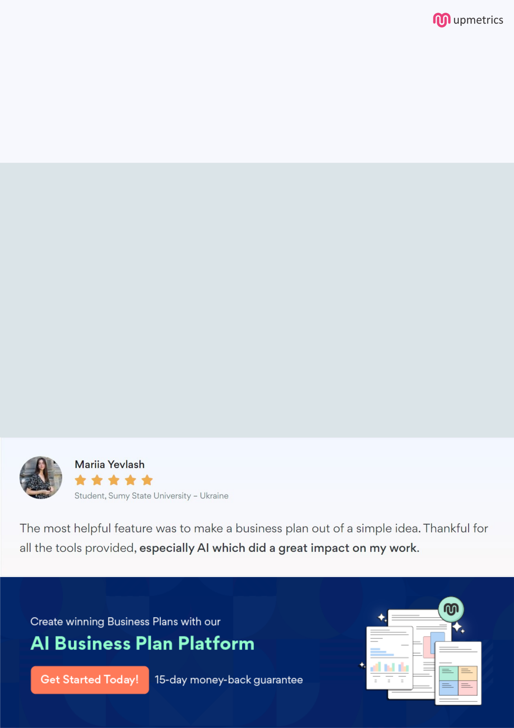
Create a winning business plan that gets you funded

Creating a stunning and investment-ready plan requires no writing, graphic designing, or financial planning expertise.

Upmetrics has all the features required to help you create a comprehensive business plan—from start to finish. Make no mistakes, it’s the modern way of planning to structure ideas, make plans, and create stunning pitch decks to awe investors.

Pitch decks that impress investors

Create pitch decks that provide a visual representation of your business, engage investors, and make them want to invest in your business idea.

Interactive plans in no time

Import business plan sections like—SWOT analysis, comparison tables, and others to create an interactive business plan. No designing skills are required.

Stunning cover page designs

With Upmetrics, you have the liberty to choose from multiple stunning cover page designs. Choose a creative design and make your plan stand out.

Online sharing made simple

Upmetrics makes online sharing quick and easier for users. Easily share your business plans with a link while tracking reader activity.

500+ sample business plans

Simply import a template from our library of sample plans into the editor and start customizing it to make it yours. It takes only a few clicks to get started.

Collaborate with team in real-time

Invite team members, initiate conversations, discuss ideas & strategies, share feedback, and work on a business plan in real-time.

