
BUSINESS PLAN

2023

Warehouse Business Plan

Storage, Logistics, Efficiency

John Doe

10200 Bolsa Ave, Westminster, CA, 92683

- 359-3153 info@example.com http://www.example.com

Information provided in this business plan is unique to this business and confidential; therefore, anyone reading this plan agrees not to disclose any of the information in this business plan without prior written permission of the company.
Table of Contents

Executive Summary | 6
Market opportunity | 6
Services Offered | 6
Marketing & Sales Strategies | 7
Financial Highlights | 7
Units Sold v/s Revenue | 8

Company Overview | 9
Ownership | 9
Business Owners | 9
Mission statement | 10
Business history | 10
Future goals | 10

Market Analysis | 11
Target Market | 11
Market size and growth potential | 11
Market Size | 12
Competitive analysis | 12
Amazon Fulfillment | 12
DHL Supply Chain | 13
Ryder Supply Chain Solutions | 13
Market trends | 13
Regulatory environment | 14

Products and Services | 15
Services | 15
Storage | 15
Inventory Management | 16
Order Fulfillment | 16
Distribution & Shipping | 17
Cross-Docking Services | 17
Customs and Compliance | 18
Specialized Storage | 18
Additional Services | 18

Sales And Marketing Strategies | 19
Unique Selling Proposition (USP) | 19
Pricing Strategy | 19
Marketing strategies | 20
Online | 20
Offline | 20
Sales strategies | 21
Customer retention | 21

Operations Plan | 22
Staffing & Training | 22
Operational Process | 22
Equipment & Machinery | 23

Management Team | 24
Key managers | 24
John Doe | 25
Jane Doe | 25
Alice Brown | 26
Robert Brown | 26
Organizational structure | 27
Organization chart | 27
Compensation plan | 27
Advisors/Consultants | 28
Michael Smith | 28
Emma Johnson | 28
Financial Plan | 29
Profit & loss statement | 29
Cash flow statement | 32
Balance sheet | 34
Break-even Analysis | 36
Financing needs | 38
Appendix
Appendix | 40
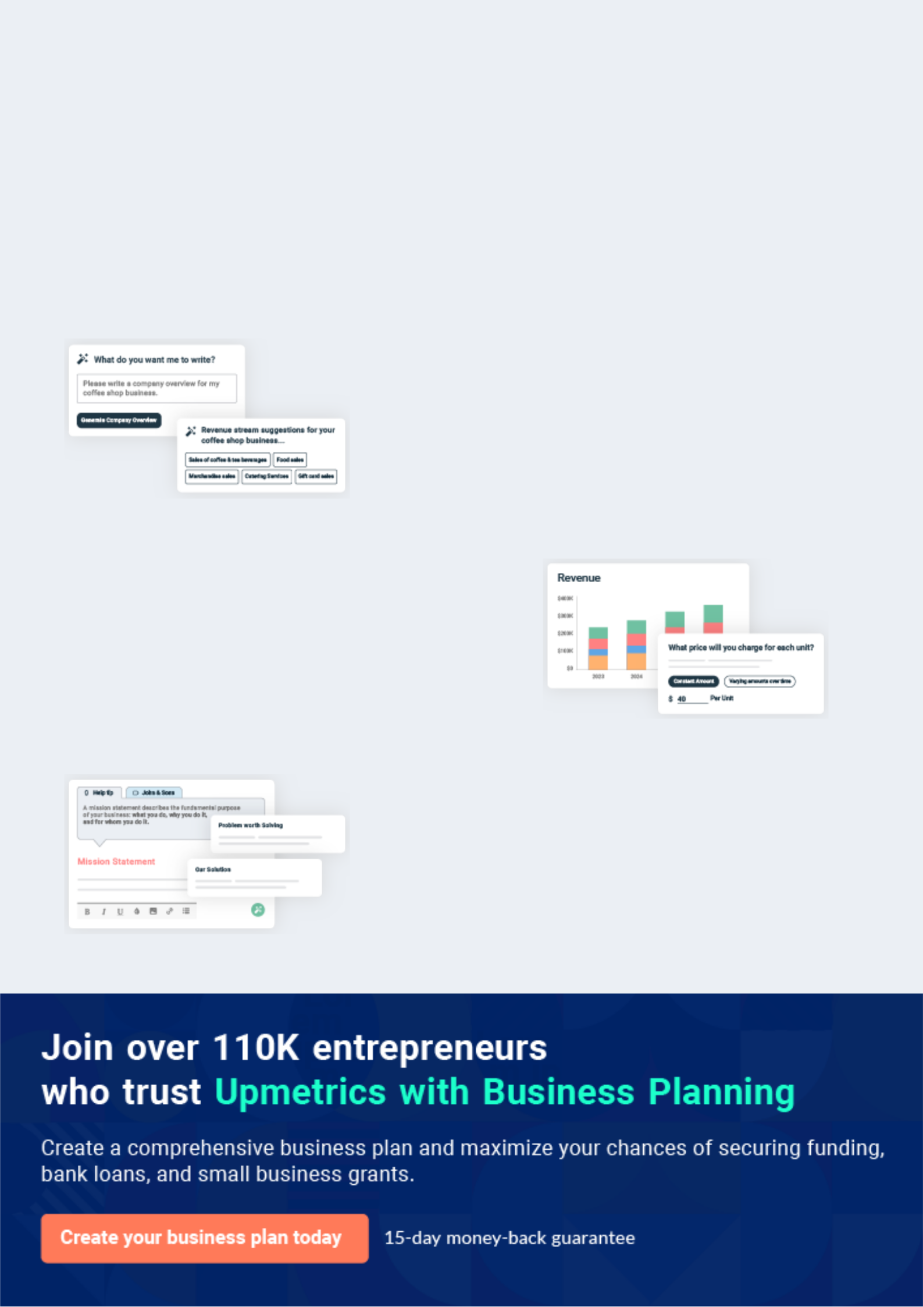
Business planning that’s simpler and faster than you think

Creating a business plan using Upmetrics to start and grow a business is literally the easiest thing in the World. Simply read the instructions and fill in the blanks. It’s as simple as that.

❛ | Upmetrics has everything you need to create a | ❜
❛ | comprehensive business plan. | ❜

AI-powered Upmetrics Assistant

AI-powered insights to streamline your plan

Not sure where to start? Upmetrics’ AI Assistant will automatically generate ideas for each section of your plan and offer improved versions of your writing, adjusting for tone, voice, and grammar or spelling errors.

Financial Forecasting Tool

All the financials are calculated for you

Forget the complex formulas and clumsy spreadsheets — with automatic financials and drag-and-drop forecasting, you can finish your plan faster and be confident that your numbers are accurate.

Business Plan Builder

Guides you like a business mentor

Upmetrics’ step-by-step instructions, prompts, and the library of 400+ sample business plans will guide you through each section of your plan as a business mentor.
Executive Summary


An executive summary is the first section of the business plan intended to provide an overview of the whole business plan.
To unlock help try Upmetrics! 

 Help tip  Warehouse Business Plan


Start your executive summary by briefly introducing your business to your readers.

This section may include the name of your warehouse business, its location, when it was
To unlock help try Upmetrics! 

Start writing here..

Market opportunity

 Help tip  Warehouse Business Plan

Summarize your market research, including market size, growth potential, and marketing trends. Highlight the opportunities in the market and how your business will fit in to fill the gap.
To unlock help try Upmetrics! 

Start writing here..

Services Offered

 Help tip  Warehouse Business Plan

Highlight the warehouse services you offer your clients. The USPs and differentiators you offer are always a plus.
To unlock help try Upmetrics! 

Start writing here..

Marketing & Sales Strategies
To unlock help try Upmetrics!

 Help tip  Warehouse Business Plan

Outline your sales and marketing strategies—what marketing platforms you use, how you plan on acquiring customers, etc.
To unlock help try Upmetrics! 

Start writing here..

Financial Highlights

 Help tip  Warehouse Business Plan

Briefly summarize your financial projections for the initial years of business operations. Include any capital or investment requirements, associated startup costs, projected revenues, and profit forecasts.



Start writing here..
Units Sold v/s Revenue

 |  | Units Sold | Revenue
15.00k
10.00k
5.00k
0
Year 1 | Year 2 | Year 3
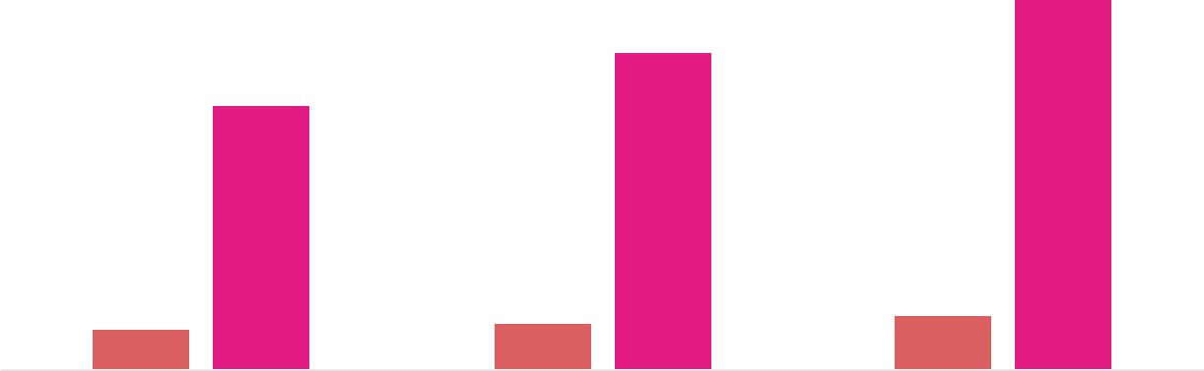

Financial Year |  |  | Units Sold | Revenue
Year 1 | 1,550 |  |  | $10,000
Year 2 | 1,800 |  |  | $12,000
Year 3 | 2,050 |  |  | $14,000
 Help tip |  |  Warehouse Business Plan


Summarize your executive summary section with a clear CTA, for example, inviting angel investors to discuss the potential business investment.
To unlock help try Upmetrics! 

Write a call to action for your business plan.
Company Overview

Depending on what details of your business are essential, you’ll need different elements in your business overview.
To unlock help try Upmetrics! 

 Help tip  Warehouse Business Plan

Describe your business in this section by providing all the basic information:

Describe what kind of warehouse company you run and the name of it. You may specialize in
To unlock help try Upmetrics! 

Start writing here..

Ownership

 Help tip  Warehouse Business Plan

List the names of your warehouse company’s founders or owners. Describe what shares they own and their responsibilities for efficiently managing the business.
To unlock help try Upmetrics! 

Start writing here..

Business Owners



60% John Doe



40% Jane Doe
Mission statement

 Help tip  Warehouse Business Plan

Summarize your business’ objective, core principles, and values in your mission statement. This statement needs to be memorable, clear, and brief.
To unlock help try Upmetrics! 

❛ At [ABC Warehousing], we are committed to offering unparalleled storage and distribution solutions. By integrating state-of-the-art technology with a customer-first approach, we aim to redefine warehousing standards and empower businesses with efficiency,

reliability, and trust.
❜

Business history

 Help tip  Warehouse Business Plan

If you’re an established warehouse service provider, briefly describe your business history, like— when it was founded, how it evolved over time, etc.
To unlock help try Upmetrics! 

Start writing here..

Future goals

 Help tip  Warehouse Business Plan

It’s crucial to convey your aspirations and vision. Mention your short-term and long-term goals; they can be specific targets for revenue, market share, or expanding your services.
To unlock help try Upmetrics! 

Start writing here..

Market Analysis
To unlock help try Upmetrics!


 |  | Market analysis provides a clear understanding of the market in which your
 |  | printing business will run along with the target market, competitors, and
 |  | growth opportunities.
 |  |  |  | To unlock help try Upmetrics! 
 Help tip |  |  Warehouse Business Plan

To write the introduction section of your market analysis, start by clearly identifying your primary target market.
To unlock help try Upmetrics! 

Start writing here..

Target Market

 Help tip  Warehouse Business Plan

Start this section by describing your target market. Define your ideal customer and explain what types of services they prefer. Creating a buyer persona will help you easily define your target market to your readers.



Start writing here..

Market size and growth potential

 Help tip  Warehouse Business Plan

Describe your market size and growth potential and whether you will target a niche or a much broader market.
To unlock help try Upmetrics! 

Start writing here..

Market Size


Available Market | 100M
Total global warehousing market. | 100M

Served Market
Part of the available market our 25M services can cater to.

Target Market
Core focus area within the served 10M market.

 Help tip  Warehouse Business Plan

Identify and analyze your direct and indirect competitors. Identify their strengths and weaknesses, and describe what differentiates your warehouse services from them.
To unlock help try Upmetrics! 

Competitive analysis

Amazon Fulfillment

Amazon Fulfillment, a subsidiary of the e-commerce giant Amazon, offers a comprehensive suite of warehousing and order fulfillment services, catering to businesses of all sizes.

Features | Strengths | Weaknesses
Warehousing and storage | Established brand with global | Limited customization for small
Inventory management | recognition | businesses
Order fulfillment and shipping | Extensive network of | Higher costs compared to
Order fulfillment and shipping | warehouses worldwide | smaller warehousing providers
Returns processing | Advanced technology
 | integration for efficient
 | operations

DHL Supply Chain

DHL Supply Chain is a leading logistics company offering tailored warehousing solutions to meet the unique needs of their diverse clientele.

Features

Customized warehousing solutions

Transportation management

Inventory management

Supply chain consulting

Strengths

Strong global presence with a network of over 2,000 warehouses

Robust technology infrastructure for seamless operations

Expertise in various industries including automotive, consumer, and healthcare

Weaknesses

Complexity in service offerings may be overwhelming for small businesses

Higher pricing compared to local warehousing providers

Ryder Supply Chain Solutions

Ryder Supply Chain Solutions is a renowned provider of end-to-end logistics, transportation, and supply chain management solutions.

Features

Dedicated and multi-client warehousing

Transportation management

Last-mile delivery

Global supply chain consulting

Strengths | Weaknesses
Over 50 years of industry | Limited global presence
experience | compared to other competitors
Customized solutions tailored | May not be the most cost-
to specific industry needs | effective option for smaller
Strong focus on sustainability | businesses
and green initiatives

Market trends

 Help tip  Warehouse Business Plan

Analyze emerging trends in the industry, such as technology disruptions, changes in customer behavior or preferences, etc. Explain how your business will cope with all the trends.
To unlock help try Upmetrics! 

Start writing here..

Regulatory environment
To unlock help try Upmetrics!

 Help tip  Warehouse Business Plan

List regulations and licensing requirements that may affect your warehouse company, such as occupational safety & health, labor laws & employment regulations, data protection & privacy, licensing & permits, etc.



Start writing here..
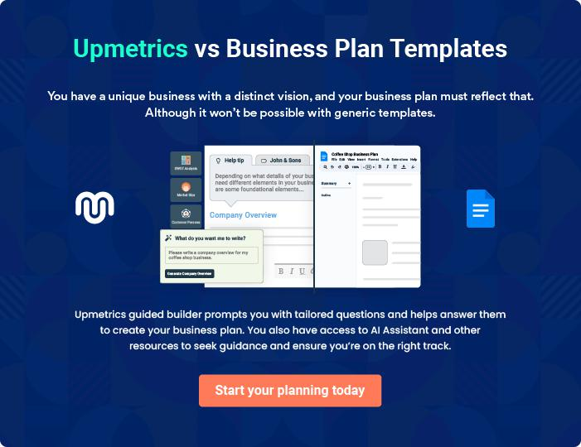
Products and Services
To unlock help try Upmetrics!

The product and services section of a warehouse business plan should describe the specific services and products that will be offered to customers. To write this section should include the following:



 Help tip  Warehouse Business Plan

To craft the introduction for your "Products and Services" chapter, begin by positioning your business within its industry, emphasizing its unique strengths or value proposition.
To unlock help try Upmetrics! 

Start writing here..

 Help tip


Mention the warehouse services your business will offer. This list may include services like,

• Storage
To unlock help try Upmetrics! 

Services

Storage


Price: Starting from [$10] per cubic foot per month.

Our storage facilities are equipped with state-of-the-art security systems and climate control options to ensure the optimal condition of your goods.

Specifications

- Secure facilities with 24/7 surveillance.

- Climate-controlled options available.

- Various storage unit sizes available to meet different needs.
Inventory Management

Price: Starting from [$50] per month.

We provide a comprehensive inventory management service that includes real-time tracking and reporting to help you maintain optimal stock levels.

Specifications

- Real-time inventory tracking.

- Monthly reporting.

- Dedicated account manager.

Order Fulfillment

Price: Starting from [$2] per order.

Our order fulfillment service includes picking, packing, and shipping, ensuring that your customers receive their orders on time and in perfect condition.

Specifications

- Fast and reliable shipping options.

- Customized packaging available.

- Order tracking and customer notifications.
Distribution & Shipping

Price: Pricing varies based on destination and weight.

Please contact us for a quote.

We offer a range of distribution and shipping options to ensure that your products reach their destination on time and at a competitive cost.

Specifications

- Multiple shipping options available, including express, standard, and economy.

- International shipping available.

- Real-time tracking and delivery confirmation.

Cross-Docking Services

Price: Starting from [$5] per pallet.

Our cross-docking services streamline your supply chain by reducing the need for storage and handling, saving you time and money.

Specifications

- Fast and efficient transloading.

- Short-term storage options available.

- Real-time tracking and reporting.
Customs and Compliance

Price: Pricing varies based on the specific requirements of your shipment. Please contact us for a quote.

We handle all aspects of customs and compliance, ensuring that your international shipments are processed smoothly and in accordance with the law.

Specifications

- Expertise in international shipping regulations.

- Customs clearance and documentation handling.

- Dedicated compliance team to ensure your shipments meet all requirements.

Specialized Storage

 Help tip  Warehouse Business Plan


Give an outline of the storage options your warehouse will offer. Describe the things you can
store, the amount of space you have, and any specialized storage alternatives you might have
(such as cold storage or hazardous material storage).
 |  |  |  | To unlock help try Upmetrics! 
Start writing here..
Additional Services
 Help tip |  |  Warehouse Business Plan

Mention if your warehouse company offers any additional services. You may include services like, reverse logistics, quality control & inspection, packaging & labeling, inventory financing, etc.
To unlock help try Upmetrics! 

Start writing here..

Sales And Marketing Strategies

Writing the sales and marketing strategies section means a list of strategies you will use to attract and retain your clients.
To unlock help try Upmetrics! 

 Help Tip  Warehouse Business Plan


To create an effective introduction for your "Sales and Marketing Strategies" chapter, start by setting the stage within your specific industry or market.
To unlock help try Upmetrics! 

Start writing here..

Unique Selling Proposition (USP)

 Help tip  Warehouse Business Plan

Define your business’s USPs depending on the market you serve, the equipment you use, and the unique services you provide. Identifying USPs will help you plan your marketing strategies.
To unlock help try Upmetrics! 

Start writing here..

Pricing Strategy

 Help tip  Warehouse Business Plan

Describe your pricing strategy—how you plan to price your services and stay competitive in the local market. You can mention any discounts you plan on offering to attract new customers.
To unlock help try Upmetrics! 

Start writing here..

 Help tip  Warehouse Business Plan
To unlock help try Upmetrics!

Discuss your marketing strategies to market your services. You may include some of these marketing strategies in your business plan—social media marketing, Google ads, email marketing, content marketing, etc.



Marketing strategies

Online


Social Media

Leveraging platforms like [Facebook, LinkedIn, Instagram] to showcase our facilities, client testimonials, and industry insights.

Content Marketing

Informative blogs, videos, and articles about warehousing trends, best practices, and our services.

Offline

Brochures

Detailed informational brochures available at our outlets and events.

Email Marketing

Regular newsletters, updates, and promotional offers to our subscribed client base.

Print Marketing

Advertisements in [specific mediums, e.g., "local newspapers and industry magazines"].

Events Google Ads

Participation in [specific events, Targeting businesses and

e.g., "industry trade shows and individuals seeking warehousing

local tech fairs"]. solutions.

 Help tip  Warehouse Business Plan

Outline the strategies you’ll implement to maximize your sales. Your sales strategies may include partnering with other businesses, offering referral programs, etc.
To unlock help try Upmetrics! 

Sales strategies

Partner with Businesses

Collaborating with [local businesses, e-commerce platforms, logistic companies] to offer integrated solutions.

Referral Programs

Incentivizing our existing clients to refer our services to other businesses, thereby expanding our client base.

 Help tip  Warehouse Business Plan

Describe your customer retention strategies and how you plan to execute them. For instance, introducing loyalty programs, personalized service, etc.
To unlock help try Upmetrics! 

Customer retention

Loyalty Programs

Offering discounts and additional services to our long-standing clients.

Personalized Service

Understanding each client's unique needs and tailoring our services accordingly.

Regular Feedback

Monthly or quarterly feedback sessions to understand areas of improvement and to consistently enhance our service standards.

Operations Plan
To unlock help try Upmetrics!

 |  | When writing the operations plan section, it’s important to consider the
 |  | various aspects of your business operations.
 |  |  |  | To unlock help try Upmetrics! 
 Help tip |  |  Warehouse Business Plan


To create an effective introduction for your "Operational Plan" chapter, start by emphasizing the
pivotal role of efficient operations in the success of your business, underscoring how they
directly impact the quality of services delivered.
 |  |  |  | To unlock help try Upmetrics! 
Start writing here..
Staffing & Training
 Help tip |  |  Warehouse Business Plan

Mention your business’s staffing requirements, including the number of employees or
warehouse staff needed. Include their qualifications, the training required, and the duties they
will perform.
 |  |  |  | To unlock help try Upmetrics! 
Start writing here..
Operational Process
 Help tip |  |  Warehouse Business Plan

Outline the processes and procedures you will use to run your warehouse business. Your operational processes may include inventory management, storage & organization, order fulfillment, etc.



Start writing here..

Equipment & Machinery

 Help tip  Warehouse Business Plan

Include the list of equipment and machinery required for the warehouse, such as forklifts & material handling equipment, racking & shelving systems, warehouse management system, etc.
To unlock help try Upmetrics! 

Start writing here..
Management Team

The management team section provides an overview of the individuals responsible for running your business plan.
To unlock help try Upmetrics! 

 Help tip  Warehouse Business Plan

To craft an introduction for your "Management Team" chapter, begin by emphasizing the crucial role of leadership in the success of any business.
To unlock help try Upmetrics! 

Start writing here..

Key managers

 Help tip  Warehouse Business Plan

Introduce your management and key members of your team, and explain their roles and responsibilities.
To unlock help try Upmetrics! 

Start writing here..

JOHN DOE

CEO - john.doe@example.com

Role & Responsibilities:

- John leads the strategic planning and overall management of the business, with a primary focus on business development, client relationship management, and operational excellence.


Background:

- John holds a Bachelor's degree in Business Administration and a Master's degree in Logistics and Supply Chain Management.

- With over 15 years of experience in the logistics and warehousing industry, he has a profound understanding of market dynamics and the challenges faced by our clients.

- Prior to founding [ABC Warehousing], John worked in various leadership roles at top logistics companies, where he developed a strong business acumen and industry expertise.


JANE DOE

Chief Operating Officer (COO) - jane.doe@example.com

Role & Responsibilities:

- Jane is responsible for overseeing the day-to-day operations of the business, ensuring that all processes run efficiently and meet our clients' needs.

- She coordinates with various departments to align operations with our strategic objectives.

Background:

- Jane earned a Bachelor's degree in Operations Management and has over 10 years of experience in operational leadership roles.

- Before joining [ABC Warehousing], Jane worked at several logistics companies where she successfully implemented process improvements and enhanced operational efficiency.

ALICE BROWN

CMO - alice.brown@example.com

Role & Responsibilities:

- Alice leads our marketing strategies, ensuring that our services are effectively promoted to our target audience.

- She is in charge of managing social media campaigns, client outreach programs, and other promotional activities.

Background:

- Alice graduated with a degree in Marketing and Communications.

- She has 12 years of experience in marketing, with a strong track record of leading successful campaigns that significantly increased market presence. Alice's expertise lies in digital marketing and brand development.


ROBERT BROWN

Operations Manager - robert.brown@example.com

Role & Responsibilities:

- Robert oversees the warehouse operations, including inventory management, order fulfillment, and shipping.

- He is dedicated to ensuring that our operations run seamlessly and meet client expectations.

Background:

- Robert holds a degree in Logistics Management and brings over 8 years of experience in warehouse management and logistics.

- His analytical skills and attention to detail have been instrumental in improving our operational processes and enhancing customer satisfaction.
Organizational structure

 Help tip  Warehouse Business Plan

Explain the organizational structure of your management team. Include the reporting line and decision-making hierarchy.
To unlock help try Upmetrics! 

Start writing here..

Organization chart


John Doe

CEO


Alice Brown Jane Doe

CMO COO


Peter Jones Robert Brown Mary Smith

Marketing Associate Operations Manager Inventory Manager

Compensation plan

 Help tip  Warehouse Business Plan

Describe your compensation plan for the management and staff. Include their salaries, incentives, and other benefits.
To unlock help try Upmetrics! 

Start writing here..

 Help tip

Mentioning advisors or consultants in your business plans adds credibility to your business idea.
To unlock help try Upmetrics! 

Advisors/Consultants


MICHAEL SMITH

Legal Advisor

Michael provides legal counsel, ensuring our operations comply with all relevant laws and regulations.


EMMA JOHNSON

Financial Consultant

Emma assists us in financial planning, budgeting, and other monetary aspects crucial to our business's sustainability and growth.
Financial Plan

When writing the financial plan section of a business plan, it’s important to provide a comprehensive overview of your financial projections for the first few years of your business, You may provide the following:
To unlock help try Upmetrics! 

 Help tip  Warehouse Business Plan


To create an effective introduction for your "Financial Plan" chapter, begin by stressing the critical role of a well-structured financial plan in the success of your venture.
To unlock help try Upmetrics! 

Start writing here..

 Help tip  Warehouse Business Plan

Describe details such as projected revenue, operational costs, and service costs in your projected profit and loss statement. Make sure to include your business’s expected net profit or loss.
To unlock help try Upmetrics! 

Profit & loss statement

Revenue

Cost Of Sales

General Costs

Revenue Specific Costs

Personnel Costs (Direct

Labor)

Gross Margin

Gross Margin (%)

Operating Expense

Payroll Expense

(Indirect Labor)

General Expense

Bad Debt

Amortization of Current

Assets

2023-24 | 2024-25 | 2025-26 | 2026-27 | 2027-28
$0 | $0 | $0 | $0 | $0

$0 | $0 | $0 | $0 | $0
$0 | $0 | $0 | $0 | $0
$0 | $0 | $0 | $0 | $0
$0 | $0 | $0 | $0 | $0

$0 | $0 | $0 | $0 | $0
0% | 0% | 0% | 0% | 0%

$0 | $0 | $0 | $0 | $0
$0 | $0 | $0 | $0 | $0
$0 | $0 | $0 | $0 | $0
$0 | $0 | $0 | $0 | $0
$0 | $0 | $0 | $0 | $0

EBITDA

Additional Expense

Long Term

Depreciation

Gain or loss from Sale

of Assets

EBIT

Interest Expenses

EBT

Income Tax Expense

Total Expense

Net Income

Net Income (%)

2023-24 | 2024-25 | 2025-26 | 2026-27 | 2027-28
$0 | $0 | $0 | $0 | $0
$0 | $0 | $0 | $0 | $0
$0 | $0 | $0 | $0 | $0
$0 | $0 | $0 | $0 | $0
$0 | $0 | $0 | $0 | $0
$0 | $0 | $0 | $0 | $0
$0 | $0 | $0 | $0 | $0
$0 | $0 | $0 | $0 | $0
$0 | $0 | $0 | $0 | $0
$0 | $0 | $0 | $0 | $0
0% | 0% | 0% | 0% | 0%

 |  |  | 2023-24 |  | 2024-25 | 2025-26
Retained Earning |  |  | $0 |  | $0 | $0
Opening |  |  |  |  | $0 | $0
Owner's Distribution |  |  | $0 |  | $0 | $0
Retained Earning |  |  | $0 |  | $0 | $0
Closing |  |  |  |  | $0 | $0
 Help tip |  |  |  Warehouse Business Plan


The cash flow for the first few years of your operation should be estimated and described in this section.

This may include billing invoices, payment receipts, loan payments, and any other cash flow statements.
2026-27 2027-28

$0 $0

$0 $0

$0 $0

To unlock help try Upmetrics! 

Cash flow statement

 | 2023-24 | 2024-25 | 2025-26 | 2026-27 | 2027-28
Cash Received | $0 | $0 | $0 | $0 | $0
Cash Paid | $0 | $0 | $0 | $0 | $0
COS & General Expenses | $0 | $0 | $0 | $0 | $0
Salary & Wages | $0 | $0 | $0 | $0 | $0
Interest | $0 | $0 | $0 | $0 | $0

Sales Tax

Income Tax

Net Cash From

Operations

Assets Sell

Assets Purchase

Net Cash From

Investments

Amount Received

Loan Received

Common Stock

Preferred Stock

Owner's Contribution

Amount Paid

2023-24 | 2024-25 | 2025-26 | 2026-27 | 2027-28
$0 | $0 | $0 | $0 | $0
$0 | $0 | $0 | $0 | $0
$0 | $0 | $0 | $0 | $0

$0 | $0 | $0 | $0 | $0
$0 | $0 | $0 | $0 | $0
$0 | $0 | $0 | $0 | $0

$0 | $0 | $0 | $0 | $0
$0 | $0 | $0 | $0 | $0

$0 | $0 | $0 | $0 | $0
$0 | $0 | $0 | $0 | $0
$0 | $0 | $0 | $0 | $0

Loan Capital $0 $0 $0 $0 $0

 |  |  | 2023-24 | 2024-25 | 2025-26 | 2026-27 | 2027-28
Dividends & Distributions |  |  | $0 | $0 | $0 | $0 | $0
Net Cash From |  |  | $0 | $0 | $0 | $0 | $0
Financing
Summary
Starting Cash |  |  | $0 | $0 | $0 | $0 | $0
Cash In |  |  | $0 | $0 | $0 | $0 | $0
Cash Out |  |  | $0 | $0 | $0 | $0 | $0
Change in Cash |  |  | $0 | $0 | $0 | $0 | $0
Ending Cash |  |  | $0 | $0 | $0 | $0 | $0
 Help tip |  |  Warehouse Business Plan

Create a projected balance sheet documenting your warehouse business’s assets, liabilities, and equity.

To unlock help try Upmetrics! 

Balance sheet

 | 2023-24 | 2024-25 | 2025-26 | 2026-27 | 2027-28
Assets | $0 | $0 | $0 | $0 | $0
Current Assets | $0 | $0 | $0 | $0 | $0
Cash | $0 | $0 | $0 | $0 | $0
Accounts Receivable | $0 | $0 | $0 | $0 | $0
Inventory | $0 | $0 | $0 | $0 | $0
Other Current Assets | $0 | $0 | $0 | $0 | $0
Long Term Assets | $0 | $0 | $0 | $0 | $0
Gross Long Term Assets | $0 | $0 | $0 | $0 | $0
Accumulated Depreciation | $0 | $0 | $0 | $0 | $0

Liabilities & Equity | $0 | $0 | $0 | $0 | $0
Liabilities | $0 | $0 | $0 | $0 | $0
Current Liabilities | $0 | $0 | $0 | $0 | $0
Accounts Payable | $0 | $0 | $0 | $0 | $0
Income Tax Payable | $0 | $0 | $0 | $0 | $0
Sales Tax Payable | $0 | $0 | $0 | $0 | $0
Short Term Debt | $0 | $0 | $0 | $0 | $0
 | 2023-24 | 2024-25 | 2025-26 | 2026-27 | 2027-28
Long Term Liabilities | $0 | $0 | $0 | $0 | $0
Long Term Debt | $0 | $0 | $0 | $0 | $0
Equity | $0 | $0 | $0 | $0 | $0
Paid-in Capital | $0 | $0 | $0 | $0 | $0
Common Stock | $0 | $0 | $0 | $0 | $0
Preferred Stock | $0 | $0 | $0 | $0 | $0
Owner's Contribution | $0 | $0 | $0 | $0 | $0
Retained Earnings | $0 | $0 | $0 | $0 | $0

Check | $0 |  |  | $0 | $0 | $0 | $0
 Help tip |  |  Warehouse Business Plan

Determine and mention your business’s break-even point—the point at which your business costs and revenue will be equal.

This exercise will help you understand how much revenue you need to generate to sustain or be profitable.
To unlock help try Upmetrics! 

Break-even Analysis

 | 2023-24 | 2024-25 | 2025-26 | 2026-27 | 2027-28
Starting Revenue | $0 | $0 | $0 | $0 | $0
Net Revenue | $0 | $0 | $0 | $0 | $0
Closing Revenue | $0 | $0 | $0 | $0 | $0

Starting Expense | $0 | $0 | $0 | $0 | $0
Net Expense | $0 | $0 | $0 | $0 | $0
Closing Expense | $0 | $0 | $0 | $0 | $0

Is Break Even? | 0 | 0 | 0 | 0 | 0
Break Even Month | 0 | 0 | 0 | 0 | 0
Days Required | 0 | 0 | 0 | 0 | 0
Break Even Revenue | $0 | $0 | $0 | $0 | $0
Break Even Units
Financing needs

 Help tip  Warehouse Business Plan

Calculate costs associated with starting a warehouse business, and estimate your financing needs and how much capital you need to raise to operate your business.
To unlock help try Upmetrics! 

Start writing here..
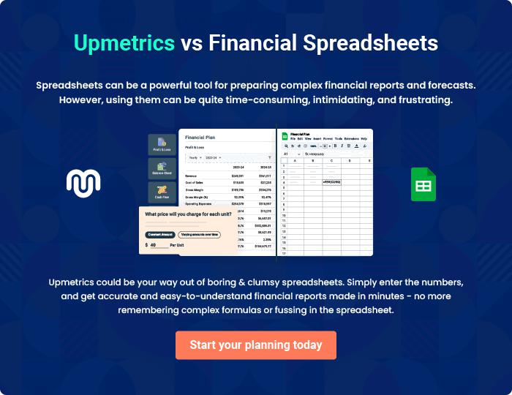
Appendix

When writing the appendix section, you should include any additional information that supports the main content of your plan. This may include financial statements, market research data, legal documents, and other
To unlock help try Upmetrics! 

Create a winning business plan that gets you funded

Creating a stunning and investment-ready plan requires no writing, graphic designing, or financial planning expertise.

Upmetrics has all the features required to help you create a comprehensive business plan—from start to finish. Make no mistakes, it’s the modern way of planning to structure ideas, make plans, and create stunning pitch decks to awe investors.

Pitch decks that impress investors

Create pitch decks that provide a visual representation of your business, engage investors, and make them want to invest in your business idea.

Interactive plans in no time

Import business plan sections like—SWOT analysis, comparison tables, and others to create an interactive business plan. No designing skills are required.

Stunning cover page designs

With Upmetrics, you have the liberty to choose from multiple stunning cover page designs. Choose a creative design and make your plan stand out.

Online sharing made simple

Upmetrics makes online sharing quick and easier for users. Easily share your business plans with a link while tracking reader activity.

500+ sample business plans

Simply import a template from our library of sample plans into the editor and start customizing it to make it yours. It takes only a few clicks to get started.

Collaborate with team in real-time

Invite team members, initiate conversations, discuss ideas & strategies, share feedback, and work on a business plan in real-time.

