

Virtual Assistant Business Plan

Visual Solutions, Seamless Support

Business

Plan

2023

John Doe

10200 Bolsa Ave, Westminster, CA, 92683

- 359-3153 info@example.com http://www.example.com

CONFIDENTIAL

Table of Contents

Executive Summary | 6
Market opportunity | 6
Services Offered | 6
Marketing & Sales Strategies | 7
Financial Highlights | 7
Units Sold v/s Revenue | 8

Company Overview | 9
Ownership | 9
Mission statement | 10
Business history | 10
Future goals | 10

Market Analysis | 11
Target Market | 11
Market size and growth potential | 11
Market Size | 12
Competitive analysis | 12
Belay Solutions | 12
Time Etc | 13
Fancy Hands | 13
Market trends | 13
Regulatory environment | 14

Products and Services | 15
Virtual assistant services | 15
Administrative Support | 16
Social Media Management | 16
Email Management | 17
Scheduling | 17
Bookkeeping | 18
Additional Services | 18

Sales And Marketing Strategies | 19
Unique Selling Proposition (USP) | 19
Pricing Strategy | 19
Marketing strategies | 20
Online | 20
Sales strategies | 20
Customer retention | 21

Operations Plan | 22
Staffing & Training | 22
Operational Process | 22
Equipment & Machinery | 23

Management Team | 24
Key managers | 24
John Doe | 24
Jane Doe | 25
Alice Brown | 25
Organizational structure | 25
Organization chart | 26
Compensation plan | 26
Advisors/Consultants | 27
Robert Brown | 27
Emily White | 27

Financial Plan | 28
Profit & loss statement | 28
Cash flow statement | 31
Balance sheet | 33
Break-even Analysis | 35
Financing needs | 37
Appendix | 39
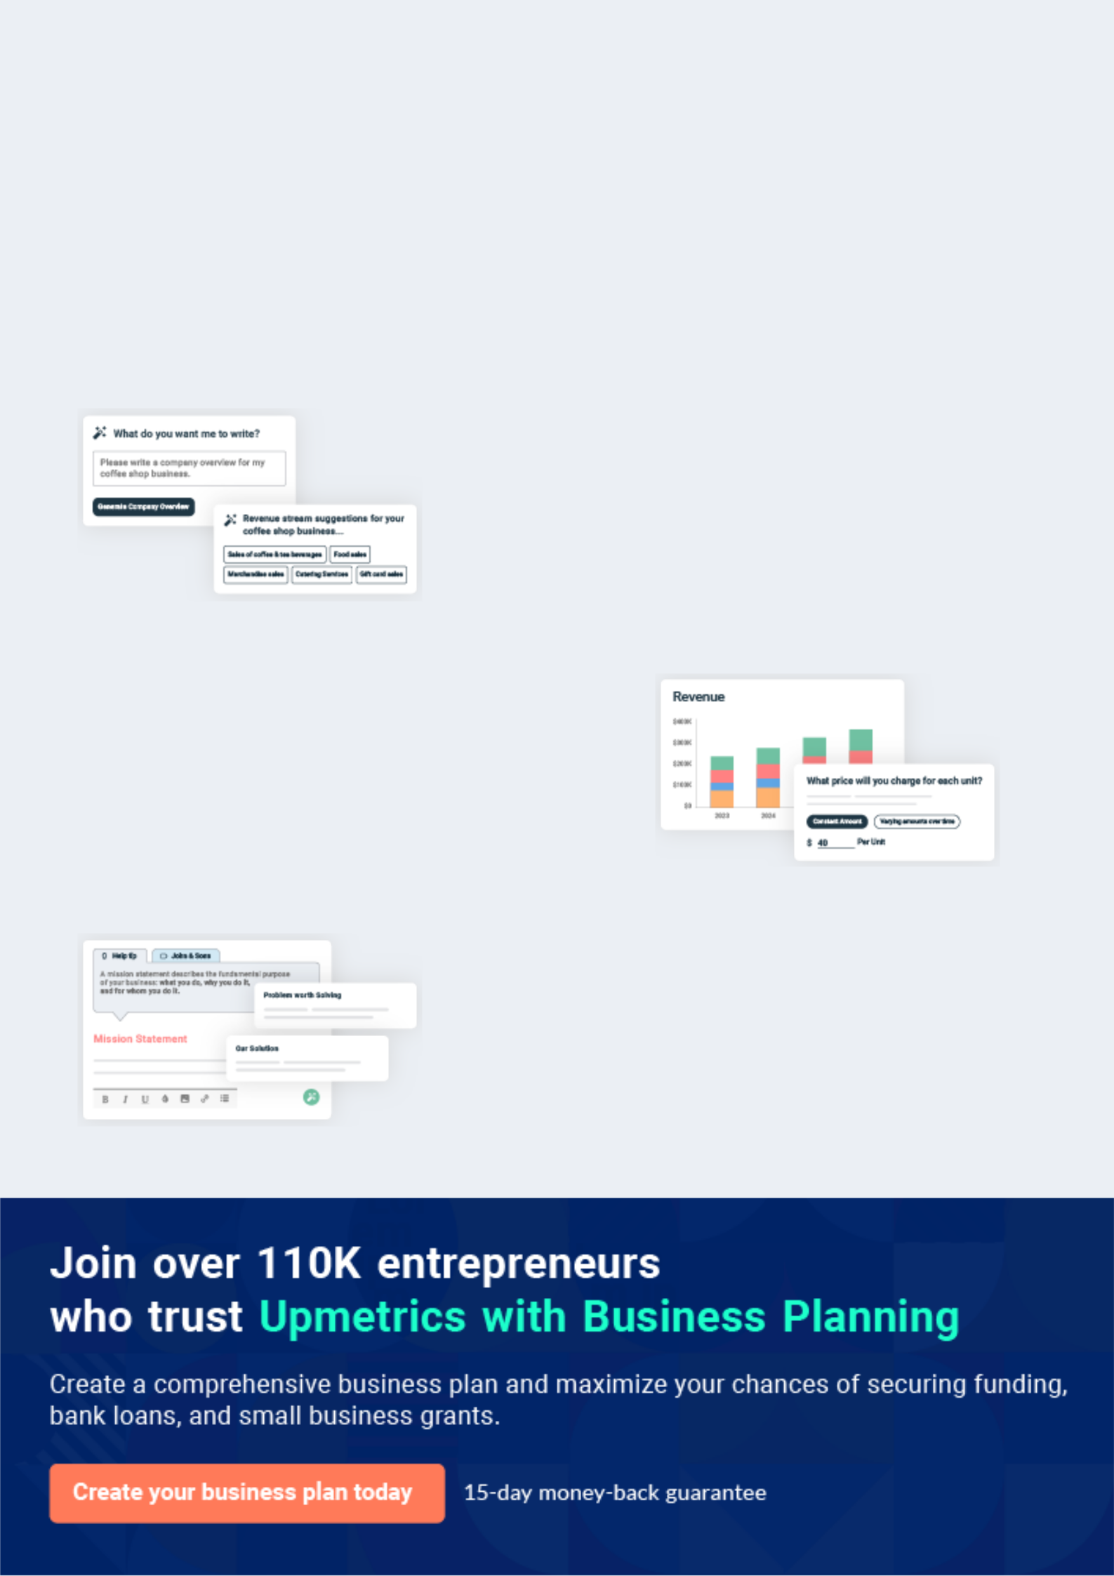
Business planning that’s simpler and faster than you think

Creating a business plan using Upmetrics to start and grow a business is literally the easiest thing in the World. Simply read the instructions and fill in the blanks. It’s as simple as that.

❛ | Upmetrics has everything you need to create a | ❜
❛ | comprehensive business plan. | ❜

AI-powered Upmetrics Assistant

AI-powered insights to streamline your plan

Not sure where to start? Upmetrics’ AI Assistant will automatically generate ideas for each section of your plan and offer improved versions of your writing, adjusting for tone, voice, and grammar or spelling errors.

Financial Forecasting Tool

All the financials are calculated for you

Forget the complex formulas and clumsy spreadsheets — with automatic financials and drag-and-drop forecasting, you can finish your plan faster and be confident that your numbers are accurate.

Business Plan Builder

Guides you like a business mentor

Upmetrics’ step-by-step instructions, prompts, and the library of 400+ sample business plans will guide you through each section of your plan as a business mentor.
Executive Summary


An executive summary is the first section of the business plan intended to provide an overview of the whole business plan.
To unlock help try Upmetrics! 

 Help tip  Virtual Assistant Business Plan


Start your business overview section by briefly introducing your business to your readers.

This section may include the name of your virtual assistant business, its location, when it was
To unlock help try Upmetrics! 

Start writing here..

Market opportunity

 Help tip  Virtual Assistant Business Plan

Summarize your market research, including market size, growth potential, and marketing trends. Highlight the opportunities in the market and how your business will fit in to fill the gap.
To unlock help try Upmetrics! 

Start writing here..

Services Offered

 Help tip  Virtual Assistant Business Plan

Highlight the virtual assistant services you offer your clients. The USPs and differentiators you offer are always a plus.
To unlock help try Upmetrics! 

Start writing here..

Marketing & Sales Strategies
To unlock help try Upmetrics!

 Help tip  Virtual Assistant Business Plan

Outline your sales and marketing strategies—what marketing platforms you use, how you plan on acquiring customers, etc.
To unlock help try Upmetrics! 

Start writing here..

Financial Highlights

 Help tip  Virtual Assistant Business Plan

Briefly summarize your financial projections for the initial years of business operations. Include any capital or investment requirements, associated startup costs, projected revenues, and profit forecasts.



Start writing here..
Units Sold v/s Revenue

 |  | Units Sold | Revenue
15.00k
10.00k
5.00k
0
Year 1 | Year 2 | Year 3


Financial Year |  |  | Units Sold | Revenue
Year 1 | 1,550 |  |  | $10,000
Year 2 | 1,800 |  |  | $12,000
Year 3 | 2,050 |  |  | $14,000
 Help tip |  |  Virtual Assistant Business Plan


Summarize your executive summary section with a clear CTA, for example, inviting angel investors to discuss the potential business investment.
To unlock help try Upmetrics! 

Write a call to action for your business plan.
Company Overview

Depending on what details of your business are essential, you’ll need different elements in your business overview.
To unlock help try Upmetrics! 

 Help tip  Virtual Assistant Business Plan

Describe what kind of virtual assistant company you run and the name of it. You may specialize in one of the following types of businesses:
To unlock help try Upmetrics! 

Start writing here..

Ownership

 Help tip  Virtual Assistant Business Plan

List the names of your virtual assistant company’s founders or owners. Describe what shares they own and their responsibilities for efficiently managing the business.
To unlock help try Upmetrics! 

Start writing here..
Mission statement

 Help tip  Virtual Assistant Business Plan

Summarize your business’ objective, core principles, and values in your mission statement. This statement needs to be memorable, clear, and brief.
To unlock help try Upmetrics! 

❛ At [Virtual Assistant Solutions], our mission is to empower businesses by providing them with top-notch virtual assistance services that drive efficiency and foster growth.

We are committed to upholding our core principles of integrity, quality, and customer satisfaction in every aspect of our operations.

❜

Business history

 Help tip  Virtual Assistant Business Plan

If you’re an established virtual assistant business provider, briefly describe your business history, like—when it was founded, how it evolved over time, etc.
To unlock help try Upmetrics! 

Start writing here..

Future goals

 Help tip  Virtual Assistant Business Plan

It’s crucial to convey your aspirations and vision. Mention your short-term and long-term goals; they can be specific targets for revenue, market share, or expanding your services.
To unlock help try Upmetrics! 

Start writing here..

Market Analysis
To unlock help try Upmetrics!


 |  | Market analysis provides a clear understanding of the market in which your
 |  | printing business will run along with the target market, competitors, and
 |  | growth opportunities.
 |  |  |  | To unlock help try Upmetrics! 
 Help tip |  |  Virtual Assistant Business Plan

To write the introduction section of your market analysis, start by clearly identifying your primary target market.
To unlock help try Upmetrics! 

Start writing here..

Target Market

 Help tip  Virtual Assistant Business Plan

Start this section by describing your target market. Define your ideal customer and explain what types of services they prefer. Creating a buyer persona will help you easily define your target market to your readers.



Start writing here..

Market size and growth potential

 Help tip  Virtual Assistant Business Plan

Describe your market size and growth potential and whether you will target a niche or a much broader market.
To unlock help try Upmetrics! 

Start writing here..

Market Size
To unlock help try Upmetrics!

 |  |  |  |  |  |  | Available Market |  | 100M
 |  |  |  |  |  |  | All individuals and businesses seeking |  | 100M
 |  |  |  |  |  |  | virtual assistant services globally.
 |  |  |  |  |  |  | Served Market |  | 70M
 |  |  |  |  |  |  | The portion of the available market |  | 70M
 |  |  |  |  |  |  | that [Virtual Assistant Solutions] can |  | 70M
 |  |  |  |  |  |  | feasibly reach.
 |  |  |  |  |  |  | Target Market |  | 10M
 |  |  |  |  |  |  | Small businesses and entrepreneurs |  | 10M
 |  |  |  |  |  |  | in need of administrative and |  | 10M
 |  |  |  |  |  |  | technical support.
 Help tip |  |  |  Virtual Assistant Business Plan

Identify and analyze your direct and indirect competitors. Identify their strengths and weaknesses, and describe what differentiates your virtual assistant business from competitors.



Competitive analysis

Belay Solutions

Belay Solutions is a renowned virtual assistant service provider that offers a range of services, from administrative support to social media management and bookkeeping.

Features

Administrative Support Social Media Management Bookkeeping and Accounting Website Maintenance

Strengths

Extensive range of services catering to diverse client needs.

Well-established brand with a strong market presence.

Professional team with specialized skill sets.

Weaknesses

Premium pricing may not be accessible to small businesses or startups.

Limited personalized interaction due to the size of the operation.

Time Etc

Time Etc is a versatile virtual assistant platform offering flexible plans and a variety of services tailored to the needs of entrepreneurs and businesses.

Features

General Administrative Tasks

Social Media Assistance

Content Creation

Email and Calendar

Management

Strengths

Flexible plans and pricing suitable for different business sizes.

A vast network of skilled virtual assistants.

A vast network of skilled virtual assistants. Positive customer reviews and strong client satisfaction.

Weaknesses

Limited availability of specialized services.

May not be suitable for businesses seeking long-term, dedicated virtual assistant partnerships.

Fancy Hands

Fancy Hands is a popular choice for individuals and businesses seeking task-based virtual assistant services.

Features

Task-Based Assistance

Scheduling and Calendar Management

Research

Data Entry

Strengths

Affordable pricing with a task-based model.

Quick turnaround time for task completion.

User-friendly platform for easy task management.

Weaknesses

Limited scope for specialized or industry-specific tasks.

Inconsistency in quality due to a diverse pool of virtual assistants.

Market trends

 Help tip  Virtual Assistant Business Plan

Analyse emerging trends in the industry, such as technology disruptions, changes in customer behavior or preferences, etc. Explain how your business will cope with all the trends.
To unlock help try Upmetrics! 

Start writing here..

Regulatory environment
To unlock help try Upmetrics!

 Help tip  Virtual Assistant Business Plan

List regulations and licensing requirements that may affect your virtual assistant business, such as CCPA regulations for data privacy, intellectual property laws, consumer protection laws, cybersecurity, etc.



Start writing here..
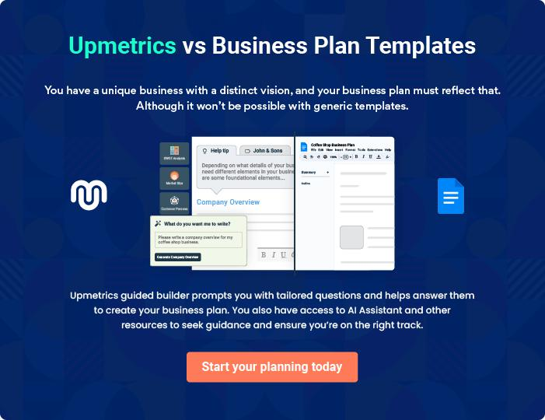
Products and Services
To unlock help try Upmetrics!

The product and services section of a virtual assistant business plan should describe the specific services and products that will be offered to customers. To write this section should include the following:



 Help tip  Virtual Assistant Business Plan

To craft the introduction for your "Products and Services" chapter, begin by positioning your business within its industry, emphasizing its unique strengths or value proposition.
To unlock help try Upmetrics! 

Start writing here..

 Help tip


Mention the virtual assistant services your business will offer. This list may include services like,
To unlock help try Upmetrics! 

Virtual assistant services
Administrative Support


Price: [$25] per hour

Our administrative support services handle a variety of tasks including data entry, document preparation, and other clerical duties to keep your operations running smoothly.

Specifications

- Data entry

- Document preparation

- Clerical duties

- Time management

- Office organization

Social Media Management

Price: [$30] per hour or [$400] per month for a comprehensive package

We manage your social media profiles, ensuring they are updated regularly with relevant content to engage your audience.

Specifications

- Account setup and optimization

- Content creation and scheduling

- Engagement with followers

- Performance analysis and reporting

- Ad campaign management (additional costs may apply)
Email Management

Price: [$20] per hour

Our team will handle your email correspondence, ensuring timely responses to your clients and organizing your inbox.

Specifications

- Inbox organization

- Spam filtering

- Responding to client emails

- Calendar management and scheduling from email communications

Scheduling

Price: [$20] per hour

We will organize and manage your schedule, ensuring you never miss an appointment or deadline.

Specifications

- Calendar management

- Appointment scheduling and reminders

- Travel arrangements

- Meeting coordination
Bookkeeping

Price: [$30] per hour

Our virtual assistants will take care of your finances, from managing invoices to preparing financial reports.

Specifications

- Invoice management

- Expense tracking

- Financial report preparation

- Tax preparation assistance

- Budgeting and forecasting

Additional Services

 Help tip  Virtual Assistant Business Plan

Mention if your virtual assistant business offers any additional services. You may provide a description of all the additional services too in this section.
To unlock help try Upmetrics! 

Start writing here..
Sales And Marketing Strategies

Writing the sales and marketing strategies section means a list of strategies you will use to attract and retain your clients.
To unlock help try Upmetrics! 

 Help Tip  Virtual Assistant Business Plan


To create an effective introduction for your "Sales and Marketing Strategies" chapter, start by setting the stage within your specific industry or market.
To unlock help try Upmetrics! 

Start writing here..

Unique Selling Proposition (USP)

 Help tip  Virtual Assistant Business Plan

Define your business’s USPs depending on the market you serve, the equipment you use, and the unique services you provide. Identifying USPs will help you plan your marketing strategies.
To unlock help try Upmetrics! 

Start writing here..

Pricing Strategy

 Help tip  Virtual Assistant Business Plan

Describe your pricing strategy—how you plan to price your services and stay competitive in the market. You can mention any discounts you plan on offering to attract new customers.
To unlock help try Upmetrics! 

Start writing here..

 Help tip  Virtual Assistant Business Plan
To unlock help try Upmetrics!

Discuss your marketing strategies to market your services. You may include some of these marketing strategies in your business plan—social media marketing, Google ads, email marketing, content marketing, SEO, etc.



Marketing strategies

Online


Social Media

Utilizing platforms such as [mention platforms] to engage with potential clients and build our online presence.

Email Marketing

Leveraging our mailing list to send out promotional offers and updates on our services.

Content Marketing & SEO Google Ads

Creating valuable content that ranks well on search engines, thereby increasing our visibility and attracting organic traffic.

Implementing paid advertising to reach potential clients actively searching for virtual assistant services.

 Help tip  Virtual Assistant Business Plan

Outline the strategies you’ll implement to maximize your sales. Your sales strategies may include cold outreach, free consultation, etc.
To unlock help try Upmetrics! 

Sales strategies

Cold Outreach Free Consultation

Engaging potential clients through cold calls and emails to offer our services.

Offering free consultations to potential clients to demonstrate the value of our services.

 Help tip  Virtual Assistant Business Plan

Describe your customer retention strategies and how you plan to execute them. For instance, introducing loyalty programs, discounts on annual membership, personalized service, etc.
To unlock help try Upmetrics! 

Customer retention

Loyalty Programs

Annual Membership Discounts

Introducing loyalty programs to reward repeat clients.

Offering discounts to clients who opt for annual memberships.

Personalized Service

Customizing our services to meet

the specific needs of each client,

thereby increasing satisfaction and

loyalty.

Operations Plan
To unlock help try Upmetrics!

 |  | When writing the operations plan section, it’s important to consider the
 |  | various aspects of your business operations.
 |  |  |  | To unlock help try Upmetrics! 
 Help tip |  |  Virtual Assistant Business Plan


To create an effective introduction for your "Operational Plan" chapter, start by emphasizing the
pivotal role of efficient operations in the success of your business, underscoring how they
directly impact the quality of services delivered.
 |  |  |  | To unlock help try Upmetrics! 
Start writing here..
Staffing & Training
 Help tip |  |  Virtual Assistant Business Plan

Mention your business’s staffing requirements, including the number of employees or technical staff needed. Include their qualifications, the training required, and the duties they will perform.
To unlock help try Upmetrics! 

Start writing here..

Operational Process

 Help tip  Virtual Assistant Business Plan

Outline the processes and procedures you will use to run your virtual assistant business. Your operational processes may include sending quotations, training employees, providing customer services, etc.



Start writing here..

Equipment & Machinery

 Help tip  Virtual Assistant Business Plan

Include the list of equipment and machinery required for virtual assistant business, such as proper backup storage, communication tools, virtual assistant software, etc.
To unlock help try Upmetrics! 

Start writing here..
Management Team

The management team section provides an overview of the individuals responsible for running your business plan.
To unlock help try Upmetrics! 

 Help tip  Virtual Assistant Business Plan

To craft an introduction for your "Management Team" chapter, begin by emphasizing the crucial role of leadership in the success of any business.
To unlock help try Upmetrics! 

Start writing here..

Key managers

 Help tip  Virtual Assistant Business Plan

Introduce your management and key members of your team, and explain their roles and responsibilities.
To unlock help try Upmetrics! 

Start writing here..


JOHN DOE

CEO - john.doe@example.com

John is a visionary entrepreneur with a Bachelor's in Business Administration from the University of California.

With over 15 years of experience in the virtual assistant industry, he has a deep understanding of the market dynamics and the skills required to succeed in this field.


JANE DOE

Chief Operating Officer (COO) - jane.doe@example.com

Jane holds a Master's in Operations Management from Stanford University.

With 10 years of experience in operational management, she ensures our business processes are efficient and effective.



ALICE BROWN

CMO - alice.brown@example.com

Alice graduated with a degree in Marketing from Harvard University.

She has a rich experience of 12 years in the marketing field, specializing in digital marketing strategies.

Organizational structure

 Help tip  Virtual Assistant Business Plan

Explain the organizational structure of your management team. Include the reporting line and decision-making hierarchy.
To unlock help try Upmetrics! 

Start writing here..
Organization chart


John Doe

CEO


Alice Brown

Jane Doe

Robert White

CMO



COO


CFO

Michael Johnson

Emily Green

Sales Director

HR Director

Compensation plan

 Help tip  Virtual Assistant Business Plan

Describe your compensation plan for the management and staff. Include their salaries, incentives, and other benefits.
To unlock help try Upmetrics! 

Start writing here..

 Help tip

Mentioning advisors or consultants in your business plans adds credibility to your business idea.
To unlock help try Upmetrics! 

Advisors/Consultants


ROBERT BROWN

Legal Advisor - robert.brown@example.com

Robert has a Juris Doctor degree from Yale Law School and has been practicing law for 20 years.

He advises us on all legal matters to ensure our business complies with all regulations and laws.


EMILY WHITE

Financial Consultant - emily.white@example.com

Emily is a certified accountant with a Master's in Finance from the University of Chicago.

She has 15 years of experience in financial consulting and helps us make informed financial decisions.
Financial Plan

When writing the financial plan section of a business plan, it’s important to provide a comprehensive overview of your financial projections for the first few years of your business, You may provide the following:
To unlock help try Upmetrics! 

 Help tip  Virtual Assistant Business Plan


To create an effective introduction for your "Financial Plan" chapter, begin by stressing the critical role of a well-structured financial plan in the success of your venture.
To unlock help try Upmetrics! 

Start writing here..

 Help tip  Virtual Assistant Business Plan

Describe details such as projected revenue, operational costs, and service costs in your projected profit and loss statement. Make sure to include your business’s expected net profit or loss.
To unlock help try Upmetrics! 

Profit & loss statement

Revenue

Cost Of Sales

General Costs

Revenue Specific Costs

Personnel Costs (Direct

Labor)

Gross Margin

Gross Margin (%)

Operating Expense

Payroll Expense

(Indirect Labor)

General Expense

Bad Debt

Amortization of Current

Assets

2023-24 | 2024-25 | 2025-26 | 2026-27 | 2027-28
$0 | $0 | $0 | $0 | $0

$0 | $0 | $0 | $0 | $0
$0 | $0 | $0 | $0 | $0
$0 | $0 | $0 | $0 | $0
$0 | $0 | $0 | $0 | $0

$0 | $0 | $0 | $0 | $0
0% | 0% | 0% | 0% | 0%

$0 | $0 | $0 | $0 | $0
$0 | $0 | $0 | $0 | $0
$0 | $0 | $0 | $0 | $0
$0 | $0 | $0 | $0 | $0
$0 | $0 | $0 | $0 | $0

EBITDA

Additional Expense

Long Term

Depreciation

Gain or loss from Sale

of Assets

EBIT

Interest Expenses

EBT

Income Tax Expense

Total Expense

Net Income

Net Income (%)

2023-24 | 2024-25 | 2025-26 | 2026-27 | 2027-28
$0 | $0 | $0 | $0 | $0
$0 | $0 | $0 | $0 | $0
$0 | $0 | $0 | $0 | $0
$0 | $0 | $0 | $0 | $0
$0 | $0 | $0 | $0 | $0
$0 | $0 | $0 | $0 | $0
$0 | $0 | $0 | $0 | $0
$0 | $0 | $0 | $0 | $0
$0 | $0 | $0 | $0 | $0
$0 | $0 | $0 | $0 | $0
0% | 0% | 0% | 0% | 0%

 |  |  | 2023-24 |  | 2024-25 | 2025-26
Retained Earning |  |  | $0 |  | $0 | $0
Opening |  |  |  |  | $0 | $0
Owner's Distribution |  |  | $0 |  | $0 | $0
Retained Earning |  |  | $0 |  | $0 | $0
Closing |  |  |  |  | $0 | $0
 Help tip |  |  |  Virtual Assistant Business Plan


The cash flow for the first few years of your operation should be estimated and described in this section.

This may include billing invoices, payment receipts, loan payments, and any other cash flow statements.
2026-27 2027-28

$0 $0

$0 $0

$0 $0

To unlock help try Upmetrics! 

Cash flow statement

 | 2023-24 | 2024-25 | 2025-26 | 2026-27 | 2027-28
Cash Received | $0 | $0 | $0 | $0 | $0
Cash Paid | $0 | $0 | $0 | $0 | $0
COS & General Expenses | $0 | $0 | $0 | $0 | $0
Salary & Wages | $0 | $0 | $0 | $0 | $0
Interest | $0 | $0 | $0 | $0 | $0

Sales Tax

Income Tax

Net Cash From

Operations

Assets Sell

Assets Purchase

Net Cash From

Investments

Amount Received

Loan Received

Common Stock

Preferred Stock

Owner's Contribution

Amount Paid

2023-24 | 2024-25 | 2025-26 | 2026-27 | 2027-28
$0 | $0 | $0 | $0 | $0
$0 | $0 | $0 | $0 | $0
$0 | $0 | $0 | $0 | $0

$0 | $0 | $0 | $0 | $0
$0 | $0 | $0 | $0 | $0
$0 | $0 | $0 | $0 | $0

$0 | $0 | $0 | $0 | $0
$0 | $0 | $0 | $0 | $0

$0 | $0 | $0 | $0 | $0
$0 | $0 | $0 | $0 | $0
$0 | $0 | $0 | $0 | $0

Loan Capital $0 $0 $0 $0 $0

 |  |  | 2023-24 |  | 2024-25 | 2025-26 | 2026-27 | 2027-28
Dividends & Distributions |  |  | $0 |  | $0 | $0 | $0 | $0
Net Cash From |  |  | $0 |  | $0 | $0 | $0 | $0
Financing
Summary
Starting Cash |  |  | $0 |  | $0 | $0 | $0 | $0
Cash In |  |  | $0 |  | $0 | $0 | $0 | $0
Cash Out |  |  | $0 |  | $0 | $0 | $0 | $0
Change in Cash |  |  | $0 |  | $0 | $0 | $0 | $0
Ending Cash |  |  | $0 |  | $0 | $0 | $0 | $0
 Help tip |  |  Virtual Assistant Business Plan

Create a projected balance sheet documenting your virtual assistant business’s assets, liabilities, and equity.

To unlock help try Upmetrics! 

Balance sheet

 | 2023-24 | 2024-25 | 2025-26 | 2026-27 | 2027-28
Assets | $0 | $0 | $0 | $0 | $0
Current Assets | $0 | $0 | $0 | $0 | $0
Cash | $0 | $0 | $0 | $0 | $0
Accounts Receivable | $0 | $0 | $0 | $0 | $0
Inventory | $0 | $0 | $0 | $0 | $0
Other Current Assets | $0 | $0 | $0 | $0 | $0
Long Term Assets | $0 | $0 | $0 | $0 | $0
Gross Long Term Assets | $0 | $0 | $0 | $0 | $0
Accumulated Depreciation | $0 | $0 | $0 | $0 | $0

Liabilities & Equity | $0 | $0 | $0 | $0 | $0
Liabilities | $0 | $0 | $0 | $0 | $0
Current Liabilities | $0 | $0 | $0 | $0 | $0
Accounts Payable | $0 | $0 | $0 | $0 | $0
Income Tax Payable | $0 | $0 | $0 | $0 | $0
Sales Tax Payable | $0 | $0 | $0 | $0 | $0
Short Term Debt | $0 | $0 | $0 | $0 | $0
 | 2023-24 | 2024-25 | 2025-26 | 2026-27 | 2027-28
Long Term Liabilities | $0 | $0 | $0 | $0 | $0
Long Term Debt | $0 | $0 | $0 | $0 | $0
Equity | $0 | $0 | $0 | $0 | $0
Paid-in Capital | $0 | $0 | $0 | $0 | $0
Common Stock | $0 | $0 | $0 | $0 | $0
Preferred Stock | $0 | $0 | $0 | $0 | $0
Owner's Contribution | $0 | $0 | $0 | $0 | $0
Retained Earnings | $0 | $0 | $0 | $0 | $0

Check | $0 |  |  | $0 | $0 | $0 | $0
 Help tip |  |  Virtual Assistant Business Plan

Determine and mention your business’s break-even point—the point at which your business costs and revenue will be equal.

This exercise will help you understand how much revenue you need to generate to sustain or be profitable.
To unlock help try Upmetrics! 

Break-even Analysis

 | 2023-24 | 2024-25 | 2025-26 | 2026-27 | 2027-28
Starting Revenue | $0 | $0 | $0 | $0 | $0
Net Revenue | $0 | $0 | $0 | $0 | $0
Closing Revenue | $0 | $0 | $0 | $0 | $0

Starting Expense | $0 | $0 | $0 | $0 | $0
Net Expense | $0 | $0 | $0 | $0 | $0
Closing Expense | $0 | $0 | $0 | $0 | $0

Is Break Even? | 0 | 0 | 0 | 0 | 0
Break Even Month | 0 | 0 | 0 | 0 | 0
Days Required | 0 | 0 | 0 | 0 | 0
Break Even Revenue | $0 | $0 | $0 | $0 | $0
Break Even Units
Financing needs

 Help tip  Virtual Assistant Business Plan

Calculate costs associated with starting a virtual assistant business, and estimate your financing needs and how much capital you need to raise to operate your business.
To unlock help try Upmetrics! 

Start writing here..
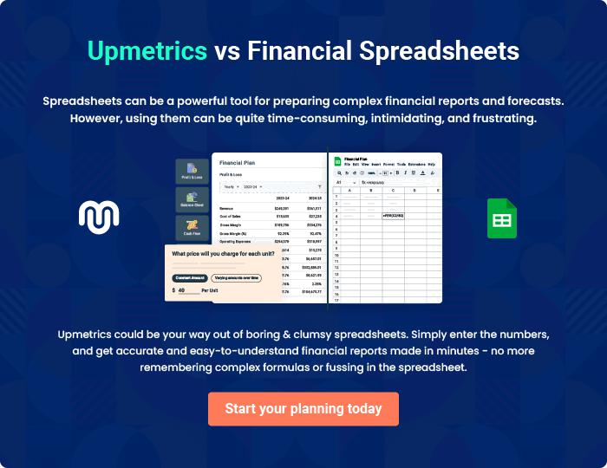
Appendix

When writing the appendix section, you should include any additional information that supports the main content of your plan. This may include financial statements, market research data, legal documents, and other
To unlock help try Upmetrics! 
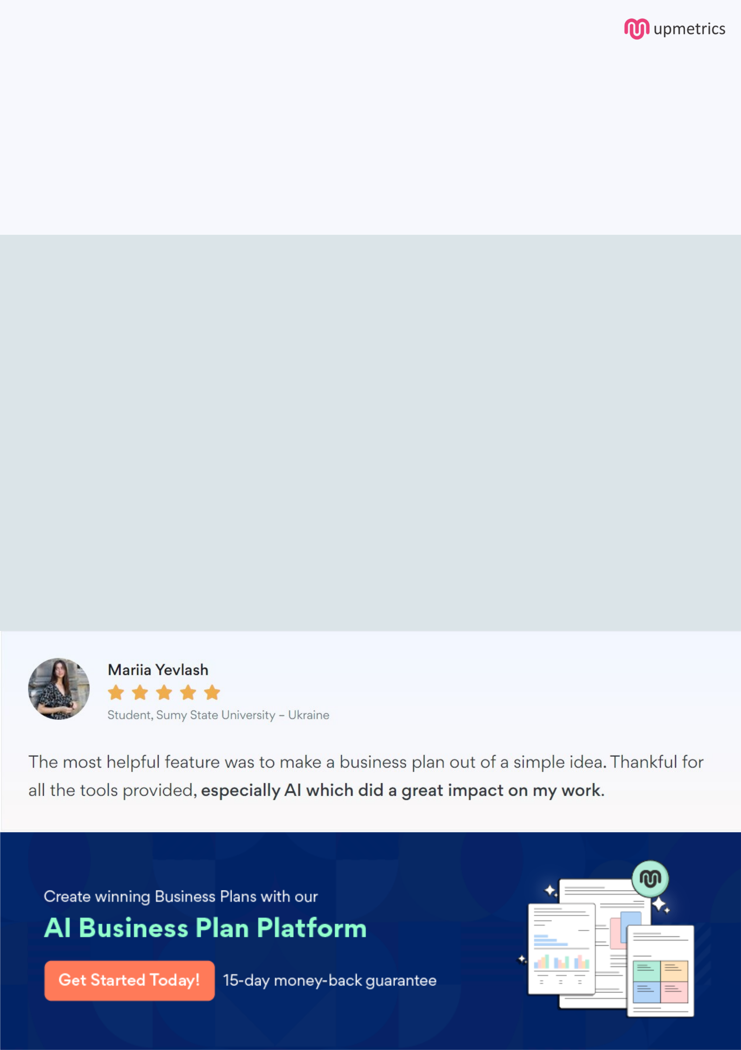
Create a winning business plan that gets you funded

Creating a stunning and investment-ready plan requires no writing, graphic designing, or financial planning expertise.

Upmetrics has all the features required to help you create a comprehensive business plan—from start to finish. Make no mistakes, it’s the modern way of planning to structure ideas, make plans, and create stunning pitch decks to awe investors.

Pitch decks that impress investors

Create pitch decks that provide a visual representation of your business, engage investors, and make them want to invest in your business idea.

Interactive plans in no time

Import business plan sections like—SWOT analysis, comparison tables, and others to create an interactive business plan. No designing skills are required.

Stunning cover page designs

With Upmetrics, you have the liberty to choose from multiple stunning cover page designs. Choose a creative design and make your plan stand out.

Online sharing made simple

Upmetrics makes online sharing quick and easier for users. Easily share your business plans with a link while tracking reader activity.

500+ sample business plans

Simply import a template from our library of sample plans into the editor and start customizing it to make it yours. It takes only a few clicks to get started.

Collaborate with team in real-time

Invite team members, initiate conversations, discuss ideas & strategies, share feedback, and work on a business plan in real-time.

