
Vegan Restaurant Business Plan

BUSINESS PLAN

Vegan Flavors, Blissful Bites

Prepared By

John Doe

10200 Bolsa Ave, Westminster, CA, 92683

info@example.com

(650) 359-3153 http://www.example.com

Table of Contents

Executive Summary | 6
Market opportunity | 6
Services Offered | 6
Marketing & Sales Strategies | 7
Financial Highlights | 7
Units Sold v/s Revenue | 8

Company Overview | 9
Ownership | 9
Business Owners | 10
Mission statement | 11
Business history | 11
Future goals | 12

Market Analysis | 13
Target Market | 13
Market size and growth potential | 13
Market Size | 14
Competitive analysis | 14
Café Gratitude | 14
Veggie Grill | 15
Crossroads Kitchen | 15
Market trends | 15
Regulatory environment | 16

Products and Services | 17
Vegan restaurant menu | 17
Appetizers: Vegan Spring Rolls | 17
Salads: Kale and Quinoa Delight | 18
Main Courses: Lentil Shepherd's Pie | 18
Pasta & Noodles: Spinach and Walnut Pesto Pasta | 18
Sides: Roasted Rosemary Potatoes | 19
Desserts: Chocolate Avocado Mousse | 19
Beverages: Cucumber Mint Cooler | 19
Mocktails: Passionfruit Fizz | 20
Ingredient sourcing | 20
Quality measures | 20
Additional Services | 21

Sales And Marketing Strategies | 22
Unique Selling Proposition (USP) | 22
Pricing Strategy | 22
Marketing strategies | 23
Online | 23
Offline | 23
Sales strategies | 24
Customer retention | 25

Operations Plan | 26
Staffing & Training | 26
Operational Process | 26
Equipment & Machinery | 27

Management Team | 28
Key managers | 28
John Doe | 28
Jane Doe | 29
Alice Brown | 29
Robert Brown | 29
Organizational structure | 29
Organization chart | 30
Compensation plan | 30
Advisors/Consultants | 31
Richard White | 31
Emily Davis | 31
Financial Plan | 32
Profit & loss statement | 32
Cash flow statement | 35
Balance sheet | 37
Break-even Analysis | 39
Financing needs | 41
Appendix
Appendix | 43
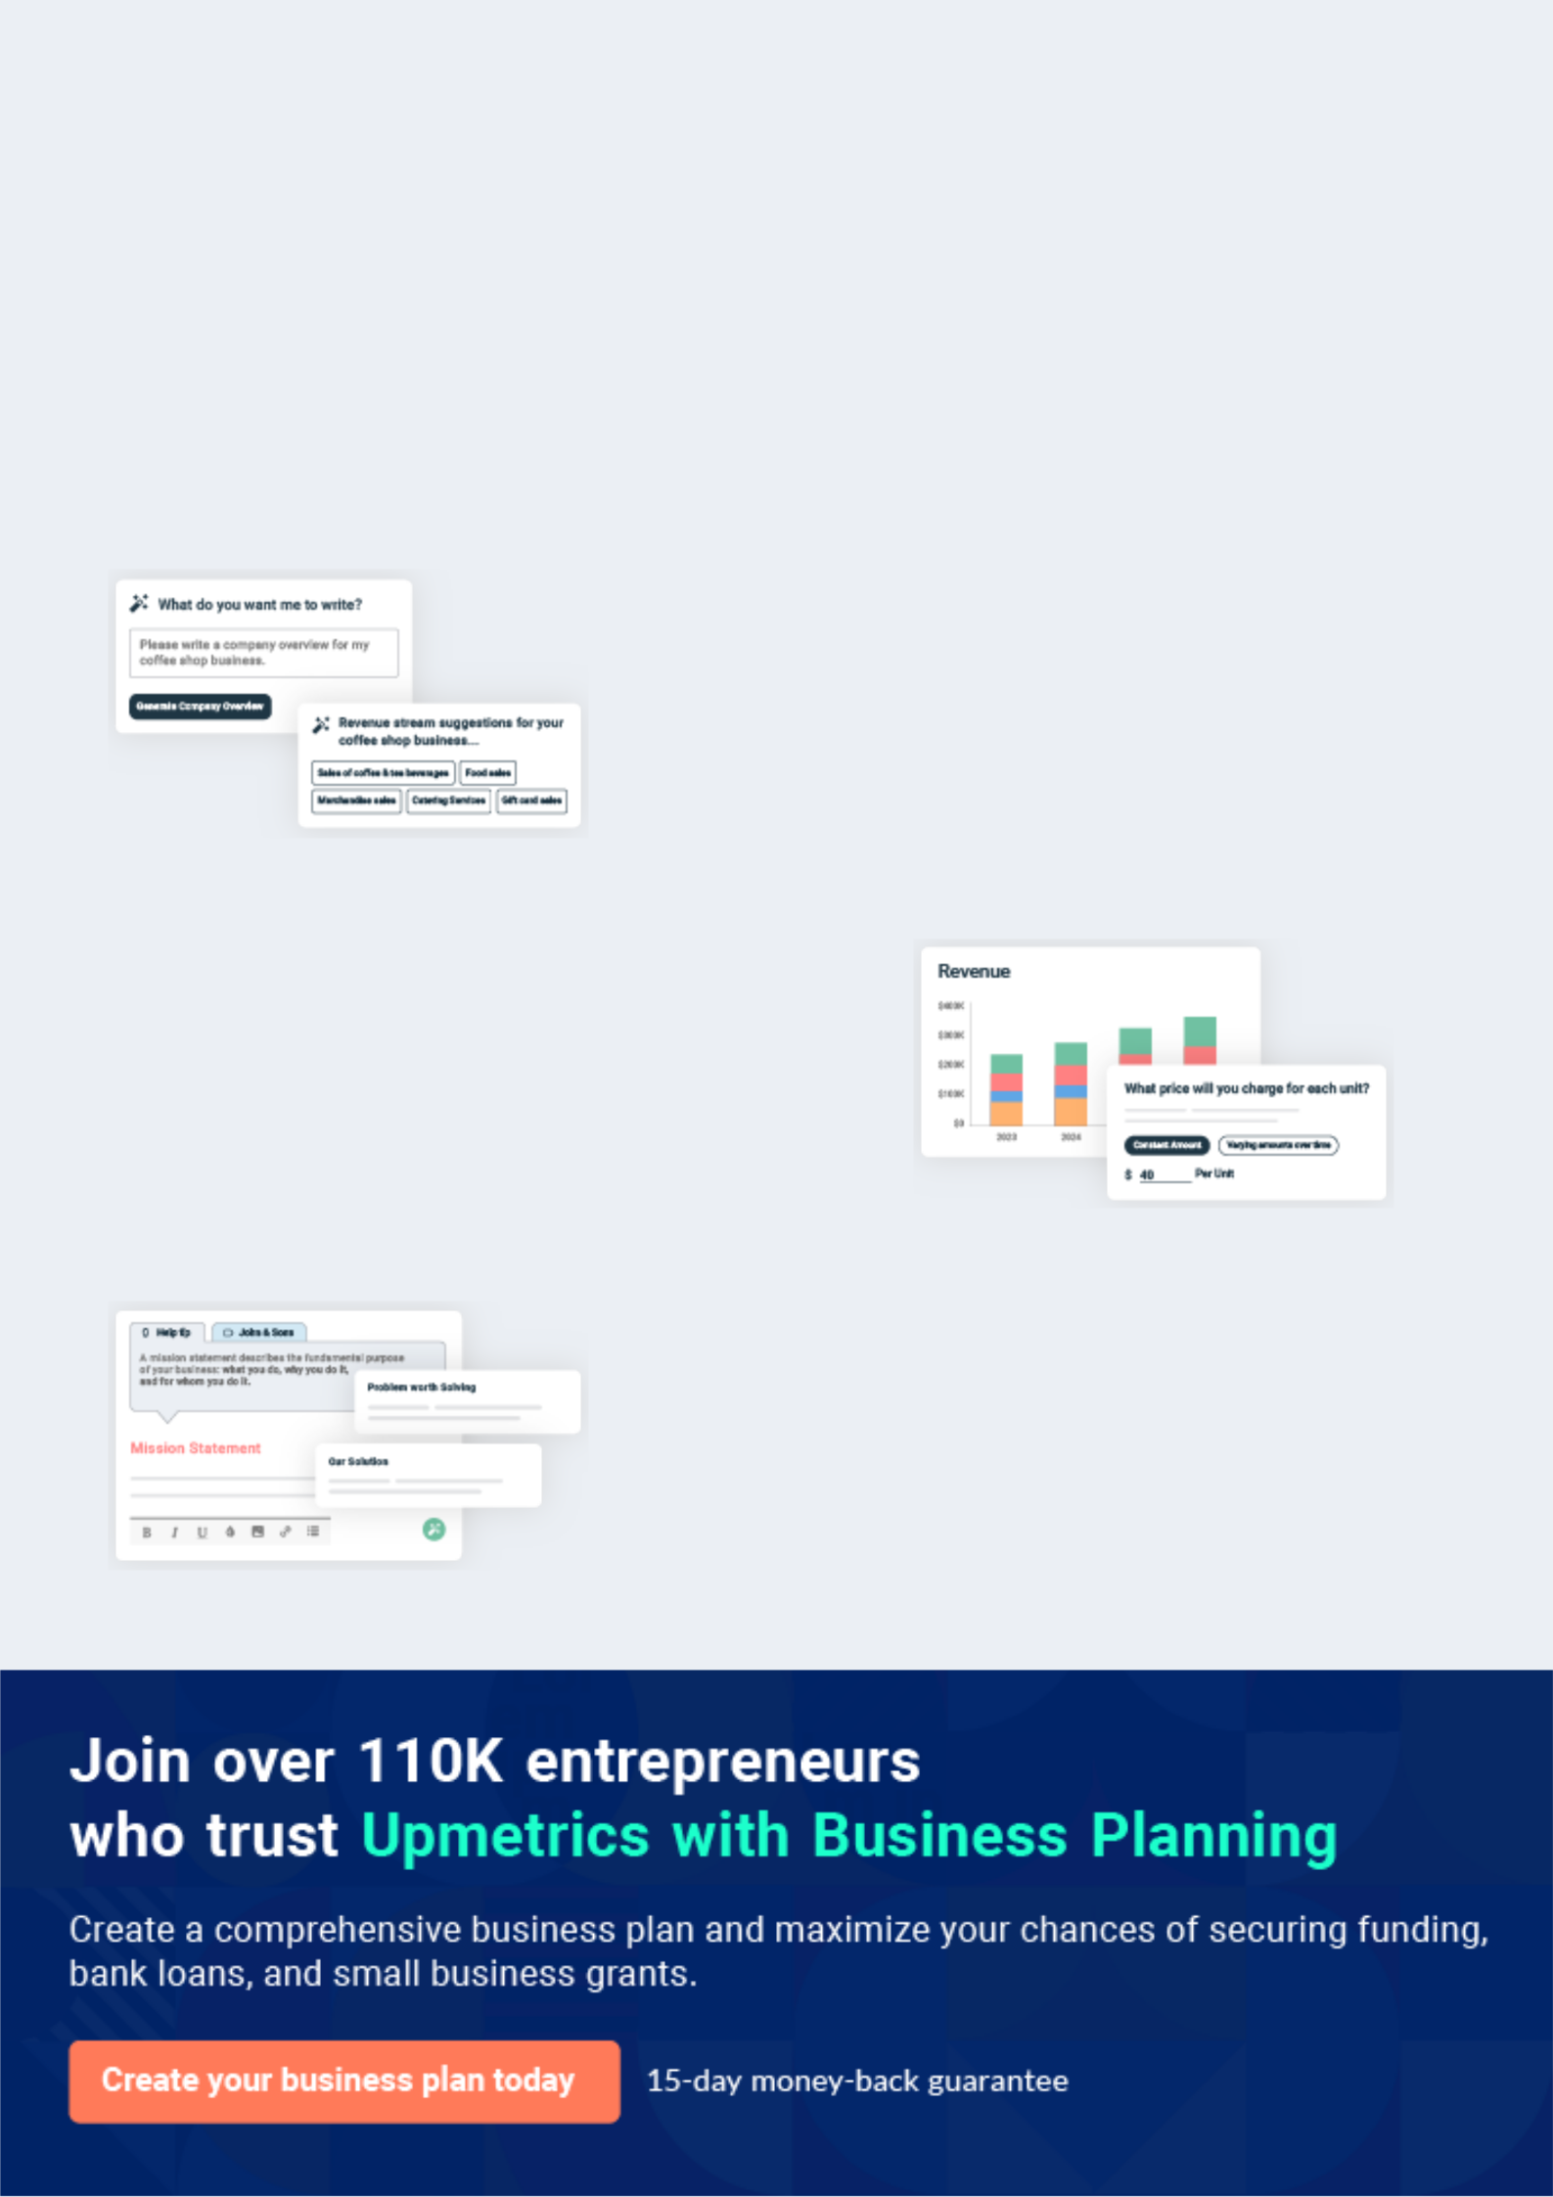
Business planning that’s simpler and faster than you think

Creating a business plan using Upmetrics to start and grow a business is literally the easiest thing in the World. Simply read the instructions and fill in the blanks. It’s as simple as that.

❛ | Upmetrics has everything you need to create a | ❜
❛ | comprehensive business plan. | ❜

AI-powered Upmetrics Assistant

AI-powered insights to streamline your plan

Not sure where to start? Upmetrics’ AI Assistant will automatically generate ideas for each section of your plan and offer improved versions of your writing, adjusting for tone, voice, and grammar or spelling errors.

Financial Forecasting Tool

All the financials are calculated for you

Forget the complex formulas and clumsy spreadsheets — with automatic financials and drag-and-drop forecasting, you can finish your plan faster and be confident that your numbers are accurate.

Business Plan Builder

Guides you like a business mentor

Upmetrics’ step-by-step instructions, prompts, and the library of 400+ sample business plans will guide you through each section of your plan as a business mentor.
Executive Summary


An executive summary is the first section of the business plan intended to provide an overview of the whole business plan.
To unlock help try Upmetrics! 

 Help tip  Vegan Restaurant Business Plan


Start your executive summary by briefly introducing your business to your readers.

This section may include the name of your vegan restaurant, its location, when it was founded,
To unlock help try Upmetrics! 

Start writing here..

Market opportunity

 Help tip  Vegan Restaurant Business Plan

Summarize your market research, including market size, growth potential, and marketing trends. Highlight the opportunities in the market and how your business will fit in to fill the gap.
To unlock help try Upmetrics! 

Start writing here..

Services Offered

 Help tip  Vegan Restaurant Business Plan

Highlight the vegan restaurant menu you offer your clients. The USPs and differentiators you offer are always a plus.
To unlock help try Upmetrics! 

Start writing here..

Marketing & Sales Strategies
To unlock help try Upmetrics!

 Help tip  Vegan Restaurant Business Plan

Outline your sales and marketing strategies—what marketing platforms you use, how you plan on acquiring customers, etc.
To unlock help try Upmetrics! 

Start writing here..

Financial Highlights

 Help tip  Vegan Restaurant Business Plan

Briefly summarize your financial projections for the initial years of business operations. Include any capital or investment requirements, associated startup costs, projected revenues, and profit forecasts.



Start writing here..
Units Sold v/s Revenue

 |  | Units Sold | Revenue
15.00k
10.00k
5.00k
0
Year 1 | Year 2 | Year 3


Financial Year |  |  | Units Sold | Revenue
Year 1 | 1,550 |  |  | $10,000
Year 2 | 1,800 |  |  | $12,000
Year 3 | 2,050 |  |  | $14,000
 Help tip |  |  Vegan Restaurant Business Plan


Summarize your executive summary section with a clear CTA, for example, inviting angel investors to discuss the potential business investment.
To unlock help try Upmetrics! 

Write a call to action for your business plan.
Company Overview

Depending on what details of your business are essential, you’ll need different elements in your business overview.
To unlock help try Upmetrics! 

 Help tip  Vegan Restaurant Business Plan

Describe your business in this section by providing all the basic information:

Describe what kind of vegan restaurant company you run and the name of it. You may
To unlock help try Upmetrics! 

Start writing here..

Ownership

 Help tip  Vegan Restaurant Business Plan

List the names of your vegan restaurant’s founders or owners. Describe what shares they own and their responsibilities for efficiently managing the business.
To unlock help try Upmetrics! 

Start writing here..
Business Owners



60% John Doe



20% Jane Doe



15% Alice Brown



5% Robert Brown
Mission statement

 Help tip  Vegan Restaurant Business Plan

Summarize your business’ objective, core principles, and values in your mission statement. This statement needs to be memorable, clear, and brief.
To unlock help try Upmetrics! 

❛ Our mission at [Green Harvest Vegan Bistro] is to provide a unique and memorable dining experience through our delicious and sustainably sourced vegan cuisine.

We are committed to promoting a healthier lifestyle and a greener planet by offering innovative dishes made from the finest organic ingredients. Our core principles include integrity, excellence, and customer satisfaction.

❜

Business history

 Help tip  Vegan Restaurant Business Plan

If you’re an established vegan restaurant, briefly describe your business history, like—when it was founded, how it evolved over time, etc.
To unlock help try Upmetrics! 

Start writing here..
Future goals

 Help tip  Vegan Restaurant Business Plan

It’s crucial to convey your aspirations and vision. Mention your short-term and long-term goals; they can be specific targets for revenue, market share, or expanding your services.
To unlock help try Upmetrics! 

Start writing here..
Market Analysis
To unlock help try Upmetrics!


 |  | Market analysis provides a clear understanding of the market in which your
 |  | printing business will run along with the target market, competitors, and
 |  | growth opportunities.
 |  |  |  | To unlock help try Upmetrics! 
 Help tip |  |  Vegan Restaurant Business Plan

To write the introduction section of your market analysis, start by clearly identifying your primary target market.
To unlock help try Upmetrics! 

Start writing here..

Target Market

 Help tip  Vegan Restaurant Business Plan

Start this section by describing your target market. Define your ideal customer and explain what types of services they prefer. Creating a buyer persona will help you easily define your target market to your readers.



Start writing here..

Market size and growth potential

 Help tip  Vegan Restaurant Business Plan

Describe your market size and growth potential and whether you will target a niche or a much broader market.
To unlock help try Upmetrics! 

Start writing here..

Market Size

Available Market | 10M
All potential vegan food consumers in the | 10M
area.


Served Market | 5M
Vegan food consumers actively seeking | 5M
restaurant options. | 5M
Target Market | 1M
Health-conscious vegans seeking | 1M
gourmet dishes. | 1M

 Help tip  Vegan Restaurant Business Plan

Identify and analyze your direct and indirect competitors. Identify their strengths and weaknesses, and describe what differentiates your vegan restaurant from them.
To unlock help try Upmetrics! 

Competitive analysis

Café Gratitude

Café Gratitude is a popular vegan restaurant chain known for its organic plant-based dishes and its unique affirmation-based ordering system, where dishes have positive names like "I am Radiant" or "I am Grateful."

Features

Comprehensive vegan menu including breakfast, lunch, dinner, and desserts.

Specialty beverages, including organic wines and craft beers.

Commitment to sustainability with eco-friendly practices in their operations.

Strengths

Strong brand recognition and a loyal customer base.

Unique and positive dining experience with its affirmation-based system.

Comprehensive menu catering to all meal types.

Weaknesses

Premium pricing, which might alienate some potential customers.

Limited presence, with locations primarily in specific urban centers.

Veggie Grill

Veggie Grill is a fast-casual vegan chain that focuses on offering comforting vegan versions of classic American dishes, from burgers to mac 'n' cheese.

Features | Strengths | Weaknesses
Wide variety of plant-based | Affordable pricing making it | Relies heavily on meat-alternative
comfort foods. | accessible to a broader | products, which might not appeal
Seasonal menu items, ensuring | demographic | to all vegans.
variety and fresh options year- | Frequent menu updates keep | Fast-casual setting might not
round. | regular customers engaged | attract those looking for a fine-
Offers online ordering and | and excited. | dining experience.
catering services. | Extensive presence with
 | multiple locations across
 | various states.

Crossroads Kitchen

Crossroads Kitchen offers a refined Mediterranean-themed vegan menu, serving dishes that are both artistic and flavorful in a sophisticated setting.

Features

Fine dining experience with a vegan twist.

Offers a brunch menu, a rarity in many vegan establishments.

Features a full bar with vegan alcoholic options.

Strengths

Upscale atmosphere, attracting a clientele willing to spend more for a premium experience.

Innovative and aesthetically pleasing dish presentations.

Renowned for its excellent customer service.

Weaknesses

Higher pricing due to its upscale positioning.

Limited seating capacity, which can lead to longer wait times during peak hours.

Market trends

 Help tip  Vegan Restaurant Business Plan

Analyze emerging trends in the industry, such as technology disruptions, changes in customer behavior or preferences, etc. Explain how your business will cope with all the trends.
To unlock help try Upmetrics! 

Start writing here..

Regulatory environment

 Help tip  Vegan Restaurant Business Plan

List regulations and licensing requirements that may affect your vegan restaurant, such as food safety regulations, menu labeling requirements, licensing & permits, alcohol licensing, etc.
To unlock help try Upmetrics! 

Start writing here..
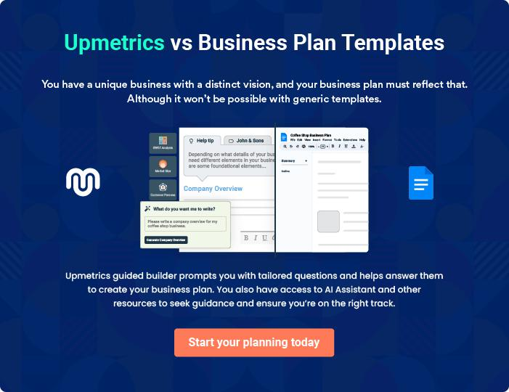
Products and Services
To unlock help try Upmetrics!

The product and services section of a vegan restaurant business plan should describe the specific services and products that will be offered to customers. To write this section should include the following:



 Help tip  Vegan Restaurant Business Plan

To craft the introduction for your "Products and Services" chapter, begin by positioning your business within its industry, emphasizing its unique strengths or value proposition.
To unlock help try Upmetrics! 

Start writing here..

 Help tip


Mention the vegan restaurant menu your business will offer. This list may include

• Appetizers
To unlock help try Upmetrics! 

Vegan restaurant menu

Appetizers: Vegan Spring Rolls


Price: [$6.95]

Crispy rolls filled with a mix of vegetables and served with a side of sweet chili sauce.

Specifications

Vegan, contains soy and wheat.
Salads: Kale and Quinoa Delight

Price: [$9.95]

A nutrient-packed salad featuring kale, quinoa, cherry tomatoes, and avocado, drizzled with a lemon-tahini dressing.

Specifications

Vegan, gluten-free, nut-free.

Main Courses: Lentil Shepherd's Pie

Price: [$14.95]

A hearty and comforting dish made with a layer of savory lentil filling and topped with creamy mashed potatoes.

Specifications

Vegan, gluten-free option available.

Pasta & Noodles: Spinach and Walnut Pesto Pasta

Price: [$12.95]

A delicious pasta dish tossed in a rich and creamy spinach and walnut pesto sauce.

Specifications

Vegan, contains nuts, gluten-free option available.
Sides: Roasted Rosemary Potatoes

Price: [$5.95]

Golden roasted potatoes seasoned with rosemary and garlic.

Specifications

Vegan, gluten-free, nut-free.

Desserts: Chocolate Avocado Mousse

Price: [$7.95]

A decadent and creamy chocolate mousse made with avocados, topped with a sprinkle of sea salt.

Specifications

Vegan, gluten-free, nut-free.

Beverages: Cucumber Mint Cooler

Price: [$4.95]

A refreshing beverage made with fresh cucumber juice, mint leaves, and a splash of lemon.

Specifications

Vegan, gluten-free, nut-free.
Mocktails: Passionfruit Fizz

Price: [$5.95]

A tropical mocktail made with passionfruit juice, soda, and a hint of lime, garnished with a slice of passionfruit.

Specifications

Vegan, gluten-free, nut-free.

Ingredient sourcing

 Help tip  Vegan Restaurant Business Plan


Mention your plan for getting ingredients if you place a high priority on ingredient quality,
sustainability, or ethical issues. Describe your attempts to use ingredients that are non-GMO,
fair trade, organic, or locally sourced.
 |  |  |  | To unlock help try Upmetrics! 
Start writing here..
Quality measures
 Help tip |  |  Vegan Restaurant Business Plan

This section should explain how you maintain quality standards and consistently provide the highest quality service.
To unlock help try Upmetrics! 

Start writing here..
Additional Services

 Help tip  Vegan Restaurant Business Plan

Mention if your vegan restaurant offers any additional services. You may include services like cooking classes, meal planning, vegan catering, private dining, etc.
To unlock help try Upmetrics! 

Start writing here..
Sales And Marketing Strategies

Writing the sales and marketing strategies section means a list of strategies you will use to attract and retain your clients.
To unlock help try Upmetrics! 

 Help Tip  Vegan Restaurant Business Plan


To create an effective introduction for your "Sales and Marketing Strategies" chapter, start by setting the stage within your specific industry or market.
To unlock help try Upmetrics! 

Start writing here..

Unique Selling Proposition (USP)

 Help tip  Vegan Restaurant Business Plan

Define your business’s USPs depending on the market you serve, the equipment you use, and the unique services you provide. Identifying USPs will help you plan your marketing strategies.
To unlock help try Upmetrics! 

Start writing here..

Pricing Strategy

 Help tip  Vegan Restaurant Business Plan

Describe your pricing strategy—how you plan to price your dishes and stay competitive in the local market. You can mention any discounts you plan on offering to attract new customers.
To unlock help try Upmetrics! 

Start writing here..

 Help tip  Vegan Restaurant Business Plan
To unlock help try Upmetrics!

Discuss your marketing strategies to market your services. You may include some of these marketing strategies in your business plan—social media marketing, content marketing, and print marketing.



Marketing strategies

Online


Social Media

Leveraging platforms like Instagram, Facebook, and Pinterest to showcase our culinary creations, share behind-the-scenes looks, and engage with our audience.

Content Marketing

Regular blog posts on our website about vegan lifestyles, health benefits, recipes, and more.

Offline

Print Marketing

Local magazine features, flyers, and partnerships with vegan and health-centric publications to reach a broader demographic.

 Help tip  Vegan Restaurant Business Plan

Outline the strategies you’ll implement to maximize your sales. Your sales strategies may include partnering with other businesses, influencer marketing, offering referral programs, etc.
To unlock help try Upmetrics! 

Sales strategies

Partner with Businesses

Collaborating with local vegan product companies or wellness centers to offer bundled deals or promotions.

Referral Programs

Offering discounts or specials to customers who refer friends and family, incentivizing word-of-mouth promotion.

Influencer Marketing

Partnering with vegan influencers to showcase our menu, enhancing our reach and credibility.

 Help tip  Vegan Restaurant Business Plan

Describe your customer retention strategies and how you plan to execute them. For instance, introducing loyalty programs, discounts or offers, personalized service, etc.
To unlock help try Upmetrics! 

Customer retention

Loyalty Programs

Rewarding our regular diners with points for every visit, which can be redeemed for complimentary dishes or discounts.

Special Offers

Exclusive deals for our newsletter subscribers or members.

Personalized Service

Remembering our regulars' favorite

dishes, personalizing their dining

experience, and seeking feedback

to continuously improve.

Operations Plan
To unlock help try Upmetrics!

 |  | When writing the operations plan section, it’s important to consider the
 |  | various aspects of your business operations.
 |  |  |  | To unlock help try Upmetrics! 
 Help tip |  |  Vegan Restaurant Business Plan


To create an effective introduction for your "Operational Plan" chapter, start by emphasizing the
pivotal role of efficient operations in the success of your business, underscoring how they
directly impact the quality of services delivered.
 |  |  |  | To unlock help try Upmetrics! 
Start writing here..
Staffing & Training
 Help tip |  |  Vegan Restaurant Business Plan

Mention your business’s staffing requirements, including the number of employees, chefs, or
other staff needed. Include their qualifications, the training required, and the duties they will
perform.
 |  |  |  | To unlock help try Upmetrics! 
Start writing here..
Operational Process
 Help tip |  |  Vegan Restaurant Business Plan

Outline the processes and procedures you will use to run your vegan restaurant. Your operational processes may include menu planning & development, kitchen operations, inventory management, staffing & training, etc.



Start writing here..

Equipment & Machinery

 Help tip  Vegan Restaurant Business Plan

Include the list of equipment and machinery required for a vegan restaurant, such as an oven, blender, food processor, freezer, safety equipment, refrigerators, etc.
To unlock help try Upmetrics! 

Start writing here..
Management Team

The management team section provides an overview of the individuals responsible for running your business plan.
To unlock help try Upmetrics! 

 Help tip  Vegan Restaurant Business Plan

To craft an introduction for your "Management Team" chapter, begin by emphasizing the crucial role of leadership in the success of any business.
To unlock help try Upmetrics! 

Start writing here..

Key managers

 Help tip  Vegan Restaurant Business Plan

Introduce your management and key members of your team, and explain their roles and responsibilities.
To unlock help try Upmetrics! 

Start writing here..


JOHN DOE

CEO - john.doe@example.com

John holds a Bachelor’s degree in Business Administration from the University of California and has over 15 years of experience in the food and beverage industry.


Before founding [Green Harvest Vegan Bistro], he worked as a manager at a renowned vegan restaurant in California. His passion for vegan cuisine and sustainable living drove him to start his own venture.

His responsibilities include strategic planning, financial management, and ensuring the highest quality of service is provided to customers.

JANE DOE

Chief Operating Officer (COO) - jane.doe@example.com

Jane holds a Master’s degree in Hospitality Management from Cornell University. She has 10 years of experience in the restaurant industry, specializing in operations management.


Her keen attention to detail and exceptional organizational skills are vital in managing the day-to-day operations of the restaurant and ensuring everything runs smoothly.


ALICE BROWN

CMO - alice.brown@example.com

Alice graduated with a degree in Marketing from the University of Texas and has a background in brand management for several top restaurants in the U.S.

She brings a creative approach to marketing strategies that resonate with our target audience and build a strong brand presence.


ROBERT BROWN

Operations Manager - robert.brown@example.com

Robert has a degree in Culinary Arts from Johnson & Wales University and experience as a chef in top vegan restaurants.

His culinary expertise and knowledge of kitchen operations are crucial in managing the restaurant's menu and kitchen staff.

Organizational structure

 Help tip  Vegan Restaurant Business Plan

Explain the organizational structure of your management team. Include the reporting line and decision-making hierarchy.
To unlock help try Upmetrics! 

Start writing here..

Organization chart


John Doe

CEO


 |  |  | Richard White
Jane Doe | Alice Brown |  | Business Strategy
COO | CMO |  | Advisor

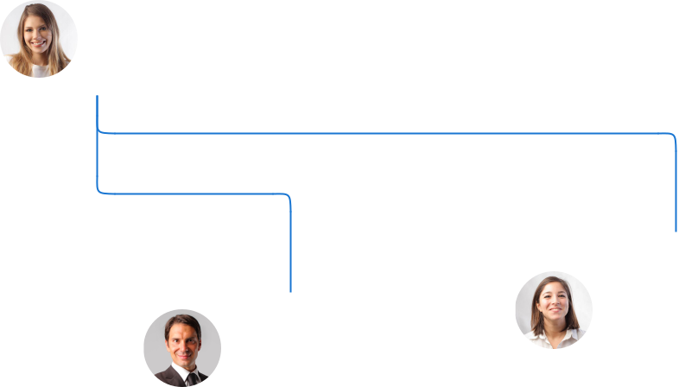

 | Emily Davis
Robert Brown | Sustainability
Operations Manager | Consultant

Compensation plan

 Help tip  Vegan Restaurant Business Plan

Describe your compensation plan for the management and staff. Include their salaries, incentives, and other benefits.
To unlock help try Upmetrics! 

Start writing here..
 Help tip

Mentioning advisors or consultants in your business plans adds credibility to your business idea.
To unlock help try Upmetrics! 

Advisors/Consultants


RICHARD WHITE

Business Strategy Advisor - richard.white@example.com

Richard has a PhD in Business Strategy from Harvard University and over 20 years of experience in the restaurant industry.

He provides valuable insights that guide the strategic direction of [Green Harvest Vegan Bistro].


EMILY DAVIS

Sustainability Consultant - emily.davis@example.com

Emily has a Master’s degree in Environmental Science from Stanford University and specializes in sustainable practices in the food industry.

She helps the restaurant incorporate eco-friendly practices in its operations.
Financial Plan

When writing the financial plan section of a business plan, it’s important to provide a comprehensive overview of your financial projections for the first few years of your business, You may provide the following:
To unlock help try Upmetrics! 

 Help tip  Vegan Restaurant Business Plan


To create an effective introduction for your "Financial Plan" chapter, begin by stressing the critical role of a well-structured financial plan in the success of your venture.
To unlock help try Upmetrics! 

Start writing here..

 Help tip  Vegan Restaurant Business Plan

Describe details such as projected revenue, operational costs, and service costs in your projected profit and loss statement. Make sure to include your business’s expected net profit or loss.
To unlock help try Upmetrics! 

Profit & loss statement

Revenue

Cost Of Sales

General Costs

Revenue Specific Costs

Personnel Costs (Direct

Labor)

Gross Margin

Gross Margin (%)

Operating Expense

Payroll Expense

(Indirect Labor)

General Expense

Bad Debt

Amortization of Current

Assets

2023-24 | 2024-25 | 2025-26 | 2026-27 | 2027-28
$0 | $0 | $0 | $0 | $0

$0 | $0 | $0 | $0 | $0
$0 | $0 | $0 | $0 | $0
$0 | $0 | $0 | $0 | $0
$0 | $0 | $0 | $0 | $0

$0 | $0 | $0 | $0 | $0
0% | 0% | 0% | 0% | 0%

$0 | $0 | $0 | $0 | $0
$0 | $0 | $0 | $0 | $0
$0 | $0 | $0 | $0 | $0
$0 | $0 | $0 | $0 | $0
$0 | $0 | $0 | $0 | $0

EBITDA

Additional Expense

Long Term

Depreciation

Gain or loss from Sale

of Assets

EBIT

Interest Expenses

EBT

Income Tax Expense

Total Expense

Net Income

Net Income (%)

2023-24 | 2024-25 | 2025-26 | 2026-27 | 2027-28
$0 | $0 | $0 | $0 | $0
$0 | $0 | $0 | $0 | $0
$0 | $0 | $0 | $0 | $0
$0 | $0 | $0 | $0 | $0
$0 | $0 | $0 | $0 | $0
$0 | $0 | $0 | $0 | $0
$0 | $0 | $0 | $0 | $0
$0 | $0 | $0 | $0 | $0
$0 | $0 | $0 | $0 | $0
$0 | $0 | $0 | $0 | $0
0% | 0% | 0% | 0% | 0%
 |  |  | 2023-24 |  | 2024-25 | 2025-26 | 2026-27 | 2027-28
Retained Earning |  |  | $0 |  | $0 | $0 | $0 | $0
Opening
Owner's Distribution |  |  | $0 |  | $0 | $0 | $0 | $0
Retained Earning |  |  | $0 |  | $0 | $0 | $0 | $0
Closing
 Help tip |  |  |  Vegan Restaurant Business Plan


The cash flow for the first few years of your operation should be estimated and described in this section. This may include billing invoices, payment receipts, loan payments, and any other cash flow statements.
To unlock help try Upmetrics! 

Cash flow statement

 | 2023-24 | 2024-25 | 2025-26 | 2026-27 | 2027-28
Cash Received | $0 | $0 | $0 | $0 | $0
Cash Paid | $0 | $0 | $0 | $0 | $0
COS & General Expenses | $0 | $0 | $0 | $0 | $0
Salary & Wages | $0 | $0 | $0 | $0 | $0
Interest | $0 | $0 | $0 | $0 | $0

Sales Tax

Income Tax

Net Cash From

Operations

Assets Sell

Assets Purchase

Net Cash From

Investments

Amount Received

Loan Received

Common Stock

Preferred Stock

Owner's Contribution

Amount Paid

2023-24 | 2024-25 | 2025-26 | 2026-27 | 2027-28
$0 | $0 | $0 | $0 | $0
$0 | $0 | $0 | $0 | $0
$0 | $0 | $0 | $0 | $0

$0 | $0 | $0 | $0 | $0
$0 | $0 | $0 | $0 | $0
$0 | $0 | $0 | $0 | $0

$0 | $0 | $0 | $0 | $0
$0 | $0 | $0 | $0 | $0

$0 | $0 | $0 | $0 | $0
$0 | $0 | $0 | $0 | $0
$0 | $0 | $0 | $0 | $0

Loan Capital $0 $0 $0 $0 $0

 |  |  | 2023-24 |  | 2024-25 | 2025-26 | 2026-27 | 2027-28
Dividends & Distributions |  |  | $0 |  | $0 | $0 | $0 | $0
Net Cash From |  |  | $0 |  | $0 | $0 | $0 | $0
Financing
Summary
Starting Cash |  |  | $0 |  | $0 | $0 | $0 | $0
Cash In |  |  | $0 |  | $0 | $0 | $0 | $0
Cash Out |  |  | $0 |  | $0 | $0 | $0 | $0
Change in Cash |  |  | $0 |  | $0 | $0 | $0 | $0
Ending Cash |  |  | $0 |  | $0 | $0 | $0 | $0
 Help tip |  |  Vegan Restaurant Business Plan

Create a projected balance sheet documenting your vegan restaurant’s assets, liabilities, and equity.

To unlock help try Upmetrics! 

Balance sheet

 | 2023-24 | 2024-25 | 2025-26 | 2026-27 | 2027-28
Assets | $0 | $0 | $0 | $0 | $0
Current Assets | $0 | $0 | $0 | $0 | $0
Cash | $0 | $0 | $0 | $0 | $0
Accounts Receivable | $0 | $0 | $0 | $0 | $0
Inventory | $0 | $0 | $0 | $0 | $0
Other Current Assets | $0 | $0 | $0 | $0 | $0
Long Term Assets | $0 | $0 | $0 | $0 | $0
Gross Long Term Assets | $0 | $0 | $0 | $0 | $0
Accumulated Depreciation | $0 | $0 | $0 | $0 | $0

Liabilities & Equity | $0 | $0 | $0 | $0 | $0
Liabilities | $0 | $0 | $0 | $0 | $0
Current Liabilities | $0 | $0 | $0 | $0 | $0
Accounts Payable | $0 | $0 | $0 | $0 | $0
Income Tax Payable | $0 | $0 | $0 | $0 | $0
Sales Tax Payable | $0 | $0 | $0 | $0 | $0
Short Term Debt | $0 | $0 | $0 | $0 | $0
 | 2023-24 | 2024-25 | 2025-26 | 2026-27 | 2027-28
Long Term Liabilities | $0 | $0 | $0 | $0 | $0
Long Term Debt | $0 | $0 | $0 | $0 | $0
Equity | $0 | $0 | $0 | $0 | $0
Paid-in Capital | $0 | $0 | $0 | $0 | $0
Common Stock | $0 | $0 | $0 | $0 | $0
Preferred Stock | $0 | $0 | $0 | $0 | $0
Owner's Contribution | $0 | $0 | $0 | $0 | $0
Retained Earnings | $0 | $0 | $0 | $0 | $0

Check | $0 |  |  | $0 | $0 | $0 | $0
 Help tip |  |  Vegan Restaurant Business Plan

Determine and mention your business’s break-even point—the point at which your business costs and revenue will be equal.

This exercise will help you understand how much revenue you need to generate to sustain or be profitable.
To unlock help try Upmetrics! 

Break-even Analysis

 | 2023-24 | 2024-25 | 2025-26 | 2026-27 | 2027-28
Starting Revenue | $0 | $0 | $0 | $0 | $0
Net Revenue | $0 | $0 | $0 | $0 | $0
Closing Revenue | $0 | $0 | $0 | $0 | $0

Starting Expense | $0 | $0 | $0 | $0 | $0
Net Expense | $0 | $0 | $0 | $0 | $0
Closing Expense | $0 | $0 | $0 | $0 | $0

Is Break Even? | 0 | 0 | 0 | 0 | 0
Break Even Month | 0 | 0 | 0 | 0 | 0
Days Required | 0 | 0 | 0 | 0 | 0
Break Even Revenue | $0 | $0 | $0 | $0 | $0
Break Even Units
Financing needs

 Help tip  Vegan Restaurant Business Plan

Calculate costs associated with starting a vegan restaurant, and estimate your financing needs and how much capital you need to raise to operate your business.
To unlock help try Upmetrics! 

Start writing here..
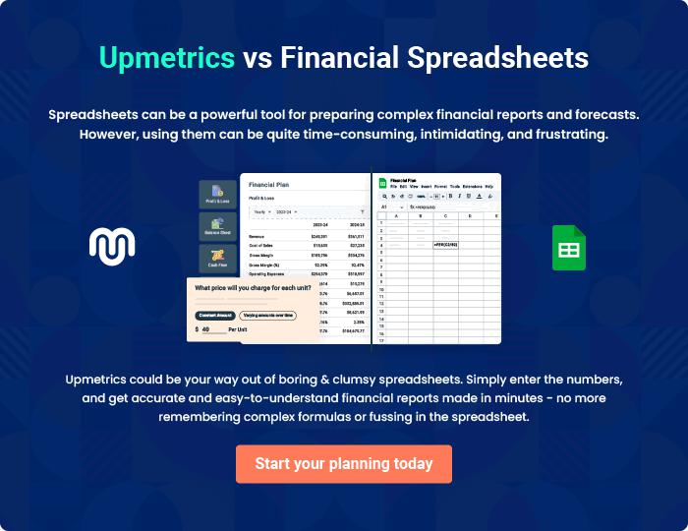
Appendix

When writing the appendix section, you should include any additional information that supports the main content of your plan. This may include financial statements, market research data, legal documents, and other
To unlock help try Upmetrics! 
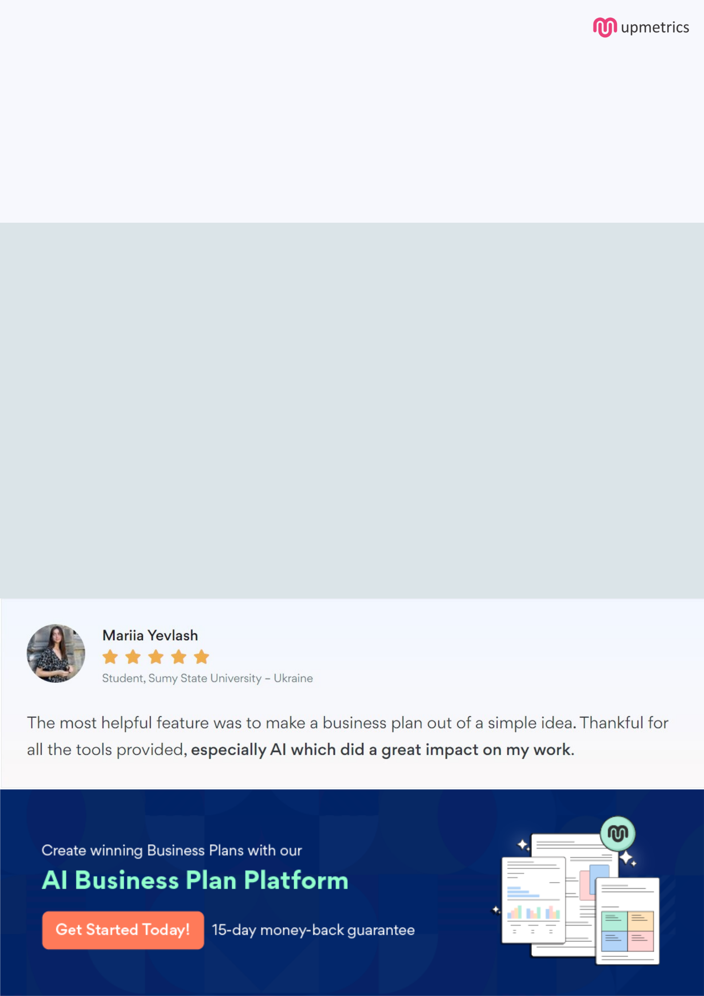
Create a winning business plan that gets you funded

Creating a stunning and investment-ready plan requires no writing, graphic designing, or financial planning expertise.

Upmetrics has all the features required to help you create a comprehensive business plan—from start to finish. Make no mistakes, it’s the modern way of planning to structure ideas, make plans, and create stunning pitch decks to awe investors.

Pitch decks that impress investors

Create pitch decks that provide a visual representation of your business, engage investors, and make them want to invest in your business idea.

Interactive plans in no time

Import business plan sections like—SWOT analysis, comparison tables, and others to create an interactive business plan. No designing skills are required.

Stunning cover page designs

With Upmetrics, you have the liberty to choose from multiple stunning cover page designs. Choose a creative design and make your plan stand out.

Online sharing made simple

Upmetrics makes online sharing quick and easier for users. Easily share your business plans with a link while tracking reader activity.

500+ sample business plans

Simply import a template from our library of sample plans into the editor and start customizing it to make it yours. It takes only a few clicks to get started.

Collaborate with team in real-time

Invite team members, initiate conversations, discuss ideas & strategies, share feedback, and work on a business plan in real-time.

