Truck Owner Operator Business Plan



Business Plan

2023


On the Road to Success

Information provided in this business plan is unique to this business and confidential; therefore, anyone reading this plan agrees not to disclose any of the information in this business plan without prior written permission of the company.

Prepared By

John Doe

10200 Bolsa Ave, Westminster, CA, 92683

info@example.com

(650) 359-3153 http://www.example.com

Table of Contents

Executive Summary | 6
Market opportunity | 6
Services Offered | 6
Marketing & Sales Strategies | 7
Financial Highlights | 7
Units Sold v/s Revenue | 8

Company Overview | 9
Ownership | 9
Mission statement | 10
Business history | 10
Future goals | 11

Market Analysis | 12
Target Market | 12
Market size and growth potential | 12
Market Size | 13
Competitive analysis | 13
Swift Transport Services | 13
Rapid Roadways | 14
Nationwide Haulers | 14
Market trends | 14
Regulatory environment | 15

Products and Services | 16
Services | 16
Full Truckload (FTL) Services | 16
Less Than Truckload (LTL) Services | 17
Expedited Shipping | 17
Warehousing and Distribution | 18
Intermodal Transportation | 18
Local Delivery | 19
Specialized Services | 19
Additional Services | 19

Sales And Marketing Strategies | 20
Unique Selling Proposition (USP) | 20
Pricing Strategy | 20
Marketing strategies | 21
Online | 21
Offline | 21
Sales strategies | 22
Customer retention | 23

Operations Plan | 24
Staffing & Training | 24
Operational Process | 24
Equipment | 25

Management Team | 26
Key managers | 26
John Doe | 26
Jane Doe | 27
Alice Brown | 27
Robert Brown | 28
Organizational structure | 28
Organization chart | 29
Compensation plan | 29
Advisors/Consultants | 30
Dr. Thomas Richardson | 30
Ms. Angela Martinez | 30
Financial Plan
Financial Plan | 31

Profit & loss statement 31

Cash flow statement | 34
Balance sheet | 36
Break-even Analysis | 38
Financing needs | 40
Appendix
Appendix | 42
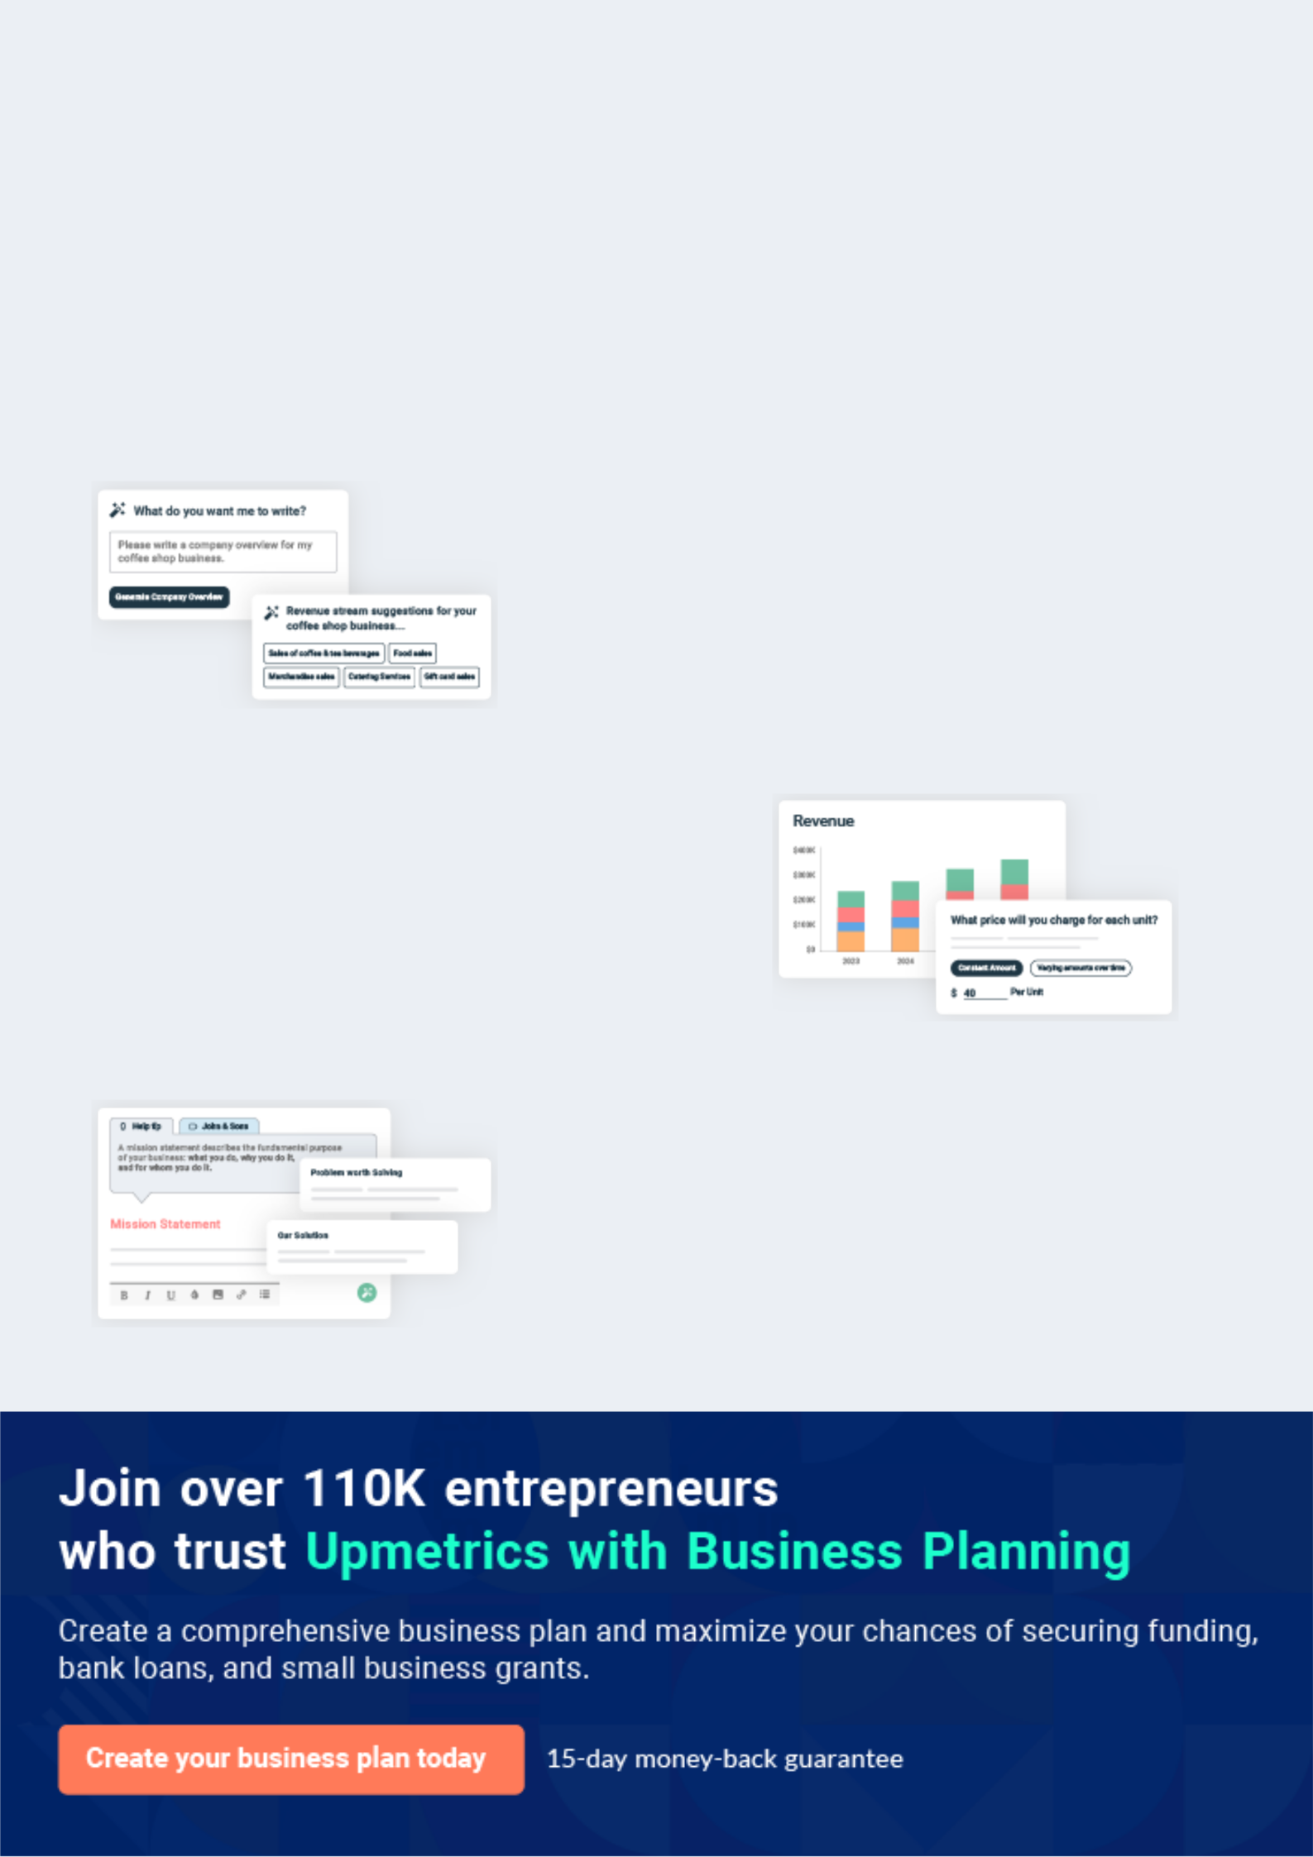
Business planning that’s simpler and faster than you think

Creating a business plan using Upmetrics to start and grow a business is literally the easiest thing in the World. Simply read the instructions and fill in the blanks. It’s as simple as that.

❛ | Upmetrics has everything you need to create a | ❜
❛ | comprehensive business plan. | ❜

AI-powered Upmetrics Assistant

AI-powered insights to streamline your plan

Not sure where to start? Upmetrics’ AI Assistant will automatically generate ideas for each section of your plan and offer improved versions of your writing, adjusting for tone, voice, and grammar or spelling errors.

Financial Forecasting Tool

All the financials are calculated for you

Forget the complex formulas and clumsy spreadsheets — with automatic financials and drag-and-drop forecasting, you can finish your plan faster and be confident that your numbers are accurate.

Business Plan Builder

Guides you like a business mentor

Upmetrics’ step-by-step instructions, prompts, and the library of 400+ sample business plans will guide you through each section of your plan as a business mentor.
Executive Summary


An executive summary is the first section of the business plan intended to provide an overview of the whole business plan.
To unlock help try Upmetrics! 

 Help tip  Truck Owner Operator Business Plan


Start your executive summary by briefly introducing your business to your readers.

This section may include the name of your business, its location, when it was founded, the type
To unlock help try Upmetrics! 

Start writing here..

Market opportunity

 Help tip  Truck Owner Operator Business Plan

Summarize your market research, including market size, growth potential, and marketing trends. Highlight the opportunities in the market and how your business will fit in to fill the gap.
To unlock help try Upmetrics! 

Start writing here..

Services Offered

 Help tip  Truck Owner Operator Business Plan

Highlight the truck owner-operator services you offer your clients. The USPs and differentiators you offer are always a plus.
To unlock help try Upmetrics! 

Start writing here..

Marketing & Sales Strategies
To unlock help try Upmetrics!

 Help tip  Truck Owner Operator Business Plan

Outline your sales and marketing strategies—what marketing platforms you use, how you plan on acquiring customers, etc.
To unlock help try Upmetrics! 

Start writing here..

Financial Highlights

 Help tip  Truck Owner Operator Business Plan

Briefly summarize your financial projections for the initial years of business operations. Include any capital or investment requirements, associated startup costs, projected revenues, and profit forecasts.



Start writing here..
Units Sold v/s Revenue

 |  | Units Sold | Revenue
15.00k
10.00k
5.00k
0
Year 1 | Year 2 | Year 3


Financial Year |  | Units Sold |  | Revenue
Year 1 | 1,550 |  |  | $10,000
Year 2 | 1,800 |  |  | $12,000
Year 3 | 2,050 |  |  | $14,000
 Help tip |  |  Truck Owner Operator Business Plan


Summarize your executive summary section with a clear CTA, for example, inviting angel investors to discuss the potential business investment.
To unlock help try Upmetrics! 

Write a call to action for your business plan.
Company Overview

Depending on what details of your business are essential, you’ll need different elements in your business overview.
To unlock help try Upmetrics! 

 Help tip  Truck Owner Operator Business Plan

Describe your business in this section by providing all the basic information:

Describe what kind of company you run and the name of it. You may specialize in one of the
To unlock help try Upmetrics! 

Start writing here..

Ownership

 Help tip  Truck Owner Operator Business Plan

List the names of your business’s founders or owners. Describe what shares they own and their responsibilities for efficiently managing the business.
To unlock help try Upmetrics! 

Start writing here..
Mission statement

 Help tip  Truck Owner Operator Business Plan

Summarize your business’ objective, core principles, and values in your mission statement. This statement needs to be memorable, clear, and brief.
To unlock help try Upmetrics! 

❛ At [Transcend Trucking Co.], our mission is clear and straightforward: “To provide exceptional and reliable transportation solutions, ensuring timely deliveries and unparalleled customer service, while upholding the highest standards of safety and efficiency.”

We are driven by our core principles of integrity, innovation, and excellence, striving to exceed expectations and set new standards in the trucking industry.

❜

Business history

 Help tip  Truck Owner Operator Business Plan

If you’re an established truck owner operator service provider, briefly describe your business history, like—when it was founded, how it evolved over time, etc.
To unlock help try Upmetrics! 

Start writing here..
Future goals

 Help tip  Truck Owner Operator Business Plan

It’s crucial to convey your aspirations and vision. Mention your short-term and long-term goals; they can be specific targets for revenue, market share, or expanding your services.
To unlock help try Upmetrics! 

Start writing here..
Market Analysis
To unlock help try Upmetrics!


 |  | Market analysis provides a clear understanding of the market in which your
 |  | printing business will run along with the target market, competitors, and
 |  | growth opportunities.
 |  |  |  | To unlock help try Upmetrics! 
 Help tip |  |  Truck Owner Operator Business Plan

To write the introduction section of your market analysis, start by clearly identifying your primary target market.
To unlock help try Upmetrics! 

Start writing here..

Target Market

 Help tip  Truck Owner Operator Business Plan

Start this section by describing your target market. Define your ideal customer and explain what types of services they prefer. Creating a buyer persona will help you easily define your target market to your readers.



Start writing here..

Market size and growth potential

 Help tip  Truck Owner Operator Business Plan

Describe your market size and growth potential and whether you will target a niche or a much broader market.
To unlock help try Upmetrics! 

Start writing here..

Market Size

Available Market | 50M
Total potential trucking demand in the | 50M
region
Served Market | 15M
Portion of available market served by all | 15M
players


Target Market | 3M
Niche market [Transcend Trucking Co.] | 3M
aims to capture | 3M

 Help tip  Truck Owner Operator Business Plan

Identify and analyze your direct and indirect competitors. Identify their strengths and weaknesses, and describe what differentiates your business from them.
To unlock help try Upmetrics! 

Competitive analysis

Swift Transport Services

Swift Transport Services is a well-established player in the trucking industry, with a large fleet of trucks serving customers nationwide. They have a strong reputation for reliability and extensive coverage, making them a formidable competitor in the market.

Features | Strengths | Weaknesses
Nationwide network with | Established brand with a strong | Higher pricing compared to
extensive coverage | market presence | smaller operators
Advanced fleet management | Robust infrastructure and | Some reports of customer
and tracking systems | logistics capabilities | service challenges
Variety of truck types to meet | Diverse service offerings | Potential for less personalized
different customer needs | catering to various industries | service due to size

Rapid Roadways

Rapid Roadways is a growing trucking company known for its quick turnaround times and competitive pricing. They have developed a strong regional presence, with a focus on customer service and efficiency.

Features | Strengths | Weaknesses
Quick and reliable delivery | Agility and ability to quickly | Limited nationwide coverage
times | adapt to market changes | compared to larger competitors
Competitive pricing structures | Strong customer service | Smaller fleet size may limit
Strong regional network with | reputation | capacity during peak times
local expertise | Competitive pricing, attracting | Less established brand and
 | cost-sensitive customers | market presence

Nationwide Haulers

Nationwide Haulers is a well-rounded trucking company with a balanced focus on both nationwide coverage and customer service. They have invested heavily in technology to improve their operations and customer experience.

Features

Strengths Weaknesses

Extensive nationwide network

State-of-the-art tracking and fleet management systems

Focus on customer service and reliability

Strong nationwide presence and coverage

Investment in technology for operational efficiency

Reputation for reliability and consistent service

Potential for higher operating costs due to technology investments

May face challenges with personalized service at scale

Competitive market may impact pricing strategies

Market trends

 Help tip  Truck Owner Operator Business Plan

Analyze emerging trends in the industry, such as technology disruptions, changes in customer behavior or preferences, etc. Explain how your business will cope with all the trends.
To unlock help try Upmetrics! 

Start writing here..

Regulatory environment
To unlock help try Upmetrics!

 Help tip  Truck Owner Operator Business Plan

List regulations and licensing requirements that may affect your truck owner operator company, such as federal motor carrier safety administration, Department of Transportation, tax laws, etc.



Start writing here..
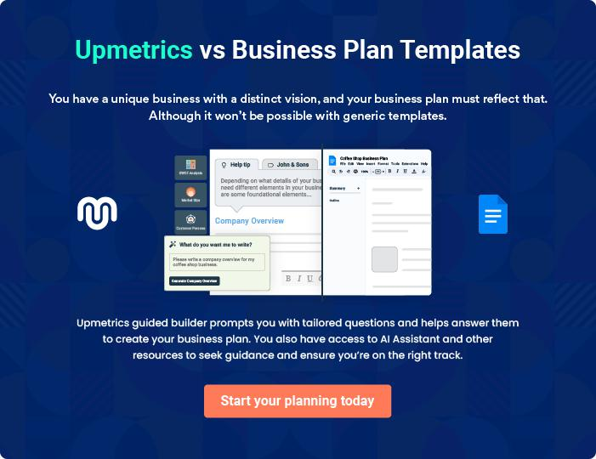
Products and Services

The product and services section of the truck owner operator business plan should describe the specific services and products that will be offered to customers. To write this section should include the following:
To unlock help try Upmetrics! 

 Help tip  Truck Owner Operator Business Plan

To craft the introduction for your "Products and Services" chapter, begin by positioning your business within its industry, emphasizing its unique strengths or value proposition.
To unlock help try Upmetrics! 

Start writing here..

 Help tip


Mention the truck owner operator services your business will offer. This list may include services like,
To unlock help try Upmetrics! 

Services

Full Truckload (FTL) Services
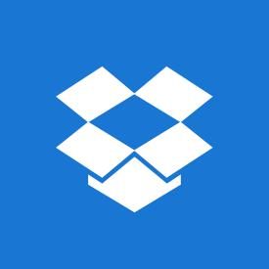

Price: Starting at [$2.00] per mile

Our FTL services provide a dedicated trailer for large shipments, ensuring direct and secure transportation.

Specifications

- Maximum Load: [45,000 lbs]

- Trailer Type: Enclosed 53-foot

- Service Area: Nationwide

- Delivery Time: As per distance and client requirements
Less Than Truckload (LTL) Services

Price: Varies based on weight, starting at [$1.50] per pound

Perfect for smaller shipments, our LTL services offer cost-effective transportation without the need for a full trailer.

Specifications

- Maximum Load: [10,000 lbs]

- Trailer Type: Enclosed 53-foot (shared)

- Service Area: Nationwide

- Delivery Time: As per distance and consolidation

Expedited Shipping

Price: Custom quote based on distance and urgency

When time is of the essence, our expedited shipping guarantees the fastest delivery possible, utilizing our dedicated team and resources.

Specifications

- Availability: 24/7

- Delivery Time: Guaranteed as per client requirements

- Additional Features: GPS tracking and priority routing
Warehousing and Distribution

Price: Monthly fee starting at [$500] + additional handling charges

Beyond transportation, we offer comprehensive warehousing solutions, aiding in inventory management, order fulfillment, and distribution.

Specifications

- Facility Size: [50,000 sq. ft.]

- Security: 24/7 CCTV and onsite security

- Additional Services: Inventory management software, order processing

Intermodal Transportation

Price: Custom quote based on route and cargo type

Our intermodal services optimize the shipping process, utilizing a combination of trucks, trains, and ships.

Specifications

- Container Types: [20 ft, 40 ft]

- Service Area: International and domestic

- Additional Features: Eco-friendly, cost-effective
Local Delivery

Price: Starting at [$50] per delivery

Catering to the immediate community, our local delivery services ensure fast and reliable transport within the [Specific Area/Region].

Specifications

- Maximum Distance: [50 miles]

- Vehicle Type: Varies based on load

- Delivery Time: Same-day options available

Specialized Services

Price: Custom quote based on cargo type and requirements

Our specialized services cater to niche markets, ensuring the safe and compliant transport of unique or sensitive cargo.

Specifications

- Cargo Types: [Aerospace components, art, antiques]

- Custom Solutions: Tailored to client specifications

- Additional Features: Climate control, secure transport options

Additional Services

 Help tip  Truck Owner Operator Business Plan

Mention if your company offers any additional services. You may include services like warehousing, driver services, maintenance & repair services, etc.
To unlock help try Upmetrics! 

Start writing here..

Sales And Marketing Strategies

Writing the sales and marketing strategies section means a list of strategies you will use to attract and retain your clients.
To unlock help try Upmetrics! 

 Help Tip  Truck Owner Operator Business Plan


To create an effective introduction for your "Sales and Marketing Strategies" chapter, start by setting the stage within your specific industry or market.
To unlock help try Upmetrics! 

Start writing here..

Unique Selling Proposition (USP)

 Help tip  Truck Owner Operator Business Plan

Define your business’s USPs depending on the market you serve, the equipment you use, and the unique services you provide. Identifying USPs will help you plan your marketing strategies.
To unlock help try Upmetrics! 

Start writing here..

Pricing Strategy

 Help tip  Truck Owner Operator Business Plan

Describe your pricing strategy—how you plan to price your services and stay competitive in the local market. You can mention any discounts you plan on offering to attract new customers.
To unlock help try Upmetrics! 

Start writing here..

 Help tip
To unlock help try Upmetrics!

Discuss your marketing strategies to market your services. You may include some of these marketing strategies in your business plan—social media marketing, developing referral programs, offering promotions & discounts, etc.



Marketing strategies

Online


Social Media

Leveraging platforms such as [LinkedIn, Twitter, Facebook], we will engage with our audience, share valuable content, and promote our services.

Search Engine Optimization (SEO)

Ensuring our website ranks high in search results, making it easier for potential clients to find us.

Offline

Promotions and Discounts

Seasonal promotions and discounts to attract new customers and boost sales during off-peak periods.

Referral Programs

Encouraging word-of-mouth through a referral program, rewarding existing clients for bringing in new business.

 Help tip

Outline the strategies you’ll implement to maximize your sales. Your sales strategies may include developing strong relationships with customers, leveraging technology, etc.
To unlock help try Upmetrics! 

Sales strategies

Relationship Building

Establishing and maintaining strong relationships with clients and industry partners to foster trust and loyalty.

Training and Development

Investing in our sales team, ensuring they have the necessary skills and knowledge to effectively sell our services and support our clients.

Technology Utilization

Leveraging CRM tools to manage leads, optimize sales processes, and enhance customer interactions.

 Help tip

Describe your customer retention strategies and how you plan to execute them. For instance, introducing loyalty programs, discounts on annual membership, personalized service, etc.
To unlock help try Upmetrics! 

Customer retention

Loyalty Programs

Introducing programs that reward repeat business, encouraging long-term partnerships.

Personalized Service

Offering customized solutions and attentive service to meet the unique needs of each client.

Regular Follow-Ups

Maintaining communication with clients post-service to gather feedback, address any concerns, and nurture the relationship.

Operations Plan
To unlock help try Upmetrics!

 |  | When writing the operations plan section, it’s important to consider the
 |  | various aspects of your business operations.
 |  |  |  | To unlock help try Upmetrics! 
 Help tip |  |  Truck Owner Operator Business Plan


To create an effective introduction for your "Operational Plan" chapter, start by emphasizing the
pivotal role of efficient operations in the success of your business, underscoring how they
directly impact the quality of services delivered.
 |  |  |  | To unlock help try Upmetrics! 
Start writing here..
Staffing & Training
 Help tip |  |  Truck Owner Operator Business Plan

Mention your business’s staffing requirements, including the number of employees, drivers, or
support staff needed. Include their qualifications, the training required, and the duties they will
perform.
 |  |  |  | To unlock help try Upmetrics! 
Start writing here..
Operational Process
 Help tip |  |  Truck Owner Operator Business Plan

Outline the processes and procedures you will use to run your truck owner operator business. Your operational processes may include dispatching, loading & unloading, transportation, delivery, etc.



Start writing here..

Equipment

 Help tip  Truck Owner Operator Business Plan

Include the list of equipment and machinery required for truck owner operators, such as trucks, trailers, GPS & telematics, safety equipment, etc.
To unlock help try Upmetrics! 

Start writing here..
Management Team

The management team section provides an overview of the individuals responsible for running your business plan.
To unlock help try Upmetrics! 

 Help tip  Truck Owner Operator Business Plan

To craft an introduction for your "Management Team" chapter, begin by emphasizing the crucial role of leadership in the success of any business.
To unlock help try Upmetrics! 

Start writing here..

Key managers

 Help tip  Truck Owner Operator Business Plan

Introduce your management and key members of your team, and explain their roles and responsibilities.
To unlock help try Upmetrics! 

Start writing here..


JOHN DOE

CEO - john.doe@example.com

As one of the co-founders and the Chief Executive Officer of [Transcend Trucking Co.], [He/She] brings over [X] years of experience in the trucking and logistics industry.


[His/Her] responsibilities include overall strategic planning, financial oversight, and establishing long-term goals for the company.

JANE DOE

CMO - jane.doe@example.com

Jane Doe leads our marketing and promotional efforts, developing strategies to strengthen our market presence and drive business growth.

She has a Bachelor’s Degree in Marketing from [University Name] and an MBA with a focus on Digital Marketing from [Another University Name].


Prior to joining [Transcend Trucking Co.], Jane served as a Senior Marketing Manager at [Previous Company Name], where she successfully led multiple digital transformation initiatives and innovative marketing campaigns.

Her expertise in digital marketing, brand development, and strategic planning are vital assets to our team.


ALICE BROWN

Operations Manager - alice.brown@example.com

Alice Brown plays a crucial role in managing the logistics of our operations, ensuring efficiency and reliability in transportation and delivery.

She has a Bachelor’s Degree in Business Administration from [University Name] and over 10 years of experience in logistics and fleet management.

Before joining our team, Alice worked as a Logistics Manager at [Previous Company Name], where she was renowned for her ability to optimize operational workflows and enhance service reliability.

Her keen attention to detail and strong organizational skills are essential to our daily operations.

ROBERT BROWN

Fleet Manager - robert.brown@example.com

Robert Brown is responsible for the oversight of our fleet, ensuring that all vehicles are maintained to the highest standards and comply with industry regulations.

He holds an Associate Degree in Automotive Technology from [Community College Name] and a certification in Fleet Management.

With over 12 years of experience in vehicle maintenance and fleet management, including a previous role as a Fleet Maintenance Supervisor at [Previous Company Name], Robert’s expertise is crucial in minimizing downtime and maximizing the lifespan of our assets.

Organizational structure

 Help tip  Truck Owner Operator Business Plan

Explain the organizational structure of your management team. Include the reporting line and decision-making hierarchy.
To unlock help try Upmetrics! 

Start writing here..
Organization chart


John Doe

CEO


Sarah Johnson

Emily Davis

COO

CFO

Jane Doe

CMO


Alice Brown

Robert Brown

Operations Manager

Fleet Manager

Compensation plan

 Help tip  Truck Owner Operator Business Plan

Describe your compensation plan for the management and staff. Include their salaries, incentives, and other benefits.
To unlock help try Upmetrics! 

Start writing here..

 Help tip  Truck Owner Operator Business Plan

Mentioning advisors or consultants in your business plans adds credibility to your business idea.
To unlock help try Upmetrics! 

Advisors/Consultants


DR. THOMAS RICHARDSON

Advisor on Logistics and Supply Chain Management - thomas.richardson@example.com

With a Ph.D. in Supply Chain Management from the University of Michigan, Dr. Richardson has over 20 years of experience in logistics optimization and supply chain efficiency.


Dr. Richardson advises us on optimizing our logistics operations, ensuring that we utilize the best routes and methodologies to minimize costs and maximize efficiency.


MS. ANGELA MARTINEZ

Financial Consultant - angela.martinez@example.com

An MBA graduate from Harvard Business School, Angela has worked with several top-tier investment banks and brings a decade of financial modeling and investment advisory experience.

Contribution to [Transcend Trucking Co.]: Angela plays a pivotal role in our financial planning, ensuring that our business remains financially viable and guiding us on potential investment opportunities.
Financial Plan

When writing the financial plan section of a business plan, it’s important to provide a comprehensive overview of your financial projections for the first few years of your business, You may provide the following:
To unlock help try Upmetrics! 

 Help tip  Truck Owner Operator Business Plan


To create an effective introduction for your "Financial Plan" chapter, begin by stressing the critical role of a well-structured financial plan in the success of your venture.
To unlock help try Upmetrics! 

Start writing here..

 Help tip  Truck Owner Operator Business Plan

Describe details such as projected revenue, operational costs, and service costs in your projected profit and loss statement. Make sure to include your business’s expected net profit or loss.
To unlock help try Upmetrics! 

Profit & loss statement

Revenue

Cost Of Sales

General Costs

Revenue Specific Costs

Personnel Costs (Direct

Labor)

Gross Margin

Gross Margin (%)

Operating Expense

Payroll Expense

(Indirect Labor)

General Expense

Bad Debt

Amortization of Current

Assets

2023-24 | 2024-25 | 2025-26 | 2026-27 | 2027-28
$0 | $0 | $0 | $0 | $0

$0 | $0 | $0 | $0 | $0
$0 | $0 | $0 | $0 | $0
$0 | $0 | $0 | $0 | $0
$0 | $0 | $0 | $0 | $0

$0 | $0 | $0 | $0 | $0
0% | 0% | 0% | 0% | 0%

$0 | $0 | $0 | $0 | $0
$0 | $0 | $0 | $0 | $0
$0 | $0 | $0 | $0 | $0
$0 | $0 | $0 | $0 | $0
$0 | $0 | $0 | $0 | $0

EBITDA

Additional Expense

Long Term

Depreciation

Gain or loss from Sale

of Assets

EBIT

Interest Expenses

EBT

Income Tax Expense

Total Expense

Net Income

Net Income (%)

2023-24 | 2024-25 | 2025-26 | 2026-27 | 2027-28
$0 | $0 | $0 | $0 | $0
$0 | $0 | $0 | $0 | $0
$0 | $0 | $0 | $0 | $0
$0 | $0 | $0 | $0 | $0
$0 | $0 | $0 | $0 | $0
$0 | $0 | $0 | $0 | $0
$0 | $0 | $0 | $0 | $0
$0 | $0 | $0 | $0 | $0
$0 | $0 | $0 | $0 | $0
$0 | $0 | $0 | $0 | $0
0% | 0% | 0% | 0% | 0%

 |  |  | 2023-24 | 2024-25 | 2025-26
Retained Earning |  |  | $0 | $0 | $0
Opening |  |  | $0 | $0 | $0
Owner's Distribution |  |  | $0 | $0 | $0
Retained Earning |  |  | $0 | $0 | $0
Closing |  |  | $0 | $0 | $0
 Help tip |  |  |  Truck Owner Operator Business Plan


The cash flow for the first few years of your operation should be estimated and described in this section.

This may include billing invoices, payment receipts, loan payments, and any other cash flow statements.
2026-27 2027-28

$0 $0

$0 $0

$0 $0

To unlock help try Upmetrics! 

Cash flow statement

 | 2023-24 | 2024-25 | 2025-26 | 2026-27 | 2027-28
Cash Received | $0 | $0 | $0 | $0 | $0
Cash Paid | $0 | $0 | $0 | $0 | $0
COS & General Expenses | $0 | $0 | $0 | $0 | $0
Salary & Wages | $0 | $0 | $0 | $0 | $0
Interest | $0 | $0 | $0 | $0 | $0

Sales Tax

Income Tax

Net Cash From

Operations

Assets Sell

Assets Purchase

Net Cash From

Investments

Amount Received

Loan Received

Common Stock

Preferred Stock

Owner's Contribution

Amount Paid

2023-24 | 2024-25 | 2025-26 | 2026-27 | 2027-28
$0 | $0 | $0 | $0 | $0
$0 | $0 | $0 | $0 | $0
$0 | $0 | $0 | $0 | $0

$0 | $0 | $0 | $0 | $0
$0 | $0 | $0 | $0 | $0
$0 | $0 | $0 | $0 | $0

$0 | $0 | $0 | $0 | $0
$0 | $0 | $0 | $0 | $0

$0 | $0 | $0 | $0 | $0
$0 | $0 | $0 | $0 | $0
$0 | $0 | $0 | $0 | $0

Loan Capital $0 $0 $0 $0 $0

 |  |  | 2023-24 |  | 2024-25 | 2025-26 | 2026-27 | 2027-28
Dividends & Distributions |  |  | $0 |  | $0 | $0 | $0 | $0
Net Cash From |  |  | $0 |  | $0 | $0 | $0 | $0
Financing
Summary
Starting Cash |  |  | $0 |  | $0 | $0 | $0 | $0
Cash In |  |  | $0 |  | $0 | $0 | $0 | $0
Cash Out |  |  | $0 |  | $0 | $0 | $0 | $0
Change in Cash |  |  | $0 |  | $0 | $0 | $0 | $0
Ending Cash |  |  | $0 |  | $0 | $0 | $0 | $0
 Help tip |  |  Truck Owner Operator Business Plan

Create a projected balance sheet documenting your business’s assets, liabilities, and equity.

To unlock help try Upmetrics! 

Balance sheet

 | 2023-24 | 2024-25 | 2025-26 | 2026-27 | 2027-28
Assets | $0 | $0 | $0 | $0 | $0
Current Assets | $0 | $0 | $0 | $0 | $0
Cash | $0 | $0 | $0 | $0 | $0
Accounts Receivable | $0 | $0 | $0 | $0 | $0
Inventory | $0 | $0 | $0 | $0 | $0
Other Current Assets | $0 | $0 | $0 | $0 | $0
Long Term Assets | $0 | $0 | $0 | $0 | $0
Gross Long Term Assets | $0 | $0 | $0 | $0 | $0
Accumulated Depreciation | $0 | $0 | $0 | $0 | $0

Liabilities & Equity | $0 | $0 | $0 | $0 | $0
Liabilities | $0 | $0 | $0 | $0 | $0
Current Liabilities | $0 | $0 | $0 | $0 | $0
Accounts Payable | $0 | $0 | $0 | $0 | $0
Income Tax Payable | $0 | $0 | $0 | $0 | $0
Sales Tax Payable | $0 | $0 | $0 | $0 | $0
Short Term Debt | $0 | $0 | $0 | $0 | $0
 | 2023-24 | 2024-25 | 2025-26 | 2026-27 | 2027-28
Long Term Liabilities | $0 | $0 | $0 | $0 | $0
Long Term Debt | $0 | $0 | $0 | $0 | $0
Equity | $0 | $0 | $0 | $0 | $0
Paid-in Capital | $0 | $0 | $0 | $0 | $0
Common Stock | $0 | $0 | $0 | $0 | $0
Preferred Stock | $0 | $0 | $0 | $0 | $0
Owner's Contribution | $0 | $0 | $0 | $0 | $0
Retained Earnings | $0 | $0 | $0 | $0 | $0

Check | $0 |  |  | $0 | $0 | $0 | $0
 Help tip |  |  Truck Owner Operator Business Plan

Determine and mention your business’s break-even point—the point at which your business costs and revenue will be equal.

This exercise will help you understand how much revenue you need to generate to sustain or be profitable.
To unlock help try Upmetrics! 

Break-even Analysis

 | 2023-24 | 2024-25 | 2025-26 | 2026-27 | 2027-28
Starting Revenue | $0 | $0 | $0 | $0 | $0
Net Revenue | $0 | $0 | $0 | $0 | $0
Closing Revenue | $0 | $0 | $0 | $0 | $0

Starting Expense | $0 | $0 | $0 | $0 | $0
Net Expense | $0 | $0 | $0 | $0 | $0
Closing Expense | $0 | $0 | $0 | $0 | $0

Is Break Even? | 0 | 0 | 0 | 0 | 0
Break Even Month | 0 | 0 | 0 | 0 | 0
Days Required | 0 | 0 | 0 | 0 | 0
Break Even Revenue | $0 | $0 | $0 | $0 | $0
Break Even Units
Financing needs

 Help tip  Truck Owner Operator Business Plan

Calculate costs associated with starting a truck owner operator business, and estimate your financing needs and how much capital you need to raise to operate your business.
To unlock help try Upmetrics! 

Start writing here..
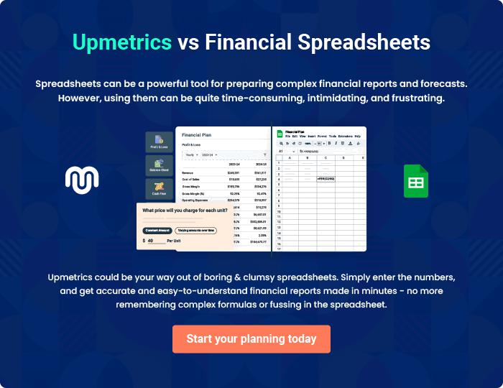
Appendix

When writing the appendix section, you should include any additional information that supports the main content of your plan. This may include financial statements, market research data, legal documents, and other
To unlock help try Upmetrics! 

Create a winning business plan that gets you funded

Creating a stunning and investment-ready plan requires no writing, graphic designing, or financial planning expertise.

Upmetrics has all the features required to help you create a comprehensive business plan—from start to finish. Make no mistakes, it’s the modern way of planning to structure ideas, make plans, and create stunning pitch decks to awe investors.

Pitch decks that impress investors

Create pitch decks that provide a visual representation of your business, engage investors, and make them want to invest in your business idea.

Interactive plans in no time

Import business plan sections like—SWOT analysis, comparison tables, and others to create an interactive business plan. No designing skills are required.

Stunning cover page designs

With Upmetrics, you have the liberty to choose from multiple stunning cover page designs. Choose a creative design and make your plan stand out.

Online sharing made simple

Upmetrics makes online sharing quick and easier for users. Easily share your business plans with a link while tracking reader activity.

500+ sample business plans

Simply import a template from our library of sample plans into the editor and start customizing it to make it yours. It takes only a few clicks to get started.

Collaborate with team in real-time

Invite team members, initiate conversations, discuss ideas & strategies, share feedback, and work on a business plan in real-time.

