
BUSINESS PLAN

2023


Trading Business Plan

Invest, Trade, Prosper

John Doe

10200 Bolsa Ave, Westminster, CA, 92683

- 359-3153 info@example.com http://www.example.com

Information provided in this business plan is unique to this business and confidential; therefore, anyone reading this plan agrees not to disclose any of the information in this business plan without prior written permission of the company.
Table of Contents

Executive Summary | 6
Market opportunity | 6
Product Range | 6
Marketing & Sales Strategies | 7
Financial Highlights | 7
Units Sold v/s Revenue | 8

Company Overview | 9
Ownership | 9
Mission statement | 10
Business history | 10
Future goals | 10

Market Analysis | 11
Target Market | 11
Market size and growth potential | 11
Market Size | 12
Competitive analysis | 12
AlphaTrade Solutions | 12
BetaInvest Group | 13
Gamma Trading Corp | 13
Market trends | 13
Regulatory environment | 14

Products and Services | 15
Products & Services | 15
Premium Consumer Electronics | 15
Gourmet Food and Beverages | 16
Logistics and Shipping Solutions | 16
Warehousing and Storage | 17
Product Customization and Branding | 17
Additional Services | 18

Sales And Marketing Strategies | 19
Unique Selling Proposition (USP) | 19
Pricing Strategy | 19
Marketing strategies | 20
Online | 20
Offline | 20
Sales strategies | 21
Customer retention | 22

Operations Plan | 23
Staffing & Training | 23
Operational Process | 23
Equipment & Machinery | 24

Management Team | 25
Key managers | 25
John Doe | 25
Jane Doe | 26
Alice Brown | 26
Robert Brown | 26
Organizational structure | 27
Organization chart | 27
Compensation plan | 27
Advisors/Consultants | 28
Mr. Alan White | 28
Rose Anderson | 28

Financial Plan | 29
Profit & loss statement | 29
Cash flow statement | 32
Balance sheet | 34
Break-even Analysis | 36
Financing needs | 38
Appendix
Appendix | 40
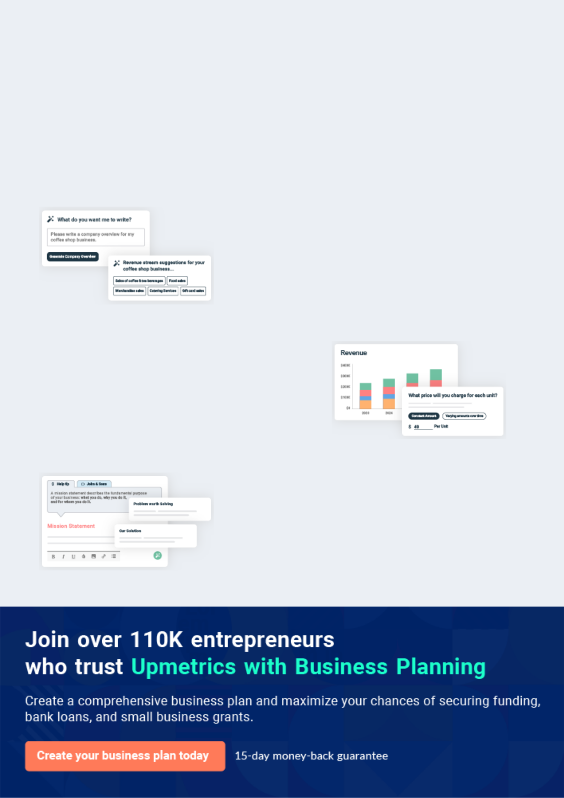
Business planning that’s simpler and faster than you think

Creating a business plan using Upmetrics to start and grow a business is literally the easiest thing in the World. Simply read the instructions and fill in the blanks. It’s as simple as that.

❛ | Upmetrics has everything you need to create a | ❜
❛ | comprehensive business plan. | ❜

AI-powered Upmetrics Assistant

AI-powered insights to streamline your plan

Not sure where to start? Upmetrics’ AI Assistant will automatically generate ideas for each section of your plan and offer improved versions of your writing, adjusting for tone, voice, and grammar or spelling errors.

Financial Forecasting Tool

All the financials are calculated for you

Forget the complex formulas and clumsy spreadsheets — with automatic financials and drag-and-drop forecasting, you can finish your plan faster and be confident that your numbers are accurate.

Business Plan Builder

Guides you like a business mentor

Upmetrics’ step-by-step instructions, prompts, and the library of 400+ sample business plans will guide you through each section of your plan as a business mentor.
Executive Summary


An executive summary is the first section of the business plan intended to provide an overview of the whole business plan.
To unlock help try Upmetrics! 

 Help tip  Trading Business Plan


Start your executive summary by briefly introducing your business to your readers.

This section may include the name of your trading business, its location, when it was founded,
To unlock help try Upmetrics! 

Start writing here..

Market opportunity

 Help tip  Trading Business Plan

Summarize your market research, including market size, growth potential, and marketing trends. Highlight the opportunities in the market and how your business will fit in to fill the gap.
To unlock help try Upmetrics! 

Start writing here..

Product Range

 Help tip  Trading Business Plan

Highlight the product range of your trading business you offer your clients. The USPs and differentiators you offer are always a plus.
To unlock help try Upmetrics! 

Start writing here..

Marketing & Sales Strategies
To unlock help try Upmetrics!

 Help tip  Trading Business Plan

Outline your sales and marketing strategies—what marketing platforms you use, how you plan on acquiring customers, etc.
To unlock help try Upmetrics! 

Start writing here..

Financial Highlights

 Help tip  Trading Business Plan

Briefly summarize your financial projections for the initial years of business operations. Include any capital or investment requirements, associated startup costs, projected revenues, and profit forecasts.



Start writing here..
Units Sold v/s Revenue

 |  | Units Sold | Revenue
15.00k
10.00k
5.00k
0
Year 1 | Year 2 | Year 3
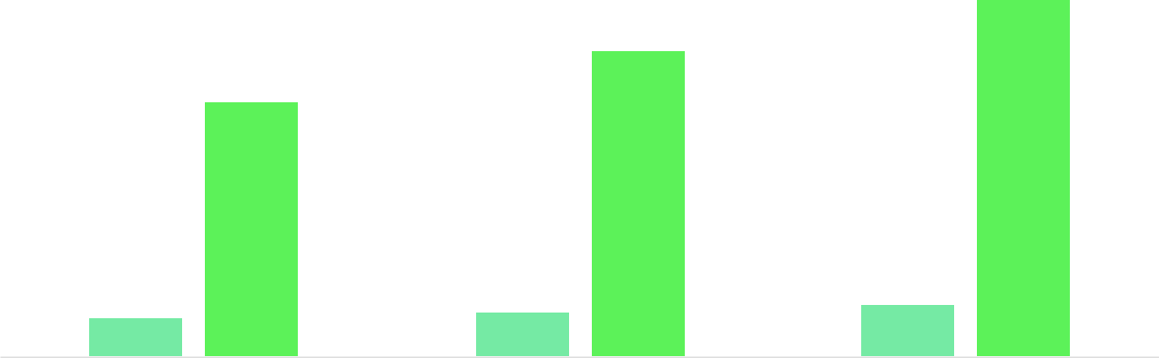

Financial Year |  |  | Units Sold | Revenue
Year 1 | 1,550 |  |  | $10,000
Year 2 | 1,800 |  |  | $12,000
Year 3 | 2,050 |  |  | $14,000
 Help tip |  |  Trading Business Plan


Summarize your executive summary section with a clear CTA, for example, inviting angel investors to discuss the potential business investment.
To unlock help try Upmetrics! 

Write a call to action for your business plan.
Company Overview

Depending on what details of your business are essential, you’ll need different elements in your business overview.
To unlock help try Upmetrics! 

 Help tip  Trading Business Plan

Describe your business in this section by providing all the basic information:

Describe what kind of trading company you run and the name of it. You may specialize in one of
To unlock help try Upmetrics! 

Start writing here..

Ownership

 Help tip  Trading Business Plan

List the names of your trading company’s founders or owners. Describe what shares they own and their responsibilities for efficiently managing the business.
To unlock help try Upmetrics! 

Start writing here..
Mission statement

 Help tip  Trading Business Plan

Summarize your business’ objective, core principles, and values in your mission statement. This statement needs to be memorable, clear, and brief.
To unlock help try Upmetrics! 

- At [WealthWave Trading], we are dedicated to creating lasting value and exceptional service for our clients, suppliers, and partners. We strive to lead the way in innovation, efficiency, and integrity, ensuring a seamless trading experience.

Our commitment to excellence and our passion for fostering meaningful relationships are the cornerstones of our business. ❜

Business history

 Help tip  Trading Business Plan

If you’re an established trading business, briefly describe your business history, like—when it was founded, how it evolved over time, etc.
To unlock help try Upmetrics! 

Start writing here..

Future goals

 Help tip  Trading Business Plan

It’s crucial to convey your aspirations and vision. Mention your short-term and long-term goals; they can be specific targets for revenue, market share, or expanding your services.
To unlock help try Upmetrics! 

Start writing here..

Market Analysis
To unlock help try Upmetrics!


 |  | Market analysis provides a clear understanding of the market in which your
 |  | printing business will run along with the target market, competitors, and
 |  | growth opportunities.
 |  |  |  | To unlock help try Upmetrics! 
 Help tip |  |  Trading Business Plan

To write the introduction section of your market analysis, start by clearly identifying your primary target market.
To unlock help try Upmetrics! 

Start writing here..

Target Market

 Help tip  Trading Business Plan

Start this section by describing your target market. Define your ideal customer and explain what types of services they prefer. Creating a buyer persona will help you easily define your target market to your readers.



Start writing here..

Market size and growth potential

 Help tip  Trading Business Plan

Describe your market size and growth potential and whether you will target a niche or a much broader market.
To unlock help try Upmetrics! 

Start writing here..

Market Size


Available Market | 12B
Total global trading market potential | 12B

Served Market
Portion of TAM accessible by our 3B services

Target Market | 500M
Our specific market focus within SAM | 500M

 Help tip  Trading Business Plan

Identify and analyze your direct and indirect competitors. Identify their strengths and weaknesses, and describe what differentiates your trading business from them.
To unlock help try Upmetrics! 

Competitive analysis

AlphaTrade Solutions

AlphaTrade Solutions is a well-established trading firm with over 15 years in the industry. They have a strong customer base and are known for their comprehensive trading tools and resources.

Features

Offers a variety of platforms catering to different levels of traders.

Provides extensive learning materials and webinars.

Delivers timely and accurate market insights.

Strengths

With 15 years in the market, they have built a solid reputation.

They offer a wide array of tools that cater to both novice and seasoned traders.

They have a broad network of industry connections and partnerships.

Weaknesses

Their services and tools come at a premium price.

Some users find their platforms overwhelming and not user-friendly.

Their tools offer limited customization options for unique trading strategies.

BetaInvest Group

BetaInvest Group is known for their innovative approach to trading, providing cutting-edge solutions and a user-friendly experience.

Features

Offers tools that incorporate the latest technologies.

Their platforms are designed with the user in mind, ensuring ease of use

Provides 24/7 customer support with a reputation for quick responses.

Strengths

Constantly updating and improving their tools to stay ahead.

Prioritizes user experience, resulting in high customer satisfaction.

- Has a robust digital marketing strategy that attracts a wide audience.

Weaknesses

Being relatively new in the market, they lack the extensive history and experience of some competitors.

Does not have as extensive a network within the trading industry.

Offers fewer learning materials compared to competitors.

Gamma Trading Corp

Gamma Trading Corp is a traditional trading company with a long-standing history, known for their reliability and extensive market knowledge.

Features

Offers a range of traditional trading tools and resources.

Possesses in-depth knowledge of market trends and movements.

Known for their reliability and consistent performance.

Strengths

Over 20 years in the industry provides them with a wealth of experience.

Their long-standing presence has resulted in deep market insights.

Known for their consistent and dependable services.

Weaknesses

Their traditional approach means they are slower to adopt new technologies.

Some of their tools and platforms are seen as outdated compared to competitors.

They have a weaker online marketing strategy, potentially limiting their reach to newer audiences.

Market trends

 Help tip  Trading Business Plan

Analyze emerging trends in the industry, such as technology disruptions, changes in customer behavior or preferences, etc. Explain how your business will cope with all the trends.
To unlock help try Upmetrics! 

Start writing here..

Regulatory environment

 Help tip  Trading Business Plan

List regulations and licensing requirements that may affect your trading company, such as business registration, insurance, licensing, etc.
To unlock help try Upmetrics! 

Start writing here..
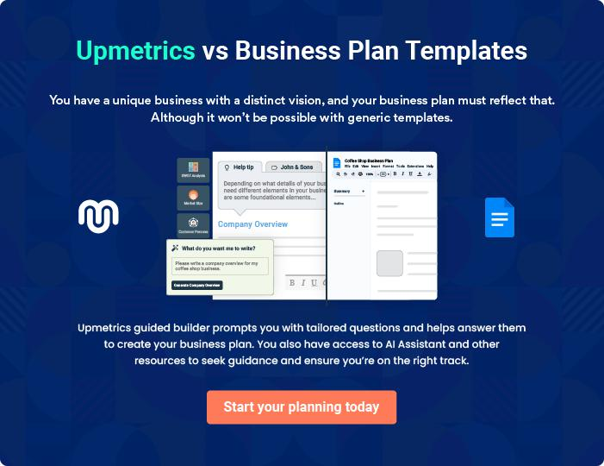
Products and Services
To unlock help try Upmetrics!

The product and services section of the trading business plan should describe the specific services and products that will be offered to customers. To write this section should include the following:



 Help tip  Trading Business Plan

To craft the introduction for your "Products and Services" chapter, begin by positioning your business within its industry, emphasizing its unique strengths or value proposition.
To unlock help try Upmetrics! 

Start writing here..

 Help tip


Mention the trading products your business will offer. This may include product categories, product range, product features, product sourcing, etc.
To unlock help try Upmetrics! 

Products & Services

Premium Consumer Electronics


Price: Ranges from [$200 to $2,000] depending on the product and specifications.

A wide assortment of consumer electronics, including smartphones, laptops, and accessories from leading brands ensuring reliability and the latest technology.

Product Specifications

- Brand: Variety of top-tier brands such as Apple, Samsung, and HP.

- Warranty: Minimum 1-year warranty on all products.

- Features: Latest models, high performance, durable build quality.
Gourmet Food and Beverages

Price: Ranges from [$10 to $500], varying by product type and brand.

An exquisite selection of gourmet foods and beverages, including fine wines, artisanal cheeses, and premium coffee.

Product Specifications

- Source: Products sourced from renowned producers worldwide.

- Quality: All items adhere to strict quality standards, ensuring freshness and excellence.

- Packaging: Products are securely packaged to maintain their integrity during transport.

Logistics and Shipping Solutions

Price: Custom pricing based on the distance, volume, and nature of goods.

Comprehensive logistics and shipping solutions ensuring safe, timely, and efficient delivery of products across [Insert Geographic Reach].

Service Specifications

- Capacity: Capable of handling shipments of all sizes, from small parcels to bulk goods.

- Network: Extensive network ensuring delivery to both urban and remote locations.

- Tracking: Real-time tracking available for all shipments.
Warehousing and Storage

Price: Variable pricing based on the size and duration of storage required.

State-of-the-art warehousing facilities offering secure and optimal storage conditions for a wide range of products.

Service Specifications

- Security: 24/7 security and surveillance ensuring the safety of stored goods.

- Conditions: Controlled conditions with options for climate-controlled storage.

- Accessibility: Conveniently located facilities for easy access and distribution.

Product Customization and Branding

Price: Pricing varies based on customization requirements and product type.

Tailored product customization and branding solutions to enhance product appeal and brand visibility.

Service Specifications

- Options: Wide range of customization options, including engraving, printing, and packaging.

- Design: Professional design services available to create unique and attractive branding.

- Quality: High-quality materials and processes ensuring durable and professional results.
Additional Services

 Help tip  Trading Business Plan

Mention if your trading company offers any additional services. You may include services like, product customization & branding, packaging & labeling, supply chain consultation, etc.
To unlock help try Upmetrics! 

Start writing here..
Sales And Marketing Strategies

Writing the sales and marketing strategies section means a list of strategies you will use to attract and retain your clients.
To unlock help try Upmetrics! 

 Help Tip  Trading Business Plan


To create an effective introduction for your "Sales and Marketing Strategies" chapter, start by setting the stage within your specific industry or market.
To unlock help try Upmetrics! 

Start writing here..

Unique Selling Proposition (USP)

 Help tip  Trading Business Plan

Define your business’s USPs depending on the market you serve, the equipment you use, and the unique services you provide. Identifying USPs will help you plan your marketing strategies.
To unlock help try Upmetrics! 

Start writing here..

Pricing Strategy

 Help tip  Trading Business Plan

Describe your pricing strategy—how you plan to price your products and stay competitive in the local market. You can mention any discounts you plan on offering to attract new customers.
To unlock help try Upmetrics! 

Start writing here..

 Help tip
To unlock help try Upmetrics!

Discuss your marketing strategies to market your services. You may include some of these marketing strategies in your business plan—social media marketing, brochures, email marketing, content marketing, and print marketing.



Marketing strategies

Online


Social Media

We leverage popular social media platforms to connect with our target audience, share product information, and engage in community building. Our strategy involves regular updates, promotional campaigns, and user engagement initiatives.

Email Marketing

Our email marketing campaigns are designed to nurture leads, provide product updates, and share promotional offers, helping to drive conversions and build customer loyalty.

Content Marketing

We invest in content marketing to

establish thought leadership,

provide valuable information to our

audience, and improve our online

visibility. Our content strategy

includes blogs, articles, and

informative guides.

Offline

Brochures & Print Marketing

High-quality brochures and print materials are utilized to showcase our product range and services, distributed at trade shows, industry events, and directly to potential clients.

 Help tip

Outline the strategies you’ll implement to maximize your sales. Your sales strategies may include direct sales calls, partnering with other businesses, offering referral programs, etc.
To unlock help try Upmetrics! 

Sales strategies

Partner with Businesses

Collaborations with [specific businesses, e.g., "design studios and architectural firms"] to offer them specialized services.

Referral Programs

To incentivize word-of-mouth referrals, we implement referral programs, offering rewards and discounts to customers who bring in new business.

Direct Sales Calls

Our sales team actively engages in direct sales calls, reaching out to potential clients, understanding their needs, and offering tailored solutions.

 Help tip

Describe your customer retention strategies and how you plan to execute them. For instance, introducing loyalty programs, discounts or offers, personalized service, etc.
To unlock help try Upmetrics! 

Customer retention

Loyalty Programs

We introduce loyalty programs to reward repeat business, offering points, discounts, and exclusive offers to frequent buyers.

Personalized Service

We are committed to providing personalized service, ensuring that each customer’s unique needs are met, and their expectations are exceeded.

After-Sales Support

Our after-sales support is second to none, providing timely assistance, product support, and ensuring customer satisfaction post-purchase.

Operations Plan
To unlock help try Upmetrics!

 |  | When writing the operations plan section, it’s important to consider the
 |  | various aspects of your business operations.
 |  |  |  | To unlock help try Upmetrics! 
 Help tip |  |  Trading Business Plan


To create an effective introduction for your "Operational Plan" chapter, start by emphasizing the
pivotal role of efficient operations in the success of your business, underscoring how they
directly impact the quality of services delivered.
 |  |  |  | To unlock help try Upmetrics! 
Start writing here..
Staffing & Training
 Help tip |  |  Trading Business Plan

Mention your business’s staffing requirements, including the number of employees or traders needed. Include their qualifications, the training required, and the duties they will perform.
To unlock help try Upmetrics! 

Start writing here..

Operational Process

 Help tip  Trading Business Plan

Outline the processes and procedures you will use to run your trading business. Your operational processes may include inventory management, sales & marketing, order processing, customer service, etc.



Start writing here..

Equipment & Machinery

 Help tip  Trading Business Plan

Include the list of equipment and machinery required for trading, such as office equipment, warehouse equipment, transportation vehicles, packaging & testing equipment, etc.
To unlock help try Upmetrics! 

Start writing here..
Management Team

The management team section provides an overview of the individuals responsible for running your business plan.
To unlock help try Upmetrics! 

 Help tip  Trading Business Plan

To craft an introduction for your "Management Team" chapter, begin by emphasizing the crucial role of leadership in the success of any business.
To unlock help try Upmetrics! 

Start writing here..

Key managers

 Help tip  Trading Business Plan

Introduce your management and key members of your team, and explain their roles and responsibilities.
To unlock help try Upmetrics! 

Start writing here..


JOHN DOE

CEO - john.doe@example.com

As one of the co-founders and the CEO of [WealthWave Trading], [Name] plays a pivotal role in setting the strategic direction of the company and overseeing all aspects of our operations.


With over [XX] years of experience in the trading industry, [his/her] leadership and vision have been instrumental in shaping the success of our business.

[He/She] holds a [Degree] from [University] and has a strong background in [specific trading domain or expertise].

JANE DOE

Chief Operating Officer (COO) - jane.doe@example.com

Jane Doe serves as the Chief Operating Officer of [WealthWave Trading], playing a critical role in the day-to-day management and operational efficiency of the company.


With over 15 years of experience in the trading industry, Jane has developed a keen understanding of market dynamics and operational excellence.

She holds a Master’s degree in Business Administration from Harvard Business School, where she specialized in Operations Management.

Prior to joining [WealthWave Trading], Jane held senior management positions at prominent trading firms, where she was renowned for streamlining processes and improving operational workflows.


ALICE BROWN

CMO - alice.brown@example.com

Alice Brown brings a wealth of experience and a strategic mindset to her role as the Chief Marketing Officer at [WealthWave Trading].

With a B.A. in Marketing from the University of California and over 12 years of experience in marketing within the trading sector, Alice has a profound understanding of how to build and maintain strong brand presence.

She has successfully led marketing campaigns that resulted in significant revenue growth and enhanced market penetration. Her expertise lies in digital marketing, brand development, and strategic planning.


ROBERT BROWN

Operations Manager - robert.brown@example.com

Robert Brown oversees the operational aspects of [WealthWave Trading], ensuring that all processes run smoothly and efficiently.

He holds a Bachelor’s degree in Operations Management from the Massachusetts Institute of Technology and has accumulated over 10 years of experience in operations within the trading industry.

His exceptional organizational skills and attention to detail have been crucial in optimizing our supply chain and inventory management processes.
Organizational structure

 Help tip  Trading Business Plan

Explain the organizational structure of your management team. Include the reporting line and decision-making hierarchy.
To unlock help try Upmetrics! 

Start writing here..

Organization chart


John Doe

CEO
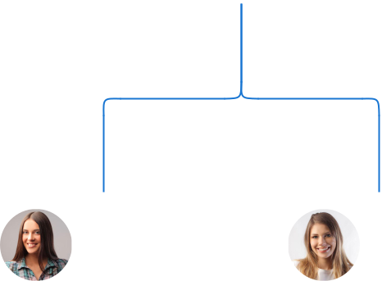

Alice Brown Jane Doe

CMO COO



David White | Nancy Green |  |  |  | Michael
David White |  |  | Robert Brown |  | Michael
David White | Customer Service |  |  |  | Johnson
Sales Manager |  |  |  |  | Johnson
Sales Manager | Manager |  | Operations |  | HR Manager
 |  |  | Manager





Compensation plan

 Help tip  Trading Business Plan

Describe your compensation plan for the management and staff. Include their salaries, incentives, and other benefits.
To unlock help try Upmetrics! 

Start writing here..

 Help tip  Trading Business Plan

Mentioning advisors or consultants in your business plans adds credibility to your business idea.
To unlock help try Upmetrics! 

Advisors/Consultants


MR. ALAN WHITE

Regulatory & Compliance Advisor

Trading, being a heavily regulated sector, requires acute knowledge of global and local regulations.

Mr. White, with his stints at regulatory bodies like [Specific Regulatory Authority], offers us insights that ensure our operations remain compliant while also being efficient.

His [X years] in regulatory consultancy has made him a sought-after name in the industry.


ROSE ANDERSON

Technology & Infrastructure Consultant

As trading technologies rapidly evolve, having a technological edge becomes imperative.

Ms. Anderson, formerly a tech lead at [High-Profile Trading Platform], brings in the technological foresight that ensures our infrastructure remains cutting-edge.

Her contributions have been pivotal in integrating AI and ML-based algorithms into our trading systems.
Financial Plan

When writing the financial plan section of a business plan, it’s important to provide a comprehensive overview of your financial projections for the first few years of your business, You may provide the following:
To unlock help try Upmetrics! 

 Help tip  Trading Business Plan


To create an effective introduction for your "Financial Plan" chapter, begin by stressing the critical role of a well-structured financial plan in the success of your venture.
To unlock help try Upmetrics! 

Start writing here..

 Help tip  Trading Business Plan

Describe details such as projected revenue, operational costs, and service costs in your projected profit and loss statement. Make sure to include your business’s expected net profit or loss.
To unlock help try Upmetrics! 

Profit & loss statement

Revenue

Cost Of Sales

General Costs

Revenue Specific Costs

Personnel Costs (Direct

Labor)

Gross Margin

Gross Margin (%)

Operating Expense

Payroll Expense

(Indirect Labor)

General Expense

Bad Debt

Amortization of Current

Assets

2023-24 | 2024-25 | 2025-26 | 2026-27 | 2027-28
$0 | $0 | $0 | $0 | $0

$0 | $0 | $0 | $0 | $0
$0 | $0 | $0 | $0 | $0
$0 | $0 | $0 | $0 | $0
$0 | $0 | $0 | $0 | $0

$0 | $0 | $0 | $0 | $0
0% | 0% | 0% | 0% | 0%

$0 | $0 | $0 | $0 | $0
$0 | $0 | $0 | $0 | $0
$0 | $0 | $0 | $0 | $0
$0 | $0 | $0 | $0 | $0
$0 | $0 | $0 | $0 | $0

EBITDA

Additional Expense

Long Term

Depreciation

Gain or loss from Sale

of Assets

EBIT

Interest Expenses

EBT

Income Tax Expense

Total Expense

Net Income

Net Income (%)

2023-24 | 2024-25 | 2025-26 | 2026-27 | 2027-28
$0 | $0 | $0 | $0 | $0
$0 | $0 | $0 | $0 | $0
$0 | $0 | $0 | $0 | $0
$0 | $0 | $0 | $0 | $0
$0 | $0 | $0 | $0 | $0
$0 | $0 | $0 | $0 | $0
$0 | $0 | $0 | $0 | $0
$0 | $0 | $0 | $0 | $0
$0 | $0 | $0 | $0 | $0
$0 | $0 | $0 | $0 | $0
0% | 0% | 0% | 0% | 0%

 |  |  | 2023-24 |  | 2024-25 | 2025-26
Retained Earning |  |  | $0 |  | $0 | $0
Opening |  |  |  |  | $0 | $0
Owner's Distribution |  |  | $0 |  | $0 | $0
Retained Earning |  |  | $0 |  | $0 | $0
Closing |  |  |  |  | $0 | $0
 Help tip |  |  |  Trading Business Plan


The cash flow for the first few years of your operation should be estimated and described in this section.

This may include billing invoices, payment receipts, loan payments, and any other cash flow statements.
2026-27 2027-28

$0 $0

$0 $0

$0 $0

To unlock help try Upmetrics! 

Cash flow statement

 | 2023-24 | 2024-25 | 2025-26 | 2026-27 | 2027-28
Cash Received | $0 | $0 | $0 | $0 | $0
Cash Paid | $0 | $0 | $0 | $0 | $0
COS & General Expenses | $0 | $0 | $0 | $0 | $0
Salary & Wages | $0 | $0 | $0 | $0 | $0
Interest | $0 | $0 | $0 | $0 | $0

Sales Tax

Income Tax

Net Cash From

Operations

Assets Sell

Assets Purchase

Net Cash From

Investments

Amount Received

Loan Received

Common Stock

Preferred Stock

Owner's Contribution

Amount Paid

2023-24 | 2024-25 | 2025-26 | 2026-27 | 2027-28
$0 | $0 | $0 | $0 | $0
$0 | $0 | $0 | $0 | $0
$0 | $0 | $0 | $0 | $0

$0 | $0 | $0 | $0 | $0
$0 | $0 | $0 | $0 | $0
$0 | $0 | $0 | $0 | $0

$0 | $0 | $0 | $0 | $0
$0 | $0 | $0 | $0 | $0

$0 | $0 | $0 | $0 | $0
$0 | $0 | $0 | $0 | $0
$0 | $0 | $0 | $0 | $0

Loan Capital $0 $0 $0 $0 $0

 |  |  | 2023-24 | 2024-25 | 2025-26 | 2026-27 | 2027-28
Dividends & Distributions |  |  | $0 | $0 | $0 | $0 | $0
Net Cash From |  |  | $0 | $0 | $0 | $0 | $0
Financing
Summary
Starting Cash |  |  | $0 | $0 | $0 | $0 | $0
Cash In |  |  | $0 | $0 | $0 | $0 | $0
Cash Out |  |  | $0 | $0 | $0 | $0 | $0
Change in Cash |  |  | $0 | $0 | $0 | $0 | $0
Ending Cash |  |  | $0 | $0 | $0 | $0 | $0
 Help tip |  |  Trading Business Plan

Create a projected balance sheet documenting your trading business’s assets, liabilities, and equity.

To unlock help try Upmetrics! 

Balance sheet

 | 2023-24 | 2024-25 | 2025-26 | 2026-27 | 2027-28
Assets | $0 | $0 | $0 | $0 | $0
Current Assets | $0 | $0 | $0 | $0 | $0
Cash | $0 | $0 | $0 | $0 | $0
Accounts Receivable | $0 | $0 | $0 | $0 | $0
Inventory | $0 | $0 | $0 | $0 | $0
Other Current Assets | $0 | $0 | $0 | $0 | $0
Long Term Assets | $0 | $0 | $0 | $0 | $0
Gross Long Term Assets | $0 | $0 | $0 | $0 | $0
Accumulated Depreciation | $0 | $0 | $0 | $0 | $0

Liabilities & Equity | $0 | $0 | $0 | $0 | $0
Liabilities | $0 | $0 | $0 | $0 | $0
Current Liabilities | $0 | $0 | $0 | $0 | $0
Accounts Payable | $0 | $0 | $0 | $0 | $0
Income Tax Payable | $0 | $0 | $0 | $0 | $0
Sales Tax Payable | $0 | $0 | $0 | $0 | $0
Short Term Debt | $0 | $0 | $0 | $0 | $0
 | 2023-24 | 2024-25 | 2025-26 | 2026-27 | 2027-28
Long Term Liabilities | $0 | $0 | $0 | $0 | $0
Long Term Debt | $0 | $0 | $0 | $0 | $0
Equity | $0 | $0 | $0 | $0 | $0
Paid-in Capital | $0 | $0 | $0 | $0 | $0
Common Stock | $0 | $0 | $0 | $0 | $0
Preferred Stock | $0 | $0 | $0 | $0 | $0
Owner's Contribution | $0 | $0 | $0 | $0 | $0
Retained Earnings | $0 | $0 | $0 | $0 | $0

Check | $0 |  |  | $0 | $0 | $0 | $0
 Help tip |  |  Trading Business Plan

Determine and mention your business’s break-even point—the point at which your business costs and revenue will be equal.

This exercise will help you understand how much revenue you need to generate to sustain or be profitable.
To unlock help try Upmetrics! 

Break-even Analysis

 | 2023-24 | 2024-25 | 2025-26 | 2026-27 | 2027-28
Starting Revenue | $0 | $0 | $0 | $0 | $0
Net Revenue | $0 | $0 | $0 | $0 | $0
Closing Revenue | $0 | $0 | $0 | $0 | $0

Starting Expense | $0 | $0 | $0 | $0 | $0
Net Expense | $0 | $0 | $0 | $0 | $0
Closing Expense | $0 | $0 | $0 | $0 | $0

Is Break Even? | 0 | 0 | 0 | 0 | 0
Break Even Month | 0 | 0 | 0 | 0 | 0
Days Required | 0 | 0 | 0 | 0 | 0
Break Even Revenue | $0 | $0 | $0 | $0 | $0
Break Even Units
Financing needs

 Help tip  Trading Business Plan

Calculate costs associated with starting a trading business, and estimate your financing needs and how much capital you need to raise to operate your business.
To unlock help try Upmetrics! 

Start writing here..
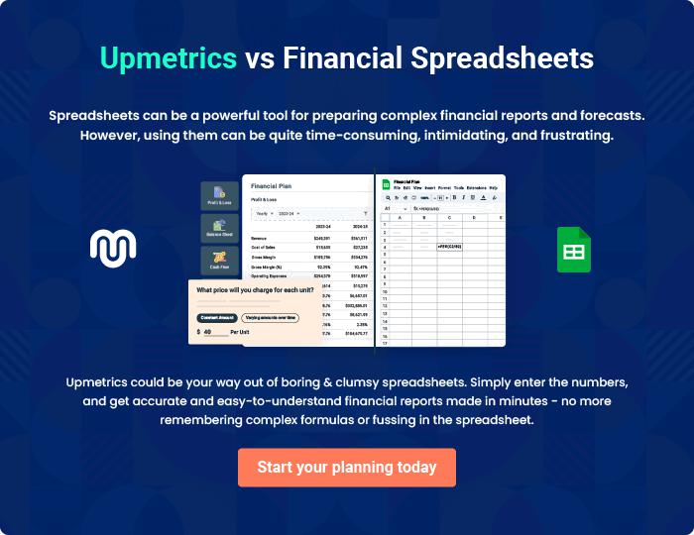
Appendix

When writing the appendix section, you should include any additional information that supports the main content of your plan. This may include financial statements, market research data, legal documents, and other
To unlock help try Upmetrics! 

Create a winning business plan that gets you funded

Creating a stunning and investment-ready plan requires no writing, graphic designing, or financial planning expertise.

Upmetrics has all the features required to help you create a comprehensive business plan—from start to finish. Make no mistakes, it’s the modern way of planning to structure ideas, make plans, and create stunning pitch decks to awe investors.

Pitch decks that impress investors

Create pitch decks that provide a visual representation of your business, engage investors, and make them want to invest in your business idea.

Interactive plans in no time

Import business plan sections like—SWOT analysis, comparison tables, and others to create an interactive business plan. No designing skills are required.

Stunning cover page designs

With Upmetrics, you have the liberty to choose from multiple stunning cover page designs. Choose a creative design and make your plan stand out.

Online sharing made simple

Upmetrics makes online sharing quick and easier for users. Easily share your business plans with a link while tracking reader activity.

500+ sample business plans

Simply import a template from our library of sample plans into the editor and start customizing it to make it yours. It takes only a few clicks to get started.

Collaborate with team in real-time

Invite team members, initiate conversations, discuss ideas & strategies, share feedback, and work on a business plan in real-time.

