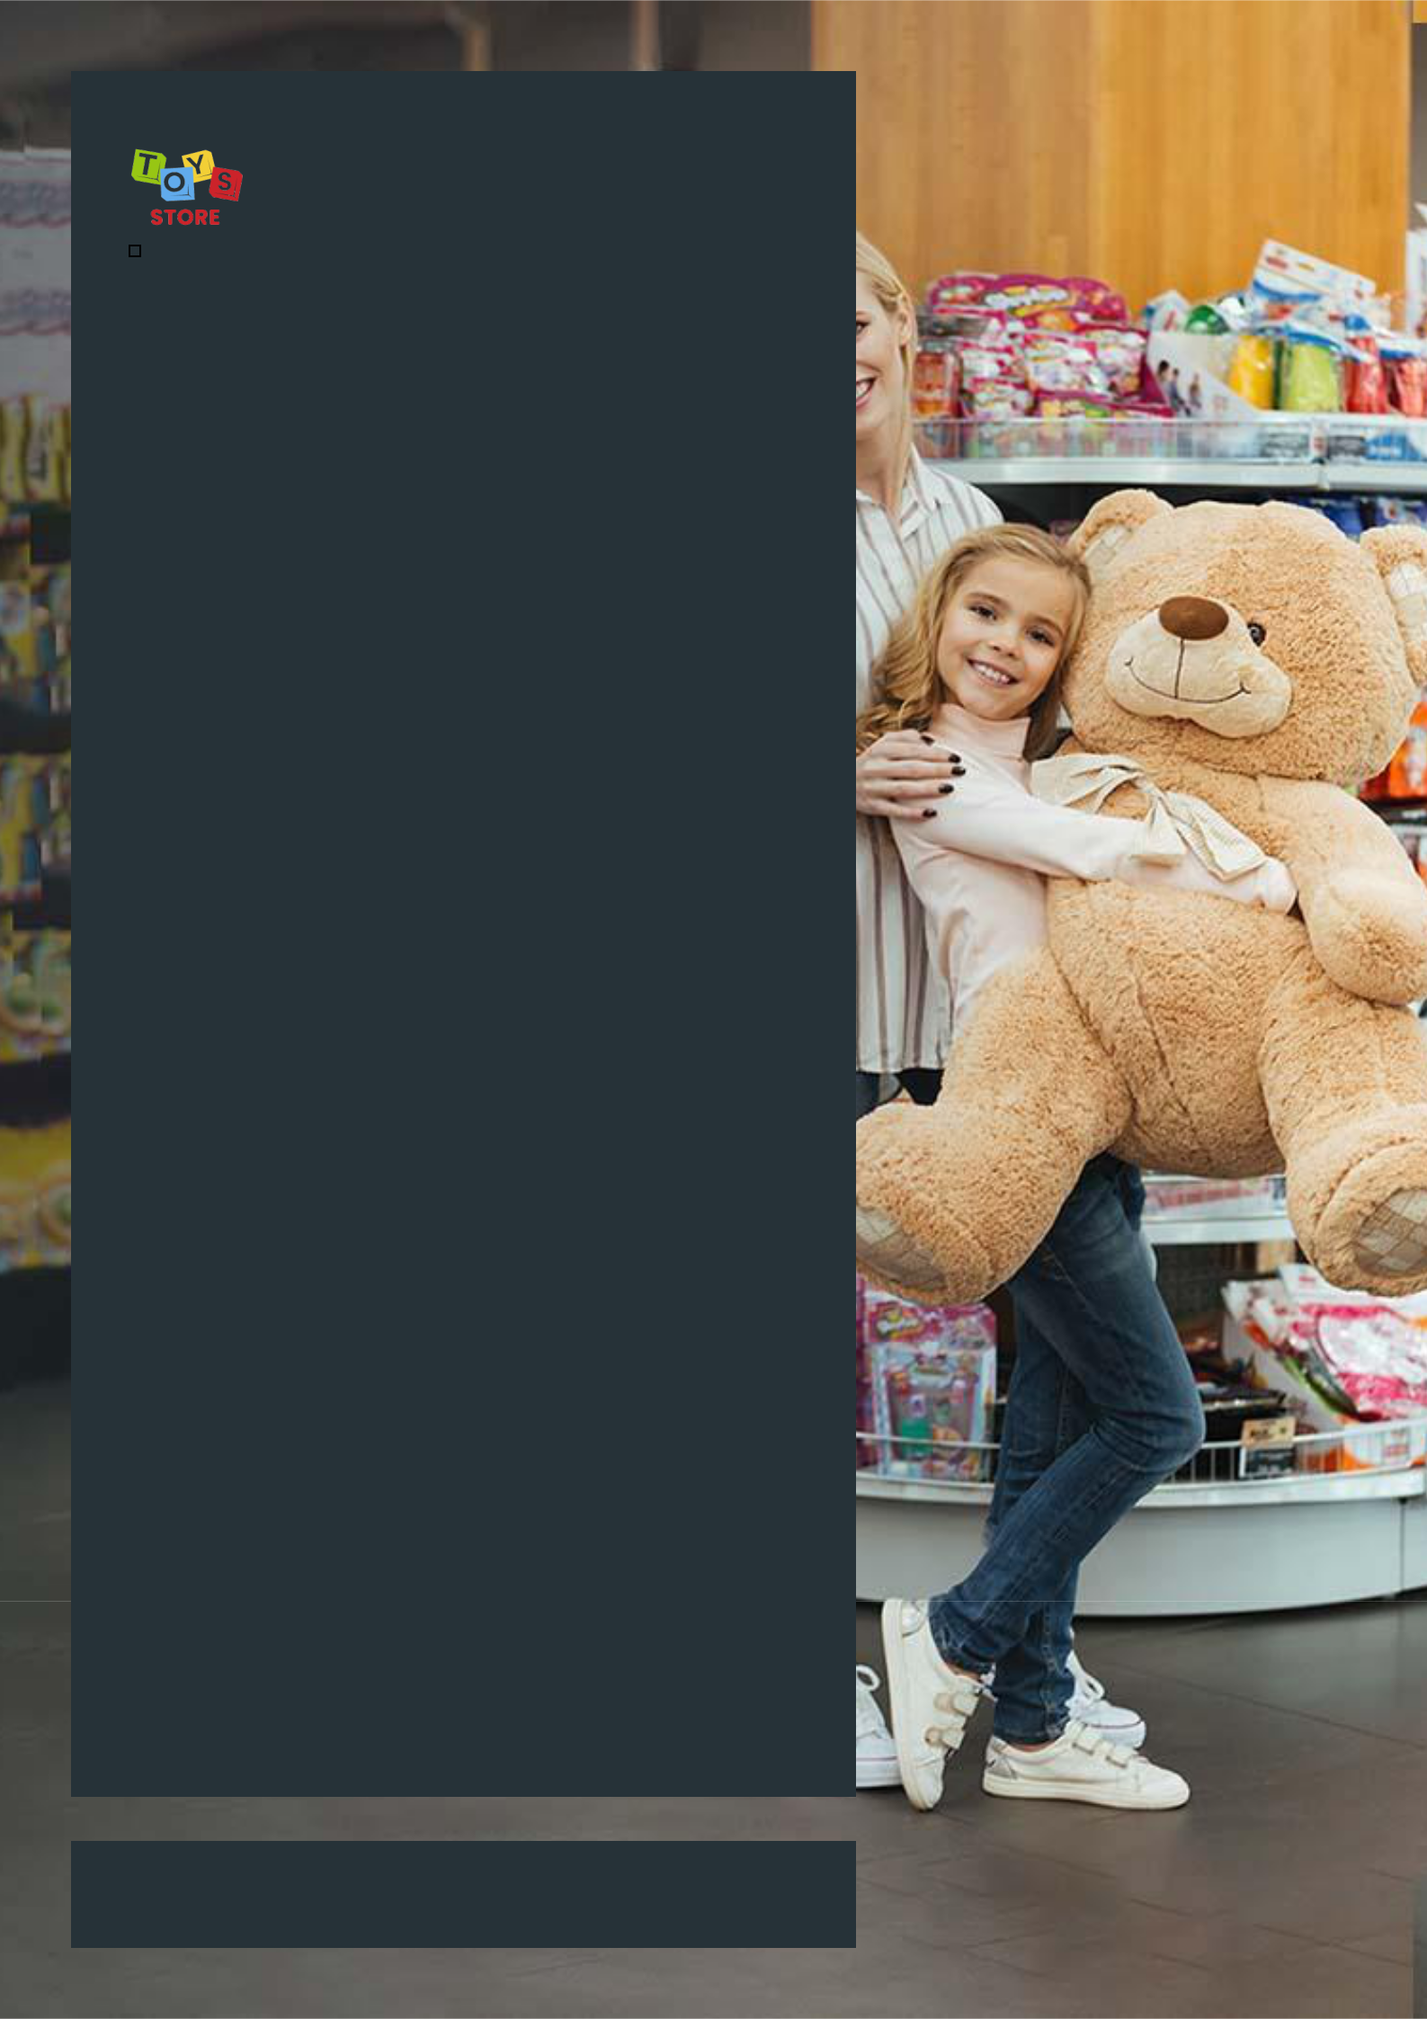

Toy Store Business Plan

Where Play Comes Alive

Business

Plan

2023

John Doe

10200 Bolsa Ave, Westminster, CA, 92683

- 359-3153 info@example.com http://www.example.com

CONFIDENTIAL

Table of Contents

Executive Summary | 6
Market opportunity | 6
Services Offered | 6
Marketing & Sales Strategies | 7
Financial Highlights | 7
Units Sold v/s Revenue | 8

Company Overview | 9
Ownership | 9
Business Owners | 9
Mission statement | 10
Business history | 10
Future goals | 11

Market Analysis | 12
Target Market | 12
Market size and growth potential | 12
Market Size | 13
Competitive analysis | 13
Toys "R" Us | 13
FAO Schwarz | 14
Learning Express Toys | 14
Market trends | 14
Regulatory environment | 15

Products and Services | 16
Products & Services | 16
STEM Toys | 16
Hobby Toys | 17
Art and Craft Toys | 17
Electronic Toys | 17
Puzzles and Board Games | 18
Subscription Services | 18
Special Events and Workshops | 18
Quality Measures | 19
Additional Services | 19

Sales And Marketing Strategies | 20
Unique Selling Proposition (USP) | 20
Pricing Strategy | 20
Marketing strategies | 21
Online | 21
Offline | 21
Sales strategies | 22
Customer retention | 23

Operations Plan | 24
Staffing & Training | 24
Operational Process | 24
Equipment & Machinery | 25

Management Team | 26
Key managers | 26
John Doe | 26
Jane Doe | 27
Alice Brown | 27
Organizational structure | 27
Organization chart | 28
Compensation plan | 28
Board of advisors | 29
Robert Brown | 29
Financial Plan
Financial Plan | 30

Profit & loss statement 30

Cash flow statement | 33
Balance sheet | 35
Break-even Analysis | 37
Financing needs | 39
Appendix
Appendix | 41
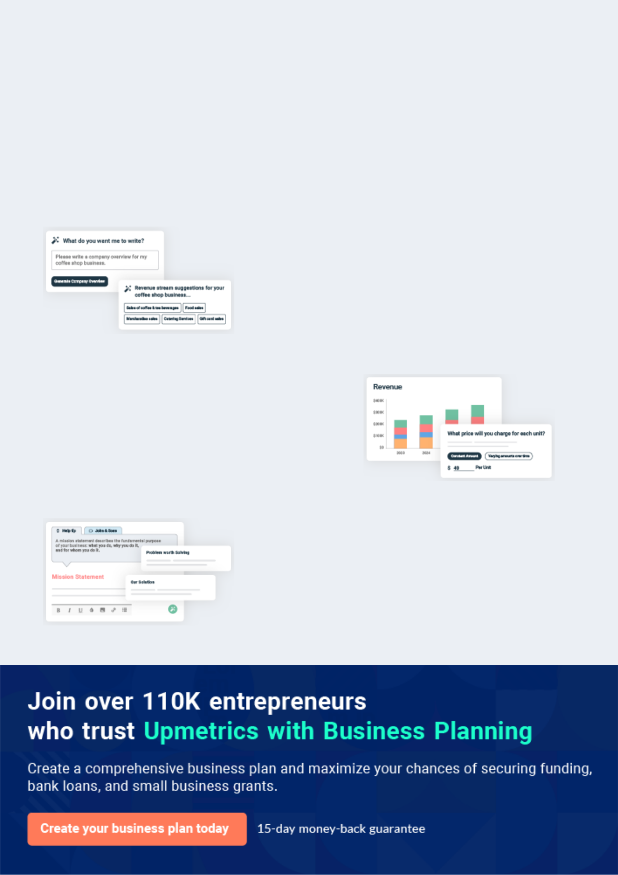
Business planning that’s simpler and faster than you think

Creating a business plan using Upmetrics to start and grow a business is literally the easiest thing in the World. Simply read the instructions and fill in the blanks. It’s as simple as that.

❛ | Upmetrics has everything you need to create a | ❜
❛ | comprehensive business plan. | ❜

AI-powered Upmetrics Assistant

AI-powered insights to streamline your plan

Not sure where to start? Upmetrics’ AI Assistant will automatically generate ideas for each section of your plan and offer improved versions of your writing, adjusting for tone, voice, and grammar or spelling errors.

Financial Forecasting Tool

All the financials are calculated for you

Forget the complex formulas and clumsy spreadsheets — with automatic financials and drag-and-drop forecasting, you can finish your plan faster and be confident that your numbers are accurate.

Business Plan Builder

Guides you like a business mentor

Upmetrics’ step-by-step instructions, prompts, and the library of 400+ sample business plans will guide you through each section of your plan as a business mentor.
Executive Summary


An executive summary is the first section of the business plan intended to provide an overview of the whole business plan.
To unlock help try Upmetrics! 

 Help tip  Toy Store Business Plan


Start your executive summary by briefly introducing your business to your readers.

This section may include the name of your toy store, its location, when it was founded, the type
To unlock help try Upmetrics! 

Start writing here..

Market opportunity

 Help tip  Toy Store Business Plan

Summarize your market research, including market size, growth potential, and marketing trends. Highlight the opportunities in the market and how your business will fit in to fill the gap.
To unlock help try Upmetrics! 

Start writing here..

Services Offered

 Help tip  Toy Store Business Plan

Highlight the toy store products you offer your clients. The USPs and differentiators you offer are always a plus.
To unlock help try Upmetrics! 

Start writing here..

Marketing & Sales Strategies
To unlock help try Upmetrics!

 Help tip  Toy Store Business Plan

Outline your sales and marketing strategies—what marketing platforms you use, how you plan on acquiring customers, etc.
To unlock help try Upmetrics! 

Start writing here..

Financial Highlights

 Help tip  Toy Store Business Plan

Briefly summarize your financial projections for the initial years of business operations. Include any capital or investment requirements, associated startup costs, projected revenues, and profit forecasts.



Start writing here..
Units Sold v/s Revenue

 |  | Units Sold | Revenue
15.00k
10.00k
5.00k
0
Year 1 | Year 2 | Year 3
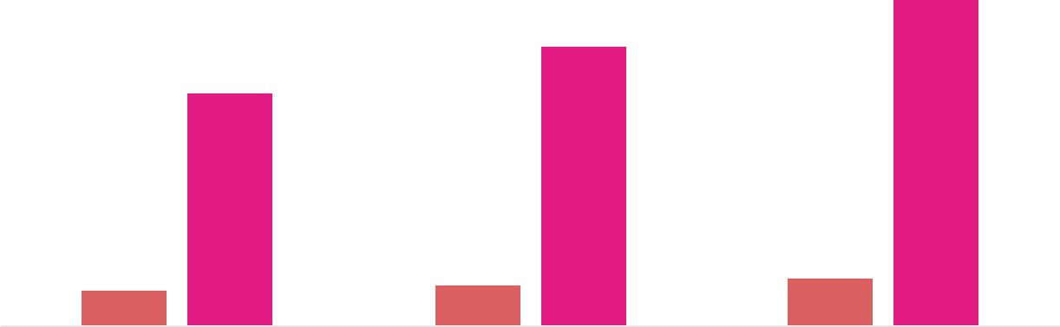

Financial Year |  |  | Units Sold | Revenue
Year 1 | 1,550 |  |  | $10,000
Year 2 | 1,800 |  |  | $12,000
Year 3 | 2,050 |  |  | $14,000
 Help tip |  |  Toy Store Business Plan


Summarize your executive summary section with a clear CTA, for example, inviting angel investors to discuss the potential business investment.
To unlock help try Upmetrics! 

Write a call to action for your business plan.
Company Overview

Depending on what details of your business are essential, you’ll need different elements in your business overview.
To unlock help try Upmetrics! 

 Help tip  Toy Store Business Plan

Describe your business in this section by providing all the basic information:

Describe what kind of toy store you run and the name of it. You may specialize in one of the
To unlock help try Upmetrics! 

Start writing here..

Ownership

 Help tip  Toy Store Business Plan

List the names of the founders or owners of your toy store. Describe what shares they own and their responsibilities for efficiently managing the business.
To unlock help try Upmetrics! 

Start writing here..

Business Owners



60% John Doe



40% Jane Doe
Mission statement

 Help tip  Toy Store Business Plan

Summarize your business’ objective, core principles, and values in your mission statement. This statement needs to be memorable, clear, and brief.
To unlock help try Upmetrics! 

❛ Our mission at [Wonderful Whimsy Toys] is to provide an interactive and educational shopping experience that inspires creativity, fosters a love for learning, and brings joy to children and parents alike.

We are committed to offering high-quality toys that are not only fun but also contribute to the holistic development of children. Our core principles revolve around customer satisfaction, innovation, and community engagement.

❜

Business history

 Help tip  Toy Store Business Plan

If you have an established toy store, briefly describe your business history, like—when it was founded, how it evolved over time, etc.
To unlock help try Upmetrics! 

Start writing here..
Future goals

 Help tip  Toy Store Business Plan

It’s crucial to convey your aspirations and vision. Mention your short-term and long-term goals; they can be specific targets for revenue, market share, or expanding your services.
To unlock help try Upmetrics! 

Start writing here..
Market Analysis
To unlock help try Upmetrics!


 |  | Market analysis provides a clear understanding of the market in which your
 |  | printing business will run along with the target market, competitors, and
 |  | growth opportunities.
 |  |  |  | To unlock help try Upmetrics! 
 Help tip |  |  Toy Store Business Plan

To write the introduction section of your market analysis, start by clearly identifying your primary target market.
To unlock help try Upmetrics! 

Start writing here..

Target Market

 Help tip  Toy Store Business Plan

Start this section by describing your target market. Define your ideal customer and explain what types of services they prefer. Creating a buyer persona will help you easily define your target market to your readers.



Start writing here..

Market size and growth potential

 Help tip  Toy Store Business Plan

Describe your market size and growth potential and whether you will target a niche or a much broader market.
To unlock help try Upmetrics! 

Start writing here..

Market Size


Available Market | 500M
Total global toy market audience | 500M

Served Market
Customers accessible to our 150M distribution

Target Market | 50M
Parents, educators, and gift buyers | 50M

 Help tip  Toy Store Business Plan

Identify and analyze your direct and indirect competitors. Identify their strengths and weaknesses, and describe what differentiates your toy store services from them.
To unlock help try Upmetrics! 

Competitive analysis

Toys "R" Us

Toys "R" Us is an internationally recognized brand with a vast network of brick-and-mortar stores and a robust online presence. Founded in 1948, the company has established itself as one of the industry's major players, offering a wide range of toys and children's products.

Features | Strengths
Comprehensive toy selection | Strong brand recognition
across all categories | Vast distribution network
Exclusive product lines | Economies of scale allowing
Loyalty program and frequent | for competitive pricing
sales promotions
Online shopping with in-store
pick-up options

Weaknesses

Less focus on niche markets, such as specialty or educational toys

Potential impersonal shopping experience due to store size

Challenges in maintaining consistent inventory across all locations

FAO Schwarz

FAO Schwarz is an iconic luxury toy store with a history dating back to 1862. Known for its unique, high-end product offerings, the brand is synonymous with quality and exclusivity.

Features | Strengths | Weaknesses
Specialty and luxury toy lines | Strong emphasis on customer | Higher price point might alienate
Unique in-store experiences | experience | some customer segments
(e.g., giant piano, toy soldiers) | Reputation for quality and | Limited store locations
Personalized shopping | exclusivity | Less focus on mass-market
assistance | High customer loyalty and | products
Exclusive designer | brand desirability
collaborations

Learning Express Toys

Learning Express Toys is a franchise chain that emphasizes educational toys and gifts. With a commitment to quality, they focus on providing products that promote learning and development.

Features | Strengths | Weaknesses
Curated selection of | Strong focus on educational | Limited product range compared
educational toys and games | products | to larger competitors
In-store events and workshops | Active community engagement | Reliance on franchise model
for kids | through workshops and events | might lead to inconsistencies
Personalized customer service | Tailored shopping experience | across stores
 |  | Less brand recognition
 |  | compared to larger chains

Market trends

 Help tip  Toy Store Business Plan

Analyze emerging trends in the industry, such as technology disruptions, changes in customer behavior or preferences, etc. Explain how your business will cope with all the trends.
To unlock help try Upmetrics! 

Start writing here..

Regulatory environment
To unlock help try Upmetrics!

 Help tip  Toy Store Business Plan

List regulations and licensing requirements that may affect your toy store, such as business registration, safety compliances, intellectual property license compliances, environmental regulations, state and federal regulations, etc.



Start writing here..
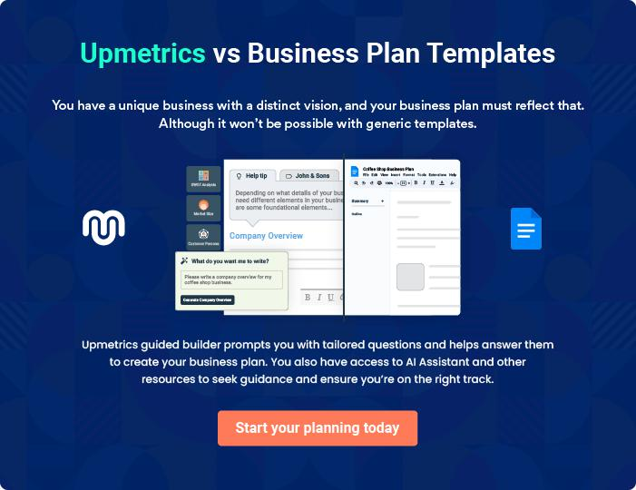
Products and Services
To unlock help try Upmetrics!

The product and services section of a toy store business plan should describe the specific services and products that will be offered to customers. To write this section should include the following:



 Help tip  Toy Store Business Plan

To craft the introduction for your "Products and Services" chapter, begin by positioning your business within its industry, emphasizing its unique strengths or value proposition.
To unlock help try Upmetrics! 

Start writing here..

 Help tip


Describe your products: Mention the products your business will offer. This list may include toys like,
To unlock help try Upmetrics! 

Products & Services

STEM Toys


Price: [$15 - $50]

A variety of toys designed to enhance children's science, technology, engineering, and math skills.

Product Specifications

Includes building kits, science lab sets, and interactive learning games.
Hobby Toys

Price: [$10 - $100]

Toys catering to specific interests such as model kits, collectibles, and more.

Product Specifications

High-quality materials, attention to detail, and availability for various hobbies and interests.

Art and Craft Toys

Price: [$5 - $30]

Toys designed to unleash children's creativity and imagination.

Product Specifications

Includes coloring books, craft kits, and painting sets with non-toxic and child-safe materials.

Electronic Toys

Price: [$20 - $150]

A range of electronic toys including educational tablets and interactive robots.

Product Specifications

Battery-operated or rechargeable, user-friendly interfaces, and age-appropriate content.
Puzzles and Board Games

Price: [$10 - $40]

A wide selection of puzzles and board games perfect for family bonding and learning.

Product Specifications

Durable materials, various difficulty levels, and options for all age groups.

Subscription Services

Price: [$20 - $50] per month

A subscription service allowing parents to rent toys for a specified period.

Service Specifications

Monthly or annual plans, options for different toy categories, and flexible rental periods.

Special Events and Workshops

Price: [$10 - $30] per event

Regular events and workshops providing children with an opportunity to learn and play in a social setting.

Service Specifications

Led by trained instructors, includes all necessary materials, and suitable for various age groups.
Quality Measures

 Help tip  Toy Store Business Plan

This section should explain how you maintain quality standards and consistently provide the highest quality service.
To unlock help try Upmetrics! 

Start writing here..

Additional Services

 Help tip  Toy Store Business Plan

Mention if your toy store offers any primary or additional services. You may include services like, free delivery, personalized toys, etc.
To unlock help try Upmetrics! 

Start writing here..
Sales And Marketing Strategies
To unlock help try Upmetrics!

Writing the sales and marketing strategies section means a list of strategies you will use to attract and retain your clients.
To unlock help try Upmetrics! 

 Help Tip  Toy Store Business Plan


To create an effective introduction for your "Sales and Marketing Strategies" chapter, start by setting the stage within your specific industry or market.
To unlock help try Upmetrics! 

Start writing here..

Unique Selling Proposition (USP)

 Help tip  Toy Store Business Plan

Define your business’s USPs depending on the market you serve, the equipment you use, and the unique services you provide. Identifying USPs will help you plan your marketing strategies.
To unlock help try Upmetrics! 

Start writing here..

Pricing Strategy

 Help tip  Toy Store Business Plan

Describe your pricing strategy—how you plan to price products of your toy store and stay competitive in the local market. You can mention any discounts you plan on offering to attract new customers to your toy store.



Start writing here..

 Help tip  Toy Store Business Plan

Discuss your marketing strategies to market your services.

You may include some of these marketing strategies in your business plan—social media
To unlock help try Upmetrics! 

Marketing strategies

Online


Social Media Email Marketing

Engaging with our audience on platforms like [Facebook, Instagram, Twitter, etc.].

Sending regular updates and offers to our mailing list.

Content Marketing Google Ads

Creating valuable content that Targeting potential customers

showcases our expertise and the through online advertising.

quality of our toys.

Offline

Brochures & Print Marketing

Distributing promotional material in our local community and at events.

 Help tip

Outline the strategies you’ll implement to maximize your sales.

Your sales strategies may include direct sales, partnering with kid stores and educational
To unlock help try Upmetrics! 

Sales strategies

Partner with Businesses

[Partnering with local kid stores and educational institutions] to offer our products to a wider audience.

Direct Sales

[Direct sales] through our retail location and online store.

Referral Programs

Reward customers for bringing in

new business.

 Help tip  Toy Store Business Plan

Describe your customer retention strategies and how you plan to execute them.

For instance, introducing loyalty programs, discounts on annual membership, special offers,
To unlock help try Upmetrics! 

Customer retention

Loyalty Programs

Offers

Reward repeat customers with discounts and exclusive offers.

[Special offers] for [annual memberships] and [bulk purchases].

Customer feedback programs

Allow us to gather valuable

insights and make improvements

based on customer input.

Operations Plan

 |  | When writing the operations plan section, it’s important to consider the
 |  | various aspects of your business operations.
 |  |  |  | To unlock help try Upmetrics! 
 Help tip |  |  Toy Store Business Plan


To create an effective introduction for your "Operational Plan" chapter, start by emphasizing the
pivotal role of efficient operations in the success of your business, underscoring how they
directly impact the quality of services delivered.
 |  |  |  | To unlock help try Upmetrics! 
Start writing here..
Staffing & Training
 Help tip |  |  Toy Store Business Plan

Mention staffing requirements for your toy store, including the number of employees, and administrative and marketing staff needed.
To unlock help try Upmetrics! 

Start writing here..

Operational Process

 Help tip  Toy Store Business Plan

Outline the processes and procedures you will use to run your toy store.

Your operational processes may include attending store visitors, fulfilling online orders, helping
To unlock help try Upmetrics! 

Start writing here..

Equipment & Machinery

 Help tip  Toy Store Business Plan

Include the list of equipment and machinery required for the toy store, such as packing equipment, loading machines, cleaning and maintenance equipment, etc.
To unlock help try Upmetrics! 

Start writing here..
Management Team

The management team section provides an overview of the individuals responsible for running your business plan.
To unlock help try Upmetrics! 

 Help tip  Toy Store Business Plan

To craft an introduction for your "Management Team" chapter, begin by emphasizing the crucial role of leadership in the success of any business.
To unlock help try Upmetrics! 

Start writing here..

Key managers

 Help tip  Toy Store Business Plan

Introduce your management and key members of your team, and explain their roles and responsibilities.
To unlock help try Upmetrics! 

Start writing here..


JOHN DOE

CEO & Co-founder - john.doe@example.com

With over 15 years of experience in the toy industry, John Doe leads the charge at Wonderful Whimsy Toys.

He has a keen eye for market trends and product development, ensuring that the store always has the most popular and high-quality toys.


- Educational Background: MBA from Harvard Business School, Bachelor’s in Marketing from University of California, Los Angeles.

- Professional Background: Previous experience includes working at top toy companies like Hasbro and Mattel in managerial roles.

JANE DOE

Chief Operating Officer (COO) - jane.doe@example.com

Jane is responsible for the daily operations of Wonderful Whimsy Toys, ensuring that everything runs smoothly and efficiently.

She brings a wealth of experience in operations management and a passion for creating a positive customer experience.


- Educational Background: Bachelor’s in Business Administration from University of Southern California.

- Professional Background: Over 10 years of experience in operations management, with a focus on retail.


ALICE BROWN

Chief Technology Officer (CTO) - alice.brown@example.com

Alice spearheads the marketing initiatives at Wonderful Whimsy Toys.

Her innovative campaigns and in-depth market knowledge have significantly increased the store's visibility and customer base.

- Educational Background: Bachelor’s in Marketing from University of California, Berkeley.

- Professional Background: Worked in marketing roles at various retail companies, gaining valuable experience in retail marketing.

Organizational structure

 Help tip  Toy Store Business Plan

Explain the organizational structure of your management team. Include the reporting line and decision-making hierarchy.
To unlock help try Upmetrics! 

Start writing here..

Organization chart


John Doe

CEO


Jane Doe

Alice Brown

Robert Brown

COO


CTO


Financial Advisor

Emily White | David Johnson
Customer Service | David Johnson
Customer Service | Operations Manager
Manager | Operations Manager


Compensation plan

 Help tip  Toy Store Business Plan

Describe your compensation plan for the management and staff. Include their salaries, incentives, and other benefits.
To unlock help try Upmetrics! 

Start writing here..

 Help tip

Mentioning advisors or consultants in your business plans adds credibility to your business idea.
To unlock help try Upmetrics! 

Board of advisors


ROBERT BROWN

Financial Advisor - robert.brown@example.com

Robert brings over 20 years of financial expertise to Wonderful Whimsy Toys. His guidance has been instrumental in securing funding and managing the store's finances effectively.
Financial Plan

When writing the financial plan section of a business plan, it’s important to provide a comprehensive overview of your financial projections for the first few years of your business, You may provide the following:
To unlock help try Upmetrics! 

 Help tip  Toy Store Business Plan


To create an effective introduction for your "Financial Plan" chapter, begin by stressing the critical role of a well-structured financial plan in the success of your venture.
To unlock help try Upmetrics! 

Start writing here..

 Help tip  Toy Store Business Plan

Describe details such as projected revenue, operational costs, and service costs in your projected profit and loss statement. Make sure to include your business’s expected net profit or loss.
To unlock help try Upmetrics! 

Profit & loss statement

Revenue

Cost Of Sales

General Costs

Revenue Specific Costs

Personnel Costs (Direct

Labor)

Gross Margin

Gross Margin (%)

Operating Expense

Payroll Expense

(Indirect Labor)

General Expense

Bad Debt

Amortization of Current

Assets

2023-24 | 2024-25 | 2025-26 | 2026-27 | 2027-28
$0 | $0 | $0 | $0 | $0

$0 | $0 | $0 | $0 | $0
$0 | $0 | $0 | $0 | $0
$0 | $0 | $0 | $0 | $0
$0 | $0 | $0 | $0 | $0

$0 | $0 | $0 | $0 | $0
0% | 0% | 0% | 0% | 0%

$0 | $0 | $0 | $0 | $0
$0 | $0 | $0 | $0 | $0
$0 | $0 | $0 | $0 | $0
$0 | $0 | $0 | $0 | $0
$0 | $0 | $0 | $0 | $0

EBITDA

Additional Expense

Long Term

Depreciation

Gain or loss from Sale

of Assets

EBIT

Interest Expenses

EBT

Income Tax Expense

Total Expense

Net Income

Net Income (%)

2023-24 | 2024-25 | 2025-26 | 2026-27 | 2027-28
$0 | $0 | $0 | $0 | $0
$0 | $0 | $0 | $0 | $0
$0 | $0 | $0 | $0 | $0
$0 | $0 | $0 | $0 | $0
$0 | $0 | $0 | $0 | $0
$0 | $0 | $0 | $0 | $0
$0 | $0 | $0 | $0 | $0
$0 | $0 | $0 | $0 | $0
$0 | $0 | $0 | $0 | $0
$0 | $0 | $0 | $0 | $0
0% | 0% | 0% | 0% | 0%

 |  |  | 2023-24 |  | 2024-25 | 2025-26
Retained Earning |  |  | $0 |  | $0 | $0
Opening |  |  |  |  | $0 | $0
Owner's Distribution |  |  | $0 |  | $0 | $0
Retained Earning |  |  | $0 |  | $0 | $0
Closing |  |  |  |  | $0 | $0
 Help tip |  |  |  Toy Store Business Plan


The cash flow for the first few years of your operation should be estimated and described in this section.

This may include billing invoices, payment receipts, loan payments, and any other cash flow statements.
2026-27 2027-28

$0 $0

$0 $0

$0 $0

To unlock help try Upmetrics! 

Cash flow statement

 | 2023-24 | 2024-25 | 2025-26 | 2026-27 | 2027-28
Cash Received | $0 | $0 | $0 | $0 | $0
Cash Paid | $0 | $0 | $0 | $0 | $0
COS & General Expenses | $0 | $0 | $0 | $0 | $0
Salary & Wages | $0 | $0 | $0 | $0 | $0
Interest | $0 | $0 | $0 | $0 | $0

Sales Tax

Income Tax

Net Cash From

Operations

Assets Sell

Assets Purchase

Net Cash From

Investments

Amount Received

Loan Received

Common Stock

Preferred Stock

Owner's Contribution

Amount Paid

2023-24 | 2024-25 | 2025-26 | 2026-27 | 2027-28
$0 | $0 | $0 | $0 | $0
$0 | $0 | $0 | $0 | $0
$0 | $0 | $0 | $0 | $0

$0 | $0 | $0 | $0 | $0
$0 | $0 | $0 | $0 | $0
$0 | $0 | $0 | $0 | $0

$0 | $0 | $0 | $0 | $0
$0 | $0 | $0 | $0 | $0

$0 | $0 | $0 | $0 | $0
$0 | $0 | $0 | $0 | $0
$0 | $0 | $0 | $0 | $0

Loan Capital $0 $0 $0 $0 $0

 |  |  | 2023-24 | 2024-25 | 2025-26 | 2026-27 | 2027-28
Dividends & Distributions |  |  | $0 | $0 | $0 | $0 | $0
Net Cash From |  |  | $0 | $0 | $0 | $0 | $0
Financing
Summary
Starting Cash |  |  | $0 | $0 | $0 | $0 | $0
Cash In |  |  | $0 | $0 | $0 | $0 | $0
Cash Out |  |  | $0 | $0 | $0 | $0 | $0
Change in Cash |  |  | $0 | $0 | $0 | $0 | $0
Ending Cash |  |  | $0 | $0 | $0 | $0 | $0
 Help tip |  |  Toy Store Business Plan

Create a projected balance sheet documenting your toy store’s assets, liabilities, and equity.

To unlock help try Upmetrics! 

Balance sheet

 | 2023-24 | 2024-25 | 2025-26 | 2026-27 | 2027-28
Assets | $0 | $0 | $0 | $0 | $0
Current Assets | $0 | $0 | $0 | $0 | $0
Cash | $0 | $0 | $0 | $0 | $0
Accounts Receivable | $0 | $0 | $0 | $0 | $0
Inventory | $0 | $0 | $0 | $0 | $0
Other Current Assets | $0 | $0 | $0 | $0 | $0
Long Term Assets | $0 | $0 | $0 | $0 | $0
Gross Long Term Assets | $0 | $0 | $0 | $0 | $0
Accumulated Depreciation | $0 | $0 | $0 | $0 | $0

Liabilities & Equity | $0 | $0 | $0 | $0 | $0
Liabilities | $0 | $0 | $0 | $0 | $0
Current Liabilities | $0 | $0 | $0 | $0 | $0
Accounts Payable | $0 | $0 | $0 | $0 | $0
Income Tax Payable | $0 | $0 | $0 | $0 | $0
Sales Tax Payable | $0 | $0 | $0 | $0 | $0
Short Term Debt | $0 | $0 | $0 | $0 | $0
 | 2023-24 | 2024-25 | 2025-26 | 2026-27 | 2027-28
Long Term Liabilities | $0 | $0 | $0 | $0 | $0
Long Term Debt | $0 | $0 | $0 | $0 | $0
Equity | $0 | $0 | $0 | $0 | $0
Paid-in Capital | $0 | $0 | $0 | $0 | $0
Common Stock | $0 | $0 | $0 | $0 | $0
Preferred Stock | $0 | $0 | $0 | $0 | $0
Owner's Contribution | $0 | $0 | $0 | $0 | $0
Retained Earnings | $0 | $0 | $0 | $0 | $0

Check | $0 |  |  | $0 | $0 | $0 | $0
 Help tip |  |  Toy Store Business Plan

Determine and mention your business’s break-even point—the point at which your business costs and revenue will be equal.

This exercise will help you understand how much revenue you need to generate to sustain or be profitable.
To unlock help try Upmetrics! 

Break-even Analysis

 | 2023-24 | 2024-25 | 2025-26 | 2026-27 | 2027-28
Starting Revenue | $0 | $0 | $0 | $0 | $0
Net Revenue | $0 | $0 | $0 | $0 | $0
Closing Revenue | $0 | $0 | $0 | $0 | $0

Starting Expense | $0 | $0 | $0 | $0 | $0
Net Expense | $0 | $0 | $0 | $0 | $0
Closing Expense | $0 | $0 | $0 | $0 | $0

Is Break Even? | 0 | 0 | 0 | 0 | 0
Break Even Month | 0 | 0 | 0 | 0 | 0
Days Required | 0 | 0 | 0 | 0 | 0
Break Even Revenue | $0 | $0 | $0 | $0 | $0
Break Even Units
Financing needs

 Help tip  Toy Store Business Plan

Calculate costs associated with starting a toy store, and estimate your financing needs and how much capital you need to raise to operate your business.
To unlock help try Upmetrics! 

Start writing here..
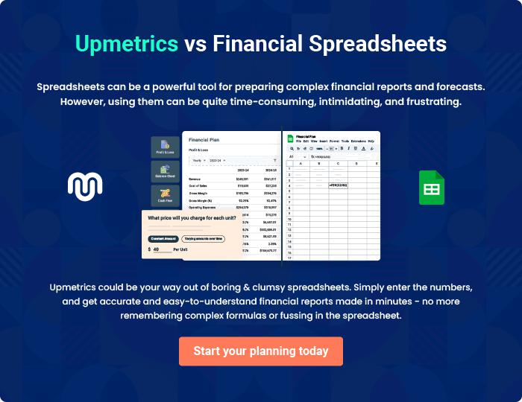
Appendix

When writing the appendix section, you should include any additional information that supports the main content of your plan. This may include financial statements, market research data, legal documents, and other
To unlock help try Upmetrics! 
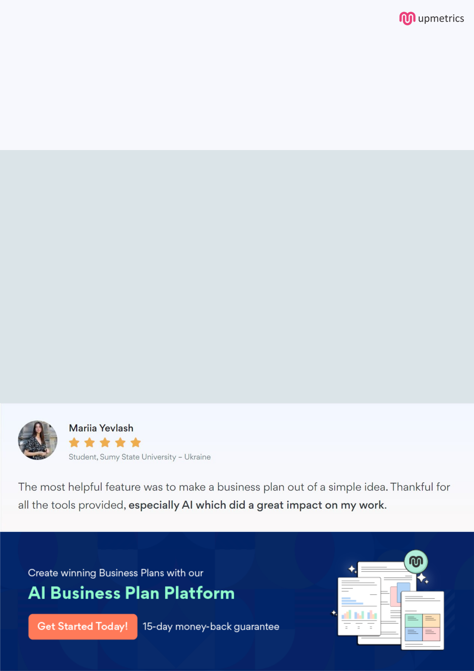
Create a winning business plan that gets you funded

Creating a stunning and investment-ready plan requires no writing, graphic designing, or financial planning expertise.

Upmetrics has all the features required to help you create a comprehensive business plan—from start to finish. Make no mistakes, it’s the modern way of planning to structure ideas, make plans, and create stunning pitch decks to awe investors.

Pitch decks that impress investors

Create pitch decks that provide a visual representation of your business, engage investors, and make them want to invest in your business idea.

Interactive plans in no time

Import business plan sections like—SWOT analysis, comparison tables, and others to create an interactive business plan. No designing skills are required.

Stunning cover page designs

With Upmetrics, you have the liberty to choose from multiple stunning cover page designs. Choose a creative design and make your plan stand out.

Online sharing made simple

Upmetrics makes online sharing quick and easier for users. Easily share your business plans with a link while tracking reader activity.

500+ sample business plans

Simply import a template from our library of sample plans into the editor and start customizing it to make it yours. It takes only a few clicks to get started.

Collaborate with team in real-time

Invite team members, initiate conversations, discuss ideas & strategies, share feedback, and work on a business plan in real-time.

