
Tow Truck Business Plan

BUSINESS PLAN

Roadside Help, Anytime

Prepared By

John Doe

10200 Bolsa Ave, Westminster, CA, 92683

info@example.com

(650) 359-3153 http://www.example.com

Table of Contents

Executive Summary | 6
Market opportunity | 6
Services Offered | 6
Marketing & Sales Strategies | 7
Financial Highlights | 7
Units Sold v/s Revenue | 8

Company Overview | 9
Ownership | 9
Mission statement | 10
Business history | 10
Future goals | 10

Market Analysis | 11
Target Market | 11
Market size and growth potential | 11
Market Size | 12
Competitive analysis | 12
AAA Towing | 12
Pep Boys Towing | 13
U-Haul Towing | 13
Market trends | 13
Regulatory environment | 14

Products and Services | 15
Services | 15
Light-Duty Towing | 15
Medium-Duty Towing | 16
Heavy-Duty Towing | 16
Roadside Assistance | 16
Vehicle Storage | 17
Vehicle Transport | 17
Quality Measures | 17
Additional Services | 18

Sales And Marketing Strategies | 19
Unique Selling Proposition (USP) | 19
Pricing Strategy | 19
Marketing strategies | 20
Online | 20
Offline | 20
Sales strategies | 21
Customer retention | 22

Operations Plan | 23
Staffing & Training | 23
Operational Process | 23
Equipment & Machinery | 24

Management Team | 25
Key managers | 25
John Doe | 26
Jane Doe | 27
Alice Brown | 27
Robert Brown | 27
Organizational structure | 28
Organization chart | 28
Compensation plan | 28
Advisors/consultants | 29
Mr. Michael Smith | 29
Dr. Emily Johnson | 29
Financial Plan
Financial Plan | 30

Profit & loss statement 30

Cash flow statement | 33
Balance sheet | 35
Break-even Analysis | 37
Financing needs | 39
Appendix
Appendix | 41
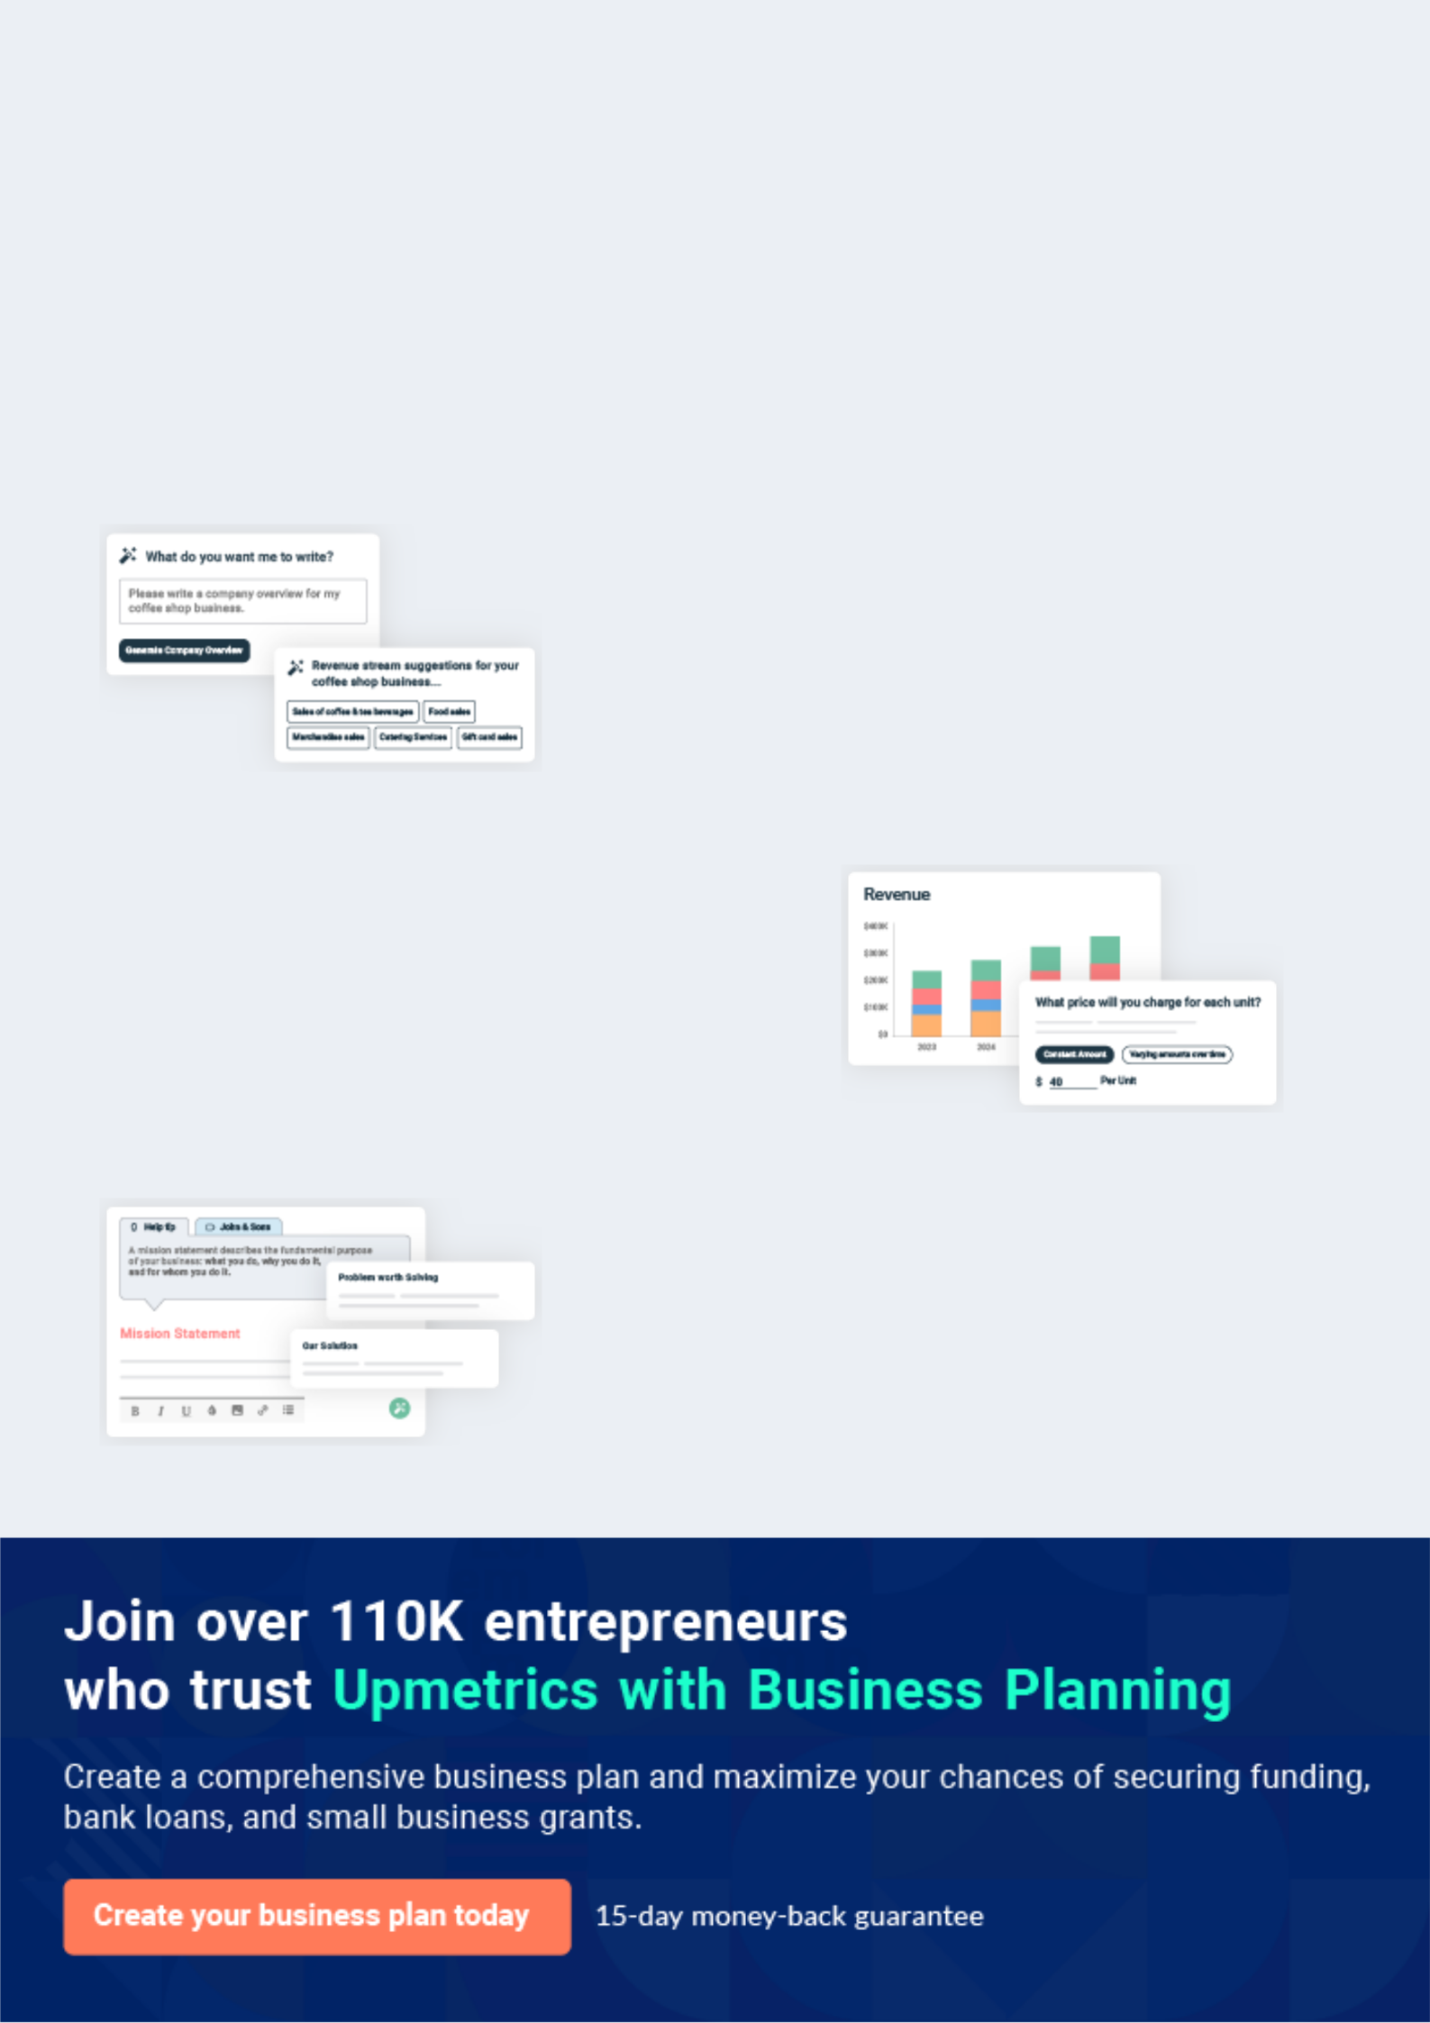
Business planning that’s simpler and faster than you think

Creating a business plan using Upmetrics to start and grow a business is literally the easiest thing in the World. Simply read the instructions and fill in the blanks. It’s as simple as that.

❛ | Upmetrics has everything you need to create a | ❜
❛ | comprehensive business plan. | ❜

AI-powered Upmetrics Assistant

AI-powered insights to streamline your plan

Not sure where to start? Upmetrics’ AI Assistant will automatically generate ideas for each section of your plan and offer improved versions of your writing, adjusting for tone, voice, and grammar or spelling errors.

Financial Forecasting Tool

All the financials are calculated for you

Forget the complex formulas and clumsy spreadsheets — with automatic financials and drag-and-drop forecasting, you can finish your plan faster and be confident that your numbers are accurate.

Business Plan Builder

Guides you like a business mentor

Upmetrics’ step-by-step instructions, prompts, and the library of 400+ sample business plans will guide you through each section of your plan as a business mentor.
Executive Summary


An executive summary is the first section of the business plan intended to provide an overview of the whole business plan.
To unlock help try Upmetrics! 

 Help tip  Tow Truck Business Plan


Start your executive summary by briefly introducing your business to your readers.

This section may include the name of your tow truck business, its location, when it was
To unlock help try Upmetrics! 

Start writing here..

Market opportunity

 Help tip  Tow Truck Business Plan

Summarize your market research, including market size, growth potential, and marketing trends. Highlight the opportunities in the market and how your business will fit in to fill the gap.
To unlock help try Upmetrics! 

Start writing here..

Services Offered

 Help tip  Tow Truck Business Plan

Highlight the towing services you offer your clients. The USPs and differentiators you offer are always a plus.
To unlock help try Upmetrics! 

Start writing here..

Marketing & Sales Strategies
To unlock help try Upmetrics!

 Help tip  Tow Truck Business Plan

Outline your sales and marketing strategies—what marketing platforms you use, how you plan on acquiring customers, etc.
To unlock help try Upmetrics! 

Start writing here..

Financial Highlights

 Help tip  Tow Truck Business Plan

Briefly summarize your financial projections for the initial years of business operations. Include any capital or investment requirements, associated startup costs, projected revenues, and profit forecasts.



Start writing here..
Units Sold v/s Revenue

 |  | Units Sold | Revenue
15.00k
10.00k
5.00k
0
Year 1 | Year 2 | Year 3
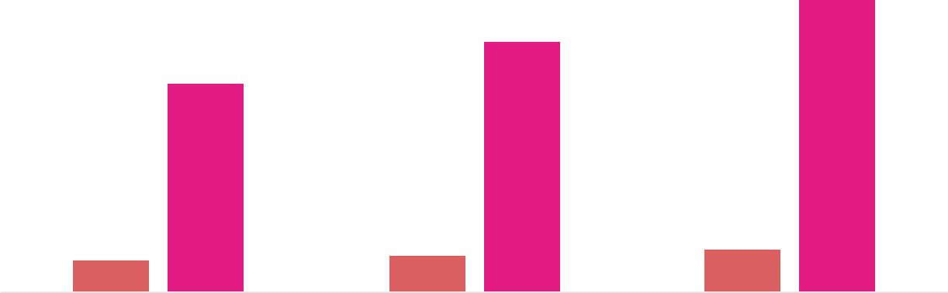

Financial Year |  |  | Units Sold | Revenue
Year 1 | 1,550 |  |  | $10,000
Year 2 | 1,800 |  |  | $12,000
Year 3 | 2,050 |  |  | $14,000
 Help tip |  |  Tow Truck Business Plan


Summarize your executive summary section with a clear CTA, for example, inviting angel investors to discuss the potential business investment.
To unlock help try Upmetrics! 

Write a call to action for your business plan.
Company Overview

Depending on what details of your business are essential, you’ll need different elements in your business overview.
To unlock help try Upmetrics! 

 Help tip  Tow Truck Business Plan

Describe your business in this section by providing all the basic information:

Describe what kind of towing company you run and the name of it. For instance, here are some
To unlock help try Upmetrics! 

Start writing here..

Ownership

 Help tip  Tow Truck Business Plan

List the founders or owners of your towing company. Describe what shares they own and their responsibilities for efficiently managing the business.
To unlock help try Upmetrics! 

Start writing here..
Mission statement

 Help tip  Tow Truck Business Plan

Summarize your business’ objective, core principles, and values in your mission statement. This statement needs to be memorable, clear, and brief.
To unlock help try Upmetrics! 

❛ Our mission at [Quick Tow] is to provide fast, reliable, and affordable towing services to our clients, ensuring their safety and satisfaction.

We strive to be the premier tow truck service provider in the [Westminster] area, upholding the highest standards of professionalism and integrity in everything we do.

❜

Business history

 Help tip  Tow Truck Business Plan

If you’re an established towing service provider, briefly describe your business history, like— when it was founded, how it evolved over time, etc.
To unlock help try Upmetrics! 

Start writing here..

Future goals

 Help tip  Tow Truck Business Plan

It’s crucial to convey your aspirations and vision. Mention your short-term and long-term goals; they can be specific targets for revenue, market share, or expanding your services.
To unlock help try Upmetrics! 

Start writing here..

Market Analysis
To unlock help try Upmetrics!


 |  | Market analysis provides a clear understanding of the market in which your
 |  | printing business will run along with the target market, competitors, and
 |  | growth opportunities.
 |  |  |  | To unlock help try Upmetrics! 
 Help tip |  |  Tow Truck Business Plan

To write the introduction section of your market analysis, start by clearly identifying your primary target market.
To unlock help try Upmetrics! 

Start writing here..

Target Market

 Help tip  Tow Truck Business Plan

Start this section by describing your target market. Define your ideal customer and explain what types of services they prefer. Creating a buyer persona will help you easily define your target market to your readers.



Start writing here..

Market size and growth potential

 Help tip  Tow Truck Business Plan

Describe your market size and growth potential and whether you will target a niche or a much broader market.
To unlock help try Upmetrics! 

Start writing here..

Market Size

Available Market | 5M
Total number of towing service requests | 5M
annually in the region.
Served Market | 3M
Total number of towing service requests | 3M
annually that [Quick Tow] can realistically | 3M
serve.
Target Market | 1M
Number of towing service requests from | 1M
commercial businesses and law enforcement | 1M

agencies [Quick Tow

 Help tip  Tow Truck Business Plan

Identify and analyze your direct and indirect competitors. Identify their strengths and weaknesses, and describe what differentiates your towing services from them.
To unlock help try Upmetrics! 

Competitive analysis

AAA Towing

- is a well-established player in the towing industry, offering a range of services including towing, flat tire changes, and battery jump-starts.

Features | Strengths
24/7 roadside assistance | Strong brand recognition
Nationwide coverage | Comprehensive service
Additional services such as | offerings beyond towing
travel planning and insurance | Extensive network of service
 | providers

Weaknesses

Higher pricing compared to smaller, local providers

Some customers report long wait times due to high demand

Pep Boys Towing

Part of the larger Pep Boys automotive retail and service chain, Pep Boys Towing provides towing and roadside assistance services.

Features

Towing services for cars, trucks, and motorcycles

Roadside assistance including tire changes, jump-starts, and fuel delivery

Online appointment scheduling

Strengths | Weaknesses
National presence with | Limited availability in rural areas
locations in most major cities | Services may vary by location
Convenient online scheduling
Affiliation with a well-known
automotive service brand

U-Haul Towing

U-Haul is primarily known for its rental moving trucks, but they also offer towing services as part of their comprehensive moving solutions.

Features

Towing equipment rental including trailers, tow dollies, and auto transports

24/7 roadside assistance for customers renting their equipment

Moving supplies and storage solutions

Strengths

Extensive network of locations across North America

All-in-one solution for moving and towing needs

Well-known and trusted brand

Weaknesses

Towing services are mainly limited to customers renting their equipment

Some customers report issues with equipment availability and condition

Market trends

 Help tip  Tow Truck Business Plan

Analyse emerging trends in the industry, such as technology disruptions, changes in customer behavior or preferences, etc. Explain how your business will cope with all the trends.
To unlock help try Upmetrics! 

Start writing here..

Regulatory environment
To unlock help try Upmetrics!

 Help tip  Tow Truck Business Plan

Describe any regulations or licensing requirements that affect the printing house such as meeting the quality and safety criteria, and having an experienced employee to perform printing activities.



Start writing here..
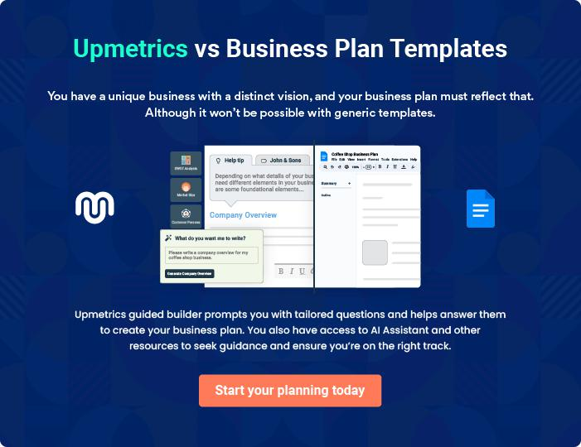
Products and Services
To unlock help try Upmetrics!

The product and services section of a tow truck business plan should describe the specific services and products that will be offered to customers. To write this section should include the following:



 Help tip  Tow Truck Business Plan

To craft the introduction for your "Products and Services" chapter, begin by positioning your business within its industry, emphasizing its unique strengths or value proposition.
To unlock help try Upmetrics! 

Start writing here..

 Help tip


Mention the towing services your business will offer. This list may include services like,

• Towing services
To unlock help try Upmetrics! 

Services

Light-Duty Towing


Price: [$75] per tow within city limits

Towing services for light-duty vehicles such as cars, motorcycles, and small trailers.

Specifications

- Weight capacity: Up to 4,000 lbs

- Service range: City-wide

- Availability: 24/7
Medium-Duty Towing

Price: [$150] per tow within city limits

Towing services for medium-duty vehicles including small trucks, vans, and larger trailers.

Specifications

- Weight capacity: 4,000 lbs to 12,000 lbs

- Service range: City-wide

- Availability: 24/7

Heavy-Duty Towing

Price: [$250] per tow within city limits

Towing services for heavy-duty vehicles such as buses, large trucks, and RVs.

Specifications

- Weight capacity: 12,000 lbs and above

- Service range: City-wide and intercity (additional charges may apply for intercity tows)

- Availability: 24/7

Roadside Assistance

Price: [$50] per service call

Assistance for common roadside issues like flat tires, dead batteries, and lockouts.

Specifications

- Service range: City-wide

- Availability: 24/7

- Includes: Tire change, jump start, fuel delivery, lockout service
Vehicle Storage

Price: [$30] per day

Secure storage facilities for vehicles of all sizes, available for both short-term and long-term durations.

Specifications

- Security: 24/7 surveillance and gated facilities

- Access: 24/7 access with prior notice

- Size: Can accommodate vehicles of all sizes, including RVs and buses

Vehicle Transport

Price: Starts at [$100] per transport within city limits

Safe and secure transport of vehicles from one location to another.

Specifications

- Service range: City-wide and intercity (additional charges may apply for intercity transports)

- Availability: Scheduled

- Includes: Door-to-door service, insurance coverage

Quality Measures

 Help tip  Tow Truck Business Plan

This section should explain how you maintain quality standards and consistently provide the highest quality service.
To unlock help try Upmetrics! 

Start writing here..

Additional Services

 Help tip  Tow Truck Business Plan

Mention if your tow truck company offers any additional services. You may include services like, emergency towing, accidental recovery, winch-out services, etc.
To unlock help try Upmetrics! 

Start writing here..
Sales And Marketing Strategies
To unlock help try Upmetrics!

Writing the sales and marketing strategies section means a list of strategies you will use to attract and retain your clients.
To unlock help try Upmetrics! 

 Help Tip  Tow Truck Business Plan


To create an effective introduction for your "Sales and Marketing Strategies" chapter, start by setting the stage within your specific industry or market.
To unlock help try Upmetrics! 

Start writing here..

Unique Selling Proposition (USP)

 Help tip  Tow Truck Business Plan

Define your business’s USPs depending on the market you serve, the equipment you use, and the unique services you provide. Identifying USPs will help you plan your marketing strategies.
To unlock help try Upmetrics! 

Start writing here..

Pricing Strategy

 Help tip  Tow Truck Business Plan

Describe your pricing strategy—how you plan to price your towing services and stay competitive in the local market. You can mention any discounts you plan on offering to attract new customers to your towing service.



Start writing here..

 Help tip  Tow Truck Business Plan
To unlock help try Upmetrics!

Discuss your marketing strategies to market your services. You may include some of these marketing strategies in your business plan—social media marketing, Google ads, brochures, email marketing, content marketing, and print marketing.



Marketing strategies

Online


Social Media

Engaging content on platforms like [Facebook], [Instagram], and [LinkedIn] to build brand awareness and community engagement.

Content Marketing

Informative blogs and articles about car safety, maintenance tips, and the importance of reliable towing services.

Email Marketing

Regular updates and promotions sent to our mailing list.

Google Ads

Targeted ads to reach users actively searching for towing services in our region.

Offline

Brochures and Flyers

Distributed at strategic locations, such as [local garages], [car dealerships], and [community centers].

Print Marketing

Local newspaper ads and magazine placements to reach a broader audience.

 Help tip  Tow Truck Business Plan
To unlock help try Upmetrics!

Outline the strategies you’ll implement to maximize your sales. Your sales strategies may include direct sales calls and emails, partnering with other law enforcement agencies and businesses, offering referral programs, community involvement, etc.



Sales strategies

Direct Sales Outreach

Calls and emails targeting businesses that regularly require towing services.

Referral Programs

Incentives for customers who refer our services to friends, family, or businesses.

Partnerships

Collaborations with [local law enforcement agencies], [insurance companies], and [car repair shops] for referral business.

Community Involvement

Participation in local events, sponsorship, and community initiatives to increase brand visibility.

 Help tip  Tow Truck Business Plan

Describe your customer retention strategies and how you plan to execute them.

For instance, you may include introducing loyalty programs and offering personalized service
To unlock help try Upmetrics! 

Customer retention

Loyalty Programs

Repeat customers can earn points with each service, redeemable for discounts or free services.

Feedback Loop

Actively seeking and acting upon feedback to continually improve our services.

Personalized Service

Recognizing and acknowledging

regular customers, understanding

their specific needs, and tailoring

services accordingly.

Operations Plan
To unlock help try Upmetrics!

 |  | When writing the operations plan section, it’s important to consider the
 |  | various aspects of your business operations.
 |  |  |  | To unlock help try Upmetrics! 
 Help tip |  |  Tow Truck Business Plan


To create an effective introduction for your "Operational Plan" chapter, start by emphasizing the
pivotal role of efficient operations in the success of your business, underscoring how they
directly impact the quality of services delivered.
 |  |  |  | To unlock help try Upmetrics! 
Start writing here..
Staffing & Training
 Help tip |  |  Tow Truck Business Plan

Mention your towing business’s staffing requirements, including the number of tow truck
drivers, mechanics, dispatchers, and other employees needed. Include their qualifications, the
training required, and the duties they will perform.
 |  |  |  | To unlock help try Upmetrics! 
Start writing here..
Operational Process
 Help tip |  |  Tow Truck Business Plan

Outline the processes and procedures you will use to run your tow truck business. Your operational processes may include receiving service calls, towing vehicles, maintaining tow trucks, and ensuring safety and compliance.



Start writing here..

Equipment & Machinery

 Help tip  Tow Truck Business Plan

Include the list of equipment and machinery required for a tow truck business, such as tow trucks, winches, safety equipment, tools and supplies, diagnostic equipment, etc.
To unlock help try Upmetrics! 

Start writing here..
Management Team

The management team section provides an overview of the individuals responsible for running your business plan.
To unlock help try Upmetrics! 

 Help tip  Tow Truck Business Plan

To craft an introduction for your "Management Team" chapter, begin by emphasizing the crucial role of leadership in the success of any business.
To unlock help try Upmetrics! 

Start writing here..

Key managers

 Help tip  Tow Truck Business Plan

Introduce your management and key members of your team, and explain their roles and responsibilities.
To unlock help try Upmetrics! 

Start writing here..

JOHN DOE

CEO - john.doe@example.com

As the founder and CEO of Quick Tow, John is responsible for overall strategic planning, business development, and operations.

His passion for the towing industry and commitment to excellent service are the driving forces behind the company's success.


- Education: John has a Bachelor’s degree in Business Administration from the University of California, Los Angeles.

- Professional Background: With over 15 years of experience in the towing industry, John has a deep understanding of the market and the operational challenges involved in the towing business.

JANE DOE

Operations Manager - jane.doe@example.com

Jane oversees the daily operations of Quick Tow, ensuring everything runs smoothly and efficiently.

She is dedicated to optimizing processes to provide fast and reliable service to customers.

- Education: Bachelor’s degree in Operations Management from the University of Southern California.

- Professional Background: With over 10 years of experience in operations, Jane has a proven track record of improving operational efficiency and customer satisfaction.


ALICE BROWN

Safety Manager - alice.brown@example.com

Alice is responsible for ensuring all safety protocols are strictly followed and that the team is well-equipped and trained to handle any situation safely.

- Education: Bachelor’s degree in Safety Management from California State University, Fullerton.

- Professional Background: With over 8 years of experience in safety management in the towing industry, Alice is committed to creating a safe working environment and promoting a safety culture within the organization.


ROBERT BROWN

Marketing Manager - robert.brown@example.com

Robert is responsible for developing and implementing effective marketing strategies to promote Quick Tow's services and increase brand awareness.

- Education: Bachelor’s degree in Marketing from the University of California, Berkeley.

- Professional Background: With over 12 years of experience in marketing, Robert has a keen understanding of the towing market and knows how to effectively reach and engage the target audience.
Organizational structure

 Help tip  Tow Truck Business Plan

Explain the organizational structure of your management team. Include the reporting line and decision-making hierarchy.
To unlock help try Upmetrics! 

Start writing here..

Organization chart


John Doe

CEO


Alice Brown Jane Doe Robert Brown

Safety Manager Operations Manager Marketing Manager




Emily White Mike Johnson

HR Supervisor Dispatch Supervisor

Compensation plan

 Help tip  Tow Truck Business Plan

Describe your compensation plan for the management and staff. Include their salaries, incentives, and other benefits.
To unlock help try Upmetrics! 

Start writing here..

 Help tip  Tow Truck Business Plan

Mentioning advisors or consultants in your business plans adds credibility to your business idea.
To unlock help try Upmetrics! 

Advisors/consultants


MR. MICHAEL SMITH

Legal consultant

Mr. Smith is a legal consultant with [X] years of experience. His expertise ensures that we are always compliant with industry regulations and legal requirements.


DR. EMILY JOHNSON

Advisor

With over [X] years of experience in the towing industry, Dr. Johnson provides valuable insights and advice to help us navigate the industry's challenges and opportunities.
Financial Plan

When writing the financial plan section of a business plan, it’s important to provide a comprehensive overview of your financial projections for the first few years of your business, You may provide the following:
To unlock help try Upmetrics! 

 Help tip  Tow Truck Business Plan


To create an effective introduction for your "Financial Plan" chapter, begin by stressing the critical role of a well-structured financial plan in the success of your venture.
To unlock help try Upmetrics! 

Start writing here..

 Help tip  Tow Truck Business Plan

Describe details such as projected revenue, operational costs, and service costs in your projected profit and loss statement. Make sure to include your business’s expected net profit or loss.
To unlock help try Upmetrics! 

Profit & loss statement

Revenue

Cost Of Sales

General Costs

Revenue Specific Costs

Personnel Costs (Direct

Labor)

Gross Margin

Gross Margin (%)

Operating Expense

Payroll Expense

(Indirect Labor)

General Expense

Bad Debt

Amortization of Current

Assets

2023-24 | 2024-25 | 2025-26 | 2026-27 | 2027-28
$0 | $0 | $0 | $0 | $0

$0 | $0 | $0 | $0 | $0
$0 | $0 | $0 | $0 | $0
$0 | $0 | $0 | $0 | $0
$0 | $0 | $0 | $0 | $0

$0 | $0 | $0 | $0 | $0
0% | 0% | 0% | 0% | 0%

$0 | $0 | $0 | $0 | $0
$0 | $0 | $0 | $0 | $0
$0 | $0 | $0 | $0 | $0
$0 | $0 | $0 | $0 | $0
$0 | $0 | $0 | $0 | $0

EBITDA

Additional Expense

Long Term

Depreciation

Gain or loss from Sale

of Assets

EBIT

Interest Expenses

EBT

Income Tax Expense

Total Expense

Net Income

Net Income (%)

2023-24 | 2024-25 | 2025-26 | 2026-27 | 2027-28
$0 | $0 | $0 | $0 | $0
$0 | $0 | $0 | $0 | $0
$0 | $0 | $0 | $0 | $0
$0 | $0 | $0 | $0 | $0
$0 | $0 | $0 | $0 | $0
$0 | $0 | $0 | $0 | $0
$0 | $0 | $0 | $0 | $0
$0 | $0 | $0 | $0 | $0
$0 | $0 | $0 | $0 | $0
$0 | $0 | $0 | $0 | $0
0% | 0% | 0% | 0% | 0%

 |  |  | 2023-24 |  | 2024-25 | 2025-26
Retained Earning |  |  | $0 |  | $0 | $0
Opening |  |  |  |  | $0 | $0
Owner's Distribution |  |  | $0 |  | $0 | $0
Retained Earning |  |  | $0 |  | $0 | $0
Closing |  |  |  |  | $0 | $0
 Help tip |  |  |  Tow Truck Business Plan


The cash flow for the first few years of your operation should be estimated and described in this section.

This may include billing invoices, payment receipts, loan payments, and any other cash flow statements.
2026-27 2027-28

$0 $0

$0 $0

$0 $0

To unlock help try Upmetrics! 

Cash flow statement

 | 2023-24 | 2024-25 | 2025-26 | 2026-27 | 2027-28
Cash Received | $0 | $0 | $0 | $0 | $0
Cash Paid | $0 | $0 | $0 | $0 | $0
COS & General Expenses | $0 | $0 | $0 | $0 | $0
Salary & Wages | $0 | $0 | $0 | $0 | $0
Interest | $0 | $0 | $0 | $0 | $0

Sales Tax

Income Tax

Net Cash From

Operations

Assets Sell

Assets Purchase

Net Cash From

Investments

Amount Received

Loan Received

Common Stock

Preferred Stock

Owner's Contribution

Amount Paid

2023-24 | 2024-25 | 2025-26 | 2026-27 | 2027-28
$0 | $0 | $0 | $0 | $0
$0 | $0 | $0 | $0 | $0
$0 | $0 | $0 | $0 | $0

$0 | $0 | $0 | $0 | $0
$0 | $0 | $0 | $0 | $0
$0 | $0 | $0 | $0 | $0

$0 | $0 | $0 | $0 | $0
$0 | $0 | $0 | $0 | $0

$0 | $0 | $0 | $0 | $0
$0 | $0 | $0 | $0 | $0
$0 | $0 | $0 | $0 | $0

Loan Capital $0 $0 $0 $0 $0

 |  |  | 2023-24 | 2024-25 | 2025-26 | 2026-27 | 2027-28
Dividends & Distributions |  |  | $0 | $0 | $0 | $0 | $0
Net Cash From |  |  | $0 | $0 | $0 | $0 | $0
Financing
Summary
Starting Cash |  |  | $0 | $0 | $0 | $0 | $0
Cash In |  |  | $0 | $0 | $0 | $0 | $0
Cash Out |  |  | $0 | $0 | $0 | $0 | $0
Change in Cash |  |  | $0 | $0 | $0 | $0 | $0
Ending Cash |  |  | $0 | $0 | $0 | $0 | $0
 Help tip |  |  Tow Truck Business Plan

Create a projected balance sheet documenting your tow truck business’s assets, liabilities, and equity.

To unlock help try Upmetrics! 

Balance sheet

 | 2023-24 | 2024-25 | 2025-26 | 2026-27 | 2027-28
Assets | $0 | $0 | $0 | $0 | $0
Current Assets | $0 | $0 | $0 | $0 | $0
Cash | $0 | $0 | $0 | $0 | $0
Accounts Receivable | $0 | $0 | $0 | $0 | $0
Inventory | $0 | $0 | $0 | $0 | $0
Other Current Assets | $0 | $0 | $0 | $0 | $0
Long Term Assets | $0 | $0 | $0 | $0 | $0
Gross Long Term Assets | $0 | $0 | $0 | $0 | $0
Accumulated Depreciation | $0 | $0 | $0 | $0 | $0

Liabilities & Equity | $0 | $0 | $0 | $0 | $0
Liabilities | $0 | $0 | $0 | $0 | $0
Current Liabilities | $0 | $0 | $0 | $0 | $0
Accounts Payable | $0 | $0 | $0 | $0 | $0
Income Tax Payable | $0 | $0 | $0 | $0 | $0
Sales Tax Payable | $0 | $0 | $0 | $0 | $0
Short Term Debt | $0 | $0 | $0 | $0 | $0
 | 2023-24 | 2024-25 | 2025-26 | 2026-27 | 2027-28
Long Term Liabilities | $0 | $0 | $0 | $0 | $0
Long Term Debt | $0 | $0 | $0 | $0 | $0
Equity | $0 | $0 | $0 | $0 | $0
Paid-in Capital | $0 | $0 | $0 | $0 | $0
Common Stock | $0 | $0 | $0 | $0 | $0
Preferred Stock | $0 | $0 | $0 | $0 | $0
Owner's Contribution | $0 | $0 | $0 | $0 | $0
Retained Earnings | $0 | $0 | $0 | $0 | $0

Check | $0 |  |  | $0 | $0 | $0 | $0
 Help tip |  |  Tow Truck Business Plan

Determine and mention your business’s break-even point—the point at which your business costs and revenue will be equal.

This exercise will help you understand how much revenue you need to generate to sustain or be profitable.
To unlock help try Upmetrics! 

Break-even Analysis

 | 2023-24 | 2024-25 | 2025-26 | 2026-27 | 2027-28
Starting Revenue | $0 | $0 | $0 | $0 | $0
Net Revenue | $0 | $0 | $0 | $0 | $0
Closing Revenue | $0 | $0 | $0 | $0 | $0

Starting Expense | $0 | $0 | $0 | $0 | $0
Net Expense | $0 | $0 | $0 | $0 | $0
Closing Expense | $0 | $0 | $0 | $0 | $0

Is Break Even? | 0 | 0 | 0 | 0 | 0
Break Even Month | 0 | 0 | 0 | 0 | 0
Days Required | 0 | 0 | 0 | 0 | 0
Break Even Revenue | $0 | $0 | $0 | $0 | $0
Break Even Units
Financing needs

 Help tip  Tow Truck Business Plan

Calculate costs associated with starting a tow truck business, and estimate your financing needs and how much capital you need to raise to operate your business.
To unlock help try Upmetrics! 

Start writing here..
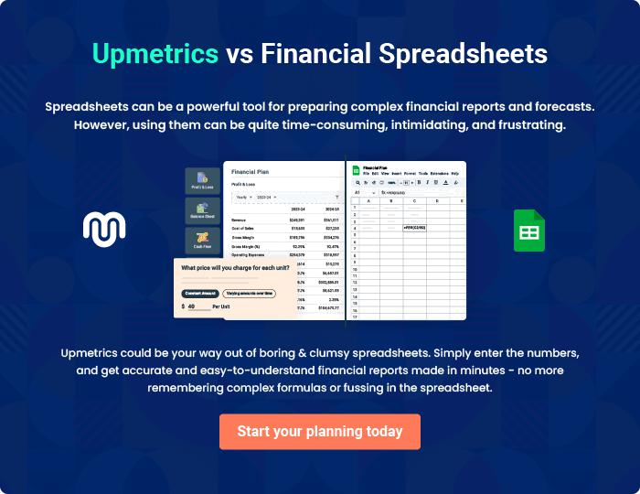
Appendix

When writing the appendix section, you should include any additional information that supports the main content of your plan. This may include financial statements, market research data, legal documents, and other
To unlock help try Upmetrics! 

Create a winning business plan that gets you funded

Creating a stunning and investment-ready plan requires no writing, graphic designing, or financial planning expertise.

Upmetrics has all the features required to help you create a comprehensive business plan—from start to finish. Make no mistakes, it’s the modern way of planning to structure ideas, make plans, and create stunning pitch decks to awe investors.

Pitch decks that impress investors

Create pitch decks that provide a visual representation of your business, engage investors, and make them want to invest in your business idea.

Interactive plans in no time

Import business plan sections like—SWOT analysis, comparison tables, and others to create an interactive business plan. No designing skills are required.

Stunning cover page designs

With Upmetrics, you have the liberty to choose from multiple stunning cover page designs. Choose a creative design and make your plan stand out.

Online sharing made simple

Upmetrics makes online sharing quick and easier for users. Easily share your business plans with a link while tracking reader activity.

500+ sample business plans

Simply import a template from our library of sample plans into the editor and start customizing it to make it yours. It takes only a few clicks to get started.

Collaborate with team in real-time

Invite team members, initiate conversations, discuss ideas & strategies, share feedback, and work on a business plan in real-time.

