
BUSINESS PLAN

2023

Tour Operator

Business Plan

Explore, Experience, Wander

John Doe

10200 Bolsa Ave, Westminster, CA, 92683

- 359-3153 info@example.com http://www.example.com

Information provided in this business plan is unique to this business and confidential; therefore, anyone reading this plan agrees not to disclose any of the information in this business plan without prior written permission of the company.
Table of Contents

Executive Summary | 6
Market opportunity | 6
Services Offered | 6
Marketing & Sales Strategies | 7
Financial Highlights | 7
Units Sold v/s Revenue | 8

Company Overview | 9
Ownership | 9
Mission statement | 10
Business history | 10
Future goals | 10

Market Analysis | 11
Target Market | 11
Market size and growth potential | 11
Market Size | 12
Competitive analysis | 12
Intrepid Travel | 12
G Adventures | 13
REI Adventures | 13
Market trends | 13
Regulatory environment | 14

Products and Services | 15
Services | 15
Custom Itinerary Planning | 15
Guided Tours | 16
Accommodation Booking | 16
Activities & Excursions | 16
Travel Documentation & Visa Assistance | 17
Travel Insurance | 17
Destination Management Services | 17
Quality Assurance & Safety Measures | 18
Additional Services | 18

Sales And Marketing Strategies | 19
Unique Selling Proposition (USP) | 19
Pricing Strategy | 19
Marketing strategies | 20
Online | 20
Offline | 20
Sales strategies | 21
Customer retention | 22

Operations Plan | 23
Staffing & Training | 23
Operational Process | 23
Equipment & Software | 24

Management Team | 25
Key managers | 25
John Doe | 25
Jane Doe | 26
Alice Brown | 26
Robert Brown | 26
Organizational structure | 26
Organization chart | 27
Compensation plan | 27
Advisors/Consultants | 28
Michael Johnson | 28
Dr Emma Smith | 28
Financial Plan | 29
Profit & loss statement | 29
Cash flow statement | 32
Balance sheet | 34
Break-even Analysis | 36
Financing needs | 38
Appendix
Appendix | 40
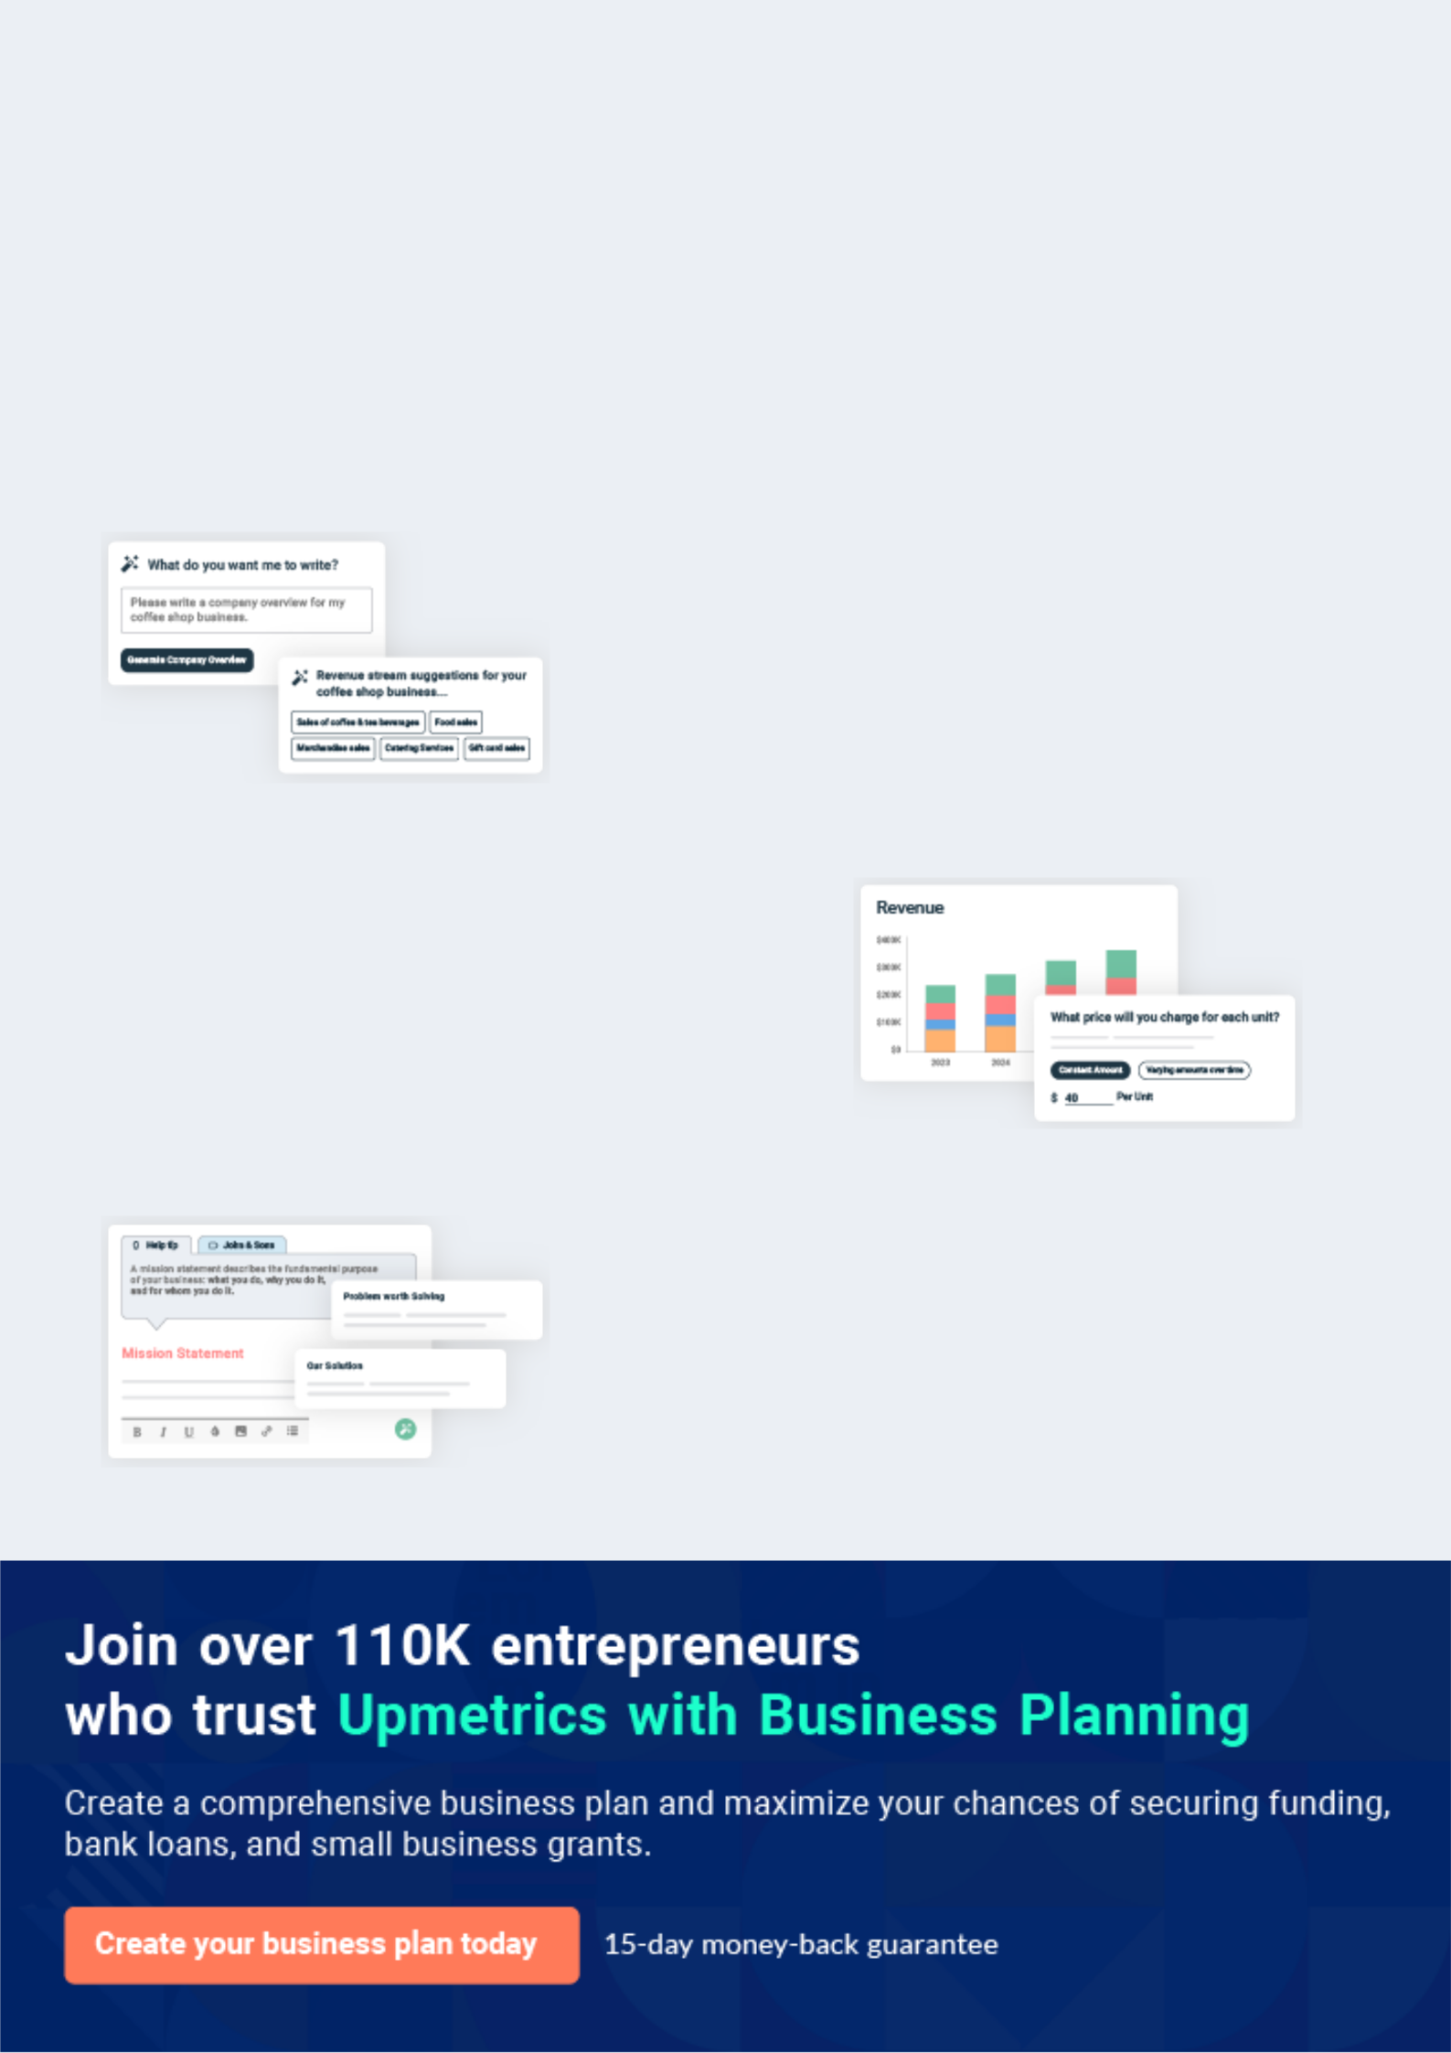
Business planning that’s simpler and faster than you think

Creating a business plan using Upmetrics to start and grow a business is literally the easiest thing in the World. Simply read the instructions and fill in the blanks. It’s as simple as that.

❛ | Upmetrics has everything you need to create a | ❜
❛ | comprehensive business plan. | ❜

AI-powered Upmetrics Assistant

AI-powered insights to streamline your plan

Not sure where to start? Upmetrics’ AI Assistant will automatically generate ideas for each section of your plan and offer improved versions of your writing, adjusting for tone, voice, and grammar or spelling errors.

Financial Forecasting Tool

All the financials are calculated for you

Forget the complex formulas and clumsy spreadsheets — with automatic financials and drag-and-drop forecasting, you can finish your plan faster and be confident that your numbers are accurate.

Business Plan Builder

Guides you like a business mentor

Upmetrics’ step-by-step instructions, prompts, and the library of 400+ sample business plans will guide you through each section of your plan as a business mentor.
Executive Summary


An executive summary is the first section of the business plan intended to provide an overview of the whole business plan.
To unlock help try Upmetrics! 

 Help tip  Tour Operator Business Plan


Start your executive summary by briefly introducing your business to your readers.

This section may include the name of your tour operator business, its location, when it was
To unlock help try Upmetrics! 

Start writing here..

Market opportunity

 Help tip  Tour Operator Business Plan

Summarize your market research, including market size, growth potential, and marketing trends. Highlight the opportunities in the market and how your business will fit in to fill the gap.
To unlock help try Upmetrics! 

Start writing here..

Services Offered

 Help tip  Tour Operator Business Plan

Highlight the tour operator services you offer your clients. The USPs and differentiators you offer are always a plus.
To unlock help try Upmetrics! 

Start writing here..

Marketing & Sales Strategies
To unlock help try Upmetrics!

 Help tip  Tour Operator Business Plan

Outline your sales and marketing strategies—what marketing platforms you use, how you plan on acquiring customers, etc.
To unlock help try Upmetrics! 

Start writing here..

Financial Highlights

 Help tip  Tour Operator Business Plan

Briefly summarize your financial projections for the initial years of business operations. Include any capital or investment requirements, associated startup costs, projected revenues, and profit forecasts.



Start writing here..
Units Sold v/s Revenue

 |  | Units Sold | Revenue
15.00k
10.00k
5.00k
0
Year 1 | Year 2 | Year 3
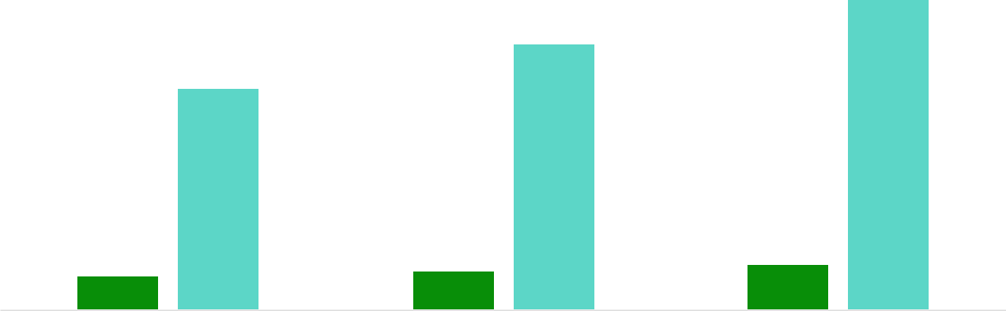

Financial Year |  |  | Units Sold | Revenue
Year 1 | 1,550 |  |  | $10,000
Year 2 | 1,800 |  |  | $12,000
Year 3 | 2,050 |  |  | $14,000
 Help tip |  |  Tour Operator Business Plan


Summarize your executive summary section with a clear CTA, for example, inviting angel investors to discuss the potential business investment.
To unlock help try Upmetrics! 

Write a call to action for your business plan.
Company Overview

Depending on what details of your business are essential, you’ll need different elements in your business overview.
To unlock help try Upmetrics! 

 Help tip  Tour Operator Business Plan

Describe your business in this section by providing all the basic information:

Describe what kind of tour operator company you run and the name of it. You may specialize in
To unlock help try Upmetrics! 

Start writing here..

Ownership

 Help tip  Tour Operator Business Plan

List the names of your tour operator business’s founders or owners. Describe what shares they own and their responsibilities for efficiently managing the business.
To unlock help try Upmetrics! 

Start writing here..
Mission statement

 Help tip  Tour Operator Business Plan

Summarize your business’ objective, core principles, and values in your mission statement. This statement needs to be memorable, clear, and brief.
To unlock help try Upmetrics! 

❛ At [Sunny Adventures Tours], our mission is to provide unique, exciting, and safe adventure experiences that cater to the thrill-seeker's desire for exploration and discovery.

We are committed to delivering top-notch services that exceed expectations, adhering to the highest standards of safety, integrity, and customer satisfaction.

❜

Business history

 Help tip  Tour Operator Business Plan

If you’re an established tour operator service provider, briefly describe your business history, like —when it was founded, how it evolved over time, etc.
To unlock help try Upmetrics! 

Start writing here..

Future goals

 Help tip  Tour Operator Business Plan

It’s crucial to convey your aspirations and vision. Mention your short-term and long-term goals; they can be specific targets for revenue, market share, or expanding your services.
To unlock help try Upmetrics! 

Start writing here..

Market Analysis
To unlock help try Upmetrics!


 |  | Market analysis provides a clear understanding of the market in which your
 |  | printing business will run along with the target market, competitors, and
 |  | growth opportunities.
 |  |  |  | To unlock help try Upmetrics! 
 Help tip |  |  Tour Operator Business Plan

To write the introduction section of your market analysis, start by clearly identifying your primary target market.
To unlock help try Upmetrics! 

Start writing here..

Target Market

 Help tip  Tour Operator Business Plan

Start this section by describing your target market. Define your ideal customer and explain what types of services they prefer. Creating a buyer persona will help you easily define your target market to your readers.



Start writing here..

Market size and growth potential

 Help tip  Tour Operator Business Plan

Describe your market size and growth potential and whether you will target a niche or a much broader market.
To unlock help try Upmetrics! 

Start writing here..

Market Size

Available Market

Total global market for adventure 150M tourism.

Served Market
Customers seeking adventure tours 50M worldwide.

Target Market
Young adults interested in unique, 15M thrilling experiences

 Help tip  Tour Operator Business Plan

Identify and analyze your direct and indirect competitors. Identify their strengths and weaknesses, and describe what differentiates your tour operator services from them.
To unlock help try Upmetrics! 

Competitive analysis

Intrepid Travel

Intrepid Travel is one of the leading adventure travel companies worldwide, offering a range of small group tours that immerse travelers in local cultures and landscapes.

Features Strengths

Small group tours, local guides Established brand reputation

Focus on sustainable travel Extensive global network

Range of destinations Strong emphasis on

worldwide. sustainability

Comprehensive range of tour

options

Weaknesses

Higher price points

Limited customization options for itineraries

Large group sizes can sometimes detract from the personalized experience.

- Adventures

- Adventures is a prominent player in the adventure tourism industry, known for its socially

responsible approach and wide variety of tour options.

Features | Strengths | Weaknesses
Small group tours, a range of | Strong focus on social | Limited personalized itinerary
destinations worldwide | responsibility and community | options
Emphasis on social | engagement | Variability in tour quality
responsibility | Diverse range of tour options | depending on the destination
Variety of tour styles to cater to | Competitive pricing | Some customer service
different interests and |  | complaints.
demographics

REI Adventures

REI Adventures, operated by the popular outdoor retailer REI, offers a selection of adventure tours that leverage the company's extensive knowledge of outdoor gear and activities.

Features | Strengths
Small group tours | Expertise in outdoor activities
Expert guides with deep | and gear,
outdoor knowledge | Strong commitment to
Range of outdoor-focused | sustainability
activities | Comprehensive range of
Focus on sustainability | outdoor-focused tours

Weaknesses

Limited international tour options, higher price points, and a lack of customization options for itineraries.

Market trends

 Help tip  Tour Operator Business Plan

Analyze emerging trends in the industry, such as technology disruptions, changes in customer behavior or preferences, etc. Explain how your business will cope with all the trends.
To unlock help try Upmetrics! 

Start writing here..

Regulatory environment
To unlock help try Upmetrics!

 Help tip  Tour Operator Business Plan

List regulations and licensing requirements that may affect your tour operator company, such as business registration & licensing, transportation regulation, consumer protection laws, employment laws, consumer protection laws, etc.



Start writing here..
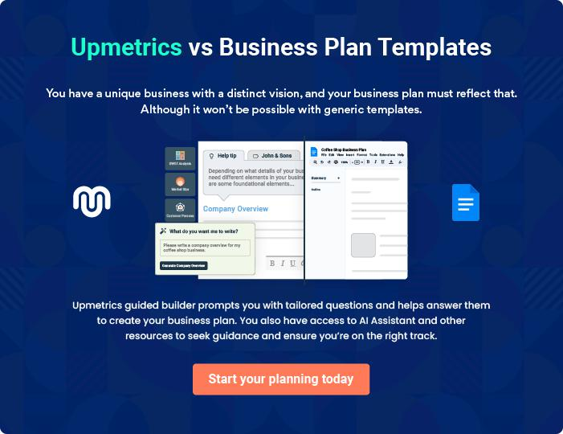
Products and Services
To unlock help try Upmetrics!

The product and services section of a tour operator business plan should describe the specific services and products that will be offered to customers. To write this section should include the following:



 Help tip  Tour Operator Business Plan

To craft the introduction for your "Products and Services" chapter, begin by positioning your business within its industry, emphasizing its unique strengths or value proposition.
To unlock help try Upmetrics! 

Start writing here..

 Help tip


Mention the tour operator services your business will offer. This list may include services like,

• Itinerary planning
To unlock help try Upmetrics! 

Services

Custom Itinerary Planning


Price: Starting at [$200] per itinerary

We offer personalized itinerary planning services to create a tailored travel experience that meets our client's preferences and interests.

Specifications

Inclusive of destination research, accommodation suggestions, activity recommendations, and transportation options.

Guided Tours

Price: Varies by destination, starting at [$50] per person

Our guided tours are led by knowledgeable local guides who provide valuable insights into the culture and history of each destination.

Specifications

Group sizes are limited to 15 people, and tours typically last 2-3 hours.

Accommodation Booking

Price: Varies by location and accommodation type, starting at [$100] per night

We offer a range of accommodation options, from luxury hotels to charming bed and breakfasts, ensuring our clients have a comfortable stay.

Specifications

Accommodations are vetted for quality, safety, and comfort.

Activities & Excursions

Price: Varies by activity, starting at [$30] per person

Our selection of activities and excursions are carefully curated to enhance the adventure experience, ranging from cultural immersions to adrenaline-pumping adventures.

Specifications

Activities are tailored to the client's interests and physical abilities.

Travel Documentation & Visa Assistance

Price: Starting at [$100] per application

We provide comprehensive assistance with travel documentation and visa applications to ensure a smooth travel process.

Specifications

Includes form filling, document collection, and application submission.

Travel Insurance

Price: Varies by coverage level, starting at [$50] per trip

Our travel insurance options provide peace of mind during the journey, covering unforeseen events such as trip cancellations, medical emergencies, and lost luggage.

Specifications

Multiple coverage levels are available to suit the client's needs and budget.

Destination Management Services

Price: Customized pricing based on destination and services required

Our destination management services expertly handle all aspects of the destination experience, from transportation to activities, ensuring a seamless travel experience.

Specifications

Services are tailored to the client's preferences, with a focus on quality and convenience.

Quality Assurance & Safety Measures

 Help tip  Tour Operator Business Plan

This section should explain how you maintain quality standards.

This may include any certifications, affiliations, or industry memberships.
To unlock help try Upmetrics! 

Start writing here..

Additional Services

 Help tip  Tour Operator Business Plan

Mention if your tour operator company offers any additional services. You may include services like visa assistance, travel insurance, local transportation, etc.
To unlock help try Upmetrics! 

Start writing here..
Sales And Marketing Strategies

Writing the sales and marketing strategies section means a list of strategies you will use to attract and retain your clients.
To unlock help try Upmetrics! 

 Help Tip  Tour Operator Business Plan


To create an effective introduction for your "Sales and Marketing Strategies" chapter, start by setting the stage within your specific industry or market.
To unlock help try Upmetrics! 

Start writing here..

Unique Selling Proposition (USP)

 Help tip  Tour Operator Business Plan

Define your business’s USPs depending on the market you serve, the equipment you use, and the unique services you provide. Identifying USPs will help you plan your marketing strategies.
To unlock help try Upmetrics! 

Start writing here..

Pricing Strategy

 Help tip  Tour Operator Business Plan

Describe your pricing strategy—how you plan to price your services and stay competitive in the local market. You can mention any discounts you plan on offering to attract new customers.
To unlock help try Upmetrics! 

Start writing here..

 Help tip  Tour Operator Business Plan
To unlock help try Upmetrics!

Discuss your marketing strategies to market your services. You may include some of these marketing strategies in your business plan—social media marketing, Google ads, email marketing, content marketing, and print marketing.



Marketing strategies

Online


Social Media

Utilizing platforms such as [mention specific social media platforms, e.g., Facebook, Instagram, Twitter, etc.] to share engaging content, promotional offers, and interact with our audience

Content Marketing

Creating valuable content, such as travel guides, blog posts, and videos, to showcase our expertise and attract organic traffic to our website.

Email Marketing

Sending regular newsletters and promotional emails to our subscriber list, informing them of upcoming tours, special offers, and company news.

Google Ads

Running targeted Google Ads campaigns to reach potential customers searching for tour operator services in our location.

Offline

Print Marketing

Distributing brochures and flyers in strategic locations, such as hotels, travel agencies, and tourist information centers.

 Help tip  Tour Operator Business Plan

Outline the strategies you’ll implement to maximize your sales. Your sales strategies may include direct sales calls, partnering with other businesses, offering referral programs, etc.
To unlock help try Upmetrics! 

Sales strategies

Partner with Businesses

Forming partnerships with local businesses, hotels, and other relevant organizations to cross-promote our services and generate leads.

Referral Programs

Implementing a referral program to encourage satisfied clients to refer new customers, in exchange for discounts on future bookings.

Direct Sales Calls

Actively reaching out to potential clients through phone calls and emails to introduce our services and offer personalized tour packages.

 Help tip  Tour Operator Business Plan

Describe your customer retention strategies and how you plan to execute them. For instance, introducing loyalty programs, discounts & offers, personalized service, etc.
To unlock help try Upmetrics! 

Customer retention

Loyalty Programs

Offering a loyalty program that rewards repeat customers with points that can be redeemed for discounts on future tours.

Personalized Service

Ensuring that each client receives personalized attention and services tailored to their preferences, creating a memorable experience that encourages repeat business.

Discounts & Offers

Providing exclusive discounts and promotional offers to our regular clients.

Operations Plan
To unlock help try Upmetrics!

 |  | When writing the operations plan section, it’s important to consider the
 |  | various aspects of your business operations.
 |  |  |  | To unlock help try Upmetrics! 
 Help tip |  |  Tour Operator Business Plan


To create an effective introduction for your "Operational Plan" chapter, start by emphasizing the
pivotal role of efficient operations in the success of your business, underscoring how they
directly impact the quality of services delivered.
 |  |  |  | To unlock help try Upmetrics! 
Start writing here..
Staffing & Training
 Help tip |  |  Tour Operator Business Plan

Mention your business’s staffing requirements, including the number of employees or other staff needed. Include their qualifications, the training required, and the duties they will perform.
To unlock help try Upmetrics! 

Start writing here..

Operational Process

 Help tip  Tour Operator Business Plan

Outline the processes and procedures you will use to run your tour operator business. Your operational processes may include tour planning & development, marketing & sales, reservation & booking management, operations & logistics, etc.



Start writing here..

Equipment & Software
To unlock help try Upmetrics!

 Help tip  Tour Operator Business Plan

Include the list of equipment and software required for tour operators, such as computers & laptops, printers & scanners, communication devices, safety equipment, booking & reservation system, tour management software, etc.



Start writing here..
Management Team

The management team section provides an overview of the individuals responsible for running your business plan.
To unlock help try Upmetrics! 

 Help tip  Tour Operator Business Plan

To craft an introduction for your "Management Team" chapter, begin by emphasizing the crucial role of leadership in the success of any business.
To unlock help try Upmetrics! 

Start writing here..

Key managers

 Help tip  Tour Operator Business Plan

Introduce your management and key members of your team, and explain their roles and responsibilities.
To unlock help try Upmetrics! 

Start writing here..


JOHN DOE

CEO - john.doe@example.com

John Doe holds a Bachelor’s degree in Business Management and has over 15 years of experience in the tourism industry.

His passion for travel and in-depth knowledge of market trends have been instrumental in shaping the vision of Sunny Adventures Tours.


As the CEO, John oversees the strategic direction and overall operations of the company.

JANE DOE

Operations Manager - jane.doe@example.com

Jane Doe, with her MBA in Operations Management, brings over 10 years of experience in tour operations.

She specializes in optimizing internal processes to enhance efficiency and customer satisfaction.



ALICE BROWN

Tour Operations Manager - alice.brown@example.com

Alice holds a degree in Tourism Management and has 8 years of experience in designing and managing tours.

Her creativity and attention to detail ensure that each tour offers a unique and memorable experience to our clients.


ROBERT BROWN

Customer Service Manager - robert.brown@example.com

Robert has a Bachelor’s degree in Communication and 7 years of experience in customer service.

His people skills and commitment to excellence have played a pivotal role in building a strong customer base for Sunny Adventures Tours.

Organizational structure

 Help tip  Tour Operator Business Plan

Describe the organizational structure of the management team, including reporting lines and how decisions will be made.
To unlock help try Upmetrics! 

Start writing here..

Organization chart


John Doe

CEO


Alice Brown



Tour Operations

Jane Doe

Manager




Operations

Manager




Emma Smith | William Davis | Robert Brown | Michael
Industry | Marketing | Customer Service | Johnson
Consultant | Manager | Manager | Legal Advisor

Compensation plan

 Help tip  Tour Operator Business Plan

Describe your compensation plan for the management and staff. Include their salaries, incentives, and other benefits.
To unlock help try Upmetrics! 

Start writing here..

 Help tip

Mentioning advisors or consultants in your business plans adds credibility to your business idea.
To unlock help try Upmetrics! 

Advisors/Consultants


MICHAEL JOHNSON

Legal Advisor - michael.johnson@example.com

Mr. Michael Johnson, a graduate of Harvard Law School, has 25 years of experience in corporate law.

His expertise in legal matters has been instrumental in ensuring that Sunny Adventures Tours complies with all industry regulations and legal requirements.


DR EMMA SMITH

Industry Consultant - emma.smith@example.com

Dr. Emma Smith has a Ph.D. in Hospitality and Tourism and 20 years of experience as a consultant in the tourism industry.

Her insights have been invaluable in helping Sunny Adventures Tours navigate the market dynamics and stay ahead of the competition.
Financial Plan

When writing the financial plan section of a business plan, it’s important to provide a comprehensive overview of your financial projections for the first few years of your business, You may provide the following:
To unlock help try Upmetrics! 

 Help tip  Tour Operator Business Plan


To create an effective introduction for your "Financial Plan" chapter, begin by stressing the critical role of a well-structured financial plan in the success of your venture.
To unlock help try Upmetrics! 

Start writing here..

 Help tip  Tour Operator Business Plan

Describe details such as projected revenue, operational costs, and service costs in your projected profit and loss statement. Make sure to include your business’s expected net profit or loss.
To unlock help try Upmetrics! 

Profit & loss statement

Revenue

Cost Of Sales

General Costs

Revenue Specific Costs

Personnel Costs (Direct

Labor)

Gross Margin

Gross Margin (%)

Operating Expense

Payroll Expense

(Indirect Labor)

General Expense

Bad Debt

Amortization of Current

Assets

2023-24 | 2024-25 | 2025-26 | 2026-27 | 2027-28
$0 | $0 | $0 | $0 | $0

$0 | $0 | $0 | $0 | $0
$0 | $0 | $0 | $0 | $0
$0 | $0 | $0 | $0 | $0
$0 | $0 | $0 | $0 | $0

$0 | $0 | $0 | $0 | $0
0% | 0% | 0% | 0% | 0%

$0 | $0 | $0 | $0 | $0
$0 | $0 | $0 | $0 | $0
$0 | $0 | $0 | $0 | $0
$0 | $0 | $0 | $0 | $0
$0 | $0 | $0 | $0 | $0

EBITDA

Additional Expense

Long Term

Depreciation

Gain or loss from Sale

of Assets

EBIT

Interest Expenses

EBT

Income Tax Expense

Total Expense

Net Income

Net Income (%)

2023-24 | 2024-25 | 2025-26 | 2026-27 | 2027-28
$0 | $0 | $0 | $0 | $0
$0 | $0 | $0 | $0 | $0
$0 | $0 | $0 | $0 | $0
$0 | $0 | $0 | $0 | $0
$0 | $0 | $0 | $0 | $0
$0 | $0 | $0 | $0 | $0
$0 | $0 | $0 | $0 | $0
$0 | $0 | $0 | $0 | $0
$0 | $0 | $0 | $0 | $0
$0 | $0 | $0 | $0 | $0
0% | 0% | 0% | 0% | 0%

 |  |  | 2023-24 |  | 2024-25 | 2025-26
Retained Earning |  |  | $0 |  | $0 | $0
Opening |  |  |  |  | $0 | $0
Owner's Distribution |  |  | $0 |  | $0 | $0
Retained Earning |  |  | $0 |  | $0 | $0
Closing |  |  |  |  | $0 | $0
 Help tip |  |  |  Tour Operator Business Plan


The cash flow for the first few years of your operation should be estimated and described in this section.

This may include billing invoices, payment receipts, loan payments, and any other cash flow statements.
2026-27 2027-28

$0 $0

$0 $0

$0 $0

To unlock help try Upmetrics! 

Cash flow statement

 | 2023-24 | 2024-25 | 2025-26 | 2026-27 | 2027-28
Cash Received | $0 | $0 | $0 | $0 | $0
Cash Paid | $0 | $0 | $0 | $0 | $0
COS & General Expenses | $0 | $0 | $0 | $0 | $0
Salary & Wages | $0 | $0 | $0 | $0 | $0
Interest | $0 | $0 | $0 | $0 | $0

Sales Tax

Income Tax

Net Cash From

Operations

Assets Sell

Assets Purchase

Net Cash From

Investments

Amount Received

Loan Received

Common Stock

Preferred Stock

Owner's Contribution

Amount Paid

2023-24 | 2024-25 | 2025-26 | 2026-27 | 2027-28
$0 | $0 | $0 | $0 | $0
$0 | $0 | $0 | $0 | $0
$0 | $0 | $0 | $0 | $0

$0 | $0 | $0 | $0 | $0
$0 | $0 | $0 | $0 | $0
$0 | $0 | $0 | $0 | $0

$0 | $0 | $0 | $0 | $0
$0 | $0 | $0 | $0 | $0

$0 | $0 | $0 | $0 | $0
$0 | $0 | $0 | $0 | $0
$0 | $0 | $0 | $0 | $0

Loan Capital $0 $0 $0 $0 $0

 |  |  | 2023-24 | 2024-25 | 2025-26 | 2026-27 | 2027-28
Dividends & Distributions |  |  | $0 | $0 | $0 | $0 | $0
Net Cash From |  |  | $0 | $0 | $0 | $0 | $0
Financing
Summary
Starting Cash |  |  | $0 | $0 | $0 | $0 | $0
Cash In |  |  | $0 | $0 | $0 | $0 | $0
Cash Out |  |  | $0 | $0 | $0 | $0 | $0
Change in Cash |  |  | $0 | $0 | $0 | $0 | $0
Ending Cash |  |  | $0 | $0 | $0 | $0 | $0
 Help tip |  |  Tour Operator Business Plan

Create a projected balance sheet documenting your tour operator business’s assets, liabilities, and equity.

To unlock help try Upmetrics! 

Balance sheet

 | 2023-24 | 2024-25 | 2025-26 | 2026-27 | 2027-28
Assets | $0 | $0 | $0 | $0 | $0
Current Assets | $0 | $0 | $0 | $0 | $0
Cash | $0 | $0 | $0 | $0 | $0
Accounts Receivable | $0 | $0 | $0 | $0 | $0
Inventory | $0 | $0 | $0 | $0 | $0
Other Current Assets | $0 | $0 | $0 | $0 | $0
Long Term Assets | $0 | $0 | $0 | $0 | $0
Gross Long Term Assets | $0 | $0 | $0 | $0 | $0
Accumulated Depreciation | $0 | $0 | $0 | $0 | $0

Liabilities & Equity | $0 | $0 | $0 | $0 | $0
Liabilities | $0 | $0 | $0 | $0 | $0
Current Liabilities | $0 | $0 | $0 | $0 | $0
Accounts Payable | $0 | $0 | $0 | $0 | $0
Income Tax Payable | $0 | $0 | $0 | $0 | $0
Sales Tax Payable | $0 | $0 | $0 | $0 | $0
Short Term Debt | $0 | $0 | $0 | $0 | $0
 | 2023-24 | 2024-25 | 2025-26 | 2026-27 | 2027-28
Long Term Liabilities | $0 | $0 | $0 | $0 | $0
Long Term Debt | $0 | $0 | $0 | $0 | $0
Equity | $0 | $0 | $0 | $0 | $0
Paid-in Capital | $0 | $0 | $0 | $0 | $0
Common Stock | $0 | $0 | $0 | $0 | $0
Preferred Stock | $0 | $0 | $0 | $0 | $0
Owner's Contribution | $0 | $0 | $0 | $0 | $0
Retained Earnings | $0 | $0 | $0 | $0 | $0

Check | $0 |  |  | $0 | $0 | $0 | $0
 Help tip |  |  Tour Operator Business Plan

Determine and mention your business’s break-even point—the point at which your business costs and revenue will be equal.

This exercise will help you understand how much revenue you need to generate to sustain or be profitable.
To unlock help try Upmetrics! 

Break-even Analysis

 | 2023-24 | 2024-25 | 2025-26 | 2026-27 | 2027-28
Starting Revenue | $0 | $0 | $0 | $0 | $0
Net Revenue | $0 | $0 | $0 | $0 | $0
Closing Revenue | $0 | $0 | $0 | $0 | $0

Starting Expense | $0 | $0 | $0 | $0 | $0
Net Expense | $0 | $0 | $0 | $0 | $0
Closing Expense | $0 | $0 | $0 | $0 | $0

Is Break Even? | 0 | 0 | 0 | 0 | 0
Break Even Month | 0 | 0 | 0 | 0 | 0
Days Required | 0 | 0 | 0 | 0 | 0
Break Even Revenue | $0 | $0 | $0 | $0 | $0
Break Even Units
Financing needs

 Help tip  Tour Operator Business Plan

Calculate costs associated with starting a tour operator business, and estimate your financing needs and how much capital you need to raise to operate your business.
To unlock help try Upmetrics! 

Start writing here..
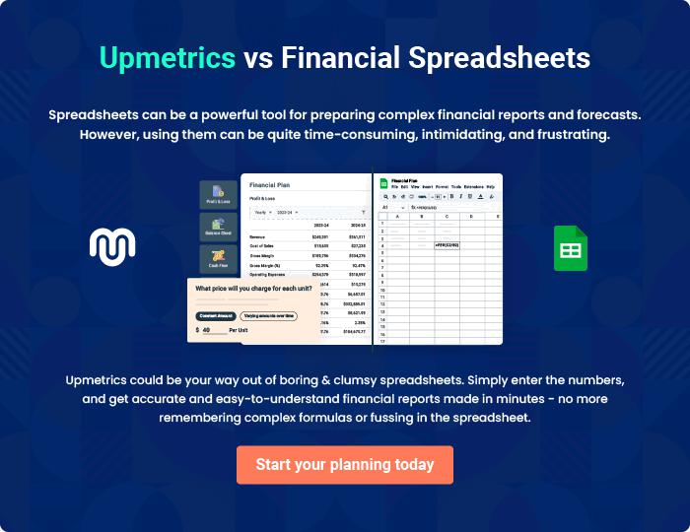
Appendix

When writing the appendix section, you should include any additional information that supports the main content of your plan. This may include financial statements, market research data, legal documents, and other
To unlock help try Upmetrics! 
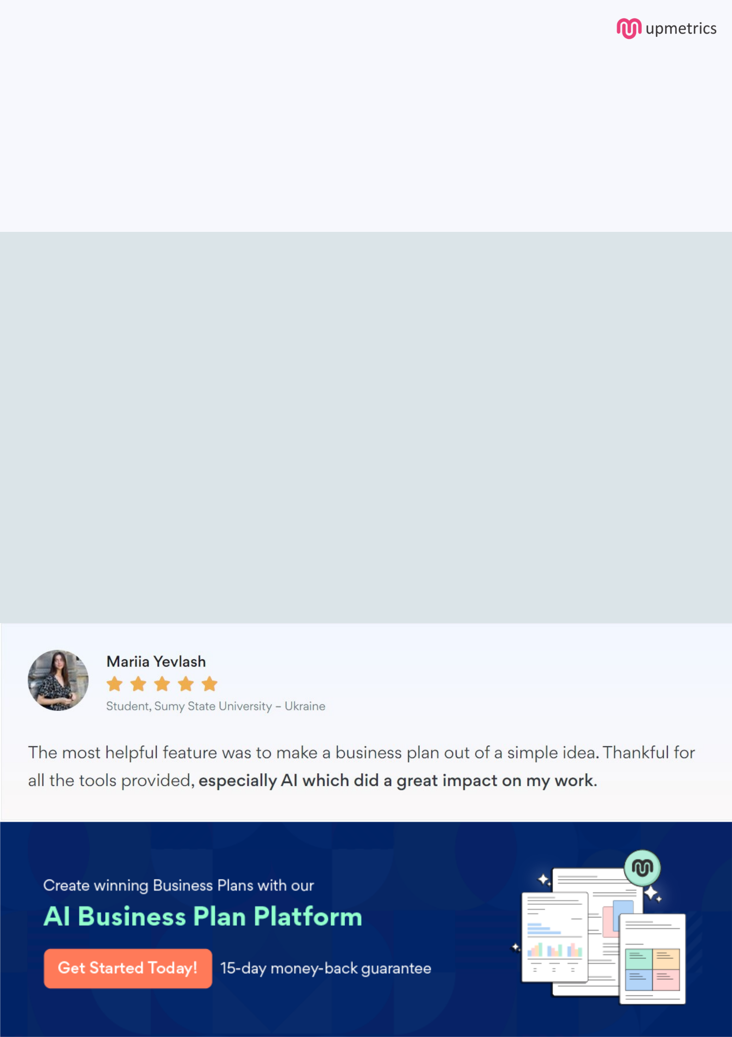
Create a winning business plan that gets you funded

Creating a stunning and investment-ready plan requires no writing, graphic designing, or financial planning expertise.

Upmetrics has all the features required to help you create a comprehensive business plan—from start to finish. Make no mistakes, it’s the modern way of planning to structure ideas, make plans, and create stunning pitch decks to awe investors.

Pitch decks that impress investors

Create pitch decks that provide a visual representation of your business, engage investors, and make them want to invest in your business idea.

Interactive plans in no time

Import business plan sections like—SWOT analysis, comparison tables, and others to create an interactive business plan. No designing skills are required.

Stunning cover page designs

With Upmetrics, you have the liberty to choose from multiple stunning cover page designs. Choose a creative design and make your plan stand out.

Online sharing made simple

Upmetrics makes online sharing quick and easier for users. Easily share your business plans with a link while tracking reader activity.

500+ sample business plans

Simply import a template from our library of sample plans into the editor and start customizing it to make it yours. It takes only a few clicks to get started.

Collaborate with team in real-time

Invite team members, initiate conversations, discuss ideas & strategies, share feedback, and work on a business plan in real-time.

