
Telemedicine Business Plan


Business
Plan

2023


Healing through Screens

Information provided in this business plan is unique to this business and confidential; therefore, anyone reading this plan agrees not to disclose any of the information in this business plan without prior written permission of the company.

 | Prepared By | 10200 Bolsa Ave, Westminster, CA, 92683
 | John Doe | info@example.com
 | (650) 359-3153 | http://www.example.com

Table of Contents

Executive Summary | 6
Market opportunity | 6
Services Offered | 6
Marketing & Sales Strategies | 7
Financial Highlights | 7
Units Sold v/s Revenue | 8

Company Overview | 9
Ownership | 9
Mission statement | 10
Business history | 10
Future goals | 10

Market Analysis | 11
Target Market | 11
Market size and growth potential | 11
Market Size | 12
Competitive analysis | 12
Teladoc Health, Inc. | 12
Doctor On Demand | 13
Amwell | 13
Market trends | 13
Regulatory environment | 14

Products and Services | 15
Services | 15
Virtual Consultation | 15
Second Opinion | 16
Prescription Writing | 16
Teletherapy | 16
Follow-up Care | 17
Service Model | 17
Quality Measures | 17
Additional Services | 18

Sales And Marketing Strategies | 19
Unique Selling Proposition (USP) | 19
Pricing Strategy | 19
Marketing strategies | 20
Online | 20
Offline | 20
Sales strategies | 21
Customer retention | 22

Operations Plan | 23
Staffing & Training | 23
Operational Process | 23
Equipment & Machinery | 24

Management Team | 25
Key managers | 25
John Doe | 25
Jane Doe | 26
Alice Brown | 26
Robert Brown | 26
Organizational structure | 27
Organization chart | 27
Compensation plan | 27
Advisors/Consultants | 28
Mr. Richard Green | 28
Dr. Emily White | 28
Financial Plan
Financial Plan | 29

Profit & loss statement 29

Cash flow statement | 32
Balance sheet | 34
Break-even Analysis | 36
Financing needs | 38
Appendix
Appendix | 40
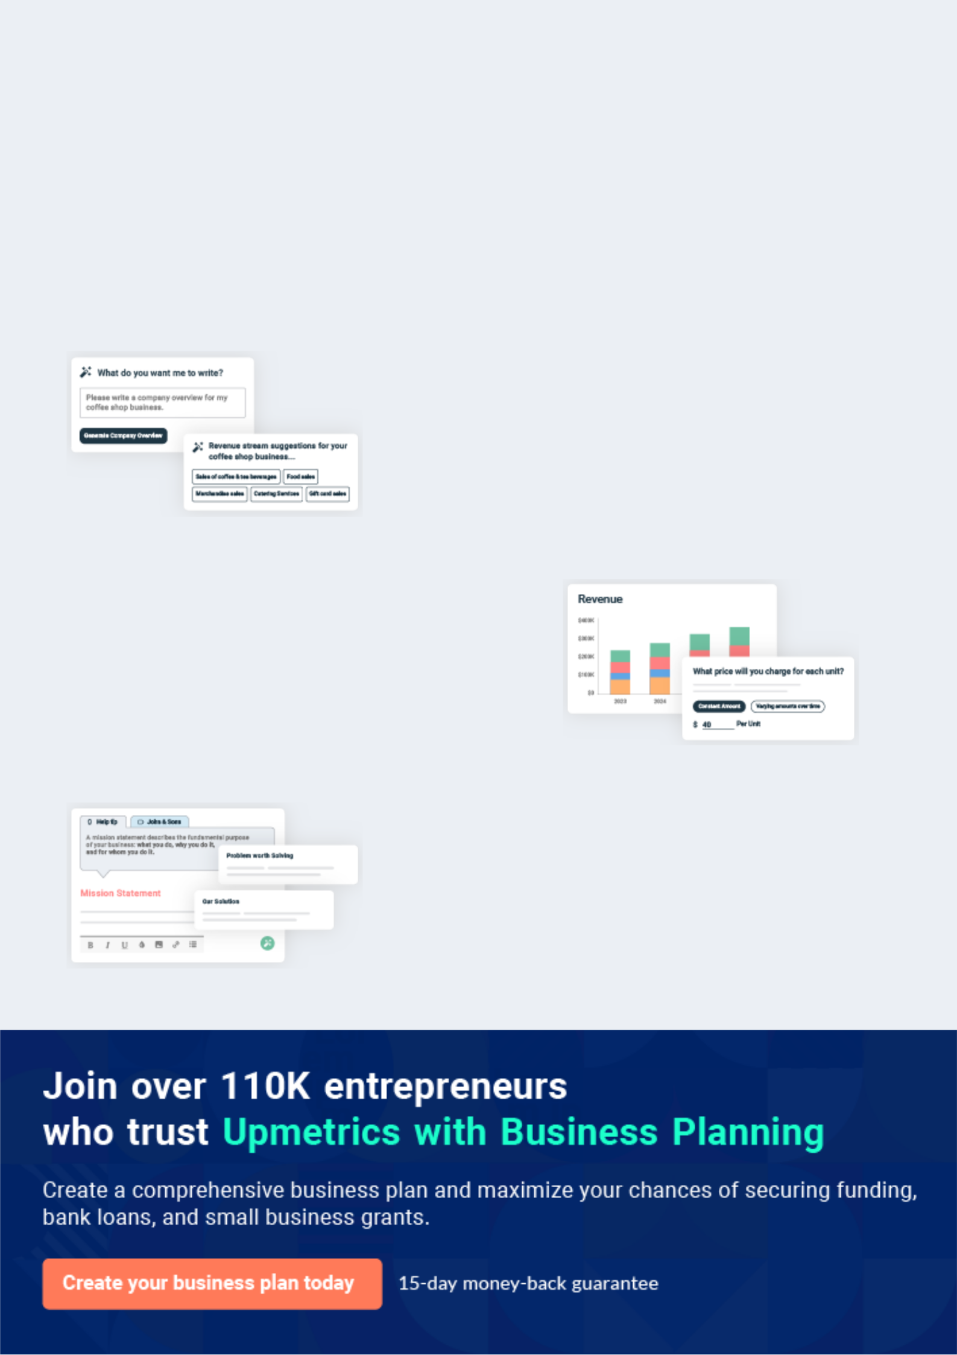
Business planning that’s simpler and faster than you think

Creating a business plan using Upmetrics to start and grow a business is literally the easiest thing in the World. Simply read the instructions and fill in the blanks. It’s as simple as that.

❛ | Upmetrics has everything you need to create a | ❜
❛ | comprehensive business plan. | ❜

AI-powered Upmetrics Assistant

AI-powered insights to streamline your plan

Not sure where to start? Upmetrics’ AI Assistant will automatically generate ideas for each section of your plan and offer improved versions of your writing, adjusting for tone, voice, and grammar or spelling errors.

Financial Forecasting Tool

All the financials are calculated for you

Forget the complex formulas and clumsy spreadsheets — with automatic financials and drag-and-drop forecasting, you can finish your plan faster and be confident that your numbers are accurate.

Business Plan Builder

Guides you like a business mentor

Upmetrics’ step-by-step instructions, prompts, and the library of 400+ sample business plans will guide you through each section of your plan as a business mentor.
Executive Summary


An executive summary is the first section of the business plan intended to provide an overview of the whole business plan.
To unlock help try Upmetrics! 

 Help tip  Telemedicine Business Plan


Start your executive summary by briefly introducing your business to your readers.

This section may include the name of your telemedicine business, its location, when it was
To unlock help try Upmetrics! 

Start writing here..

Market opportunity

 Help tip  Telemedicine Business Plan

Summarize your market research, including market size, growth potential, and marketing trends. Highlight the opportunities in the market and how your business will fit in to fill the gap.
To unlock help try Upmetrics! 

Start writing here..

Services Offered

 Help tip  Telemedicine Business Plan

Highlight the telemedicine services you offer your clients. The USPs and differentiators you offer are always a plus.
To unlock help try Upmetrics! 

Start writing here..

Marketing & Sales Strategies
To unlock help try Upmetrics!

 Help tip  Telemedicine Business Plan

Outline your sales and marketing strategies—what marketing platforms you use, how you plan on acquiring customers, etc.
To unlock help try Upmetrics! 

Start writing here..

Financial Highlights

 Help tip  Telemedicine Business Plan

Briefly summarize your financial projections for the initial years of business operations. Include any capital or investment requirements, associated startup costs, projected revenues, and profit forecasts.



Start writing here..
Units Sold v/s Revenue

 |  | Units Sold | Revenue
15.00k
10.00k
5.00k
0
Year 1 | Year 2 | Year 3


Financial Year |  |  | Units Sold | Revenue
Year 1 | 1,550 |  |  | $10,000
Year 2 | 1,800 |  |  | $12,000
Year 3 | 2,050 |  |  | $14,000
 Help tip |  |  Telemedicine Business Plan


Summarize your executive summary section with a clear CTA, for example, inviting angel investors to discuss the potential business investment.
To unlock help try Upmetrics! 

Write a call to action for your business plan.
Company Overview

Depending on what details of your business are essential, you’ll need different elements in your business overview.
To unlock help try Upmetrics! 

 Help tip  Telemedicine Business Plan

Describe your business in this section by providing all the basic information:

Describe what kind of telemedicine company you run and the name of it. Briefly explain the type
To unlock help try Upmetrics! 

Start writing here..

Ownership

 Help tip  Telemedicine Business Plan

Describe the owners of your business and mention their roles in running it. Whose shares in the corporation are they, and how each owner helps in the business?
To unlock help try Upmetrics! 

Start writing here..
Mission statement

 Help tip  Telemedicine Business Plan

Summarize your business’ objective, core principles, and values in your mission statement. This statement needs to be memorable, clear, and brief.
To unlock help try Upmetrics! 

❛ Our mission at [ABC TeleMed Inc.] is to provide unparalleled telemedicine services, ensuring healthcare is not just accessible, but also affordable.

We are committed to reimagining healthcare delivery, rooted in our core principles of trust, transparency, and technological excellence.

❜

Business history

 Help tip  Telemedicine Business Plan

If you’re an established telemedicine service provider, briefly describe your business history, like —when it was founded, how it evolved over time, etc.
To unlock help try Upmetrics! 

Start writing here..

Future goals

 Help tip  Telemedicine Business Plan

It’s crucial to convey your aspirations and vision. Mention your short-term and long-term goals; they can be specific targets for revenue, market share, or expanding your services.
To unlock help try Upmetrics! 

Start writing here..

Market Analysis
To unlock help try Upmetrics!


 |  | Market analysis provides a clear understanding of the market in which your
 |  | printing business will run along with the target market, competitors, and
 |  | growth opportunities.
 |  |  |  | To unlock help try Upmetrics! 
 Help tip |  |  Telemedicine Business Plan

To write the introduction section of your market analysis, start by clearly identifying your primary target market.
To unlock help try Upmetrics! 

Start writing here..

Target Market

 Help tip  Telemedicine Business Plan

Start this section by describing your target market. Define your ideal customer and explain what types of services they prefer. Creating a buyer persona will help you easily define your target market to your readers.



Start writing here..

Market size and growth potential

 Help tip  Telemedicine Business Plan

Describe your market size and growth potential and whether you will target a niche or a much broader market.
To unlock help try Upmetrics! 

Start writing here..

Market Size

Available Market | 500M
Global population seeking remote | 500M
healthcare solutions | 500M
Served Market | 300M
Global population with access to | 300M
online telemedicine | 300M
Target Market | 100M
Individuals preferring virtual | 100M
consultations for non-emergency | 100M

health issues.

 Help tip  Telemedicine Business Plan

Identify and analyze your direct and indirect competitors. Identify their strengths and weaknesses, and describe what differentiates your telemedicine services from them.
To unlock help try Upmetrics! 

Competitive analysis

Teladoc Health, Inc.

As a pioneer in the telemedicine industry, Teladoc Health, Inc. has been at the forefront of transforming healthcare delivery.

With its comprehensive range of services and vast network of healthcare providers, Teladoc has established itself as a market leader, setting the standard for quality and innovation in virtual care.

Features

Provides a wide range of services including general medical consultations

Mental health services and dermatology

Specialized care for chronic conditions

Strengths

Established market presence with a broad network of healthcare providers

Extensive service offerings

Robust technological

infrastructure

Weaknesses

Service costs can be on the higher side

Some users have reported long wait times

Doctor On Demand

Doctor On Demand stands out in the telemedicine landscape as a platform that emphasizes quality and convenience.

With a strong focus on mental health, the company has carved a niche for itself, appealing to individuals seeking comprehensive and accessible psychiatric and psychological care.

Features

Offers virtual consultations with board-certified physicians, psychiatrists, and licensed psychologists

Catering to a wide range of medical and mental health needs.

Strengths

Easy-to-use platform

Availability of mental health services

Strong customer service

Weaknesses

Limited availability of healthcare providers in certain geographical areas

Result in longer wait times for appointments.

Amwell

Amwell has emerged as a key player in the telemedicine sector, providing innovative virtual care solutions to meet the diverse needs of patients.

With its user-friendly platform and wide range of services, Amwell has been instrumental in making healthcare more accessible and convenient.

Features

Provides virtual care for various health concerns, including urgent care, therapy and psychiatry

Specialized care for conditions such as diabetes and heart disease

Strengths

Broad range of services User-friendly platform

Partnerships with major health insurers to facilitate coverage for virtual consultations.

Weaknesses

Service quality can vary depending on the healthcare provider

There have been instances of technical difficulties during virtual consultations.

Market trends

 Help tip  Telemedicine Business Plan

Analyze emerging trends in the industry, such as technology disruptions, changes in customer behavior or preferences, etc. Explain how your business will cope with all the trends.
To unlock help try Upmetrics! 

Start writing here..

Regulatory environment
To unlock help try Upmetrics!

 Help tip  Telemedicine Business Plan

List regulations and licensing requirements that may affect your telemedicine company, such as business registration, HIPAA compliance, IMLC agreement, insurance, state and federal regulations, etc.



Start writing here..
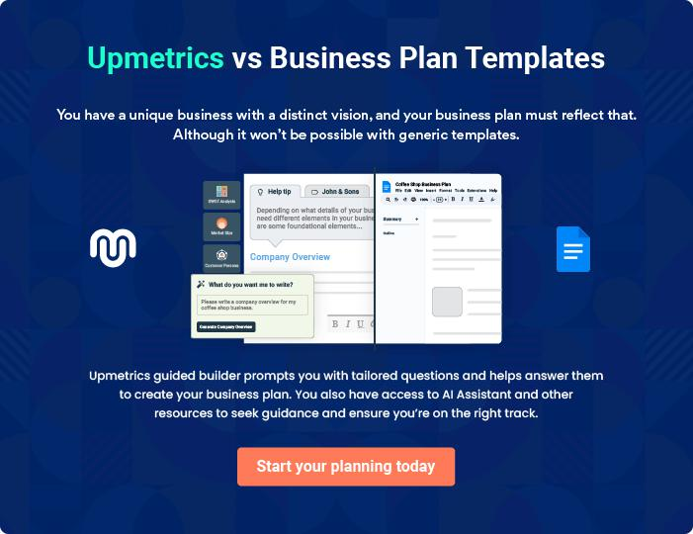
Products and Services
To unlock help try Upmetrics!

The product and services section of a telemedicine business plan should describe the specific services and products that will be offered to customers. To write this section should include the following:



 Help tip  Telemedicine Business Plan

To craft the introduction for your "Products and Services" chapter, begin by positioning your business within its industry, emphasizing its unique strengths or value proposition.
To unlock help try Upmetrics! 

Start writing here..

 Help tip


Mention the telemedicine services your business will offer. This list may include services like,

• Virtual Consultation
To unlock help try Upmetrics! 

Services

Virtual Consultation


Price: [$100] per session

Real-time consultations with certified healthcare professionals to address immediate medical needs.

Specifications

- 30-minute sessions

- Secure video conferencing platform

- Access to a wide range of specialists
Second Opinion

Price: [$150] per session

Expert opinions from top specialists to help patients make informed healthcare decisions.

Specifications

- In-depth analysis of medical history

- Written report included

- Follow-up session for clarification

Prescription Writing

Price: [$50] per prescription

Allows physicians to write and renew prescriptions, which can be sent directly to the patient's pharmacy of choice.

Specifications

- Secure e-prescribing platform

- Includes consultation with a physician

- Prescription delivered to a pharmacy within 24 hours

Teletherapy

Price: [$120] per session

Mental health support provided by certified therapists and psychiatrists, accessible from the comfort of home.

Specifications

- 45-minute sessions

- Options for ongoing treatment plans

- Confidential and secure platform
Follow-up Care

Price: [$80] per session

Ongoing care for patients post-diagnosis or treatment, with regular check-ins and support.

Specifications

- 30-minute sessions

- Direct communication with the treating physician

- Personalized treatment plan

Service Model

 Help tip  Telemedicine Business Plan

Provide a detailed description of your service model briefly describing different ways of providing services.
To unlock help try Upmetrics! 

Start writing here..

Quality Measures

 Help tip  Telemedicine Business Plan

This section should explain how you maintain quality standards and consistently provide the highest quality service.
To unlock help try Upmetrics! 

Start writing here..
Additional Services

 Help tip  Telemedicine Business Plan

Mention if your telemedicine company offers any additional services. You may include services like medicine delivery, EHR integration, health and wellness programs, etc.
To unlock help try Upmetrics! 

Start writing here..
Sales And Marketing Strategies

Writing the sales and marketing strategies section means a list of strategies you will use to attract and retain your clients.
To unlock help try Upmetrics! 

 Help Tip  Telemedicine Business Plan


To create an effective introduction for your "Sales and Marketing Strategies" chapter, start by setting the stage within your specific industry or market.
To unlock help try Upmetrics! 

Start writing here..

Unique Selling Proposition (USP)

 Help tip  Telemedicine Business Plan

Define your business’s USPs depending on the market you serve, the equipment you use, and the unique services you provide. Identifying USPs will help you plan your marketing strategies.
To unlock help try Upmetrics! 

Start writing here..

Pricing Strategy

 Help tip  Telemedicine Business Plan

Describe your pricing strategy—how you plan to price your telehealth services and stay competitive in the local market.
To unlock help try Upmetrics! 

Start writing here..

 Help tip  Telemedicine Business Plan

Discuss your marketing strategies to market your services.

You may include some of these marketing strategies in your business plan—social media
To unlock help try Upmetrics! 

Marketing strategies

Online


Social Media

Leveraging platforms like Facebook, Instagram, and LinkedIn to reach and engage our target audience.

Content Marketing

Producing high-quality articles and videos addressing common health concerns, positioning us as thought leaders in the industry.

Email Marketing

Sending periodic newsletters and promotions to our subscriber list, keeping our brand top-of-mind.

Google Ads

Ensuring we appear at the top of search results for relevant keywords, driving more traffic to our website.

Offline

Brochures

Creating informative brochures for distribution in [relevant locations, e.g., clinics, pharmacies].

Print Marketing

Local newspaper ads, magazine features, and other print media methods to capture the local market.

 Help tip  Telemedicine Business Plan
To unlock help try Upmetrics!

Outline the strategies you’ll implement to maximize your sales. Your sales strategies may include direct sales, offering free trials, partnering with healthcare providers, offering referral programs, etc.



Sales strategies

Partner with Businesses

Collaborating with healthcare providers to provide our services as an added benefit to their existing patients

Referral Programs

Encouraging our satisfied clients to refer friends and family in exchange for discounts or free sessions.

Direct Sales

Actively reaching out to potential clients, offering personalized consultations to understand their needs.

Free Trials

Offering first-time users a free initial consultation, giving them a risk-free opportunity to experience our services.

 Help tip  Telemedicine Business Plan

Describe your customer retention strategies and how you plan to execute them. For instance, introducing loyalty programs, discounts on annual membership, personalized service, etc.
To unlock help try Upmetrics! 

Customer retention

Loyalty Programs

Offering points for each consultation, which can be redeemed for discounts or free sessions.

Personalized Service

Remembering patient histories and preferences, ensuring they feel seen and valued in each session.

Annual Membership Discounts

Providing price reductions for clients who commit to a year-long membership.

Operations Plan

 |  | When writing the operations plan section, it’s important to consider the
 |  | various aspects of your business operations.
 |  |  |  | To unlock help try Upmetrics! 
 Help tip |  |  Telemedicine Business Plan


To create an effective introduction for your "Operational Plan" chapter, start by emphasizing the
pivotal role of efficient operations in the success of your business, underscoring how they
directly impact the quality of services delivered.
 |  |  |  | To unlock help try Upmetrics! 
Start writing here..
Staffing & Training
 Help tip |  |  Telemedicine Business Plan

Mention your telehealth business’s staffing requirements, including the healthcare
professionals, nursing and assisting staff, tech specialists, or sales and marketing
professionals.
 |  |  |  | To unlock help try Upmetrics! 
Start writing here..
Operational Process
 Help tip |  |  Telemedicine Business Plan

Outline the processes and procedures you will use to run your telemedicine business.

Your operational processes may include scheduling appointments, offering virtual
To unlock help try Upmetrics! 

Start writing here..

Equipment & Machinery

 Help tip  Telemedicine Business Plan

Include the list of equipment and machinery required for telemedicine, such as computer systems, software, hardware, remote diagnostic tools, mobile applications, etc.
To unlock help try Upmetrics! 

Start writing here..
Management Team

The management team section provides an overview of the individuals responsible for running your business plan.
To unlock help try Upmetrics! 

 Help tip  Telemedicine Business Plan

To craft an introduction for your "Management Team" chapter, begin by emphasizing the crucial role of leadership in the success of any business.
To unlock help try Upmetrics! 

Start writing here..

Key managers

 Help tip  Telemedicine Business Plan

Introduce your management and key members of your team, and explain their roles and responsibilities.
To unlock help try Upmetrics! 

Start writing here..


JOHN DOE

CEO & Co-founder - john.doe@example.com

John leads the company's vision, strategy, and growth. He is responsible for overseeing all executive decisions and ensuring the company's financial viability.


- Education: MBA from Harvard Business School, Bachelor's in Computer Science from MIT.

- Professional Background: With over 20 years in the healthcare industry, John has previously held leadership roles at top healthcare firms and has successfully launched multiple health-tech startups.

JANE DOE

Chief Operating Officer (COO) - jane.doe@example.com

Jane is responsible for the overall operations of the company, including day-to-day management and implementing business strategies.

- Education: Master’s in Healthcare Administration from UCLA, Bachelor’s in Nursing from UCSF.

- Professional Background: Jane brings over 15 years of experience in healthcare management and operations.



ALICE BROWN

CMO - alice.brown@example.com

Alice oversees the company's marketing strategy, brand development, and customer acquisition efforts.

- Education: MBA in Marketing from NYU Stern, Bachelor’s in Communication from USC.

- Professional Background: Alice has over 12 years of experience in healthcare marketing and has successfully led marketing campaigns for major healthcare brands.


ROBERT BROWN

Chief Technology Officer (CTO) - robert.brown@example.com

Robert is responsible for the company's technology strategy, development, and implementation.

- Education: PhD in Computer Science from Stanford University, Master’s in Electrical Engineering from UC Berkeley.

- Professional Background: With over 18 years in technology and healthcare, Robert has extensive experience in developing innovative healthcare technologies.
Organizational structure

 Help tip  Telemedicine Business Plan

Explain the organizational structure of your management team. Include the reporting line and decision-making hierarchy.
To unlock help try Upmetrics! 

Start writing here..

Organization chart


John Doe

CEO


Robert Brown Jane Doe

CTO COO


Alice Brown Emily White

Richard Green CMO HealthCare Consultant

Business Strategist

Compensation plan

 Help tip  Telemedicine Business Plan

Describe your compensation plan for the management and staff. Include their salaries, incentives, and other benefits.
To unlock help try Upmetrics! 

Start writing here..

 Help tip

Mentioning advisors or consultants in your business plans adds credibility to your business idea.
To unlock help try Upmetrics! 

Advisors/Consultants


MR. RICHARD GREEN

Advisor - richard.green@example.com

Richard is a business strategist who specializes in helping healthcare startups scale their operations and achieve sustainable growth.

Years of Experience: 20 years



DR. EMILY WHITE

Consultant - emily.white@example.com

A serial entrepreneur and a Wharton School alumna, Clara has successfully founded and scaled multiple tech startups.

Recognized by Forbes in their "30 Under 30" list, she possesses a deep understanding of the tech landscape, startup dynamics, and growth strategies.


Her vast network and entrepreneurial insights are invaluable assets to our board.
Financial Plan

When writing the financial plan section of a business plan, it’s important to provide a comprehensive overview of your financial projections for the first few years of your business, You may provide the following:
To unlock help try Upmetrics! 

 Help tip  Telemedicine Business Plan


To create an effective introduction for your "Financial Plan" chapter, begin by stressing the critical role of a well-structured financial plan in the success of your venture.
To unlock help try Upmetrics! 

Start writing here..

 Help tip  Telemedicine Business Plan

Describe details such as projected revenue, operational costs, and service costs in your projected profit and loss statement. Make sure to include your business’s expected net profit or loss.
To unlock help try Upmetrics! 

Profit & loss statement

Revenue

Cost Of Sales

General Costs

Revenue Specific Costs

Personnel Costs (Direct

Labor)

Gross Margin

Gross Margin (%)

Operating Expense

Payroll Expense

(Indirect Labor)

General Expense

Bad Debt

Amortization of Current

Assets

2023-24 | 2024-25 | 2025-26 | 2026-27 | 2027-28
$0 | $0 | $0 | $0 | $0

$0 | $0 | $0 | $0 | $0
$0 | $0 | $0 | $0 | $0
$0 | $0 | $0 | $0 | $0
$0 | $0 | $0 | $0 | $0

$0 | $0 | $0 | $0 | $0
0% | 0% | 0% | 0% | 0%

$0 | $0 | $0 | $0 | $0
$0 | $0 | $0 | $0 | $0
$0 | $0 | $0 | $0 | $0
$0 | $0 | $0 | $0 | $0
$0 | $0 | $0 | $0 | $0

EBITDA

Additional Expense

Long Term

Depreciation

Gain or loss from Sale

of Assets

EBIT

Interest Expenses

EBT

Income Tax Expense

Total Expense

Net Income

Net Income (%)

2023-24 | 2024-25 | 2025-26 | 2026-27 | 2027-28
$0 | $0 | $0 | $0 | $0
$0 | $0 | $0 | $0 | $0
$0 | $0 | $0 | $0 | $0
$0 | $0 | $0 | $0 | $0
$0 | $0 | $0 | $0 | $0
$0 | $0 | $0 | $0 | $0
$0 | $0 | $0 | $0 | $0
$0 | $0 | $0 | $0 | $0
$0 | $0 | $0 | $0 | $0
$0 | $0 | $0 | $0 | $0
0% | 0% | 0% | 0% | 0%
 |  |  | 2023-24 |  | 2024-25 | 2025-26 | 2026-27 | 2027-28
Retained Earning |  |  | $0 |  | $0 | $0 | $0 | $0
Opening
Owner's Distribution |  |  | $0 |  | $0 | $0 | $0 | $0
Retained Earning |  |  | $0 |  | $0 | $0 | $0 | $0
Closing
 Help tip |  |  |  Telemedicine Business Plan


The cash flow for the first few years of your operation should be estimated and described in this section. This may include billing invoices, payment receipts, loan payments, and any other cash flow statements.
To unlock help try Upmetrics! 

Cash flow statement

 | 2023-24 | 2024-25 | 2025-26 | 2026-27 | 2027-28
Cash Received | $0 | $0 | $0 | $0 | $0
Cash Paid | $0 | $0 | $0 | $0 | $0
COS & General Expenses | $0 | $0 | $0 | $0 | $0
Salary & Wages | $0 | $0 | $0 | $0 | $0
Interest | $0 | $0 | $0 | $0 | $0

Sales Tax

Income Tax

Net Cash From

Operations

Assets Sell

Assets Purchase

Net Cash From

Investments

Amount Received

Loan Received

Common Stock

Preferred Stock

Owner's Contribution

Amount Paid

2023-24 | 2024-25 | 2025-26 | 2026-27 | 2027-28
$0 | $0 | $0 | $0 | $0
$0 | $0 | $0 | $0 | $0
$0 | $0 | $0 | $0 | $0

$0 | $0 | $0 | $0 | $0
$0 | $0 | $0 | $0 | $0
$0 | $0 | $0 | $0 | $0

$0 | $0 | $0 | $0 | $0
$0 | $0 | $0 | $0 | $0

$0 | $0 | $0 | $0 | $0
$0 | $0 | $0 | $0 | $0
$0 | $0 | $0 | $0 | $0

Loan Capital $0 $0 $0 $0 $0

 |  |  | 2023-24 | 2024-25 | 2025-26 | 2026-27 | 2027-28
Dividends & Distributions |  |  | $0 | $0 | $0 | $0 | $0
Net Cash From |  |  | $0 | $0 | $0 | $0 | $0
Financing
Summary
Starting Cash |  |  | $0 | $0 | $0 | $0 | $0
Cash In |  |  | $0 | $0 | $0 | $0 | $0
Cash Out |  |  | $0 | $0 | $0 | $0 | $0
Change in Cash |  |  | $0 | $0 | $0 | $0 | $0
Ending Cash |  |  | $0 | $0 | $0 | $0 | $0
 Help tip |  |  Telemedicine Business Plan

Create a projected balance sheet documenting your telemedicine business’s assets, liabilities, and equity.

To unlock help try Upmetrics! 

Balance sheet

 | 2023-24 | 2024-25 | 2025-26 | 2026-27 | 2027-28
Assets | $0 | $0 | $0 | $0 | $0
Current Assets | $0 | $0 | $0 | $0 | $0
Cash | $0 | $0 | $0 | $0 | $0
Accounts Receivable | $0 | $0 | $0 | $0 | $0
Inventory | $0 | $0 | $0 | $0 | $0
Other Current Assets | $0 | $0 | $0 | $0 | $0
Long Term Assets | $0 | $0 | $0 | $0 | $0
Gross Long Term Assets | $0 | $0 | $0 | $0 | $0
Accumulated Depreciation | $0 | $0 | $0 | $0 | $0

Liabilities & Equity | $0 | $0 | $0 | $0 | $0
Liabilities | $0 | $0 | $0 | $0 | $0
Current Liabilities | $0 | $0 | $0 | $0 | $0
Accounts Payable | $0 | $0 | $0 | $0 | $0
Income Tax Payable | $0 | $0 | $0 | $0 | $0
Sales Tax Payable | $0 | $0 | $0 | $0 | $0
Short Term Debt | $0 | $0 | $0 | $0 | $0
 | 2023-24 | 2024-25 | 2025-26 | 2026-27 | 2027-28
Long Term Liabilities | $0 | $0 | $0 | $0 | $0
Long Term Debt | $0 | $0 | $0 | $0 | $0
Equity | $0 | $0 | $0 | $0 | $0
Paid-in Capital | $0 | $0 | $0 | $0 | $0
Common Stock | $0 | $0 | $0 | $0 | $0
Preferred Stock | $0 | $0 | $0 | $0 | $0
Owner's Contribution | $0 | $0 | $0 | $0 | $0
Retained Earnings | $0 | $0 | $0 | $0 | $0

Check | $0 |  |  | $0 | $0 | $0 | $0
 Help tip |  |  Telemedicine Business Plan

Determine and mention your business’s break-even point—the point at which your business costs and revenue will be equal.

This exercise will help you understand how much revenue you need to generate to sustain or be profitable.
To unlock help try Upmetrics! 

Break-even Analysis

 | 2023-24 | 2024-25 | 2025-26 | 2026-27 | 2027-28
Starting Revenue | $0 | $0 | $0 | $0 | $0
Net Revenue | $0 | $0 | $0 | $0 | $0
Closing Revenue | $0 | $0 | $0 | $0 | $0

Starting Expense | $0 | $0 | $0 | $0 | $0
Net Expense | $0 | $0 | $0 | $0 | $0
Closing Expense | $0 | $0 | $0 | $0 | $0

Is Break Even? | 0 | 0 | 0 | 0 | 0
Break Even Month | 0 | 0 | 0 | 0 | 0
Days Required | 0 | 0 | 0 | 0 | 0
Break Even Revenue | $0 | $0 | $0 | $0 | $0
Break Even Units
Financing needs

 Help tip  Telemedicine Business Plan

Calculate costs associated with starting a telemedicine business, and estimate your financing needs and how much capital you need to raise to operate your business.
To unlock help try Upmetrics! 

Start writing here..
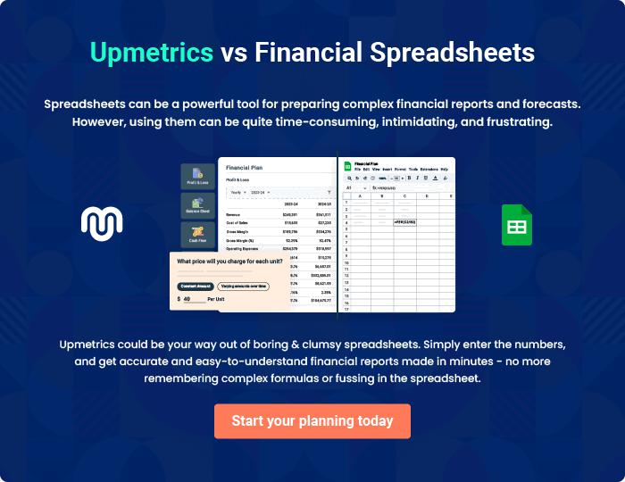
Appendix

When writing the appendix section, you should include any additional information that supports the main content of your plan. This may include financial statements, market research data, legal documents, and other
To unlock help try Upmetrics! 

Create a winning business plan that gets you funded

Creating a stunning and investment-ready plan requires no writing, graphic designing, or financial planning expertise.

Upmetrics has all the features required to help you create a comprehensive business plan—from start to finish. Make no mistakes, it’s the modern way of planning to structure ideas, make plans, and create stunning pitch decks to awe investors.

Pitch decks that impress investors

Create pitch decks that provide a visual representation of your business, engage investors, and make them want to invest in your business idea.

Interactive plans in no time

Import business plan sections like—SWOT analysis, comparison tables, and others to create an interactive business plan. No designing skills are required.

Stunning cover page designs

With Upmetrics, you have the liberty to choose from multiple stunning cover page designs. Choose a creative design and make your plan stand out.

Online sharing made simple

Upmetrics makes online sharing quick and easier for users. Easily share your business plans with a link while tracking reader activity.

500+ sample business plans

Simply import a template from our library of sample plans into the editor and start customizing it to make it yours. It takes only a few clicks to get started.

Collaborate with team in real-time

Invite team members, initiate conversations, discuss ideas & strategies, share feedback, and work on a business plan in real-time.

