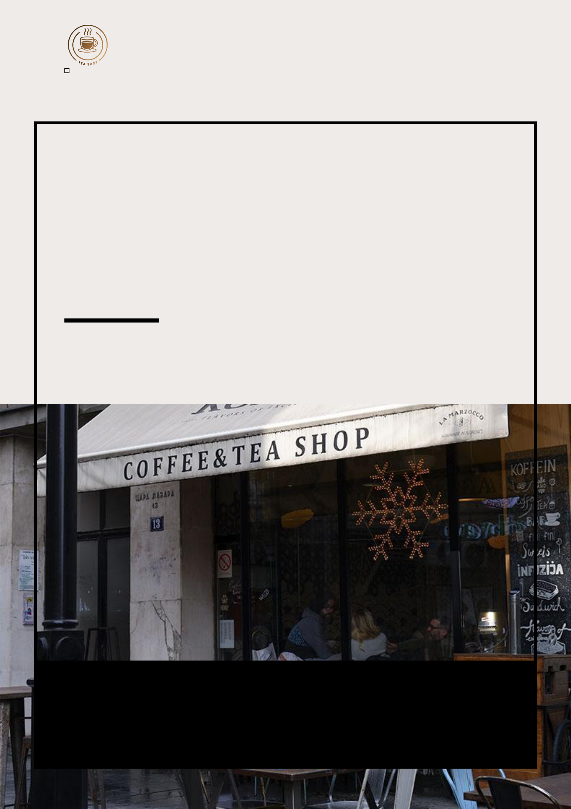
Tea Shop Business Plan

BUSINESS PLAN

Tea Time, Taste Magic

Prepared By

John Doe

10200 Bolsa Ave, Westminster, CA, 92683

info@example.com

(650) 359-3153 http://www.example.com

Table of Contents

Executive Summary | 6
Market opportunity | 6
Products | 6
Marketing & Sales Strategies | 7
Financial Highlights | 7
Units Sold v/s Revenue | 8

Company Overview | 9
Ownership | 9
Business Owners | 9
Mission statement | 10
Business history | 10
Future goals | 11

Market Analysis | 12
Target Market | 12
Market size and growth potential | 12
Market Size | 13
Competitive analysis | 13
David's Tea | 13
Teavana | 14
T2 Tea | 14
Market trends | 14
Regulatory environment | 15

Products and Services | 16
Products | 16
Classic Milk Tea | 16
Specialty Flavors | 17
Ready-to-Drink Tea Flavors | 17
Artisanal Tea | 17
Tea Leaves | 18
Light Snacks | 18
Tea Fusions | 18
Sandwiches | 19
Teapots | 19
Tea Infusers | 19
Cups/Mugs | 20
Tea Sets | 20
Quality Measures | 20
Additional Services | 21

Sales And Marketing Strategies | 22
Unique Selling Proposition (USP) | 22
Pricing Strategy | 22
Marketing strategies | 23
Online | 23
Offline | 23
Sales strategies | 24
Customer retention | 25

Operations Plan | 26
Staffing & Training | 26
Operational Process | 26
Equipment & Appliances | 27

Management Team | 28
Key managers | 28
John Doe | 28
Jane Doe | 29
Alice Brown | 29
Robert Brown | 29
Organizational structure | 29
Organization chart | 30

Compensation plan 30

Advisors/Consultants | 31
Dr. Emily Green | 31
Mr. David White | 31

Financial Plan | 32
Profit & loss statement | 32
Cash flow statement | 35
Balance sheet | 37
Break-even Analysis | 39
Financing needs | 41
Appendix
Appendix | 43
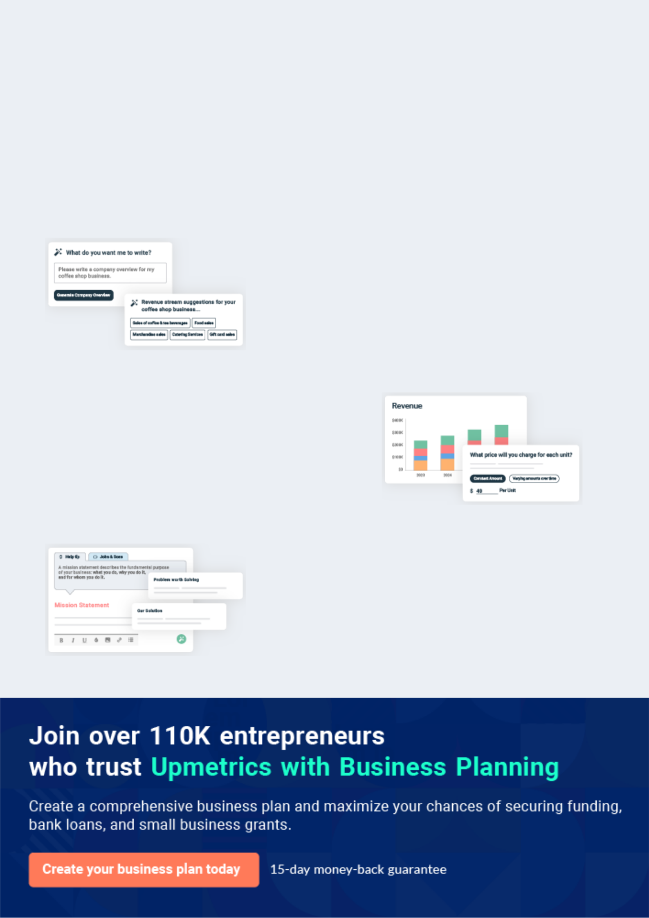
Business planning that’s simpler and faster than you think

Creating a business plan using Upmetrics to start and grow a business is literally the easiest thing in the World. Simply read the instructions and fill in the blanks. It’s as simple as that.

❛ | Upmetrics has everything you need to create a | ❜
❛ | comprehensive business plan. | ❜

AI-powered Upmetrics Assistant

AI-powered insights to streamline your plan

Not sure where to start? Upmetrics’ AI Assistant will automatically generate ideas for each section of your plan and offer improved versions of your writing, adjusting for tone, voice, and grammar or spelling errors.

Financial Forecasting Tool

All the financials are calculated for you

Forget the complex formulas and clumsy spreadsheets — with automatic financials and drag-and-drop forecasting, you can finish your plan faster and be confident that your numbers are accurate.

Business Plan Builder

Guides you like a business mentor

Upmetrics’ step-by-step instructions, prompts, and the library of 400+ sample business plans will guide you through each section of your plan as a business mentor.
Executive Summary


An executive summary is the first section of the business plan intended to provide an overview of the whole business plan.
To unlock help try Upmetrics! 

 Help tip  Tea Shop Business Plan


Start your executive summary by briefly introducing your business to your readers.

This section may include the name of your tea shop, its location, when it was founded, the type
To unlock help try Upmetrics! 

Start writing here..

Market opportunity

 Help tip  Tea Shop Business Plan

Summarize your market research, including market size, growth potential, and marketing trends. Highlight the opportunities in the market and how your business will fit in to fill the gap.
To unlock help try Upmetrics! 

Start writing here..

Products

 Help tip  Tea Shop Business Plan

Highlight the tea shop products you offer your clients. The USPs and differentiators you offer are always a plus.
To unlock help try Upmetrics! 

Start writing here..

Marketing & Sales Strategies
To unlock help try Upmetrics!

 Help tip  Tea Shop Business Plan

Outline your sales and marketing strategies—what marketing platforms you use, how you plan on acquiring customers, etc.
To unlock help try Upmetrics! 

Start writing here..

Financial Highlights

 Help tip  Tea Shop Business Plan

Briefly summarize your financial projections for the initial years of business operations. Include any capital or investment requirements, associated startup costs, projected revenues, and profit forecasts.



Start writing here..
Units Sold v/s Revenue

 |  | Units Sold | Revenue
15.00k
10.00k
5.00k
0
Year 1 | Year 2 | Year 3
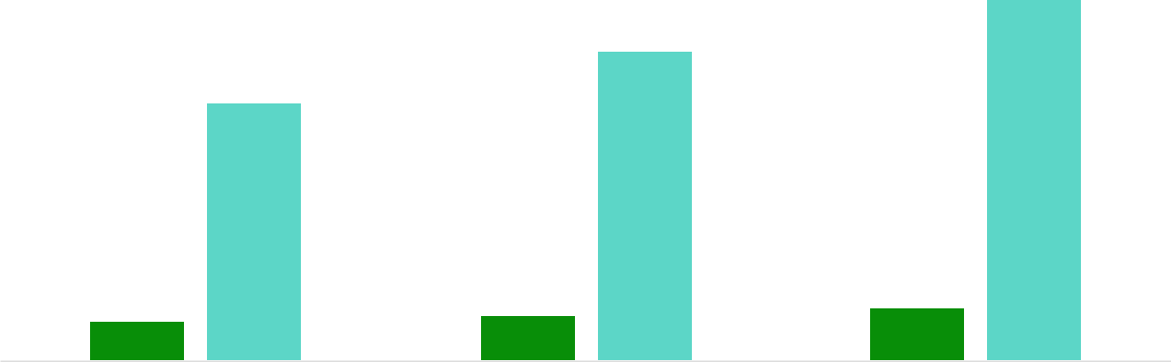

Financial Year |  |  | Units Sold | Revenue
Year 1 | 1,550 |  |  | $10,000
Year 2 | 1,800 |  |  | $12,000
Year 3 | 2,050 |  |  | $14,000
 Help tip |  |  Tea Shop Business Plan


Summarize your executive summary section with a clear CTA, for example, inviting angel investors to discuss the potential business investment.
To unlock help try Upmetrics! 

Write a call to action for your business plan.
Company Overview

Depending on what details of your business are essential, you’ll need different elements in your business overview.
To unlock help try Upmetrics! 

 Help tip  Tea Shop Business Plan

Describe your business in this section by providing all the basic information:

Describe what kind of tea shop you run and the name of it. You may specialize in one of the
To unlock help try Upmetrics! 

Start writing here..

Ownership

 Help tip  Tea Shop Business Plan

List the names of your tea shop’s owners. Describe what shares they own and their responsibilities for efficiently managing the business.
To unlock help try Upmetrics! 

Start writing here..

Business Owners



100% John Doe
Mission statement

 Help tip  Tea Shop Business Plan

Summarize your business’ objective, core principles, and values in your mission statement. This statement needs to be memorable, clear, and brief.
To unlock help try Upmetrics! 

❛ At [Tea Haven], our mission is to provide customers with an unparalleled tea experience that showcases the richness and diversity of tea cultures from around the world.

We are committed to offering a curated selection of the finest teas, served with passion and expertise, in a cozy and inviting ambience that feels like a home away from home.

Our core values include quality, authenticity, and customer satisfaction, guiding us in our pursuit of excellence and innovation in the tea industry.

❜

Business history

 Help tip  Tea Shop Business Plan

If you have an established tea shop, briefly describe your business history, like—when it was founded, how it evolved over time, etc.
To unlock help try Upmetrics! 

Start writing here..
Future goals

 Help tip  Tea Shop Business Plan

It’s crucial to convey your aspirations and vision. Mention your short-term and long-term goals; they can be specific targets for revenue, market share, or expanding your services.
To unlock help try Upmetrics! 

Start writing here..
Market Analysis
To unlock help try Upmetrics!


 |  | Market analysis provides a clear understanding of the market in which your
 |  | printing business will run along with the target market, competitors, and
 |  | growth opportunities.
 |  |  |  | To unlock help try Upmetrics! 
 Help tip |  |  Tea Shop Business Plan

To write the introduction section of your market analysis, start by clearly identifying your primary target market.
To unlock help try Upmetrics! 

Start writing here..

Target Market

 Help tip  Tea Shop Business Plan

Start this section by describing your target market. Define your ideal customer and explain what types of services they prefer. Creating a buyer persona will help you easily define your target market to your readers.



Start writing here..

Market size and growth potential

 Help tip  Tea Shop Business Plan

Describe your market size and growth potential and whether you will target a niche or a much broader market.
To unlock help try Upmetrics! 

Start writing here..

Market Size

Available Market

Total potential customers in the global 300M tea industry.

Served Market
Current customers being served by 200M tea businesses worldwide.

Target Market
Health-conscious tea drinkers aged 50M 20-40 worldwide.

 Help tip  Tea Shop Business Plan

Identify and analyze your direct and indirect competitors. Identify their strengths and weaknesses, and describe what differentiates your tea services from them.
To unlock help try Upmetrics! 

Competitive analysis

David's Tea

David's Tea is a well-known brand that offers a wide range of loose-leaf teas, tea blends, and tea-related accessories. They have a strong online presence and a variety of physical retail locations.

Features | Strengths
Extensive selection of loose- | Well-established brand with a
leaf teas and blends | strong customer base
Online store and physical retail | Wide variety of tea options to
locations | choose from
Subscription box service | Attractive and user-friendly
Frequent promotions and | website
discounts | Loyalty program for repeat
 | customers

Weaknesses

Limited personalized customer service due to the size of the company

Some products can be more expensive compared to competitors

Limited focus on sustainability and ethically sourced teas

Teavana

Teavana is a popular tea retailer that was acquired by Starbucks in 2012. They offer a range of premium teas and tea accessories and have locations inside many Starbucks stores.

Features

Premium teas and tea blends In-store tea sampling

Co-branded products with Starbucks

Co-branded products with Starbucks Loyalty program through Starbucks Rewards

Strengths | Weaknesses
Strong brand recognition and | Higher price points compared to
association with Starbucks | other tea retailers
High-quality teas and blends | Limited selection of teas
Wide distribution through | compared to specialty tea shops
Starbucks locations | Less focus on online sales
Strong marketing efforts

T2 Tea

T2 Tea is an Australian-based tea retailer that offers a range of loose-leaf teas, teabags, and tea-related accessories. They have a strong global presence with stores in multiple countries.

Features | Strengths | Weaknesses
Wide range of tea options, | Global brand with a strong | Limited marketing efforts in
including seasonal blends | presence in multiple countries | some regions
Physical retail locations and | Unique and innovative tea | Some products can be more
online store | blends | expensive compared to
Tea masterclasses and | Attractive packaging and gift | competitors
workshops | options | Limited customer loyalty
Gift sets and tea subscriptions | Strong community engagement | program options
 | through events and workshops

Market trends

 Help tip  Tea Shop Business Plan

Analyze emerging trends in the industry, such as technology disruptions, changes in customer behavior or preferences, etc. Explain how your business will cope with all the trends.
To unlock help try Upmetrics! 

Start writing here..

Regulatory environment
To unlock help try Upmetrics!

 Help tip  Tea Shop Business Plan

List regulations and licensing requirements that may affect your tea shop, such as business registration, food safety regulations, labeling and packaging regulations, insurance, environmental regulations, state and federal regulations, etc.



Start writing here..
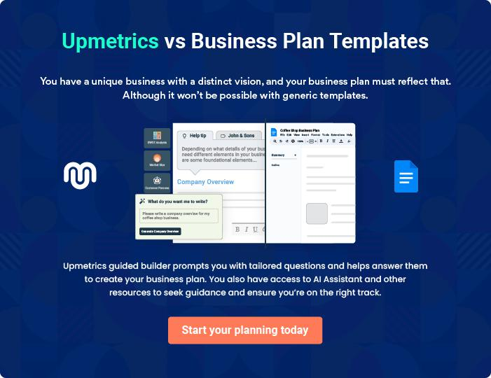
Products and Services
To unlock help try Upmetrics!

The product and services section of a tea shop business plan should describe the specific services and products that will be offered to customers. To write this section should include the following:



 Help tip  Tea Shop Business Plan

To craft the introduction for your "Products and Services" chapter, begin by positioning your business within its industry, emphasizing its unique strengths or value proposition.
To unlock help try Upmetrics! 

Start writing here..

 Help tip


Tea Selection: Mention all sorts of tea assortments your tea shop will offer. This includes

• Classic Milk Tea
To unlock help try Upmetrics! 

Products

Classic Milk Tea


Price: [$3.50] per cup

Our classic milk tea is a timeless favorite, made with premium black tea leaves and creamy milk. It's sweet and satisfying, perfect for those who enjoy a traditional tea experience.

Specifications

- Tea Type: Black Tea

- Size: 16 oz

- Sweetness Level: Adjustable
Specialty Flavors

Price: [$4.49] per cup

Explore our range of unique and innovative tea flavors. From lavender-infused Earl Grey to tropical fruit blends, there's something for every adventurous tea lover.

Specifications

- Tea Types: Varies (e.g., Earl Grey, Fruit Infusions)

- Size: 16 oz

- Flavor Options: Multiple

Ready-to-Drink Tea Flavors

Price: [$2.99] per bottle

For those on the go, we offer a selection of refreshing bottled teas in various flavors. Grab one and enjoy the convenience of tea wherever you are.

Specifications

- Flavors: Green Tea, Hibiscus, Lemon, etc.

- Bottle Size: 12 oz

- Shelf Life: 6 months

Artisanal Tea

Price: Varies by type

Our artisanal teas are sourced from small, independent tea growers worldwide. Each tea is carefully selected for its unique flavor profile and exceptional quality.

Specifications

- Tea Types: White, Green, Oolong, etc.

- Origin: Varies by type

- Packaging: Loose leaf or tea bags
Tea Leaves

Price: [$9.99] per 100g

Take home your favorite tea leaves to brew at your leisure. We offer a wide range of loose tea leaves, ensuring freshness and flavor.

Specifications

- Varieties: Assam, Darjeeling, Jasmine, etc.

- Packaging: Resealable pouch

Light Snacks

Price: [$2.99 - $4.99] per item

Complement your tea with our selection of light snacks, including cookies, pastries, and nuts. Perfect for a quick bite with your beverage.

Specifications

- Options: Cookies, Croissants, Mixed Nuts, etc.

- Freshly Baked: Daily

Tea Fusions

Price: [$6.99] per fusion

Try our unique tea fusions, where we combine tea with fresh fruit and herbs to create a refreshing and healthy beverage option.

Specifications

- Varieties: Berry Blast, Citrus Mint, Cucumber Melon, etc.

- Size: 20 oz
Sandwiches

Price: [$7.99 - $9.99] per sandwich

Enjoy a savory sandwich with your tea. Our menu includes a variety of options, from classic cucumber sandwiches to hearty paninis.

Specifications

- Options: Turkey Club, Caprese, Veggie Delight, etc.

- Served with: Chips or Salad

Teapots

Price: [$19.99 - $49.99]

Enhance your tea-making experience with our stylish and functional teapots. Available in different sizes and designs to suit your preference.

Specifications

- Material: Glass, Ceramic, Cast Iron, etc.

- Capacity: Varies

Tea Infusers

Price: [$7.99 - $12.99]

Brew loose leaf tea with ease using our quality tea infusers. They come in various styles, including ball, basket, and novelty shapes.

Specifications

- Material: Stainless Steel, Silicone

- Size: Standard, Large
Cups/Mugs

Price: [$5.99 - $15.99]

Enjoy your tea in our beautifully crafted cups and mugs. We offer a range of sizes and designs to suit every tea enthusiast.

Specifications

- Materials: Porcelain, Ceramic, Glass

- Sizes: Varies

Tea Sets

Price: [$29.99 - $69.99]

Elevate your tea experience with our complete tea sets, which include teapot, cups, saucers, and more. They also make excellent gifts for tea lovers.

Specifications

- Set Components: Varies by set

- Styles: Traditional, Modern

Quality Measures

 Help tip  Tea Shop Business Plan

This section should explain how you maintain quality standards and consistently provide the highest quality service.
To unlock help try Upmetrics! 

Start writing here..

Additional Services

 Help tip  Tea Shop Business Plan

Mention if your tea shop offers any additional services. You may include services like, tea tasting and events, custom tea blending, etc.
To unlock help try Upmetrics! 

Start writing here..
Sales And Marketing Strategies

Writing the sales and marketing strategies section means a list of strategies you will use to attract and retain your clients.
To unlock help try Upmetrics! 

 Help Tip  Tea Shop Business Plan


To create an effective introduction for your "Sales and Marketing Strategies" chapter, start by setting the stage within your specific industry or market.
To unlock help try Upmetrics! 

Start writing here..

Unique Selling Proposition (USP)

 Help tip  Tea Shop Business Plan

Define your business’s USPs depending on the market you serve, the equipment you use, and the unique services you provide. Identifying USPs will help you plan your marketing strategies.
To unlock help try Upmetrics! 

Start writing here..

Pricing Strategy

 Help tip  Tea Shop Business Plan

Describe your pricing strategy—how you plan to price your tea shop products/services and stay competitive in the local market.
To unlock help try Upmetrics! 

Start writing here..

 Help tip  Tea Shop Business Plan
To unlock help try Upmetrics!

Discuss your marketing strategies to market your services. You may include some of these marketing strategies in your business plan—social media marketing, Google ads, brochures, email marketing, content marketing, and print marketing.



Marketing strategies

Online


Social Media

Leveraging platforms like Instagram and Facebook to showcase our teas, share stories, and engage with our audience.

Content Marketing

Blog posts and articles educating readers about the art of tea making, history, and benefits of different teas

Email Marketing

Regular newsletters updating our subscribers about new tea blends, offers, and events.

Google Ads

Targeted ads to reach potential customers actively searching for premium tea experiences.

Offline

Print Marketing

Elegant brochures and flyers to be distributed in local communities and events.

 Help tip  Tea Shop Business Plan
To unlock help try Upmetrics!

Outline the strategies you’ll implement to maximize your sales. Your sales strategies may include direct sales, online sales, partnering with tea enthusiasts and food influencers, offering referral programs, etc.



Sales strategies

Partner with Businesses

Collaborating with tea enthusiasts, bloggers, and food influencers to amplify our reach.

Direct Sales

In-store promotions, sampling sessions, and events to introduce customers to our diverse range.

Online Sales

A user-friendly website with an integrated e-commerce platform, allowing customers to explore and purchase our products from the comfort of their homes

Referral Programs

Encouraging our loyal customers to introduce [Tea Haven] to their friends and family, offering rewards in return.

 Help tip  Tea Shop Business Plan

Describe your customer retention strategies and how you plan to execute them.

For instance, introducing loyalty programs, special events, discount vouchers, surprise gifts,
To unlock help try Upmetrics! 

Customer retention

Loyalty Programs

Rewarding regular customers with points for every purchase, which can be redeemed for discounts or free products.

Personalized Service

Understanding individual preferences and customizing their experience, ensuring they always feel at home at [Tea Haven].

Special Events

Organizing tea tasting events, workshops, and themed evenings to engage with our community.

Discount Vouchers

Offering special vouchers on anniversaries or birthdays, making our patrons' special days even more memorable.

Operations Plan

 |  | When writing the operations plan section, it’s important to consider the
 |  | various aspects of your business operations.
 |  |  |  | To unlock help try Upmetrics! 
 Help tip |  |  Tea Shop Business Plan


To create an effective introduction for your "Operational Plan" chapter, start by emphasizing the
pivotal role of efficient operations in the success of your business, underscoring how they
directly impact the quality of services delivered.
 |  |  |  | To unlock help try Upmetrics! 
Start writing here..
Staffing & Training
 Help tip |  |  Tea Shop Business Plan

Mention your tea shop’s staffing requirements, including the number of tea baristas, and
marketing and sales staff needed. Include their qualifications, the training required, and the
duties they will perform.
 |  |  |  | To unlock help try Upmetrics! 
Start writing here..
Operational Process
 Help tip |  |  Tea Shop Business Plan

Outline the processes and procedures you will use to run your tea shop.

Your operational processes may include taking orders, greeting customers, offering knowledge,
To unlock help try Upmetrics! 

Start writing here..

Equipment & Appliances
To unlock help try Upmetrics!

 Help tip  Tea Shop Business Plan

Include the list of equipment and machinery required for a tea shop, such as tea machines, brewing equipment, security system, kitchen appliances, storage and refrigeration equipment, etc.



Start writing here..
Management Team

The management team section provides an overview of the individuals responsible for running your business plan.
To unlock help try Upmetrics! 

 Help tip  Tea Shop Business Plan

To craft an introduction for your "Management Team" chapter, begin by emphasizing the crucial role of leadership in the success of any business.
To unlock help try Upmetrics! 

Start writing here..

Key managers

 Help tip  Tea Shop Business Plan

Introduce your management and key members of your team, and explain their roles and responsibilities.
To unlock help try Upmetrics! 

Start writing here..


JOHN DOE

CEO - john.doe@example.com

John holds a Bachelor's degree in Business Administration from Harvard University and has over 15 years of experience in the food and beverage industry, with a focus on tea.


His passion for high-quality tea and his knowledge of market trends have been integral in shaping the vision of [Tea Haven].

JANE DOE

Chief Operating Officer (COO) - jane.doe@example.com

Jane has a Master's degree in Operations Management and over 10 years of experience in managing food and beverage outlets.

Her responsibilities include ensuring operational efficiency, managing staff, and implementing business strategies.



ALICE BROWN

CMO - alice.brown@example.com

With a background in Advertising and over 12 years of experience in the tea industry, Alice is responsible for developing and executing our marketing strategies.

She has a keen eye for identifying market trends and crafting campaigns that resonate with our target audience.


ROBERT BROWN

Operations Manager - robert.brown@example.com

Robert holds a degree in Supply Chain Management and has 8 years of experience in managing operations in the food and beverage sector.

His duties include inventory management, quality control, and supplier negotiations.

Organizational structure

 Help tip  Tea Shop Business Plan

Explain the organizational structure of your management team. Include the reporting line and decision-making hierarchy.
To unlock help try Upmetrics! 

Start writing here..

Organization chart


John Doe

CEO


Alice Brown Jane Doe

CMO COO


Emily Smith

Marketing Manager Robert Brown

Operations Manager




Sarah White Mark Gray

HR Manager Customer Relation Manager

Compensation plan

 Help tip  Tea Shop Business Plan

Describe your compensation plan for the management and staff. Include their salaries, incentives, and other benefits.
To unlock help try Upmetrics! 

Start writing here..

 Help tip

Mentioning advisors or consultants in your business plans adds credibility to your business idea.
To unlock help try Upmetrics! 

Advisors/Consultants


DR. EMILY GREEN

Tea Cultivation and Production Advisor

With over 25 years of experience in tea cultivation, Dr. Green advises us on sourcing the best quality teas and sustainable farming practices.


MR. DAVID WHITE

Business Strategy Consultant

David brings in 30 years of experience in the retail and beverage industry. His insights have been invaluable in shaping [Tea Haven]'s business strategies and expansion plans.
Financial Plan

When writing the financial plan section of a business plan, it’s important to provide a comprehensive overview of your financial projections for the first few years of your business, You may provide the following:
To unlock help try Upmetrics! 

 Help tip  Tea Shop Business Plan


To create an effective introduction for your "Financial Plan" chapter, begin by stressing the critical role of a well-structured financial plan in the success of your venture.
To unlock help try Upmetrics! 

Start writing here..

 Help tip  Tea Shop Business Plan

Describe details such as projected revenue, operational costs, and service costs in your projected profit and loss statement. Make sure to include your business’s expected net profit or loss.
To unlock help try Upmetrics! 

Profit & loss statement

Revenue

Cost Of Sales

General Costs

Revenue Specific Costs

Personnel Costs (Direct

Labor)

Gross Margin

Gross Margin (%)

Operating Expense

Payroll Expense

(Indirect Labor)

General Expense

Bad Debt

Amortization of Current

Assets

2023-24 | 2024-25 | 2025-26 | 2026-27 | 2027-28
$0 | $0 | $0 | $0 | $0

$0 | $0 | $0 | $0 | $0
$0 | $0 | $0 | $0 | $0
$0 | $0 | $0 | $0 | $0
$0 | $0 | $0 | $0 | $0

$0 | $0 | $0 | $0 | $0
0% | 0% | 0% | 0% | 0%

$0 | $0 | $0 | $0 | $0
$0 | $0 | $0 | $0 | $0
$0 | $0 | $0 | $0 | $0
$0 | $0 | $0 | $0 | $0
$0 | $0 | $0 | $0 | $0

EBITDA

Additional Expense

Long Term

Depreciation

Gain or loss from Sale

of Assets

EBIT

Interest Expenses

EBT

Income Tax Expense

Total Expense

Net Income

Net Income (%)

2023-24 | 2024-25 | 2025-26 | 2026-27 | 2027-28
$0 | $0 | $0 | $0 | $0
$0 | $0 | $0 | $0 | $0
$0 | $0 | $0 | $0 | $0
$0 | $0 | $0 | $0 | $0
$0 | $0 | $0 | $0 | $0
$0 | $0 | $0 | $0 | $0
$0 | $0 | $0 | $0 | $0
$0 | $0 | $0 | $0 | $0
$0 | $0 | $0 | $0 | $0
$0 | $0 | $0 | $0 | $0
0% | 0% | 0% | 0% | 0%

 |  |  | 2023-24 |  | 2024-25 | 2025-26
Retained Earning |  |  | $0 |  | $0 | $0
Opening |  |  |  |  | $0 | $0
Owner's Distribution |  |  | $0 |  | $0 | $0
Retained Earning |  |  | $0 |  | $0 | $0
Closing |  |  |  |  | $0 | $0
 Help tip |  |  |  Tea Shop Business Plan


The cash flow for the first few years of your operation should be estimated and described in this section.

This may include billing invoices, payment receipts, loan payments, and any other cash flow statements.
2026-27 2027-28

$0 $0

$0 $0

$0 $0

To unlock help try Upmetrics! 

Cash flow statement

 | 2023-24 | 2024-25 | 2025-26 | 2026-27 | 2027-28
Cash Received | $0 | $0 | $0 | $0 | $0
Cash Paid | $0 | $0 | $0 | $0 | $0
COS & General Expenses | $0 | $0 | $0 | $0 | $0
Salary & Wages | $0 | $0 | $0 | $0 | $0
Interest | $0 | $0 | $0 | $0 | $0

Sales Tax

Income Tax

Net Cash From

Operations

Assets Sell

Assets Purchase

Net Cash From

Investments

Amount Received

Loan Received

Common Stock

Preferred Stock

Owner's Contribution

Amount Paid

2023-24 | 2024-25 | 2025-26 | 2026-27 | 2027-28
$0 | $0 | $0 | $0 | $0
$0 | $0 | $0 | $0 | $0
$0 | $0 | $0 | $0 | $0

$0 | $0 | $0 | $0 | $0
$0 | $0 | $0 | $0 | $0
$0 | $0 | $0 | $0 | $0

$0 | $0 | $0 | $0 | $0
$0 | $0 | $0 | $0 | $0

$0 | $0 | $0 | $0 | $0
$0 | $0 | $0 | $0 | $0
$0 | $0 | $0 | $0 | $0

Loan Capital $0 $0 $0 $0 $0

 |  |  | 2023-24 | 2024-25 | 2025-26 | 2026-27 | 2027-28
Dividends & Distributions |  |  | $0 | $0 | $0 | $0 | $0
Net Cash From |  |  | $0 | $0 | $0 | $0 | $0
Financing
Summary
Starting Cash |  |  | $0 | $0 | $0 | $0 | $0
Cash In |  |  | $0 | $0 | $0 | $0 | $0
Cash Out |  |  | $0 | $0 | $0 | $0 | $0
Change in Cash |  |  | $0 | $0 | $0 | $0 | $0
Ending Cash |  |  | $0 | $0 | $0 | $0 | $0
 Help tip |  |  Tea Shop Business Plan

Create a projected balance sheet documenting your tea shop’s assets, liabilities, and equity.

To unlock help try Upmetrics! 

Balance sheet

 | 2023-24 | 2024-25 | 2025-26 | 2026-27 | 2027-28
Assets | $0 | $0 | $0 | $0 | $0
Current Assets | $0 | $0 | $0 | $0 | $0
Cash | $0 | $0 | $0 | $0 | $0
Accounts Receivable | $0 | $0 | $0 | $0 | $0
Inventory | $0 | $0 | $0 | $0 | $0
Other Current Assets | $0 | $0 | $0 | $0 | $0
Long Term Assets | $0 | $0 | $0 | $0 | $0
Gross Long Term Assets | $0 | $0 | $0 | $0 | $0
Accumulated Depreciation | $0 | $0 | $0 | $0 | $0

Liabilities & Equity | $0 | $0 | $0 | $0 | $0
Liabilities | $0 | $0 | $0 | $0 | $0
Current Liabilities | $0 | $0 | $0 | $0 | $0
Accounts Payable | $0 | $0 | $0 | $0 | $0
Income Tax Payable | $0 | $0 | $0 | $0 | $0
Sales Tax Payable | $0 | $0 | $0 | $0 | $0
Short Term Debt | $0 | $0 | $0 | $0 | $0
 | 2023-24 | 2024-25 | 2025-26 | 2026-27 | 2027-28
Long Term Liabilities | $0 | $0 | $0 | $0 | $0
Long Term Debt | $0 | $0 | $0 | $0 | $0
Equity | $0 | $0 | $0 | $0 | $0
Paid-in Capital | $0 | $0 | $0 | $0 | $0
Common Stock | $0 | $0 | $0 | $0 | $0
Preferred Stock | $0 | $0 | $0 | $0 | $0
Owner's Contribution | $0 | $0 | $0 | $0 | $0
Retained Earnings | $0 | $0 | $0 | $0 | $0

Check | $0 |  |  | $0 | $0 | $0 | $0
 Help tip |  |  Tea Shop Business Plan

Determine and mention your business’s break-even point—the point at which your business costs and revenue will be equal.

This exercise will help you understand how much revenue you need to generate to sustain or be profitable.
To unlock help try Upmetrics! 

Break-even Analysis

 | 2023-24 | 2024-25 | 2025-26 | 2026-27 | 2027-28
Starting Revenue | $0 | $0 | $0 | $0 | $0
Net Revenue | $0 | $0 | $0 | $0 | $0
Closing Revenue | $0 | $0 | $0 | $0 | $0

Starting Expense | $0 | $0 | $0 | $0 | $0
Net Expense | $0 | $0 | $0 | $0 | $0
Closing Expense | $0 | $0 | $0 | $0 | $0

Is Break Even? | 0 | 0 | 0 | 0 | 0
Break Even Month | 0 | 0 | 0 | 0 | 0
Days Required | 0 | 0 | 0 | 0 | 0
Break Even Revenue | $0 | $0 | $0 | $0 | $0
Break Even Units
Financing needs

 Help tip  Tea Shop Business Plan

Calculate costs associated with starting a tea shop, and estimate your financing needs and how much capital you need to raise to operate your business.
To unlock help try Upmetrics! 

Start writing here..
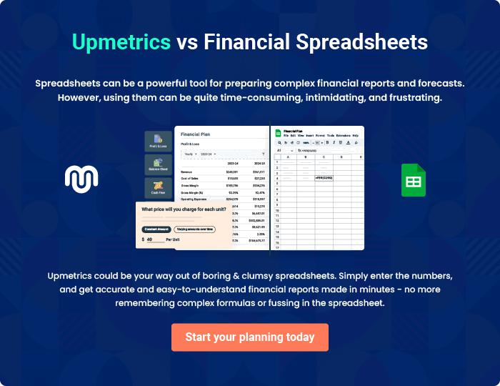
Appendix

When writing the appendix section, you should include any additional information that supports the main content of your plan. This may include financial statements, market research data, legal documents, and other
To unlock help try Upmetrics! 

Create a winning business plan that gets you funded

Creating a stunning and investment-ready plan requires no writing, graphic designing, or financial planning expertise.

Upmetrics has all the features required to help you create a comprehensive business plan—from start to finish. Make no mistakes, it’s the modern way of planning to structure ideas, make plans, and create stunning pitch decks to awe investors.

Pitch decks that impress investors

Create pitch decks that provide a visual representation of your business, engage investors, and make them want to invest in your business idea.

Interactive plans in no time

Import business plan sections like—SWOT analysis, comparison tables, and others to create an interactive business plan. No designing skills are required.

Stunning cover page designs

With Upmetrics, you have the liberty to choose from multiple stunning cover page designs. Choose a creative design and make your plan stand out.

Online sharing made simple

Upmetrics makes online sharing quick and easier for users. Easily share your business plans with a link while tracking reader activity.

500+ sample business plans

Simply import a template from our library of sample plans into the editor and start customizing it to make it yours. It takes only a few clicks to get started.

Collaborate with team in real-time

Invite team members, initiate conversations, discuss ideas & strategies, share feedback, and work on a business plan in real-time.

