
BUSINESS PLAN

2023


Summer Camp

Business Plan

Campfire Tales, Lifelong Bonds

John Doe

10200 Bolsa Ave, Westminster, CA, 92683

- 359-3153 info@example.com http://www.example.com

Information provided in this business plan is unique to this business and confidential; therefore, anyone reading this plan agrees not to disclose any of the information in this business plan without prior written permission of the company.
Table of Contents

Executive Summary | 6
Market opportunity | 6
Services Offered | 6
Marketing & Sales Strategies | 7
Financial Highlights | 7
Units Sold v/s Revenue | 8

Company Overview | 9
Ownership | 9
Mission statement | 9
Business history | 10
Future goals | 10

Market Analysis | 11
Target Market | 11
Market size and growth potential | 11
Market Size | 12
Competitive analysis | 12
Camp Lakewood | 12
Science Camp for Kids | 13
Adventure Explorers Camp | 13
Market trends | 13
Regulatory environment | 14

Products and Services | 15
Services | 15
Camp Programs | 15
Accommodation | 16
Instruction and Coaching | 16
Safety and First Aid | 16
Camp Merchandise | 17
Activity Equipment and Supplies | 17
Facilities and Accommodation | 17
Safety Measures | 18
Additional Products | 18

Sales And Marketing Strategies | 19
Unique Selling Proposition (USP) | 19
Pricing Strategy | 19
Marketing strategies | 20
Online | 20
Offline | 20
Sales strategies | 21
Customer retention | 22

Operations Plan | 23
Staffing & Training | 23
Operational Process | 23
Equipment & Machinery | 24

Management Team | 25
Key managers | 25
John Doe | 25
Jane Doe | 26
Alice Brown | 26
Emma Smith | 26
Organizational structure | 27
Organization chart | 27
Compensation plan | 28
Advisors/Consultants | 28
Dr. Emily Smith | 28
Mr. Peter Johnson | 28
Financial Plan | 29
Profit & loss statement | 29
Cash flow statement | 32
Balance sheet | 34
Break-even Analysis | 36
Financing needs | 38
Appendix
Appendix | 40
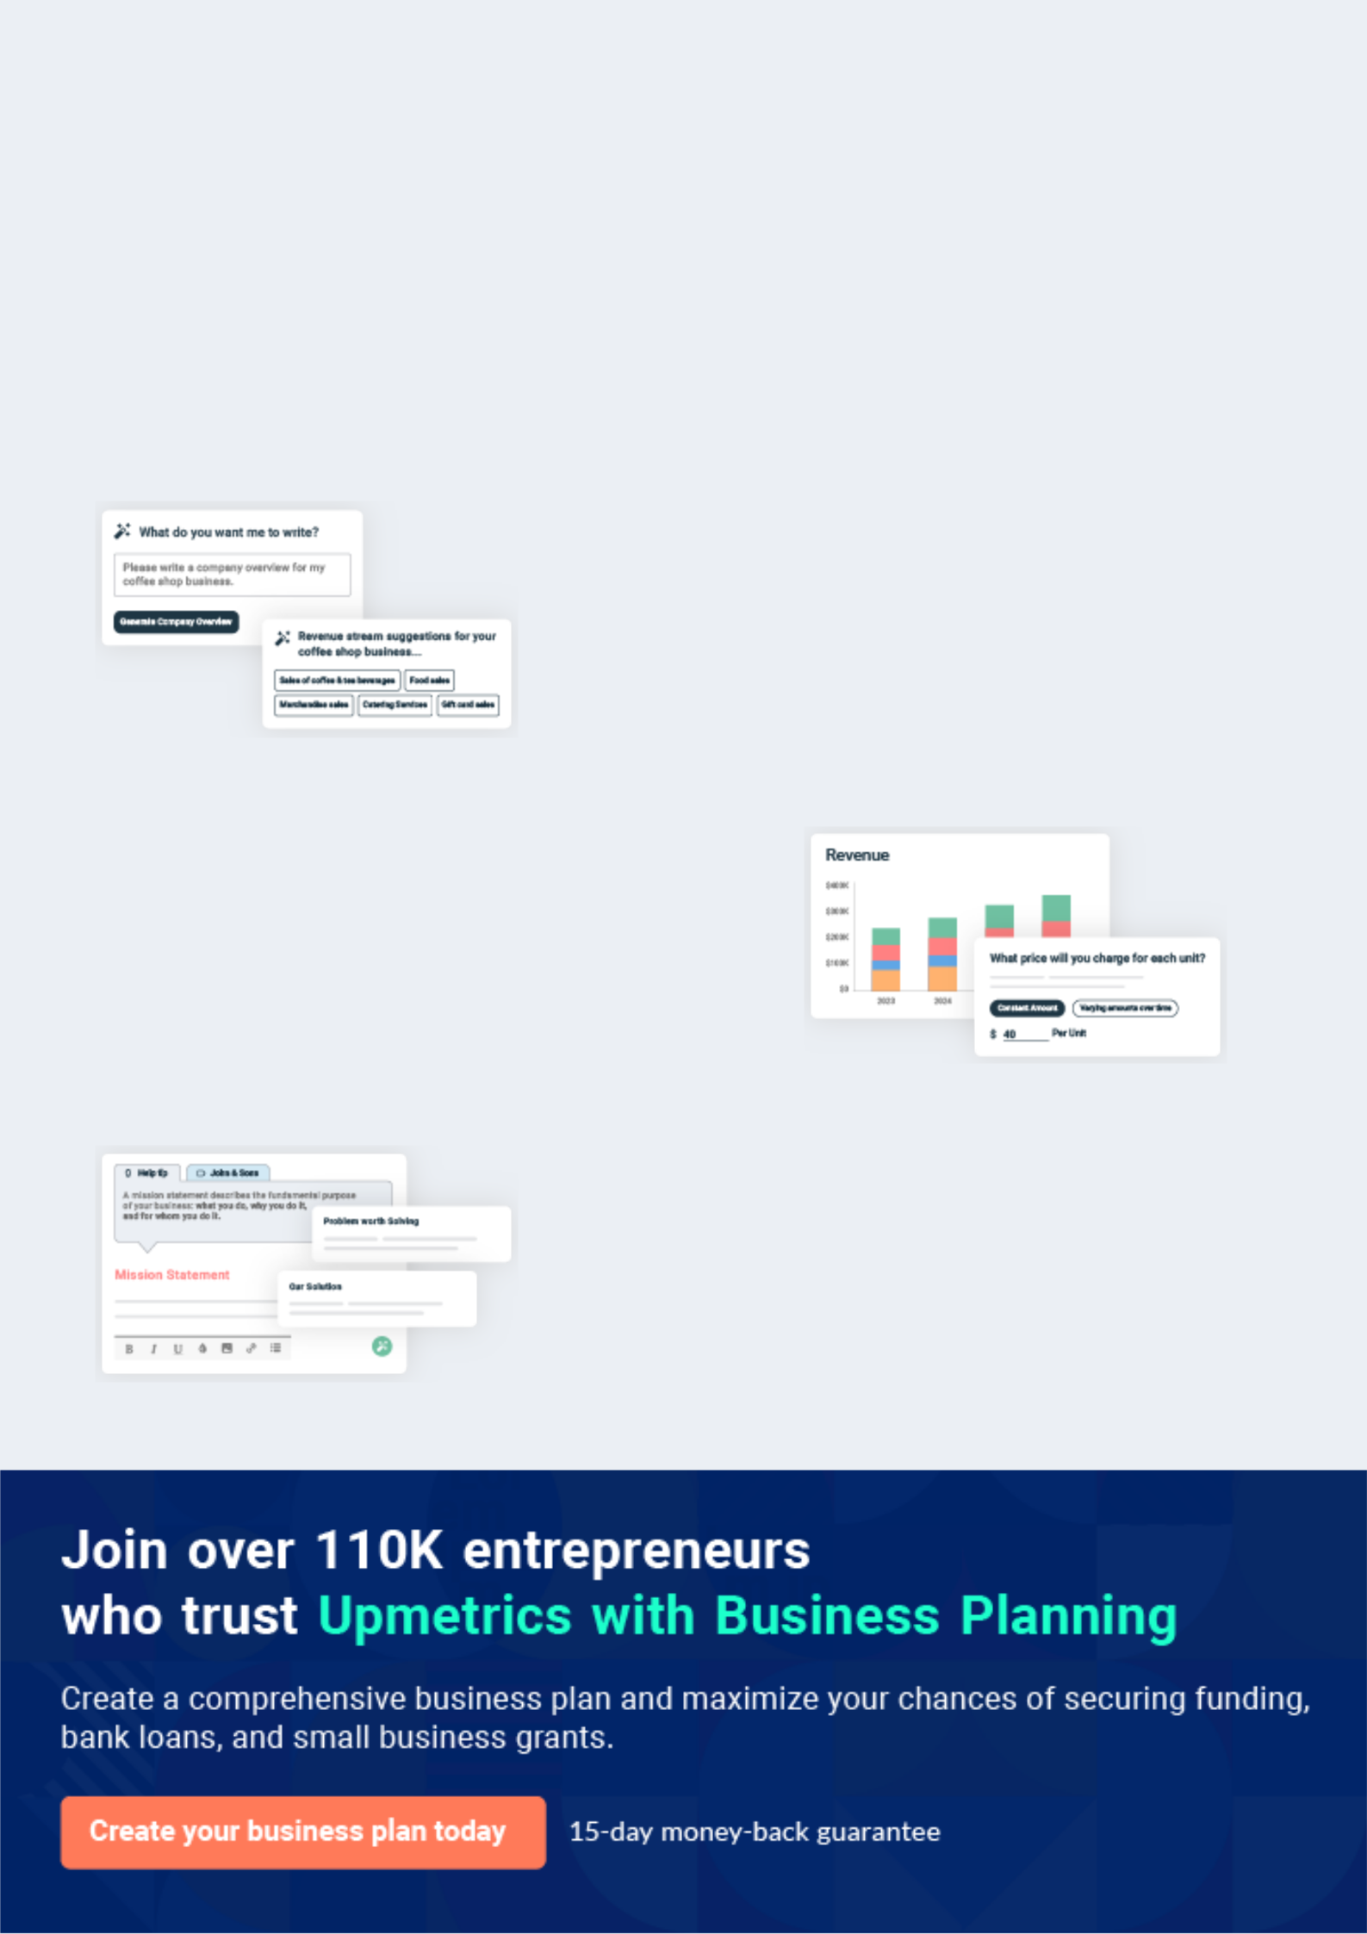
Business planning that’s simpler and faster than you think

Creating a business plan using Upmetrics to start and grow a business is literally the easiest thing in the World. Simply read the instructions and fill in the blanks. It’s as simple as that.

❛ | Upmetrics has everything you need to create a | ❜
❛ | comprehensive business plan. | ❜

AI-powered Upmetrics Assistant

AI-powered insights to streamline your plan

Not sure where to start? Upmetrics’ AI Assistant will automatically generate ideas for each section of your plan and offer improved versions of your writing, adjusting for tone, voice, and grammar or spelling errors.

Financial Forecasting Tool

All the financials are calculated for you

Forget the complex formulas and clumsy spreadsheets — with automatic financials and drag-and-drop forecasting, you can finish your plan faster and be confident that your numbers are accurate.

Business Plan Builder

Guides you like a business mentor

Upmetrics’ step-by-step instructions, prompts, and the library of 400+ sample business plans will guide you through each section of your plan as a business mentor.
Executive Summary


An executive summary is the first section of the business plan intended to provide an overview of the whole business plan.
To unlock help try Upmetrics! 

 Help tip  Summer Camp Business Plan


Start your executive summary by briefly introducing your business to your readers.

This section may include the name of your summer camp business, its location, when it was
To unlock help try Upmetrics! 

Start writing here..

Market opportunity

 Help tip  Summer Camp Business Plan

Summarize your market research, including market size, growth potential, and marketing trends. Highlight the opportunities in the market and how your business will fit in to fill the gap.
To unlock help try Upmetrics! 

Start writing here..

Services Offered

 Help tip  Summer Camp Business Plan

Highlight the summer camp services you offer your customers. The USPs and differentiators you offer are always a plus.
To unlock help try Upmetrics! 

Start writing here..

Marketing & Sales Strategies
To unlock help try Upmetrics!

 Help tip  Summer Camp Business Plan

Outline your sales and marketing strategies—what marketing platforms you use, how you plan on acquiring customers, etc.
To unlock help try Upmetrics! 

Start writing here..

Financial Highlights

 Help tip  Summer Camp Business Plan

Briefly summarize your financial projections for the initial years of business operations. Include any capital or investment requirements, associated startup costs, projected revenues, and profit forecasts.



Start writing here..
Units Sold v/s Revenue

 |  | Units Sold | Revenue
15.00k
10.00k
5.00k
0
Year 1 | Year 2 | Year 3
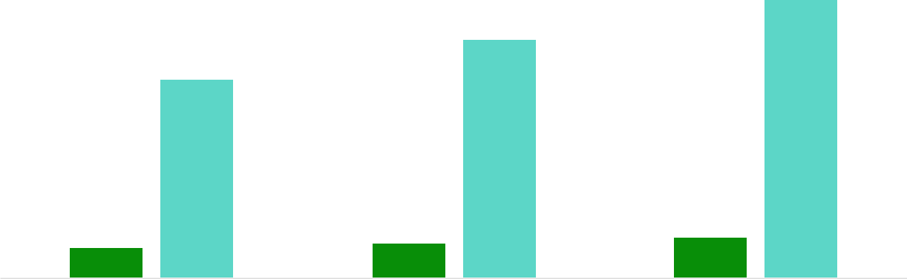

Financial Year |  |  | Units Sold | Revenue
Year 1 | 1,550 |  |  | $10,000
Year 2 | 1,800 |  |  | $12,000
Year 3 | 2,050 |  |  | $14,000
 Help tip |  |  Summer Camp Business Plan
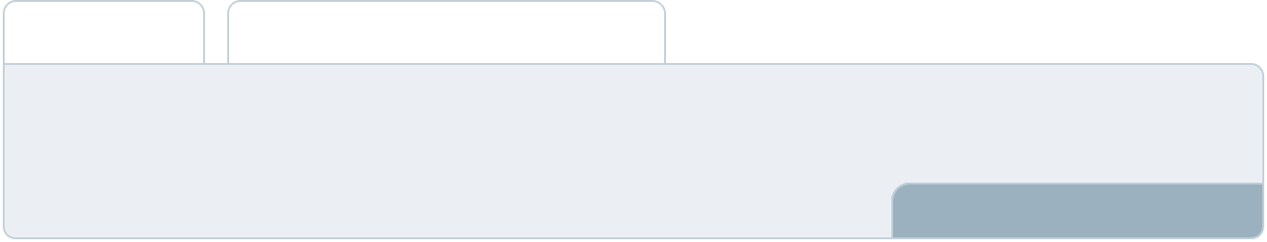

Summarize your executive summary section with a clear CTA, for example, inviting angel investors to discuss the potential business investment.
To unlock help try Upmetrics! 

Write a call to action for your business plan.
Company Overview

Depending on what details of your business are essential, you’ll need different elements in your business overview.
To unlock help try Upmetrics! 

 Help tip  Summer Camp Business Plan

Describe your business in this section by providing all the basic information:

Describe what kind of summer camp business you run and the name of it. Here are some of the
To unlock help try Upmetrics! 

Start writing here..

Ownership

 Help tip  Summer Camp Business Plan

List the founders or owners of your summer camp business. Describe what shares they own and their responsibilities for efficiently managing the business.
To unlock help try Upmetrics! 

Start writing here..

Mission statement

 Help tip  Summer Camp Business Plan

Summarize your business’ objective, core principles, and values in your mission statement. This statement needs to be memorable, clear, and brief.
To unlock help try Upmetrics! 
❛ A memorable and concise statement that encapsulates the
camp's core principles, objectives, and values, such as 'Empowering Tomorrow's Leaders through Unforgettable Summer Experiences.

❜

Business history

 Help tip  Summer Camp Business Plan

If you’re an established camping service provider, briefly describe your business history, like— when it was founded, how it evolved over time, etc.
To unlock help try Upmetrics! 

Start writing here..

Future goals

 Help tip  Summer Camp Business Plan

It’s crucial to convey your aspirations and vision. Mention your short-term and long-term goals; they can be specific targets for revenue, market share, or expanding your services.
To unlock help try Upmetrics! 

Start writing here..
Market Analysis
To unlock help try Upmetrics!


 |  | Market analysis provides a clear understanding of the market in which your
 |  | printing business will run along with the target market, competitors, and
 |  | growth opportunities.
 |  |  |  | To unlock help try Upmetrics! 
 Help tip |  |  Summer Camp Business Plan

To write the introduction section of your market analysis, start by clearly identifying your primary target market.
To unlock help try Upmetrics! 

Start writing here..

Target Market

 Help tip  Summer Camp Business Plan

Start this section by describing your target market. Define your ideal customer and explain what types of services they prefer. Creating a buyer persona will help you easily define your target market to your readers.



Start writing here..

Market size and growth potential

 Help tip  Summer Camp Business Plan

Describe your market size and growth potential and whether you will target a niche or a much broader market.
To unlock help try Upmetrics! 

Start writing here..

Market Size

Available Market | 2M
Total potential campers aged 8-17 in the | 2M
region.
Served Market | 1M
Campers who have attended or are | 1M
interested in summer | 1M
Target Market | 500k
Campers interested in our specific camp | 500k
offerings


 Help tip  Summer Camp Business Plan

Identify and analyze your direct and indirect competitors. Identify their strengths and weaknesses, and describe what differentiates your summer camp services from them.
To unlock help try Upmetrics! 

Competitive analysis

Camp Lakewood

A traditional summer camp that offers a wide range of outdoor activities, from hiking and swimming to team sports and arts and crafts

Features | Strengths | Weaknesses
Wide variety of activities | Strong brand recognition in the | Limited personalization due to
Accredited by the American | community | large group sizes
Camp Association | Highly experienced staff | Higher cost compared to other
Camps available for different | Beautiful and extensive | camps
age groups | campgrounds

Science Camp for Kids

A specialized academic camp focused on science-related activities, including hands-on experiments, field trips, and lectures from guest speakers.

Features

Focus on STEM learning

Access to specialized equipment and resources

Partnerships with local schools and organizations

Strengths

Unique offering in the market focusing on academic enrichment

Strong ties with the educational community

Positive reviews from past campers and parents

Weaknesses

Limited appeal for children seeking a more traditional camp experience

Smaller range of activities outside of academic focus

Adventure Explorers Camp

A high-energy camp offering adventure-based activities such as rock climbing, white-water rafting, and wilderness survival training.

Features

Adventure-focused curriculum

Certified instructors for specialized activities

Emphasis on team-building and leadership development

Strengths

Unique and thrilling experiences not offered by most camps

Dedicated and highly trained staff

Positive reviews for safety and program quality

Weaknesses

Limited options for children who prefer less physically demanding activities

Higher costs associated with specialized equipment and training

Market trends

 Help tip  Summer Camp Business Plan

analyze emerging trends in the industry, such as technology disruptions, changes in customer behavior or preferences, etc. Explain how your business will cope with all the trends.
To unlock help try Upmetrics! 

Start writing here..

Regulatory environment
To unlock help try Upmetrics!

 Help tip  Summer Camp Business Plan

List regulations and licensing requirements that may affect your summer camp business, such as business registration, insurance, health and safety regulations, and transportation regulations.



Start writing here..
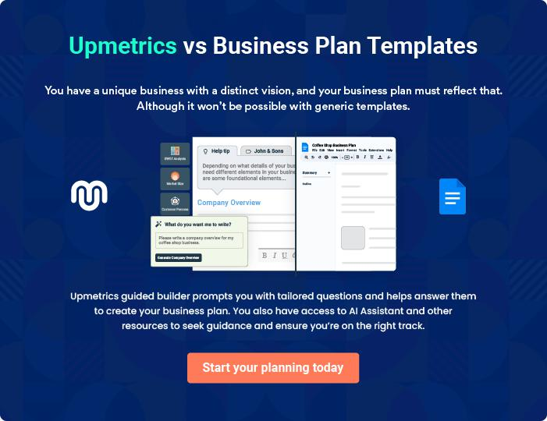
Products and Services
To unlock help try Upmetrics!

The product and services section of a summer camp business plan should describe the specific services and products that will be offered to customers. To write this section should include the following:



 Help tip  Summer Camp Business Plan

To craft the introduction for your "Products and Services" chapter, begin by positioning your business within its industry, emphasizing its unique strengths or value proposition.
To unlock help try Upmetrics! 

Start writing here..

 Help tip


Mention the summer camp services your business will offer. This list may include services like,

• Camp programs
To unlock help try Upmetrics! 

Services

Camp Programs


Price: [$400 - $800 per week]

A diverse range of programs from arts and crafts to outdoor survival skills

Specifications

- Age groups: 8-17 years

- Duration: 1-2 weeks

- Instructor-to-camper ratio: 1:10
Accommodation

Price: Included in camp program fee

Comfortable and secure cabins or tents located within the campgrounds.

Specifications

- Options: Cabins or tents

- Capacity: 4-6 campers per cabin/tent

- Amenities: Beds, storage space, electricity

Instruction and Coaching

Price: Included in camp program fee

Expert-led sessions designed to provide both educational and recreational experiences.

Specifications

- Areas: Aquatic sports, wildlife studies, arts, and more

- Instructor qualifications: Certified professionals in their respective fields

Safety and First Aid

Price: Included in camp program fee

A dedicated station equipped to handle any medical emergencies, along with certified professionals.

Specifications

- Location: Central area within the campgrounds

- Staff: Certified first aid professionals

- Equipment: Fully-stocked with necessary medical supplies
Camp Merchandise

Price: [$10 - $50] per item

A range of branded merchandise for campers to take home as souvenirs.

Specifications

- Items: T-shirts, water bottles, hats, and more

- Sizes: Available in different sizes

- Customization: Option available for certain items

Activity Equipment and Supplies

Price: Included in camp program fee

Top-quality equipment provided for all camp activities.

Specifications

- Types: Sporting goods, art supplies, safety gear, and more

- Safety: All equipment meets necessary safety standards

- Maintenance: Regularly inspected and maintained

Facilities and Accommodation

 Help tip  Summer Camp Business Plan

Provide the details about the accommodation and facilities available at your summer camp.

This may include details about tents, cabins, sports fields, swimming pools, etc.
To unlock help try Upmetrics! 

Start writing here..

Safety Measures
To unlock help try Upmetrics!

 Help tip  Summer Camp Business Plan

This section should explain how you ensure the safety and well-being of your staff and customers.
To unlock help try Upmetrics! 

Start writing here..

Additional Products

 Help tip  Summer Camp Business Plan

Mention if your summer camp business offers any additional services. You may include services like specialized workshops or clinics, parent information sessions, opportunities for family involvement, etc.



Start writing here..
Sales And Marketing Strategies

Writing the sales and marketing strategies section means a list of strategies you will use to attract and retain your clients.
To unlock help try Upmetrics! 

 Help Tip  Summer Camp Business Plan


To create an effective introduction for your "Sales and Marketing Strategies" chapter, start by setting the stage within your specific industry or market.
To unlock help try Upmetrics! 

Start writing here..

Unique Selling Proposition (USP)

 Help tip  Summer Camp Business Plan


Mention if your summer camp business offers any additional services. You may include
services like specialized workshops or clinics, parent information sessions, opportunities for
family involvement, etc.
 |  |  |  | To unlock help try Upmetrics! 
Start writing here..
Pricing Strategy
 Help tip |  |  Summer Camp Business Plan

Describe your pricing strategy—how you plan to price your services and stay competitive in the local market. You can mention any discounts you plan on offering to attract new customers.
To unlock help try Upmetrics! 

Start writing here..

 Help tip  Summer Camp Business Plan
To unlock help try Upmetrics!

Discuss your marketing strategies to market your services. You may include some of these marketing strategies in your business plan—social media marketing, Google ads, brochures, email marketing, content marketing, and print marketing.



Marketing strategies

Online


Social Media

Engaging with our audience and promoting our programs on platforms such as Facebook, Instagram, and Twitter.

Content Marketing

Showcasing our camp's offerings and benefits through blog posts, videos, and other mediums.

Email Marketing

Keeping our audience informed about upcoming programs, special offers, and other news.

Google Ads

Reaching potential customers searching for summer camps in our area.

Offline

Brochures

Distributing materials to local schools, community centers, and other relevant locations.

 Help tip
Early Bird and Limited-Time Promotions
Encouraging early registrations through special offers.
To unlock help try Upmetrics!

Outline the strategies you’ll implement to maximize your sales. Your sales strategies may include early bird and limited-time offers, partnerships and collaborations, referral programs, etc.



Sales strategies

Partner with Businesses

Forming relationships with local businesses and organizations to increase our reach.

Referral Programs

Implementing a program where

existing campers can refer friends

and receive a discount on their

next registration.
 Help tip

Describe your customer retention strategies and how you plan to execute them. For instance, special events and reunions, referral programs, etc.
To unlock help try Upmetrics! 

Customer retention

Special Events and Reunions

Organizing events for past campers to stay connected with our community.

Loyalty Discounts

Offering discounts for returning campers to encourage repeat business.

Referral Program

Implementing a program where

campers can refer friends and

receive a discount or other

incentives.

Operations Plan

 |  | When writing the operations plan section, it’s important to consider the
 |  | various aspects of your business operations.
 |  |  |  | To unlock help try Upmetrics! 
 Help tip |  |  Summer Camp Business Plan
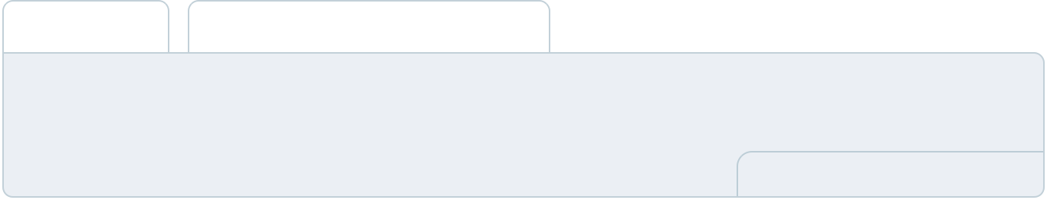

To create an effective introduction for your "Operational Plan" chapter, start by emphasizing the
pivotal role of efficient operations in the success of your business, underscoring how they
directly impact the quality of services delivered.
 |  |  |  | To unlock help try Upmetrics! 
Start writing here..
Staffing & Training
 Help tip |  |  Summer Camp Business Plan

Mention your business’s staffing requirements, including the number of employees or lash
technicians needed. Include their qualifications, the training required, and the duties they will
perform.
 |  |  |  | To unlock help try Upmetrics! 
Start writing here..
Operational Process
 Help tip |  |  Summer Camp Business Plan

Outline the processes and procedures you will use to run your summer camp business.

Your operational processes may include staff management, safety and risk management,
To unlock help try Upmetrics! 

Start writing here..

Equipment & Machinery

 Help tip  Summer Camp Business Plan

Include the list of equipment and machinery required for summer camp, such as outdoor equipment, performing arts equipment, sports and recreational equipment, etc.
To unlock help try Upmetrics! 

Start writing here..
Management Team

The management team section provides an overview of the individuals responsible for running your business plan.
To unlock help try Upmetrics! 

 Help tip  Summer Camp Business Plan

To craft an introduction for your "Management Team" chapter, begin by emphasizing the crucial role of leadership in the success of any business.
To unlock help try Upmetrics! 

Start writing here..

Key managers

 Help tip  Summer Camp Business Plan

Introduce your management and key team members, and explain their roles and responsibilities.
To unlock help try Upmetrics! 

Start writing here..


JOHN DOE

CEO & Co-founder - john.doe@example.com

John is the visionary behind Camp Sunshine, bringing his passion for youth development and outdoor education to the forefront.

With a Bachelor's degree in Recreation Management from the University of Example, John has garnered over a decade of industry experience.


He worked at Outdoor Adventures, a leading summer camp provider, where he served as a Camp Director, honing his skills in camp management and program development.

At Camp Sunshine, John is responsible for overall strategic planning and business development.

JANE DOE

Camp Director - jane.doe@example.com

Jane is the linchpin that holds the operations together at Camp Sunshine.

She has a Master's degree in Education with a focus on Outdoor Learning from Example University.


With eight years of experience working in various camp settings, Jane brings a wealth of knowledge in program design, staff training, and camper engagement.

She ensures that each program aligns with our mission to provide enriching and fun learning experiences for kids and teens.


ALICE BROWN

Operations Manager - robert.brown@example.com

Alice plays a crucial role in ensuring that all the logistical aspects of Camp Sunshine are managed efficiently.

With a Bachelor's degree in Business Administration from Example College, she has honed her skills over the past seven years, specializing in operations management for summer camps.

Her responsibilities include procuring supplies, managing schedules, and ensuring that the camp runs seamlessly


EMMA SMITH

Marketing Manager - emma.smith@example.com

With her creative flair and strategic mindset, Emma spearheads the marketing initiatives at Camp Sunshine.

She has a degree in Marketing from the University of Example and over six years of experience working in the camping industry, focusing on digital marketing and brand building.

Her role involves driving brand awareness and enrollment through various marketing channels, including social media, email marketing, and print advertising.
Organizational structure

 Help tip  Summer Camp Business Plan

Explain the organizational structure of your management team. Include the reporting line and decision-making hierarchy.
To unlock help try Upmetrics! 

Start writing here..

Organization chart



David Wilson

Facility

Manager

Alice Brown



Operations Manager


Sophia Davis

HR Manager

John Doe

CEO


Jane Doe

Camp Director


 |  | Emma Smith
Robert Brown |  | Emma Smith
 |  | Marketing
Program |  | Manager
Manager



Compensation plan

 Help tip  Summer Camp Business Plan

Describe your compensation plan for the management and staff. Include their salaries, incentives, and other benefits.
To unlock help try Upmetrics! 

Start writing here..

 Help tip

Mentioning advisors or consultants in your business plans adds credibility to your business idea.
To unlock help try Upmetrics! 

Advisors/Consultants


DR. EMILY SMITH

Camp Safety Advisor

With [20] years of experience in camp safety, Dr. Smith advises us on best practices, ensuring our camp remains a safe environment for all.


MR. PETER JOHNSON

Camp Program Consultant

Peter has [18] years of experience in designing unique camp programs. His insights have been invaluable in creating engaging and educational programs for our campers.
Financial Plan

When writing the financial plan section of a business plan, it’s important to provide a comprehensive overview of your financial projections for the first few years of your business, You may provide the following:
To unlock help try Upmetrics! 

 Help tip  Summer Camp Business Plan


To create an effective introduction for your "Financial Plan" chapter, begin by stressing the critical role of a well-structured financial plan in the success of your venture.
To unlock help try Upmetrics! 

Start writing here..

 Help tip  Summer Camp Business Plan

Describe details such as projected revenue, operational costs, and service costs in your projected profit and loss statement. Make sure to include your business’s expected net profit or loss.
To unlock help try Upmetrics! 

Profit & loss statement

Revenue

Cost Of Sales

General Costs

Revenue Specific Costs

Personnel Costs (Direct

Labor)

Gross Margin

Gross Margin (%)

Operating Expense

Payroll Expense

(Indirect Labor)

General Expense

Bad Debt

Amortization of Current

Assets

2023-24 | 2024-25 | 2025-26 | 2026-27 | 2027-28
$0 | $0 | $0 | $0 | $0

$0 | $0 | $0 | $0 | $0
$0 | $0 | $0 | $0 | $0
$0 | $0 | $0 | $0 | $0
$0 | $0 | $0 | $0 | $0

$0 | $0 | $0 | $0 | $0
0% | 0% | 0% | 0% | 0%

$0 | $0 | $0 | $0 | $0
$0 | $0 | $0 | $0 | $0
$0 | $0 | $0 | $0 | $0
$0 | $0 | $0 | $0 | $0
$0 | $0 | $0 | $0 | $0

EBITDA

Additional Expense

Long Term

Depreciation

Gain or loss from Sale

of Assets

EBIT

Interest Expenses

EBT

Income Tax Expense

Total Expense

Net Income

Net Income (%)

2023-24 | 2024-25 | 2025-26 | 2026-27 | 2027-28
$0 | $0 | $0 | $0 | $0
$0 | $0 | $0 | $0 | $0
$0 | $0 | $0 | $0 | $0
$0 | $0 | $0 | $0 | $0
$0 | $0 | $0 | $0 | $0
$0 | $0 | $0 | $0 | $0
$0 | $0 | $0 | $0 | $0
$0 | $0 | $0 | $0 | $0
$0 | $0 | $0 | $0 | $0
$0 | $0 | $0 | $0 | $0
0% | 0% | 0% | 0% | 0%
 |  |  | 2023-24 |  | 2024-25 | 2025-26 | 2026-27 | 2027-28
Retained Earning |  |  | $0 |  | $0 | $0 | $0 | $0
Opening
Owner's Distribution |  |  | $0 |  | $0 | $0 | $0 | $0
Retained Earning |  |  | $0 |  | $0 | $0 | $0 | $0
Closing
 Help tip |  |  |  Summer Camp Business Plan
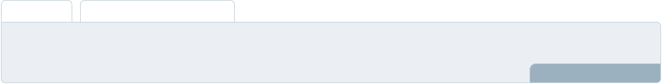

The cash flow for the first few years of your operation should be estimated and described in this section. This may include billing invoices, payment receipts, loan payments, and any other cash flow statements.
To unlock help try Upmetrics! 

Cash flow statement

 | 2023-24 | 2024-25 | 2025-26 | 2026-27 | 2027-28
Cash Received | $0 | $0 | $0 | $0 | $0
Cash Paid | $0 | $0 | $0 | $0 | $0
COS & General Expenses | $0 | $0 | $0 | $0 | $0
Salary & Wages | $0 | $0 | $0 | $0 | $0
Interest | $0 | $0 | $0 | $0 | $0

Sales Tax

Income Tax

Net Cash From

Operations

Assets Sell

Assets Purchase

Net Cash From

Investments

Amount Received

Loan Received

Common Stock

Preferred Stock

Owner's Contribution

Amount Paid

2023-24 | 2024-25 | 2025-26 | 2026-27 | 2027-28
$0 | $0 | $0 | $0 | $0
$0 | $0 | $0 | $0 | $0
$0 | $0 | $0 | $0 | $0

$0 | $0 | $0 | $0 | $0
$0 | $0 | $0 | $0 | $0
$0 | $0 | $0 | $0 | $0

$0 | $0 | $0 | $0 | $0
$0 | $0 | $0 | $0 | $0

$0 | $0 | $0 | $0 | $0
$0 | $0 | $0 | $0 | $0
$0 | $0 | $0 | $0 | $0

Loan Capital $0 $0 $0 $0 $0

 |  |  | 2023-24 |  | 2024-25 | 2025-26 | 2026-27 | 2027-28
Dividends & Distributions |  |  | $0 |  | $0 | $0 | $0 | $0
Net Cash From |  |  | $0 |  | $0 | $0 | $0 | $0
Financing
Summary
Starting Cash |  |  | $0 |  | $0 | $0 | $0 | $0
Cash In |  |  | $0 |  | $0 | $0 | $0 | $0
Cash Out |  |  | $0 |  | $0 | $0 | $0 | $0
Change in Cash |  |  | $0 |  | $0 | $0 | $0 | $0
Ending Cash |  |  | $0 |  | $0 | $0 | $0 | $0
 Help tip |  |  Summer Camp Business Plan

Create a projected balance sheet documenting your summer camp business’s assets, liabilities, and equity.

To unlock help try Upmetrics! 

Balance sheet

 | 2023-24 | 2024-25 | 2025-26 | 2026-27 | 2027-28
Assets | $0 | $0 | $0 | $0 | $0
Current Assets | $0 | $0 | $0 | $0 | $0
Cash | $0 | $0 | $0 | $0 | $0
Accounts Receivable | $0 | $0 | $0 | $0 | $0
Inventory | $0 | $0 | $0 | $0 | $0
Other Current Assets | $0 | $0 | $0 | $0 | $0
Long Term Assets | $0 | $0 | $0 | $0 | $0
Gross Long Term Assets | $0 | $0 | $0 | $0 | $0
Accumulated Depreciation | $0 | $0 | $0 | $0 | $0

Liabilities & Equity | $0 | $0 | $0 | $0 | $0
Liabilities | $0 | $0 | $0 | $0 | $0
Current Liabilities | $0 | $0 | $0 | $0 | $0
Accounts Payable | $0 | $0 | $0 | $0 | $0
Income Tax Payable | $0 | $0 | $0 | $0 | $0
Sales Tax Payable | $0 | $0 | $0 | $0 | $0
Short Term Debt | $0 | $0 | $0 | $0 | $0
 | 2023-24 | 2024-25 | 2025-26 | 2026-27 | 2027-28
Long Term Liabilities | $0 | $0 | $0 | $0 | $0
Long Term Debt | $0 | $0 | $0 | $0 | $0
Equity | $0 | $0 | $0 | $0 | $0
Paid-in Capital | $0 | $0 | $0 | $0 | $0
Common Stock | $0 | $0 | $0 | $0 | $0
Preferred Stock | $0 | $0 | $0 | $0 | $0
Owner's Contribution | $0 | $0 | $0 | $0 | $0
Retained Earnings | $0 | $0 | $0 | $0 | $0

Check | $0 |  |  | $0 | $0 | $0 | $0
 Help tip |  |  Summer Camp Business Plan

Determine and mention your business’s break-even point—the point at which your business costs and revenue will be equal.

This exercise will help you understand how much revenue you need to generate to sustain or be profitable.
To unlock help try Upmetrics! 

Break-even Analysis

 | 2023-24 | 2024-25 | 2025-26 | 2026-27 | 2027-28
Starting Revenue | $0 | $0 | $0 | $0 | $0
Net Revenue | $0 | $0 | $0 | $0 | $0
Closing Revenue | $0 | $0 | $0 | $0 | $0

Starting Expense | $0 | $0 | $0 | $0 | $0
Net Expense | $0 | $0 | $0 | $0 | $0
Closing Expense | $0 | $0 | $0 | $0 | $0

Is Break Even? | 0 | 0 | 0 | 0 | 0
Break Even Month | 0 | 0 | 0 | 0 | 0
Days Required | 0 | 0 | 0 | 0 | 0
Break Even Revenue | $0 | $0 | $0 | $0 | $0
Break Even Units
Financing needs

 Help tip  Summer Camp Business Plan

Calculate costs associated with starting a summer camp business, and estimate your financing needs and how much capital you need to raise to operate your business.
To unlock help try Upmetrics! 

Start writing here..
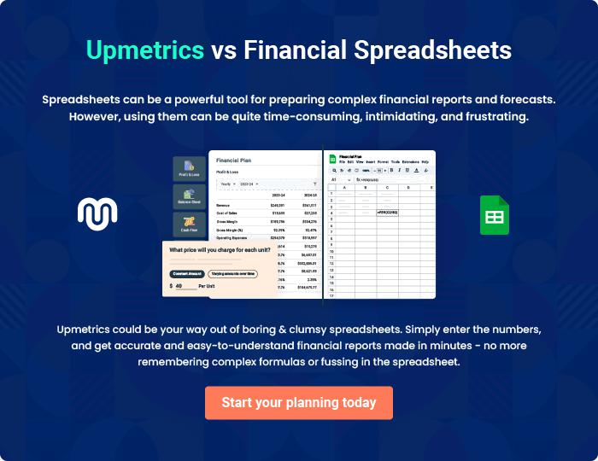
Appendix

When writing the appendix section, you should include any additional information that supports the main content of your plan. This may include financial statements, market research data, legal documents, and other
To unlock help try Upmetrics! 
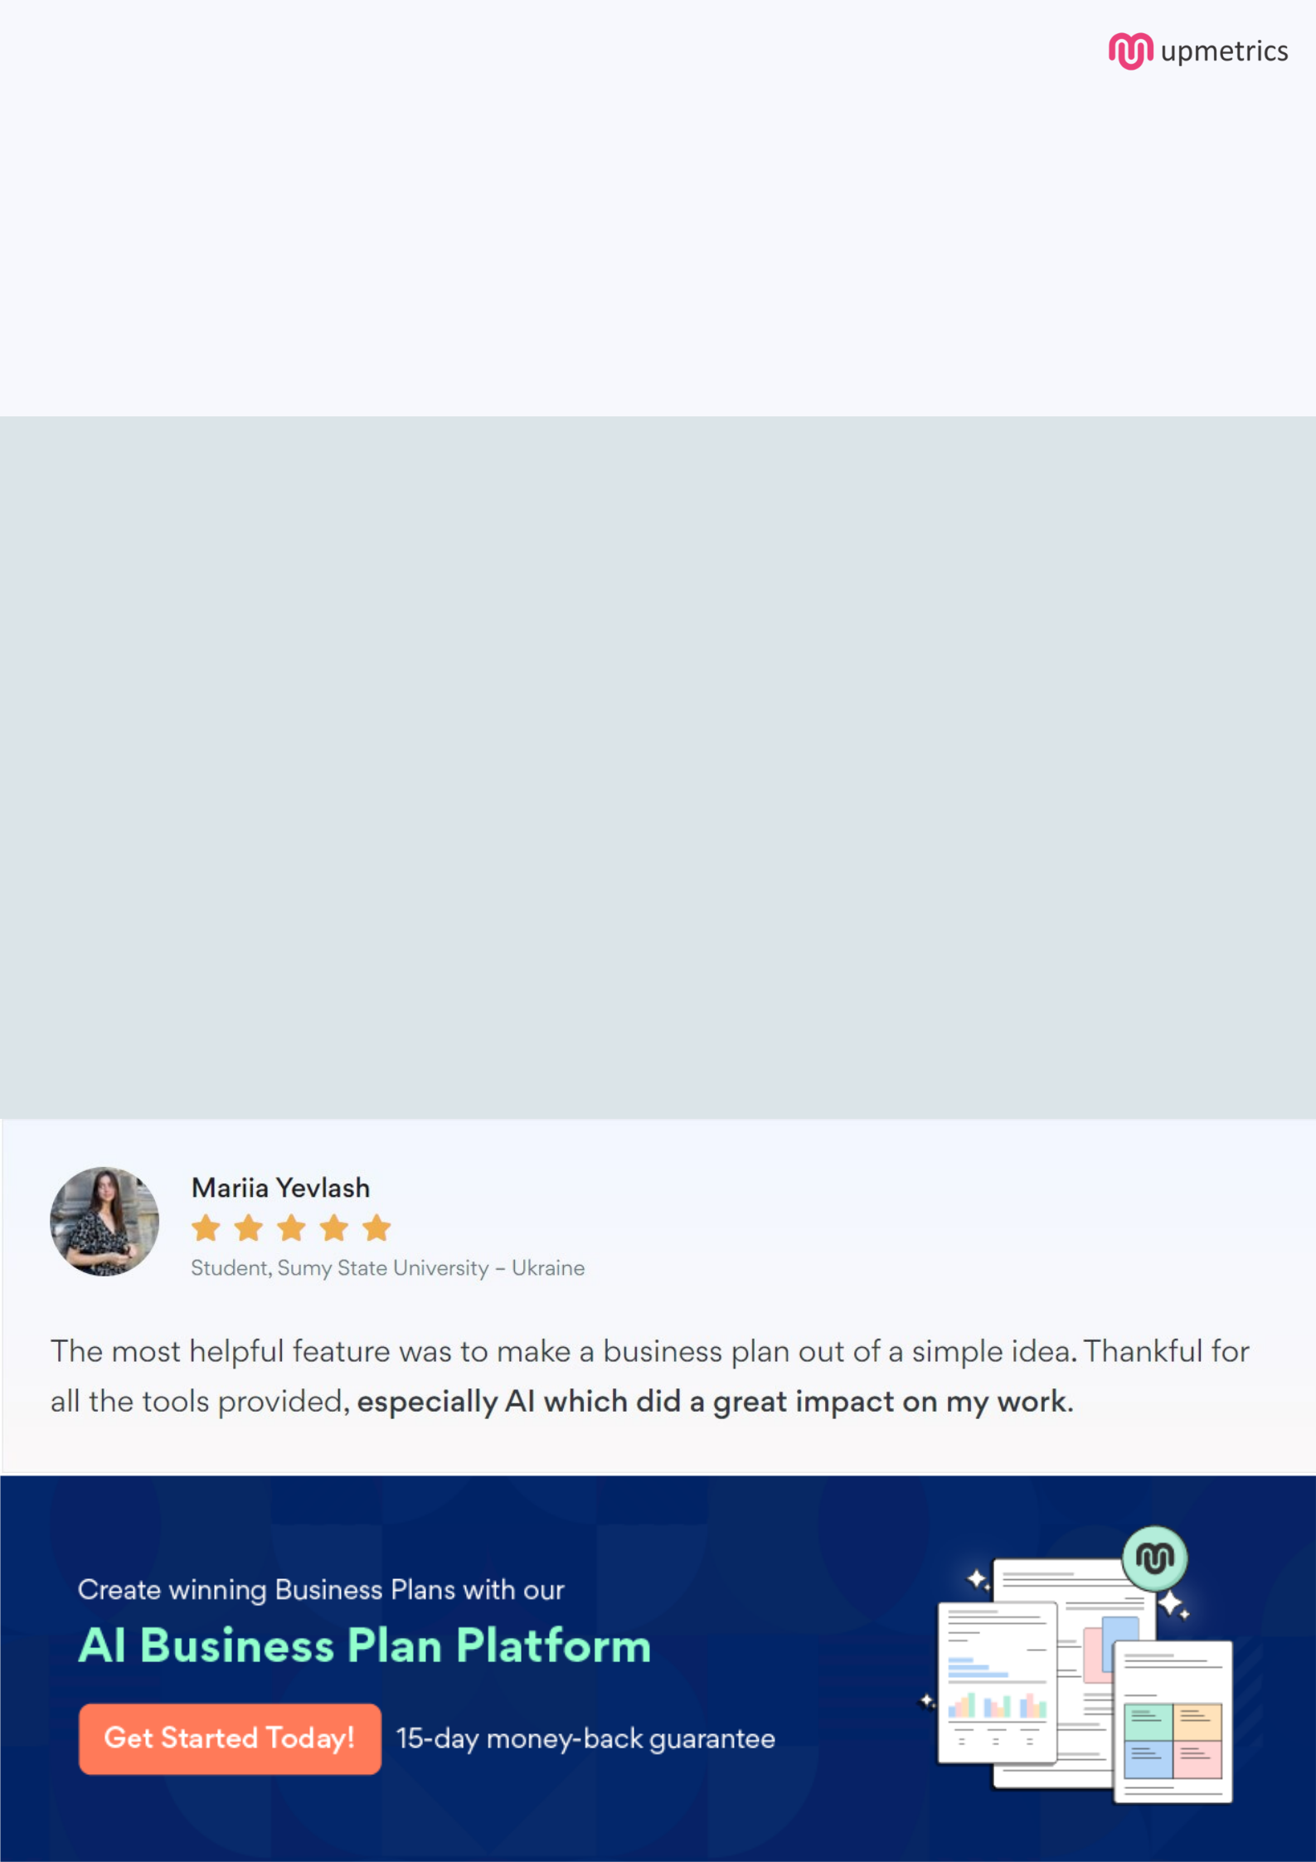
Create a winning business plan that gets you funded

Creating a stunning and investment-ready plan requires no writing, graphic designing, or financial planning expertise.

Upmetrics has all the features required to help you create a comprehensive business plan—from start to finish. Make no mistakes, it’s the modern way of planning to structure ideas, make plans, and create stunning pitch decks to awe investors.

Pitch decks that impress investors

Create pitch decks that provide a visual representation of your business, engage investors, and make them want to invest in your business idea.

Interactive plans in no time

Import business plan sections like—SWOT analysis, comparison tables, and others to create an interactive business plan. No designing skills are required.

Stunning cover page designs

With Upmetrics, you have the liberty to choose from multiple stunning cover page designs. Choose a creative design and make your plan stand out.

Online sharing made simple

Upmetrics makes online sharing quick and easier for users. Easily share your business plans with a link while tracking reader activity.

500+ sample business plans

Simply import a template from our library of sample plans into the editor and start customizing it to make it yours. It takes only a few clicks to get started.

Collaborate with team in real-time

Invite team members, initiate conversations, discuss ideas & strategies, share feedback, and work on a business plan in real-time.

