

Subscription Box Business Plan

Monthly Surprises, Tailored for You


Business
Plan

2023

Prepared By

John Doe

10200 Bolsa Ave, Westminster, CA, 92683

info@example.com

(650) 359-3153 http://www.example.com

Table of Contents

Executive Summary | 6
Market opportunity | 6
Services Offered | 6
Marketing & Sales Strategies | 7
Financial Highlights | 7
Units Sold v/s Revenue | 8

Company Overview | 9
Ownership | 9
Business Owners | 9
Mission statement | 10
Business history | 10
Future goals | 11

Market Analysis | 12
Target Market | 12
Market size and growth potential | 12
Market Size | 13
Competitive analysis | 13
Birchbox | 13
Ipsy | 14
FabFitFun | 14
Market trends | 14
Regulatory environment | 15

Products and Services | 16
Products & services | 16
Premium Beauty Box | 16
Classic Beauty Box | 17
Skincare Box | 17
Makeup Box | 18
One-Time Gift Box | 18
Curated Section | 18
Quality Measure | 19
Additional Services | 19

Sales And Marketing Strategies | 20
Unique Selling Proposition (USP) | 20
Pricing Strategy | 20
Marketing strategies | 21
Online | 21
Sales strategies | 22
Customer retention | 23

Operations Plan | 24
Staffing & Training | 24
Operational Process | 24
Equipment & Software | 25

Management Team | 26
Key managers | 26
John Doe | 26
Jane Doe | 27
Alice Brown | 27
Robert Brown | 27
Organizational structure | 28
Organization chart | 28
Compensation plan | 28
Advisors/Consultants | 29
Sarah White | 29
David Johnson | 29
Financial Plan
Financial Plan | 30

Profit & loss statement 30

Cash flow statement | 33
Balance sheet | 35
Break-even Point | 37
Financing needs | 39
Appendix
Appendix | 41
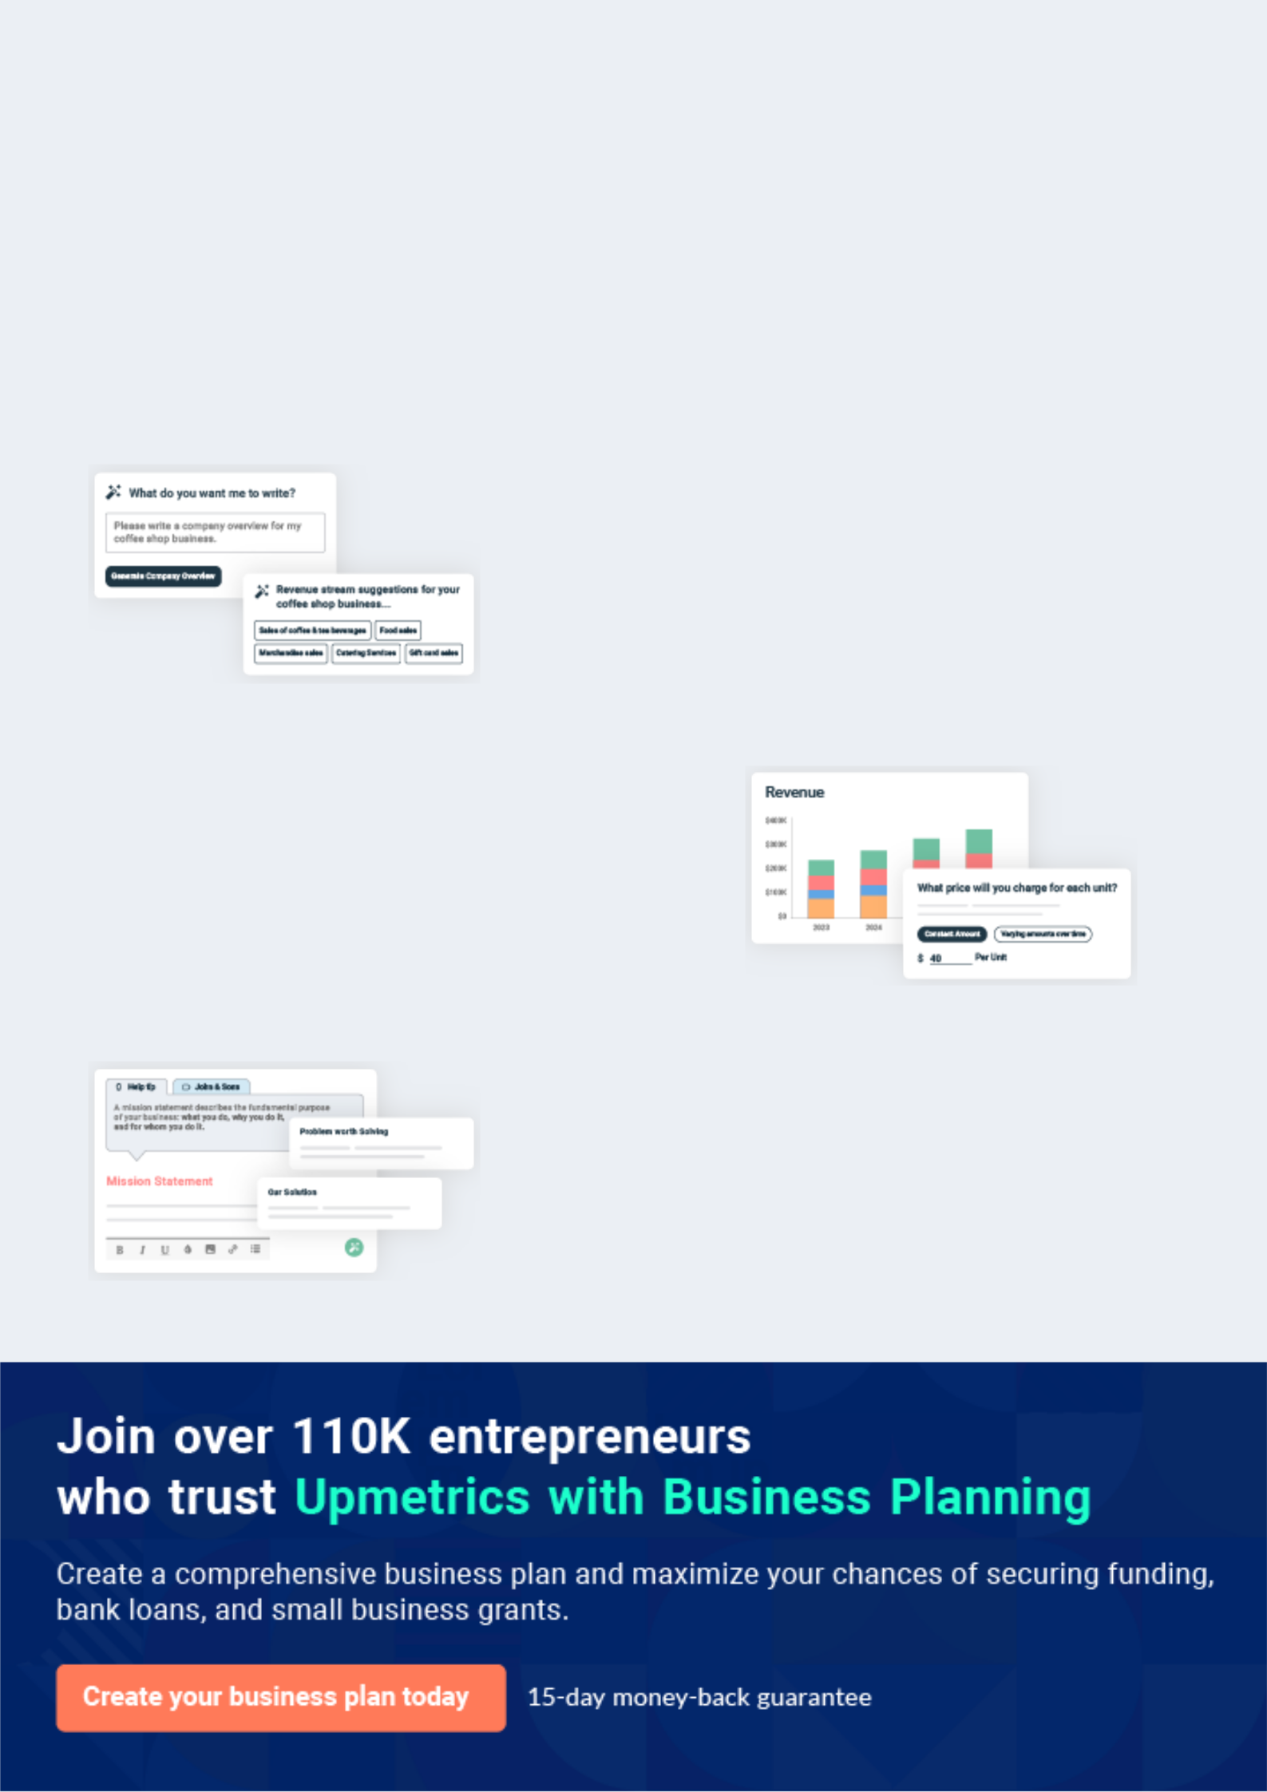
Business planning that’s simpler and faster than you think

Creating a business plan using Upmetrics to start and grow a business is literally the easiest thing in the World. Simply read the instructions and fill in the blanks. It’s as simple as that.

❛ | Upmetrics has everything you need to create a | ❜
❛ | comprehensive business plan. | ❜

AI-powered Upmetrics Assistant

AI-powered insights to streamline your plan

Not sure where to start? Upmetrics’ AI Assistant will automatically generate ideas for each section of your plan and offer improved versions of your writing, adjusting for tone, voice, and grammar or spelling errors.

Financial Forecasting Tool

All the financials are calculated for you

Forget the complex formulas and clumsy spreadsheets — with automatic financials and drag-and-drop forecasting, you can finish your plan faster and be confident that your numbers are accurate.

Business Plan Builder

Guides you like a business mentor

Upmetrics’ step-by-step instructions, prompts, and the library of 400+ sample business plans will guide you through each section of your plan as a business mentor.
Executive Summary


An executive summary is the first section of the business plan intended to provide an overview of the whole business plan.
To unlock help try Upmetrics! 

 Help tip  Subscription Box Business Plan


Start your executive summary by briefly introducing your business to your readers.

This section may include the name of your subscription box business, its location, when it was
To unlock help try Upmetrics! 

Start writing here..

Market opportunity

 Help tip  Subscription Box Business Plan

Summarize your market research, including market size, growth potential, and marketing trends. Highlight the opportunities in the market and how your business will fit in to fill the gap.
To unlock help try Upmetrics! 

Start writing here..

Services Offered

 Help tip  Subscription Box Business Plan

Highlight the subscription box products you offer your clients. The USPs and differentiators you offer are always a plus.
To unlock help try Upmetrics! 

Start writing here..

Marketing & Sales Strategies
To unlock help try Upmetrics!

 Help tip  Subscription Box Business Plan

Outline your sales and marketing strategies—what marketing platforms you use, how you plan on acquiring customers, etc.
To unlock help try Upmetrics! 

Start writing here..

Financial Highlights

 Help tip  Subscription Box Business Plan

Briefly summarize your financial projections for the initial years of business operations. Include any capital or investment requirements, associated startup costs, projected revenues, and profit forecasts.



Start writing here..
Units Sold v/s Revenue

 |  | Units Sold | Revenue
15.00k
10.00k
5.00k
0
Year 1 | Year 2 | Year 3


Financial Year |  |  | Units Sold | Revenue
Year 1 | 1,550 |  |  | $10,000
Year 2 | 1,800 |  |  | $12,000
Year 3 | 2,050 |  |  | $14,000
 Help tip |  |  Subscription Box Business Plan


Summarize your executive summary section with a clear CTA, for example, inviting angel investors to discuss the potential business investment.
To unlock help try Upmetrics! 

Write a call to action for your business plan.
Company Overview

Depending on what details of your business are essential, you’ll need different elements in your business overview.
To unlock help try Upmetrics! 

 Help tip  Subscription Box Business Plan

Describe your business in this section by providing all the basic information.

Describe what kind of subscription box company you run and the name of it. You may
To unlock help try Upmetrics! 

Start writing here..

Ownership

 Help tip  Subscription Box Business Plan

List the names of your subscription box company’s founders or owners. Describe what shares they own and their responsibilities for efficiently managing the business.
To unlock help try Upmetrics! 

Start writing here..

Business Owners



70% John Doe



20% Jane Doe



10% Alice Brown

Mission statement

 Help tip  Subscription Box Business Plan

Summarize your business’ objective, core principles, and values in your mission statement. This statement needs to be memorable, clear, and brief.
To unlock help try Upmetrics! 

❛ Our mission at [Sample Box Co.] is to deliver joy and discovery through our curated boxes of [type of subscription box, e.g.,beauty & personal care] products.

We are committed to sourcing the best products, providing personalized customer experiences, and fostering a community of like-minded individuals who share our passion for [beauty & personal care].

Our core principles are quality, customer satisfaction, and innovation, and we value transparency, integrity, and community engagement.

❜

Business history

 Help tip  Subscription Box Business Plan

If you’re an established subscription box service provider, briefly describe your business history, like—when it was founded, how it evolved over time, etc.
To unlock help try Upmetrics! 

Start writing here..
Future goals

 Help tip  Subscription Box Business Plan

It’s crucial to convey your aspirations and vision. Mention your short-term and long-term goals; they can be specific targets for revenue, market share, or expanding your services.
To unlock help try Upmetrics! 

Start writing here..
Market Analysis
To unlock help try Upmetrics!


 |  | Market analysis provides a clear understanding of the market in which your
 |  | printing business will run along with the target market, competitors, and
 |  | growth opportunities.
 |  |  |  | To unlock help try Upmetrics! 
 Help tip |  |  Subscription Box Business Plan

To write the introduction section of your market analysis, start by clearly identifying your primary target market.
To unlock help try Upmetrics! 

Start writing here..

Target Market

 Help tip  Subscription Box Business Plan

Start this section by describing your target market. Define your ideal customer and explain what types of services they prefer. Creating a buyer persona will help you easily define your target market to your readers.



Start writing here..

Market size and growth potential

 Help tip  Subscription Box Business Plan

Describe your market size and growth potential and whether you will target a niche or a much broader market.
To unlock help try Upmetrics! 

Start writing here..

Market Size

Available Market

Total potential customers for beauty & 50M personal care boxes.

Served Market
Customers currently using subscription 10M boxes.

Target Market
Busy professionals seeking beauty 2M products.

 Help tip  Subscription Box Business Plan

Identify and analyze your direct and indirect competitors. Identify their strengths and weaknesses, and describe what differentiates your subscription box services from them.
To unlock help try Upmetrics! 

Competitive analysis

Birchbox

Birchbox is one of the pioneers in the beauty subscription box industry, providing subscribers with a monthly box of personalized beauty samples.

Features | Strengths | Weaknesses
Personalized box of 5 beauty | Strong brand recognition and | Limited full-sized product
samples. | large subscriber base. | offerings.
Wide range of products from | Extensive partnerships with | Some customers have expressed
various brands. | various beauty brands. | dissatisfaction with sample
Rewards program for reviewing |  | repetition.
products.

Ipsy

Ipsy is another popular beauty subscription box service that delivers personalized beauty products to subscribers, based on their beauty profile.

Features | Strengths | Weaknesses
Personalized Glam Bag with 5 | Wide range of products | Some customers have reported
beauty products (samples and | catering to various beauty | inconsistent product curation.
full-sized). | preferences. | Quality of customer service has
Access to exclusive offers and | Active and engaged online | been a concern for some
promotions. | community. | subscribers.
Interactive beauty community
for reviews and tips.

FabFitFun

FabFitFun offers seasonal subscription boxes filled with full-sized beauty, fashion, and wellness products.

Features | Strengths | Weaknesses
Seasonal box with full-sized | High value for money with full- | Higher price point may not be
products. | sized products. | suitable for all customers.
Access to member-only sales | Strong community engagement | Limited customization options
and exclusive content. | through member-only sales | for some products.
Customization options for box | and exclusive events.
contents.

Market trends

 Help tip  Subscription Box Business Plan

Analyse emerging trends in the industry, such as technology disruptions, changes in customer behavior or preferences, etc. Explain how your business will cope with all the trends.
To unlock help try Upmetrics! 

Start writing here..

Regulatory environment

 Help tip  Subscription Box Business Plan

List regulations and licensing requirements that may affect your subscription box company, such as business registration, customer protection laws, shipping & customs regulations, etc.
To unlock help try Upmetrics! 

Start writing here..
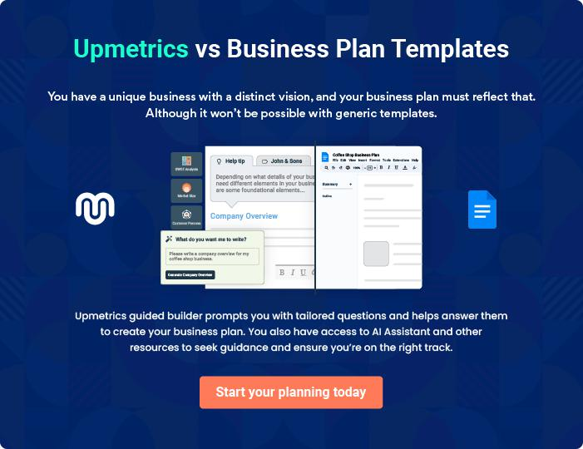
Products and Services
To unlock help try Upmetrics!

The product and services section of a subscription box business plan should describe the specific services and products that will be offered to customers. To write this section should include the following:



 Help tip  Subscription Box Business Plan

To craft the introduction for your "Products and Services" chapter, begin by positioning your business within its industry, emphasizing its unique strengths or value proposition.
To unlock help try Upmetrics! 

Start writing here..

 Help tip


Mention the subscription box products & services your business will offer. This list may include:

• Curated products
To unlock help try Upmetrics! 

Products & services

Premium Beauty Box


Price: [$50] per month

Our Premium Beauty Box is designed for the discerning customer seeking luxury beauty products. Each box is curated with high-end brands and products that cater to the customer's specific beauty needs and preferences.

Specifications

- 5-7 full-sized luxury beauty products

- Personalized based on customer's beauty profile

- Access to exclusive online content and member-only sales
Classic Beauty Box

Price: [$30] per month

The Classic Beauty Box is perfect for those who want to explore a range of beauty products without breaking the bank. It offers a mix of full-sized and sample-sized products that are tailored to the customer's preferences.

Specifications

- 3-5 full-sized and sample-sized beauty products

- Personalized based on customer's beauty profile

- Access to online content and member-only discounts

Skincare Box

Price: [$40] per month

Our Skincare Box is curated for customers who want to focus solely on skincare products. Each box includes a range of products designed to create a complete skincare routine.

Specifications

- 4-6 full-sized skincare products

- Products include cleansers, moisturizers, serums, and masks

- Personalized based on customer's skin type and concerns
Makeup Box

Price: [$35] per month

The Makeup Box is perfect for makeup enthusiasts who want to expand their collection. Each box includes a variety of makeup products, from lipsticks to eyeshadows, that are tailored to the customer's preferences.

Specifications

- 4-6 full-sized makeup products

- Products include lipsticks, eyeshadows, mascaras, and more

- Personalized based on customer's makeup preferences

One-Time Gift Box

Price: [$60]

The One-Time Gift Box is a perfect gift option for a loved one. It includes a curated selection of beauty products that are tailored to the recipient's preferences.

Specifications

- 5-7 full-sized beauty products

- Personalized based on the recipient's beauty profile

- Beautifully packaged with a personalized note

Curated Section

 Help tip  Subscription Box Business Plan

Explain how you carefully choose products to give members a satisfying and seamless experience to emphasize the curation process.
To unlock help try Upmetrics! 

Start writing here..

Quality Measure
To unlock help try Upmetrics!

 Help tip  Subscription Box Business Plan

This section should explain how you maintain quality standards and consistently provide the highest quality service.
To unlock help try Upmetrics! 

Start writing here..

Additional Services

 Help tip  Subscription Box Business Plan

Mention if your subscription box company offers any additional services. You may include online resources, member-only discounts, referral programs, or exclusive partnerships with other brands that add value to the subscription.



Start writing here..
Sales And Marketing Strategies

Writing the sales and marketing strategies section means a list of strategies you will use to attract and retain your clients.
To unlock help try Upmetrics! 

 Help Tip  Subscription Box Business Plan


To create an effective introduction for your "Sales and Marketing Strategies" chapter, start by setting the stage within your specific industry or market.
To unlock help try Upmetrics! 

Start writing here..

Unique Selling Proposition (USP)

 Help tip  Subscription Box Business Plan

Define your business’s USPs depending on the market you serve, the equipment you use, and the unique services you provide. Identifying USPs will help you plan your marketing strategies.
To unlock help try Upmetrics! 

Start writing here..

Pricing Strategy

 Help tip  Subscription Box Business Plan

Describe your pricing strategy—how you plan to price your services and stay competitive in the local market. You can mention any discounts you plan on offering to attract new customers.
To unlock help try Upmetrics! 

Start writing here..

 Help tip  Subscription Box Business Plan
To unlock help try Upmetrics!

Discuss your marketing strategies to market your services. You may include some of these marketing strategies in your business plan—social media marketing, email marketing, content marketing, and influencer marketing.



Marketing strategies

Online


Social Media

We utilize platforms such as Instagram, Facebook, and Twitter to connect with our audience, share valuable content, and promote our subscription boxes.

Content Marketing

Our blog and other content channels provide valuable information on beauty trends, product reviews, and tips for maximizing the benefits of our subscription boxes.

Email Marketing

Our email marketing campaigns are designed to nurture leads, engage existing customers, and promote special offers and new product launches.

Influencer Marketing

We collaborate with influencers in the beauty and lifestyle space to increase brand awareness and drive sales.

 Help tip  Subscription Box Business Plan

Outline the strategies you’ll implement to maximize your sales. Your sales strategies may include free trials & samples, upselling & cross-selling, personalized recommendations, etc.
To unlock help try Upmetrics! 

Sales strategies

Upselling & Cross-Selling

We leverage personalized recommendations and promotions to upsell and cross-sell products, thereby increasing the average transaction value.

Personalized

Recommendations

Our customer profiling system enables us to provide personalized product recommendations that resonate with each individual customer, thereby increasing the likelihood of purchase.

Free Trials and Samples

We offer free trials and samples to prospective customers, allowing them to experience the quality and value of our subscription boxes firsthand.

 Help tip  Subscription Box Business Plan

Outline the strategies you’ll implement to maximize your sales. Your sales strategies may include free trials & samples, upselling & cross-selling, personalized recommendations, etc.
To unlock help try Upmetrics! 

Customer retention

Loyalty Programs

Our loyalty program rewards repeat customers with points that can be redeemed for discounts, free products, and other exclusive perks.

Personalized Service

We strive to offer personalized customer service that exceeds expectations, ensuring that our customers feel valued and appreciated.

Discounts on Annual Membership

We offer discounts on annual subscriptions, providing an incentive for customers to commit to long-term memberships.

Operations Plan
To unlock help try Upmetrics!

 |  | When writing the operations plan section, it’s important to consider the
 |  | various aspects of your business operations.
 |  |  |  | To unlock help try Upmetrics! 
 Help tip |  |  Subscription Box Business Plan


To create an effective introduction for your "Operational Plan" chapter, start by emphasizing the
pivotal role of efficient operations in the success of your business, underscoring how they
directly impact the quality of services delivered.
 |  |  |  | To unlock help try Upmetrics! 
Start writing here..
Staffing & Training
 Help tip |  |  Subscription Box Business Plan

Mention your business’s staffing requirements, including the number of employees or warehouse staff needed.
To unlock help try Upmetrics! 

Start writing here..

Operational Process

 Help tip  Subscription Box Business Plan

Outline the processes and procedures you will use to run your subscription box business. Your operational processes may include product sourcing & inventory management, box curation & packaging, shipping, etc.



Start writing here..

Equipment & Software
To unlock help try Upmetrics!

 Help tip  Subscription Box Business Plan

Include the list of equipment and software required for the subscription box, such as computers & laptops, label printers, packaging supplies, subscription management software, inventory management system, etc.



Start writing here..
Management Team

The management team section provides an overview of the individuals responsible for running your business plan.
To unlock help try Upmetrics! 

 Help tip  Subscription Box Business Plan

To craft an introduction for your "Management Team" chapter, begin by emphasizing the crucial role of leadership in the success of any business.
To unlock help try Upmetrics! 

Start writing here..

Key managers

 Help tip  Subscription Box Business Plan

Introduce your management and key members of your team, and explain their roles and responsibilities.
To unlock help try Upmetrics! 

Start writing here..


JOHN DOE

Founder and CEO - john.doe@example.com

John Doe has a degree in Business Administration from Harvard University and over 15 years of professional experience in the subscription box industry.

Under his leadership, Sample Box Co. has successfully curated and delivered premium quality subscription boxes that cater to the diverse needs of customers.


JANE DOE

Chief Operating Officer (COO) - jane.doe@example.com

Jane Doe, a seasoned operations professional, has a degree in Supply Chain Management from Stanford University and has worked in various operations and logistics roles for the past 10 years.


She is responsible for managing the entire supply chain process, from product sourcing to delivery, ensuring efficiency and customer satisfaction.


ALICE BROWN

CMO - alice.brown@example.com

Alice Brown holds a degree in Marketing from the University of California, Berkeley, and has over 12 years of experience in digital marketing.

She has a proven track record of driving customer acquisition and revenue growth through innovative marketing strategies.

At Sample Box Co., she oversees all marketing activities, from social media to email marketing, ensuring that the brand's message resonates with its target audience.


ROBERT BROWN

Operations Manager - robert.brown@example.com

Robert Brown is a logistics expert with a degree in Logistics and Supply Chain Management from the University of Southern California.

With over 8 years of experience in the logistics industry, he plays a crucial role in managing the operational processes at Sample Box Co., ensuring that all subscription boxes are packed and shipped on time.
Organizational structure

 Help tip  Subscription Box Business Plan

Explain the organizational structure of your management team. Include the reporting line and decision-making hierarchy.
To unlock help try Upmetrics! 

Start writing here..

Organization chart


John Doe

CEO


Alice Brown Jane Doe

CMO COO



Mark Wilson | Lucy Green |  |  |  | Emily Smith
Mark Wilson |  |  | Robert Brown |  | Emily Smith
Marketing | Content |  |  |  | Customer Service
Manager | Manager |  | Operations |  | Manager
 |  |  | Manager





Compensation plan

 Help tip  Subscription Box Business Plan

Describe your compensation plan for the management and staff. Include their salaries, incentives, and other benefits.
To unlock help try Upmetrics! 

Start writing here..

 Help tip

Mentioning advisors or consultants in your business plans adds credibility to your business idea.
To unlock help try Upmetrics! 

Advisors/Consultants


SARAH WHITE

Business Strategist

With over 20 years of experience in business strategy and development, Sarah White is an integral part of the Sample Box Co. team.

She provides valuable insights and advice on market trends, business growth, and strategic planning, helping to guide the company towards success.



DAVID JOHNSON

Financial Consultant

David Johnson, a certified financial consultant with a degree in Finance from the University of Chicago, has worked with various companies to help them achieve their financial goals.

At Sample Box Co., he provides expert advice on budgeting, financial planning, and investment strategies, ensuring that the company remains financially stable and profitable.
Financial Plan

When writing the financial plan section of a business plan, it’s important to provide a comprehensive overview of your financial projections for the first few years of your business, You may provide the following:
To unlock help try Upmetrics! 

 Help tip  Subscription Box Business Plan


To create an effective introduction for your "Financial Plan" chapter, begin by stressing the critical role of a well-structured financial plan in the success of your venture.
To unlock help try Upmetrics! 

Start writing here..

 Help tip  Subscription Box Business Plan

Describe details such as projected revenue, operational costs, and service costs in your projected profit and loss statement. Make sure to include your business’s expected net profit or loss.
To unlock help try Upmetrics! 

Profit & loss statement

Revenue

Cost Of Sales

General Costs

Revenue Specific Costs

Personnel Costs (Direct

Labor)

Gross Margin

Gross Margin (%)

Operating Expense

Payroll Expense

(Indirect Labor)

General Expense

Bad Debt

Amortization of Current

Assets

2023-24 | 2024-25 | 2025-26 | 2026-27 | 2027-28
$0 | $0 | $0 | $0 | $0

$0 | $0 | $0 | $0 | $0
$0 | $0 | $0 | $0 | $0
$0 | $0 | $0 | $0 | $0
$0 | $0 | $0 | $0 | $0

$0 | $0 | $0 | $0 | $0
0% | 0% | 0% | 0% | 0%

$0 | $0 | $0 | $0 | $0
$0 | $0 | $0 | $0 | $0
$0 | $0 | $0 | $0 | $0
$0 | $0 | $0 | $0 | $0
$0 | $0 | $0 | $0 | $0

EBITDA

Additional Expense

Long Term

Depreciation

Gain or loss from Sale

of Assets

EBIT

Interest Expenses

EBT

Income Tax Expense

Total Expense

Net Income

Net Income (%)

2023-24 | 2024-25 | 2025-26 | 2026-27 | 2027-28
$0 | $0 | $0 | $0 | $0
$0 | $0 | $0 | $0 | $0
$0 | $0 | $0 | $0 | $0
$0 | $0 | $0 | $0 | $0
$0 | $0 | $0 | $0 | $0
$0 | $0 | $0 | $0 | $0
$0 | $0 | $0 | $0 | $0
$0 | $0 | $0 | $0 | $0
$0 | $0 | $0 | $0 | $0
$0 | $0 | $0 | $0 | $0
0% | 0% | 0% | 0% | 0%

 |  |  | 2023-24 |  | 2024-25 | 2025-26
Retained Earning |  |  | $0 |  | $0 | $0
Opening |  |  |  |  | $0 | $0
Owner's Distribution |  |  | $0 |  | $0 | $0
Retained Earning |  |  | $0 |  | $0 | $0
Closing |  |  |  |  | $0 | $0
 Help tip |  |  |  Subscription Box Business Plan


The cash flow for the first few years of your operation should be estimated and described in this section.

This may include billing invoices, payment receipts, loan payments, and any other cash flow statements.
2026-27 2027-28

$0 $0

$0 $0

$0 $0

To unlock help try Upmetrics! 

Cash flow statement

 | 2023-24 | 2024-25 | 2025-26 | 2026-27 | 2027-28
Cash Received | $0 | $0 | $0 | $0 | $0
Cash Paid | $0 | $0 | $0 | $0 | $0
COS & General Expenses | $0 | $0 | $0 | $0 | $0
Salary & Wages | $0 | $0 | $0 | $0 | $0
Interest | $0 | $0 | $0 | $0 | $0

Sales Tax

Income Tax

Net Cash From

Operations

Assets Sell

Assets Purchase

Net Cash From

Investments

Amount Received

Loan Received

Common Stock

Preferred Stock

Owner's Contribution

Amount Paid

2023-24 | 2024-25 | 2025-26 | 2026-27 | 2027-28
$0 | $0 | $0 | $0 | $0
$0 | $0 | $0 | $0 | $0
$0 | $0 | $0 | $0 | $0

$0 | $0 | $0 | $0 | $0
$0 | $0 | $0 | $0 | $0
$0 | $0 | $0 | $0 | $0

$0 | $0 | $0 | $0 | $0
$0 | $0 | $0 | $0 | $0

$0 | $0 | $0 | $0 | $0
$0 | $0 | $0 | $0 | $0
$0 | $0 | $0 | $0 | $0

Loan Capital $0 $0 $0 $0 $0

 |  |  | 2023-24 |  | 2024-25 | 2025-26 | 2026-27 | 2027-28
Dividends & Distributions |  |  | $0 |  | $0 | $0 | $0 | $0
Net Cash From |  |  | $0 |  | $0 | $0 | $0 | $0
Financing
Summary
Starting Cash |  |  | $0 |  | $0 | $0 | $0 | $0
Cash In |  |  | $0 |  | $0 | $0 | $0 | $0
Cash Out |  |  | $0 |  | $0 | $0 | $0 | $0
Change in Cash |  |  | $0 |  | $0 | $0 | $0 | $0
Ending Cash |  |  | $0 |  | $0 | $0 | $0 | $0
 Help tip |  |  Subscription Box Business Plan

Create a projected balance sheet documenting your subscription box business’s assets, liabilities, and equity.

To unlock help try Upmetrics! 

Balance sheet

 | 2023-24 | 2024-25 | 2025-26 | 2026-27 | 2027-28
Assets | $0 | $0 | $0 | $0 | $0
Current Assets | $0 | $0 | $0 | $0 | $0
Cash | $0 | $0 | $0 | $0 | $0
Accounts Receivable | $0 | $0 | $0 | $0 | $0
Inventory | $0 | $0 | $0 | $0 | $0
Other Current Assets | $0 | $0 | $0 | $0 | $0
Long Term Assets | $0 | $0 | $0 | $0 | $0
Gross Long Term Assets | $0 | $0 | $0 | $0 | $0
Accumulated Depreciation | $0 | $0 | $0 | $0 | $0

Liabilities & Equity | $0 | $0 | $0 | $0 | $0
Liabilities | $0 | $0 | $0 | $0 | $0
Current Liabilities | $0 | $0 | $0 | $0 | $0
Accounts Payable | $0 | $0 | $0 | $0 | $0
Income Tax Payable | $0 | $0 | $0 | $0 | $0
Sales Tax Payable | $0 | $0 | $0 | $0 | $0
Short Term Debt | $0 | $0 | $0 | $0 | $0
 | 2023-24 | 2024-25 | 2025-26 | 2026-27 | 2027-28
Long Term Liabilities | $0 | $0 | $0 | $0 | $0
Long Term Debt | $0 | $0 | $0 | $0 | $0
Equity | $0 | $0 | $0 | $0 | $0
Paid-in Capital | $0 | $0 | $0 | $0 | $0
Common Stock | $0 | $0 | $0 | $0 | $0
Preferred Stock | $0 | $0 | $0 | $0 | $0
Owner's Contribution | $0 | $0 | $0 | $0 | $0
Retained Earnings | $0 | $0 | $0 | $0 | $0

Check | $0 | $0 | $0 | $0 | $0

Break-even Point

 Help tip  Subscription Box Business Plan

Determine and mention your business’s break-even point—the point at which your business costs and revenue will be equal.

This exercise will help you understand how much revenue you need to generate to sustain or be profitable.

To unlock help try Upmetrics! 

Start writing here..

 | 2023-24 | 2024-25 | 2025-26 | 2026-27 | 2027-28
Starting Revenue | $0 | $0 | $0 | $0 | $0
Net Revenue | $0 | $0 | $0 | $0 | $0
Closing Revenue | $0 | $0 | $0 | $0 | $0

Starting Expense | $0 | $0 | $0 | $0 | $0
Net Expense | $0 | $0 | $0 | $0 | $0
Closing Expense | $0 | $0 | $0 | $0 | $0

Is Break Even? | 0 | 0 | 0 | 0 | 0
Break Even Month | 0 | 0 | 0 | 0 | 0
Days Required | 0 | 0 | 0 | 0 | 0
Break Even Revenue | $0 | $0 | $0 | $0 | $0
Break Even Units
Financing needs

 Help tip  Subscription Box Business Plan

Calculate costs associated with starting a subscription box business, and estimate your financing needs and how much capital you need to raise to operate your business.
To unlock help try Upmetrics! 

Start writing here..
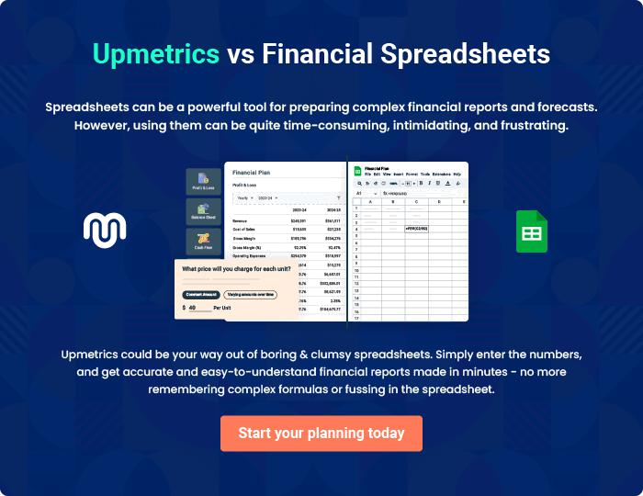
Appendix

When writing the appendix section, you should include any additional information that supports the main content of your plan. This may include financial statements, market research data, legal documents, and other
To unlock help try Upmetrics! 
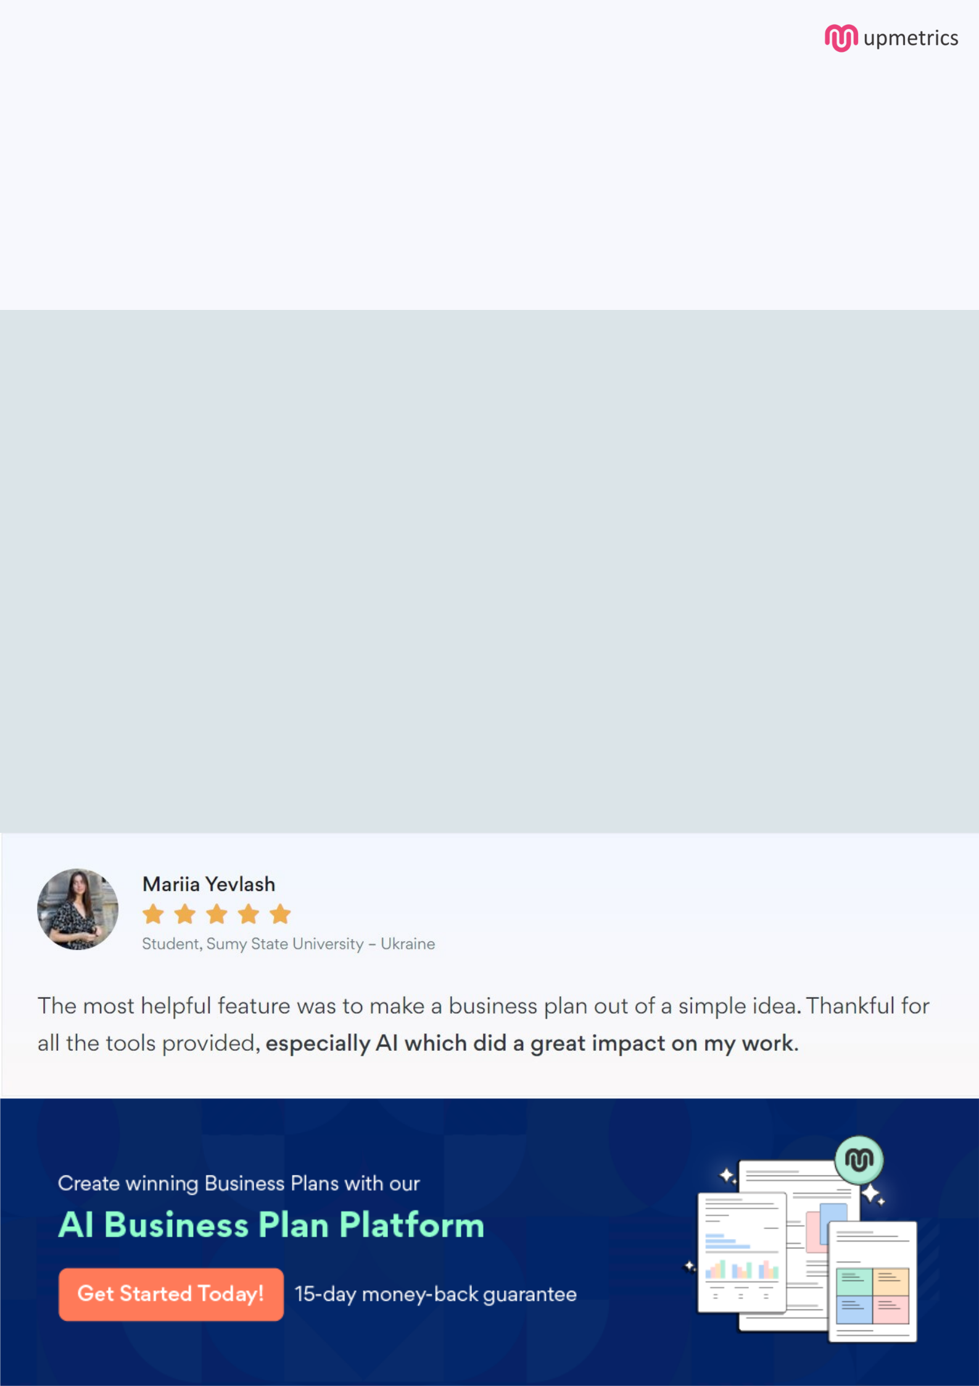
Create a winning business plan that gets you funded

Creating a stunning and investment-ready plan requires no writing, graphic designing, or financial planning expertise.

Upmetrics has all the features required to help you create a comprehensive business plan—from start to finish. Make no mistakes, it’s the modern way of planning to structure ideas, make plans, and create stunning pitch decks to awe investors.

Pitch decks that impress investors

Create pitch decks that provide a visual representation of your business, engage investors, and make them want to invest in your business idea.

Interactive plans in no time

Import business plan sections like—SWOT analysis, comparison tables, and others to create an interactive business plan. No designing skills are required.

Stunning cover page designs

With Upmetrics, you have the liberty to choose from multiple stunning cover page designs. Choose a creative design and make your plan stand out.

Online sharing made simple

Upmetrics makes online sharing quick and easier for users. Easily share your business plans with a link while tracking reader activity.

500+ sample business plans

Simply import a template from our library of sample plans into the editor and start customizing it to make it yours. It takes only a few clicks to get started.

Collaborate with team in real-time

Invite team members, initiate conversations, discuss ideas & strategies, share feedback, and work on a business plan in real-time.

