
BUSINESS PLAN

2023


Stationery Business Plan

Create, Write, Captivate

John Doe

10200 Bolsa Ave, Westminster, CA, 92683

- 359-3153 info@example.com http://www.example.com

Information provided in this business plan is unique to this business and confidential; therefore, anyone reading this plan agrees not to disclose any of the information in this business plan without prior written permission of the company.
Table of Contents

Executive Summary | 6
Market opportunity | 6
Products | 6
Marketing & Sales Strategies | 7
Financial Highlights | 7
Units Sold v/s Revenue | 8

Company Overview | 9
Ownership | 9
Business Owners | 9
Mission statement | 10
Business history | 10
Future goals | 10

Market Analysis | 11
Target Market | 11
Market size and growth potential | 11
Market Size | 12
Competitive analysis | 12
Staples | 12
Etsy | 13
Muji | 13
Market trends | 13
Regulatory environment | 14

Products and Services | 15
Products | 15
Premium Notebooks | 15
Customized Pens | 16
Art Supplies Set | 16
Gift Wrapping Service | 16
[Printing and Copying] | 17
Quality Measures | 17
Additional Services | 17

Sales And Marketing Strategies | 18
Unique Selling Proposition (USP) | 18
Pricing Strategy | 18
Marketing strategies | 19
Online | 19
Offline | 19
Sales strategies | 20
Customer retention | 20

Operations Plan | 21
Staffing & Training | 21
Operational Process | 21
Equipment & Software | 22

Management Team | 23
Key managers | 23
John Doe | 23
Jane Doe | 24
Alice Brown | 24
Robert Brown | 24
Organizational structure | 24
Organization chart | 25
Compensation plan | 25
Advisors/Consultants | 26
Michael Smith | 26
Emily Johnson | 26
Financial Plan
Financial Plan | 27

Profit & loss statement 27

Cash flow statement | 30
Balance sheet | 32
Break-even Analysis | 34
Financing needs | 36
Appendix
Appendix | 38
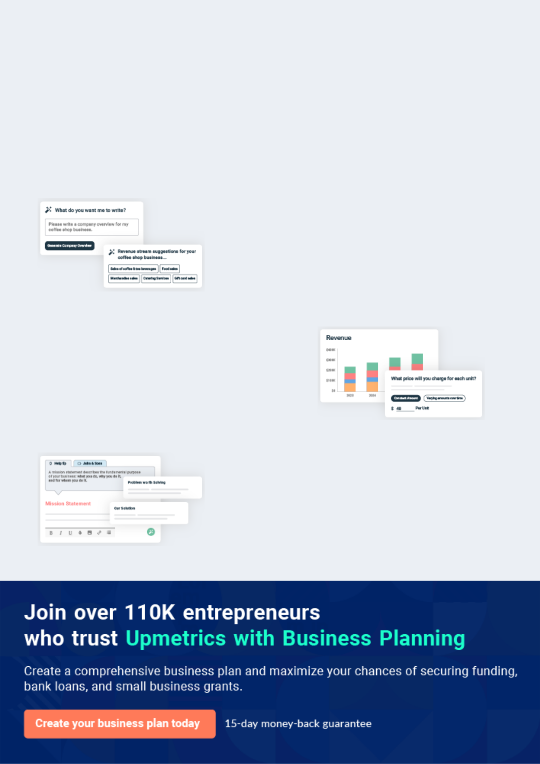
Business planning that’s simpler and faster than you think

Creating a business plan using Upmetrics to start and grow a business is literally the easiest thing in the World. Simply read the instructions and fill in the blanks. It’s as simple as that.

❛ | Upmetrics has everything you need to create a | ❜
❛ | comprehensive business plan. | ❜

AI-powered Upmetrics Assistant

AI-powered insights to streamline your plan

Not sure where to start? Upmetrics’ AI Assistant will automatically generate ideas for each section of your plan and offer improved versions of your writing, adjusting for tone, voice, and grammar or spelling errors.

Financial Forecasting Tool

All the financials are calculated for you

Forget the complex formulas and clumsy spreadsheets — with automatic financials and drag-and-drop forecasting, you can finish your plan faster and be confident that your numbers are accurate.

Business Plan Builder

Guides you like a business mentor

Upmetrics’ step-by-step instructions, prompts, and the library of 400+ sample business plans will guide you through each section of your plan as a business mentor.
Executive Summary


An executive summary is the first section of the business plan intended to provide an overview of the whole business plan.
To unlock help try Upmetrics! 

 Help tip  Stationery Business Plan


Start your executive summary by briefly introducing your business to your readers.

This section may include the name of your stationery business, its location, when it was
To unlock help try Upmetrics! 

Start writing here..

Market opportunity

 Help tip  Stationery Business Plan

Summarize your market research, including market size, growth potential, and marketing trends. Highlight the opportunities in the market and how your business will fit in to fill the gap.
To unlock help try Upmetrics! 

Start writing here..

Products

 Help tip  Stationery Business Plan

Highlight the stationery products you offer your clients. The USPs and differentiators you offer are always a plus.
To unlock help try Upmetrics! 

Start writing here..

Marketing & Sales Strategies
To unlock help try Upmetrics!

 Help tip  Stationery Business Plan

Outline your sales and marketing strategies—what marketing platforms you use, how you plan on acquiring customers, etc.
To unlock help try Upmetrics! 

Start writing here..

Financial Highlights

 Help tip  Stationery Business Plan

Briefly summarize your financial projections for the initial years of business operations. Include any capital or investment requirements, associated startup costs, projected revenues, and profit forecasts.



Start writing here..
Units Sold v/s Revenue

 |  | Units Sold | Revenue
15.00k
10.00k
5.00k
0
Year 1 | Year 2 | Year 3


Financial Year |  |  | Units Sold | Revenue
Year 1 | 1,550 |  |  | $10,000
Year 2 | 1,800 |  |  | $12,000
Year 3 | 2,050 |  |  | $14,000
 Help tip |  |  Stationery Business Plan


Summarize your executive summary section with a clear CTA, for example, inviting angel investors to discuss the potential business investment.
To unlock help try Upmetrics! 

Write a call to action for your business plan.
Company Overview

Depending on what details of your business are essential, you’ll need different elements in your business overview.
To unlock help try Upmetrics! 

 Help tip  Stationery Business Plan

Describe your business in this section by providing all the basic information:

Describe what kind of stationery shop you run and the name of it. You may specialize in one of
To unlock help try Upmetrics! 

Start writing here..

Ownership

 Help tip  Stationery Business Plan

List the names of your stationery shop’s founders or owners. Describe what shares they own and their responsibilities for efficiently managing the business.
To unlock help try Upmetrics! 

Start writing here..

Business Owners



60% John Doe



40% Jane Doe
Mission statement

 Help tip  Stationery Business Plan

Summarize your business’ objective, core principles, and values in your mission statement. This statement needs to be memorable, clear, and brief.
To unlock help try Upmetrics! 

- At [Stationery Haven], our mission is to ignite creativity, foster efficiency, and enhance experiences through a curated selection of stationery products.

We stand by quality, sustainability, and customer-centricity, endeavouring to be the trusted partner for all stationery needs. ❜

Business history

 Help tip  Stationery Business Plan

If you have an established stationery business, briefly describe your business history, like— when it was founded, how it evolved over time, etc.
To unlock help try Upmetrics! 

Start writing here..

Future goals

 Help tip  Stationery Business Plan

It’s crucial to convey your aspirations and vision. Mention your short-term and long-term goals; they can be specific targets for revenue, market share, or expanding your services.
To unlock help try Upmetrics! 

Start writing here..

Market Analysis
To unlock help try Upmetrics!


 |  | Market analysis provides a clear understanding of the market in which your
 |  | printing business will run along with the target market, competitors, and
 |  | growth opportunities.
 |  |  |  | To unlock help try Upmetrics! 
 Help tip |  |  Stationery Business Plan

To write the introduction section of your market analysis, start by clearly identifying your primary target market.
To unlock help try Upmetrics! 

Start writing here..

Target Market

 Help tip  Stationery Business Plan

Start this section by describing your target market. Define your ideal customer and explain what types of services they prefer. Creating a buyer persona will help you easily define your target market to your readers.



Start writing here..

Market size and growth potential

 Help tip  Stationery Business Plan

Describe your market size and growth potential and whether you will target a niche or a much broader market.
To unlock help try Upmetrics! 

Start writing here..

Market Size


Available Market | 15M
Total global stationery consumers. | 15M

Served Market
Consumers with access to stationery 7M retail stores.

Target Market
Eco-conscious consumers seeking 2M sustainable stationery options.

 Help tip  Stationery Business Plan

Identify and analyze your direct and indirect competitors. Identify their strengths and weaknesses, and describe what differentiates your stationery services from them.
To unlock help try Upmetrics! 

Competitive analysis

Staples

Staples is a well-known chain retailer specializing in office supplies and stationery. They offer a wide range of products, from general office supplies to electronics and furniture.

Features | Strengths | Weaknesses
Extensive range of products | Wide brand recognition | Limited personalized and
Online and in-store shopping | Large customer base | handmade options
options | Established supply chain and | Less emphasis on eco-friendly
 | Established supply chain and | products
Loyalty rewards program | distribution network | products
Regular sales and discounts |  | Impersonal customer service due
Regular sales and discounts |  | to large size

Etsy

Etsy is an online marketplace that connects buyers with independent artists and craftspeople who sell handmade and vintage items, including a wide range of stationery products.

Features | Strengths | Weaknesses
Unique, handmade products | Strong community of artists | Limited quality control due to
Direct connection between | and craftspeople | independent sellers
buyers and sellers | Emphasis on unique, | Potentially higher prices for
Customizable options for | handmade items | handmade items
personalized products | Positive reputation for | Lack of physical retail locations
 | customer service

Muji

Muji is a Japanese retail company known for its minimalist design and eco-friendly products, including a range of stationery items.

Features | Strengths | Weaknesses
Minimalist, aesthetically | Strong brand recognition for | Limited range of products
pleasing design | minimalist design | compared to larger retailers
Eco-friendly products | Emphasis on sustainability | Premium pricing
Online and in-store shopping | Positive reputation for product | Limited personalized and custom
options | quality | options

Market trends

 Help tip  Stationery Business Plan

Analyze emerging trends in the industry, such as technology disruptions, changes in customer behavior or preferences, etc. Explain how your business will cope with all the trends.
To unlock help try Upmetrics! 

Start writing here..
Regulatory environment

 Help tip  Stationery Business Plan

List regulations and licensing requirements that may affect your stationery business, such as business registration, insurance, environmental regulations, state and federal regulations, etc.
To unlock help try Upmetrics! 

Start writing here..
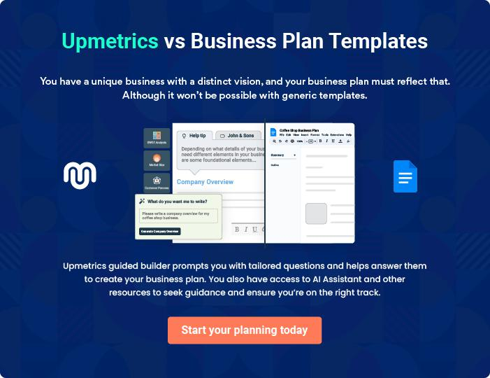
Products and Services
To unlock help try Upmetrics!

The product and services section of a stationery business plan should describe the specific services and products that will be offered to customers. To write this section should include the following:



 Help tip  Stationery Business Plan

To craft the introduction for your "Products and Services" chapter, begin by positioning your business within its industry, emphasizing its unique strengths or value proposition.
To unlock help try Upmetrics! 

Start writing here..

 Help tip


Mention all the stationery products your business will offer. This list may include products like,

• Paper & notebooks
To unlock help try Upmetrics! 

Products

Premium Notebooks


Price: [$20.00]

Our premium notebooks are perfect for journaling, note-taking, and sketching.

Specifications

- Size: [8.5 x 11 inches]

- Pages: [200 pages]

- Paper type: [Recycled paper]

- Cover: [Leather-bound]
Customized Pens

Price: [$15.00]

Get your name or a special message engraved on our high-quality pens.

Specifications

- Material: [Stainless steel]

- Ink color: [Blue]

- Engraving options: [Name, message, or logo]

Art Supplies Set

Price: [$50.00]

Our art supplies set includes everything you need to unleash your creativity.

Specifications

- Contents: [Acrylic paints, brushes, sketch pads, and more]

- Brand: [Winsor & Newton]

- Packaging: [Eco-friendly box]

Gift Wrapping Service

Price: [$5.00 per item]

Let us add a touch of elegance to your gifts with our professional wrapping service.

Specifications

- Wrapping paper options: [Solid colors, patterns, holiday themes]

- Ribbon options: [Satin, grosgrain, organza]

- Add-ons: [Gift tags, stickers]
[Printing and Copying]

Price: [Starting at $0.10 per page]

Our printing and copying services are perfect for your business or personal needs.

Specifications

- Paper size options: [Letter, legal, A4]

- Colour options: [Black & white, colour]

- Additional services: [Binding, laminating]

Quality Measures

 Help tip  Stationery Business Plan

This section should explain how you maintain quality standards and consistently provide the highest quality products.
To unlock help try Upmetrics! 

Start writing here..

Additional Services

 Help tip  Stationery Business Plan

Mention if your stationery business offers any additional services. You may include services like printing and copying, digital integration, bulk custom orders, delivery, etc.
To unlock help try Upmetrics! 

Start writing here..
Sales And Marketing Strategies

Writing the sales and marketing strategies section means a list of strategies you will use to attract and retain your clients.
To unlock help try Upmetrics! 

 Help Tip  Stationery Business Plan


To create an effective introduction for your "Sales and Marketing Strategies" chapter, start by setting the stage within your specific industry or market.
To unlock help try Upmetrics! 

Start writing here..

Unique Selling Proposition (USP)

 Help tip  Stationery Business Plan

Define your business’s USPs depending on the market you serve, the equipment you use, and the unique services you provide. Identifying USPs will help you plan your marketing strategies.
To unlock help try Upmetrics! 

Start writing here..

Pricing Strategy

 Help tip  Stationery Business Plan

Describe your pricing strategy—how you plan to price your stationery and stay competitive in the local market.
To unlock help try Upmetrics! 

Start writing here..

 Help tip  Stationery Business Plan

Discuss your marketing strategies to market your services. You may include some of these marketing strategies in your business plan—social media marketing, influencer marketing, Google ads, brochures, email marketing, content marketing, and print marketing.
To unlock help try Upmetrics! 

Marketing strategies

Online


Social Media

Utilize platforms such as Instagram, Facebook, and Pinterest to showcase our products and engage with customers.

Content Marketing

Create valuable content, such as blogs and videos, to educate customers and drive traffic to our website.

Email Marketing

Send regular newsletters to our subscribers, updating them on new arrivals, promotions, and more.

Google Ads

Invest in Google Ads to target potential customers actively searching for stationery products.

Influencer Marketing

Partner with influencers in the

stationery and art niche to reach a

wider audience.

Offline

Print Marketing

Distribute brochures and flyers in local communities and events to increase brand awareness.

 Help tip

Outline the strategies you’ll implement to maximize your sales. Your sales strategies may include direct sales, partnering with educational institutions, offering referral programs, etc.
To unlock help try Upmetrics! 

Sales strategies

Direct Sales

Open a physical store to offer customers the opportunity to experience our products firsthand.

Engage with Universities

Collaborate with schools and colleges to supply stationery products at a discounted rate.

Referral Programs

Introduce referral programs to

incentivize existing customers to

refer new customers to our store.

 Help tip

Describe your customer retention strategies and how you plan to execute them.

For instance, introducing loyalty programs, discounts on monthly stationery subscriptions,
To unlock help try Upmetrics! 

Customer retention

Loyalty Programs

Offer rewards points for every purchase, which can be redeemed for discounts or free products.

Access to Exclusive Products

Offer access to limited-edition stationery products only available to loyal customers.

Personalized Service

Ensure our customer service is top-notch, addressing customer queries and issues promptly and efficiently.

Monthly Stationery Subscriptions

Provide customers the option to subscribe to a monthly stationery box, with exclusive products and discounts

Operations Plan

 |  | When writing the operations plan section, it’s important to consider the
 |  | various aspects of your business operations.
 |  |  |  | To unlock help try Upmetrics! 
 Help tip |  |  Stationery Business Plan


To create an effective introduction for your "Operational Plan" chapter, start by emphasizing the
pivotal role of efficient operations in the success of your business, underscoring how they
directly impact the quality of services delivered.
 |  |  |  | To unlock help try Upmetrics! 
Start writing here..
Staffing & Training
 Help tip |  |  Stationery Business Plan

Mention your stationery business’s staffing requirements, including the number of sales and inventory associates needed.
To unlock help try Upmetrics! 

Start writing here..

Operational Process

 Help tip  Stationery Business Plan

Outline the processes and procedures you will use to run your stationery business. Your operational processes may include store setup and maintenance, procurement, inventory management, making sales, custom designing, billing, and making deliveries.
To unlock help try Upmetrics! 

Start writing here..

Equipment & Software
To unlock help try Upmetrics!

 Help tip  Stationery Business Plan

Include the list of equipment and machinery required for the stationery business, such as laminating and packaging equipment, display shelves and racks, computers, printing machinery, etc.



Start writing here..
Management Team

The management team section provides an overview of the individuals responsible for running your business plan.
To unlock help try Upmetrics! 

 Help tip  Stationery Business Plan

To craft an introduction for your "Management Team" chapter, begin by emphasizing the crucial role of leadership in the success of any business.
To unlock help try Upmetrics! 

Start writing here..

Key managers

 Help tip  Stationery Business Plan

Introduce your management and key members of your team, and explain their roles and responsibilities.
To unlock help try Upmetrics! 

Start writing here..


JOHN DOE

Founder and CEO - john.doe@example.com

John holds a Bachelor's degree in Business Administration from the University of California and has over 15 years of experience in the stationery industry.

He founded [Stationery Haven] with the vision of providing high-quality and unique stationery products to customers.


JANE DOE

Chief Operating Officer (COO) - jane.doe@example.com

Jane has a Master's degree in Operations Management and brings over 10 years of operational management experience to the team.

She is responsible for ensuring that the daily operations of the business run smoothly and efficiently.



ALICE BROWN

CMO - alice.brown@example.com

Alice graduated with a degree in Marketing and has 12 years of experience in marketing and branding.

She plays a crucial role in developing and implementing marketing strategies to promote [Stationery Haven].


ROBERT BROWN

Store Manager - robert.brown@example.com

Robert holds a Bachelor's degree in Retail Management and has 8 years of experience in store management.

He is responsible for the overall management of the store, including staff management, inventory control, and customer service.

Organizational structure

 Help tip  Stationery Business Plan

Explain the organizational structure of your management team. Include the reporting line and decision-making hierarchy.
To unlock help try Upmetrics! 

Start writing here..

Organization chart


John Doe

CEO


Alice Brown Jane Doe

CMO COO


Emily Johnson

Customer Service Manager Robert Brown

Store Manager




David Lee Sarah Clark

Finance Manager Inventory Manager

Compensation plan

 Help tip  Stationery Business Plan

Describe your compensation plan for the management and staff. Include their salaries, incentives, and other benefits.
To unlock help try Upmetrics! 

Start writing here..

 Help tip

Mentioning advisors or consultants in your business plans adds credibility to your business idea.
To unlock help try Upmetrics! 

Advisors/Consultants


MICHAEL SMITH

Business Development Advisor - michael.smith@example.com

Michael has over 20 years of experience in business development and has been instrumental in providing strategic insights to [Stationery Haven].



EMILY JOHNSON

Legal Consultant - emily.johnson@example.com

Emily is an experienced lawyer specializing in business law. She has been a key advisor in ensuring that [Stationery Haven] complies with all legal requirements and regulations.

Financial Plan

When writing the financial plan section of a business plan, it’s important to provide a comprehensive overview of your financial projections for the first few years of your business, You may provide the following:
To unlock help try Upmetrics! 

 Help tip  Stationery Business Plan


To create an effective introduction for your "Financial Plan" chapter, begin by stressing the critical role of a well-structured financial plan in the success of your venture.
To unlock help try Upmetrics! 

Start writing here..

 Help tip  Stationery Business Plan

Describe details such as projected revenue, operational costs, and service costs in your projected profit and loss statement. Make sure to include your business’s expected net profit or loss.
To unlock help try Upmetrics! 

Profit & loss statement

Revenue

Cost Of Sales

General Costs

Revenue Specific Costs

Personnel Costs (Direct

Labor)

Gross Margin

Gross Margin (%)

Operating Expense

Payroll Expense

(Indirect Labor)

General Expense

Bad Debt

Amortization of Current

Assets

2023-24 | 2024-25 | 2025-26 | 2026-27 | 2027-28
$0 | $0 | $0 | $0 | $0

$0 | $0 | $0 | $0 | $0
$0 | $0 | $0 | $0 | $0
$0 | $0 | $0 | $0 | $0
$0 | $0 | $0 | $0 | $0

$0 | $0 | $0 | $0 | $0
0% | 0% | 0% | 0% | 0%

$0 | $0 | $0 | $0 | $0
$0 | $0 | $0 | $0 | $0
$0 | $0 | $0 | $0 | $0
$0 | $0 | $0 | $0 | $0
$0 | $0 | $0 | $0 | $0

EBITDA

Additional Expense

Long Term

Depreciation

Gain or loss from Sale

of Assets

EBIT

Interest Expenses

EBT

Income Tax Expense

Total Expense

Net Income

Net Income (%)

2023-24 | 2024-25 | 2025-26 | 2026-27 | 2027-28
$0 | $0 | $0 | $0 | $0
$0 | $0 | $0 | $0 | $0
$0 | $0 | $0 | $0 | $0
$0 | $0 | $0 | $0 | $0
$0 | $0 | $0 | $0 | $0
$0 | $0 | $0 | $0 | $0
$0 | $0 | $0 | $0 | $0
$0 | $0 | $0 | $0 | $0
$0 | $0 | $0 | $0 | $0
$0 | $0 | $0 | $0 | $0
0% | 0% | 0% | 0% | 0%
 |  |  | 2023-24 |  | 2024-25 | 2025-26 | 2026-27 | 2027-28
Retained Earning |  |  | $0 |  | $0 | $0 | $0 | $0
Opening
Owner's Distribution |  |  | $0 |  | $0 | $0 | $0 | $0
Retained Earning |  |  | $0 |  | $0 | $0 | $0 | $0
Closing
 Help tip |  |  |  Stationery Business Plan


The cash flow for the first few years of your operation should be estimated and described in this section. This may include billing invoices, payment receipts, loan payments, and any other cash flow statements.
To unlock help try Upmetrics! 

Cash flow statement

 | 2023-24 | 2024-25 | 2025-26 | 2026-27 | 2027-28
Cash Received | $0 | $0 | $0 | $0 | $0
Cash Paid | $0 | $0 | $0 | $0 | $0
COS & General Expenses | $0 | $0 | $0 | $0 | $0
Salary & Wages | $0 | $0 | $0 | $0 | $0
Interest | $0 | $0 | $0 | $0 | $0

Sales Tax

Income Tax

Net Cash From

Operations

Assets Sell

Assets Purchase

Net Cash From

Investments

Amount Received

Loan Received

Common Stock

Preferred Stock

Owner's Contribution

Amount Paid

2023-24 | 2024-25 | 2025-26 | 2026-27 | 2027-28
$0 | $0 | $0 | $0 | $0
$0 | $0 | $0 | $0 | $0
$0 | $0 | $0 | $0 | $0

$0 | $0 | $0 | $0 | $0
$0 | $0 | $0 | $0 | $0
$0 | $0 | $0 | $0 | $0

$0 | $0 | $0 | $0 | $0
$0 | $0 | $0 | $0 | $0

$0 | $0 | $0 | $0 | $0
$0 | $0 | $0 | $0 | $0
$0 | $0 | $0 | $0 | $0

Loan Capital $0 $0 $0 $0 $0

 |  |  | 2023-24 | 2024-25 | 2025-26 | 2026-27 | 2027-28
Dividends & Distributions |  |  | $0 | $0 | $0 | $0 | $0
Net Cash From |  |  | $0 | $0 | $0 | $0 | $0
Financing
Summary
Starting Cash |  |  | $0 | $0 | $0 | $0 | $0
Cash In |  |  | $0 | $0 | $0 | $0 | $0
Cash Out |  |  | $0 | $0 | $0 | $0 | $0
Change in Cash |  |  | $0 | $0 | $0 | $0 | $0
Ending Cash |  |  | $0 | $0 | $0 | $0 | $0
 Help tip |  |  Stationery Business Plan

Create a projected balance sheet documenting your stationery business’s assets, liabilities, and equity.

To unlock help try Upmetrics! 

Balance sheet

 | 2023-24 | 2024-25 | 2025-26 | 2026-27 | 2027-28
Assets | $0 | $0 | $0 | $0 | $0
Current Assets | $0 | $0 | $0 | $0 | $0
Cash | $0 | $0 | $0 | $0 | $0
Accounts Receivable | $0 | $0 | $0 | $0 | $0
Inventory | $0 | $0 | $0 | $0 | $0
Other Current Assets | $0 | $0 | $0 | $0 | $0
Long Term Assets | $0 | $0 | $0 | $0 | $0
Gross Long Term Assets | $0 | $0 | $0 | $0 | $0
Accumulated Depreciation | $0 | $0 | $0 | $0 | $0

Liabilities & Equity | $0 | $0 | $0 | $0 | $0
Liabilities | $0 | $0 | $0 | $0 | $0
Current Liabilities | $0 | $0 | $0 | $0 | $0
Accounts Payable | $0 | $0 | $0 | $0 | $0
Income Tax Payable | $0 | $0 | $0 | $0 | $0
Sales Tax Payable | $0 | $0 | $0 | $0 | $0
Short Term Debt | $0 | $0 | $0 | $0 | $0
 | 2023-24 | 2024-25 | 2025-26 | 2026-27 | 2027-28
Long Term Liabilities | $0 | $0 | $0 | $0 | $0
Long Term Debt | $0 | $0 | $0 | $0 | $0
Equity | $0 | $0 | $0 | $0 | $0
Paid-in Capital | $0 | $0 | $0 | $0 | $0
Common Stock | $0 | $0 | $0 | $0 | $0
Preferred Stock | $0 | $0 | $0 | $0 | $0
Owner's Contribution | $0 | $0 | $0 | $0 | $0
Retained Earnings | $0 | $0 | $0 | $0 | $0

Check | $0 | $0 | $0 | $0 | $0

Break-even Analysis

 Help tip  Stationery Business Plan

Determine and mention your business’s break-even point—the point at which your business costs and revenue will be equal.

This exercise will help you understand how much revenue you need to generate to sustain or be profitable.

To unlock help try Upmetrics! 

Start writing here..

 | 2023-24 | 2024-25 | 2025-26 | 2026-27 | 2027-28
Starting Revenue | $0 | $0 | $0 | $0 | $0
Net Revenue | $0 | $0 | $0 | $0 | $0
Closing Revenue | $0 | $0 | $0 | $0 | $0

Starting Expense | $0 | $0 | $0 | $0 | $0
Net Expense | $0 | $0 | $0 | $0 | $0
Closing Expense | $0 | $0 | $0 | $0 | $0

Is Break Even? | 0 | 0 | 0 | 0 | 0
Break Even Month | 0 | 0 | 0 | 0 | 0
Days Required | 0 | 0 | 0 | 0 | 0
Break Even Revenue | $0 | $0 | $0 | $0 | $0
Break Even Units
Financing needs

 Help tip  Stationery Business Plan

Calculate costs associated with starting a stationery business, and estimate your financing needs and how much capital you need to raise to operate your business.
To unlock help try Upmetrics! 

Start writing here..
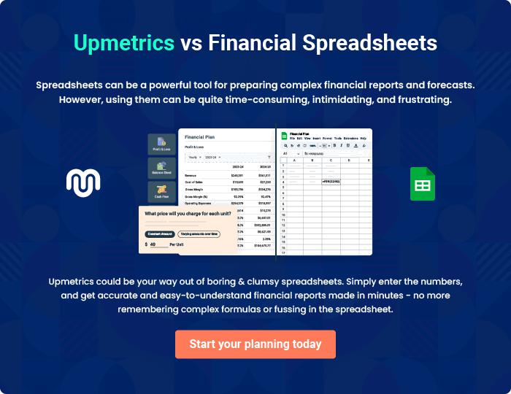
Appendix

When writing the appendix section, you should include any additional information that supports the main content of your plan. This may include financial statements, market research data, legal documents, and other
To unlock help try Upmetrics! 
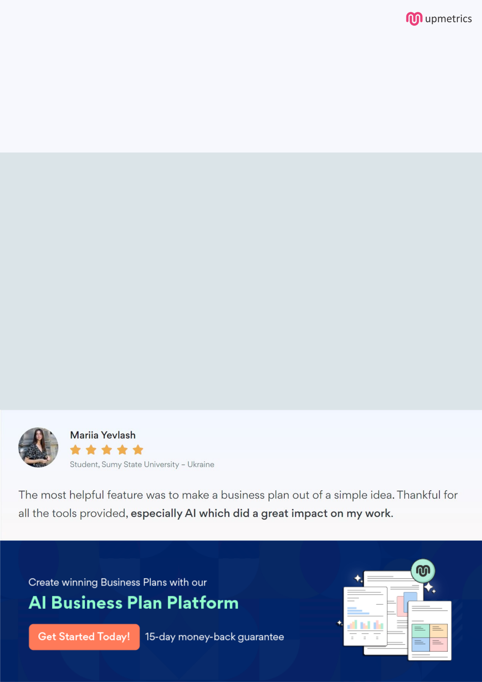
Create a winning business plan that gets you funded

Creating a stunning and investment-ready plan requires no writing, graphic designing, or financial planning expertise.

Upmetrics has all the features required to help you create a comprehensive business plan—from start to finish. Make no mistakes, it’s the modern way of planning to structure ideas, make plans, and create stunning pitch decks to awe investors.

Pitch decks that impress investors

Create pitch decks that provide a visual representation of your business, engage investors, and make them want to invest in your business idea.

Interactive plans in no time

Import business plan sections like—SWOT analysis, comparison tables, and others to create an interactive business plan. No designing skills are required.

Stunning cover page designs

With Upmetrics, you have the liberty to choose from multiple stunning cover page designs. Choose a creative design and make your plan stand out.

Online sharing made simple

Upmetrics makes online sharing quick and easier for users. Easily share your business plans with a link while tracking reader activity.

500+ sample business plans

Simply import a template from our library of sample plans into the editor and start customizing it to make it yours. It takes only a few clicks to get started.

Collaborate with team in real-time

Invite team members, initiate conversations, discuss ideas & strategies, share feedback, and work on a business plan in real-time.

