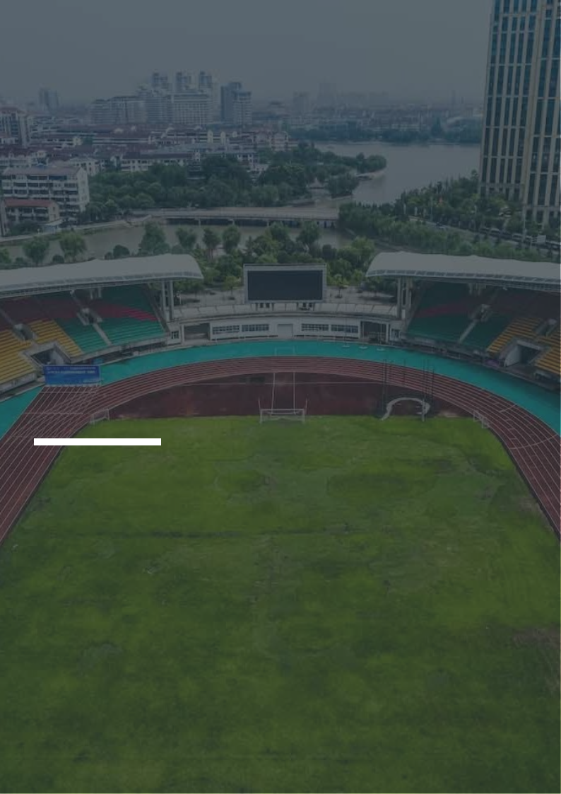
Sports Complex Business Plan

Your Arena for Action and Adventure

BUSINESS PLAN

2023

John Doe | 10200 Bolsa Ave, Westminster, CA, 92683 | (650) 359-3153 | info@example.com
http://www.example.com

Information provided in this business plan is unique to this business and confidential; therefore, anyone reading this plan agrees not to disclose any of the information in this business plan without prior written permission of the company.
Table of Contents

Executive Summary | 6
Market opportunity | 6
Services Offered | 6
Marketing & Sales Strategies | 7
Financial Highlights | 7
Units Sold v/s Revenue | 8

Company Overview | 9
Ownership | 9
Mission statement | 10
Business history | 10
Future goals | 11

Market Analysis | 12
Target Market | 12
Market size and growth potential | 12
Market Size | 13
Competitive analysis | 13
LA Fitness | 13
24 Hour Fitness | 14
YMCA | 14
Market trends | 14
Regulatory environment | 15

Products and Services | 16
Services | 16
Basketball Training | 16
Swimming Classes | 17
Golf Course Access | 17
Fitness Classes | 17
Tennis Lessons | 18
Facilities | 18
Schedule list | 18

Sales And Marketing Strategies | 19
Unique Selling Proposition (USP) | 19
Pricing Strategy | 19
Marketing strategies | 20
Online | 20
Offline | 20
Sales strategies | 21
Customer retention | 22

Operations Plan | 23
Staffing & Training | 23
Operational Process | 23
Equipment | 24

Management Team | 25
Key managers | 25
John Doe | 25
Jane Doe | 26
Alice Brown | 26
Robert Brown | 26
Organizational structure | 26
Organization chart | 27
Compensation plan | 27
Advisors/Consultants | 28
Dr. Richard White | 28
Emily Johnson | 28

Financial Plan | 29
Profit & loss statement | 29
Cash flow statement | 32
Balance sheet | 34
Break-even Analysis | 36
Financing needs | 38
Appendix
Appendix | 40
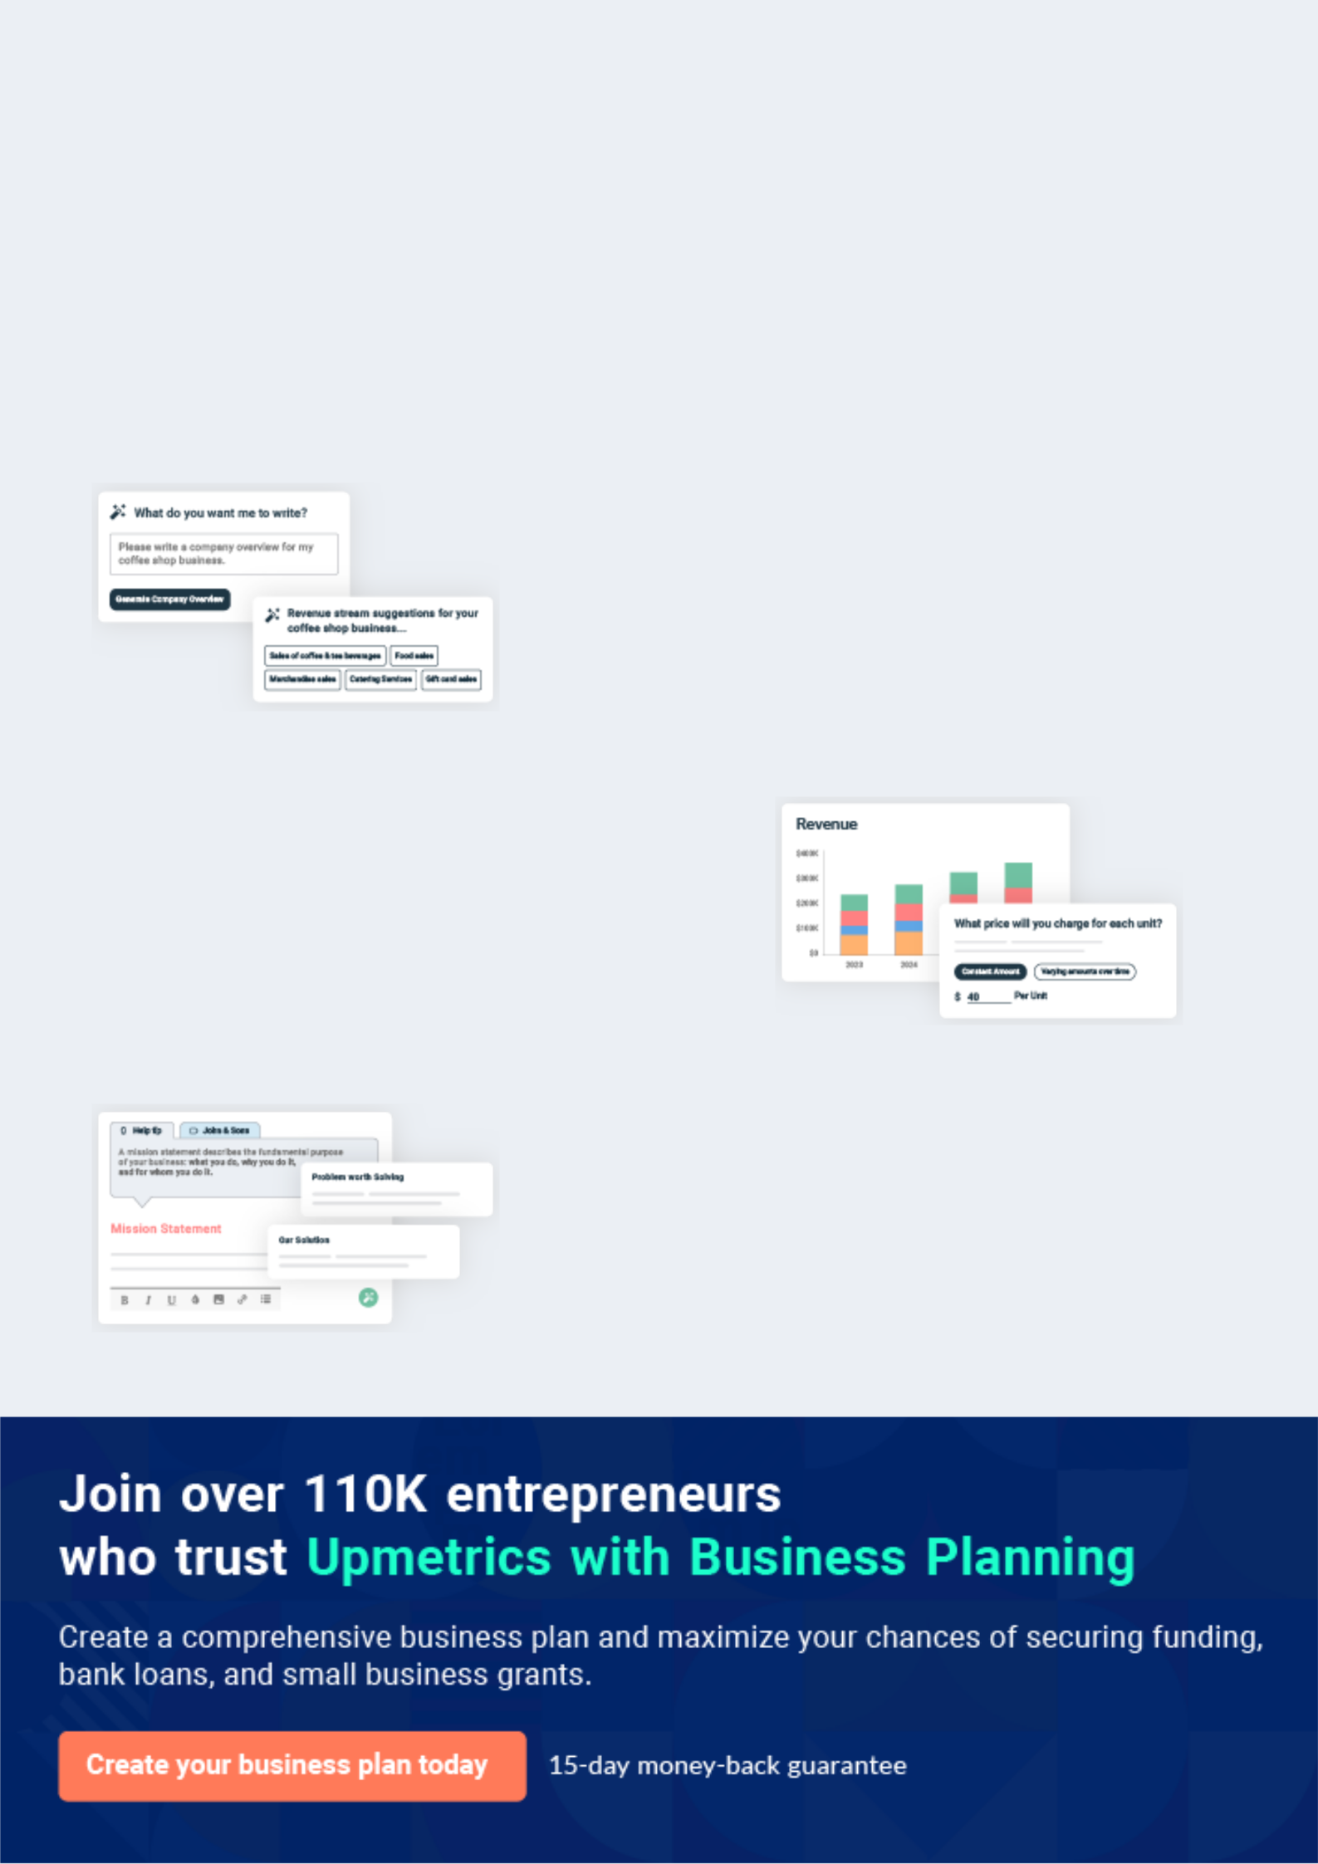
Business planning that’s simpler and faster than you think

Creating a business plan using Upmetrics to start and grow a business is literally the easiest thing in the World. Simply read the instructions and fill in the blanks. It’s as simple as that.

❛ | Upmetrics has everything you need to create a | ❜
❛ | comprehensive business plan. | ❜

AI-powered Upmetrics Assistant

AI-powered insights to streamline your plan

Not sure where to start? Upmetrics’ AI Assistant will automatically generate ideas for each section of your plan and offer improved versions of your writing, adjusting for tone, voice, and grammar or spelling errors.

Financial Forecasting Tool

All the financials are calculated for you

Forget the complex formulas and clumsy spreadsheets — with automatic financials and drag-and-drop forecasting, you can finish your plan faster and be confident that your numbers are accurate.

Business Plan Builder

Guides you like a business mentor

Upmetrics’ step-by-step instructions, prompts, and the library of 400+ sample business plans will guide you through each section of your plan as a business mentor.
Executive Summary


An executive summary is the first section of the business plan intended to provide an overview of the whole business plan.
To unlock help try Upmetrics! 

 Help tip  Sports Complex Business Plan


Start your executive summary section by briefly introducing your business to your readers.

This section may include the name of your sports complex business, its location, when it was
To unlock help try Upmetrics! 

Start writing here..

Market opportunity

 Help tip  Sports Complex Business Plan

Summarize your market research, including market size, growth potential, and marketing trends. Highlight the opportunities in the market and how your business will fit in to fill the gap.
To unlock help try Upmetrics! 

Start writing here..

Services Offered

 Help tip  Sports Complex Business Plan

Highlight the products or services you offer your clients. The USPs and differentiators you offer are always a plus.
To unlock help try Upmetrics! 

Start writing here..

Marketing & Sales Strategies
To unlock help try Upmetrics!

 Help tip  Sports Complex Business Plan

Outline your sales and marketing strategies—what marketing platforms you use, how you plan on acquiring customers, etc.
To unlock help try Upmetrics! 

Start writing here..

Financial Highlights

 Help tip  Sports Complex Business Plan

Briefly summarize your financial projections for the initial years of business operations. Include any capital or investment requirements, associated startup costs, projected revenues, and profit forecasts.



Start writing here..
Units Sold v/s Revenue

 |  | Units Sold | Revenue
15.00k
10.00k
5.00k
0
Year 1 | Year 2 | Year 3


Financial Year |  |  | Units Sold | Revenue
Year 1 | 1,550 |  |  | $10,000
Year 2 | 1,800 |  |  | $12,000
Year 3 | 2,050 |  |  | $14,000
 Help tip |  |  Sports Complex Business Plan


Summarize your executive summary section with a clear CTA, for example, inviting angel investors to discuss the potential business investment.
To unlock help try Upmetrics! 

Write a call to action for your business plan.
Company Overview

Depending on what details of your business are essential, you’ll need different elements in your business overview.
To unlock help try Upmetrics! 

 Help tip  Sports Complex Business Plan

Describe what kind of sports complex business you run and the name of it. You may specialize in one of the following businesses:
To unlock help try Upmetrics! 

Start writing here..

Ownership

 Help tip  Sports Complex Business Plan

List the names of your sports complex business’s founders or owners. Describe what shares they own and their responsibilities for efficiently managing the business.
To unlock help try Upmetrics! 

Start writing here..
Mission statement

 Help tip  Sports Complex Business Plan

Summarize your business’ objective, core principles, and values in your mission statement. This statement needs to be memorable, clear, and brief.
To unlock help try Upmetrics! 

❛ At [ProElite Sports Complex], our mission is to provide an unparalleled sports and fitness experience that fosters a healthy and active lifestyle.

We are committed to delivering top-notch facilities, professional training, and exceptional customer service, all while upholding our core principles of integrity, excellence, and community engagement.

❜

Business history

 Help tip  Sports Complex Business Plan

If you’re an established sports complex business, briefly describe your business history, like— when it was founded, how it evolved over time, etc.
To unlock help try Upmetrics! 

Start writing here..
Future goals

 Help tip  Sports Complex Business Plan

It’s crucial to convey your aspirations and vision. Mention your short-term and long-term goals; they can be specific targets for revenue, market share, or expanding your services.
To unlock help try Upmetrics! 

Start writing here..
Market Analysis
To unlock help try Upmetrics!


 |  | Market analysis provides a clear understanding of the market in which your
 |  | printing business will run along with the target market, competitors, and
 |  | growth opportunities.
 |  |  |  | To unlock help try Upmetrics! 
 Help tip |  |  Sports Complex Business Plan

To write the introduction section of your market analysis, start by clearly identifying your primary target market.
To unlock help try Upmetrics! 

Start writing here..

Target Market

 Help tip  Sports Complex Business Plan

Start this section by describing your target market. Define your ideal customer and explain what types of services they prefer. Creating a buyer persona will help you easily define your target market to your readers.



Start writing here..

Market size and growth potential

 Help tip  Sports Complex Business Plan

Describe your market size and growth potential and whether you will target a niche or a much broader market.
To unlock help try Upmetrics! 

Start writing here..

Market Size

Available Market

Total potential customers seeking 50M sports complex services nationally.

Served Market
Customers in the regional area 5M accessible to existing sports complexes.

Target Market
Fitness enthusiasts and athletes in local 500k communities and neighborhoods.

Competitive analysis

LA Fitness

LA Fitness is a nationally recognized brand with a strong presence in the fitness industry, offering a wide range of fitness equipment, group classes, and personal training services.

Features | Strengths | Weaknesses
Extensive fitness equipment | Well-established brand with a | Higher membership fees
Group fitness classes including | strong market presence | compared to local gyms
yoga, spinning, and Zumba | Comprehensive range of | Some complaints about
Personal training services | fitness equipment and classes | customer service and facility
Personal training services |  | maintenance
 | Nationwide locations provide | maintenance
Swimming pool and sauna | Nationwide locations provide
Swimming pool and sauna | convenience for customers | Limited customization for
facilities | convenience for customers | Limited customization for
facilities |  | individual needs
Childcare services

24 Hour Fitness

24 Hour Fitness is a popular fitness chain that offers a convenient, around-the-clock gym experience, catering to customers with busy schedules.

Features

24/7 access to gym facilities

Wide variety of fitness equipment

Group fitness classes

Personal training services

Kids' club facilities

Strengths

Open 24 hours, catering to customers with varying schedules

Extensive range of equipment and classes

Multiple locations for easy access

Weaknesses

Some locations may be overcrowded during peak hours

Membership fees may be high for some customers

Limited availability of advanced fitness classes and equipment in certain locations

YMCA

The YMCA is a community-focused organization that provides a variety of fitness facilities and programs for individuals and families.

Features

Fitness equipment and facilities

Group fitness classes Youth and family programs

Community events and activities

Financial assistance for low-income families

Strengths

Strong community focus with a variety of programs for all ages

Affordable membership options

Nationwide locations provide easy access for customers

Weaknesses

Limited availability of advanced fitness equipment and classes

Facility quality may vary by location

Some locations may be crowded during peak hours

Market trends

 Help tip  Sports Complex Business Plan

Analyse emerging trends in the industry, such as technology disruptions, changes in customer behavior or preferences, etc. Explain how your business will cope with all the trends.
To unlock help try Upmetrics! 

Start writing here..

Regulatory environment
To unlock help try Upmetrics!

 Help tip  Sports Complex Business Plan

List regulations and licensing requirements that may affect your sports complex business such as zoning regulations, health & safety regulations, environmental regulations, insurance & liability, etc.



Start writing here..
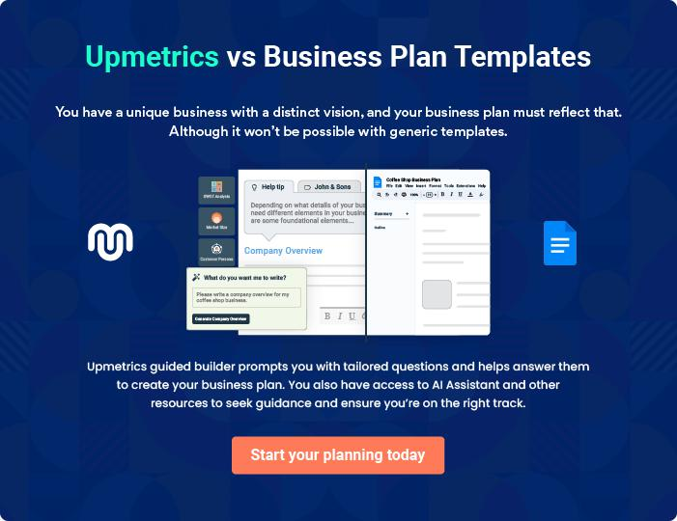
Products and Services
To unlock help try Upmetrics!

The product and services section of a sports complex business plan should describe the specific services and products that will be offered to customers. To write this section should include the following:



 Help tip  Sports Complex Business Plan

To craft the introduction for your "Products and Services" chapter, begin by positioning your business within its industry, emphasizing its unique strengths or value proposition.
To unlock help try Upmetrics! 

Start writing here..

 Help tip


Mention the sports complex services your business will offer. This list may include services like,
To unlock help try Upmetrics! 

Services

Basketball Training


Price: [$50 per hour]

Expert coaching to improve skills and performance on the basketball court.

Specifications

- Duration: 1 hour

- Includes access to state-of-the-art basketball courts and equipment

- Coached by professional basketball players
Swimming Classes

Price: [$40 per class]

Group swimming classes for all ages and skill levels, focused on safety and technique.

Specifications

- Duration: 45 minutes

- Access to Olympic-size swimming pool

- Certified swimming instructors

Golf Course Access

Price: [$100 per day]

Access to our premium golf course, meticulously maintained for an optimal golfing experience.

Specifications

- Duration: One day access

- Includes access to golf carts and equipment

- Par 72, 18-hole golf course

Fitness Classes

Price: [$30 per class]

A variety of fitness classes including yoga, pilates, spinning, and more, suitable for all fitness levels.

Specifications

- Duration: 1 hour

- All necessary equipment provided

- Classes led by certified fitness instructors
Tennis Lessons
- To unlock help try Upmetrics!

Price: [$60 per hour]

Personalized tennis lessons with professional coaches to improve technique, agility, and performance.

Specifications

- Duration: 1 hour

- Access to high-quality tennis courts and equipment

- Coached by experienced tennis professionals

Facilities

 Help tip  Sports Complex Business Plan


Describe the sports complex’s physical amenities, such as the size and design of the
building(s), the kinds of courts or fields, and any equipment or customer amenities (such as
changing rooms, showers, and snack bars).
 |  |  |  |  | To unlock help try Upmetrics! 
Start writing here..
Schedule list
 Help tip |  |  |  Sports Complex Business Plan

Give a list of future competitions, events, and other unique activities that the sports complex will be hosting. It will show the variety and caliber of the products and services that are offered to customers.



Start writing here..
Sales And Marketing Strategies

Writing the sales and marketing strategies section means a list of strategies you will use to attract and retain your clients.
To unlock help try Upmetrics! 

 Help Tip  Sports Complex Business Plan


To create an effective introduction for your "Sales and Marketing Strategies" chapter, start by setting the stage within your specific industry or market.
To unlock help try Upmetrics! 

Start writing here..

Unique Selling Proposition (USP)

 Help tip  Sports Complex Business Plan

Define your business’s USPs depending on the market you serve, the equipment you use, and the unique services you provide. Identifying USPs will help you plan your marketing strategies.
To unlock help try Upmetrics! 

Start writing here..

Pricing Strategy

 Help tip  Sports Complex Business Plan

Describe your pricing strategy—how you plan to price your business and stay competitive in the local market.
To unlock help try Upmetrics! 

Start writing here..

 Help tip  Sports Complex Business Plan
To unlock help try Upmetrics!

Discuss your marketing strategies to market your services. You may include some of these marketing strategies in your business plan—social media marketing, Google ads, brochures, email marketing, content marketing, and print marketing.



Marketing strategies

Online


Social Media

Utilize platforms such as Facebook, Instagram, and Twitter to engage with our community and promote our services.

Content Marketing

Create valuable content such as blog posts, videos, and infographics to educate and engage our audience.

Email Marketing

Send regular newsletters to our subscribers, highlighting upcoming events, promotions, and new services.

Google Ads

Implement targeted Google Ads campaigns to reach potential customers actively searching for sports complexes in their area.

Offline

Print Marketing

Design and distribute brochures and flyers in local communities and businesses to increase brand awareness.

 Help tip  Sports Complex Business Plan

Outline the strategies you’ll implement to maximize your sales. Your sales strategies may include offering discounts on annual membership, referral programs, etc.
To unlock help try Upmetrics! 

Sales strategies

Bundled Services

Provide discounted rates for customers who sign up for multiple services or bring in family members.

Referral Programs

Implement a referral program that rewards existing customers for bringing in new members.

Memberships

Offer promotional discounts on annual memberships to encourage long-term commitments.

 Help tip  Sports Complex Business Plan

Describe your customer retention strategies and how you plan to execute them. For instance, introducing loyalty programs, personalized service, etc.
To unlock help try Upmetrics! 

Customer retention

Loyalty Programs

Implement a loyalty program that rewards customers for their continued support and frequent visits.

Personalized Service

Ensure our staff is trained to provide exceptional, personalized service to each customer, making them feel valued and appreciated.

Feedback Mechanisms

Establish feedback mechanisms such as surveys and suggestion boxes to gather valuable customer insights and make necessary improvements.

Operations Plan

 |  | When writing the operations plan section, it’s important to consider the
 |  | various aspects of your business operations.
 |  |  |  | To unlock help try Upmetrics! 
 Help tip |  |  Sports Complex Business Plan


To create an effective introduction for your "Operational Plan" chapter, start by emphasizing the
pivotal role of efficient operations in the success of your business, underscoring how they
directly impact the quality of services delivered.
 |  |  |  | To unlock help try Upmetrics! 
Start writing here..
Staffing & Training
 Help tip |  |  Sports Complex Business Plan

Mention your business’s staffing requirements, including the number of employees, coaches, or trainers.
To unlock help try Upmetrics! 

Start writing here..

Operational Process

 Help tip  Sports Complex Business Plan

Outline the processes and procedures you will use to run your sports complex business. Your operational processes may include sending quotations, scheduling classes, etc.
To unlock help try Upmetrics! 

Start writing here..

Equipment

 Help tip  Sports Complex Business Plan

Include the list of equipment required for the sports complex, such as fitness equipment, sports equipment, mats & padding, etc.
To unlock help try Upmetrics! 

Start writing here..
Management Team

The management team section provides an overview of the individuals responsible for running your business plan.
To unlock help try Upmetrics! 

 Help tip  Sports Complex Business Plan

To craft an introduction for your "Management Team" chapter, begin by emphasizing the crucial role of leadership in the success of any business.
To unlock help try Upmetrics! 

Start writing here..

Key managers

 Help tip  Sports Complex Business Plan

Introduce your management and key members of your team, and explain their roles and responsibilities.
To unlock help try Upmetrics! 

Start writing here..


JOHN DOE

Founder and CEO - john.doe@example.com

With over 15 years of experience in the sports and fitness industry, John holds a bachelor's degree in Sports Management and an MBA.

He founded ProElite Sports Complex with the vision of providing a state-of-the-art facility for athletes and fitness enthusiasts alike.


JANE DOE

Operations Manager - jane.doe@example.com

Jane has a background in facility management with a bachelor's degree in Business Administration.

She has over 10 years of experience managing sports complexes and is responsible for the smooth operation of ProElite Sports Complex.



ALICE BROWN

Marketing Manager - alice.brown@example.com

Alice holds a degree in Marketing and has extensive experience in the fitness industry.

She is responsible for leading our marketing efforts, managing our online presence, and attracting new members to our facility


ROBERT BROWN

Head Coach - robert.brown@example.com

Robert has a degree in Exercise Science and holds multiple certifications in fitness training.

With over 12 years of experience in coaching, he oversees all coaches and trainers, ensuring they provide the best support to our members.

Organizational structure

 Help tip  Sports Complex Business Plan

Explain the organizational structure of your management team. Include the reporting line and decision-making hierarchy.
To unlock help try Upmetrics! 

Start writing here..

Organization chart


John Doe

CEO


Alice Brown

Robert Brown

Jane Doe

Marketing Manager


Head Coach

Operations Manager

Marketing Team

Coaches & Trainers

Staff Members

-

-

-

Compensation plan

 Help tip  Sports Complex Business Plan

Describe your compensation plan for the management and staff. Include their salaries, incentives, and other benefits.
To unlock help try Upmetrics! 

Start writing here..

 Help tip

Mentioning advisors or consultants in your business plans adds credibility to your business idea.
To unlock help try Upmetrics! 

Advisors/Consultants


DR. RICHARD WHITE

Strategic Advisor

Richard has over 20 years of experience in business strategy and sports management. He provides valuable insights and strategic guidance to our team.



EMILY JOHNSON

Marketing Consultant

Emily is an expert in digital marketing with a focus on the fitness industry. She advises us on our online marketing strategies to effectively reach our target audience.

Financial Plan

When writing the financial plan section of a business plan, it’s important to provide a comprehensive overview of your financial projections for the first few years of your business, You may provide the following:
To unlock help try Upmetrics! 

 Help tip  Sports Complex Business Plan


To create an effective introduction for your "Financial Plan" chapter, begin by stressing the critical role of a well-structured financial plan in the success of your venture.
To unlock help try Upmetrics! 

Start writing here..

 Help tip  Sports Complex Business Plan

Describe details such as projected revenue, operational costs, and service costs in your projected profit and loss statement. Make sure to include your business’s expected net profit or loss.
To unlock help try Upmetrics! 

Profit & loss statement

Revenue

Cost Of Sales

General Costs

Revenue Specific Costs

Personnel Costs (Direct

Labor)

Gross Margin

Gross Margin (%)

Operating Expense

Payroll Expense

(Indirect Labor)

General Expense

Bad Debt

Amortization of Current

Assets

2023-24 | 2024-25 | 2025-26 | 2026-27 | 2027-28
$0 | $0 | $0 | $0 | $0

$0 | $0 | $0 | $0 | $0
$0 | $0 | $0 | $0 | $0
$0 | $0 | $0 | $0 | $0
$0 | $0 | $0 | $0 | $0

$0 | $0 | $0 | $0 | $0
0% | 0% | 0% | 0% | 0%

$0 | $0 | $0 | $0 | $0
$0 | $0 | $0 | $0 | $0
$0 | $0 | $0 | $0 | $0
$0 | $0 | $0 | $0 | $0
$0 | $0 | $0 | $0 | $0

EBITDA

Additional Expense

Long Term

Depreciation

Gain or loss from Sale

of Assets

EBIT

Interest Expenses

EBT

Income Tax Expense

Total Expense

Net Income

Net Income (%)

2023-24 | 2024-25 | 2025-26 | 2026-27 | 2027-28
$0 | $0 | $0 | $0 | $0
$0 | $0 | $0 | $0 | $0
$0 | $0 | $0 | $0 | $0
$0 | $0 | $0 | $0 | $0
$0 | $0 | $0 | $0 | $0
$0 | $0 | $0 | $0 | $0
$0 | $0 | $0 | $0 | $0
$0 | $0 | $0 | $0 | $0
$0 | $0 | $0 | $0 | $0
$0 | $0 | $0 | $0 | $0
0% | 0% | 0% | 0% | 0%
 |  |  | 2023-24 |  | 2024-25 | 2025-26 | 2026-27 | 2027-28
Retained Earning |  |  | $0 |  | $0 | $0 | $0 | $0
Opening
Owner's Distribution |  |  | $0 |  | $0 | $0 | $0 | $0
Retained Earning |  |  | $0 |  | $0 | $0 | $0 | $0
Closing
 Help tip |  |  |  Sports Complex Business Plan


The cash flow for the first few years of your operation should be estimated and described in this section. This may include billing invoices, payment receipts, loan payments, and any other cash flow statements.
To unlock help try Upmetrics! 

Cash flow statement

 | 2023-24 | 2024-25 | 2025-26 | 2026-27 | 2027-28
Cash Received | $0 | $0 | $0 | $0 | $0
Cash Paid | $0 | $0 | $0 | $0 | $0
COS & General Expenses | $0 | $0 | $0 | $0 | $0
Salary & Wages | $0 | $0 | $0 | $0 | $0
Interest | $0 | $0 | $0 | $0 | $0

Sales Tax

Income Tax

Net Cash From

Operations

Assets Sell

Assets Purchase

Net Cash From

Investments

Amount Received

Loan Received

Common Stock

Preferred Stock

Owner's Contribution

Amount Paid

2023-24 | 2024-25 | 2025-26 | 2026-27 | 2027-28
$0 | $0 | $0 | $0 | $0
$0 | $0 | $0 | $0 | $0
$0 | $0 | $0 | $0 | $0

$0 | $0 | $0 | $0 | $0
$0 | $0 | $0 | $0 | $0
$0 | $0 | $0 | $0 | $0

$0 | $0 | $0 | $0 | $0
$0 | $0 | $0 | $0 | $0

$0 | $0 | $0 | $0 | $0
$0 | $0 | $0 | $0 | $0
$0 | $0 | $0 | $0 | $0

Loan Capital $0 $0 $0 $0 $0

 |  |  | 2023-24 |  | 2024-25 | 2025-26 | 2026-27 | 2027-28
Dividends & Distributions |  |  | $0 |  | $0 | $0 | $0 | $0
Net Cash From |  |  | $0 |  | $0 | $0 | $0 | $0
Financing
Summary
Starting Cash |  |  | $0 |  | $0 | $0 | $0 | $0
Cash In |  |  | $0 |  | $0 | $0 | $0 | $0
Cash Out |  |  | $0 |  | $0 | $0 | $0 | $0
Change in Cash |  |  | $0 |  | $0 | $0 | $0 | $0
Ending Cash |  |  | $0 |  | $0 | $0 | $0 | $0
 Help tip |  |  Sports Complex Business Plan

Create a projected balance sheet documenting your sports complex business’s assets, liabilities, and equity.

To unlock help try Upmetrics! 

Balance sheet

 | 2023-24 | 2024-25 | 2025-26 | 2026-27 | 2027-28
Assets | $0 | $0 | $0 | $0 | $0
Current Assets | $0 | $0 | $0 | $0 | $0
Cash | $0 | $0 | $0 | $0 | $0
Accounts Receivable | $0 | $0 | $0 | $0 | $0
Inventory | $0 | $0 | $0 | $0 | $0
Other Current Assets | $0 | $0 | $0 | $0 | $0
Long Term Assets | $0 | $0 | $0 | $0 | $0
Gross Long Term Assets | $0 | $0 | $0 | $0 | $0
Accumulated Depreciation | $0 | $0 | $0 | $0 | $0

Liabilities & Equity | $0 | $0 | $0 | $0 | $0
Liabilities | $0 | $0 | $0 | $0 | $0
Current Liabilities | $0 | $0 | $0 | $0 | $0
Accounts Payable | $0 | $0 | $0 | $0 | $0
Income Tax Payable | $0 | $0 | $0 | $0 | $0
Sales Tax Payable | $0 | $0 | $0 | $0 | $0
Short Term Debt | $0 | $0 | $0 | $0 | $0
 | 2023-24 | 2024-25 | 2025-26 | 2026-27 | 2027-28
Long Term Liabilities | $0 | $0 | $0 | $0 | $0
Long Term Debt | $0 | $0 | $0 | $0 | $0
Equity | $0 | $0 | $0 | $0 | $0
Paid-in Capital | $0 | $0 | $0 | $0 | $0
Common Stock | $0 | $0 | $0 | $0 | $0
Preferred Stock | $0 | $0 | $0 | $0 | $0
Owner's Contribution | $0 | $0 | $0 | $0 | $0
Retained Earnings | $0 | $0 | $0 | $0 | $0

Check | $0 | $0 | $0 | $0 | $0

Break-even Analysis

 Help tip  Sports Complex Business Plan

Determine and mention your business’s break-even point—the point at which your business costs and revenue will be equal.

This exercise will help you understand how much revenue you need to generate to sustain or be profitable.

To unlock help try Upmetrics! 

Start writing here..

 | 2023-24 | 2024-25 | 2025-26 | 2026-27 | 2027-28
Starting Revenue | $0 | $0 | $0 | $0 | $0
Net Revenue | $0 | $0 | $0 | $0 | $0
Closing Revenue | $0 | $0 | $0 | $0 | $0

Starting Expense | $0 | $0 | $0 | $0 | $0
Net Expense | $0 | $0 | $0 | $0 | $0
Closing Expense | $0 | $0 | $0 | $0 | $0

Is Break Even? | 0 | 0 | 0 | 0 | 0
Break Even Month | 0 | 0 | 0 | 0 | 0
Days Required | 0 | 0 | 0 | 0 | 0
Break Even Revenue | $0 | $0 | $0 | $0 | $0
Break Even Units
Financing needs

 Help tip  Sports Complex Business Plan

Calculate costs associated with starting a sports complex business, and estimate your financing needs and how much capital you need to raise to operate your business.
To unlock help try Upmetrics! 

Start writing here..
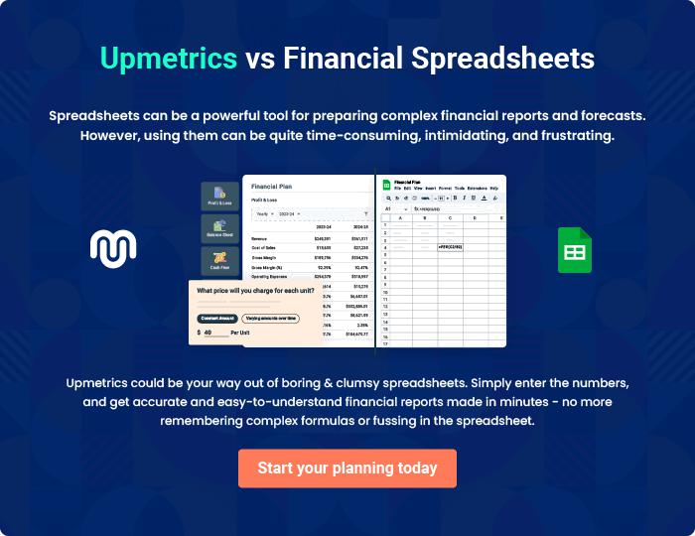
Appendix

When writing the appendix section, you should include any additional information that supports the main content of your plan. This may include financial statements, market research data, legal documents, and other
To unlock help try Upmetrics! 
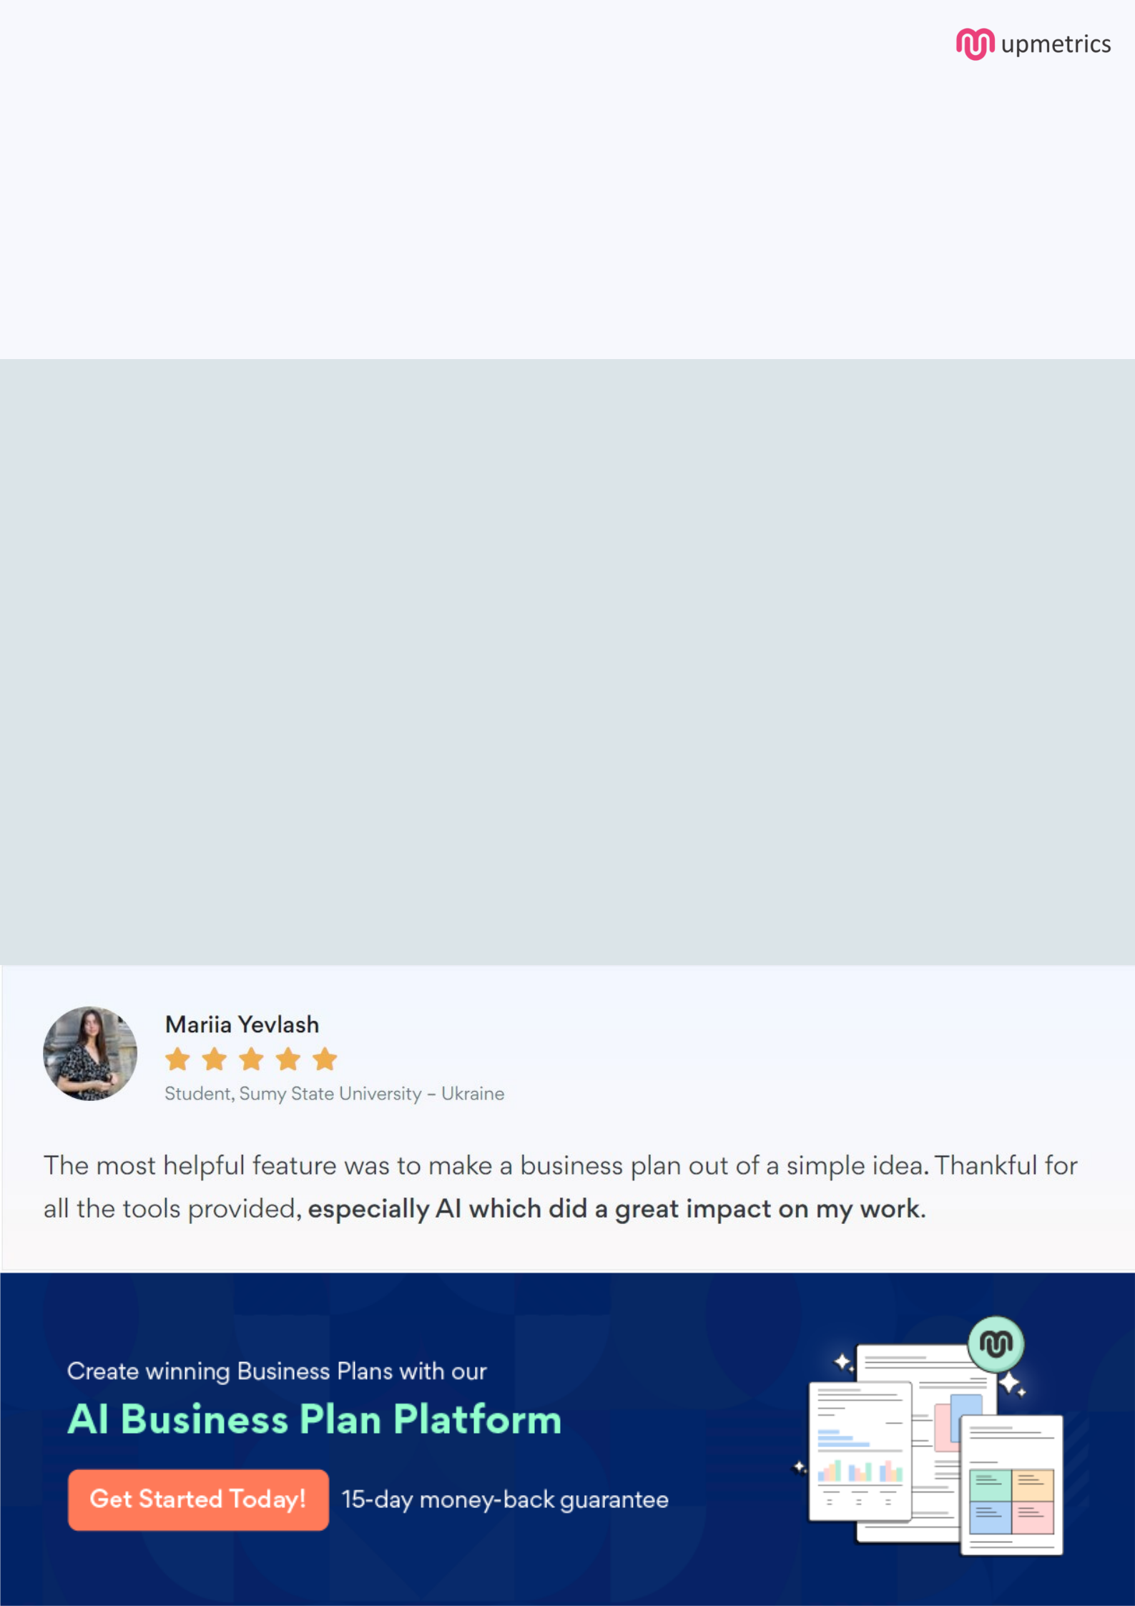
Create a winning business plan that gets you funded

Creating a stunning and investment-ready plan requires no writing, graphic designing, or financial planning expertise.

Upmetrics has all the features required to help you create a comprehensive business plan—from start to finish. Make no mistakes, it’s the modern way of planning to structure ideas, make plans, and create stunning pitch decks to awe investors.

Pitch decks that impress investors

Create pitch decks that provide a visual representation of your business, engage investors, and make them want to invest in your business idea.

Interactive plans in no time

Import business plan sections like—SWOT analysis, comparison tables, and others to create an interactive business plan. No designing skills are required.

Stunning cover page designs

With Upmetrics, you have the liberty to choose from multiple stunning cover page designs. Choose a creative design and make your plan stand out.

Online sharing made simple

Upmetrics makes online sharing quick and easier for users. Easily share your business plans with a link while tracking reader activity.

500+ sample business plans

Simply import a template from our library of sample plans into the editor and start customizing it to make it yours. It takes only a few clicks to get started.

Collaborate with team in real-time

Invite team members, initiate conversations, discuss ideas & strategies, share feedback, and work on a business plan in real-time.

