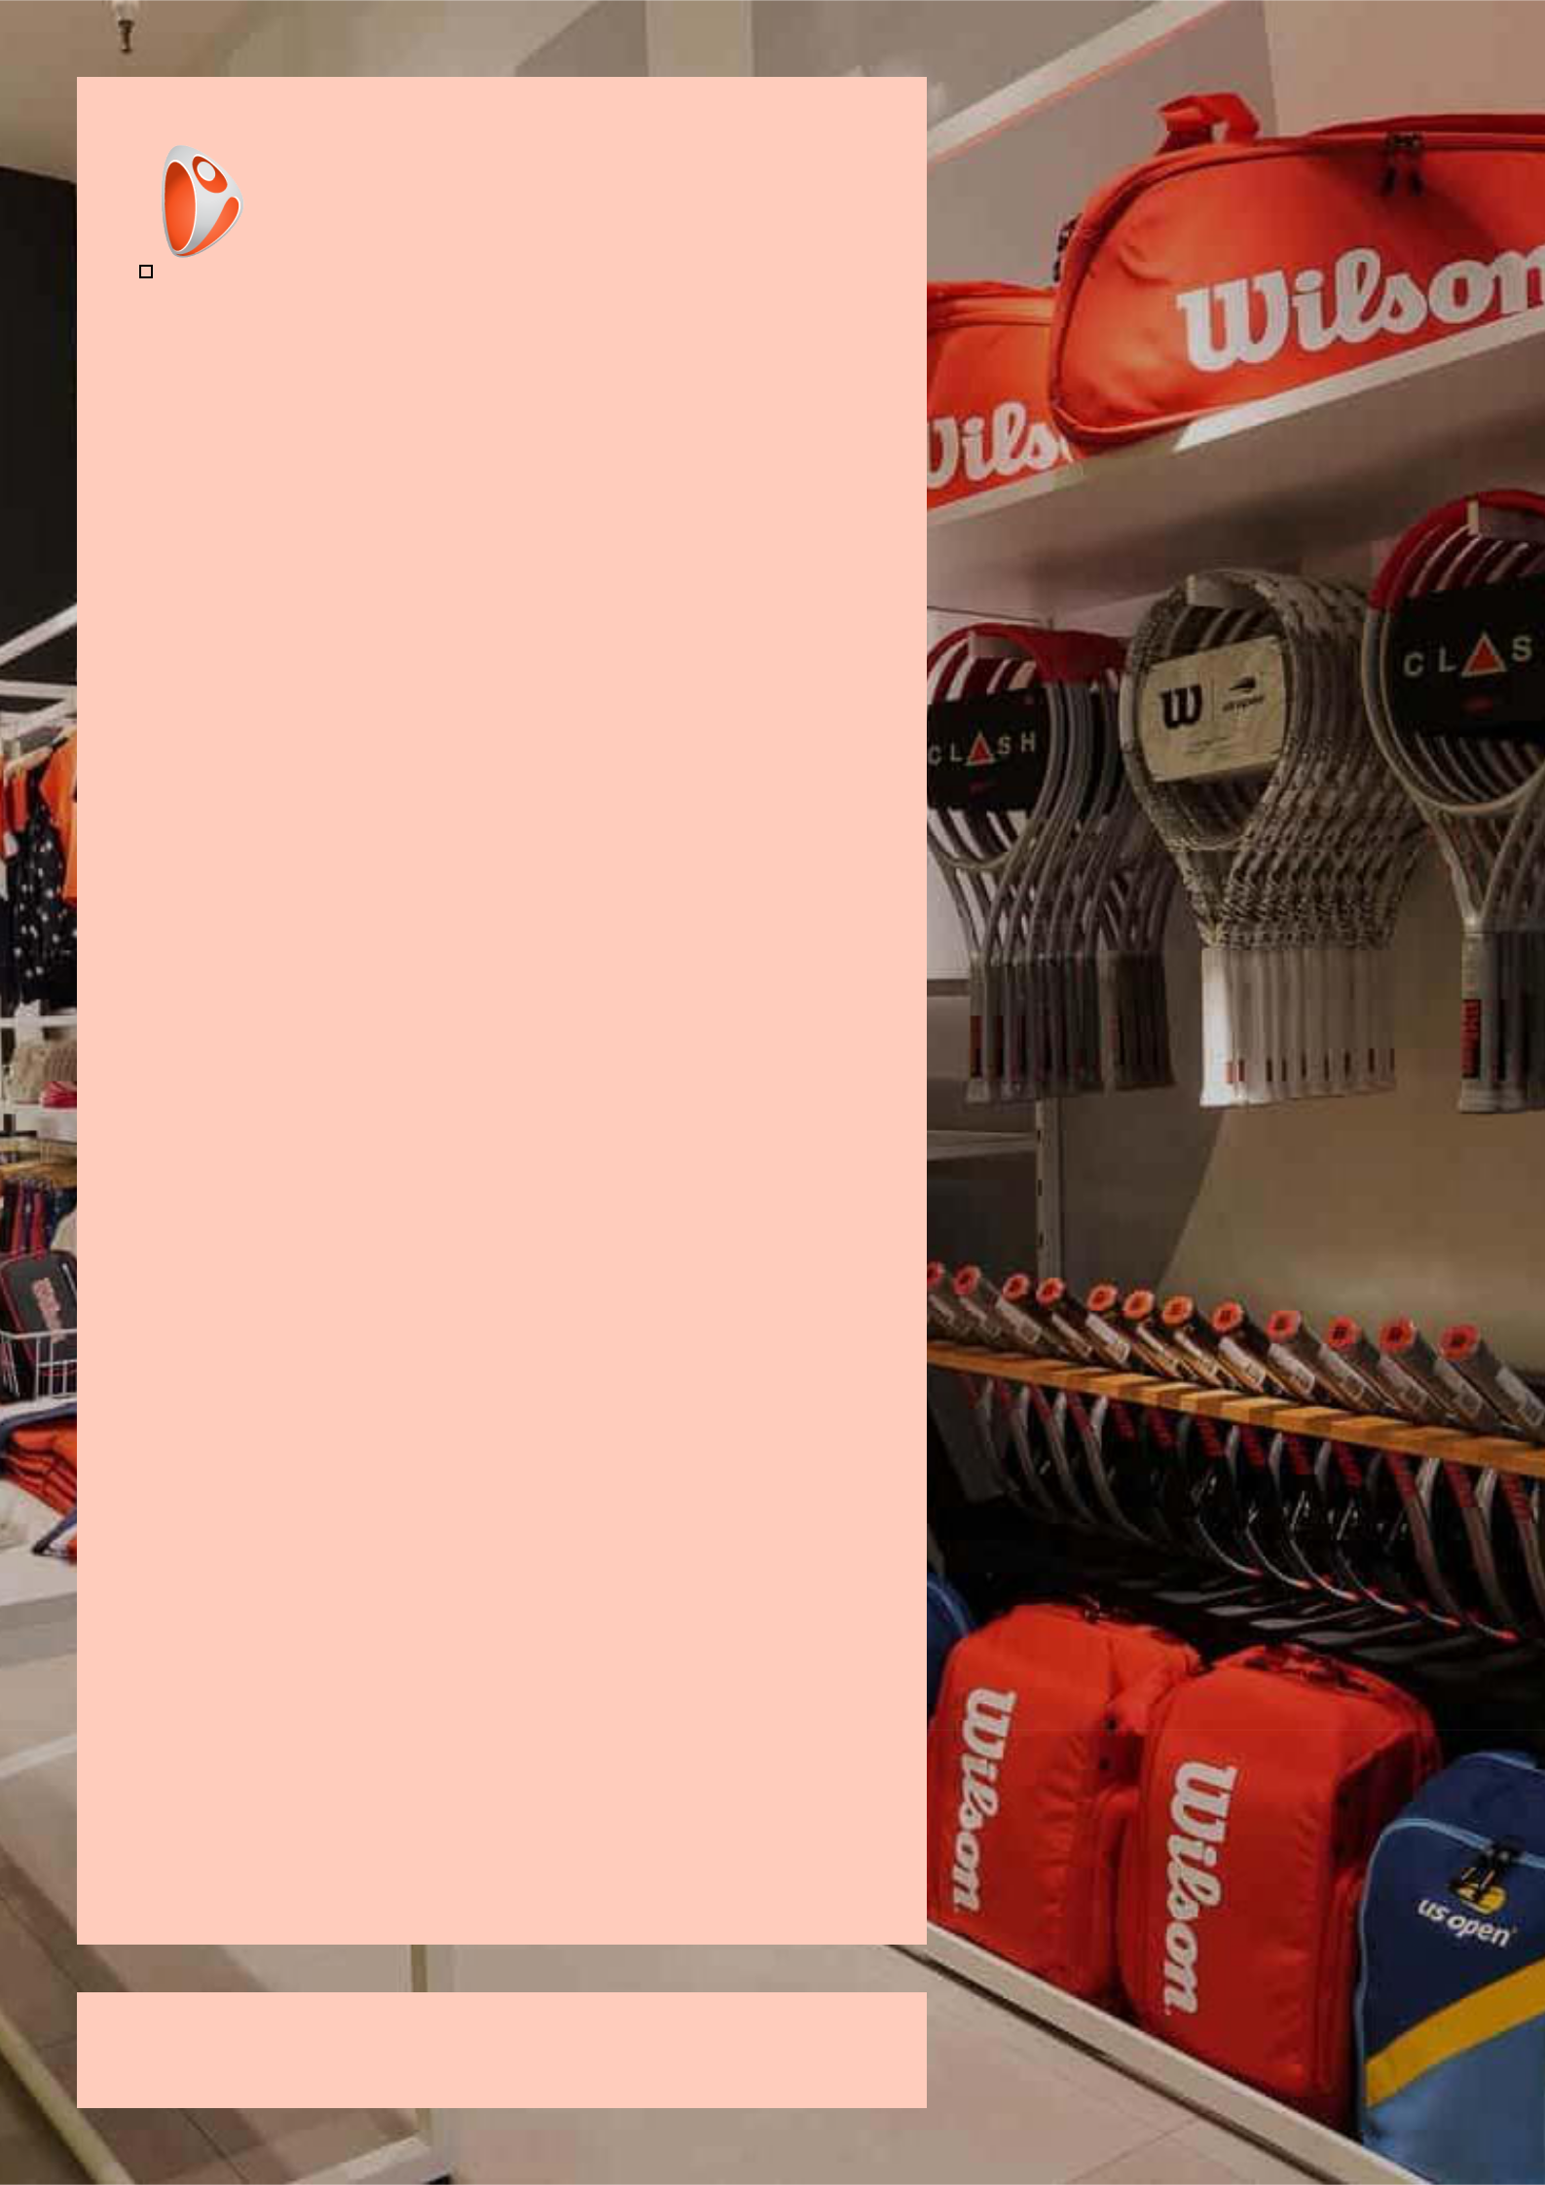

Sporting Goods

Store Business

Plan

Gear up, Play On

Business

Plan

2023

John Doe

10200 Bolsa Ave, Westminster, CA, 92683

- 359-3153 info@example.com http://www.example.com

CONFIDENTIAL

Table of Contents

Executive Summary | 6
Market opportunity | 6
Services Offered | 6
Marketing & Sales Strategies | 7
Financial Highlights | 7
Units Sold v/s Revenue | 8

Company Overview | 9
Ownership | 9
Mission statement | 10
Business history | 10
Future goals | 11

Market Analysis | 12
Target Market | 12
Market size and growth potential | 12
Market Size | 13
Competitive analysis | 13
Dick's Sporting Goods | 13
Academy Sports + Outdoors | 14
REI (Recreational Equipment, Inc.) | 14
Market trends | 14
Regulatory environment | 15

Products and Services | 16
Products | 16
Pro Soccer Ball | 16
Compression Running Shorts | 17
Fitness Tracker Watch | 17
Custom Basketball Jersey | 17
Camping Tent | 18
Kayak Rental | 18
Bike Tune-Up Service | 18
Personal Training Session | 19
Quality Measures | 19
Additional Services | 19

Sales And Marketing Strategies | 20
Unique Selling Proposition (USP) | 20
Pricing Strategy | 20
Marketing strategies | 21
Online | 21
Offline | 21
Sales strategies | 22
Customer retention | 22

Operations Plan | 23
Staffing & Training | 23
Operational Process | 23
Equipment & Machinery | 24

Management Team | 25
Key managers | 25
John Doe | 25
Jane Doe | 26
Alice Brown | 26
Robert Brown | 26
Organizational structure | 27
Organization chart | 27
Compensation plan | 27
Advisors/Consultants | 28
David Wilson | 28
Emma Taylor | 28
Financial Plan | 29
Profit & loss statement | 29
Cash flow statement | 32
Balance sheet | 34
Break-even Analysis | 36
Financing needs | 38
Appendix
Appendix | 40
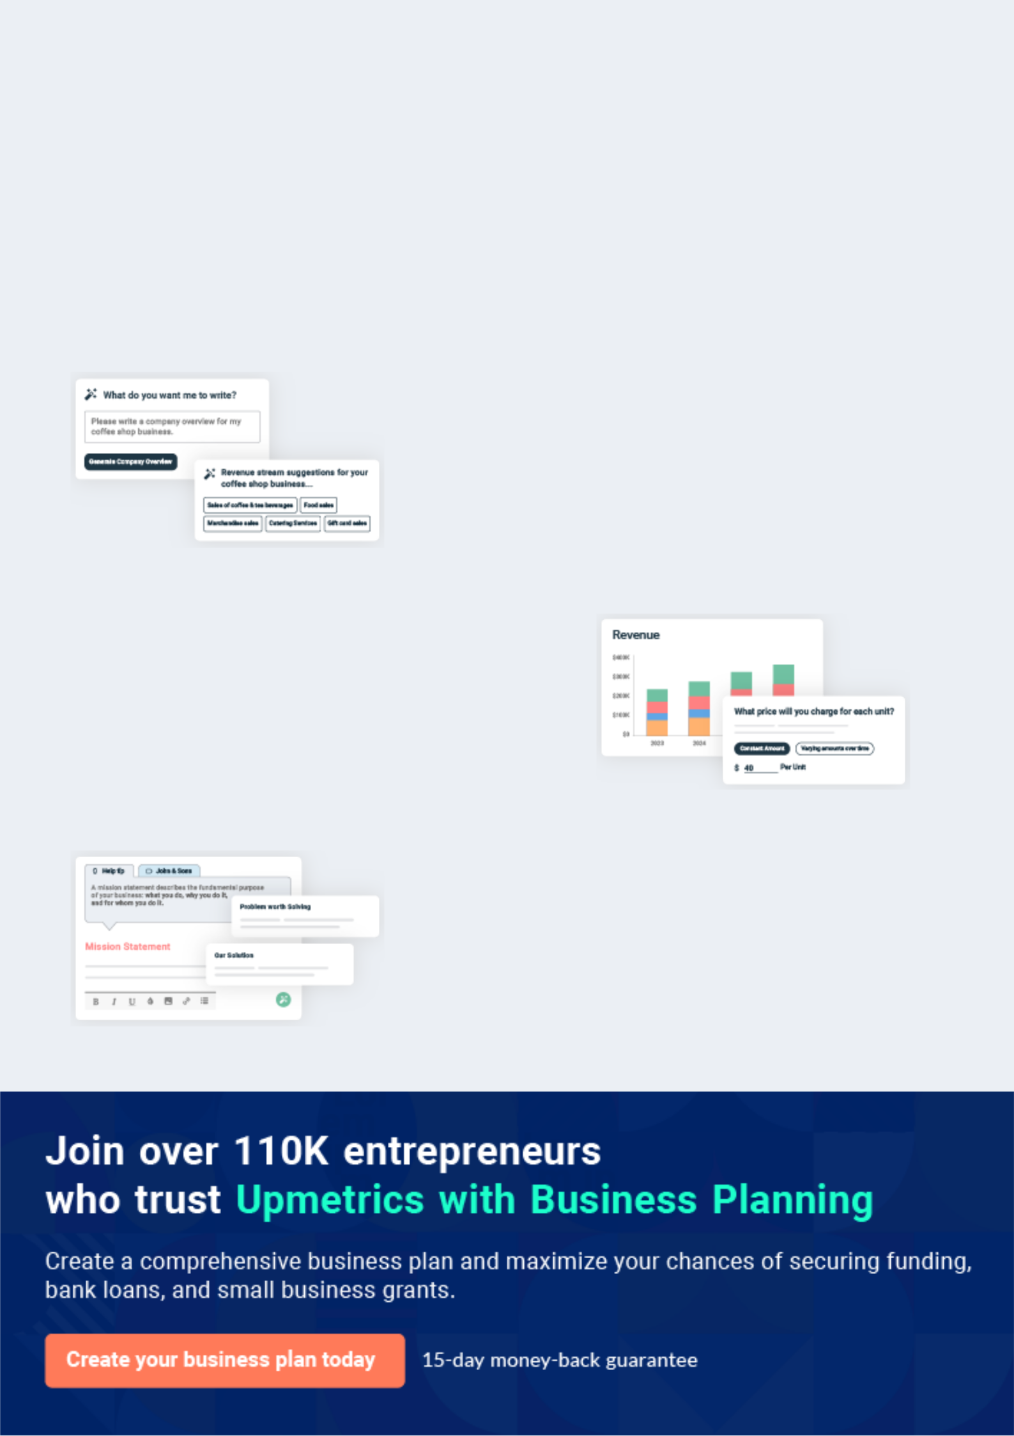
Business planning that’s simpler and faster than you think

Creating a business plan using Upmetrics to start and grow a business is literally the easiest thing in the World. Simply read the instructions and fill in the blanks. It’s as simple as that.

❛ | Upmetrics has everything you need to create a | ❜
❛ | comprehensive business plan. | ❜

AI-powered Upmetrics Assistant

AI-powered insights to streamline your plan

Not sure where to start? Upmetrics’ AI Assistant will automatically generate ideas for each section of your plan and offer improved versions of your writing, adjusting for tone, voice, and grammar or spelling errors.

Financial Forecasting Tool

All the financials are calculated for you

Forget the complex formulas and clumsy spreadsheets — with automatic financials and drag-and-drop forecasting, you can finish your plan faster and be confident that your numbers are accurate.

Business Plan Builder

Guides you like a business mentor

Upmetrics’ step-by-step instructions, prompts, and the library of 400+ sample business plans will guide you through each section of your plan as a business mentor.
Executive Summary


An executive summary is the first section of the business plan intended to provide an overview of the whole business plan.
To unlock help try Upmetrics! 

 Help tip  Sporting Goods Store Business Plan


Start your executive summary by briefly introducing your business to your readers.

This section may include the name of your sporting goods business, its location, when it was
To unlock help try Upmetrics! 

Start writing here..

Market opportunity

 Help tip  Sporting Goods Store Business Plan

Summarize your market research, including market size, growth potential, and marketing trends. Highlight the opportunities in the market and how your business will fit in to fill the gap.
To unlock help try Upmetrics! 

Start writing here..

Services Offered

 Help tip  Sporting Goods Store Business Plan

Highlight the sporting goods products & services you offer your clients. The USPs and differentiators you offer are always a plus.
To unlock help try Upmetrics! 

Start writing here..

Marketing & Sales Strategies
To unlock help try Upmetrics!

 Help tip  Sporting Goods Store Business Plan

Outline your sales and marketing strategies—what marketing platforms you use, how you plan on acquiring customers, etc.
To unlock help try Upmetrics! 

Start writing here..

Financial Highlights

 Help tip  Sporting Goods Store Business Plan

Briefly summarize your financial projections for the initial years of business operations. Include any capital or investment requirements, associated startup costs, projected revenues, and profit forecasts.



Start writing here..
Units Sold v/s Revenue

 |  | Units Sold | Revenue
15.00k
10.00k
5.00k
0
Year 1 | Year 2 | Year 3


Financial Year |  |  | Units Sold | Revenue
Year 1 | 1,550 |  |  | $10,000
Year 2 | 1,800 |  |  | $12,000
Year 3 | 2,050 |  |  | $14,000
 Help tip |  |  Sporting Goods Store Business Plan


Summarize your executive summary section with a clear CTA, for example, inviting angel investors to discuss the potential business investment.
To unlock help try Upmetrics! 

Write a call to action for your business plan.
Company Overview

Depending on what details of your business are essential, you’ll need different elements in your business overview.
To unlock help try Upmetrics! 

 Help tip  Sporting Goods Store Business Plan

Describe your business in this section by providing all the basic information:

Describe what kind of sporting goods company you run and the name of it. You may specialize
To unlock help try Upmetrics! 

Start writing here..

Ownership

 Help tip  Sporting Goods Store Business Plan

List the names of your sporting goods company’s founders or owners. Describe what shares they own and their responsibilities for efficiently managing the business.
To unlock help try Upmetrics! 

Start writing here..
Mission statement

 Help tip  Sporting Goods Store Business Plan

Summarize your business’ objective, core principles, and values in your mission statement. This statement needs to be memorable, clear, and brief.
To unlock help try Upmetrics! 

❛ Our mission at [ACE Sports and Outdoors] is to empower athletes and fitness enthusiasts by providing them with the highest quality sporting goods and unparalleled customer service.

We strive to foster a culture of excellence, innovation, and community engagement, ensuring that our customers are well-equipped to achieve their fitness goals and excel in their respective sports.

❜

Business history

 Help tip  Sporting Goods Store Business Plan

If you’re an established sporting goods business, briefly describe your business history, like— when it was founded, how it evolved over time, etc.
To unlock help try Upmetrics! 

Start writing here..
Future goals

 Help tip  Sporting Goods Store Business Plan

It’s crucial to convey your aspirations and vision. Mention your short-term and long-term goals; they can be specific targets for revenue, market share, or expanding your services.
To unlock help try Upmetrics! 

Start writing here..
Market Analysis
To unlock help try Upmetrics!


 |  | Market analysis provides a clear understanding of the market in which your
 |  | printing business will run along with the target market, competitors, and
 |  | growth opportunities.
 |  |  |  | To unlock help try Upmetrics! 
 Help tip |  |  Sporting Goods Store Business Plan

To write the introduction section of your market analysis, start by clearly identifying your primary target market.
To unlock help try Upmetrics! 

Start writing here..

Target Market

 Help tip  Sporting Goods Store Business Plan

Start this section by describing your target market. Define your ideal customer and explain what types of services they prefer. Creating a buyer persona will help you easily define your target market to your readers.



Start writing here..

Market size and growth potential

 Help tip  Sporting Goods Store Business Plan

Describe your market size and growth potential and whether you will target a niche or a much broader market.
To unlock help try Upmetrics! 

Start writing here..

Market Size

Available Market

Total potential sporting goods 200M consumers in North America.

Served Market
Consumers who purchase sporting 75M goods in-store and online.

Target Market
Active individuals seeking quality 30M sports equipment.

 Help tip  Sporting Goods Store Business Plan

Identify and analyze your direct and indirect competitors. Identify their strengths and weaknesses, and describe what differentiates your sporting goods from them.
To unlock help try Upmetrics! 

Competitive analysis

Dick's Sporting Goods

A leading sporting goods retailer offering a wide range of sports equipment, apparel, footwear, and accessories.

Features | Strengths
Comprehensive product lineup | Extensive product range
Diverse brand offerings | Strong brand recognition
In-store and online shopping | Nationwide presence
options | Well-established e-commerce
Expert advice and services | platform
Loyalty programs | Regular promotions and
 | discounts

Weaknesses

Some customers report inconsistent customer service

Higher price points compared to some competitors

Limited options for niche sports

Academy Sports + Outdoors

A popular retail chain that provides a variety of sports and recreational equipment, apparel, and footwear.

Features | Strengths
Wide product range | Competitive prices
Competitive pricing | Regular sales and promotions
In-store and online sales | User-friendly website
Exclusive brand partnerships | Strong regional presence in the
Customer rewards program | South and Southeast US

Weaknesses

Limited presence outside the South and Southeast US

Some product categories lack depth

Online customer service could be improved.

REI (Recreational Equipment, Inc.)

A leading outdoor retailer known for high-quality gear and apparel for camping, hiking, climbing, and other outdoor activities.

Features

High-quality products

In-store and online sales

Expert advice and services

Outdoor classes and events

Co-op membership program

Strengths | Weaknesses
Strong reputation for quality | Higher price points
and customer service | Limited options for traditional
Commitment to sustainability | sports equipment
Wide range of outdoor gear | Co-op membership fee is
Knowledgeable staff | required for some benefits

Market trends

 Help tip  Sporting Goods Store Business Plan

Analyze emerging trends in the industry, such as technology disruptions, changes in customer behavior or preferences, etc. Explain how your business will cope with all the trends.
To unlock help try Upmetrics! 

Start writing here..

Regulatory environment
To unlock help try Upmetrics!

 Help tip  Sporting Goods Store Business Plan

List regulations and licensing requirements that may affect your sporting goods company, such as Consumer Product Safety Commission, Federal Trade Commission, environmental regulations, intellectual property, etc.



Start writing here..
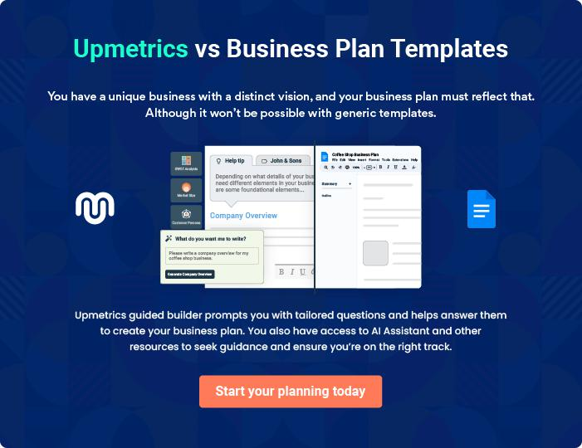
Products and Services

The product and services section of a sporting goods store business plan should describe the specific services and products that will be offered to customers. To write this section should include the following:
To unlock help try Upmetrics! 

 Help tip  Sporting Goods Store Business Plan

To craft the introduction for your "Products and Services" chapter, begin by positioning your business within its industry, emphasizing its unique strengths or value proposition.
To unlock help try Upmetrics! 

Start writing here..

 Help tip


Mention the sporting products & services your business will offer. This list may include:

• Sports equipment
To unlock help try Upmetrics! 

Products

Pro Soccer Ball


Price: [$30.00]

High-quality soccer ball designed for professional-level play and maximum durability.

Specifications

- Synthetic leather cover,

- latex bladder,

- size 5,

- FIFA approved.
Compression Running Shorts

Price: [$25.00]

Lightweight and breathable compression shorts designed to enhance performance and support muscles during runs

Specifications

- Polyester and spandex blend,

- moisture-wicking technology,

- available in sizes XS to XL.

Fitness Tracker Watch

Price: [$150.00]

Track your fitness goals and monitor your health with our advanced fitness tracker watch.

Specifications

- Heart rate monitor, GPS tracking,

- sleep tracking,

- water-resistant,

- compatible with iOS and Android.

Custom Basketball Jersey

Price: [$50.00] per jersey

Fully customizable basketball jerseys made with high-quality materials to ensure comfort and durability.

Specifications

- 100% polyester, available in sizes XS to XXL,

- customizable team logo,

- name,

- number.
Camping Tent

Price: [$200.00]

Spacious and durable camping tent designed to withstand various weather conditions, providing you with a comfortable shelter during your outdoor adventures.

Specifications

- 4-person capacity,

- waterproof,

- UV-resistant,

- easy setup design.

Kayak Rental

Price: [$50.00] per day

Rent one of our high-quality kayaks and explore the waters at your own pace.

Specifications

- Single-person kayak,

- paddle included,

- safety vest provided,

- rental duration is 24 hours.

Bike Tune-Up Service

Price: [$70.00]

Keep your bike in top condition with our comprehensive tune-up service, including adjustments, lubrication, and safety checks.

Specifications

- Includes gear adjustment,

- brake tuning,

- chain lubrication,

- tire pressure check,

- and safety inspection
Personal Training Session

Price: [$60.00] per hour

Work one-on-one with our certified personal trainers to reach your fitness goals faster and more effectively.

Specifications

- Certified personal trainers,

- customizable workout plans,

- available for all fitness levels,

- sessions are one hour long.

Quality Measures

 Help tip  Sporting Goods Store Business Plan

This section should explain how you maintain quality standards and consistently provide the highest quality products.
To unlock help try Upmetrics! 

Start writing here..

Additional Services

 Help tip  Sporting Goods Store Business Plan

Mention if your sporting goods company offers any additional services. You may include services like event organization & sponsorship, online resources & guides, etc.
To unlock help try Upmetrics! 

Start writing here..
Sales And Marketing Strategies

Writing the sales and marketing strategies section means a list of strategies you will use to attract and retain your clients.
To unlock help try Upmetrics! 

 Help Tip  Sporting Goods Store Business Plan


To create an effective introduction for your "Sales and Marketing Strategies" chapter, start by setting the stage within your specific industry or market.
To unlock help try Upmetrics! 

Start writing here..

Unique Selling Proposition (USP)

 Help tip  Sporting Goods Store Business Plan

Define your business’s USPs depending on the market you serve, the equipment you use, and the unique services you provide. Identifying USPs will help you plan your marketing strategies.
To unlock help try Upmetrics! 

Start writing here..

Pricing Strategy

 Help tip  Sporting Goods Store Business Plan

Describe your pricing strategy—how you plan to price your products and stay competitive in the local market. You can mention any discounts you plan on offering to attract new customers.
To unlock help try Upmetrics! 

Start writing here..

 Help tip  Sporting Goods Store Business Plan
To unlock help try Upmetrics!

Discuss your marketing strategies to market your services. You may include some of these marketing strategies in your business plan—social media marketing, influencer marketing, content marketing, etc.



Marketing strategies

Online


Social Media

Utilizing platforms such as [list of social media platforms] to connect with our audience, share promotions, and showcase our products.

Content Marketing

Creating valuable content like blogs, videos, and infographics to educate our customers and establish [ACE Sports and Outdoors] as a thought leader in the sporting goods industry.

Offline

Brochures

Detailed informational brochures available at our outlets and events.

Influencer Marketing

Partnering with [list of influencers or types of influencers] to increase brand awareness and credibility.

Print Marketing

Advertisements in [specific mediums, e.g., "local newspapers and industry magazines"].

Events

Participation in [specific events,

e.g., "industry trade shows and

local tech fairs"].

 Help tip  Sporting Goods Store Business Plan
To unlock help try Upmetrics!

Outline the strategies you’ll implement to maximize your sales. Your sales strategies may include partnering with other businesses, collaborations with sportspeople, offering referral programs, etc.



Sales strategies

Partner with Businesses

Collaborating with [list of partners or types of partners] to increase our market reach.

Exclusive Offers

Providing exclusive promotions and discounts to our loyal customers.

Referral Programs

Offering incentives for customers

who refer new business to us.

 Help tip  Sporting Goods Store Business Plan

Describe your customer retention strategies and how you plan to execute them. For instance, introducing loyalty programs, discounts & offers, personalized service, etc.
To unlock help try Upmetrics! 

Customer retention

Loyalty Programs

Rewarding repeat customers with discounts, points, or other incentives.

Customer Feedback

Actively seeking and implementing customer feedback to continually improve our products and services.

Personalized Service

Offering personalized

recommendations and services to

meet individual customer needs.

Operations Plan

 |  | When writing the operations plan section, it’s important to consider the
 |  | various aspects of your business operations.
 |  |  |  | To unlock help try Upmetrics! 
 Help tip |  |  Sporting Goods Store Business Plan


To create an effective introduction for your "Operational Plan" chapter, start by emphasizing the
pivotal role of efficient operations in the success of your business, underscoring how they
directly impact the quality of services delivered.
 |  |  |  | To unlock help try Upmetrics! 
Start writing here..
Staffing & Training
 Help tip |  |  Sporting Goods Store Business Plan

Mention your business’s staffing requirements, including the number of employees or sales associates needed.
To unlock help try Upmetrics! 

Start writing here..

Operational Process

 Help tip  Sporting Goods Store Business Plan

Outline the processes and procedures you will use to run your sporting goods business.

Your operational processes may include procurement & inventory management, product display
To unlock help try Upmetrics! 

Start writing here..

Equipment & Machinery
To unlock help try Upmetrics!

 Help tip  Sporting Goods Store Business Plan

Include the list of equipment and machinery required for sporting goods business, such as manufacturing equipment, maintenance & repair equipment, retail store equipment, fitness equipment, etc.



Start writing here..
Management Team

The management team section provides an overview of the individuals responsible for running your business plan.
To unlock help try Upmetrics! 

 Help tip  Sporting Goods Store Business Plan

To craft an introduction for your "Management Team" chapter, begin by emphasizing the crucial role of leadership in the success of any business.
To unlock help try Upmetrics! 

Start writing here..

Key managers

 Help tip  Sporting Goods Store Business Plan

Introduce your management and key members of your team, and explain their roles and responsibilities.
To unlock help try Upmetrics! 

Start writing here..


JOHN DOE

CEO & Co-founder - john.doe@example.com

As the CEO, John plays a crucial role in setting the strategic direction of the company.

With his vast experience and deep knowledge of the industry, he ensures that ACE Sports and Outdoors remain at the forefront of the sporting goods retail sector.


JANE DOE

Senior Manager - jane.doe@example.com

Education & Background: Jane has a Master’s degree in Management from Stanford University and has worked in the retail industry for over 10 years.

As a Senior Manager, Jane oversees the day-to-day operations of the store, ensuring everything runs smoothly and efficiently



ALICE BROWN

Operations Manager - alice.brown@example.com

Education & Background: Alice graduated with a degree in Operations Management from Harvard University and has been working in operations for 12 years.

Alice is responsible for managing the daily operations of ACE Sports and Outdoors.

She ensures that all business processes are efficient and effective, ultimately contributing to customer satisfaction


ROBERT BROWN

Customer Service Manager - robert.brown@example.com

Education & Background: Robert has a degree in Marketing from the University of Southern California and has been working in customer

Robert is tasked with managing customer inquiries and improving customer service procedures.

His role is vital in ensuring that customers have a positive experience with ACE Sports and Outdoors.
Organizational structure

 Help tip  Sporting Goods Store Business Plan

Explain the organizational structure of your management team. Include the reporting line and decision-making hierarchy.
To unlock help try Upmetrics! 

Start writing here..

Organization chart


John Doe

CEO


Alice Brown | Jane Doe
Operations | Jane Doe
Operations | Senior Manager
Manager | Senior Manager



William | Sarah Smith | Robert Brown | Emily White
Johnson | Sarah Smith | Robert Brown | Emily White
Johnson | Sarah Smith | Customer Service | Marketing
Inventory | Store Manager | Customer Service | Marketing
Inventory | Store Manager | Manager | Manager
Manager |  | Manager | Manager






Compensation plan

 Help tip  Sporting Goods Store Business Plan

Describe your compensation plan for the management and staff. Include their salaries, incentives, and other benefits.
To unlock help try Upmetrics! 

Start writing here..

 Help tip

Mentioning advisors or consultants in your business plans adds credibility to your business idea.
To unlock help try Upmetrics! 

Advisors/Consultants


DAVID WILSON

Financial Consultant - david.wilson@example.com

David assists us in making informed financial decisions, ensuring the long-term stability and profitability of the company.



EMMA TAYLOR

Business Development Advisor - emma.taylor@example.com

Emma provides invaluable advice on business development and strategy, helping ACE Sports and Outdoors expand its market presence.

Financial Plan

When writing the financial plan section of a business plan, it’s important to provide a comprehensive overview of your financial projections for the first few years of your business, You may provide the following:
To unlock help try Upmetrics! 

 Help tip  Sporting Goods Store Business Plan


To create an effective introduction for your "Financial Plan" chapter, begin by stressing the critical role of a well-structured financial plan in the success of your venture.
To unlock help try Upmetrics! 

Start writing here..

 Help tip  Sporting Goods Store Business Plan

Describe details such as projected revenue, operational costs, and service costs in your projected profit and loss statement. Make sure to include your business’s expected net profit or loss.
To unlock help try Upmetrics! 

Profit & loss statement

Revenue

Cost Of Sales

General Costs

Revenue Specific Costs

Personnel Costs (Direct

Labor)

Gross Margin

Gross Margin (%)

Operating Expense

Payroll Expense

(Indirect Labor)

General Expense

Bad Debt

Amortization of Current

Assets

2023-24 | 2024-25 | 2025-26 | 2026-27 | 2027-28
$0 | $0 | $0 | $0 | $0

$0 | $0 | $0 | $0 | $0
$0 | $0 | $0 | $0 | $0
$0 | $0 | $0 | $0 | $0
$0 | $0 | $0 | $0 | $0

$0 | $0 | $0 | $0 | $0
0% | 0% | 0% | 0% | 0%

$0 | $0 | $0 | $0 | $0
$0 | $0 | $0 | $0 | $0
$0 | $0 | $0 | $0 | $0
$0 | $0 | $0 | $0 | $0
$0 | $0 | $0 | $0 | $0

EBITDA

Additional Expense

Long Term

Depreciation

Gain or loss from Sale

of Assets

EBIT

Interest Expenses

EBT

Income Tax Expense

Total Expense

Net Income

Net Income (%)

2023-24 | 2024-25 | 2025-26 | 2026-27 | 2027-28
$0 | $0 | $0 | $0 | $0
$0 | $0 | $0 | $0 | $0
$0 | $0 | $0 | $0 | $0
$0 | $0 | $0 | $0 | $0
$0 | $0 | $0 | $0 | $0
$0 | $0 | $0 | $0 | $0
$0 | $0 | $0 | $0 | $0
$0 | $0 | $0 | $0 | $0
$0 | $0 | $0 | $0 | $0
$0 | $0 | $0 | $0 | $0
0% | 0% | 0% | 0% | 0%

 |  |  | 2023-24 |  | 2024-25 | 2025-26
Retained Earning |  |  | $0 |  | $0 | $0
Opening |  |  | $0 |  | $0 | $0
Owner's Distribution |  |  | $0 |  | $0 | $0
Retained Earning |  |  | $0 |  | $0 | $0
Closing |  |  |  |  | $0 | $0
 Help tip |  |  |  Sporting Goods Store Business Plan


The cash flow for the first few years of your operation should be estimated and described in this section.

This may include billing invoices, payment receipts, loan payments, and any other cash flow statements.
2026-27 2027-28

$0 $0

$0 $0

$0 $0

To unlock help try Upmetrics! 

Cash flow statement

 | 2023-24 | 2024-25 | 2025-26 | 2026-27 | 2027-28
Cash Received | $0 | $0 | $0 | $0 | $0
Cash Paid | $0 | $0 | $0 | $0 | $0
COS & General Expenses | $0 | $0 | $0 | $0 | $0
Salary & Wages | $0 | $0 | $0 | $0 | $0
Interest | $0 | $0 | $0 | $0 | $0

Sales Tax

Income Tax

Net Cash From

Operations

Assets Sell

Assets Purchase

Net Cash From

Investments

Amount Received

Loan Received

Common Stock

Preferred Stock

Owner's Contribution

Amount Paid

2023-24 | 2024-25 | 2025-26 | 2026-27 | 2027-28
$0 | $0 | $0 | $0 | $0
$0 | $0 | $0 | $0 | $0
$0 | $0 | $0 | $0 | $0

$0 | $0 | $0 | $0 | $0
$0 | $0 | $0 | $0 | $0
$0 | $0 | $0 | $0 | $0

$0 | $0 | $0 | $0 | $0
$0 | $0 | $0 | $0 | $0

$0 | $0 | $0 | $0 | $0
$0 | $0 | $0 | $0 | $0
$0 | $0 | $0 | $0 | $0

Loan Capital $0 $0 $0 $0 $0

 |  |  | 2023-24 |  | 2024-25 | 2025-26 | 2026-27 | 2027-28
Dividends & Distributions |  |  | $0 |  | $0 | $0 | $0 | $0
Net Cash From |  |  | $0 |  | $0 | $0 | $0 | $0
Financing
Summary
Starting Cash |  |  | $0 |  | $0 | $0 | $0 | $0
Cash In |  |  | $0 |  | $0 | $0 | $0 | $0
Cash Out |  |  | $0 |  | $0 | $0 | $0 | $0
Change in Cash |  |  | $0 |  | $0 | $0 | $0 | $0
Ending Cash |  |  | $0 |  | $0 | $0 | $0 | $0
 Help tip |  |  Sporting Goods Store Business Plan

Create a projected balance sheet documenting your sporting goods business’s assets, liabilities, and equity.

To unlock help try Upmetrics! 

Balance sheet

 | 2023-24 | 2024-25 | 2025-26 | 2026-27 | 2027-28
Assets | $0 | $0 | $0 | $0 | $0
Current Assets | $0 | $0 | $0 | $0 | $0
Cash | $0 | $0 | $0 | $0 | $0
Accounts Receivable | $0 | $0 | $0 | $0 | $0
Inventory | $0 | $0 | $0 | $0 | $0
Other Current Assets | $0 | $0 | $0 | $0 | $0
Long Term Assets | $0 | $0 | $0 | $0 | $0
Gross Long Term Assets | $0 | $0 | $0 | $0 | $0
Accumulated Depreciation | $0 | $0 | $0 | $0 | $0

Liabilities & Equity | $0 | $0 | $0 | $0 | $0
Liabilities | $0 | $0 | $0 | $0 | $0
Current Liabilities | $0 | $0 | $0 | $0 | $0
Accounts Payable | $0 | $0 | $0 | $0 | $0
Income Tax Payable | $0 | $0 | $0 | $0 | $0
Sales Tax Payable | $0 | $0 | $0 | $0 | $0
Short Term Debt | $0 | $0 | $0 | $0 | $0
 | 2023-24 | 2024-25 | 2025-26 | 2026-27 | 2027-28
Long Term Liabilities | $0 | $0 | $0 | $0 | $0
Long Term Debt | $0 | $0 | $0 | $0 | $0
Equity | $0 | $0 | $0 | $0 | $0
Paid-in Capital | $0 | $0 | $0 | $0 | $0
Common Stock | $0 | $0 | $0 | $0 | $0
Preferred Stock | $0 | $0 | $0 | $0 | $0
Owner's Contribution | $0 | $0 | $0 | $0 | $0
Retained Earnings | $0 | $0 | $0 | $0 | $0

Check | $0 | $0 | $0 | $0 | $0

Break-even Analysis

 Help tip  Sporting Goods Store Business Plan

Determine and mention your business’s break-even point—the point at which your business costs and revenue will be equal.

This exercise will help you understand how much revenue you need to generate to sustain or be profitable.

To unlock help try Upmetrics! 

Start writing here..

 | 2023-24 | 2024-25 | 2025-26 | 2026-27 | 2027-28
Starting Revenue | $0 | $0 | $0 | $0 | $0
Net Revenue | $0 | $0 | $0 | $0 | $0
Closing Revenue | $0 | $0 | $0 | $0 | $0

Starting Expense | $0 | $0 | $0 | $0 | $0
Net Expense | $0 | $0 | $0 | $0 | $0
Closing Expense | $0 | $0 | $0 | $0 | $0

Is Break Even? | 0 | 0 | 0 | 0 | 0
Break Even Month | 0 | 0 | 0 | 0 | 0
Days Required | 0 | 0 | 0 | 0 | 0
Break Even Revenue | $0 | $0 | $0 | $0 | $0
Break Even Units
Financing needs

 Help tip  Sporting Goods Store Business Plan

Calculate costs associated with starting a sporting goods business, and estimate your financing needs and how much capital you need to raise to operate your business.
To unlock help try Upmetrics! 

Start writing here..
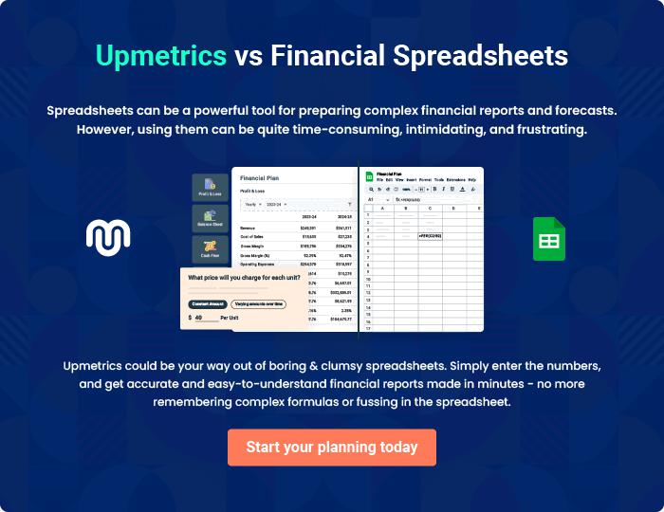
Appendix

When writing the appendix section, you should include any additional information that supports the main content of your plan. This may include financial statements, market research data, legal documents, and other
To unlock help try Upmetrics! 

Create a winning business plan that gets you funded

Creating a stunning and investment-ready plan requires no writing, graphic designing, or financial planning expertise.

Upmetrics has all the features required to help you create a comprehensive business plan—from start to finish. Make no mistakes, it’s the modern way of planning to structure ideas, make plans, and create stunning pitch decks to awe investors.

Pitch decks that impress investors

Create pitch decks that provide a visual representation of your business, engage investors, and make them want to invest in your business idea.

Interactive plans in no time

Import business plan sections like—SWOT analysis, comparison tables, and others to create an interactive business plan. No designing skills are required.

Stunning cover page designs

With Upmetrics, you have the liberty to choose from multiple stunning cover page designs. Choose a creative design and make your plan stand out.

Online sharing made simple

Upmetrics makes online sharing quick and easier for users. Easily share your business plans with a link while tracking reader activity.

500+ sample business plans

Simply import a template from our library of sample plans into the editor and start customizing it to make it yours. It takes only a few clicks to get started.

Collaborate with team in real-time

Invite team members, initiate conversations, discuss ideas & strategies, share feedback, and work on a business plan in real-time.

