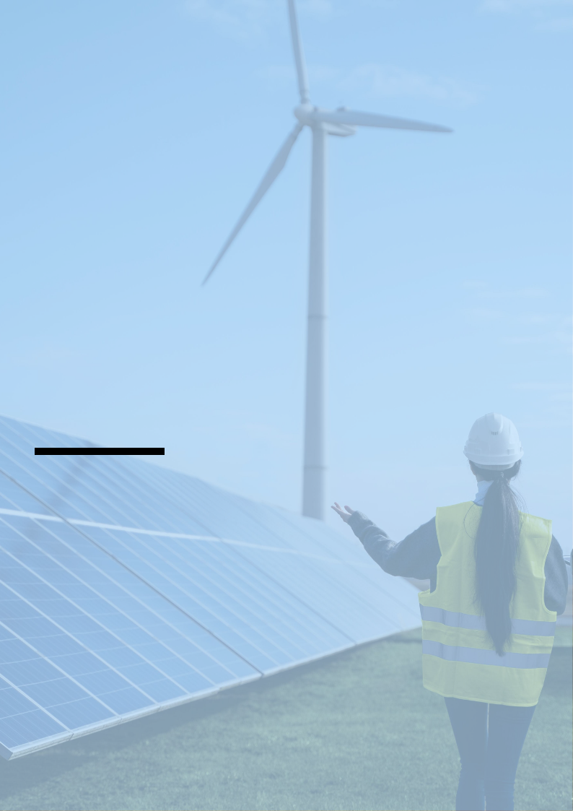
Solar Panel Business Plan

Harnessing Sunshine, Powering Tomorrow

BUSINESS PLAN

2023

John Doe | 10200 Bolsa Ave, Westminster, CA, 92683 | (650) 359-3153 | info@example.com
http://www.example.com

Information provided in this business plan is unique to this business and confidential; therefore, anyone reading this plan agrees not to disclose any of the information in this business plan without prior written permission of the company.
Table of Contents

Executive Summary | 6
Market opportunity | 6
Services Offered | 6
Marketing & Sales Strategies | 7
Financial Highlights | 7
Units Sold v/s Revenue | 8

Company Overview | 9
Ownership | 9
Business Owners | 9
Mission statement | 10
Business history | 10
Future goals | 10

Market Analysis | 11
Target Market | 11
Market size and growth potential | 11
Market Size | 12
Competitive analysis | 12
SolarCity (now part of Tesla Energy) | 12
Vivint Solar | 13
Sunrun | 13
Market trends | 13
Regulatory environment | 14

Products and Services | 15
Services | 15
Monocrystalline Solar Panels | 15
Polycrystalline Solar Panels | 16
Installation Service | 16
Consultation and Site Assessment | 16
System Design | 17
Repair and Maintenance Package | 17
Quality Measures | 17
Additional Services | 18

Sales And Marketing Strategies | 19
Unique Selling Proposition (USP) | 19
Pricing Strategy | 19
Marketing strategies | 20
Online | 20
Offline | 20
Sales strategies | 21
Customer retention | 21

Operations Plan | 22
Staffing & Training | 22
Operational Process | 22
Equipment & Machinery | 23

Management Team | 24
Key managers | 24
John Doe | 24
Jane Doe | 25
Robert Brown | 25
Emily White | 25
Michael Green | 25
Rachel Blue | 26
Organizational structure | 26
Organization chart | 27
Compensation plan | 27
Advisors/Consultants | 28
Dr.Alan Gray | 28
Ms. Laura Stone | 28
Financial Plan | 29
Profit & loss statement | 29
Cash flow statement | 32
Balance sheet | 34
Break-even Analysis | 36
Financing needs | 38
Appendix
Appendix | 40
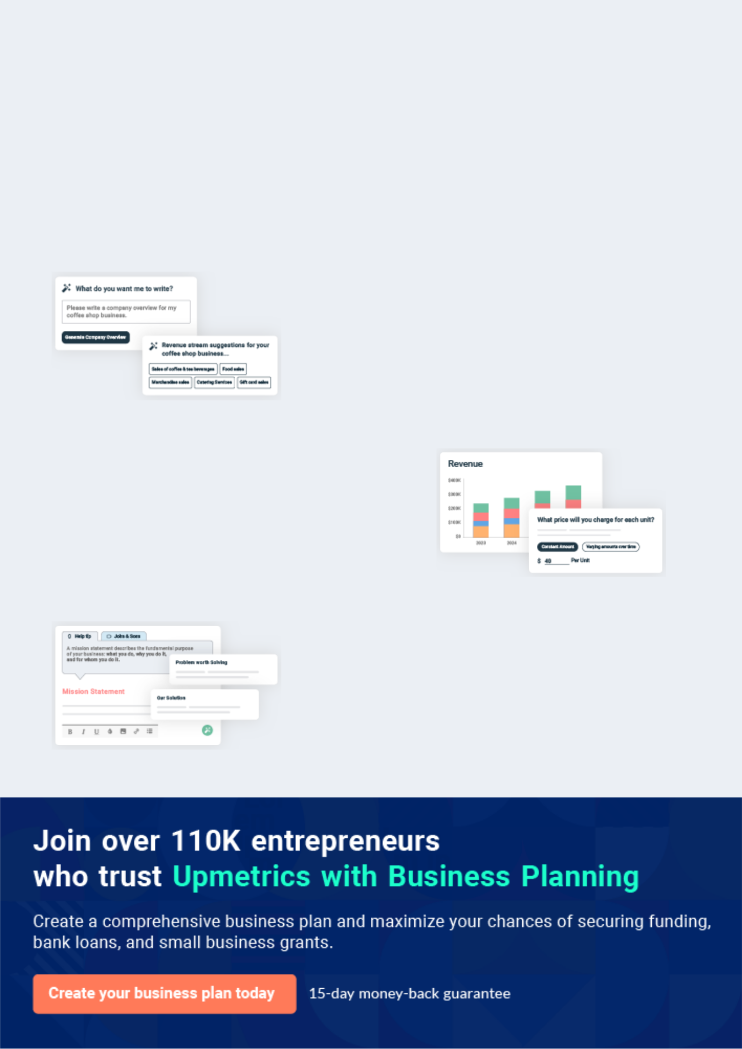
Business planning that’s simpler and faster than you think

Creating a business plan using Upmetrics to start and grow a business is literally the easiest thing in the World. Simply read the instructions and fill in the blanks. It’s as simple as that.

❛ | Upmetrics has everything you need to create a | ❜
❛ | comprehensive business plan. | ❜

AI-powered Upmetrics Assistant

AI-powered insights to streamline your plan

Not sure where to start? Upmetrics’ AI Assistant will automatically generate ideas for each section of your plan and offer improved versions of your writing, adjusting for tone, voice, and grammar or spelling errors.

Financial Forecasting Tool

All the financials are calculated for you

Forget the complex formulas and clumsy spreadsheets — with automatic financials and drag-and-drop forecasting, you can finish your plan faster and be confident that your numbers are accurate.

Business Plan Builder

Guides you like a business mentor

Upmetrics’ step-by-step instructions, prompts, and the library of 400+ sample business plans will guide you through each section of your plan as a business mentor.
Executive Summary


An executive summary is the first section of the business plan intended to provide an overview of the whole business plan.
To unlock help try Upmetrics! 

 Help tip  Solar Panel Business Plan


Start your executive summary by briefly introducing your business to your readers.

This section may include the name of your solar panel business, its location, when it was
To unlock help try Upmetrics! 

Start writing here..

Market opportunity

 Help tip  Solar Panel Business Plan

Summarize your market research, including market size, growth potential, and marketing trends. Highlight the opportunities in the market and how your business will fit in to fill the gap.
To unlock help try Upmetrics! 

Start writing here..

Services Offered

 Help tip  Solar Panel Business Plan

Highlight the solar panel services you offer your clients. The USPs and differentiators you offer are always a plus.
To unlock help try Upmetrics! 

Start writing here..

Marketing & Sales Strategies
To unlock help try Upmetrics!

 Help tip  Solar Panel Business Plan

Outline your sales and marketing strategies—what marketing platforms you use, how you plan on acquiring customers, etc.
To unlock help try Upmetrics! 

Start writing here..

Financial Highlights

 Help tip  Solar Panel Business Plan

Briefly summarize your financial projections for the initial years of business operations. Include any capital or investment requirements, associated startup costs, projected revenues, and profit forecasts.



Start writing here..
Units Sold v/s Revenue
To unlock help try Upmetrics!

 |  | Units Sold | Revenue
15.00k
10.00k
5.00k
0
Year 1 | Year 2 | Year 3
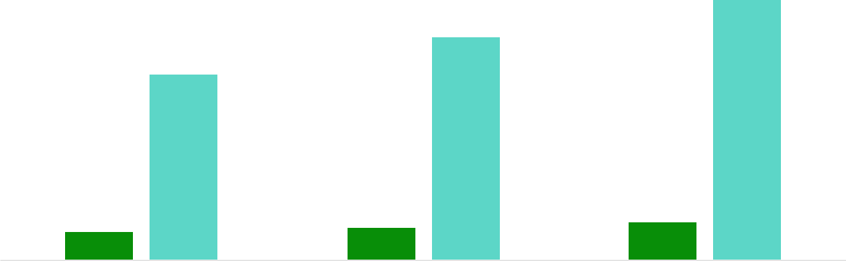

Financial Year |  |  | Units Sold | Revenue
Year 1 | 1,550 |  |  | $10,000
Year 2 | 1,800 |  |  | $12,000
Year 3 | 2,050 |  |  | $14,000
 Help tip |  |  Solar Panel Business Plan


After giving a brief about your business plan, end your summary with a call to action, for example; inviting potential investors or readers to the next meeting if they are interested in your business.



Write a call to action for your business plan.
Company Overview

Depending on what details of your business are essential, you’ll need different elements in your business overview.
To unlock help try Upmetrics! 

 Help tip  Solar Panel Business Plan

Describe your business in this section by providing all the basic information:

Describe what kind of solar panel company you run and the name of it. You may specialize in
To unlock help try Upmetrics! 

Start writing here..

Ownership

 Help tip  Solar Panel Business Plan

List the names of your solar panel company’s founders or owners. Describe what shares they own and their responsibilities for efficiently managing the business.
To unlock help try Upmetrics! 

Start writing here..

Business Owners



60% John Doe



40% Jane Doe
Mission statement

 Help tip  Solar Panel Business Plan

Summarize your business’ objective, core principles, and values in your mission statement. This statement needs to be memorable, clear, and brief.
To unlock help try Upmetrics! 

❛ Our mission at [SunPower Solutions] is to empower communities with sustainable energy solutions, ensuring a brighter, cleaner future.

We are dedicated to delivering unparalleled service and products that stand the test of time, reflecting our core values of integrity, innovation, and excellence.

❜

Business history

 Help tip  Solar Panel Business Plan

If you’re an established solar panel service provider, briefly describe your business history, like— when it was founded, how it evolved over time, etc.
To unlock help try Upmetrics! 

Start writing here..

Future goals

 Help tip  Solar Panel Business Plan

It’s crucial to convey your aspirations and vision. Mention your short-term and long-term goals; they can be specific targets for revenue, market share, or expanding your services.
To unlock help try Upmetrics! 

Start writing here..

Market Analysis
To unlock help try Upmetrics!


 |  | Market analysis provides a clear understanding of the market in which your
 |  | printing business will run along with the target market, competitors, and
 |  | growth opportunities.
 |  |  |  | To unlock help try Upmetrics! 
 Help tip |  |  Solar Panel Business Plan

To write the introduction section of your market analysis, start by clearly identifying your primary target market.
To unlock help try Upmetrics! 

Start writing here..

Target Market

 Help tip  Solar Panel Business Plan

Start this section by describing your target market. Define your ideal customer and explain what types of services they prefer. Creating a buyer persona will help you easily define your target market to your readers.



Start writing here..

Market size and growth potential

 Help tip  Solar Panel Business Plan

Describe your market size and growth potential and whether you will target a niche or a much broader market.
To unlock help try Upmetrics! 

Start writing here..

Market Size

Available Market | 50M
Total potential customers seeking solar | 50M
solutions. | 50M
Served Market | 15M
Customers in regions we can realistically | 15M
serve.


Target Market | 5M
Home and business owners we aim to | 5M
serve. | 5M

 Help tip  Solar Panel Business Plan

dentify and analyze your direct and indirect competitors. Identify their strengths and weaknesses, and describe what differentiates your solar panel services from them.
To unlock help try Upmetrics! 

Competitive analysis

SolarCity (now part of Tesla Energy)

SolarCity is a prominent player in the solar panel industry, known for its innovative solutions and wide range of products, including solar panels, solar roofs, and energy storage systems.

Features

Solar panels and solar roofs for residential and commercial properties.

Energy storage solutions, including the Tesla Powerwall.

Comprehensive installation and maintenance services.

Strengths Weaknesses

Strong brand recognition and Higher pricing compared to

association with Tesla. competitors.

Wide range of products Customer complaints regarding

catering to diverse customer installation and customer

needs. service.

Extensive geographic coverage

with a strong presence across

the United States.

Vivint Solar
To unlock help try Upmetrics!

Vivint Solar is a well-established solar panel installation company that focuses on providing customized solar energy solutions for homeowners.

Features

Customized solar panel installation for residential properties.

Energy monitoring and maintenance services.

Various financing options, including solar leases and power purchase agreements.

Strengths

Customized solutions tailored to individual customer needs.

A user-friendly app that allows customers to monitor their energy consumption.

Various financing options to make solar energy more accessible.

Weaknesses

Limited to residential installations, missing out on the commercial market.

Limited to residential installations, missing out on the commercial market.

Less geographic coverage compared to competitors like SolarCity.

Sunrun

Sunrun is a leading provider of residential solar panel installations, offering a range of products and services designed to make solar energy more accessible to homeowners.

Features Strengths

Solar panel installations for Strong focus on the residential

residential properties. market with tailored solutions.

Energy storage solutions, Wide range of financing

including the Brightbox battery options, including leases, PPAs,

system. and loans.

Comprehensive maintenance User-friendly online platform

and support services. for customer support and

service requests.

Weaknesses

Limited to residential installations, missing out on the commercial sector.

Less brand recognition compared to competitors like SolarCity.

Market trends

 Help tip  Solar Panel Business Plan

Analyze emerging trends in the industry, such as technology disruptions like virtual site assessments, smart energy management, Integrated photovoltaics, etc. Explain how your business will cope with all the trends.



Start writing here..

Regulatory environment

 Help tip  Solar Panel Business Plan

List regulations and licensing requirements that may affect your solar panel company, such as business registration, electrical contracting licenses, installation and inspection permits, solar-specific certifications, environmental regulations, state and federal regulations, etc.
To unlock help try Upmetrics! 

Start writing here..
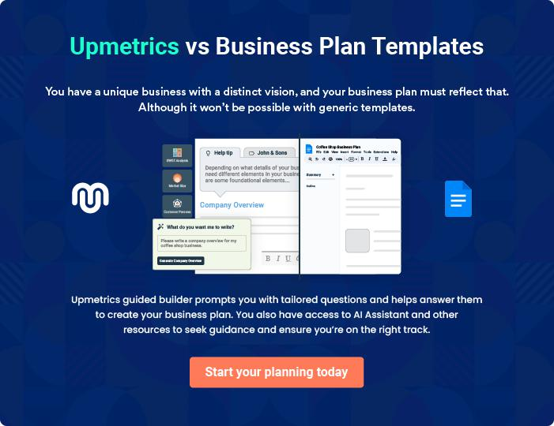
Products and Services
To unlock help try Upmetrics!

The product and services section of a solar panel business plan should describe the specific services and products that will be offered to customers. To write this section should include the following:



 Help tip  Solar Panel Business Plan

To craft the introduction for your "Products and Services" chapter, begin by positioning your business within its industry, emphasizing its unique strengths or value proposition.
To unlock help try Upmetrics! 

Start writing here..

 Help tip


Mention the solar panel services your business will offer. This list may include services like,

• Installation
To unlock help try Upmetrics! 

Services

Monocrystalline Solar Panels
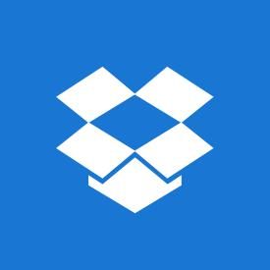

Price: [$0.65] per watt

Premium solar panels made from single-crystal silicon, providing maximum efficiency and sleek aesthetics.

Specifications

- Efficiency: 20-25%

- Warranty: 25 years

- Color: Black

- Performance in low-light: Excellent
Polycrystalline Solar Panels

Price: [$0.50] per watt

Cost-effective solar panels made from multiple crystalline structures, known for their blue tint.

Specifications

- Efficiency: 15-20%

- Warranty: 25 years

- Color: Blue

- Performance in low-light: Good

Installation Service

Price: [$1.50] per watt

Comprehensive installation services ensuring optimal positioning for maximum sunlight absorption.

Specifications

- Time frame: 1-3 days depending on project size

- Warranty: 10 years

- Customer support: 24/7 hotline

Consultation and Site Assessment

Price: [$250] per session

Professional consultation to analyze the site and recommend the most suitable solar solution.

Specifications

- Duration: 1-2 hours

- Deliverables: Detailed assessment report and recommended solution

- Follow-up support: Available
System Design

Price: Starting at [$500]

Custom solar system design tailored to the specific needs of the client.

Specifications

- Customization: Fully tailored to client's energy consumption patterns

- Warranty: 10 years

- Maintenance: Optional annual check-ups

Repair and Maintenance Package

Price: [$200] per year

Annual check-ups and repair services to ensure peak performance of the solar panels.

Specifications

- Frequency: Annual check-ups or as needed

- Repairs: Included in the package

- Customer support: 24/7 hotline

Quality Measures

 Help tip  Solar Panel Business Plan

This section should explain how you maintain quality standards and consistently provide the highest quality service.
To unlock help try Upmetrics! 

Start writing here..

Additional Services

 Help tip  Solar Panel Business Plan

Mention if your solar panel company offers any additional services. You may include services like solar panel financing, lifetime support, smart home energy-efficient services, etc.
To unlock help try Upmetrics! 

Start writing here..
Sales And Marketing Strategies

Writing the sales and marketing strategies section means a list of strategies you will use to attract and retain your clients.
To unlock help try Upmetrics! 

 Help Tip  Solar Panel Business Plan


To create an effective introduction for your "Sales and Marketing Strategies" chapter, start by setting the stage within your specific industry or market.
To unlock help try Upmetrics! 

Start writing here..

Unique Selling Proposition (USP)

 Help tip  Solar Panel Business Plan

Define your business’s USPs depending on the market you serve, the equipment you use, and the unique services you provide. Identifying USPs will help you plan your marketing strategies.
To unlock help try Upmetrics! 

Start writing here..

Pricing Strategy

 Help tip  Solar Panel Business Plan

Describe your pricing strategy—how you plan to price your solar panel services and stay competitive in the local market.
To unlock help try Upmetrics! 

Start writing here..

 Help tip  Solar Panel Business Plan

Discuss your marketing strategies to market your services. You may include some of these marketing strategies in your business plan—social media marketing, Google ads, brochures,
email marketing, content marketing, print marketing in trade magazines, networking events, etc.
To unlock help try Upmetrics! 

Marketing strategies

Online


Social Media

Utilize platforms like Facebook, Instagram, and LinkedIn to showcase our products, share customer success stories, and engage with potential customers.

Content Marketing

Develop informative content such as blog posts, e-books, and videos to educate our audience about the benefits of solar energy.

Offline

Print Marketing

Advertise in trade magazines and local newspapers to reach a wider audience.

Google Ads

Invest in Google Ads to increase online visibility and drive traffic to our website.

Networking Events

Participate in industry conferences, seminars, and local community events to build relationships and generate leads.

 Help tip  Solar Panel Business Plan
To unlock help try Upmetrics!

Outline the strategies you’ll implement to maximize your sales. Your sales strategies may include direct sales calls, consultative selling, partnering with home builders, real estate agencies and relevant businesses, offering referral programs, etc.



Sales strategies

Partner with Businesses

Forge partnerships with home builders, real estate agencies, and other relevant businesses to generate leads and expand our customer base.

Consultative Selling

Employ a consultative approach to understand customer needs and recommend tailored solutions.

Referral Programs Direct Sales Calls

Implement referral programs to incentivize current customers to refer new clients.

Proactive outreach to potential customers to introduce our products and services.

 Help tip  Solar Panel Business Plan

Describe your customer retention strategies and how you plan to execute them. For instance, offering lifetime support, annual maintenance services, referral bonuses, etc.
To unlock help try Upmetrics! 

Customer retention

Lifetime Support

Offering lifetime support to address any customer queries or issues.

Annual Maintenance Services

Providing annual maintenance services to ensure the optimal performance of our solar panels.

Referral Bonuses

Rewarding customers for referring

new clients, thereby fostering

loyalty and repeat business.

Operations Plan
To unlock help try Upmetrics!

 |  | When writing the operations plan section, it’s important to consider the
 |  | various aspects of your business operations.
 |  |  |  | To unlock help try Upmetrics! 
 Help tip |  |  Solar Panel Business Plan


To create an effective introduction for your "Operational Plan" chapter, start by emphasizing the
pivotal role of efficient operations in the success of your business, underscoring how they
directly impact the quality of services delivered.
 |  |  |  | To unlock help try Upmetrics! 
Start writing here..
Staffing & Training
 Help tip |  |  Solar Panel Business Plan

Mention your solar panel business’s staffing requirements, including the number of employees needed. Include their qualifications, the training required, and the duties they will perform.
To unlock help try Upmetrics! 

Start writing here..

Operational Process

 Help tip  Solar Panel Business Plan

Outline the processes and procedures you will use to run your solar panel business. Your operational processes may include performing installation, maintaining solar panels, processing paperwork, site assessments, and writing grants.



Start writing here..

Equipment & Machinery
To unlock help try Upmetrics!

 Help tip  Solar Panel Business Plan

Include the list of equipment and machinery required for the solar panel business, such as manufacturing and installation equipment, testing and maintenance machinery, transport vehicles, office equipment, etc.



Start writing here..
Management Team

The management team section provides an overview of the individuals responsible for running your business plan.
To unlock help try Upmetrics! 

 Help tip  Solar Panel Business Plan

To craft an introduction for your "Management Team" chapter, begin by emphasizing the crucial role of leadership in the success of any business.
To unlock help try Upmetrics! 

Start writing here..

Key managers

 Help tip  Solar Panel Business Plan

Introduce your management and key members of your team, and explain their roles and responsibilities.
To unlock help try Upmetrics! 

Start writing here..


JOHN DOE

CEO & Co-founder - john.doe@example.com

John holds an MBA in Sustainable Energy from Harvard University.

With over 15 years of experience in the solar industry, he has successfully led several major projects and has a proven track record of driving business growth.


Before founding [SunPower Solutions], John worked with major solar companies in the US, developing innovative solutions that significantly reduced energy costs for clients.

JANE DOE

Chief Operating Officer (COO) - jane.doe@example.com

Jane earned her Masters in Environmental Engineering from MIT.

She brings 12 years of diverse experience in the solar industry, having worked in both the technical and managerial aspects of the business.


Her deep understanding of solar panel technologies and project management skills are invaluable to our daily operations.


ROBERT BROWN

CMO - robert.brown@example.com

With a Bachelor’s degree in Marketing from Stanford University, Robert has spent the past 10 years crafting marketing strategies for renewable energy companies.

His innovative approach and in-depth knowledge of the market dynamics have significantly improved brand visibility and revenue for the businesses he’s worked with.


EMILY WHITE

Operations Manager - emily.white@example.com

Emily graduated with a Bachelor’s in Business Management from UCLA.

She has been a part of [SunPower Solutions] for 8 years, and her proficiency in project management, procurement, and logistics has streamlined our operational processes, ensuring timely delivery of services to our clients.


MICHAEL GREEN

Sales Manager - michael.green@example.com

Michael brings over 7 years of specialized experience in solar panel sales.

His strong interpersonal skills and strategic sales planning have consistently exceeded sales targets, bringing substantial revenue to the companies he’s worked with.

RACHEL BLUE

Finance Manager - rachel.blue@example.com

Rachel, a CPA, graduated from the University of Chicago with a major in Accounting.

She has 9 years of experience managing finances for various companies in the renewable energy sector.

Her expertise lies in financial planning, budgeting, and ensuring fiscal responsibility throughout the organization.

Organizational structure

 Help tip  Solar Panel Business Plan

Explain the organizational structure of your management team. Include the reporting line and decision-making hierarchy.
To unlock help try Upmetrics! 

Start writing here..
Organization chart


John Doe

CEO


Rachel Blue

Jane Doe

Robert Brown

Finance Manager



COO


CMO

Michael Green

Emily White

Sales Manager

Operations Manager

Compensation plan

 Help tip  Solar Panel Business Plan

Describe your compensation plan for the management and staff. Include their salaries, incentives, and other benefits.
To unlock help try Upmetrics! 

Start writing here..

 Help tip

Mentioning advisors or consultants in your business plans adds credibility to your business idea.
To unlock help try Upmetrics! 

Advisors/Consultants


DR.ALAN GRAY

Solar Technology Advisor

With over [20] years in solar research and development, Dr. Gray provides us with insights into emerging solar technologies and innovations.


MS. LAURA STONE

Business Strategy Consultant

Laura, boasting a solid [18] years in business strategy and renewable energy, guides our expansion and partnership endeavors, ensuring our growth is sustainable and profitable.
Financial Plan

When writing the financial plan section of a business plan, it’s important to provide a comprehensive overview of your financial projections for the first few years of your business, You may provide the following:
To unlock help try Upmetrics! 

 Help tip  Solar Panel Business Plan


To create an effective introduction for your "Financial Plan" chapter, begin by stressing the critical role of a well-structured financial plan in the success of your venture.
To unlock help try Upmetrics! 

Start writing here..

 Help tip  Solar Panel Business Plan

Describe details such as projected revenue, operational costs, and service costs in your projected profit and loss statement. Make sure to include your business’s expected net profit or loss.
To unlock help try Upmetrics! 

Profit & loss statement

Revenue

Cost Of Sales

General Costs

Revenue Specific Costs

Personnel Costs (Direct

Labor)

Gross Margin

Gross Margin (%)

Operating Expense

Payroll Expense

(Indirect Labor)

General Expense

Bad Debt

Amortization of Current

Assets

2023-24 | 2024-25 | 2025-26 | 2026-27 | 2027-28
$0 | $0 | $0 | $0 | $0

$0 | $0 | $0 | $0 | $0
$0 | $0 | $0 | $0 | $0
$0 | $0 | $0 | $0 | $0
$0 | $0 | $0 | $0 | $0

$0 | $0 | $0 | $0 | $0
0% | 0% | 0% | 0% | 0%

$0 | $0 | $0 | $0 | $0
$0 | $0 | $0 | $0 | $0
$0 | $0 | $0 | $0 | $0
$0 | $0 | $0 | $0 | $0
$0 | $0 | $0 | $0 | $0

EBITDA

Additional Expense

Long Term

Depreciation

Gain or loss from Sale

of Assets

EBIT

Interest Expenses

EBT

Income Tax Expense

Total Expense

Net Income

Net Income (%)

2023-24 | 2024-25 | 2025-26 | 2026-27 | 2027-28
$0 | $0 | $0 | $0 | $0
$0 | $0 | $0 | $0 | $0
$0 | $0 | $0 | $0 | $0
$0 | $0 | $0 | $0 | $0
$0 | $0 | $0 | $0 | $0
$0 | $0 | $0 | $0 | $0
$0 | $0 | $0 | $0 | $0
$0 | $0 | $0 | $0 | $0
$0 | $0 | $0 | $0 | $0
$0 | $0 | $0 | $0 | $0
0% | 0% | 0% | 0% | 0%
 |  |  | 2023-24 |  | 2024-25 | 2025-26 | 2026-27 | 2027-28
Retained Earning |  |  | $0 |  | $0 | $0 | $0 | $0
Opening
Owner's Distribution |  |  | $0 |  | $0 | $0 | $0 | $0
Retained Earning |  |  | $0 |  | $0 | $0 | $0 | $0
Closing
 Help tip |  |  |  Solar Panel Business Plan


The cash flow for the first few years of your operation should be estimated and described in this section. This may include billing invoices, payment receipts, loan payments, and any other cash flow statements.
To unlock help try Upmetrics! 

Cash flow statement

 | 2023-24 | 2024-25 | 2025-26 | 2026-27 | 2027-28
Cash Received | $0 | $0 | $0 | $0 | $0
Cash Paid | $0 | $0 | $0 | $0 | $0
COS & General Expenses | $0 | $0 | $0 | $0 | $0
Salary & Wages | $0 | $0 | $0 | $0 | $0
Interest | $0 | $0 | $0 | $0 | $0

Sales Tax

Income Tax

Net Cash From

Operations

Assets Sell

Assets Purchase

Net Cash From

Investments

Amount Received

Loan Received

Common Stock

Preferred Stock

Owner's Contribution

Amount Paid

2023-24 | 2024-25 | 2025-26 | 2026-27 | 2027-28
$0 | $0 | $0 | $0 | $0
$0 | $0 | $0 | $0 | $0
$0 | $0 | $0 | $0 | $0

$0 | $0 | $0 | $0 | $0
$0 | $0 | $0 | $0 | $0
$0 | $0 | $0 | $0 | $0

$0 | $0 | $0 | $0 | $0
$0 | $0 | $0 | $0 | $0

$0 | $0 | $0 | $0 | $0
$0 | $0 | $0 | $0 | $0
$0 | $0 | $0 | $0 | $0

Loan Capital $0 $0 $0 $0 $0

 |  |  | 2023-24 | 2024-25 | 2025-26 | 2026-27 | 2027-28
Dividends & Distributions |  |  | $0 | $0 | $0 | $0 | $0
Net Cash From |  |  | $0 | $0 | $0 | $0 | $0
Financing
Summary
Starting Cash |  |  | $0 | $0 | $0 | $0 | $0
Cash In |  |  | $0 | $0 | $0 | $0 | $0
Cash Out |  |  | $0 | $0 | $0 | $0 | $0
Change in Cash |  |  | $0 | $0 | $0 | $0 | $0
Ending Cash |  |  | $0 | $0 | $0 | $0 | $0
 Help tip |  |  Solar Panel Business Plan

Create a projected balance sheet documenting your solar panel business’s assets, liabilities, and equity.

To unlock help try Upmetrics! 

Balance sheet

 | 2023-24 | 2024-25 | 2025-26 | 2026-27 | 2027-28
Assets | $0 | $0 | $0 | $0 | $0
Current Assets | $0 | $0 | $0 | $0 | $0
Cash | $0 | $0 | $0 | $0 | $0
Accounts Receivable | $0 | $0 | $0 | $0 | $0
Inventory | $0 | $0 | $0 | $0 | $0
Other Current Assets | $0 | $0 | $0 | $0 | $0
Long Term Assets | $0 | $0 | $0 | $0 | $0
Gross Long Term Assets | $0 | $0 | $0 | $0 | $0
Accumulated Depreciation | $0 | $0 | $0 | $0 | $0

Liabilities & Equity | $0 | $0 | $0 | $0 | $0
Liabilities | $0 | $0 | $0 | $0 | $0
Current Liabilities | $0 | $0 | $0 | $0 | $0
Accounts Payable | $0 | $0 | $0 | $0 | $0
Income Tax Payable | $0 | $0 | $0 | $0 | $0
Sales Tax Payable | $0 | $0 | $0 | $0 | $0
Short Term Debt | $0 | $0 | $0 | $0 | $0
 | 2023-24 | 2024-25 | 2025-26 | 2026-27 | 2027-28
Long Term Liabilities | $0 | $0 | $0 | $0 | $0
Long Term Debt | $0 | $0 | $0 | $0 | $0
Equity | $0 | $0 | $0 | $0 | $0
Paid-in Capital | $0 | $0 | $0 | $0 | $0
Common Stock | $0 | $0 | $0 | $0 | $0
Preferred Stock | $0 | $0 | $0 | $0 | $0
Owner's Contribution | $0 | $0 | $0 | $0 | $0
Retained Earnings | $0 | $0 | $0 | $0 | $0

Check | $0 |  |  | $0 | $0 | $0 | $0
 Help tip |  |  Solar Panel Business Plan

Determine and mention your business’s break-even point—the point at which your business costs and revenue will be equal.

This exercise will help you understand how much revenue you need to generate to sustain or be profitable.
To unlock help try Upmetrics! 

Break-even Analysis

 | 2023-24 | 2024-25 | 2025-26 | 2026-27 | 2027-28
Starting Revenue | $0 | $0 | $0 | $0 | $0
Net Revenue | $0 | $0 | $0 | $0 | $0
Closing Revenue | $0 | $0 | $0 | $0 | $0

Starting Expense | $0 | $0 | $0 | $0 | $0
Net Expense | $0 | $0 | $0 | $0 | $0
Closing Expense | $0 | $0 | $0 | $0 | $0

Is Break Even? | 0 | 0 | 0 | 0 | 0
Break Even Month | 0 | 0 | 0 | 0 | 0
Days Required | 0 | 0 | 0 | 0 | 0
Break Even Revenue | $0 | $0 | $0 | $0 | $0
Break Even Units
Financing needs

 Help tip  Solar Panel Business Plan

Calculate costs associated with starting a solar panel business, and estimate your financing needs and how much capital you need to raise to operate your business.
To unlock help try Upmetrics! 

Start writing here..
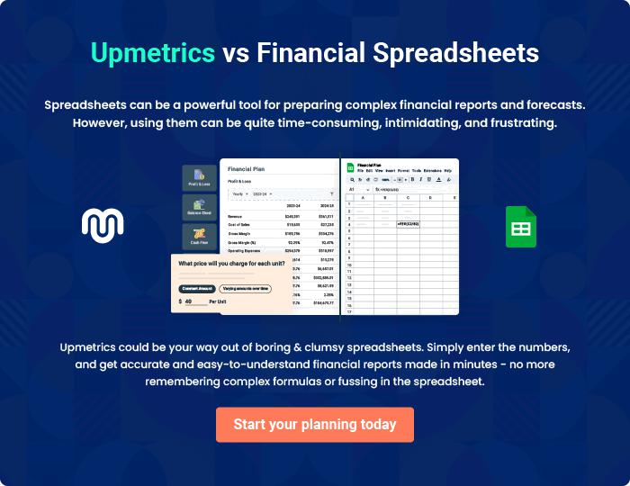
Appendix

When writing the appendix section, you should include any additional information that supports the main content of your plan. This may include financial statements, market research data, legal documents, and other
To unlock help try Upmetrics! 
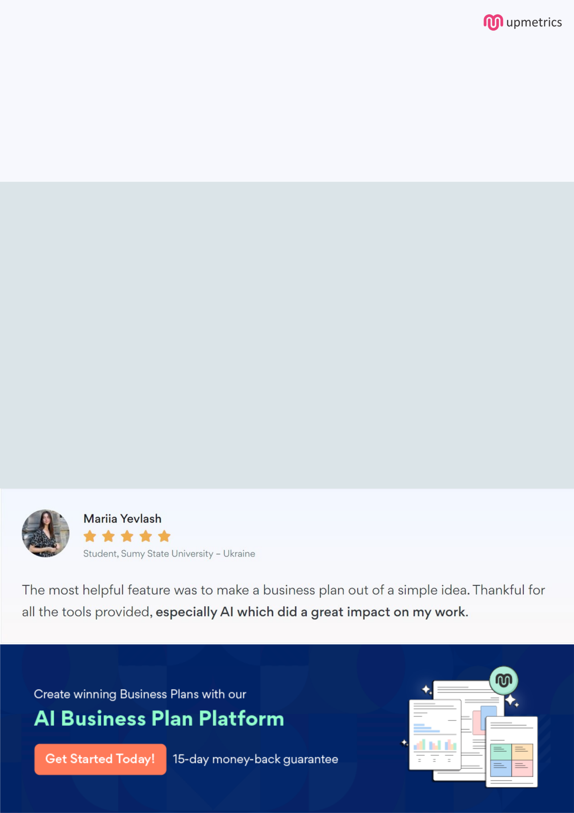
Create a winning business plan that gets you funded

Creating a stunning and investment-ready plan requires no writing, graphic designing, or financial planning expertise.

Upmetrics has all the features required to help you create a comprehensive business plan—from start to finish. Make no mistakes, it’s the modern way of planning to structure ideas, make plans, and create stunning pitch decks to awe investors.

Pitch decks that impress investors

Create pitch decks that provide a visual representation of your business, engage investors, and make them want to invest in your business idea.

Interactive plans in no time

Import business plan sections like—SWOT analysis, comparison tables, and others to create an interactive business plan. No designing skills are required.

Stunning cover page designs

With Upmetrics, you have the liberty to choose from multiple stunning cover page designs. Choose a creative design and make your plan stand out.

Online sharing made simple

Upmetrics makes online sharing quick and easier for users. Easily share your business plans with a link while tracking reader activity.

500+ sample business plans

Simply import a template from our library of sample plans into the editor and start customizing it to make it yours. It takes only a few clicks to get started.

Collaborate with team in real-time

Invite team members, initiate conversations, discuss ideas & strategies, share feedback, and work on a business plan in real-time.

