
Software Company Business Plan

ADDRESS CONTACT

10200 Bolsa Ave, Westminster, CA, 92683 (650) 359-3153

http://www.example.com info@example.com


Business Plan

2023

Prepared By

John Doe


Empowering Digital Evolution

Information provided in this business plan is unique to this business and confidential; therefore, anyone reading this plan agrees not to disclose any of the information in this business plan without prior written permission of the company.

Table of Contents

Executive Summary | 6
Market opportunity | 6
Services Offered | 6
Marketing & Sales Strategies | 7
Financial Highlights | 7
Units Sold v/s Revenue | 8

Company Overview | 9
Ownership | 9
Business Owners | 9
Mission statement | 10
Business history | 10
Future goals | 10

Market Analysis | 11
Target Market | 11
Market size and growth potential | 11
Market Size | 12
Competitive analysis | 12
Salesforce | 12
Microsoft Dynamics 365 | 13
HubSpot | 13
Market trends | 13
Regulatory environment | 14

Products and Services | 15
Services | 15
Custom Software Development | 15
Commercial Off-The-Shelf (COTS) Software | 16
Software as a Service (SaaS) | 16
Software Development Tools | 17
Software Consulting | 17
Quality Measures | 18
Additional Services | 18

Sales And Marketing Strategies | 19
Unique Selling Proposition (USP) | 19
Pricing Strategy | 19
Marketing strategies | 20
Online | 20
Sales strategies | 20
Customer retention | 21

Operations Plan | 22
Staffing & Training | 22
Operational Process | 22
Software & Tools | 23

Management Team | 24
Key managers | 24
John Doe | 24
Jane Doe | 25
Emily Johnson | 25
Organizational structure | 25
Organization chart | 26
Compensation plan | 26
Advisors/Consultants | 27
David Brown | 27
Lisa Green | 27

Financial Plan | 28
Profit & loss statement | 28
Cash flow statement | 31
Balance sheet | 33
Break-even Analysis | 35
Financing needs | 37
Appendix
Appendix | 39
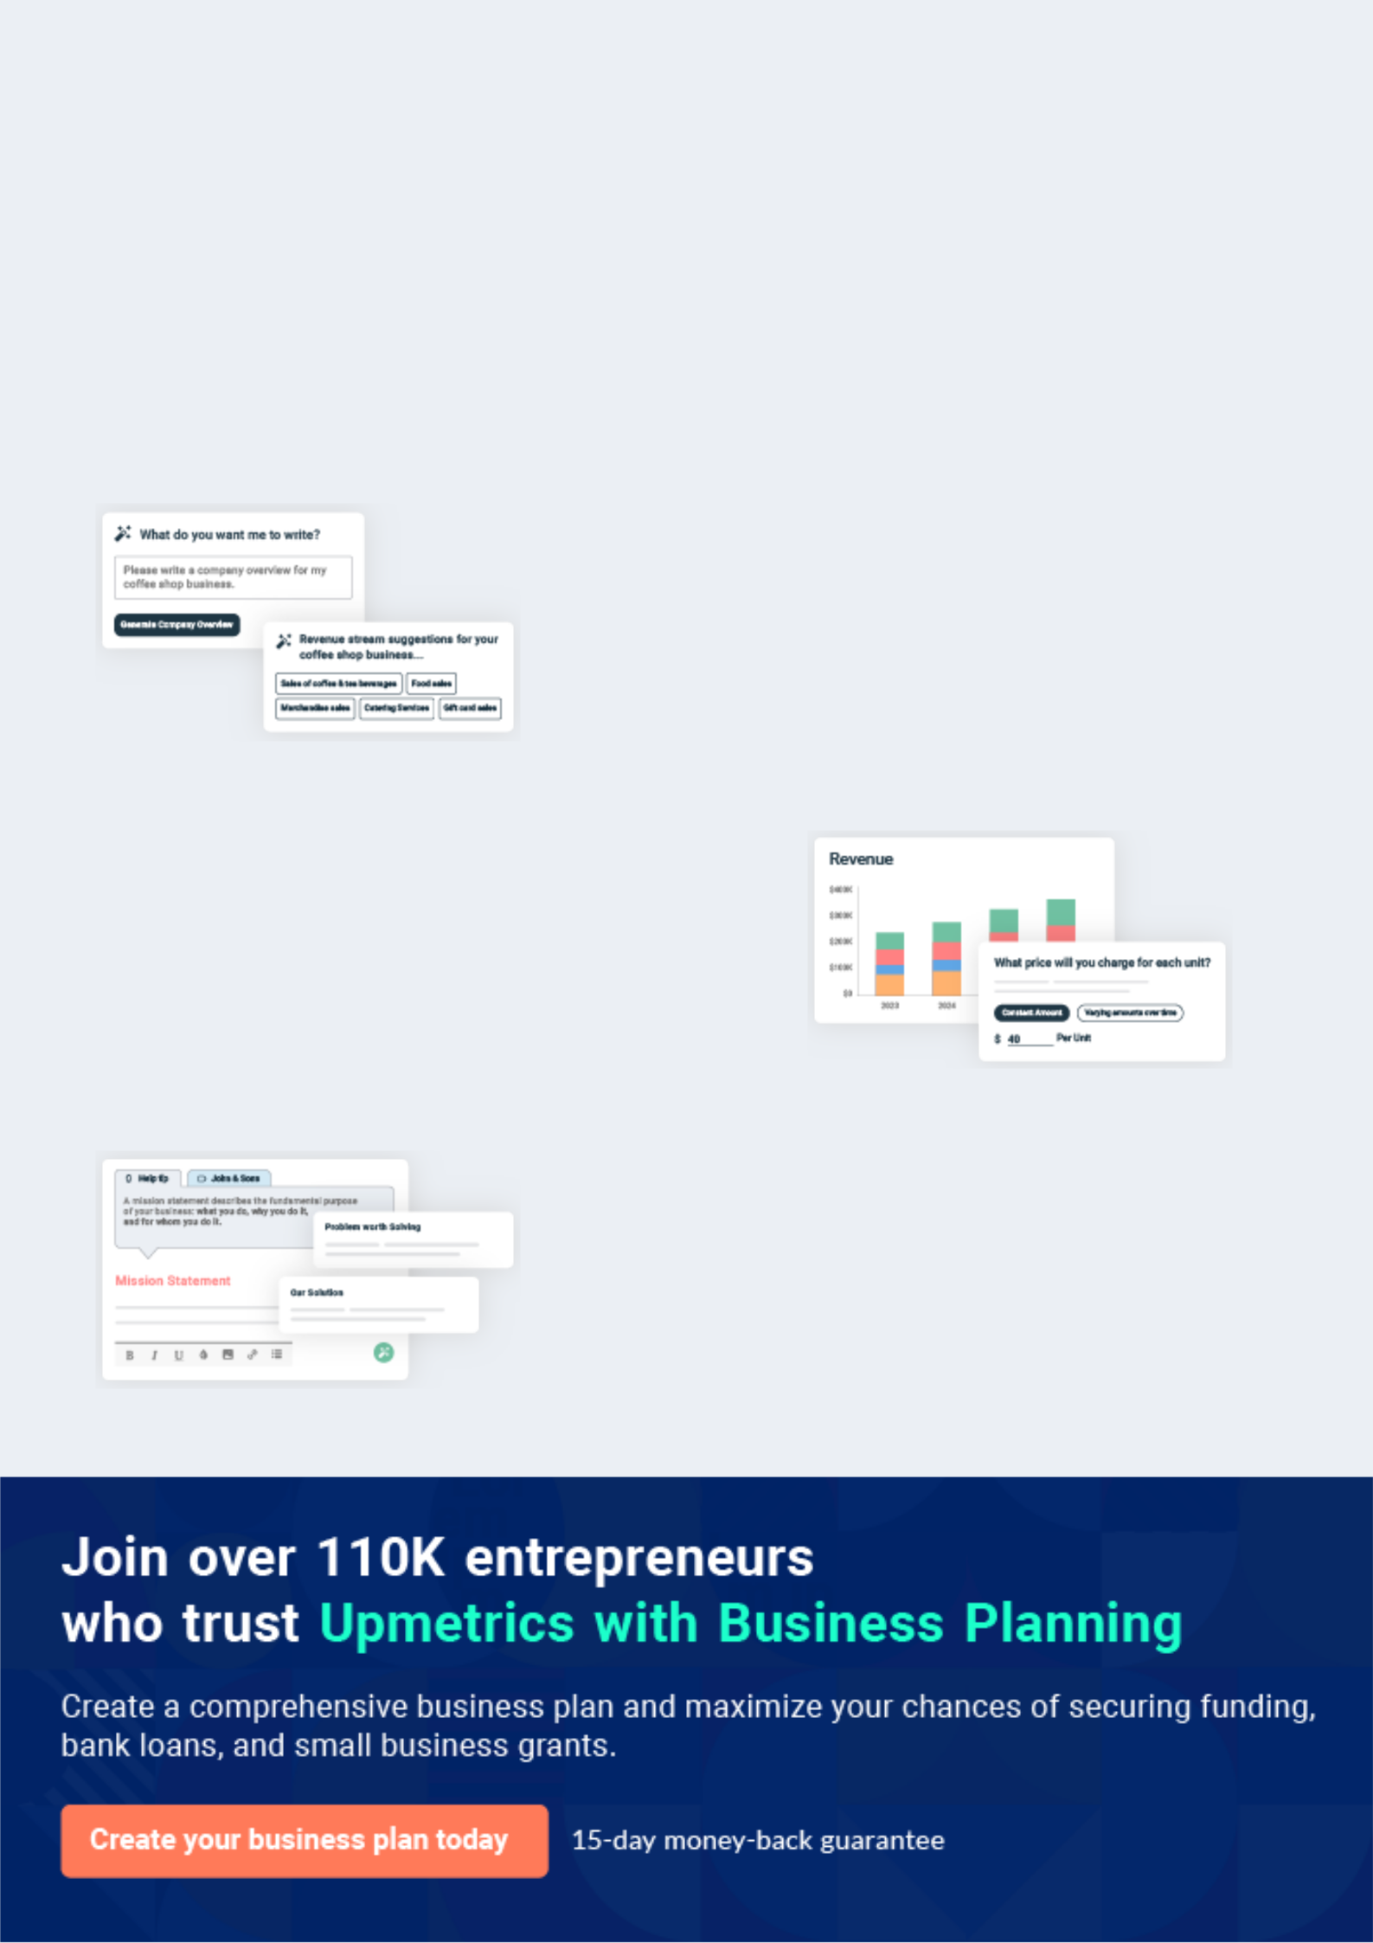
Business planning that’s simpler and faster than you think

Creating a business plan using Upmetrics to start and grow a business is literally the easiest thing in the World. Simply read the instructions and fill in the blanks. It’s as simple as that.

❛ | Upmetrics has everything you need to create a | ❜
❛ | comprehensive business plan. | ❜

AI-powered Upmetrics Assistant

AI-powered insights to streamline your plan

Not sure where to start? Upmetrics’ AI Assistant will automatically generate ideas for each section of your plan and offer improved versions of your writing, adjusting for tone, voice, and grammar or spelling errors.

Financial Forecasting Tool

All the financials are calculated for you

Forget the complex formulas and clumsy spreadsheets — with automatic financials and drag-and-drop forecasting, you can finish your plan faster and be confident that your numbers are accurate.

Business Plan Builder

Guides you like a business mentor

Upmetrics’ step-by-step instructions, prompts, and the library of 400+ sample business plans will guide you through each section of your plan as a business mentor.
Executive Summary


An executive summary is the first section of the business plan intended to provide an overview of the whole business plan.
To unlock help try Upmetrics! 

 Help tip  Software Company Business Plan


Start your executive summary by briefly introducing your business to your readers.

This section may include the name of your software company, its location, when it was
To unlock help try Upmetrics! 

Start writing here..

Market opportunity

 Help tip  Software Company Business Plan

Summarize your market research, including market size, growth potential, and marketing trends. Highlight the opportunities in the market and how your business will fit in to fill the gap.
To unlock help try Upmetrics! 

Start writing here..

Services Offered

 Help tip  Software Company Business Plan

Highlight the software company services you offer your clients. The USPs and differentiators you offer are always a plus.
To unlock help try Upmetrics! 

Start writing here..

Marketing & Sales Strategies
To unlock help try Upmetrics!

 Help tip  Software Company Business Plan

Outline your sales and marketing strategies—what marketing platforms you use, how you plan on acquiring customers, etc.
To unlock help try Upmetrics! 

Start writing here..

Financial Highlights

 Help tip  Software Company Business Plan

Briefly summarize your financial projections for the initial years of business operations. Include any capital or investment requirements, associated startup costs, projected revenues, and profit forecasts.



Start writing here..
Units Sold v/s Revenue

 |  | Units Sold | Revenue
15.00k
10.00k
5.00k
0
Year 1 | Year 2 | Year 3
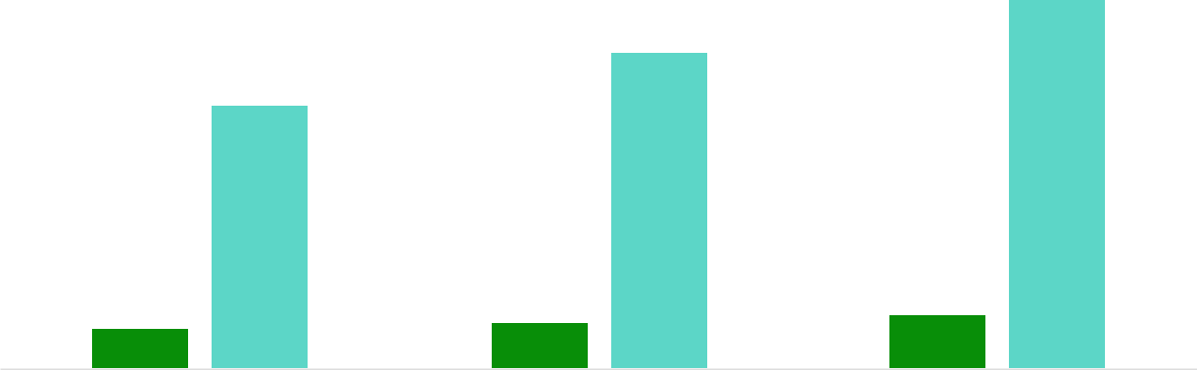

Financial Year |  |  | Units Sold | Revenue
Year 1 | 1,550 |  |  | $10,000
Year 2 | 1,800 |  |  | $12,000
Year 3 | 2,050 |  |  | $14,000
 Help tip |  |  Software Company Business Plan


Summarize your executive summary section with a clear CTA, for example, inviting angel investors to discuss the potential business investment.
To unlock help try Upmetrics! 

Write a call to action for your business plan.
Company Overview

Depending on what details of your business are essential, you’ll need different elements in your business overview.
To unlock help try Upmetrics! 

 Help tip  Software Company Business Plan

Describe your business in this section by providing all the basic information:

Describe what kind of software company you run and the name of it. You may specialize in one
To unlock help try Upmetrics! 

Start writing here..

Ownership

 Help tip  Software Company Business Plan

List the names of your software company’s founders or owners. Describe what shares they own and their responsibilities for efficiently managing the business.
To unlock help try Upmetrics! 

Start writing here..

Business Owners



50% John Doe



30% Jane Doe



20% Alice Brown

Mission statement

 Help tip  Software Company Business Plan

Summarize your business’ objective, core principles, and values in your mission statement. This statement needs to be memorable, clear, and brief.
To unlock help try Upmetrics! 

❛ Our mission at [XYZ Softwares Inc.] is to empower businesses
with cutting-edge software solutions that drive efficiency, innovation, and growth.

We are committed to delivering unparalleled value to our clients, adhering to our core principles of integrity, excellence, and customer satisfaction.

❜

Business history

 Help tip  Software Company Business Plan

If you’re an established software company, briefly describe your business history, like—when it was founded, how it evolved over time, etc.
To unlock help try Upmetrics! 

Start writing here..

Future goals

 Help tip  Software Company Business Plan

It’s crucial to convey your aspirations and vision. Mention your short-term and long-term goals; they can be specific targets for revenue, market share, or expanding your services.
To unlock help try Upmetrics! 

Start writing here..

Market Analysis
To unlock help try Upmetrics!


 |  | Market analysis provides a clear understanding of the market in which your
 |  | printing business will run along with the target market, competitors, and
 |  | growth opportunities.
 |  |  |  | To unlock help try Upmetrics! 
 Help tip |  |  Software Company Business Plan

To write the introduction section of your market analysis, start by clearly identifying your primary target market.
To unlock help try Upmetrics! 

Start writing here..

Target Market

 Help tip  Software Company Business Plan

Start this section by describing your target market. Define your ideal customer and explain what types of services they prefer. Creating a buyer persona will help you easily define your target market to your readers.



Start writing here..

Market size and growth potential

 Help tip  Software Company Business Plan

Describe your market size and growth potential and whether you will target a niche or a much broader market.
To unlock help try Upmetrics! 

Start writing here..

Market Size

Available Market

Global users needing software 200M solutions.

Served Market
Users in our reach with current 50M capabilities.

Target Market
Users in need of our specific software 10M solutions.

 Help tip  Software Company Business Plan

Identify and analyze your direct and indirect competitors. Identify their strengths and weaknesses, and describe what differentiates your software company from them.
To unlock help try Upmetrics! 

Competitive analysis

Salesforce

Salesforce is a global leader in customer relationship management (CRM) software, offering a suite of tools for sales, marketing, customer service, and more.

Features

CRM software with a range of tools for sales, marketing, and customer service.

- comprehensive AppExchange marketplace.

Robust analytics and reporting tools.

Integration capabilities with various third-party applications.

Strengths

Market leader with a strong brand presence.

Wide range of features catering to various business needs.

Large customer base and community.

Strong ecosystem of partners and developers.

Weaknesses

Complex pricing structure.

The steeper learning curve for new users.

Limited customization options for smaller businesses.

Microsoft Dynamics 365

Microsoft Dynamics 365 is a suite of business applications that combines CRM and enterprise resource planning (ERP) capabilities.

Features

A complete suite of business applications covering CRM, ERP, and more.

Integration with Microsoft's suite of productivity tools.

Advanced analytics powered by AI and machine learning.

Extensive customization options.

Strengths

Seamless integration with Microsoft's ecosystem.

A comprehensive suite of business applications.

Strong analytics capabilities.

Regular updates and enhancements.

Weaknesses

Can be expensive for smaller businesses.

May require additional resources for customization and maintenance.

Complexity can be challenging for some users.

HubSpot

HubSpot is a comprehensive platform that offers a suite of tools for marketing, sales, and customer service.

Features

An all-in-one platform for marketing, sales, and customer service.

Free CRM with paid add-ons for additional features.

User-friendly interface with a drag-and-drop editor.

Extensive library of

integrations.

Strengths

User-friendly interface is ideal for small businesses and startups.

Wide range of features and tools.

Strong community and customer support.

Frequent updates and new feature releases.

Weaknesses

Can become expensive as you add more features.

Limited advanced features for larger enterprises

Some users may find the platform too simplistic for complex business needs.

Market trends

 Help tip  Software Company Business Plan

Analyze emerging trends in the industry, such as technology disruptions, changes in customer behavior or preferences, etc. Explain how your business will cope with all the trends.
To unlock help try Upmetrics! 

Start writing here..

Regulatory environment
To unlock help try Upmetrics!

 Help tip  Software Company Business Plan

List regulations and licensing requirements that may affect your software company, such as intellectual property protection, software licensing, software licensing, data protection, antitrust & competition laws, etc.



Start writing here..
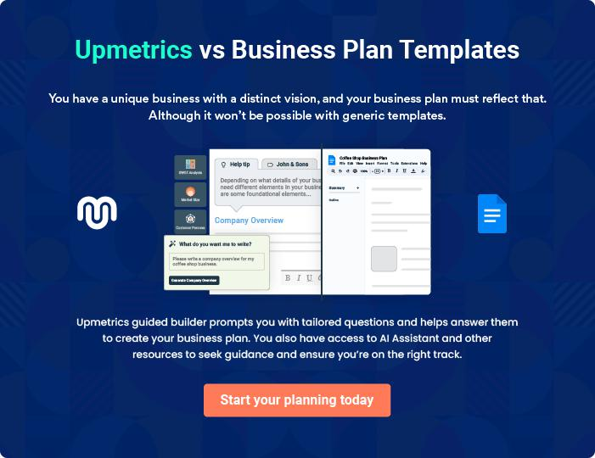
Products and Services

The product and services section of a software company business plan should describe the specific services and products that will be offered to customers. To write this section should include the following:
To unlock help try Upmetrics! 

 Help tip  Software Company Business Plan

To craft the introduction for your "Products and Services" chapter, begin by positioning your business within its industry, emphasizing its unique strengths or value proposition.
To unlock help try Upmetrics! 

Start writing here..

 Help tip


Mention the software company products or services your business will offer. This list may include:
To unlock help try Upmetrics! 

Services

Custom Software Development


Price: Starting at $[10,000] (varies based on project scope and complexity)

Tailored software solutions to meet the specific needs and requirements of your business.

Specifications

- Complete requirement analysis

- User-centric design

- Agile development methodology

- Rigorous testing and QA

- Ongoing maintenance and support
Commercial Off-The-Shelf (COTS) Software

Price: $[499] per license

Ready-made software solutions designed for a wide range of business applications

Specifications

- User-friendly interface

- Multi-platform compatibility

- Regular updates and enhancements

- Dedicated customer support

- Comprehensive documentation

Software as a Service (SaaS)

Price: Starting at $[29] per user/month

Cloud-based software solutions offered on a subscription basis, providing flexibility and scalability for businesses of all sizes.

Specifications

- Web-based access from anywhere

- Regular feature updates and improvements

- Robust security protocols

- Scalable infrastructure to accommodate growth

- Dedicated customer support
Software Development Tools

Price: Varies based on the tool (some tools are free, while others require a purchase or subscription)

A suite of tools designed to assist developers in the software development process, from coding to testing and deployment.

Specifications

- Includes IDEs, frameworks, libraries, and more

- Compatible with various programming languages

- Regular updates and enhancements

- Community support and documentation

- Cross-platform compatibility

Software Consulting

Price: Starting at $[150] per hour

Expert advice and guidance to help businesses make informed decisions about their software needs.

Specifications

- Comprehensive analysis of business requirements

- Identification of suitable software solutions

- Assistance with implementation and integration

- Ongoing support and advice

- Customized recommendations based on business goals and objectives
Quality Measures
- To unlock help try Upmetrics!

 Help tip  Software Company Business Plan

This section should explain how you maintain quality standards and consistently provide the highest quality service.
To unlock help try Upmetrics! 

Start writing here..

Additional Services

 Help tip  Software Company Business Plan

Mention if your software company offers any additional services. You may include services like custom software development, software consulting & advisory services, software training & documentation, etc.



Start writing here..
Sales And Marketing Strategies
To unlock help try Upmetrics!

Writing the sales and marketing strategies section means a list of strategies you will use to attract and retain your clients.
To unlock help try Upmetrics! 

 Help Tip  Software Company Business Plan


To create an effective introduction for your "Sales and Marketing Strategies" chapter, start by setting the stage within your specific industry or market.
To unlock help try Upmetrics! 

Start writing here..

Unique Selling Proposition (USP)

 Help tip  Software Company Business Plan

Define your business’s USPs depending on the market you serve, the equipment you use, and the unique services you provide. Identifying USPs will help you plan your marketing strategies.
To unlock help try Upmetrics! 

Start writing here..

Pricing Strategy

 Help tip  Software Company Business Plan

Describe your pricing strategy—how you plan to price your products or services and stay competitive in the local market. You can mention any discounts you plan on offering to attract new customers.



Start writing here..

 Help tip  Software Company Business Plan
To unlock help try Upmetrics!

Discuss your marketing strategies to market your services. You may include some of these marketing strategies in your business plan—social media marketing, Google ads, email marketing, content marketing, etc.



Marketing strategies

Online


Social Media

Through platforms like LinkedIn, Twitter, and Facebook, we engage with our audience, share insights, and promote our solutions.

Email Marketing

Our monthly newsletters and promotional campaigns keep our clients informed about the latest updates and offers.

Content Marketing Google Ads

By sharing blogs, whitepapers, and case studies, we establish ourselves as thought leaders in the software domain.

Targeted ads will help capture potential clients actively seeking software solutions.

 Help tip

Outline the strategies you’ll implement to maximize your sales. Your sales strategies may include partnering with other businesses, offering referral programs, etc.
To unlock help try Upmetrics! 

Sales strategies

Partner with Businesses

Collaborating with complementary businesses can open up new avenues for client acquisition.

Referral Programs

Existing clients referring potential leads can avail of special benefits and discounts, creating a win-win scenario.

 Help tip  Software Company Business Plan

Describe your customer retention strategies and how you plan to execute them. For instance, introducing loyalty programs, discounts or offers, personalized service, etc.
To unlock help try Upmetrics! 

Customer retention

Loyalty Programs

Regular clients will be enrolled in our loyalty program, offering them exclusive discounts and early access to new products

Personalized Service

By understanding the unique requirements of each client, we offer solutions and services tailored to their needs.

Exclusive Offers

Periodic discounts or add-on services ensure our clients always find value in our partnership.

Operations Plan
To unlock help try Upmetrics!

 |  | When writing the operations plan section, it’s important to consider the
 |  | various aspects of your business operations.
 |  |  |  | To unlock help try Upmetrics! 
 Help tip |  |  Software Company Business Plan


To create an effective introduction for your "Operational Plan" chapter, start by emphasizing the
pivotal role of efficient operations in the success of your business, underscoring how they
directly impact the quality of services delivered.
 |  |  |  | To unlock help try Upmetrics! 
Start writing here..
Staffing & Training
 Help tip |  |  Software Company Business Plan

Mention your business’s staffing requirements, including the number of employees or
developers needed. Include their qualifications, the training required, and the duties they will
perform.
 |  |  |  | To unlock help try Upmetrics! 
Start writing here..
Operational Process
 Help tip |  |  Software Company Business Plan

Outline the processes and procedures you will use to run your software company. Your operational processes may include requirements gathering, design & planning, development, deployment, project management, collaboration & communication, etc.



Start writing here..

Software & Tools
To unlock help try Upmetrics!

 Help tip  Software Company Business Plan

Include the list of software & tools required for a software company, such as cloud services & infrastructure, project management tools, Version Control Systems, collaboration & communication tools, etc.



Start writing here..
Management Team

The management team section provides an overview of the individuals responsible for running your business plan.
To unlock help try Upmetrics! 

 Help tip  Software Company Business Plan

To craft an introduction for your "Management Team" chapter, begin by emphasizing the crucial role of leadership in the success of any business.
To unlock help try Upmetrics! 

Start writing here..

Key managers

 Help tip  Software Company Business Plan

Introduce your management and key members of your team, and explain their roles and responsibilities.
To unlock help try Upmetrics! 

Start writing here..


JOHN DOE

CEO & Co-founder - john.doe@example.com

John Doe is a seasoned professional in the software industry, holding a Bachelor's degree in Computer Science from [University Name].

With over 15 years of experience, John has worked with some of the leading software companies, specializing in [specific software specialities or industries served].


As the CEO, John is responsible for setting the strategic direction of XYZ Softwares Inc. and ensuring the company's growth and success.

JANE DOE

Chief Operating Officer (COO) - jane.doe@example.com

Jane Doe holds a Master's degree in Business Administration from [University Name] and has over 10 years of experience in operational management.

As the COO, Jane oversees the day-to-day operations of XYZ Softwares Inc., ensuring that all processes are streamlined and efficient.


She plays a key role in implementing the company's strategic plan and achieving operational excellence.


EMILY JOHNSON

CMO - emily.johnson@example.com

Emily Johnson is a dynamic marketing professional with a Bachelor's degree in Marketing from [University Name].

With over 8 years of experience in the software industry, Emily specializes in developing innovative marketing strategies that drive business growth.

As the CMO, she is responsible for leading the marketing team and ensuring the company's message resonates with its target audience.

Organizational structure

 Help tip  Software Company Business Plan

Explain the organizational structure of your management team. Include the reporting line and decision-making hierarchy.
To unlock help try Upmetrics! 

Start writing here..
Organization chart


John Doe

CEO


Emily Johnson Jane Doe

CMO COO


[Name 1]

[Name 2] [Position 1] [Position 2]


[Name 3]

[Name 4] [Position 3] [Position 4]

Compensation plan

 Help tip  Software Company Business Plan

Describe your compensation plan for the management and staff. Include their salaries, incentives, and other benefits.
To unlock help try Upmetrics! 

Start writing here..

 Help tip  Software Company Business Plan

Mentioning advisors or consultants in your business plans adds credibility to your business idea.
To unlock help try Upmetrics! 

Advisors/Consultants


DAVID BROWN

Financial Advisor

With over 20 years of experience in financial management and a CPA certification, David provides valuable insights to XYZ Softwares Inc. on financial planning and strategy



LISA GREEN

Legal Consultant

Lisa is a seasoned attorney specializing in software and intellectual property law. With over 15 years of experience, she advises XYZ Softwares Inc. on legal matters related to software licensing and IP protection.

Financial Plan

When writing the financial plan section of a business plan, it’s important to provide a comprehensive overview of your financial projections for the first few years of your business, You may provide the following:
To unlock help try Upmetrics! 

 Help tip  Software Company Business Plan


To create an effective introduction for your "Financial Plan" chapter, begin by stressing the critical role of a well-structured financial plan in the success of your venture.
To unlock help try Upmetrics! 

Start writing here..

 Help tip  Software Company Business Plan

Describe details such as projected revenue, operational costs, and service costs in your projected profit and loss statement. Make sure to include your business’s expected net profit or loss.
To unlock help try Upmetrics! 

Profit & loss statement

Revenue

Cost Of Sales

General Costs

Revenue Specific Costs

Personnel Costs (Direct

Labor)

Gross Margin

Gross Margin (%)

Operating Expense

Payroll Expense

(Indirect Labor)

General Expense

Bad Debt

Amortization of Current

Assets

2023-24 | 2024-25 | 2025-26 | 2026-27 | 2027-28
$0 | $0 | $0 | $0 | $0

$0 | $0 | $0 | $0 | $0
$0 | $0 | $0 | $0 | $0
$0 | $0 | $0 | $0 | $0
$0 | $0 | $0 | $0 | $0

$0 | $0 | $0 | $0 | $0
0% | 0% | 0% | 0% | 0%

$0 | $0 | $0 | $0 | $0
$0 | $0 | $0 | $0 | $0
$0 | $0 | $0 | $0 | $0
$0 | $0 | $0 | $0 | $0
$0 | $0 | $0 | $0 | $0

EBITDA

Additional Expense

Long Term

Depreciation

Gain or loss from Sale

of Assets

EBIT

Interest Expenses

EBT

Income Tax Expense

Total Expense

Net Income

Net Income (%)

2023-24 | 2024-25 | 2025-26 | 2026-27 | 2027-28
$0 | $0 | $0 | $0 | $0
$0 | $0 | $0 | $0 | $0
$0 | $0 | $0 | $0 | $0
$0 | $0 | $0 | $0 | $0
$0 | $0 | $0 | $0 | $0
$0 | $0 | $0 | $0 | $0
$0 | $0 | $0 | $0 | $0
$0 | $0 | $0 | $0 | $0
$0 | $0 | $0 | $0 | $0
$0 | $0 | $0 | $0 | $0
0% | 0% | 0% | 0% | 0%
 |  |  | 2023-24 |  | 2024-25 | 2025-26 | 2026-27 | 2027-28
Retained Earning |  |  | $0 |  | $0 | $0 | $0 | $0
Opening
Owner's Distribution |  |  | $0 |  | $0 | $0 | $0 | $0
Retained Earning |  |  | $0 |  | $0 | $0 | $0 | $0
Closing
 Help tip |  |  |  Software Company Business Plan


The cash flow for the first few years of your operation should be estimated and described in this section. This may include billing invoices, payment receipts, loan payments, and any other cash flow statements.
To unlock help try Upmetrics! 

Cash flow statement

 | 2023-24 | 2024-25 | 2025-26 | 2026-27 | 2027-28
Cash Received | $0 | $0 | $0 | $0 | $0
Cash Paid | $0 | $0 | $0 | $0 | $0
COS & General Expenses | $0 | $0 | $0 | $0 | $0
Salary & Wages | $0 | $0 | $0 | $0 | $0
Interest | $0 | $0 | $0 | $0 | $0

Sales Tax

Income Tax

Net Cash From

Operations

Assets Sell

Assets Purchase

Net Cash From

Investments

Amount Received

Loan Received

Common Stock

Preferred Stock

Owner's Contribution

Amount Paid

2023-24 | 2024-25 | 2025-26 | 2026-27 | 2027-28
$0 | $0 | $0 | $0 | $0
$0 | $0 | $0 | $0 | $0
$0 | $0 | $0 | $0 | $0

$0 | $0 | $0 | $0 | $0
$0 | $0 | $0 | $0 | $0
$0 | $0 | $0 | $0 | $0

$0 | $0 | $0 | $0 | $0
$0 | $0 | $0 | $0 | $0

$0 | $0 | $0 | $0 | $0
$0 | $0 | $0 | $0 | $0
$0 | $0 | $0 | $0 | $0

Loan Capital $0 $0 $0 $0 $0

 |  |  | 2023-24 |  | 2024-25 | 2025-26 | 2026-27 | 2027-28
Dividends & Distributions |  |  | $0 |  | $0 | $0 | $0 | $0
Net Cash From |  |  | $0 |  | $0 | $0 | $0 | $0
Financing
Summary
Starting Cash |  |  | $0 |  | $0 | $0 | $0 | $0
Cash In |  |  | $0 |  | $0 | $0 | $0 | $0
Cash Out |  |  | $0 |  | $0 | $0 | $0 | $0
Change in Cash |  |  | $0 |  | $0 | $0 | $0 | $0
Ending Cash |  |  | $0 |  | $0 | $0 | $0 | $0
 Help tip |  |  Software Company Business Plan

Create a projected balance sheet documenting your software company’s assets, liabilities, and equity.

To unlock help try Upmetrics! 

Balance sheet

 | 2023-24 | 2024-25 | 2025-26 | 2026-27 | 2027-28
Assets | $0 | $0 | $0 | $0 | $0
Current Assets | $0 | $0 | $0 | $0 | $0
Cash | $0 | $0 | $0 | $0 | $0
Accounts Receivable | $0 | $0 | $0 | $0 | $0
Inventory | $0 | $0 | $0 | $0 | $0
Other Current Assets | $0 | $0 | $0 | $0 | $0
Long Term Assets | $0 | $0 | $0 | $0 | $0
Gross Long Term Assets | $0 | $0 | $0 | $0 | $0
Accumulated Depreciation | $0 | $0 | $0 | $0 | $0

Liabilities & Equity | $0 | $0 | $0 | $0 | $0
Liabilities | $0 | $0 | $0 | $0 | $0
Current Liabilities | $0 | $0 | $0 | $0 | $0
Accounts Payable | $0 | $0 | $0 | $0 | $0
Income Tax Payable | $0 | $0 | $0 | $0 | $0
Sales Tax Payable | $0 | $0 | $0 | $0 | $0
Short Term Debt | $0 | $0 | $0 | $0 | $0
 | 2023-24 | 2024-25 | 2025-26 | 2026-27 | 2027-28
Long Term Liabilities | $0 | $0 | $0 | $0 | $0
Long Term Debt | $0 | $0 | $0 | $0 | $0
Equity | $0 | $0 | $0 | $0 | $0
Paid-in Capital | $0 | $0 | $0 | $0 | $0
Common Stock | $0 | $0 | $0 | $0 | $0
Preferred Stock | $0 | $0 | $0 | $0 | $0
Owner's Contribution | $0 | $0 | $0 | $0 | $0
Retained Earnings | $0 | $0 | $0 | $0 | $0

Check | $0 |  |  | $0 | $0 | $0 | $0
 Help tip |  |  Software Company Business Plan

Determine and mention your business’s break-even point—the point at which your business costs and revenue will be equal.

This exercise will help you understand how much revenue you need to generate to sustain or be profitable.
To unlock help try Upmetrics! 

Break-even Analysis

 | 2023-24 | 2024-25 | 2025-26 | 2026-27 | 2027-28
Starting Revenue | $0 | $0 | $0 | $0 | $0
Net Revenue | $0 | $0 | $0 | $0 | $0
Closing Revenue | $0 | $0 | $0 | $0 | $0

Starting Expense | $0 | $0 | $0 | $0 | $0
Net Expense | $0 | $0 | $0 | $0 | $0
Closing Expense | $0 | $0 | $0 | $0 | $0

Is Break Even? | 0 | 0 | 0 | 0 | 0
Break Even Month | 0 | 0 | 0 | 0 | 0
Days Required | 0 | 0 | 0 | 0 | 0
Break Even Revenue | $0 | $0 | $0 | $0 | $0
Break Even Units
Financing needs

 Help tip  Software Company Business Plan

Calculate costs associated with starting a software company, and estimate your financing needs and how much capital you need to raise to operate your business.
To unlock help try Upmetrics! 

Start writing here..
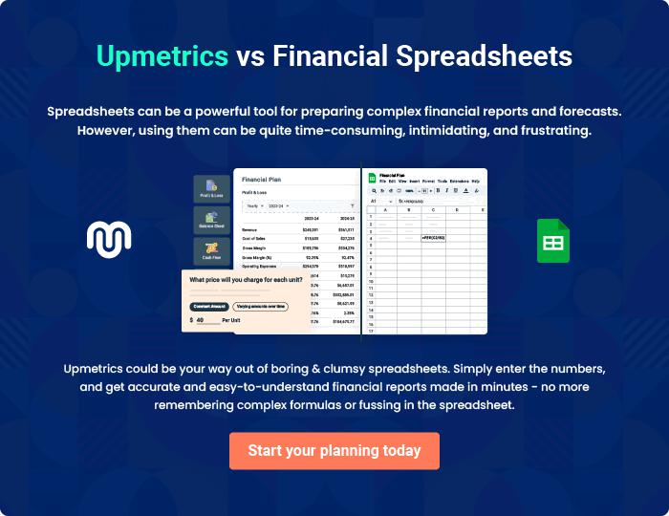
Appendix

When writing the appendix section, you should include any additional information that supports the main content of your plan. This may include financial statements, market research data, legal documents, and other
To unlock help try Upmetrics! 
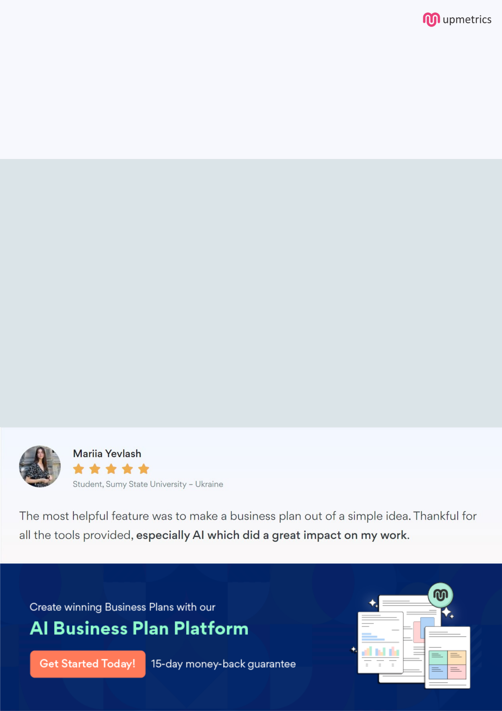
Create a winning business plan that gets you funded

Creating a stunning and investment-ready plan requires no writing, graphic designing, or financial planning expertise.

Upmetrics has all the features required to help you create a comprehensive business plan—from start to finish. Make no mistakes, it’s the modern way of planning to structure ideas, make plans, and create stunning pitch decks to awe investors.

Pitch decks that impress investors

Create pitch decks that provide a visual representation of your business, engage investors, and make them want to invest in your business idea.

Interactive plans in no time

Import business plan sections like—SWOT analysis, comparison tables, and others to create an interactive business plan. No designing skills are required.

Stunning cover page designs

With Upmetrics, you have the liberty to choose from multiple stunning cover page designs. Choose a creative design and make your plan stand out.

Online sharing made simple

Upmetrics makes online sharing quick and easier for users. Easily share your business plans with a link while tracking reader activity.

500+ sample business plans

Simply import a template from our library of sample plans into the editor and start customizing it to make it yours. It takes only a few clicks to get started.

Collaborate with team in real-time

Invite team members, initiate conversations, discuss ideas & strategies, share feedback, and work on a business plan in real-time.

