
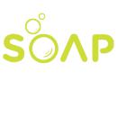 Soap Making Business Plan

ADDRESS CONTACT

10200 Bolsa Ave, Westminster, CA, 92683 (650) 359-3153

http://www.example.com info@example.com


Business Plan

2023

Prepared By

John Doe


Natural Luxury, Handmade Soaps

Information provided in this business plan is unique to this business and confidential; therefore, anyone reading this plan agrees not to disclose any of the information in this business plan without prior written permission of the company.

Table of Contents

Executive Summary | 6
Market opportunity | 6
Services Offered | 6
Marketing & Sales Strategies | 7
Financial Highlights | 7
Units Sold v/s Revenue | 8

Company Overview | 9
Ownership | 9
Mission statement | 10
Business history | 10
Future goals | 11

Market Analysis | 12
Target Market | 12
Market size and growth potential | 12
Market Size | 13
Competitive analysis | 13
Natural Bliss Soaps | 13
Artisan Aromas | 14
EcoClean Soaps | 14
Market trends | 14
Regulatory environment | 15

Products and Services | 16
Product line | 16
Lavender Bliss Handmade Soap | 17
Citrus Zing Liquid Soap | 17
Coconut Bliss Shampoo Bar | 18
Organic Avocado Soap | 18
Sweet Almond Lotion Bar | 19
Quality Measures | 19
Packaging and Labeling | 19

Sales And Marketing Strategies | 20
Unique Selling Proposition (USP) | 20
Pricing Strategy | 20
Marketing strategies | 21
Online | 21
Offline | 21
Sales strategies | 22
Customer retention | 23

Operations Plan | 24
Staffing & Training | 24
Operational Process | 24
Equipment & Machinery | 25

Management Team | 26
Key managers | 26
John Doe | 27
Jane Doe | 27
Alice Brown | 28
Robert Brown | 28
Organizational structure | 29
Organization chart | 29
Compensation plan | 29
Advisors/Consultants | 30
Dr. Emily White | 30
Mr. Jacob Green | 30

Financial Plan | 31
Profit & loss statement | 31
Cash flow statement | 34
Balance sheet | 36
Break-even Analysis | 38
Financing needs | 40
Appendix
Appendix | 42
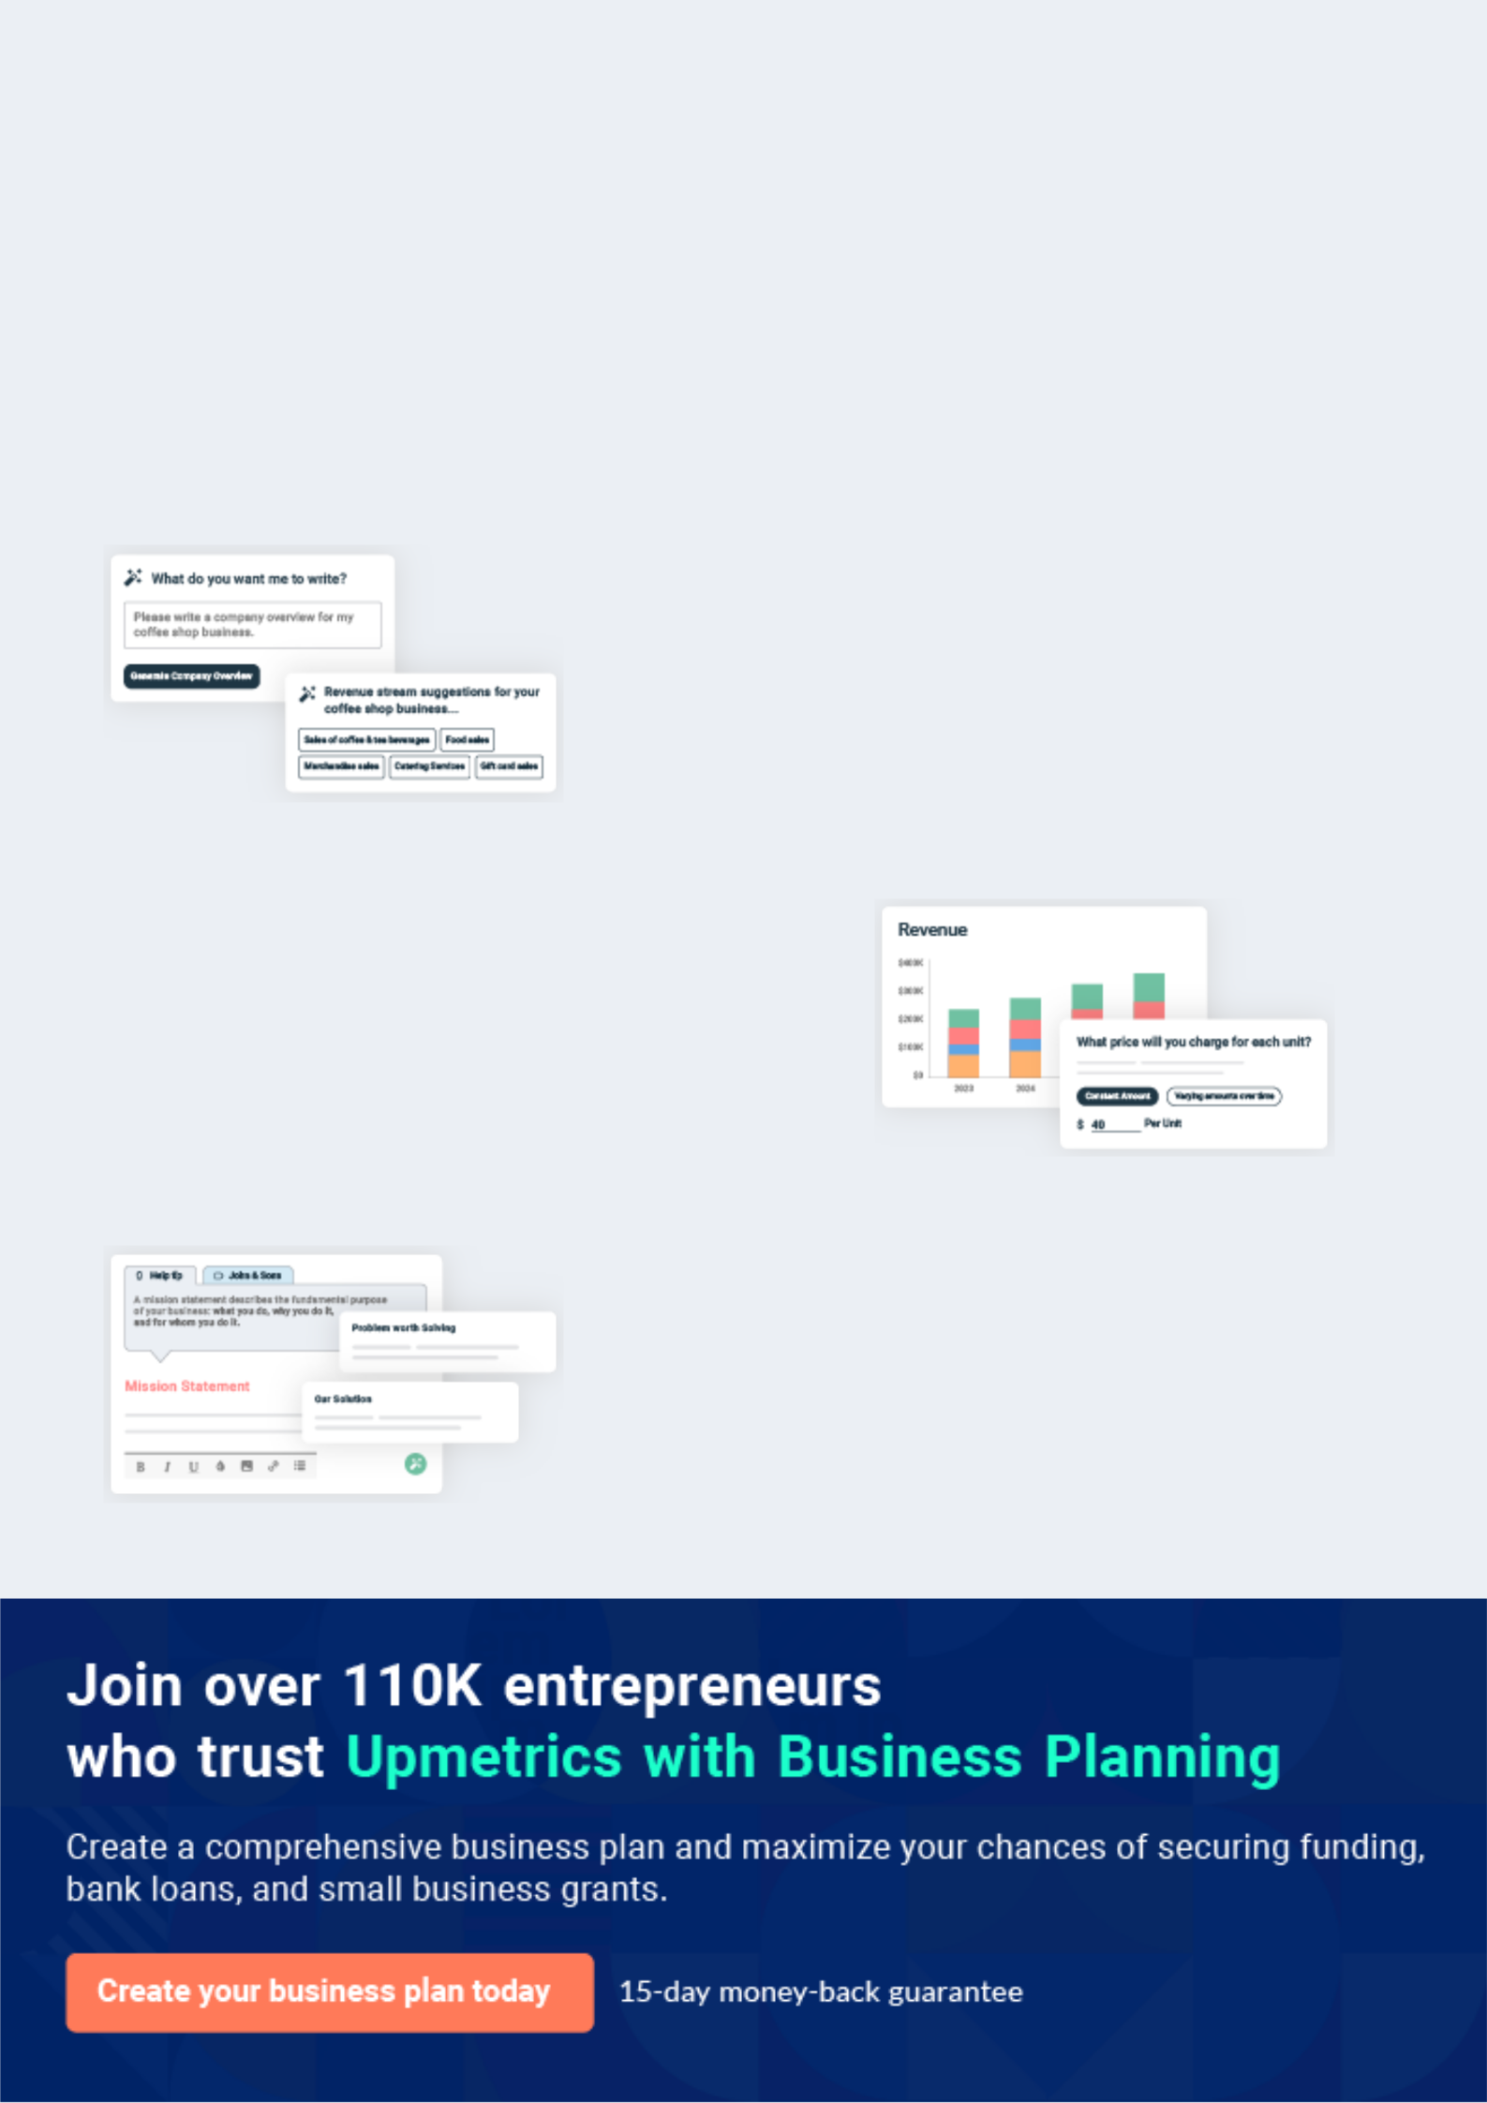
Business planning that’s simpler and faster than you think

Creating a business plan using Upmetrics to start and grow a business is literally the easiest thing in the World. Simply read the instructions and fill in the blanks. It’s as simple as that.

❛ | Upmetrics has everything you need to create a | ❜
❛ | comprehensive business plan. | ❜

AI-powered Upmetrics Assistant

AI-powered insights to streamline your plan

Not sure where to start? Upmetrics’ AI Assistant will automatically generate ideas for each section of your plan and offer improved versions of your writing, adjusting for tone, voice, and grammar or spelling errors.

Financial Forecasting Tool

All the financials are calculated for you

Forget the complex formulas and clumsy spreadsheets — with automatic financials and drag-and-drop forecasting, you can finish your plan faster and be confident that your numbers are accurate.

Business Plan Builder

Guides you like a business mentor

Upmetrics’ step-by-step instructions, prompts, and the library of 400+ sample business plans will guide you through each section of your plan as a business mentor.
Executive Summary


An executive summary is the first section of the business plan intended to provide an overview of the whole business plan.
To unlock help try Upmetrics! 

 Help tip  Soap Making Business Plan


Start your executive summary by briefly introducing your business to your readers.

This section may include the name of your soap making business, its location, when it was
To unlock help try Upmetrics! 

Start writing here..

Market opportunity

 Help tip  Soap Making Business Plan

Summarize your market research, including market size, growth potential, and marketing trends. Highlight the opportunities in the market and how your business will fit in to fill the gap.
To unlock help try Upmetrics! 

Start writing here..

Services Offered

 Help tip  Soap Making Business Plan

Highlight the product line you offer your clients. The USPs and differentiator products you offer are always a plus.
To unlock help try Upmetrics! 

Start writing here..

Marketing & Sales Strategies
To unlock help try Upmetrics!

 Help tip  Soap Making Business Plan

Outline your sales and marketing strategies—what marketing platforms you use, how you plan on acquiring customers, etc.
To unlock help try Upmetrics! 

Start writing here..

Financial Highlights

 Help tip  Soap Making Business Plan

Briefly summarize your financial projections for the initial years of business operations. Include any capital or investment requirements, associated startup costs, projected revenues, and profit forecasts.



Start writing here..
Units Sold v/s Revenue

 |  | Units Sold | Revenue
15.00k
10.00k
5.00k
0
Year 1 | Year 2 | Year 3
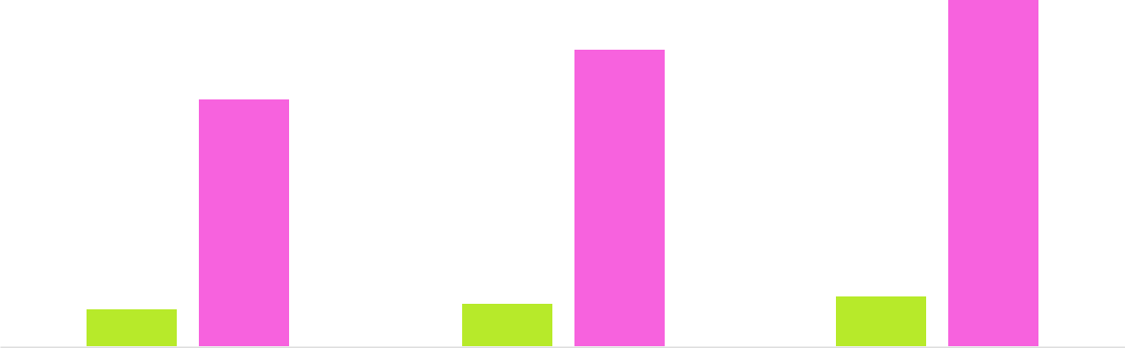

Financial Year |  |  | Units Sold | Revenue
Year 1 | 1,550 |  |  | $10,000
Year 2 | 1,800 |  |  | $12,000
Year 3 | 2,050 |  |  | $14,000
 Help tip |  |  Soap Making Business Plan
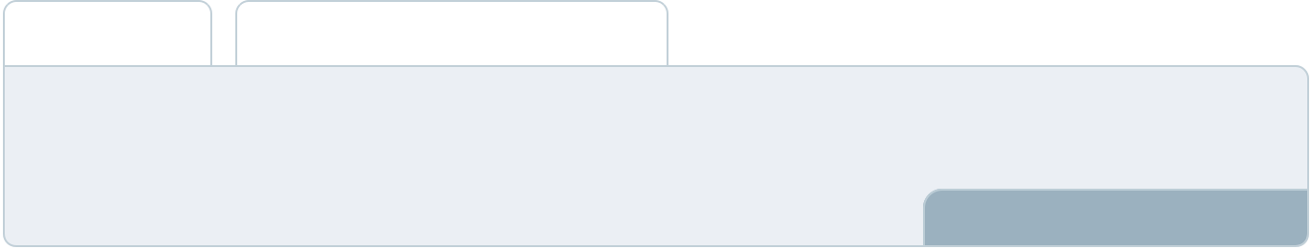

Summarize your executive summary section with a clear CTA, for example, inviting angel investors to discuss the potential business investment.
To unlock help try Upmetrics! 

Write a call to action for your business plan.
Company Overview

Depending on what details of your business are essential, you’ll need different elements in your business overview.
To unlock help try Upmetrics! 

 Help tip  Soap Making Business Plan

Describe your business in this section by providing all the basic information:

Describe what kind of soap making company you run and the name of it. For instance, these
To unlock help try Upmetrics! 

Start writing here..

Ownership

 Help tip  Soap Making Business Plan

List the owners of your soap making company. Describe what shares they own and their responsibilities for efficiently managing the business.
To unlock help try Upmetrics! 

Start writing here..
Mission statement

 Help tip  Soap Making Business Plan

Summarize your business’ objective, core principles, and values in your mission statement. This statement needs to be memorable, clear, and brief.
To unlock help try Upmetrics! 

❛ At [Sudsy Success Soaps], our mission is clear – to create high-quality, innovative soap products that enhance the daily lives of our customers. We are committed to sustainability, excellence, and customer satisfaction, values that are the cornerstone of our business.

Our goal is to be a leader in the soap-making industry, setting standards for quality, innovation, and service.

❜

Business history

 Help tip  Soap Making Business Plan

If you’re an established soap making service provider, briefly describe your business history, like —when it was founded, how it evolved over time, etc.
To unlock help try Upmetrics! 

Start writing here..
Future goals

 Help tip  Soap Making Business Plan

It’s crucial to convey your aspirations and vision. Mention your short-term and long-term goals; they can be specific targets for revenue, market share, or expanding your business.
To unlock help try Upmetrics! 

Start writing here..
Market Analysis
To unlock help try Upmetrics!


 |  | Market analysis provides a clear understanding of the market in which your
 |  | printing business will run along with the target market, competitors, and
 |  | growth opportunities.
 |  |  |  | To unlock help try Upmetrics! 
 Help tip |  |  Soap Making Business Plan

To write the introduction section of your market analysis, start by clearly identifying your primary target market.
To unlock help try Upmetrics! 

Start writing here..

Target Market

 Help tip  Soap Making Business Plan

Start this section by describing your target market. Define your ideal customer and explain what types of products they prefer. Creating a buyer persona will help you easily define your target market to your readers.



Start writing here..

Market size and growth potential

 Help tip  Soap Making Business Plan

Describe your market size and growth potential and whether you will target a niche or a much broader market.
To unlock help try Upmetrics! 

Start writing here..

Market Size


Available Market | 20M
All consumers interested in buying soap. | 20M

Served Market
Consumers seeking artisanal and natural 5M soaps.

Target Market
Eco-conscious consumers desiring 1M customized soaps.

 Help tip  Soap Making Business Plan

Identify and analyze your direct and indirect competitors. Identify their strengths and weaknesses, and describe what differentiates your products from them.
To unlock help try Upmetrics! 

Competitive analysis

Natural Bliss Soaps

With a decade of experience, Natural Bliss Soaps is a market leader in organic soap production, known for their commitment to natural ingredients.

Features | Strengths | Weaknesses
Extensive range of organic | Established brand reputation | Higher price point due to
soaps | for quality and organic integrity | premium product positioning
Subscription box service for | Loyal customer base with high | Limited product customization
regular product delivery | repeat purchase rates | options for individual customers
Strong online presence with a | Comprehensive product range | Dependence on organic
well-maintained e-commerce | catering to various customer | ingredient suppliers can lead to
platform | needs | potential supply chain issues

Artisan Aromas

Artisan Aromas has carved a niche in the handmade soap market, known for their unique scents and vibrant soap designs.

Features | Strengths | Weaknesses
Handcrafted soaps with artistic | Unique product offerings | Smaller production scale can
designs | create a strong brand identity | lead to stock issues during high
Seasonal and limited-edition | Agile production processes | demand periods
scent ranges | allow for rapid product | Limited range of unscented or
Emphasis on sensory | innovation | mildly scented options
experience with strong | Strong engagement with | Higher production costs due to
aromatic profiles | customers through social | labor-intensive manufacturing
 | media and events | processes

EcoClean Soaps

Focused on sustainability, EcoClean Soaps offers a range of eco-friendly and biodegradable soap products.

Features

100% biodegradable ingredients

Plastic-free packaging

Partnership programs with environmental organizations

Strengths | Weaknesses
Strong market position in the | Limited product scents and
eco-friendly product space | varieties
Positive brand image | Premium pricing may deter
associated with environmental | budget-conscious customers
stewardship | Dependence on niche market
Wide distribution in organic | may limit growth potential
and specialty stores

Market trends

 Help tip  Soap Making Business Plan

Analyse emerging trends in the industry, such as technology disruptions, changes in customer behavior or preferences, etc. Explain how your business will cope with all the trends.
To unlock help try Upmetrics! 

Start writing here..

Regulatory environment
To unlock help try Upmetrics!

 Help tip  Soap Making Business Plan

List regulations and licensing requirements that may affect your soap making company, such as business registration, packaging and labeling requirements, ingredient regulations, environmental regulations, etc.



Start writing here..
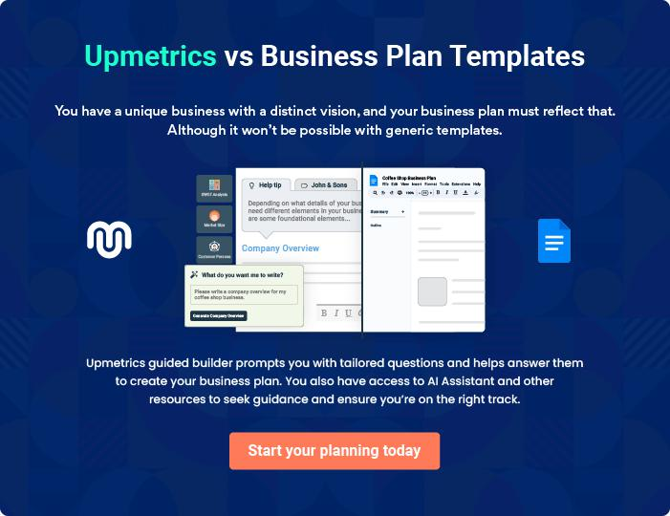
Products and Services
To unlock help try Upmetrics!

The product and services section of the soap making business plan should describe the specific services and products that will be offered to customers. To write this section should include the following:



 Help tip  Soap Making Business Plan

To craft the introduction for your "Products and Services" chapter, begin by positioning your business within its industry, emphasizing its unique strengths or value proposition.
To unlock help try Upmetrics! 

Start writing here..

 Help tip


List the types of soaps your soap making business will offer. Your product line may include,

• Lotion bars
To unlock help try Upmetrics! 

Product line
Lavender Bliss Handmade Soap


Price: [$7.00] per bar

Indulge in the soothing scent of Lavender Bliss, our meticulously handcrafted soap designed to calm your senses and provide a luxurious cleansing experience.

Product Specifications

- Ingredients: Olive Oil, Coconut Oil, Shea Butter, Lavender Essential Oil, Lye, Distilled Water

- Size: Approximately 4 oz per bar

- Shelf Life: 12 months

- Vegan and Cruelty-Free

- Free from: Parabens, Phthalates, Sulfates

Citrus Zing Liquid Soap

Price: [$12.00] per 250ml bottle

Elevate your hand washing routine with our Citrus Zing Liquid Soap, bursting with the invigorating aromas of fresh citrus fruits to leave your hands feeling refreshed and revitalized.

Product Specifications

- Ingredients: Aqua, Potassium Oleate, Potassium Cocoate, Glycerin, Potassium Citrate, Citric Acid, Essential Oils of Orange, Lemon, and Grapefruit

- Packaging: Recyclable plastic bottle with pump dispenser

- Vegan and Cruelty-Free

- pH-balanced for skin compatibility
Coconut Bliss Shampoo Bar

Price: [$10.00] per bar

Transform your hair care routine with our Coconut Bliss Shampoo Bar, enriched with nourishing coconut oil to leave your hair feeling soft, shiny, and full of life.

Product Specifications

- Ingredients: Sodium Cocoyl Isethionate, Behentrimonium Methosulfate, Cetearyl Alcohol, Coconut Oil, Cocoa Butter, Provitamin B5, Hydrolyzed Wheat Protein

- Size: Approximately 3.5 oz per bar

- Suitable for: All hair types

- Vegan and Cruelty-Free

- Packaging: Biodegradable wrapper

Organic Avocado Soap

Price: [$8.50] per bar

Experience the luxurious touch of our Organic Avocado Soap, crafted with rich avocado oil and other organic ingredients to nourish and rejuvenate your skin.

Product Specifications

- Ingredients: Organic Avocado Oil, Organic Olive Oil, Organic Coconut Oil, Organic Shea Butter, Lye, Distilled Water

- Size: Approximately 4 oz per bar

- Certified Organic Ingredients

- Vegan and Cruelty-Free

- Free from: Synthetic Fragrances, Dyes
Sweet Almond Lotion Bar
- To unlock help try Upmetrics!

Price: [$9.00] per bar

Discover the enriching moisture of our Sweet Almond Lotion Bar, a solid lotion infused with sweet almond oil to hydrate and protect your skin.

Product Specifications

- Ingredients: Beeswax, Sweet Almond Oil, Cocoa Butter, Vitamin E Oil

- Size: Approximately 2.5 oz per bar

- Packaging: Reusable metal tin

- Cruelty-Free

- Free from: Parabens, Phthalates, Sulfates

Quality Measures

 Help tip  Soap Making Business Plan

This section should explain how you maintain quality standards and consistently provide the highest quality products.
To unlock help try Upmetrics! 

Start writing here..

Packaging and Labeling

 Help tip  Soap Making Business Plan

Discuss your final product’s packaging and labeling options, including sustainable and eco-friendly packaging options. Explain how you meet regulations by providing relevant information about your packaging process.



Start writing here..

Sales And Marketing Strategies

Writing the sales and marketing strategies section means a list of strategies you will use to attract and retain your clients.
To unlock help try Upmetrics! 

 Help Tip  Soap Making Business Plan


To create an effective introduction for your "Sales and Marketing Strategies" chapter, start by setting the stage within your specific industry or market.
To unlock help try Upmetrics! 

Start writing here..

Unique Selling Proposition (USP)

 Help tip  Soap Making Business Plan

Define your business’s USPs depending on the market you serve, the equipment you use, and the unique products you provide. Identifying USPs will help you plan your marketing strategies.
To unlock help try Upmetrics! 

Start writing here..

Pricing Strategy

 Help tip  Soap Making Business Plan

Describe your pricing strategy—how you plan to price your products and stay competitive in the local market. You can mention any discounts you plan on offering to attract new customers.
To unlock help try Upmetrics! 

Start writing here..

 Help tip  Soap Making Business Plan
To unlock help try Upmetrics!

Discuss your marketing strategies to market your products. You may include some of these marketing strategies in your business plan—social media marketing, Google ads, brochures, email marketing, content marketing, and print marketing.



Marketing strategies

Online


Social Media

Leveraging platforms like Instagram, Facebook, and Pinterest to showcase our products, share customer testimonials, and engage with our community

Content Marketing

Creating engaging blog posts and videos that highlight the benefits of our products, the soap-making process, and the importance of eco-friendly practices.

Email Marketing

Sending out regular newsletters to our subscribers, providing them with updates, promotions, and useful content.

Google Ads

Utilizing paid search advertising to increase visibility and drive traffic to our website.

Offline

Brochures & Print Marketing

Distributing beautifully designed brochures at local businesses, events, and farmers markets to raise brand awareness.

 Help tip  Soap Making Business Plan
To unlock help try Upmetrics!

Outline the strategies you’ll implement to maximize your sales. Your sales strategies may include direct sales calls, offering competitive pricing, seasonal discounts, product customizations, and attending trade shows and events.



Sales strategies

Direct Sales Calls

Reaching out to local businesses, spas, and retailers to establish B2B relationships and secure bulk orders.

Seasonal Discounts

Offering promotions during peak holiday seasons to boost sales.

Trade Shows and Events

Participating in industry trade shows and local events to network, showcase our products, and attract wholesale buyers.

Competitive Pricing

Ensuring our pricing remains attractive and competitive in the local market.

Product Customizations

Providing options for personalized scents, shapes, and packaging for special occasions and corporate gifts.

 Help tip  Soap Making Business Plan

Describe your customer retention strategies and how you plan to execute them. For instance, introducing loyalty programs, offering free samples, personalized service, etc.
To unlock help try Upmetrics! 

Customer retention

Loyalty Programs

Introducing a rewards program to encourage repeat purchases.

Free Samples

Offering free samples with purchases to introduce customers to new products.

Personalized Service Engaging Content

Providing exceptional customer Creating and sharing content that

service and personalized educates and adds value, fostering

recommendations based on a sense of community around our

individual preferences. brand.

Operations Plan

 |  | When writing the operations plan section, it’s important to consider the
 |  | various aspects of your business operations.
 |  |  |  | To unlock help try Upmetrics! 
 Help tip |  |  Soap Making Business Plan
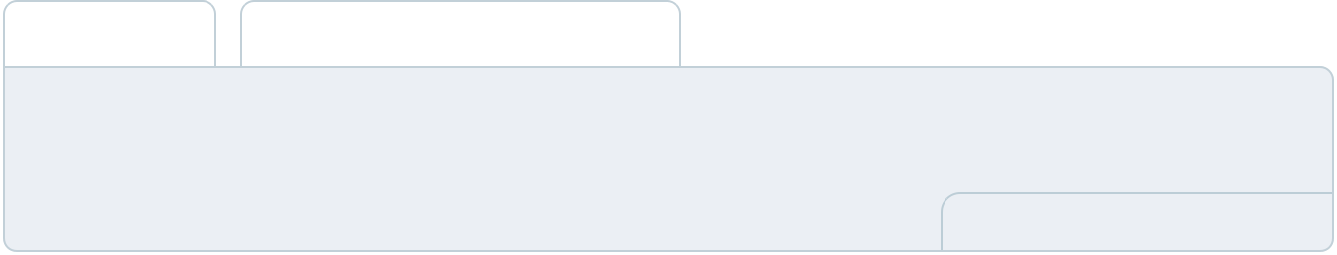

To create an effective introduction for your "Operational Plan" chapter, start by emphasizing the
pivotal role of efficient operations in the success of your business, underscoring how they
directly impact the quality of services delivered.
 |  |  |  | To unlock help try Upmetrics! 
Start writing here..
Staffing & Training
 Help tip |  |  Soap Making Business Plan

Mention your soap making business’s staffing requirements, including the number of
employees or production staff needed. Include their qualifications, the training required, and the
duties they will perform.
 |  |  |  | To unlock help try Upmetrics! 
Start writing here..
Operational Process
 Help tip |  |  Soap Making Business Plan

Outline the processes and procedures you will use to run your soap making business. Your operational processes may include soap production, inventory management, sales and marketing, shipping and fulfillment, customer service, and administrative tasks.
To unlock help try Upmetrics! 

Start writing here..

Equipment & Machinery

 Help tip  Soap Making Business Plan

Include the list of equipment and machinery required for soap making, such as mixing and blending equipment, heating equipment, cutting and molding equipment, safety equipment, etc.
To unlock help try Upmetrics! 

Start writing here..
Management Team

The management team section provides an overview of the individuals responsible for running your business plan.
To unlock help try Upmetrics! 

 Help tip  Soap Making Business Plan

To craft an introduction for your "Management Team" chapter, begin by emphasizing the crucial role of leadership in the success of any business.
To unlock help try Upmetrics! 

Start writing here..

Key managers

 Help tip  Soap Making Business Plan

Introduce your management and key members of your team, and explain their roles and responsibilities.
To unlock help try Upmetrics! 

Start writing here..

JOHN DOE

CEO & Co-founder - john.doe@example.com

John Doe is the visionary founder of [Sudsy Success Soaps], bringing over 15 years of experience in the soap-making and personal care industry.

With a deep passion for natural and sustainable products, he has successfully led the company to become a renowned name in the market.


John holds a Bachelor’s degree in Chemistry and a Master’s in Business Administration, providing a solid foundation for his role at [Sudsy Success Soaps].

- Educational Background: B.Sc. in Chemistry from [University Name], MBA from [Business School Name]

- Professional Background: Prior to founding [Sudsy Success Soaps], John worked in various capacities within the personal care industry, including roles in product development, marketing, and operations at several leading companies.


JANE DOE

Operations Manager - jane.doe@example.com

Jane Doe is an experienced operations manager with over 10 years of experience in manufacturing and production.

She is responsible for ensuring the smooth operation of all manufacturing processes, maintaining high-quality standards, and optimizing workflows for efficiency.

Jane holds a Bachelor’s degree in Industrial Engineering and is certified in Lean Manufacturing.

- Educational Background: B.Eng. in Industrial Engineering from [University Name]

- Professional Background: Jane has a robust background in manufacturing, having worked as a production supervisor and process engineer in her previous roles, where she successfully implemented process improvements and cost-saving initiatives.

ALICE BROWN

QC Manager - alice.brown@example.com

Alice Brown is a dedicated quality control manager with a keen eye for detail and a commitment to excellence.

She is responsible for ensuring that all [Sudsy Success Soaps] products meet the highest quality standards, conducting regular inspections, and leading quality improvement initiatives.

Alice holds a Bachelor’s degree in Chemistry and is certified in Quality Management.

- Educational Background: B.Sc. in Chemistry from [University Name]

- Professional Background: Prior to joining [Sudsy Success Soaps], Alice worked as a laboratory analyst and quality assurance specialist, gaining valuable experience in product testing and quality control.


ROBERT BROWN

Marketing Manager - robert.brown@example.com

Robert Brown is an innovative marketing manager with a talent for compelling marketing campaigns.

He is responsible for leading [Sudsy Success Soaps]’ marketing efforts, driving brand awareness, and generating sales. Robert holds a Bachelor’s degree in Marketing and has a strong background in digital marketing.

- Educational Background: B.Sc. in Marketing from [University Name]

- Professional Background: Robert has over 8 years of experience in marketing, with a focus on digital channels.

He has previously worked as a digital marketing specialist and brand manager, where he developed and executed successful marketing strategies.
Organizational structure

 Help tip  Soap Making Business Plan

Explain the organizational structure of your management team. Include the reporting line and decision-making hierarchy.
To unlock help try Upmetrics! 

Start writing here..

Organization chart


John Doe

CEO
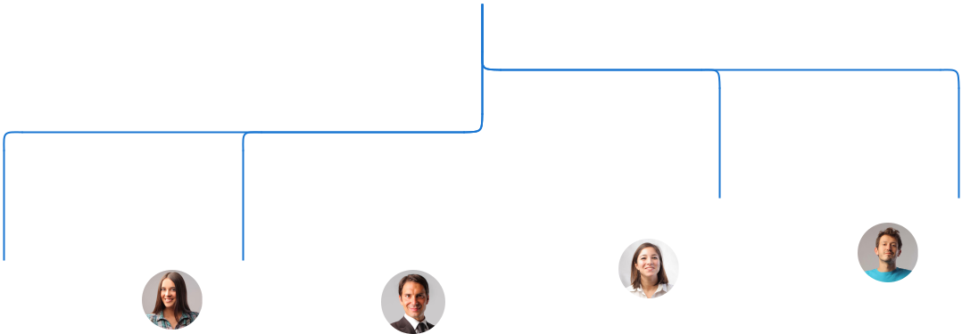

 |  |  |  |  |  |  | Emily | William
Jane Doe |  |  | Alice | Robert |  |  | Emily | White
 |  |  | Alice |  |  |  | Johnson | White
 |  |  |  |  |  |  |  | Sales
Operations |  |  | Brown | Brown |  |  | CFO | Sales
 |  |  |  |  |  |  |  | Manager
Manager |  |  | QC | Marketing |  |  |  | Manager
 |  |  | Manager | Manager
Compensation plan
 Help tip |  |  |  Soap Making Business Plan


Describe your compensation plan for the management and staff. Include their salaries, incentives, and other benefits.
To unlock help try Upmetrics! 

Start writing here..

 Help tip  Soap Making Business Plan

Mentioning advisors or consultants in your business plans adds credibility to your business idea.
To unlock help try Upmetrics! 

Advisors/Consultants


DR. EMILY WHITE

Business Strategy Advisor - emily.white@example.com

Offering guidance on business expansion, market penetration, and strategic positioning.

With a Ph.D. in Business Management and over [15] years of experience advising startups and established businesses, Dr. White has a profound understanding of industry dynamics and growth strategies.


MR. JACOB GREEN

Production & Quality Assurance Consultant

Advising on manufacturing processes, quality control measures, and ensuring adherence to industry standards.

Holding a Masters in Chemical Engineering and having [10] years in the soap manufacturing sector, Jacob's expertise ensures our products are of superior quality.
Financial Plan

When writing the financial plan section of a business plan, it’s important to provide a comprehensive overview of your financial projections for the first few years of your business, You may provide the following:
To unlock help try Upmetrics! 

 Help tip  Soap Making Business Plan


To create an effective introduction for your "Financial Plan" chapter, begin by stressing the critical role of a well-structured financial plan in the success of your venture.
To unlock help try Upmetrics! 

Start writing here..

 Help tip  Soap Making Business Plan

Describe details such as projected revenue, operational costs, and service costs in your projected profit and loss statement. Make sure to include your business’s expected net profit or loss.
To unlock help try Upmetrics! 

Profit & loss statement

Revenue

Cost Of Sales

General Costs

Revenue Specific Costs

Personnel Costs (Direct

Labor)

Gross Margin

Gross Margin (%)

Operating Expense

Payroll Expense

(Indirect Labor)

General Expense

Bad Debt

Amortization of Current

Assets

2023-24 | 2024-25 | 2025-26 | 2026-27 | 2027-28
$0 | $0 | $0 | $0 | $0

$0 | $0 | $0 | $0 | $0
$0 | $0 | $0 | $0 | $0
$0 | $0 | $0 | $0 | $0
$0 | $0 | $0 | $0 | $0

$0 | $0 | $0 | $0 | $0
0% | 0% | 0% | 0% | 0%

$0 | $0 | $0 | $0 | $0
$0 | $0 | $0 | $0 | $0
$0 | $0 | $0 | $0 | $0
$0 | $0 | $0 | $0 | $0
$0 | $0 | $0 | $0 | $0

EBITDA

Additional Expense

Long Term

Depreciation

Gain or loss from Sale

of Assets

EBIT

Interest Expenses

EBT

Income Tax Expense

Total Expense

Net Income

Net Income (%)

2023-24 | 2024-25 | 2025-26 | 2026-27 | 2027-28
$0 | $0 | $0 | $0 | $0
$0 | $0 | $0 | $0 | $0
$0 | $0 | $0 | $0 | $0
$0 | $0 | $0 | $0 | $0
$0 | $0 | $0 | $0 | $0
$0 | $0 | $0 | $0 | $0
$0 | $0 | $0 | $0 | $0
$0 | $0 | $0 | $0 | $0
$0 | $0 | $0 | $0 | $0
$0 | $0 | $0 | $0 | $0
0% | 0% | 0% | 0% | 0%

 |  |  | 2023-24 |  | 2024-25 | 2025-26
Retained Earning |  |  | $0 |  | $0 | $0
Opening |  |  |  |  | $0 | $0
Owner's Distribution |  |  | $0 |  | $0 | $0
Retained Earning |  |  | $0 |  | $0 | $0
Closing |  |  |  |  | $0 | $0
 Help tip |  |  |  Soap Making Business Plan
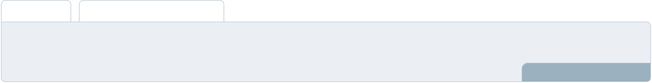

The cash flow for the first few years of your operation should be estimated and described in this section.

This may include billing invoices, payment receipts, loan payments, and any other cash flow statements.
2026-27 2027-28

$0 $0

$0 $0

$0 $0

To unlock help try Upmetrics! 

Cash flow statement

 | 2023-24 | 2024-25 | 2025-26 | 2026-27 | 2027-28
Cash Received | $0 | $0 | $0 | $0 | $0
Cash Paid | $0 | $0 | $0 | $0 | $0
COS & General Expenses | $0 | $0 | $0 | $0 | $0
Salary & Wages | $0 | $0 | $0 | $0 | $0
Interest | $0 | $0 | $0 | $0 | $0

Sales Tax

Income Tax

Net Cash From

Operations

Assets Sell

Assets Purchase

Net Cash From

Investments

Amount Received

Loan Received

Common Stock

Preferred Stock

Owner's Contribution

Amount Paid

2023-24 | 2024-25 | 2025-26 | 2026-27 | 2027-28
$0 | $0 | $0 | $0 | $0
$0 | $0 | $0 | $0 | $0
$0 | $0 | $0 | $0 | $0

$0 | $0 | $0 | $0 | $0
$0 | $0 | $0 | $0 | $0
$0 | $0 | $0 | $0 | $0

$0 | $0 | $0 | $0 | $0
$0 | $0 | $0 | $0 | $0

$0 | $0 | $0 | $0 | $0
$0 | $0 | $0 | $0 | $0
$0 | $0 | $0 | $0 | $0

Loan Capital $0 $0 $0 $0 $0

 |  |  | 2023-24 | 2024-25 | 2025-26 | 2026-27 | 2027-28
Dividends & Distributions |  |  | $0 | $0 | $0 | $0 | $0
Net Cash From |  |  | $0 | $0 | $0 | $0 | $0
Financing
Summary
Starting Cash |  |  | $0 | $0 | $0 | $0 | $0
Cash In |  |  | $0 | $0 | $0 | $0 | $0
Cash Out |  |  | $0 | $0 | $0 | $0 | $0
Change in Cash |  |  | $0 | $0 | $0 | $0 | $0
Ending Cash |  |  | $0 | $0 | $0 | $0 | $0
 Help tip |  |  Soap Making Business Plan

Create a projected balance sheet documenting your soap making business’s assets, liabilities, and equity.

To unlock help try Upmetrics! 

Balance sheet

 | 2023-24 | 2024-25 | 2025-26 | 2026-27 | 2027-28
Assets | $0 | $0 | $0 | $0 | $0
Current Assets | $0 | $0 | $0 | $0 | $0
Cash | $0 | $0 | $0 | $0 | $0
Accounts Receivable | $0 | $0 | $0 | $0 | $0
Inventory | $0 | $0 | $0 | $0 | $0
Other Current Assets | $0 | $0 | $0 | $0 | $0
Long Term Assets | $0 | $0 | $0 | $0 | $0
Gross Long Term Assets | $0 | $0 | $0 | $0 | $0
Accumulated Depreciation | $0 | $0 | $0 | $0 | $0

Liabilities & Equity | $0 | $0 | $0 | $0 | $0
Liabilities | $0 | $0 | $0 | $0 | $0
Current Liabilities | $0 | $0 | $0 | $0 | $0
Accounts Payable | $0 | $0 | $0 | $0 | $0
Income Tax Payable | $0 | $0 | $0 | $0 | $0
Sales Tax Payable | $0 | $0 | $0 | $0 | $0
Short Term Debt | $0 | $0 | $0 | $0 | $0
 | 2023-24 | 2024-25 | 2025-26 | 2026-27 | 2027-28
Long Term Liabilities | $0 | $0 | $0 | $0 | $0
Long Term Debt | $0 | $0 | $0 | $0 | $0
Equity | $0 | $0 | $0 | $0 | $0
Paid-in Capital | $0 | $0 | $0 | $0 | $0
Common Stock | $0 | $0 | $0 | $0 | $0
Preferred Stock | $0 | $0 | $0 | $0 | $0
Owner's Contribution | $0 | $0 | $0 | $0 | $0
Retained Earnings | $0 | $0 | $0 | $0 | $0

Check | $0 |  |  | $0 | $0 | $0 | $0
 Help tip |  |  Soap Making Business Plan

Determine and mention your business’s break-even point—the point at which your business costs and revenue will be equal.

This exercise will help you understand how much revenue you need to generate to sustain or be profitable.
To unlock help try Upmetrics! 

Break-even Analysis

 | 2023-24 | 2024-25 | 2025-26 | 2026-27 | 2027-28
Starting Revenue | $0 | $0 | $0 | $0 | $0
Net Revenue | $0 | $0 | $0 | $0 | $0
Closing Revenue | $0 | $0 | $0 | $0 | $0

Starting Expense | $0 | $0 | $0 | $0 | $0
Net Expense | $0 | $0 | $0 | $0 | $0
Closing Expense | $0 | $0 | $0 | $0 | $0

Is Break Even? | 0 | 0 | 0 | 0 | 0
Break Even Month | 0 | 0 | 0 | 0 | 0
Days Required | 0 | 0 | 0 | 0 | 0
Break Even Revenue | $0 | $0 | $0 | $0 | $0
Break Even Units
Financing needs

 Help tip  Soap Making Business Plan

Calculate costs associated with starting a soap making business, and estimate your financing needs and how much capital you need to raise to operate your business.
To unlock help try Upmetrics! 

Start writing here..
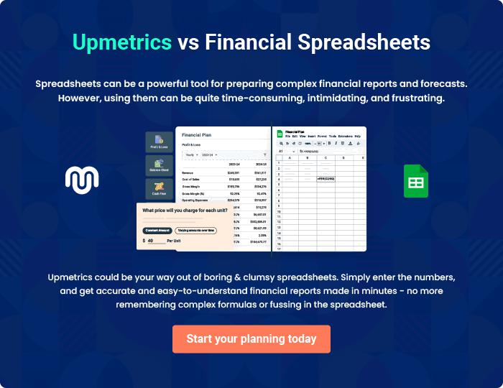
Appendix

When writing the appendix section, you should include any additional information that supports the main content of your plan. This may include financial statements, market research data, legal documents, and other
To unlock help try Upmetrics! 
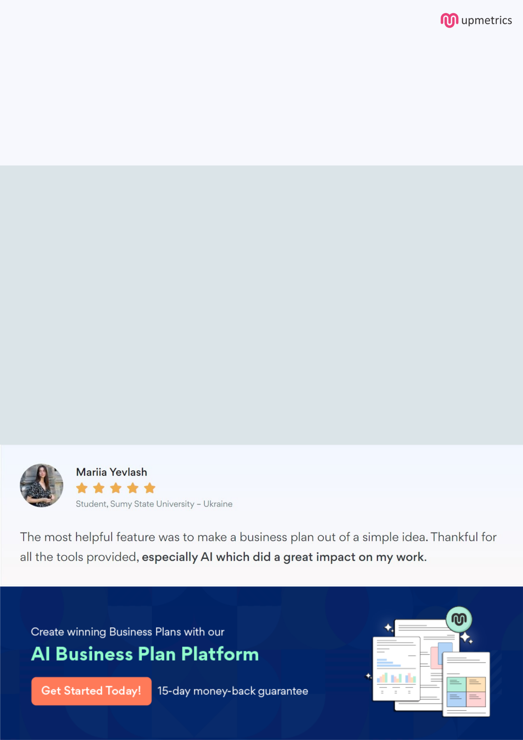
Create a winning business plan that gets you funded

Creating a stunning and investment-ready plan requires no writing, graphic designing, or financial planning expertise.

Upmetrics has all the features required to help you create a comprehensive business plan—from start to finish. Make no mistakes, it’s the modern way of planning to structure ideas, make plans, and create stunning pitch decks to awe investors.

Pitch decks that impress investors

Create pitch decks that provide a visual representation of your business, engage investors, and make them want to invest in your business idea.

Interactive plans in no time

Import business plan sections like—SWOT analysis, comparison tables, and others to create an interactive business plan. No designing skills are required.

Stunning cover page designs

With Upmetrics, you have the liberty to choose from multiple stunning cover page designs. Choose a creative design and make your plan stand out.

Online sharing made simple

Upmetrics makes online sharing quick and easier for users. Easily share your business plans with a link while tracking reader activity.

500+ sample business plans

Simply import a template from our library of sample plans into the editor and start customizing it to make it yours. It takes only a few clicks to get started.

Collaborate with team in real-time

Invite team members, initiate conversations, discuss ideas & strategies, share feedback, and work on a business plan in real-time.

