
 Smoke Shop Business Plan

ADDRESS CONTACT

10200 Bolsa Ave, Westminster, CA, 92683 (650) 359-3153

http://www.example.com info@example.com
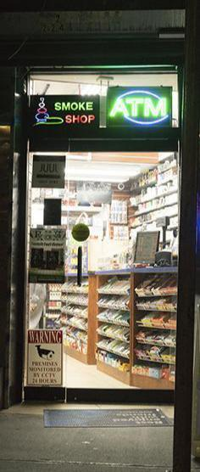

Business Plan

2023

Prepared By

John Doe


Smoke Essentials, Discover

Information provided in this business plan is unique to this business and confidential; therefore, anyone reading this plan agrees not to disclose any of the information in this business plan without prior written permission of the company.

Table of Contents

Executive Summary | 6
Market opportunity | 6
Services Offered | 6
Marketing & Sales Strategies | 7
Financial Highlights | 7
Units Sold v/s Revenue | 8

Company Overview | 9
Ownership | 9
Mission statement | 10
Business history | 10
Future goals | 10

Market Analysis | 11
Target Market | 11
Market size and growth potential | 11
Market Size | 12
Competitive analysis | 12
Smoke City | 12
Green Leaf Vapes & CBD | 13
Oasis Tobacco & Gifts | 13
Market trends | 13
Regulatory environment | 14

Products and Services | 15
Products | 15
Traditional Tobacco | 15
Vaping Products | 16
Smoking Accessories | 16
CBD Products | 16
Custom Glassware | 17
Tobacco and Vape Consultations | 17
Educational Workshops | 17
Community Events | 18
Personalization Options | 18
Quality Measures | 19
Additional Services | 19

Sales And Marketing Strategies | 20
Unique Selling Proposition (USP) | 20
Pricing Strategy | 20
Marketing strategies | 21
Online | 21
Sales strategies | 22
Customer retention | 23

Operations Plan | 24
Staffing & Training | 24
Operational Process | 24
Equipment & Machinery | 25

Management Team | 26
Key managers | 26
John Doe | 27
Jane Doe | 28
Alice Brown | 28
Robert Brown | 28
Organizational structure | 29
Organization chart | 29
Compensation plan | 29
Board of advisors | 30
[ADVISOR NAME] | 30
[ADVISOR NAME] | 30
Financial Plan | 31
Profit & loss statement | 31
Cash flow statement | 34
Balance sheet | 36
Break-even Analysis | 38
Financing needs | 40
Appendix
Appendix | 42
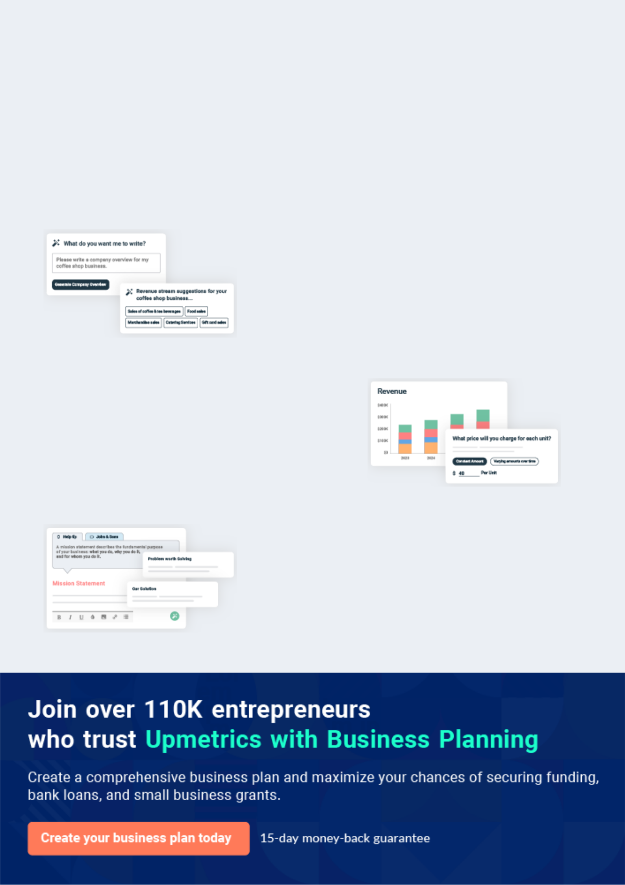
Business planning that’s simpler and faster than you think

Creating a business plan using Upmetrics to start and grow a business is literally the easiest thing in the World. Simply read the instructions and fill in the blanks. It’s as simple as that.

❛ | Upmetrics has everything you need to create a | ❜
❛ | comprehensive business plan. | ❜

AI-powered Upmetrics Assistant

AI-powered insights to streamline your plan

Not sure where to start? Upmetrics’ AI Assistant will automatically generate ideas for each section of your plan and offer improved versions of your writing, adjusting for tone, voice, and grammar or spelling errors.

Financial Forecasting Tool

All the financials are calculated for you

Forget the complex formulas and clumsy spreadsheets — with automatic financials and drag-and-drop forecasting, you can finish your plan faster and be confident that your numbers are accurate.

Business Plan Builder

Guides you like a business mentor

Upmetrics’ step-by-step instructions, prompts, and the library of 400+ sample business plans will guide you through each section of your plan as a business mentor.
Executive Summary


An executive summary is the first section of the business plan intended to provide an overview of the whole business plan.
To unlock help try Upmetrics! 

 Help tip  Smoke Shop Business Plan


Start your executive summary by briefly introducing your business to your readers.

This section may include the name of your smoke shop, its location, when it was founded, the
To unlock help try Upmetrics! 

Start writing here..

Market opportunity

 Help tip  Smoke Shop Business Plan

Summarize your market research, including market size, growth potential, and marketing trends. Highlight the opportunities in the market and how your business will fit in to fill the gap.
To unlock help try Upmetrics! 

Start writing here..

Services Offered

 Help tip  Smoke Shop Business Plan

Highlight the smoking products you offer your clients. The USPs and differentiators you offer are always a plus.
To unlock help try Upmetrics! 

Start writing here..

Marketing & Sales Strategies
To unlock help try Upmetrics!

 Help tip  Smoke Shop Business Plan

Outline your sales and marketing strategies—what marketing platforms you use, how you plan on acquiring customers, etc.
To unlock help try Upmetrics! 

Start writing here..

Financial Highlights

 Help tip  Smoke Shop Business Plan

Briefly summarize your financial projections for the initial years of business operations. Include any capital or investment requirements, associated startup costs, projected revenues, and profit forecasts.



Start writing here..
Units Sold v/s Revenue

 |  | Units Sold | Revenue
15.00k
10.00k
5.00k
0
Year 1 | Year 2 | Year 3
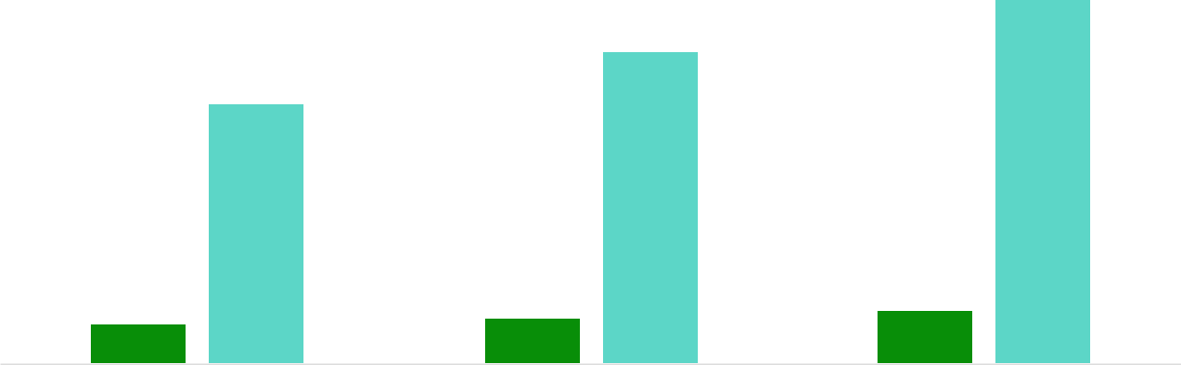

Financial Year |  |  | Units Sold | Revenue
Year 1 | 1,550 |  |  | $10,000
Year 2 | 1,800 |  |  | $12,000
Year 3 | 2,050 |  |  | $14,000
 Help tip |  |  Smoke Shop Business Plan


Summarize your executive summary section with a clear CTA, for example, inviting angel investors to discuss the potential business investment.
To unlock help try Upmetrics! 

Write a call to action for your business plan.
Company Overview

Depending on what details of your business are essential, you’ll need different elements in your business overview.
To unlock help try Upmetrics! 

 Help tip  Smoke Shop Business Plan

Describe your business in this section by providing all the basic information:

Describe what kind of smoke shop you run and the name of it. You may operate one of the
To unlock help try Upmetrics! 

Start writing here..

Ownership

 Help tip  Smoke Shop Business Plan

List the founders or owners of your smoke shop. Describe what shares they own and their responsibilities for efficiently managing the business.
To unlock help try Upmetrics! 

Start writing here..
Mission statement

 Help tip  Smoke Shop Business Plan

Summarize your business’ objective, core principles, and values in your mission statement. This statement needs to be memorable, clear, and brief.
To unlock help try Upmetrics! 

❛ At [Smoke Shop Name], our mission is to provide our customers with an unparalleled shopping experience by offering a diverse range of high-quality smoking products and accessories.

We are committed to upholding the core principles and values of integrity, customer satisfaction, and innovation, creating a unique and memorable experience for all.

❜

Business history

 Help tip  Smoke Shop Business Plan

If you’re an established smoke shop owner, briefly describe your business history, like—when it was founded, how it evolved over time, etc.
To unlock help try Upmetrics! 

Start writing here..

Future goals

 Help tip  Smoke Shop Business Plan

It’s crucial to convey your aspirations and vision. Mention your short-term and long-term goals; they can be specific targets for revenue, market share, or expanding your services.
To unlock help try Upmetrics! 

Start writing here..

Market Analysis
To unlock help try Upmetrics!


 |  | Market analysis provides a clear understanding of the market in which your
 |  | printing business will run along with the target market, competitors, and
 |  | growth opportunities.
 |  |  |  | To unlock help try Upmetrics! 
 Help tip |  |  Smoke Shop Business Plan

To write the introduction section of your market analysis, start by clearly identifying your primary target market.
To unlock help try Upmetrics! 

Start writing here..

Target Market

 Help tip  Smoke Shop Business Plan

Start this section by describing your target market. Define your ideal customer and explain what types of services they prefer. Creating a buyer persona will help you easily define your target market to your readers.



Start writing here..

Market size and growth potential

 Help tip  Smoke Shop Business Plan

Describe your market size and growth potential and whether you will target a niche or a much broader market.
To unlock help try Upmetrics! 

Start writing here..

Market Size

Available Market

Total potential customers seeking 50M smoking products.

Served Market | 20M
Customers in regions where we operate. | 20M

Target Market
Customers seeking premium cigars & 5M vapes.

 Help tip  Smoke Shop Business Plan

Identify and analyze your direct and indirect competitors. Identify their strengths and weaknesses, and describe what differentiates your smoke shop services from them.
To unlock help try Upmetrics! 

Competitive analysis

Smoke City

Established in 2000, Smoke City has been a staple in the industry, offering a diverse range of traditional smoking products and more recent innovations like vapes.

Features | Strengths
Tobacco products | Wide product range.
vaping equipment | Established brand with loyal
premium cigars | customer base.
CBD products | Frequent promotions and
CBD products | loyalty programs.

Weaknesses

Limited online presence and e-commerce capabilities.

Concentrated in a few locations, limiting their market reach.

Green Leaf Vapes & CBD

A modern smoke shop primarily focused on vaping and CBD products. Green Leaf Vapes & CBD prides itself on its curated selection and knowledgeable staff.

Features

E-cigarettes

vape juices

vaping equipment

CBD oils

Edibles and topical products

Strengths Weaknesses

Expertise in vaping and CBD, Limited range of traditional

catering to a niche market. tobacco products.

Active online presence with a Relatively newer in the market,

functional e-commerce still establishing brand credibility.

platform.

Regular workshops and

informational sessions about

vaping and CBD.

Oasis Tobacco & Gifts

A one-stop shop for tobacco enthusiasts, Oasis offers a unique blend of traditional and modern smoking products alongside a selection of novelty gifts.

Features

Premium tobacco

Cigars

Pipes

Hookahs

Novelty Gifts

Strengths

Diverse product range catering to both traditional and modern smokers.

Unique gifts section attracting a broader audience.

Strong supplier relationships ensuring product availability.

Weaknesses

Less focus on emerging markets like vaping and CBD.

Limited marketing and promotional activities.

Market trends

 Help tip  Smoke Shop Business Plan

Analyze emerging trends in the industry, such as technology disruptions, changes in customer behavior or preferences, etc. Explain how your business will cope with all the trends.
To unlock help try Upmetrics! 

Start writing here..

Regulatory environment
To unlock help try Upmetrics!

 Help tip  Smoke Shop Business Plan

List regulations and licensing requirements that may affect your smoke shop, such as business registration, insurance, compliance with tobacco regulations, vaping regulations, cannabis regulations, etc.



Start writing here..
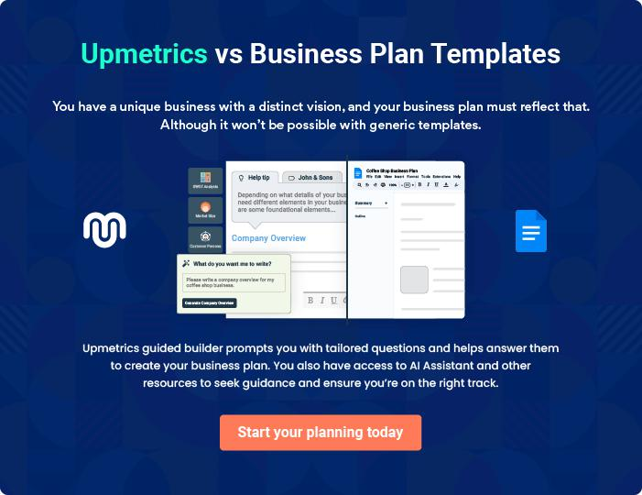
Products and Services
To unlock help try Upmetrics!

The product and services section of a smoke shop business plan should describe the specific services and products that will be offered to customers. To write this section should include the following:



 Help tip  Smoke Shop Business Plan

To craft the introduction for your "Products and Services" chapter, begin by positioning your business within its industry, emphasizing its unique strengths or value proposition.
To unlock help try Upmetrics! 

Start writing here..

 Help tip


Mention the smoking products your smoke shop will offer to its customers. This list may include services like
To unlock help try Upmetrics! 

Products

Traditional Tobacco


Price: [$5 - $30] per pack/ounce

Our traditional tobacco range includes an extensive selection of brands and types, catering to all tastes and preferences.

Specifications

- Cigars, pipe tobacco, rolling tobacco available

- Multiple flavors, including classic, menthol, and others

- A range of strengths from mild to full-bodied
Vaping Products

Price: [$10 - $100] per item

Our collection of vaping products is comprehensive, providing options for both novices and seasoned vapers.

Specifications

- E-cigarettes, vape pens, mods, and e-liquids

- Wide variety of flavours, from fruity to dessert options

- Different nicotine strengths to suit individual preferences

Smoking Accessories

Price: [$1 - $50] per item

Our assortment of smoking accessories includes everything from fundamental necessities to specialized gear.

Specifications

- Lighters, ashtrays, rolling papers, and filters

- Rolling machines, herb grinders, and storage containers

- Variety of styles and designs to choose from

CBD Products

Price: [$10 - $200] per item

Our selection of CBD products is derived from trusted brands, ensuring quality and consistency.

Specifications

- CBD oils, tinctures, edibles, capsules, and topicals

- Multiple concentrations and flavors available

- All products are third-party lab tested
Custom Glassware

Price: [$50 - $500] per item

Our custom glassware is perfect for those seeking a unique and personalized smoking experience.

Specifications

- Handcrafted pieces made by skilled artisans

- Option to customize designs, sizes, and colours

- High-quality glass materials used

Tobacco and Vape Consultations

Price: [$20 - $100] per session

Our experts are on hand to provide tailored advice, helping customers find the best tobacco or vape products to meet their needs.

Specifications

- In-store and online consultations available

- Personalized recommendations based on preferences and experiences

- Option to sample products during sessions

Educational Workshops

Price: [$50 - $150] per workshop

We offer informative workshops on various topics related to smoking and vaping, promoting safety and responsible use.

Specifications

- Sessions led by industry experts and professionals

- Covering topics such as product safety, responsible use, and more

- Interactive sessions with Q&A segments
Community Events

Price: [$50] per event

Our community events are a great opportunity for customers to connect and share their passion for smoking and vaping.

Specifications

- Product launches, social gatherings, and more

- Opportunity to meet like-minded individuals

- Some events may include product samples and giveaways

Personalization Options

 Help tip  Smoke Shop Business Plan

Mention if you offer any product personalization or customizations. These may include personalized tobacco blends, unique product combinations, and custom glassware.
To unlock help try Upmetrics! 

Start writing here..
Quality Measures

 Help tip  Smoke Shop Business Plan

This section should explain how you maintain quality standards and consistently provide the highest quality service.
To unlock help try Upmetrics! 

Start writing here..

Additional Services

 Help tip  Smoke Shop Business Plan

Mention if your smoke shop offers any additional services. You may include services like tobacco or vape product consultations, educational resources, and community events.
To unlock help try Upmetrics! 

Start writing here..
Sales And Marketing Strategies
To unlock help try Upmetrics!

Writing the sales and marketing strategies section means a list of strategies you will use to attract and retain your clients.
To unlock help try Upmetrics! 

 Help Tip  Smoke Shop Business Plan


To create an effective introduction for your "Sales and Marketing Strategies" chapter, start by setting the stage within your specific industry or market.
To unlock help try Upmetrics! 

Start writing here..

Unique Selling Proposition (USP)

 Help tip  Smoke Shop Business Plan

Define your business’s USPs depending on the market you serve, the equipment you use, and the unique services you provide. Identifying USPs will help you plan your marketing strategies.
To unlock help try Upmetrics! 

Start writing here..

Pricing Strategy

 Help tip  Smoke Shop Business Plan

Describe your pricing strategy—how you plan to price your products and stay competitive in the local market. You can mention any discounts you plan on offering to attract new customers to your shop.



Start writing here..

 Help tip  Smoke Shop Business Plan

Discuss your marketing strategies to market your services. You may include some of these marketing strategies in your business plan—social media marketing, online advertising, influence marketing, email marketing, content marketing, and print marketing.
To unlock help try Upmetrics! 

Marketing strategies

Online


Social Media

Utilizing platforms like [mention specific social media platforms] to connect with customers and share updates on new products, promotions, and industry news

Content Marketing

Creating valuable content such as blog posts, videos, and infographics to educate our customers and position ourselves as industry experts.

Influencer Marketing

Partnering with influencers in the smoking industry to promote our products and increase brand credibility.

Email Marketing

Sending regular newsletters to our subscribers to keep them informed about new products, promotions, and other exciting news.

Online Advertising

Employing targeted online advertising campaigns to reach potential customers actively searching for smoke shop products.

 Help tip  Smoke Shop Business Plan
To unlock help try Upmetrics!

Outline the strategies you’ll implement to maximize your sales. Your sales strategies may include partnering with local businesses, offering referral programs, targeted marketing campaigns, etc.



Sales strategies

Partner with Businesses

Partnering with other local businesses to cross-promote our products and increase brand visibility.

Referral Programs

Offering referral incentives to existing customers who refer new clients to our shop.

Targeted Marketing Campaigns

Running targeted marketing campaigns to reach specific customer segments based on their preferences and purchase history.

 Help tip  Smoke Shop Business Plan
To unlock help try Upmetrics!

Describe your customer retention strategies and how you plan to execute them. For instance, introducing loyalty programs, hosting special events, personalized service, and creating VIP or insider clubs.



Customer retention

Loyalty Programs

Implementing loyalty programs that reward customers for their repeat business.

Personalized Service

Offering personalized customer service to make each customer feel valued and appreciated.

Special Events

Hosting special events and promotions to engage with our customers and provide them with a unique shopping experience.

VIP or Insider Clubs

Creating exclusive clubs for our most loyal customers, providing them with special offers, early access to new products, and other perks.

Operations Plan

 |  | When writing the operations plan section, it’s important to consider the
 |  | various aspects of your business operations.
 |  |  |  | To unlock help try Upmetrics! 
 Help tip |  |  Smoke Shop Business Plan


To create an effective introduction for your "Operational Plan" chapter, start by emphasizing the
pivotal role of efficient operations in the success of your business, underscoring how they
directly impact the quality of services delivered.
 |  |  |  | To unlock help try Upmetrics! 
Start writing here..
Staffing & Training
 Help tip |  |  Smoke Shop Business Plan

Mention your business’s staffing requirements, including the number of employees or support staff needed. Include their qualifications, the training required, and the duties they will perform.
To unlock help try Upmetrics! 

Start writing here..

Operational Process

 Help tip  Smoke Shop Business Plan

Outline the processes and procedures you will use to run your smoke shop.

Your operational processes may include opening and closing procedures, inventory
To unlock help try Upmetrics! 

Start writing here..

Equipment & Machinery
To unlock help try Upmetrics!

 Help tip  Smoke Shop Business Plan

Include the list of equipment and machinery required for a smoke shop, such as display cases, cash register and point-of-sale system, security systems, vaporizers, grinders and rolling machines, and weighing scales.



Start writing here..
Management Team

The management team section provides an overview of the individuals responsible for running your business plan.
To unlock help try Upmetrics! 

 Help tip  Smoke Shop Business Plan

To craft an introduction for your "Management Team" chapter, begin by emphasizing the crucial role of leadership in the success of any business.
To unlock help try Upmetrics! 

Start writing here..

Key managers

 Help tip  Smoke Shop Business Plan

Introduce your management and key members of your team, and explain their roles and responsibilities.
To unlock help try Upmetrics! 

Start writing here..

JOHN DOE

CEO and Founder - john.doe@example.com

John Doe is the visionary founder and CEO of [Smoke Shop Name]. With a B.A. in Business Administration from [University], John has over 10 years of experience in the smoke shop industry.


Before starting [Smoke Shop Name], John managed several successful smoke shops in California, gaining valuable insights and a deep understanding of the market.

His leadership, industry knowledge, and commitment to quality have been integral in establishing [Smoke Shop Name] as a premier destination for smoking products and accessories.

John oversees the strategic direction of the business and ensures that the shop consistently meets the highest standards of quality and customer satisfaction.

JANE DOE

General Manager - jane.doe@example.com

Jane Doe brings a wealth of experience and expertise to her role as General Manager at [Smoke Shop Name].

With an M.B.A. in Retail Management from [University], Jane has worked in various managerial roles in the smoke shop industry for over 7 years.

At [Smoke Shop Name], she is responsible for the day-to-day operations of the shop, ensuring that everything runs smoothly and efficiently.

Jane's strong organizational skills and attention to detail have been key factors in the success of the business.


ALICE BROWN

Marketing Manager - alice.brown@example.com

Alice Brown is the Marketing Manager at [Smoke Shop Name], where she oversees all marketing and advertising efforts.

With a B.S. in Marketing from [University] and over 5 years of experience in marketing, Alice is an expert at creating effective marketing campaigns that drive traffic to the shop and increase sales.

Her creativity and analytical skills are crucial in developing strategies that resonate with the target audience and set [Smoke Shop Name] apart from competitors.


ROBERT BROWN

Inventory Manager - robert.brown@example.com

As the Inventory Manager at [Smoke Shop Name], Robert Brown is responsible for managing the shop's inventory and ensuring that the stock levels are always optimized.

With a B.A. in Supply Chain Management from [University] and over 8 years of experience in inventory management, Robert has a deep understanding of supply chain logistics and inventory control.

His attention to detail and ability to negotiate with suppliers have been key to maintaining a diverse range of high-quality products at [Smoke Shop Name].
Organizational structure

 Help tip  Smoke Shop Business Plan

Explain the organizational structure of your management team. Include the reporting line and decision-making hierarchy.
To unlock help try Upmetrics! 

Start writing here..

Organization chart


John Doe

CEO
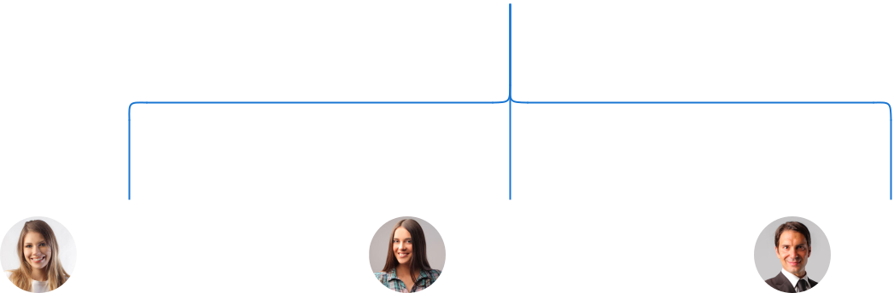

Jane Doe Alice Brown Robert Brown

General Manager Marketing Manager Inventory Manager


Tom Smith
Assistant Manager Emily Davis

Assistant Manager

Compensation plan

 Help tip  Smoke Shop Business Plan

Describe your compensation plan for the management and staff. Include their salaries, incentives, and other benefits.
To unlock help try Upmetrics! 

Start writing here..

 Help tip  Smoke Shop Business Plan

Mentioning advisors or consultants in your business plans adds credibility to your business idea.
To unlock help try Upmetrics! 

Board of advisors


[ADVISOR NAME]

Advisor 1

With [X years] of experience in [Advisor's Field/Industry], [Advisor's Name] serves as a [Role/Title] for [Smoke Shop Name], offering valuable insights and guidance.


[ADVISOR NAME]

Advisor 2

As a [Another Advisor's Role/Title], [Another Advisor's Name] brings [X years] of experience in [Another Advisor's Field/Industry] to help [Smoke Shop Name] achieve its objectives.
Financial Plan

When writing the financial plan section of a business plan, it’s important to provide a comprehensive overview of your financial projections for the first few years of your business, You may provide the following:
To unlock help try Upmetrics! 

 Help tip  Smoke Shop Business Plan


To create an effective introduction for your "Financial Plan" chapter, begin by stressing the critical role of a well-structured financial plan in the success of your venture.
To unlock help try Upmetrics! 

Start writing here..

 Help tip  Smoke Shop Business Plan

Describe details such as projected revenue, operational costs, and service costs in your projected profit and loss statement. Make sure to include your business’s expected net profit or loss.
To unlock help try Upmetrics! 

Profit & loss statement

Revenue

Cost Of Sales

General Costs

Revenue Specific Costs

Personnel Costs (Direct

Labor)

Gross Margin

Gross Margin (%)

Operating Expense

Payroll Expense

(Indirect Labor)

General Expense

Bad Debt

Amortization of Current

Assets

2023-24 | 2024-25 | 2025-26 | 2026-27 | 2027-28
$0 | $0 | $0 | $0 | $0

$0 | $0 | $0 | $0 | $0
$0 | $0 | $0 | $0 | $0
$0 | $0 | $0 | $0 | $0
$0 | $0 | $0 | $0 | $0

$0 | $0 | $0 | $0 | $0
0% | 0% | 0% | 0% | 0%

$0 | $0 | $0 | $0 | $0
$0 | $0 | $0 | $0 | $0
$0 | $0 | $0 | $0 | $0
$0 | $0 | $0 | $0 | $0
$0 | $0 | $0 | $0 | $0

EBITDA

Additional Expense

Long Term

Depreciation

Gain or loss from Sale

of Assets

EBIT

Interest Expenses

EBT

Income Tax Expense

Total Expense

Net Income

Net Income (%)

2023-24 | 2024-25 | 2025-26 | 2026-27 | 2027-28
$0 | $0 | $0 | $0 | $0
$0 | $0 | $0 | $0 | $0
$0 | $0 | $0 | $0 | $0
$0 | $0 | $0 | $0 | $0
$0 | $0 | $0 | $0 | $0
$0 | $0 | $0 | $0 | $0
$0 | $0 | $0 | $0 | $0
$0 | $0 | $0 | $0 | $0
$0 | $0 | $0 | $0 | $0
$0 | $0 | $0 | $0 | $0
0% | 0% | 0% | 0% | 0%
 |  |  | 2023-24 |  | 2024-25 | 2025-26 | 2026-27 | 2027-28
Retained Earning |  |  | $0 |  | $0 | $0 | $0 | $0
Opening
Owner's Distribution |  |  | $0 |  | $0 | $0 | $0 | $0
Retained Earning |  |  | $0 |  | $0 | $0 | $0 | $0
Closing
 Help tip |  |  |  Smoke Shop Business Plan


The cash flow for the first few years of your operation should be estimated and described in this section. This may include billing invoices, payment receipts, loan payments, and any other cash flow statements.
To unlock help try Upmetrics! 

Cash flow statement

 | 2023-24 | 2024-25 | 2025-26 | 2026-27 | 2027-28
Cash Received | $0 | $0 | $0 | $0 | $0
Cash Paid | $0 | $0 | $0 | $0 | $0
COS & General Expenses | $0 | $0 | $0 | $0 | $0
Salary & Wages | $0 | $0 | $0 | $0 | $0
Interest | $0 | $0 | $0 | $0 | $0

Sales Tax

Income Tax

Net Cash From

Operations

Assets Sell

Assets Purchase

Net Cash From

Investments

Amount Received

Loan Received

Common Stock

Preferred Stock

Owner's Contribution

Amount Paid

2023-24 | 2024-25 | 2025-26 | 2026-27 | 2027-28
$0 | $0 | $0 | $0 | $0
$0 | $0 | $0 | $0 | $0
$0 | $0 | $0 | $0 | $0

$0 | $0 | $0 | $0 | $0
$0 | $0 | $0 | $0 | $0
$0 | $0 | $0 | $0 | $0

$0 | $0 | $0 | $0 | $0
$0 | $0 | $0 | $0 | $0

$0 | $0 | $0 | $0 | $0
$0 | $0 | $0 | $0 | $0
$0 | $0 | $0 | $0 | $0

Loan Capital $0 $0 $0 $0 $0

 |  |  | 2023-24 | 2024-25 | 2025-26 | 2026-27 | 2027-28
Dividends & Distributions |  |  | $0 | $0 | $0 | $0 | $0
Net Cash From |  |  | $0 | $0 | $0 | $0 | $0
Financing
Summary
Starting Cash |  |  | $0 | $0 | $0 | $0 | $0
Cash In |  |  | $0 | $0 | $0 | $0 | $0
Cash Out |  |  | $0 | $0 | $0 | $0 | $0
Change in Cash |  |  | $0 | $0 | $0 | $0 | $0
Ending Cash |  |  | $0 | $0 | $0 | $0 | $0
 Help tip |  |  Smoke Shop Business Plan

Create a projected balance sheet documenting your smoke shop business’s assets, liabilities, and equity.

To unlock help try Upmetrics! 

Balance sheet

 | 2023-24 | 2024-25 | 2025-26 | 2026-27 | 2027-28
Assets | $0 | $0 | $0 | $0 | $0
Current Assets | $0 | $0 | $0 | $0 | $0
Cash | $0 | $0 | $0 | $0 | $0
Accounts Receivable | $0 | $0 | $0 | $0 | $0
Inventory | $0 | $0 | $0 | $0 | $0
Other Current Assets | $0 | $0 | $0 | $0 | $0
Long Term Assets | $0 | $0 | $0 | $0 | $0
Gross Long Term Assets | $0 | $0 | $0 | $0 | $0
Accumulated Depreciation | $0 | $0 | $0 | $0 | $0

Liabilities & Equity | $0 | $0 | $0 | $0 | $0
Liabilities | $0 | $0 | $0 | $0 | $0
Current Liabilities | $0 | $0 | $0 | $0 | $0
Accounts Payable | $0 | $0 | $0 | $0 | $0
Income Tax Payable | $0 | $0 | $0 | $0 | $0
Sales Tax Payable | $0 | $0 | $0 | $0 | $0
Short Term Debt | $0 | $0 | $0 | $0 | $0
 | 2023-24 | 2024-25 | 2025-26 | 2026-27 | 2027-28
Long Term Liabilities | $0 | $0 | $0 | $0 | $0
Long Term Debt | $0 | $0 | $0 | $0 | $0
Equity | $0 | $0 | $0 | $0 | $0
Paid-in Capital | $0 | $0 | $0 | $0 | $0
Common Stock | $0 | $0 | $0 | $0 | $0
Preferred Stock | $0 | $0 | $0 | $0 | $0
Owner's Contribution | $0 | $0 | $0 | $0 | $0
Retained Earnings | $0 | $0 | $0 | $0 | $0

Check | $0 |  |  | $0 | $0 | $0 | $0
 Help tip |  |  Smoke Shop Business Plan

Determine and mention your business’s break-even point—the point at which your business costs and revenue will be equal.

This exercise will help you understand how much revenue you need to generate to sustain or be profitable.
To unlock help try Upmetrics! 

Break-even Analysis

 | 2023-24 | 2024-25 | 2025-26 | 2026-27 | 2027-28
Starting Revenue | $0 | $0 | $0 | $0 | $0
Net Revenue | $0 | $0 | $0 | $0 | $0
Closing Revenue | $0 | $0 | $0 | $0 | $0

Starting Expense | $0 | $0 | $0 | $0 | $0
Net Expense | $0 | $0 | $0 | $0 | $0
Closing Expense | $0 | $0 | $0 | $0 | $0

Is Break Even? | 0 | 0 | 0 | 0 | 0
Break Even Month | 0 | 0 | 0 | 0 | 0
Days Required | 0 | 0 | 0 | 0 | 0
Break Even Revenue | $0 | $0 | $0 | $0 | $0
Break Even Units
Financing needs

 Help tip  Smoke Shop Business Plan

Calculate costs associated with starting a smoke shop, and estimate your financing needs and how much capital you need to raise to operate your business.
To unlock help try Upmetrics! 

Start writing here..
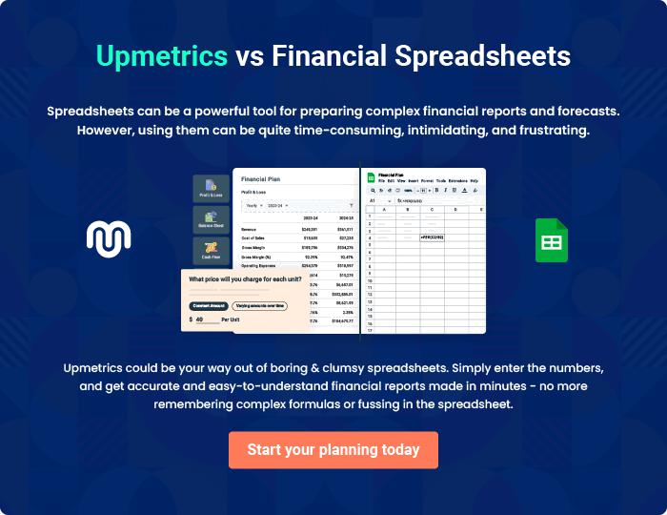
Appendix

When writing the appendix section, you should include any additional information that supports the main content of your plan. This may include financial statements, market research data, legal documents, and other
To unlock help try Upmetrics! 
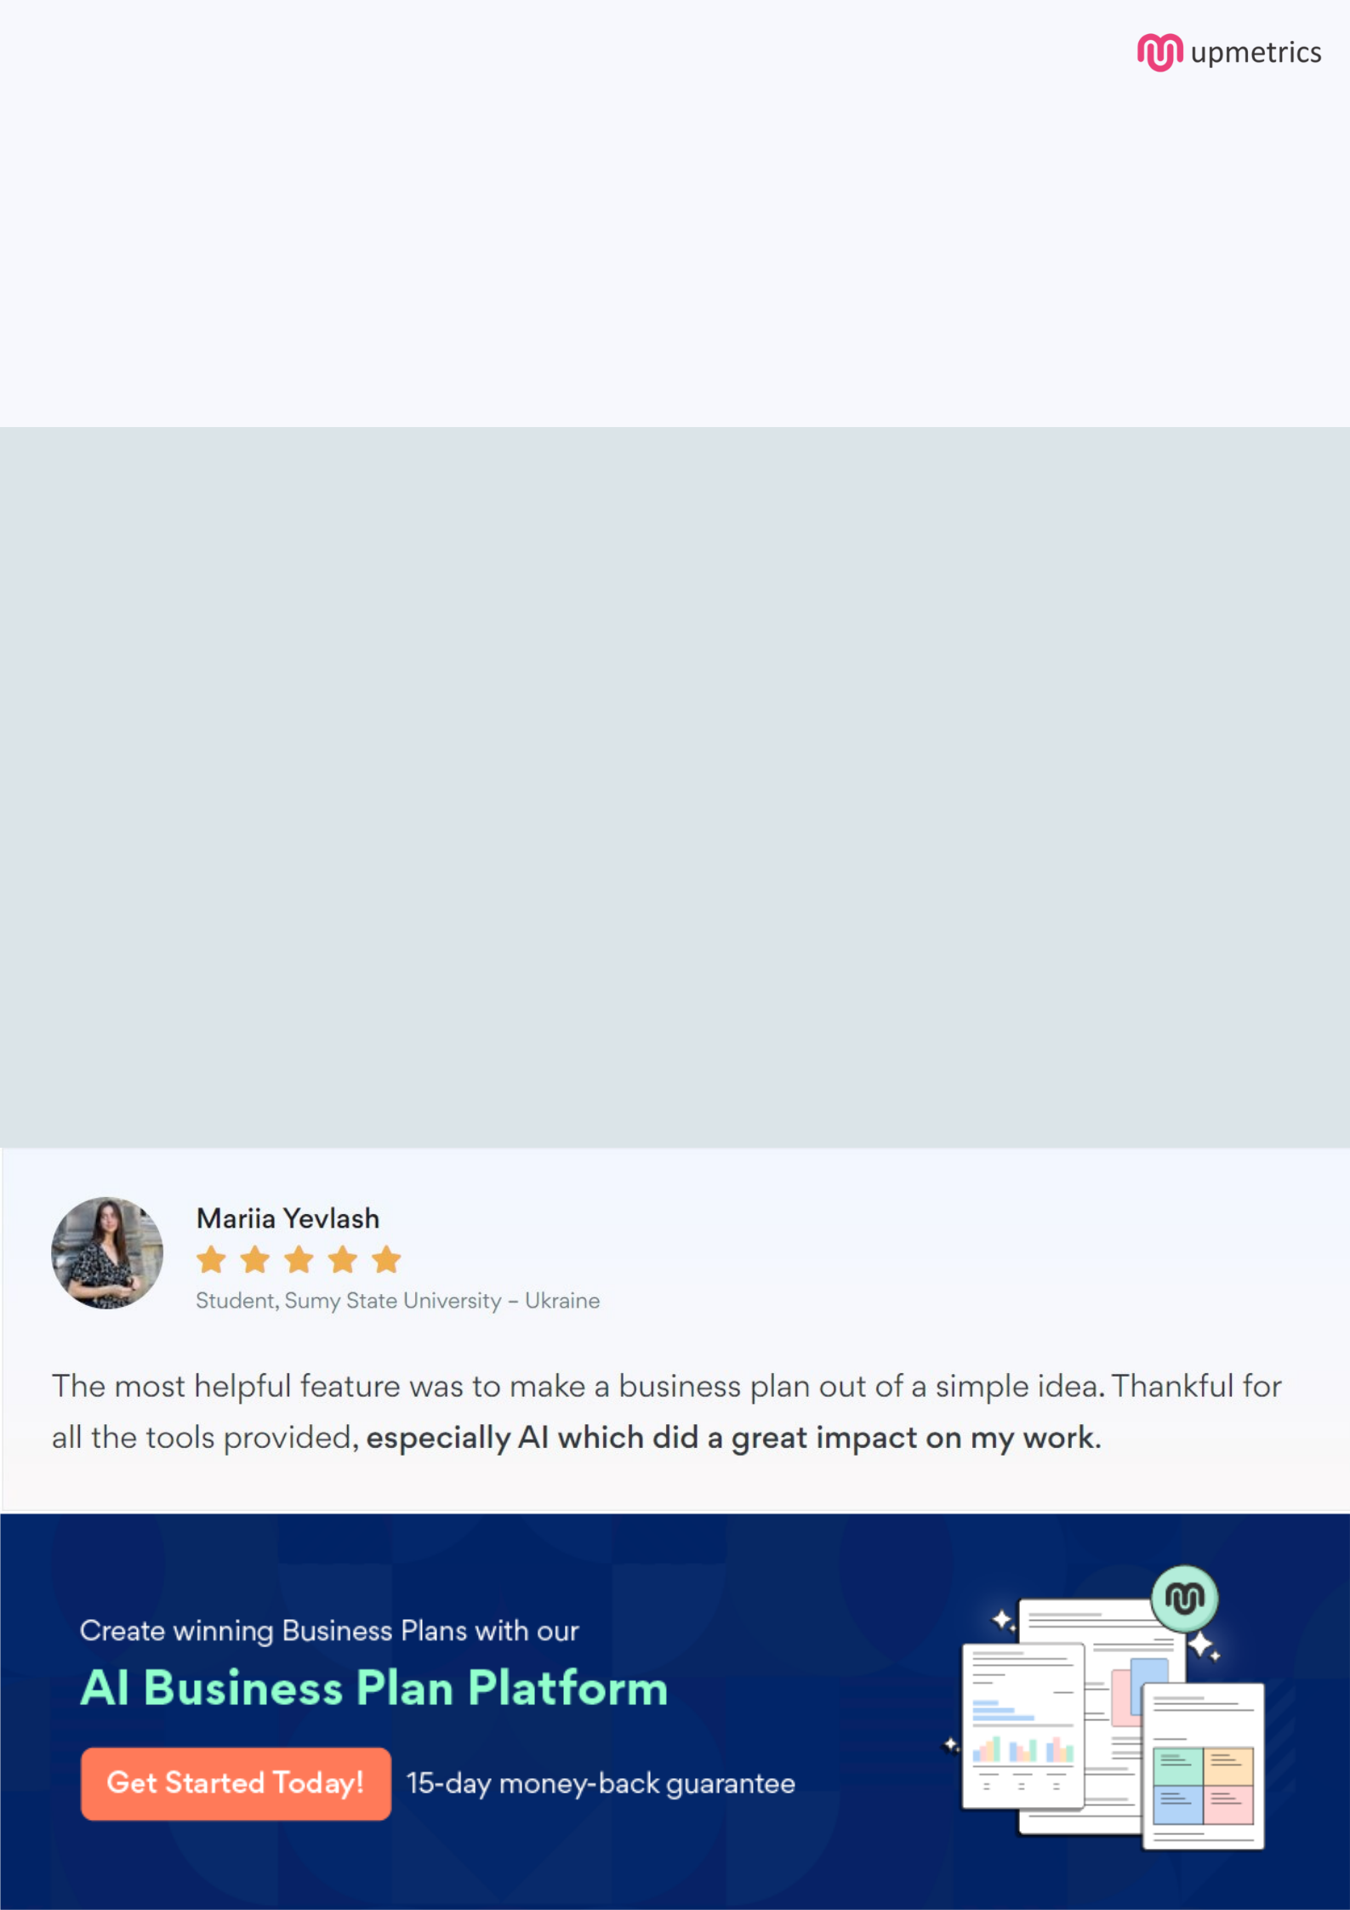
Create a winning business plan that gets you funded

Creating a stunning and investment-ready plan requires no writing, graphic designing, or financial planning expertise.

Upmetrics has all the features required to help you create a comprehensive business plan—from start to finish. Make no mistakes, it’s the modern way of planning to structure ideas, make plans, and create stunning pitch decks to awe investors.

Pitch decks that impress investors

Create pitch decks that provide a visual representation of your business, engage investors, and make them want to invest in your business idea.

Interactive plans in no time

Import business plan sections like—SWOT analysis, comparison tables, and others to create an interactive business plan. No designing skills are required.

Stunning cover page designs

With Upmetrics, you have the liberty to choose from multiple stunning cover page designs. Choose a creative design and make your plan stand out.

Online sharing made simple

Upmetrics makes online sharing quick and easier for users. Easily share your business plans with a link while tracking reader activity.

500+ sample business plans

Simply import a template from our library of sample plans into the editor and start customizing it to make it yours. It takes only a few clicks to get started.

Collaborate with team in real-time

Invite team members, initiate conversations, discuss ideas & strategies, share feedback, and work on a business plan in real-time.

