
Shoe store Business Plan
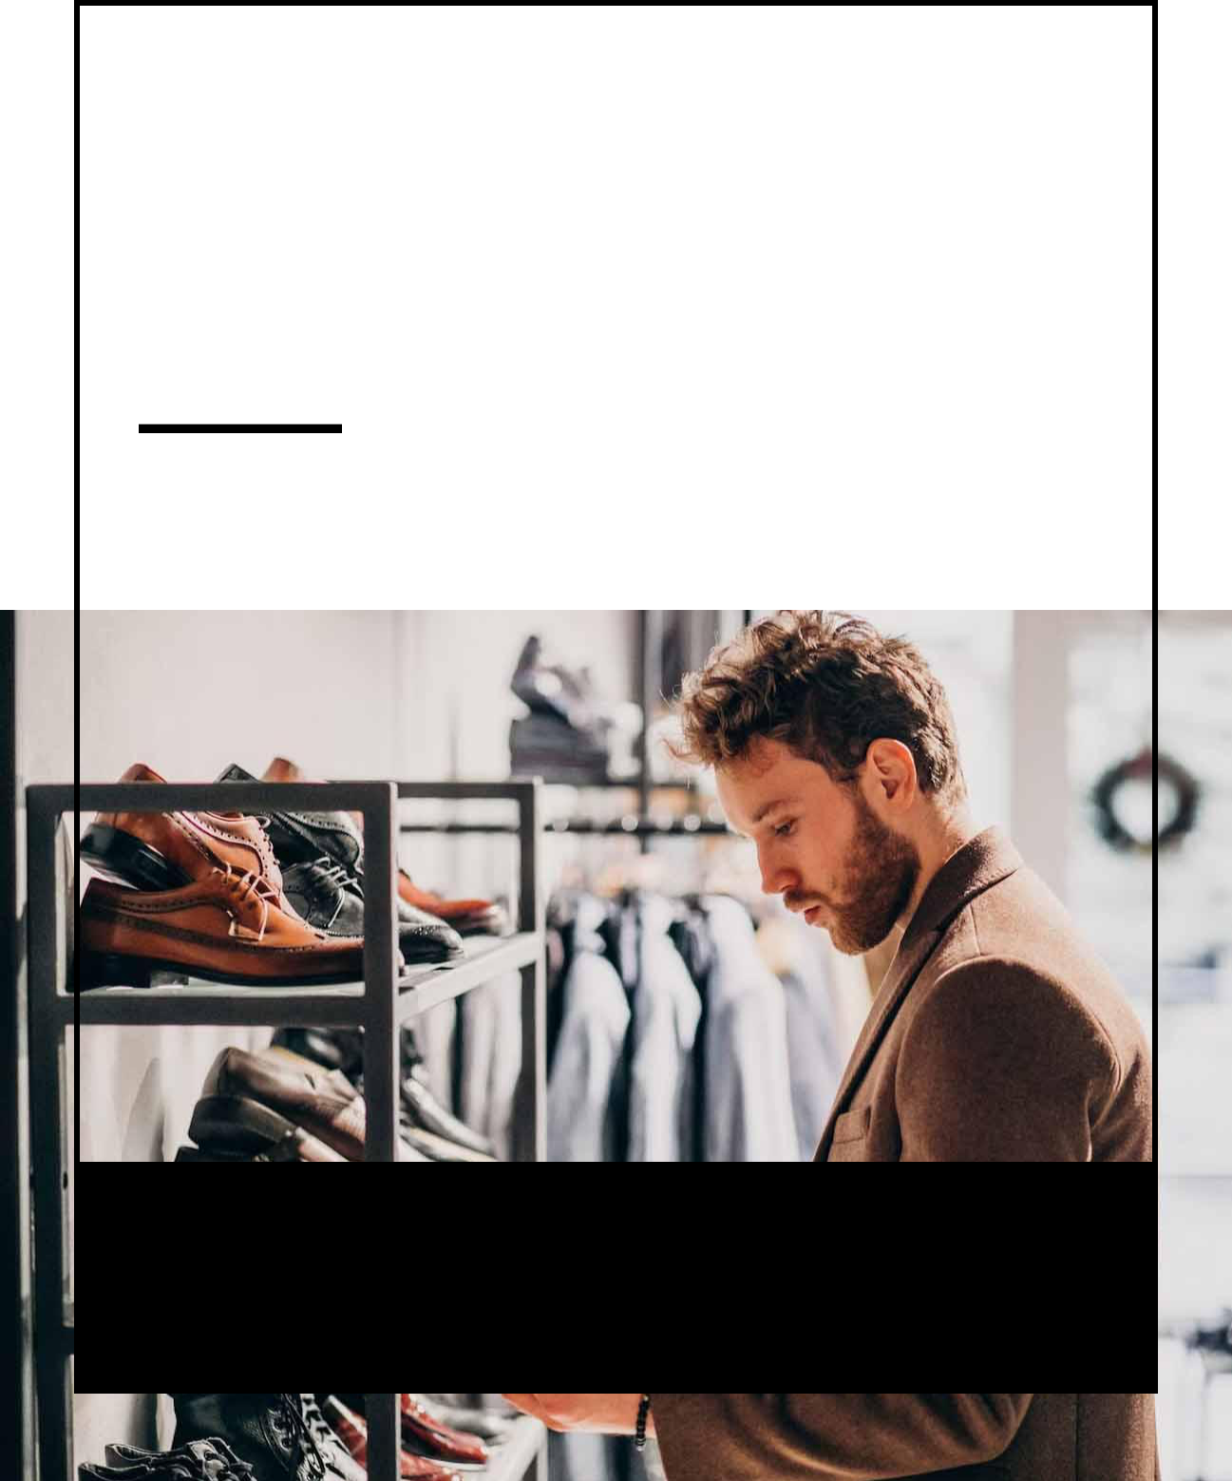

BUSINESS PLAN

Shoes for Every Journey

Prepared By

John Doe

10200 Bolsa Ave, Westminster, CA, 92683

info@example.com

(650) 359-3153 http://www.example.com

Table of Contents

Executive Summary | 6
Market opportunity | 6
Products | 6
Marketing & Sales Strategies | 7
Financial Highlights | 7
Units Sold v/s Revenue | 8

Company Overview | 9
Ownership | 9
Mission statement | 10
Business history | 10
Future goals | 11

Market Analysis | 12
Target Market | 12
Market size and growth potential | 12
Market Size | 13
Competitive analysis | 13
Trendy Treads | 13
Comfort & Co | 14
EcoStep Footwear | 14
Market trends | 14
Regulatory environment | 15

Products and Services | 16
Product offerings | 16
Classic Leather Loafers | 16
Athletic Running Shoes | 17
Fashionable High Heels | 17
Children’s Sneakers | 18
Waterproof Hiking Boots | 18
Inventory Management | 19
Suppliers and Vendors | 19
Return Policy | 19

Sales And Marketing Strategies | 20
Unique Selling Proposition (USP) | 20
Pricing Strategy | 20
Marketing strategies | 21
Online | 21
Offline | 21
Sales strategies | 22
Customer retention | 23

Operations Plan | 24
Staffing & Training | 24
Operational Process | 24
Equipment & Technology | 25

Management Team | 26
Key managers | 26
John Doe | 26
Jane Doe | 27
Alice Brown | 27
Robert Brown | 27
Organizational structure | 28
Organization chart | 28
Compensation plan | 29
Advisors/Consultants | 29
Sarah Thompson | 29
Michael Rodriguez | 30
Financial Plan
Financial Plan | 31

Profit & loss statement 31

Cash flow statement | 34
Balance sheet | 36
Break-even Analysis | 38
Financing needs | 40
Appendix
Appendix | 42
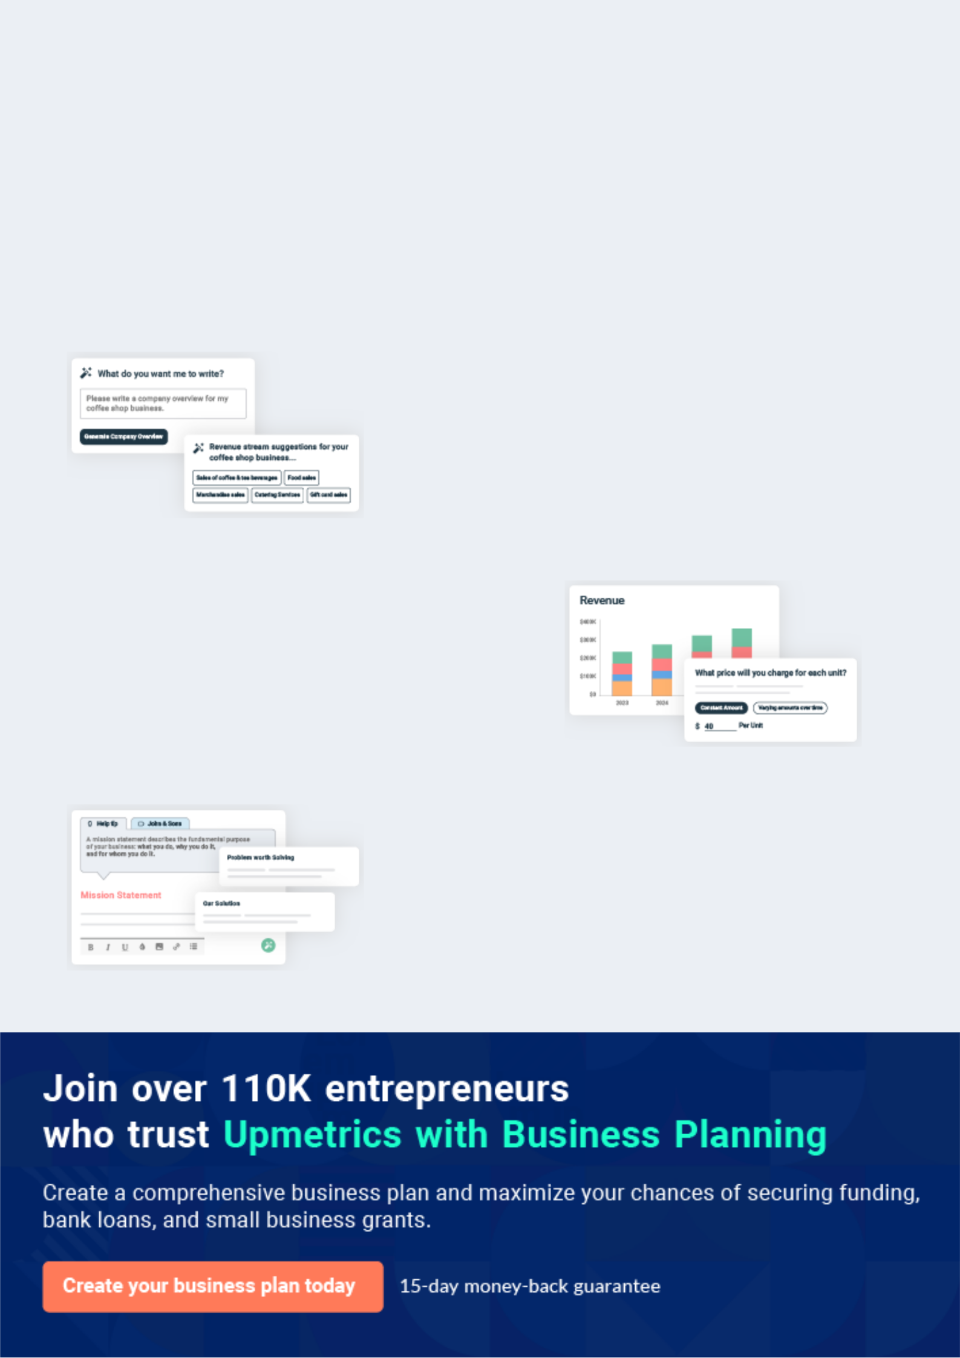
Business planning that’s simpler and faster than you think

Creating a business plan using Upmetrics to start and grow a business is literally the easiest thing in the World. Simply read the instructions and fill in the blanks. It’s as simple as that.

❛ | Upmetrics has everything you need to create a | ❜
❛ | comprehensive business plan. | ❜

AI-powered Upmetrics Assistant

AI-powered insights to streamline your plan

Not sure where to start? Upmetrics’ AI Assistant will automatically generate ideas for each section of your plan and offer improved versions of your writing, adjusting for tone, voice, and grammar or spelling errors.

Financial Forecasting Tool

All the financials are calculated for you

Forget the complex formulas and clumsy spreadsheets — with automatic financials and drag-and-drop forecasting, you can finish your plan faster and be confident that your numbers are accurate.

Business Plan Builder

Guides you like a business mentor

Upmetrics’ step-by-step instructions, prompts, and the library of 400+ sample business plans will guide you through each section of your plan as a business mentor.
Executive Summary


An executive summary is the first section of the business plan intended to provide an overview of the whole business plan.
To unlock help try Upmetrics! 

 Help tip  Shoe store Business Plan


Start your executive summary by briefly introducing your business to your readers.

This section may include the name of your store, its location, when it was founded, the type of
To unlock help try Upmetrics! 

Start writing here..

Market opportunity

 Help tip  Shoe store Business Plan

Summarize your market research, including market size, growth potential, and marketing trends. Highlight the opportunities in the market and how your business will fit in to fill the gap.
To unlock help try Upmetrics! 

Start writing here..

Products

 Help tip  Shoe store Business Plan

Highlight the shoe store services you offer your clients. The USPs and differentiator products you offer are always a plus.
To unlock help try Upmetrics! 

Start writing here..

Marketing & Sales Strategies
To unlock help try Upmetrics!

 Help tip  Shoe store Business Plan

Outline your sales and marketing strategies—what marketing platforms you use, how you plan on acquiring customers, etc.
To unlock help try Upmetrics! 

Start writing here..

Financial Highlights

 Help tip  Shoe store Business Plan

Briefly summarize your financial projections for the initial years of business operations. Include any capital or investment requirements, associated startup costs, projected revenues, and profit forecasts.



Start writing here..
Units Sold v/s Revenue
To unlock help try Upmetrics!

 |  | Units Sold | Revenue
15.00k
10.00k
5.00k
0
Year 1 | Year 2 | Year 3


Financial Year |  |  | Units Sold | Revenue
Year 1 | 1,550 |  |  | $10,000
Year 2 | 1,800 |  |  | $12,000
Year 3 | 2,050 |  |  | $14,000
 Help tip |  |  Shoe store Business Plan


After giving a brief about your business plan, end your summary with a call to action, for example; inviting potential investors or readers to the next meeting if they are interested in your business.



Write a call to action for your business plan.
Company Overview

Depending on what details of your business are essential, you’ll need different elements in your business overview.
To unlock help try Upmetrics! 

 Help tip  Shoe store Business Plan

Describe your business in this section by providing all the basic information:

Describe what kind of shoe store you operate and the name of it. For instance, here are some
To unlock help try Upmetrics! 

Start writing here..

Ownership

 Help tip  Shoe store Business Plan

List the owners of your shoe store. Describe what shares they own and their responsibilities for efficiently managing the business.
To unlock help try Upmetrics! 

Start writing here..
Mission statement

 Help tip  Shoe store Business Plan

Summarize your business’ objective, core principles, and values in your mission statement. This statement needs to be memorable, clear, and brief.
To unlock help try Upmetrics! 

❛ At [Urban Step Shoes], our mission is to provide an unparalleled shopping experience, offering a unique blend of quality, style, and comfort in footwear.

We are dedicated to enriching our customers’ lives through our products, building lasting relationships within our community, and promoting sustainable and ethical practices in all aspects of our business.

❜

Business history

 Help tip  Shoe store Business Plan

If you’re an established shoe store, briefly describe your business history, like—when it was founded, how it evolved over time, etc.
To unlock help try Upmetrics! 

Start writing here..
Future goals

 Help tip  Shoe store Business Plan

It’s crucial to convey your aspirations and vision. Mention your short-term and long-term goals; they can be specific targets for revenue, market share, or expanding your services.
To unlock help try Upmetrics! 

Start writing here..
Market Analysis
To unlock help try Upmetrics!


 |  | Market analysis provides a clear understanding of the market in which your
 |  | printing business will run along with the target market, competitors, and
 |  | growth opportunities.
 |  |  |  | To unlock help try Upmetrics! 
 Help tip |  |  Shoe store Business Plan

To write the introduction section of your market analysis, start by clearly identifying your primary target market.
To unlock help try Upmetrics! 

Start writing here..

Target Market

 Help tip  Shoe store Business Plan

Start this section by describing your target market. Define your ideal customer and explain what types of services they prefer. Creating a buyer persona will help you easily define your target market to your readers.



Start writing here..

Market size and growth potential

 Help tip  Shoe store Business Plan

Describe your market size and growth potential and whether you will target a niche or a much broader market.
To unlock help try Upmetrics! 

Start writing here..

Market Size

Available Market

All individuals in the region interested in 3M purchasing shoes

Served Market
Customers looking for both casual and 1M athletic footwear

Target Market
Young adults and professionals seeking 300k trendy and comfortable shoes

 Help tip  Shoe store Business Plan

Identify and analyze your direct and indirect competitors. Identify their strengths and weaknesses, and describe what differentiates your shoe store from them.
To unlock help try Upmetrics! 

Competitive analysis

Trendy Treads

Trendy Treads is a well-established shoe store located in a bustling shopping district, catering to a young, fashion-forward demographic.

Features | Strengths | Weaknesses
Extensive variety of trendy and | Strong brand recognition | Limited options for more classic
fashionable footwear | among younger shoppers | or timeless shoe styles
Collaborations with popular | Prime location with high foot | Higher price points due to the
fashion influencers for | traffic | focus on trendiness and brand
promotions | Regularly updated product line | collaborations
Loyalty program offering | following the latest fashion
discounts and early access to | trends
new releases

Comfort & Co

Comfort & Co is a shoe retailer that specializes in comfortable footwear, serving an older demographic and individuals seeking orthopaedic solutions.

Features Strengths Weaknesses

Wide range of orthopaedic and Established a reputation for

comfort-oriented footwear quality and comfort

In-store foot assessments and Loyal customer base of repeat

personalized fitting services purchasers

Strong partnerships with Expert staff providing

podiatrists and foot health exceptional customer service

professionals

Limited appeal to younger demographics

Aesthetic design of shoes is often secondary to comfort, which can deter fashion-conscious shoppers

EcoStep Footwear

EcoStep Footwear is a boutique shoe store that focuses on eco-friendly and sustainable shoe options, attracting environmentally conscious consumers.

Features Strengths

All products made from Strong niche positioning in the

sustainable and ethically growing market of sustainable

sourced materials fashion

Active involvement in Positive brand image

environmental initiatives and associated with environmental

community events responsibility

Educational content and Engaged and passionate

branding focused on customer base

sustainability

Weaknesses

Smaller product selection compared to larger competitors

Higher production costs associated with sustainable materials, potentially lead to higher retail prices

Market trends

 Help tip  Shoe store Business Plan

Analyze emerging trends in the industry, such as technology disruptions, changes in customer behavior or preferences, etc. Explain how your business will cope with all the trends.
To unlock help try Upmetrics! 

Start writing here..

Regulatory environment
To unlock help try Upmetrics!

 Help tip  Shoe store Business Plan

List regulations and licensing requirements that may affect your shoe shops, such as business license, sales tax permit, zoning and land use, employment regulations, intellectual property regulations, etc.



Start writing here..
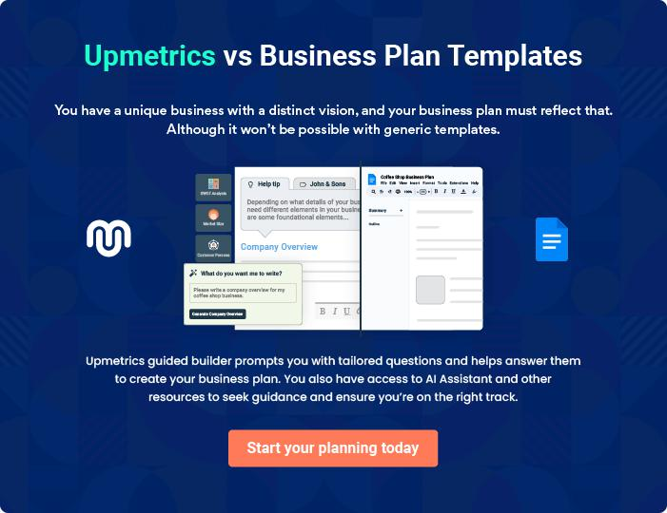
Products and Services
To unlock help try Upmetrics!

The product and services section of the shoe store business plan should describe the specific services and products that will be offered to customers. To write this section should include the following:



 Help tip  Shoe store Business Plan

To craft the introduction for your "Products and Services" chapter, begin by positioning your business within its industry, emphasizing its unique strengths or value proposition.
To unlock help try Upmetrics! 

Start writing here..

 Help tip


List the type of shoes your store will provide to its customers. For instance, your product line may include boots, casual shoes, sandals, designer shoes, dress shoes, etc.
To unlock help try Upmetrics! 

Product offerings

Classic Leather Loafers


Price: [$89.99] per pair

Our Classic Leather Loafers are a timeless addition to any wardrobe, perfect for both casual and formal occasions. Crafted from high-quality genuine leather, these loafers provide exceptional comfort and durability.

Specifications

- Material: 100% Genuine Leather

- Available Sizes: 7-12 (including half sizes)

- Colors: Black, Brown, Tan

- Sole Material: Rubber, for added traction and durability
Athletic Running Shoes

Price: [$120.00] per pair

Designed for both amateur and professional athletes, our Athletic Running Shoes offer superior support, cushioning, and breathability to enhance performance and reduce the risk of injury.

Specifications

- Upper Material: Lightweight Mesh Fabric

- Midsole: Cushioned EVA foam

- Outsole: Durable rubber with traction pattern

- Available Sizes: 6-13 (including half sizes)

- Special Features: Breathable design, arch support, and shock absorption

Fashionable High Heels

Price: [$79.99] per pair

Make a statement with our Fashionable High Heels, designed to add a touch of elegance to any outfit while ensuring comfort for prolonged wear.

Specifications

- Material: Synthetic Leather

- Heel Height: 4 inches

- Available Sizes: 5-10

- Colors: Red, Black, Nude

- Special Features: Padded insole, slip-resistant outsole
Children’s Sneakers

Price: [$45.00] per pair

Durable, comfortable, and stylish, our Children’s Sneakers are designed to keep up with the active lifestyles of kids while providing the support they need.

Specifications

- Upper Material: Durable Canvas

- Sole Material: Non-marking rubber

- Available Sizes: 1-6 (youth)

- Colors: Variety of fun patterns and colors

- Special Features: Reinforced toe for added durability, Velcro straps for easy on/off

Waterproof Hiking Boots

Price: [$150.00] per pair

Explore the great outdoors with confidence in our Waterproof Hiking Boots, providing unparalleled protection, support, and comfort on any terrain.

Specifications

- Material: Waterproof Leather and Synthetic Upper

- Sole Material: Vibram® outsole for superior grip

- Available Sizes: 7-14 (including half sizes)

- Special Features: Ankle support, waterproof membrane, and durable construction
Inventory Management

 Help tip  Shoe store Business Plan

Describe how you plan to manage your inventory, including details about how you will track sales, restock bestselling products, etc.
To unlock help try Upmetrics! 

Start writing here..

Suppliers and Vendors

 Help tip  Shoe store Business Plan

Describe your supply chain, including information about your relationships with suppliers and vendors and any partnerships or agreements you have.
To unlock help try Upmetrics! 

Start writing here..

Return Policy

 Help tip  Shoe store Business Plan

Describe your store’s return policies, including any fees or restrictions that apply. This section is crucial for customer satisfaction and reducing exchange or return risks.
To unlock help try Upmetrics! 

Start writing here..
Sales And Marketing Strategies
To unlock help try Upmetrics!

Writing the sales and marketing strategies section means a list of strategies you will use to attract and retain your clients.
To unlock help try Upmetrics! 

 Help Tip  Shoe store Business Plan


To create an effective introduction for your "Sales and Marketing Strategies" chapter, start by setting the stage within your specific industry or market.
To unlock help try Upmetrics! 

Start writing here..

Unique Selling Proposition (USP)

 Help tip  Shoe store Business Plan

Define your business’s USPs depending on the market you serve, the equipment you use, and the unique services you provide. Identifying USPs will help you plan your marketing strategies.
To unlock help try Upmetrics! 

Start writing here..

Pricing Strategy

 Help tip  Shoe store Business Plan

Describe your pricing strategy—how you plan to price your products and stay competitive in the local market. You can mention any discounts you plan on offering to attract new customers to your store.



Start writing here..

 Help tip  Shoe store Business Plan

Discuss your marketing strategies to market your services. You may include some of these marketing strategies in your business plan—social media marketing, local advertising, Google ads, brochures, email marketing, content marketing, and print marketing._{To unlock help try Upmetrics!} 

Marketing strategies

Online


Social Media

Utilizing platforms such as Facebook, Instagram, and Twitter to connect with our audience and promote our products.

Content Marketing

Creating valuable content, including blog posts and buying guides, to educate our customers and improve our website’s SEO.

Offline

Local Advertising

Engaging in local print and digital advertising to increase brand awareness in the [City/Region] area.

Email Marketing

Sending regular newsletters and promotions to our mailing list to drive sales and keep our brand top-of-mind.

In-Store Events

Hosting events and promotions in-store to attract foot traffic and engage with our local community.

 Help tip  Shoe store Business Plan
To unlock help try Upmetrics!

Outline the strategies you’ll implement to maximize your sales. Your sales strategies may include upselling and cross-selling, bundle deals, gift cards, personalized recommendations, follow-up emails, and retargeting.



Sales strategies

Upselling and Cross-Selling

Training our staff to identify opportunities for upselling and cross-selling, increasing average transaction value.

Follow-Up Emails

Sending follow-up communications to customers after a purchase, encouraging reviews and repeat business.

Bundle Deals

Offering bundle promotions on complementary products to encourage larger purchases.

Retargeting

Implementing online retargeting campaigns to recapture the attention of visitors who did not make a purchase.

 Help tip  Shoe store Business Plan

Describe your customer retention strategies and how you plan to execute them. For instance, loyalty programs, personalized communication, follow-up surveys, etc.
To unlock help try Upmetrics! 

Customer retention

Loyalty Programs

Implementing a loyalty program to reward repeat customers and encourage frequent purchases.

Follow-Up Surveys

Sending post-purchase surveys to gather feedback and identify areas for improvement

Personalized Communication

Utilizing customer data to send personalized communications and offers, enhancing the customer experience.

Operations Plan

 |  | When writing the operations plan section, it’s important to consider the
 |  | various aspects of your business operations.
 |  |  |  | To unlock help try Upmetrics! 
 Help tip |  |  Shoe store Business Plan


To create an effective introduction for your "Operational Plan" chapter, start by emphasizing the
pivotal role of efficient operations in the success of your business, underscoring how they
directly impact the quality of services delivered.
 |  |  |  | To unlock help try Upmetrics! 
Start writing here..
Staffing & Training
 Help tip |  |  Shoe store Business Plan

Mention your store’s staffing requirements, including the number of employees or store
associates needed. Include their qualifications, the training required, and the duties they will
perform.
 |  |  |  | To unlock help try Upmetrics! 
Start writing here..
Operational Process
 Help tip |  |  Shoe store Business Plan

Outline the processes and procedures you will use to run your store. Your operational processes may include opening and closing the store, maintaining inventory, processing sales transactions, managing returns and exchanges, cleaning and organizing the store, etc.
To unlock help try Upmetrics! 

Start writing here..

Equipment & Technology
To unlock help try Upmetrics!

 Help tip  Shoe store Business Plan

Include the list of equipment and technology required for a shoe store to operate, such as POS system, shoe sizing equipment, security equipment, office equipment, shelving and displays, etc.



Start writing here..
Management Team

The management team section provides an overview of the individuals responsible for running your business plan.
To unlock help try Upmetrics! 

 Help tip  Shoe store Business Plan

To craft an introduction for your "Management Team" chapter, begin by emphasizing the crucial role of leadership in the success of any business.
To unlock help try Upmetrics! 

Start writing here..

Key managers

 Help tip  Shoe store Business Plan

Introduce your management and key members of your team, and explain their roles and responsibilities.
To unlock help try Upmetrics! 

Start writing here..


JOHN DOE

CEO - john.doe@example.com

John Doe is the visionary behind [Urban Step Shoes], bringing over 15 years of experience in the footwear industry. He holds a Master's degree in Business Administration from the [University of XYZ] and has an exceptional track record in retail management and product development.


John has worked with some of the leading brands in the industry, where he excelled in sales strategy and customer relationship management.

As Founder & CEO, John is responsible for setting the strategic direction of the company, overseeing product development, and ensuring customer satisfaction.

JANE DOE

Store Manager - jane.doe@example.com

Jane Doe is an experienced retail professional with over 10 years in the footwear retail sector. She holds a Bachelor's degree in Retail Management from [University of ABC].


Before joining [Urban Step Shoes], Jane managed a high-performing store for a well-known shoe brand, where she demonstrated her ability to increase sales and improve operational efficiency.

At [Urban Step Shoes], Jane oversees the day-to-day operations of the store, manages the staff, and ensures a high level of customer service.


ALICE BROWN

Marketing Manager - robert.brown@example.com

Alice Brown brings a creative and analytical approach to our marketing initiatives. She has a degree in Marketing from [University of XYZ] and has spent the last 8 years refining her skills in digital marketing and brand development.

Prior to joining [Urban Step Shoes], Alice played a key role in developing online sales channels and social media presence for a regional shoe retailer.

At [Urban Step Shoes], Alice is responsible for developing our marketing strategy, overseeing our advertising campaigns, and managing our online and offline presence to build brand awareness and drive sales.


ROBERT BROWN

Inventory and Supply Chain Manager - robert.brown@example.com

Robert Brown is an experienced inventory and supply chain professional, ensuring that [Urban Step Shoes] always has the right products in stock to meet customer demand.

He holds a degree in Supply Chain Management from [University of XYZ] and has over 12 years of experience in inventory management and logistics.

Robert excels at developing efficient inventory systems, negotiating with suppliers, and optimizing the supply chain to reduce costs and improve product availability.

At [Urban Step Shoes], he plays a crucial role in managing our inventory, working with suppliers, and ensuring our products are delivered to customers on time.
Organizational structure

 Help tip  Shoe store Business Plan

Explain the organizational structure of your management team. Include the reporting line and decision-making hierarchy.
To unlock help try Upmetrics! 

Start writing here..

Organization chart


John Doe

CEO


Alice Brown | Jane Doe
Marketing | Jane Doe
Marketing | Store Manager
Manager | Store Manager






Michael White | Lisa Green | Emma Taylor | Robert Brown
Assistant Store | Social Media | Emma Taylor | Inventory and Sup
Assistant Store | Social Media | Sales Associate | Inventory and Sup
Manager | Specialist | Sales Associate | Chain Manager

Compensation plan

 Help tip  Shoe store Business Plan

Describe your compensation plan for the management and staff. Include their salaries, incentives, and other benefits.
To unlock help try Upmetrics! 

Start writing here..

 Help tip

Mentioning advisors or consultants in your business plans adds credibility to your business idea.
To unlock help try Upmetrics! 

Advisors/Consultants


SARAH THOMPSON

Retail Strategist and Consultant

Over 15 years in retail management and consultancy, with a focus on footwear and apparel.

Education: MBA in Retail Management from [University Name], B.A. in Business Administration.

Sarah brings a wealth of knowledge in retail operations and strategic planning. She has successfully helped numerous footwear stores in optimizing their inventory, enhancing customer experience, and increasing sales.

At [Urban Step Shoes], Sarah will be instrumental in advising on store layout, product assortment, and customer engagement strategies.

MICHAEL RODRIGUEZ

Fashion Trend Analyst

10 years of experience in identifying and analyzing fashion trends in footwear.

Education: Bachelor’s in Fashion Merchandising from [University Name].

Michael’s keen eye for upcoming trends and his deep understanding of the fashion landscape make him a valuable asset for [Urban Step Shoes].

He will guide us in curating a product line that is not just fashionable but also aligns with our brand ethos, ensuring we stay ahead of market trends.
Financial Plan

When writing the financial plan section of a business plan, it’s important to provide a comprehensive overview of your financial projections for the first few years of your business, You may provide the following:
To unlock help try Upmetrics! 

 Help tip  Shoe store Business Plan


To create an effective introduction for your "Financial Plan" chapter, begin by stressing the critical role of a well-structured financial plan in the success of your venture.
To unlock help try Upmetrics! 

Start writing here..

 Help tip  Shoe store Business Plan

Describe details such as projected revenue, operational costs, and service costs in your projected profit and loss statement. Make sure to include your business’s expected net profit or loss.
To unlock help try Upmetrics! 

Profit & loss statement

Revenue

Cost Of Sales

General Costs

Revenue Specific Costs

Personnel Costs (Direct

Labor)

Gross Margin

Gross Margin (%)

Operating Expense

Payroll Expense

(Indirect Labor)

General Expense

Bad Debt

Amortization of Current

Assets

2023-24 | 2024-25 | 2025-26 | 2026-27 | 2027-28
$0 | $0 | $0 | $0 | $0

$0 | $0 | $0 | $0 | $0
$0 | $0 | $0 | $0 | $0
$0 | $0 | $0 | $0 | $0
$0 | $0 | $0 | $0 | $0

$0 | $0 | $0 | $0 | $0
0% | 0% | 0% | 0% | 0%

$0 | $0 | $0 | $0 | $0
$0 | $0 | $0 | $0 | $0
$0 | $0 | $0 | $0 | $0
$0 | $0 | $0 | $0 | $0
$0 | $0 | $0 | $0 | $0

EBITDA

Additional Expense

Long Term

Depreciation

Gain or loss from Sale

of Assets

EBIT

Interest Expenses

EBT

Income Tax Expense

Total Expense

Net Income

Net Income (%)

2023-24 | 2024-25 | 2025-26 | 2026-27 | 2027-28
$0 | $0 | $0 | $0 | $0
$0 | $0 | $0 | $0 | $0
$0 | $0 | $0 | $0 | $0
$0 | $0 | $0 | $0 | $0
$0 | $0 | $0 | $0 | $0
$0 | $0 | $0 | $0 | $0
$0 | $0 | $0 | $0 | $0
$0 | $0 | $0 | $0 | $0
$0 | $0 | $0 | $0 | $0
$0 | $0 | $0 | $0 | $0
0% | 0% | 0% | 0% | 0%

 |  |  | 2023-24 |  | 2024-25 | 2025-26
Retained Earning |  |  | $0 |  | $0 | $0
Opening |  |  |  |  | $0 | $0
Owner's Distribution |  |  | $0 |  | $0 | $0
Retained Earning |  |  | $0 |  | $0 | $0
Closing |  |  |  |  | $0 | $0
 Help tip |  |  |  Shoe store Business Plan


The cash flow for the first few years of your operation should be estimated and described in this section.

This may include billing invoices, payment receipts, loan payments, and any other cash flow statements.
2026-27 2027-28

$0 $0

$0 $0

$0 $0

To unlock help try Upmetrics! 

Cash flow statement

 | 2023-24 | 2024-25 | 2025-26 | 2026-27 | 2027-28
Cash Received | $0 | $0 | $0 | $0 | $0
Cash Paid | $0 | $0 | $0 | $0 | $0
COS & General Expenses | $0 | $0 | $0 | $0 | $0
Salary & Wages | $0 | $0 | $0 | $0 | $0
Interest | $0 | $0 | $0 | $0 | $0

Sales Tax

Income Tax

Net Cash From

Operations

Assets Sell

Assets Purchase

Net Cash From

Investments

Amount Received

Loan Received

Common Stock

Preferred Stock

Owner's Contribution

Amount Paid

2023-24 | 2024-25 | 2025-26 | 2026-27 | 2027-28
$0 | $0 | $0 | $0 | $0
$0 | $0 | $0 | $0 | $0
$0 | $0 | $0 | $0 | $0

$0 | $0 | $0 | $0 | $0
$0 | $0 | $0 | $0 | $0
$0 | $0 | $0 | $0 | $0

$0 | $0 | $0 | $0 | $0
$0 | $0 | $0 | $0 | $0

$0 | $0 | $0 | $0 | $0
$0 | $0 | $0 | $0 | $0
$0 | $0 | $0 | $0 | $0

Loan Capital $0 $0 $0 $0 $0

 |  |  | 2023-24 | 2024-25 | 2025-26 | 2026-27 | 2027-28
Dividends & Distributions |  |  | $0 | $0 | $0 | $0 | $0
Net Cash From |  |  | $0 | $0 | $0 | $0 | $0
Financing
Summary
Starting Cash |  |  | $0 | $0 | $0 | $0 | $0
Cash In |  |  | $0 | $0 | $0 | $0 | $0
Cash Out |  |  | $0 | $0 | $0 | $0 | $0
Change in Cash |  |  | $0 | $0 | $0 | $0 | $0
Ending Cash |  |  | $0 | $0 | $0 | $0 | $0
 Help tip |  |  Shoe store Business Plan

Create a projected balance sheet documenting your business’s assets, liabilities, and equity.

To unlock help try Upmetrics! 

Balance sheet

 | 2023-24 | 2024-25 | 2025-26 | 2026-27 | 2027-28
Assets | $0 | $0 | $0 | $0 | $0
Current Assets | $0 | $0 | $0 | $0 | $0
Cash | $0 | $0 | $0 | $0 | $0
Accounts Receivable | $0 | $0 | $0 | $0 | $0
Inventory | $0 | $0 | $0 | $0 | $0
Other Current Assets | $0 | $0 | $0 | $0 | $0
Long Term Assets | $0 | $0 | $0 | $0 | $0
Gross Long Term Assets | $0 | $0 | $0 | $0 | $0
Accumulated Depreciation | $0 | $0 | $0 | $0 | $0

Liabilities & Equity | $0 | $0 | $0 | $0 | $0
Liabilities | $0 | $0 | $0 | $0 | $0
Current Liabilities | $0 | $0 | $0 | $0 | $0
Accounts Payable | $0 | $0 | $0 | $0 | $0
Income Tax Payable | $0 | $0 | $0 | $0 | $0
Sales Tax Payable | $0 | $0 | $0 | $0 | $0
Short Term Debt | $0 | $0 | $0 | $0 | $0
 | 2023-24 | 2024-25 | 2025-26 | 2026-27 | 2027-28
Long Term Liabilities | $0 | $0 | $0 | $0 | $0
Long Term Debt | $0 | $0 | $0 | $0 | $0
Equity | $0 | $0 | $0 | $0 | $0
Paid-in Capital | $0 | $0 | $0 | $0 | $0
Common Stock | $0 | $0 | $0 | $0 | $0
Preferred Stock | $0 | $0 | $0 | $0 | $0
Owner's Contribution | $0 | $0 | $0 | $0 | $0
Retained Earnings | $0 | $0 | $0 | $0 | $0

Check | $0 |  |  | $0 | $0 | $0 | $0
 Help tip |  |  Shoe store Business Plan

Determine and mention your business’s break-even point—the point at which your business costs and revenue will be equal.

This exercise will help you understand how much revenue you need to generate to sustain or be profitable.
To unlock help try Upmetrics! 

Break-even Analysis

 | 2023-24 | 2024-25 | 2025-26 | 2026-27 | 2027-28
Starting Revenue | $0 | $0 | $0 | $0 | $0
Net Revenue | $0 | $0 | $0 | $0 | $0
Closing Revenue | $0 | $0 | $0 | $0 | $0

Starting Expense | $0 | $0 | $0 | $0 | $0
Net Expense | $0 | $0 | $0 | $0 | $0
Closing Expense | $0 | $0 | $0 | $0 | $0

Is Break Even? | 0 | 0 | 0 | 0 | 0
Break Even Month | 0 | 0 | 0 | 0 | 0
Days Required | 0 | 0 | 0 | 0 | 0
Break Even Revenue | $0 | $0 | $0 | $0 | $0
Break Even Units
Financing needs

 Help tip  Shoe store Business Plan

Calculate costs associated with starting a business, and estimate your financing needs and how much capital you need to raise to operate your business.
To unlock help try Upmetrics! 

Start writing here..
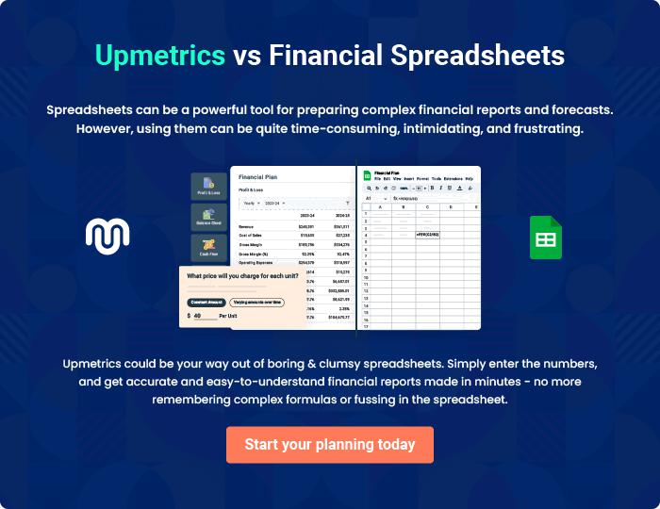
Appendix

When writing the appendix section, you should include any additional information that supports the main content of your plan. This may include financial statements, market research data, legal documents, and other
To unlock help try Upmetrics! 

Create a winning business plan that gets you funded

Creating a stunning and investment-ready plan requires no writing, graphic designing, or financial planning expertise.

Upmetrics has all the features required to help you create a comprehensive business plan—from start to finish. Make no mistakes, it’s the modern way of planning to structure ideas, make plans, and create stunning pitch decks to awe investors.

Pitch decks that impress investors

Create pitch decks that provide a visual representation of your business, engage investors, and make them want to invest in your business idea.

Interactive plans in no time

Import business plan sections like—SWOT analysis, comparison tables, and others to create an interactive business plan. No designing skills are required.

Stunning cover page designs

With Upmetrics, you have the liberty to choose from multiple stunning cover page designs. Choose a creative design and make your plan stand out.

Online sharing made simple

Upmetrics makes online sharing quick and easier for users. Easily share your business plans with a link while tracking reader activity.

500+ sample business plans

Simply import a template from our library of sample plans into the editor and start customizing it to make it yours. It takes only a few clicks to get started.

Collaborate with team in real-time

Invite team members, initiate conversations, discuss ideas & strategies, share feedback, and work on a business plan in real-time.

