
Seafood Restaurant Business Plan

BUSINESS PLAN

From Sea to Plate, Unforgettable Tastes

Prepared By

John Doe

10200 Bolsa Ave, Westminster, CA, 92683

info@example.com

(650) 359-3153 http://www.example.com/

Table of Contents

Executive Summary | 6
Market opportunity | 6
Services Offered | 6
Marketing & Sales Strategies | 7
Financial Highlights | 7
Units Sold v/s Revenue | 8

Company Overview | 9
Ownership | 9
Business Owners | 9
Mission statement | 10
Business history | 10
Future goals | 10

Market Analysis | 11
Target Market | 11
Market size and growth potential | 11
Market Size | 12
Competitive analysis | 12
Red Lobster | 12
Bonefish Grill | 13
Legal Sea Foods | 13
Market trends | 13
Regulatory environment | 14

Products and Services | 15
Products | 15
Grilled Salmon | 15
Lobster Bisque | 16
Oyster Platter | 16
Seafood Paella | 16
Takeaway Service | 17
Catering Service | 17
Quality Measures | 17
Additional Services | 18

Sales And Marketing Strategies | 19
Unique Selling Proposition (USP) | 19
Pricing Strategy | 19
Marketing strategies | 20
Online | 20
Offline | 20
Sales strategies | 21
Customer retention | 21

Operations Plan | 22
Staffing & Training | 22
Operational Process | 22
Equipment & Machinery | 23

Management Team | 24
Key managers | 24
John Doe | 24
Jane Doe | 25
Alice Brown | 25
Robert Brown | 25
Organizational structure | 26
Organization chart | 26
Compensation plan | 26
Advisors/Consultants | 27
[NAME] | 27
[NAME] | 27
Financial Plan | 28
Profit & loss statement | 28
Cash flow statement | 31
Balance sheet | 33
Break-even Analysis | 35
Financing needs | 37
Appendix
Appendix | 39
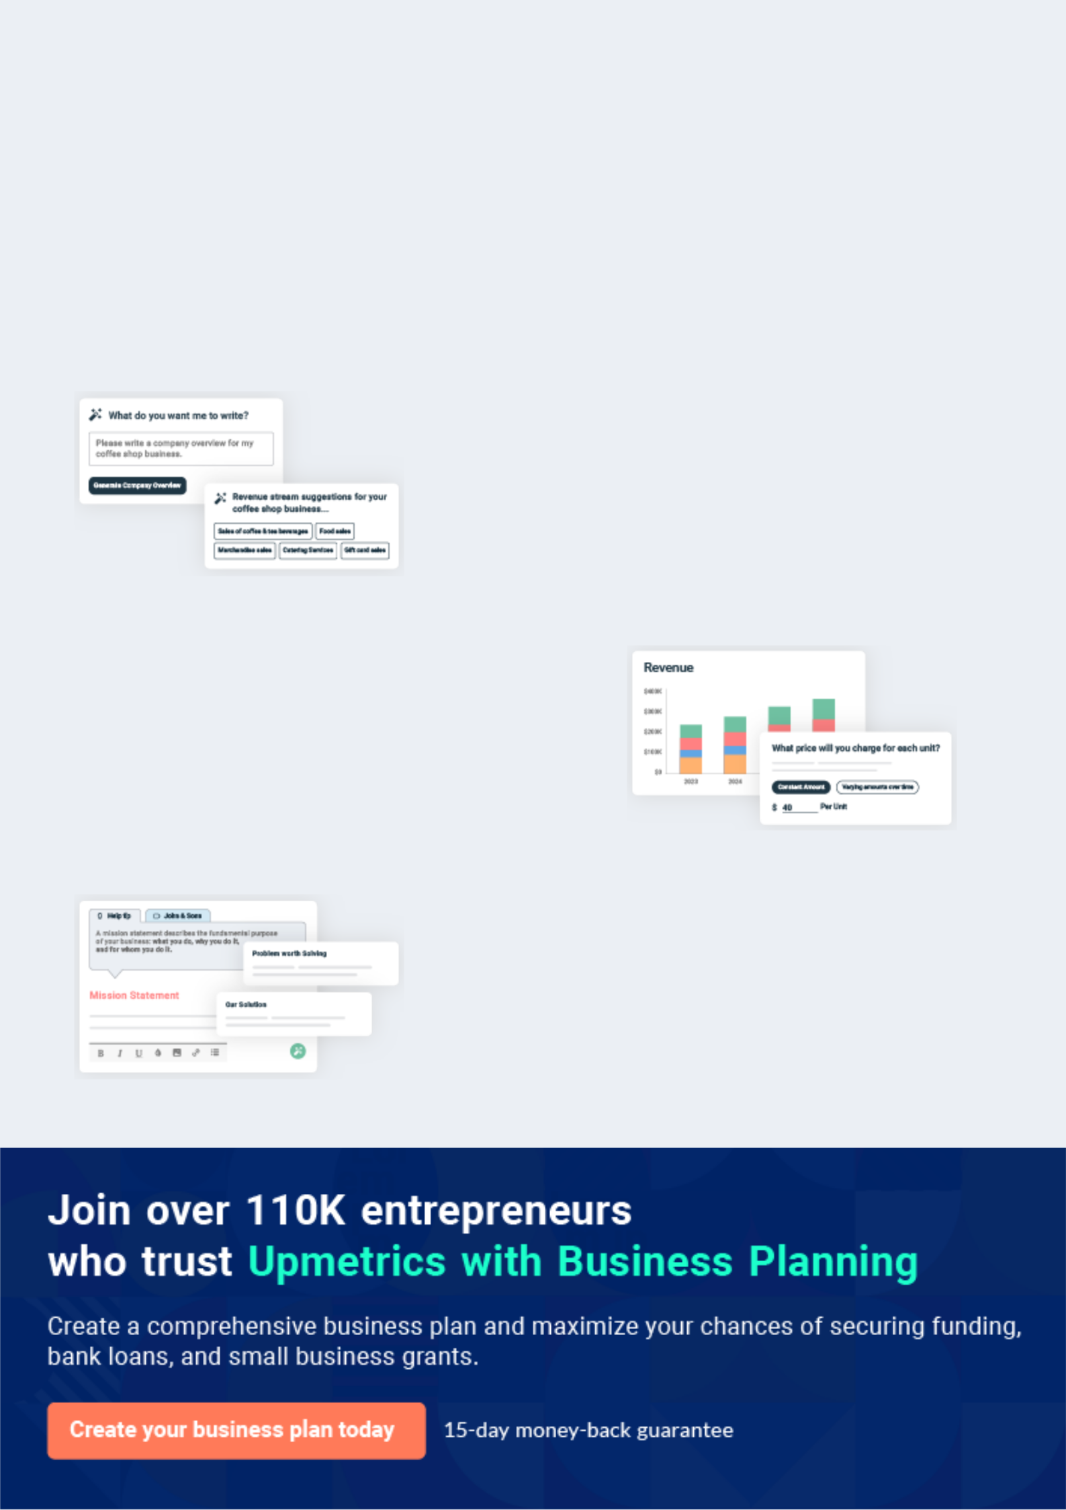
Business planning that’s simpler and faster than you think

Creating a business plan using Upmetrics to start and grow a business is literally the easiest thing in the World. Simply read the instructions and fill in the blanks. It’s as simple as that.

❛ | Upmetrics has everything you need to create a | ❜
❛ | comprehensive business plan. | ❜

AI-powered Upmetrics Assistant

AI-powered insights to streamline your plan

Not sure where to start? Upmetrics’ AI Assistant will automatically generate ideas for each section of your plan and offer improved versions of your writing, adjusting for tone, voice, and grammar or spelling errors.

Financial Forecasting Tool

All the financials are calculated for you

Forget the complex formulas and clumsy spreadsheets — with automatic financials and drag-and-drop forecasting, you can finish your plan faster and be confident that your numbers are accurate.

Business Plan Builder

Guides you like a business mentor

Upmetrics’ step-by-step instructions, prompts, and the library of 400+ sample business plans will guide you through each section of your plan as a business mentor.
Executive Summary


An executive summary is the first section of the business plan intended to provide an overview of the whole business plan.
To unlock help try Upmetrics! 

 Help tip  Seafood Restaurant Business Plan


Start your executive summary by briefly introducing your business to your readers.

This section may include the name of your seafood restaurant, its location, when it was
To unlock help try Upmetrics! 

Start writing here..

Market opportunity

 Help tip  Seafood Restaurant Business Plan

Summarize your market research, including market size, growth potential, and marketing trends. Highlight the opportunities in the market and how your business will fit in to fill the gap.
To unlock help try Upmetrics! 

Start writing here..

Services Offered

 Help tip  Seafood Restaurant Business Plan

Highlight the products in your seafood menu. The clients’ favorite and the specials you offer are always a plus.
To unlock help try Upmetrics! 

Start writing here..

Marketing & Sales Strategies
To unlock help try Upmetrics!

 Help tip  Seafood Restaurant Business Plan

Outline your sales and marketing strategies—what marketing platforms you use, how you plan on acquiring customers, etc.
To unlock help try Upmetrics! 

Start writing here..

Financial Highlights

 Help tip  Seafood Restaurant Business Plan

Briefly summarize your financial projections for the initial years of business operations. Include any capital or investment requirements, associated startup costs, projected revenues, and profit forecasts.



Start writing here..
Units Sold v/s Revenue

 |  | Units Sold | Revenue
15.00k
10.00k
5.00k
0
Year 1 | Year 2 | Year 3


Financial Year |  |  | Units Sold | Revenue
Year 1 | 1,550 |  |  | $10,000
Year 2 | 1,800 |  |  | $12,000
Year 3 | 2,050 |  |  | $14,000
 Help tip |  |  Seafood Restaurant Business Plan


Summarize your executive summary section with a clear CTA, for example, inviting angel investors to discuss the potential business investment.
To unlock help try Upmetrics! 

Write a call to action for your business plan.
Company Overview

Depending on what details of your business are essential, you’ll need different elements in your business overview.
To unlock help try Upmetrics! 

 Help tip  Seafood Restaurant Business Plan

Describe your restaurant in this section by providing all the basic information:

Describe what kind of seafood restaurant you run and the name of it. You may specialize in one
To unlock help try Upmetrics! 

Start writing here..

Ownership

 Help tip  Seafood Restaurant Business Plan

List the names of founders or owners at your seafood restaurant. Describe what shares they own and their responsibilities for efficiently managing the business.
To unlock help try Upmetrics! 

Start writing here..

Business Owners



60% John Doe



40% Jane Doe
Mission statement

 Help tip  Seafood Restaurant Business Plan

Summarize your restaurant’s objective, core principles, and values in your mission statement.

This statement needs to be memorable, clear, and brief.
To unlock help try Upmetrics! 

❛ At [Seafood Delight], our mission is to provide an unparalleled seafood dining experience, bringing the freshest and most delicious seafood dishes to our customers.

We are committed to quality, sustainability, and customer satisfaction, upholding our core values of integrity, innovation, and excellence.

❜

Business history

 Help tip  Seafood Restaurant Business Plan

If you’re an established seafood restaurant service provider, briefly describe your restaurant history, like—when it was founded, how it evolved over time, etc.
To unlock help try Upmetrics! 

Start writing here..

Future goals

 Help tip  Seafood Restaurant Business Plan

It’s crucial to convey your aspirations and vision. Mention your short-term and long-term goals; they can be specific targets for revenue, market share, or expanding your services.
To unlock help try Upmetrics! 

Start writing here..

Market Analysis
To unlock help try Upmetrics!


 |  | Market analysis provides a clear understanding of the market in which your
 |  | printing business will run along with the target market, competitors, and
 |  | growth opportunities.
 |  |  |  | To unlock help try Upmetrics! 
 Help tip |  |  Seafood Restaurant Business Plan

To write the introduction section of your market analysis, start by clearly identifying your primary target market.
To unlock help try Upmetrics! 

Start writing here..

Target Market

 Help tip  Seafood Restaurant Business Plan

Start this section by describing your target market. Define your ideal customer and explain what types of services they prefer. Creating a buyer persona will help you easily define your target market to your readers.



Start writing here..

Market size and growth potential

 Help tip  Seafood Restaurant Business Plan

Describe your market size and growth potential and whether you will target a niche or a much broader market.
To unlock help try Upmetrics! 

Start writing here..

Market Size


Available Market | 50M
Total potential seafood diners in the U.S. | 50M

Served Market
U.S. diners who frequent seafood 15M restaurants.

Target Market
Affluent diners and seafood enthusiasts 5M in the U.S.

 Help tip  Seafood Restaurant Business Plan

Identify and analyze your direct and indirect competitors. Identify their strengths and weaknesses, and describe what differentiates your services from them.
To unlock help try Upmetrics! 

Competitive analysis

Red Lobster

Red Lobster is a well-established seafood restaurant chain with a widespread presence across the United States and internationally. They are known for their extensive menu featuring a variety of seafood dishes.

Features Strengths Weaknesses

Extensive menu with a wide | Strong brand recognition and
range of seafood options | customer loyalty
Family-friendly atmosphere | Large geographic footprint with
Frequent promotions, such as | over 700 locations worldwide
the popular "Endless Shrimp" | Consistent quality and service
promotion
Loyalty program for repeat
customers

Limited menu innovation

Heavier reliance on frozen and imported seafood

Bonefish Grill

Bonefish Grill is a popular seafood restaurant chain that is known for its upscale dining experience and high-quality seafood dishes.

Features

Upscale, modern atmosphere

Focus on high-quality, fresh seafood

Signature dishes such as the "Bang Bang Shrimp"

Full-service bar with a variety of cocktails and wines

Strengths Weaknesses

High-quality ingredients and Higher price points may deter

delicious seafood dishes some customers

Strong reputation for excellent Limited presence in certain

customer service regions

Aesthetic and inviting

restaurant design

Legal Sea Foods

Legal Sea Foods is a family-owned seafood restaurant chain with locations along the East Coast of the United States. They are known for their commitment to serving fresh and high-quality seafood.

Features | Strengths | Weaknesses
Emphasis on fresh, locally | Commitment to freshness and | Limited national presence
sourced seafood | quality | Relatively higher prices
Wide variety of seafood | Strong regional presence and | compared to other seafood
options, including seasonal | brand loyalty on the East Coast | chains
dishes | Exceptional customer service
Casual, yet refined dining
atmosphere
Catering and private dining
services available

Market trends

 Help tip  Seafood Restaurant Business Plan

Analyze emerging trends in the industry, such as technology disruptions, changes in customer behavior or preferences, etc. Explain how your business will cope with all the trends.
To unlock help try Upmetrics! 

Start writing here..

Regulatory environment
To unlock help try Upmetrics!

 Help tip  Seafood Restaurant Business Plan

List regulations and licensing requirements that may affect your seafood restaurants, such as business licensing and permits, HACCP procedures, FDA compliance, seafood inspection and labeling, alcohol licensing, etc.



Start writing here..
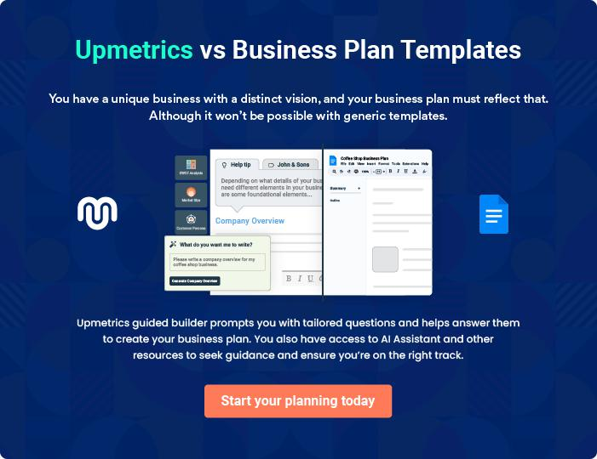
Products and Services

The product and services section of a seafood restaurant business plan should describe the specific services and products that will be offered to customers. To write this section should include the following:
To unlock help try Upmetrics! 

 Help tip  Seafood Restaurant Business Plan

To craft the introduction for your "Products and Services" chapter, begin by positioning your business within its industry, emphasizing its unique strengths or value proposition.
To unlock help try Upmetrics! 

Start writing here..

 Help tip


Mention the categories of dishes and drinks you will offer in the restaurant. This list may include,
To unlock help try Upmetrics! 

Products

Grilled Salmon


Price: [$25.00]

Fresh salmon fillet grilled to perfection and served with a side of lemon butter sauce.

Specifications

- Freshly sourced salmon

- Grilled with olive oil and herbs

- Served with a homemade lemon butter sauce
Lobster Bisque

Price: [$12.00]

A creamy and rich lobster bisque made from fresh lobsters and a blend of spices.

Specifications

- Made with fresh lobster meat

- Cream-based soup

- Seasoned with garlic, onions, and a mix of herbs

Oyster Platter

Price: [$20.00]

A platter of fresh oysters served on the half shell with a side of mignonette sauce.

Specifications

- Freshly shucked oysters

- Served on a bed of crushed ice

- Accompanied by a tangy mignonette sauce

Seafood Paella

Price: [$30.00]

A traditional Spanish paella made with a mix of seafood, including shrimp, mussels, and clams, cooked with saffron rice.

Specifications

- Made with a mix of fresh seafood

- Cooked with saffron-infused rice

- Served in a traditional paella pan
Takeaway Service

Price: Varies depending on the order

Offers customers the option to enjoy their favourite seafood dishes in the comfort of their own homes.

Specifications

- Available for all items on the menu

- Packaging designed to maintain food quality

- Fast and efficient service

Catering Service

Price: Varies depending on the event size and menu selection

Provides catering services for events, offering a customized menu based on the client's preferences.

Specifications

- Customizable menu options

- Professional and experienced catering staff

- High-quality ingredients are used for all dishes

Quality Measures

 Help tip  Seafood Restaurant Business Plan

This section should explain how you maintain quality standards and consistently provide the highest quality service.
To unlock help try Upmetrics! 

Start writing here..

Additional Services

 Help tip  Seafood Restaurant Business Plan

Mention if your seafood restaurant company offers any additional services. You may include services like catering, wine, and food pairing workshops, cooking classes, etc.
To unlock help try Upmetrics! 

Start writing here..
Sales And Marketing Strategies
To unlock help try Upmetrics!

Writing the sales and marketing strategies section means a list of strategies you will use to attract and retain your clients.
To unlock help try Upmetrics! 

 Help Tip  Seafood Restaurant Business Plan


To create an effective introduction for your "Sales and Marketing Strategies" chapter, start by setting the stage within your specific industry or market.
To unlock help try Upmetrics! 

Start writing here..

Unique Selling Proposition (USP)

 Help tip  Seafood Restaurant Business Plan

Define your business’s USPs depending on the market you serve, the equipment you use, and the unique services you provide. Identifying USPs will help you plan your marketing strategies.
To unlock help try Upmetrics! 

Start writing here..

Pricing Strategy

 Help tip  Seafood Restaurant Business Plan

Describe your pricing strategy—how you plan to price your restaurant services and stay competitive in the local market. You can mention happy hours, Combo offers tasting days, and special discounts to attract new diners to your restaurant.



Start writing here..

 Help tip  Seafood Restaurant Business Plan

Discuss your marketing strategies to market your services.

You may include some of these marketing strategies in your business plan—social media
To unlock help try Upmetrics! 

Marketing strategies

Online


Social Media

Regular updates, promotions, and engagement on platforms such as [Instagram, Facebook, and Twitter].

Google Ads

Targeted ads to reach potential patrons in our vicinity.

Collaborations with Food Influencers

Partnering with prominent food bloggers and influencers for reviews and promotions.

Offline

Brochures and Print Marketing

Distributed in [hotels, tourist spots, and local businesses] to attract local and out-of-town patrons.

Events

Organizing [live music, seafood festivals] to attract a larger audience.

 Help tip
To unlock help try Upmetrics!

Outline the strategies you’ll implement to maximize your sales. Your sales strategies may include partnering with influencers, online delivery platforms, direct walk-ins, employee recommendations, etc.



Sales strategies

Partner with Influencers

Collaborations with local influencers for promotional events and reviews.

Online Delivery Platforms

Tying up with platforms like [UberEats, Grubhub] to reach a broader audience who prefer dining at home.

Direct Walk-Ins Employee Recomendations

Offering discounts or promotional Incentivizing staff to recommend

offers for direct bookings and our restaurant to potential diners.

walk-ins.

 Help tip

Describe your customer retention strategies and how you plan to execute them.

For instance, introducing loyalty programs, discounts on annual membership, celebratory
To unlock help try Upmetrics! 

Customer retention

Loyalty Programs Annual Membership Discounts

Points-based or frequency-based Offering premium members a fixed

rewards for our regular patrons. discount on all their visits

throughout the year.

Celebatory Discounts Personalized Service

Special discounts or Remembering customer

complimentary dishes for diners preferences, allergies, or special

celebrating birthdays, requests to provide a tailored

anniversaries, etc. experience.

Operations Plan

 |  | When writing the operations plan section, it’s important to consider the
 |  | various aspects of your business operations.
 |  |  |  | To unlock help try Upmetrics! 
 Help tip |  |  Seafood Restaurant Business Plan


To create an effective introduction for your "Operational Plan" chapter, start by emphasizing the
pivotal role of efficient operations in the success of your business, underscoring how they
directly impact the quality of services delivered.
 |  |  |  | To unlock help try Upmetrics! 
Start writing here..
Staffing & Training
 Help tip |  |  Seafood Restaurant Business Plan

Mention your restaurant’s staffing requirements, including the number of chefs, servers,
managers, and cleaners needed. Include their qualifications, skillset, training requirement, and
the duties they will perform.
 |  |  |  | To unlock help try Upmetrics! 
Start writing here..
Operational Process
 Help tip |  |  Seafood Restaurant Business Plan

Outline the processes and procedures you will use to run your seafood restaurant.

Your operational processes may include seafood sourcing, quality inspection, dish preparation,
To unlock help try Upmetrics! 

Start writing here..

Equipment & Machinery
To unlock help try Upmetrics!

 Help tip  Seafood Restaurant Business Plan

Include the list of equipment and machinery required for a seafood restaurant, such as grilling machines, cooking equipment, cleaning equipment, technology for an interactive dining experience, quality check equipment, etc.



Start writing here..
Management Team

The management team section provides an overview of the individuals responsible for running your business plan.
To unlock help try Upmetrics! 

 Help tip  Seafood Restaurant Business Plan

To craft an introduction for your "Management Team" chapter, begin by emphasizing the crucial role of leadership in the success of any business.
To unlock help try Upmetrics! 

Start writing here..

Key managers

 Help tip  Seafood Restaurant Business Plan

Introduce your management and key members of your team, and explain their roles and responsibilities.
To unlock help try Upmetrics! 

Start writing here..


JOHN DOE

Founder & CEO - john.doe@example.com

John, with his visionary leadership and profound love for seafood, laid the foundation of [Seafood Delight].

With a Bachelor’s degree in Business Administration and a Diploma in Culinary Arts, he has successfully combined his academic learnings with his culinary passion.


John brings over 15 years of experience in the food and beverage industry, having worked in various managerial roles in esteemed restaurants across the country.

JANE DOE

Restaurant Owner - jane.doe@example.com

Jane is the operational backbone of [Seafood Delight]. With a Master’s degree in Restaurant Management from the prestigious Culinary Institute of America, she brings a rich blend of academic knowledge and practical experience.


Her career spans over 12 years, where she has held significant roles in renowned restaurants.

Jane’s strong organizational skills and keen attention to detail ensure that the restaurant operates seamlessly.


ALICE BROWN

Master Chef - alice.brown@example.com

Alice, a graduate of Le Cordon Bleu, brings her culinary magic to [Seafood Delight].

With over 10 years of experience in the seafood culinary scene, Alice specializes in combining traditional and modern cooking techniques to create exquisite dishes.

Her innovative recipes and attention to detail have earned her multiple accolades in the culinary world.


ROBERT BROWN

Procurement Head - robert.brown@example.com

Robert’s role as the Procurement Head is pivotal in maintaining the quality of the seafood served at [Seafood Delight].

With a degree in Supply Chain Management and over 8 years of experience in procurement, Robert ensures that the restaurant sources the freshest and most sustainable seafood.

His extensive network of suppliers and negotiation skills play a crucial role in maintaining the restaurant’s quality standards.
Organizational structure

 Help tip  Seafood Restaurant Business Plan

Explain the organizational structure of your management team. Include the reporting line and decision-making hierarchy.
To unlock help try Upmetrics! 

Start writing here..

Organization chart


John Doe

CEO


Alice Brown Robert Brown Jane Doe

Master Chef Procurement Head Restaurant Owner




[Sous Chef] [Purchase Assistant] [Assistant 1]

- - -

Compensation plan

 Help tip  Seafood Restaurant Business Plan

Describe your compensation plan for the management and staff. Include their salaries, incentives, and other benefits.
To unlock help try Upmetrics! 

Start writing here..

 Help tip

Mentioning advisors or consultants in your business plans adds credibility to your business idea.
To unlock help try Upmetrics! 

Advisors/Consultants


[NAME]

Advisor

A stalwart in the restaurant industry, with over [X years] of experience. [He/She] provides valuable insights into market dynamics and customer preferences.


[NAME]

Consultant

Specializing in sustainable seafood sourcing, [he/she] has been instrumental in helping us maintain our commitment to sustainability and quality for over [X years].
Financial Plan

When writing the financial plan section of a business plan, it’s important to provide a comprehensive overview of your financial projections for the first few years of your business, You may provide the following:
To unlock help try Upmetrics! 

 Help tip  Seafood Restaurant Business Plan


To create an effective introduction for your "Financial Plan" chapter, begin by stressing the critical role of a well-structured financial plan in the success of your venture.
To unlock help try Upmetrics! 

Start writing here..

 Help tip  Seafood Restaurant Business Plan

Describe details such as projected revenue, operational costs, and service costs in your projected profit and loss statement. Make sure to include your restaurant’s expected net profit or loss.
To unlock help try Upmetrics! 

Profit & loss statement

Revenue

Cost Of Sales

General Costs

Revenue Specific Costs

Personnel Costs (Direct

Labor)

Gross Margin

Gross Margin (%)

Operating Expense

Payroll Expense

(Indirect Labor)

General Expense

Bad Debt

Amortization of Current

Assets

2023-24 | 2024-25 | 2025-26 | 2026-27 | 2027-28
$0 | $0 | $0 | $0 | $0

$0 | $0 | $0 | $0 | $0
$0 | $0 | $0 | $0 | $0
$0 | $0 | $0 | $0 | $0
$0 | $0 | $0 | $0 | $0

$0 | $0 | $0 | $0 | $0
0% | 0% | 0% | 0% | 0%

$0 | $0 | $0 | $0 | $0
$0 | $0 | $0 | $0 | $0
$0 | $0 | $0 | $0 | $0
$0 | $0 | $0 | $0 | $0
$0 | $0 | $0 | $0 | $0

EBITDA

Additional Expense

Long Term

Depreciation

Gain or loss from Sale

of Assets

EBIT

Interest Expenses

EBT

Income Tax Expense

Total Expense

Net Income

Net Income (%)

2023-24 | 2024-25 | 2025-26 | 2026-27 | 2027-28
$0 | $0 | $0 | $0 | $0
$0 | $0 | $0 | $0 | $0
$0 | $0 | $0 | $0 | $0
$0 | $0 | $0 | $0 | $0
$0 | $0 | $0 | $0 | $0
$0 | $0 | $0 | $0 | $0
$0 | $0 | $0 | $0 | $0
$0 | $0 | $0 | $0 | $0
$0 | $0 | $0 | $0 | $0
$0 | $0 | $0 | $0 | $0
0% | 0% | 0% | 0% | 0%
 |  |  | 2023-24 |  | 2024-25 | 2025-26 | 2026-27 | 2027-28
Retained Earning |  |  | $0 |  | $0 | $0 | $0 | $0
Opening
Owner's Distribution |  |  | $0 |  | $0 | $0 | $0 | $0
Retained Earning |  |  | $0 |  | $0 | $0 | $0 | $0
Closing
 Help tip |  |  |  Seafood Restaurant Business Plan


The cash flow for the first few years of your operation should be estimated and described in this section. This may include billing invoices, payment receipts, loan payments, and any other cash flow statements.
To unlock help try Upmetrics! 

Cash flow statement

 | 2023-24 | 2024-25 | 2025-26 | 2026-27 | 2027-28
Cash Received | $0 | $0 | $0 | $0 | $0
Cash Paid | $0 | $0 | $0 | $0 | $0
COS & General Expenses | $0 | $0 | $0 | $0 | $0
Salary & Wages | $0 | $0 | $0 | $0 | $0
Interest | $0 | $0 | $0 | $0 | $0

Sales Tax

Income Tax

Net Cash From

Operations

Assets Sell

Assets Purchase

Net Cash From

Investments

Amount Received

Loan Received

Common Stock

Preferred Stock

Owner's Contribution

Amount Paid

2023-24 | 2024-25 | 2025-26 | 2026-27 | 2027-28
$0 | $0 | $0 | $0 | $0
$0 | $0 | $0 | $0 | $0
$0 | $0 | $0 | $0 | $0

$0 | $0 | $0 | $0 | $0
$0 | $0 | $0 | $0 | $0
$0 | $0 | $0 | $0 | $0

$0 | $0 | $0 | $0 | $0
$0 | $0 | $0 | $0 | $0

$0 | $0 | $0 | $0 | $0
$0 | $0 | $0 | $0 | $0
$0 | $0 | $0 | $0 | $0

Loan Capital $0 $0 $0 $0 $0

 |  |  | 2023-24 |  | 2024-25 | 2025-26 | 2026-27 | 2027-28
Dividends & Distributions |  |  | $0 |  | $0 | $0 | $0 | $0
Net Cash From |  |  | $0 |  | $0 | $0 | $0 | $0
Financing
Summary
Starting Cash |  |  | $0 |  | $0 | $0 | $0 | $0
Cash In |  |  | $0 |  | $0 | $0 | $0 | $0
Cash Out |  |  | $0 |  | $0 | $0 | $0 | $0
Change in Cash |  |  | $0 |  | $0 | $0 | $0 | $0
Ending Cash |  |  | $0 |  | $0 | $0 | $0 | $0
 Help tip |  |  Seafood Restaurant Business Plan

Create a projected balance sheet documenting your seafood restaurant’s assets, liabilities, and equity.

To unlock help try Upmetrics! 

Balance sheet

 | 2023-24 | 2024-25 | 2025-26 | 2026-27 | 2027-28
Assets | $0 | $0 | $0 | $0 | $0
Current Assets | $0 | $0 | $0 | $0 | $0
Cash | $0 | $0 | $0 | $0 | $0
Accounts Receivable | $0 | $0 | $0 | $0 | $0
Inventory | $0 | $0 | $0 | $0 | $0
Other Current Assets | $0 | $0 | $0 | $0 | $0
Long Term Assets | $0 | $0 | $0 | $0 | $0
Gross Long Term Assets | $0 | $0 | $0 | $0 | $0
Accumulated Depreciation | $0 | $0 | $0 | $0 | $0

Liabilities & Equity | $0 | $0 | $0 | $0 | $0
Liabilities | $0 | $0 | $0 | $0 | $0
Current Liabilities | $0 | $0 | $0 | $0 | $0
Accounts Payable | $0 | $0 | $0 | $0 | $0
Income Tax Payable | $0 | $0 | $0 | $0 | $0
Sales Tax Payable | $0 | $0 | $0 | $0 | $0
Short Term Debt | $0 | $0 | $0 | $0 | $0
 | 2023-24 | 2024-25 | 2025-26 | 2026-27 | 2027-28
Long Term Liabilities | $0 | $0 | $0 | $0 | $0
Long Term Debt | $0 | $0 | $0 | $0 | $0
Equity | $0 | $0 | $0 | $0 | $0
Paid-in Capital | $0 | $0 | $0 | $0 | $0
Common Stock | $0 | $0 | $0 | $0 | $0
Preferred Stock | $0 | $0 | $0 | $0 | $0
Owner's Contribution | $0 | $0 | $0 | $0 | $0
Retained Earnings | $0 | $0 | $0 | $0 | $0

Check | $0 |  |  | $0 | $0 | $0 | $0
 Help tip |  |  Seafood Restaurant Business Plan

Determine and mention your business’s break-even point—the point at which your business costs and revenue will be equal.

This exercise will help you understand how much revenue you need to generate to sustain or be profitable.
To unlock help try Upmetrics! 

Break-even Analysis

 | 2023-24 | 2024-25 | 2025-26 | 2026-27 | 2027-28
Starting Revenue | $0 | $0 | $0 | $0 | $0
Net Revenue | $0 | $0 | $0 | $0 | $0
Closing Revenue | $0 | $0 | $0 | $0 | $0

Starting Expense | $0 | $0 | $0 | $0 | $0
Net Expense | $0 | $0 | $0 | $0 | $0
Closing Expense | $0 | $0 | $0 | $0 | $0

Is Break Even? | 0 | 0 | 0 | 0 | 0
Break Even Month | 0 | 0 | 0 | 0 | 0
Days Required | 0 | 0 | 0 | 0 | 0
Break Even Revenue | $0 | $0 | $0 | $0 | $0
Break Even Units
Financing needs

 Help tip  Seafood Restaurant Business Plan

Calculate costs associated with starting a seafood restaurant, and estimate your financing needs and how much capital you need to raise to operate your business.
To unlock help try Upmetrics! 

Start writing here..
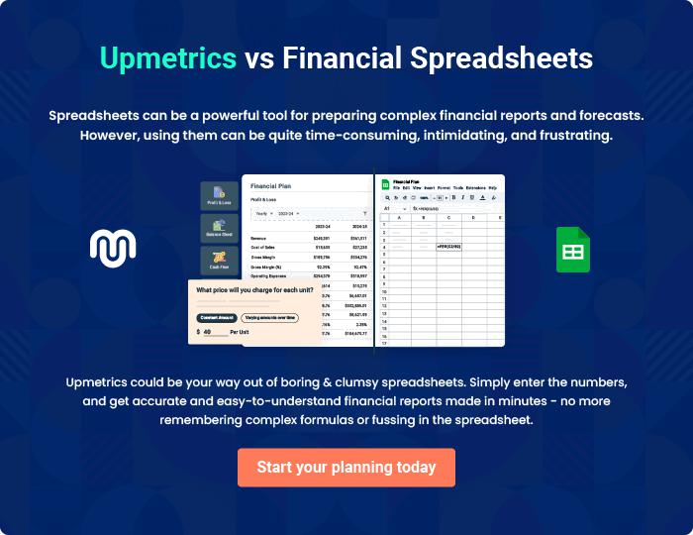
Appendix

When writing the appendix section, you should include any additional information that supports the main content of your plan. This may include financial statements, market research data, legal documents, and other
To unlock help try Upmetrics! 
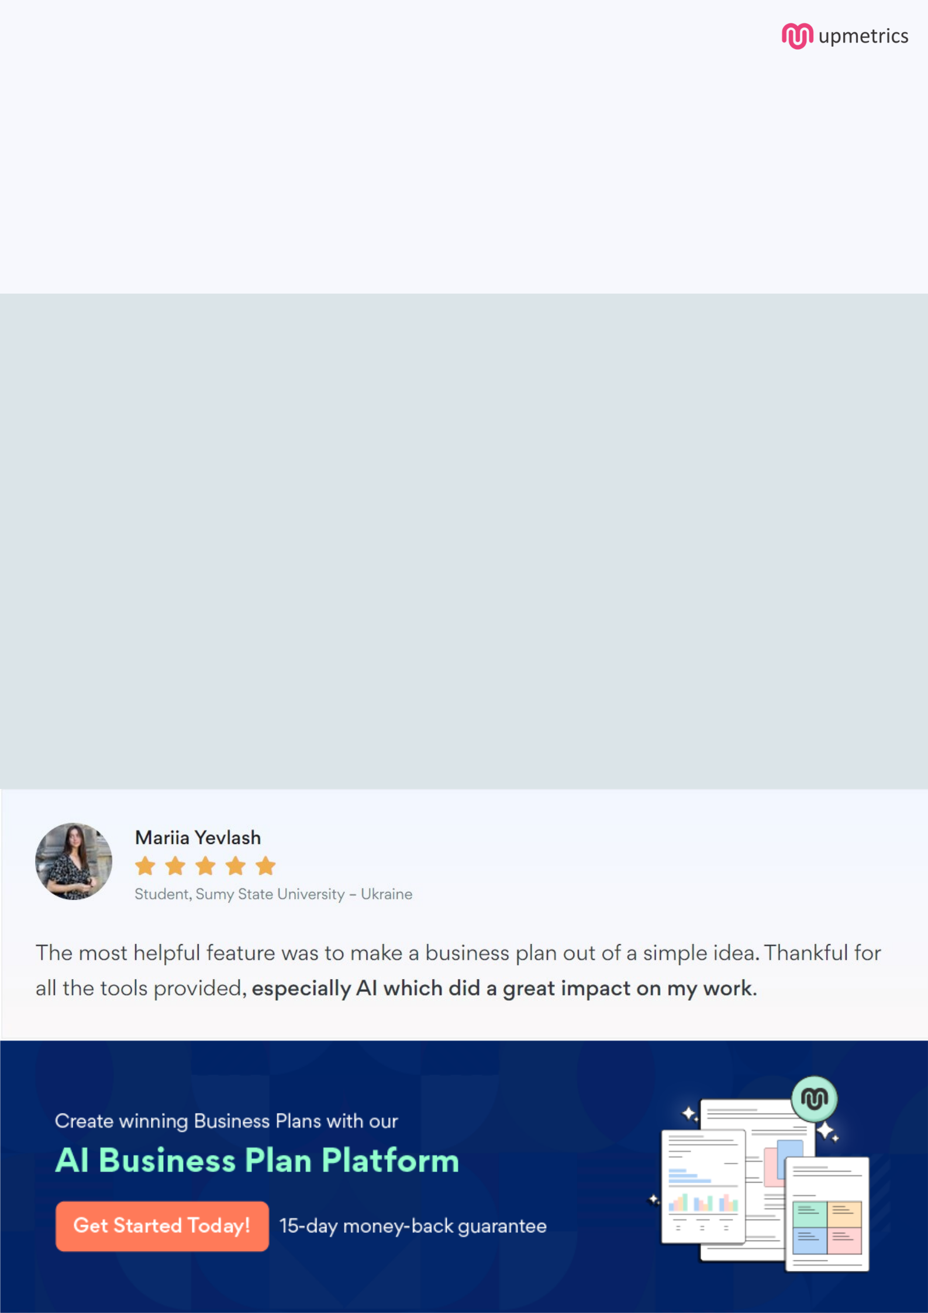
Create a winning business plan that gets you funded

Creating a stunning and investment-ready plan requires no writing, graphic designing, or financial planning expertise.

Upmetrics has all the features required to help you create a comprehensive business plan—from start to finish. Make no mistakes, it’s the modern way of planning to structure ideas, make plans, and create stunning pitch decks to awe investors.

Pitch decks that impress investors

Create pitch decks that provide a visual representation of your business, engage investors, and make them want to invest in your business idea.

Interactive plans in no time

Import business plan sections like—SWOT analysis, comparison tables, and others to create an interactive business plan. No designing skills are required.

Stunning cover page designs

With Upmetrics, you have the liberty to choose from multiple stunning cover page designs. Choose a creative design and make your plan stand out.

Online sharing made simple

Upmetrics makes online sharing quick and easier for users. Easily share your business plans with a link while tracking reader activity.

500+ sample business plans

Simply import a template from our library of sample plans into the editor and start customizing it to make it yours. It takes only a few clicks to get started.

Collaborate with team in real-time

Invite team members, initiate conversations, discuss ideas & strategies, share feedback, and work on a business plan in real-time.

