

Scrap Metal Business Plan

Turning Waste into Worth


Business
Plan

2023

Prepared By

John Doe

10200 Bolsa Ave, Westminster, CA, 92683

info@example.com

(650) 359-3153 http://www.example.com

Table of Contents

Executive Summary | 6
Market opportunity | 6
Services Offered | 6
Marketing & Sales Strategies | 7
Financial Highlights | 7
Units Sold v/s Revenue | 8

Company Overview | 9
Ownership | 9
Mission statement | 10
Business history | 10
Future goals | 11

Market Analysis | 12
Target Market | 12
Market size and growth potential | 12
Market Size | 13
Competitive analysis | 13
Schnitzer Steel Industries | 13
Sims Limited | 14
Commercial Metals Company | 14
Market trends | 14
Regulatory environment | 15

Products and Services | 16
Scrap metal products & services | 16
Sorted & Processed Scrap Metal | 16
Shredded Scrap Metal | 17
Scrap Metal Collection | 17
Metal Recycling | 18
Metal Testing Analysis | 18
Scrap Metal Management Consulting | 19
Quality measures | 19
Additional Services | 19

Sales And Marketing Strategies | 20
Unique Selling Proposition (USP) | 20
Pricing Strategy | 20
Marketing strategies | 21
Online | 21
Offline | 21
Sales strategies | 22
Customer retention | 22

Operations Plan | 23
Staffing & Training | 23
Operational Process | 23
Equipment & Machinery | 24

Management Team | 25
Key managers | 25
John Doe | 25
Jane Doe | 26
Alice Brown | 26
Robert Brown | 26
Emily White | 26
Michael Johnson | 27
Organizational structure | 27
Organization chart | 27
Compensation plan | 28
Advisors/Consultants | 28
[ADVISOR NAME] | 28
[CONSULTANT NAME] | 28
Financial Plan | 29
Profit & loss statement | 29
Cash flow statement | 32
Balance sheet | 34
Break-even Analysis | 36
Financing needs | 38
Appendix
Appendix | 40
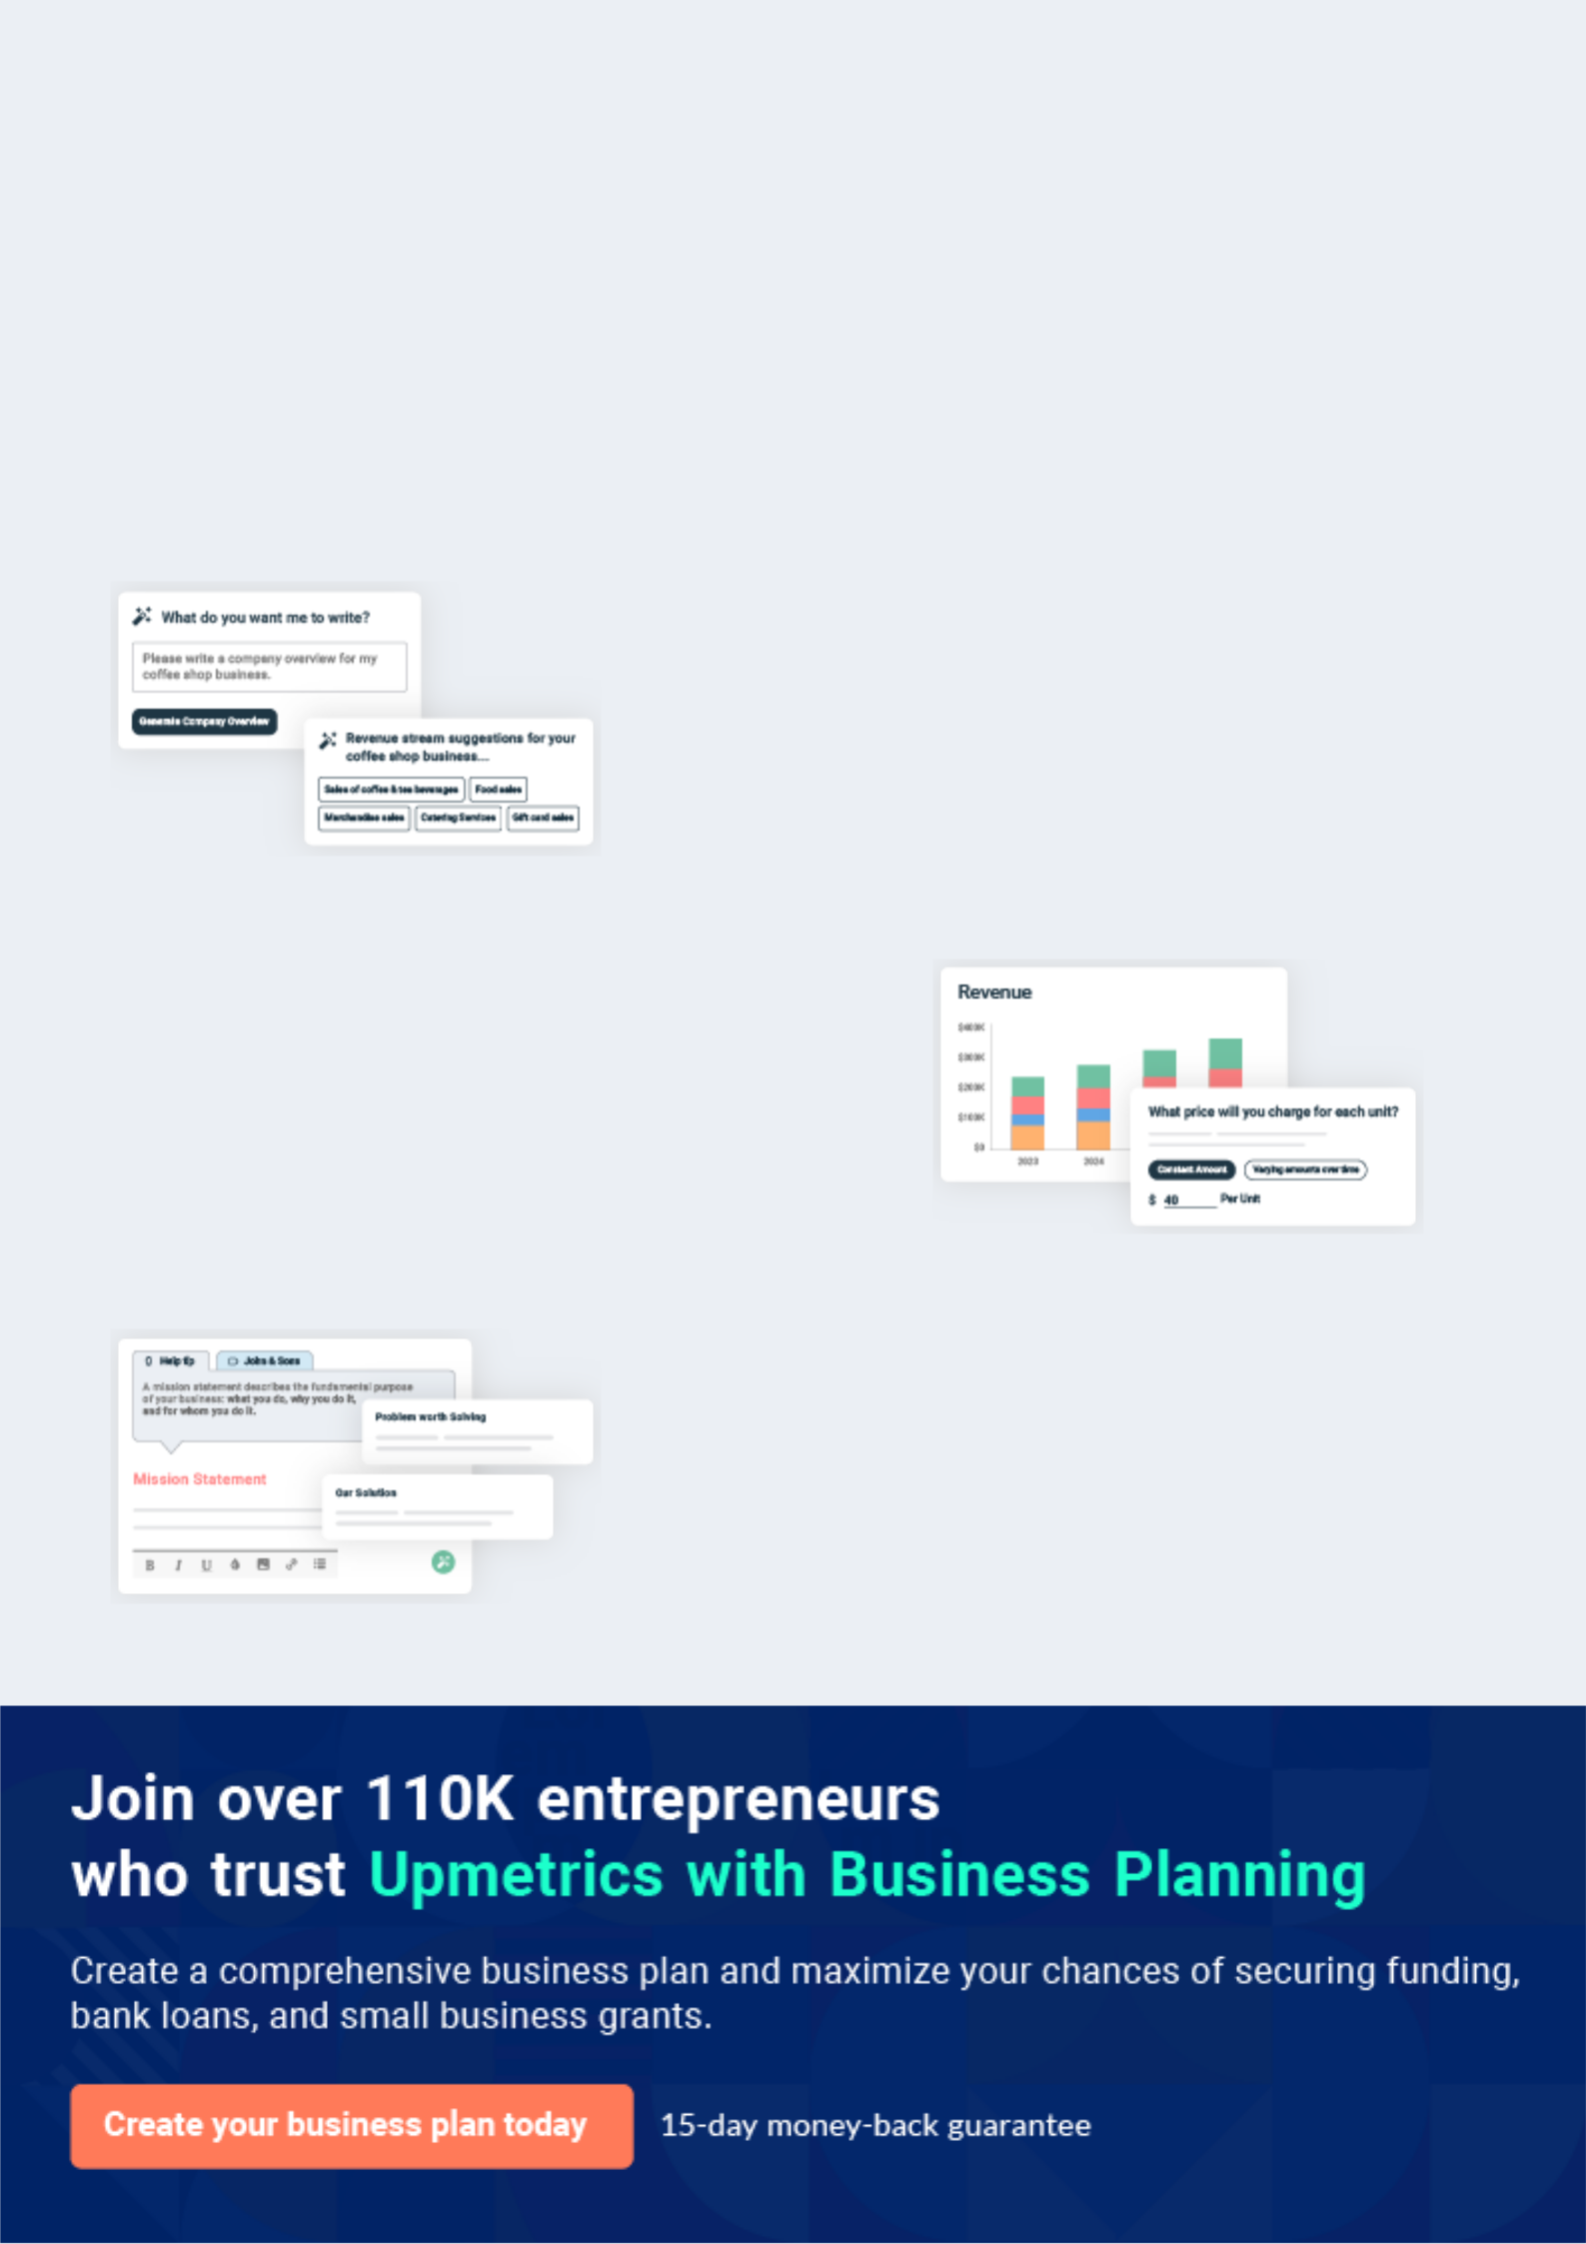
Business planning that’s simpler and faster than you think

Creating a business plan using Upmetrics to start and grow a business is literally the easiest thing in the World. Simply read the instructions and fill in the blanks. It’s as simple as that.

❛ | Upmetrics has everything you need to create a | ❜
❛ | comprehensive business plan. | ❜

AI-powered Upmetrics Assistant

AI-powered insights to streamline your plan

Not sure where to start? Upmetrics’ AI Assistant will automatically generate ideas for each section of your plan and offer improved versions of your writing, adjusting for tone, voice, and grammar or spelling errors.

Financial Forecasting Tool

All the financials are calculated for you

Forget the complex formulas and clumsy spreadsheets — with automatic financials and drag-and-drop forecasting, you can finish your plan faster and be confident that your numbers are accurate.

Business Plan Builder

Guides you like a business mentor

Upmetrics’ step-by-step instructions, prompts, and the library of 400+ sample business plans will guide you through each section of your plan as a business mentor.
Executive Summary


An executive summary is the first section of the business plan intended to provide an overview of the whole business plan.
To unlock help try Upmetrics! 

 Help tip  Scrap Metal Business Plan


Start your executive summary by briefly introducing your business to your readers.

This section may include the name of your scrap metal business, its location, when it was
To unlock help try Upmetrics! 

Start writing here..

Market opportunity

 Help tip  Scrap Metal Business Plan

Summarize your market research, including market size, growth potential, and marketing trends. Highlight the opportunities in the market and how your business will fit in to fill the gap.
To unlock help try Upmetrics! 

Start writing here..

Services Offered

 Help tip  Scrap Metal Business Plan

Highlight the scrap metal services you offer your clients. The USPs and differentiators you offer are always a plus.
To unlock help try Upmetrics! 

Start writing here..

Marketing & Sales Strategies
To unlock help try Upmetrics!

 Help tip  Scrap Metal Business Plan

Outline your sales and marketing strategies—what marketing platforms you use, how you plan on acquiring customers, etc.
To unlock help try Upmetrics! 

Start writing here..

Financial Highlights

 Help tip  Scrap Metal Business Plan

Briefly summarize your financial projections for the initial years of business operations. Include any capital or investment requirements, associated startup costs, projected revenues, and profit forecasts.



Start writing here..
Units Sold v/s Revenue

 |  | Units Sold | Revenue
15.00k
10.00k
5.00k
0
Year 1 | Year 2 | Year 3
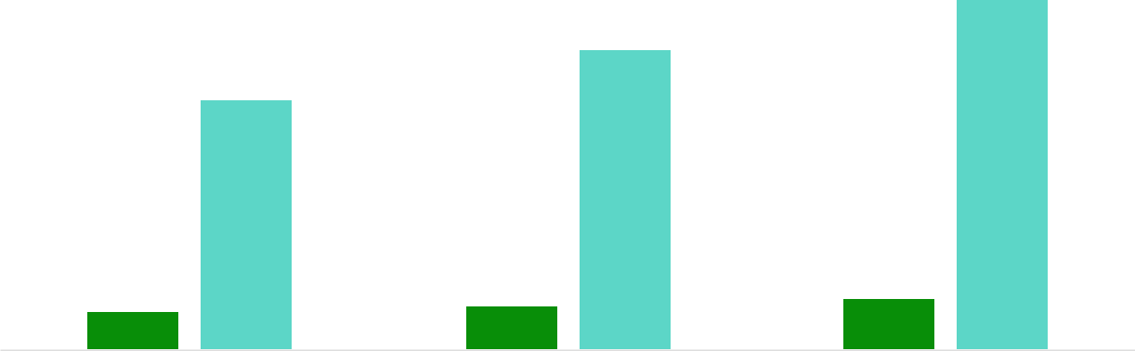

Financial Year |  |  | Units Sold | Revenue
Year 1 | 1,550 |  |  | $10,000
Year 2 | 1,800 |  |  | $12,000
Year 3 | 2,050 |  |  | $14,000
 Help tip |  |  Scrap Metal Business Plan
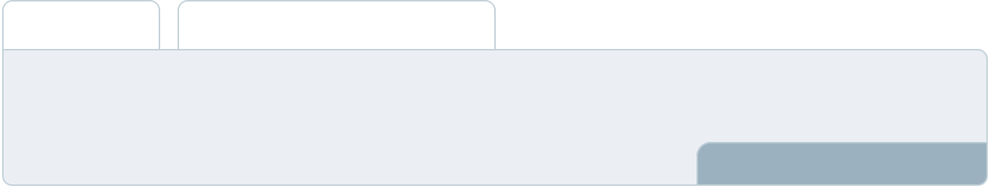

Summarize your executive summary section with a clear CTA, for example, inviting angel investors to discuss the potential business investment.
To unlock help try Upmetrics! 

Write a call to action for your business plan.
Company Overview

Depending on what details of your business are essential, you’ll need different elements in your business overview.
To unlock help try Upmetrics! 

 Help tip  Scrap Metal Business Plan

Describe your business in this section by providing all the basic information:

Describe what kind of scrap metal company you run and the name of it. You may specialize in
To unlock help try Upmetrics! 

Start writing here..

Ownership

 Help tip  Scrap Metal Business Plan

List the names of your scrap metal company’s founders or owners. Describe what shares they own and their responsibilities for efficiently managing the business.
To unlock help try Upmetrics! 

Start writing here..
Mission statement

 Help tip  Scrap Metal Business Plan

Summarize your business’ objective, core principles, and values in your mission statement. This statement needs to be memorable, clear, and brief.
To unlock help try Upmetrics! 

❛ At [Your Scrap Metal Business Name], we strive to redefine excellence in the scrap metal industry. Committed to sustainability, innovation, and client satisfaction, our mission is to provide top-tier scrap metal solutions while championing environmental responsibility.

Our core principles revolve around integrity, quality, and unparalleled service, ensuring we remain at the forefront of industry advancements.

❜

Business history

 Help tip  Scrap Metal Business Plan

If you’re an established scrap metal service provider, briefly describe your business history, like —when it was founded, how it evolved over time, etc.
To unlock help try Upmetrics! 

Start writing here..
Future goals

 Help tip  Scrap Metal Business Plan

It’s crucial to convey your aspirations and vision. Mention your short-term and long-term goals; they can be specific targets for revenue, market share, or expanding your services
To unlock help try Upmetrics! 

Start writing here..
Market Analysis
To unlock help try Upmetrics!


 |  | Market analysis provides a clear understanding of the market in which your
 |  | printing business will run along with the target market, competitors, and
 |  | growth opportunities.
 |  |  |  | To unlock help try Upmetrics! 
 Help tip |  |  Scrap Metal Business Plan

To write the introduction section of your market analysis, start by clearly identifying your primary target market.
To unlock help try Upmetrics! 

Start writing here..

Target Market

 Help tip  Scrap Metal Business Plan

Start this section by describing your target market. Define your ideal customer and explain what types of services they prefer. Creating a buyer persona will help you easily define your target market to your readers.



Start writing here..

Market size and growth potential

 Help tip  Scrap Metal Business Plan

Describe your market size and growth potential and whether you will target a niche or a much broader market.
To unlock help try Upmetrics! 

Start writing here..

Market Size

Available Market

Total global market for scrap metal 150M services.

Served Market
Portion of the market our services 50M cater to.

Target Market
Our primary focus within the served 10M market.

 Help tip  Scrap Metal Business Plan

Identify and analyze your direct and indirect competitors. Identify their strengths and weaknesses, and describe what differentiates your scrap metal services from them.
To unlock help try Upmetrics! 

Competitive analysis

Schnitzer Steel Industries

Schnitzer Steel Industries is a global leader in the metal recycling industry, with extensive operations that include collecting, processing, and selling ferrous and non-ferrous scrap metal. They have a strong network of recycling facilities and export terminals across North America and Asia.

Features | Strengths | Weaknesses
Collection and processing of | Strong global presence with | Reliance on global market
both ferrous and non-ferrous | well-established infrastructure. | conditions, which can be volatile.
scrap metal. | Diverse range of services | Challenges in managing
Sale of recycled metal to steel | catering to various customer | operational costs due to
mills and foundries globally. | needs. | fluctuating commodity prices.
Auto recycling business that | Robust environmental
provides used auto parts to | compliance and sustainability
retail and wholesale | initiatives.
customers.

Sims Limited

Sims Limited is a global leader in metal recycling, with a focus on providing sustainable solutions for the recovery and recycling of scrap metal. They have a significant presence in North America, Europe, and Asia, offering a wide range of recycling services.

Features | Strengths | Weaknesses
Metal recycling services for | Strong global network and | Vulnerability to fluctuations in
ferrous and non-ferrous metals. | industry presence. | global commodity prices.
E-waste recycling and IT asset | Comprehensive range of | Dependence on regulatory
disposal services. | services catering to diverse | compliance in multiple
Circular economy solutions for | markets. | jurisdictions.
various industries. | Commitment to sustainability
 | and circular economy
 | principles.

Commercial Metals Company

Commercial Metals Company (CMC) specializes in recycling ferrous and non-ferrous metals and manufacturing steel products. They have a significant presence in the United States and Europe, with a focus on providing innovative and sustainable solutions.

Features | Strengths | Weaknesses
Recycling of ferrous and non- | Strong manufacturing | Limited global presence
ferrous scrap metal. | capabilities with a focus on | compared to competitors.
Manufacturing of steel | innovation. | Exposure to fluctuations in steel
products, including rebar and | Comprehensive range of | prices and market demand.
wire rod. | products and services.
Sustainable practices and | Commitment to environmental
environmental compliance. | sustainability and compliance.

Market trends

 Help tip  Scrap Metal Business Plan

Analyze emerging trends in the industry, such as technology disruptions, changes in customer behavior or preferences, etc. Explain how your business will cope with all the trends.
To unlock help try Upmetrics! 

Start writing here..

Regulatory environment
To unlock help try Upmetrics!

 Help tip  Scrap Metal Business Plan

List regulations and licensing requirements that may affect your scrap metal company, such as licensing & permits, environmental regulations, theft prevention & compliance, health & safety regulations, export & import regulations, etc.



Start writing here..
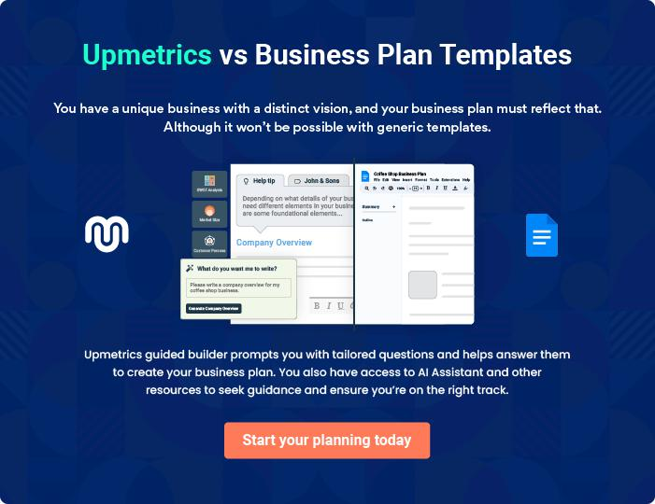
Products and Services
To unlock help try Upmetrics!

The product and services section of a scrap metal business plan should describe the specific services and products that will be offered to customers. To write this section should include the following:



 Help tip  Scrap Metal Business Plan

To craft the introduction for your "Products and Services" chapter, begin by positioning your business within its industry, emphasizing its unique strengths or value proposition.
To unlock help try Upmetrics! 

Start writing here..

 Help tip


Mention the scrap metal products & services your business will offer. This list may include:

• Sorted & processed scrap metal
To unlock help try Upmetrics! 

Scrap metal products & services

Sorted & Processed Scrap Metal


Price: [$150] per ton

Our sorted and processed scrap metal is meticulously separated and cleaned, ensuring you receive only the highest quality metal, ready for manufacturing or recycling.

Specifications

- Types of metals included: Iron, Copper, Aluminum, and Brass

- Cleanliness: 99% free from contaminants

- Size specifications: Pieces range from 2 to 5 inches in length
Shredded Scrap Metal

Price: [$100] per ton

Utilizing state-of-the-art machinery, our shredded scrap metal service breaks down large metal items into manageable pieces, facilitating easier transportation and recycling.

Specifications

- Shred size: 1 to 3 inches in length

- Types of metals accepted: All types, excluding hazardous materials

- Maximum item size for shredding: 6 feet in length and 2 feet in width

Scrap Metal Collection

Price: [$50] per pickup

Our comprehensive scrap metal collection service ensures timely and efficient removal of all your scrap metal, with the convenience of scheduled pickups.

Specifications

- Maximum weight per pickup: 2 tons

- Service area: Within 50 miles of [Your Business Location]

- Collection frequency: Weekly, bi-weekly, or monthly options available
Metal Recycling

Price: Prices vary based on the type and amount of metal to be recycled; contact us for a quote.

Our eco-friendly metal recycling service transforms your scrap metal into valuable resources, contributing to environmental sustainability.

Specifications

- Acceptable metals: Iron, Copper, Aluminum, Brass, and Stainless Steel

- Non-acceptable items: Electronics, batteries, and hazardous materials

- Recycling process: Sorting, cleaning, shredding, and melting

Metal Testing Analysis

Price: [$30] per analysis

Our metal testing analysis service provides detailed insights into the quality and type of metal, empowering you to make informed decisions.

Specifications

- Analysis includes: Composition, purity, and grade

- Report delivery: Within 48 hours of testing

- Sample size required: At least 500 grams of metal
Scrap Metal Management Consulting
- To unlock help try Upmetrics!

Price: [$100] per hour

Leverage the expertise of our industry professionals to optimize your scrap metal management processes and boost efficiency.

Specifications

- Consultation areas: Process optimization, cost reduction, and compliance

- Available formats: In-person or virtual consultations

- Minimum consultation time: 1 hour

Quality measures

 Help tip  Scrap Metal Business Plan

This section should explain how you maintain quality standards and consistently provide the highest quality service.
To unlock help try Upmetrics! 

Start writing here..

Additional Services

 Help tip  Scrap Metal Business Plan

Mention if your scrap metal company offers any additional services. You may include services like metal testing analysis, scrap metal collection & transportation, scrap metal management consulting, etc.



Start writing here..

Sales And Marketing Strategies
To unlock help try Upmetrics!

Writing the sales and marketing strategies section means a list of strategies you will use to attract and retain your clients.
To unlock help try Upmetrics! 

 Help Tip  Scrap Metal Business Plan


To create an effective introduction for your "Sales and Marketing Strategies" chapter, start by setting the stage within your specific industry or market.
To unlock help try Upmetrics! 

Start writing here..

Unique Selling Proposition (USP)

 Help tip  Scrap Metal Business Plan

Define your business’s USPs depending on the market you serve, the equipment you use, and the unique services you provide. Identifying USPs will help you plan your marketing strategies.
To unlock help try Upmetrics! 

Start writing here..

Pricing Strategy

 Help tip  Scrap Metal Business Plan

Describe your pricing strategy—how you plan to price your products & services and stay competitive in the local market. You can mention any discounts you plan on offering to attract new customers.



Start writing here..

 Help tip  Scrap Metal Business Plan
To unlock help try Upmetrics!

Discuss your marketing strategies to market your services. You may include some of these marketing strategies in your business plan— Google ads, brochures, email marketing, content marketing, etc.



Marketing strategies

Online


Google Ads

Utilizing targeted Google Ads campaigns to capture the attention of potential customers actively searching for scrap metal services.

Email Marketing

Engaging our existing customer base and potential leads through regular email newsletters highlighting our services, promotions, and industry news.

Content Marketing

Developing valuable content such

as blog posts and infographics to

educate our audience and

establish [Your Scrap Metal

Business Name] as an industry

authority.

Offline

Brochures

Distributing informative brochures at local businesses and community centers to increase local awareness.

 Help tip

Outline the strategies you’ll implement to maximize your sales. Your sales strategies may include partnering with other businesses, offering referral programs, etc.
To unlock help try Upmetrics! 

Sales strategies

Partner with Businesses

Establishing partnerships with local businesses to expand our customer base.

Engage with Universities

Establishing programs with [specific universities or institutes, e.g., "XYZ University's Engineering Department"] to cater to academic projects and research.

Referral Programs

Implementing referral programs

that reward existing customers for

bringing in new business.

 Help tip

Describe your customer retention strategies and how you plan to execute them. For instance, introducing loyalty programs, discounts & offers, personalized service, etc.
To unlock help try Upmetrics! 

Customer retention

Loyalty Programs

Offering loyalty programs that provide discounts and exclusive offers to repeat customers.

Discounts and Offers

Regularly introducing discounts and special offers to encourage repeat business.

Personalized Service

Providing personalized services

tailored to meet the unique needs

of each customer, ensuring

satisfaction and repeat business.

Operations Plan

 |  | When writing the operations plan section, it’s important to consider the
 |  | various aspects of your business operations.
 |  |  |  | To unlock help try Upmetrics! 
 Help tip |  |  Scrap Metal Business Plan
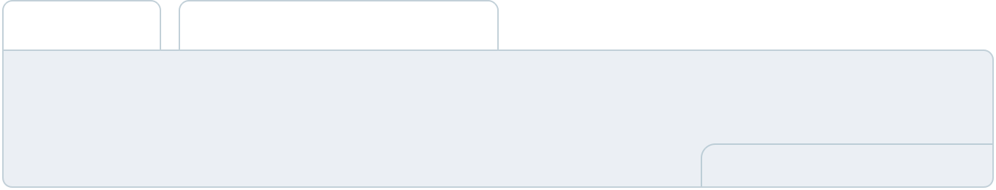

To create an effective introduction for your "Operational Plan" chapter, start by emphasizing the
pivotal role of efficient operations in the success of your business, underscoring how they
directly impact the quality of services delivered.
 |  |  |  | To unlock help try Upmetrics! 
Start writing here..
Staffing & Training
 Help tip |  |  Scrap Metal Business Plan

Mention your business’s staffing requirements, including the number of employees or warehouse personnel needed.
To unlock help try Upmetrics! 

Start writing here..

Operational Process

 Help tip  Scrap Metal Business Plan

Outline the processes and procedures you will use to run your scrap metal business.

Your operational processes may include sourcing & acquisition of scrap metal, sorting &
To unlock help try Upmetrics! 

Start writing here..

Equipment & Machinery
To unlock help try Upmetrics!

 Help tip  Scrap Metal Business Plan

Include the list of equipment and machinery required for scrap metal, such as sorting & grading equipment, scrap metal collection equipment, processing equipment, safety & environmental equipment, etc.



Start writing here..
Management Team

The management team section provides an overview of the individuals responsible for running your business plan.
To unlock help try Upmetrics! 

 Help tip  Scrap Metal Business Plan

To craft an introduction for your "Management Team" chapter, begin by emphasizing the crucial role of leadership in the success of any business.
To unlock help try Upmetrics! 

Start writing here..

Key managers

 Help tip  Scrap Metal Business Plan

Introduce your management and key members of your team, and explain their roles and responsibilities.
To unlock help try Upmetrics! 

Start writing here..


JOHN DOE

Founder and CEO - john.doe@example.com

With over 15 years of experience in the scrap metal industry, John is the visionary behind [Your Scrap Metal Business Name].

He holds a Bachelor's degree in Business Administration and a Master's degree in Environmental Management.


JANE DOE

Chief Operating Officer (COO) - jane.doe@example.com

Jane brings over 10 years of operational excellence to [Your Scrap Metal Business Name]. She holds a Bachelor's degree in Industrial Engineering and an MBA.


Her experience spans various industries, providing her with a versatile approach to operational management.


ALICE BROWN

CMO - alice.brown@example.com

With a keen eye for market trends, Alice is the creative force behind the marketing initiatives at [Your Scrap Metal Business Name].

She has a Bachelor's degree in Marketing and over 8 years of industry experience, providing a solid foundation for strategic marketing planning.


ROBERT BROWN

Operations Manager - robert.brown@example.com

Robert is dedicated to ensuring the smooth operation of all business processes. He has a Bachelor's degree in Operations Management and 10 years of experience in the industry.

His keen attention to detail and process optimization skills are pivotal to the company's success.


EMILY WHITE

Customer Services Manager - emily.white@example.com

Emily is passionate about customer satisfaction and building lasting relationships. She has a Bachelor's degree in Communications and over 6 years of customer service experience.

Her commitment to excellence is reflected in her ability to manage customer relations effectively.

MICHAEL JOHNSON

Procurement Manager - michael.johnson@example.com

Michael is responsible for sourcing the highest quality scrap metal for [Your Scrap Metal Business Name].

With a Bachelor's degree in Supply Chain Management and over 7 years of experience, he has developed a keen eye for identifying the best suppliers in the industry.

Organizational structure

 Help tip  Scrap Metal Business Plan

Explain the organizational structure of your management team. Include the reporting line and decision-making hierarchy.
To unlock help try Upmetrics! 

Start writing here..

Organization chart


John Doe

CEO


 |  |  | Michael Johnson
Alice Brown | Jane Doe |  | Michael Johnson
Alice Brown |  |  | Procurement Manager
CMO | COO

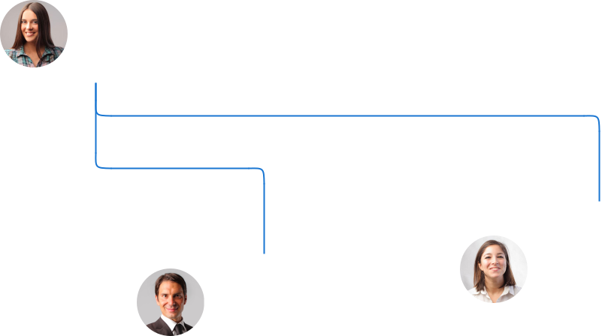

 | Emily White
Robert Brown | Customer Service
Operations Manager | Manager

Compensation plan

 Help tip  Scrap Metal Business Plan

Describe your compensation plan for the management and staff. Include their salaries, incentives, and other benefits.
To unlock help try Upmetrics! 

Start writing here..

 Help tip

Mentioning advisors or consultants in your business plans adds credibility to your business idea.
To unlock help try Upmetrics! 

Advisors/Consultants


[ADVISOR NAME]

Advisor

With [X] years of experience in [relevant industry/field], [Advisor's Name] serves as a crucial advisor, providing insights into [specific areas of advice].


[CONSULTANT NAME]

Consultant

As our consultant in [specific field], [Consultant's Name] brings [X] years of experience and plays a vital role in [specific consulting area].
Financial Plan

When writing the financial plan section of a business plan, it’s important to provide a comprehensive overview of your financial projections for the first few years of your business, You may provide the following:
To unlock help try Upmetrics! 

 Help tip  Scrap Metal Business Plan


To create an effective introduction for your "Financial Plan" chapter, begin by stressing the critical role of a well-structured financial plan in the success of your venture.
To unlock help try Upmetrics! 

Start writing here..

 Help tip  Scrap Metal Business Plan

Describe details such as projected revenue, operational costs, and service costs in your projected profit and loss statement. Make sure to include your business’s expected net profit or loss.
To unlock help try Upmetrics! 

Profit & loss statement

Revenue

Cost Of Sales

General Costs

Revenue Specific Costs

Personnel Costs (Direct

Labor)

Gross Margin

Gross Margin (%)

Operating Expense

Payroll Expense

(Indirect Labor)

General Expense

Bad Debt

Amortization of Current

Assets

2023-24 | 2024-25 | 2025-26 | 2026-27 | 2027-28
$0 | $0 | $0 | $0 | $0

$0 | $0 | $0 | $0 | $0
$0 | $0 | $0 | $0 | $0
$0 | $0 | $0 | $0 | $0
$0 | $0 | $0 | $0 | $0

$0 | $0 | $0 | $0 | $0
0% | 0% | 0% | 0% | 0%

$0 | $0 | $0 | $0 | $0
$0 | $0 | $0 | $0 | $0
$0 | $0 | $0 | $0 | $0
$0 | $0 | $0 | $0 | $0
$0 | $0 | $0 | $0 | $0

EBITDA

Additional Expense

Long Term

Depreciation

Gain or loss from Sale

of Assets

EBIT

Interest Expenses

EBT

Income Tax Expense

Total Expense

Net Income

Net Income (%)

2023-24 | 2024-25 | 2025-26 | 2026-27 | 2027-28
$0 | $0 | $0 | $0 | $0
$0 | $0 | $0 | $0 | $0
$0 | $0 | $0 | $0 | $0
$0 | $0 | $0 | $0 | $0
$0 | $0 | $0 | $0 | $0
$0 | $0 | $0 | $0 | $0
$0 | $0 | $0 | $0 | $0
$0 | $0 | $0 | $0 | $0
$0 | $0 | $0 | $0 | $0
$0 | $0 | $0 | $0 | $0
0% | 0% | 0% | 0% | 0%
 |  |  | 2023-24 |  | 2024-25 | 2025-26 | 2026-27 | 2027-28
Retained Earning |  |  | $0 |  | $0 | $0 | $0 | $0
Opening
Owner's Distribution |  |  | $0 |  | $0 | $0 | $0 | $0
Retained Earning |  |  | $0 |  | $0 | $0 | $0 | $0
Closing
 Help tip |  |  |  Scrap Metal Business Plan
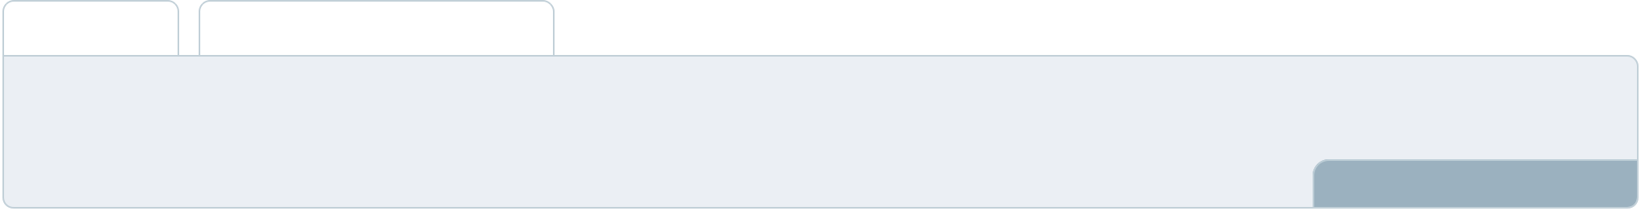

The cash flow for the first few years of your operation should be estimated and described in this section. This may include billing invoices, payment receipts, loan payments, and any other cash flow statements.
To unlock help try Upmetrics! 

Cash flow statement

 | 2023-24 | 2024-25 | 2025-26 | 2026-27 | 2027-28
Cash Received | $0 | $0 | $0 | $0 | $0
Cash Paid | $0 | $0 | $0 | $0 | $0
COS & General Expenses | $0 | $0 | $0 | $0 | $0
Salary & Wages | $0 | $0 | $0 | $0 | $0
Interest | $0 | $0 | $0 | $0 | $0

Sales Tax

Income Tax

Net Cash From

Operations

Assets Sell

Assets Purchase

Net Cash From

Investments

Amount Received

Loan Received

Common Stock

Preferred Stock

Owner's Contribution

Amount Paid

2023-24 | 2024-25 | 2025-26 | 2026-27 | 2027-28
$0 | $0 | $0 | $0 | $0
$0 | $0 | $0 | $0 | $0
$0 | $0 | $0 | $0 | $0

$0 | $0 | $0 | $0 | $0
$0 | $0 | $0 | $0 | $0
$0 | $0 | $0 | $0 | $0

$0 | $0 | $0 | $0 | $0
$0 | $0 | $0 | $0 | $0

$0 | $0 | $0 | $0 | $0
$0 | $0 | $0 | $0 | $0
$0 | $0 | $0 | $0 | $0

Loan Capital $0 $0 $0 $0 $0

 |  |  | 2023-24 | 2024-25 | 2025-26 | 2026-27 | 2027-28
Dividends & Distributions |  |  | $0 | $0 | $0 | $0 | $0
Net Cash From |  |  | $0 | $0 | $0 | $0 | $0
Financing
Summary
Starting Cash |  |  | $0 | $0 | $0 | $0 | $0
Cash In |  |  | $0 | $0 | $0 | $0 | $0
Cash Out |  |  | $0 | $0 | $0 | $0 | $0
Change in Cash |  |  | $0 | $0 | $0 | $0 | $0
Ending Cash |  |  | $0 | $0 | $0 | $0 | $0
 Help tip |  |  Scrap Metal Business Plan

Create a projected balance sheet documenting your scrap metal business’s assets, liabilities, and equity.

To unlock help try Upmetrics! 

Balance sheet

 | 2023-24 | 2024-25 | 2025-26 | 2026-27 | 2027-28
Assets | $0 | $0 | $0 | $0 | $0
Current Assets | $0 | $0 | $0 | $0 | $0
Cash | $0 | $0 | $0 | $0 | $0
Accounts Receivable | $0 | $0 | $0 | $0 | $0
Inventory | $0 | $0 | $0 | $0 | $0
Other Current Assets | $0 | $0 | $0 | $0 | $0
Long Term Assets | $0 | $0 | $0 | $0 | $0
Gross Long Term Assets | $0 | $0 | $0 | $0 | $0
Accumulated Depreciation | $0 | $0 | $0 | $0 | $0

Liabilities & Equity | $0 | $0 | $0 | $0 | $0
Liabilities | $0 | $0 | $0 | $0 | $0
Current Liabilities | $0 | $0 | $0 | $0 | $0
Accounts Payable | $0 | $0 | $0 | $0 | $0
Income Tax Payable | $0 | $0 | $0 | $0 | $0
Sales Tax Payable | $0 | $0 | $0 | $0 | $0
Short Term Debt | $0 | $0 | $0 | $0 | $0
 | 2023-24 | 2024-25 | 2025-26 | 2026-27 | 2027-28
Long Term Liabilities | $0 | $0 | $0 | $0 | $0
Long Term Debt | $0 | $0 | $0 | $0 | $0
Equity | $0 | $0 | $0 | $0 | $0
Paid-in Capital | $0 | $0 | $0 | $0 | $0
Common Stock | $0 | $0 | $0 | $0 | $0
Preferred Stock | $0 | $0 | $0 | $0 | $0
Owner's Contribution | $0 | $0 | $0 | $0 | $0
Retained Earnings | $0 | $0 | $0 | $0 | $0

Check | $0 |  |  | $0 | $0 | $0 | $0
 Help tip |  |  Scrap Metal Business Plan

Determine and mention your business’s break-even point—the point at which your business costs and revenue will be equal.

This exercise will help you understand how much revenue you need to generate to sustain or be profitable.
To unlock help try Upmetrics! 

Break-even Analysis

 | 2023-24 | 2024-25 | 2025-26 | 2026-27 | 2027-28
Starting Revenue | $0 | $0 | $0 | $0 | $0
Net Revenue | $0 | $0 | $0 | $0 | $0
Closing Revenue | $0 | $0 | $0 | $0 | $0

Starting Expense | $0 | $0 | $0 | $0 | $0
Net Expense | $0 | $0 | $0 | $0 | $0
Closing Expense | $0 | $0 | $0 | $0 | $0

Is Break Even? | 0 | 0 | 0 | 0 | 0
Break Even Month | 0 | 0 | 0 | 0 | 0
Days Required | 0 | 0 | 0 | 0 | 0
Break Even Revenue | $0 | $0 | $0 | $0 | $0
Break Even Units
Financing needs

 Help tip  Scrap Metal Business Plan

Calculate costs associated with starting a scrap metal business, and estimate your financing needs and how much capital you need to raise to operate your business.
To unlock help try Upmetrics! 

Start writing here..
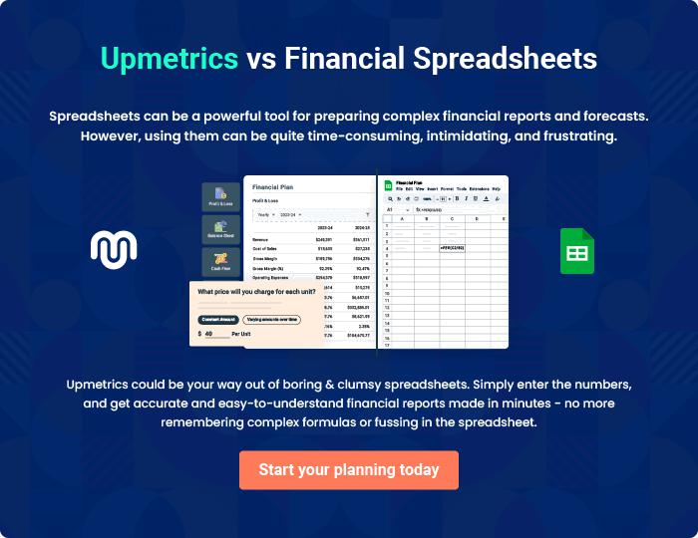
Appendix

When writing the appendix section, you should include any additional information that supports the main content of your plan. This may include financial statements, market research data, legal documents, and other
To unlock help try Upmetrics! 
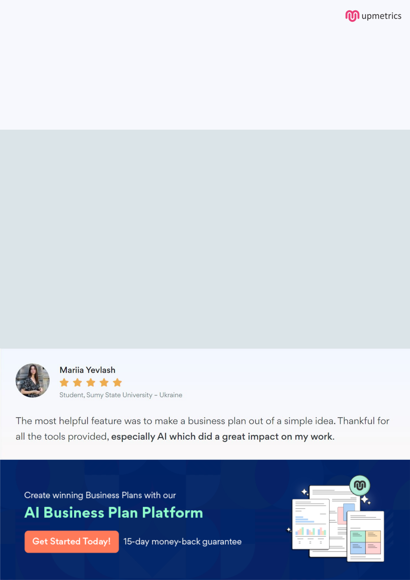
Create a winning business plan that gets you funded

Creating a stunning and investment-ready plan requires no writing, graphic designing, or financial planning expertise.

Upmetrics has all the features required to help you create a comprehensive business plan—from start to finish. Make no mistakes, it’s the modern way of planning to structure ideas, make plans, and create stunning pitch decks to awe investors.

Pitch decks that impress investors

Create pitch decks that provide a visual representation of your business, engage investors, and make them want to invest in your business idea.

Interactive plans in no time

Import business plan sections like—SWOT analysis, comparison tables, and others to create an interactive business plan. No designing skills are required.

Stunning cover page designs

With Upmetrics, you have the liberty to choose from multiple stunning cover page designs. Choose a creative design and make your plan stand out.

Online sharing made simple

Upmetrics makes online sharing quick and easier for users. Easily share your business plans with a link while tracking reader activity.

500+ sample business plans

Simply import a template from our library of sample plans into the editor and start customizing it to make it yours. It takes only a few clicks to get started.

Collaborate with team in real-time

Invite team members, initiate conversations, discuss ideas & strategies, share feedback, and work on a business plan in real-time.

