

School Business Plan

Where Dreams Take Flight


Business
Plan

2023

Prepared By

John Doe

10200 Bolsa Ave, Westminster, CA, 92683

info@example.com

(650) 359-3153 http://www.example.com

Table of Contents

Executive Summary | 6
Market opportunity | 6
Services Offered | 6
Marketing & Sales Strategies | 7
Financial Highlights | 7
Units Sold v/s Revenue | 8

Company Overview | 9
Ownership | 9
Business Owners | 9
Mission statement | 10
Business history | 10
Future goals | 10

Market Analysis | 11
Target Market | 11
Market size and growth potential | 11
Market Size | 12
Competitive analysis | 12
Harvard-Westlake School | 12
KIPP Public Charter School | 13
Connections Academy | 13
Market trends | 13
Regulatory environment | 14

Products and Services | 15
Services | 15
Elementary Education Program | 15
After-School Tutoring | 16
School Transportation | 16
Summer Camp | 17
Specialized Programs | 17
Student Leadership Programs | 17
Additional Services | 18

Sales And Marketing Strategies | 19
Unique Selling Proposition (USP) | 19
Pricing Strategy | 19
Marketing strategies | 20
Online | 20
Offline | 20
Sales strategies | 21
Customer retention | 21

Operations Plan | 22
Staffing & Training | 22
Operational Process | 22
Equipment & Software | 23

Management Team | 24
Key managers | 24
John Doe | 24
Jane Doe | 25
Michael Johnson | 25
Lisa White | 25
David Brown | 25
Organizational structure | 26
Organization chart | 26
Compensation plan | 26
Board of advisors | 27
[ADVISOR 1 NAME] | 27
[ADVISOR 2 NAME] | 27
Financial Plan | 28
Profit & loss statement | 28
Cash flow statement | 31
Balance sheet | 33
Break-even Analysis | 35
Financing needs | 37
Appendix
Appendix | 39
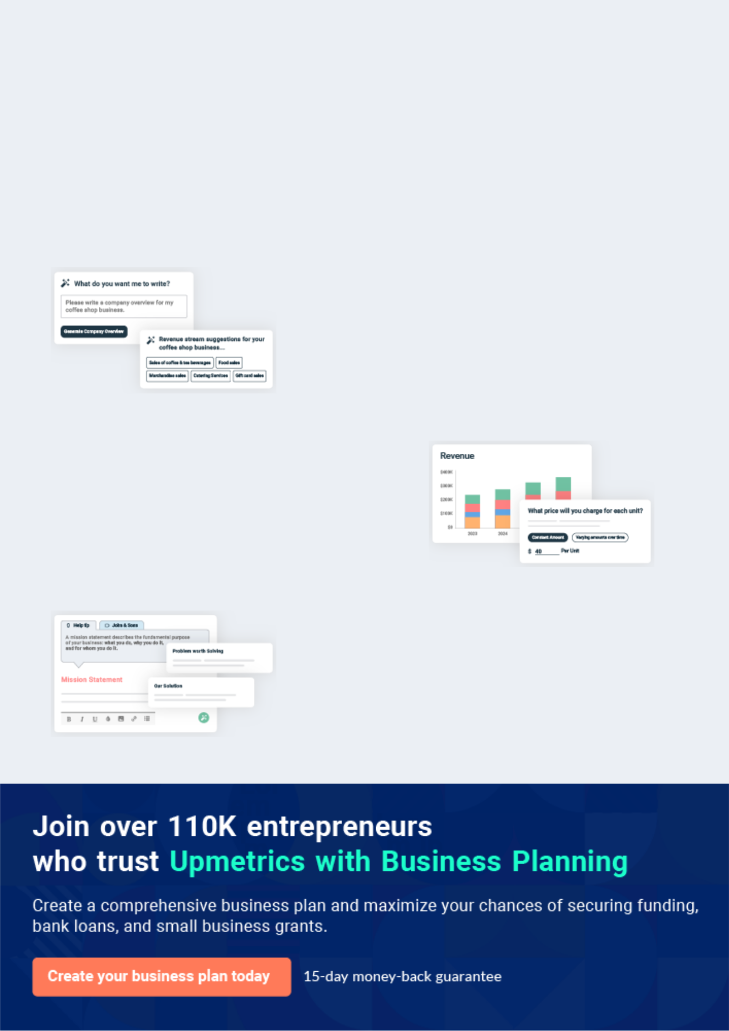
Business planning that’s simpler and faster than you think

Creating a business plan using Upmetrics to start and grow a business is literally the easiest thing in the World. Simply read the instructions and fill in the blanks. It’s as simple as that.

❛ | Upmetrics has everything you need to create a | ❜
❛ | comprehensive business plan. | ❜

AI-powered Upmetrics Assistant

AI-powered insights to streamline your plan

Not sure where to start? Upmetrics’ AI Assistant will automatically generate ideas for each section of your plan and offer improved versions of your writing, adjusting for tone, voice, and grammar or spelling errors.

Financial Forecasting Tool

All the financials are calculated for you

Forget the complex formulas and clumsy spreadsheets — with automatic financials and drag-and-drop forecasting, you can finish your plan faster and be confident that your numbers are accurate.

Business Plan Builder

Guides you like a business mentor

Upmetrics’ step-by-step instructions, prompts, and the library of 400+ sample business plans will guide you through each section of your plan as a business mentor.
Executive Summary


An executive summary is the first section of the business plan intended to provide an overview of the whole business plan.
To unlock help try Upmetrics! 

 Help tip  School Business Plan


Start your executive summary by briefly introducing your business to your readers.

This section may include the name of your school business, its location, when it was founded,
To unlock help try Upmetrics! 

Start writing here..

Market opportunity

 Help tip  School Business Plan

Summarize your market research, including market size, growth potential, and marketing trends. Highlight the opportunities in the market and how your business will fit in to fill the gap.
To unlock help try Upmetrics! 

Start writing here..

Services Offered

 Help tip  School Business Plan

Highlight the school services you offer your clients. The USPs and differentiators you offer are always a plus.
To unlock help try Upmetrics! 

Start writing here..

Marketing & Sales Strategies
To unlock help try Upmetrics!

 Help tip  School Business Plan

Outline your sales and marketing strategies—what marketing platforms you use, how you plan on acquiring students, etc.
To unlock help try Upmetrics! 

Start writing here..

Financial Highlights

 Help tip  School Business Plan

Briefly summarize your financial projections for the initial years of business operations. Include any capital or investment requirements, associated startup costs, projected revenues, and profit forecasts.



Start writing here..
Units Sold v/s Revenue

 |  | Units Sold | Revenue
15.00k
10.00k
5.00k
0
Year 1 | Year 2 | Year 3


Financial Year |  |  | Units Sold | Revenue
Year 1 | 1,550 |  |  | $10,000
Year 2 | 1,800 |  |  | $12,000
Year 3 | 2,050 |  |  | $14,000
 Help tip |  |  School Business Plan


Summarize your executive summary section with a clear CTA, for example, inviting angel investors to discuss the potential business investment.
To unlock help try Upmetrics! 

Write a call to action for your business plan.
Company Overview

Depending on what details of your business are essential, you’ll need different elements in your business overview.
To unlock help try Upmetrics! 

 Help tip  School Business Plan

Describe your business in this section by providing all the basic information:

Describe what kind of school business you run and the name of it. You may specialize in one of
To unlock help try Upmetrics! 

Start writing here..

Ownership

 Help tip  School Business Plan

List the names of your school’s founders or owners. Describe what shares they own and their responsibilities for efficiently managing the business.
To unlock help try Upmetrics! 

Start writing here..

Business Owners



100% John Doe
Mission statement

 Help tip  School Business Plan

Summarize your business’ objective, core principles, and values in your mission statement. This statement needs to be memorable, clear, and brief.
To unlock help try Upmetrics! 

❛ Our mission at [School Name] is to [Mission Statement, e.g., provide a high-quality, holistic education that equips our students with the necessary skills and knowledge to succeed in their future endeavours, while also fostering a love for learning and a sense of global citizenship].

❜

Business history

 Help tip  School Business Plan

If you’re an established school, briefly describe your business history, like—when it was founded, how it evolved over time, etc.
To unlock help try Upmetrics! 

Start writing here..

Future goals

 Help tip  School Business Plan

It’s crucial to convey your aspirations and vision. Mention your short-term and long-term goals; they can be specific targets for revenue, market share, or expanding your services
To unlock help try Upmetrics! 

Start writing here..

Market Analysis
To unlock help try Upmetrics!


 |  | Market analysis provides a clear understanding of the market in which your
 |  | printing business will run along with the target market, competitors, and
 |  | growth opportunities.
 |  |  |  | To unlock help try Upmetrics! 
 Help tip |  |  School Business Plan

To write the introduction section of your market analysis, start by clearly identifying your primary target market.
To unlock help try Upmetrics! 

Start writing here..

Target Market

 Help tip  School Business Plan

Start this section by describing your target market. Define your ideal customer and explain what types of services they prefer. Creating a buyer persona will help you easily define your target market to your readers.



Start writing here..

Market size and growth potential

 Help tip  School Business Plan

Describe your market size and growth potential and whether you will target a niche or a much broader market.
To unlock help try Upmetrics! 

Start writing here..

Market Size

All students in the region aged 5-18. | 500k
Available Market

Served Market | 300k
Students in the region seeking K-12 | 300k
education. | 300k
Target Market | 50k
Students aged 5-18 seeking quality, | 50k
personalized K-12 education with a | 50k

focus on [specific program or

 Help tip  School Business Plan

Identify and analyze your direct and indirect competitors. Identify their strengths and weaknesses, and describe what differentiates your school from them.
To unlock help try Upmetrics! 

Competitive analysis

Harvard-Westlake School

Harvard-Westlake School is a prestigious private school located in Los Angeles, known for its rigorous academic programs and exceptional faculty.

Features | Strengths | Weaknesses
Comprehensive academic | Renowned reputation and high | High tuition fees, limiting access
curriculum | academic standards | for low-income families
Wide range of extracurricular | Established network of alumni | Limited scholarship programs
activities | Strategic location in Los | Some criticism regarding lack of
Strong emphasis on college | Angeles, attracting students | diversity among faculty
preparation | from affluent families
Diverse and inclusive student
body

KIPP Public Charter School

KIPP is a network of public charter schools that focuses on providing education to underserved communities across the United States.

Features

Extended school day and year

Strong emphasis on character development

College and career counseling

Support services for alumni in college

Strengths Weaknesses

Proven success in improving Limited extracurricular activities

academic outcomes for low- and resources compared to

income students private schools

Strong sense of community Some criticism regarding strict

and support disciplinary policies

Diverse student body and Possible limitations in curriculum

faculty due to public funding restrictions

Connections Academy

Connections Academy is a leading online virtual school provider, offering K-12 education to students across the United States.

Features | Strengths | Weaknesses
Flexible online learning | Accessibility for students in | Limited social interaction and
environment | remote or underserved areas | extracurricular activities
Accredited curriculum and | Flexibility for students with | Some criticism regarding the
certified teachers | specific needs or | quality of online instruction
Wide range of courses, | circumstances | Potential technical barriers for
including AP and honors | Strong support services, | students without reliable internet
classes | including counseling and | access
Personalized learning plans | tutoring

Market trends

 Help tip  School Business Plan

Analyze emerging trends in the industry, such as technology disruptions, changes in customer behavior or preferences, etc. Explain how your business will cope with all the trends.
To unlock help try Upmetrics! 

Start writing here..

Regulatory environment
To unlock help try Upmetrics!

 Help tip  School Business Plan

List regulations and licensing requirements that may affect your school business, such as education laws & regulations, government accreditation, teacher certificate & licensing, health & safety regulations, etc.



Start writing here..
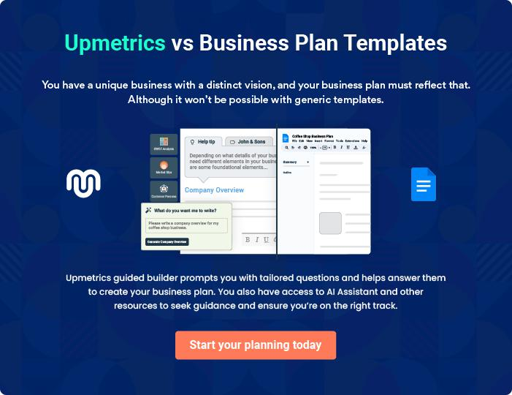
Products and Services

 |  | The product and services section of a school business plan should describe
 |  | the specific services and products that will be offered to customers. To write
 |  | this section should include the following:
 |  |  |  | To unlock help try Upmetrics! 
 Help tip |  |  School Business Plan

To craft the introduction for your "Products and Services" chapter, begin by positioning your business within its industry, emphasizing its unique strengths or value proposition.
To unlock help try Upmetrics! 

Start writing here..

 Help tip


Mention the school services your business will offer. This list may include services like,

• Education programs
To unlock help try Upmetrics! 

Services

Elementary Education Program


Price: [$5,000] per annum

A comprehensive education program tailored to meet the needs of elementary school students, covering essential subjects such as mathematics, science, and English.

Specifications

- Grades: 1st to 5th

- Subjects Covered: Mathematics, Science, English, Social Studies, and Art.

- Class Size: Maximum of 20 students per class

- Duration: 9 months
After-School Tutoring

Price: [$30] per hour

One-on-one tutoring sessions with qualified teachers, focused on providing additional academic support in subjects where the student may need extra help.

Specifications

- Subjects Covered: Mathematics, Science, English, and Social Studies.

- Age Group: 6 to 18 years old

- Availability: Monday to Friday, 3 PM to 6 PM

School Transportation

Price: [$1,000] per annum

Safe and reliable transportation services for students, ensuring they can commute to and from school without any hassle.

Specifications

- Service Area: Within 20 miles of the school location.

- Vehicle Type: Buses and vans, all equipped with safety features.

- Pickup/Drop-off Points: Designated areas within the service area.
Summer Camp
- To unlock help try Upmetrics!

Price: [$500] per week

A fun and educational summer camp program that includes a mix of academic learning, sports, and creative activities.

Specifications

- Age Group: 6 to 15 years old

- Duration: 1 week

- Activities Included: Academic classes, sports, art and crafts, and outdoor adventures.

- Location: School premises and nearby locations for outdoor activities.

Specialized Programs

 Help tip  School Business Plan

Highlight any specialized programs or services your school provides in this section.

Extracurricular activities, artistic initiatives, sports teams, STEM efforts, language immersion
To unlock help try Upmetrics! 

Start writing here..

Student Leadership Programs

 Help tip  School Business Plan

If your school has a vibrant student leadership program that encourages students to grow as leaders, participate in volunteer work in the community, and actively contribute to the improvement, then mention it here.



Start writing here..

Additional Services
To unlock help try Upmetrics!

 Help tip  School Business Plan

Mention if your school business offers any additional services. You may include services like, after-school programs, school transportation, food services, parent education & involvement, etc.



Start writing here..
Sales And Marketing Strategies

Writing the sales and marketing strategies section means a list of strategies you will use to attract and retain your clients.
To unlock help try Upmetrics! 

 Help Tip  School Business Plan


To create an effective introduction for your "Sales and Marketing Strategies" chapter, start by setting the stage within your specific industry or market.
To unlock help try Upmetrics! 

Start writing here..

Unique Selling Proposition (USP)

 Help tip  School Business Plan

Define your business’s USPs depending on the market you serve, the equipment you use, and the unique services you provide. Identifying USPs will help you plan your marketing strategies.
To unlock help try Upmetrics! 

Start writing here..

Pricing Strategy

 Help tip  School Business Plan

Describe your pricing strategy—how you plan to price your services and stay competitive in the local market. You can mention any discounts you plan on offering to attract new students.
To unlock help try Upmetrics! 

Start writing here..

 Help tip  School Business Plan
To unlock help try Upmetrics!

Discuss your marketing strategies to market your services. You may include some of these marketing strategies in your business plan—social media marketing, Google ads, brochures, content marketing, and print marketing.



Marketing strategies

Online


Social Media

Use social media platforms to connect with potential students and parents.

Googlr

Leverage Google Ads to target your audience and promote your services.

Content Marketing

Create valuable content to educate

and engage your audience.

Offline

Brochures and Print Marketing

Use brochures and print marketing to showcase your offerings.

 Help tip
To unlock help try Upmetrics!

Outline the strategies you’ll implement to maximize your sales. Your sales strategies may include targeted marketing, personalized sales approach, referral programs, conversion strategies, etc.



Sales strategies

Personalized Sales Approach

Personalize your sales approach to meet the unique needs of each prospective student and parent.

Referral Programs

Add referral programs you have in place to incentivize word-of-mouth marketing.

Targeted Marketing Conversion Strategies

Target specific segments of your market to increase sales.

Analyze the techniques you use to convert leads into enrolled students.

 Help tip

Describe your customer retention strategies and how you plan to execute them. For instance excellent services, alumni engagement, parental engagement, etc.
To unlock help try Upmetrics! 

Customer retention

Parental Engagement

Involve parents in the educational process and create a supportive community.

Alumni Engagement

Engage with alumni to maintain a strong relationship.

Excellent Services

Provide exceptional services that

contribute to customer satisfaction

and retention.

Operations Plan
To unlock help try Upmetrics!

 |  | When writing the operations plan section, it’s important to consider the
 |  | various aspects of your business operations.
 |  |  |  | To unlock help try Upmetrics! 
 Help tip |  |  School Business Plan


To create an effective introduction for your "Operational Plan" chapter, start by emphasizing the
pivotal role of efficient operations in the success of your business, underscoring how they
directly impact the quality of services delivered.
 |  |  |  | To unlock help try Upmetrics! 
Start writing here..
Staffing & Training
 Help tip |  |  School Business Plan

Mention your business’s staffing requirements, including the number of employees or teachers needed. Include their qualifications, the training required, and the duties they will perform.
To unlock help try Upmetrics! 

Start writing here..

Operational Process

 Help tip  School Business Plan

Outline the processes and procedures you will use to run your school business. Your operational processes may include enrollment process, staffing & human resources, classroom management, finance & budgeting, etc.



Start writing here..

Equipment & Software
To unlock help try Upmetrics!

 Help tip  School Business Plan

Include the list of equipment and software required for school, such as whiteboards & projectors, student information systems, learning management systems, communication & collaboration tools, etc.



Start writing here..
Management Team

The management team section provides an overview of the individuals responsible for running your business plan.
To unlock help try Upmetrics! 

 Help tip  School Business Plan

To craft an introduction for your "Management Team" chapter, begin by emphasizing the crucial role of leadership in the success of any business.
To unlock help try Upmetrics! 

Start writing here..

Key managers

 Help tip  School Business Plan

Introduce your management and key members of your team, and explain their roles and responsibilities.
To unlock help try Upmetrics! 

Start writing here..


JOHN DOE

CEO & Co-founder - john.doe@example.com

John is a visionary leader with a passion for education and a commitment to excellence.

He has a Masters in Education Leadership from Harvard University and over 20 years of experience in the educational sector.


His career spans various roles, from a classroom teacher to an educational consultant, before co-founding [School Name].

JANE DOE

Principal - jane.doe@example.com

Jane is an experienced educator with a strong background in curriculum development and school administration.

She holds a Master's in Education Administration from Stanford University and has 15 years of experience in the education sector.


Her leadership and strategic planning skills have been instrumental in shaping the academic programs at [School Name].


MICHAEL JOHNSON

Operations Manager - michael.johnson@example.com

Michael has a degree in Business Administration and over 10 years of experience in managing operations for educational institutions.

His expertise lies in optimizing processes, ensuring compliance with regulations, and managing day-to-day school operations efficiently.


LISA WHITE

Admission Manager - lisa.white@example.com

Lisa has a Bachelor's degree in Public Relations and has worked in student admissions for over 8 years.

Her role involves managing the admission process, handling public relations, and ensuring a smooth enrollment process for new students.


DAVID BROWN

Facilities Manager - david.brown@example.com

David has a degree in Civil Engineering and has been managing facilities for educational institutions for 12 years.

His expertise lies in maintaining and improving school facilities to provide a safe and conducive learning environment.
Organizational structure

 Help tip  School Business Plan

Explain the organizational structure of your management team. Include the reporting line and decision-making hierarchy.
To unlock help try Upmetrics! 

Start writing here..

Organization chart


John Doe

CEO


Michael
Johnson


Operations | Jane Doe
Manager | COO



Emily Adams |  |  | Lisa White
Emily Adams | Robert Gray |  |  |  | David Brown
Emily Adams |  |  | Admission |  | David Brown
HR Manager |  |  |  |  | David Brown
HR Manager | Finance |  | Manager |  | Facilities
 | Manager |  |  |  | Manager





Compensation plan

 Help tip  School Business Plan

Describe your compensation plan for the management and staff. Include their salaries, incentives, and other benefits.
To unlock help try Upmetrics! 

Start writing here..

 Help tip

Mentioning advisors or consultants in your business plans adds credibility to your business idea.
To unlock help try Upmetrics! 

Board of advisors


[ADVISOR 1 NAME]

Advisor 1

- Role: [Describe their role and the specific areas of the business they advise on.]

- Years of Experience: [Include their years of experience and any relevant qualifications.]

[ADVISOR 2 NAME]

Advisor 2

- Role: [Describe their role and the specific areas of the business they advise on.]

- Years of Experience: [Include their years of experience and any relevant qualifications.]
Financial Plan

When writing the financial plan section of a business plan, it’s important to provide a comprehensive overview of your financial projections for the first few years of your business, You may provide the following:
To unlock help try Upmetrics! 

 Help tip  School Business Plan


To create an effective introduction for your "Financial Plan" chapter, begin by stressing the critical role of a well-structured financial plan in the success of your venture.
To unlock help try Upmetrics! 

Start writing here..

 Help tip  School Business Plan

Describe details such as projected revenue, operational costs, and service costs in your projected profit and loss statement. Make sure to include your business’s expected net profit or loss.
To unlock help try Upmetrics! 

Profit & loss statement

Revenue

Cost Of Sales

General Costs

Revenue Specific Costs

Personnel Costs (Direct

Labor)

Gross Margin

Gross Margin (%)

Operating Expense

Payroll Expense

(Indirect Labor)

General Expense

Bad Debt

Amortization of Current

Assets

2023-24 | 2024-25 | 2025-26 | 2026-27 | 2027-28
$0 | $0 | $0 | $0 | $0

$0 | $0 | $0 | $0 | $0
$0 | $0 | $0 | $0 | $0
$0 | $0 | $0 | $0 | $0
$0 | $0 | $0 | $0 | $0

$0 | $0 | $0 | $0 | $0
0% | 0% | 0% | 0% | 0%

$0 | $0 | $0 | $0 | $0
$0 | $0 | $0 | $0 | $0
$0 | $0 | $0 | $0 | $0
$0 | $0 | $0 | $0 | $0
$0 | $0 | $0 | $0 | $0

EBITDA

Additional Expense

Long Term

Depreciation

Gain or loss from Sale

of Assets

EBIT

Interest Expenses

EBT

Income Tax Expense

Total Expense

Net Income

Net Income (%)

2023-24 | 2024-25 | 2025-26 | 2026-27 | 2027-28
$0 | $0 | $0 | $0 | $0
$0 | $0 | $0 | $0 | $0
$0 | $0 | $0 | $0 | $0
$0 | $0 | $0 | $0 | $0
$0 | $0 | $0 | $0 | $0
$0 | $0 | $0 | $0 | $0
$0 | $0 | $0 | $0 | $0
$0 | $0 | $0 | $0 | $0
$0 | $0 | $0 | $0 | $0
$0 | $0 | $0 | $0 | $0
0% | 0% | 0% | 0% | 0%
 |  |  | 2023-24 |  | 2024-25 | 2025-26 | 2026-27 | 2027-28
Retained Earning |  |  | $0 |  | $0 | $0 | $0 | $0
Opening
Owner's Distribution |  |  | $0 |  | $0 | $0 | $0 | $0
Retained Earning |  |  | $0 |  | $0 | $0 | $0 | $0
Closing
 Help tip |  |  |  School Business Plan


The cash flow for the first few years of your operation should be estimated and described in this section. This may include billing invoices, payment receipts, loan payments, and any other cash flow statements.
To unlock help try Upmetrics! 

Cash flow statement

 | 2023-24 | 2024-25 | 2025-26 | 2026-27 | 2027-28
Cash Received | $0 | $0 | $0 | $0 | $0
Cash Paid | $0 | $0 | $0 | $0 | $0
COS & General Expenses | $0 | $0 | $0 | $0 | $0
Salary & Wages | $0 | $0 | $0 | $0 | $0
Interest | $0 | $0 | $0 | $0 | $0

Sales Tax

Income Tax

Net Cash From

Operations

Assets Sell

Assets Purchase

Net Cash From

Investments

Amount Received

Loan Received

Common Stock

Preferred Stock

Owner's Contribution

Amount Paid

2023-24 | 2024-25 | 2025-26 | 2026-27 | 2027-28
$0 | $0 | $0 | $0 | $0
$0 | $0 | $0 | $0 | $0
$0 | $0 | $0 | $0 | $0

$0 | $0 | $0 | $0 | $0
$0 | $0 | $0 | $0 | $0
$0 | $0 | $0 | $0 | $0

$0 | $0 | $0 | $0 | $0
$0 | $0 | $0 | $0 | $0

$0 | $0 | $0 | $0 | $0
$0 | $0 | $0 | $0 | $0
$0 | $0 | $0 | $0 | $0

Loan Capital $0 $0 $0 $0 $0

 |  |  | 2023-24 | 2024-25 | 2025-26 | 2026-27 | 2027-28
Dividends & Distributions |  |  | $0 | $0 | $0 | $0 | $0
Net Cash From |  |  | $0 | $0 | $0 | $0 | $0
Financing
Summary
Starting Cash |  |  | $0 | $0 | $0 | $0 | $0
Cash In |  |  | $0 | $0 | $0 | $0 | $0
Cash Out |  |  | $0 | $0 | $0 | $0 | $0
Change in Cash |  |  | $0 | $0 | $0 | $0 | $0
Ending Cash |  |  | $0 | $0 | $0 | $0 | $0
 Help tip |  |  School Business Plan

Create a projected balance sheet documenting your school business’s assets, liabilities, and equity.

To unlock help try Upmetrics! 

Balance sheet

 | 2023-24 | 2024-25 | 2025-26 | 2026-27 | 2027-28
Assets | $0 | $0 | $0 | $0 | $0
Current Assets | $0 | $0 | $0 | $0 | $0
Cash | $0 | $0 | $0 | $0 | $0
Accounts Receivable | $0 | $0 | $0 | $0 | $0
Inventory | $0 | $0 | $0 | $0 | $0
Other Current Assets | $0 | $0 | $0 | $0 | $0
Long Term Assets | $0 | $0 | $0 | $0 | $0
Gross Long Term Assets | $0 | $0 | $0 | $0 | $0
Accumulated Depreciation | $0 | $0 | $0 | $0 | $0

Liabilities & Equity | $0 | $0 | $0 | $0 | $0
Liabilities | $0 | $0 | $0 | $0 | $0
Current Liabilities | $0 | $0 | $0 | $0 | $0
Accounts Payable | $0 | $0 | $0 | $0 | $0
Income Tax Payable | $0 | $0 | $0 | $0 | $0
Sales Tax Payable | $0 | $0 | $0 | $0 | $0
Short Term Debt | $0 | $0 | $0 | $0 | $0
 | 2023-24 | 2024-25 | 2025-26 | 2026-27 | 2027-28
Long Term Liabilities | $0 | $0 | $0 | $0 | $0
Long Term Debt | $0 | $0 | $0 | $0 | $0
Equity | $0 | $0 | $0 | $0 | $0
Paid-in Capital | $0 | $0 | $0 | $0 | $0
Common Stock | $0 | $0 | $0 | $0 | $0
Preferred Stock | $0 | $0 | $0 | $0 | $0
Owner's Contribution | $0 | $0 | $0 | $0 | $0
Retained Earnings | $0 | $0 | $0 | $0 | $0

Check | $0 |  |  | $0 | $0 | $0 | $0
 Help tip |  |  School Business Plan

Determine and mention your business’s break-even point—the point at which your business costs and revenue will be equal.

This exercise will help you understand how much revenue you need to generate to sustain or be profitable.
To unlock help try Upmetrics! 

Break-even Analysis

 | 2023-24 | 2024-25 | 2025-26 | 2026-27 | 2027-28
Starting Revenue | $0 | $0 | $0 | $0 | $0
Net Revenue | $0 | $0 | $0 | $0 | $0
Closing Revenue | $0 | $0 | $0 | $0 | $0

Starting Expense | $0 | $0 | $0 | $0 | $0
Net Expense | $0 | $0 | $0 | $0 | $0
Closing Expense | $0 | $0 | $0 | $0 | $0

Is Break Even? | 0 | 0 | 0 | 0 | 0
Break Even Month | 0 | 0 | 0 | 0 | 0
Days Required | 0 | 0 | 0 | 0 | 0
Break Even Revenue | $0 | $0 | $0 | $0 | $0
Break Even Units
Financing needs

 Help tip  School Business Plan

Calculate costs associated with starting a school business, and estimate your financing needs and how much capital you need to raise to operate your business.
To unlock help try Upmetrics! 

Start writing here..
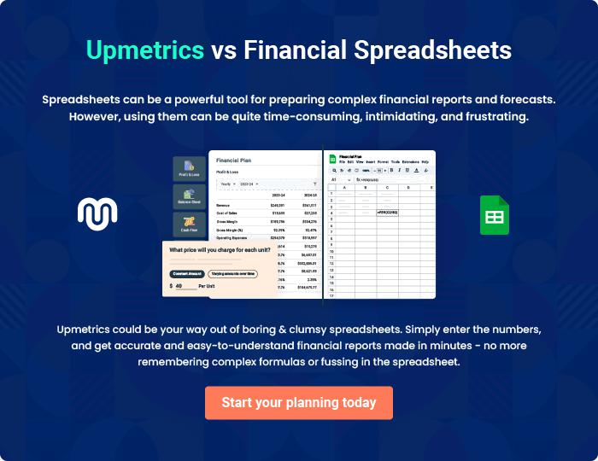
Appendix

When writing the appendix section, you should include any additional information that supports the main content of your plan. This may include financial statements, market research data, legal documents, and other
To unlock help try Upmetrics! 
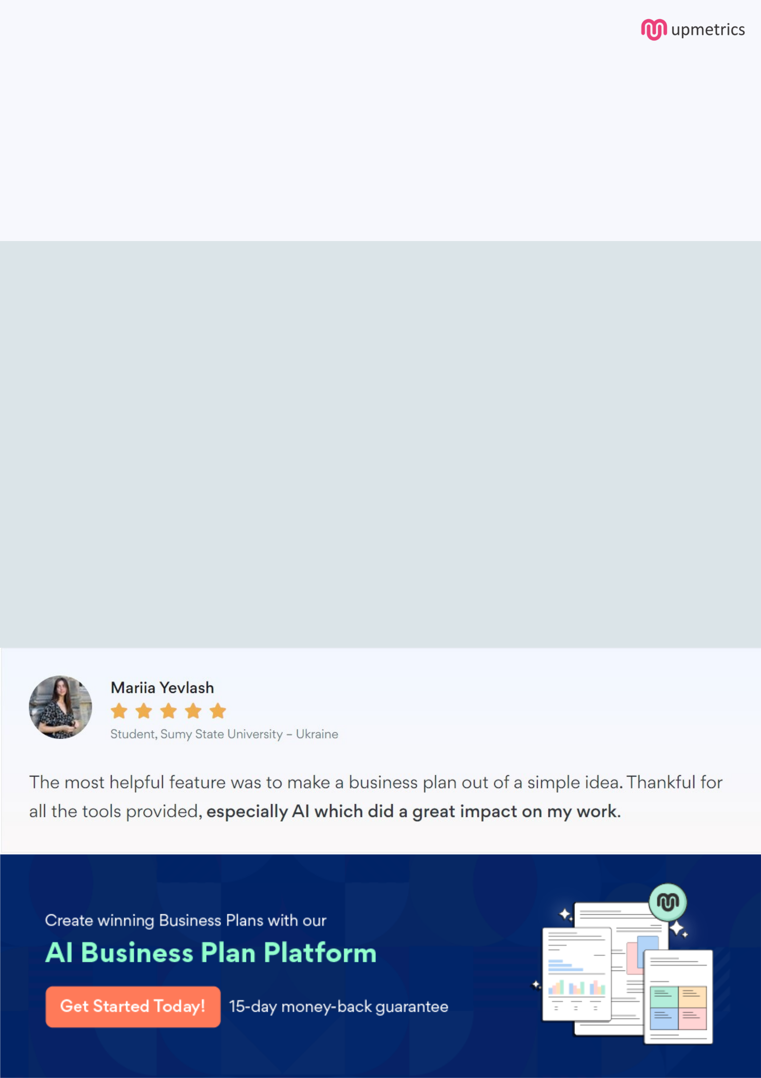
Create a winning business plan that gets you funded

Creating a stunning and investment-ready plan requires no writing, graphic designing, or financial planning expertise.

Upmetrics has all the features required to help you create a comprehensive business plan—from start to finish. Make no mistakes, it’s the modern way of planning to structure ideas, make plans, and create stunning pitch decks to awe investors.

Pitch decks that impress investors

Create pitch decks that provide a visual representation of your business, engage investors, and make them want to invest in your business idea.

Interactive plans in no time

Import business plan sections like—SWOT analysis, comparison tables, and others to create an interactive business plan. No designing skills are required.

Stunning cover page designs

With Upmetrics, you have the liberty to choose from multiple stunning cover page designs. Choose a creative design and make your plan stand out.

Online sharing made simple

Upmetrics makes online sharing quick and easier for users. Easily share your business plans with a link while tracking reader activity.

500+ sample business plans

Simply import a template from our library of sample plans into the editor and start customizing it to make it yours. It takes only a few clicks to get started.

Collaborate with team in real-time

Invite team members, initiate conversations, discuss ideas & strategies, share feedback, and work on a business plan in real-time.

