
Roller Skating Rink Business Plan

ADDRESS CONTACT

10200 Bolsa Ave, Westminster, CA, 92683 (650) 359-3153

http://www.example.com info@example.com


Business Plan

2023

Prepared By

John Doe


Skate, Laugh, Glide

Information provided in this business plan is unique to this business and confidential; therefore, anyone reading this plan agrees not to disclose any of the information in this business plan without prior written permission of the company.

Table of Contents

Executive Summary | 6
Market opportunity | 6
Services | 6
Marketing & Sales Strategies | 7
Financial Highlights | 7
Units Sold v/s Revenue | 8

Company Overview | 9
Ownership | 9
Mission statement | 10
Business history | 10
Future goals | 11

Market Analysis | 12
Target Market | 12
Market size and growth potential | 12
Market Size | 13
Competitive analysis | 13
SkateWorld | 13
Roller Kingdom | 14
Galaxy Skateway | 14
Market trends | 14
Regulatory environment | 15

Products and Services | 16
Services | 16
Roller Disco | 16
Roller Hockey | 17
Skate Rental | 17
Skating Lessons for Beginners | 17
Private Event Rental | 18
Quality Measure | 18
Additional Services | 18

Sales And Marketing Strategies | 19
Unique Selling Proposition (USP) | 19
Pricing Strategy | 19
Marketing strategies | 20
Online | 20
Offline | 20
Sales strategies | 21
Customer retention | 22

Operations Plan | 23
Staffing & Training | 23
Operational Processes | 23
Equipment & Machinery | 24

Management Team | 25
Key managers | 25
John Doe | 25
Jane Doe | 26
Alice Brown | 26
Robert Brown | 26
Organizational structure | 26
Organization chart | 27
Compensation plan | 27
Advisors/Consultants | 28
Mr. James Green | 28
Dr. Emily White | 28

Financial Plan | 29
Profit & loss statement | 29
Cash flow statement | 32
Balance sheet | 34
Break-even Analysis | 36
Financing needs | 38
Appendix
Appendix | 40
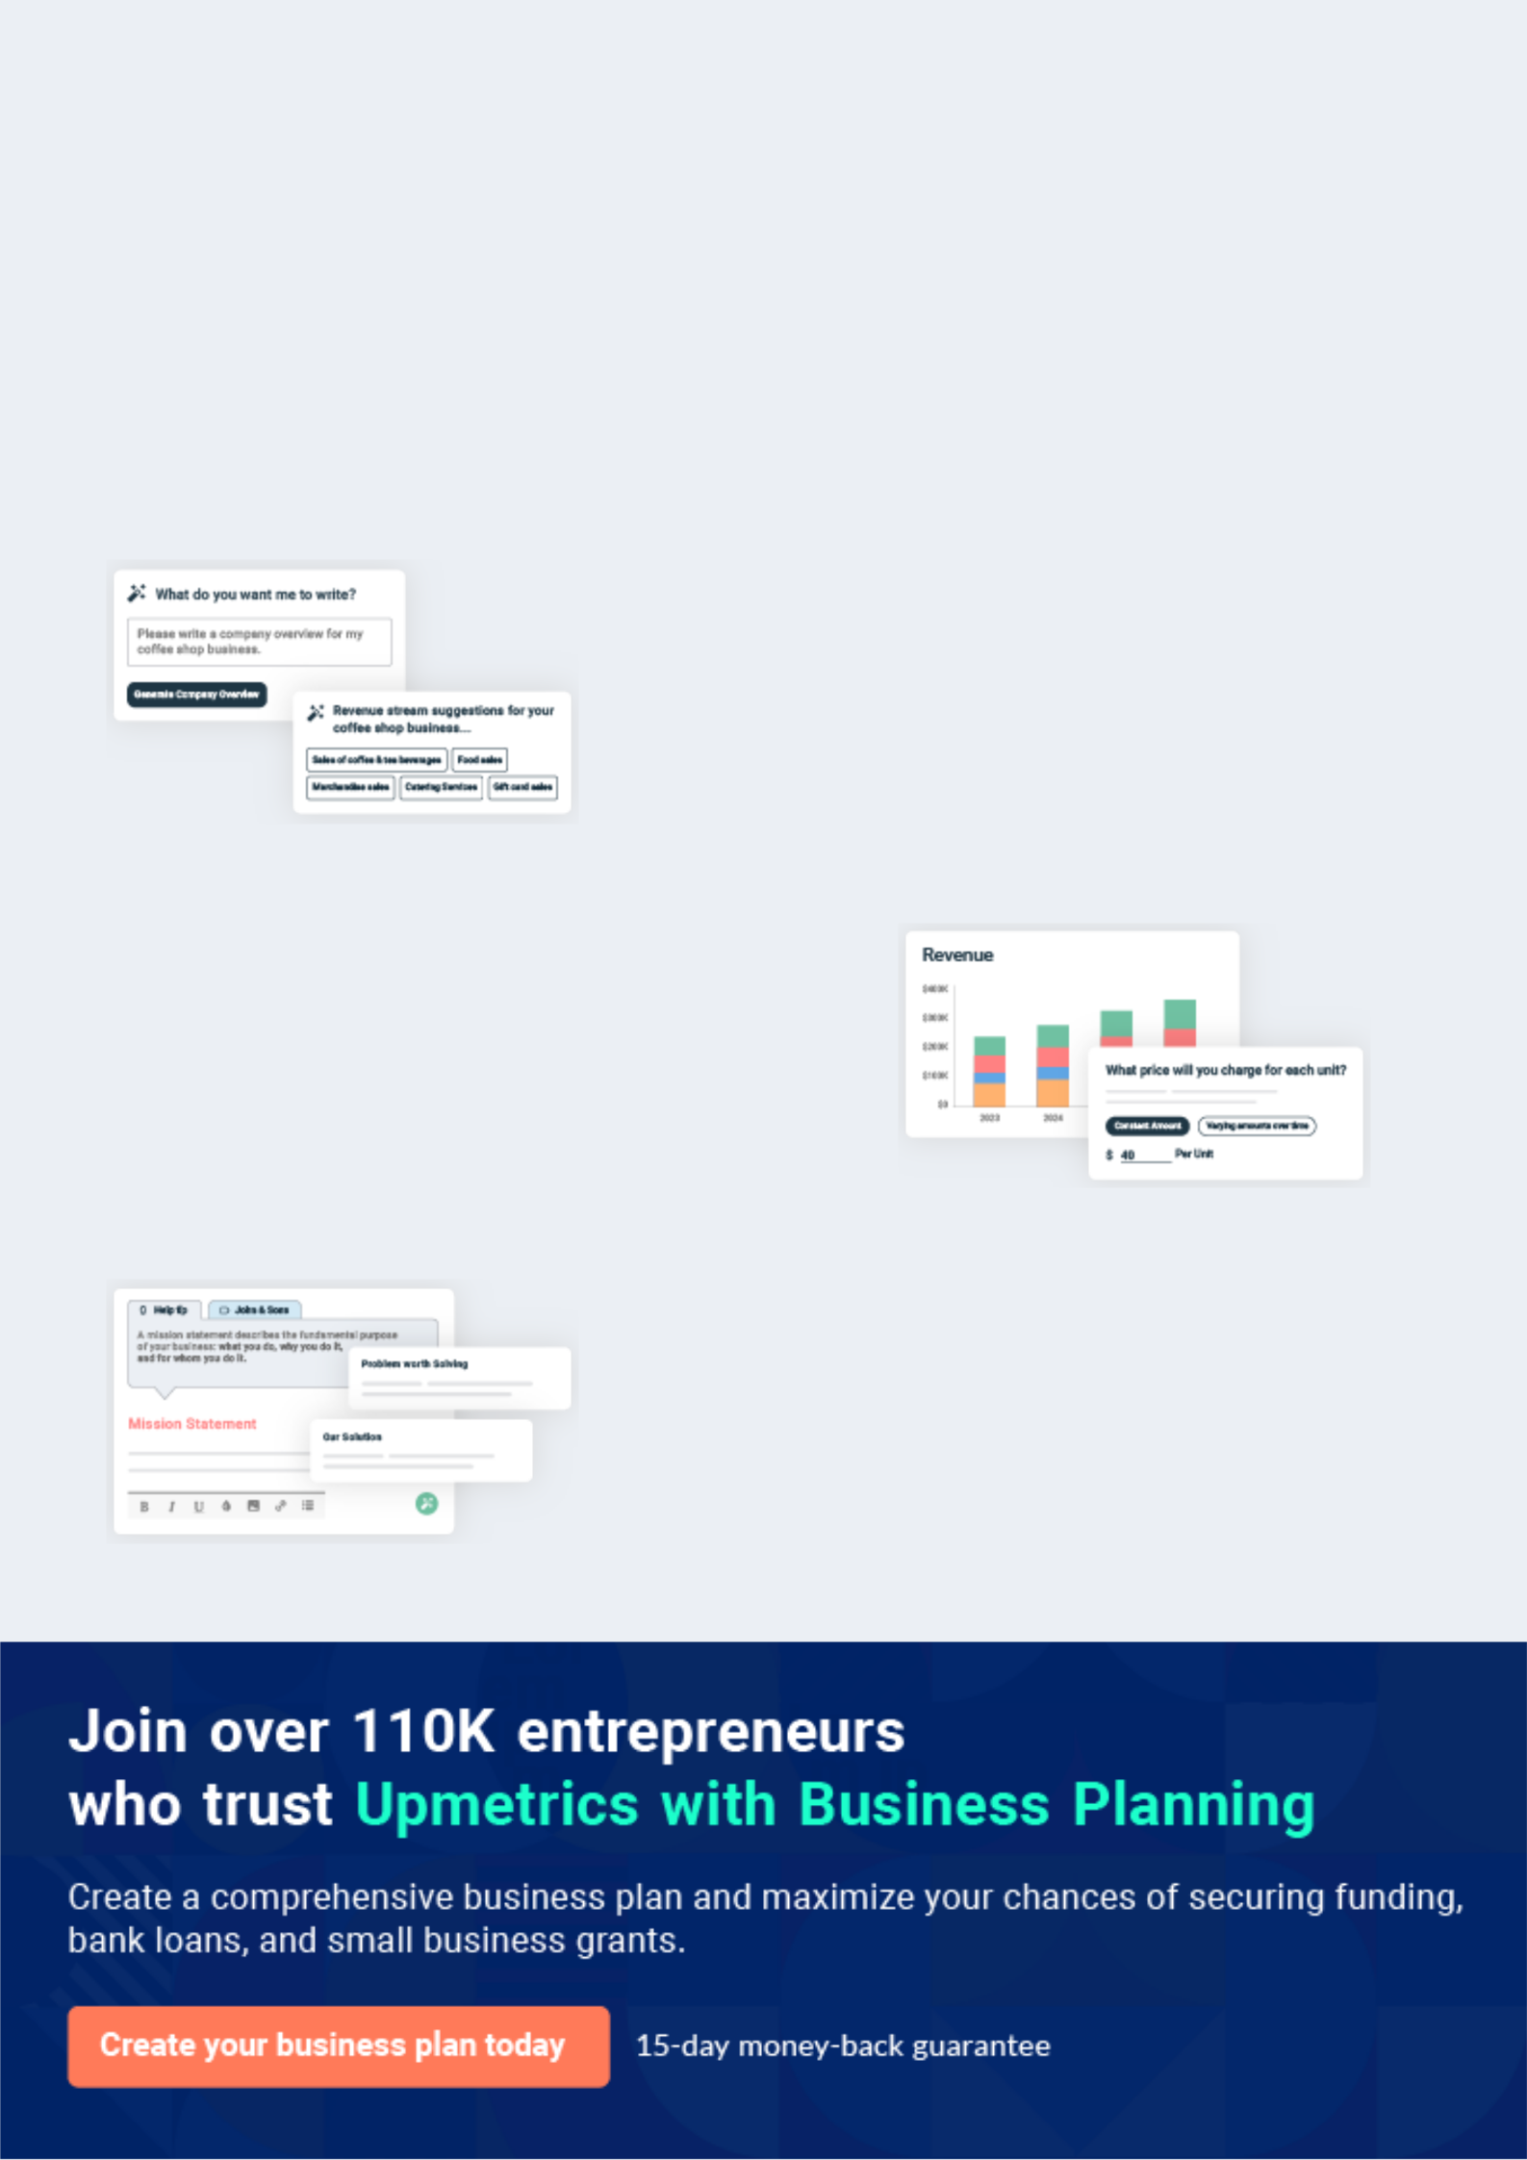
Business planning that’s simpler and faster than you think

Creating a business plan using Upmetrics to start and grow a business is literally the easiest thing in the World. Simply read the instructions and fill in the blanks. It’s as simple as that.

❛ | Upmetrics has everything you need to create a | ❜
❛ | comprehensive business plan. | ❜

AI-powered Upmetrics Assistant

AI-powered insights to streamline your plan

Not sure where to start? Upmetrics’ AI Assistant will automatically generate ideas for each section of your plan and offer improved versions of your writing, adjusting for tone, voice, and grammar or spelling errors.

Financial Forecasting Tool

All the financials are calculated for you

Forget the complex formulas and clumsy spreadsheets — with automatic financials and drag-and-drop forecasting, you can finish your plan faster and be confident that your numbers are accurate.

Business Plan Builder

Guides you like a business mentor

Upmetrics’ step-by-step instructions, prompts, and the library of 400+ sample business plans will guide you through each section of your plan as a business mentor.
Executive Summary


An executive summary is the first section of the business plan intended to provide an overview of the whole business plan.
To unlock help try Upmetrics! 

 Help tip  Roller Skating Rink Business Plan


Start your executive summary by briefly introducing your business to your readers.

This section may include the name of your roller skating rink business, its location, when it was
To unlock help try Upmetrics! 

Start writing here..

Market opportunity

 Help tip  Roller Skating Rink Business Plan

Summarize your market research, including market size, growth potential, and marketing trends. Highlight the opportunities in the market and how your business will fit in to fill the gap.
To unlock help try Upmetrics! 

Start writing here..

Services

 Help tip  Roller Skating Rink Business Plan

Highlight the roller skating rink services you offer your clients. The USPs and differentiators you offer are always a plus.
To unlock help try Upmetrics! 

Start writing here..

Marketing & Sales Strategies
To unlock help try Upmetrics!

 Help tip  Roller Skating Rink Business Plan

Outline your sales and marketing strategies—what marketing platforms you use, how you plan on acquiring customers, etc.
To unlock help try Upmetrics! 

Start writing here..

Financial Highlights

 Help tip  Roller Skating Rink Business Plan

Briefly summarize your financial projections for the initial years of business operations. Include any capital or investment requirements, associated startup costs, projected revenues, and profit forecasts.



Start writing here..
Units Sold v/s Revenue

 |  | Units Sold | Revenue
15.00k
10.00k
5.00k
0
Year 1 | Year 2 | Year 3
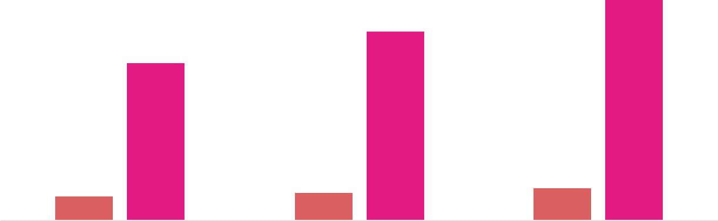

Financial Year |  |  | Units Sold | Revenue
Year 1 | 1,550 |  |  | $10,000
Year 2 | 1,800 |  |  | $12,000
Year 3 | 2,050 |  |  | $14,000
 Help tip |  |  Roller Skating Rink Business Plan
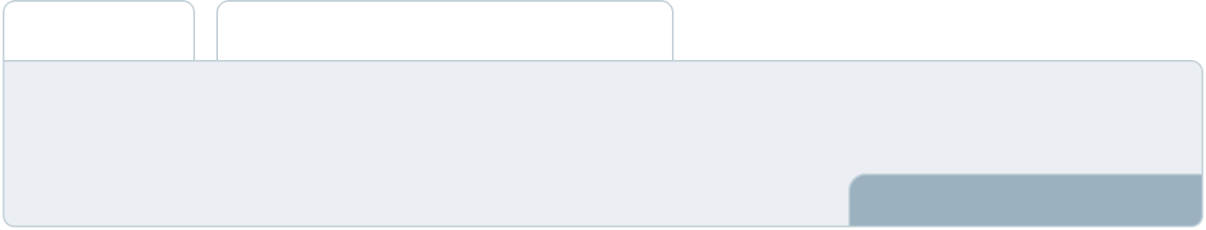

Summarize your executive summary section with a clear CTA, for example, inviting angel investors to discuss the potential business investment.
To unlock help try Upmetrics! 

Write a call to action for your business plan.
Company Overview

Depending on what details of your business are essential, you’ll need different elements in your business overview.
To unlock help try Upmetrics! 

 Help tip  Roller Skating Rink Business Plan

Describe your business in this section by providing all the basic information:

Describe what kind of skating rink business you run and the name of it. Here are some of the
To unlock help try Upmetrics! 

Start writing here..

Ownership

 Help tip  Roller Skating Rink Business Plan

List the founders of your roller skating rink business. Describe what shares they own and their responsibilities for efficiently managing the business.
To unlock help try Upmetrics! 

Start writing here..
Mission statement

 Help tip  Roller Skating Rink Business Plan

Summarize your business’ objective, core principles, and values in your mission statement. This statement needs to be memorable, clear, and brief.
To unlock help try Upmetrics! 

❛ At [Business Name], we are committed to redefining the roller skating experience. Guided by our core principles of [integrity, safety, and innovation], our mission is to offer unparalleled skating experiences embedded with fun, community, and lasting memories.

Every spin, turn, and glide on our rink is a testament to our dedication to our patrons.

❜

Business history

 Help tip  Roller Skating Rink Business Plan

If you’re an established skating rink business, briefly describe your business history, like—when it was founded, how it evolved over time, etc.
To unlock help try Upmetrics! 

Start writing here..
Future goals

 Help tip  Roller Skating Rink Business Plan

It’s crucial to convey your aspirations and vision. Mention your short-term and long-term goals; they can be specific targets for revenue, market share, or expanding your services.
To unlock help try Upmetrics! 

Start writing here..
Market Analysis
To unlock help try Upmetrics!


 |  | Market analysis provides a clear understanding of the market in which your
 |  | printing business will run along with the target market, competitors, and
 |  | growth opportunities.
 |  |  |  | To unlock help try Upmetrics! 
 Help tip |  |  Roller Skating Rink Business Plan

To write the introduction section of your market analysis, start by clearly identifying your primary target market.
To unlock help try Upmetrics! 

Start writing here..

Target Market

 Help tip  Roller Skating Rink Business Plan

Start this section by describing your target market. Define your ideal customer and explain what types of services they prefer. Creating a buyer persona will help you easily define your target market to your readers.



Start writing here..

Market size and growth potential

 Help tip  Roller Skating Rink Business Plan

Describe your market size and growth potential and whether you will target a niche or a much broader market.
To unlock help try Upmetrics! 

Start writing here..

Market Size

Available Market | 500k
All potential roller skating patrons in the | 500k
region.


Served Market | 300k
Patrons within our geographical and | 300k
operational reach. | 300k
Target Market | 100k
Families, teens, and roller derby | 100k
enthusiasts we aim to serve. | 100k

 Help tip  Roller Skating Rink Business Plan

Identify and analyze your direct and indirect competitors. Identify their strengths and weaknesses, and describe what differentiates your roller skating rink services from them.
To unlock help try Upmetrics! 

Competitive analysis

SkateWorld

SkateWorld is a well-established roller skating rink known for its large facility and diverse range of events catering to all age groups.

Features

Large facility that can accommodate a high number of patrons

Offers a wide range of events, including themed nights, birthday parties, and private events

Provides roller skating lessons for all skill levels

Strengths

Well-known brand with a strong customer base

Offers a comprehensive range of events catering to different interests

Extensive experience in the roller skating industry

Weaknesses

Facility can become crowded, affecting the customer experience

Limited food and beverage options

The website and online booking system are outdated

Roller Kingdom

Roller Kingdom is a family-owned roller skating rink with a strong focus on community engagement and family-friendly events.

Features | Strengths | Weaknesses
Regular family nights with | Strong community ties and | Facility size is smaller compared
discounted prices | positive local reputation | to competitors
Partnership with local schools | Affordable pricing and family- | Limited offerings for teenagers
for after-school programs | friendly atmosphere | and adults
Wide range of games and | Proactive engagement with | Limited parking space available
activities for children | local schools and
 | organizations

Galaxy Skateway

Galaxy Skateway is a modern roller skating rink that focuses on providing a high-energy, entertaining experience for teenagers and young adults.

Features

Regular themed nights catering to teenagers and young adults

State-of-the-art lighting and sound systems

Partnership with local DJs and artists for live performances

Strengths

Offers a modern and energetic atmosphere

Regular events and live performances attract a younger demographic

Strong online presence and active social media engagement

Weaknesses

May be too loud and energetic for families and older patrons

Limited offerings for children

Prices are higher compared to competitors

Market trends

 Help tip  Roller Skating Rink Business Plan

Analyse emerging trends in the industry, such as technology disruptions, changes in customer behavior or preferences, etc. Explain how your business will cope with all the trends.
To unlock help try Upmetrics! 

Start writing here..

Regulatory environment
To unlock help try Upmetrics!

 Help tip  Roller Skating Rink Business Plan

List regulations and licensing requirements that may affect your roller skating rink company, such as business registration, safety and health regulations, zoning and land use, music licensing, etc.



Start writing here..
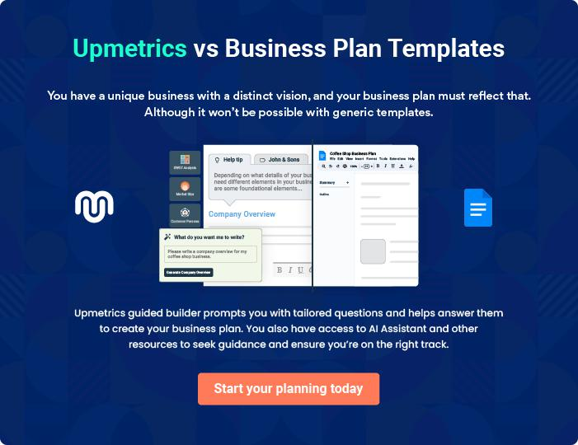
Products and Services
To unlock help try Upmetrics!

The product and services section of a roller skating rink business plan should describe the specific services and products that will be offered to customers. To write this section should include the following:



 Help tip  Roller Skating Rink Business Plan

To craft the introduction for your "Products and Services" chapter, begin by positioning your business within its industry, emphasizing its unique strengths or value proposition.
To unlock help try Upmetrics! 

Start writing here..

 Help tip


Mention the roller skating rink services your business will offer. This list may include services like skating rinks, skate rentals, and skating lessons for beginners.
To unlock help try Upmetrics! 

Services

Roller Disco
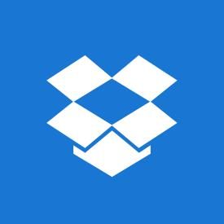

Price: [$15] per person

A vibrant and lively experience, our roller disco nights combine retro music and modern lighting effects to create a unique skating atmosphere.

Specifications

- Duration: 2 hours

- Age Limit: None

- Skates Rental: Included in the price
Roller Hockey

Price: [$10] per person or [$80] per team

Catering to both amateur and seasoned roller hockey players, our roller hockey sessions provide a space for practice and competition.

Specifications

- Duration: 1.5 hours

- Age Limit: 8 years and above

- Skates Rental: [$5] extra per person

Skate Rental

Price: [$5] per pair

Our skate rental service offers a wide variety of sizes and styles, ensuring a perfect fit for every skater.

Specifications

- Duration: Per session

- Sizes Available: Kids 1 to Adults 13

- Styles Available: Inline and Quad

Skating Lessons for Beginners

Price: [$20] per person

Designed for those new to the sport, our beginner lessons are conducted by experienced instructors who guide novices through the basics.

Specifications

- Duration: 1 hour

- Age Limit: None

- Skates Rental: Included in the price
Private Event Rental

Price: Starting at [$300]

Our facility can be rented out for private functions, providing a personalized skating experience for birthdays, anniversaries, or corporate events.

Specifications

- Duration: 3 hours

- Age Limit: None

- Skates Rental: Included in the price for up to 20 guests

Quality Measure

 Help tip  Roller Skating Rink Business Plan

This section should explain how you maintain quality standards and consistently provide the highest quality service.
To unlock help try Upmetrics! 

Start writing here..

Additional Services

 Help tip  Roller Skating Rink Business Plan

Mention if your skating rink business offers any additional services. You may include services skate rental, snack bar, private event rental, etc.
To unlock help try Upmetrics! 

Start writing here..

Sales And Marketing Strategies

Writing the sales and marketing strategies section means a list of strategies you will use to attract and retain your clients.
To unlock help try Upmetrics! 

 Help Tip  Roller Skating Rink Business Plan


To create an effective introduction for your "Sales and Marketing Strategies" chapter, start by setting the stage within your specific industry or market.
To unlock help try Upmetrics! 

Start writing here..

Unique Selling Proposition (USP)

 Help tip  Roller Skating Rink Business Plan

Define your business’s USPs depending on the market you serve, the equipment you use, and the unique services you provide. Identifying USPs will help you plan your marketing strategies.
To unlock help try Upmetrics! 

Start writing here..

Pricing Strategy

 Help tip  Roller Skating Rink Business Plan

Describe your pricing strategy—how you plan to price your services and stay competitive in the local market.
To unlock help try Upmetrics! 

Start writing here..

 Help tip  Roller Skating Rink Business Plan
To unlock help try Upmetrics!

Discuss your marketing strategies to market your services. You may include some of these marketing strategies in your business plan—social media marketing, brochures, email marketing, local advertising, and print marketing.



Marketing strategies

Online


Social Media

Leveraging platforms like Facebook, Instagram, and Twitter to showcase our events, promotions, and general rink ambiance.

Email Marketing

Sending out regular newsletters to our email subscribers, detailing upcoming events, promotions, and other news.

Offline

Brochures

Distributing informative brochures at local businesses, community centers, and schools to increase awareness of our services.

Local Advertising

Placing ads in local newspapers, magazines, and community bulletins.

Print Marketing

Designing visually appealing posters and flyers to be displayed at our rink and other strategic locations.

 Help tip  Roller Skating Rink Business Plan
To unlock help try Upmetrics!

Outline the strategies you’ll implement to maximize your sales. Your sales strategies may include hosting events, partnering with local organizations and schools, offering promotions and discounts, etc.



Sales strategies

Partnering with Local Organizations and Schools

Building partnerships with local organizations and schools to host group skating sessions, events, and fundraisers.

Promotions and Discounts

Providing promotions, such as family discounts, holiday specials, and group rates, to attract new customers and incentivize repeat visits.

Hosting Events

Organizing regular events, such as skate nights, live music, and themed parties, to increase foot traffic.

 Help tip  Roller Skating Rink Business Plan

Describe your customer retention strategies and how you plan to execute them. For instance, introducing loyalty programs, discounts on annual membership, personalized service, etc.
To unlock help try Upmetrics! 

Customer retention

Loyalty Programs

Implementing loyalty programs that reward frequent visitors with discounts, freebies, and other perks.

Discounts on Annual Memberships

Offering discounted rates for customers who commit to an annual membership.

Personalized Service

Training our staff to provide

personalized service, ensuring that

each customer feels valued and

appreciated.

Operations Plan
To unlock help try Upmetrics!

 |  | When writing the operations plan section, it’s important to consider the
 |  | various aspects of your business operations.
 |  |  |  | To unlock help try Upmetrics! 
 Help tip |  |  Roller Skating Rink Business Plan
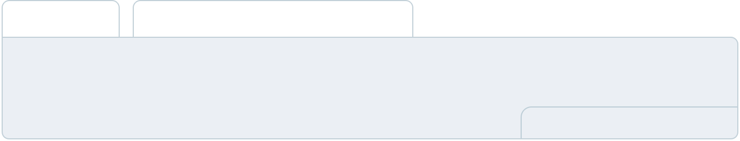

To create an effective introduction for your "Operational Plan" chapter, start by emphasizing the
pivotal role of efficient operations in the success of your business, underscoring how they
directly impact the quality of services delivered.
 |  |  |  | To unlock help try Upmetrics! 
Start writing here..
Staffing & Training
 Help tip |  |  Roller Skating Rink Business Plan

Mention your business’s staffing requirements, including the number of employees or carers need. Include their qualifications, the training required, and the duties they will perform.
To unlock help try Upmetrics! 

Start writing here..

Operational Processes

 Help tip  Roller Skating Rink Business Plan

Outline the processes and procedures you will use to run your roller skating rink business. Your operational processes may include opening procedures, staff briefing, skating lessons, skate guard duties, snack bar operations, maintenance, etc.



Start writing here..

Equipment & Machinery

 Help tip  Roller Skating Rink Business Plan

Include the equipment and machinery required for the roller skating rink, such as roller skates, maintenance equipment, cleaning equipment, POS system, and snack bar equipment.
To unlock help try Upmetrics! 

Start writing here..
Management Team

The management team section provides an overview of the individuals responsible for running your business plan.
To unlock help try Upmetrics! 

 Help tip  Roller Skating Rink Business Plan

To craft an introduction for your "Management Team" chapter, begin by emphasizing the crucial role of leadership in the success of any business.
To unlock help try Upmetrics! 

Start writing here..

Key managers

 Help tip  Roller Skating Rink Business Plan

Introduce your management and key team members, and explain their roles and responsibilities.
To unlock help try Upmetrics! 

Start writing here..


JOHN DOE

Founder & CEO - john.doe@example.com

John Doe is the driving force behind [Business Name], bringing his vision to life of a world-class roller skating rink.

Holding a Bachelor’s in Business Management from [University Name], John's entrepreneurial spirit has been evident from his early days.


With over 15 years of experience in the roller skating industry, John's expertise spans from rink operations to customer experience design.

Address: 10200 Bolsa Ave, Westminster, CA, 92683

JANE DOE

Facility Manager - jane.doe@example.com

Jane graduated with a degree in Facility Management from [University Name].

She boasts a decade of experience in maintaining and managing recreational facilities.


Her acute attention to detail ensures that the skating rink remains in top-notch condition for our customers.


ALICE BROWN

Human Resources Manager - alice.brown@example.com

Alice Brown holds an MBA in Human Resources from [University Name].

With her 12 years of experience in HR, Alice has a track record of creating vibrant work cultures.

She has a knack for spotting talent and ensuring they're trained and integrated seamlessly into our dynamic team.


ROBERT BROWN

Marketing Manager - robert.brown@example.com

Robert Brown is a marketing maven. After acquiring his Master’s in Marketing from [University Name], Robert dived into the entertainment industry, garnering 10 years of experience.

He is adept at identifying market trends and crafting campaigns that resonate with our target audience.

Organizational structure

 Help tip  Roller Skating Rink Business Plan

Explain the organizational structure of your management team. Include the reporting line and decision-making hierarchy.
To unlock help try Upmetrics! 

Start writing here..

Organization chart


[John Doe]

[CEO & Founder]
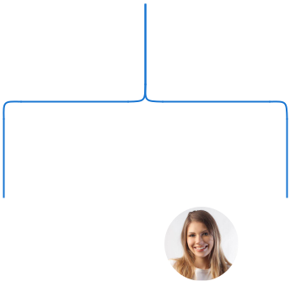

[Alice Brown] | [Jane Doe]
[Alice Brown] | [Facility
[HR Manager] | [Facility
[HR Manager] | Manager]




 | [Michael | [Sarah White] | [Emma Green]
 | Black] | [Sarah White] | [Emma Green]
[Robert Green] | Black] | [Cleaning Staff] | [Maintenance]
[Robert Green] | [Cashier] | [Cleaning Staff] | [Maintenance]
[Skate Guard] | [Cashier]




Compensation plan

 Help tip  Roller Skating Rink Business Plan

Describe your compensation plan for the management and staff. Include their salaries, incentives, and other benefits.
To unlock help try Upmetrics! 

Start writing here..
 Help tip

Mentioning advisors or consultants in your business plans adds credibility to your business idea.
To unlock help try Upmetrics! 

Advisors/Consultants


MR. JAMES GREEN

Financial Consultant - james.green@example.com

James Green, a finance wizard, holds a Master’s in Finance from [University Name].

With over 18 years in the financial consultancy realm, he brings a robust understanding of financial planning and forecasting.

His insights have been pivotal in ensuring the financial health and sustainability of several businesses.


DR. EMILY WHITE

Business Strategy Advisor - emily.white@example.com

Dr. Emily White is a renowned business strategist with a Ph.D. in Business Administration from [University Name].

Her prowess in business modeling and strategy formulation has made her a sought-after consultant.

With her 20 years of experience, she has been instrumental in scaling numerous ventures to their peak.
Financial Plan

When writing the financial plan section of a business plan, it’s important to provide a comprehensive overview of your financial projections for the first few years of your business, You may provide the following:
To unlock help try Upmetrics! 

 Help tip  Roller Skating Rink Business Plan


To create an effective introduction for your "Financial Plan" chapter, begin by stressing the critical role of a well-structured financial plan in the success of your venture.
To unlock help try Upmetrics! 

Start writing here..

 Help tip  Roller Skating Rink Business Plan

Describe details such as projected revenue, operational costs, and service costs in your projected profit and loss statement. Make sure to include your business’s expected net profit or loss.
To unlock help try Upmetrics! 

Profit & loss statement

Revenue

Cost Of Sales

General Costs

Revenue Specific Costs

Personnel Costs (Direct

Labor)

Gross Margin

Gross Margin (%)

Operating Expense

Payroll Expense

(Indirect Labor)

General Expense

Bad Debt

Amortization of Current

Assets

2023-24 | 2024-25 | 2025-26 | 2026-27 | 2027-28
$0 | $0 | $0 | $0 | $0

$0 | $0 | $0 | $0 | $0
$0 | $0 | $0 | $0 | $0
$0 | $0 | $0 | $0 | $0
$0 | $0 | $0 | $0 | $0

$0 | $0 | $0 | $0 | $0
0% | 0% | 0% | 0% | 0%

$0 | $0 | $0 | $0 | $0
$0 | $0 | $0 | $0 | $0
$0 | $0 | $0 | $0 | $0
$0 | $0 | $0 | $0 | $0
$0 | $0 | $0 | $0 | $0

EBITDA

Additional Expense

Long Term

Depreciation

Gain or loss from Sale

of Assets

EBIT

Interest Expenses

EBT

Income Tax Expense

Total Expense

Net Income

Net Income (%)

2023-24 | 2024-25 | 2025-26 | 2026-27 | 2027-28
$0 | $0 | $0 | $0 | $0
$0 | $0 | $0 | $0 | $0
$0 | $0 | $0 | $0 | $0
$0 | $0 | $0 | $0 | $0
$0 | $0 | $0 | $0 | $0
$0 | $0 | $0 | $0 | $0
$0 | $0 | $0 | $0 | $0
$0 | $0 | $0 | $0 | $0
$0 | $0 | $0 | $0 | $0
$0 | $0 | $0 | $0 | $0
0% | 0% | 0% | 0% | 0%

 |  |  | 2023-24 |  | 2024-25 | 2025-26
Retained Earning |  |  | $0 |  | $0 | $0
Opening |  |  |  |  | $0 | $0
Owner's Distribution |  |  | $0 |  | $0 | $0
Retained Earning |  |  | $0 |  | $0 | $0
Closing |  |  |  |  | $0 | $0
 Help tip |  |  |  Roller Skating Rink Business Plan
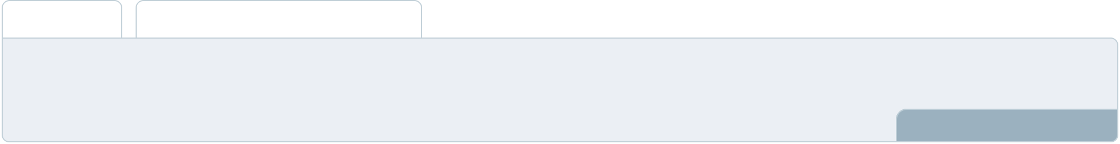

The cash flow for the first few years of your operation should be estimated and described in this section.

This may include billing invoices, payment receipts, loan payments, and any other cash flow statements.
2026-27 2027-28

$0 $0

$0 $0

$0 $0

To unlock help try Upmetrics! 

Cash flow statement

 | 2023-24 | 2024-25 | 2025-26 | 2026-27 | 2027-28
Cash Received | $0 | $0 | $0 | $0 | $0
Cash Paid | $0 | $0 | $0 | $0 | $0
COS & General Expenses | $0 | $0 | $0 | $0 | $0
Salary & Wages | $0 | $0 | $0 | $0 | $0
Interest | $0 | $0 | $0 | $0 | $0

Sales Tax

Income Tax

Net Cash From

Operations

Assets Sell

Assets Purchase

Net Cash From

Investments

Amount Received

Loan Received

Common Stock

Preferred Stock

Owner's Contribution

Amount Paid

2023-24 | 2024-25 | 2025-26 | 2026-27 | 2027-28
$0 | $0 | $0 | $0 | $0
$0 | $0 | $0 | $0 | $0
$0 | $0 | $0 | $0 | $0

$0 | $0 | $0 | $0 | $0
$0 | $0 | $0 | $0 | $0
$0 | $0 | $0 | $0 | $0

$0 | $0 | $0 | $0 | $0
$0 | $0 | $0 | $0 | $0

$0 | $0 | $0 | $0 | $0
$0 | $0 | $0 | $0 | $0
$0 | $0 | $0 | $0 | $0

Loan Capital $0 $0 $0 $0 $0

 |  |  | 2023-24 |  | 2024-25 | 2025-26 | 2026-27 | 2027-28
Dividends & Distributions |  |  | $0 |  | $0 | $0 | $0 | $0
Net Cash From |  |  | $0 |  | $0 | $0 | $0 | $0
Financing
Summary
Starting Cash |  |  | $0 |  | $0 | $0 | $0 | $0
Cash In |  |  | $0 |  | $0 | $0 | $0 | $0
Cash Out |  |  | $0 |  | $0 | $0 | $0 | $0
Change in Cash |  |  | $0 |  | $0 | $0 | $0 | $0
Ending Cash |  |  | $0 |  | $0 | $0 | $0 | $0
 Help tip |  |  Roller Skating Rink Business Plan

Create a projected balance sheet documenting your roller skating rink business’s assets, liabilities, and equity.

To unlock help try Upmetrics! 

Balance sheet

 | 2023-24 | 2024-25 | 2025-26 | 2026-27 | 2027-28
Assets | $0 | $0 | $0 | $0 | $0
Current Assets | $0 | $0 | $0 | $0 | $0
Cash | $0 | $0 | $0 | $0 | $0
Accounts Receivable | $0 | $0 | $0 | $0 | $0
Inventory | $0 | $0 | $0 | $0 | $0
Other Current Assets | $0 | $0 | $0 | $0 | $0
Long Term Assets | $0 | $0 | $0 | $0 | $0
Gross Long Term Assets | $0 | $0 | $0 | $0 | $0
Accumulated Depreciation | $0 | $0 | $0 | $0 | $0

Liabilities & Equity | $0 | $0 | $0 | $0 | $0
Liabilities | $0 | $0 | $0 | $0 | $0
Current Liabilities | $0 | $0 | $0 | $0 | $0
Accounts Payable | $0 | $0 | $0 | $0 | $0
Income Tax Payable | $0 | $0 | $0 | $0 | $0
Sales Tax Payable | $0 | $0 | $0 | $0 | $0
Short Term Debt | $0 | $0 | $0 | $0 | $0
 | 2023-24 | 2024-25 | 2025-26 | 2026-27 | 2027-28
Long Term Liabilities | $0 | $0 | $0 | $0 | $0
Long Term Debt | $0 | $0 | $0 | $0 | $0
Equity | $0 | $0 | $0 | $0 | $0
Paid-in Capital | $0 | $0 | $0 | $0 | $0
Common Stock | $0 | $0 | $0 | $0 | $0
Preferred Stock | $0 | $0 | $0 | $0 | $0
Owner's Contribution | $0 | $0 | $0 | $0 | $0
Retained Earnings | $0 | $0 | $0 | $0 | $0

Check | $0 |  |  | $0 | $0 | $0 | $0
 Help tip |  |  Roller Skating Rink Business Plan

Determine and mention your business’s break-even point—the point at which your business costs and revenue will be equal.

This exercise will help you understand how much revenue you need to generate to sustain or be profitable.
To unlock help try Upmetrics! 

Break-even Analysis

 | 2023-24 | 2024-25 | 2025-26 | 2026-27 | 2027-28
Starting Revenue | $0 | $0 | $0 | $0 | $0
Net Revenue | $0 | $0 | $0 | $0 | $0
Closing Revenue | $0 | $0 | $0 | $0 | $0

Starting Expense | $0 | $0 | $0 | $0 | $0
Net Expense | $0 | $0 | $0 | $0 | $0
Closing Expense | $0 | $0 | $0 | $0 | $0

Is Break Even? | 0 | 0 | 0 | 0 | 0
Break Even Month | 0 | 0 | 0 | 0 | 0
Days Required | 0 | 0 | 0 | 0 | 0
Break Even Revenue | $0 | $0 | $0 | $0 | $0
Break Even Units
Financing needs

 Help tip  Roller Skating Rink Business Plan

Calculate costs associated with starting a roller skating rink business, and estimate your financing needs and how much capital you need to raise to operate your business.
To unlock help try Upmetrics! 

Start writing here..
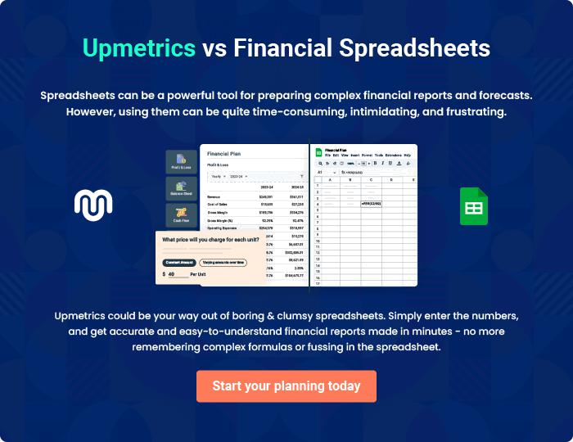
Appendix

When writing the appendix section, you should include any additional information that supports the main content of your plan. This may include financial statements, market research data, legal documents, and other
To unlock help try Upmetrics! 
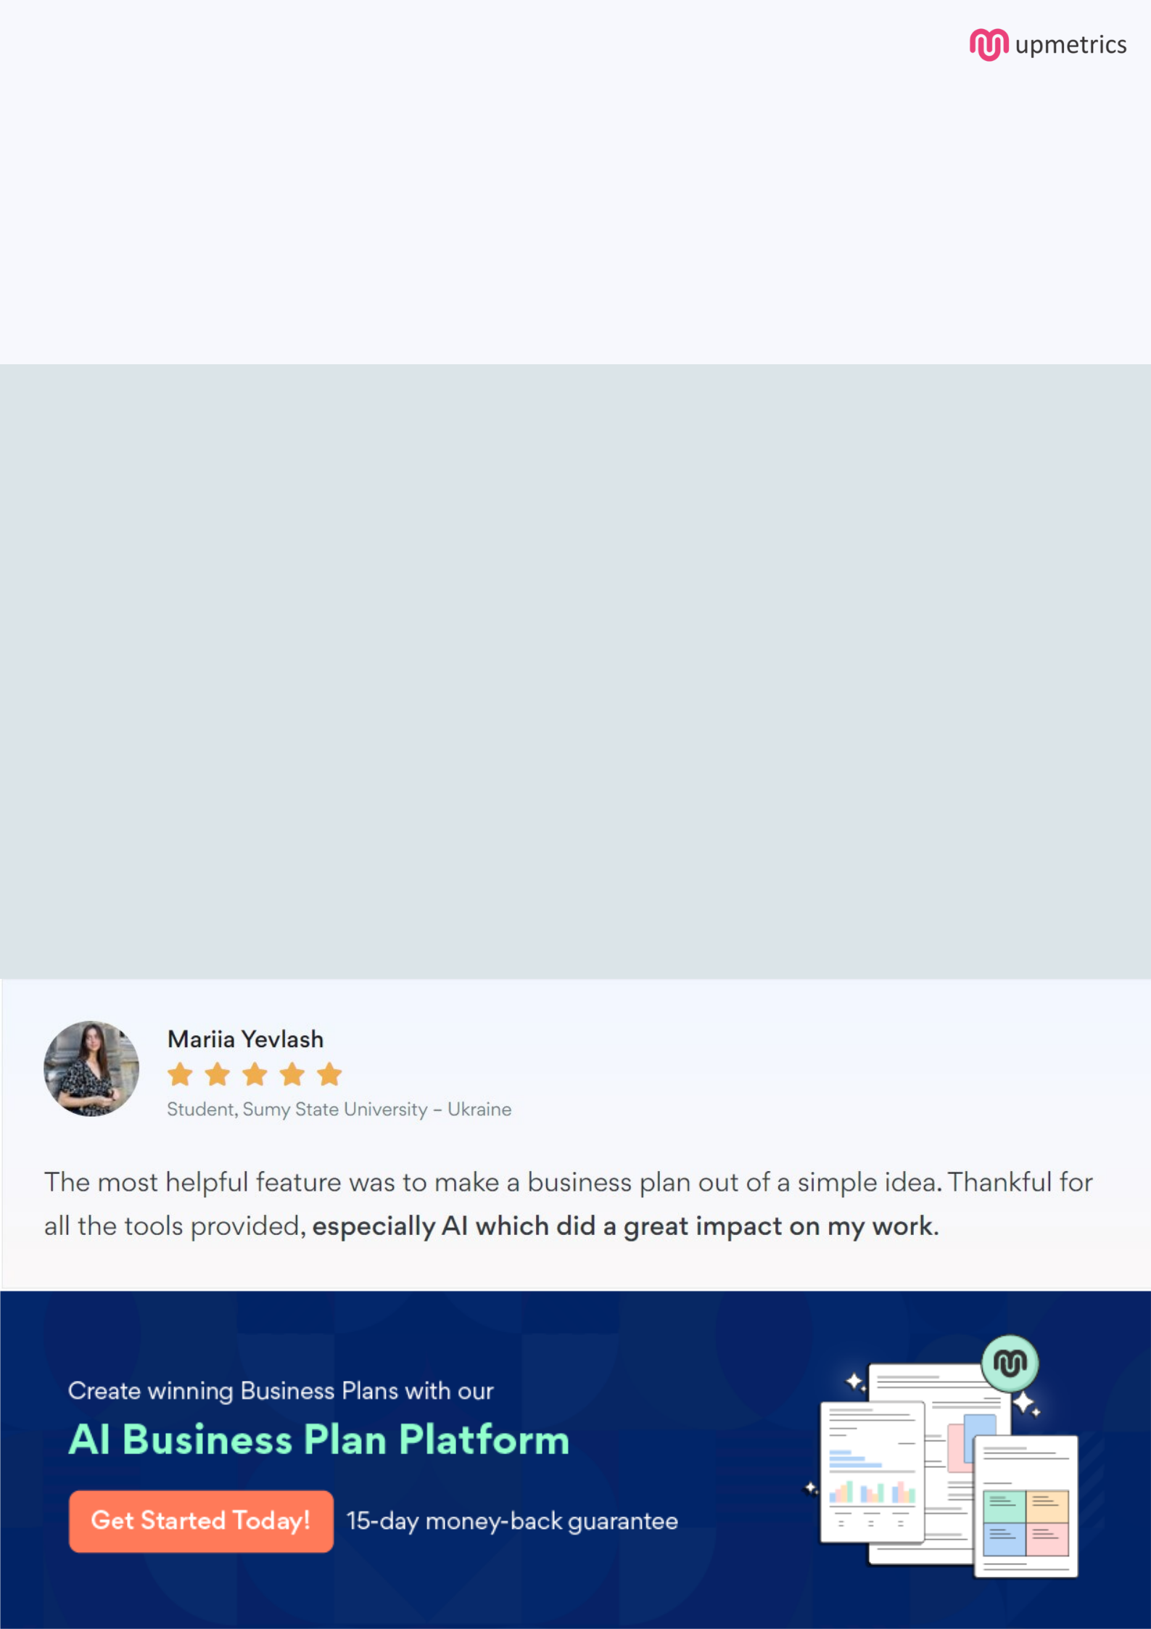
Create a winning business plan that gets you funded

Creating a stunning and investment-ready plan requires no writing, graphic designing, or financial planning expertise.

Upmetrics has all the features required to help you create a comprehensive business plan—from start to finish. Make no mistakes, it’s the modern way of planning to structure ideas, make plans, and create stunning pitch decks to awe investors.

Pitch decks that impress investors

Create pitch decks that provide a visual representation of your business, engage investors, and make them want to invest in your business idea.

Interactive plans in no time

Import business plan sections like—SWOT analysis, comparison tables, and others to create an interactive business plan. No designing skills are required.

Stunning cover page designs

With Upmetrics, you have the liberty to choose from multiple stunning cover page designs. Choose a creative design and make your plan stand out.

Online sharing made simple

Upmetrics makes online sharing quick and easier for users. Easily share your business plans with a link while tracking reader activity.

500+ sample business plans

Simply import a template from our library of sample plans into the editor and start customizing it to make it yours. It takes only a few clicks to get started.

Collaborate with team in real-time

Invite team members, initiate conversations, discuss ideas & strategies, share feedback, and work on a business plan in real-time.

