

Roadside

Assistance

Business Plan

Helping Hands, Anytime, Anywhere

Business

Plan

2023

John Doe

10200 Bolsa Ave, Westminster, CA, 92683

- 359-3153 info@example.com http://www.example.com

CONFIDENTIAL

Table of Contents

Executive Summary | 6
Market opportunity | 6
Services Offered | 6
Marketing & Sales Strategies | 7
Financial Highlights | 7
Units Sold v/s Revenue | 8

Company Overview | 9
Ownership | 9
Business Owners | 9
Mission statement | 10
Business history | 10
Future goals | 10

Market Analysis | 11
Target Market | 11
Market size and growth potential | 11
Market Size | 12
Competitive analysis | 12
FastTrack Roadside Co. | 12
SafetyNet Assist | 13
RescueRide Solutions | 13
Market trends | 13
Regulatory environment | 14

Products and Services | 15
Roadside assistance services | 15
Towing Service | 15
Tire Changing Service | 16
Fuel Delivery | 16
Mobile Mechanic Services | 17
Battery Replacement | 17
Dead Battery Jump Start | 18
Quality Measures | 18
Additional Services | 18

Sales And Marketing Strategies | 19
Unique Selling Proposition (USP) | 19
Pricing Strategy | 19
Marketing strategies | 20
Online | 20
Offline | 20
Sales strategies | 21
Customer retention | 21

Operations Plan | 22
Staffing & Training | 22
Operational Process | 22
Equipment & Machinery | 23

Management Team | 24
Key managers | 24
John Doe | 24
Jane Doe | 25
Alice Brown | 25
Robert Brown | 25
Organizational structure | 26
Organization chart | 26
Compensation plan | 26
Advisors/Consultants | 27
Dr. Emily Johnson | 27
Mr. Richard White | 27
Financial Plan | 28
Profit & loss statement | 28
Cash flow statement | 31
Balance sheet | 33
Break-even Analysis | 35
Financing needs | 37
Appendix
Appendix | 39
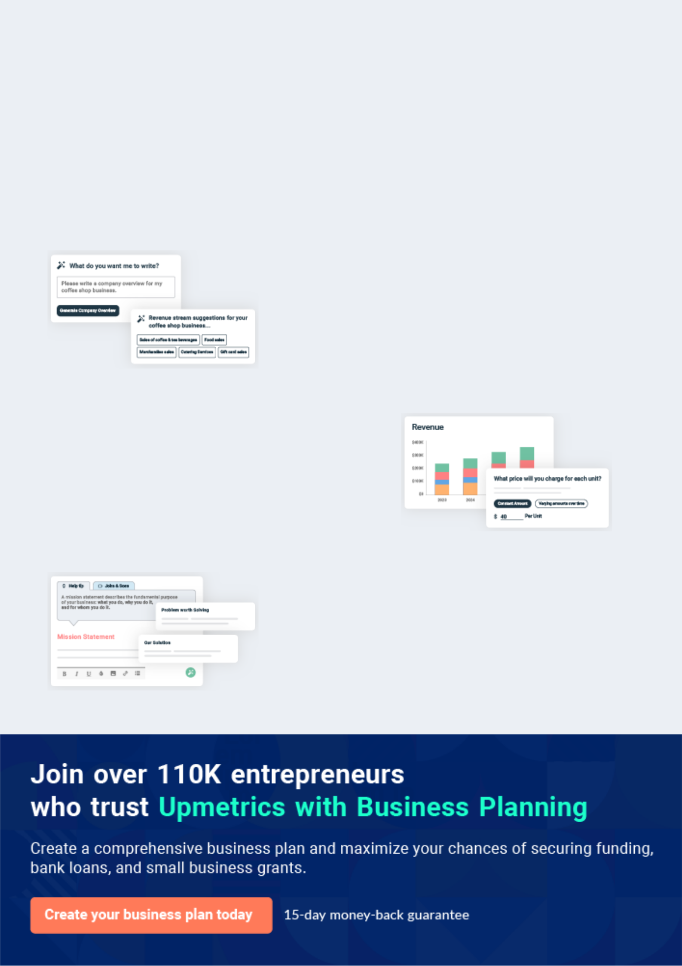
Business planning that’s simpler and faster than you think

Creating a business plan using Upmetrics to start and grow a business is literally the easiest thing in the World. Simply read the instructions and fill in the blanks. It’s as simple as that.

❛ | Upmetrics has everything you need to create a | ❜
❛ | comprehensive business plan. | ❜

AI-powered Upmetrics Assistant

AI-powered insights to streamline your plan

Not sure where to start? Upmetrics’ AI Assistant will automatically generate ideas for each section of your plan and offer improved versions of your writing, adjusting for tone, voice, and grammar or spelling errors.

Financial Forecasting Tool

All the financials are calculated for you

Forget the complex formulas and clumsy spreadsheets — with automatic financials and drag-and-drop forecasting, you can finish your plan faster and be confident that your numbers are accurate.

Business Plan Builder

Guides you like a business mentor

Upmetrics’ step-by-step instructions, prompts, and the library of 400+ sample business plans will guide you through each section of your plan as a business mentor.
Executive Summary


An executive summary is the first section of the business plan intended to provide an overview of the whole business plan.
To unlock help try Upmetrics! 

 Help tip  Roadside Assistance Business Plan


Start your executive summary by briefly introducing your business to your readers.

This section may include the name of your roadside assistance business, its location, when it
To unlock help try Upmetrics! 

Start writing here..

Market opportunity

 Help tip  Roadside Assistance Business Plan

Summarize your market research, including market size, growth potential, and marketing trends. Highlight the opportunities in the market and how your business will fit in to fill the gap.
To unlock help try Upmetrics! 

Start writing here..

Services Offered

 Help tip  Roadside Assistance Business Plan

Highlight the roadside assistance services you offer your clients. The USPs and differentiators you offer are always a plus.
To unlock help try Upmetrics! 

Start writing here..

Marketing & Sales Strategies
To unlock help try Upmetrics!

 Help tip  Roadside Assistance Business Plan

Outline your sales and marketing strategies—what marketing platforms you use, how you plan on acquiring customers, etc.
To unlock help try Upmetrics! 

Start writing here..

Financial Highlights

 Help tip  Roadside Assistance Business Plan

Briefly summarize your financial projections for the initial years of business operations. Include any capital or investment requirements, associated startup costs, projected revenues, and profit forecasts.



Start writing here..
Units Sold v/s Revenue

 |  | Units Sold | Revenue
15.00k
10.00k
5.00k
0
Year 1 | Year 2 | Year 3


Financial Year |  |  | Units Sold | Revenue
Year 1 | 1,550 |  |  | $10,000
Year 2 | 1,800 |  |  | $12,000
Year 3 | 2,050 |  |  | $14,000
 Help tip |  |  Roadside Assistance Business Plan


Summarize your executive summary section with a clear CTA, for example, inviting angel investors to discuss the potential business investment.
To unlock help try Upmetrics! 

Write a call to action for your business plan.
Company Overview

Depending on what details of your business are essential, you’ll need different elements in your business overview.
To unlock help try Upmetrics! 

 Help tip  Roadside Assistance Business Plan

Describe your business in this section by providing all the basic information:

Describe what kind of roadside assistance company you run and the name of it. You may
To unlock help try Upmetrics! 

Start writing here..

Ownership

 Help tip  Roadside Assistance Business Plan

List the names of founders or owners at your roadside assistance company. Describe what shares they own and their responsibilities for efficiently managing the business.
To unlock help try Upmetrics! 

Start writing here..

Business Owners



60% John Doe



20% Jane Doe



20% Robert Brown

Mission statement

 Help tip  Roadside Assistance Business Plan

Summarize your business’ objective, core principles, and values in your mission statement. This statement needs to be memorable, clear, and brief.
To unlock help try Upmetrics! 

❛ At [RoadGuardian Assistance LLC], our mission is to provide unmatched roadside assistance, ensuring safety, trust, and peace of mind for every motorist.

Guided by our core principles of reliability, efficiency, and compassion, we strive to be the guardian angel on the road for those in need.

❜

Business history

 Help tip  Roadside Assistance Business Plan

If you’re an established roadside assistance provider, briefly describe your business history, like —when it was founded, how it evolved over time, etc.
To unlock help try Upmetrics! 

Start writing here..

Future goals

 Help tip  Roadside Assistance Business Plan

It’s crucial to convey your aspirations and vision. Mention your short-term and long-term goals; they can be specific targets for revenue, market share, or expanding your services.
To unlock help try Upmetrics! 

Start writing here..

Market Analysis
To unlock help try Upmetrics!


 |  | Market analysis provides a clear understanding of the market in which your
 |  | printing business will run along with the target market, competitors, and
 |  | growth opportunities.
 |  |  |  | To unlock help try Upmetrics! 
 Help tip |  |  Roadside Assistance Business Plan

To write the introduction section of your market analysis, start by clearly identifying your primary target market.
To unlock help try Upmetrics! 

Start writing here..

Target Market

 Help tip  Roadside Assistance Business Plan

Start this section by describing your target market. Define your ideal customer and explain what types of services they prefer. Creating a buyer persona will help you easily define your target market to your readers.



Start writing here..

Market size and growth potential

 Help tip  Roadside Assistance Business Plan

Describe your market size and growth potential and whether you will target a niche or a much broader market.
To unlock help try Upmetrics! 

Start writing here..

Market Size

Available Market | 10M
Total drivers in the region, irrespective of | 10M
vehicle type or frequency of use.
Served Market | 7M
Drivers actively seeking roadside | 7M
assistance, including those using | 7M
competitors.
Target Market | 3M
Regular commuters & long-route drivers | 3M
valuing premium, quick-response | 3M

services.

 Help tip  Roadside Assistance Business Plan

Identify and analyze your direct and indirect competitors. Identify their strengths and weaknesses, and describe what differentiates your roadside assistance services from them.
To unlock help try Upmetrics! 

Competitive analysis

FastTrack Roadside Co.

Established in 2010, FastTrack Roadside Co. has quickly become a household name in the area, renowned for its rapid response times and a broad network of service providers.

Features Strengths

24/7 Call center. Wide service area coverage.

Basic towing, tire changes, Strong brand recognition due to

jump starts, and fuel delivery. their longstanding presence.

Membership programs with Efficient mobile app allowing

added benefits. easy access to services.

Mobile app for instant

assistance.

Weaknesses

Limited service customization options.

Reports of inconsistent service quality in peak times.

Higher pricing compared to new market entrants.

SafetyNet Assist

SafetyNet Assist, founded in 2015, has carved a niche for itself by focusing heavily on customer service and integrating advanced technologies in their operations.

Features

24/7 assistance with a focus on eco-friendly solutions.

Advanced telematics integration for proactive assistance.

On-road repair services.

Special packages for RVs and heavy-duty vehicles.

Strengths

Strong emphasis on green and sustainable practices.

Advanced tech solutions leading to high customer satisfaction.

Diverse service offerings catering to a wide range of vehicles.

Weaknesses

Limited geographical presence, mainly confined to urban areas.

Higher membership costs can be prohibitive for some potential clients.

Dependency on tech might alienate non-tech-savvy users.

RescueRide Solutions

A relatively new entrant, RescueRide Solutions, initiated operations in 2019 but has garnered attention for its innovative packages and partnerships with vehicle manufacturers.

Features

Basic roadside services.

Collaboration with car manufacturers for integrated assistance.

Membership benefits including partner discounts and premium services.

Concierge services for hotel bookings in case of vehicle breakdowns.

Strengths

Innovative partnerships provide them with an edge in acquiring new vehicle owners.

Strong focus on enhancing customer experience beyond just vehicle assistance.

Flexible pricing models.

Weaknesses

Still establishing their brand in the market, leading to lower initial trust.

Still establishing their brand in the market, leading to lower initial trust. Smaller fleet size, potentially leading to slower response times.

Dependency on partner relationships might affect consistency in service offerings.

Market trends

 Help tip  Roadside Assistance Business Plan

Analyze emerging trends in the industry, such as vehicle telematics technology, mobile applications, etc. Explain how your business will cope with all the trends.
To unlock help try Upmetrics! 

Start writing here..

Regulatory environment
To unlock help try Upmetrics!

 Help tip  Roadside Assistance Business Plan

List regulations and licensing requirements that may affect your roadside assistance company, such as business licensing, compliance with FMCSR, tow truck licensing, environmental regulations, compliance with consumer protection laws, etc.



Start writing here..
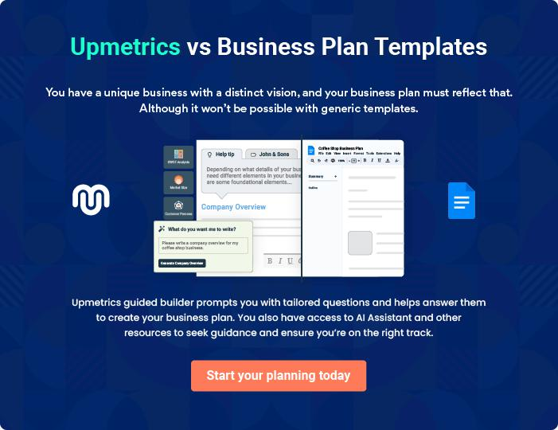
Products and Services

The product and services section of a roadside assistance business plan should describe the specific services and products that will be offered to customers. To write this section should include the following:
To unlock help try Upmetrics! 

 Help tip  Roadside Assistance Business Plan

To craft the introduction for your "Products and Services" chapter, begin by positioning your business within its industry, emphasizing its unique strengths or value proposition.
To unlock help try Upmetrics! 

Start writing here..

 Help tip


Mention the roadside assistance services your business will offer. This list may include services like,
To unlock help try Upmetrics! 

Roadside assistance services

Towing Service


Price: [$100] flat rate for up to 20 miles. Additional [$3] per mile thereafter.

Safely transports vehicles to the desired location or service station, ensuring utmost care and minimal inconvenience to our clients.

Specifications

- Suitable for vehicles up to 3 tons.

- 24/7 availability.

- Equipped with the latest GPS technology for precise location tracking.
Tire Changing Service

Price: [$45] per service.

Skilled technicians replace flat or damaged tires with efficiency and precision, minimizing downtime for the driver.

Specifications

- Supports a wide range of vehicle tire sizes.

- Uses professional-grade tools for efficient service.

- Replacement tires available upon request at additional cost.

Fuel Delivery

Price: [$15] service fee plus the cost of fuel.

Prompt fuel delivery to ensure drivers can safely reach the nearest fueling station without the hassles of a tow.

Specifications

- Provides up to 5 gallons of regular, premium, or diesel fuel.

- Delivery within 30 minutes (location-dependent).
Mobile Mechanic Services

Price: Starts at [$60], varies based on the nature of repairs.

On-the-spot repairs by certified mechanics for minor issues, avoiding the inconvenience of a tow to a service station.

Specifications

- Equipped to handle basic mechanical and electrical issues.

- Carries essential spare parts for common vehicle models.

- Service time varies depending on the complexity of the iss

Battery Replacement

Price: [$120] (includes the cost of a standard battery).

Quick and efficient battery replacement service, ensuring vehicles are back on the road without delay.

Specifications

- Offers a variety of battery brands/models.

- Suitable for most vehicle types.

- Warranty available for selected battery models.
Dead Battery Jump Start

Price: [$35] per service.

Professional technicians jump-start vehicles ensuring safety and no harm to the vehicle's electronic systems.

Specifications

- Utilizes industry-approved jump start kits.

- Suitable for both traditional and hybrid vehicles.

- Pre-service battery assessment to determine if a jump start is the best solution.

Quality Measures

 Help tip  Roadside Assistance Business Plan

This section should explain how you maintain quality standards and consistently provide the highest quality service.
To unlock help try Upmetrics! 

Start writing here..

Additional Services

 Help tip  Roadside Assistance Business Plan

Mention if your roadside assistance company offers any additional services. You may include concierge services, related insurance, law enforcement services, real-time tracking, etc.
To unlock help try Upmetrics! 

Start writing here..

Sales And Marketing Strategies

Writing the sales and marketing strategies section means a list of strategies you will use to attract and retain your clients.
To unlock help try Upmetrics! 

 Help Tip  Roadside Assistance Business Plan


To create an effective introduction for your "Sales and Marketing Strategies" chapter, start by setting the stage within your specific industry or market.
To unlock help try Upmetrics! 

Start writing here..

Unique Selling Proposition (USP)

 Help tip  Roadside Assistance Business Plan

Define your business’s USPs depending on the market you serve, the equipment you use, and the unique services you provide. Identifying USPs will help you plan your marketing strategies.
To unlock help try Upmetrics! 

Start writing here..

Pricing Strategy

 Help tip  Roadside Assistance Business Plan

Describe your pricing strategy—how you plan to price your assistance services and stay competitive in the local market.
To unlock help try Upmetrics! 

Start writing here..

 Help tip  Roadside Assistance Business Plan

Discuss your marketing strategies to market your services.

You may include some of these marketing strategies in your business plan—partnerships and
To unlock help try Upmetrics! 

Marketing strategies

Online


Social Media

Harness the power of social media platforms, Google ads, and email campaigns for targeted promotions

Content Marketing

Regularly update our blog and engage users with informative content about vehicle maintenance and safety.

Offline

Vehicle Signage

Our fleet will act as mobile advertisements, highlighting our services and contact information.

Partnerships & Affiliations

Collaborate with local businesses, automobile clubs, and travel agencies to broaden our reach.

Print Marketing

Distribute brochures and flyers in strategic locations such as gas stations, motels, and restaurants along popular routes.

 Help tip
To unlock help try Upmetrics!

Outline the strategies you’ll implement to maximize your sales. Your sales strategies may include collaboration with insurance companies, auto repair shops and car dealerships, referral programs, customized sales proposals, demonstrations, and trials, etc.



Sales strategies

Partner with Businesses

Partner with insurance companies, auto repair shops, and car dealerships for referrals.

Demonstrations & Trials

Organize events and workshops showcasing our state-of-the-art equipment and expert technicians.

Referral Programs

Incentivize existing customers to

refer our services to others.

 Help tip

Describe your customer retention strategies and how you plan to execute them. For instance, introducing loyalty programs, memberships, subscriptions, referral discounts, etc.
To unlock help try Upmetrics! 

Customer retention

Loyalty Programs

Offer reward points for every service availed, which can be redeemed in future transactions.

Referral Discounts

Memberships & Subscriptions

Provide exclusive benefits to regular clients, ensuring they find more value in sticking with RoadGuardian.

Offer discounts to both the referrer

and the referee, strengthening our

community bond.

Operations Plan

 |  | When writing the operations plan section, it’s important to consider the
 |  | various aspects of your business operations.
 |  |  |  | To unlock help try Upmetrics! 
 Help tip |  |  Roadside Assistance Business Plan


To create an effective introduction for your "Operational Plan" chapter, start by emphasizing the
pivotal role of efficient operations in the success of your business, underscoring how they
directly impact the quality of services delivered.
 |  |  |  | To unlock help try Upmetrics! 
Start writing here..
Staffing & Training
 Help tip |  |  Roadside Assistance Business Plan

Mention your roadside assistance business’s staffing requirements, including the number of employees, vehicle operators, servicemen, CSR, and repair technicians needed.
To unlock help try Upmetrics! 

Start writing here..

Operational Process

 Help tip  Roadside Assistance Business Plan

Outline the processes and procedures you will use to run your roadside assistance business.

Your operational processes may include answering emergency calls, routing, and tracking,
To unlock help try Upmetrics! 

Start writing here..

Equipment & Machinery

 Help tip  Roadside Assistance Business Plan

Include the list of equipment and machinery required for roadside assistance, such as repair tools, vehicles, tow trucks, office equipment, etc.
To unlock help try Upmetrics! 

Start writing here..
Management Team

The management team section provides an overview of the individuals responsible for running your business plan.
To unlock help try Upmetrics! 

 Help tip  Roadside Assistance Business Plan

To craft an introduction for your "Management Team" chapter, begin by emphasizing the crucial role of leadership in the success of any business.
To unlock help try Upmetrics! 

Start writing here..

Key managers

 Help tip  Roadside Assistance Business Plan

Introduce your management and key members of your team, and explain their roles and responsibilities.
To unlock help try Upmetrics! 

Start writing here..


JOHN DOE

CEO & Co-founder - john.doe@example.com

As the driving force behind [RoadGuardian Assistance LLC], John has always been passionate about revolutionizing the roadside assistance industry.

His visionary leadership has been instrumental in setting the gold standard in services offered.


- Educational Background: John is an alumnus of [University Name], where he earned his degree in [Relevant Field].

- Professional Background: Prior to establishing RoadGuardian, he spent [X years] in senior leadership roles within the auto-service industry, honing his business acumen and forging invaluable industry relationships.

JANE DOE

Chief Operating Officer (COO) - jane.doe@example.com

Jane is the operational backbone of RoadGuardian. Her strategic planning and oversight ensure that all functions run smoothly and efficiently, setting the stage for consistent delivery of premium services.


- Educational Background: Graduated from [University Name] with a Master's degree in [Relevant Field].

- Professional Background: Her vast experience includes [X years] in operational management roles within leading auto service companies.


ALICE BROWN

CMO - alice.brown@example.com

Alice leads our dynamic marketing team, ensuring that our brand voice resonates with our target audience. Her strategies have greatly expanded our reach and brand recognition.

- Educational Background: Alice holds an MBA in Marketing from [University Name].

- Professional Background: She boasts over [X years] in marketing leadership roles, with a focus on the automotive and service sectors.


ROBERT BROWN

Operation Manager - robert.brown@example.com

Robert plays a pivotal role, overseeing the day-to-day operations from dispatch to service delivery. His hands-on approach ensures our services are timely and meet the high standards we've set.

- Educational Background: Robert graduated from [University Name] with a degree in [Relevant Field].

- Professional Background: With [X years] in the roadside assistance realm, Robert’s expertise is foundational to our operation's excellence.
Organizational structure

 Help tip  Roadside Assistance Business Plan

Explain the organizational structure of your management team. Include the reporting line and decision-making hierarchy.
To unlock help try Upmetrics! 

Start writing here..

Organization chart


John Doe

CEO


 |  |  | Emily White
Alice Brown | Jane Doe | Robert Brown | Customer Service
Alice Brown | Jane Doe | Operations | Manager
CMO | COO | Operations | Manager
CMO | COO | Manager




Mark Green | Susan Gray
Mark Green | Finance
Tow Truck Lead | Finance
Tow Truck Lead | Manager


Compensation plan

 Help tip  Roadside Assistance Business Plan

Describe your compensation plan for the management and staff. Include their salaries, incentives, and other benefits.
To unlock help try Upmetrics! 

Start writing here..

 Help tip

Mentioning advisors or consultants in your business plans adds credibility to your business idea.
To unlock help try Upmetrics! 

Advisors/Consultants


DR. EMILY JOHNSON

Consultant

An expert in business strategy with [X years] experience, Mr. White's advice has been crucial in our expansion and business development plans.


MR. RICHARD WHITE

Advisor

With [X years] in the automobile industry, Dr. Johnson provides invaluable insights into technological advancements and industry trends.
Financial Plan

When writing the financial plan section of a business plan, it’s important to provide a comprehensive overview of your financial projections for the first few years of your business, You may provide the following:
To unlock help try Upmetrics! 

 Help tip  Roadside Assistance Business Plan


To create an effective introduction for your "Financial Plan" chapter, begin by stressing the critical role of a well-structured financial plan in the success of your venture.
To unlock help try Upmetrics! 

Start writing here..

 Help tip  Roadside Assistance Business Plan

Describe details such as projected revenue, operational costs, and service costs in your projected profit and loss statement. Make sure to include your business’s expected net profit or loss.
To unlock help try Upmetrics! 

Profit & loss statement

Revenue

Cost Of Sales

General Costs

Revenue Specific Costs

Personnel Costs (Direct

Labor)

Gross Margin

Gross Margin (%)

Operating Expense

Payroll Expense

(Indirect Labor)

General Expense

Bad Debt

Amortization of Current

Assets

2023-24 | 2024-25 | 2025-26 | 2026-27 | 2027-28
$0 | $0 | $0 | $0 | $0

$0 | $0 | $0 | $0 | $0
$0 | $0 | $0 | $0 | $0
$0 | $0 | $0 | $0 | $0
$0 | $0 | $0 | $0 | $0

$0 | $0 | $0 | $0 | $0
0% | 0% | 0% | 0% | 0%

$0 | $0 | $0 | $0 | $0
$0 | $0 | $0 | $0 | $0
$0 | $0 | $0 | $0 | $0
$0 | $0 | $0 | $0 | $0
$0 | $0 | $0 | $0 | $0

EBITDA

Additional Expense

Long Term

Depreciation

Gain or loss from Sale

of Assets

EBIT

Interest Expenses

EBT

Income Tax Expense

Total Expense

Net Income

Net Income (%)

2023-24 | 2024-25 | 2025-26 | 2026-27 | 2027-28
$0 | $0 | $0 | $0 | $0
$0 | $0 | $0 | $0 | $0
$0 | $0 | $0 | $0 | $0
$0 | $0 | $0 | $0 | $0
$0 | $0 | $0 | $0 | $0
$0 | $0 | $0 | $0 | $0
$0 | $0 | $0 | $0 | $0
$0 | $0 | $0 | $0 | $0
$0 | $0 | $0 | $0 | $0
$0 | $0 | $0 | $0 | $0
0% | 0% | 0% | 0% | 0%
 |  |  | 2023-24 |  | 2024-25 | 2025-26 | 2026-27 | 2027-28
Retained Earning |  |  | $0 |  | $0 | $0 | $0 | $0
Opening
Owner's Distribution |  |  | $0 |  | $0 | $0 | $0 | $0
Retained Earning |  |  | $0 |  | $0 | $0 | $0 | $0
Closing
 Help tip |  |  |  Roadside Assistance Business Plan


The cash flow for the first few years of your operation should be estimated and described in this section. This may include billing invoices, payment receipts, loan payments, and any other cash flow statements.
To unlock help try Upmetrics! 

Cash flow statement

 | 2023-24 | 2024-25 | 2025-26 | 2026-27 | 2027-28
Cash Received | $0 | $0 | $0 | $0 | $0
Cash Paid | $0 | $0 | $0 | $0 | $0
COS & General Expenses | $0 | $0 | $0 | $0 | $0
Salary & Wages | $0 | $0 | $0 | $0 | $0
Interest | $0 | $0 | $0 | $0 | $0

Sales Tax

Income Tax

Net Cash From

Operations

Assets Sell

Assets Purchase

Net Cash From

Investments

Amount Received

Loan Received

Common Stock

Preferred Stock

Owner's Contribution

Amount Paid

2023-24 | 2024-25 | 2025-26 | 2026-27 | 2027-28
$0 | $0 | $0 | $0 | $0
$0 | $0 | $0 | $0 | $0
$0 | $0 | $0 | $0 | $0

$0 | $0 | $0 | $0 | $0
$0 | $0 | $0 | $0 | $0
$0 | $0 | $0 | $0 | $0

$0 | $0 | $0 | $0 | $0
$0 | $0 | $0 | $0 | $0

$0 | $0 | $0 | $0 | $0
$0 | $0 | $0 | $0 | $0
$0 | $0 | $0 | $0 | $0

Loan Capital $0 $0 $0 $0 $0

 |  |  | 2023-24 |  | 2024-25 | 2025-26 | 2026-27 | 2027-28
Dividends & Distributions |  |  | $0 |  | $0 | $0 | $0 | $0
Net Cash From |  |  | $0 |  | $0 | $0 | $0 | $0
Financing
Summary
Starting Cash |  |  | $0 |  | $0 | $0 | $0 | $0
Cash In |  |  | $0 |  | $0 | $0 | $0 | $0
Cash Out |  |  | $0 |  | $0 | $0 | $0 | $0
Change in Cash |  |  | $0 |  | $0 | $0 | $0 | $0
Ending Cash |  |  | $0 |  | $0 | $0 | $0 | $0
 Help tip |  |  Roadside Assistance Business Plan

Create a projected balance sheet documenting your roadside assistance business’s assets, liabilities, and equity.

To unlock help try Upmetrics! 

Balance sheet

 | 2023-24 | 2024-25 | 2025-26 | 2026-27 | 2027-28
Assets | $0 | $0 | $0 | $0 | $0
Current Assets | $0 | $0 | $0 | $0 | $0
Cash | $0 | $0 | $0 | $0 | $0
Accounts Receivable | $0 | $0 | $0 | $0 | $0
Inventory | $0 | $0 | $0 | $0 | $0
Other Current Assets | $0 | $0 | $0 | $0 | $0
Long Term Assets | $0 | $0 | $0 | $0 | $0
Gross Long Term Assets | $0 | $0 | $0 | $0 | $0
Accumulated Depreciation | $0 | $0 | $0 | $0 | $0

Liabilities & Equity | $0 | $0 | $0 | $0 | $0
Liabilities | $0 | $0 | $0 | $0 | $0
Current Liabilities | $0 | $0 | $0 | $0 | $0
Accounts Payable | $0 | $0 | $0 | $0 | $0
Income Tax Payable | $0 | $0 | $0 | $0 | $0
Sales Tax Payable | $0 | $0 | $0 | $0 | $0
Short Term Debt | $0 | $0 | $0 | $0 | $0
 | 2023-24 | 2024-25 | 2025-26 | 2026-27 | 2027-28
Long Term Liabilities | $0 | $0 | $0 | $0 | $0
Long Term Debt | $0 | $0 | $0 | $0 | $0
Equity | $0 | $0 | $0 | $0 | $0
Paid-in Capital | $0 | $0 | $0 | $0 | $0
Common Stock | $0 | $0 | $0 | $0 | $0
Preferred Stock | $0 | $0 | $0 | $0 | $0
Owner's Contribution | $0 | $0 | $0 | $0 | $0
Retained Earnings | $0 | $0 | $0 | $0 | $0

Check | $0 |  |  | $0 | $0 | $0 | $0
 Help tip |  |  Roadside Assistance Business Plan

Determine and mention your business’s break-even point—the point at which your business costs and revenue will be equal.

This exercise will help you understand how much revenue you need to generate to sustain or be profitable.
To unlock help try Upmetrics! 

Break-even Analysis

 | 2023-24 | 2024-25 | 2025-26 | 2026-27 | 2027-28
Starting Revenue | $0 | $0 | $0 | $0 | $0
Net Revenue | $0 | $0 | $0 | $0 | $0
Closing Revenue | $0 | $0 | $0 | $0 | $0

Starting Expense | $0 | $0 | $0 | $0 | $0
Net Expense | $0 | $0 | $0 | $0 | $0
Closing Expense | $0 | $0 | $0 | $0 | $0

Is Break Even? | 0 | 0 | 0 | 0 | 0
Break Even Month | 0 | 0 | 0 | 0 | 0
Days Required | 0 | 0 | 0 | 0 | 0
Break Even Revenue | $0 | $0 | $0 | $0 | $0
Break Even Units
Financing needs

 Help tip  Roadside Assistance Business Plan

Calculate costs associated with starting a roadside assistance business, and estimate your financing needs and how much capital you need to raise to operate your business.
To unlock help try Upmetrics! 

Start writing here..
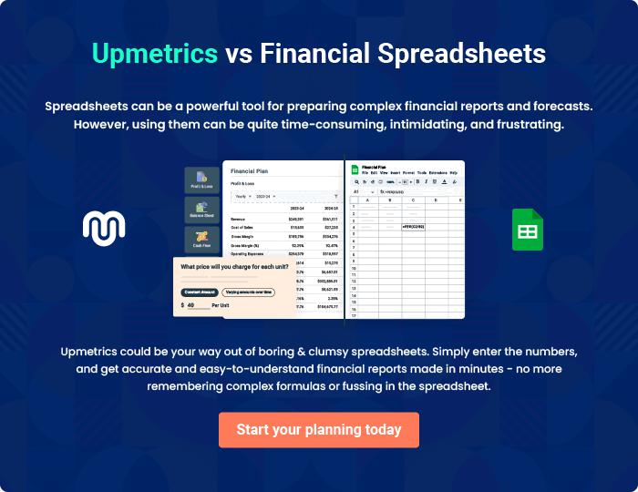
Appendix

When writing the appendix section, you should include any additional information that supports the main content of your plan. This may include financial statements, market research data, legal documents, and other
To unlock help try Upmetrics! 
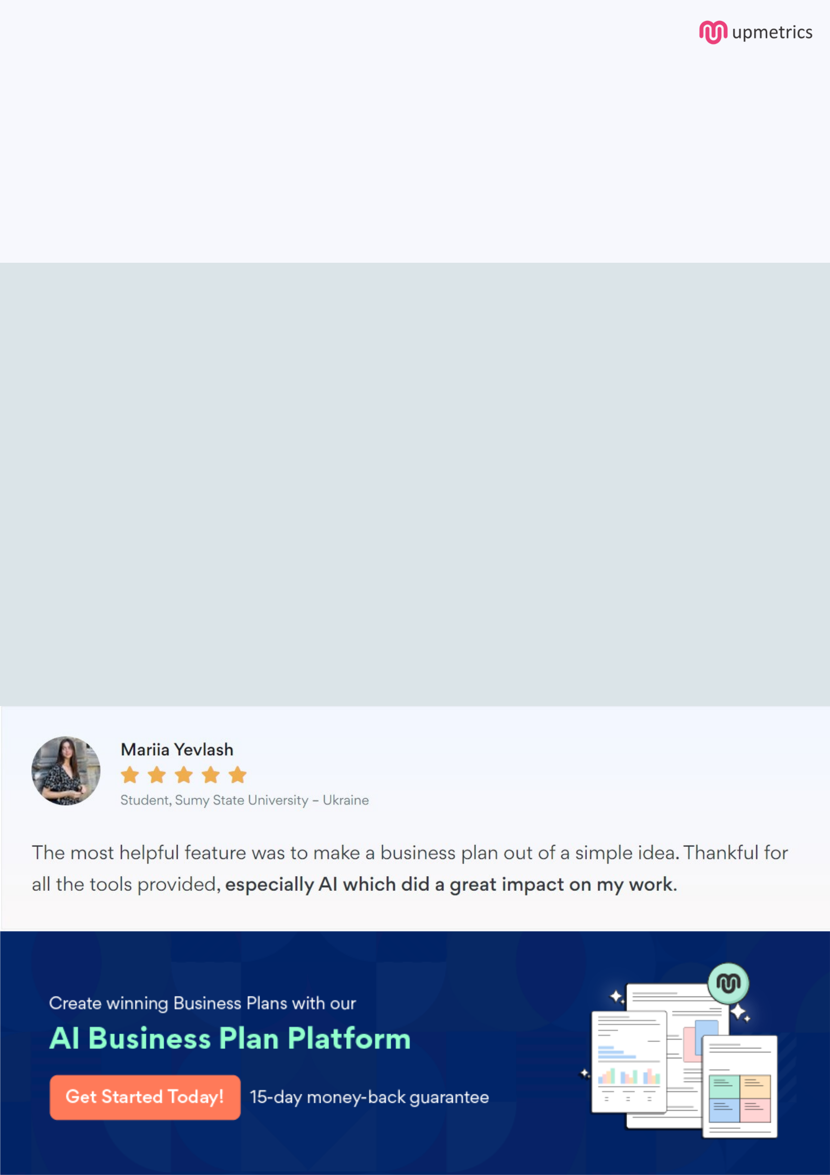
Create a winning business plan that gets you funded

Creating a stunning and investment-ready plan requires no writing, graphic designing, or financial planning expertise.

Upmetrics has all the features required to help you create a comprehensive business plan—from start to finish. Make no mistakes, it’s the modern way of planning to structure ideas, make plans, and create stunning pitch decks to awe investors.

Pitch decks that impress investors

Create pitch decks that provide a visual representation of your business, engage investors, and make them want to invest in your business idea.

Interactive plans in no time

Import business plan sections like—SWOT analysis, comparison tables, and others to create an interactive business plan. No designing skills are required.

Stunning cover page designs

With Upmetrics, you have the liberty to choose from multiple stunning cover page designs. Choose a creative design and make your plan stand out.

Online sharing made simple

Upmetrics makes online sharing quick and easier for users. Easily share your business plans with a link while tracking reader activity.

500+ sample business plans

Simply import a template from our library of sample plans into the editor and start customizing it to make it yours. It takes only a few clicks to get started.

Collaborate with team in real-time

Invite team members, initiate conversations, discuss ideas & strategies, share feedback, and work on a business plan in real-time.

