

Resort Business Plan

Luxury, Tranquility, Resort

Business

Plan

2023

John Doe

10200 Bolsa Ave, Westminster, CA, 92683

- 359-3153 info@example.com http://www.example.com

CONFIDENTIAL

Table of Contents

Executive Summary | 6
Market opportunity | 6
Facilities | 6
Marketing & Sales Strategies | 7
Financial Highlights | 7
Units Sold v/s Revenue | 8

Company Overview | 9
Ownership | 9
Business Owners | 9
Mission statement | 10
Business history | 10
Future goals | 10

Market Analysis | 11
Target Market | 11
Market size and growth potential | 11
Market Size | 12
Competitive analysis | 12
Four Seasons Resorts | 12
Marriott’s Luxury Collection | 13
Aman Resorts | 13
Market trends | 13
Regulatory environment | 14

Products and Services | 15
Amenities & facilities | 15
Deluxe Beachfront Villa | 15
Holistic Spa Treatment | 16
Guided Snorkeling Adventure | 16
Gourmet Seafood Dinner | 16
Corporate Conference Package | 17
Quality Measures | 17
Additional Services | 17

Sales And Marketing Strategies | 18
Unique Selling Proposition (USP) | 18
Pricing Strategy | 18
Marketing strategies | 19
Online | 19
Offline | 19
Sales strategies | 20
Customer retention | 20

Operations Plan | 21
Staffing & Training | 21
Operational Processes | 21
Equipment & Machinery | 22

Management Team | 23
Key managers | 23
John Doe | 24
Jane Doe | 25
Alice Brown | 25
Robert Brown | 26
Organizational structure | 26
Organization chart | 27
Compensation plan | 27
Advisors/Consultants | 28
Dr. Michael Taylor | 28
Emily Johnson | 28
Financial Plan
Financial Plan | 29

Profit & loss statement 29

Cash flow statement | 32
Balance sheet | 34
Break-even Analysis | 36
Financing needs | 38
Appendix
Appendix | 40
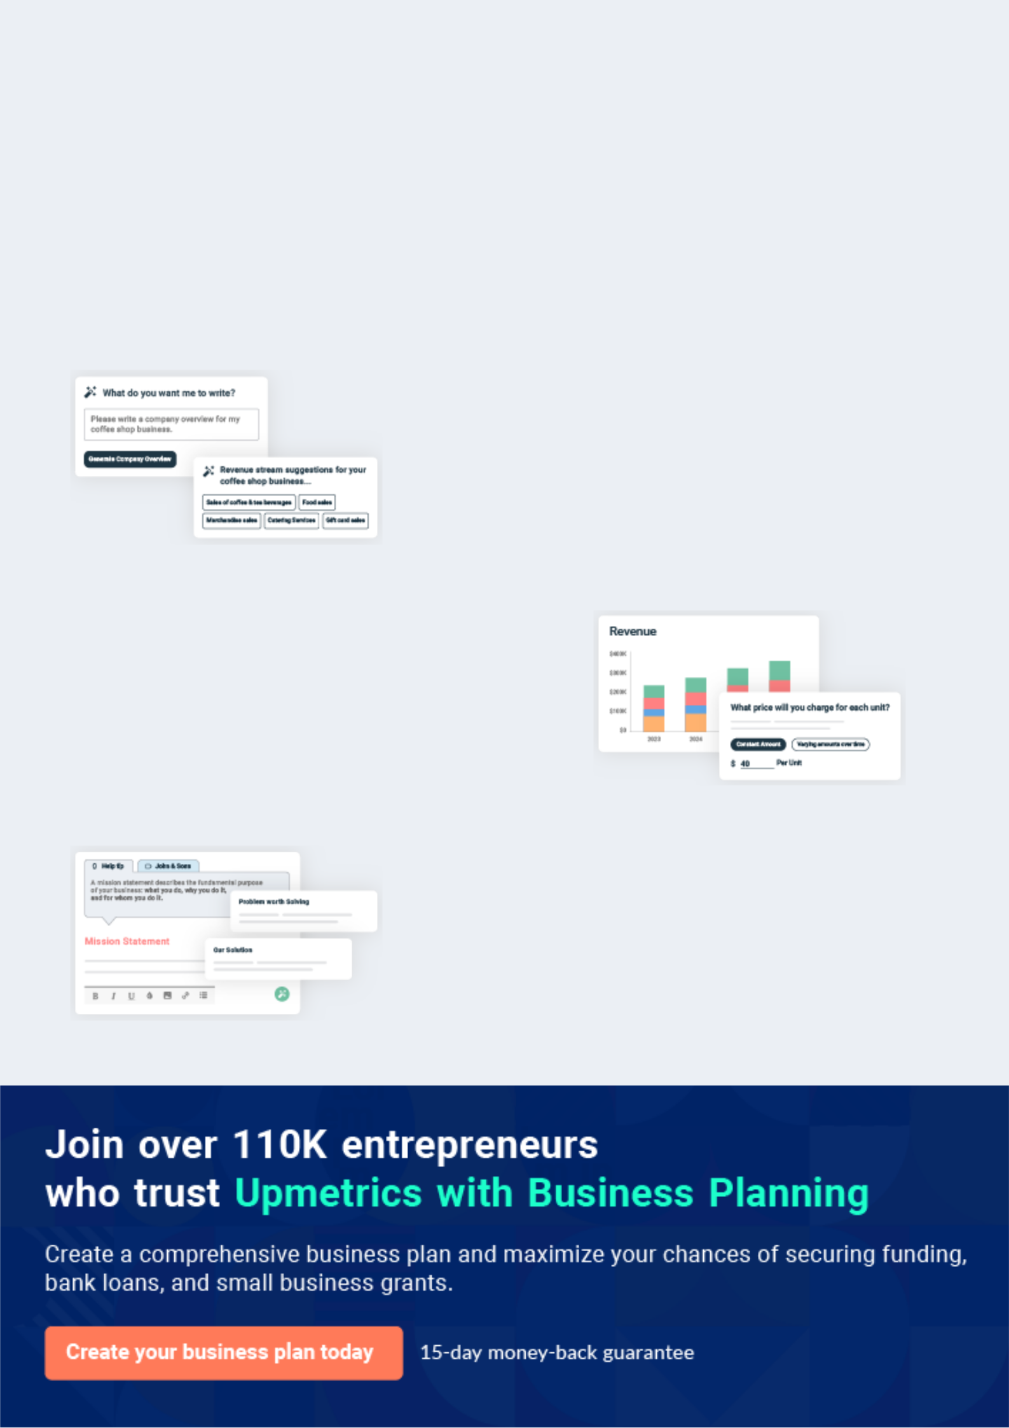
Business planning that’s simpler and faster than you think

Creating a business plan using Upmetrics to start and grow a business is literally the easiest thing in the World. Simply read the instructions and fill in the blanks. It’s as simple as that.

❛ | Upmetrics has everything you need to create a | ❜
❛ | comprehensive business plan. | ❜

AI-powered Upmetrics Assistant

AI-powered insights to streamline your plan

Not sure where to start? Upmetrics’ AI Assistant will automatically generate ideas for each section of your plan and offer improved versions of your writing, adjusting for tone, voice, and grammar or spelling errors.

Financial Forecasting Tool

All the financials are calculated for you

Forget the complex formulas and clumsy spreadsheets — with automatic financials and drag-and-drop forecasting, you can finish your plan faster and be confident that your numbers are accurate.

Business Plan Builder

Guides you like a business mentor

Upmetrics’ step-by-step instructions, prompts, and the library of 400+ sample business plans will guide you through each section of your plan as a business mentor.
Executive Summary


An executive summary is the first section of the business plan intended to provide an overview of the whole business plan.
To unlock help try Upmetrics! 

 Help tip  Resort Business Plan


Start your executive summary by briefly introducing your business to your readers.

This section may include the name of your resort business, its location, when it was founded,
To unlock help try Upmetrics! 

Start writing here..

Market opportunity

 Help tip  Resort Business Plan

Summarize your market research, including market size, growth potential, and marketing trends. Highlight the opportunities in the market and how your business will fit in to fill the gap.
To unlock help try Upmetrics! 

Start writing here..

Facilities

 Help tip  Resort Business Plan

Highlight the resort facilities you offer your clients. The USPs and differentiators you offer are always a plus.
To unlock help try Upmetrics! 

Start writing here..

Marketing & Sales Strategies
To unlock help try Upmetrics!

 Help tip  Resort Business Plan

Outline your sales and marketing strategies—what marketing platforms you use, how you plan on acquiring customers, etc.
To unlock help try Upmetrics! 

Start writing here..

Financial Highlights

 Help tip  Resort Business Plan

Briefly summarize your financial projections for the initial years of business operations. Include any capital or investment requirements, associated startup costs, projected revenues, and profit forecasts.



Start writing here..
Units Sold v/s Revenue

 |  | Units Sold | Revenue
15.00k
10.00k
5.00k
0
Year 1 | Year 2 | Year 3


Financial Year |  |  | Units Sold | Revenue
Year 1 | 1,550 |  |  | $10,000
Year 2 | 1,800 |  |  | $12,000
Year 3 | 2,050 |  |  | $14,000
 Help tip |  |  Resort Business Plan


Summarize your executive summary section with a clear CTA, for example, inviting angel investors to discuss the potential business investment.
To unlock help try Upmetrics! 

Write a call to action for your business plan.
Company Overview

Depending on what details of your business are essential, you’ll need different elements in your business overview.
To unlock help try Upmetrics! 

 Help tip  Resort Business Plan

Describe your business in this section by providing all the basic information:

Describe what kind of resort you run and the name of it. You may specialize in one of the
To unlock help try Upmetrics! 

Start writing here..

Ownership

 Help tip  Resort Business Plan

List the names of your resort’s founders or owners. Describe what shares they own and their responsibilities for efficiently managing the business.
To unlock help try Upmetrics! 

Start writing here..

Business Owners



50% John Doe



50% Jane Doe
Mission statement

 Help tip  Resort Business Plan

Summarize your business’ objective, core principles, and values in your mission statement. This statement needs to be memorable, clear, and brief.
To unlock help try Upmetrics! 

❛ Our mission at [Paradise Palms Resort] is to provide guests with a unique and unforgettable experience that combines the natural beauty of our location with world-class amenities and exceptional service.

We strive to exceed expectations, creating lasting memories for everyone who visits our resort.

❜

Business history

 Help tip  Resort Business Plan

If you’re an established resort, briefly describe your business history, like—when it was founded, how it evolved over time, etc.
To unlock help try Upmetrics! 

Start writing here..

Future goals

 Help tip  Resort Business Plan

It’s crucial to convey your aspirations and vision. Mention your short-term and long-term goals; they can be specific targets for revenue, market share, or expanding your services.
To unlock help try Upmetrics! 

Start writing here..

Market Analysis
To unlock help try Upmetrics!


 |  | Market analysis provides a clear understanding of the market in which your
 |  | printing business will run along with the target market, competitors, and
 |  | growth opportunities.
 |  |  |  | To unlock help try Upmetrics! 
 Help tip |  |  Resort Business Plan

To write the introduction section of your market analysis, start by clearly identifying your primary target market.
To unlock help try Upmetrics! 

Start writing here..

Target Market

 Help tip  Resort Business Plan

Start this section by describing your target market. Define your ideal customer and explain what types of services they prefer. Creating a buyer persona will help you easily define your target market to your readers.



Start writing here..

Market size and growth potential

 Help tip  Resort Business Plan

Describe your market size and growth potential and whether you will target a niche or a much broader market.
To unlock help try Upmetrics! 

Start writing here..

Market Size

Available Market

Global travelers seeking resort 500M accommodations.

Served Market
Travelers within Paradise Palms' 100M geographical reach.

Target Market
Luxury travelers seeking beachfront 10M resorts.

 Help tip  Resort Business Plan

Identify and analyze your direct and indirect competitors. Identify their strengths and weaknesses, and describe what differentiates your resort from them.
To unlock help try Upmetrics! 

Competitive analysis

Four Seasons Resorts

Four Seasons is a globally renowned luxury hotel and resort chain, offering its guests a blend of local culture and the brand's universally high standards of service.

Features Strengths Weaknesses

Luxurious accommodations with modern amenities

Personalized spa treatments

Diverse dining options with international and local cuisines

Adventure and local excursion offerings

Exclusive events and wedding services

Strong brand recognition Premium pricing might alienate

globally some potential guests

Consistent quality across Limited presence in certain

locations geographies

Proven track record in guest

satisfaction

Marriott’s Luxury Collection

Marriott's Luxury Collection is a grouping of unique and historic hotels and resorts across the globe, each characterized by its own distinct identity while being a part of the Marriott brand.

Features

Historic properties with a blend of modern amenities

Destination-specific experiences

Health and wellness facilities, including spas and fitness centers

Diverse gastronomic experiences

Strengths | Weaknesses
Backed by Marriott's vast | While each property is unique,
resources and distribution | the experiences might not be
channels | consistent across resorts
Unique properties with | Limited flexibility due to the
historical significance | constraints of historic buildings
Loyal customer base due to | in some properties
Marriott Bonvoy rewards
program

Aman Resorts

Aman Resorts offers a collection of intimate retreats located in off-the-beaten-path destinations. They focus on providing a serene experience, blending luxury with the natural beauty of the location.

Features | Strengths
Secluded locations providing | Unique and serene locations
privacy | Strong emphasis on guest
Tailored local experiences | privacy and exclusivity
Wellness centers focusing on | Personalized service due to a
holistic health | limited number of rooms
Local artisan involvement in
resort activities

Weaknesses

Premium pricing can be a barrier for many travelers

Limited number of properties worldwide

Market trends

 Help tip  Resort Business Plan

Analyze emerging trends in the industry, such as technology disruptions, changes in customer behavior or preferences, etc. Explain how your business will cope with all the trends.
To unlock help try Upmetrics! 

Start writing here..

Regulatory environment
To unlock help try Upmetrics!

 Help tip  Resort Business Plan

List regulations and licensing requirements that may affect your resort business, such as zoning & land use regulations, licensing & permits, environmental regulations, food & safety laws, health & sanitation regulations, etc.



Start writing here..
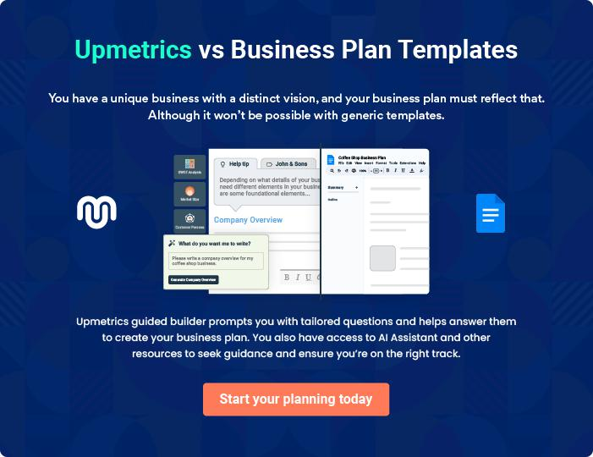
Products and Services

 |  | The product and services section of a resort business plan should describe
 |  | the specific services and products that will be offered to customers. To write
 |  | this section should include the following:
 |  |  |  | To unlock help try Upmetrics! 
 Help tip |  |  Resort Business Plan

To craft the introduction for your "Products and Services" chapter, begin by positioning your business within its industry, emphasizing its unique strengths or value proposition.
To unlock help try Upmetrics! 

Start writing here..

 Help tip


Mention the resort facilities your business will offer. This list may include:

• Accommodation
To unlock help try Upmetrics! 

Amenities & facilities

Deluxe Beachfront Villa


Price: [$1,000] per night

Luxurious private villa situated right on the beach, providing stunning ocean views and exclusive access to the beach.

Specifications

- Size: 2,000 sq. ft.

- Amenities: Private pool, sun deck, modern kitchen, en-suite bathroom, and complimentary Wi-Fi.
Holistic Spa Treatment

Price: [$150] per session

A rejuvenating spa treatment that combines traditional massages with contemporary wellness therapies, tailored to individual needs.

Specifications

- Duration: 90 minutes

- Includes: Aromatherapy, hot stone massage, and personalized wellness consultation.

Guided Snorkeling Adventure

Price: [$75] per person

Explore the vibrant underwater world with our expert-guided snorkeling adventures, suitable for all experience levels.

Specifications

- Duration: 2 hours

- Includes: All necessary snorkeling gear, expert guide, and refreshments.

Gourmet Seafood Dinner

Price: [$50] per person

Savor the flavors of the ocean with our gourmet seafood dinner, featuring locally-sourced ingredients prepared by top chefs.

Specifications

- Includes: Three-course seafood meal, complimentary drink, and live music.

Corporate Conference Package

Price: [$5,000]

Our state-of-the-art conference rooms, equipped with the latest technology, provide the perfect setting for business meetings and conferences.

Specifications

- Duration: 8 hours

- Includes: Conference room rental, audio-visual equipment, catering, and dedicated event coordinator.

Quality Measures

 Help tip  Resort Business Plan

This section should explain how you maintain quality standards and consistently provide the highest quality service.
To unlock help try Upmetrics! 

Start writing here..

Additional Services

 Help tip  Resort Business Plan

Mention if your resort business offers any additional services. You may include services like transportation services, event planning & catering, concierge services, etc.
To unlock help try Upmetrics! 

Start writing here..
Sales And Marketing Strategies
To unlock help try Upmetrics!

Writing the sales and marketing strategies section means a list of strategies you will use to attract and retain your clients.
To unlock help try Upmetrics! 

 Help Tip  Resort Business Plan


To create an effective introduction for your "Sales and Marketing Strategies" chapter, start by setting the stage within your specific industry or market.
To unlock help try Upmetrics! 

Start writing here..

Unique Selling Proposition (USP)

 Help tip  Resort Business Plan

Define your business’s USPs depending on the market you serve, the equipment you use, and the unique services you provide. Identifying USPs will help you plan your marketing strategies.
To unlock help try Upmetrics! 

Start writing here..

Pricing Strategy

 Help tip  Resort Business Plan

Describe your pricing strategy—how you plan to price your services & facilities and stay competitive in the local market. You can mention any discounts you plan on offering to attract new customers.



Start writing here..

 Help tip  Resort Business Plan
To unlock help try Upmetrics!

Discuss your marketing strategies to market your services. You may include some of these marketing strategies in your business plan—social media marketing, Google ads, brochures, email marketing, content marketing, and print marketing.



Marketing strategies

Online


Social Media

Harnessing platforms like [Instagram, Facebook, and Pinterest] to showcase our amenities, share guest testimonials, and promote seasonal offers.

Content Marketing

Engaging travel bloggers, hosting media stays, and publishing articles about the unique experiences at our resort.

Email Marketing

Periodic newsletters highlighting upcoming events, offers, and news about [Paradise Palms Resort].

Google Ads

Strategic bidding on keywords related to luxury resorts in [Westminster] to ensure top visibility for those seeking premium getaways.

Offline

Brochures & Print Media

Collaborating with travel agencies, placing ads in luxury travel magazines, and distributing brochures at strategic points like [airports, upscale malls].

 Help tip  Resort Business Plan

Outline the strategies you’ll implement to maximize your sales. Your sales strategies may include partnering with other businesses, offering referral programs, etc.
To unlock help try Upmetrics! 

Sales strategies

Business Partnerships

Forming alliances with [travel agencies, corporate event planners, and airlines].

Referral Programs

Offering discounts or value-added services to guests who refer friends and family to our resort.

 Help tip  Resort Business Plan

Describe your customer retention strategies and how you plan to execute them. For instance, introducing loyalty programs, discounts on the second visit, personalized service, etc.
To unlock help try Upmetrics! 

Customer retention

Loyalty Programs

Rewarding frequent guests with points that can be redeemed for complimentary stays, spa treatments, or dining experiences.

Personalized Service

Recognizing returning guests, noting their preferences from previous stays, and tailoring services accordingly.

Feedback Loop

Encouraging guests to provide feedback and ensuring their concerns, if any, are addressed promptly.

Operations Plan
To unlock help try Upmetrics!
To unlock help try Upmetrics!

 |  | When writing the operations plan section, it’s important to consider the
 |  | various aspects of your business operations.
 |  |  |  | To unlock help try Upmetrics! 
 Help tip |  |  Resort Business Plan


To create an effective introduction for your "Operational Plan" chapter, start by emphasizing the
pivotal role of efficient operations in the success of your business, underscoring how they
directly impact the quality of services delivered.
 |  |  |  | To unlock help try Upmetrics! 
Start writing here..
Staffing & Training
 Help tip |  |  Resort Business Plan

Mention your business’s staffing requirements, including the number of employees, chefs, or other staff needed. Include their qualifications, the training required, and the duties they will perform.



Start writing here..

Operational Processes

 Help tip  Resort Business Plan

Outline the processes and procedures you will use to run your resort business. Your operational processes may include housekeeping & maintenance, front office operations, food & beverage options, sales & marketing, etc.



Start writing here..

Equipment & Machinery

 Help tip  Resort Business Plan

Include the list of equipment and machinery required for the resort, such as recreational activities equipment, spa & wellness equipment, vehicles, etc.
To unlock help try Upmetrics! 

Start writing here..
Management Team

The management team section provides an overview of the individuals responsible for running your business plan.
To unlock help try Upmetrics! 

 Help tip  Resort Business Plan

To craft an introduction for your "Management Team" chapter, begin by emphasizing the crucial role of leadership in the success of any business.
To unlock help try Upmetrics! 

Start writing here..

Key managers

 Help tip  Resort Business Plan

Introduce your management and key members of your team, and explain their roles and responsibilities.
To unlock help try Upmetrics! 

Start writing here..

JOHN DOE

CEO & Co-founder - john.doe@example.com

John is a visionary leader with a passion for hospitality and a commitment to providing the best possible experience for guests at [Paradise Palms Resort].

He brings a strategic mindset to the resort, always looking for ways to innovate and improve.


- Educational Background: John holds a Bachelor’s degree in Hospitality Management from the University of Hospitality.

- Professional Background: With over 15 years of experience in the hospitality industry, John has worked in various managerial roles, gaining a deep understanding of what it takes to run a successful resort.

JANE DOE

Chief Operating Officer (COO) - jane.doe@example.com

Jane is a dynamic and results-driven operations professional, responsible for ensuring the smooth and efficient day-to-day running of [Paradise Palms Resort].

She works closely with all departments to ensure guest satisfaction is always at the forefront.

- Educational Background: Jane has a Master’s degree in Business Administration from the University of Business and Management.

- Professional Background: Jane has over 10 years of experience in operations management within the hospitality sector, providing her with the skills and knowledge necessary to excel in her role.


ALICE BROWN

CMO - alice.brown@example.com

Alice is a creative and strategic marketing professional, leading the resort's sales and marketing efforts to increase brand awareness and drive revenue.

She is always looking for innovative ways to reach potential guests and keep existing guests coming back.

- Educational Background: Alice graduated with a Bachelor’s degree in Marketing from the University of Marketing and Communication.

- Professional Background: With 8 years of experience in marketing, Alice has worked for various hospitality brands, developing and implementing successful marketing campaigns.

ROBERT BROWN

Operations Manager - robert.brown@example.com

Robert is a dedicated and experienced operations manager, ensuring that all guest needs are met, and the quality of service is consistently high.

He works closely with all departments to ensure a seamless guest experience.

- Educational Background: Robert has a Bachelor’s degree in Hotel Management from the University of Hotel and Resort Management.

- Professional Background: Robert has over 5 years of experience in operations management, specializing in the hospitality sector.

Organizational structure

 Help tip  Resort Business Plan

Explain the organizational structure of your management team. Include the reporting line and decision-making hierarchy.
To unlock help try Upmetrics! 

Start writing here..
Organization chart


John Doe

CEO


Alice Brown

Jane Doe

Robert Brown

CMO



COO


Operations Manager

Emily Smith

Mark Lee

Front Desk Supervisor

Accountant

Compensation plan

 Help tip  Resort Business Plan

Describe your compensation plan for the management and staff. Include their salaries, incentives, and other benefits.
To unlock help try Upmetrics! 

Start writing here..

 Help tip

Mentioning advisors or consultants in your business plans adds credibility to your business idea.
To unlock help try Upmetrics! 

Advisors/Consultants


DR. MICHAEL TAYLOR

Hospitality Advisor

With over [20] years of experience in the hospitality industry, Dr. Taylor provides invaluable advice and insights to ensure the resort operates at the highest standard.


EMILY JOHNSON

Financial Consultant

Emily specializes in financial planning and analysis for businesses in the hospitality sector, aiding in the strategic financial management of [Paradise Palms Resort].
Financial Plan

When writing the financial plan section of a business plan, it’s important to provide a comprehensive overview of your financial projections for the first few years of your business, You may provide the following:
To unlock help try Upmetrics! 

 Help tip  Resort Business Plan


To create an effective introduction for your "Financial Plan" chapter, begin by stressing the critical role of a well-structured financial plan in the success of your venture.
To unlock help try Upmetrics! 

Start writing here..

 Help tip  Resort Business Plan

Describe details such as projected revenue, operational costs, and service costs in your projected profit and loss statement. Make sure to include your business’s expected net profit or loss.
To unlock help try Upmetrics! 

Profit & loss statement

Revenue

Cost Of Sales

General Costs

Revenue Specific Costs

Personnel Costs (Direct

Labor)

Gross Margin

Gross Margin (%)

Operating Expense

Payroll Expense

(Indirect Labor)

General Expense

Bad Debt

Amortization of Current

Assets

2023-24 | 2024-25 | 2025-26 | 2026-27 | 2027-28
$0 | $0 | $0 | $0 | $0

$0 | $0 | $0 | $0 | $0
$0 | $0 | $0 | $0 | $0
$0 | $0 | $0 | $0 | $0
$0 | $0 | $0 | $0 | $0

$0 | $0 | $0 | $0 | $0
0% | 0% | 0% | 0% | 0%

$0 | $0 | $0 | $0 | $0
$0 | $0 | $0 | $0 | $0
$0 | $0 | $0 | $0 | $0
$0 | $0 | $0 | $0 | $0
$0 | $0 | $0 | $0 | $0

EBITDA

Additional Expense

Long Term

Depreciation

Gain or loss from Sale

of Assets

EBIT

Interest Expenses

EBT

Income Tax Expense

Total Expense

Net Income

Net Income (%)

2023-24 | 2024-25 | 2025-26 | 2026-27 | 2027-28
$0 | $0 | $0 | $0 | $0
$0 | $0 | $0 | $0 | $0
$0 | $0 | $0 | $0 | $0
$0 | $0 | $0 | $0 | $0
$0 | $0 | $0 | $0 | $0
$0 | $0 | $0 | $0 | $0
$0 | $0 | $0 | $0 | $0
$0 | $0 | $0 | $0 | $0
$0 | $0 | $0 | $0 | $0
$0 | $0 | $0 | $0 | $0
0% | 0% | 0% | 0% | 0%

 |  |  | 2023-24 |  | 2024-25 | 2025-26
Retained Earning |  |  | $0 |  | $0 | $0
Opening |  |  |  |  | $0 | $0
Owner's Distribution |  |  | $0 |  | $0 | $0
Retained Earning |  |  | $0 |  | $0 | $0
Closing |  |  |  |  | $0 | $0
 Help tip |  |  |  Resort Business Plan


The cash flow for the first few years of your operation should be estimated and described in this section.

This may include billing invoices, payment receipts, loan payments, and any other cash flow statements.
2026-27 2027-28

$0 $0

$0 $0

$0 $0

To unlock help try Upmetrics! 

Cash flow statement

 | 2023-24 | 2024-25 | 2025-26 | 2026-27 | 2027-28
Cash Received | $0 | $0 | $0 | $0 | $0
Cash Paid | $0 | $0 | $0 | $0 | $0
COS & General Expenses | $0 | $0 | $0 | $0 | $0
Salary & Wages | $0 | $0 | $0 | $0 | $0
Interest | $0 | $0 | $0 | $0 | $0

Sales Tax

Income Tax

Net Cash From

Operations

Assets Sell

Assets Purchase

Net Cash From

Investments

Amount Received

Loan Received

Common Stock

Preferred Stock

Owner's Contribution

Amount Paid

2023-24 | 2024-25 | 2025-26 | 2026-27 | 2027-28
$0 | $0 | $0 | $0 | $0
$0 | $0 | $0 | $0 | $0
$0 | $0 | $0 | $0 | $0

$0 | $0 | $0 | $0 | $0
$0 | $0 | $0 | $0 | $0
$0 | $0 | $0 | $0 | $0

$0 | $0 | $0 | $0 | $0
$0 | $0 | $0 | $0 | $0

$0 | $0 | $0 | $0 | $0
$0 | $0 | $0 | $0 | $0
$0 | $0 | $0 | $0 | $0

Loan Capital $0 $0 $0 $0 $0

 |  |  | 2023-24 | 2024-25 | 2025-26 | 2026-27 | 2027-28
Dividends & Distributions |  |  | $0 | $0 | $0 | $0 | $0
Net Cash From |  |  | $0 | $0 | $0 | $0 | $0
Financing
Summary
Starting Cash |  |  | $0 | $0 | $0 | $0 | $0
Cash In |  |  | $0 | $0 | $0 | $0 | $0
Cash Out |  |  | $0 | $0 | $0 | $0 | $0
Change in Cash |  |  | $0 | $0 | $0 | $0 | $0
Ending Cash |  |  | $0 | $0 | $0 | $0 | $0
 Help tip |  |  Resort Business Plan

Create a projected balance sheet documenting your resort business’s assets, liabilities, and equity.

To unlock help try Upmetrics! 

Balance sheet

 | 2023-24 | 2024-25 | 2025-26 | 2026-27 | 2027-28
Assets | $0 | $0 | $0 | $0 | $0
Current Assets | $0 | $0 | $0 | $0 | $0
Cash | $0 | $0 | $0 | $0 | $0
Accounts Receivable | $0 | $0 | $0 | $0 | $0
Inventory | $0 | $0 | $0 | $0 | $0
Other Current Assets | $0 | $0 | $0 | $0 | $0
Long Term Assets | $0 | $0 | $0 | $0 | $0
Gross Long Term Assets | $0 | $0 | $0 | $0 | $0
Accumulated Depreciation | $0 | $0 | $0 | $0 | $0

Liabilities & Equity | $0 | $0 | $0 | $0 | $0
Liabilities | $0 | $0 | $0 | $0 | $0
Current Liabilities | $0 | $0 | $0 | $0 | $0
Accounts Payable | $0 | $0 | $0 | $0 | $0
Income Tax Payable | $0 | $0 | $0 | $0 | $0
Sales Tax Payable | $0 | $0 | $0 | $0 | $0
Short Term Debt | $0 | $0 | $0 | $0 | $0
 | 2023-24 | 2024-25 | 2025-26 | 2026-27 | 2027-28
Long Term Liabilities | $0 | $0 | $0 | $0 | $0
Long Term Debt | $0 | $0 | $0 | $0 | $0
Equity | $0 | $0 | $0 | $0 | $0
Paid-in Capital | $0 | $0 | $0 | $0 | $0
Common Stock | $0 | $0 | $0 | $0 | $0
Preferred Stock | $0 | $0 | $0 | $0 | $0
Owner's Contribution | $0 | $0 | $0 | $0 | $0
Retained Earnings | $0 | $0 | $0 | $0 | $0

Check | $0 |  |  | $0 | $0 | $0 | $0
 Help tip |  |  Resort Business Plan

Determine and mention your business’s break-even point—the point at which your business costs and revenue will be equal.

This exercise will help you understand how much revenue you need to generate to sustain or be profitable.
To unlock help try Upmetrics! 

Break-even Analysis

 | 2023-24 | 2024-25 | 2025-26 | 2026-27 | 2027-28
Starting Revenue | $0 | $0 | $0 | $0 | $0
Net Revenue | $0 | $0 | $0 | $0 | $0
Closing Revenue | $0 | $0 | $0 | $0 | $0

Starting Expense | $0 | $0 | $0 | $0 | $0
Net Expense | $0 | $0 | $0 | $0 | $0
Closing Expense | $0 | $0 | $0 | $0 | $0

Is Break Even? | 0 | 0 | 0 | 0 | 0
Break Even Month | 0 | 0 | 0 | 0 | 0
Days Required | 0 | 0 | 0 | 0 | 0
Break Even Revenue | $0 | $0 | $0 | $0 | $0
Break Even Units
Financing needs

 Help tip  Resort Business Plan

Calculate costs associated with starting a resort business, and estimate your financing needs and how much capital you need to raise to operate your business.
To unlock help try Upmetrics! 

Start writing here..
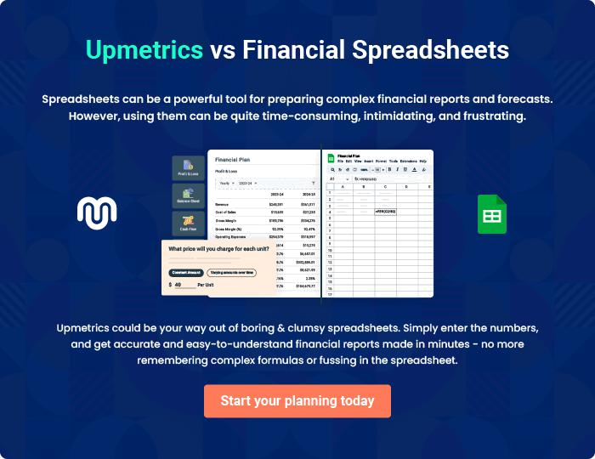
Appendix

When writing the appendix section, you should include any additional information that supports the main content of your plan. This may include financial statements, market research data, legal documents, and other
To unlock help try Upmetrics! 
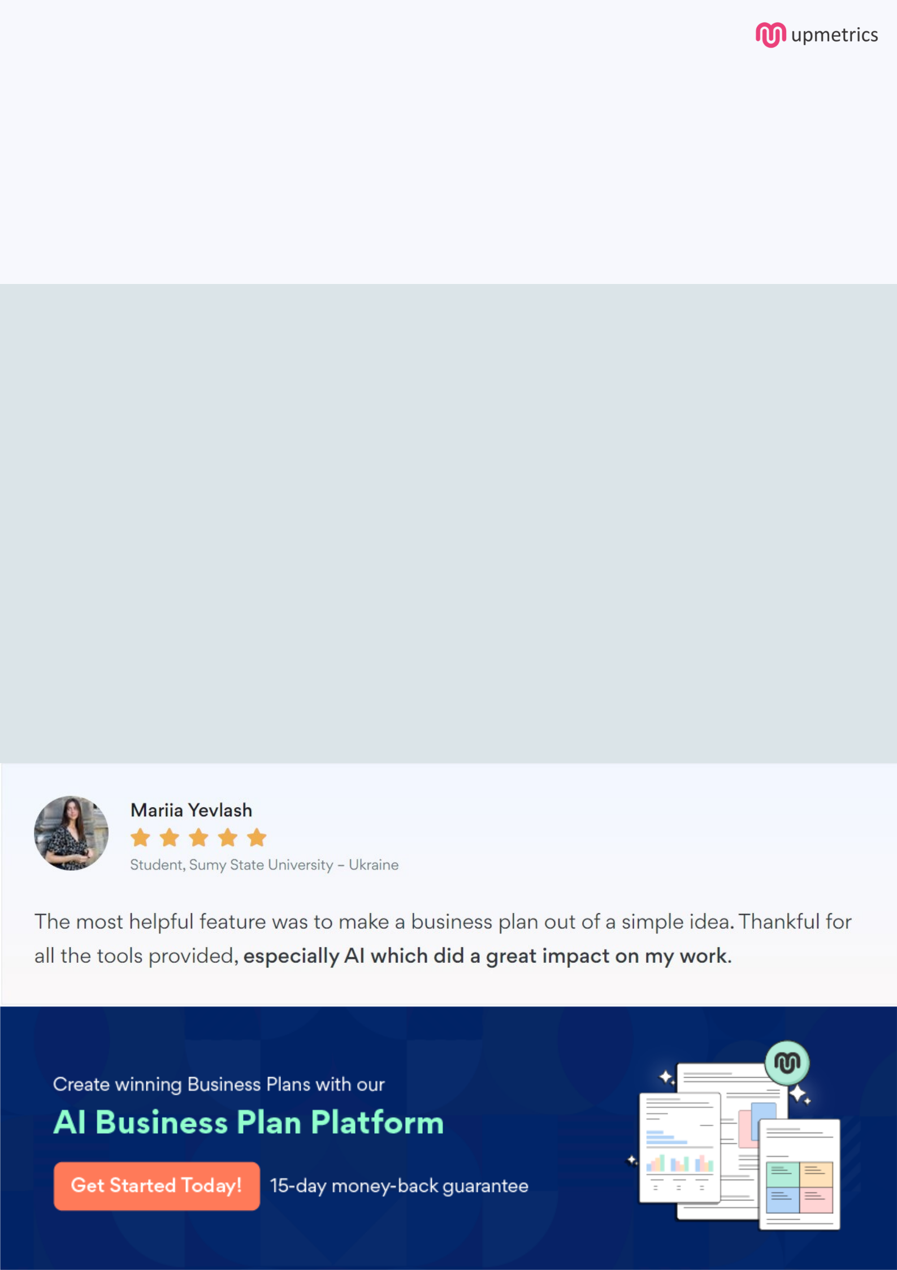
Create a winning business plan that gets you funded

Creating a stunning and investment-ready plan requires no writing, graphic designing, or financial planning expertise.

Upmetrics has all the features required to help you create a comprehensive business plan—from start to finish. Make no mistakes, it’s the modern way of planning to structure ideas, make plans, and create stunning pitch decks to awe investors.

Pitch decks that impress investors

Create pitch decks that provide a visual representation of your business, engage investors, and make them want to invest in your business idea.

Interactive plans in no time

Import business plan sections like—SWOT analysis, comparison tables, and others to create an interactive business plan. No designing skills are required.

Stunning cover page designs

With Upmetrics, you have the liberty to choose from multiple stunning cover page designs. Choose a creative design and make your plan stand out.

Online sharing made simple

Upmetrics makes online sharing quick and easier for users. Easily share your business plans with a link while tracking reader activity.

500+ sample business plans

Simply import a template from our library of sample plans into the editor and start customizing it to make it yours. It takes only a few clicks to get started.

Collaborate with team in real-time

Invite team members, initiate conversations, discuss ideas & strategies, share feedback, and work on a business plan in real-time.

