
BUSINESS PLAN

2023


Renewable Energy Business Plan

Powering Tomorrow, Sustainably

John Doe

10200 Bolsa Ave, Westminster, CA, 92683

- 359-3153 info@example.com http://www.example.com

Information provided in this business plan is unique to this business and confidential; therefore, anyone reading this plan agrees not to disclose any of the information in this business plan without prior written permission of the company.
Table of Contents

Executive Summary | 6
Market opportunity | 6
Services Offered | 6
Marketing & Sales Strategies | 7
Financial Highlights | 7
Units Sold v/s Revenue | 8

Company Overview | 9
Ownership | 9
Mission statement | 10
Business history | 10
Future goals | 11

Market Analysis | 12
Target Market | 12
Market size and growth potential | 12
Market Size | 13
Competitive analysis | 13
SunPower Innovations | 13
WindTech Energy | 14
Market trends | 14
Regulatory environment | 14

Products and Services | 16
Products and Services | 16
Solar Panels | 16
Wind Turbines | 17
Energy Storage Systems | 17
Consultancy & Feasibility Studies | 18
System Design & Engineering | 18

Quality measures 18

Additional Services | 19

Sales And Marketing Strategies | 20
Unique Selling Proposition (USP) | 20
Pricing Strategy | 20
Marketing strategies | 21
Online | 21
Offline | 21
Sales strategies | 22
Customer retention | 22

Operations Plan | 23
Staffing & Training | 23
Operational Process | 23
Equipment & Machinery | 24

Management Team | 25
Key managers | 25
John Doe | 25
Jane Doe | 26
Alice Brown | 26
Robert Brown | 26
Jane Smith | 27
Organizational structure | 27
Organization chart | 28
Compensation plan | 28
Advisors/Consultants | 29
Mr. Richard Gray | 29
Dr. Emily Wilson | 29

Financial Plan | 30
Profit & loss statement | 30
Cash flow statement | 33
Balance sheet | 35
Break-even Analysis | 37
Financing needs | 39
Appendix
Appendix | 41
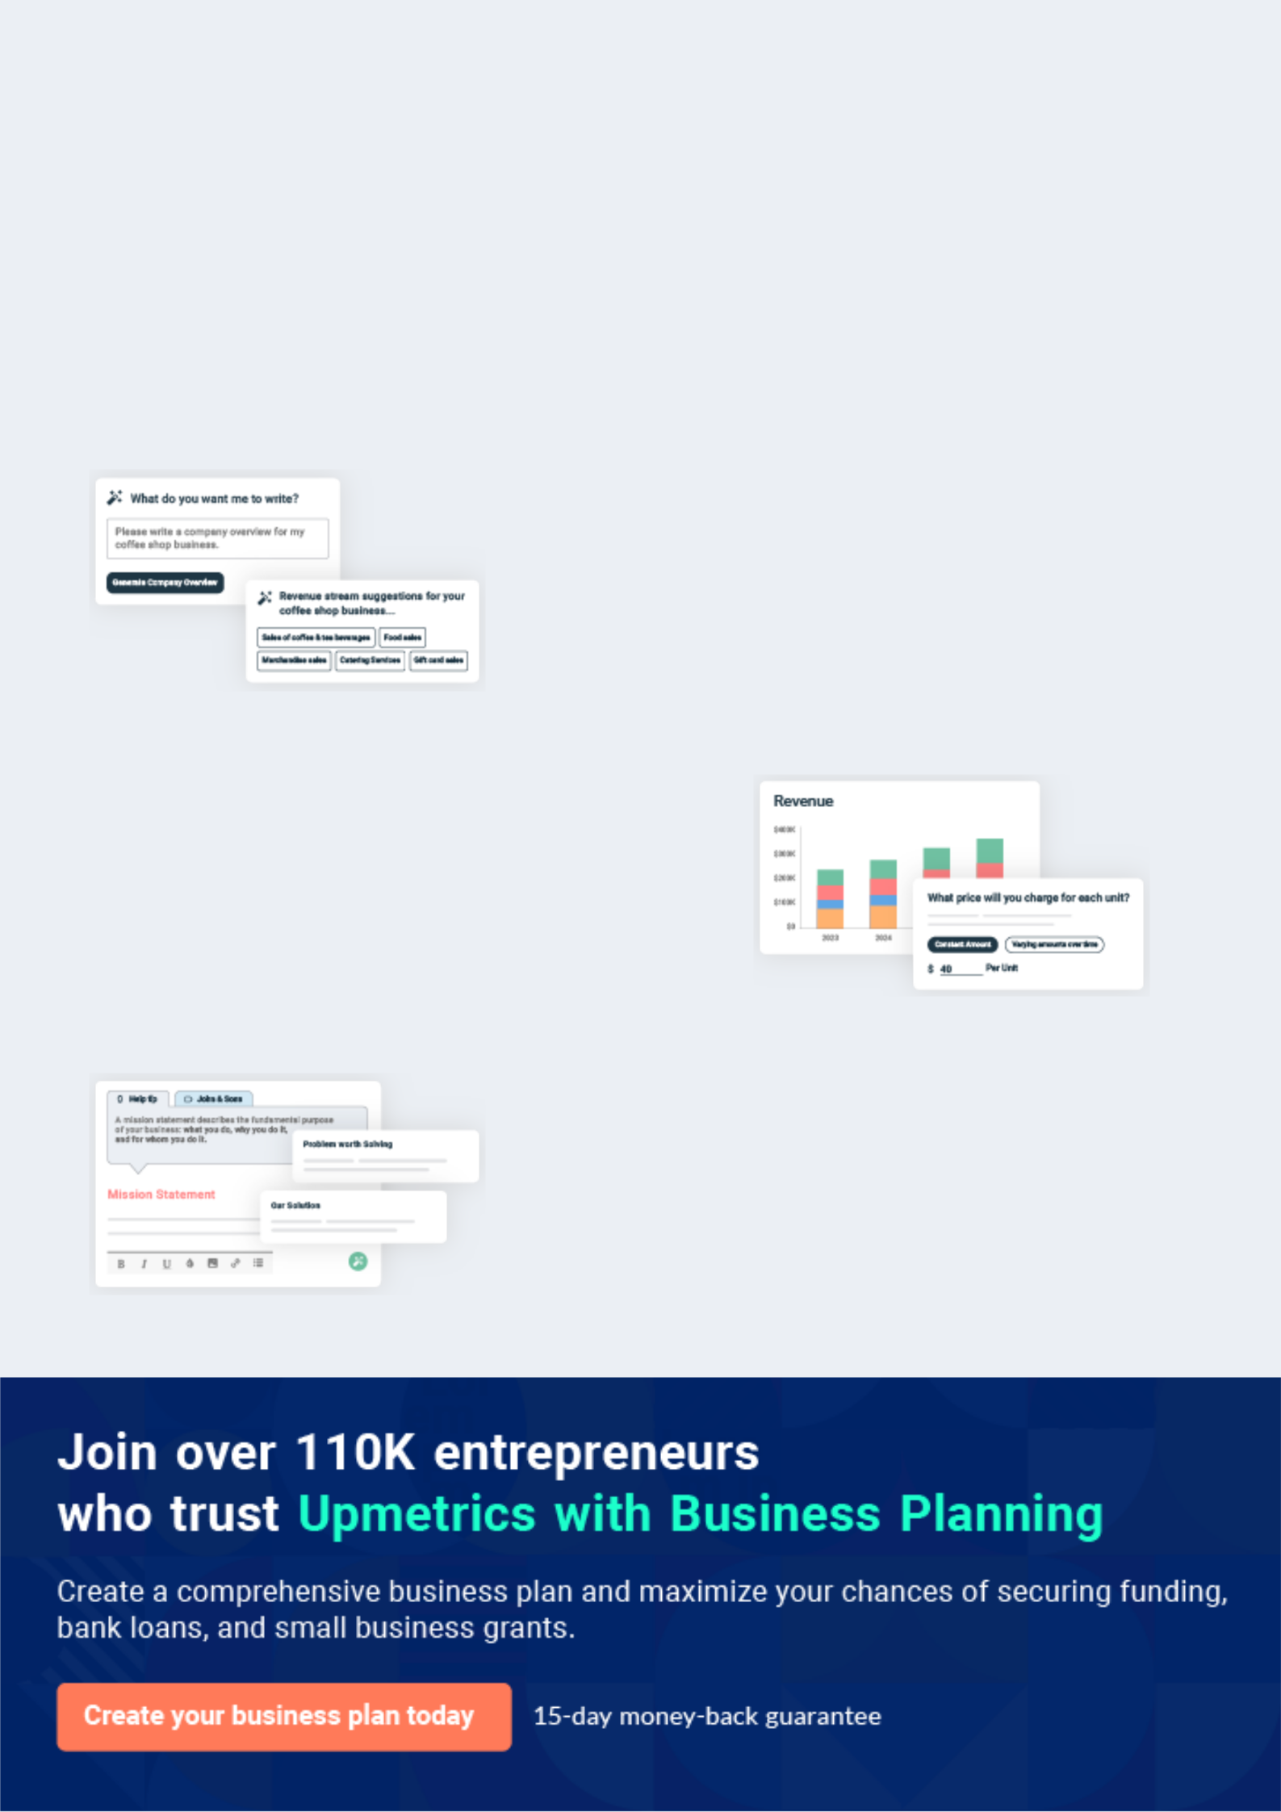
Business planning that’s simpler and faster than you think

Creating a business plan using Upmetrics to start and grow a business is literally the easiest thing in the World. Simply read the instructions and fill in the blanks. It’s as simple as that.

❛ | Upmetrics has everything you need to create a | ❜
❛ | comprehensive business plan. | ❜

AI-powered Upmetrics Assistant

AI-powered insights to streamline your plan

Not sure where to start? Upmetrics’ AI Assistant will automatically generate ideas for each section of your plan and offer improved versions of your writing, adjusting for tone, voice, and grammar or spelling errors.

Financial Forecasting Tool

All the financials are calculated for you

Forget the complex formulas and clumsy spreadsheets — with automatic financials and drag-and-drop forecasting, you can finish your plan faster and be confident that your numbers are accurate.

Business Plan Builder

Guides you like a business mentor

Upmetrics’ step-by-step instructions, prompts, and the library of 400+ sample business plans will guide you through each section of your plan as a business mentor.
Executive Summary


An executive summary is the first section of the business plan intended to provide an overview of the whole business plan.
To unlock help try Upmetrics! 

 Help tip  Renewable Energy Business Plan


Start your executive summary by briefly introducing your business to your readers.

This section may include the name of your renewable energy business, its location, when it was
To unlock help try Upmetrics! 

Start writing here..

Market opportunity

 Help tip  Renewable Energy Business Plan

Summarize your market research, including market size, growth potential, and marketing trends. Highlight the opportunities in the market and how your business will fit in to fill the gap.
To unlock help try Upmetrics! 

Start writing here..

Services Offered

 Help tip  Renewable Energy Business Plan

Highlight the renewable energy services you offer your clients. The USPs and differentiators you offer are always a plus.
To unlock help try Upmetrics! 

Start writing here..

Marketing & Sales Strategies
To unlock help try Upmetrics!

 Help tip  Renewable Energy Business Plan

Outline your sales and marketing strategies—what marketing platforms you use, how you plan on acquiring customers, etc.
To unlock help try Upmetrics! 

Start writing here..

Financial Highlights

 Help tip  Renewable Energy Business Plan

Briefly summarize your financial projections for the initial years of business operations. Include any capital or investment requirements, associated startup costs, projected revenues, and profit forecasts.



Start writing here..
Units Sold v/s Revenue

 |  | Units Sold | Revenue
15.00k
10.00k
5.00k
0
Year 1 | Year 2 | Year 3
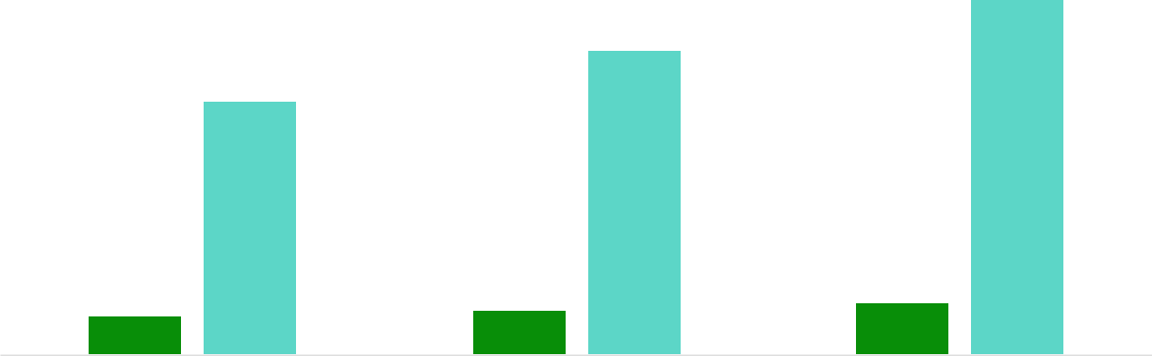

Financial Year |  |  | Units Sold | Revenue
Year 1 | 1,550 |  |  | $10,000
Year 2 | 1,800 |  |  | $12,000
Year 3 | 2,050 |  |  | $14,000
 Help tip |  |  Renewable Energy Business Plan


Summarize your executive summary section with a clear CTA, for example, inviting angel investors to discuss the potential business investment.
To unlock help try Upmetrics! 

Write a call to action for your business plan.
Company Overview

Depending on what details of your business are essential, you’ll need different elements in your business overview.
To unlock help try Upmetrics! 

 Help tip  Renewable Energy Business Plan

Describe your business in this section by providing all the basic information:

Describe what kind of renewable energy company you run and the name of it. You may
To unlock help try Upmetrics! 

Start writing here..

Ownership

 Help tip  Renewable Energy Business Plan

List the names of your renewable energy company’s founders or owners. Describe what shares they own and their responsibilities for efficiently managing the business.
To unlock help try Upmetrics! 

Start writing here..
Mission statement

 Help tip  Renewable Energy Business Plan

Summarize your business’ objective, core principles, and values in your mission statement. This statement needs to be memorable, clear, and brief.
To unlock help try Upmetrics! 

❛ At [GreenFuture Energies], we envision a world empowered by
sustainable and clean energy. Our mission is to innovate, integrate, and instate renewable energy solutions that not only cater to present needs but also forge a path for future generations.

Rooted in integrity, excellence, and commitment, we strive to be the beacon of change in the energy landscape.

❜

Business history

 Help tip  Renewable Energy Business Plan

If you’re an established renewable energy business, briefly describe your business history, like— when it was founded, how it evolved over time, etc.
To unlock help try Upmetrics! 

Start writing here..
Future goals

 Help tip  Renewable Energy Business Plan

It’s crucial to convey your aspirations and vision. Mention your short-term and long-term goals; they can be specific targets for revenue, market share, or expanding your services.
To unlock help try Upmetrics! 

Start writing here..
Market Analysis
To unlock help try Upmetrics!


 |  | Market analysis provides a clear understanding of the market in which your
 |  | printing business will run along with the target market, competitors, and
 |  | growth opportunities.
 |  |  |  | To unlock help try Upmetrics! 
 Help tip |  |  Renewable Energy Business Plan

To write the introduction section of your market analysis, start by clearly identifying your primary target market.
To unlock help try Upmetrics! 

Start writing here..

Target Market

 Help tip  Renewable Energy Business Plan

Start this section by describing your target market. Define your ideal customer and explain what types of services they prefer. Creating a buyer persona will help you easily define your target market to your readers.



Start writing here..

Market size and growth potential

 Help tip  Renewable Energy Business Plan

Describe your market size and growth potential and whether you will target a niche or a much broader market.
To unlock help try Upmetrics! 

Start writing here..

Market Size

Available Market | 1B
Total potential users of renewable | 1B
energy services globally. | 1B
Served Market | 750M
Segment of the total market currently | 750M
using renewable energy solutions
Target Market | 150M
Our focused segment; mid-sized | 150M
businesses transitioning to green | 150M

energy.

 Help tip


Identify and analyze your direct and indirect competitors. Identify their strengths and weaknesses, and describe what differentiates your renewable energy services from them.
To unlock help try Upmetrics! 

Competitive analysis

SunPower Innovations

Established in 2010, SunPower Innovations has been a key player in the renewable energy sector, especially in the solar power segment.

With their headquarters based in [City, State, e.g., "San Francisco, CA"], they have expanded their operations to over [X number, e.g., "10"] states and have a solid international presence in [X countries, e.g., "3 countries"].

Features

Advanced solar panel technology with a [specific feature, e.g., "25-year warranty"].

Turnkey solar solutions for commercial enterprises.

Solar energy storage solutions.

In-house solar financing options.

Strengths

Wide market presence and established brand recognition.

In-house financing allows for competitive pricing and flexible payment solutions.

Extensive R&D department leading to advanced and efficient solar panel technologies.

Weaknesses

Limited to solar energy solutions, not exploring other renewable energy sectors.

Customer service has been a point of contention in certain regions, as per [source, e.g., "Yelp reviews"].

Longer installation times compared to newer entrants in the market.

WindTech Energy
To unlock help try Upmetrics!

WindTech Energy is a front-runner in harnessing wind energy, founded in 2005. With its main operations in [City, State, e.g., "Dallas, TX"], they have set up over [X number, e.g., "200"] wind farms across the nation and ventured into international terrains like [X countries, e.g., "Canada and Mexico"].

Features

State-of-the-art wind turbines capable of harnessing energy in low wind conditions.

Solutions for both onshore and offshore wind farms.

Wind energy consulting for governments and large enterprises.

Maintenance and upgrade services for existing wind energy infrastructures.

Strengths

Pioneers in introducing [specific technology, e.g., "adaptive blade technology"] improving turbine efficiency.

Strong governmental contracts leading to large-scale projects.

Comprehensive maintenance and consultancy services, ensuring longevity and performance.

Weaknesses

High initial setup costs making it less attractive for smaller projects.

Lack of diversification into other renewable energy areas.

Dependency on specific geographical regions for optimal performance.

Market trends

 Help tip  Renewable Energy Business Plan

Analyze emerging trends in the industry, such as technology disruptions, changes in customer behavior or preferences, etc. Explain how your business will cope with all the trends.
To unlock help try Upmetrics! 

Start writing here..

Regulatory environment

 Help tip  Renewable Energy Business Plan

List regulations and licensing requirements that may affect your renewable energy company, such as federal renewable energy policies, State Renewable Portfolio Standards, Power Purchase Agreements, etc.



Start writing here..

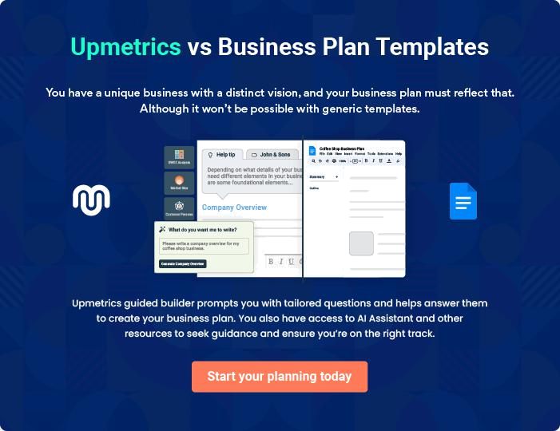
Products and Services

The product and services section of a renewable energy business plan should describe the specific services and products that will be offered to customers. To write this section should include the following:
To unlock help try Upmetrics! 

 Help tip  Renewable Energy Business Plan

To craft the introduction for your "Products and Services" chapter, begin by positioning your business within its industry, emphasizing its unique strengths or value proposition.
To unlock help try Upmetrics! 

Start writing here..

 Help tip

Mention the renewable energy products & services your business will offer. This list may include:
To unlock help try Upmetrics! 

Products and Services

Solar Panels
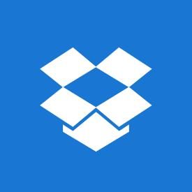

Price: $[250] per panel

High-efficiency photovoltaic panels designed to harness sunlight effectively and convert it into usable electricity.

Specifications

- Type: Monocrystalline/Polycrystalline

- Efficiency: [20%]

- Wattage: [320W]

- Dimensions: [65.7 x 39.4 x 1.26 inches]

- Warranty: [25 years]
Wind Turbines

Price: $[15,000] per unit

Robust turbines tailored for varied terrains, leveraging wind energy to produce clean electricity.

Specifications

- Rotor Diameter: [80 feet]

- Capacity: [2.5MW]

- Tower Height: [220 feet]

- Life Span: [20 years]

- Noise: [Less than 45 dB]

Energy Storage Systems

Price: $[4,500] per system

Advanced battery storage solutions to ensure continuous power supply, especially during peak load times.

Specifications

- Capacity: [10kWh]

- Type: Lithium-ion

- Depth of Discharge: [90%]

- Round Trip Efficiency: [95%]

- Warranty: [10 years]
Consultancy & Feasibility Studies

Price: $[500] per assessment

Expert assessments to determine the viability of renewable energy projects, offering insights into the best energy solutions for specific locales.

Specifications

- Duration: [3-4 weeks]

- Deliverables: Full report including recommendations, ROI analysis, and system designs.

- Areas Covered: Solar potential, wind viability, grid connectivity, and local regulations.

System Design & Engineering

Price: $[2,000] per project

Custom energy system designs that guarantee maximum energy efficiency and seamless integration.

Specifications

- Software Used: [e.g., AutoCAD, HelioScope]

- Design Duration: [1-2 weeks]

- Included: Site layouts, energy yield predictions, shade analyses.

Quality measures

 Help tip  Renewable Energy Business Plan

This section should explain how you maintain quality standards and consistently provide the highest quality service.
To unlock help try Upmetrics! 

Start writing here..

Additional Services
To unlock help try Upmetrics!

 Help tip  Renewable Energy Business Plan

Mention if your renewable energy company offers any additional services. You may include services like energy audits & efficiency assessments, financing & incentive programs, grid integration & energy management, etc.



Start writing here..
Sales And Marketing Strategies
To unlock help try Upmetrics!

Writing the sales and marketing strategies section means a list of strategies you will use to attract and retain your clients.
To unlock help try Upmetrics! 

 Help Tip  Renewable Energy Business Plan


To create an effective introduction for your "Sales and Marketing Strategies" chapter, start by setting the stage within your specific industry or market.
To unlock help try Upmetrics! 

Start writing here..

Unique Selling Proposition (USP)

 Help tip  Renewable Energy Business Plan

Define your business’s USPs depending on the market you serve, the equipment you use, and the unique services you provide. Identifying USPs will help you plan your marketing strategies.
To unlock help try Upmetrics! 

Start writing here..

Pricing Strategy

 Help tip  Renewable Energy Business Plan

Describe your pricing strategy—how you plan to price your products & services and stay competitive in the local market. You can mention any discounts you plan on offering to attract new customers.



Start writing here..

 Help tip  Renewable Energy Business Plan
To unlock help try Upmetrics!

Discuss your marketing strategies to market your services. You may include some of these marketing strategies in your business plan—social media marketing, Google ads, brochures, email marketing, content marketing, and print marketing.



Marketing strategies

Online


Social Media

Leveraging platforms like Facebook, LinkedIn, and Instagram to engage with a younger, environmentally-conscious demographic.

Content Marketing

Informative blogs, articles, and whitepapers that position [GreenFuture Energies] as an industry thought leader.

Email Marketing

Monthly newsletters, case studies, and promotional offers to engage with our subscriber base.

Google Ads

Targeted ad campaigns to capture potential leads actively searching for renewable energy solutions.

Offline

Print Marketing

Brochures, flyers, and magazines for local distribution and trade fairs.

 Help tip

Outline the strategies you’ll implement to maximize your sales. Your sales strategies may include direct sales calls, partnering with other businesses, offering referral programs, etc.
To unlock help try Upmetrics! 

Sales strategies

Partner with Businesses

Collaborating with complementary businesses to co-offer services, tapping into a wider customer base.

Direct Sales Calls

A dedicated sales team actively reaches out to potential leads and nurtures them through the sales funnel.

Referral Programs

Encouraging satisfied customers

to refer [GreenFuture Energies] to

others, with incentives for

successful referrals.

 Help tip

Describe your customer retention strategies and how you plan to execute them. For instance, introducing loyalty programs, discounts & offers, personalized service, etc.
To unlock help try Upmetrics! 

Customer retention

Loyalty Programs

Offering benefits to repeat clients, ensuring they continually choose [GreenFuture Energies].

Feedback and Improvement

Regularly soliciting feedback and making continual improvements based on customer insights.

Personalized Service

Using CRM tools to understand

each customer's history and

preferences, delivering bespoke

service.

Operations Plan

 |  | When writing the operations plan section, it’s important to consider the
 |  | various aspects of your business operations.
 |  |  |  | To unlock help try Upmetrics! 
 Help tip |  |  Renewable Energy Business Plan


To create an effective introduction for your "Operational Plan" chapter, start by emphasizing the
pivotal role of efficient operations in the success of your business, underscoring how they
directly impact the quality of services delivered.
 |  |  |  | To unlock help try Upmetrics! 
Start writing here..
Staffing & Training
 Help tip |  |  Renewable Energy Business Plan

Mention your cleaning business’s staffing requirements, including the number of employees or
other skilled professionals needed. Include their qualifications, the training required, and the
duties they will perform.
 |  |  |  | To unlock help try Upmetrics! 
Start writing here..
Operational Process
 Help tip |  |  Renewable Energy Business Plan

Outline the processes and procedures you will use to run your renewable energy business. Your operational processes may include product development, design & engineering, procurement & logistics, installation, testing & commissioning, performance testing & monitoring, etc.
To unlock help try Upmetrics! 

Start writing here..

Equipment & Machinery
To unlock help try Upmetrics!

 Help tip  Renewable Energy Business Plan

Include the list of equipment and machinery required for renewable energy, such as for solar energy; solar panels, inverters, racks or frames, solar tracking systems, solar charge controllers, etc are needed.



Start writing here..
Management Team

The management team section provides an overview of the individuals responsible for running your business plan.
To unlock help try Upmetrics! 

 Help tip  Renewable Energy Business Plan

To craft an introduction for your "Management Team" chapter, begin by emphasizing the crucial role of leadership in the success of any business.
To unlock help try Upmetrics! 

Start writing here..

Key managers

 Help tip  Renewable Energy Business Plan

Introduce your management and key members of your team, and explain their roles and responsibilities.
To unlock help try Upmetrics! 

Start writing here..


JOHN DOE

Founder and CEO - john.doe@example.com

- Educational Background: John holds a Master's in Renewable Energy Engineering from [Stanford University]. He further augmented his academic credentials with an MBA from [Harvard Business School].


• Professional Background: John began his career as an energy consultant for major corporations, working on strategic integrations of renewable energy solutions.

Before founding [GreenFuture Energies], he served as a VP of Operations for a renowned solar energy firm for 10 years.

JANE DOE

Chief Operating Officer (COO) - jane.doe@example.com

- Educational Background: Jane earned her Bachelor's in Electrical Engineering from [MIT] and later pursued her MBA from [Wharton School of Business].

- Professional Background: With a strong foundation in energy systems, Jane transitioned into operational roles early in her career.


She played a significant role as an operations director for a wind energy company for over 8 years, optimizing processes and scaling projects.


ALICE BROWN

CMO - alice.brown@example.com

- Educational Background: Alice holds a degree in Marketing and Communications from [UCLA] and has additional certifications in Digital Marketing from [Oxford University].

- Professional Background: Alice's expertise lies in creating compelling narratives for green initiatives.

She served as a marketing lead in a biomass energy startup for 6 years, where she crafted successful campaigns that resonated with a global audience.


ROBERT BROWN

Operations Manager - robert.brown@example.com

- Educational Background: Robert graduated with a BSc in Mechanical Engineering from [Georgia Tech] and further specialized with a Master's in Sustainable Energy from [Cambridge University].

- Professional Background: Robert’s acumen in renewable energy systems led him to various managerial roles in the sector.

Before joining [GreenFuture Energies], he was instrumental in setting up the offshore wind energy operations for a major corporation for 7 years.

JANE SMITH

Customer Services Manager - jane.smith@example.com

- Educational Background: Jane pursued her Bachelor's in Business Administration from [New York University] with a specialization in Customer Relationship Management.

• Professional Background: Passionate about fostering client relationships, Jane managed customer service teams in two major hydro energy companies over a span of 8 years, ensuring high satisfaction rates and proactive issue resolutions.

Organizational structure

 Help tip  Renewable Energy Business Plan

Explain the organizational structure of your management team. Include the reporting line and decision-making hierarchy.
To unlock help try Upmetrics! 

Start writing here..

Organization chart


Alice Brown

CMO


Jane Smith

Customer Service

Manager

John Doe

CEO
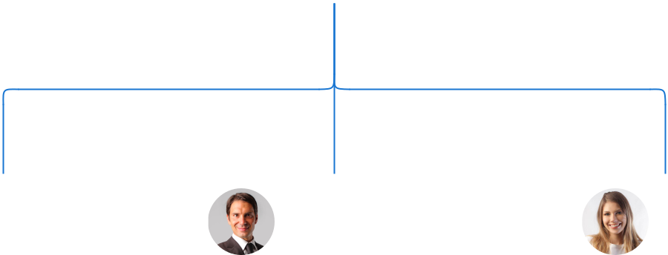

Robert Brown Jane Doe

Operations Manager COO



Ellen Gray Tom White

HR Manager Finance Manager

Compensation plan

 Help tip  Renewable Energy Business Plan

Describe your compensation plan for the management and staff. Include their salaries, incentives, and other benefits.
To unlock help try Upmetrics! 

Start writing here..

 Help tip

Mentioning advisors or consultants in your business plans adds credibility to your business idea.
To unlock help try Upmetrics! 

Advisors/Consultants


MR. RICHARD GRAY

Advisor

A veteran in renewable energy policy with over [30 years] of experience. He advises on regulatory compliance and market entry strategies.


DR. EMILY WILSON

Consultant

With a Ph.D. in Environmental Sciences, she consults on sustainability and green innovation, boasting [20 years] in the field.
Financial Plan

When writing the financial plan section of a business plan, it’s important to provide a comprehensive overview of your financial projections for the first few years of your business, You may provide the following:
To unlock help try Upmetrics! 

 Help tip  Renewable Energy Business Plan


To create an effective introduction for your "Financial Plan" chapter, begin by stressing the critical role of a well-structured financial plan in the success of your venture.
To unlock help try Upmetrics! 

Start writing here..

 Help tip


Describe details such as projected revenue, operational costs, and service costs in your projected profit and loss statement. Make sure to include your business’s expected net profit or loss.
To unlock help try Upmetrics! 

Profit & loss statement

Revenue

Cost Of Sales

General Costs

Revenue Specific Costs

Personnel Costs (Direct

Labor)

Gross Margin

Gross Margin (%)

Operating Expense

Payroll Expense

(Indirect Labor)

General Expense

Bad Debt

Amortization of Current

Assets

2023-24 | 2024-25 | 2025-26 | 2026-27 | 2027-28
$0 | $0 | $0 | $0 | $0

$0 | $0 | $0 | $0 | $0
$0 | $0 | $0 | $0 | $0
$0 | $0 | $0 | $0 | $0
$0 | $0 | $0 | $0 | $0

$0 | $0 | $0 | $0 | $0
0% | 0% | 0% | 0% | 0%

$0 | $0 | $0 | $0 | $0
$0 | $0 | $0 | $0 | $0
$0 | $0 | $0 | $0 | $0
$0 | $0 | $0 | $0 | $0
$0 | $0 | $0 | $0 | $0

EBITDA

Additional Expense

Long Term

Depreciation

Gain or loss from Sale

of Assets

EBIT

Interest Expenses

EBT

Income Tax Expense

Total Expense

Net Income

Net Income (%)

2023-24 | 2024-25 | 2025-26 | 2026-27 | 2027-28
$0 | $0 | $0 | $0 | $0
$0 | $0 | $0 | $0 | $0
$0 | $0 | $0 | $0 | $0
$0 | $0 | $0 | $0 | $0
$0 | $0 | $0 | $0 | $0
$0 | $0 | $0 | $0 | $0
$0 | $0 | $0 | $0 | $0
$0 | $0 | $0 | $0 | $0
$0 | $0 | $0 | $0 | $0
$0 | $0 | $0 | $0 | $0
0% | 0% | 0% | 0% | 0%
 |  |  | 2023-24 |  | 2024-25 | 2025-26 | 2026-27 | 2027-28
Retained Earning |  |  | $0 |  | $0 | $0 | $0 | $0
Opening
Owner's Distribution |  |  | $0 |  | $0 | $0 | $0 | $0
Retained Earning |  |  | $0 |  | $0 | $0 | $0 | $0
Closing
 Help tip |  |  |  Renewable Energy Business Plan


The cash flow for the first few years of your operation should be estimated and described in this section. This may include billing invoices, payment receipts, loan payments, and any other cash flow statements.
To unlock help try Upmetrics! 

Cash flow statement

 | 2023-24 | 2024-25 | 2025-26 | 2026-27 | 2027-28
Cash Received | $0 | $0 | $0 | $0 | $0
Cash Paid | $0 | $0 | $0 | $0 | $0
COS & General Expenses | $0 | $0 | $0 | $0 | $0
Salary & Wages | $0 | $0 | $0 | $0 | $0
Interest | $0 | $0 | $0 | $0 | $0

Sales Tax

Income Tax

Net Cash From

Operations

Assets Sell

Assets Purchase

Net Cash From

Investments

Amount Received

Loan Received

Common Stock

Preferred Stock

Owner's Contribution

Amount Paid

2023-24 | 2024-25 | 2025-26 | 2026-27 | 2027-28
$0 | $0 | $0 | $0 | $0
$0 | $0 | $0 | $0 | $0
$0 | $0 | $0 | $0 | $0

$0 | $0 | $0 | $0 | $0
$0 | $0 | $0 | $0 | $0
$0 | $0 | $0 | $0 | $0

$0 | $0 | $0 | $0 | $0
$0 | $0 | $0 | $0 | $0

$0 | $0 | $0 | $0 | $0
$0 | $0 | $0 | $0 | $0
$0 | $0 | $0 | $0 | $0

Loan Capital $0 $0 $0 $0 $0

 |  |  | 2023-24 |  | 2024-25 | 2025-26 | 2026-27 | 2027-28
Dividends & Distributions |  |  | $0 |  | $0 | $0 | $0 | $0
Net Cash From |  |  | $0 |  | $0 | $0 | $0 | $0
Financing
Summary
Starting Cash |  |  | $0 |  | $0 | $0 | $0 | $0
Cash In |  |  | $0 |  | $0 | $0 | $0 | $0
Cash Out |  |  | $0 |  | $0 | $0 | $0 | $0
Change in Cash |  |  | $0 |  | $0 | $0 | $0 | $0
Ending Cash |  |  | $0 |  | $0 | $0 | $0 | $0
 Help tip |  |  Renewable Energy Business Plan

Create a projected balance sheet documenting your renewable energy business’s assets, liabilities, and equity.

To unlock help try Upmetrics! 

Balance sheet

 | 2023-24 | 2024-25 | 2025-26 | 2026-27 | 2027-28
Assets | $0 | $0 | $0 | $0 | $0
Current Assets | $0 | $0 | $0 | $0 | $0
Cash | $0 | $0 | $0 | $0 | $0
Accounts Receivable | $0 | $0 | $0 | $0 | $0
Inventory | $0 | $0 | $0 | $0 | $0
Other Current Assets | $0 | $0 | $0 | $0 | $0
Long Term Assets | $0 | $0 | $0 | $0 | $0
Gross Long Term Assets | $0 | $0 | $0 | $0 | $0
Accumulated Depreciation | $0 | $0 | $0 | $0 | $0

Liabilities & Equity | $0 | $0 | $0 | $0 | $0
Liabilities | $0 | $0 | $0 | $0 | $0
Current Liabilities | $0 | $0 | $0 | $0 | $0
Accounts Payable | $0 | $0 | $0 | $0 | $0
Income Tax Payable | $0 | $0 | $0 | $0 | $0
Sales Tax Payable | $0 | $0 | $0 | $0 | $0
Short Term Debt | $0 | $0 | $0 | $0 | $0
 | 2023-24 | 2024-25 | 2025-26 | 2026-27 | 2027-28
Long Term Liabilities | $0 | $0 | $0 | $0 | $0
Long Term Debt | $0 | $0 | $0 | $0 | $0
Equity | $0 | $0 | $0 | $0 | $0
Paid-in Capital | $0 | $0 | $0 | $0 | $0
Common Stock | $0 | $0 | $0 | $0 | $0
Preferred Stock | $0 | $0 | $0 | $0 | $0
Owner's Contribution | $0 | $0 | $0 | $0 | $0
Retained Earnings | $0 | $0 | $0 | $0 | $0

Check | $0 |  |  | $0 | $0 | $0 | $0
 Help tip |  |  Renewable Energy Business Plan

Determine and mention your business’s break-even point—the point at which your business costs and revenue will be equal.

This exercise will help you understand how much revenue you need to generate to sustain or be profitable.
To unlock help try Upmetrics! 

Break-even Analysis

 | 2023-24 | 2024-25 | 2025-26 | 2026-27 | 2027-28
Starting Revenue | $0 | $0 | $0 | $0 | $0
Net Revenue | $0 | $0 | $0 | $0 | $0
Closing Revenue | $0 | $0 | $0 | $0 | $0

Starting Expense | $0 | $0 | $0 | $0 | $0
Net Expense | $0 | $0 | $0 | $0 | $0
Closing Expense | $0 | $0 | $0 | $0 | $0

Is Break Even? | 0 | 0 | 0 | 0 | 0
Break Even Month | 0 | 0 | 0 | 0 | 0
Days Required | 0 | 0 | 0 | 0 | 0
Break Even Revenue | $0 | $0 | $0 | $0 | $0
Break Even Units
Financing needs

 Help tip  Renewable Energy Business Plan

Calculate costs associated with starting a renewable energy business, and estimate your financing needs and how much capital you need to raise to operate your business.
To unlock help try Upmetrics! 

Start writing here..
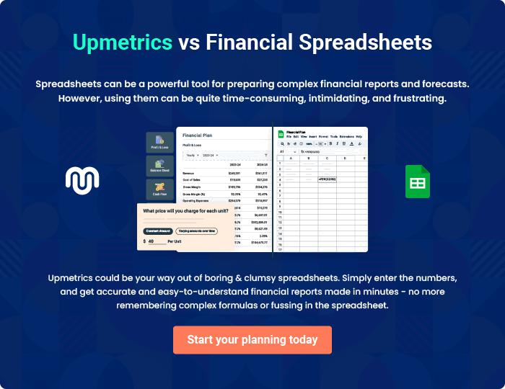
Appendix

When writing the appendix section, you should include any additional information that supports the main content of your plan. This may include financial statements, market research data, legal documents, and other
To unlock help try Upmetrics! 
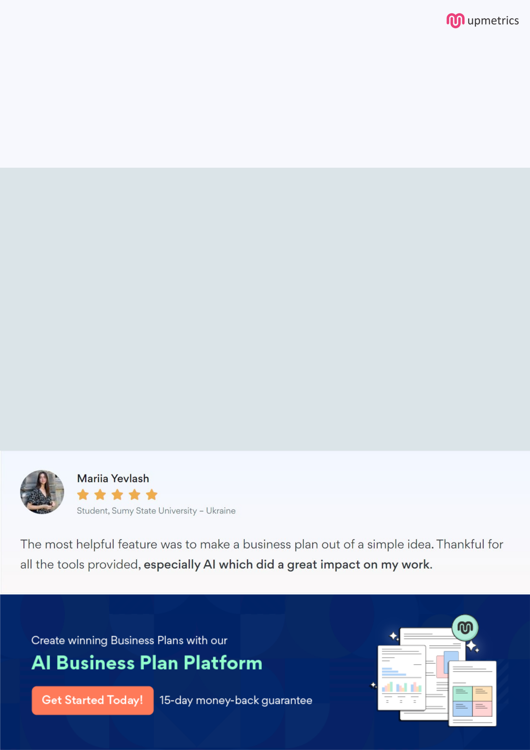
Create a winning business plan that gets you funded

Creating a stunning and investment-ready plan requires no writing, graphic designing, or financial planning expertise.

Upmetrics has all the features required to help you create a comprehensive business plan—from start to finish. Make no mistakes, it’s the modern way of planning to structure ideas, make plans, and create stunning pitch decks to awe investors.

Pitch decks that impress investors

Create pitch decks that provide a visual representation of your business, engage investors, and make them want to invest in your business idea.

Interactive plans in no time

Import business plan sections like—SWOT analysis, comparison tables, and others to create an interactive business plan. No designing skills are required.

Stunning cover page designs

With Upmetrics, you have the liberty to choose from multiple stunning cover page designs. Choose a creative design and make your plan stand out.

Online sharing made simple

Upmetrics makes online sharing quick and easier for users. Easily share your business plans with a link while tracking reader activity.

500+ sample business plans

Simply import a template from our library of sample plans into the editor and start customizing it to make it yours. It takes only a few clicks to get started.

Collaborate with team in real-time

Invite team members, initiate conversations, discuss ideas & strategies, share feedback, and work on a business plan in real-time.

