

Public Relations Business Plan

Communication, Influence, Success

Business Plan

2023

John Doe

10200 Bolsa Ave, Westminster, CA, 92683

- 359-3153 info@example.com http://www.example.com

Information provided in this business plan is unique to this business and confidential; therefore, anyone reading this plan agrees not to disclose any of the information in this business plan without prior written permission of the company.
Table of Contents

Executive Summary | 6
Market opportunity | 6
Services Offered | 6
Marketing & Sales Strategies | 7
Financial Highlights | 7
Units Sold v/s Revenue | 8

Company Overview | 9
Ownership | 9
Mission statement | 10
Business history | 10
Future goals | 10

Market Analysis | 11
Target Market | 11
Market size and growth potential | 11
Market Size | 12
Competitive analysis | 12
GlobalPR Nexus | 12
NextGen Communique | 13
Classic Comm & Co. | 13
Market trends | 13
Regulatory environment | 14

Products and Services | 15
Public relations services | 15
Media Relations | 16
Crisis Communications | 16
Strategic Communications Planning | 17
Reputation Management | 17
Content Creation and Management | 18
Social Media Management | 18
Event Management | 19
Stakeholder Engagement | 19
Additional Services | 20

Sales And Marketing Strategies | 21
Unique Selling Proposition (USP) | 21
Pricing Strategy | 21
Marketing strategies | 22
Online | 22
Offline | 22
Sales strategies | 23
Customer retention | 24

Operations Plan | 25
Staffing & Training | 25
Operational Process | 25
Equipment & Software | 26

Management Team | 27
Key managers | 27
John Doe | 28
Jane Doe | 29
Alice Brown | 29
Robert Brown | 29
Organizational structure | 30
Organization chart | 30
Compensation plan | 30
Advisors/Consultants | 31
Dr. Sarah White | 31
Mr. James Green | 31
Financial Plan
Financial Plan | 32

Profit & loss statement 32

Cash flow statement | 35
Balance sheet | 37
Break-even Analysis | 39
Financing needs | 41
Appendix
Appendix | 43
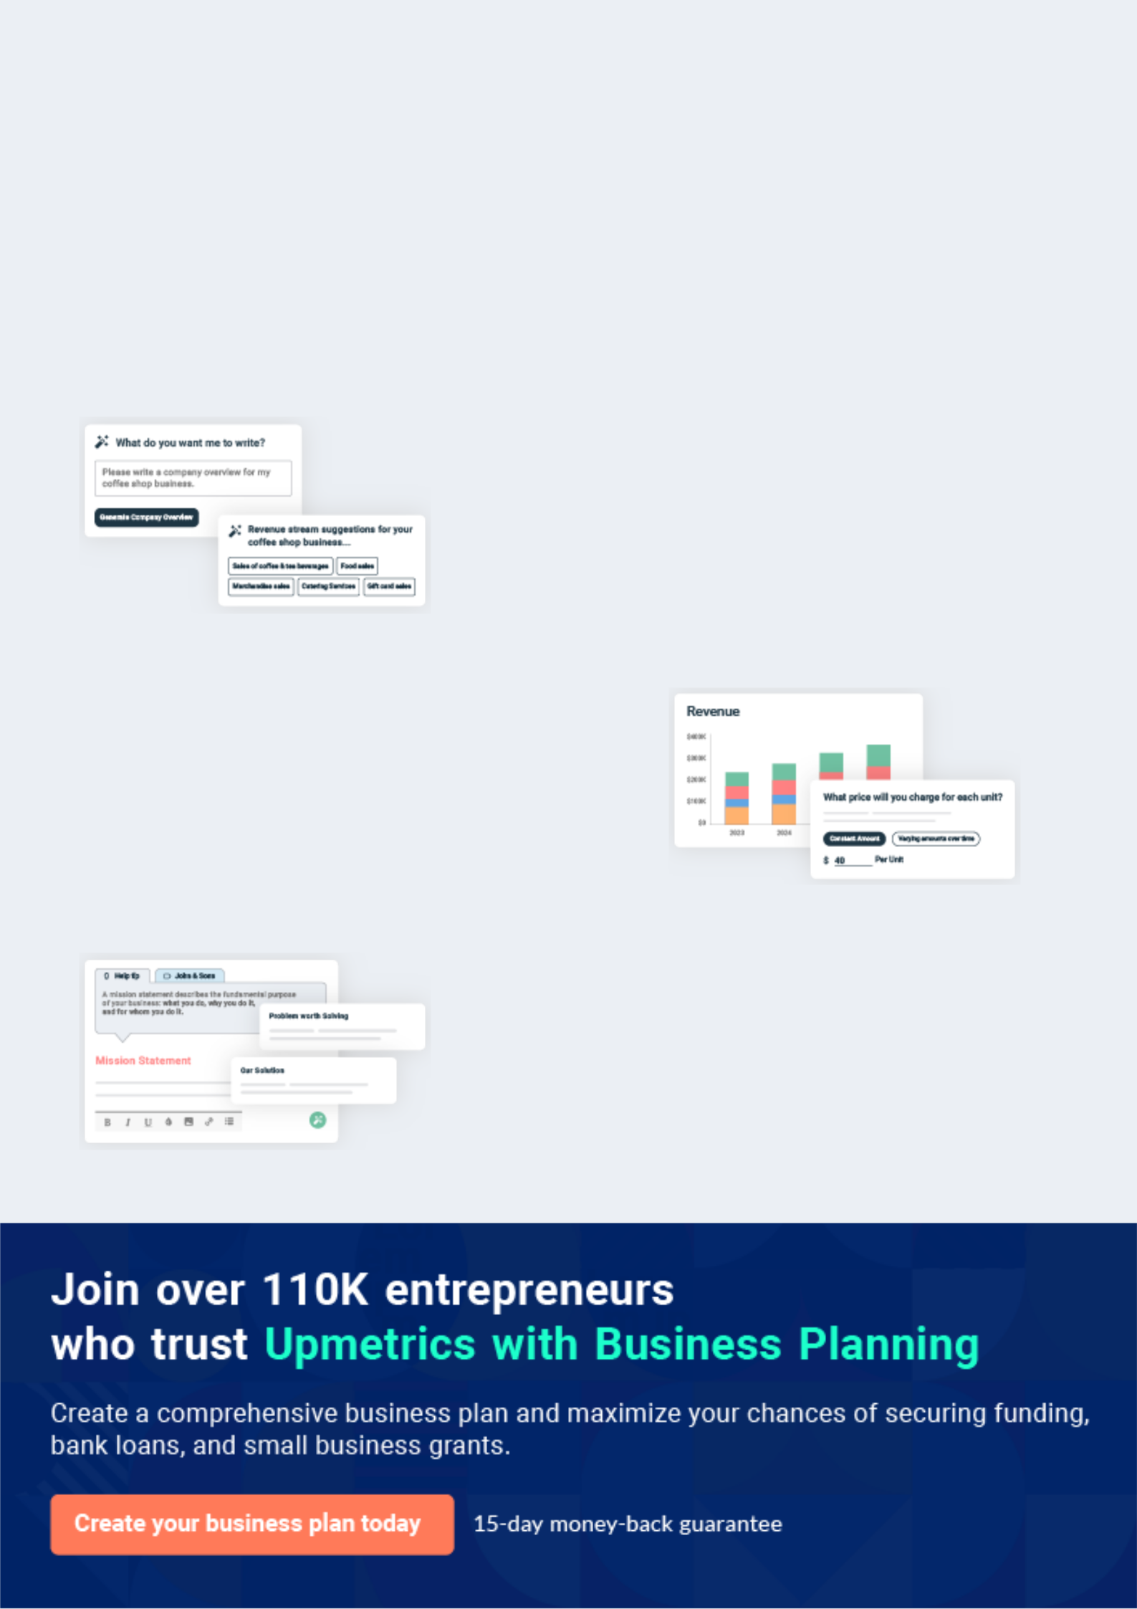
Business planning that’s simpler and faster than you think

Creating a business plan using Upmetrics to start and grow a business is literally the easiest thing in the World. Simply read the instructions and fill in the blanks. It’s as simple as that.

❛ | Upmetrics has everything you need to create a | ❜
❛ | comprehensive business plan. | ❜

AI-powered Upmetrics Assistant

AI-powered insights to streamline your plan

Not sure where to start? Upmetrics’ AI Assistant will automatically generate ideas for each section of your plan and offer improved versions of your writing, adjusting for tone, voice, and grammar or spelling errors.

Financial Forecasting Tool

All the financials are calculated for you

Forget the complex formulas and clumsy spreadsheets — with automatic financials and drag-and-drop forecasting, you can finish your plan faster and be confident that your numbers are accurate.

Business Plan Builder

Guides you like a business mentor

Upmetrics’ step-by-step instructions, prompts, and the library of 400+ sample business plans will guide you through each section of your plan as a business mentor.
Executive Summary


An executive summary is the first section of the business plan intended to provide an overview of the whole business plan.
To unlock help try Upmetrics! 

 Help tip  Public Relations Business Plan


Start your executive summary by briefly introducing your business to your readers.

This section may include the name of your public relations business, its location, when it was
To unlock help try Upmetrics! 

Start writing here..

Market opportunity

 Help tip  Public Relations Business Plan

Summarize your market research, including market size, growth potential, and marketing trends. Highlight the opportunities in the market and how your business will fit in to fill the gap.
To unlock help try Upmetrics! 

Start writing here..

Services Offered

 Help tip  Public Relations Business Plan

Highlight the public relations services you offer your clients. The USPs and differentiators you offer are always a plus.
To unlock help try Upmetrics! 

Start writing here..

Marketing & Sales Strategies
To unlock help try Upmetrics!

 Help tip  Public Relations Business Plan

Outline your sales and marketing strategies—what marketing platforms you use, how you plan on acquiring customers, etc.
To unlock help try Upmetrics! 

Start writing here..

Financial Highlights

 Help tip  Public Relations Business Plan

Briefly summarize your financial projections for the initial years of business operations. Include any capital or investment requirements, associated startup costs, projected revenues, and profit forecasts.



Start writing here..
Units Sold v/s Revenue

 |  | Units Sold | Revenue
15.00k
10.00k
5.00k
0
Year 1 | Year 2 | Year 3


Financial Year |  |  | Units Sold | Revenue
Year 1 | 1,550 |  |  | $10,000
Year 2 | 1,800 |  |  | $12,000
Year 3 | 2,050 |  |  | $14,000
 Help tip |  |  Public Relations Business Plan


Summarize your executive summary section with a clear CTA, for example, inviting angel investors to discuss the potential business investment.
To unlock help try Upmetrics! 

Write a call to action for your business plan.
Company Overview

Depending on what details of your business are essential, you’ll need different elements in your business overview.
To unlock help try Upmetrics! 

 Help tip  Public Relations Business Plan

Describe your business in this section by providing all the basic information:

Describe what kind of public relations company you run and the name of it. You may specialize
To unlock help try Upmetrics! 

Start writing here..

Ownership

 Help tip  Public Relations Business Plan

List the names of your public relations company’s founders or owners. Describe what shares they own and their responsibilities for efficiently managing the business.
To unlock help try Upmetrics! 

Start writing here..
Mission statement

 Help tip  Public Relations Business Plan

Summarize your business’ objective, core principles, and values in your mission statement. This statement needs to be memorable, clear, and brief.
To unlock help try Upmetrics! 

❛ At [PR Visionaries], our mission is to craft compelling narratives, championing our clients' vision, and catalyzing transformative engagements. Anchored in integrity, innovation, and impact, we pledge to redefine the standards of public relations, one story at

a time.
❜

Business history

 Help tip  Public Relations Business Plan

If you’re an established public relations service provider, briefly describe your business history, like—when it was founded, how it evolved over time, etc.
To unlock help try Upmetrics! 

Start writing here..

Future goals

 Help tip  Public Relations Business Plan

It’s crucial to convey your aspirations and vision. Mention your short-term and long-term goals; they can be specific targets for revenue, market share, or expanding your services.
To unlock help try Upmetrics! 

Start writing here..

Market Analysis
To unlock help try Upmetrics!


 |  | Market analysis provides a clear understanding of the market in which your
 |  | printing business will run along with the target market, competitors, and
 |  | growth opportunities.
 |  |  |  | To unlock help try Upmetrics! 
 Help tip |  |  Public Relations Business Plan

To write the introduction section of your market analysis, start by clearly identifying your primary target market.
To unlock help try Upmetrics! 

Start writing here..

Target Market

 Help tip  Public Relations Business Plan

Start this section by describing your target market. Define your ideal customer and explain what types of services they prefer. Creating a buyer persona will help you easily define your target market to your readers.



Start writing here..

Market size and growth potential

 Help tip  Public Relations Business Plan

Describe your market size and growth potential and whether you will target a niche or a much broader market.
To unlock help try Upmetrics! 

Start writing here..

Market Size

Available Market

Total potential customers needing PR 1B services globally.

Served Market
Businesses in sectors we have 600M expertise & capability to serve

Target Market
Tech startups & SMEs in US, our 60M primary focus for the next 5 years.

 Help tip  Public Relations Business Plan

Identify and analyze your direct and indirect competitors. Identify their strengths and weaknesses, and describe what differentiates your public relations services from them.
To unlock help try Upmetrics! 

Competitive analysis

GlobalPR Nexus

[GlobalPR Nexus] is a stalwart in the PR realm, with operations spanning over three decades. With headquarters in [City, e.g., "New York"], they have a vast network of offices across the globe, catering to clients from diverse sectors.

Features Strengths Weaknesses

Comprehensive media outreach program.

Crisis management suite.

Digital PR initiatives, including influencer partnerships.

Tailored PR strategies for mergers and acquisitions.

Vast and entrenched media Potential bureaucracy due to

network. large organizational size.

Rich history of handling high- Less agility in adapting to rapidly

profile PR crises. changing PR trends.

Multidisciplinary team with Premium pricing may alienate

industry veterans. emerging startups or smaller

enterprises.

NextGen Communique

[NextGen Communique] is a relative newcomer but has quickly made its mark due to its tech-centric approach to PR. Founded in [Year, e.g., "2018"], they have become the go-to agency for tech startups and digital enterprises.

Features

AI-driven PR analytics platform.

Virtual and augmented reality press releases.

Influencer-driven campaigns with a focus on tech influencers.

Social media PR blitz.

Strengths

Strong foothold in the tech PR segment.

Innovative solutions harnessing the latest in technology.

Agile and adaptive to evolving market needs.

Weaknesses

Limited experience in handling traditional PR challenges.

Narrow focus may limit clientele from diverse sectors.

Potential scalability concerns due to rapid growth.

Classic Comm & Co.

A boutique PR agency with a strong focus on the arts, culture, and entertainment sectors. Operating since [Year, e.g., "2005"], [Classic Comm & Co.] has built a reputation for crafting compelling narratives for its niche clientele.

Features

Arts and entertainment media partnerships.

Event PR, including exhibitions, launches, and shows.

Celebrity PR management.

Niche PR campaigns for authors, artists, and cultural institutions.

Strengths

Deep-rooted relationships in the arts and entertainment sectors.

Expertise in handling high-profile events and launches.

Tailored PR solutions for a niche market.

Weaknesses

Limited diversification beyond the arts sector.

May struggle to adapt to the digital PR transformation.

Smaller team sizes may limit scalability.

Market trends

 Help tip  Public Relations Business Plan

Analyze emerging trends in the industry, such as technology disruptions, changes in customer behavior or preferences, etc. Explain how your business will cope with all the trends.
To unlock help try Upmetrics! 

Start writing here..

Regulatory environment
To unlock help try Upmetrics!

 Help tip  Public Relations Business Plan

List regulations and licensing requirements that may affect your public relations company, such as privacy & data protection, advertising & marketing laws, intellectual property rights, financial regulations, media regulations, etc.



Start writing here..
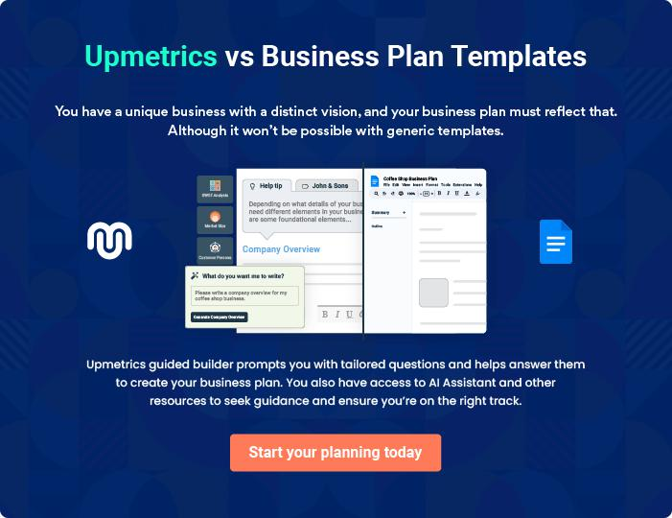
Products and Services
To unlock help try Upmetrics!

The product and services section of a public relations business plan should describe the specific services and products that will be offered to customers. To write this section should include the following:



 Help tip  Public Relations Business Plan

To craft the introduction for your "Products and Services" chapter, begin by positioning your business within its industry, emphasizing its unique strengths or value proposition.
To unlock help try Upmetrics! 

Start writing here..

 Help tip


Mention the public relations services your business will offer. This list may include services like,

• Media Relations
To unlock help try Upmetrics! 

Public relations services
Media Relations


Price: [$5,000] per campaign

This service ensures our clients are presented in the best light in the media landscape. We create media proposals, craft news releases, and facilitate interviews and press conferences.

Specifications

- Media Outreach: Engage with 50+ media houses/ outlets.

- Press Release Creation: Up to 3 custom press releases.

- Interview Coordination: Organizing up to 5 interviews with major publications.

- Media Monitoring: Monitor and report on all client mentions in media.

Crisis Communications

Price: Starting at [$7,500] (Variable depending on the nature of the crisis)

We offer immediate response strategies to manage potential brand threats and ensure the brand image remains untarnished.

Specifications

- 24/7 Availability: Immediate response team availability.

- Communication Blueprint: Outline of all necessary communications to stakeholders.

- Media Training: Training spokespeople to handle media interactions during the crisis.

- Post-crisis Analysis: Analyzing crisis management effectiveness and areas for improvement.
Strategic Communications Planning

Price: [$10,000] for annual planning

Tailored communication strategies to align messaging with business goals, ensuring consistent brand narratives.

Specifications

- Brand Audit: Assess current brand positioning and communication strategies.

- Content Calendar: Monthly breakdown of communication activities.

- Stakeholder Mapping: Identification and prioritization of key audience segments.

- Feedback Loop Integration: Mechanisms to gauge communication effectiveness.

Reputation Management

Price: [$6,000] per quarter

We ensure the brand's online and offline reputation remains stellar through monitoring, feedback, and strategic interventions.

Specifications

- Online Monitoring: Tracking brand mentions across the web.

- Stakeholder Feedback: Quarterly surveys and feedback mechanisms.

- Intervention Strategies: Actionable plans for any negative brand mentions.

- Monthly Reports: Comprehensive report on reputation metrics.
Content Creation and Management

Price: [$3,000] per month

From crafting compelling press releases to insightful op-eds, we ensure each content piece aligns with the brand's voice and objectives.

Specifications

- Custom Content: Up to 10 custom pieces per month.

- Content Strategy: Quarterly content roadmaps.

- Editorial Standards: Adherence to highest writing and brand standards.

- SEO Optimization: Ensure content is optimized for search engines.

Social Media Management

Price: [$4,500] per month

We manage and curate brand narratives on digital platforms, from content creation to audience engagement and campaign management.

Specifications

- Platform Coverage: Management of up to 3 platforms (e.g., Twitter, LinkedIn, Instagram).

- Content Calendar: Monthly content scheduling.

- Engagement Metrics: Track and report engagement metrics.

- Campaign Management: Up to 2 promotional campaigns per month.
Event Management

Price: Starting at [$15,000] per event

From concept to execution, we ensure every event amplifies brand visibility and offers impeccable attendee experience.

Specifications

- End-to-end Management: From venue selection to post-event feedback.

- Vendor Coordination: Managing all event vendors and partners.

- Guest Management: Invitations, RSVPs, and attendee interactions.

- Post-event Analysis: Comprehensive report on event success metrics.

Stakeholder Engagement

Price: [$8,000] per engagement campaign

Building and maintaining robust relationships with stakeholders, ensuring brand narratives resonate and foster trust.

Specifications

- Engagement Strategies: Tailored strategies for each stakeholder segment.

- Communication Channels: Selection and management of best engagement channels.

- Feedback Mechanisms: Ensuring continuous feedback loops.

- Engagement Reports: Quarterly reports on engagement metrics.
Additional Services
- To unlock help try Upmetrics!

 Help tip  Public Relations Business Plan

Mention if your public relations company offers any additional services. You may include services like event management, internal communications, community relations, investor relations, etc.



Start writing here..
Sales And Marketing Strategies

Writing the sales and marketing strategies section means a list of strategies you will use to attract and retain your clients.
To unlock help try Upmetrics! 

 Help Tip  Public Relations Business Plan


To create an effective introduction for your "Sales and Marketing Strategies" chapter, start by setting the stage within your specific industry or market.
To unlock help try Upmetrics! 

Start writing here..

Unique Selling Proposition (USP)

 Help tip  Public Relations Business Plan

Define your business’s USPs depending on the market you serve, the equipment you use, and the unique services you provide. Identifying USPs will help you plan your marketing strategies.
To unlock help try Upmetrics! 

Start writing here..

Pricing Strategy

 Help tip  Public Relations Business Plan

Describe your pricing strategy—how you plan to price your services and stay competitive in the local market. You can mention any discounts you plan on offering to attract new customers.
To unlock help try Upmetrics! 

Start writing here..

 Help tip  Public Relations Business Plan
To unlock help try Upmetrics!

Discuss your marketing strategies to market your services. You may include some of these marketing strategies in your business plan—social media marketing, brochures, email marketing, content marketing, etc.



Marketing strategies

Online


Social Media

Regular updates, campaigns, and engagements on platforms like LinkedIn, Twitter, and Instagram.

Email Marketing

Monthly newsletters, service updates, and personalized offers sent to our curated database of [X, 000] potential clients.

Content Marketing

Insightful articles, case studies,

and whitepapers showcasing our

industry expertise on platforms like

[PR-specific blogs], Medium, and

our official website.

Offline

Brochures

High-quality brochures detailing our services, distributed at industry events and corporate meetups.

 Help tip

Outline the strategies you’ll implement to maximize your sales. Your sales strategies may include direct sales calls, partnering with other businesses, offering referral programs, etc.
To unlock help try Upmetrics! 

Sales strategies

Partner with Businesses

Collaborating with complementary businesses, like advertising agencies or event management companies, to offer bundled services.

Referral Programs

Incentivizing our existing clients to refer our services to their network, offering them [X%] discounts on their next campaign.

Direct Sales Calls

Proactive outreach to potential clients, discussing their PR needs and showcasing how we can add value.

 Help tip

Describe your customer retention strategies and how you plan to execute them. For instance, introducing loyalty programs, discounts on annual membership, personalized service, etc.
To unlock help try Upmetrics! 

Customer retention

Loyalty Programs

Repeat clients can accumulate points for every campaign, redeemable for discounts or complimentary services.

Personalized Service

Ensuring that each client has a dedicated account manager who understands their unique needs and preferences.

Annual Membership Discount

Offering a [X%] discount to clients opting for an annual contract.

Feedback Mechanism

Regular surveys and feedback loops to continuously improve our service offerings based on client inputs.

Operations Plan
To unlock help try Upmetrics!

 |  | When writing the operations plan section, it’s important to consider the
 |  | various aspects of your business operations.
 |  |  |  | To unlock help try Upmetrics! 
 Help tip |  |  Public Relations Business Plan


To create an effective introduction for your "Operational Plan" chapter, start by emphasizing the
pivotal role of efficient operations in the success of your business, underscoring how they
directly impact the quality of services delivered.
 |  |  |  | To unlock help try Upmetrics! 
Start writing here..
Staffing & Training
 Help tip |  |  Public Relations Business Plan

Mention your business’s staffing requirements, including the number of employees, account
executives, copywriters, or other staff needed. Include their qualifications, the training required,
and the duties they will perform.
 |  |  |  | To unlock help try Upmetrics! 
Start writing here..
Operational Process
 Help tip |  |  Public Relations Business Plan

Outline the processes and procedures you will use to run your public relations business. Your operational processes may include client onboarding, research & strategy development, media relations, content creation, social media management, etc.



Start writing here..

Equipment & Software

 Help tip  Public Relations Business Plan

Include the list of equipment and machinery required for public relations, such as computers & laptops, printers & scanners, audio equipment, media monitoring tools, social media management platforms, press release distribution services, media monitoring & analysis tools,
To unlock help try Upmetrics! 

Start writing here..
Management Team

The management team section provides an overview of the individuals responsible for running your business plan.
To unlock help try Upmetrics! 

 Help tip  Public Relations Business Plan

To craft an introduction for your "Management Team" chapter, begin by emphasizing the crucial role of leadership in the success of any business.
To unlock help try Upmetrics! 

Start writing here..

Key managers

 Help tip  Public Relations Business Plan

Introduce your management and key members of your team, and explain their roles and responsibilities.
To unlock help try Upmetrics! 

Start writing here..

JOHN DOE

CEO & Co-founder - john.doe@example.com

A visionary leader, John founded [PR Visionaries] with the aim of revolutionizing the public relations landscape.

With his innate ability to build relationships and understand market dynamics, John has been instrumental in setting the company's strategic direction.


- Educational Background: MBA in Strategic Management from Harvard Business School.

- Professional Background: Over 15 years in the PR industry, with prior roles including Director of Communications at [Major PR Firm] and Senior PR Strategist at [Global Agency].

JANE DOE

Chief Operating Officer (COO) - jane.doe@example.com

A dynamic and results-driven professional, Jane ensures the company's operations run seamlessly. Her keen analytical skills and leadership acumen drive operational excellence.

- Educational Background: MBA in Operations from Stanford Graduate School of Business.

- Professional Background: Over 12 years in PR operations, previously served as Senior Operations Manager at [Leading PR Agency].


ALICE BROWN

CMO - alice.brown@example.com

With her creative flair and strategic mindset, Alice leads the company's marketing endeavors, enhancing brand visibility and driving growth.

- Educational Background: MA in Marketing from Columbia University.

- Professional Background: 10 years in PR marketing, previously Head of Marketing at [Top PR Firm].


ROBERT BROWN

PR Director - robert.brown@example.com

Robert's expertise in media relations and knack for curating compelling narratives make him invaluable to the company. He's the linchpin between clients and major media outlets.

- Educational Background: BA in Communications from New York University.

- Professional Background: 13 years in media relations, formerly Media Relations Manager at [Global PR Company].
Organizational structure

 Help tip  Public Relations Business Plan

Explain the organizational structure of your management team. Include the reporting line and decision-making hierarchy.
To unlock help try Upmetrics! 

Start writing here..

Organization chart


John Doe

CEO


Alice Brown Robert Brown Jane Doe

CMO PR Manager COO


Emily Clark | Daniel Adams | Sam Smith
Emily Clark | Media Relations | Sam Smith
Marketing Associate | Media Relations | Operations Manager
Marketing Associate | Specialist | Operations Manager



Compensation plan

 Help tip  Public Relations Business Plan

Describe your compensation plan for the management and staff. Include their salaries, incentives, and other benefits.
To unlock help try Upmetrics! 

Start writing here..

 Help tip

Mentioning advisors or consultants in your business plans adds credibility to your business idea.
To unlock help try Upmetrics! 

Advisors/Consultants


DR. SARAH WHITE

Advisor

With over [20] years of PR consultancy experience, Dr. White advises on strategic alignment and industry trends.


MR. JAMES GREEN

Consultant

A renowned industry figure, Mr. Green's expertise lies in international PR. He guides [PR Visionaries] on global expansion strategies.
Financial Plan

When writing the financial plan section of a business plan, it’s important to provide a comprehensive overview of your financial projections for the first few years of your business, You may provide the following:
To unlock help try Upmetrics! 

 Help tip  Public Relations Business Plan


To create an effective introduction for your "Financial Plan" chapter, begin by stressing the critical role of a well-structured financial plan in the success of your venture.
To unlock help try Upmetrics! 

Start writing here..

 Help tip


Describe details such as projected revenue, operational costs, and service costs in your projected profit and loss statement. Make sure to include your business’s expected net profit or loss.
To unlock help try Upmetrics! 

Profit & loss statement

Revenue

Cost Of Sales

General Costs

Revenue Specific Costs

Personnel Costs (Direct

Labor)

Gross Margin

Gross Margin (%)

Operating Expense

Payroll Expense

(Indirect Labor)

General Expense

Bad Debt

Amortization of Current

Assets

2023-24 | 2024-25 | 2025-26 | 2026-27 | 2027-28
$0 | $0 | $0 | $0 | $0

$0 | $0 | $0 | $0 | $0
$0 | $0 | $0 | $0 | $0
$0 | $0 | $0 | $0 | $0
$0 | $0 | $0 | $0 | $0

$0 | $0 | $0 | $0 | $0
0% | 0% | 0% | 0% | 0%

$0 | $0 | $0 | $0 | $0
$0 | $0 | $0 | $0 | $0
$0 | $0 | $0 | $0 | $0
$0 | $0 | $0 | $0 | $0
$0 | $0 | $0 | $0 | $0

EBITDA

Additional Expense

Long Term

Depreciation

Gain or loss from Sale

of Assets

EBIT

Interest Expenses

EBT

Income Tax Expense

Total Expense

Net Income

Net Income (%)

2023-24 | 2024-25 | 2025-26 | 2026-27 | 2027-28
$0 | $0 | $0 | $0 | $0
$0 | $0 | $0 | $0 | $0
$0 | $0 | $0 | $0 | $0
$0 | $0 | $0 | $0 | $0
$0 | $0 | $0 | $0 | $0
$0 | $0 | $0 | $0 | $0
$0 | $0 | $0 | $0 | $0
$0 | $0 | $0 | $0 | $0
$0 | $0 | $0 | $0 | $0
$0 | $0 | $0 | $0 | $0
0% | 0% | 0% | 0% | 0%
 | 2023-24 | 2024-25 | 2025-26 | 2026-27 | 2027-28
Retained Earning | $0 | $0 | $0 | $0 | $0
Opening
Owner's Distribution | $0 | $0 | $0 | $0 | $0
Retained Earning | $0 | $0 | $0 | $0 | $0
Closing

 Help tip

The cash flow for the first few years of your operation should be estimated and described in this section. This may include billing invoices, payment receipts, loan payments, and any other cash flow statements.
To unlock help try Upmetrics! 

Cash flow statement

 | 2023-24 | 2024-25 | 2025-26 | 2026-27 | 2027-28
Cash Received | $0 | $0 | $0 | $0 | $0
Cash Paid | $0 | $0 | $0 | $0 | $0
COS & General Expenses | $0 | $0 | $0 | $0 | $0
Salary & Wages | $0 | $0 | $0 | $0 | $0
Interest | $0 | $0 | $0 | $0 | $0

Sales Tax

Income Tax

Net Cash From

Operations

Assets Sell

Assets Purchase

Net Cash From

Investments

Amount Received

Loan Received

Common Stock

Preferred Stock

Owner's Contribution

Amount Paid

2023-24 | 2024-25 | 2025-26 | 2026-27 | 2027-28
$0 | $0 | $0 | $0 | $0
$0 | $0 | $0 | $0 | $0
$0 | $0 | $0 | $0 | $0

$0 | $0 | $0 | $0 | $0
$0 | $0 | $0 | $0 | $0
$0 | $0 | $0 | $0 | $0

$0 | $0 | $0 | $0 | $0
$0 | $0 | $0 | $0 | $0

$0 | $0 | $0 | $0 | $0
$0 | $0 | $0 | $0 | $0
$0 | $0 | $0 | $0 | $0

Loan Capital $0 $0 $0 $0 $0

 | 2023-24 | 2024-25 | 2025-26 | 2026-27 | 2027-28
Dividends & Distributions | $0 | $0 | $0 | $0 | $0
Net Cash From | $0 | $0 | $0 | $0 | $0
Financing

Summary
Starting Cash | $0 | $0 | $0 | $0 | $0
Cash In | $0 | $0 | $0 | $0 | $0
Cash Out | $0 | $0 | $0 | $0 | $0
Change in Cash | $0 | $0 | $0 | $0 | $0
Ending Cash | $0 | $0 | $0 | $0 | $0

 Help tip

Create a projected balance sheet documenting your public relations business’s assets, liabilities, and equity.

To unlock help try Upmetrics! 

Balance sheet

 | 2023-24 | 2024-25 | 2025-26 | 2026-27 | 2027-28
Assets | $0 | $0 | $0 | $0 | $0
Current Assets | $0 | $0 | $0 | $0 | $0
Cash | $0 | $0 | $0 | $0 | $0
Accounts Receivable | $0 | $0 | $0 | $0 | $0
Inventory | $0 | $0 | $0 | $0 | $0
Other Current Assets | $0 | $0 | $0 | $0 | $0
Long Term Assets | $0 | $0 | $0 | $0 | $0
Gross Long Term Assets | $0 | $0 | $0 | $0 | $0
Accumulated Depreciation | $0 | $0 | $0 | $0 | $0

Liabilities & Equity | $0 | $0 | $0 | $0 | $0
Liabilities | $0 | $0 | $0 | $0 | $0
Current Liabilities | $0 | $0 | $0 | $0 | $0
Accounts Payable | $0 | $0 | $0 | $0 | $0
Income Tax Payable | $0 | $0 | $0 | $0 | $0
Sales Tax Payable | $0 | $0 | $0 | $0 | $0
Short Term Debt | $0 | $0 | $0 | $0 | $0
 | 2023-24 | 2024-25 | 2025-26 | 2026-27 | 2027-28
Long Term Liabilities | $0 | $0 | $0 | $0 | $0
Long Term Debt | $0 | $0 | $0 | $0 | $0
Equity | $0 | $0 | $0 | $0 | $0
Paid-in Capital | $0 | $0 | $0 | $0 | $0
Common Stock | $0 | $0 | $0 | $0 | $0
Preferred Stock | $0 | $0 | $0 | $0 | $0
Owner's Contribution | $0 | $0 | $0 | $0 | $0
Retained Earnings | $0 | $0 | $0 | $0 | $0

Check | $0 |  |  | $0 | $0 | $0 | $0
 Help Tip |  |  Public Relations Business Plan


Determine and mention your business’s break-even point—the point at which your business costs and revenue will be equal.

This exercise will help you understand how much revenue you need to generate to sustain or be profitable.
To unlock help try Upmetrics! 

Break-even Analysis

 | 2023-24 | 2024-25 | 2025-26 | 2026-27 | 2027-28
Starting Revenue | $0 | $0 | $0 | $0 | $0
Net Revenue | $0 | $0 | $0 | $0 | $0
Closing Revenue | $0 | $0 | $0 | $0 | $0

Starting Expense | $0 | $0 | $0 | $0 | $0
Net Expense | $0 | $0 | $0 | $0 | $0
Closing Expense | $0 | $0 | $0 | $0 | $0

Is Break Even? | 0 | 0 | 0 | 0 | 0
Break Even Month | 0 | 0 | 0 | 0 | 0
Days Required | 0 | 0 | 0 | 0 | 0
Break Even Revenue | $0 | $0 | $0 | $0 | $0
Break Even Units
Financing needs

 Help tip  Public Relations Business Plan

Calculate costs associated with starting a public relations business, and estimate your financing needs and how much capital you need to raise to operate your business.
To unlock help try Upmetrics! 

Start writing here..
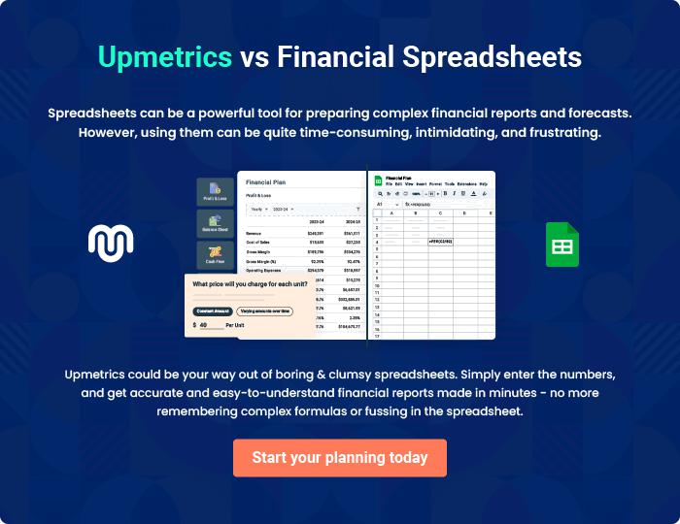
Appendix

When writing the appendix section, you should include any additional information that supports the main content of your plan. This may include financial statements, market research data, legal documents, and other
To unlock help try Upmetrics! 

Create a winning business plan that gets you funded

Creating a stunning and investment-ready plan requires no writing, graphic designing, or financial planning expertise.

Upmetrics has all the features required to help you create a comprehensive business plan—from start to finish. Make no mistakes, it’s the modern way of planning to structure ideas, make plans, and create stunning pitch decks to awe investors.

Pitch decks that impress investors

Create pitch decks that provide a visual representation of your business, engage investors, and make them want to invest in your business idea.

Interactive plans in no time

Import business plan sections like—SWOT analysis, comparison tables, and others to create an interactive business plan. No designing skills are required.

Stunning cover page designs

With Upmetrics, you have the liberty to choose from multiple stunning cover page designs. Choose a creative design and make your plan stand out.

Online sharing made simple

Upmetrics makes online sharing quick and easier for users. Easily share your business plans with a link while tracking reader activity.

500+ sample business plans

Simply import a template from our library of sample plans into the editor and start customizing it to make it yours. It takes only a few clicks to get started.

Collaborate with team in real-time

Invite team members, initiate conversations, discuss ideas & strategies, share feedback, and work on a business plan in real-time.

