

Printing Press Business Plan

From Idea to Page, Precision in Print


Business
Plan

2023

Prepared By

John Doe

10200 Bolsa Ave, Westminster, CA, 92683

info@example.com

(650) 359-3153 http://www.example.com

Table of Contents

Executive Summary | 6
Market opportunity | 6
Services Offered | 6
Marketing & Sales Strategies | 7
Financial Highlights | 7
Units Sold v/s Revenue | 8

Company Overview | 9
Ownership | 9
Mission statement | 9
Business history | 10
Future goals | 10

Market Analysis | 11
Target Market | 11
Market size and growth potential | 11
Market Size | 12
Competitive analysis | 12
PrintTech Enterprises | 12
Impressions PrintHouse | 13
QuickPrint Solutions | 13
Market trends | 13
Regulatory environment | 14

Products and Services | 15
Products and Services | 15
Digital Printing | 15
Offset Printing | 16
3D Printing | 16
Wide Format Printing | 17
Graphic Design Services | 17
Print Finishing Solutions (Lamination) | 18
Stationery Products (Business Cards) | 18
Packaging and Label Solutions | 19
Quality Measures | 19
Additional services | 19

Sales And Marketing Strategies | 20
Unique Selling Proposition (USP) | 20
Pricing Strategy | 20
Marketing strategies | 21
Online | 21
Offline | 21
Sales strategies | 22
Customer retention | 22

Operations Plan | 23
Staffing & Training | 23
Operational Process | 23
Equipment & Machinery | 24

Management Team | 25
Key managers | 25
John Doe | 25
Jane Doe | 26
Alice Brown | 26
Robert Brown | 26
Organizational structure | 27
Organization chart | 27
Compensation plan | 28
Advisors/Consultants | 28
[CONSULTANT NAME] | 28
[ADVISOR NAME] | 28
Financial Plan | 29
Profit & loss statement | 29
Cash flow statement | 32
Balance sheet | 34
Break-even Analysis | 36
Financing needs | 38
Appendix
Appendix | 40
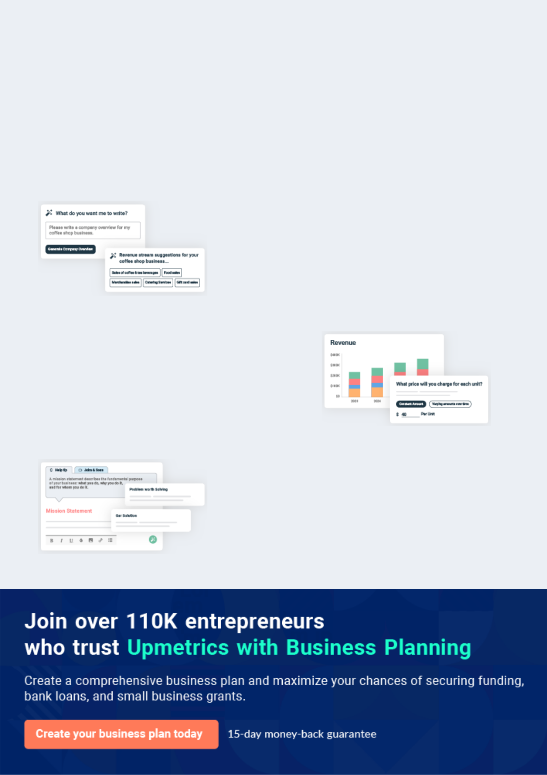
Business planning that’s simpler and faster than you think

Creating a business plan using Upmetrics to start and grow a business is literally the easiest thing in the World. Simply read the instructions and fill in the blanks. It’s as simple as that.

❛ | Upmetrics has everything you need to create a | ❜
❛ | comprehensive business plan. | ❜

AI-powered Upmetrics Assistant

AI-powered insights to streamline your plan

Not sure where to start? Upmetrics’ AI Assistant will automatically generate ideas for each section of your plan and offer improved versions of your writing, adjusting for tone, voice, and grammar or spelling errors.

Financial Forecasting Tool

All the financials are calculated for you

Forget the complex formulas and clumsy spreadsheets — with automatic financials and drag-and-drop forecasting, you can finish your plan faster and be confident that your numbers are accurate.

Business Plan Builder

Guides you like a business mentor

Upmetrics’ step-by-step instructions, prompts, and the library of 400+ sample business plans will guide you through each section of your plan as a business mentor.
Executive Summary


An executive summary is the first section of the business plan intended to provide an overview of the whole business plan.
To unlock help try Upmetrics! 

 Help tip  Printing Press Business Plan


Start your executive summary by briefly introducing your business to your readers.

This section may include the name of your printing press business, its location, when it was
To unlock help try Upmetrics! 

Start writing here..

Market opportunity

 Help tip  Printing Press Business Plan

Summarize your market research, including market size, growth potential, and marketing trends. Highlight the opportunities in the market and how your business will fit in to fill the gap.
To unlock help try Upmetrics! 

Start writing here..

Services Offered

 Help tip  Printing Press Business Plan

Highlight the products and services you offer in your printing press business. Highlight the USPs and differentiators to establish a competitive edge.
To unlock help try Upmetrics! 

Start writing here..

Marketing & Sales Strategies
To unlock help try Upmetrics!

 Help tip  Printing Press Business Plan

Outline your sales and marketing strategies—what marketing platforms you use, how you plan on acquiring customers, etc.
To unlock help try Upmetrics! 

Start writing here..

Financial Highlights

 Help tip  Printing Press Business Plan

Briefly summarize your financial projections for the initial years of business operations. Include any capital or investment requirements, associated startup costs, projected revenues, and profit forecasts.



Start writing here..
Units Sold v/s Revenue

 |  | Units Sold | Revenue
15.00k
10.00k
5.00k
0
Year 1 | Year 2 | Year 3


Financial Year |  |  | Units Sold | Revenue
Year 1 | 1,550 |  |  | $10,000
Year 2 | 1,800 |  |  | $12,000
Year 3 | 2,050 |  |  | $14,000
 Help tip |  |  Printing Press Business Plan


Summarize your executive summary section with a clear CTA, for example, inviting angel investors to discuss the potential business investment.
To unlock help try Upmetrics! 

Write a call to action for your business plan.
Company Overview

Depending on what details of your business are essential, you’ll need different elements in your business overview.
To unlock help try Upmetrics! 

 Help tip  Printing Press Business Plan

Describe your business in this section by providing all the basic information:

Describe what kind of printing press company you run and the name of it. You may specialize in
To unlock help try Upmetrics! 

Start writing here..

Ownership

 Help tip  Printing Press Business Plan

List the names of your printing press company’s founders or owners. Describe what shares they own and their responsibilities for efficiently managing the business.
To unlock help try Upmetrics! 

Start writing here..

Mission statement

 Help tip  Printing Press Business Plan

Summarize your business’ objective, core principles, and values in your mission statement. This statement needs to be memorable, clear, and brief.
To unlock help try Upmetrics! 
❛ At [Printing Press Company Name], our mission is to empower businesses and individuals through unparalleled print solutions, embodying innovation, quality, and sustainability at every

touchpoint.
❜

Business history

 Help tip  Printing Press Business Plan

If you’re an established printing press service provider, briefly describe your business history, like—when it was founded, how it evolved over time, etc.
To unlock help try Upmetrics! 

Start writing here..

Future goals

 Help tip  Printing Press Business Plan

It’s crucial to convey your aspirations and vision. Mention your short-term and long-term goals; they can be specific targets for revenue, market share, or expanding your services.
To unlock help try Upmetrics! 

Start writing here..
Market Analysis
To unlock help try Upmetrics!


 |  | Market analysis provides a clear understanding of the market in which your
 |  | printing business will run along with the target market, competitors, and
 |  | growth opportunities.
 |  |  |  | To unlock help try Upmetrics! 
 Help tip |  |  Printing Press Business Plan

To write the introduction section of your market analysis, start by clearly identifying your primary target market.
To unlock help try Upmetrics! 

Start writing here..

Target Market

 Help tip  Printing Press Business Plan

Start this section by describing your target market. Define your ideal customer and explain what types of services they prefer. Creating a buyer persona will help you easily define your target market to your readers.



Start writing here..

Market size and growth potential

 Help tip  Printing Press Business Plan

Describe your market size and growth potential and whether you will target a niche or a much broader market.
To unlock help try Upmetrics! 

Start writing here..

Market Size

Available Market

Total businesses needing printing 10M services in the region.

Served Market
Businesses currently accessing any form 7M of printing services.

Target Market
SMEs, agencies, and event planners 1M seeking premium prints.

 Help tip  Printing Press Business Plan

Identify and analyze your direct and indirect competitors. Identify their strengths and weaknesses, and describe what differentiates your printing press services from them.
To unlock help try Upmetrics! 

Competitive analysis

PrintTech Enterprises

Established in [Year], [PrintTech Enterprises] has been a major player in the [Region/Country] printing industry, boasting a vast client base that includes major corporations and small businesses alike. They have built their brand on the foundation of reliable service and innovative print solutions.

Features | Strengths | Weaknesses
Comprehensive digital printing | Broad service range catering to | Longer turnaround time
services. | diverse client needs. | compared to industry standards.
Specialty printing including | Robust online presence with an | Premium pricing, making it less
embossed and foil stamped | intuitive ordering system. | accessible to small businesses.
products. | Strong emphasis on | The limited physical presence or
An online portal for custom | environmentally conscious | local service centers.
orders and design uploads. | printing.
Sustainable printing using eco-
friendly inks and materials.

Impressions PrintHouse
To unlock help try Upmetrics!

[Impressions PrintHouse], founded in [Year], carved a niche for themselves by focusing on large format and graphic-intensive prints. Their clientele predominantly includes advertising agencies and event planners.

Features

Large format prints including banners and posters.

Graphic design services for clients without ready-to-print designs.

Seasonal discounts and bulk order incentives.

Collaborations with artists for unique print collections.

Strengths

Unparalleled quality in large format prints.

Strong partnerships with local artists, adding value to their offerings

Efficient bulk order handling.

Weaknesses

Limited to specific print types, not a comprehensive service provider.

No online ordering system; relies heavily on in-person consultations.

Lack of eco-friendly printing options.

QuickPrint Solutions

[QuickPrint Solutions], a relatively newer entrant since [Year], focuses on rapid delivery, primarily catering to businesses with urgent print needs.

Features | Strengths | Weaknesses
Express printing with same-day | Fastest turnaround times in the | Compromises on print quality for
delivery options. | market. | speed.
Self-service kiosks in multiple | Multiple access points for | Limited service variety;
locations for quick prints. | customers through kiosks. | predominantly caters to basic
Mobile application for swift | Strong technological | print needs.
order placements. | infrastructure supporting their | Often faces operational hiccups
 | rapid services. | due to the rush, leading to order
 |  | backlogs.

Market trends

 Help tip  Printing Press Business Plan

Analyze emerging trends in the printing press market like advanced technologies and equipment, emerging demand for novelty printing solutions, etc. Explain how your business will cope with all the trends.



Start writing here..

Regulatory environment
To unlock help try Upmetrics!

 Help tip  Printing Press Business Plan

List regulations and licensing requirements that may affect your printing press company, such as business registration, environmental compliances, intellectual and copyright property rights, local zoning permits, etc.



Start writing here..
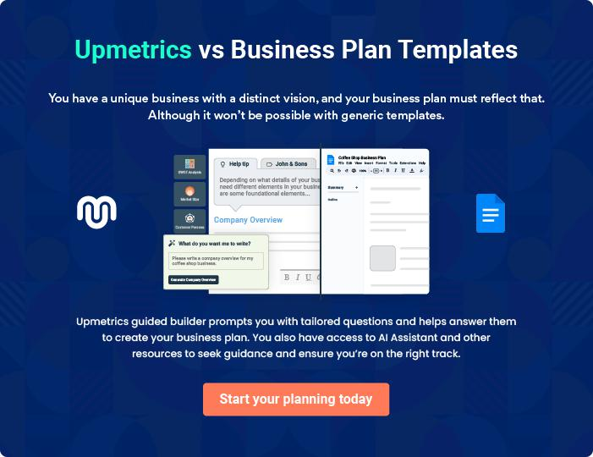
Products and Services
To unlock help try Upmetrics!

The product and services section of a printing press business plan should describe the specific services and products that will be offered to customers. To write this section should include the following:



 Help tip  Printing Press Business Plan

To craft the introduction for your "Products and Services" chapter, begin by positioning your business within its industry, emphasizing its unique strengths or value proposition.
To unlock help try Upmetrics! 

Start writing here..

 Help tip


Mention the printing press products and services your business will offer. This list may include products and services like,
To unlock help try Upmetrics! 

Products and Services

Digital Printing


Price: $[XX.XX] per square foot or $[YY.YY] per page

High-resolution, quick turnaround printing suitable for brochures, flyers, and posters.

Specifications

- Resolution: [300 dpi or specific resolution]

- Maximum Size: [A1, A2, etc.]

- Paper Type: Glossy/Matte

- Ink Type: UV resistant
Offset Printing

Price: $[XX.XX] per 1000 sheets

Ideal for large volume printing such as magazines and newspapers, offering consistent high-quality results.

Specifications

- Print Speed: [XXXX] sheets/hour

- Color Modes: CMYK, Pantone

- Paper Thickness: [XX gsm]

- Finish Type: Varnish/UV coated

3D Printing

Price: Starting at $[XX.XX] per cubic inch

Transforming digital designs into tangible 3D objects using advanced printing techniques.

Specifications

- Material: PLA, ABS, TPU, etc.

- Print Resolution: [0.XX mm]

- Build Volume: [XXX x XXX x XXX] mm

- Layer Height: [0.XX] mm
Wide Format Printing

Price: $[XX.XX] per square foot

Perfect for banners, billboards, and large-scale advertisements with vivid colors and durability.

Specifications

- Maximum Width: [XXX inches]

- Ink Type: Solvent/Eco-Solvent/UltraChrome

- Material: Vinyl, Canvas, Fabric, etc.

- Lifespan: [XX] years outdoors

Graphic Design Services

Price: Starting at $[XX.XX] per hour or project-based pricing at $[YYY.YY]

Custom design solutions ranging from logos to complete branding kits tailored to the client's vision.

Specifications

- Software Used: Adobe Suite, CorelDraw, etc.

- Revisions: Up to [X] rounds included

- Delivery Format: .png, .jpg, .ai, .psd, etc.

- Turnaround Time: [X-X] days
Print Finishing Solutions (Lamination)

Price: $[XX.XX] per sheet

Adds durability and a professional finish to printed materials.

Specifications

- Type: Gloss/Matte/Satin

- Thickness: [XX microns]

- Maximum Width: [XXX inches]

- Resistance: Water-resistant, UV-resistant

Stationery Products (Business Cards)

Price: $[XX.XX] for a pack of [XXX]

Premium quality business cards to make a lasting impression.

Specifications

- Size: Standard [3.5 x 2 inches]

- Material: [XXX gsm cardstock]

- Finish: Glossy/Matte/Textured

- Printing: Single-sided/Double-sided
Packaging and Label Solutions
- To unlock help try Upmetrics!

Price: Starting at $[XX.XX] for [XXX] labels

Customized packaging and labels to enhance brand visibility and product presentation.

Specifications

- Material: Paper/Plastic/Metallic

- Print: CMYK/Pantone

- Adhesive: Permanent/Removable

- Sizes: Variety, based on client needs

Quality Measures

 Help tip  Printing Press Business Plan

This section should explain how you maintain quality standards and consistently provide the highest quality service.
To unlock help try Upmetrics! 

Start writing here..

Additional services

 Help tip  Printing Press Business Plan

Mention if your printing press company offers any additional products or services. You may include ready-to-customize marketing materials, customized printing services, i.e. variable data printing, sustainable printing solutions, free delivery, etc.



Start writing here..

Sales And Marketing Strategies

Writing the sales and marketing strategies section means a list of strategies you will use to attract and retain your clients.
To unlock help try Upmetrics! 

 Help Tip  Printing Press Business Plan


To create an effective introduction for your "Sales and Marketing Strategies" chapter, start by setting the stage within your specific industry or market.
To unlock help try Upmetrics! 

Start writing here..

Unique Selling Proposition (USP)

 Help tip  Printing Press Business Plan

Define your business’s USPs depending on the market you serve, the equipment you use, and the unique services you provide. Identifying USPs will help you plan your marketing strategies.
To unlock help try Upmetrics! 

Start writing here..

Pricing Strategy

 Help tip  Printing Press Business Plan

Describe your pricing strategies- how you plan to price your printing services to stay competitive in the local and online market.
To unlock help try Upmetrics! 

Start writing here..

 Help tip  Printing Press Business Plan

Discuss your marketing strategies to market your services. You may include some of these marketing strategies in your business plan—local advertising, banners and hoardings, social media marketing, Google ads, brochures, email marketing, content marketing, and print
To unlock help try Upmetrics! 

Marketing strategies

Online


Social Media

Regular updates, promotions, and engagement activities on platforms like Facebook, Instagram, and LinkedIn.

Content Marketing

Blog posts and articles highlighting industry trends, DIY tips, and our services.

Email Marketing

Periodic newsletters and promotional offers to our subscribed user base.

Google Ads

Targeted campaigns to reach potential customers actively searching for printing solutions.

Offline

Banners Local Advertising

Strategic placements in high-traffic Building brand awareness in our

areas to maximize visibility. immediate community through

newspapers, local TV channels, and community events.

 Help tip
To unlock help try Upmetrics!
To unlock help try Upmetrics!

Outline the strategies you’ll implement to maximize your sales. Your sales strategies may include direct sales calls to startups, businesses, and industries, referral programs, partnering with graphics designing specialists and agencies, etc.



Sales strategies

Partner with Businesses

Collaborating with graphic designers and agencies, offering them special rates to serve their clientele.

Direct Sales Calls

Actively reaching out to startups, local businesses, educational institutions, and event planners to offer tailored printing solutions.

Referral Programs

Incentivizing satisfied customers

to refer our services to their

networks.

 Help tip

Describe your customer retention strategies and how you plan to execute them. For instance, special offers for existing clients, priority pass, complimentary services like post-printing finishes, etc.



Customer retention

Loyalty Programs Priority Pass

Special discounts for repeat Expedited service timelines for our

customers. premium clients.

Complimentary Services

Offering post-printing finishes or

consultation sessions as added

benefits.

Operations Plan

 |  | When writing the operations plan section, it’s important to consider the
 |  | various aspects of your business operations.
 |  |  |  | To unlock help try Upmetrics! 
 Help tip |  |  Printing Press Business Plan


To create an effective introduction for your "Operational Plan" chapter, start by emphasizing the
pivotal role of efficient operations in the success of your business, underscoring how they
directly impact the quality of services delivered.
 |  |  |  | To unlock help try Upmetrics! 
Start writing here..
Staffing & Training
 Help tip |  |  Printing Press Business Plan

Mention your printing business’s staffing requirement, including the number of employees
needed. Include desired qualifications, skill sets and training requirements, familiarity level with
advanced technologies, and their duties.
 |  |  |  | To unlock help try Upmetrics! 
Start writing here..
Operational Process
 Help tip |  |  Printing Press Business Plan

Outline the processes and procedures you will use to run your printing press business.

Your operational processes may include getting a client and directing them with appropriate
To unlock help try Upmetrics! 

Start writing here..

Equipment & Machinery

 Help tip  Printing Press Business Plan

Include the list of equipment and machinery required for a printing press, such as printing machines, inkjet technologies, finishing tools and equipment, etc.
To unlock help try Upmetrics! 

Start writing here..
Management Team
To unlock help try Upmetrics!

The management team section provides an overview of the individuals responsible for running your business plan.
To unlock help try Upmetrics! 

 Help tip  Printing Press Business Plan

To craft an introduction for your "Management Team" chapter, begin by emphasizing the crucial role of leadership in the success of any business.
To unlock help try Upmetrics! 

Start writing here..

Key managers

 Help tip  Printing Press Business Plan

Introduce your management and key members of your team, and explain their roles and responsibilities. Include qualifications, skills, and relevant experience of key members in this section.



Start writing here..


JOHN DOE

CEO & Co-founder - john.doe@example.com

John brings a rich blend of passion and experience to [Printing Press Company Name].

After graduating from [Top-tier University] with a degree in [Relevant Field], he ventured into the world of printing, learning the intricacies of the industry.


With over [15] years in the printing business, John possesses the know-how to navigate the challenges and capitalize on opportunities. His leadership has been instrumental in the company's growth and vision.

JANE DOE

Operations Manager - jane.doe@example.com

Jane Doe oversees the operational heartbeat of [Printing Press Company Name].

Holding an MBA from [Top Business School], Jane has carved out a successful career in operations management spanning over [10] years.


Before joining [Printing Press Company Name], she served as an Operations Lead at [Previous Printing Company], where she excelled in streamlining processes and improving operational efficiency.


ALICE BROWN

Marketing Manager - alice.brown@example.com

Alice Brown, a graduate of Marketing from [Prominent University], is the marketing maven behind [Printing Press Company Name]'s brand presence and outreach.

Her [8-year] stint at [Previous Marketing Firm] as a Senior Marketing Strategist honed her skills in targeted marketing campaigns, elevating brands in the printing industry.

With her innovative strategies, she is all set to put [Printing Press Company Name] on the global map.


ROBERT BROWN

Finance Manager - robert.brown@example.com

Robert, an alumnus of [Renowned University] with a degree in Finance, is the financial backbone of [Printing Press Company Name].

He brings over [12] years of experience in corporate finance, having served as a Financial Analyst at [Previous Financial Institution].

His expertise lies in budgeting, forecasting, and ensuring the financial health of the organization.
Organizational structure

 Help tip  Printing Press Business Plan

Explain the organizational structure of your management team. Include the reporting line and decision-making hierarchy.
To unlock help try Upmetrics! 

Start writing here..

Organization chart


John Doe

CEO


Alice Brown

Jane Doe

Marketing Manager


Operations Manager

Emily Smith

HR Manager Robert Brown

Finance Manager




Sam Green

Lisa White

Tech Lead

Customer Service Manager

Compensation plan

 Help tip  Printing Press Business Plan

Describe your compensation plan for the management and staff. Include their salaries, incentives, and other benefits.
To unlock help try Upmetrics! 

Start writing here..

 Help tip

Mentioning advisors or consultants in your business plans adds credibility to your business idea.
To unlock help try Upmetrics! 

Advisors/Consultants


[CONSULTANT NAME]

Printing Technology Consultant

Advising on the latest printing technologies and machinery acquisitions. Over [x] years in the printing technology sector.


[ADVISOR NAME]

Sustainability Advisor

Guiding sustainable and eco-friendly practices within the company. [x] years championing sustainable practices in the industry.
Financial Plan

When writing the financial plan section of a business plan, it’s important to provide a comprehensive overview of your financial projections for the first few years of your business, You may provide the following:
To unlock help try Upmetrics! 

 Help tip  Printing Press Business Plan


To create an effective introduction for your "Financial Plan" chapter, begin by stressing the critical role of a well-structured financial plan in the success of your venture.
To unlock help try Upmetrics! 

Start writing here..

 Help tip


Describe details such as projected revenue, operational costs, and service costs in your projected profit and loss statement. Make sure to include your business’s expected net profit or loss.
To unlock help try Upmetrics! 

Profit & loss statement

Revenue

Cost Of Sales

General Costs

Revenue Specific Costs

Personnel Costs (Direct

Labor)

Gross Margin

Gross Margin (%)

Operating Expense

Payroll Expense

(Indirect Labor)

General Expense

Bad Debt

Amortization of Current

Assets

2023-24 | 2024-25 | 2025-26 | 2026-27 | 2027-28
$0 | $0 | $0 | $0 | $0

$0 | $0 | $0 | $0 | $0
$0 | $0 | $0 | $0 | $0
$0 | $0 | $0 | $0 | $0
$0 | $0 | $0 | $0 | $0

$0 | $0 | $0 | $0 | $0
0% | 0% | 0% | 0% | 0%

$0 | $0 | $0 | $0 | $0
$0 | $0 | $0 | $0 | $0
$0 | $0 | $0 | $0 | $0
$0 | $0 | $0 | $0 | $0
$0 | $0 | $0 | $0 | $0

EBITDA

Additional Expense

Long Term

Depreciation

Gain or loss from Sale

of Assets

EBIT

Interest Expenses

EBT

Income Tax Expense

Total Expense

Net Income

Net Income (%)

2023-24 | 2024-25 | 2025-26 | 2026-27 | 2027-28
$0 | $0 | $0 | $0 | $0
$0 | $0 | $0 | $0 | $0
$0 | $0 | $0 | $0 | $0
$0 | $0 | $0 | $0 | $0
$0 | $0 | $0 | $0 | $0
$0 | $0 | $0 | $0 | $0
$0 | $0 | $0 | $0 | $0
$0 | $0 | $0 | $0 | $0
$0 | $0 | $0 | $0 | $0
$0 | $0 | $0 | $0 | $0
0% | 0% | 0% | 0% | 0%
 | 2023-24 | 2024-25 | 2025-26 | 2026-27 | 2027-28
Retained Earning | $0 | $0 | $0 | $0 | $0
Opening
Owner's Distribution | $0 | $0 | $0 | $0 | $0
Retained Earning | $0 | $0 | $0 | $0 | $0
Closing

 Help tip

The cash flow for the first few years of your operation should be estimated and described in this section. This may include billing invoices, payment receipts, loan payments, and any other cash flow statements.
To unlock help try Upmetrics! 

Cash flow statement

 | 2023-24 | 2024-25 | 2025-26 | 2026-27 | 2027-28
Cash Received | $0 | $0 | $0 | $0 | $0
Cash Paid | $0 | $0 | $0 | $0 | $0
COS & General Expenses | $0 | $0 | $0 | $0 | $0
Salary & Wages | $0 | $0 | $0 | $0 | $0
Interest | $0 | $0 | $0 | $0 | $0

Sales Tax

Income Tax

Net Cash From

Operations

Assets Sell

Assets Purchase

Net Cash From

Investments

Amount Received

Loan Received

Common Stock

Preferred Stock

Owner's Contribution

Amount Paid

2023-24 | 2024-25 | 2025-26 | 2026-27 | 2027-28
$0 | $0 | $0 | $0 | $0
$0 | $0 | $0 | $0 | $0
$0 | $0 | $0 | $0 | $0

$0 | $0 | $0 | $0 | $0
$0 | $0 | $0 | $0 | $0
$0 | $0 | $0 | $0 | $0

$0 | $0 | $0 | $0 | $0
$0 | $0 | $0 | $0 | $0

$0 | $0 | $0 | $0 | $0
$0 | $0 | $0 | $0 | $0
$0 | $0 | $0 | $0 | $0

Loan Capital $0 $0 $0 $0 $0

 | 2023-24 | 2024-25 | 2025-26 | 2026-27 | 2027-28
Dividends & Distributions | $0 | $0 | $0 | $0 | $0
Net Cash From | $0 | $0 | $0 | $0 | $0
Financing

Summary
Starting Cash | $0 | $0 | $0 | $0 | $0
Cash In | $0 | $0 | $0 | $0 | $0
Cash Out | $0 | $0 | $0 | $0 | $0
Change in Cash | $0 | $0 | $0 | $0 | $0
Ending Cash | $0 | $0 | $0 | $0 | $0

 Help tip

Create a projected balance sheet documenting your printing press business’s assets, liabilities, and equity.

To unlock help try Upmetrics! 

Balance sheet

 | 2023-24 | 2024-25 | 2025-26 | 2026-27 | 2027-28
Assets | $0 | $0 | $0 | $0 | $0
Current Assets | $0 | $0 | $0 | $0 | $0
Cash | $0 | $0 | $0 | $0 | $0
Accounts Receivable | $0 | $0 | $0 | $0 | $0
Inventory | $0 | $0 | $0 | $0 | $0
Other Current Assets | $0 | $0 | $0 | $0 | $0
Long Term Assets | $0 | $0 | $0 | $0 | $0
Gross Long Term Assets | $0 | $0 | $0 | $0 | $0
Accumulated Depreciation | $0 | $0 | $0 | $0 | $0

Liabilities & Equity | $0 | $0 | $0 | $0 | $0
Liabilities | $0 | $0 | $0 | $0 | $0
Current Liabilities | $0 | $0 | $0 | $0 | $0
Accounts Payable | $0 | $0 | $0 | $0 | $0
Income Tax Payable | $0 | $0 | $0 | $0 | $0
Sales Tax Payable | $0 | $0 | $0 | $0 | $0
Short Term Debt | $0 | $0 | $0 | $0 | $0
 | 2023-24 | 2024-25 | 2025-26 | 2026-27 | 2027-28
Long Term Liabilities | $0 | $0 | $0 | $0 | $0
Long Term Debt | $0 | $0 | $0 | $0 | $0
Equity | $0 | $0 | $0 | $0 | $0
Paid-in Capital | $0 | $0 | $0 | $0 | $0
Common Stock | $0 | $0 | $0 | $0 | $0
Preferred Stock | $0 | $0 | $0 | $0 | $0
Owner's Contribution | $0 | $0 | $0 | $0 | $0
Retained Earnings | $0 | $0 | $0 | $0 | $0

Check | $0 |  |  | $0 | $0 | $0 | $0
 Help Tip |  |  Printing Press Business Plan


Determine and mention your business’s break-even point—the point at which your business costs and revenue will be equal.

This exercise will help you understand how much revenue you need to generate to sustain or be profitable.
To unlock help try Upmetrics! 

Break-even Analysis

 | 2023-24 | 2024-25 | 2025-26 | 2026-27 | 2027-28
Starting Revenue | $0 | $0 | $0 | $0 | $0
Net Revenue | $0 | $0 | $0 | $0 | $0
Closing Revenue | $0 | $0 | $0 | $0 | $0

Starting Expense | $0 | $0 | $0 | $0 | $0
Net Expense | $0 | $0 | $0 | $0 | $0
Closing Expense | $0 | $0 | $0 | $0 | $0

Is Break Even? | 0 | 0 | 0 | 0 | 0
Break Even Month | 0 | 0 | 0 | 0 | 0
Days Required | 0 | 0 | 0 | 0 | 0
Break Even Revenue | $0 | $0 | $0 | $0 | $0
Break Even Units
Financing needs

 Help tip  Printing Press Business Plan

Calculate costs associated with starting a printing press business, and estimate your financing needs and how much capital you need to raise to operate your business.
To unlock help try Upmetrics! 

Start writing here..
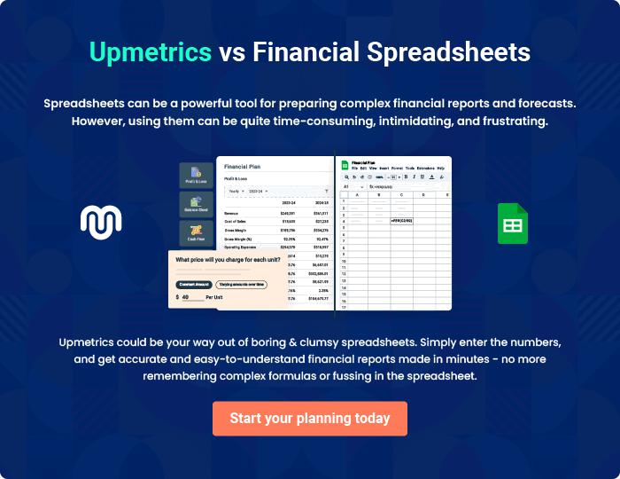
Appendix

When writing the appendix section, you should include any additional information that supports the main content of your plan. This may include financial statements, market research data, legal documents, and other
To unlock help try Upmetrics! 

Create a winning business plan that gets you funded

Creating a stunning and investment-ready plan requires no writing, graphic designing, or financial planning expertise.

Upmetrics has all the features required to help you create a comprehensive business plan—from start to finish. Make no mistakes, it’s the modern way of planning to structure ideas, make plans, and create stunning pitch decks to awe investors.

Pitch decks that impress investors

Create pitch decks that provide a visual representation of your business, engage investors, and make them want to invest in your business idea.

Interactive plans in no time

Import business plan sections like—SWOT analysis, comparison tables, and others to create an interactive business plan. No designing skills are required.

Stunning cover page designs

With Upmetrics, you have the liberty to choose from multiple stunning cover page designs. Choose a creative design and make your plan stand out.

Online sharing made simple

Upmetrics makes online sharing quick and easier for users. Easily share your business plans with a link while tracking reader activity.

500+ sample business plans

Simply import a template from our library of sample plans into the editor and start customizing it to make it yours. It takes only a few clicks to get started.

Collaborate with team in real-time

Invite team members, initiate conversations, discuss ideas & strategies, share feedback, and work on a business plan in real-time.

