
Pool Cleaning Business Plan

Refreshing Waters, Sparkling Smiles

BUSINESS PLAN

2023

John Doe | 10200 Bolsa Ave, Westminster, CA, 92683 | (650) 359-3153 | info@example.com
http://www.example.com

Information provided in this business plan is unique to this business and confidential; therefore, anyone reading this plan agrees not to disclose any of the information in this business plan without prior written permission of the company.
Table of Contents

Executive Summary | 6
Market opportunity | 6
Services Offered | 6
Marketing & Sales Strategies | 7
Financial Highlights | 7
Units Sold v/s Revenue | 8

Company Overview | 9
Ownership | 9
Mission statement | 10
Business history | 10
Future goals | 10

Market Analysis | 11
Target Market | 11
Market size and growth potential | 11
Market Size | 12
Competitive analysis | 12
Blue Haven Pools | 12
Aqua Pool Services | 13
EcoPools | 13
Market trends | 13
Regulatory environment | 14

Products and Services | 15
Services | 15
Regular Pool Maintenance | 15
Chemical Balancing | 16
Filter Cleaning | 16
Algae Removal | 17
Pool Opening/Closing | 17
Emergency Cleaning and Repair | 18
Quality measures | 18
Additional Services | 18

Sales And Marketing Strategies | 19
Unique Selling Proposition (USP) | 19
Pricing Strategy | 19
Marketing strategies | 20
Online | 20
Offline | 20
Sales strategies | 21
Customer retention | 22

Operations Plan | 23
Staffing & Training | 23
Operational Process | 23
Equipment & Machinery | 24

Management Team | 25
Key managers | 25
John Doe | 25
Jane Doe | 26
Alice Brown | 26
Robert Brown | 27
Organizational structure | 27
Organization chart | 28
Compensation plan | 28
Advisors/Consultants | 29
[ADVISOR NAME] | 29
[CONSULTANT NAME] | 29
Financial Plan
Financial Plan | 30

Profit & loss statement 30

Cash flow statement | 33
Balance sheet | 35
Break-even Analysis | 37
Financing needs | 39
Appendix
Appendix | 41
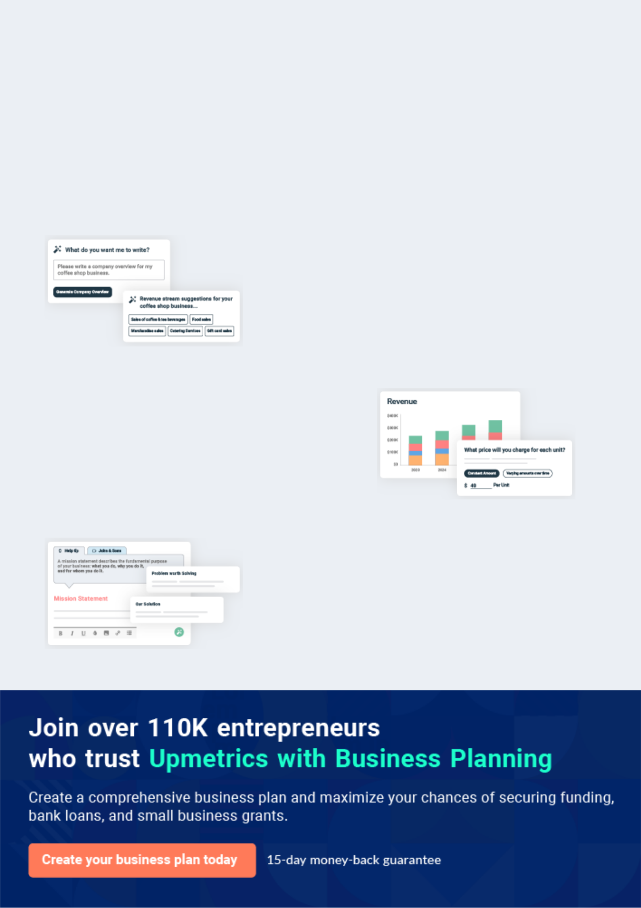
Business planning that’s simpler and faster than you think

Creating a business plan using Upmetrics to start and grow a business is literally the easiest thing in the World. Simply read the instructions and fill in the blanks. It’s as simple as that.

❛ | Upmetrics has everything you need to create a | ❜
❛ | comprehensive business plan. | ❜

AI-powered Upmetrics Assistant

AI-powered insights to streamline your plan

Not sure where to start? Upmetrics’ AI Assistant will automatically generate ideas for each section of your plan and offer improved versions of your writing, adjusting for tone, voice, and grammar or spelling errors.

Financial Forecasting Tool

All the financials are calculated for you

Forget the complex formulas and clumsy spreadsheets — with automatic financials and drag-and-drop forecasting, you can finish your plan faster and be confident that your numbers are accurate.

Business Plan Builder

Guides you like a business mentor

Upmetrics’ step-by-step instructions, prompts, and the library of 400+ sample business plans will guide you through each section of your plan as a business mentor.
Executive Summary


An executive summary is the first section of the business plan intended to provide an overview of the whole business plan.
To unlock help try Upmetrics! 

 Help tip  Pool Cleaning Business Plan


Start your executive summary by briefly introducing your business to your readers.

This section may include the name of your pool cleaning business, its location when it was
To unlock help try Upmetrics! 

Start writing here..

Market opportunity

 Help tip  Pool Cleaning Business Plan

Summarize your market research, including market size, growth potential, and marketing trends. Highlight the opportunities in the market and how your business will fit in to fill the gap.
To unlock help try Upmetrics! 

Start writing here..

Services Offered

 Help tip  Pool Cleaning Business Plan

Highlight the pool cleaning services you offer your clients. The USPs and differentiators you offer are always a plus.
To unlock help try Upmetrics! 

Start writing here..

Marketing & Sales Strategies
To unlock help try Upmetrics!

 Help tip  Pool Cleaning Business Plan

Outline your sales and marketing strategies—what marketing platforms you use, how you plan on acquiring customers, etc.
To unlock help try Upmetrics! 

Start writing here..

Financial Highlights

 Help tip  Pool Cleaning Business Plan

Briefly summarize your financial projections for the initial years of business operations. Include any capital or investment requirements, associated startup costs, projected revenues, and profit forecasts.



Start writing here..
Units Sold v/s Revenue

 |  | Units Sold | Revenue
15.00k
10.00k
5.00k
0
Year 1 | Year 2 | Year 3


Financial Year |  |  | Units Sold | Revenue
Year 1 | 1,550 |  |  | $10,000
Year 2 | 1,800 |  |  | $12,000
Year 3 | 2,050 |  |  | $14,000
 Help tip |  |  Pool Cleaning Business Plan


Summarize your executive summary section with a clear CTA, for example, inviting angel investors to discuss the potential business investment.
To unlock help try Upmetrics! 

Write a call to action for your business plan.
Company Overview

Depending on what details of your business are essential, you’ll need different elements in your business overview.
To unlock help try Upmetrics! 

 Help tip  Pool Cleaning Business Plan

Describe your business in this section by providing all the basic information:

Describe what kind of pool cleaning company you run and the name of it. You may specialize in
To unlock help try Upmetrics! 

Start writing here..

Ownership

 Help tip  Pool Cleaning Business Plan

List the names of your pool cleaning company’s founders or owners. Describe what shares they own and their responsibilities for efficiently managing the business.
To unlock help try Upmetrics! 

Start writing here..
Mission statement

 Help tip  Pool Cleaning Business Plan

Summarize your business’ objective, core principles, and values in your mission statement. This statement needs to be memorable, clear, and brief.
To unlock help try Upmetrics! 

❛ At [Crystal Clear Pools], our mission is to provide unparalleled pool cleaning and maintenance services, ensuring every pool we service is crystal clear, safe, and ready for enjoyment. We are committed to excellence, sustainability, and building lasting

relationships with our clients.
❜

Business history

 Help tip  Pool Cleaning Business Plan

If you’re an established pool cleaning service provider, briefly describe your business history, like—when it was founded, how it evolved over time, etc.
To unlock help try Upmetrics! 

Start writing here..

Future goals

 Help tip  Pool Cleaning Business Plan

It’s crucial to convey your aspirations and vision. Mention your short-term and long-term goals; they can be specific targets for revenue, market share, or expanding your services.
To unlock help try Upmetrics! 

Start writing here..

Market Analysis
To unlock help try Upmetrics!


 |  | Market analysis provides a clear understanding of the market in which your
 |  | printing business will run along with the target market, competitors, and
 |  | growth opportunities.
 |  |  |  | To unlock help try Upmetrics! 
 Help tip |  |  Pool Cleaning Business Plan

To write the introduction section of your market analysis, start by clearly identifying your primary target market.
To unlock help try Upmetrics! 

Start writing here..

Target Market

 Help tip  Pool Cleaning Business Plan

Start this section by describing your target market. Define your ideal customer and explain what types of services they prefer. Creating a buyer persona will help you easily define your target market to your readers.



Start writing here..

Market size and growth potential

 Help tip  Pool Cleaning Business Plan

Describe your market size and growth potential and whether you will target a niche or a much broader market.
To unlock help try Upmetrics! 

Start writing here..

Market Size


Available Market | 120k
All potential pool owners in [City/Region] | 120k

Served Market
Pool owners looking for professional 80k cleaning

Target Market | 20k
Mid to high-end residential pools | 20k

 Help tip  Pool Cleaning Business Plan

Identify and analyze your direct and indirect competitors. Identify their strengths and weaknesses, and describe what differentiates your pool cleaning services from them.
To unlock help try Upmetrics! 

Competitive analysis

Blue Haven Pools

Blue Haven Pools is a well-established player in the market, with over [X years] of experience. They have built a solid reputation for reliability and professionalism, serving a broad customer base that includes both residential and commercial clients.

Features | Strengths | Weaknesses
Comprehensive pool cleaning | Extensive experience in the | Higher pricing compared to other
and maintenance services | industry | competitors
Seasonal pool opening and | Strong reputation and brand | Limited flexibility in scheduling
closing | recognition | Potential delays in service during
Pool renovation and repair | Broad service offerings | peak season
services | catering to a wide range of
Online appointment scheduling | customer needs

Aqua Pool Services

Aqua Pool Services is known for its competitive pricing and rapid response times. They cater primarily to the residential market and have gained popularity for their promotional deals and discounts.

Features | Strengths | Weaknesses
Standard pool cleaning and | Highly competitive pricing | Less comprehensive service
maintenance | Quick response and turnaround | offerings
Emergency cleaning services | times | Limited expertise in handling
Cost-effective maintenance | Attractive promotions and | complex pool issues
packages | discounts | May use lower-quality cleaning
User-friendly website with |  | products
online booking

EcoPools

EcoPools has carved out a niche for itself by focusing on eco-friendly pool cleaning solutions. They have a smaller but loyal customer base that prioritizes sustainable practices

Features | Strengths | Weaknesses
Eco-friendly pool cleaning and | Strong commitment to eco- | Limited service offerings outside
maintenance | friendly practices | of eco-friendly solutions
Green pool restoration services | Niche positioning attracts a | Smaller operational scale can
Water conservation solutions | specific target audience | lead to limited service availability
Educational content on | Expertise in green pool | Higher pricing due to specialized
Educational content on | restoration | services
sustainable pool care | restoration | services

Market trends

 Help tip  Pool Cleaning Business Plan

Analyse emerging trends in the industry, such as technology disruptions, changes in customer behavior or preferences, etc. Explain how your business will cope with all the trends.
To unlock help try Upmetrics! 

Start writing here..

Regulatory environment

 Help tip  Pool Cleaning Business Plan

List regulations and licensing requirements that may affect your pool cleaning company, such as business licenses, insurance, environmental regulations, safety regulations, etc.
To unlock help try Upmetrics! 

Start writing here..
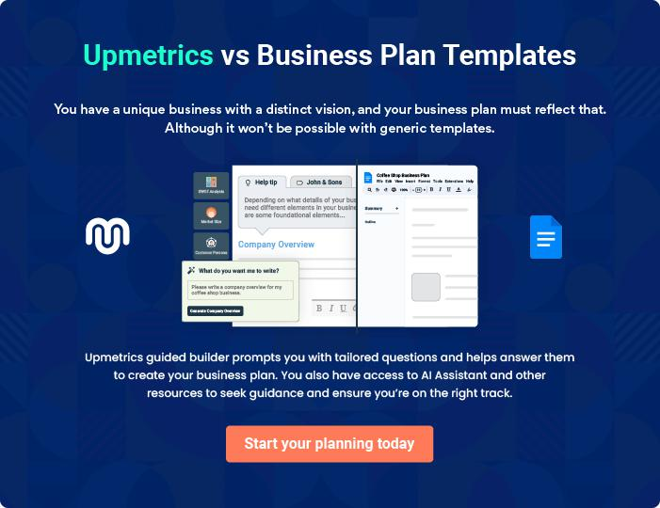
Products and Services
To unlock help try Upmetrics!

The product and services section of the pool cleaning business plan should describe the specific services and products that will be offered to customers. To write this section should include the following:



 Help tip  Pool Cleaning Business Plan

To craft the introduction for your "Products and Services" chapter, begin by positioning your business within its industry, emphasizing its unique strengths or value proposition.
To unlock help try Upmetrics! 

Start writing here..

 Help tip


Mention the pool cleaning services your business will offer. This list may include services like,

• Regular pool maintenance
To unlock help try Upmetrics! 

Services

Regular Pool Maintenance


Price: [$150] per month

Our regular pool maintenance service ensures your pool remains in pristine condition all year round. This service includes skimming, vacuuming, brushing, filter cleaning, and basic chemical balancing.

Specifications

- Frequency: Weekly visits

- Duration: 1-2 hours per visit

- Includes cleaning of pool surface, walls, and floor

- Basic chemical check and balance (chlorine and pH levels)
Chemical Balancing

Price: [$80] per session

Ensure the safety and comfort of your pool water with our chemical balancing service. We adjust chlorine, pH, alkalinity, and other essential levels to maintain a balanced and sanitary swimming environment.

Specifications

- Frequency: As needed

- Duration: 30-45 minutes

- Comprehensive water testing

- Adjustment of chemical levels

- Recommendations for maintaining water balance

Filter Cleaning

Price: [$100] per cleaning

Prolong the life of your pool equipment and ensure efficient operation with our filter cleaning service. We disassemble, clean, and reassemble your pool filter, ensuring it’s in top condition.

Specifications

- Frequency: Every 3-6 months (depending on usage)

- Duration: 1-2 hours

- Suitable for all types of pool filters

- Includes inspection of filter parts for wear and tear

- Recommendations for filter care and maintenance
Algae Removal

Price: Starting at [$200] (varies by severity)

Combat algae growth and restore clarity to your pool water with our specialized algae removal service. We use powerful, yet eco-friendly algaecides and brushing techniques to eliminate algae and prevent future growth.

Specifications

- Frequency: As needed

- Duration: Varies by severity of algae growth

- Comprehensive algae assessment

- Application of appropriate algaecides

- Brushing and vacuuming of pool surfaces

Pool Opening/Closing

Price: [$300] per service

Prepare your pool for the swimming season or winterize it with our pool opening and closing services. We handle everything from cleaning, chemical balancing, to equipment setup/shutdown.

Specifications

- Frequency: Annually

- Duration: 2-4 hours

- Opening: Removal of cover, cleaning, equipment setup, initial chemical balancing

- Closing: Cleaning, equipment shutdown, application of winterizing chemicals, cover installation
Emergency Cleaning and Repair

Price: [$150] per hour (2-hour minimum)

Address unexpected pool issues promptly with our emergency cleaning and repair services. Whether it’s an unforeseen algae bloom or equipment malfunction, we’re here to help.

Specifications

- Availability: 24/7

- Response Time: Within 2 hours

- Comprehensive assessment of the issue

- Immediate cleaning or repair as needed

- Follow-up recommendations to prevent future issues

Quality measures

 Help tip  Pool Cleaning Business Plan

This section should explain how you maintain quality standards and consistently provide the highest quality service.
To unlock help try Upmetrics! 

Start writing here..

Additional Services

 Help tip  Pool Cleaning Business Plan

Mention if your pool cleaning company offers any additional services. You may include services like tile & grout cleaning, pool repairs, acid washing, etc.
To unlock help try Upmetrics! 

Start writing here..

Sales And Marketing Strategies
To unlock help try Upmetrics!

Writing the sales and marketing strategies section means a list of strategies you will use to attract and retain your clients.
To unlock help try Upmetrics! 

 Help Tip  Pool Cleaning Business Plan


To create an effective introduction for your "Sales and Marketing Strategies" chapter, start by setting the stage within your specific industry or market.
To unlock help try Upmetrics! 

Start writing here..

Unique Selling Proposition (USP)

 Help tip  Pool Cleaning Business Plan

Define your business’s USPs depending on the market you serve, the equipment you use, and the unique services you provide. Identifying USPs will help you plan your marketing strategies.
To unlock help try Upmetrics! 

Start writing here..

Pricing Strategy

 Help tip  Pool Cleaning Business Plan

Describe your pricing strategy—how you plan to price your pool cleaning services and stay competitive in the local market. You can mention any discounts you plan on offering to attract new customers.



Start writing here..

 Help tip  Pool Cleaning Business Plan
To unlock help try Upmetrics!

Discuss your marketing strategies to market your services. You may include some of these marketing strategies in your business plan—social media marketing, Google ads, brochures, email marketing, content marketing, and print marketing.



Marketing strategies

Online


Social Media

Utilize platforms such as [Facebook, Instagram, Twitter] to engage with the community, showcase our work, and run promotional campaigns.

Content Marketing

Create engaging blog posts and articles related to pool maintenance, positioning ourselves as industry experts.

Email Marketing

Develop a newsletter to share pool maintenance tips, special promotions, and company updates with our subscribers.

Google Ads

Invest in targeted Google Ads to capture the attention of potential clients actively searching for pool cleaning services in our area.

Offline

Brochures & Print Marketing

Distribute informative brochures and flyers in strategic locations, highlighting our services, pricing, and contact information.

 Help tip  Pool Cleaning Business Plan
To unlock help try Upmetrics!

Outline the strategies you’ll implement to maximize your sales. Your sales strategies may include direct sales calls, partnering with other cleaning or housekeeping businesses, offering referral programs, etc.



Sales strategies

Partner with Businesses

Form strategic partnerships with other cleaning or housekeeping businesses to create referral networks.

Referral Programs

Implement a referral program, offering existing clients incentives for referring new business to [Crystal Clear Pools].

Direct Sales Calls

Proactively reach out to property managers and real estate agents, introducing them to our services.

 Help tip  Pool Cleaning Business Plan

Describe your customer retention strategies and how you plan to execute them. For instance, introducing loyalty programs, discounts on annual membership, personalized service, etc.
To unlock help try Upmetrics! 

Customer retention

Loyalty Programs

Introduce a loyalty program, offering discounts or additional services for repeat business.

Annual Membership Discounts

Provide attractive discounts for clients who commit to annual service contracts.

Personalized Service

Ensure that each client receives personalized attention, understanding their specific needs and preferences.

Follow-up Communication

Implement follow-up communications after each service, ensuring customer satisfaction and addressing any issues proactively.

Operations Plan
To unlock help try Upmetrics!

 |  | When writing the operations plan section, it’s important to consider the
 |  | various aspects of your business operations.
 |  |  |  | To unlock help try Upmetrics! 
 Help tip |  |  Pool Cleaning Business Plan


To create an effective introduction for your "Operational Plan" chapter, start by emphasizing the
pivotal role of efficient operations in the success of your business, underscoring how they
directly impact the quality of services delivered.
 |  |  |  | To unlock help try Upmetrics! 
Start writing here..
Staffing & Training
 Help tip |  |  Pool Cleaning Business Plan

Mention your cleaning business’s staffing requirements, including the number of employees or
cleaning staff needed. Include their qualifications, the training required, and the duties they will
perform.
 |  |  |  | To unlock help try Upmetrics! 
Start writing here..
Operational Process
 Help tip |  |  Pool Cleaning Business Plan

Outline the processes and procedures you will use to run your pool cleaning business. Your operational processes may include sending quotations, scheduling appointments, site visits, training employees, etc.



Start writing here..

Equipment & Machinery

 Help tip  Pool Cleaning Business Plan

Include the list of equipment and machinery required for pool cleaning, such as pool skimmer, pool brushes, leaf rakes, pool test kit, etc.
To unlock help try Upmetrics! 

Start writing here..
Management Team

The management team section provides an overview of the individuals responsible for running your business plan.
To unlock help try Upmetrics! 

 Help tip  Pool Cleaning Business Plan

To craft an introduction for your "Management Team" chapter, begin by emphasizing the crucial role of leadership in the success of any business.
To unlock help try Upmetrics! 

Start writing here..

Key managers

 Help tip  Pool Cleaning Business Plan

Introduce your management and key members of your team, and explain their roles and responsibilities.
To unlock help try Upmetrics! 

Start writing here..


JOHN DOE

CEO - john.doe@example.com

[John Doe] oversees all aspects of the business, from financial management to customer relations, ensuring that [Crystal Clear Pools] maintains its reputation for excellence in pool cleaning services.


With over [number] years of experience in the pool cleaning industry, [John Doe] brings a wealth of knowledge and expertise to the company.

- Background: He holds a [relevant degree] from [University/College Name] and has previously worked in [previous roles/industries], gaining invaluable experience in business management and customer service.

JANE DOE

Chief Operating Officer (COO) - jane.doe@example.com

As the COO of [Crystal Clear Pools], Jane oversees the daily operations of the company, ensuring that all business activities run smoothly and align with our quality standards and corporate policies.


She plays a pivotal role in strategic planning and execution, working closely with the CEO and other key managers to drive operational excellence.

- Educational Background: Jane holds a Bachelor’s degree in Business Administration from the University of Example and an MBA in Operations Management from Example State University.

- Professional Background: With over 15 years of experience in the pool cleaning industry, Jane has developed a comprehensive understanding of operational best practices and efficiency optimization.

Before joining [Crystal Clear Pools], she held managerial positions at other leading pool maintenance companies, where she was known for her ability to streamline operations and improve service delivery.


ALICE BROWN

CMO - alice.brown@example.com

Alice is responsible for leading the marketing and advertising initiatives at [Crystal Clear Pools]. Her innovative strategies and campaigns have played a crucial role in enhancing our brand presence and attracting new clients.

She focuses on digital marketing, community engagement, and customer relationship management to ensure we stay ahead of market trends.

- Educational Background: Alice holds a Bachelor’s degree in Marketing from Example University and a Master’s degree in Digital Marketing from Example Tech.

- Professional Background: With over a decade of experience in marketing, especially in the service industry, Alice brings a wealth of knowledge and a fresh perspective to our marketing efforts.

She has successfully led marketing teams in her previous roles, achieving remarkable results in brand awareness and customer acquisition.

ROBERT BROWN

Operations Manager - robert.brown@example.com

Robert is integral to the success of our day-to-day operations at [Crystal Clear Pools]. He oversees the scheduling of pool cleaning appointments, ensures that all equipment is in top condition, and manages the on-site cleaning teams.

His dedication to operational excellence ensures that we consistently deliver high-quality pool cleaning services to our clients.

- Educational Background: Robert has a Bachelor’s degree in Operations Management from Example University.

- Professional Background: Bringing over 12 years of experience in operations and pool maintenance, Robert has a proven track record of managing large teams and complex operations.

His attention to detail and commitment to customer satisfaction have made him a valuable asset to our team.

Organizational structure

 Help tip  Pool Cleaning Business Plan

Explain the organizational structure of your management team. Include the reporting line and decision-making hierarchy.
To unlock help try Upmetrics! 

Start writing here..
Organization chart


John Doe

CEO
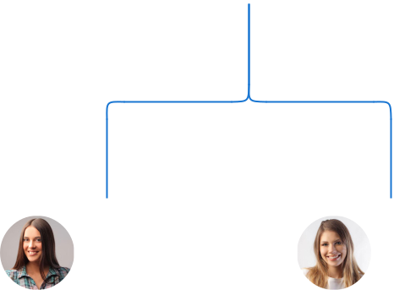

Alice Brown Jane Doe

CMO COO



Michael Taylor | Sarah Johnson |  |  |  | Emily White
Michael Taylor |  |  | Robert Brown |  | Emily White
Sales Manager | Digital Marketing |  |  |  | Emily White
Sales Manager |  |  |  |  | HR Manager
Specialist | Specialist |  | Operations |  | HR Manager
 |  |  | Manager





Compensation plan

 Help tip  Pool Cleaning Business Plan

Describe your compensation plan for the management and staff. Include their salaries, incentives, and other benefits.
To unlock help try Upmetrics! 

Start writing here..
 Help tip  Pool Cleaning Business Plan

Mentioning advisors or consultants in your business plans adds credibility to your business idea.
To unlock help try Upmetrics! 

Advisors/Consultants


[ADVISOR NAME]

Industry Expert

With over [20 years] of experience in the pool cleaning and maintenance industry, [Advisor Name] provides invaluable advice and insights, ensuring that we stay ahead of industry trends and best practices.


[CONSULTANT NAME]

Financial Strategist

[Consultant Name] assists us in navigating our financial landscape, providing expert advice on budgeting, financial planning, and risk management.
Financial Plan

When writing the financial plan section of a business plan, it’s important to provide a comprehensive overview of your financial projections for the first few years of your business, You may provide the following:
To unlock help try Upmetrics! 

 Help tip  Pool Cleaning Business Plan


To create an effective introduction for your "Financial Plan" chapter, begin by stressing the critical role of a well-structured financial plan in the success of your venture.
To unlock help try Upmetrics! 

Start writing here..

 Help tip  Pool Cleaning Business Plan

Describe details such as projected revenue, operational costs, and service costs in your projected profit and loss statement. Make sure to include your business’s expected net profit or loss.
To unlock help try Upmetrics! 

Profit & loss statement

Revenue

Cost Of Sales

General Costs

Revenue Specific Costs

Personnel Costs (Direct

Labor)

Gross Margin

Gross Margin (%)

Operating Expense

Payroll Expense

(Indirect Labor)

General Expense

Bad Debt

Amortization of Current

Assets

2023-24 | 2024-25 | 2025-26 | 2026-27 | 2027-28
$0 | $0 | $0 | $0 | $0

$0 | $0 | $0 | $0 | $0
$0 | $0 | $0 | $0 | $0
$0 | $0 | $0 | $0 | $0
$0 | $0 | $0 | $0 | $0

$0 | $0 | $0 | $0 | $0
0% | 0% | 0% | 0% | 0%

$0 | $0 | $0 | $0 | $0
$0 | $0 | $0 | $0 | $0
$0 | $0 | $0 | $0 | $0
$0 | $0 | $0 | $0 | $0
$0 | $0 | $0 | $0 | $0

EBITDA

Additional Expense

Long Term

Depreciation

Gain or loss from Sale

of Assets

EBIT

Interest Expenses

EBT

Income Tax Expense

Total Expense

Net Income

Net Income (%)

2023-24 | 2024-25 | 2025-26 | 2026-27 | 2027-28
$0 | $0 | $0 | $0 | $0
$0 | $0 | $0 | $0 | $0
$0 | $0 | $0 | $0 | $0
$0 | $0 | $0 | $0 | $0
$0 | $0 | $0 | $0 | $0
$0 | $0 | $0 | $0 | $0
$0 | $0 | $0 | $0 | $0
$0 | $0 | $0 | $0 | $0
$0 | $0 | $0 | $0 | $0
$0 | $0 | $0 | $0 | $0
0% | 0% | 0% | 0% | 0%

 |  |  | 2023-24 |  | 2024-25 | 2025-26
Retained Earning |  |  | $0 |  | $0 | $0
Opening |  |  |  |  | $0 | $0
Owner's Distribution |  |  | $0 |  | $0 | $0
Retained Earning |  |  | $0 |  | $0 | $0
Closing |  |  |  |  | $0 | $0
 Help tip |  |  |  Pool Cleaning Business Plan


The cash flow for the first few years of your operation should be estimated and described in this section.

This may include billing invoices, payment receipts, loan payments, and any other cash flow statements.
2026-27 2027-28

$0 $0

$0 $0

$0 $0

To unlock help try Upmetrics! 

Cash flow statement

 | 2023-24 | 2024-25 | 2025-26 | 2026-27 | 2027-28
Cash Received | $0 | $0 | $0 | $0 | $0
Cash Paid | $0 | $0 | $0 | $0 | $0
COS & General Expenses | $0 | $0 | $0 | $0 | $0
Salary & Wages | $0 | $0 | $0 | $0 | $0
Interest | $0 | $0 | $0 | $0 | $0

Sales Tax

Income Tax

Net Cash From

Operations

Assets Sell

Assets Purchase

Net Cash From

Investments

Amount Received

Loan Received

Common Stock

Preferred Stock

Owner's Contribution

Amount Paid

2023-24 | 2024-25 | 2025-26 | 2026-27 | 2027-28
$0 | $0 | $0 | $0 | $0
$0 | $0 | $0 | $0 | $0
$0 | $0 | $0 | $0 | $0

$0 | $0 | $0 | $0 | $0
$0 | $0 | $0 | $0 | $0
$0 | $0 | $0 | $0 | $0

$0 | $0 | $0 | $0 | $0
$0 | $0 | $0 | $0 | $0

$0 | $0 | $0 | $0 | $0
$0 | $0 | $0 | $0 | $0
$0 | $0 | $0 | $0 | $0

Loan Capital $0 $0 $0 $0 $0

 |  |  | 2023-24 | 2024-25 | 2025-26 | 2026-27 | 2027-28
Dividends & Distributions |  |  | $0 | $0 | $0 | $0 | $0
Net Cash From |  |  | $0 | $0 | $0 | $0 | $0
Financing
Summary
Starting Cash |  |  | $0 | $0 | $0 | $0 | $0
Cash In |  |  | $0 | $0 | $0 | $0 | $0
Cash Out |  |  | $0 | $0 | $0 | $0 | $0
Change in Cash |  |  | $0 | $0 | $0 | $0 | $0
Ending Cash |  |  | $0 | $0 | $0 | $0 | $0
 Help tip |  |  Pool Cleaning Business Plan

Create a projected balance sheet documenting your pool cleaning business’s assets, liabilities, and equity.

To unlock help try Upmetrics! 

Balance sheet

 | 2023-24 | 2024-25 | 2025-26 | 2026-27 | 2027-28
Assets | $0 | $0 | $0 | $0 | $0
Current Assets | $0 | $0 | $0 | $0 | $0
Cash | $0 | $0 | $0 | $0 | $0
Accounts Receivable | $0 | $0 | $0 | $0 | $0
Inventory | $0 | $0 | $0 | $0 | $0
Other Current Assets | $0 | $0 | $0 | $0 | $0
Long Term Assets | $0 | $0 | $0 | $0 | $0
Gross Long Term Assets | $0 | $0 | $0 | $0 | $0
Accumulated Depreciation | $0 | $0 | $0 | $0 | $0

Liabilities & Equity | $0 | $0 | $0 | $0 | $0
Liabilities | $0 | $0 | $0 | $0 | $0
Current Liabilities | $0 | $0 | $0 | $0 | $0
Accounts Payable | $0 | $0 | $0 | $0 | $0
Income Tax Payable | $0 | $0 | $0 | $0 | $0
Sales Tax Payable | $0 | $0 | $0 | $0 | $0
Short Term Debt | $0 | $0 | $0 | $0 | $0
 | 2023-24 | 2024-25 | 2025-26 | 2026-27 | 2027-28
Long Term Liabilities | $0 | $0 | $0 | $0 | $0
Long Term Debt | $0 | $0 | $0 | $0 | $0
Equity | $0 | $0 | $0 | $0 | $0
Paid-in Capital | $0 | $0 | $0 | $0 | $0
Common Stock | $0 | $0 | $0 | $0 | $0
Preferred Stock | $0 | $0 | $0 | $0 | $0
Owner's Contribution | $0 | $0 | $0 | $0 | $0
Retained Earnings | $0 | $0 | $0 | $0 | $0

Check | $0 |  |  | $0 | $0 | $0 | $0
 Help tip |  |  Pool Cleaning Business Plan

Determine and mention your business’s break-even point—the point at which your business costs and revenue will be equal.

This exercise will help you understand how much revenue you need to generate to sustain or be profitable.
To unlock help try Upmetrics! 

Break-even Analysis

 | 2023-24 | 2024-25 | 2025-26 | 2026-27 | 2027-28
Starting Revenue | $0 | $0 | $0 | $0 | $0
Net Revenue | $0 | $0 | $0 | $0 | $0
Closing Revenue | $0 | $0 | $0 | $0 | $0

Starting Expense | $0 | $0 | $0 | $0 | $0
Net Expense | $0 | $0 | $0 | $0 | $0
Closing Expense | $0 | $0 | $0 | $0 | $0

Is Break Even? | 0 | 0 | 0 | 0 | 0
Break Even Month | 0 | 0 | 0 | 0 | 0
Days Required | 0 | 0 | 0 | 0 | 0
Break Even Revenue | $0 | $0 | $0 | $0 | $0
Break Even Units
Financing needs

 Help tip  Pool Cleaning Business Plan

Calculate costs associated with starting a pool cleaning business, and estimate your financing needs and how much capital you need to raise to operate your business.
To unlock help try Upmetrics! 

Start writing here..
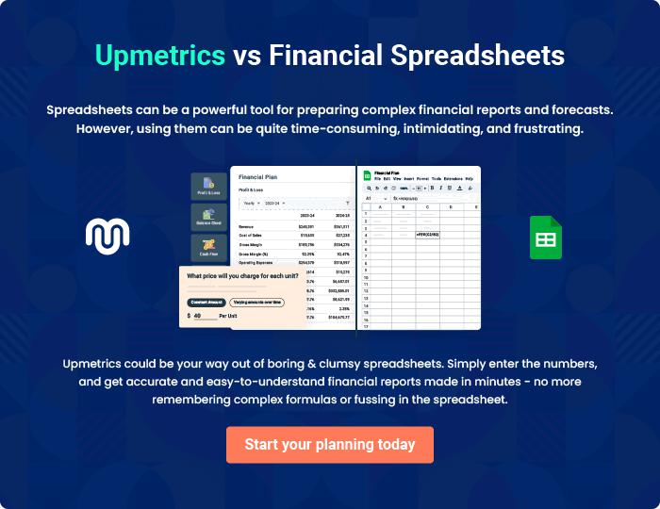
Appendix

When writing the appendix section, you should include any additional information that supports the main content of your plan. This may include financial statements, market research data, legal documents, and other
To unlock help try Upmetrics! 
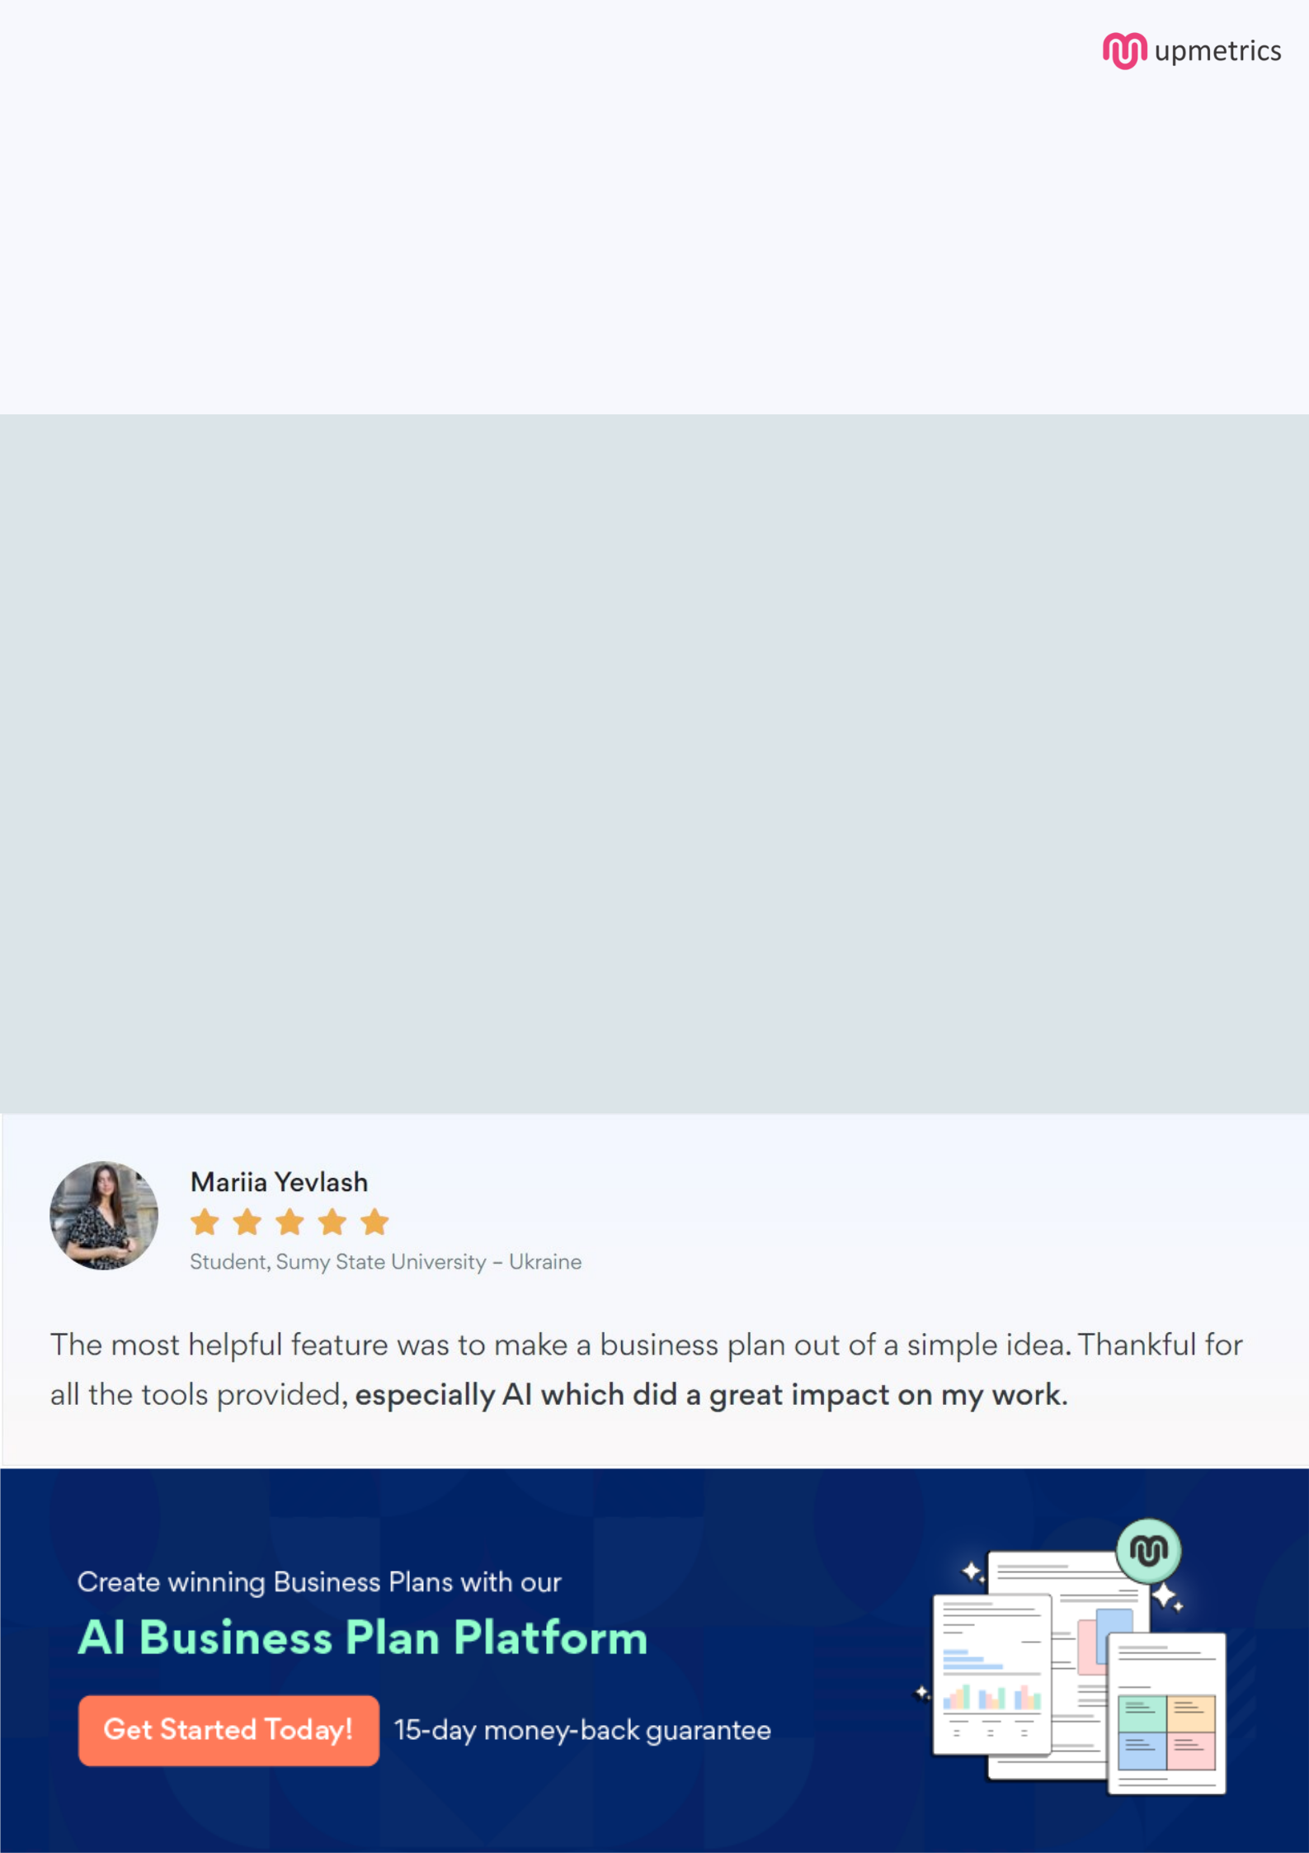
Create a winning business plan that gets you funded

Creating a stunning and investment-ready plan requires no writing, graphic designing, or financial planning expertise.

Upmetrics has all the features required to help you create a comprehensive business plan—from start to finish. Make no mistakes, it’s the modern way of planning to structure ideas, make plans, and create stunning pitch decks to awe investors.

Pitch decks that impress investors

Create pitch decks that provide a visual representation of your business, engage investors, and make them want to invest in your business idea.

Interactive plans in no time

Import business plan sections like—SWOT analysis, comparison tables, and others to create an interactive business plan. No designing skills are required.

Stunning cover page designs

With Upmetrics, you have the liberty to choose from multiple stunning cover page designs. Choose a creative design and make your plan stand out.

Online sharing made simple

Upmetrics makes online sharing quick and easier for users. Easily share your business plans with a link while tracking reader activity.

500+ sample business plans

Simply import a template from our library of sample plans into the editor and start customizing it to make it yours. It takes only a few clicks to get started.

Collaborate with team in real-time

Invite team members, initiate conversations, discuss ideas & strategies, share feedback, and work on a business plan in real-time.

