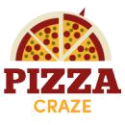
Pizza Shop Business Plan


Business
Plan

2023


Where Every Slice Tells a Story

Information provided in this business plan is unique to this business and confidential; therefore, anyone reading this plan agrees not to disclose any of the information in this business plan without prior written permission of the company.

 | Prepared By | 10200 Bolsa Ave, Westminster, CA, 92683
 | John Doe | info@example.com
 | (650) 359-3153 | http://www.example.com

Table of Contents

Executive Summary | 6
Market opportunity | 6
Services Offered | 6
Marketing & Sales Strategies | 7
Financial Highlights | 7
Units Sold v/s Revenue | 8

Company Overview | 9
Ownership | 9
Business Owners | 9
Mission statement | 10
Business history | 10
Future goals | 10

Market Analysis | 11
Target Market | 11
Market size and growth potential | 11
Market Size | 12
Competitive analysis | 12
Golden Crust Pizzeria | 12
Napoli Neapolitan | 13
Market trends | 13
Regulatory environment | 13

Products and Services | 15
Pizza shop menu | 15
Classic Margherita Pizza | 15
Spicy Thai Chicken Pizza | 16
Tiramisu Dessert | 16
Garlic Dip | 16
Birthday Party Catering Package | 17
Pizza Offerings | 17
Quality Measures | 17
Additional Services | 18

Sales And Marketing Strategies | 19
Unique Selling Proposition (USP) | 19
Pricing Strategy | 19
Marketing strategies | 20
Online | 20
Offline | 20
Sales strategies | 21
Customer retention | 21

Operations Plan | 22
Staffing & Training | 22
Operational Process | 22
Equipment & Machinery | 23

Management Team | 24
Key managers | 24
John Doe | 25
Jane Doe | 26
Alice Brown | 26
Robert Brown | 26
Organizational structure | 27
Organization chart | 27
Compensation plan | 28
Advisors/Consultants | 28
[ADVISOR NAME] | 28
[CONSULTANT NAME] | 28
Financial Plan
Financial Plan | 29

Profit & loss statement 29

Cash flow statement | 32
Balance sheet | 34
Break-even Analysis | 36
Financing needs | 38
Appendix
Appendix | 40
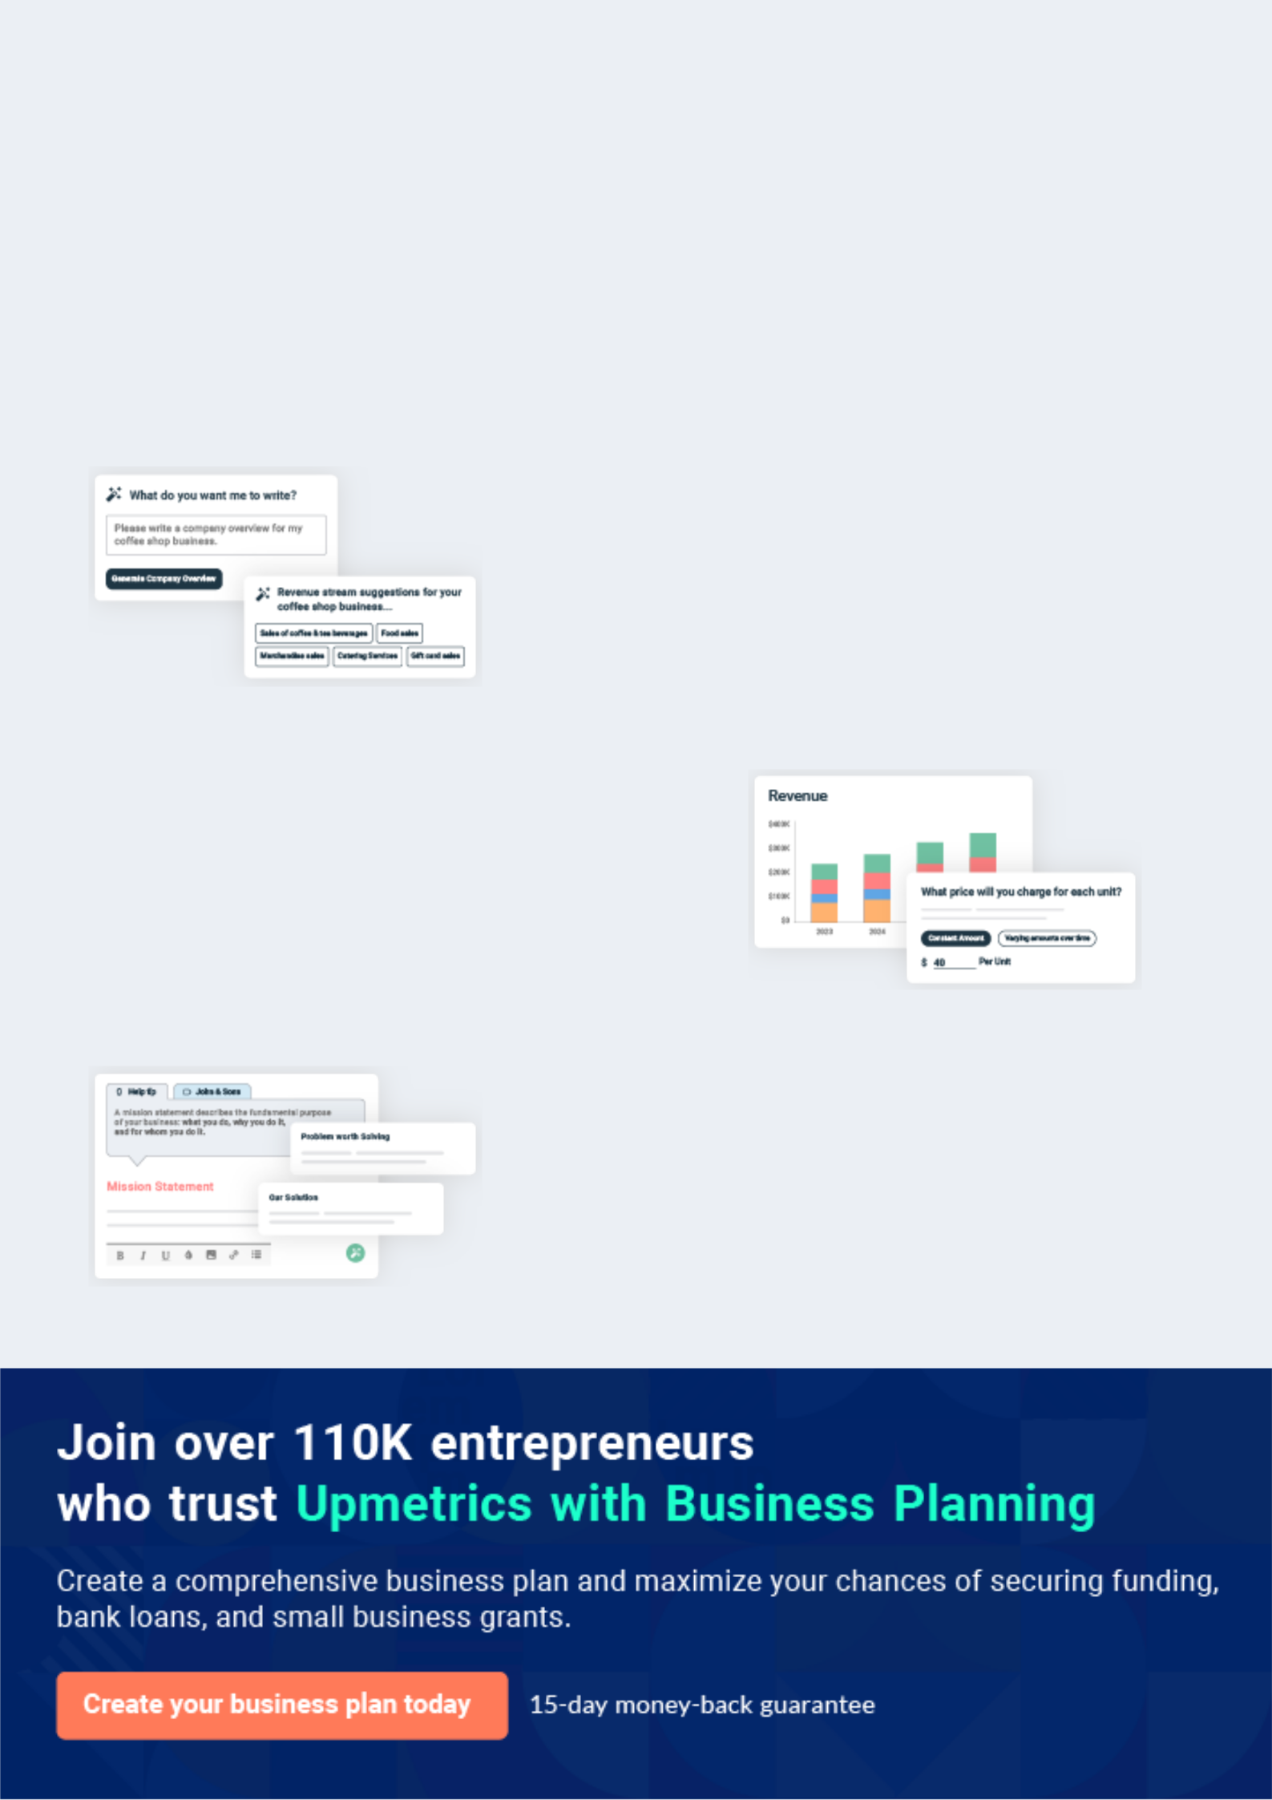
Business planning that’s simpler and faster than you think

Creating a business plan using Upmetrics to start and grow a business is literally the easiest thing in the World. Simply read the instructions and fill in the blanks. It’s as simple as that.

❛ | Upmetrics has everything you need to create a | ❜
❛ | comprehensive business plan. | ❜

AI-powered Upmetrics Assistant

AI-powered insights to streamline your plan

Not sure where to start? Upmetrics’ AI Assistant will automatically generate ideas for each section of your plan and offer improved versions of your writing, adjusting for tone, voice, and grammar or spelling errors.

Financial Forecasting Tool

All the financials are calculated for you

Forget the complex formulas and clumsy spreadsheets — with automatic financials and drag-and-drop forecasting, you can finish your plan faster and be confident that your numbers are accurate.

Business Plan Builder

Guides you like a business mentor

Upmetrics’ step-by-step instructions, prompts, and the library of 400+ sample business plans will guide you through each section of your plan as a business mentor.
Executive Summary


An executive summary is the first section of the business plan intended to provide an overview of the whole business plan.
To unlock help try Upmetrics! 

 Help tip  Pizza Shop Business Plan


Start your executive summary by briefly introducing your business to your readers.

This section may include the name of your pizza shop, its location, when it was founded, the
To unlock help try Upmetrics! 

Start writing here..

Market opportunity

 Help tip  Pizza Shop Business Plan

Summarize your market research, including market size, growth potential, and marketing trends. Highlight the opportunities in the market and how your business will fit in to fill the gap.
To unlock help try Upmetrics! 

Start writing here..

Services Offered

 Help tip  Pizza Shop Business Plan

Highlight the pizzas you offer your clients. The USPs and differentiators you offer are always a plus.
To unlock help try Upmetrics! 

Start writing here..

Marketing & Sales Strategies
To unlock help try Upmetrics!

 Help tip  Pizza Shop Business Plan

Outline your sales and marketing strategies—what marketing platforms you use, how you plan on acquiring customers, etc.
To unlock help try Upmetrics! 

Start writing here..

Financial Highlights

 Help tip  Pizza Shop Business Plan

Briefly summarize your financial projections for the initial years of business operations. Include any capital or investment requirements, associated startup costs, projected revenues, and profit forecasts.



Start writing here..
Units Sold v/s Revenue

 |  | Units Sold | Revenue
15.00k
10.00k
5.00k
0
Year 1 | Year 2 | Year 3


Financial Year |  |  | Units Sold | Revenue
Year 1 | 1,550 |  |  | $10,000
Year 2 | 1,800 |  |  | $12,000
Year 3 | 2,050 |  |  | $14,000
 Help tip |  |  Pizza Shop Business Plan


Summarize your executive summary section with a clear CTA, for example, inviting angel investors to discuss the potential business investment.
To unlock help try Upmetrics! 

Write a call to action for your business plan.
Company Overview

Depending on what details of your business are essential, you’ll need different elements in your business overview.
To unlock help try Upmetrics! 

 Help tip  Pizza Shop Business Plan

Describe your business in this section by providing all the basic information:

Describe what kind of pizza shop you run and the name of it. You may specialize in one of the
To unlock help try Upmetrics! 

Start writing here..

Ownership

 Help tip  Pizza Shop Business Plan

List the names of your pizza shop’s founders or owners. Describe what shares they own and their responsibilities for efficiently managing the business.
To unlock help try Upmetrics! 

Start writing here..

Business Owners



50% John Doe



50% Jane Doe
Mission statement

 Help tip  Pizza Shop Business Plan

Summarize your business’ objective, core principles, and values in your mission statement. This statement needs to be memorable, clear, and brief.
To unlock help try Upmetrics! 

❛ Our mission at [Slice of Heaven Pizzeria] is to deliver an authentic [e.g., "Neapolitan"] pizza experience, forging memories one slice at a time.

We believe in using the finest ingredients, upholding traditional pizza-making methods, and fostering a sense of community in every interaction.

❜

Business history

 Help tip  Pizza Shop Business Plan

If you’re an established pizza shop, briefly describe your business history, like—when it was founded, how it evolved over time, etc.
To unlock help try Upmetrics! 

Start writing here..

Future goals

 Help tip  Pizza Shop Business Plan

It’s crucial to convey your aspirations and vision. Mention your short-term and long-term goals; they can be specific targets for revenue, market share, or expanding your services.
To unlock help try Upmetrics! 

Start writing here..

Market Analysis
To unlock help try Upmetrics!


 |  | Market analysis provides a clear understanding of the market in which your
 |  | printing business will run along with the target market, competitors, and
 |  | growth opportunities.
 |  |  |  | To unlock help try Upmetrics! 
 Help tip |  |  Pizza Shop Business Plan

To write the introduction section of your market analysis, start by clearly identifying your primary target market.
To unlock help try Upmetrics! 

Start writing here..

Target Market

 Help tip  Pizza Shop Business Plan

Start this section by describing your target market. Define your ideal customer and explain what types of services they prefer. Creating a buyer persona will help you easily define your target market to your readers.



Start writing here..

Market size and growth potential

 Help tip  Pizza Shop Business Plan

Describe your market size and growth potential and whether you will target a niche or a much broader market.
To unlock help try Upmetrics! 

Start writing here..

Market Size

Available Market | 10M
Total pizza consumers in [City/Location | 10M
Name].
Served Market | 6M
Consumers preferring specialty or | 6M
gourmet pizzas. | 6M
Target Market | 1M
Millennials & foodies seeking unique | 1M
pizza flavors. | 1M


 Help tip  Pizza Shop Business Plan

Identify and analyze your direct and indirect competitors. Identify their strengths and weaknesses, and describe what differentiates your pizza shop from them.
To unlock help try Upmetrics! 

Competitive analysis

Golden Crust Pizzeria

- Location: [Address or general location, e.g., "Downtown Market Street"]

- Business Model: [e.g., "Fast-casual pizza chain with a focus on delivery"]

- Years in Business: [e.g., "Established in 2005"]

Features

Comprehensive online ordering system with a loyalty rewards program

Diverse menu including gluten-free and vegan options

Collaborations with third-party delivery platforms for wider reach

Strengths

Wide delivery radius ensuring expansive customer reach

Robust online presence with active social media campaigns and promotions

Diverse menu catering to varied dietary needs

Weaknesses

Reliance on third-party delivery platforms, impacting profit margins

Inconsistent pizza quality, as per customer reviews

Limited dine-in space, deterring larger groups

Napoli Neapolitan

Location: [Address or general location, e.g., "Eastside Shopping Plaza"]

Business Model: [e.g., "Traditional Neapolitan Pizzeria with dine-in emphasis"]

Years in Business: [e.g., "Since 2015"]

Features | Strengths | Weaknesses
Authentic wood-fired pizza | Unique gourmet pizzas, | Premium pricing potentially
oven enhancing flavor profiles | offering a differentiated dining | alienating budget-conscious
Monthly rotational specialty | experience | customers
pizzas featuring unique | Authentic Neapolitan pizza- | Limited marketing efforts,
ingredients | making methods ensuring | especially in the digital domain
Wine pairing suggestions with | consistent quality | Absence of a delivery model,
select gourmet pizzas | Active engagement in | limiting service to dine-in patrons
 | community events, bolstering
 | local brand recognition

Market trends

 Help tip  Pizza Shop Business Plan

Analyze emerging trends in the industry, such as technology disruptions, changes in customer behavior or preferences, etc. Explain how your business will cope with all the trends.
To unlock help try Upmetrics! 

Start writing here..

Regulatory environment

 Help tip  Pizza Shop Business Plan

List regulations and licensing requirements that may affect your pizza shop, such as business licenses & permits, food safety & sanitation, employee health & safety, alcohol licensing, etc.
To unlock help try Upmetrics! 

Start writing here..

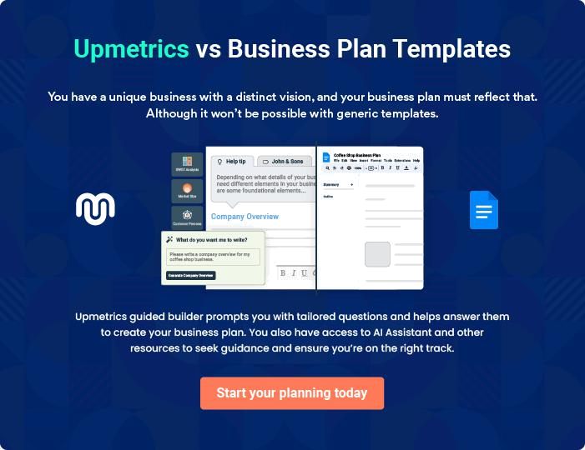
Products and Services
To unlock help try Upmetrics!

The product and services section of a pizza shop business plan should describe the specific services and products that will be offered to customers. To write this section should include the following:



 Help tip  Pizza Shop Business Plan

To craft the introduction for your "Products and Services" chapter, begin by positioning your business within its industry, emphasizing its unique strengths or value proposition.
To unlock help try Upmetrics! 

Start writing here..

 Help tip


Mention the pizza shop menu your business will offer. This list may include:

• Classic pizzas
To unlock help try Upmetrics! 

Pizza shop menu

Classic Margherita Pizza


Price: [$10.99]

A timeless favorite, our Margherita Pizza boasts a luscious tomato base, topped with fresh mozzarella cheese, ripe tomatoes, and fragrant basil.

Specifications

- Size: 12" (Medium)

- Crust: Thin Crust

- Toppings: Mozzarella Cheese, Sliced Tomatoes, Fresh Basil

- Sauce: Tomato Basil Sauce
Spicy Thai Chicken Pizza

Price: [$14.99]

A fusion of flavors, this pizza combines spicy Thai sauce with tender chicken chunks, fresh vegetables, and a sprinkle of herbs.

Specifications

- Size: 12" (Medium)

- Crust: Thick Pan Base

- Toppings: Grilled Chicken, Red Bell Peppers, Red Onions, Cilantro

- Sauce: Spicy Thai Sauce

Tiramisu Dessert

Price: [$6.99]

A classic Italian dessert, our Tiramisu is layered with coffee-soaked ladyfingers and a rich mascarpone cheese mixture, topped with cocoa powder.

Specifications

- Serving Size: One slice (Approx. 150g)

- Ingredients: Ladyfingers, Espresso, Mascarpone Cheese, Sugar, Cocoa Powder

Garlic Dip

Price: [$1.50]

A creamy and flavorful dip, perfect for complementing our pizzas and appetizers.

Specifications

- Volume: 2 oz.

- Ingredients: Garlic, Cream, Olive Oil, Salt, Parsley
Birthday Party Catering Package

Price: Starting at [$199.99]

Elevate your birthday celebration with our special catering package. This package caters to a group of up to 20 people and includes a selection of pizzas, appetizers, and desserts.

Specifications

- Inclusions: Choice of 5 medium pizzas, 3 appetizers, and 2 dessert options.

- Serving Size: Up to 20 people

- Additional Services: Dedicated waitstaff, optional customization, dietary accommodation.

Pizza Offerings

 Help tip  Pizza Shop Business Plan


Describe the various pizza options you’ll have, such as traditional pizzas and specialized
versions. Indicate the sizes (personal, medium, large), types of toppings, and options for the
crust (thin, thick, gluten-free).
 |  |  |  | To unlock help try Upmetrics! 
Start writing here..
Quality Measures
 Help tip |  |  Pizza Shop Business Plan

This section should explain how you maintain quality standards and consistently provide the highest quality.
To unlock help try Upmetrics! 

Start writing here..

Additional Services

 Help tip  Pizza Shop Business Plan

Mention if your pizza shop offers any additional services. You may include services like catering, event handling, etc.
To unlock help try Upmetrics! 

Start writing here..
Sales And Marketing Strategies

Writing the sales and marketing strategies section means a list of strategies you will use to attract and retain your clients.
To unlock help try Upmetrics! 

 Help Tip  Pizza Shop Business Plan


To create an effective introduction for your "Sales and Marketing Strategies" chapter, start by setting the stage within your specific industry or market.
To unlock help try Upmetrics! 

Start writing here..

Unique Selling Proposition (USP)

 Help tip  Pizza Shop Business Plan

Define your business’s USPs depending on the market you serve, the equipment you use, and the unique services you provide. Identifying USPs will help you plan your marketing strategies.
To unlock help try Upmetrics! 

Start writing here..

Pricing Strategy

 Help tip  Pizza Shop Business Plan

Describe your pricing strategy—how you plan to price your products and stay competitive in the local market. You can mention any discounts you plan on offering to attract new customers.
To unlock help try Upmetrics! 

Start writing here..

 Help tip  Pizza Shop Business Plan
To unlock help try Upmetrics!

Discuss your marketing strategies to market your services. You may include some of these marketing strategies in your business plan—social media marketing, brochures, email marketing, content marketing, and print marketing.



Marketing strategies

Online


Social Media

Leveraging platforms like Instagram and Facebook, we'll share our culinary creations, customer testimonials, and behind-the-scenes glimpses.

Content Marketing

Engaging blog posts and articles will be centered around pizza-making, ingredient sourcing, and more to drive organic traffic to our website.

Offline

Brochures

Distributed locally, these will spotlight our offerings, promotions, and events.

Email Marketing

Through regular newsletters, we'll update our subscribers on upcoming specials, events, and loyalty program benefits.

Print Marketing

Strategic partnerships with local publications will see our ads and editorials reaching a wider audience.

 Help tip  Pizza Shop Business Plan

Outline the strategies you’ll implement to maximize your sales. Your sales strategies may include loyalty programs, targeted advertising, cross-promotions, influencer marketing, etc.
To unlock help try Upmetrics! 

Sales strategies

Loyalty Programs

Rewarding consistent patronage, members will enjoy special discounts, early-bird promotions, and exclusive events.

Targeted Advertising

Using data analytics, we'll tailor our promotions to resonate with specific segments of our audience.

Cross-Promotions Influencer Marketing

Collaborations with local businesses will allow us to offer bundled deals, expanding our reach and providing added value.

By partnering with local influencers, we'll tap into their audience, broadening our visibility and appeal.

 Help tip  Pizza Shop Business Plan

Describe your customer retention strategies and how you plan to execute them. For instance, introducing loyalty programs, discounts on bulk orders, personalized service, etc.
To unlock help try Upmetrics! 

Customer retention

Loyalty Programs

Points-based rewards will incentivize repeat orders and referrals.

Bulk Order Discounts

Catering to parties and events, customers placing large orders will enjoy special discounts.

Personalized Service

Using customer order history, we'll

offer personalized

recommendations, enhancing their

ordering experience.

Operations Plan
To unlock help try Upmetrics!

 |  | When writing the operations plan section, it’s important to consider the
 |  | various aspects of your business operations.
 |  |  |  | To unlock help try Upmetrics! 
 Help tip |  |  Pizza Shop Business Plan


To create an effective introduction for your "Operational Plan" chapter, start by emphasizing the
pivotal role of efficient operations in the success of your business, underscoring how they
directly impact the quality of services delivered.
 |  |  |  | To unlock help try Upmetrics! 
Start writing here..
Staffing & Training
 Help tip |  |  Pizza Shop Business Plan

Mention your business’s staffing requirements, including the number of employees, chefs, or other staff needed.
To unlock help try Upmetrics! 

Start writing here..

Operational Process

 Help tip  Pizza Shop Business Plan

Outline the processes and procedures you will use to run your pizza shop. Your operational processes may include facility & equipment, menu & recipes, food preparation, inventory management, etc.



Start writing here..

Equipment & Machinery

 Help tip  Pizza Shop Business Plan

Include the list of equipment and machinery required for a pizza shop, such as an oven, dough mixer, refrigerators, pizza press, food prep tools, etc.
To unlock help try Upmetrics! 

Start writing here..
Management Team

The management team section provides an overview of the individuals responsible for running your business plan.
To unlock help try Upmetrics! 

 Help tip  Pizza Shop Business Plan

To craft an introduction for your "Management Team" chapter, begin by emphasizing the crucial role of leadership in the success of any business.
To unlock help try Upmetrics! 

Start writing here..

Key managers

 Help tip  Pizza Shop Business Plan

Introduce your management and key members of your team, and explain their roles and responsibilities.
To unlock help try Upmetrics! 

Start writing here..

JOHN DOE

CEO - john.doe@example.com

As the visionary behind [Slice of Heaven Pizzeria], John's entrepreneurial spirit, combined with his love for pizza, has been the driving force behind our establishment.


His leadership skills and ability to foster team spirit have set the tone for our business's culture.

- Educational Background: John holds a Master’s Degree in Business Administration from [University Name] and a Bachelor’s Degree in Culinary Arts from [Culinary Institute Name].

- Professional Background: With over 15 years in the restaurant industry, John has managed and consulted for various successful dining establishments before founding [Slice of Heaven Pizzeria].

JANE DOE

General Manager - jane.doe@example.com

Jane's operational prowess ensures that [Slice of Heaven Pizzeria] functions like a well-oiled machine.

She excels in staff management and coordinates seamlessly between various departments.

- Educational Background: Jane graduated with a degree in Hotel Management from [University Name].

- Professional Background: Prior to joining us, Jane managed operations at [Another Renowned Restaurant], where she was known for her team leadership and efficient management.


ALICE BROWN

Kitchen Manager - alice.brown@example.com

Alice's culinary expertise and meticulous attention to detail make her an indispensable part of our team.

She ensures our kitchen maintains the highest standards of quality.

- Educational Background: Alice trained at [Culinary School Name], where she specialized in Italian Cuisine.

- Professional Background: With over a decade in the culinary world, Alice has worked in top-tier restaurants such as [Famous Restaurant Name] and [Another Famous Restaurant].


ROBERT BROWN

Delivery Manager - robert.brown@example.com

Robert ensures that our pizzas are delivered to customers hot, fresh, and on time.

His expertise in logistics has led to the creation of an efficient and reliable delivery system.

- Educational Background: Robert holds a degree in Logistics and Supply Chain Management from [University Name].

- Professional Background: Robert previously headed the delivery operations at [Major Food Delivery Service], making him a perfect fit for [Slice of Heaven Pizzeria].
Organizational structure

 Help tip  Pizza Shop Business Plan

Explain the organizational structure of your management team. Include the reporting line and decision-making hierarchy.
To unlock help try Upmetrics! 

Start writing here..

Organization chart


John Doe

CEO


 | Emily Adams | Michael Green
 | Emily Adams | Customer Service
Jane Doe | Marketing Manager | Customer Service
General Manager |  | Manager



Alice Brown

Robert Brown

Kitchen Manager

Delivery Manager

Compensation plan

 Help tip  Pizza Shop Business Plan

Describe your compensation plan for the management and staff. Include their salaries, incentives, and other benefits.
To unlock help try Upmetrics! 

Start writing here..

 Help tip

Mentioning advisors or consultants in your business plans adds credibility to your business idea.
To unlock help try Upmetrics! 

Advisors/Consultants


[ADVISOR NAME]

Advisor

Specializing in [specific domain, e.g., "restaurant business growth"], [Name]'s insights have been invaluable in streamlining our operations.


[CONSULTANT NAME]

Consultant

With a focus on [specific domain, e.g., "culinary trends"], [Name]'s expertise ensures our menu remains current and delightful.
Financial Plan

When writing the financial plan section of a business plan, it’s important to provide a comprehensive overview of your financial projections for the first few years of your business, You may provide the following:
To unlock help try Upmetrics! 

 Help tip  Pizza Shop Business Plan


To create an effective introduction for your "Financial Plan" chapter, begin by stressing the critical role of a well-structured financial plan in the success of your venture.
To unlock help try Upmetrics! 

Start writing here..

 Help tip  Pizza Shop Business Plan

Describe details such as projected revenue, operational costs, and service costs in your projected profit and loss statement. Make sure to include your business’s expected net profit or loss.
To unlock help try Upmetrics! 

Profit & loss statement

Revenue

Cost Of Sales

General Costs

Revenue Specific Costs

Personnel Costs (Direct

Labor)

Gross Margin

Gross Margin (%)

Operating Expense

Payroll Expense

(Indirect Labor)

General Expense

Bad Debt

Amortization of Current

Assets

2023-24 | 2024-25 | 2025-26 | 2026-27 | 2027-28
$0 | $0 | $0 | $0 | $0

$0 | $0 | $0 | $0 | $0
$0 | $0 | $0 | $0 | $0
$0 | $0 | $0 | $0 | $0
$0 | $0 | $0 | $0 | $0

$0 | $0 | $0 | $0 | $0
0% | 0% | 0% | 0% | 0%

$0 | $0 | $0 | $0 | $0
$0 | $0 | $0 | $0 | $0
$0 | $0 | $0 | $0 | $0
$0 | $0 | $0 | $0 | $0
$0 | $0 | $0 | $0 | $0

EBITDA

Additional Expense

Long Term

Depreciation

Gain or loss from Sale

of Assets

EBIT

Interest Expenses

EBT

Income Tax Expense

Total Expense

Net Income

Net Income (%)

2023-24 | 2024-25 | 2025-26 | 2026-27 | 2027-28
$0 | $0 | $0 | $0 | $0
$0 | $0 | $0 | $0 | $0
$0 | $0 | $0 | $0 | $0
$0 | $0 | $0 | $0 | $0
$0 | $0 | $0 | $0 | $0
$0 | $0 | $0 | $0 | $0
$0 | $0 | $0 | $0 | $0
$0 | $0 | $0 | $0 | $0
$0 | $0 | $0 | $0 | $0
$0 | $0 | $0 | $0 | $0
0% | 0% | 0% | 0% | 0%

 |  |  | 2023-24 |  | 2024-25 | 2025-26
Retained Earning |  |  | $0 |  | $0 | $0
Opening |  |  |  |  | $0 | $0
Owner's Distribution |  |  | $0 |  | $0 | $0
Retained Earning |  |  | $0 |  | $0 | $0
Closing |  |  |  |  | $0 | $0
 Help tip |  |  |  Pizza Shop Business Plan


The cash flow for the first few years of your operation should be estimated and described in this section.

This may include billing invoices, payment receipts, loan payments, and any other cash flow statements.
2026-27 2027-28

$0 $0

$0 $0

$0 $0

To unlock help try Upmetrics! 

Cash flow statement

 | 2023-24 | 2024-25 | 2025-26 | 2026-27 | 2027-28
Cash Received | $0 | $0 | $0 | $0 | $0
Cash Paid | $0 | $0 | $0 | $0 | $0
COS & General Expenses | $0 | $0 | $0 | $0 | $0
Salary & Wages | $0 | $0 | $0 | $0 | $0
Interest | $0 | $0 | $0 | $0 | $0

Sales Tax

Income Tax

Net Cash From

Operations

Assets Sell

Assets Purchase

Net Cash From

Investments

Amount Received

Loan Received

Common Stock

Preferred Stock

Owner's Contribution

Amount Paid

2023-24 | 2024-25 | 2025-26 | 2026-27 | 2027-28
$0 | $0 | $0 | $0 | $0
$0 | $0 | $0 | $0 | $0
$0 | $0 | $0 | $0 | $0

$0 | $0 | $0 | $0 | $0
$0 | $0 | $0 | $0 | $0
$0 | $0 | $0 | $0 | $0

$0 | $0 | $0 | $0 | $0
$0 | $0 | $0 | $0 | $0

$0 | $0 | $0 | $0 | $0
$0 | $0 | $0 | $0 | $0
$0 | $0 | $0 | $0 | $0

Loan Capital $0 $0 $0 $0 $0

 |  |  | 2023-24 | 2024-25 | 2025-26 | 2026-27 | 2027-28
Dividends & Distributions |  |  | $0 | $0 | $0 | $0 | $0
Net Cash From |  |  | $0 | $0 | $0 | $0 | $0
Financing
Summary
Starting Cash |  |  | $0 | $0 | $0 | $0 | $0
Cash In |  |  | $0 | $0 | $0 | $0 | $0
Cash Out |  |  | $0 | $0 | $0 | $0 | $0
Change in Cash |  |  | $0 | $0 | $0 | $0 | $0
Ending Cash |  |  | $0 | $0 | $0 | $0 | $0
 Help tip |  |  Pizza Shop Business Plan

Create a projected balance sheet documenting your pizza shop’s assets, liabilities, and equity.

To unlock help try Upmetrics! 

Balance sheet

 | 2023-24 | 2024-25 | 2025-26 | 2026-27 | 2027-28
Assets | $0 | $0 | $0 | $0 | $0
Current Assets | $0 | $0 | $0 | $0 | $0
Cash | $0 | $0 | $0 | $0 | $0
Accounts Receivable | $0 | $0 | $0 | $0 | $0
Inventory | $0 | $0 | $0 | $0 | $0
Other Current Assets | $0 | $0 | $0 | $0 | $0
Long Term Assets | $0 | $0 | $0 | $0 | $0
Gross Long Term Assets | $0 | $0 | $0 | $0 | $0
Accumulated Depreciation | $0 | $0 | $0 | $0 | $0

Liabilities & Equity | $0 | $0 | $0 | $0 | $0
Liabilities | $0 | $0 | $0 | $0 | $0
Current Liabilities | $0 | $0 | $0 | $0 | $0
Accounts Payable | $0 | $0 | $0 | $0 | $0
Income Tax Payable | $0 | $0 | $0 | $0 | $0
Sales Tax Payable | $0 | $0 | $0 | $0 | $0
Short Term Debt | $0 | $0 | $0 | $0 | $0
 | 2023-24 | 2024-25 | 2025-26 | 2026-27 | 2027-28
Long Term Liabilities | $0 | $0 | $0 | $0 | $0
Long Term Debt | $0 | $0 | $0 | $0 | $0
Equity | $0 | $0 | $0 | $0 | $0
Paid-in Capital | $0 | $0 | $0 | $0 | $0
Common Stock | $0 | $0 | $0 | $0 | $0
Preferred Stock | $0 | $0 | $0 | $0 | $0
Owner's Contribution | $0 | $0 | $0 | $0 | $0
Retained Earnings | $0 | $0 | $0 | $0 | $0

Check | $0 |  |  | $0 | $0 | $0 | $0
 Help tip |  |  Pizza Shop Business Plan

Determine and mention your business’s break-even point—the point at which your business costs and revenue will be equal.

This exercise will help you understand how much revenue you need to generate to sustain or be profitable.
To unlock help try Upmetrics! 

Break-even Analysis

 | 2023-24 | 2024-25 | 2025-26 | 2026-27 | 2027-28
Starting Revenue | $0 | $0 | $0 | $0 | $0
Net Revenue | $0 | $0 | $0 | $0 | $0
Closing Revenue | $0 | $0 | $0 | $0 | $0

Starting Expense | $0 | $0 | $0 | $0 | $0
Net Expense | $0 | $0 | $0 | $0 | $0
Closing Expense | $0 | $0 | $0 | $0 | $0

Is Break Even? | 0 | 0 | 0 | 0 | 0
Break Even Month | 0 | 0 | 0 | 0 | 0
Days Required | 0 | 0 | 0 | 0 | 0
Break Even Revenue | $0 | $0 | $0 | $0 | $0
Break Even Units
Financing needs

 Help tip  Pizza Shop Business Plan

Calculate costs associated with starting a pizza shop, and estimate your financing needs and how much capital you need to raise to operate your business.
To unlock help try Upmetrics! 

Start writing here..
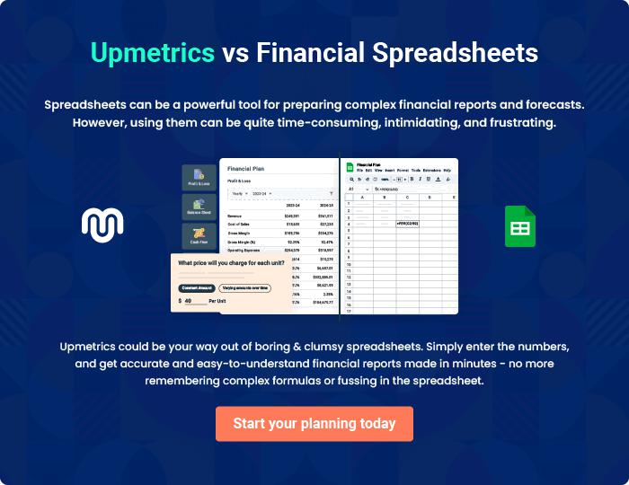
Appendix

When writing the appendix section, you should include any additional information that supports the main content of your plan. This may include financial statements, market research data, legal documents, and other
To unlock help try Upmetrics! 
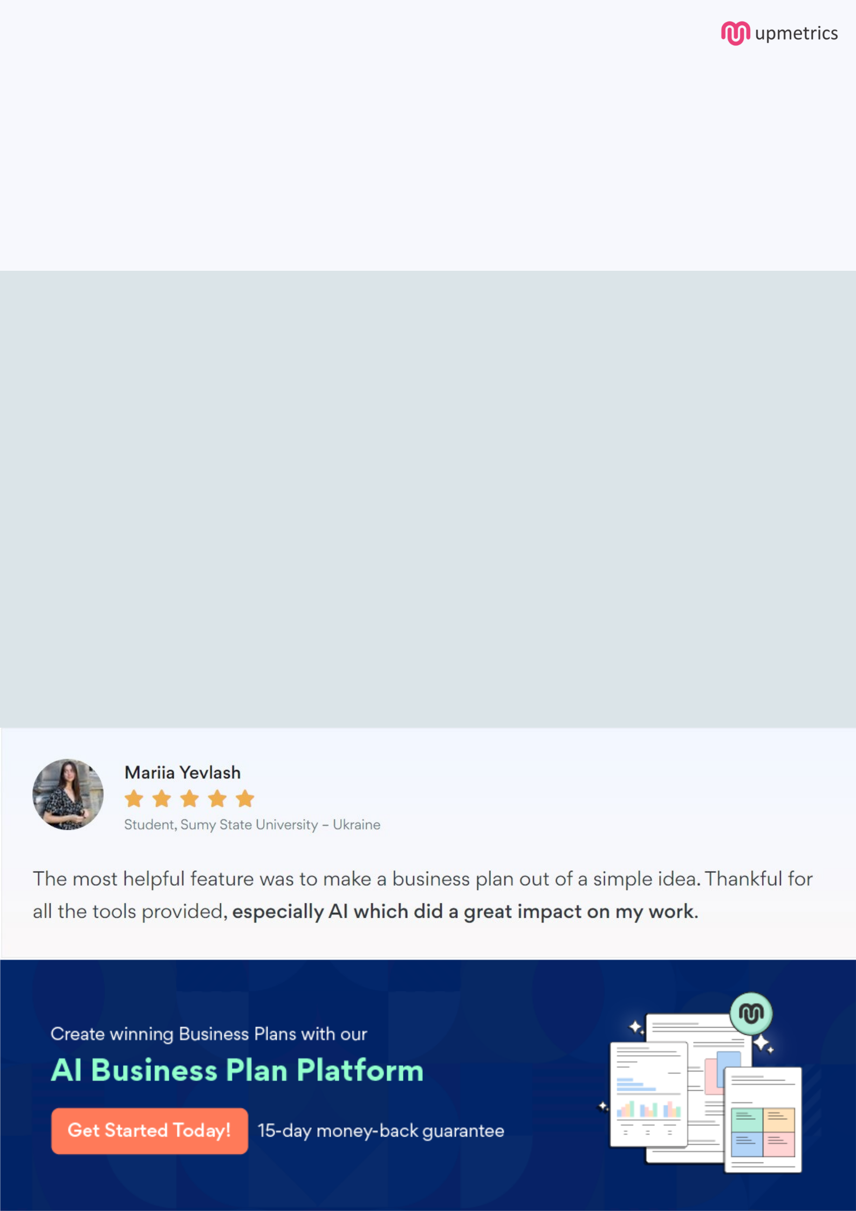
Create a winning business plan that gets you funded

Creating a stunning and investment-ready plan requires no writing, graphic designing, or financial planning expertise.

Upmetrics has all the features required to help you create a comprehensive business plan—from start to finish. Make no mistakes, it’s the modern way of planning to structure ideas, make plans, and create stunning pitch decks to awe investors.

Pitch decks that impress investors

Create pitch decks that provide a visual representation of your business, engage investors, and make them want to invest in your business idea.

Interactive plans in no time

Import business plan sections like—SWOT analysis, comparison tables, and others to create an interactive business plan. No designing skills are required.

Stunning cover page designs

With Upmetrics, you have the liberty to choose from multiple stunning cover page designs. Choose a creative design and make your plan stand out.

Online sharing made simple

Upmetrics makes online sharing quick and easier for users. Easily share your business plans with a link while tracking reader activity.

500+ sample business plans

Simply import a template from our library of sample plans into the editor and start customizing it to make it yours. It takes only a few clicks to get started.

Collaborate with team in real-time

Invite team members, initiate conversations, discuss ideas & strategies, share feedback, and work on a business plan in real-time.

