
BUSINESS PLAN

2023


Physical Therapy Business Plan

Your Wellness, Our Expertise

John Doe

10200 Bolsa Ave, Westminster, CA, 92683

- 359-3153 info@example.com http://www.example.com

Information provided in this business plan is unique to this business and confidential; therefore, anyone reading this plan agrees not to disclose any of the information in this business plan without prior written permission of the company.
Table of Contents

Executive Summary | 6
Market opportunity | 6
Services Offered | 6
Marketing & Sales Strategies | 7
Financial Highlights | 7
Units Sold v/s Revenue | 8

Company Overview | 9
Ownership | 9
Mission statement | 10
Business history | 10
Future goals | 11

Market Analysis | 12
Target Market | 12
Market size and growth potential | 12
Market Size | 13
Competitive analysis | 13
EliteCare Therapy Solutions | 13
PhysioFit Dynamics | 14
RehabRight Centers | 14
Market trends | 14
Regulatory environment | 15

Products and Services | 16
Services | 16
Exercise Therapy | 16
Sports Injury Management | 17
Rehabilitation and Recovery Services | 17
Assistive Devices | 18
Education and Counseling | 18
Service packages | 18
Insurance & Payment Options | 19
Additional services | 19

Sales And Marketing Strategies | 20
Unique Selling Proposition (USP) | 20
Pricing Strategy | 20
Marketing strategies | 21
Online | 21
Offline | 21
Sales strategies | 22
Customer retention | 22

Operations Plan | 23
Staffing & Training | 23
Operational Process | 23
Equipment & Machinery | 24

Management Team | 25
Key managers | 25
John Doe | 26
Jane Doe | 27
Alice Brown | 27
Robert Brown | 27
Organizational structure | 28
Organization chart | 28
Compensation plan | 29
Advisors/Consultants | 29
[ADVISOR NAME] | 29
[CONSULTANT NAME] | 29
Financial Plan
Financial Plan | 30

Profit & loss statement 30

Cash flow statement | 33
Balance sheet | 35
Break-even Analysis | 37
Financing needs | 39
Appendix
Appendix | 41
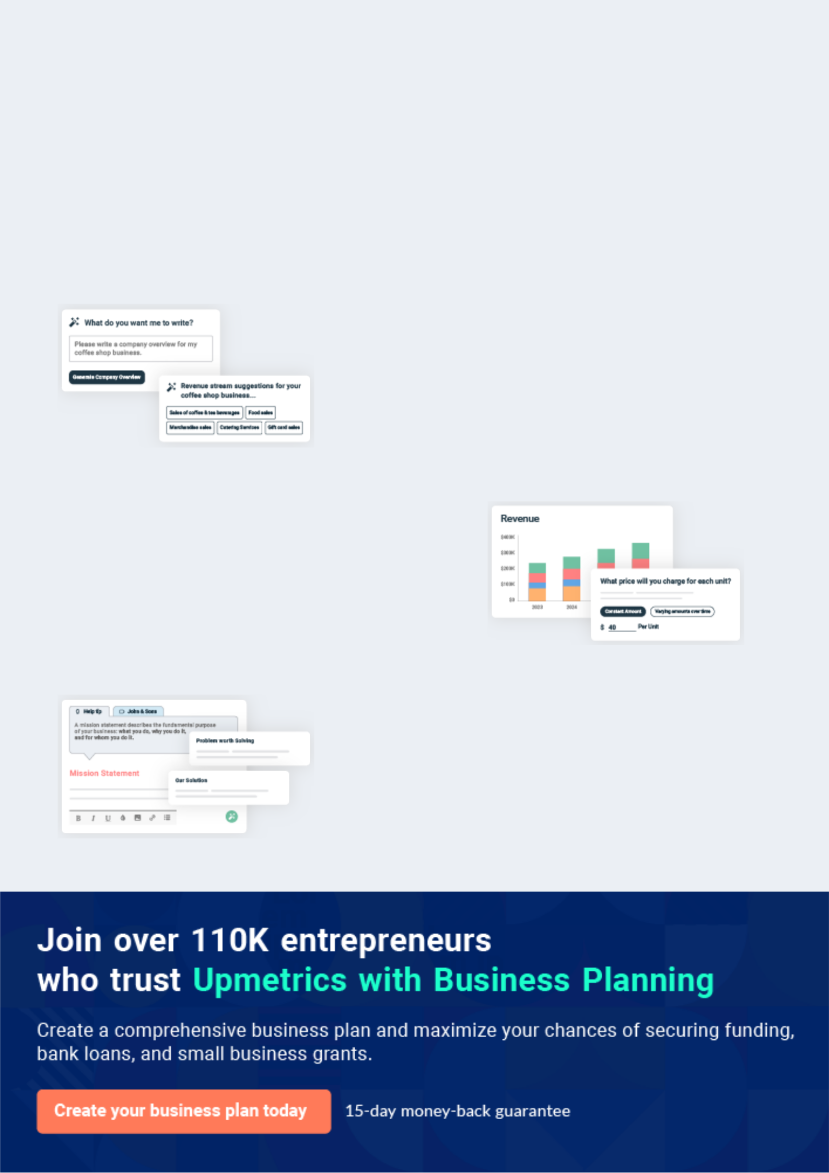
Business planning that’s simpler and faster than you think

Creating a business plan using Upmetrics to start and grow a business is literally the easiest thing in the World. Simply read the instructions and fill in the blanks. It’s as simple as that.

❛ | Upmetrics has everything you need to create a | ❜
❛ | comprehensive business plan. | ❜

AI-powered Upmetrics Assistant

AI-powered insights to streamline your plan

Not sure where to start? Upmetrics’ AI Assistant will automatically generate ideas for each section of your plan and offer improved versions of your writing, adjusting for tone, voice, and grammar or spelling errors.

Financial Forecasting Tool

All the financials are calculated for you

Forget the complex formulas and clumsy spreadsheets — with automatic financials and drag-and-drop forecasting, you can finish your plan faster and be confident that your numbers are accurate.

Business Plan Builder

Guides you like a business mentor

Upmetrics’ step-by-step instructions, prompts, and the library of 400+ sample business plans will guide you through each section of your plan as a business mentor.
Executive Summary


An executive summary is the first section of the business plan intended to provide an overview of the whole business plan.
To unlock help try Upmetrics! 

 Help tip  Physical Therapy Business Plan


Start your executive summary by briefly introducing your business to your readers.

This section may include the name of your physical therapy business, its location, when it was
To unlock help try Upmetrics! 

Start writing here..

Market opportunity

 Help tip  Physical Therapy Business Plan

Summarize your market research, including market size, growth potential, and marketing trends. Highlight the opportunities in the market and how your business will fit in to fill the gap.
To unlock help try Upmetrics! 

Start writing here..

Services Offered

 Help tip  Physical Therapy Business Plan

Highlight the physical therapy services you offer your clients. Mention any PT specialties you have.
To unlock help try Upmetrics! 

Start writing here..

Marketing & Sales Strategies

 Help tip  Physical Therapy Business Plan

Outline your sales and marketing strategies—what marketing platforms you use, how you plan on acquiring patients, etc.
To unlock help try Upmetrics! 

Start writing here..

Financial Highlights

 Help tip  Physical Therapy Business Plan

Briefly summarize your financial projections for the initial years of business operations.

Include any capital or investment requirements, associated startup costs, projected revenues,
To unlock help try Upmetrics! 

Start writing here..
Units Sold v/s Revenue

 |  | Units Sold | Revenue
15.00k
10.00k
5.00k
0
Year 1 | Year 2 | Year 3


Financial Year |  |  | Units Sold | Revenue
Year 1 | 1,550 |  |  | $10,000
Year 2 | 1,800 |  |  | $12,000
Year 3 | 2,050 |  |  | $14,000
 Help tip |  |  Physical Therapy Business Plan


Summarize your executive summary section with a clear CTA, for example, inviting angel investors to discuss the potential business investment.
To unlock help try Upmetrics! 

Write a call to action for your business plan.
Company Overview

Depending on what details of your business are essential, you’ll need different elements in your business overview.
To unlock help try Upmetrics! 

 Help tip  Physical Therapy Business Plan

Describe your business in this section by providing all the basic information:

Describe what kind of physical therapy clinic you run and the name of it. You may specialize in
To unlock help try Upmetrics! 

Start writing here..

Ownership

 Help tip  Physical Therapy Business Plan

List the names of the founders of your clinic. Describe what shares they own and their responsibilities for efficiently managing the business.
To unlock help try Upmetrics! 

Start writing here..
Mission statement

 Help tip  Physical Therapy Business Plan


Summarize your business’ objective, core principles, and values in your mission statement. This statement needs to be memorable, clear, and brief.

 |  | To unlock help try Upmetrics! 
❛ | At [Revive & Thrive Physical Therapy Clinic], we are dedicated to
❛ | [Core Principle: e.g., "restoring mobility and strength"]. Through

personalized care and evidence-based treatments, our mission is to empower every patient to reclaim their active lifestyle.

Our core values encompass [Core Values: e.g., "integrity, compassion, innovation"], ensuring each individual's journey to recovery is effective, compassionate, and supported.

❜

Business history

 Help tip  Physical Therapy Business Plan

If you’re an established physical therapy service provider, briefly describe your business history, like—when it was founded, how it evolved over time, etc.
To unlock help try Upmetrics! 

Start writing here..
Future goals

 Help tip  Physical Therapy Business Plan

It’s crucial to convey your aspirations and vision. Mention your short-term and long-term goals; they can be specific targets for revenue, market share, or expanding your services.
To unlock help try Upmetrics! 

Start writing here..
Market Analysis
To unlock help try Upmetrics!


 |  | Market analysis provides a clear understanding of the market in which your
 |  | printing business will run along with the target market, competitors, and
 |  | growth opportunities.
 |  |  |  | To unlock help try Upmetrics! 
 Help tip |  |  Physical Therapy Business Plan

To write the introduction section of your market analysis, start by clearly identifying your primary target market.
To unlock help try Upmetrics! 

Start writing here..

Target Market

 Help tip  Physical Therapy Business Plan

Start this section by describing your target market. Define your ideal patient and explain what types of services they prefer. Creating a buyer persona will help you easily define your target market to your readers.



Start writing here..

Market size and growth potential

 Help tip  Physical Therapy Business Plan

Describe your market size and growth potential and whether you will target a niche or a much broader market.
To unlock help try Upmetrics! 

Start writing here..

Market Size

Available Market

Total number of people requiring physical 50M therapy services annually.

Served Market
People currently accessing physical 35M therapy services in clinics or remotely.

Target Market
Elderly patients (65+) in urban areas 5M seeking specialized geriatric care.

 Help tip  Physical Therapy Business Plan

Identify and analyze your direct and indirect competitors. Identify their strengths and weaknesses, and describe what differentiates your physical therapy services from them.
To unlock help try Upmetrics! 

Competitive analysis

EliteCare Therapy Solutions

EliteCare Therapy Solutions has been a prominent name in the physical therapy domain for over a decade. With multiple clinics spread across the region, they have catered to a wide demographic of patients, from athletes to the elderly.

Features | Strengths | Weaknesses
Advanced physiotherapy | Extensive regional presence | Limited integration of technology
equipment for treatments | with several clinics | in treatment plans
Customized rehabilitation | A diverse team of seasoned | Absence of home-based or
programs for post-surgery | therapists and specialists | remote therapy solutions
recovery | Strong community reputation | Lengthy waiting times due to
Dedicated pediatric and | built over the years | high patient volumes
geriatric units
Wellness workshops and
seminars for community
engagement

PhysioFit Dynamics

PhysioFit Dynamics is a modern physical therapy clinic known for its technology-driven approach.

Founded five years ago, it has rapidly gained popularity, especially among younger patients.

Features | Strengths | Weaknesses
Tele-rehabilitation for remote | Strong adoption of technology, | Limited physical presence with
consultations and sessions | offering unique solutions | only a couple of clinics
AI-driven exercise | Flexibility with online and | Less experienced compared to
recommendations and | offline consultation options | long-standing competitors
progress tracking | Dynamic and responsive | Potential data security concerns
Virtual reality-based therapy | customer support | with their digital platforms
solutions
Mobile app for scheduling and
feedback

RehabRight Centers

RehabRight Centers, established two decades ago, are synonymous with traditional, tried-and-tested physical therapy methods. They are trusted by families over generations for their consistent care.

Features | Strengths | Weaknesses
Comprehensive therapy | Deep-rooted trust and | Resistance to modernizing or
solutions covering all age | reputation in the community | adopting newer methodologies
groups | Wide range of services | Clinic interiors and equipment
Specialized programs for | covering diverse patient needs | show signs of wear and tear
chronic pain management | Experienced professionals with | Limited marketing and online
On-site gym facilities for | deep industry knowledge | presence, relying heavily on word
supervised exercises |  | of mouth
Regular patient-family
counseling sessions

Market trends

 Help tip  Physical Therapy Business Plan

Analyse emerging trends in the industry, such as changes in technology, customer behavior or preferences, etc. Explain how your business will cope with all the trends.
To unlock help try Upmetrics! 

Start writing here..

Regulatory environment

 Help tip  Physical Therapy Business Plan

List regulations and licensing requirements that may affect your physical therapy clinic, such as business license, professional liability insurance, HIPPA compliance, etc.
To unlock help try Upmetrics! 

Start writing here..
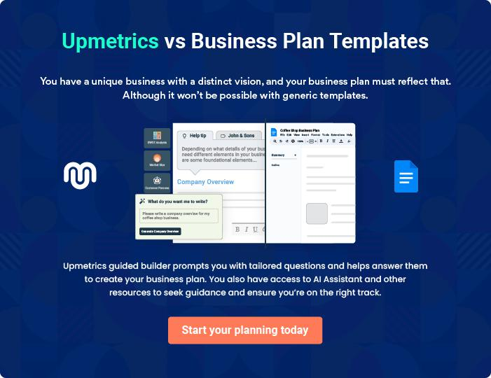
Products and Services
To unlock help try Upmetrics!

The product and services section of a physical therapy business plan should describe the specific services and products that will be offered to customers. To write this section should include the following:



 Help tip  Physical Therapy Business Plan

To craft the introduction for your "Products and Services" chapter, begin by positioning your business within its industry, emphasizing its unique strengths or value proposition.
To unlock help try Upmetrics! 

Start writing here..

 Help tip


Mention the physical therapy services your business will offer. This list may include services like,

• Exercise therapy

Services
To unlock help try Upmetrics! 

Exercise Therapy


Price: $[XX] per session

A customized therapeutic approach that employs a series of exercises designed to restore movement, strengthen muscles, and boost overall flexibility.

Specifications

- Personalized exercise regimen

- Assisted by certified physical therapists

- Use of advanced equipment, if necessary

- Suitable for all age groups

- Session duration: [XX] minutes

Sports Injury Management

Price: $[XX] per assessment, $[XX] per follow-up session

A comprehensive service tailored for athletes and sports enthusiasts, focusing on the diagnosis, treatment, and rehabilitation of sport-specific injuries.

Specifications

- Initial injury assessment

- Personalized treatment plan

- Rehabilitation guidance and support

- Access to specialized equipment

- Session duration: Initial assessment ([XX] minutes), Follow-up sessions ([XX] minutes)

Rehabilitation and Recovery Services

Price: $[XX] per session

Aimed at patients recovering from injuries, surgeries, or long-term mobility issues, ensuring they regain optimal physical function.

Specifications

- Comprehensive patient evaluation

- Structured recovery regimen

- Involves both passive and active therapies

- Access to advanced rehab equipment

- Session duration: [XX] to [XX] minutes
Assistive Devices

Price: $[XX], Wheelchairs - $[XX], etc.

Providing patients with high-quality mobility aids to assist in daily activities and enhance independent movement.

Specifications

- Devices available: Crutches, wheelchairs, walkers, etc.

- Made with durable materials

- Ergonomic design for comfort

- Suitable for varied age groups and mobility requirements

Education and Counseling

Price: $[XX] per session

Sessions aimed at educating patients about their conditions, preventive measures, and imparting mental and emotional support during their recovery journey.

Specifications

- Conducted by experienced counselors and therapists

- Employs multimedia tools for effective learning

- Focuses on holistic well-being

- Session duration: [XX] minutes

Service packages

 Help tip  Physical Therapy Business Plan

Provide an overview of the various service packages your clinic will offer to its patients, such as one-on-one sessions, group therapy, etc.
To unlock help try Upmetrics! 

Start writing here..

Insurance & Payment Options

 Help tip  Physical Therapy Business Plan

This section should include details about accepted payment methods and insurance plans.

These options may include credit cards, cash, health insurance, third-party insurance, etc.
To unlock help try Upmetrics! 

Start writing here..

Additional services

 Help tip  Physical Therapy Business Plan

Mention if your physical therapy clinic offers any additional services. You may include services like massage therapy, acupuncture, wellness programs, speech therapy, etc.
To unlock help try Upmetrics! 

Start writing here..
Sales And Marketing Strategies
To unlock help try Upmetrics!

Writing the sales and marketing strategies section means a list of strategies you will use to attract and retain your clients.
To unlock help try Upmetrics! 

 Help Tip  Physical Therapy Business Plan


To create an effective introduction for your "Sales and Marketing Strategies" chapter, start by setting the stage within your specific industry or market.
To unlock help try Upmetrics! 

Start writing here..

Unique Selling Proposition (USP)

 Help tip  Physical Therapy Business Plan

Define your business’s USPs depending on the market you serve, the equipment you use, and the unique services you provide.
To unlock help try Upmetrics! 

Start writing here..

Pricing Strategy

 Help tip  Physical Therapy Business Plan

Describe your pricing strategy—how you plan to price your therapy services and stay competitive in the local market. You can mention any discounts you plan on offering to attract new patients to your therapy service.



Start writing here..

 Help tip  Physical Therapy Business Plan

Discuss your marketing strategies to market your services. You may include some of these marketing strategies in your business plan—social media marketing, Google ads, brochures, email marketing, content marketing, local business directory listing, and print marketing.
To unlock help try Upmetrics! 

Marketing strategies

Online


Social Media

Regular updates, success stories, and informative content on platforms like Facebook, Instagram, and LinkedIn will keep our audience engaged and informed.

Content Marketing

Informative blogs, articles, and videos showcasing our expertise.

Offline

Brochures & Print Marketing

Distributed in strategic locations like local gyms, doctor's offices, and community centers.

Google Ads

Targeted advertisements will place our clinic at the forefront when potential patients search for therapy services in our region.

Local Business Directory Listing

Ensuring our presence in local directories will aid in organic search visibility and local recognition.

 Help tip
Corporate Wellness Programs
Collaborating with local businesses to offer their employees specialized therapy sessions and wellness programs.
To unlock help try Upmetrics!

Outline the strategies you’ll implement to maximize your sales. Your sales strategies may include community outreach, conducting corporate wellness programs, offering referral programs, etc.



Sales strategies

Community Outreach

Regular participation in local health fairs, workshops, and community events to promote our services.

Referral Programs

Encouraging our satisfied patients

to refer friends and family with

incentives for both the referrer and

the referred.

 Help tip

Describe your patient retention strategies and how you plan to execute them. For instance, introducing personalized treatment plans, conducting wellness programs, etc.
To unlock help try Upmetrics! 

Customer retention

Personalized Treatment Plans

Every patient receives a bespoke treatment plan catering to their specific needs and recovery goals.

Wellness Programs

Regularly scheduled wellness programs focusing on general health, preventive care, and physical well-being, ensuring patients see us as more than just a therapy clinic.

Operations Plan

 |  | When writing the operations plan section, it’s important to consider the
 |  | various aspects of your business operations.
 |  |  |  | To unlock help try Upmetrics! 
 Help tip |  |  Physical Therapy Business Plan


To create an effective introduction for your "Operational Plan" chapter, start by emphasizing the
pivotal role of efficient operations in the success of your business, underscoring how they
directly impact the quality of services delivered.
 |  |  |  | To unlock help try Upmetrics! 
Start writing here..
Staffing & Training
 Help tip |  |  Physical Therapy Business Plan

Describe your staffing requirements, including the number of physiotherapists, PT assistants,
administrative staff, and any other departmental staff you need. Include their qualifications,
years of experience, and the duties they will perform.
 |  |  |  | To unlock help try Upmetrics! 
Start writing here..
Operational Process
 Help tip |  |  Physical Therapy Business Plan

Outline the processes and procedures you will use to run your physical therapy business.

Your operational processes may include patient scheduling, check-in and check-outs, treatment
To unlock help try Upmetrics! 

Start writing here..

Equipment & Machinery
To unlock help try Upmetrics!

 Help tip  Physical Therapy Business Plan

Include the list of equipment and machinery required for physical therapy, such as treadmills, resistance bands, treatment tables, therapeutic tools like massage balls and foam rollers, assistive devices such as crutches and walkers, etc.



Start writing here..
Management Team

The management team section provides an overview of the individuals responsible for running your business plan.
To unlock help try Upmetrics! 

 Help tip  Physical Therapy Business Plan

To craft an introduction for your "Management Team" chapter, begin by emphasizing the crucial role of leadership in the success of any business.
To unlock help try Upmetrics! 

Start writing here..

Key managers

 Help tip  Physical Therapy Business Plan

Introduce your management and key members of your team, and explain their roles and responsibilities.
To unlock help try Upmetrics! 

Start writing here..

JOHN DOE

CEO - john.doe@example.com

John is the visionary force behind [Revive & Thrive Physical Therapy Clinic], providing both strategic and operational direction.

With a Doctorate in Physical Therapy from [Prestigious University], John has practiced in various capacities within the physical therapy domain for over 15 years, amassing an enviable depth of clinical and administrative expertise.


- Educational Background: Doctorate in Physical Therapy, [Prestigious University].

- Professional Background: Prior to founding [Revive & Thrive Physical Therapy Clinic], John worked as a Senior Physiotherapist at [Previous Workplace] and was instrumental in developing rehabilitation programs tailored for athletes.

JANE DOE

Chief Operating Officer (COO) - jane.doe@example.com

As the COO, Jane is responsible for ensuring seamless day-to-day operations.

She champions process efficiencies, resource optimization, and patient service excellence, ensuring the clinic’s operations align with its vision.

- Educational Background: MBA in Healthcare Management, [Top Business School].

- Professional Background: Jane brings a decade of operational experience from her previous role as an Operations Manager at [Notable Healthcare Institution].


ALICE BROWN

CFO - alice.brown@example.com

Alice holds the financial reins of [Revive & Thrive Physical Therapy Clinic], overseeing budgeting, financial forecasting, and fiscal strategy.

Her astute financial acumen ensures the clinic's sustainable growth.

- Educational Background: Master's in Finance, [Reputed University].

- Professional Background: Before joining our team, Alice served as an Associate Finance Director at [Prominent Healthcare Chain], where she played a key role in strategic financial planning.


ROBERT BROWN

Physical Therapist Lead - robert.brown@example.com

Robert is at the forefront of our clinical services, providing both hands-on patient care and guiding our team of therapists.

He specializes in sports rehabilitation and has been pivotal in curating some of our most effective treatment programs.

- Educational Background: Master's in Physical Therapy, [Leading Health Sciences University].

- Professional Background: Robert’s illustrious career includes a seven-year stint as a Senior Physical Therapist at [Elite Sports Clinic].
Organizational structure

 Help tip  Physical Therapy Business Plan

Explain the organizational structure of your management team. Include the reporting line and decision-making hierarchy.
To unlock help try Upmetrics! 

Start writing here..

Organization chart


John Doe

CEO


Alice Brown

Jane Doe

CFO


COO

Lisa White

Marketing Manager Robert Brown

PT Lead




James Smith

Emily Green

PT Assistant

Receptionist

Compensation plan

 Help tip  Physical Therapy Business Plan

Describe your compensation plan for the management and staff. Include their salaries, incentives, and other benefits.
To unlock help try Upmetrics! 

Start writing here..

 Help tip  Physical Therapy Business Plan

Mentioning advisors or consultants in your business plans adds credibility to your business idea.
To unlock help try Upmetrics! 

Advisors/Consultants


[ADVISOR NAME]

Advisor

A luminary in the physical therapy world, [Advisor Name] provides insights into [specific areas of advice, e.g., advanced treatment methods].


[CONSULTANT NAME]

Consultant

Specializing in [specific domain, e.g., healthcare marketing], [Consultant Name] offers strategic advice on effectively marketing our services and expanding our patient base.
Financial Plan

When writing the financial plan section of a business plan, it’s important to provide a comprehensive overview of your financial projections for the first few years of your business, You may provide the following:
To unlock help try Upmetrics! 

 Help tip  Physical Therapy Business Plan


To create an effective introduction for your "Financial Plan" chapter, begin by stressing the critical role of a well-structured financial plan in the success of your venture.
To unlock help try Upmetrics! 

Start writing here..

 Help tip  Physical Therapy Business Plan

Describe details such as projected revenue, operational costs, and service costs in your projected profit and loss statement. Make sure to include your business’s expected net profit or loss.
To unlock help try Upmetrics! 

Profit & loss statement

Revenue

Cost Of Sales

General Costs

Revenue Specific Costs

Personnel Costs (Direct

Labor)

Gross Margin

Gross Margin (%)

Operating Expense

Payroll Expense

(Indirect Labor)

General Expense

Bad Debt

Amortization of Current

Assets

2023-24 | 2024-25 | 2025-26 | 2026-27 | 2027-28
$0 | $0 | $0 | $0 | $0

$0 | $0 | $0 | $0 | $0
$0 | $0 | $0 | $0 | $0
$0 | $0 | $0 | $0 | $0
$0 | $0 | $0 | $0 | $0

$0 | $0 | $0 | $0 | $0
0% | 0% | 0% | 0% | 0%

$0 | $0 | $0 | $0 | $0
$0 | $0 | $0 | $0 | $0
$0 | $0 | $0 | $0 | $0
$0 | $0 | $0 | $0 | $0
$0 | $0 | $0 | $0 | $0

EBITDA

Additional Expense

Long Term

Depreciation

Gain or loss from Sale

of Assets

EBIT

Interest Expenses

EBT

Income Tax Expense

Total Expense

Net Income

Net Income (%)

2023-24 | 2024-25 | 2025-26 | 2026-27 | 2027-28
$0 | $0 | $0 | $0 | $0
$0 | $0 | $0 | $0 | $0
$0 | $0 | $0 | $0 | $0
$0 | $0 | $0 | $0 | $0
$0 | $0 | $0 | $0 | $0
$0 | $0 | $0 | $0 | $0
$0 | $0 | $0 | $0 | $0
$0 | $0 | $0 | $0 | $0
$0 | $0 | $0 | $0 | $0
$0 | $0 | $0 | $0 | $0
0% | 0% | 0% | 0% | 0%
 |  |  | 2023-24 |  | 2024-25 | 2025-26 | 2026-27 | 2027-28
Retained Earning |  |  | $0 |  | $0 | $0 | $0 | $0
Opening
Owner's Distribution |  |  | $0 |  | $0 | $0 | $0 | $0
Retained Earning |  |  | $0 |  | $0 | $0 | $0 | $0
Closing
 Help tip |  |  |  Physical Therapy Business Plan


The cash flow for the first few years of your operation should be estimated and described in this section. This may include billing invoices, payment receipts, loan payments, and any other cash flow statements.
To unlock help try Upmetrics! 

Cash flow statement

 | 2023-24 | 2024-25 | 2025-26 | 2026-27 | 2027-28
Cash Received | $0 | $0 | $0 | $0 | $0
Cash Paid | $0 | $0 | $0 | $0 | $0
COS & General Expenses | $0 | $0 | $0 | $0 | $0
Salary & Wages | $0 | $0 | $0 | $0 | $0
Interest | $0 | $0 | $0 | $0 | $0

Sales Tax

Income Tax

Net Cash From

Operations

Assets Sell

Assets Purchase

Net Cash From

Investments

Amount Received

Loan Received

Common Stock

Preferred Stock

Owner's Contribution

Amount Paid

2023-24 | 2024-25 | 2025-26 | 2026-27 | 2027-28
$0 | $0 | $0 | $0 | $0
$0 | $0 | $0 | $0 | $0
$0 | $0 | $0 | $0 | $0

$0 | $0 | $0 | $0 | $0
$0 | $0 | $0 | $0 | $0
$0 | $0 | $0 | $0 | $0

$0 | $0 | $0 | $0 | $0
$0 | $0 | $0 | $0 | $0

$0 | $0 | $0 | $0 | $0
$0 | $0 | $0 | $0 | $0
$0 | $0 | $0 | $0 | $0

Loan Capital $0 $0 $0 $0 $0

 |  |  | 2023-24 |  | 2024-25 | 2025-26 | 2026-27 | 2027-28
Dividends & Distributions |  |  | $0 |  | $0 | $0 | $0 | $0
Net Cash From |  |  | $0 |  | $0 | $0 | $0 | $0
Financing
Summary
Starting Cash |  |  | $0 |  | $0 | $0 | $0 | $0
Cash In |  |  | $0 |  | $0 | $0 | $0 | $0
Cash Out |  |  | $0 |  | $0 | $0 | $0 | $0
Change in Cash |  |  | $0 |  | $0 | $0 | $0 | $0
Ending Cash |  |  | $0 |  | $0 | $0 | $0 | $0
 Help tip |  |  Physical Therapy Business Plan

Create a projected balance sheet documenting your physical therapy business’s assets, liabilities, and equity.

To unlock help try Upmetrics! 

Balance sheet

 | 2023-24 | 2024-25 | 2025-26 | 2026-27 | 2027-28
Assets | $0 | $0 | $0 | $0 | $0
Current Assets | $0 | $0 | $0 | $0 | $0
Cash | $0 | $0 | $0 | $0 | $0
Accounts Receivable | $0 | $0 | $0 | $0 | $0
Inventory | $0 | $0 | $0 | $0 | $0
Other Current Assets | $0 | $0 | $0 | $0 | $0
Long Term Assets | $0 | $0 | $0 | $0 | $0
Gross Long Term Assets | $0 | $0 | $0 | $0 | $0
Accumulated Depreciation | $0 | $0 | $0 | $0 | $0

Liabilities & Equity | $0 | $0 | $0 | $0 | $0
Liabilities | $0 | $0 | $0 | $0 | $0
Current Liabilities | $0 | $0 | $0 | $0 | $0
Accounts Payable | $0 | $0 | $0 | $0 | $0
Income Tax Payable | $0 | $0 | $0 | $0 | $0
Sales Tax Payable | $0 | $0 | $0 | $0 | $0
Short Term Debt | $0 | $0 | $0 | $0 | $0
 | 2023-24 | 2024-25 | 2025-26 | 2026-27 | 2027-28
Long Term Liabilities | $0 | $0 | $0 | $0 | $0
Long Term Debt | $0 | $0 | $0 | $0 | $0
Equity | $0 | $0 | $0 | $0 | $0
Paid-in Capital | $0 | $0 | $0 | $0 | $0
Common Stock | $0 | $0 | $0 | $0 | $0
Preferred Stock | $0 | $0 | $0 | $0 | $0
Owner's Contribution | $0 | $0 | $0 | $0 | $0
Retained Earnings | $0 | $0 | $0 | $0 | $0

Check | $0 |  |  | $0 | $0 | $0 | $0
 Help tip |  |  Physical Therapy Business Plan

Determine and mention your business’s break-even point—the point at which your business costs and revenue will be equal.

This exercise will help you understand how much revenue you need to generate to sustain or be profitable.
To unlock help try Upmetrics! 

Break-even Analysis

 | 2023-24 | 2024-25 | 2025-26 | 2026-27 | 2027-28
Starting Revenue | $0 | $0 | $0 | $0 | $0
Net Revenue | $0 | $0 | $0 | $0 | $0
Closing Revenue | $0 | $0 | $0 | $0 | $0

Starting Expense | $0 | $0 | $0 | $0 | $0
Net Expense | $0 | $0 | $0 | $0 | $0
Closing Expense | $0 | $0 | $0 | $0 | $0

Is Break Even? | 0 | 0 | 0 | 0 | 0
Break Even Month | 0 | 0 | 0 | 0 | 0
Days Required | 0 | 0 | 0 | 0 | 0
Break Even Revenue | $0 | $0 | $0 | $0 | $0
Break Even Units
Financing needs

 Help tip  Physical Therapy Business Plan

Calculate costs associated with starting a physical therapy business, and estimate your financing needs and how much capital you need to raise to operate your business.
To unlock help try Upmetrics! 

Start writing here..
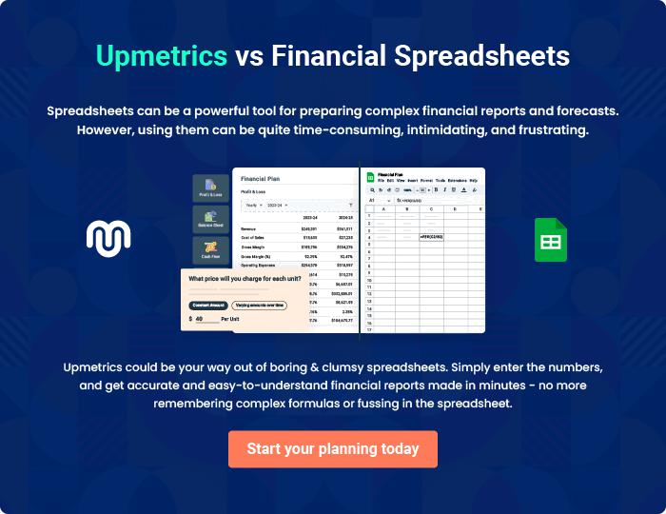
Appendix

When writing the appendix section, you should include any additional information that supports the main content of your plan. This may include financial statements, market research data, legal documents, and other
To unlock help try Upmetrics! 

Create a winning business plan that gets you funded

Creating a stunning and investment-ready plan requires no writing, graphic designing, or financial planning expertise.

Upmetrics has all the features required to help you create a comprehensive business plan—from start to finish. Make no mistakes, it’s the modern way of planning to structure ideas, make plans, and create stunning pitch decks to awe investors.

Pitch decks that impress investors

Create pitch decks that provide a visual representation of your business, engage investors, and make them want to invest in your business idea.

Interactive plans in no time

Import business plan sections like—SWOT analysis, comparison tables, and others to create an interactive business plan. No designing skills are required.

Stunning cover page designs

With Upmetrics, you have the liberty to choose from multiple stunning cover page designs. Choose a creative design and make your plan stand out.

Online sharing made simple

Upmetrics makes online sharing quick and easier for users. Easily share your business plans with a link while tracking reader activity.

500+ sample business plans

Simply import a template from our library of sample plans into the editor and start customizing it to make it yours. It takes only a few clicks to get started.

Collaborate with team in real-time

Invite team members, initiate conversations, discuss ideas & strategies, share feedback, and work on a business plan in real-time.

