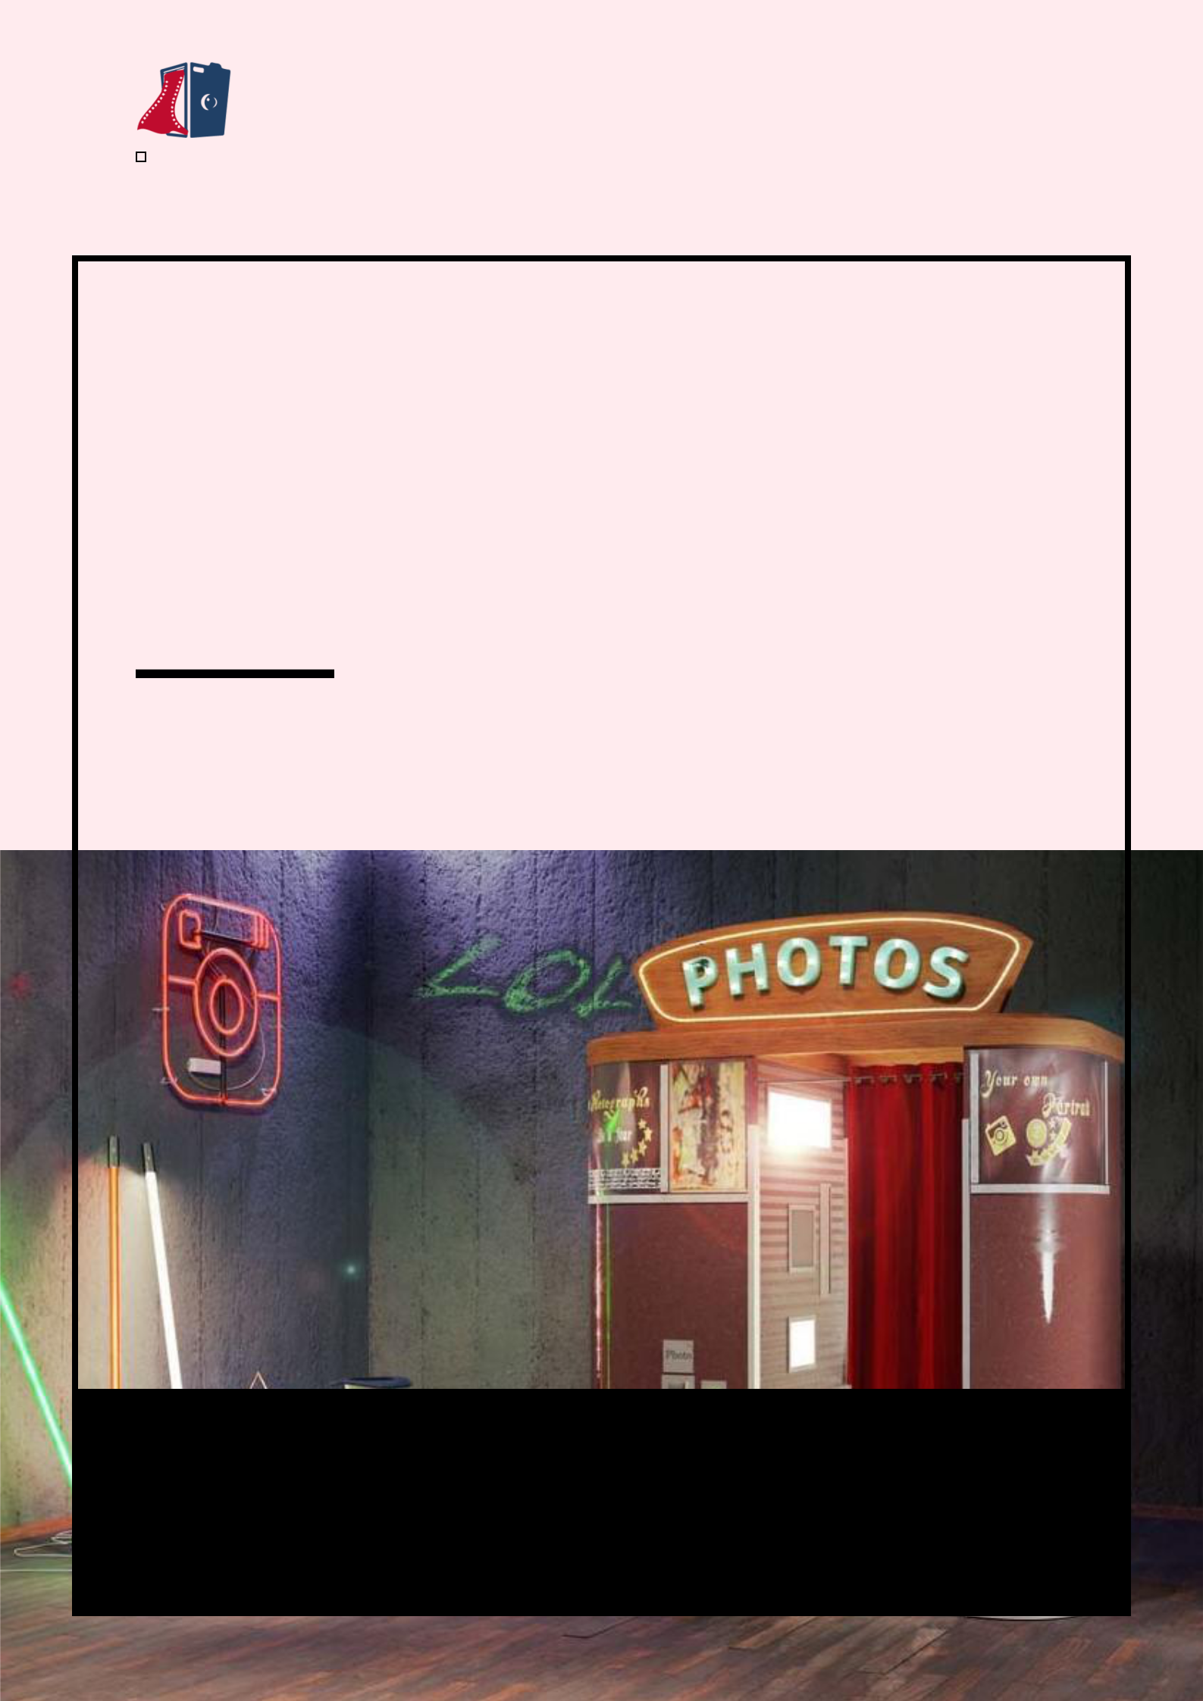
Photo Booth Business Plan

BUSINESS PLAN

Capturing Smiles, Framing Memories

Prepared By

John Doe

10200 Bolsa Ave, Westminster, CA, 92683

info@example.com

(650) 359-3153 http://www.example.com

Table of Contents

Executive Summary | 6
Market opportunity | 6
Services Offered | 6
Marketing & Sales Strategies | 7
Financial Highlights | 7
Units Sold v/s Revenue | 8

Company Overview | 9
Ownership | 9
Mission statement | 9
Business history | 10
Future goals | 10

Market Analysis | 11
Target Market | 11
Market size and growth potential | 11
Market Size | 12
Competitive analysis | 12
Snapshot Studios | 12
Moments Matter | 13
Picture Perfect | 13
Market trends | 13
Regulatory environment | 14

Products and Services | 15
Photo booth services | 15
Classic Photo Booth Rental | 15
Glambooth Experience | 16
Animated GIF Booth | 16
Digital Sharing Kiosk | 17
Party Props Package | 17
AR and VR Photo Experience | 17
Photo Booth Description | 18
Quality Measures | 18
Additional Services | 18

Sales And Marketing Strategies | 19
Unique Selling Proposition (USP) | 19
Pricing Strategy | 19
Marketing strategies | 20
Online | 20
Offline | 20
Sales strategies | 21
Customer retention | 21

Operations Plan | 22
Staffing & Training | 22
Operational Process | 22
Equipment & Machinery | 23

Management Team | 24
Key managers | 24
John Doe | 24
Jane Doe | 25
Alice Brown | 25
Robert Brown | 25
Organizational structure | 25
Organization chart | 26
Compensation plan | 26
Advisors/Consultants | 27
[ADVISOR NAME] | 27
Financial Plan
Financial Plan | 28

Profit & loss statement 28

Cash flow statement | 31
Balance sheet | 33
Break-even Analysis | 35
Financing needs | 37
Appendix
Appendix | 39

Business planning that’s simpler and faster than you think

Creating a business plan using Upmetrics to start and grow a business is literally the easiest thing in the World. Simply read the instructions and fill in the blanks. It’s as simple as that.

❛ | Upmetrics has everything you need to create a | ❜
❛ | comprehensive business plan. | ❜

AI-powered Upmetrics Assistant

AI-powered insights to streamline your plan

Not sure where to start? Upmetrics’ AI Assistant will automatically generate ideas for each section of your plan and offer improved versions of your writing, adjusting for tone, voice, and grammar or spelling errors.

Financial Forecasting Tool

All the financials are calculated for you

Forget the complex formulas and clumsy spreadsheets — with automatic financials and drag-and-drop forecasting, you can finish your plan faster and be confident that your numbers are accurate.

Business Plan Builder

Guides you like a business mentor

Upmetrics’ step-by-step instructions, prompts, and the library of 400+ sample business plans will guide you through each section of your plan as a business mentor.
Executive Summary


An executive summary is the first section of the business plan intended to provide an overview of the whole business plan.
To unlock help try Upmetrics! 

 Help tip  Photo Booth Business Plan


Start your executive summary by briefly introducing your business to your readers.

This section may include the name of your photo booth business, its location, when it was
To unlock help try Upmetrics! 

Start writing here..

Market opportunity

 Help tip  Photo Booth Business Plan

Summarize your market research, including market size, growth potential, and marketing trends. Highlight the opportunities in the market and how your business will fit in to fill the gap.
To unlock help try Upmetrics! 

Start writing here..

Services Offered

 Help tip  Photo Booth Business Plan

Highlight the photo booth services you offer your clients. The USPs and differentiators you offer are always a plus.
To unlock help try Upmetrics! 

Start writing here..

Marketing & Sales Strategies
To unlock help try Upmetrics!

 Help tip  Photo Booth Business Plan

Outline your sales and marketing strategies—what marketing platforms you use, how you plan on acquiring customers, etc.
To unlock help try Upmetrics! 

Start writing here..

Financial Highlights

 Help tip  Photo Booth Business Plan

Briefly summarize your financial projections for the initial years of business operations. Include any capital or investment requirements, associated startup costs, projected revenues, and profit forecasts.



Start writing here..
Units Sold v/s Revenue

 |  | Units Sold | Revenue
15.00k
10.00k
5.00k
0
Year 1 | Year 2 | Year 3


Financial Year |  |  | Units Sold | Revenue
Year 1 | 1,550 |  |  | $10,000
Year 2 | 1,800 |  |  | $12,000
Year 3 | 2,050 |  |  | $14,000
 Help tip |  |  Photo Booth Business Plan


Summarize your executive summary section with a clear CTA, for example, inviting angel investors to discuss the potential business investment.
To unlock help try Upmetrics! 

Write a call to action for your business plan.
Company Overview

Depending on what details of your business are essential, you’ll need different elements in your business overview.
To unlock help try Upmetrics! 

 Help tip  Photo Booth Business Plan

Describe your business in this section by providing all the basic information:

Describe what kind of photo booth business you run and the name of it. Following are some of
To unlock help try Upmetrics! 

Start writing here..

Ownership

 Help tip  Photo Booth Business Plan

List the founders or owners of your photo booth company. Describe what shares they own and their responsibilities for efficiently managing the business.
To unlock help try Upmetrics! 

Start writing here..

Mission statement

 Help tip  Photo Booth Business Plan

Summarize your business’ objective, core principles, and values in your mission statement. This statement needs to be memorable, clear, and brief.
To unlock help try Upmetrics! 
❛ [Craft a compelling mission statement, e.g., 'To immortalize moments with innovation and passion, ensuring every event becomes a treasured memory. Our commitment lies in quality,

creativity, and an unparalleled customer experience.']
❜

Business history

 Help tip  Photo Booth Business Plan

If you’re an established photo booth service provider, briefly describe your business history, like —when it was founded, how it evolved over time, etc.
To unlock help try Upmetrics! 

Start writing here..

Future goals

 Help tip  Photo Booth Business Plan

It’s crucial to convey your aspirations and vision. Mention your short-term and long-term goals; they can be specific targets for revenue, market share, or expanding your services.
To unlock help try Upmetrics! 

Start writing here..
Market Analysis
To unlock help try Upmetrics!


 |  | Market analysis provides a clear understanding of the market in which your
 |  | printing business will run along with the target market, competitors, and
 |  | growth opportunities.
 |  |  |  | To unlock help try Upmetrics! 
 Help tip |  |  Photo Booth Business Plan

To write the introduction section of your market analysis, start by clearly identifying your primary target market.
To unlock help try Upmetrics! 

Start writing here..

Target Market

 Help tip  Photo Booth Business Plan

Start this section by describing your target market. Define your ideal customer and explain what types of services they prefer. Creating a buyer persona will help you easily define your target market to your readers.



Start writing here..

Market size and growth potential

 Help tip  Photo Booth Business Plan

Describe your market size and growth potential and whether you will target a niche or a much broader market.
To unlock help try Upmetrics! 

Start writing here..

Market Size

Available Market

Total number of events hosted annually 10M across the country.

Served Market
Events that currently employ any form of 2M photo booth services

Target Market
High-end events and weddings seeking 500k premium photo booth experiences.

 Help tip  Photo Booth Business Plan

Identify and analyze your direct and indirect competitors. Identify their strengths and weaknesses, and describe what differentiates your photo booth services from them.
To unlock help try Upmetrics! 

Competitive analysis

Snapshot Studios

Founded in [Year], Snapshot Studios quickly rose to prominence in the [Region/City/State] market. Renowned for their range of traditional photo booths, they have successfully catered to over [XXX] events in the last year alone.

Features | Strengths | Weaknesses
Traditional photo booth setups | Established market presence | Limited innovation; primarily
Instant photo printing with | with a wide customer base | focused on traditional booths
customizable templates | Speedy photo printing | Customer complaints regarding
Digital photo downloads with | technology ensuring quick | their mobile app's usability
Digital photo downloads with | service
cloud storage | service | No solutions harnessing newer
Prop kits and backdrop | Robust online platform for | technologies like AR or VR
Prop kits and backdrop | post-event photo downloads
selections | post-event photo downloads

Moments Matter

Established in [Year], Moments Matter introduced the [Region/City/State] audience to open-air photo booths. Their strong alignment with tech trends has made them a favorite at corporate events and modern weddings.

Features Strengths Weaknesses

Open-air photo booths with Forward-thinking with tech

customizable skins integrations in their booths

Interactive touch screen Strong partnerships with

interfaces corporate clients

Social media integration for Seamless social media sharing

instant sharing capabilities

AR-based filters and

animations

Premium pricing, making them less accessible for smaller events

Occasional tech glitches reported during events

Limited traditional photo booth options

Picture Perfect

Picture Perfect, in business since [Year], stands out for its mobile photo booth vans. Their mobility allows them to cater to multiple events in a day, especially popular in fairs and public events.

Features

Mobile photo booth vans with interiors set up for instant shoots

On-the-spot photo merchandise like magnets and keychains

Photo booth rentals for extended events like carnivals

Strengths

Unique mobile solution allowing versatility and multiple bookings

Offers tangible photo merchandise which is a hit among younger audiences

Quick setup with no need for event space accommodations

Weaknesses

Dependent on vehicle maintenance, leading to occasional downtimes

Not ideal for formal events due to the casual setting

Limited to regions with favorable weather conditions

Market trends

 Help tip  Photo Booth Business Plan

Analyze emerging trends in the industry, such as technology disruptions, changes in customer behavior or preferences, etc. Explain how your business will cope with all the trends.
To unlock help try Upmetrics! 

Start writing here..

Regulatory environment
To unlock help try Upmetrics!

 Help tip  Photo Booth Business Plan

List regulations and licensing requirements that may affect your photo booth company, such as business registration, insurance, sales tax permit, labor regulations, and permits to use public property.



Start writing here..
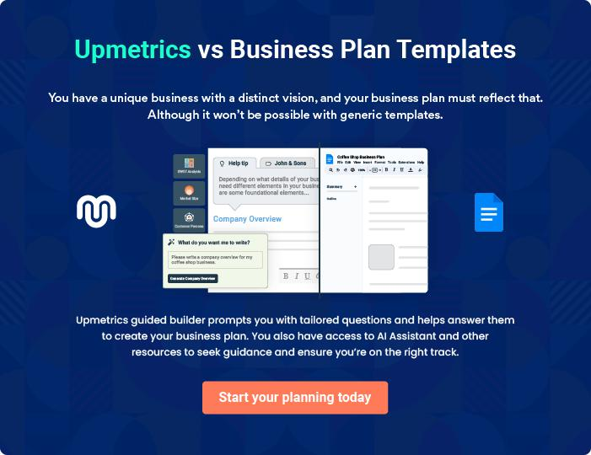
Products and Services
To unlock help try Upmetrics!

The product and services section of a photo booth business plan should describe the specific services and products that will be offered to customers. To write this section should include the following:



 Help tip  Photo Booth Business Plan

To craft the introduction for your "Products and Services" chapter, begin by positioning your business within its industry, emphasizing its unique strengths or value proposition.
To unlock help try Upmetrics! 

Start writing here..

 Help tip


Mention the photo booth services your business will offer. This list may include services like,

• Photo booth rental
To unlock help try Upmetrics! 

Photo booth services

Classic Photo Booth Rental


Price: $[XXX] per hour (Minimum 2 hours)

A traditional photo booth setup perfect for any event, providing guests with instant photo memories.

Specifications

- Type: Enclosed booth

- Camera: DSLR with HD resolution

- Print: Instant 4x6 prints

- Features: Touchscreen navigation, customizable backdrops, integrated social media sharing
Glambooth Experience

Price: $[YYY] per hour

An upscale photo booth experience with enhanced lighting, perfect for premium events and gatherings.

Specifications

- Type: Open-air booth

- Camera: Professional DSLR with studio lighting

- Print: Premium quality instant prints with a glossy finish

- Features: Premium backdrops, red carpet setup, VIP props

Animated GIF Booth

Price: $[ZZZ] per event

Bring photos to life with quirky animations, perfect for sharing on digital platforms.

Specifications

- Type: Open-air or enclosed booth (based on preference)

- Camera: DSLR with HD resolution

- Features: Touchscreen navigation, customizable animations, integrated social media sharing, digital delivery
Digital Sharing Kiosk

Price: $[AAA] for the entire event

A dedicated kiosk where guests can instantly share their photos to their email or social media platforms.

Specifications

- Type: Standalone digital kiosk

- Interface: User-friendly touchscreen

- Features: Instant sharing to email, Facebook, Instagram, and Twitter

Party Props Package

Price: $[BBB] (Add-on package)

Elevate the fun with a diverse range of props suitable for every occasion.

Specifications

- Items: Hats, glasses, masks, signs, and more

- Hygiene: Sanitized after every event

- Customization: Theme-specific props available upon request

AR and VR Photo Experience

Price: $[CCC] per hour

Dive into augmented and virtual reality experiences, adding an innovative touch to your event.

Specifications

- Type: Open-air booth

- Features: AR overlays on photos, VR headset experiences, digital delivery for VR experiences
Photo Booth Description

 Help tip  Photo Booth Business Plan

Describe your photo booth, including details about its type, features, and quality of photos your business will provide to customers.
To unlock help try Upmetrics! 

Start writing here..

Quality Measures

 Help tip  Photo Booth Business Plan

This section should explain how you maintain quality standards and consistently provide the highest quality service.
To unlock help try Upmetrics! 

Start writing here..

Additional Services

 Help tip  Photo Booth Business Plan

Mention if your photo booth company offers any additional services. You may include services like video booths, AR and VR features, custom overlay, and customized video templates.
To unlock help try Upmetrics! 

Start writing here..
Sales And Marketing Strategies
To unlock help try Upmetrics!

Writing the sales and marketing strategies section means a list of strategies you will use to attract and retain your clients.
To unlock help try Upmetrics! 

 Help Tip  Photo Booth Business Plan


To create an effective introduction for your "Sales and Marketing Strategies" chapter, start by setting the stage within your specific industry or market.
To unlock help try Upmetrics! 

Start writing here..

Unique Selling Proposition (USP)

 Help tip  Photo Booth Business Plan

Define your business’s USPs depending on the market you serve, the equipment you use, and the unique services you provide. Identifying USPs will help you plan your marketing strategies.
To unlock help try Upmetrics! 

Start writing here..

Pricing Strategy

 Help tip  Photo Booth Business Plan

Describe your pricing strategy—how you plan to price your photo booth services and stay competitive in the local market. You can mention any discounts you plan on offering to attract new customers.



Start writing here..

 Help tip  Photo Booth Business Plan
To unlock help try Upmetrics!

Discuss your marketing strategies to market your services. You may include some of these marketing strategies in your business plan—social media marketing, online advertising, brochures, email marketing, content marketing, and print marketing.



Marketing strategies

Online


Social Media

Regular updates on platforms like Instagram and Facebook showcasing our recent events and testimonials.

Content Marketing

Blog posts on our website discussing the latest trends in photo booths and event photography.

Email Marketing

Periodic newsletters and promotional offers to our database of past and potential clients.

Online Advertising

Utilizing Google AdWords and targeted Facebook ads to reach potential clients actively searching for photo booth services

Offline

Brochures

High-quality printed materials distributed at strategic locations, such as event planning agencies and venues.

Print Marketing

Collaborative ads in local magazines, especially those catering to event planning and lifestyle segments.

 Help tip  Photo Booth Business Plan
Trade Shows & Local Events
Participating actively to showcase our offerings and network with industry stakeholders.
To unlock help try Upmetrics!

Outline the strategies you’ll implement to maximize your sales. Your sales strategies may include partnering with other businesses and event planners, attending trade shows and local events, and providing excellent customer service.



Sales strategies

Partner with Businesses

Establishing affiliations with local event planners, venues, and catering businesses for mutual referrals.

Stellar Customer Service

Our dedicated team ensures every

client inquiry and concern is

addressed promptly and efficiently.

 Help tip

Describe your customer retention strategies and how you plan to execute them. For instance, introducing loyalty programs, providing personalized service, etc.
To unlock help try Upmetrics! 

Customer retention

Loyalty Programs

Rewarding frequent clients with special discounts or complimentary services.

Feedback Mechanism

Regularly seeking feedback and acting on it, ensuring continuous improvement in our offerings.

Personalized Service

Understanding and catering to

individual client preferences,

ensuring a tailored photo booth

experience every time.

Operations Plan
To unlock help try Upmetrics!

 |  | When writing the operations plan section, it’s important to consider the
 |  | various aspects of your business operations.
 |  |  |  | To unlock help try Upmetrics! 
 Help tip |  |  Photo Booth Business Plan


To create an effective introduction for your "Operational Plan" chapter, start by emphasizing the
pivotal role of efficient operations in the success of your business, underscoring how they
directly impact the quality of services delivered.
 |  |  |  | To unlock help try Upmetrics! 
Start writing here..
Staffing & Training
 Help tip |  |  Photo Booth Business Plan

Mention your cleaning business’s staffing requirements, including the number of employees needed. Include their qualifications, the training required, and the duties they will perform.
To unlock help try Upmetrics! 

Start writing here..

Operational Process

 Help tip  Photo Booth Business Plan

Outline the processes and procedures you will use to run your photo booth business. Your operational processes may include booking events, setting up and breaking down booths, operating booths, and maintaining equipment.



Start writing here..

Equipment & Machinery

 Help tip  Photo Booth Business Plan

Include the list of equipment and machinery required for the photo booth, such as camera, printer, backdrop, lighting, editing software, and sound system.
To unlock help try Upmetrics! 

Start writing here..
Management Team

The management team section provides an overview of the individuals responsible for running your business plan.
To unlock help try Upmetrics! 

 Help tip  Photo Booth Business Plan

To craft an introduction for your "Management Team" chapter, begin by emphasizing the crucial role of leadership in the success of any business.
To unlock help try Upmetrics! 

Start writing here..

Key managers

 Help tip  Photo Booth Business Plan

Introduce your management and key members of your team, and explain their roles and responsibilities.
To unlock help try Upmetrics! 

Start writing here..


JOHN DOE

CEO - john.doe@example.com

John, as the CEO and visionary of [FlashyFrames Photo Booths], is the embodiment of leadership and innovation.

Holding a Masters in Business Administration from [University Name] and possessing over a decade of experience in the photo booth industry, John's insights and strategic acumen have been pivotal to our brand's success.


JANE DOE

Chief Operating Officer (COO) - jane.doe@example.com

Jane oversees our business operations, ensuring seamless event executions and the utmost client satisfaction.

With a degree in Event Management from [University Name] and a rich professional background spanning 8 years in event logistics and planning, she plays a crucial role in elevating our operational standards.



ALICE BROWN

CMO - alice.brown@example.com

Alice leads our marketing endeavours, crafting strategies that bolster our brand's presence in a competitive market.

Graduating with honours in Marketing from [University Name] and having worked for leading brands over the past 7 years, Alice brings a blend of creativity and strategic thinking to the table.


ROBERT BROWN

Technical Head - robert.brown@example.com

Entrusted with ensuring the cutting-edge quality of our equipment and technological processes, Robert is the linchpin of our technical operations.

He holds a degree in Electronics and Communication from [University Name]. With his expertise from 6 years in the tech domain of the photo booth industry, Robert ensures that our services are always a step ahead.

Organizational structure

 Help tip  Photo Booth Business Plan

Explain the organizational structure of your management team. Include the reporting line and decision-making hierarchy.
To unlock help try Upmetrics! 

Start writing here..

Organization chart


John Doe

CEO


Alice Brown Jane Doe

CMO COO


Mike Smith

CFO Robert Brown

Technical Head



Lucy White

HR Manager

Compensation plan

 Help tip  Photo Booth Business Plan

Describe your compensation plan for the management and staff. Include their salaries, incentives, and other benefits.
To unlock help try Upmetrics! 

Start writing here..

 Help tip  Photo Booth Business Plan

Mentioning advisors or consultants in your business plans adds credibility to your business idea.
To unlock help try Upmetrics! 

Advisors/Consultants


[ADVISOR NAME]

Advisor

A stalwart in the [Specific Industry Aspect], [Name]'s insights have been invaluable in [specific contribution or area of advice].
Financial Plan

When writing the financial plan section of a business plan, it’s important to provide a comprehensive overview of your financial projections for the first few years of your business, You may provide the following:
To unlock help try Upmetrics! 

 Help tip  Photo Booth Business Plan


To create an effective introduction for your "Financial Plan" chapter, begin by stressing the critical role of a well-structured financial plan in the success of your venture.
To unlock help try Upmetrics! 

Start writing here..

 Help tip  Photo Booth Business Plan

Describe details such as projected revenue, operational costs, and service costs in your projected profit and loss statement. Make sure to include your business’s expected net profit or loss.
To unlock help try Upmetrics! 

Profit & loss statement

Revenue

Cost Of Sales

General Costs

Revenue Specific Costs

Personnel Costs (Direct

Labor)

Gross Margin

Gross Margin (%)

Operating Expense

Payroll Expense

(Indirect Labor)

General Expense

Bad Debt

Amortization of Current

Assets

2023-24 | 2024-25 | 2025-26 | 2026-27 | 2027-28
$0 | $0 | $0 | $0 | $0

$0 | $0 | $0 | $0 | $0
$0 | $0 | $0 | $0 | $0
$0 | $0 | $0 | $0 | $0
$0 | $0 | $0 | $0 | $0

$0 | $0 | $0 | $0 | $0
0% | 0% | 0% | 0% | 0%

$0 | $0 | $0 | $0 | $0
$0 | $0 | $0 | $0 | $0
$0 | $0 | $0 | $0 | $0
$0 | $0 | $0 | $0 | $0
$0 | $0 | $0 | $0 | $0

EBITDA

Additional Expense

Long Term

Depreciation

Gain or loss from Sale

of Assets

EBIT

Interest Expenses

EBT

Income Tax Expense

Total Expense

Net Income

Net Income (%)

2023-24 | 2024-25 | 2025-26 | 2026-27 | 2027-28
$0 | $0 | $0 | $0 | $0
$0 | $0 | $0 | $0 | $0
$0 | $0 | $0 | $0 | $0
$0 | $0 | $0 | $0 | $0
$0 | $0 | $0 | $0 | $0
$0 | $0 | $0 | $0 | $0
$0 | $0 | $0 | $0 | $0
$0 | $0 | $0 | $0 | $0
$0 | $0 | $0 | $0 | $0
$0 | $0 | $0 | $0 | $0
0% | 0% | 0% | 0% | 0%
 |  |  | 2023-24 |  | 2024-25 | 2025-26 | 2026-27 | 2027-28
Retained Earning |  |  | $0 |  | $0 | $0 | $0 | $0
Opening
Owner's Distribution |  |  | $0 |  | $0 | $0 | $0 | $0
Retained Earning |  |  | $0 |  | $0 | $0 | $0 | $0
Closing
 Help tip |  |  |  Photo Booth Business Plan


The cash flow for the first few years of your operation should be estimated and described in this section. This may include billing invoices, payment receipts, loan payments, and any other cash flow statements.
To unlock help try Upmetrics! 

Cash flow statement

 | 2023-24 | 2024-25 | 2025-26 | 2026-27 | 2027-28
Cash Received | $0 | $0 | $0 | $0 | $0
Cash Paid | $0 | $0 | $0 | $0 | $0
COS & General Expenses | $0 | $0 | $0 | $0 | $0
Salary & Wages | $0 | $0 | $0 | $0 | $0
Interest | $0 | $0 | $0 | $0 | $0

Sales Tax

Income Tax

Net Cash From

Operations

Assets Sell

Assets Purchase

Net Cash From

Investments

Amount Received

Loan Received

Common Stock

Preferred Stock

Owner's Contribution

Amount Paid

2023-24 | 2024-25 | 2025-26 | 2026-27 | 2027-28
$0 | $0 | $0 | $0 | $0
$0 | $0 | $0 | $0 | $0
$0 | $0 | $0 | $0 | $0

$0 | $0 | $0 | $0 | $0
$0 | $0 | $0 | $0 | $0
$0 | $0 | $0 | $0 | $0

$0 | $0 | $0 | $0 | $0
$0 | $0 | $0 | $0 | $0

$0 | $0 | $0 | $0 | $0
$0 | $0 | $0 | $0 | $0
$0 | $0 | $0 | $0 | $0

Loan Capital $0 $0 $0 $0 $0

 |  |  | 2023-24 | 2024-25 | 2025-26 | 2026-27 | 2027-28
Dividends & Distributions |  |  | $0 | $0 | $0 | $0 | $0
Net Cash From |  |  | $0 | $0 | $0 | $0 | $0
Financing
Summary
Starting Cash |  |  | $0 | $0 | $0 | $0 | $0
Cash In |  |  | $0 | $0 | $0 | $0 | $0
Cash Out |  |  | $0 | $0 | $0 | $0 | $0
Change in Cash |  |  | $0 | $0 | $0 | $0 | $0
Ending Cash |  |  | $0 | $0 | $0 | $0 | $0
 Help tip |  |  Photo Booth Business Plan

Create a projected balance sheet documenting your photo booth business’s assets, liabilities, and equity.

To unlock help try Upmetrics! 

Balance sheet

 | 2023-24 | 2024-25 | 2025-26 | 2026-27 | 2027-28
Assets | $0 | $0 | $0 | $0 | $0
Current Assets | $0 | $0 | $0 | $0 | $0
Cash | $0 | $0 | $0 | $0 | $0
Accounts Receivable | $0 | $0 | $0 | $0 | $0
Inventory | $0 | $0 | $0 | $0 | $0
Other Current Assets | $0 | $0 | $0 | $0 | $0
Long Term Assets | $0 | $0 | $0 | $0 | $0
Gross Long Term Assets | $0 | $0 | $0 | $0 | $0
Accumulated Depreciation | $0 | $0 | $0 | $0 | $0

Liabilities & Equity | $0 | $0 | $0 | $0 | $0
Liabilities | $0 | $0 | $0 | $0 | $0
Current Liabilities | $0 | $0 | $0 | $0 | $0
Accounts Payable | $0 | $0 | $0 | $0 | $0
Income Tax Payable | $0 | $0 | $0 | $0 | $0
Sales Tax Payable | $0 | $0 | $0 | $0 | $0
Short Term Debt | $0 | $0 | $0 | $0 | $0
 | 2023-24 | 2024-25 | 2025-26 | 2026-27 | 2027-28
Long Term Liabilities | $0 | $0 | $0 | $0 | $0
Long Term Debt | $0 | $0 | $0 | $0 | $0
Equity | $0 | $0 | $0 | $0 | $0
Paid-in Capital | $0 | $0 | $0 | $0 | $0
Common Stock | $0 | $0 | $0 | $0 | $0
Preferred Stock | $0 | $0 | $0 | $0 | $0
Owner's Contribution | $0 | $0 | $0 | $0 | $0
Retained Earnings | $0 | $0 | $0 | $0 | $0

Check | $0 |  |  | $0 | $0 | $0 | $0
 Help tip |  |  Photo Booth Business Plan

Determine and mention your business’s break-even point—the point at which your business costs and revenue will be equal.

This exercise will help you understand how much revenue you need to generate to sustain or be profitable.
To unlock help try Upmetrics! 

Break-even Analysis

 | 2023-24 | 2024-25 | 2025-26 | 2026-27 | 2027-28
Starting Revenue | $0 | $0 | $0 | $0 | $0
Net Revenue | $0 | $0 | $0 | $0 | $0
Closing Revenue | $0 | $0 | $0 | $0 | $0

Starting Expense | $0 | $0 | $0 | $0 | $0
Net Expense | $0 | $0 | $0 | $0 | $0
Closing Expense | $0 | $0 | $0 | $0 | $0

Is Break Even? | 0 | 0 | 0 | 0 | 0
Break Even Month | 0 | 0 | 0 | 0 | 0
Days Required | 0 | 0 | 0 | 0 | 0
Break Even Revenue | $0 | $0 | $0 | $0 | $0
Break Even Units
Financing needs

 Help tip  Photo Booth Business Plan

Calculate costs associated with starting a photo booth business, and estimate your financing needs and how much capital you need to raise to operate your business.
To unlock help try Upmetrics! 

Start writing here..
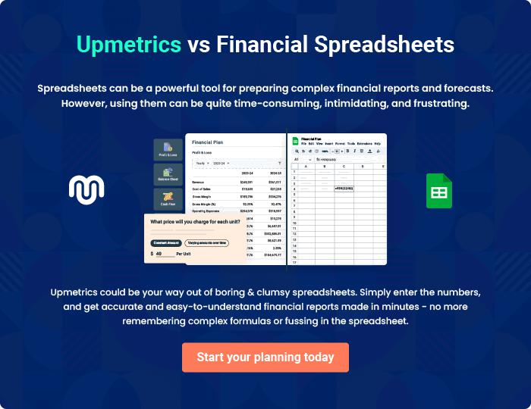
Appendix

When writing the appendix section, you should include any additional information that supports the main content of your plan. This may include financial statements, market research data, legal documents, and other
To unlock help try Upmetrics! 

Create a winning business plan that gets you funded

Creating a stunning and investment-ready plan requires no writing, graphic designing, or financial planning expertise.

Upmetrics has all the features required to help you create a comprehensive business plan—from start to finish. Make no mistakes, it’s the modern way of planning to structure ideas, make plans, and create stunning pitch decks to awe investors.

Pitch decks that impress investors

Create pitch decks that provide a visual representation of your business, engage investors, and make them want to invest in your business idea.

Interactive plans in no time

Import business plan sections like—SWOT analysis, comparison tables, and others to create an interactive business plan. No designing skills are required.

Stunning cover page designs

With Upmetrics, you have the liberty to choose from multiple stunning cover page designs. Choose a creative design and make your plan stand out.

Online sharing made simple

Upmetrics makes online sharing quick and easier for users. Easily share your business plans with a link while tracking reader activity.

500+ sample business plans

Simply import a template from our library of sample plans into the editor and start customizing it to make it yours. It takes only a few clicks to get started.

Collaborate with team in real-time

Invite team members, initiate conversations, discuss ideas & strategies, share feedback, and work on a business plan in real-time.

