
 Pet Grooming Business Plan

ADDRESS CONTACT

10200 Bolsa Ave, Westminster, CA, 92683 (650) 359-3153

http://www.example.com info@example.com
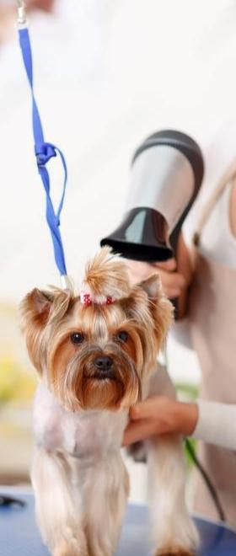

Business Plan

2023

Prepared By

John Doe


"Grooming with Love, Unleash Joy"

Information provided in this business plan is unique to this business and confidential; therefore, anyone reading this plan agrees not to disclose any of the information in this business plan without prior written permission of the company.

Table of Contents

Executive Summary | 6
Market opportunity | 6
Services Offered | 6
Management team | 7
[John Doe] | 7
[Jane Doe] | 7
[Alice Brown] | 7
Financial Highlights | 7
Units Sold v/s Revenue | 8

Company Overview | 9
Ownership | 9
Mission statement | 9
Business history | 10
Future goals | 10

Market Analysis | 11
Target Market | 11
Market size and growth potential | 11
Market Size | 12
Competitive analysis | 12
Fluffy Tails Grooming Studio | 12
Elite Paws Mobile Spa | 13
Purrfect Styles Boutique | 13
Market trends | 13
Regulatory environment | 14

Products and Services | 15
Services | 15
Bathing & Brushing | 16
Ear Cleaning | 16
Teeth Cleaning | 17
Nail Trimming | 17
Hair-Cutting & Styling | 18
Emphasize safety and quality | 18

Sales And Marketing Strategies | 19
Unique Selling Proposition (USP) | 19
Pricing Strategy | 19
Marketing strategies | 20
Online | 20
Offline | 20
Sales strategies | 21
Customer retention | 21

Operations Plan | 22
Hiring Plan | 22
Operational Process | 22
Equipment | 23

Management Team | 24
Key managers | 24
John Doe | 24
Jane Doe | 25
Alice Brown | 25
Robert Brown | 25
Organizational structure | 26
Organization chart | 26
Compensation plan | 27
Board of advisors | 27
[Advisor Name] | 27
[Advisor Name] | 27
Financial Plan
Financial Plan | 28

Profit & loss statement 28

Cash flow statement | 31
Balance sheet | 33
Break-even Analysis | 35
Financing needs | 37
Appendix
Appendix | 39
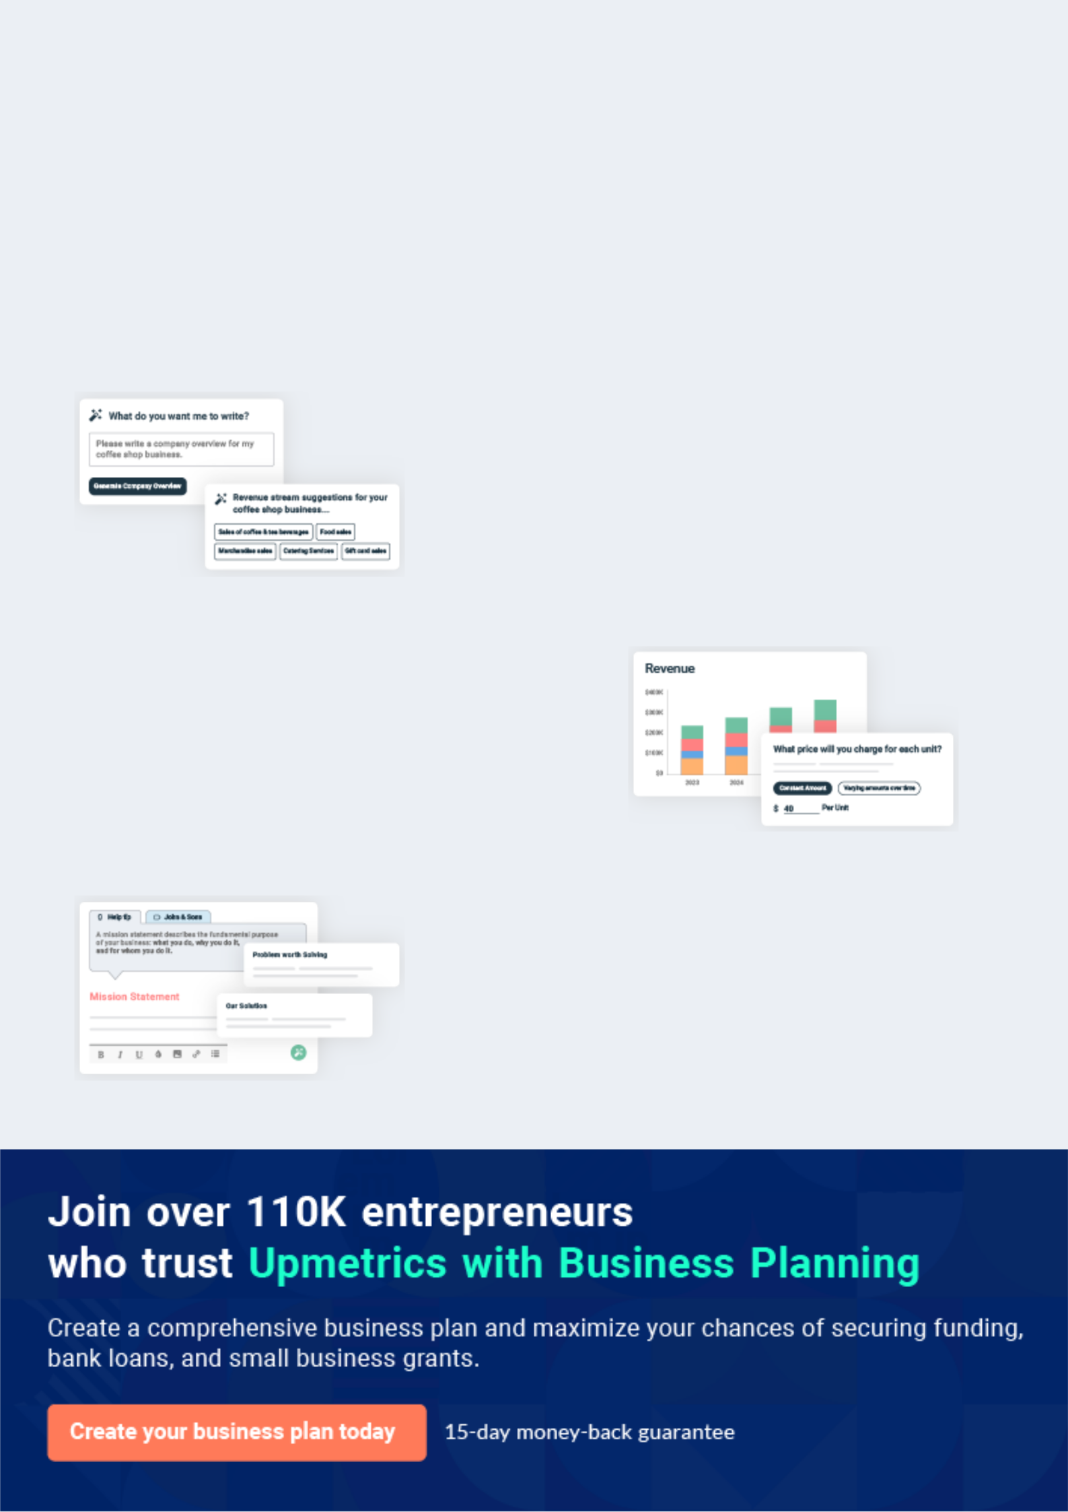
Business planning that’s simpler and faster than you think

Creating a business plan using Upmetrics to start and grow a business is literally the easiest thing in the World. Simply read the instructions and fill in the blanks. It’s as simple as that.

❛ | Upmetrics has everything you need to create a | ❜
❛ | comprehensive business plan. | ❜

AI-powered Upmetrics Assistant

AI-powered insights to streamline your plan

Not sure where to start? Upmetrics’ AI Assistant will automatically generate ideas for each section of your plan and offer improved versions of your writing, adjusting for tone, voice, and grammar or spelling errors.

Financial Forecasting Tool

All the financials are calculated for you

Forget the complex formulas and clumsy spreadsheets — with automatic financials and drag-and-drop forecasting, you can finish your plan faster and be confident that your numbers are accurate.

Business Plan Builder

Guides you like a business mentor

Upmetrics’ step-by-step instructions, prompts, and the library of 400+ sample business plans will guide you through each section of your plan as a business mentor.
Executive Summary
To unlock help try Upmetrics!


An executive summary is the first section of the business plan intended to provide an overview of the whole business plan.
To unlock help try Upmetrics! 

 Help tip  Pet Grooming Business Plan


Start your executive summary by introducing your idea behind starting a pet grooming business and explaining what it does.
To unlock help try Upmetrics! 

Start writing here..

Market opportunity

 Help tip  Pet Grooming Business Plan

Describe the target market in brief, and explain the demographics, geographic location, and psychographic attributes of your customer.
To unlock help try Upmetrics! 

Start writing here..

Services Offered

 Help tip  Pet Grooming Business Plan

Briefly describe what products customers can expect from your business. Also, incorporate brief information mentioning the safety and security systems you implement, keeping the pet’s safety in mind.



Start writing here..

Management team


[JOHN DOE]

CEO - john.doe@example.com

A certified pet groomer with over [X years] in the industry, [John] brings a wealth of expertise and a keen understanding of market needs.


[JANE DOE]

Operations Manager - jane.doe@example.com

With a background in [Relevant Field/Experience], [Jane] ensures smooth day-to-day operations and excellence in service delivery.


[ALICE BROWN]

Financial Advisor - alice.brown@example.com

[Alice] comes with [X years] of financial planning and management experience, crucial for our growth strategy.

Financial Highlights

 Help tip  Pet Grooming Business Plan

Provide a summary of your financial projections for the company’s initial years of operation.

Include any capital or investment requirements, startup costs, projected revenues, and profits.
To unlock help try Upmetrics! 

Start writing here..
Units Sold v/s Revenue

 |  | Units Sold | Revenue
15.00k
10.00k
5.00k
0
Year 1 | Year 2 | Year 3


Financial Year |  |  | Units Sold | Revenue
Year 1 | 1,550 |  |  | $10,000
Year 2 | 1,800 |  |  | $12,000
Year 3 | 2,050 |  |  | $14,000
 Help tip |  |  Pet Grooming Business Plan


After giving a brief about your business plan, end your summary with a call to action, inviting potential investors or readers to the next meeting if they are interested in your business.
To unlock help try Upmetrics! 

Write a call to action for your business plan.
Company Overview

Depending on what details of your business are essential, you’ll need different elements in your business overview.
To unlock help try Upmetrics! 

 Help tip  Pet Grooming Business Plan

Provide all the basic information about your business in this section like:

• The name and type of your business: mention whether you are a mobile, home-based,
To unlock help try Upmetrics! 

Start writing here..

Ownership

 Help tip  Pet Grooming Business Plan

Describe the owners of your pet grooming business and mention their roles in running it. Who owns what shares in the corporation, and how each owner helps in the business?
To unlock help try Upmetrics! 

Start writing here..

Mission statement

 Help tip  Pet Grooming Business Plan

Add a mission statement that sums up your pet grooming business’s objectives and core principles. This statement needs to be memorable, clear, and brief.
To unlock help try Upmetrics! 
❛ At [XYZ Pet] we believe every pet deserves to be pampered. Our mission is to provide unparalleled grooming services, prioritizing safety, comfort, and style, ensuring every pet feels as fabulous as

they look.
❜

Business history

 Help tip  Pet Grooming Business Plan


Include an outline of your business’s history and how it came to be in its current position. If you
can, add some personality and intriguing details, especially if you have any achievements or
recognitions till now for your incredible services.
 |  |  |  |  | To unlock help try Upmetrics! 
Start writing here..
Future goals
 Help tip |  |  |  Pet Grooming Business Plan

It’s crucial to convey your aspirations and your vision. Include the vision of where you see your business in the near future and if you plan to expand your business to another city or state.
To unlock help try Upmetrics! 

Start writing here..
Market Analysis
To unlock help try Upmetrics!


 |  | Market analysis provides a clear understanding of the market in which your
 |  | printing business will run along with the target market, competitors, and
 |  | growth opportunities.
 |  |  |  | To unlock help try Upmetrics! 
 Help tip |  |  Pet Grooming Business Plan

To write the introduction section of your market analysis, start by clearly identifying your primary target market.
To unlock help try Upmetrics! 

Start writing here..

Target Market

 Help tip  Pet Grooming Business Plan

Identify your target market and define your ideal customer. Know your ideal customers and what services they prefer: nail trimming, haircut and styling, etc.
To unlock help try Upmetrics! 

Start writing here..

Market size and growth potential

 Help tip  Pet Grooming Business Plan

Provide an overview of the pet grooming industry. It will include market size, trends, growth potential, and regulatory considerations. Highlight the competitive edge and how your business is different from the rest.



Start writing here..

Market Size


Available Market | 5M
Total pets in [City/Region]. | 5M

Served Market | 3M
Pets currently using grooming services. | 3M

Target Market | 1M
Pets seeking premium grooming services. | 1M

 Help tip  Pet Grooming Business Plan

Identify and analyze all other pet grooming developers in the local market, including direct and indirect competitors.
To unlock help try Upmetrics! 

Competitive analysis

Fluffy Tails Grooming Studio

Established in [Year], Fluffy Tails Grooming Studio has earned a reputation as a go-to spot for basic grooming needs. Located in the heart of [City/Region], it has built a loyal customer base over the years.

Features Strengths Weaknesses

Comprehensive grooming packages including washing, trimming, and styling.

A la carte services for specific needs.

Seasonal grooming specials, e.g., summer trims.

Loyalty program with discounts and rewards.

Strong brand recognition in the local community.

Efficient service turnaround times.

Diverse range of grooming packages.

Limited to in-store services; no mobile grooming solutions.

Limited use of technology; lacks an online booking system.

No specialized treatments or organic product offerings.

Elite Paws Mobile Spa

A relatively new entrant, established in [Year], Elite Paws Mobile Spa focuses exclusively on delivering mobile grooming services right to the pet owner's doorstep.

Features Strengths Weaknesses

On-demand mobile grooming | Exceptional convenience,
services. | servicing pets in familiar
Customized pet spa | environments.
treatments. | Modern, well-equipped mobile
Subscription-based service | grooming vans.
models. | Flexible subscription models,
 | catering to varied customer
 | needs.

Limited market presence due to recent establishment.

No brick-and-mortar location, missing out on walk-in clientele.

Potential scaling challenges due to mobile-only model.

Purrfect Styles Boutique

Purrfect Styles Boutique, in operation since [Year], combines grooming with retail, offering pet owners a one-stop solution for both services and products.

Features Strengths Weaknesses

Full-range grooming services.

Retail section with pet products, from toys to organic foods.

Online shop with home delivery options.

Diverse revenue streams (grooming + retail).

Extensive product range catering to a broad audience.

Strong online presence with e-commerce capabilities.

Services might be perceived as less specialized due to retail focus.

Potential for divided attention between grooming and sales.

Less emphasis on innovative grooming trends.

Market trends

 Help tip  Pet Grooming Business Plan

Analyze current and emerging trends in your industry, such as technological changes or customer preferences. Explain how your business will cope with all the trends.
To unlock help try Upmetrics! 

Start writing here..

Regulatory environment

 Help tip  Pet Grooming Business Plan

Describe any regulations or licensing requirements that affect pet grooming, such as animal welfare laws, record keeping, health, and safety standards, etc.
To unlock help try Upmetrics! 

Start writing here..
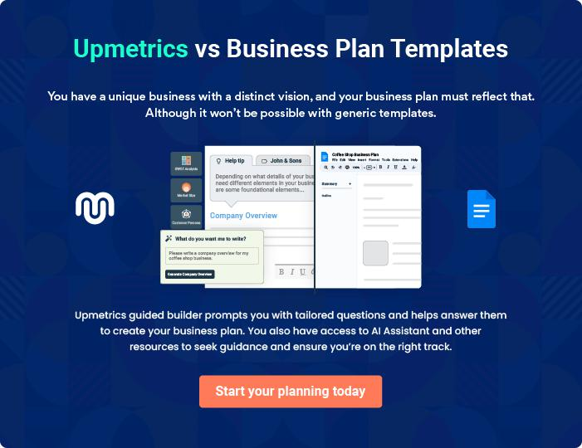
Products and Services
To unlock help try Upmetrics!

The product and services section of a pet grooming business plan should describe the specific services and products that will be offered to customers. To write this section should include the following:



 Help tip  Pet Grooming Business Plan

To craft the introduction for your "Products and Services" chapter, begin by positioning your business within its industry, emphasizing its unique strengths or value proposition.
To unlock help try Upmetrics! 

Start writing here..

 Help tip


Create a list of the services your pet grooming business will offer, including bathing & brushing, ear cleaning, teeth cleaning, nail trimming, hair-cutting, etc.
To unlock help try Upmetrics! 

Services
Bathing & Brushing


Price: $[30.00]

A refreshing and comprehensive bathing experience ensuring your pet is clean, shiny, and revitalized. Our brushing session untangles and smoothens fur, providing a sleek finish.

Specifications

- Duration: [25 minutes]

- Products Used: Vet-approved, hypoallergenic shampoo & conditioner

- Tools: Ergonomic brushes suitable for various fur types

- Suitable for: All pet breeds and sizes

Ear Cleaning

Price: $[15.00]

Thorough ear cleaning service designed to remove wax and debris, helping to prevent potential infections and maintain overall ear health.

Specifications

- Duration: [10 minutes]

- Products Used: Natural ear cleaning solution, vet-approved

- Tools: Soft cotton swabs and ear cleaning instruments

- Suitable for: All pet breeds and sizes
Teeth Cleaning

Price: $[20.00]

A dental hygiene session that ensures fresh breath and healthy gums, eliminating tartar and reducing the risk of dental diseases.

Specifications

- Duration: [15 minutes]

- Products Used: Pet-friendly dental paste and mouthwash

- Tools: Specialized pet toothbrush and dental tools

- Suitable for: All pet breeds, particularly those prone to dental issues

Nail Trimming

Price: $[10.00]

An essential service to prevent overgrowth-related complications, ensuring the pet's comfort and well-being.

Specifications

- Duration: [10 minutes]

- Products Used: None

- Tools: Pet nail clippers and filers

- Suitable for: All pet breeds and sizes
Hair-Cutting & Styling

Price: $[40.00]

Customized haircuts and styling tailored to your pet's breed and your specific requirements, ensuring a polished and attractive look.

Specifications

- Duration: [40 minutes]

- Products Used: Hypoallergenic grooming sprays and gels

- Tools: Professional grooming scissors, clippers, and styling tools

- Suitable for: All pet breeds with grooming needs

Emphasize safety and quality

 Help tip  Pet Grooming Business Plan

In all descriptions of services and products, emphasize the importance of safety standards and hygiene.
To unlock help try Upmetrics! 

Start writing here..
Sales And Marketing Strategies

Writing the sales and marketing strategies section means a list of strategies you will use to attract and retain your clients.
To unlock help try Upmetrics! 

 Help Tip  Pet Grooming Business Plan


To create an effective introduction for your "Sales and Marketing Strategies" chapter, start by setting the stage within your specific industry or market.
To unlock help try Upmetrics! 

Start writing here..

Unique Selling Proposition (USP)

 Help tip  Pet Grooming Business Plan

Clearly define your pet grooming business’s unique selling propositions, which can be your services, specialty pet grooming, mobile pet grooming, etc.
To unlock help try Upmetrics! 

Start writing here..

Pricing Strategy

 Help tip  Pet Grooming Business Plan

Develop a pricing strategy that is competitive and affordable yet profitable. Consider offering promotions, discounts, or packages for your pet grooming services to attract new customers.
To unlock help try Upmetrics! 

Start writing here..

 Help tip  Pet Grooming Business Plan
To unlock help try Upmetrics!

Develop a marketing strategy that includes a mix of online and offline marketing tactics. Consider social media, email marketing, content marketing, brochures, print marketing, and events.



Marketing strategies

Online


Social Media

Regular posts, promotions, and engagement on platforms like Facebook, Instagram, and Twitter.

Email Marketing

Monthly newsletters featuring grooming tips, promotions, and company updates.

Content Marketing

Blog posts on our website about

pet care, grooming trends, and

more.

Offline

Brochures Print Marketing

Distributed in local vet clinics, pet Advertisements in local

stores, and community centers. newspapers and magazines.

Events

Hosting or participating in local

pet-related events or fairs.

 Help tip

Mention your sales strategy as in – creating referral programs for your existing customers, offering discounts, creating service packages, etc.
To unlock help try Upmetrics! 

Sales strategies

Service Packages

Creating value-driven bundles that incentivize multiple service bookings.

Promotions

Seasonal or occasional promotions to encourage bookings during off-peak times.

Referral Programs

Offering [X%] discounts to

customers who refer friends and

family.

 Help tip

Describe how your business will retain customers and build loyalty, such as through loyalty programs, special events, or personalized service.
To unlock help try Upmetrics! 

Customer retention

Loyalty Programs

Points-based system where customers can earn free or discounted services.

Special Events

Exclusive events for regular customers, such as pet grooming workshops or appreciation days.

Personalized Service

Remembering customer

preferences, pet names, and

offering tailored advice ensures

our clients feel valued and

understood.

Operations Plan

 |  | When writing the operations plan section, it’s important to consider the
 |  | various aspects of your business operations.
 |  |  |  | To unlock help try Upmetrics! 
 Help tip |  |  Pet Grooming Business Plan


To create an effective introduction for your "Operational Plan" chapter, start by emphasizing the
pivotal role of efficient operations in the success of your business, underscoring how they
directly impact the quality of services delivered.
 |  |  |  | To unlock help try Upmetrics! 
Start writing here..
Hiring Plan
 Help tip |  |  Pet Grooming Business Plan

Tell the staffing requirements of your pet grooming business, including the number of employees needed, their qualifications, and the duties they will perform.
To unlock help try Upmetrics! 

Start writing here..

Operational Process

 Help tip  Pet Grooming Business Plan

Outline the processes and procedures you will use to run your pet grooming company. It includes scheduling appointments, grooming services, cleaning, sanitation, etc.
To unlock help try Upmetrics! 

Start writing here..

Equipment

 Help tip  Pet Grooming Business Plan

Describe grooming equipment and gadgets used in your business operations such as grooming table, clippers, blades, scissors, brushes, combs, etc.
To unlock help try Upmetrics! 

Start writing here..
Management Team

The management team section provides an overview of the individuals responsible for running your business plan.
To unlock help try Upmetrics! 

 Help tip  Pet Grooming Business Plan

To craft an introduction for your "Management Team" chapter, begin by emphasizing the crucial role of leadership in the success of any business.
To unlock help try Upmetrics! 

Start writing here..

Key managers

 Help tip  Pet Grooming Business Plan

Describe your management team’s key members, roles, and responsibilities.

It should include the owners, managers, pet groomers, accountants, and other people involved
To unlock help try Upmetrics! 

Start writing here..

JOHN DOE

CEO & Co-founder - john.doe@example.com

John holds a Bachelor’s in Business Management from Prestigious University and brings over 10 years of leadership experience in the pet care industry.

As the visionary behind "[XYZ Pet]", John is responsible for steering the strategic direction of the business, cultivating partnerships, and ensuring the financial health of the establishment.


His passion for animals and entrepreneurial flair are evident in the company's ethos and success.
JANE DOE

Operations Manager - jane.doe@example.com

Jane has a Master's in Operations Management from Renowned University and has worked in pet service establishments for over 8 years.

With an impeccable record of ensuring efficiency and customer satisfaction, she oversees the day-to-day operations of "[XYZ Pet]".


Her attention to detail, problem-solving skills, and commitment to excellence set the standard for the entire team.


ALICE BROWN

Chief Pet Groomer - alice.brown@example.com

Alice is a certified pet grooming professional from Top Pet Grooming Academy and brings to the table 7 years of hands-on experience.

Not only does she ensure that every pet receives top-notch grooming care, but she also mentors junior groomers, ensuring quality across the board.

With her deep knowledge of pet grooming techniques and aesthetics, Alice has played an instrumental role in building the company's reputation for excellence.


ROBERT BROWN

Accountant - robert.brown@example.com

With a degree in Accountancy from Elite University and 6 years of experience in financial management, Robert handles the company’s financial records, and budgets, and ensures fiscal compliance.

His meticulous nature and keen analytical skills ensure that "[XYZ Pet]" remains profitable and financially sound.

His insights have been invaluable in driving the company's fiscal strategies and maintaining transparency with stakeholders.
Organizational structure

 Help tip  Pet Grooming Business Plan

Describe the organizational structure of the management team, including reporting lines and how decisions will be made.
To unlock help try Upmetrics! 

Start writing here..

Organization chart


John Doe

CEO


Robert Brown

Jane Doe

Accountant


Operations Manager


Mike White

Alice Brown

Jr. Accountant


Chief Pet Groomer


Lucy Wilson

Assistant Groomer

Compensation plan

 Help tip  Pet Grooming Business Plan

Describe your compensation plan for the management team and staff, including salaries, bonuses, and other benefits.
To unlock help try Upmetrics! 

Start writing here..

 Help tip  Pet Grooming Business Plan

If you have a board of advisors for your business, then mention them along with their roles and experience.
To unlock help try Upmetrics! 

Board of advisors


[ADVISOR NAME]

Advisor

With [X] years in [specific field], [Advisor Name] provides insights into [specific domain].

[ADVISOR NAME]

Advisor

A veteran of [specific field], [Advisor Name]'s expertise lies in [specific domain].
Financial Plan

When writing the financial plan section of a business plan, it’s important to provide a comprehensive overview of your financial projections for the first few years of your business, You may provide the following:
To unlock help try Upmetrics! 

 Help tip  Pet Grooming Business Plan


To create an effective introduction for your "Financial Plan" chapter, begin by stressing the critical role of a well-structured financial plan in the success of your venture.
To unlock help try Upmetrics! 

Start writing here..

 Help tip  Pet Grooming Business Plan

Create a projected profit & loss statement that describes the expected revenue, cost of products sold, and operational costs. Your business’s anticipated net profit or loss should be computed and included.
To unlock help try Upmetrics! 

Profit & loss statement

Revenue

Cost Of Sales

General Costs

Revenue Specific Costs

Personnel Costs (Direct

Labor)

Gross Margin

Gross Margin (%)

Operating Expense

Payroll Expense

(Indirect Labor)

General Expense

Bad Debt

Amortization of Current

Assets

2023-24 | 2024-25 | 2025-26 | 2026-27 | 2027-28
$0 | $0 | $0 | $0 | $0

$0 | $0 | $0 | $0 | $0
$0 | $0 | $0 | $0 | $0
$0 | $0 | $0 | $0 | $0
$0 | $0 | $0 | $0 | $0

$0 | $0 | $0 | $0 | $0
0% | 0% | 0% | 0% | 0%

$0 | $0 | $0 | $0 | $0
$0 | $0 | $0 | $0 | $0
$0 | $0 | $0 | $0 | $0
$0 | $0 | $0 | $0 | $0
$0 | $0 | $0 | $0 | $0

EBITDA

Additional Expense

Long Term

Depreciation

Gain or loss from Sale

of Assets

EBIT

Interest Expenses

EBT

Income Tax Expense

Total Expense

Net Income

Net Income (%)

2023-24 | 2024-25 | 2025-26 | 2026-27 | 2027-28
$0 | $0 | $0 | $0 | $0
$0 | $0 | $0 | $0 | $0
$0 | $0 | $0 | $0 | $0
$0 | $0 | $0 | $0 | $0
$0 | $0 | $0 | $0 | $0
$0 | $0 | $0 | $0 | $0
$0 | $0 | $0 | $0 | $0
$0 | $0 | $0 | $0 | $0
$0 | $0 | $0 | $0 | $0
$0 | $0 | $0 | $0 | $0
0% | 0% | 0% | 0% | 0%
 |  |  | 2023-24 |  | 2024-25 | 2025-26 | 2026-27 | 2027-28
Retained Earning |  |  | $0 |  | $0 | $0 | $0 | $0
Opening
Owner's Distribution |  |  | $0 |  | $0 | $0 | $0 | $0
Retained Earning |  |  | $0 |  | $0 | $0 | $0 | $0
Closing
 Help tip |  |  |  Pet Grooming Business Plan


Estimate your cash inflows and outflows for the first few years of operation. It should include cash receipts from clients, vendor payments, loan payments, and any other cash inflows and outflows.
To unlock help try Upmetrics! 

Cash flow statement

 | 2023-24 | 2024-25 | 2025-26 | 2026-27 | 2027-28
Cash Received | $0 | $0 | $0 | $0 | $0
Cash Paid | $0 | $0 | $0 | $0 | $0
COS & General Expenses | $0 | $0 | $0 | $0 | $0
Salary & Wages | $0 | $0 | $0 | $0 | $0
Interest | $0 | $0 | $0 | $0 | $0

Sales Tax

Income Tax

Net Cash From

Operations

Assets Sell

Assets Purchase

Net Cash From

Investments

Amount Received

Loan Received

Common Stock

Preferred Stock

Owner's Contribution

Amount Paid

2023-24 | 2024-25 | 2025-26 | 2026-27 | 2027-28
$0 | $0 | $0 | $0 | $0
$0 | $0 | $0 | $0 | $0
$0 | $0 | $0 | $0 | $0

$0 | $0 | $0 | $0 | $0
$0 | $0 | $0 | $0 | $0
$0 | $0 | $0 | $0 | $0

$0 | $0 | $0 | $0 | $0
$0 | $0 | $0 | $0 | $0

$0 | $0 | $0 | $0 | $0
$0 | $0 | $0 | $0 | $0
$0 | $0 | $0 | $0 | $0

Loan Capital $0 $0 $0 $0 $0

 |  |  | 2023-24 | 2024-25 | 2025-26 | 2026-27 | 2027-28
Dividends & Distributions |  |  | $0 | $0 | $0 | $0 | $0
Net Cash From |  |  | $0 | $0 | $0 | $0 | $0
Financing
Summary
Starting Cash |  |  | $0 | $0 | $0 | $0 | $0
Cash In |  |  | $0 | $0 | $0 | $0 | $0
Cash Out |  |  | $0 | $0 | $0 | $0 | $0
Change in Cash |  |  | $0 | $0 | $0 | $0 | $0
Ending Cash |  |  | $0 | $0 | $0 | $0 | $0
 Help tip |  |  Pet Grooming Business Plan

Prepare a projected balance sheet, which shows the business’s assets, liabilities, and equity.

To unlock help try Upmetrics! 

Balance sheet

 | 2023-24 | 2024-25 | 2025-26 | 2026-27 | 2027-28
Assets | $0 | $0 | $0 | $0 | $0
Current Assets | $0 | $0 | $0 | $0 | $0
Cash | $0 | $0 | $0 | $0 | $0
Accounts Receivable | $0 | $0 | $0 | $0 | $0
Inventory | $0 | $0 | $0 | $0 | $0
Other Current Assets | $0 | $0 | $0 | $0 | $0
Long Term Assets | $0 | $0 | $0 | $0 | $0
Gross Long Term Assets | $0 | $0 | $0 | $0 | $0
Accumulated Depreciation | $0 | $0 | $0 | $0 | $0

Liabilities & Equity | $0 | $0 | $0 | $0 | $0
Liabilities | $0 | $0 | $0 | $0 | $0
Current Liabilities | $0 | $0 | $0 | $0 | $0
Accounts Payable | $0 | $0 | $0 | $0 | $0
Income Tax Payable | $0 | $0 | $0 | $0 | $0
Sales Tax Payable | $0 | $0 | $0 | $0 | $0
Short Term Debt | $0 | $0 | $0 | $0 | $0
 | 2023-24 | 2024-25 | 2025-26 | 2026-27 | 2027-28
Long Term Liabilities | $0 | $0 | $0 | $0 | $0
Long Term Debt | $0 | $0 | $0 | $0 | $0
Equity | $0 | $0 | $0 | $0 | $0
Paid-in Capital | $0 | $0 | $0 | $0 | $0
Common Stock | $0 | $0 | $0 | $0 | $0
Preferred Stock | $0 | $0 | $0 | $0 | $0
Owner's Contribution | $0 | $0 | $0 | $0 | $0
Retained Earnings | $0 | $0 | $0 | $0 | $0

Check | $0 |  |  | $0 | $0 | $0 | $0
 Help tip |  |  Pet Grooming Business Plan

Determine the point at which your pet grooming business will break even or generate enough revenue to cover its operating costs.

This will help you understand how much revenue you need to generate to make a profit.
To unlock help try Upmetrics! 

Break-even Analysis

 | 2023-24 | 2024-25 | 2025-26 | 2026-27 | 2027-28
Starting Revenue | $0 | $0 | $0 | $0 | $0
Net Revenue | $0 | $0 | $0 | $0 | $0
Closing Revenue | $0 | $0 | $0 | $0 | $0

Starting Expense | $0 | $0 | $0 | $0 | $0
Net Expense | $0 | $0 | $0 | $0 | $0
Closing Expense | $0 | $0 | $0 | $0 | $0

Is Break Even? | 0 | 0 | 0 | 0 | 0
Break Even Month | 0 | 0 | 0 | 0 | 0
Days Required | 0 | 0 | 0 | 0 | 0
Break Even Revenue | $0 | $0 | $0 | $0 | $0
Break Even Units
Financing needs

 Help tip  Pet Grooming Business Plan

Estimate how much financing you will need to start and operate your pet grooming business. It should include short-term and long-term financing needs, such as loans or investment capital.
To unlock help try Upmetrics! 

Start writing here..
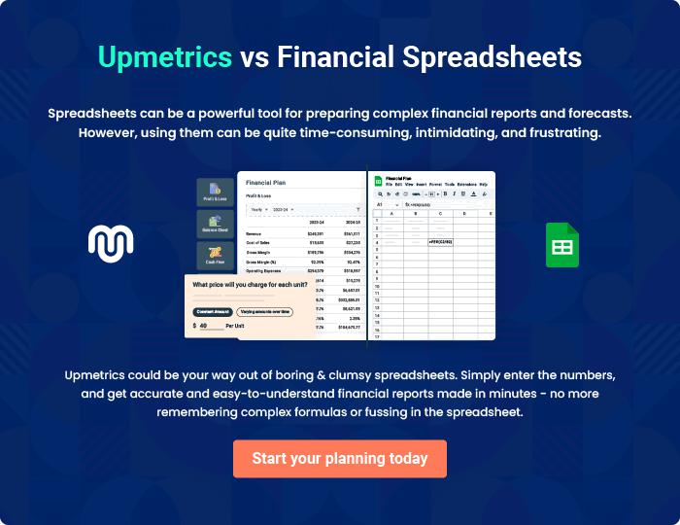
Appendix

When writing the appendix section, you should include any additional information that supports the main content of your plan. This may include financial statements, market research data, legal documents, and other
To unlock help try Upmetrics! 

Create a winning business plan that gets you funded

Creating a stunning and investment-ready plan requires no writing, graphic designing, or financial planning expertise.

Upmetrics has all the features required to help you create a comprehensive business plan—from start to finish. Make no mistakes, it’s the modern way of planning to structure ideas, make plans, and create stunning pitch decks to awe investors.

Pitch decks that impress investors

Create pitch decks that provide a visual representation of your business, engage investors, and make them want to invest in your business idea.

Interactive plans in no time

Import business plan sections like—SWOT analysis, comparison tables, and others to create an interactive business plan. No designing skills are required.

Stunning cover page designs

With Upmetrics, you have the liberty to choose from multiple stunning cover page designs. Choose a creative design and make your plan stand out.

Online sharing made simple

Upmetrics makes online sharing quick and easier for users. Easily share your business plans with a link while tracking reader activity.

500+ sample business plans

Simply import a template from our library of sample plans into the editor and start customizing it to make it yours. It takes only a few clicks to get started.

Collaborate with team in real-time

Invite team members, initiate conversations, discuss ideas & strategies, share feedback, and work on a business plan in real-time.

