

Party Rental Business Plan

Your Party, Our Rentals

Business

Plan

2023

John Doe

10200 Bolsa Ave, Westminster, CA, 92683

- 359-3153 info@example.com http://www.example.com

CONFIDENTIAL

Table of Contents

Executive Summary | 6
Market opportunity | 6
Services Offered | 6
Marketing & Sales Strategies | 7
Financial Highlights | 7
Units Sold v/s Revenue | 8

Company Overview | 9
Ownership | 9
Mission statement | 10
Business history | 10
Future goals | 10

Market Analysis | 11
Target Market | 11
Market size and growth potential | 11
Market Size | 12
Competitive analysis | 12
Eventful Rentals | 12
Party Perfection Rentals | 13
Market trends | 13
Regulatory environment | 13

Products and Services | 15
Party Rental Items and Services | 15
Elegant Event Tables | 15
Deluxe Chair Set | 16
Tent & Canopy Rental | 16
Audiovisual Equipment Package | 17
Customizable Decor & Ambiance | 17

Quality Measures 17

Additional Services | 18

Sales And Marketing Strategies | 19
Unique Selling Proposition (USP) | 19
Pricing Strategy | 19
Marketing strategies | 20
Online | 20
Offline | 20
Sales strategies | 21
Customer retention | 21

Operations Plan | 22
Staffing & Training | 22
Operational Process | 22
Equipment & Machinery | 23

Management Team | 24
Key managers | 24
John Doe | 24
Jane Doe | 25
Alice Brown | 25
Robert Brown | 25
Organizational structure | 26
Organization chart | 26
Compensation plan | 26
Advisors/Consultants | 27
[ADVISOR NAME] | 27
[CONSULTANT NAME] | 27

Financial Plan | 28
Profit & loss statement | 28
Cash flow statement | 31
Balance sheet | 33
Break-even Point | 35
Financing needs | 37
Appendix
Appendix | 39
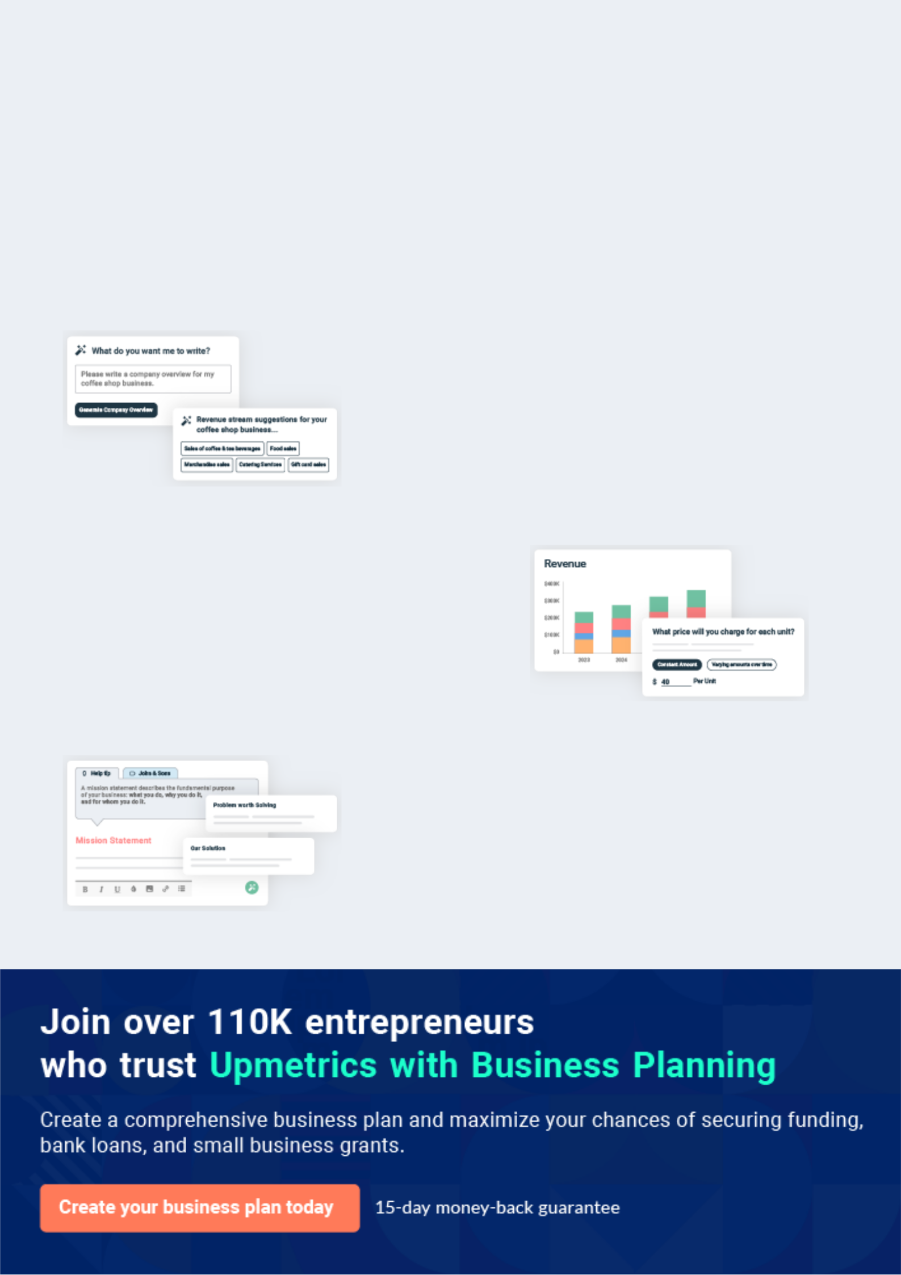
Business planning that’s simpler and faster than you think

Creating a business plan using Upmetrics to start and grow a business is literally the easiest thing in the World. Simply read the instructions and fill in the blanks. It’s as simple as that.

❛ | Upmetrics has everything you need to create a | ❜
❛ | comprehensive business plan. | ❜

AI-powered Upmetrics Assistant

AI-powered insights to streamline your plan

Not sure where to start? Upmetrics’ AI Assistant will automatically generate ideas for each section of your plan and offer improved versions of your writing, adjusting for tone, voice, and grammar or spelling errors.

Financial Forecasting Tool

All the financials are calculated for you

Forget the complex formulas and clumsy spreadsheets — with automatic financials and drag-and-drop forecasting, you can finish your plan faster and be confident that your numbers are accurate.

Business Plan Builder

Guides you like a business mentor

Upmetrics’ step-by-step instructions, prompts, and the library of 400+ sample business plans will guide you through each section of your plan as a business mentor.
Executive Summary


An executive summary is the first section of the business plan intended to provide an overview of the whole business plan.
To unlock help try Upmetrics! 

 Help tip  Party Rental Business Plan


Start your executive summary by briefly introducing your business to your readers.

This section may include the name of your party rental business, its location, when it was
To unlock help try Upmetrics! 

Start writing here..

Market opportunity

 Help tip  Party Rental Business Plan

Summarize your market research, including market size, growth potential, and marketing trends. Highlight the opportunities in the market and how your business will fit in to fill the gap.
To unlock help try Upmetrics! 

Start writing here..

Services Offered

 Help tip  Party Rental Business Plan

Highlight the party rental services you offer your clients. The USPs and differentiators you offer are always a plus.
To unlock help try Upmetrics! 

Start writing here..

Marketing & Sales Strategies
To unlock help try Upmetrics!

 Help tip  Party Rental Business Plan

Outline your sales and marketing strategies—what marketing platforms you use, how you plan on acquiring customers, etc.
To unlock help try Upmetrics! 

Start writing here..

Financial Highlights

 Help tip  Party Rental Business Plan

Briefly summarize your financial projections for the initial years of business operations. Include any capital or investment requirements, associated startup costs, projected revenues, and profit forecasts.



Start writing here..
Units Sold v/s Revenue

 |  | Units Sold | Revenue
15.00k
10.00k
5.00k
0
Year 1 | Year 2 | Year 3


Financial Year |  |  | Units Sold | Revenue
Year 1 | 1,550 |  |  | $10,000
Year 2 | 1,800 |  |  | $12,000
Year 3 | 2,050 |  |  | $14,000
 Help tip |  |  Party Rental Business Plan


Summarize your executive summary section with a clear CTA, for example, inviting angel investors to discuss the potential business investment.
To unlock help try Upmetrics! 

Write a call to action for your business plan.
Company Overview

Depending on what details of your business are essential, you’ll need different elements in your business overview.
To unlock help try Upmetrics! 

 Help tip  Party Rental Business Plan

Describe your business in this section by providing all the basic information:

Describe what kind of party rental company you run and the name of it. You may specialize in
To unlock help try Upmetrics! 

Start writing here..

Ownership

 Help tip  Party Rental Business Plan

List the names of your party rental business’s founders or owners. Describe what shares they own and their responsibilities for efficiently managing the business.
To unlock help try Upmetrics! 

Start writing here..
Mission statement

 Help tip  Party Rental Business Plan

Summarize your business’ objective, core principles, and values in your mission statement. This statement needs to be memorable, clear, and brief.
To unlock help try Upmetrics! 

❛ At [Stellar Soirees Premier Party Rental Solution], our mission is to transform ordinary events into extraordinary experiences.

Grounded in [core principle, e.g., sustainability], driven by [core value, e.g., innovation], and inspired by [another core value, e.g., the joy of celebration], we strive to elevate every gathering with impeccable attention to detail.

❜

Business history

 Help tip  Party Rental Business Plan

If you’re an established party rental service provider, briefly describe your business history, like —when it was founded, how it evolved over time, etc.
To unlock help try Upmetrics! 

Start writing here..

Future goals

 Help tip  Party Rental Business Plan

It’s crucial to convey your aspirations and vision. Mention your short-term and long-term goals; they can be specific targets for revenue, market share, or expanding your services.
To unlock help try Upmetrics! 

Start writing here..

Market Analysis
To unlock help try Upmetrics!


 |  | Market analysis provides a clear understanding of the market in which your
 |  | printing business will run along with the target market, competitors, and
 |  | growth opportunities.
 |  |  |  | To unlock help try Upmetrics! 
 Help tip |  |  Party Rental Business Plan

To write the introduction section of your market analysis, start by clearly identifying your primary target market.
To unlock help try Upmetrics! 

Start writing here..

Target Market

 Help tip  Party Rental Business Plan

Start this section by describing your target market. Define your ideal customer and explain what types of services they prefer. Creating a buyer persona will help you easily define your target market to your readers.



Start writing here..

Market size and growth potential

 Help tip  Party Rental Business Plan

Describe your market size and growth potential and whether you will target a niche or a much broader market.
To unlock help try Upmetrics! 

Start writing here..

Market Size

Available Market

Total individuals/events requiring party 5M rentals annually.

Served Market
Events within our region seeking party 2M rental services.

Target Market
Mid-to-high-end events in our city 500k looking for premium rental solutions.

 Help tip  Party Rental Business Plan

Identify and analyze your direct and indirect competitors. Identify their strengths and weaknesses, and describe what differentiates your party rental services from them.
To unlock help try Upmetrics! 

Competitive analysis

Eventful Rentals

Eventful Rentals is a seasoned player in the market, with over [10 years] of experience. Specializing in [e.g., "tent and canopy rentals"], they've catered to numerous high-profile events in the region.

Features | Strengths | Weaknesses
Comprehensive tent solutions, | A vast inventory, catering to | Limited customization options
from pop-ups to pole tents. | large-scale events. | beyond size and color.
An array of color and design | Strong brand recognition due to | Premium pricing, making it less
options to suit different event | years in the business. | accessible for smaller events.
themes. | Reliable customer service with | Slower adoption of eco-friendly
Additional services like lighting | a dedicated helpline. | or sustainable practices.
and heating for tents.

Party Perfection Rentals
To unlock help try Upmetrics!

Party Perfection Rentals is a newer entrant, focusing predominantly on [e.g., "specialty decor rentals"].

Their trendy and modern approach appeals to a younger demographic.

Features Strengths Weaknesses

Contemporary decor pieces, Fresh, modern inventory that

including centerpieces and aligns with current event

backdrops. trends.

Collaboration with local artists Agile and adaptive to changing

for unique designs. market needs.

Digital consultation and virtual Strong online presence with

event planning. interactive social media

engagement.

Limited experience in handling large-scale events

Narrow focus only on decor, excluding other rental needs.

Potential inventory shortages during peak seasons.

Market trends

 Help tip  Party Rental Business Plan

Analyze emerging trends in the industry, such as technology disruptions, changes in customer behavior or preferences, etc. Explain how your business will cope with all the trends.
To unlock help try Upmetrics! 

Start writing here..

Regulatory environment

 Help tip  Party Rental Business Plan

List regulations and licensing requirements that may affect your party rental company, such as business licensing, insurance requirements, safety regulations, health & sanitation compliance, etc.



Start writing here..

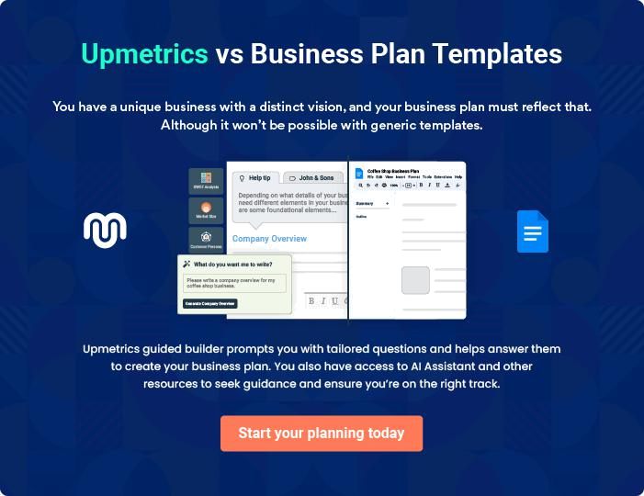
Products and Services
To unlock help try Upmetrics!

The product and services section of a party rental business plan should describe the specific services and products that will be offered to customers. To write this section should include the following:



 Help tip  Party Rental Business Plan

To craft the introduction for your "Products and Services" chapter, begin by positioning your business within its industry, emphasizing its unique strengths or value proposition.
To unlock help try Upmetrics! 

Start writing here..

 Help tip


Mention the party rental services your business will offer. This list may include services like

• Equipment rental
To unlock help try Upmetrics! 

Party Rental Items and Services

Elegant Event Tables


Price: [$15] per table/day

Crafted with precision, our elegant event tables are designed to elevate the ambiance of any event, be it a wedding reception or a corporate gala.

Specifications

- Material: Premium quality wood with a polished finish.

- Dimensions: 6 ft. x 2.5 ft.

- Weight Capacity: Up to 200 lbs.

- Shape: Rectangular, with optional round variants available.
Deluxe Chair Set

Price: [$5] per chair/day

Ensuring comfort and style, our deluxe chairs are perfect for guests to relax and enjoy the festivities. Suitable for both indoor and outdoor events.

Specifications

- Material: Reinforced steel with cushioned seating.

- Dimensions: 18 in. width x 36 in. height.

- Weight Capacity: Up to 250 lbs.

- Design: Ergonomic with padded backrest.

Tent & Canopy Rental

Price: [$150 for a 10x10 ft. tent/day]

Offering shade and shelter, our tents and canopies are versatile solutions for outdoor events, ensuring guests are protected from unpredictable weather elements.

Specifications

- Material: UV-resistant fabric with sturdy metal poles.

- Dimensions: 10 ft. x 10 ft. (custom sizes available upon request).

- Features: Waterproof, wind-resistant, and easy to set up.
Audiovisual Equipment Package

Price: [$200 per package/day]

Amplify the event experience with our state-of-the-art audiovisual equipment, perfect for presentations, performances, or background music.

Specifications

- Components: 2 microphones, 1 projector, 2 speakers, and necessary cables.

- Audio Output: 200W

- Projector Resolution: Full HD 1080p.

Customizable Decor & Ambiance

Price: Starts at [$50] for basic packages

Transform event spaces with our customizable decor options, including centerpieces, wall hangings, and lighting setups, curated to match event themes.

Specifications

- Material: A mix of sustainable and luxury materials.

- Customization: Themes, color schemes, and specific decor elements tailored to client requirements.

Quality Measures

 Help tip  Party Rental Business Plan

This section should explain how you maintain quality standards and consistently provide the highest quality service.
To unlock help try Upmetrics! 

Start writing here..

Additional Services
To unlock help try Upmetrics!

 Help tip  Party Rental Business Plan

Mention if your party rental company offers any additional services. You may include services like event planning & coordination, decor & styling services, event entertainment, event catering, event staffing, event rentals coordination, etc.



Start writing here..
Sales And Marketing Strategies

Writing the sales and marketing strategies section means a list of strategies you will use to attract and retain your clients.
To unlock help try Upmetrics! 

 Help Tip  Party Rental Business Plan


To create an effective introduction for your "Sales and Marketing Strategies" chapter, start by setting the stage within your specific industry or market.
To unlock help try Upmetrics! 

Start writing here..

Unique Selling Proposition (USP)

 Help tip  Party Rental Business Plan

Define your business’s USPs depending on the market you serve, the equipment you use, and the unique services you provide. Identifying USPs will help you plan your marketing strategies.
To unlock help try Upmetrics! 

Start writing here..

Pricing Strategy

 Help tip  Party Rental Business Plan

Describe your pricing strategy—how you plan to price your services and stay competitive in the local market. You can mention any discounts you plan on offering to attract new customers.
To unlock help try Upmetrics! 

Start writing here..

 Help tip  Party Rental Business Plan
To unlock help try Upmetrics!

Discuss your marketing strategies to market your services. You may include some of these marketing strategies in your business plan—social media marketing, Google ads, brochures, email marketing, content marketing, etc.



Marketing strategies

Online


Social Media

Engaging posts, event highlights, and client testimonials on platforms like Instagram, Facebook, and LinkedIn.

Content Marketing

Informative blogs and articles on event trends, ensuring our online presence is bolstered by valuable content.

Email Marketing

Regular newsletters and promotional mails to our client base, highlighting new offerings and special deals.

Google Ads

Targeted advertisements to capture potential clients actively seeking rental services.

Offline

Brochures

Elegantly designed brochures showcasing our services and products, distributed at strategic locations.

 Help tip  Party Rental Business Plan

Outline the strategies you’ll implement to maximize your sales. Your sales strategies may include direct sales calls, partnering with other businesses, offering referral programs, etc.
To unlock help try Upmetrics! 

Sales strategies

Partner with Businesses

Collaborating with event planners, venues, and caterers to offer bundled services.

Direct Sales Calls

Personalized outreach to potential clients, highlighting how our services can elevate their events.

Referral Programs

Encouraging our satisfied clients to

refer our services, in return for

exclusive discounts and offers.

 Help tip

Describe your customer retention strategies and how you plan to execute them. For instance, introducing loyalty programs, discounts & offers, personalized service, etc.
To unlock help try Upmetrics! 

Customer retention

Loyalty Programs

Rewarding our frequent clients with discounts, early-bird offers, and exclusive previews of new inventory.

Personalized Service

Remembering client preferences, ensuring repeat clients find familiarity and personalization in our services.

Feedback Solicitation

Actively seeking client feedback post-event and continually refining our services based on their insights.

Operations Plan

 |  | When writing the operations plan section, it’s important to consider the
 |  | various aspects of your business operations.
 |  |  |  | To unlock help try Upmetrics! 
 Help tip |  |  Party Rental Business Plan


To create an effective introduction for your "Operational Plan" chapter, start by emphasizing the
pivotal role of efficient operations in the success of your business, underscoring how they
directly impact the quality of services delivered.
 |  |  |  | To unlock help try Upmetrics! 
Start writing here..
Staffing & Training
 Help tip |  |  Party Rental Business Plan

Mention your business’s staffing requirements, including the number of employees or staff needed. Include their qualifications, the training required, and the duties they will perform.
To unlock help try Upmetrics! 

Start writing here..

Operational Process

 Help tip  Party Rental Business Plan

Outline the processes and procedures you will use to run your party rental business. Your operational processes may include inventory management, customer inquiries & bookings, reservation & contract management, customer support & event coordination, etc.
To unlock help try Upmetrics! 

Start writing here..

Equipment & Machinery
To unlock help try Upmetrics!

 Help tip  Party Rental Business Plan

Include the list of equipment and machinery required for party rentals, such as tables & chairs, linens & tableware, tents & canopies, audiovisual equipment, or event furniture & lounge areas, etc.



Start writing here..
Management Team

The management team section provides an overview of the individuals responsible for running your business plan.
To unlock help try Upmetrics! 

 Help tip  Party Rental Business Plan

To craft an introduction for your "Management Team" chapter, begin by emphasizing the crucial role of leadership in the success of any business.
To unlock help try Upmetrics! 

Start writing here..

Key managers

 Help tip  Party Rental Business Plan

Introduce your management and key members of your team, and explain their roles and responsibilities.
To unlock help try Upmetrics! 

Start writing here..


JOHN DOE

CEO & Co-founder - john.doe@example.com

John is the driving force behind the vision and strategic direction of [Stellar Soirees Premier Party Rental Solution].

With over 15 years of experience in the event and party rental industry, he has garnered invaluable insights and expertise.


He holds an MBA from Harvard Business School, which equips him with a blend of business acumen and industry know-how.

John is known for his leadership style, emphasizing team collaboration and innovative thinking.

JANE DOE

Chief Operating Officer (COO) - jane.doe@example.com

Jane is instrumental in overseeing the day-to-day operational activities of [Stellar Soirees Premier Party Rental Solution].

She has a robust background in operations, with over 12 years in various leadership roles in the event sector.


Jane has a Master's in Operations Management from Stanford University and is skilled in streamlining processes and enhancing productivity.


ALICE BROWN

CMO - alice.brown@example.com

Alice leads the marketing division with an innovative and dynamic approach.

With 10 years in marketing roles within the event industry and a degree in Marketing from New York University, she possesses the skills to create impactful marketing strategies that resonate with our target demographics.


ROBERT BROWN

Operations Manager - robert.brown@example.com

Robert manages the logistical and operational facets of [Stellar Soirees Premier Party Rental Solution].

With a background in Event Management from UCLA and 8 years of experience in party rentals, he ensures smooth event deliveries and top-tier client satisfaction.

His keen attention to detail and ability to manage large teams effectively sets him apart.
Organizational structure

 Help tip  Party Rental Business Plan

Explain the organizational structure of your management team. Include the reporting line and decision-making hierarchy.
To unlock help try Upmetrics! 

Start writing here..

Organization chart


John Doe

CEO


Alice Brown | Robert Brown | Jane Doe
Alice Brown | Operations | Jane Doe
CMO | Operations | COO
CMO | Manager | COO

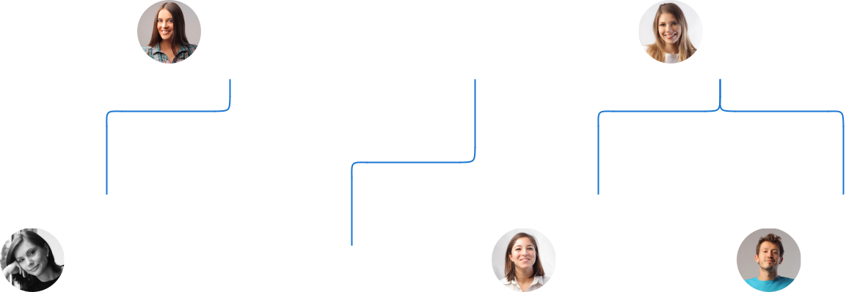

Lily Brown |  | Ella Gray | Max Blue
Logistics | James Black | Sales | Sales
Manager | Marketing | Representative | Representative
 | Specialist



Compensation plan

 Help tip  Party Rental Business Plan

Describe your compensation plan for the management and staff. Include their salaries, incentives, and other benefits.
To unlock help try Upmetrics! 

Start writing here..

 Help tip  Party Rental Business Plan

Mentioning advisors or consultants in your business plans adds credibility to your business idea.
To unlock help try Upmetrics! 

Advisors/Consultants


[ADVISOR NAME]

Advisor

A renowned figure in the event industry, [First Name]'s consultancy has been invaluable in our business modeling and industry networking.


[CONSULTANT NAME]

Consultant

With a rich history in [specific domain, e.g., "finance"], [First Name] guides us in financial planning and sustainability.
Financial Plan

When writing the financial plan section of a business plan, it’s important to provide a comprehensive overview of your financial projections for the first few years of your business, You may provide the following:
To unlock help try Upmetrics! 

 Help tip  Party Rental Business Plan


To create an effective introduction for your "Financial Plan" chapter, begin by stressing the critical role of a well-structured financial plan in the success of your venture.
To unlock help try Upmetrics! 

Start writing here..

 Help tip  Party Rental Business Plan

Describe details such as projected revenue, operational costs, and service costs in your projected profit and loss statement. Make sure to include your business’s expected net profit or loss.
To unlock help try Upmetrics! 

Profit & loss statement

Revenue

Cost Of Sales

General Costs

Revenue Specific Costs

Personnel Costs (Direct

Labor)

Gross Margin

Gross Margin (%)

Operating Expense

Payroll Expense

(Indirect Labor)

General Expense

Bad Debt

Amortization of Current

Assets

2023-24 | 2024-25 | 2025-26 | 2026-27 | 2027-28
$0 | $0 | $0 | $0 | $0

$0 | $0 | $0 | $0 | $0
$0 | $0 | $0 | $0 | $0
$0 | $0 | $0 | $0 | $0
$0 | $0 | $0 | $0 | $0

$0 | $0 | $0 | $0 | $0
0% | 0% | 0% | 0% | 0%

$0 | $0 | $0 | $0 | $0
$0 | $0 | $0 | $0 | $0
$0 | $0 | $0 | $0 | $0
$0 | $0 | $0 | $0 | $0
$0 | $0 | $0 | $0 | $0

EBITDA

Additional Expense

Long Term

Depreciation

Gain or loss from Sale

of Assets

EBIT

Interest Expenses

EBT

Income Tax Expense

Total Expense

Net Income

Net Income (%)

2023-24 | 2024-25 | 2025-26 | 2026-27 | 2027-28
$0 | $0 | $0 | $0 | $0
$0 | $0 | $0 | $0 | $0
$0 | $0 | $0 | $0 | $0
$0 | $0 | $0 | $0 | $0
$0 | $0 | $0 | $0 | $0
$0 | $0 | $0 | $0 | $0
$0 | $0 | $0 | $0 | $0
$0 | $0 | $0 | $0 | $0
$0 | $0 | $0 | $0 | $0
$0 | $0 | $0 | $0 | $0
0% | 0% | 0% | 0% | 0%
 |  |  | 2023-24 |  | 2024-25 | 2025-26 | 2026-27 | 2027-28
Retained Earning |  |  | $0 |  | $0 | $0 | $0 | $0
Opening
Owner's Distribution |  |  | $0 |  | $0 | $0 | $0 | $0
Retained Earning |  |  | $0 |  | $0 | $0 | $0 | $0
Closing
 Help tip |  |  |  Party Rental Business Plan


The cash flow for the first few years of your operation should be estimated and described in this section. This may include billing invoices, payment receipts, loan payments, and any other cash flow statements.
To unlock help try Upmetrics! 

Cash flow statement

 | 2023-24 | 2024-25 | 2025-26 | 2026-27 | 2027-28
Cash Received | $0 | $0 | $0 | $0 | $0
Cash Paid | $0 | $0 | $0 | $0 | $0
COS & General Expenses | $0 | $0 | $0 | $0 | $0
Salary & Wages | $0 | $0 | $0 | $0 | $0
Interest | $0 | $0 | $0 | $0 | $0

Sales Tax

Income Tax

Net Cash From

Operations

Assets Sell

Assets Purchase

Net Cash From

Investments

Amount Received

Loan Received

Common Stock

Preferred Stock

Owner's Contribution

Amount Paid

2023-24 | 2024-25 | 2025-26 | 2026-27 | 2027-28
$0 | $0 | $0 | $0 | $0
$0 | $0 | $0 | $0 | $0
$0 | $0 | $0 | $0 | $0

$0 | $0 | $0 | $0 | $0
$0 | $0 | $0 | $0 | $0
$0 | $0 | $0 | $0 | $0

$0 | $0 | $0 | $0 | $0
$0 | $0 | $0 | $0 | $0

$0 | $0 | $0 | $0 | $0
$0 | $0 | $0 | $0 | $0
$0 | $0 | $0 | $0 | $0

Loan Capital $0 $0 $0 $0 $0

 |  |  | 2023-24 | 2024-25 | 2025-26 | 2026-27 | 2027-28
Dividends & Distributions |  |  | $0 | $0 | $0 | $0 | $0
Net Cash From |  |  | $0 | $0 | $0 | $0 | $0
Financing
Summary
Starting Cash |  |  | $0 | $0 | $0 | $0 | $0
Cash In |  |  | $0 | $0 | $0 | $0 | $0
Cash Out |  |  | $0 | $0 | $0 | $0 | $0
Change in Cash |  |  | $0 | $0 | $0 | $0 | $0
Ending Cash |  |  | $0 | $0 | $0 | $0 | $0
 Help tip |  |  Party Rental Business Plan

Create a projected balance sheet documenting your party rental business’s assets, liabilities, and equity.

To unlock help try Upmetrics! 

Balance sheet

 | 2023-24 | 2024-25 | 2025-26 | 2026-27 | 2027-28
Assets | $0 | $0 | $0 | $0 | $0
Current Assets | $0 | $0 | $0 | $0 | $0
Cash | $0 | $0 | $0 | $0 | $0
Accounts Receivable | $0 | $0 | $0 | $0 | $0
Inventory | $0 | $0 | $0 | $0 | $0
Other Current Assets | $0 | $0 | $0 | $0 | $0
Long Term Assets | $0 | $0 | $0 | $0 | $0
Gross Long Term Assets | $0 | $0 | $0 | $0 | $0
Accumulated Depreciation | $0 | $0 | $0 | $0 | $0

Liabilities & Equity | $0 | $0 | $0 | $0 | $0
Liabilities | $0 | $0 | $0 | $0 | $0
Current Liabilities | $0 | $0 | $0 | $0 | $0
Accounts Payable | $0 | $0 | $0 | $0 | $0
Income Tax Payable | $0 | $0 | $0 | $0 | $0
Sales Tax Payable | $0 | $0 | $0 | $0 | $0
Short Term Debt | $0 | $0 | $0 | $0 | $0
 | 2023-24 | 2024-25 | 2025-26 | 2026-27 | 2027-28
Long Term Liabilities | $0 | $0 | $0 | $0 | $0
Long Term Debt | $0 | $0 | $0 | $0 | $0
Equity | $0 | $0 | $0 | $0 | $0
Paid-in Capital | $0 | $0 | $0 | $0 | $0
Common Stock | $0 | $0 | $0 | $0 | $0
Preferred Stock | $0 | $0 | $0 | $0 | $0
Owner's Contribution | $0 | $0 | $0 | $0 | $0
Retained Earnings | $0 | $0 | $0 | $0 | $0

Check | $0 | $0 | $0 | $0 | $0

Break-even Point

 Help tip  Party Rental Business Plan

Determine and mention your business’s break-even point—the point at which your business costs and revenue will be equal.

This exercise will help you understand how much revenue you need to generate to sustain or be profitable.

To unlock help try Upmetrics! 

Start writing here..

 | 2023-24 | 2024-25 | 2025-26 | 2026-27 | 2027-28
Starting Revenue | $0 | $0 | $0 | $0 | $0
Net Revenue | $0 | $0 | $0 | $0 | $0
Closing Revenue | $0 | $0 | $0 | $0 | $0

Starting Expense | $0 | $0 | $0 | $0 | $0
Net Expense | $0 | $0 | $0 | $0 | $0
Closing Expense | $0 | $0 | $0 | $0 | $0

Is Break Even? | 0 | 0 | 0 | 0 | 0
Break Even Month | 0 | 0 | 0 | 0 | 0
Days Required | 0 | 0 | 0 | 0 | 0
Break Even Revenue | $0 | $0 | $0 | $0 | $0
Break Even Units
Financing needs

 Help tip  Party Rental Business Plan

Calculate costs associated with starting a party rental business, and estimate your financing needs and how much capital you need to raise to operate your business.
To unlock help try Upmetrics! 

Start writing here..
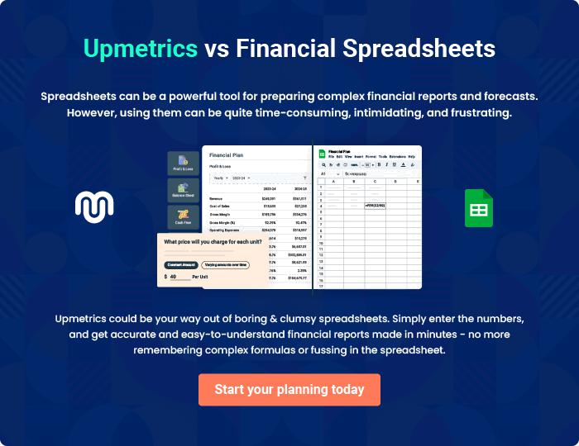
Appendix

When writing the appendix section, you should include any additional information that supports the main content of your plan. This may include financial statements, market research data, legal documents, and other
To unlock help try Upmetrics! 
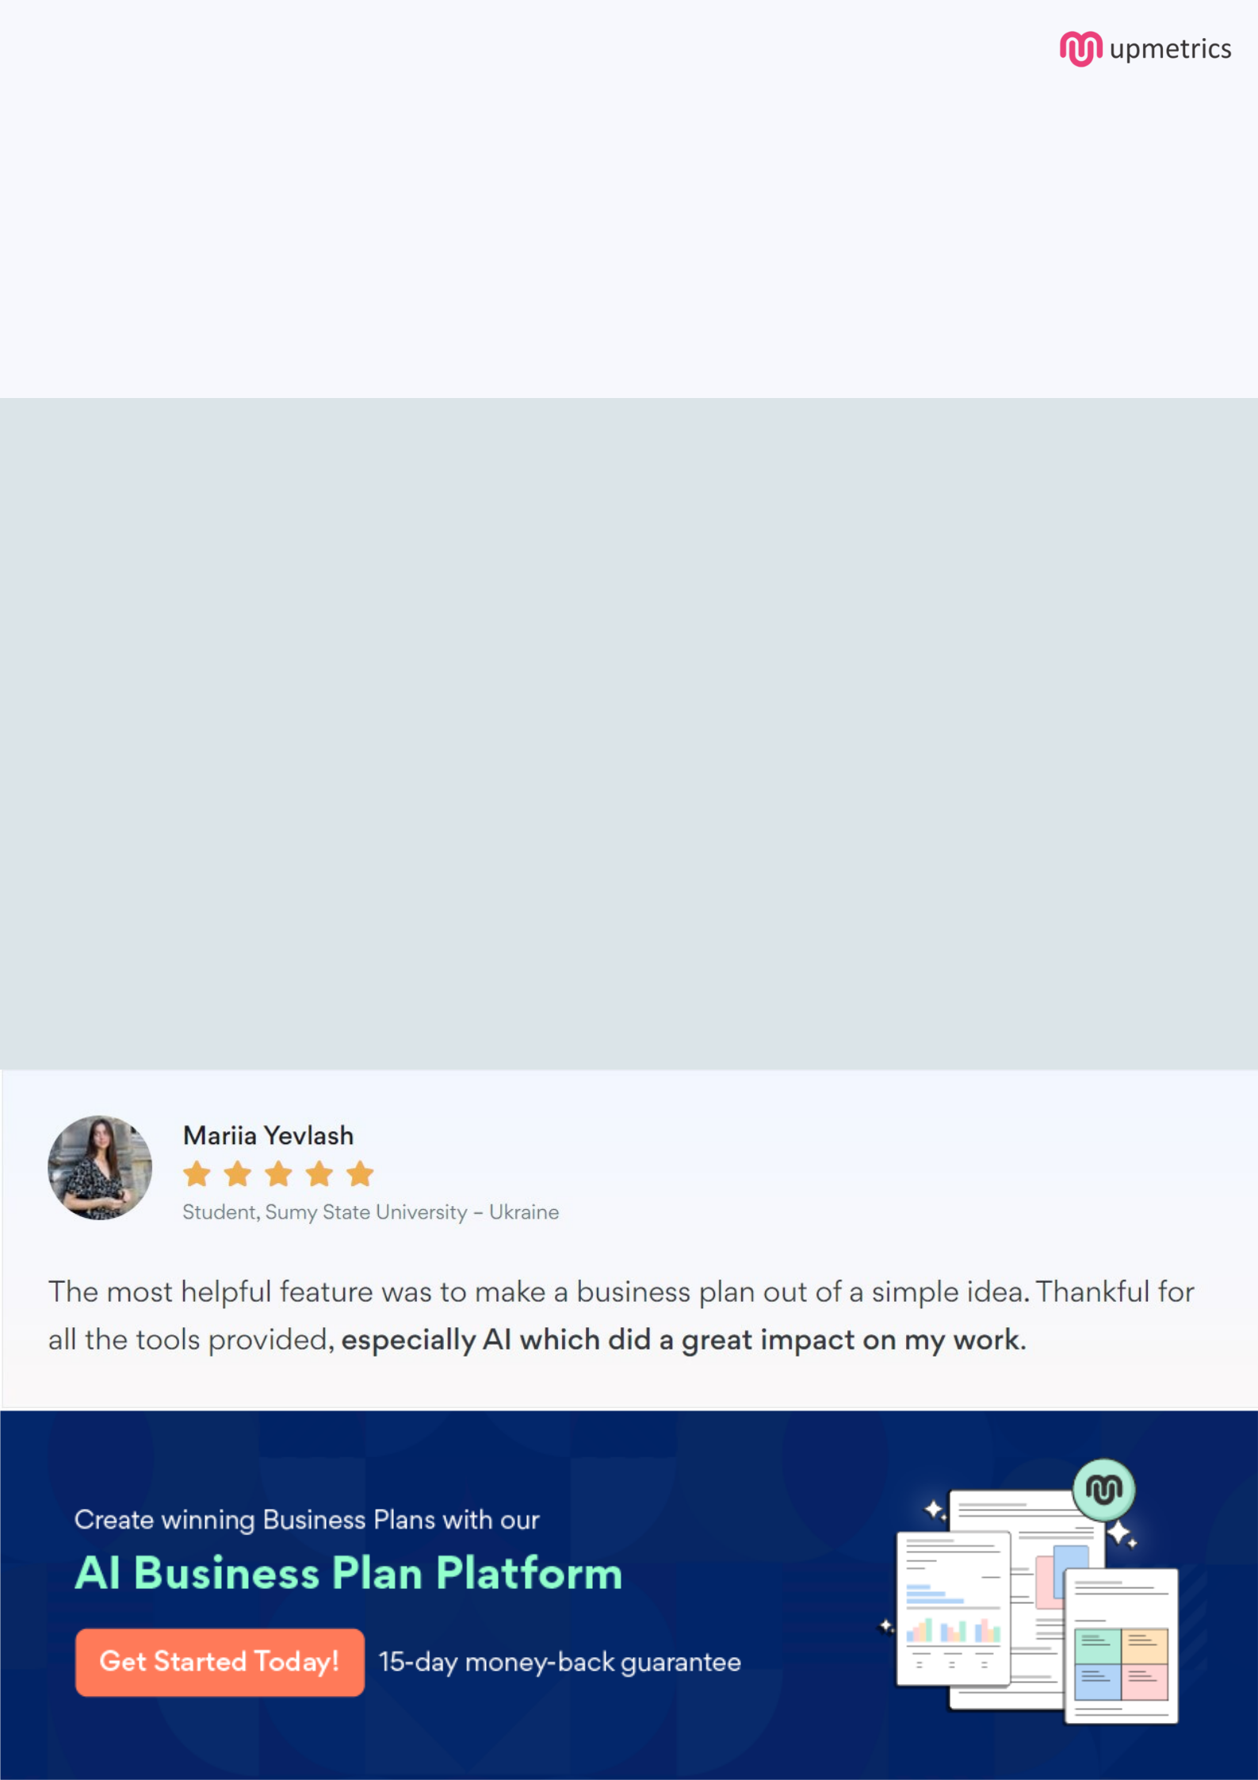
Create a winning business plan that gets you funded

Creating a stunning and investment-ready plan requires no writing, graphic designing, or financial planning expertise.

Upmetrics has all the features required to help you create a comprehensive business plan—from start to finish. Make no mistakes, it’s the modern way of planning to structure ideas, make plans, and create stunning pitch decks to awe investors.

Pitch decks that impress investors

Create pitch decks that provide a visual representation of your business, engage investors, and make them want to invest in your business idea.

Interactive plans in no time

Import business plan sections like—SWOT analysis, comparison tables, and others to create an interactive business plan. No designing skills are required.

Stunning cover page designs

With Upmetrics, you have the liberty to choose from multiple stunning cover page designs. Choose a creative design and make your plan stand out.

Online sharing made simple

Upmetrics makes online sharing quick and easier for users. Easily share your business plans with a link while tracking reader activity.

500+ sample business plans

Simply import a template from our library of sample plans into the editor and start customizing it to make it yours. It takes only a few clicks to get started.

Collaborate with team in real-time

Invite team members, initiate conversations, discuss ideas & strategies, share feedback, and work on a business plan in real-time.

