

Paralegal Business Plan

Legal Support, Trusted

Business Plan

2023

John Doe

10200 Bolsa Ave, Westminster, CA, 92683

- 359-3153 info@example.com https://www.example.com/

Information provided in this business plan is unique to this business and confidential; therefore, anyone reading this plan agrees not to disclose any of the information in this business plan without prior written permission of the company.
Table of Contents

Executive Summary | 6
Market opportunity | 6
Services Offered | 6
Marketing & Sales Strategies | 7
Financial Highlights | 7
Units Sold v/s Revenue | 8

Company Overview | 9
Ownership | 9
Mission statement | 10
Business history | 10
Future goals | 10

Market Analysis | 11
Target Market | 11
Market size and growth potential | 11
Market Size | 12
Competitive analysis | 12
LegalEase Solutions | 12
ParaPro Services | 13
LawLinc Paralegals | 13
Market trends | 13
Regulatory environment | 14

Products and Services | 15
Paralegal Services | 15
Document Preparation | 15
Litigation Support | 16
Legal Research | 16
Notary Services | 17
Legal Consultation and Assistance | 17
ADR (Alternative Dispute Resolution) | 18
Contract Review | 18
Case Management | 19
Quality Measures | 19
Additional Services | 19

Sales And Marketing Strategies | 20
Unique Selling Proposition (USP) | 20
Pricing Strategy | 20
Marketing strategies | 21
Online | 21
Offline | 21
Sales strategies | 22
Customer retention | 22

Operations Plan | 23
Staffing & Training | 23
Operational Process | 23
Technologies & Equipment | 24

Management Team | 25
Key managers | 25
John Doe | 25
Jane Doe | 26
Alice Brown | 26
Robert Brown | 26
Organizational structure | 27
Organization chart | 27
Compensation plan | 27
Advisors/Consultants | 28
[ADVISOR NAME] | 28
[CONSULTANT NAME] | 28
Financial Plan | 29
Profit & loss statement | 29
Cash flow statement | 32
Balance sheet | 34
Break-even Analysis | 36
Financing needs | 38
Appendix
Appendix | 40
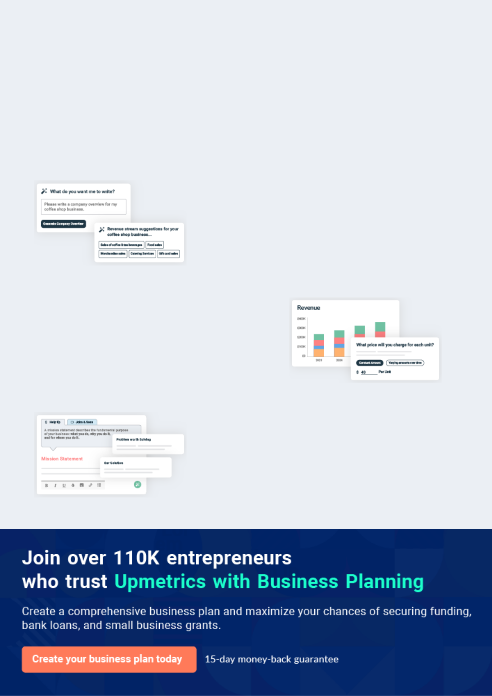
Business planning that’s simpler and faster than you think

Creating a business plan using Upmetrics to start and grow a business is literally the easiest thing in the World. Simply read the instructions and fill in the blanks. It’s as simple as that.

❛ | Upmetrics has everything you need to create a | ❜
❛ | comprehensive business plan. | ❜

AI-powered Upmetrics Assistant

AI-powered insights to streamline your plan

Not sure where to start? Upmetrics’ AI Assistant will automatically generate ideas for each section of your plan and offer improved versions of your writing, adjusting for tone, voice, and grammar or spelling errors.

Financial Forecasting Tool

All the financials are calculated for you

Forget the complex formulas and clumsy spreadsheets — with automatic financials and drag-and-drop forecasting, you can finish your plan faster and be confident that your numbers are accurate.

Business Plan Builder

Guides you like a business mentor

Upmetrics’ step-by-step instructions, prompts, and the library of 400+ sample business plans will guide you through each section of your plan as a business mentor.
Executive Summary


An executive summary is the first section of the business plan intended to provide an overview of the whole business plan.
To unlock help try Upmetrics! 

 Help tip  Paralegal Business Plan


Start your executive summary by briefly introducing your business to your readers.

This section may include the name of your paralegal business, its location, when it was
To unlock help try Upmetrics! 

Start writing here..

Market opportunity

 Help tip  Paralegal Business Plan

Summarize your market research, including market size, growth potential, and marketing trends. Highlight the opportunities in the market and how your business will fit in to fill the gap.
To unlock help try Upmetrics! 

Start writing here..

Services Offered

 Help tip  Paralegal Business Plan

Highlight the paralegal services you offer your clients. The USPs and differentiators you offer are always a plus.
To unlock help try Upmetrics! 

Start writing here..

Marketing & Sales Strategies
To unlock help try Upmetrics!

 Help tip  Paralegal Business Plan

Outline your sales and marketing strategies—what marketing platforms you use, how you plan on acquiring customers, etc.
To unlock help try Upmetrics! 

Start writing here..

Financial Highlights

 Help tip  Paralegal Business Plan

Briefly summarize your financial projections for the initial years of business operations. Include any capital or investment requirements, associated startup costs, projected revenues, and profit forecasts.



Start writing here..
Units Sold v/s Revenue

 |  | Units Sold | Revenue
15.00k
10.00k
5.00k
0
Year 1 | Year 2 | Year 3


Financial Year |  |  | Units Sold | Revenue
Year 1 | 1,550 |  |  | $10,000
Year 2 | 1,800 |  |  | $12,000
Year 3 | 2,050 |  |  | $14,000
 Help tip |  |  Paralegal Business Plan


Summarize your executive summary section with a clear CTA, for example, inviting angel investors to discuss the potential business investment.
To unlock help try Upmetrics! 

Write a call to action for your business plan.
Company Overview

Depending on what details of your business are essential, you’ll need different elements in your business overview.
To unlock help try Upmetrics! 

 Help tip  Paralegal Business Plan

Describe your business in this section by providing all the basic information:

Describe what kind of paralegal company you run and the name of it. You may specialize in one
To unlock help try Upmetrics! 

Start writing here..

Ownership

 Help tip  Paralegal Business Plan

List the names of your paralegal company’s founders or owners. Describe what shares they own and their responsibilities for efficiently managing the business.
To unlock help try Upmetrics! 

Start writing here..
Mission statement

 Help tip  Paralegal Business Plan

Summarize your business’ objective, core principles, and values in your mission statement. This statement needs to be memorable, clear, and brief.
To unlock help try Upmetrics! 

❛ At [LegalLinc Paralegal Solutions], we are dedicated to providing unparalleled paralegal services, upholding the principles of integrity, client-focused solutions, and legal excellence.

Our mission is to empower our clients with the support and expertise they require, fostering lasting professional relationships built on trust.

❜

Business history

 Help tip  Paralegal Business Plan

If you’re an established paralegal service provider, briefly describe your business history, like— when it was founded, how it evolved over time, etc.
To unlock help try Upmetrics! 

Start writing here..

Future goals

 Help tip  Paralegal Business Plan

It’s crucial to convey your aspirations and vision. Mention your short-term and long-term goals; they can be specific targets for revenue, market share, or expanding your services.
To unlock help try Upmetrics! 

Start writing here..

Market Analysis
To unlock help try Upmetrics!


 |  | Market analysis provides a clear understanding of the market in which your
 |  | printing business will run along with the target market, competitors, and
 |  | growth opportunities.
 |  |  |  | To unlock help try Upmetrics! 
 Help tip |  |  Paralegal Business Plan

To write the introduction section of your market analysis, start by clearly identifying your primary target market.
To unlock help try Upmetrics! 

Start writing here..

Target Market

 Help tip  Paralegal Business Plan

Start this section by describing your target market. Define your ideal customer and explain what types of services they prefer. Creating a buyer persona will help you easily define your target market to your readers.



Start writing here..

Market size and growth potential

 Help tip  Paralegal Business Plan

Describe your market size and growth potential and whether you will target a niche or a much broader market.
To unlock help try Upmetrics! 

Start writing here..

Market Size

Available Market

Total number of businesses requiring 3M paralegal services across the U.S.

Served Market
Companies actively seeking and using 1M paralegal services.

Target Market
Tech-centered businesses with specific 350k legal needs in [City/Region].

 Help tip  Paralegal Business Plan

Identify and analyze your direct and indirect competitors. Identify their strengths and weaknesses, and describe what differentiates your paralegal services from them.
To unlock help try Upmetrics! 

Competitive analysis

LegalEase Solutions

LegalEase Solutions has been in the paralegal arena for over a decade, serving a broad spectrum of clients ranging from startups to Fortune 500 companies. With a strong presence in [City/Region], they've made a mark with their digital-first approach.

Features

Comprehensive Document Review and Management

Litigation Support

Contract Drafting and Review

Legal Research and

Memorandums

Strengths

Extensive experience and a well-established brand reputation.

Robust digital platform facilitating seamless client interactions.

A broad array of services catering to diverse legal needs.

Weaknesses

Premium pricing might alienate smaller clients or startups.

Limited customization in service offerings.

Response times have occasionally been flagged in client reviews.

ParaPro Services

ParaPro Services, a relatively new entrant, has quickly gained traction with its focus on niche sectors like tech startups and e-commerce enterprises. Based in [City/Region], their agility and adaptability are noteworthy.

Features

IP Law Support

E-commerce Regulatory Compliance

Startup Legal Framework Assistance

Contract Automation

Strengths | Weaknesses
Tailored solutions catering | Limited experience compared to
specifically to tech and e- | more established competitors.
commerce sectors. | Narrow service range might deter
Rapid response times and | clients seeking comprehensive
client-centric service model | support.
Competitive pricing, especially | Relatively smaller team, which
appealing to startups. | might impact scalability.

LawLinc Paralegals

LawLinc Paralegals, with its rich legacy spanning two decades, is synonymous with reliability and expertise. They've catered to a diverse clientele, including major corporations and individual legal practitioners.

Features

Estate Planning Support

Corporate Compliance and Reporting

Mergers & Acquisitions Documentation

Legal Consultations

Strengths | Weaknesses
Deep industry knowledge | Slightly outdated digital
backed by years of experience. | platforms.
Extensive network of | Slower adaptation to recent
professionals and industry | industry trends and technologies.
experts. | Premium pricing, potentially
Offers consultative services in | sidelining cost-sensitive clients.
addition to standard paralegal
support.

Market trends

 Help tip  Paralegal Business Plan

Analyze emerging trends in the industry, such as technology disruptions, changes in customer behavior or preferences, etc. Explain how your business will cope with all the trends.
To unlock help try Upmetrics! 

Start writing here..

Regulatory environment
To unlock help try Upmetrics!

 Help tip  Paralegal Business Plan

List regulations and licensing requirements that may affect your paralegal company, such as business registration, FDCPA and INA compliance, insurance, environmental regulations, state and federal regulations, etc.



Start writing here..
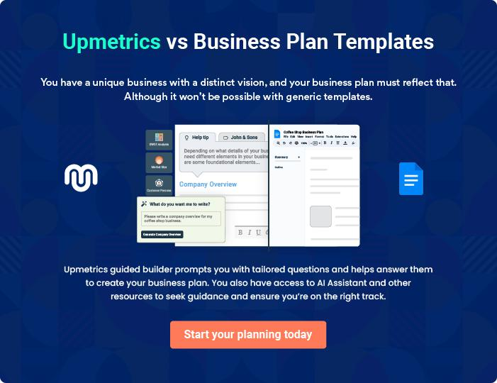
Products and Services
To unlock help try Upmetrics!

The product and services section of a paralegal business plan should describe the specific services and products that will be offered to customers. To write this section should include the following:



 Help tip  Paralegal Business Plan

To craft the introduction for your "Products and Services" chapter, begin by positioning your business within its industry, emphasizing its unique strengths or value proposition.
To unlock help try Upmetrics! 

Start writing here..

 Help tip


Mention the paralegal services your business will offer. This list may include services like,

• Document preparation
To unlock help try Upmetrics! 

Paralegal Services

Document Preparation


Price: $[100] per hour

Expert drafting, formatting, and review of various legal documents tailored to cater to individual client needs.

Specifications

- Legal document drafting

- Formatting as per the required legal standards

- Review for adherence to relevant statutes

- Suitable for contracts, wills, affidavits, etc.
Litigation Support

Price: $[120] per hour

Comprehensive support covering all facets of the trial process to ensure seamless litigation proceedings.

Specifications

- Trial preparation assistance

- Drafting and filing of legal pleadings

- Management and organization of case files

- Document management for quick access during proceedings

Legal Research

Price: $[90] per hour

In-depth legal research services using the latest tools to provide detailed insights into legal queries.

Specifications

- Access to top legal databases and journals

- Comprehensive research on statutes and case laws

- Compilation of relevant legal points and precedents

- Report generation detailing findings
Notary Services

Price: $[30] per document

Authenticating legal documents to ensure validity and provide official recognition.

Specifications

- Document verification

- Affixing of official seal or stamp

- Recording in the notary register

- Suitable for affidavits, contracts, property papers, etc.

Legal Consultation and Assistance

Price: $[150] per consultation session (1 hour)

Expert advice, insights, and hands-on assistance for navigating complex legal terrains.

Specifications

- One-on-one consultation sessions

- Strategy recommendations based on legal standing

- Advisory on potential legal actions

- Suitable for businesses and individuals seeking legal clarity
ADR (Alternative Dispute Resolution)

Price: Starting at $[500] per session

Facilitating resolutions outside of court for quicker, more cost-effective settlements.

Specifications

- Mediation sessions with a neutral third-party

- Arbitration proceedings

- Negotiation assistance

- Suitable for business disputes, property disputes, etc.

Contract Review

Price: $[80] per contract (up to 10 pages, additional charges for extra pages)

Detailed review of contracts to ensure alignment with client interests and legal norms.

Specifications

- Clause-by-clause review

- Recommendations for modifications

- Risk identification

- Suitable for business agreements, partnership deeds, etc.
Case Management

Price: $[70] per hour

Efficient handling of legal cases with the aid of modern tools to streamline processes.

Specifications

- Timeline tracking of cases

- Coordination of all case-related documentation

- Reminders and updates for upcoming hearings or deadlines

- Suitable for ongoing litigation cases or complex legal matters

Quality Measures

 Help tip  Paralegal Business Plan

This section should explain how you maintain quality standards and consistently provide the highest quality service.
To unlock help try Upmetrics! 

Start writing here..

Additional Services

 Help tip  Paralegal Business Plan

Mention if your paralegal company offers any additional services. You may include services like ADR( Alternative Dispute Resolution), contract review, case management, etc.
To unlock help try Upmetrics! 

Start writing here..

Sales And Marketing Strategies
To unlock help try Upmetrics!

Writing the sales and marketing strategies section means a list of strategies you will use to attract and retain your clients.
To unlock help try Upmetrics! 

 Help Tip  Paralegal Business Plan


To create an effective introduction for your "Sales and Marketing Strategies" chapter, start by setting the stage within your specific industry or market.
To unlock help try Upmetrics! 

Start writing here..

Unique Selling Proposition (USP)

 Help tip  Paralegal Business Plan

Define your business’s USPs depending on the market you serve, the equipment you use, and the unique services you provide. Identifying USPs will help you plan your marketing strategies.
To unlock help try Upmetrics! 

Start writing here..

Pricing Strategy

 Help tip  Paralegal Business Plan

Describe your pricing strategy—how you plan to price your paralegal services and stay competitive in the local market. You can mention limited-time discount offers you plan on offering to attract new customers to your paralegal service.



Start writing here..

 Help tip  Paralegal Business Plan
To unlock help try Upmetrics!

Discuss your marketing strategies to market your services. You may include some of these marketing strategies in your business plan—social media marketing, Google ads, brochures, email marketing, content marketing, and print marketing.



Marketing strategies

Online


Social Media

Regular updates, legal tips, and customer testimonials on platforms like [Facebook, LinkedIn, and Twitter].

Content Marketing

Blog posts and articles addressing common legal concerns and showcasing our expertise.

Email Marketing

Monthly newsletters, updates, and special offers directly to the inboxes of our subscribers.

Google Ads

Targeted advertisements to reach potential clients actively searching for paralegal services.

Offline

Brochures Print Marketing

High-quality printed materials Collaborations with [local

distributed in [strategic locations newspapers/magazines] for

such as law firms, courts, and featured articles and

corporate offices]. advertisements.

 Help tip
To unlock help try Upmetrics!

Outline the strategies you’ll implement to maximize your sales. Your sales strategies may include direct sales calls, partnering with attorneys, accounting firms, and insurance agencies, offering referral programs, etc.



Sales strategies

Partner with Businesses

Building alliances with attorneys, accounting firms, and insurance agencies to widen our referral network.

Direct Sales Calls

Engaging potential clients through direct outreach, understanding their needs, and offering tailored solutions.

Referral Programs

Incentivizing our existing clients to

introduce our services to their

acquaintances.

 Help tip

Describe your customer retention strategies and how you plan to execute them. For instance, introducing loyalty programs, discounts on packages, upselling services on special offers, etc.
To unlock help try Upmetrics! 

Customer retention

Loyalty Programs

Offering rewards and discounts to regular clients.

Package Discounts

Reduced prices for clients availing multiple services.

Upselling

Introducing existing clients to new

or complementary services at

special rates.

Operations Plan
To unlock help try Upmetrics!

 |  | When writing the operations plan section, it’s important to consider the
 |  | various aspects of your business operations.
 |  |  |  | To unlock help try Upmetrics! 
 Help tip |  |  Paralegal Business Plan


To create an effective introduction for your "Operational Plan" chapter, start by emphasizing the
pivotal role of efficient operations in the success of your business, underscoring how they
directly impact the quality of services delivered.
 |  |  |  | To unlock help try Upmetrics! 
Start writing here..
Staffing & Training
 Help tip |  |  Paralegal Business Plan

Mention your paralegal business’s staffing requirements, including the number of paralegals,
legal assistants, and office and administrative staff. Include their qualifications, the training
required, and the duties they will perform.
 |  |  |  | To unlock help try Upmetrics! 
Start writing here..
Operational Process
 Help tip |  |  Paralegal Business Plan

Outline the processes and procedures you will use to run your paralegal business. Your operational processes may include initial consultation, training and education, getting feedback, planning strategies, and delivering paralegal services.



Start writing here..

Technologies & Equipment

 Help tip  Paralegal Business Plan

Include the list of technologies and equipment, such as computers, research tools, case management software, security systems, etc.
To unlock help try Upmetrics! 

Start writing here..
Management Team

The management team section provides an overview of the individuals responsible for running your business plan.
To unlock help try Upmetrics! 

 Help tip  Paralegal Business Plan

To craft an introduction for your "Management Team" chapter, begin by emphasizing the crucial role of leadership in the success of any business.
To unlock help try Upmetrics! 

Start writing here..

Key managers

 Help tip  Paralegal Business Plan

Introduce your management and key members of your team, and explain their roles and responsibilities.
To unlock help try Upmetrics! 

Start writing here..


JOHN DOE

CEO & Co-founder - john.doe@example.com

Educational Background:

• Bachelor's Degree in Law, [Prominent University]


• Master's in Business Administration, [Prestigious B-School]

Professional Background:

- John boasts over 15 years in the legal industry.

- Starting as a paralegal assistant at [Top Law Firm], he ascended the ranks swiftly, moving to a management role at [Another Leading Firm] before embarking on the venture of [LegalLinc Paralegal Solutions].

JANE DOE

Chief Operating Officer (COO) - jane.doe@example.com

Educational Background:

- Bachelor's Degree in Legal Studies, [Well-known University]

- Professional Certification in Operations Management Professional Background:

- Jane brings a decade of operations management experience to [LegalLinc Paralegal Solutions].

- Having overseen operations at [Major Paralegal Company] and later serving as the Director of Operations at [Another Prestigious Company].



ALICE BROWN

CMO - alice.brown@example.com

Educational Background:

- Bachelor's in Communication, [Reputed University]

- Master's in Marketing, [Top-tier B-school] Professional Background:

- Alice's strategic vision is shaped by her years of experience marketing legal services.

- She previously led marketing campaigns for [Big Legal Services Provider] and transformed the online presence of [Another Paralegal Firm].


ROBERT BROWN

Operations Manager - robert.brown@example.com

Educational Background:

- Bachelor's Degree in Business Administration, [Prominent University]

- Certification in Project Management

Professional Background:

- Robert excels in optimizing operational workflows, thanks to his tenure at top-tier paralegal firms like [Major Legal Company] and [Prominent Paralegal Group].

- His expertise ensures a seamless client experience from start to finis
Organizational structure

 Help tip  Paralegal Business Plan

Explain the organizational structure of your management team. Include the reporting line and decision-making hierarchy.
To unlock help try Upmetrics! 

Start writing here..

Organization chart


John Doe

CEO


Alice Brown Jane Doe

CMO COO


Sarah Brown Emily Fox


HR Manager Robert Brown Marketing Manager

Operations Manager

Compensation plan

 Help tip  Paralegal Business Plan

Describe your compensation plan for the management and staff. Include their salaries, incentives, and other benefits.
To unlock help try Upmetrics! 

Start writing here..

 Help tip

Mentioning advisors or consultants in your business plans adds credibility to your business idea.
To unlock help try Upmetrics! 

Advisors/Consultants


[ADVISOR NAME]

Advisor

A seasoned legal expert with a specialization in [specific field e.g., "corporate law"], [Advisor's Name] provides invaluable insights, helping us navigate complex legal terrains.


[CONSULTANT NAME]

Consultant

With a deep understanding of [specific area e.g., "legal tech trends"], [Consultant's Name]'s advisory role strengthens our tech-forward approach.
Financial Plan

When writing the financial plan section of a business plan, it’s important to provide a comprehensive overview of your financial projections for the first few years of your business, You may provide the following:
To unlock help try Upmetrics! 

 Help tip  Paralegal Business Plan


To create an effective introduction for your "Financial Plan" chapter, begin by stressing the critical role of a well-structured financial plan in the success of your venture.
To unlock help try Upmetrics! 

Start writing here..

 Help tip  Paralegal Business Plan

Describe details such as projected revenue, operational costs, and service costs in your projected profit and loss statement. Make sure to include your business’s expected net profit or loss.
To unlock help try Upmetrics! 

Profit & loss statement

Revenue

Cost Of Sales

General Costs

Revenue Specific Costs

Personnel Costs (Direct

Labor)

Gross Margin

Gross Margin (%)

Operating Expense

Payroll Expense

(Indirect Labor)

General Expense

Bad Debt

Amortization of Current

Assets

2023-24 | 2024-25 | 2025-26 | 2026-27 | 2027-28
$0 | $0 | $0 | $0 | $0

$0 | $0 | $0 | $0 | $0
$0 | $0 | $0 | $0 | $0
$0 | $0 | $0 | $0 | $0
$0 | $0 | $0 | $0 | $0

$0 | $0 | $0 | $0 | $0
0% | 0% | 0% | 0% | 0%

$0 | $0 | $0 | $0 | $0
$0 | $0 | $0 | $0 | $0
$0 | $0 | $0 | $0 | $0
$0 | $0 | $0 | $0 | $0
$0 | $0 | $0 | $0 | $0

EBITDA

Additional Expense

Long Term

Depreciation

Gain or loss from Sale

of Assets

EBIT

Interest Expenses

EBT

Income Tax Expense

Total Expense

Net Income

Net Income (%)

2023-24 | 2024-25 | 2025-26 | 2026-27 | 2027-28
$0 | $0 | $0 | $0 | $0
$0 | $0 | $0 | $0 | $0
$0 | $0 | $0 | $0 | $0
$0 | $0 | $0 | $0 | $0
$0 | $0 | $0 | $0 | $0
$0 | $0 | $0 | $0 | $0
$0 | $0 | $0 | $0 | $0
$0 | $0 | $0 | $0 | $0
$0 | $0 | $0 | $0 | $0
$0 | $0 | $0 | $0 | $0
0% | 0% | 0% | 0% | 0%
 |  |  | 2023-24 |  | 2024-25 | 2025-26 | 2026-27 | 2027-28
Retained Earning |  |  | $0 |  | $0 | $0 | $0 | $0
Opening
Owner's Distribution |  |  | $0 |  | $0 | $0 | $0 | $0
Retained Earning |  |  | $0 |  | $0 | $0 | $0 | $0
Closing
 Help tip |  |  |  Paralegal Business Plan


The cash flow for the first few years of your operation should be estimated and described in this section. This may include billing invoices, payment receipts, loan payments, and any other cash flow statements.
To unlock help try Upmetrics! 

Cash flow statement

 | 2023-24 | 2024-25 | 2025-26 | 2026-27 | 2027-28
Cash Received | $0 | $0 | $0 | $0 | $0
Cash Paid | $0 | $0 | $0 | $0 | $0
COS & General Expenses | $0 | $0 | $0 | $0 | $0
Salary & Wages | $0 | $0 | $0 | $0 | $0
Interest | $0 | $0 | $0 | $0 | $0

Sales Tax

Income Tax

Net Cash From

Operations

Assets Sell

Assets Purchase

Net Cash From

Investments

Amount Received

Loan Received

Common Stock

Preferred Stock

Owner's Contribution

Amount Paid

2023-24 | 2024-25 | 2025-26 | 2026-27 | 2027-28
$0 | $0 | $0 | $0 | $0
$0 | $0 | $0 | $0 | $0
$0 | $0 | $0 | $0 | $0

$0 | $0 | $0 | $0 | $0
$0 | $0 | $0 | $0 | $0
$0 | $0 | $0 | $0 | $0

$0 | $0 | $0 | $0 | $0
$0 | $0 | $0 | $0 | $0

$0 | $0 | $0 | $0 | $0
$0 | $0 | $0 | $0 | $0
$0 | $0 | $0 | $0 | $0

Loan Capital $0 $0 $0 $0 $0

 |  |  | 2023-24 | 2024-25 | 2025-26 | 2026-27 | 2027-28
Dividends & Distributions |  |  | $0 | $0 | $0 | $0 | $0
Net Cash From |  |  | $0 | $0 | $0 | $0 | $0
Financing
Summary
Starting Cash |  |  | $0 | $0 | $0 | $0 | $0
Cash In |  |  | $0 | $0 | $0 | $0 | $0
Cash Out |  |  | $0 | $0 | $0 | $0 | $0
Change in Cash |  |  | $0 | $0 | $0 | $0 | $0
Ending Cash |  |  | $0 | $0 | $0 | $0 | $0
 Help tip |  |  Example title..


Create a projected balance sheet documenting your paralegal business’s assets, liabilities, and equity.

To unlock help try Upmetrics! 

Balance sheet

 | 2023-24 | 2024-25 | 2025-26 | 2026-27 | 2027-28
Assets | $0 | $0 | $0 | $0 | $0
Current Assets | $0 | $0 | $0 | $0 | $0
Cash | $0 | $0 | $0 | $0 | $0
Accounts Receivable | $0 | $0 | $0 | $0 | $0
Inventory | $0 | $0 | $0 | $0 | $0
Other Current Assets | $0 | $0 | $0 | $0 | $0
Long Term Assets | $0 | $0 | $0 | $0 | $0
Gross Long Term Assets | $0 | $0 | $0 | $0 | $0
Accumulated Depreciation | $0 | $0 | $0 | $0 | $0

Liabilities & Equity | $0 | $0 | $0 | $0 | $0
Liabilities | $0 | $0 | $0 | $0 | $0
Current Liabilities | $0 | $0 | $0 | $0 | $0
Accounts Payable | $0 | $0 | $0 | $0 | $0
Income Tax Payable | $0 | $0 | $0 | $0 | $0
Sales Tax Payable | $0 | $0 | $0 | $0 | $0
Short Term Debt | $0 | $0 | $0 | $0 | $0
 | 2023-24 | 2024-25 | 2025-26 | 2026-27 | 2027-28
Long Term Liabilities | $0 | $0 | $0 | $0 | $0
Long Term Debt | $0 | $0 | $0 | $0 | $0
Equity | $0 | $0 | $0 | $0 | $0
Paid-in Capital | $0 | $0 | $0 | $0 | $0
Common Stock | $0 | $0 | $0 | $0 | $0
Preferred Stock | $0 | $0 | $0 | $0 | $0
Owner's Contribution | $0 | $0 | $0 | $0 | $0
Retained Earnings | $0 | $0 | $0 | $0 | $0

Check | $0 |  |  | $0 | $0 | $0 | $0
 Help Tip |  |  Paralegal Business Plan


Determine and mention your business’s break-even point—the point at which your business costs and revenue will be equal.

This exercise will help you understand how much revenue you need to generate to sustain or be profitable.
To unlock help try Upmetrics! 

Break-even Analysis

 | 2023-24 | 2024-25 | 2025-26 | 2026-27 | 2027-28
Starting Revenue | $0 | $0 | $0 | $0 | $0
Net Revenue | $0 | $0 | $0 | $0 | $0
Closing Revenue | $0 | $0 | $0 | $0 | $0

Starting Expense | $0 | $0 | $0 | $0 | $0
Net Expense | $0 | $0 | $0 | $0 | $0
Closing Expense | $0 | $0 | $0 | $0 | $0

Is Break Even? | 0 | 0 | 0 | 0 | 0
Break Even Month | 0 | 0 | 0 | 0 | 0
Days Required | 0 | 0 | 0 | 0 | 0
Break Even Revenue | $0 | $0 | $0 | $0 | $0
Break Even Units
Financing needs

 Help tip  Paralegal Business Plan

Calculate costs associated with starting a paralegal business, and estimate your financing needs and how much capital you need to raise to operate your business.
To unlock help try Upmetrics! 

Start writing here..
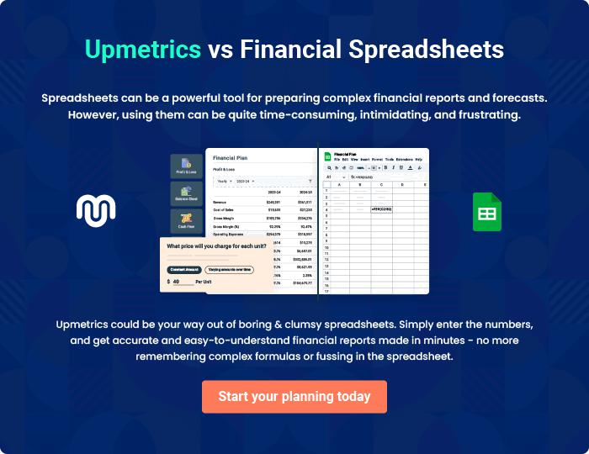
Appendix

When writing the appendix section, you should include any additional information that supports the main content of your plan. This may include financial statements, market research data, legal documents, and other
To unlock help try Upmetrics! 

Create a winning business plan that gets you funded

Creating a stunning and investment-ready plan requires no writing, graphic designing, or financial planning expertise.

Upmetrics has all the features required to help you create a comprehensive business plan—from start to finish. Make no mistakes, it’s the modern way of planning to structure ideas, make plans, and create stunning pitch decks to awe investors.

Pitch decks that impress investors

Create pitch decks that provide a visual representation of your business, engage investors, and make them want to invest in your business idea.

Interactive plans in no time

Import business plan sections like—SWOT analysis, comparison tables, and others to create an interactive business plan. No designing skills are required.

Stunning cover page designs

With Upmetrics, you have the liberty to choose from multiple stunning cover page designs. Choose a creative design and make your plan stand out.

Online sharing made simple

Upmetrics makes online sharing quick and easier for users. Easily share your business plans with a link while tracking reader activity.

500+ sample business plans

Simply import a template from our library of sample plans into the editor and start customizing it to make it yours. It takes only a few clicks to get started.

Collaborate with team in real-time

Invite team members, initiate conversations, discuss ideas & strategies, share feedback, and work on a business plan in real-time.

