
BUSINESS PLAN

2023


Painting Business Plan

Brushing Dreams, Painting Reality

John Doe

10200 Bolsa Ave, Westminster, CA, 92683

- 359-3153 info@example.com http://www.example.com

Information provided in this business plan is unique to this business and confidential; therefore, anyone reading this plan agrees not to disclose any of the information in this business plan without prior written permission of the company.
Table of Contents

Executive Summary | 6
Market opportunity | 6
Services Offered | 6
Marketing & Sales Strategies | 7
Financial Highlights | 7
Units Sold v/s Revenue | 8

Company Overview | 9
Ownership | 9
Mission statement | 10
Business history | 10
Future goals | 10

Market Analysis | 11
Target Market | 11
Market size and growth potential | 11
Market Size | 12
Competitive analysis | 12
[Competitor Name 1] | 12
[Competitor Name 2] | 13
Market trends | 13
Regulatory environment | 13

Products and Services | 15
Services | 15
Interior Painting | 15
Exterior Painting | 16
Commercial Painting | 16
Deck and Fence Painting | 17
Specialty Coating | 17
Paint/Coating Removal | 18
Quality Assurance | 18
Additional Services | 18

Sales And Marketing Strategies | 19
Unique Selling Proposition (USP) | 19
Pricing Strategy | 19
Marketing strategies | 20
Online | 20
Offline | 20
Sales strategies | 21
Customer retention | 21

Operations Plan | 22
Staffing & Training | 22
Operational Process | 22
Equipment & Machinery | 23

Management Team | 24
Key managers | 24
John Doe | 24
Jane Doe | 25
Alice Brown | 25
Robert Brown | 25
Organizational structure | 25
Organization chart | 26
Compensation plan | 26
Advisors/Consultants | 27
[ADVISOR NAME] | 27
[CONSULTANT NAME] | 27

Financial Plan | 28
Profit & loss statement | 28
Cash flow statement | 31
Balance sheet | 33
Break-even Analysis | 35
Financing needs | 37
Appendix
Appendix | 39
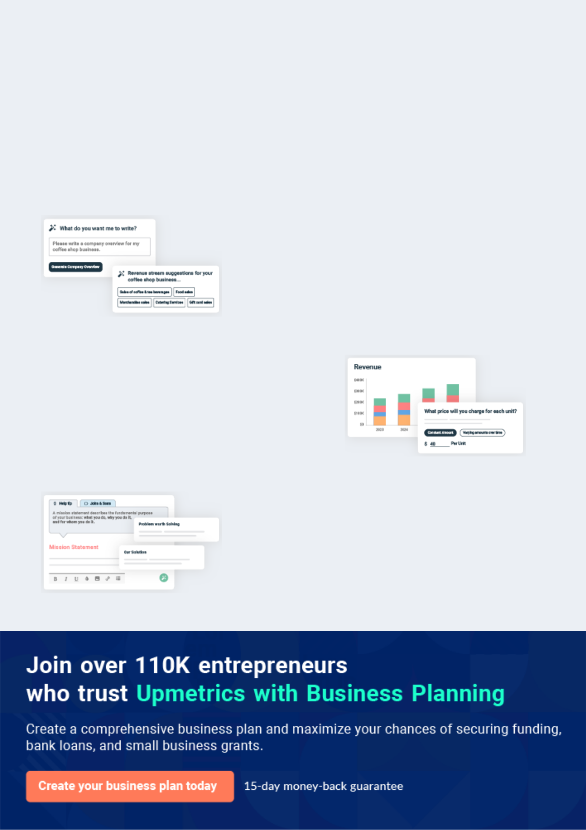
Business planning that’s simpler and faster than you think

Creating a business plan using Upmetrics to start and grow a business is literally the easiest thing in the World. Simply read the instructions and fill in the blanks. It’s as simple as that.

❛ | Upmetrics has everything you need to create a | ❜
❛ | comprehensive business plan. | ❜

AI-powered Upmetrics Assistant

AI-powered insights to streamline your plan

Not sure where to start? Upmetrics’ AI Assistant will automatically generate ideas for each section of your plan and offer improved versions of your writing, adjusting for tone, voice, and grammar or spelling errors.

Financial Forecasting Tool

All the financials are calculated for you

Forget the complex formulas and clumsy spreadsheets — with automatic financials and drag-and-drop forecasting, you can finish your plan faster and be confident that your numbers are accurate.

Business Plan Builder

Guides you like a business mentor

Upmetrics’ step-by-step instructions, prompts, and the library of 400+ sample business plans will guide you through each section of your plan as a business mentor.
Executive Summary


An executive summary is the first section of the business plan intended to provide an overview of the whole business plan.
To unlock help try Upmetrics! 

 Help tip  Painting Business Plan


Start your executive summary section by briefly introducing your business to the readers.

This section may include the name of your painting business, its location, when it was founded,
To unlock help try Upmetrics! 

Start writing here..

Market opportunity

 Help tip  Painting Business Plan

Summarize your market research, including market size, growth potential, and marketing trends. Highlight the opportunities in the market and how your business will fit in to fill the gap.
To unlock help try Upmetrics! 

Start writing here..

Services Offered

 Help tip  Painting Business Plan

Highlight the painting services you offer your clients. The USPs and differentiators you offer are always a plus.
To unlock help try Upmetrics! 

Start writing here..

Marketing & Sales Strategies
To unlock help try Upmetrics!

 Help tip  Painting Business Plan

Outline your sales and marketing strategies—what marketing platforms you use, how you plan on acquiring customers, etc.
To unlock help try Upmetrics! 

Start writing here..

Financial Highlights

 Help tip  Painting Business Plan

Briefly summarize your financial projections for the initial years of business operations. Include any capital or investment requirements, associated startup costs, projected revenues, and profit forecasts.



Start writing here..
Units Sold v/s Revenue

 |  | Units Sold | Revenue
15.00k
10.00k
5.00k
0
Year 1 | Year 2 | Year 3


Financial Year |  |  | Units Sold | Revenue
Year 1 | 1,550 |  |  | $10,000
Year 2 | 1,800 |  |  | $12,000
Year 3 | 2,050 |  |  | $14,000
 Help tip |  |  Painting Business Plan


Summarize your executive summary section with a clear CTA, for example, inviting angel investors to discuss the potential business investment.
To unlock help try Upmetrics! 

Write a call to action for your business plan.
Company Overview

Depending on what details of your business are essential, you’ll need different elements in your business overview.
To unlock help try Upmetrics! 

 Help tip  Painting Business Plan

Describe your business in this section by providing all the basic information

Describe what kind of painting business you operate and the name of it. You may specialize in
To unlock help try Upmetrics! 

Start writing here..

Ownership

 Help tip  Painting Business Plan

List founders or owners of your painting company. Describe what shares they own and their responsibilities for efficiently managing the business.
To unlock help try Upmetrics! 

Start writing here..
Mission statement

 Help tip  Painting Business Plan

Summarize your business’ objective, core principles, and values in your mission statement. This statement needs to be memorable, clear, and brief.
To unlock help try Upmetrics! 

❛ At [Vivid Visions Painting Solutions], we are committed to transforming spaces through the art of painting. Our dedication to quality, sustainability, and client satisfaction is unwavering.

Every brushstroke we make resonates with our core principles of integrity, innovation, and excellence.

❜

Business history

 Help tip  Painting Business Plan

If you’re an established painting service provider, briefly describe your business history, like— when it was founded, how it evolved over time, etc.
To unlock help try Upmetrics! 

Start writing here..

Future goals

 Help tip  Painting Business Plan

It’s crucial to convey your aspirations and vision. Mention your short-term and long-term goals; they can be specific targets for revenue, market share, or expanding your services.
To unlock help try Upmetrics! 

Start writing here..

Market Analysis
To unlock help try Upmetrics!


 |  | Market analysis provides a clear understanding of the market in which your
 |  | printing business will run along with the target market, competitors, and
 |  | growth opportunities.
 |  |  |  | To unlock help try Upmetrics! 
 Help tip |  |  Painting Business Plan

To write the introduction section of your market analysis, start by clearly identifying your primary target market.
To unlock help try Upmetrics! 

Start writing here..

Target Market

 Help tip  Painting Business Plan

Start this section by describing your target market. Define your ideal customer and explain what types of services they prefer. Creating a buyer persona will help you easily define your target market to your readers.



Start writing here..

Market size and growth potential

 Help tip  Painting Business Plan

Describe your market size and growth potential and whether you will target a niche or a much broader market.
To unlock help try Upmetrics! 

Start writing here..

Market Size

Available Market | 1M
All property owners in the Greater XYZ | 1M
area.
Served Market | 500k
Property owners actively seeking | 500k
painting services yearly | 500k
Target Market | 100k
High-end residential homeowners in | 100k
upscale | 100k


 Help tip  Painting Business Plan

Identify and analyze your direct and indirect competitors. Identify their strengths and weaknesses, and describe what differentiates your painting services from them.
To unlock help try Upmetrics! 

Competitive analysis

[Competitor Name 1]

Established in [Year], [Competitor Name 1] has become a well-recognized name in [specific region, e.g., "the Greater XYZ area"], predominantly catering to [specific market segment, e.g., "high-end residential properties"].

Features | Strengths
Comprehensive interior and | Strong brand recognition in the
exterior painting | luxury segment.
Specialty finishes with unique | Expertise in specialty finishes,
textures | attracting a niche clientele.
Environmentally-friendly | Sustainable approach with eco-
painting solutions | friendly paints appeals to
Maintenance contracts with | environmentally-conscious
Maintenance contracts with | customers.
periodic touch-ups | customers.

Weaknesses

Premium pricing may alienate budget-conscious customers.

Limited to the high-end residential market, potentially missing out on broader market segments.

Longer lead times due to specialization, leading to potential project delays.

[Competitor Name 2]
To unlock help try Upmetrics!

[Competitor Name 2], founded in [Year], has prided itself on speed and efficiency, making them a favorite among [specific segment, e.g., "commercial property owners"].

Features | Strengths
Quick-dry paint solutions for | Quick project completion times
swift project turnovers. | appeal to businesses with tight
Large team facilitating multiple | deadlines.
simultaneous projects. | Scalable operations suitable
Digital color-matching | for large commercial projects.
technology ensuring accuracy | Technology-driven approach
and consistency. | ensuring modernized solutions.

Weaknesses

Potential compromise on quality due to rapid service focus.

Potential compromise on quality due to rapid service focus. Less emphasis on personalized or customized solutions.

Some feedback on inconsistent customer service experiences.

Market trends

 Help tip  Painting Business Plan

Analyze emerging trends in the industry, such as technology disruptions, changes in customer behavior or preferences, etc. Explain how your business will cope with all the trends.
To unlock help try Upmetrics! 

Start writing here..

Regulatory environment

 Help tip  Painting Business Plan

List regulations and licensing requirements that may affect your painting company, such as business registration, insurance, environmental regulations, occupational safety, health regulations, etc.



Start writing here..

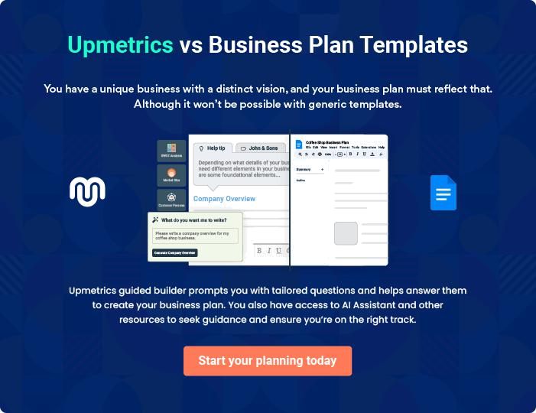
Products and Services

 |  | The product and services section of a painting business plan should describe
 |  | the specific services and products that will be offered to customers. To write
 |  | this section should include the following:
 |  |  |  | To unlock help try Upmetrics! 
 Help tip |  |  Painting Business Plan

To craft the introduction for your "Products and Services" chapter, begin by positioning your business within its industry, emphasizing its unique strengths or value proposition.
To unlock help try Upmetrics! 

Start writing here..

 Help tip


Mention the painting services your business will offer. This list may include services like,

• Interior painting
To unlock help try Upmetrics! 

Services

Interior Painting


Price: $[XX] per square foot or $[XXX] per room (varies based on room size and complexity).

Refresh and beautify your indoor spaces with our premium interior painting service. From living rooms to offices, we ensure a vibrant and long-lasting finish.

Specifications

- Paint Type: [e.g., "Water-based, Low VOC, EcoPaints"]

- Finish Options: Matte, Semi-Gloss, High Gloss.

- Surface Preparation: Cleaning, sanding, and priming.

- Drying Time: Approx. [XX hours].
Exterior Painting

Price: $[XX] per square foot or $[XXX] for a standard home exterior.

Protect and elevate your property's appearance with our exceptional exterior painting services, tailored to withstand varying climatic conditions.

Specifications

- Paint Type: [e.g., "Weather-resistant, Anti-fungal"]

- Surface Preparation: Power washing, crack filling, and priming.

- Application Method: [e.g., "Spray, brush, or roller"]

- Drying Time: Approx. [XX hours].

Commercial Painting

Price: Starts at $[XXX] for small commercial spaces; custom quotes for larger venues.

Tailored painting solutions for businesses, offering minimal disruptions and swift project completion to ensure your operations continue smoothly.

Specifications

- Paint Type: [e.g., "Quick-drying, Odorless"]

- Special Finishes: [e.g., "Anti-graffiti, Magnetic"]

- Service Hours: Flexible timings, including off-hours and weekends.

- Safety Compliance: Adherence to commercial safety standards
Deck and Fence Painting

Price: $[XX] per square foot or $[XXX] per deck/fence.

Enhance the lifespan and appearance of your outdoor wooden structures with our specialized painting and staining services.

Specifications

- Paint/Stain Type: [e.g., "UV-resistant, Water-repellent"]

- Application Method: [e.g., "Spray, brush, or roller"]

- Maintenance: Periodic touch-ups are recommended every [XX years].

Specialty Coating

Price: Starts at $[XXX] for a standard room or surface.

Create standout spaces with our range of unique finishes, designed to make an impression and showcase your individuality.

Specifications

- Finish Options: [e.g., "Metallic, Suede, Textured"]

- Durability: Resistant to chips, scratches, and fading.

- Application Process: Multi-layered for depth and visual appeal.
Paint/Coating Removal

Price: $[XX] per square foot or $[XXX] per room/space.

Prepare your surfaces for a fresh coat with our efficient paint removal service, ensuring a clean slate and optimal paint adherence.

Specifications

- Removal Method: [e.g., "Chemical-free sandblasting, Eco-friendly solvents"]

- Surface Preparation: Post-removal cleaning and priming.

- Safety Measures: Protective gear and ventilation ensured.

Quality Assurance

 Help tip  Painting Business Plan

This section should explain how you maintain quality standards and consistently provide the highest quality service.
To unlock help try Upmetrics! 

Start writing here..

Additional Services

 Help tip  Painting Business Plan

Mention if your painting company offers any additional services. You may include services like color consultation and custom finishes.
To unlock help try Upmetrics! 

Start writing here..

Sales And Marketing Strategies
To unlock help try Upmetrics!

Writing the sales and marketing strategies section means a list of strategies you will use to attract and retain your clients.
To unlock help try Upmetrics! 

 Help Tip  Painting Business Plan


To create an effective introduction for your "Sales and Marketing Strategies" chapter, start by setting the stage within your specific industry or market.
To unlock help try Upmetrics! 

Start writing here..

Unique Selling Proposition (USP)

 Help tip  Painting Business Plan

Define your business’s USPs depending on the market you serve, the equipment you use, and the unique services you provide. Identifying USPs will help you plan your marketing strategies.
To unlock help try Upmetrics! 

Start writing here..

Pricing Strategy

 Help tip  Painting Business Plan

Describe your pricing strategy—how you plan to price your painting services and stay competitive in the local market. You can mention any discounts you plan on offering to attract new customers to your painting service.



Start writing here..

 Help tip  Painting Business Plan
To unlock help try Upmetrics!

Discuss your marketing strategies to market your services. You may include some of these marketing strategies in your business plan—local SEO, social media marketing, Google ads, brochures, email marketing, content marketing, and print marketing.



Marketing strategies

Online


Social Media

Engaging content on platforms like [Facebook, Instagram, and LinkedIn] to showcase our projects and connect with a broader audience.

Content Marketing

Establishing authority by publishing articles and blogs related to painting trends, DIY tips, and more.

Email Marketing

Periodic newsletters and updates to our subscriber base, offering them insights, tips, and exclusive offers.

Local SEO

By optimizing our website and listings, we aim to rank prominently in local searches, driving organic traffic and local clientele.

Google Ads

Strategic PPC campaigns targeting

high-intent keywords to drive leads.

Offline

Print Marketing

Local advertisements in newspapers, magazines, and community boards to ensure offline visibility.

 Help tip  Painting Business Plan
To unlock help try Upmetrics!
To unlock help try Upmetrics!

Outline the strategies you’ll implement to maximize your sales. Your sales strategies may include direct sales calls, partnering with renovation companies, taking part in local events, networking with similar businesses, etc.



Sales strategies

Partner with Businesses

Collaborating with local renovation companies to provide combined service packages.

Local Events

Participating in local fairs, homeowners’ events, and expos to showcase our expertise.

Networking Direct Sales Calls

Engaging with businesses in complementary industries, creating mutual referral systems.

Reaching out to potential clients, offering them customized solutions and quotes.

 Help tip  Painting Business Plan

Describe your customer retention strategies and how you plan to execute them. For instance, building relationships, providing value-added services, offering referral discounts, maintaining communication, etc.



Customer retention

Relationship Building

Regular check-ins post-project completion to ensure client satisfaction.

Referral Discounts

Encouraging word-of-mouth promotion by offering discounts to clients who refer our services.

Value-Added Services

Offering complimentary [color consultations, touch-ups, or maintenance tips] for recurring clients

Consistent Communication

Keeping our clients informed about the latest trends, offers, and company updates through various communication channels.

Operations Plan
To unlock help try Upmetrics!

 |  | When writing the operations plan section, it’s important to consider the
 |  | various aspects of your business operations.
 |  |  |  | To unlock help try Upmetrics! 
 Help tip |  |  Painting Business Plan


To create an effective introduction for your "Operational Plan" chapter, start by emphasizing the
pivotal role of efficient operations in the success of your business, underscoring how they
directly impact the quality of services delivered.
 |  |  |  | To unlock help try Upmetrics! 
Start writing here..
Staffing & Training
 Help tip |  |  Painting Business Plan

Mention your business’s staffing requirements, including the number of employees or painting
workers needed. Include their qualifications, the training required, and the duties they will
perform.
 |  |  |  | To unlock help try Upmetrics! 
Start writing here..
Operational Process
 Help tip |  |  Painting Business Plan

Outline the processes and procedures you will use to run your painting business. Your operational processes may include project inquiry and estimation, project scheduling and planning, execution of painting work, quality control & inspection, etc.



Start writing here..

Equipment & Machinery

 Help tip  Painting Business Plan

Include the list of equipment and machinery required for painting, such as ladders and scaffolding, paint brush rollers, paint sprayers, paint mixing and storage equipment, etc.
To unlock help try Upmetrics! 

Start writing here..
Management Team

The management team section provides an overview of the individuals responsible for running your business plan.
To unlock help try Upmetrics! 

 Help tip  Painting Business Plan

To craft an introduction for your "Management Team" chapter, begin by emphasizing the crucial role of leadership in the success of any business.
To unlock help try Upmetrics! 

Start writing here..

Key managers

 Help tip  Painting Business Plan

Introduce your management and key members of your team, and explain their roles and responsibilities.
To unlock help try Upmetrics! 

Start writing here..


JOHN DOE

CEO - john.doe@example.com

As the visionary behind [Vivid Visions Painting Solutions], John spearheads the strategic direction and overall business growth.

He's responsible for setting the company culture and values, forging key partnerships, and driving the business towards its mission.


JANE DOE

Chief Operating Officer (COO) - jane.doe@example.com

Jane plays a pivotal role in the day-to-day operations of the company, ensuring each project's timely execution and adherence to quality standards.

She handles project scheduling, and resource allocation, and supervises the execution phase.



ALICE BROWN

CMO - alice.brown@example.com

Alice is the driving force behind [Vivid Visions Painting Solutions]'s branding, promotional activities, and market positioning.

Her innovative marketing strategies have been instrumental in expanding the company's clientele and enhancing its brand reputation.


ROBERT BROWN

CFO - robert.brown@example.com

Robert manages the financial health of [Vivid Visions Painting Solutions], overseeing budgeting, forecasting, and financial planning.

His acumen ensures that the company remains profitable and financially sustainable.

Organizational structure

 Help tip  Painting Business Plan

Explain the organizational structure of your management team. Include the reporting line and decision-making hierarchy.
To unlock help try Upmetrics! 

Start writing here..

Organization chart


John Doe

CEO


Alice Brown

Robert Brown

Jane Doe

CMO


CFO



COO



 | Lucy Green | Mark Lee | Emily White
Peter Gray | Financial | Project | Human
Marketing | Analyst | Manager | Resources
Manager


Compensation plan

 Help tip  Painting Business Plan

Describe your compensation plan for the management and staff. Include their salaries, incentives, and other benefits.
To unlock help try Upmetrics! 

Start writing here..

 Help tip  Painting Business Plan

Mentioning advisors or consultants in your business plans adds credibility to your business idea.
To unlock help try Upmetrics! 

Advisors/Consultants


[ADVISOR NAME]

Industry Expert

With [X years] of experience in the painting industry, [Advisor's Full Name] provides valuable insights into market trends and industry best practices.


[CONSULTANT NAME]

Business Strategy Consultant

Assists in refining our business strategy and identifying areas of expansion.
Financial Plan

When writing the financial plan section of a business plan, it’s important to provide a comprehensive overview of your financial projections for the first few years of your business, You may provide the following:
To unlock help try Upmetrics! 

 Help tip  Painting Business Plan


To create an effective introduction for your "Financial Plan" chapter, begin by stressing the critical role of a well-structured financial plan in the success of your venture.
To unlock help try Upmetrics! 

Start writing here..

 Help tip  Painting Business Plan

Describe details such as projected revenue, operational costs, and service costs in your projected profit and loss statement. Make sure to include your business’s expected net profit or loss.
To unlock help try Upmetrics! 

Profit & loss statement

Revenue

Cost Of Sales

General Costs

Revenue Specific Costs

Personnel Costs (Direct

Labor)

Gross Margin

Gross Margin (%)

Operating Expense

Payroll Expense

(Indirect Labor)

General Expense

Bad Debt

Amortization of Current

Assets

2023-24 | 2024-25 | 2025-26 | 2026-27 | 2027-28
$0 | $0 | $0 | $0 | $0

$0 | $0 | $0 | $0 | $0
$0 | $0 | $0 | $0 | $0
$0 | $0 | $0 | $0 | $0
$0 | $0 | $0 | $0 | $0

$0 | $0 | $0 | $0 | $0
0% | 0% | 0% | 0% | 0%

$0 | $0 | $0 | $0 | $0
$0 | $0 | $0 | $0 | $0
$0 | $0 | $0 | $0 | $0
$0 | $0 | $0 | $0 | $0
$0 | $0 | $0 | $0 | $0

EBITDA

Additional Expense

Long Term

Depreciation

Gain or loss from Sale

of Assets

EBIT

Interest Expenses

EBT

Income Tax Expense

Total Expense

Net Income

Net Income (%)

2023-24 | 2024-25 | 2025-26 | 2026-27 | 2027-28
$0 | $0 | $0 | $0 | $0
$0 | $0 | $0 | $0 | $0
$0 | $0 | $0 | $0 | $0
$0 | $0 | $0 | $0 | $0
$0 | $0 | $0 | $0 | $0
$0 | $0 | $0 | $0 | $0
$0 | $0 | $0 | $0 | $0
$0 | $0 | $0 | $0 | $0
$0 | $0 | $0 | $0 | $0
$0 | $0 | $0 | $0 | $0
0% | 0% | 0% | 0% | 0%
 |  |  | 2023-24 |  | 2024-25 | 2025-26 | 2026-27 | 2027-28
Retained Earning |  |  | $0 |  | $0 | $0 | $0 | $0
Opening
Owner's Distribution |  |  | $0 |  | $0 | $0 | $0 | $0
Retained Earning |  |  | $0 |  | $0 | $0 | $0 | $0
Closing
 Help tip |  |  |  Painting Business Plan


The cash flow for the first few years of your operation should be estimated and described in this section. This may include billing invoices, payment receipts, loan payments, and any other cash flow statements.
To unlock help try Upmetrics! 

Cash flow statement

 | 2023-24 | 2024-25 | 2025-26 | 2026-27 | 2027-28
Cash Received | $0 | $0 | $0 | $0 | $0
Cash Paid | $0 | $0 | $0 | $0 | $0
COS & General Expenses | $0 | $0 | $0 | $0 | $0
Salary & Wages | $0 | $0 | $0 | $0 | $0
Interest | $0 | $0 | $0 | $0 | $0

Sales Tax

Income Tax

Net Cash From

Operations

Assets Sell

Assets Purchase

Net Cash From

Investments

Amount Received

Loan Received

Common Stock

Preferred Stock

Owner's Contribution

Amount Paid

2023-24 | 2024-25 | 2025-26 | 2026-27 | 2027-28
$0 | $0 | $0 | $0 | $0
$0 | $0 | $0 | $0 | $0
$0 | $0 | $0 | $0 | $0

$0 | $0 | $0 | $0 | $0
$0 | $0 | $0 | $0 | $0
$0 | $0 | $0 | $0 | $0

$0 | $0 | $0 | $0 | $0
$0 | $0 | $0 | $0 | $0

$0 | $0 | $0 | $0 | $0
$0 | $0 | $0 | $0 | $0
$0 | $0 | $0 | $0 | $0

Loan Capital $0 $0 $0 $0 $0

 |  |  | 2023-24 | 2024-25 | 2025-26 | 2026-27 | 2027-28
Dividends & Distributions |  |  | $0 | $0 | $0 | $0 | $0
Net Cash From |  |  | $0 | $0 | $0 | $0 | $0
Financing
Summary
Starting Cash |  |  | $0 | $0 | $0 | $0 | $0
Cash In |  |  | $0 | $0 | $0 | $0 | $0
Cash Out |  |  | $0 | $0 | $0 | $0 | $0
Change in Cash |  |  | $0 | $0 | $0 | $0 | $0
Ending Cash |  |  | $0 | $0 | $0 | $0 | $0
 Help tip |  |  Painting Business Plan

Create a projected balance sheet documenting your painting business’s assets, liabilities, and equity.

To unlock help try Upmetrics! 

Balance sheet

 | 2023-24 | 2024-25 | 2025-26 | 2026-27 | 2027-28
Assets | $0 | $0 | $0 | $0 | $0
Current Assets | $0 | $0 | $0 | $0 | $0
Cash | $0 | $0 | $0 | $0 | $0
Accounts Receivable | $0 | $0 | $0 | $0 | $0
Inventory | $0 | $0 | $0 | $0 | $0
Other Current Assets | $0 | $0 | $0 | $0 | $0
Long Term Assets | $0 | $0 | $0 | $0 | $0
Gross Long Term Assets | $0 | $0 | $0 | $0 | $0
Accumulated Depreciation | $0 | $0 | $0 | $0 | $0

Liabilities & Equity | $0 | $0 | $0 | $0 | $0
Liabilities | $0 | $0 | $0 | $0 | $0
Current Liabilities | $0 | $0 | $0 | $0 | $0
Accounts Payable | $0 | $0 | $0 | $0 | $0
Income Tax Payable | $0 | $0 | $0 | $0 | $0
Sales Tax Payable | $0 | $0 | $0 | $0 | $0
Short Term Debt | $0 | $0 | $0 | $0 | $0
 | 2023-24 | 2024-25 | 2025-26 | 2026-27 | 2027-28
Long Term Liabilities | $0 | $0 | $0 | $0 | $0
Long Term Debt | $0 | $0 | $0 | $0 | $0
Equity | $0 | $0 | $0 | $0 | $0
Paid-in Capital | $0 | $0 | $0 | $0 | $0
Common Stock | $0 | $0 | $0 | $0 | $0
Preferred Stock | $0 | $0 | $0 | $0 | $0
Owner's Contribution | $0 | $0 | $0 | $0 | $0
Retained Earnings | $0 | $0 | $0 | $0 | $0

Check | $0 |  |  | $0 | $0 | $0 | $0
 Help tip |  |  Painting Business Plan

Determine and mention your business’s break-even point—the point at which your business costs and revenue will be equal.

This exercise will help you understand how much revenue you need to generate to sustain or be profitable.
To unlock help try Upmetrics! 

Break-even Analysis

 | 2023-24 | 2024-25 | 2025-26 | 2026-27 | 2027-28
Starting Revenue | $0 | $0 | $0 | $0 | $0
Net Revenue | $0 | $0 | $0 | $0 | $0
Closing Revenue | $0 | $0 | $0 | $0 | $0

Starting Expense | $0 | $0 | $0 | $0 | $0
Net Expense | $0 | $0 | $0 | $0 | $0
Closing Expense | $0 | $0 | $0 | $0 | $0

Is Break Even? | 0 | 0 | 0 | 0 | 0
Break Even Month | 0 | 0 | 0 | 0 | 0
Days Required | 0 | 0 | 0 | 0 | 0
Break Even Revenue | $0 | $0 | $0 | $0 | $0
Break Even Units
Financing needs

 Help tip  Painting Business Plan

Calculate costs associated with starting a painting business, and estimate your financing needs and how much capital you need to raise to operate your business.
To unlock help try Upmetrics! 

Start writing here..
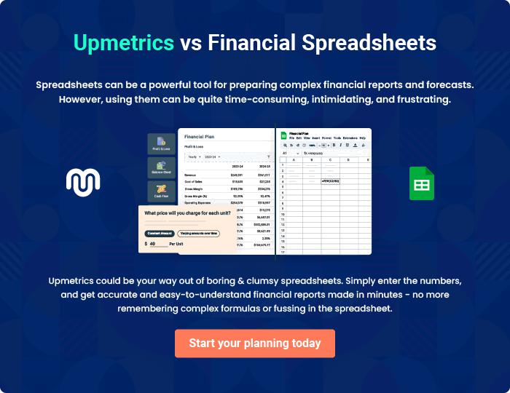
Appendix

When writing the appendix section, you should include any additional information that supports the main content of your plan. This may include financial statements, market research data, legal documents, and other
To unlock help try Upmetrics! 

Create a winning business plan that gets you funded

Creating a stunning and investment-ready plan requires no writing, graphic designing, or financial planning expertise.

Upmetrics has all the features required to help you create a comprehensive business plan—from start to finish. Make no mistakes, it’s the modern way of planning to structure ideas, make plans, and create stunning pitch decks to awe investors.

Pitch decks that impress investors

Create pitch decks that provide a visual representation of your business, engage investors, and make them want to invest in your business idea.

Interactive plans in no time

Import business plan sections like—SWOT analysis, comparison tables, and others to create an interactive business plan. No designing skills are required.

Stunning cover page designs

With Upmetrics, you have the liberty to choose from multiple stunning cover page designs. Choose a creative design and make your plan stand out.

Online sharing made simple

Upmetrics makes online sharing quick and easier for users. Easily share your business plans with a link while tracking reader activity.

500+ sample business plans

Simply import a template from our library of sample plans into the editor and start customizing it to make it yours. It takes only a few clicks to get started.

Collaborate with team in real-time

Invite team members, initiate conversations, discuss ideas & strategies, share feedback, and work on a business plan in real-time.

