
Paint and Sip Business Plan

BUSINESS PLAN

Canvas, Creativity, Cheers

Prepared By

John Doe

10200 Bolsa Ave, Westminster, CA, 92683

info@example.com

(650) 359-3153 http://www.example.com

Table of Contents

Executive Summary | 6
Market opportunity | 6
Services Offered | 6
Marketing & Sales Strategies | 7
Financial Highlights | 7
Units Sold v/s Revenue | 8

Company Overview | 9
Ownership | 9
Mission statement | 9
Business history | 10
Future goals | 10

Market Analysis | 11
Target Market | 11
Market size and growth potential | 11
Market Size | 12
Competitive analysis | 12
Colorful Creations | 12
Brush & Brew | 13
Market trends | 13
Regulatory environment | 13

Products and Services | 15
Products and Services | 15
Classic Painting Class | 15
Premium Art Supplies Kit | 16
Wine and Dine Session | 16
Private Event Package | 17
Specialty Workshop: Watercolors | 17

Retail Sales 18

Additional Services | 18

Sales And Marketing Strategies | 19
Unique Selling Proposition (USP) | 19
Pricing Strategy | 19
Marketing strategies | 20
Online | 20
Sales strategies | 21
Customer retention | 22

Operations Plan | 23
Staffing and Training | 23
Operational Process | 23
Equipment & Machinery | 24

Management Team | 25
Key managers | 25
John Doe | 25
Jane Doe | 26
Alice Brown | 26
Robert Brown | 26
Organizational structure | 27
Organization chart | 27
Compensation plan | 27
Advisors/Consultants | 28
Dr Lucy Green | 28
Mr Daniel Blue | 28

Financial Plan | 29
Profit & loss statement | 29
Cash flow statement | 32
Balance sheet | 34
Break-even Analysis | 36
Financing needs | 38
Appendix
Appendix | 40
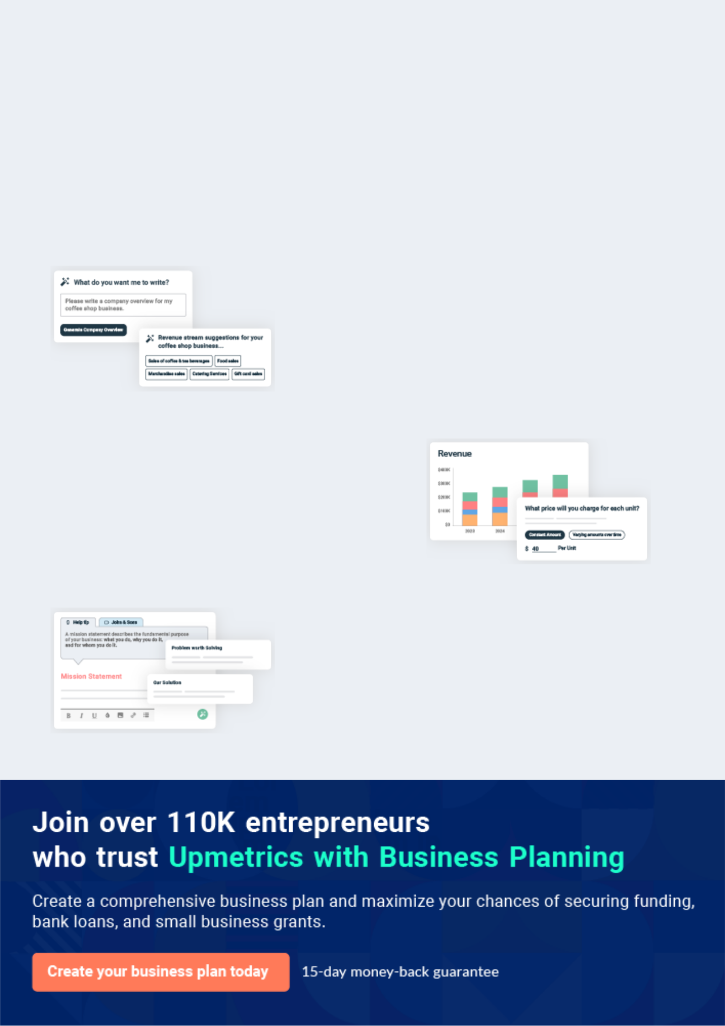
Business planning that’s simpler and faster than you think

Creating a business plan using Upmetrics to start and grow a business is literally the easiest thing in the World. Simply read the instructions and fill in the blanks. It’s as simple as that.

❛ | Upmetrics has everything you need to create a | ❜
❛ | comprehensive business plan. | ❜

AI-powered Upmetrics Assistant

AI-powered insights to streamline your plan

Not sure where to start? Upmetrics’ AI Assistant will automatically generate ideas for each section of your plan and offer improved versions of your writing, adjusting for tone, voice, and grammar or spelling errors.

Financial Forecasting Tool

All the financials are calculated for you

Forget the complex formulas and clumsy spreadsheets — with automatic financials and drag-and-drop forecasting, you can finish your plan faster and be confident that your numbers are accurate.

Business Plan Builder

Guides you like a business mentor

Upmetrics’ step-by-step instructions, prompts, and the library of 400+ sample business plans will guide you through each section of your plan as a business mentor.
Executive Summary


An executive summary is the first section of the business plan intended to provide an overview of the whole business plan.
To unlock help try Upmetrics! 

 Help tip  Paint and Sip Business Plan


Start your executive summary by briefly introducing your business to your readers.

This section may include the name of your paint and sip business, its location, when it was
To unlock help try Upmetrics! 

Start writing here..

Market opportunity

 Help tip  Paint and Sip Business Plan

Summarize your market research, including market size, growth potential, and marketing trends. Highlight the opportunities in the market and how your business will fit in to fill the gap.
To unlock help try Upmetrics! 

Start writing here..

Services Offered

 Help tip  Paint and Sip Business Plan

Highlight the paint and sip products & services you offer your clients. The USPs and differentiators you offer are always a plus.
To unlock help try Upmetrics! 

Start writing here..

Marketing & Sales Strategies
To unlock help try Upmetrics!

 Help tip  Paint and Sip Business Plan

Outline your sales and marketing strategies—what marketing platforms you use, how you plan on acquiring customers, etc.
To unlock help try Upmetrics! 

Start writing here..

Financial Highlights

 Help tip  Paint and Sip Business Plan

Briefly summarize your financial projections for the initial years of business operations. Include any capital or investment requirements, associated startup costs, projected revenues, and profit forecasts.



Start writing here..
Units Sold v/s Revenue

 |  | Units Sold | Revenue
15.00k
10.00k
5.00k
0
Year 1 | Year 2 | Year 3


Financial Year |  |  | Units Sold | Revenue
Year 1 | 1,550 |  |  | $10,000
Year 2 | 1,800 |  |  | $12,000
Year 3 | 2,050 |  |  | $14,000
 Help tip |  |  Paint and Sip Business Plan


Summarize your executive summary section with a clear CTA, for example, inviting angel investors to discuss the potential business investment.
To unlock help try Upmetrics! 

Write a call to action for your business plan.
Company Overview

Depending on what details of your business are essential, you’ll need different elements in your business overview.
To unlock help try Upmetrics! 

 Help tip  Paint and Sip Business Plan

Describe your business in this section by providing all the basic information:

Describe what kind of paint and sip company you run and the name of it. You may specialize in
To unlock help try Upmetrics! 

Start writing here..

Ownership

 Help tip  Paint and Sip Business Plan

List the names of your paint and sip company’s founders or owners. Describe what shares they own and their responsibilities for efficiently managing the business.
To unlock help try Upmetrics! 

Start writing here..

Mission statement

 Help tip  Paint and Sip Business Plan

Summarize your business’ objective, core principles, and values in your mission statement. This statement needs to be memorable, clear, and brief.
To unlock help try Upmetrics! 
❛ At [Creative Sips Studio], we believe in the transformative power of art. Our mission is to provide an unparalleled paint-and-sip experience, one that nurtures creativity, fosters community and

celebrates the artist within everyone.
❜

Business history

 Help tip  Paint and Sip Business Plan

If you’re an established paint and sip provider, briefly describe your business history, like—when it was founded, how it evolved over time, etc.
To unlock help try Upmetrics! 

Start writing here..

Future goals

 Help tip  Paint and Sip Business Plan

It’s crucial to convey your aspirations and vision. Mention your short-term and long-term goals; they can be specific targets for revenue, market share, or expanding your services.
To unlock help try Upmetrics! 

Start writing here..
Market Analysis
To unlock help try Upmetrics!


 |  | Market analysis provides a clear understanding of the market in which your
 |  | printing business will run along with the target market, competitors, and
 |  | growth opportunities.
 |  |  |  | To unlock help try Upmetrics! 
 Help tip |  |  Paint and Sip Business Plan

To write the introduction section of your market analysis, start by clearly identifying your primary target market.
To unlock help try Upmetrics! 

Start writing here..

Target Market

 Help tip  Paint and Sip Business Plan

Start this section by describing your target market. Define your ideal customer and explain what types of services they prefer. Creating a buyer persona will help you easily define your target market to your readers.



Start writing here..

Market size and growth potential

 Help tip  Paint and Sip Business Plan

Describe your market size and growth potential and whether you will target a niche or a much broader market.
To unlock help try Upmetrics! 

Start writing here..

Market Size

Available Market

Total individuals interested in art and 10M leisure activities.

Served Market
Those who have attended a paint and sip 7M event in the past year.

Target Market
Adults aged 25-45 seeking premium paint 2M and sip experiences.

 Help tip  Paint and Sip Business Plan

Identify and analyze your direct and indirect competitors. Identify their strengths and weaknesses, and describe what differentiates your paint and sip business from them.
To unlock help try Upmetrics! 

Competitive analysis

Colorful Creations

[Colorful Creations] is a renowned brand in the paint and sip sector, with over [X number] of studios nationwide. Established in [Year, e.g., "2015"], they have been pioneers in promoting the concept of group painting sessions coupled with social interaction.

Features | Strengths | Weaknesses
Group painting sessions | Extensive national presence | Limited customizability for
Private events and parties | Robust online booking system | private events
Corporate team-building events | Diverse range of painting | Relatively higher pricing
Art supplies shop | themes | Less focus on virtual offerings

Brush & Brew
To unlock help try Upmetrics!

[Brush & Brew] emerged in [Year, e.g., "2018"] and quickly distinguished itself with its unique blend of art sessions and specialty beverages. Their studios exude a café-like ambiance, making them popular among the younger audience.

Features

Art and specialty brew sessions

On-site café with artisanal beverages

Monthly art showcases

Strengths | Weaknesses
Unique café-themed ambiance | Limited studio locations
Diverse beverage menu, | Predominantly targets younger
enhancing the sip experience | demographics, limiting audience
Active engagement in local art | diversity
communities | Less variety in art themes

Market trends

 Help tip  Paint and Sip Business Plan

Analyze emerging trends in the industry, such as technology disruptions, changes in customer behavior or preferences, etc. Explain how your business will cope with all the trends.
To unlock help try Upmetrics! 

Start writing here..

Regulatory environment

 Help tip  Paint and Sip Business Plan

List regulations and licensing requirements that may affect your paint and sip company, such as business licensing, alcohol licensing, health & safety regulations, environmental regulations, zoning & land use, etc.



Start writing here..

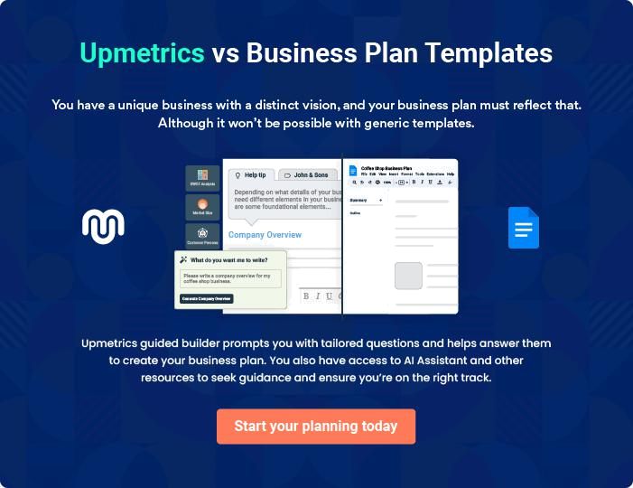
Products and Services
To unlock help try Upmetrics!

The product and services section of a paint and sip business plan should describe the specific services and products that will be offered to customers. To write this section should include the following:



 Help tip  Paint and Sip Business Plan

To craft the introduction for your "Products and Services" chapter, begin by positioning your business within its industry, emphasizing its unique strengths or value proposition.
To unlock help try Upmetrics! 

Start writing here..

 Help tip


Mention the paint and sip products and services your business will offer. This list may include:

• Painting classes
To unlock help try Upmetrics! 

Products and Services

Classic Painting Class


Price: $[45.00] per session

Our Classic Painting Class is designed for individuals of all skill levels, from beginners to seasoned artists, looking for a structured yet relaxed painting experience.

Specifications

- Duration: 2 hours

- Materials Provided: Acrylic paints, brushes, 16x20 canvas

- Themes Covered: [e.g., "Landscapes, Still Life, Abstract"]

- Instructors: Qualified art professionals
Premium Art Supplies Kit

Price: $[30.00] per kit

A comprehensive art kit for those eager to continue their painting journey at home or looking for top-quality materials for personal projects.

Specifications

- Contents: 6 premium acrylic paint tubes, 5 brushes (varied sizes), 2 pre-stretched canvases (12x16)

- Quality: Professional-grade, non-toxic materials

- Packaging: Eco-friendly, reusable art tote

Wine and Dine Session

Price: $[60.00] per session

Combining the joy of painting with the pleasure of sipping fine wine, this session offers a curated selection of wines paired with guided art instructions.

Specifications

- Duration: 2.5 hours

- Wine Selection: Choice of 3 wines (2 glasses included in price)

- Materials Provided: Acrylic paints, brushes, 16x20 canvas

- Themes Covered: [e.g., "Wine-themed paintings, Abstract expressions"]

- Instructors: Qualified art professionals with a sommelier present for wine selection
Private Event Package

Price: Starting at $[500.00] for up to 10 participants

Perfect for celebrations, corporate events, or gatherings, this package offers a private studio experience tailored to the group's preferences.

Specifications

- Duration: 3 hours

- Customization: Choice of painting theme, music, and additional services

- Materials Provided: Acrylic paints, brushes, canvas per participant

- Add-ons: Catering options, extended hours, additional participants at $[40.00] each

Specialty Workshop: Watercolors

Price: $[75.00] per workshop

Dive deep into the world of watercolors with this specialized workshop, teaching techniques and styles specific to this medium.

Specifications

- Duration: 3 hours

- Materials Provided: Watercolor paints, brushes, premium watercolor paper

- Themes Covered: [e.g., "Nature motifs, Wet-on-wet technique, Gradients and layering"]

- Instructors: Watercolor specialists
Retail Sales
- To unlock help try Upmetrics!

 Help tip  Paint and Sip Business Plan


Mention any retail elements of your paint and sip company briefly. Describe the options
available to buyers, such as art supplies, painting kits, brushes, canvases, or other relevant
products.
 |  |  |  | To unlock help try Upmetrics! 
Start writing here..
Additional Services
 Help tip |  |  Paint and Sip Business Plan

Mention if your paint and sip company offers any additional services. You may include services like art exhibitions, collaborations with local artists, art therapy sessions, or specialty workshops, etc.



Start writing here..
Sales And Marketing Strategies

Writing the sales and marketing strategies section means a list of strategies you will use to attract and retain your clients.
To unlock help try Upmetrics! 

 Help Tip  Paint and Sip Business Plan


To create an effective introduction for your "Sales and Marketing Strategies" chapter, start by setting the stage within your specific industry or market.
To unlock help try Upmetrics! 

Start writing here..

Unique Selling Proposition (USP)

 Help tip  Paint and Sip Business Plan

Define your business’s USPs depending on the market you serve, the equipment you use, and the unique services you provide. Identifying USPs will help you plan your marketing strategies.
To unlock help try Upmetrics! 

Start writing here..

Pricing Strategy

 Help tip  Paint and Sip Business Plan

Describe your pricing strategy—how you plan to price your services and stay competitive in the local market. You can mention any discounts you plan on offering to attract new customers.
To unlock help try Upmetrics! 

Start writing here..

 Help tip  Paint and Sip Business Plan
To unlock help try Upmetrics!

Discuss your marketing strategies to market your services. You may include some of these marketing strategies in your business plan—social media marketing, cross-promotions, brochures, email marketing, content marketing, and print marketing.



Marketing strategies

Online


Social Media

Leveraging platforms like Instagram, Facebook, and Pinterest, we'll showcase our sessions, testimonials, and the beautiful creations of our attendees. Regular posts, stories, and ads will help maintain an active online presence.

Content Marketing

Blog posts, video tutorials, and guest articles in local publications will position us as leaders in the paint and sip niche, driving organic traffic to our website.

Email Marketing

Newsletters featuring upcoming events, special themes, and exclusive offers will be sent to our subscriber base, ensuring ongoing engagement.

Cross-Promotions

Collaborations with [related businesses, e.g., "local wineries or art supply stores"] will provide mutual promotional opportunities.

 Help tip  Paint and Sip Business Plan

Outline the strategies you’ll implement to maximize your sales. Your sales strategies may include partnering with other businesses, offering referral programs, influencer marketing, etc.
To unlock help try Upmetrics! 

Sales strategies

Partner with Businesses

Forming alliances with [specific businesses, e.g., "local cafes, restaurants, and event spaces"] to host our sessions will expose our brand to their clientele and vice versa.

Referral Programs

Customers who refer a friend will receive benefits such as discounts or free sessions, incentivizing word-of-mouth promotion.

Influencer Marketing

Collaborating with local influencers for sponsored sessions will enhance our reach and appeal to a wider audience.

 Help tip  Paint and Sip Business Plan

Describe your customer retention strategies and how you plan to execute them. For instance, introducing loyalty programs, discounts & offers, personalized service, etc.
To unlock help try Upmetrics! 

Customer retention

Loyalty Programs

After attending a specific number of sessions, customers will be eligible for benefits such as a free class or discounts on art supplies.

Personalized Service

Taking note of customer preferences, remembering names, and occasionally customizing sessions based on feedback will make attendees feel valued.

Exclusive Offers

Loyal customers will get early access to special events, new themes, or workshops, making them feel part of an exclusive club.

Operations Plan
To unlock help try Upmetrics!

 |  | When writing the operations plan section, it’s important to consider the
 |  | various aspects of your business operations.
 |  |  |  | To unlock help try Upmetrics! 
 Help tip |  |  Paint and Sip Business Plan


To create an effective introduction for your "Operational Plan" chapter, start by emphasizing the
pivotal role of efficient operations in the success of your business, underscoring how they
directly impact the quality of services delivered.
 |  |  |  | To unlock help try Upmetrics! 
Start writing here..
Staffing and Training
 Help tip |  |  Paint and Sip Business Plan

Mention your cleaning business’s staffing requirements, including the number of employees or
instructors needed. Include their qualifications, the training required, and the duties they will
perform.
 |  |  |  | To unlock help try Upmetrics! 
Start writing here..
Operational Process
 Help tip |  |  Paint and Sip Business Plan

Outline the processes and procedures you will use to run your paint and sip business. Your operational processes may include booking & reservation, event preparation, painting session, etc.



Start writing here..

Equipment & Machinery

 Help tip  Paint and Sip Business Plan

Include the list of equipment and machinery required for paint and sip, such as art supplies, studio setup & furniture, audio-visual equipment, etc.
To unlock help try Upmetrics! 

Start writing here..
Management Team

The management team section provides an overview of the individuals responsible for running your business plan.
To unlock help try Upmetrics! 

 Help tip  Paint and Sip Business Plan

To craft an introduction for your "Management Team" chapter, begin by emphasizing the crucial role of leadership in the success of any business.
To unlock help try Upmetrics! 

Start writing here..

Key managers

 Help tip  Paint and Sip Business Plan

Introduce your management and key members of your team, and explain their roles and responsibilities.
To unlock help try Upmetrics! 

Start writing here..


JOHN DOE

CEO & Co-founder - john.doe@example.com

John is the driving force behind [Creative Sips Studio], leading with a strategic vision and passion for the art industry.

With a Master's in Business Administration from [Prestigious University] and over 15 years of entrepreneurial experience, he has been pivotal in transitioning our brand from a mere idea to a renowned art hub.


His adept business acumen, coupled with a love for fostering community and creativity, sets the tone for our business.

JANE DOE

Studio Manager - jane.doe@example.com

Jane has been an instrumental figure in managing the daily operations of our studio.

With a Bachelor's in Fine Arts from [Top Art School] and over 10 years of managerial experience in art studios, she ensures that both our staff and clients have exceptional experiences daily.


Her aptitude for organizational logistics, combined with a genuine affinity for customer service, makes her a cornerstone of our operations.


ALICE BROWN

General Manager - alice.brown@example.com

Alice, with her MBA from [Notable Business School] and 12 years of experience in event management, has been a beacon of operational excellence for [Creative Sips Studio].

As the General Manager, she deftly oversees everything from bookings to events, ensuring a seamless interface for our customers.

Her knack for detail, coupled with a hands-on approach, guarantees the consistency of our premium service standards.


ROBERT BROWN

Event Manager - robert.brown@example.com

Robert, having graduated with a degree in Event Planning from [Renowned University], possesses an eye for curating memorable and immersive art events.

With over 8 years in the event planning space, he meticulously orchestrates each of our special events to resonate with our clientele's expectations.

His rich network within the art community and a keen understanding of trends allow him to consistently elevate our event portfolio.
Organizational structure

 Help tip  Paint and Sip Business Plan

Explain the organizational structure of your management team. Include the reporting line and decision-making hierarchy.
To unlock help try Upmetrics! 

Start writing here..

Organization chart


John Doe

CEO
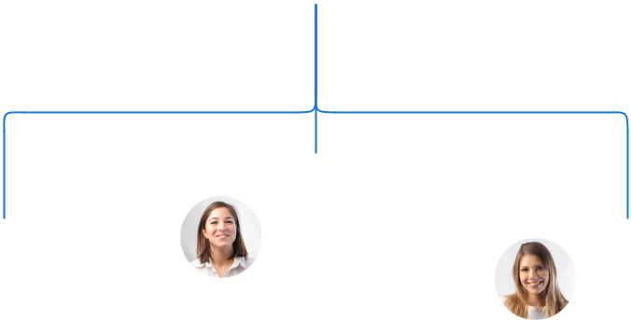

 | Alice Brown
Robert Brown | General | Jane Doe
Robert Brown | Manager | Jane Doe
Event Manager | Manager | Studio Manager

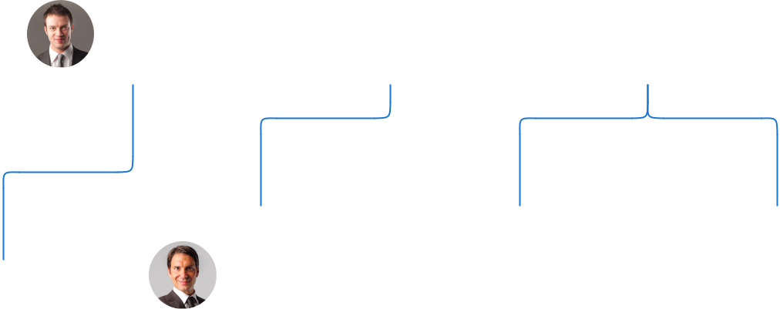

 | David Yellow | Lisa Gray | Mark Black
 | Social Media | Lisa Gray | Mark Black
Sarah Blue | Social Media | Art Instructor | Art Instructor
Sarah Blue | Cordinator | Art Instructor | Art Instructor
PR specialist | Cordinator





Compensation plan

 Help tip  Paint and Sip Business Plan

Describe your compensation plan for the management and staff. Include their salaries, incentives, and other benefits.
To unlock help try Upmetrics! 

Start writing here..

 Help tip

Mentioning advisors or consultants in your business plans adds credibility to your business idea.
To unlock help try Upmetrics! 

Advisors/Consultants


DR LUCY GREEN

Advisor

A renowned name in the art industry, Dr. Green advises on curating our art sessions and maintaining an up-to-date knowledge base


MR DANIEL BLUE

Consultant

With [XX] years in business consultancy, Mr. Blue aids in refining our business strategies, ensuring sustained growth.
Financial Plan

When writing the financial plan section of a business plan, it’s important to provide a comprehensive overview of your financial projections for the first few years of your business, You may provide the following:
To unlock help try Upmetrics! 

 Help tip  Paint and Sip Business Plan


To create an effective introduction for your "Financial Plan" chapter, begin by stressing the critical role of a well-structured financial plan in the success of your venture.
To unlock help try Upmetrics! 

Start writing here..

 Help tip  Paint and Sip Business Plan

Describe details such as projected revenue, operational costs, and service costs in your projected profit and loss statement. Make sure to include your business’s expected net profit or loss.
To unlock help try Upmetrics! 

Profit & loss statement

Revenue

Cost Of Sales

General Costs

Revenue Specific Costs

Personnel Costs (Direct

Labor)

Gross Margin

Gross Margin (%)

Operating Expense

Payroll Expense

(Indirect Labor)

General Expense

Bad Debt

Amortization of Current

Assets

2023-24 | 2024-25 | 2025-26 | 2026-27 | 2027-28
$0 | $0 | $0 | $0 | $0

$0 | $0 | $0 | $0 | $0
$0 | $0 | $0 | $0 | $0
$0 | $0 | $0 | $0 | $0
$0 | $0 | $0 | $0 | $0

$0 | $0 | $0 | $0 | $0
0% | 0% | 0% | 0% | 0%

$0 | $0 | $0 | $0 | $0
$0 | $0 | $0 | $0 | $0
$0 | $0 | $0 | $0 | $0
$0 | $0 | $0 | $0 | $0
$0 | $0 | $0 | $0 | $0

EBITDA

Additional Expense

Long Term

Depreciation

Gain or loss from Sale

of Assets

EBIT

Interest Expenses

EBT

Income Tax Expense

Total Expense

Net Income

Net Income (%)

2023-24 | 2024-25 | 2025-26 | 2026-27 | 2027-28
$0 | $0 | $0 | $0 | $0
$0 | $0 | $0 | $0 | $0
$0 | $0 | $0 | $0 | $0
$0 | $0 | $0 | $0 | $0
$0 | $0 | $0 | $0 | $0
$0 | $0 | $0 | $0 | $0
$0 | $0 | $0 | $0 | $0
$0 | $0 | $0 | $0 | $0
$0 | $0 | $0 | $0 | $0
$0 | $0 | $0 | $0 | $0
0% | 0% | 0% | 0% | 0%
 |  |  | 2023-24 |  | 2024-25 | 2025-26 | 2026-27 | 2027-28
Retained Earning |  |  | $0 |  | $0 | $0 | $0 | $0
Opening
Owner's Distribution |  |  | $0 |  | $0 | $0 | $0 | $0
Retained Earning |  |  | $0 |  | $0 | $0 | $0 | $0
Closing
 Help tip |  |  |  Paint and Sip Business Plan


The cash flow for the first few years of your operation should be estimated and described in this section. This may include billing invoices, payment receipts, loan payments, and any other cash flow statements.
To unlock help try Upmetrics! 

Cash flow statement

 | 2023-24 | 2024-25 | 2025-26 | 2026-27 | 2027-28
Cash Received | $0 | $0 | $0 | $0 | $0
Cash Paid | $0 | $0 | $0 | $0 | $0
COS & General Expenses | $0 | $0 | $0 | $0 | $0
Salary & Wages | $0 | $0 | $0 | $0 | $0
Interest | $0 | $0 | $0 | $0 | $0

Sales Tax

Income Tax

Net Cash From

Operations

Assets Sell

Assets Purchase

Net Cash From

Investments

Amount Received

Loan Received

Common Stock

Preferred Stock

Owner's Contribution

Amount Paid

2023-24 | 2024-25 | 2025-26 | 2026-27 | 2027-28
$0 | $0 | $0 | $0 | $0
$0 | $0 | $0 | $0 | $0
$0 | $0 | $0 | $0 | $0

$0 | $0 | $0 | $0 | $0
$0 | $0 | $0 | $0 | $0
$0 | $0 | $0 | $0 | $0

$0 | $0 | $0 | $0 | $0
$0 | $0 | $0 | $0 | $0

$0 | $0 | $0 | $0 | $0
$0 | $0 | $0 | $0 | $0
$0 | $0 | $0 | $0 | $0

Loan Capital $0 $0 $0 $0 $0

 |  |  | 2023-24 | 2024-25 | 2025-26 | 2026-27 | 2027-28
Dividends & Distributions |  |  | $0 | $0 | $0 | $0 | $0
Net Cash From |  |  | $0 | $0 | $0 | $0 | $0
Financing
Summary
Starting Cash |  |  | $0 | $0 | $0 | $0 | $0
Cash In |  |  | $0 | $0 | $0 | $0 | $0
Cash Out |  |  | $0 | $0 | $0 | $0 | $0
Change in Cash |  |  | $0 | $0 | $0 | $0 | $0
Ending Cash |  |  | $0 | $0 | $0 | $0 | $0
 Help tip |  |  Paint and Sip Business Plan

Create a projected balance sheet documenting your bicycle shop’s assets, liabilities, and equity.

To unlock help try Upmetrics! 

Balance sheet

 | 2023-24 | 2024-25 | 2025-26 | 2026-27 | 2027-28
Assets | $0 | $0 | $0 | $0 | $0
Current Assets | $0 | $0 | $0 | $0 | $0
Cash | $0 | $0 | $0 | $0 | $0
Accounts Receivable | $0 | $0 | $0 | $0 | $0
Inventory | $0 | $0 | $0 | $0 | $0
Other Current Assets | $0 | $0 | $0 | $0 | $0
Long Term Assets | $0 | $0 | $0 | $0 | $0
Gross Long Term Assets | $0 | $0 | $0 | $0 | $0
Accumulated Depreciation | $0 | $0 | $0 | $0 | $0

Liabilities & Equity | $0 | $0 | $0 | $0 | $0
Liabilities | $0 | $0 | $0 | $0 | $0
Current Liabilities | $0 | $0 | $0 | $0 | $0
Accounts Payable | $0 | $0 | $0 | $0 | $0
Income Tax Payable | $0 | $0 | $0 | $0 | $0
Sales Tax Payable | $0 | $0 | $0 | $0 | $0
Short Term Debt | $0 | $0 | $0 | $0 | $0
 | 2023-24 | 2024-25 | 2025-26 | 2026-27 | 2027-28
Long Term Liabilities | $0 | $0 | $0 | $0 | $0
Long Term Debt | $0 | $0 | $0 | $0 | $0
Equity | $0 | $0 | $0 | $0 | $0
Paid-in Capital | $0 | $0 | $0 | $0 | $0
Common Stock | $0 | $0 | $0 | $0 | $0
Preferred Stock | $0 | $0 | $0 | $0 | $0
Owner's Contribution | $0 | $0 | $0 | $0 | $0
Retained Earnings | $0 | $0 | $0 | $0 | $0

Check | $0 |  |  | $0 | $0 | $0 | $0
 Help tip |  |  Paint and Sip Business Plan

Determine and mention your business’s break-even point—the point at which your business costs and revenue will be equal.

This exercise will help you understand how much revenue you need to generate to sustain or be profitable.
To unlock help try Upmetrics! 

Break-even Analysis

 | 2023-24 | 2024-25 | 2025-26 | 2026-27 | 2027-28
Starting Revenue | $0 | $0 | $0 | $0 | $0
Net Revenue | $0 | $0 | $0 | $0 | $0
Closing Revenue | $0 | $0 | $0 | $0 | $0

Starting Expense | $0 | $0 | $0 | $0 | $0
Net Expense | $0 | $0 | $0 | $0 | $0
Closing Expense | $0 | $0 | $0 | $0 | $0

Is Break Even? | 0 | 0 | 0 | 0 | 0
Break Even Month | 0 | 0 | 0 | 0 | 0
Days Required | 0 | 0 | 0 | 0 | 0
Break Even Revenue | $0 | $0 | $0 | $0 | $0
Break Even Units
Financing needs

 Help tip  Paint and Sip Business Plan

Calculate costs associated with starting a paint and sip business, and estimate your financing needs and how much capital you need to raise to operate your business.
To unlock help try Upmetrics! 

Start writing here..
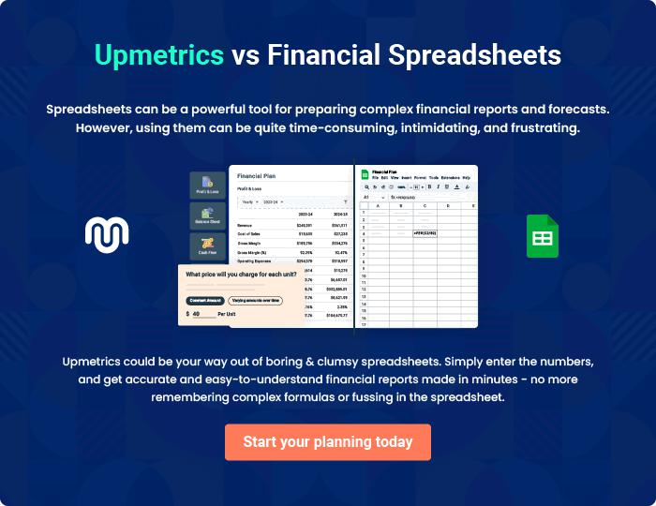
Appendix

When writing the appendix section, you should include any additional information that supports the main content of your plan. This may include financial statements, market research data, legal documents, and other
To unlock help try Upmetrics! 
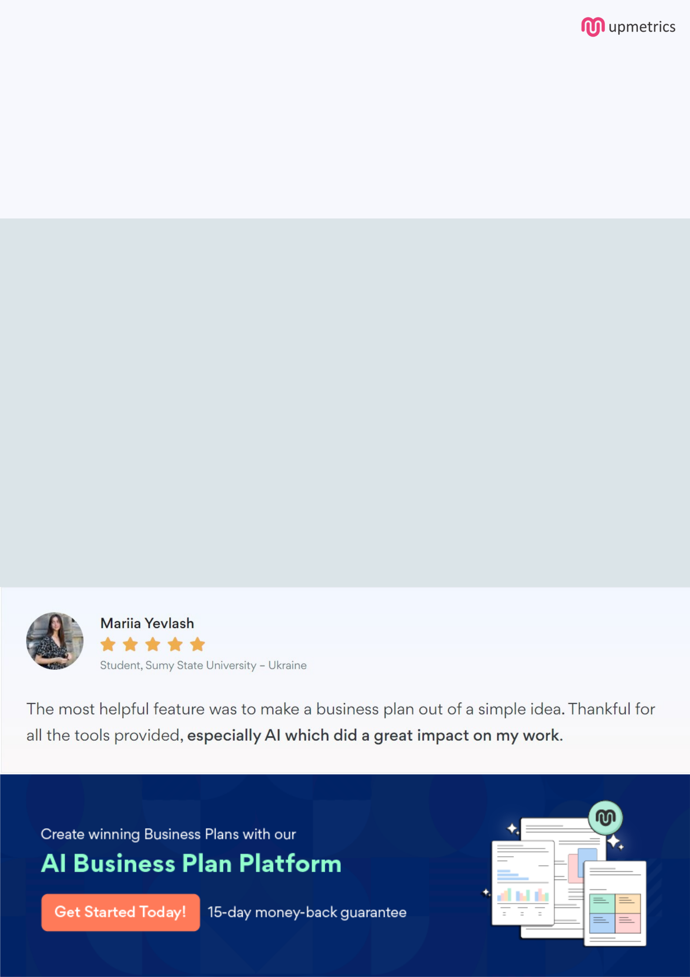
Create a winning business plan that gets you funded

Creating a stunning and investment-ready plan requires no writing, graphic designing, or financial planning expertise.

Upmetrics has all the features required to help you create a comprehensive business plan—from start to finish. Make no mistakes, it’s the modern way of planning to structure ideas, make plans, and create stunning pitch decks to awe investors.

Pitch decks that impress investors

Create pitch decks that provide a visual representation of your business, engage investors, and make them want to invest in your business idea.

Interactive plans in no time

Import business plan sections like—SWOT analysis, comparison tables, and others to create an interactive business plan. No designing skills are required.

Stunning cover page designs

With Upmetrics, you have the liberty to choose from multiple stunning cover page designs. Choose a creative design and make your plan stand out.

Online sharing made simple

Upmetrics makes online sharing quick and easier for users. Easily share your business plans with a link while tracking reader activity.

500+ sample business plans

Simply import a template from our library of sample plans into the editor and start customizing it to make it yours. It takes only a few clicks to get started.

Collaborate with team in real-time

Invite team members, initiate conversations, discuss ideas & strategies, share feedback, and work on a business plan in real-time.

