

Non Medical

Home Care

Business Plan

Home Comforts, Compassionate Care

Business

Plan

2023

John Doe

10200 Bolsa Ave, Westminster, CA, 92683

- 359-3153 info@example.com http://www.example.com

CONFIDENTIAL

Table of Contents

Executive Summary | 6
Market opportunity | 6
Services Offered | 6
Marketing & Sales Strategies | 7
Financial Highlights | 7
Units Sold v/s Revenue | 8

Company Overview | 9
Ownership | 9
Mission statement | 10
Business history | 10
Future goals | 10

Market Analysis | 11
Target Market | 11
Market size and growth potential | 11
Market Size | 12
Competitive analysis | 12
ComfortCare Homemakers | 12
HomeHeart Helpers | 13
GoldenAge Companions | 13
Market trends | 13
Regulatory environment | 14

Products and Services | 15
Services | 15
Personal Care Services | 15
Home Safety Analysis | 16
Live-in Care | 16
Meal Preparation | 17
Light Housekeeping | 17
Additional services | 17

Sales And Marketing Strategies | 18
Unique Selling Proposition (USP) | 18
Pricing Strategy | 18
Marketing strategies | 19
Online | 19
Offline | 19
Sales strategies | 20
Customer retention | 20

Operations Plan | 21
Staffing & Training | 21
Operational Process | 21
Equipment | 22

Management Team | 23
Key managers | 23
John Doe | 24
Jane Doe | 25
Alice Brown | 25
Robert Brown | 25
Organizational structure | 26
Organization chart | 26
Compensation plan | 27
Advisors/Consultants | 27
[ADVISOR NAME] | 27
[CONSULTANT NAME] | 27

Financial Plan | 28
Profit & loss statement | 28
Cash flow statement | 31
Balance sheet | 33
Break-even Analysis | 35
Financing needs | 37
Appendix
Appendix | 39
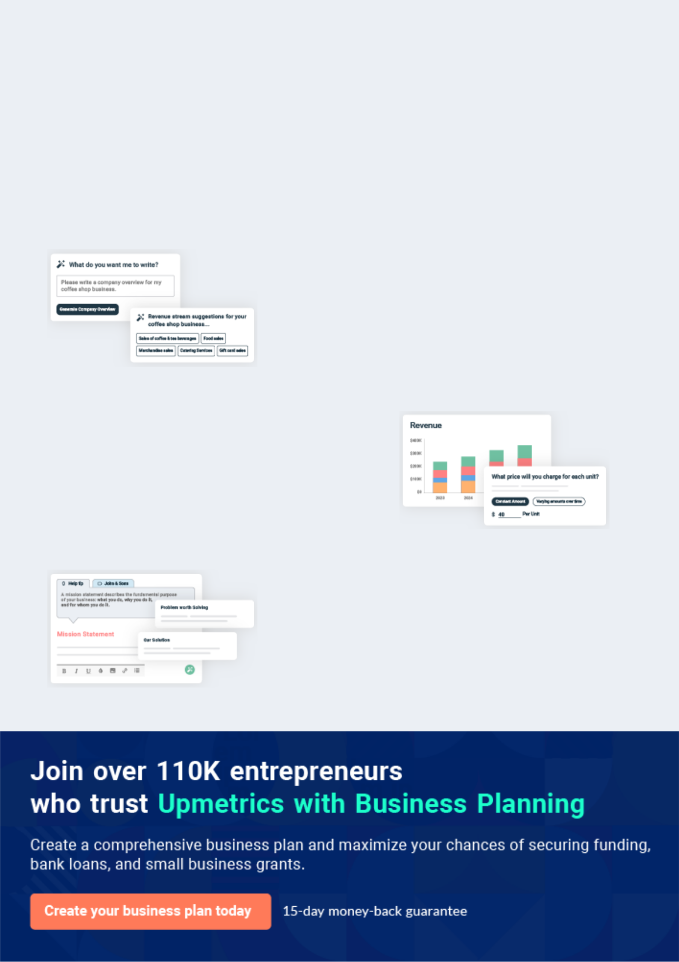
Business planning that’s simpler and faster than you think

Creating a business plan using Upmetrics to start and grow a business is literally the easiest thing in the World. Simply read the instructions and fill in the blanks. It’s as simple as that.

❛ | Upmetrics has everything you need to create a | ❜
❛ | comprehensive business plan. | ❜

AI-powered Upmetrics Assistant

AI-powered insights to streamline your plan

Not sure where to start? Upmetrics’ AI Assistant will automatically generate ideas for each section of your plan and offer improved versions of your writing, adjusting for tone, voice, and grammar or spelling errors.

Financial Forecasting Tool

All the financials are calculated for you

Forget the complex formulas and clumsy spreadsheets — with automatic financials and drag-and-drop forecasting, you can finish your plan faster and be confident that your numbers are accurate.

Business Plan Builder

Guides you like a business mentor

Upmetrics’ step-by-step instructions, prompts, and the library of 400+ sample business plans will guide you through each section of your plan as a business mentor.
Executive Summary


An executive summary is the first section of the business plan intended to provide an overview of the whole business plan.
To unlock help try Upmetrics! 

 Help tip  Non Medical Home Care Business Plan


Start your executive summary section by briefly introducing your business to your readers.

This section may include the name of your non-medical home care business, its location, when
To unlock help try Upmetrics! 

Start writing here..

Market opportunity

 Help tip  Non Medical Home Care Business Plan

Summarize your market research, including market size, growth potential, and marketing trends. Highlight the opportunities in the market and how your business will fit in to fill the gap.
To unlock help try Upmetrics! 

Start writing here..

Services Offered

 Help tip  Non Medical Home Care Business Plan

Highlight the home care services you offer your clients. The USPs and differentiators you offer are always a plus.
To unlock help try Upmetrics! 

Start writing here..

Marketing & Sales Strategies
To unlock help try Upmetrics!

 Help tip  Non Medical Home Care Business Plan

Outline your sales and marketing strategies—what marketing platforms you use, how you plan on acquiring customers, etc.
To unlock help try Upmetrics! 

Start writing here..

Financial Highlights

 Help tip  Non Medical Home Care Business Plan

Briefly summarize your financial projections for the initial years of business operations. Include any capital or investment requirements, associated startup costs, projected revenues, and profit forecasts.



Start writing here..
Units Sold v/s Revenue

 |  | Units Sold | Revenue
15.00k
10.00k
5.00k
0
Year 1 | Year 2 | Year 3


Financial Year |  | Units Sold |  | Revenue
Year 1 | 1,550 |  |  | $10,000
Year 2 | 1,800 |  |  | $12,000
Year 3 | 2,050 |  |  | $14,000
 Help tip |  |  Non Medical Home Care Business Plan
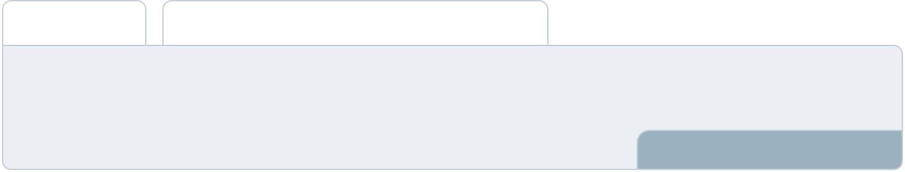

Summarize your executive summary section with a clear CTA, for example, inviting angel investors to discuss the potential business investment.
To unlock help try Upmetrics! 

Write a call to action for your business plan.
Company Overview

Depending on what details of your business are essential, you’ll need different elements in your business overview.
To unlock help try Upmetrics! 

 Help tip  Non Medical Home Care Business Plan

Describe what kind of non-medical home care you run and the name of it. You may specialize in one of the following businesses:
To unlock help try Upmetrics! 

Start writing here..

Ownership

 Help tip  Non Medical Home Care Business Plan

List the names of your non-medical home care company’s founders or owners. Describe what shares they own and their responsibilities for efficiently managing the business.
To unlock help try Upmetrics! 

Start writing here..
Mission statement

 Help tip  Non Medical Home Care Business Plan

Summarize your business’ objective, core principles, and values in your mission statement. This statement needs to be memorable, clear, and brief.
To unlock help try Upmetrics! 

❛ At [NestNurture Home Care], our mission is to provide unparalleled non-medical home care services that prioritize the dignity, safety, and well-being of our clients.

Rooted in compassion and professionalism, we are dedicated to enhancing the quality of life for those we serve.

❜

Business history

 Help tip  Non Medical Home Care Business Plan

If you’re an established non-medical service provider, briefly describe your business history, like —when it was founded, how it evolved over time, etc.
To unlock help try Upmetrics! 

Start writing here..

Future goals

 Help tip  Non Medical Home Care Business Plan

It’s crucial to convey your aspirations and vision. Mention your short-term and long-term goals; they can be specific targets for revenue, market share, or expanding your services.
To unlock help try Upmetrics! 

Start writing here..

Market Analysis
To unlock help try Upmetrics!


 |  | Market analysis provides a clear understanding of the market in which your
 |  | printing business will run along with the target market, competitors, and
 |  | growth opportunities.
 |  |  |  | To unlock help try Upmetrics! 
 Help tip |  |  Non Medical Home Care Business Plan

To write the introduction section of your market analysis, start by clearly identifying your primary target market.
To unlock help try Upmetrics! 

Start writing here..

Target Market

 Help tip  Non Medical Home Care Business Plan

Start this section by describing your target market. Define your ideal customer and explain what types of services they prefer. Creating a buyer persona will help you easily define your target market to your readers.



Start writing here..

Market size and growth potential

 Help tip  Non Medical Home Care Business Plan

Describe your market size and growth potential and whether you will target a niche or a much broader market.
To unlock help try Upmetrics! 

Start writing here..

Market Size
To unlock help try Upmetrics!

Available Market

Total individuals in the region eligible for 10M non-medical home care.

Served Market
Those currently using any form of non- 5M medical home care service.

Target Market
Elderly with specific needs we specialize 2M in, e.g., mobility issues.

 Help tip  Non Medical Home Care Business Plan

Identify and analyze your direct and indirect competitors. Identify their strengths and weaknesses, and describe what differentiates your non-medical home care services from them.



Competitive analysis

ComfortCare Homemakers

Founded in 2005, ComfortCare Homemakers has steadily become a trusted name in the industry. They have established a reputation for delivering consistent care through their large network of trained caregivers.

Features | Strengths | Weaknesses
Personalized daily living | Extensive industry experience | Limited use of technology in
assistance | with over 15 years in operation | service delivery
Specialized dementia and | Broad range of services | Higher pricing model compared
Alzheimer’s care | catering to varied client needs | to new market entrants
Companion services with | Strong community engagement | Inflexibility in customizing
activity-based engagement | and brand recognition | service packages
Live-in care options

HomeHeart Helpers

A relatively new entrant, HomeHeart Helpers, launched in 2018, brings a tech-savvy approach to home care, integrating modern solutions to enhance client experience.

Features

Basic home assistance for daily tasks

Digital portal for families to monitor and communicate

Emergency response systems

Virtual wellness and activity programs

Strengths

Strong technology integration offering transparency and real-time communication

Competitive pricing aimed at attracting a broader market segment

Active feedback mechanism leading to service improvements

Weaknesses

Limited on-ground experience and industry tenure

Narrower range of services compared to seasoned competitors

Challenges in maintaining consistent service quality due to rapid scaling

GoldenAge Companions

GoldenAge Companions, operating since 2010, emphasizes holistic wellness, offering a blend of traditional caregiving with wellness programs.

Features

Personal care and daily living assistance

Holistic wellness programs including physical therapy and meditation

Companion services with an emphasis on mental well-being

Nutrition and meal planning guidance

Strengths Weaknesses

Unique focus on holistic well- Limited technology adoption

being, setting them apart from leading to operational

competitors inefficiencies

Diverse team including Premium pricing model,

nutritionists and physical potentially alienating budget-

therapists conscious clients

Positive client testimonials and Longer onboarding process for

strong word-of-mouth referrals new clients

Market trends

 Help tip  Non Medical Home Care Business Plan

Analyse emerging trends in the industry, such as changes in technology, customer behavior or preferences, etc. Explain how your business will cope with all the trends.
To unlock help try Upmetrics! 

Start writing here..

Regulatory environment

 Help tip  Non Medical Home Care Business Plan

List regulations and licensing requirements that may affect your non-medical home care company, such as business registration, insurance, licensing, client rights, etc.
To unlock help try Upmetrics! 

Start writing here..
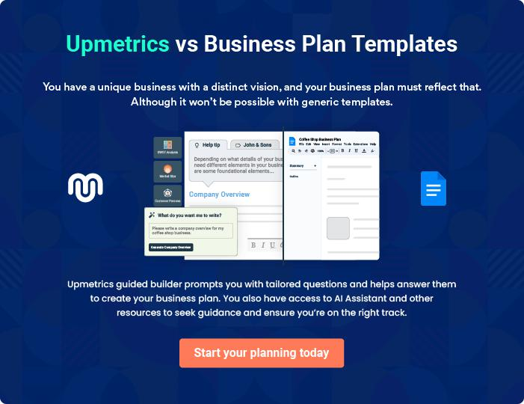
Products and Services

The product and services section of non medical home care business plan should describe the specific services and products that will be offered to customers. To write this section should include the following:
To unlock help try Upmetrics! 

 Help tip  Non Medical Home Care Business Plan

To craft the introduction for your "Products and Services" chapter, begin by positioning your business within its industry, emphasizing its unique strengths or value proposition.
To unlock help try Upmetrics! 

Start writing here..

 Help tip


Mention the services your business will offer. This list may include services like

• Personal care services
To unlock help try Upmetrics! 

Services

Personal Care Services
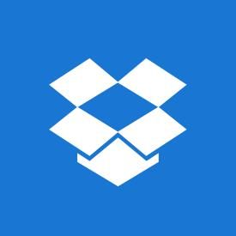

Price: [$25/hour]

Personalized assistance with daily tasks, ensuring clients can maintain their regular routines comfortably and safely.

Specifications

- Bathing and grooming assistance

- Dressing aid

- Mobility assistance

- Medication reminders
Home Safety Analysis

Price: [$100/assessment]

Comprehensive evaluation of a client's living space to identify potential hazards and ensure a safe environment.

Specifications

- Fall risk assessment

- Safety equipment recommendations

- Emergency exit planning

- Lighting and electrical safety check

Live-in Care

Price: [$200/day]

24-hour care service providing clients with constant companionship and support, ensuring they are never alone.

Specifications

- 24/7 caregiver presence

- Nighttime assistance

- Daily task support (meal prep, cleaning, etc.)

- Emergency care readiness
Meal Preparation

Price: [$15/meal]

Nutritious and tailored meal preparation based on client preferences and dietary requirements, promoting a balanced diet.

Specifications

- Dietician-approved meal plans

- Customized based on dietary restrictions (e.g., gluten-free, diabetic-friendly)

- Portioned servings

- Assistance with feeding, if necessary

Light Housekeeping

Price: [$20/hour]

Cleaning and tidying services to ensure clients' living spaces remain organized, hygienic, and pleasant.

Specifications

- Dusting and vacuuming

- Laundry assistance

- Bedding changes

- Kitchen and bathroom cleaning

Additional services

 Help tip  Non Medical Home Care Business Plan

Think about adding extra services or packages, like transportation or home safety inspections, for your clientele. Describe these extra services and how they will help clients in this section.
To unlock help try Upmetrics! 

Start writing here..

Sales And Marketing Strategies

Writing the sales and marketing strategies section means a list of strategies you will use to attract and retain your clients.
To unlock help try Upmetrics! 

 Help Tip  Non Medical Home Care Business Plan


To create an effective introduction for your "Sales and Marketing Strategies" chapter, start by setting the stage within your specific industry or market.
To unlock help try Upmetrics! 

Start writing here..

Unique Selling Proposition (USP)

 Help tip  Non Medical Home Care Business Plan

Define your business’s USPs depending on the market you serve, the equipment you use, and the unique services you provide. Identifying USPs will help you plan your marketing strategies.
To unlock help try Upmetrics! 

Start writing here..

Pricing Strategy

 Help tip  Non Medical Home Care Business Plan

Describe your pricing strategy—how you plan to price your services and stay competitive in the local market. You can mention any discounts you plan on offering to attract new customers.
To unlock help try Upmetrics! 

Start writing here..

 Help tip  Non Medical Home Care Business Plan
To unlock help try Upmetrics!

Discuss your marketing strategies to market your services. You may include some of these marketing strategies in your business plan—social media marketing, Google ads, brochures, email marketing, content marketing, and print marketing.



Marketing strategies

Online


Social Media

Building a robust presence on platforms like Facebook, Instagram, and LinkedIn to engage with potential clients and caregivers.

Content Marketing

Engaging blog posts and articles that provide value, answer common questions, and position [NestNurture Home Care] as a thought leader in the industry.

Email Marketing

Regular newsletters and updates to our client base, highlighting any new services, staff additions, or special promotions.

Google Ads

Targeting specific keywords to ensure [NestNurture Home Care] appears when potential clients are searching for our services.

Offline

Brochures

High-quality, informational brochures distributed in strategic locations, like medical centers, community hubs, and senior centers.

Print Marketing

Advertisements in local newspapers, magazines, and other relevant print media.

 Help tip  Non Medical Home Care Business Plan
To unlock help try Upmetrics!

Outline the strategies you’ll implement to maximize your sales. Your sales strategies may include partnering with other medical businesses, offering referral programs, discount on availing more than one service, etc.



Sales strategies

Partner with Businesses Discounts

Forming alliances with other Offering bundled service packages

medical and non-medical at discounted rates.

businesses to create a comprehensive care ecosystem.

Referral Programs

Introducing referral programs with

incentives for clients and partners.

 Help tip  Non Medical Home Care Business Plan

Describe your customer retention strategies and how you plan to execute them. For instance, introducing loyalty programs, discounts on annual membership, personalized service, etc.
To unlock help try Upmetrics! 

Customer retention

Loyalty Programs

Rewarding regular clients with points that can be redeemed for additional services or discounts.

Annual Membership Discounts

Special prices for clients who commit to our services on a yearly basis.

Personalized Service

Tailoring our services based on

individual client feedback and

preferences.

Operations Plan
To unlock help try Upmetrics!

 |  | When writing the operations plan section, it’s important to consider the
 |  | various aspects of your business operations.
 |  |  |  | To unlock help try Upmetrics! 
 Help tip |  |  Non Medical Home Care Business Plan


To create an effective introduction for your "Operational Plan" chapter, start by emphasizing the
pivotal role of efficient operations in the success of your business, underscoring how they
directly impact the quality of services delivered.
 |  |  |  | To unlock help try Upmetrics! 
Start writing here..
Staffing & Training
 Help tip |  |  Non Medical Home Care Business Plan

Mention your business’s staffing requirements, including the number of employees or carers need. Include their qualifications, the training required, and the duties they will perform.
To unlock help try Upmetrics! 

Start writing here..

Operational Process

 Help tip  Non Medical Home Care Business Plan

Outline the processes and procedures you will use to run your home care business. Your operational processes may include sending quotations, quality control & assurance, scheduling appointments, training employees, etc.



Start writing here..

Equipment

 Help tip  Non Medical Home Care Business Plan

Include the list of equipment required for your non-medical home care, such as personal care equipment, beds, mobility aids, communication devices, medical reminders, etc.
To unlock help try Upmetrics! 

Start writing here..
Management Team

The management team section provides an overview of the individuals responsible for running your business plan.
To unlock help try Upmetrics! 

 Help tip  Non Medical Home Care Business Plan

To craft an introduction for your "Management Team" chapter, begin by emphasizing the crucial role of leadership in the success of any business.
To unlock help try Upmetrics! 

Start writing here..

Key managers

 Help tip  Non Medical Home Care Business Plan

Introduce your management and key members of your team, and explain their roles and responsibilities.
To unlock help try Upmetrics! 

Start writing here..

JOHN DOE

CEO - john.doe@example.com

John founded [NestNurture Home Care] with the vision of redefining excellence in non-medical home care. His holistic approach to care is rooted in his personal experiences and passion for making a difference in people's lives.


- Educational Background: John holds an MBA from [Prestigious University Name] with a specialization in Health Care Management.

- Professional Background: With over 15 years in the non-medical home care industry, John has served in various capacities ranging from a care coordinator to operations management.

His vast industry knowledge ensures [NestNurture Home Care] maintains its standard of excellence.

JANE DOE

Chief Operating Officer (COO) - jane.doe@example.com

Jane's meticulous nature and dedication to operations make her an indispensable part of our team.

She ensures the smooth day-to-day running of [NestNurture Home Care], ensuring each client receives unparalleled care.

- Educational Background: Jane is a graduate of [Prominent University Name], where she earned a Bachelor's in Business Administration with a minor in Healthcare Studies.

- Professional Background: Jane has worked in the home care industry for over a decade. Her roles have spanned from operations coordination to managerial responsibilities in prominent care institutions.


ALICE BROWN

CMO - alice.brown@example.com

Alice's forte is her ability to weave compelling narratives around our services, making [NestNurture Home Care] a recognized brand in the non-medical home care market.

- Educational Background: Alice earned her Master's in Marketing from [Well-known University Name].

- Professional Background: With 12 years of experience in marketing, Alice has worked for renowned health sector brands, crafting their stories and driving their market presence.


ROBERT BROWN

Senior Client Relations Manager - robert.brown@example.com

Robert's interpersonal skills and empathy make him the perfect liaison between our clients and our team.

He ensures every client's needs are understood and addressed, ensuring their complete satisfaction.

- Educational Background: Robert holds a Bachelor's in Communication Studies from [Distinguished University Name].

- Professional Background: With a rich 8-year history in client relations, Robert has worked for various health institutions, always leaving a trail of satisfied clients.
Organizational structure

 Help tip  Non Medical Home Care Business Plan

Explain the organizational structure of your management team. Include the reporting line and decision-making hierarchy.
To unlock help try Upmetrics! 

Start writing here..

Organization chart


John Doe

CEO


Alice Brown

Jane Doe

CMO


COO


Emily Green

Robert Brown

Marketing Specialist


Client Relations Manager


Michael White

Operations Coordinator

Compensation plan

 Help tip  Non Medical Home Care Business Plan

Describe your compensation plan for the management and staff. Include their salaries, incentives, and other benefits.
To unlock help try Upmetrics! 

Start writing here..

 Help tip

Mentioning advisors or consultants in your business plans adds credibility to your business idea.
To unlock help try Upmetrics! 

Advisors/Consultants


[ADVISOR NAME]

Advisor

With a rich history in [specific sector, e.g., healthcare technology], [Advisor's Name] provides invaluable insights into [specific domain, e.g., integrating technology into our service delivery].


[CONSULTANT NAME]

Consultant

As a consultant in [specific area, e.g., customer relations], [Consultant's Name] aids in refining our client interaction and satisfaction strategies.
Financial Plan

When writing the financial plan section of a business plan, it’s important to provide a comprehensive overview of your financial projections for the first few years of your business, You may provide the following:
To unlock help try Upmetrics! 

 Help tip  Non Medical Home Care Business Plan


To create an effective introduction for your "Financial Plan" chapter, begin by stressing the critical role of a well-structured financial plan in the success of your venture.
To unlock help try Upmetrics! 

Start writing here..

 Help tip  Non Medical Home Care Business Plan

Describe details such as projected revenue, operational costs, and service costs in your projected profit and loss statement. Make sure to include your business’s expected net profit or loss.
To unlock help try Upmetrics! 

Profit & loss statement

Revenue

Cost Of Sales

General Costs

Revenue Specific Costs

Personnel Costs (Direct

Labor)

Gross Margin

Gross Margin (%)

Operating Expense

Payroll Expense

(Indirect Labor)

General Expense

Bad Debt

Amortization of Current

Assets

2023-24 | 2024-25 | 2025-26 | 2026-27 | 2027-28
$0 | $0 | $0 | $0 | $0

$0 | $0 | $0 | $0 | $0
$0 | $0 | $0 | $0 | $0
$0 | $0 | $0 | $0 | $0
$0 | $0 | $0 | $0 | $0

$0 | $0 | $0 | $0 | $0
0% | 0% | 0% | 0% | 0%

$0 | $0 | $0 | $0 | $0
$0 | $0 | $0 | $0 | $0
$0 | $0 | $0 | $0 | $0
$0 | $0 | $0 | $0 | $0
$0 | $0 | $0 | $0 | $0

EBITDA

Additional Expense

Long Term

Depreciation

Gain or loss from Sale

of Assets

EBIT

Interest Expenses

EBT

Income Tax Expense

Total Expense

Net Income

Net Income (%)

2023-24 | 2024-25 | 2025-26 | 2026-27 | 2027-28
$0 | $0 | $0 | $0 | $0
$0 | $0 | $0 | $0 | $0
$0 | $0 | $0 | $0 | $0
$0 | $0 | $0 | $0 | $0
$0 | $0 | $0 | $0 | $0
$0 | $0 | $0 | $0 | $0
$0 | $0 | $0 | $0 | $0
$0 | $0 | $0 | $0 | $0
$0 | $0 | $0 | $0 | $0
$0 | $0 | $0 | $0 | $0
0% | 0% | 0% | 0% | 0%
 |  |  | 2023-24 | 2024-25 | 2025-26 | 2026-27 | 2027-28
Retained Earning |  |  | $0 | $0 | $0 | $0 | $0
Opening
Owner's Distribution |  |  | $0 | $0 | $0 | $0 | $0
Retained Earning |  |  | $0 | $0 | $0 | $0 | $0
Closing
 Help tip |  |  |  Non Medical Home Care Business Plan
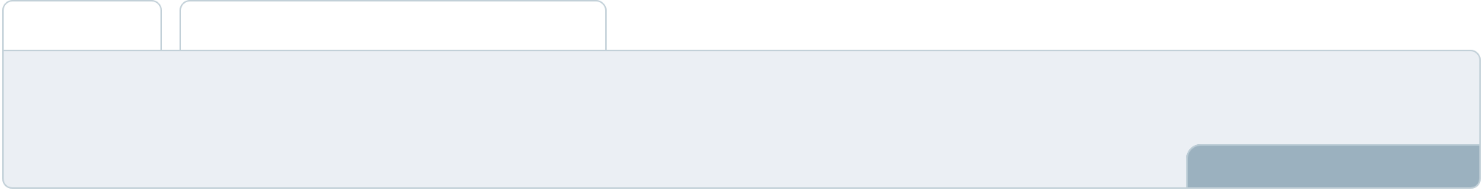

The cash flow for the first few years of your operation should be estimated and described in this section. This may include billing invoices, payment receipts, loan payments, and any other cash flow statements.
To unlock help try Upmetrics! 

Cash flow statement

 | 2023-24 | 2024-25 | 2025-26 | 2026-27 | 2027-28
Cash Received | $0 | $0 | $0 | $0 | $0
Cash Paid | $0 | $0 | $0 | $0 | $0
COS & General Expenses | $0 | $0 | $0 | $0 | $0
Salary & Wages | $0 | $0 | $0 | $0 | $0
Interest | $0 | $0 | $0 | $0 | $0

Sales Tax

Income Tax

Net Cash From

Operations

Assets Sell

Assets Purchase

Net Cash From

Investments

Amount Received

Loan Received

Common Stock

Preferred Stock

Owner's Contribution

Amount Paid

2023-24 | 2024-25 | 2025-26 | 2026-27 | 2027-28
$0 | $0 | $0 | $0 | $0
$0 | $0 | $0 | $0 | $0
$0 | $0 | $0 | $0 | $0

$0 | $0 | $0 | $0 | $0
$0 | $0 | $0 | $0 | $0
$0 | $0 | $0 | $0 | $0

$0 | $0 | $0 | $0 | $0
$0 | $0 | $0 | $0 | $0

$0 | $0 | $0 | $0 | $0
$0 | $0 | $0 | $0 | $0
$0 | $0 | $0 | $0 | $0

Loan Capital $0 $0 $0 $0 $0

 |  |  | 2023-24 | 2024-25 | 2025-26 | 2026-27 | 2027-28
Dividends & Distributions |  |  | $0 | $0 | $0 | $0 | $0
Net Cash From |  |  | $0 | $0 | $0 | $0 | $0
Financing
Summary
Starting Cash |  |  | $0 | $0 | $0 | $0 | $0
Cash In |  |  | $0 | $0 | $0 | $0 | $0
Cash Out |  |  | $0 | $0 | $0 | $0 | $0
Change in Cash |  |  | $0 | $0 | $0 | $0 | $0
Ending Cash |  |  | $0 | $0 | $0 | $0 | $0
 Help tip |  |  Non Medical Home Care Business Plan

Create a projected balance sheet documenting your non-medical home care business’s assets, liabilities, and equity.

To unlock help try Upmetrics! 

Balance sheet

 | 2023-24 | 2024-25 | 2025-26 | 2026-27 | 2027-28
Assets | $0 | $0 | $0 | $0 | $0
Current Assets | $0 | $0 | $0 | $0 | $0
Cash | $0 | $0 | $0 | $0 | $0
Accounts Receivable | $0 | $0 | $0 | $0 | $0
Inventory | $0 | $0 | $0 | $0 | $0
Other Current Assets | $0 | $0 | $0 | $0 | $0
Long Term Assets | $0 | $0 | $0 | $0 | $0
Gross Long Term Assets | $0 | $0 | $0 | $0 | $0
Accumulated Depreciation | $0 | $0 | $0 | $0 | $0

Liabilities & Equity | $0 | $0 | $0 | $0 | $0
Liabilities | $0 | $0 | $0 | $0 | $0
Current Liabilities | $0 | $0 | $0 | $0 | $0
Accounts Payable | $0 | $0 | $0 | $0 | $0
Income Tax Payable | $0 | $0 | $0 | $0 | $0
Sales Tax Payable | $0 | $0 | $0 | $0 | $0
Short Term Debt | $0 | $0 | $0 | $0 | $0
 | 2023-24 | 2024-25 | 2025-26 | 2026-27 | 2027-28
Long Term Liabilities | $0 | $0 | $0 | $0 | $0
Long Term Debt | $0 | $0 | $0 | $0 | $0
Equity | $0 | $0 | $0 | $0 | $0
Paid-in Capital | $0 | $0 | $0 | $0 | $0
Common Stock | $0 | $0 | $0 | $0 | $0
Preferred Stock | $0 | $0 | $0 | $0 | $0
Owner's Contribution | $0 | $0 | $0 | $0 | $0
Retained Earnings | $0 | $0 | $0 | $0 | $0

Check | $0 |  |  | $0 | $0 | $0 | $0
 Help tip |  |  Non Medical Home Care Business Plan

Determine and mention your business’s break-even point—the point at which your business costs and revenue will be equal.

This exercise will help you understand how much revenue you need to generate to sustain or be profitable.
To unlock help try Upmetrics! 

Break-even Analysis

 | 2023-24 | 2024-25 | 2025-26 | 2026-27 | 2027-28
Starting Revenue | $0 | $0 | $0 | $0 | $0
Net Revenue | $0 | $0 | $0 | $0 | $0
Closing Revenue | $0 | $0 | $0 | $0 | $0

Starting Expense | $0 | $0 | $0 | $0 | $0
Net Expense | $0 | $0 | $0 | $0 | $0
Closing Expense | $0 | $0 | $0 | $0 | $0

Is Break Even? | 0 | 0 | 0 | 0 | 0
Break Even Month | 0 | 0 | 0 | 0 | 0
Days Required | 0 | 0 | 0 | 0 | 0
Break Even Revenue | $0 | $0 | $0 | $0 | $0
Break Even Units
Financing needs

 Help tip  Non Medical Home Care Business Plan

Calculate costs associated with starting a non-medical home care business, and estimate your financing needs and how much capital you need to raise to operate your business.
To unlock help try Upmetrics! 

Start writing here..
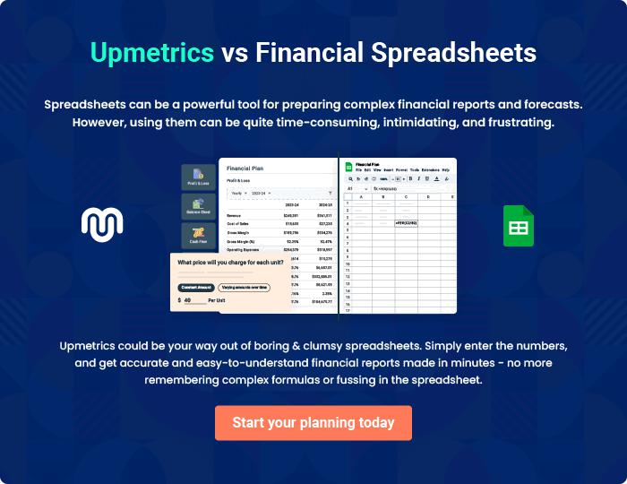
Appendix

When writing the appendix section, you should include any additional information that supports the main content of your plan. This may include financial statements, market research data, legal documents, and other
To unlock help try Upmetrics! 
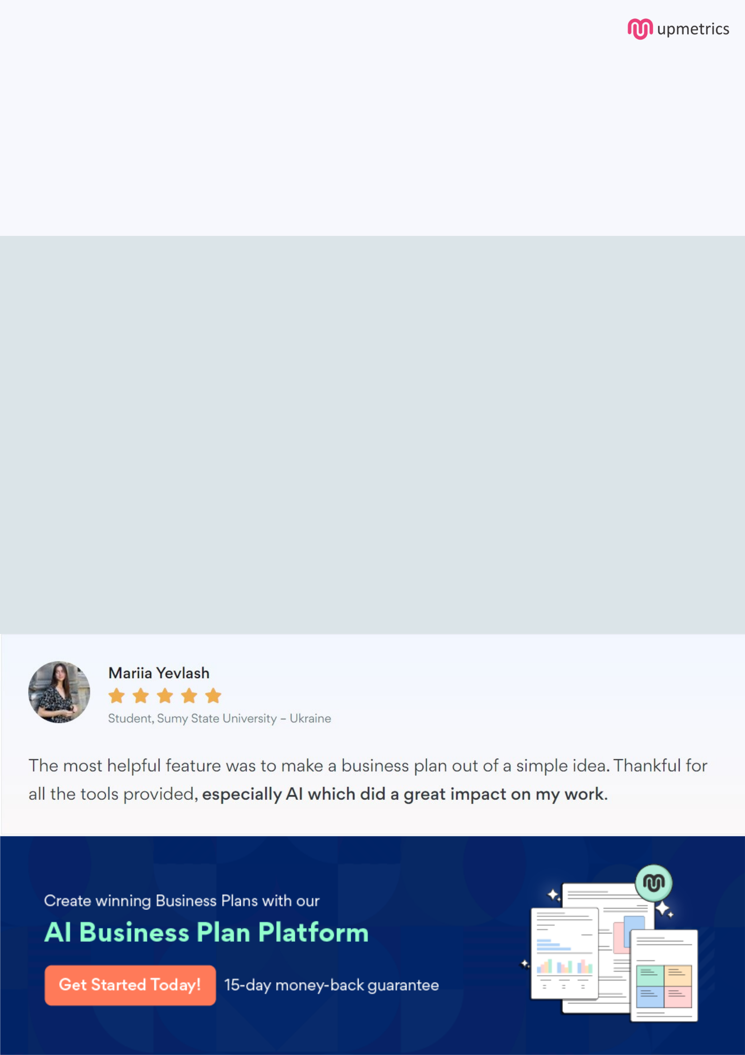
Create a winning business plan that gets you funded

Creating a stunning and investment-ready plan requires no writing, graphic designing, or financial planning expertise.

Upmetrics has all the features required to help you create a comprehensive business plan—from start to finish. Make no mistakes, it’s the modern way of planning to structure ideas, make plans, and create stunning pitch decks to awe investors.

Pitch decks that impress investors

Create pitch decks that provide a visual representation of your business, engage investors, and make them want to invest in your business idea.

Interactive plans in no time

Import business plan sections like—SWOT analysis, comparison tables, and others to create an interactive business plan. No designing skills are required.

Stunning cover page designs

With Upmetrics, you have the liberty to choose from multiple stunning cover page designs. Choose a creative design and make your plan stand out.

Online sharing made simple

Upmetrics makes online sharing quick and easier for users. Easily share your business plans with a link while tracking reader activity.

500+ sample business plans

Simply import a template from our library of sample plans into the editor and start customizing it to make it yours. It takes only a few clicks to get started.

Collaborate with team in real-time

Invite team members, initiate conversations, discuss ideas & strategies, share feedback, and work on a business plan in real-time.

