
Mobile Mechanic Business Plan

BUSINESS PLAN

Mechanics, Wherever You Are

Prepared By

John Doe

10200 Bolsa Ave, Westminster, CA, 92683

info@example.com

(650) 359-3153 http://www.example.com

Table of Contents

Executive Summary | 6
Market opportunity | 6
Services Offered | 6
Marketing & Sales Strategies | 7
Financial Highlights | 7
Units Sold v/s Revenue | 8

Company Overview | 9
Ownership | 9
Mission statement | 10
Business history | 10
Future goals | 10

Market Analysis | 11
Target Market | 11
Market size and growth potential | 11
Market Size | 12
Competitive analysis | 12
MobileFix Pros | 12
AutoAssist Now | 13
RoadReady Repairs | 13
Market trends | 13
Regulatory environment | 14

Products and Services | 15
Mechanic Services | 15
Basic Vehicle Inspection | 15
Premium Engine Service | 16
Brake System Overhaul | 16
Tire Rotation and Alignment | 17
AC Service and Refill | 17
24/7 Emergency Roadside Assistance | 18
Maintenance Services | 18
Parts and Accessories | 18
Quality Measures | 19
Additional Services | 19

Sales And Marketing Strategies | 20
Unique Selling Proposition (USP) | 20
Pricing Strategy | 20
Marketing strategies | 21
Online | 21
Offline | 21
Sales strategies | 22
Customer retention | 23

Operations Plan | 24
Staffing & Training | 24
Operational Process | 24
Equipment & Machinery | 25

Management Team | 26
Key managers | 26
John Doe | 26
Jane Doe | 27
Alice Brown | 27
Robert Brown | 27
Organizational structure | 28
Organization chart | 28
Compensation plan | 28
Advisors/Consultants | 29
[ADVISOR NAME] | 29
[CONSULTANT NAME] | 29
Financial Plan | 30
Profit & loss statement | 30
Cash flow statement | 33
Balance sheet | 35
Break-even Analysis | 37
Financing needs | 39
Appendix
Appendix | 41
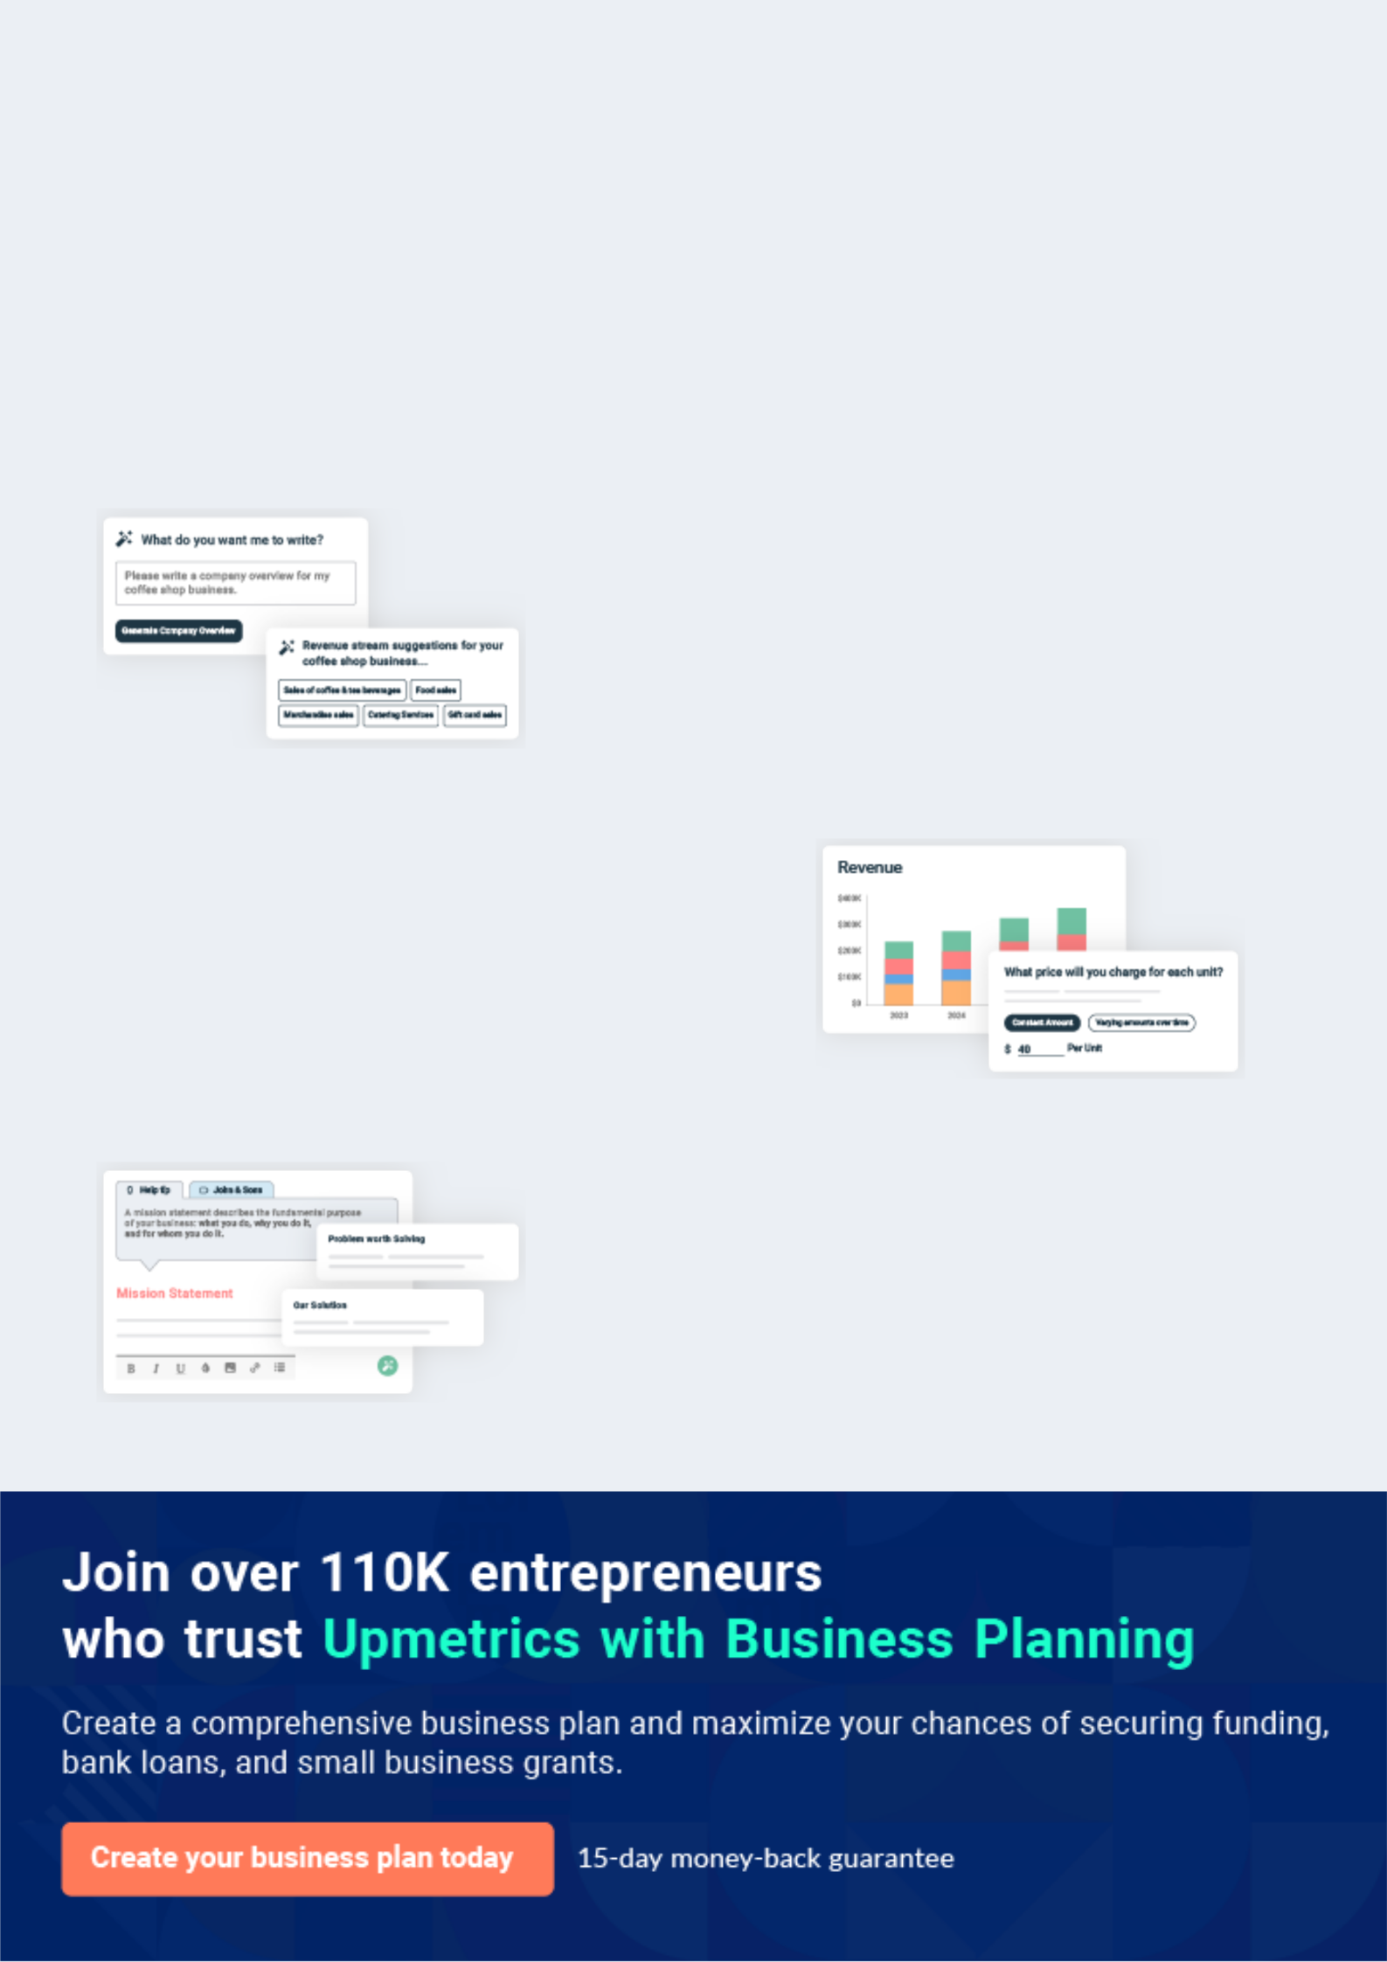
Business planning that’s simpler and faster than you think

Creating a business plan using Upmetrics to start and grow a business is literally the easiest thing in the World. Simply read the instructions and fill in the blanks. It’s as simple as that.

❛ | Upmetrics has everything you need to create a | ❜
❛ | comprehensive business plan. | ❜

AI-powered Upmetrics Assistant

AI-powered insights to streamline your plan

Not sure where to start? Upmetrics’ AI Assistant will automatically generate ideas for each section of your plan and offer improved versions of your writing, adjusting for tone, voice, and grammar or spelling errors.

Financial Forecasting Tool

All the financials are calculated for you

Forget the complex formulas and clumsy spreadsheets — with automatic financials and drag-and-drop forecasting, you can finish your plan faster and be confident that your numbers are accurate.

Business Plan Builder

Guides you like a business mentor

Upmetrics’ step-by-step instructions, prompts, and the library of 400+ sample business plans will guide you through each section of your plan as a business mentor.
Executive Summary


An executive summary is the first section of the business plan intended to provide an overview of the whole business plan.
To unlock help try Upmetrics! 

 Help tip  Mobile Mechanic Business Plan


Start your executive summary by briefly introducing your business to your readers.

This section may include the name of your mobile mechanic business, its location, when it was
To unlock help try Upmetrics! 

Start writing here..

Market opportunity

 Help tip  Mobile Mechanic Business Plan

Summarize your market research, including market size, growth potential, and marketing trends. Highlight the opportunities in the market and how your business will fit in to fill the gap.
To unlock help try Upmetrics! 

Start writing here..

Services Offered

 Help tip  Mobile Mechanic Business Plan

Highlight the mobile mechanic services you offer your clients. The USPs and differentiators you offer are always a plus.
To unlock help try Upmetrics! 

Start writing here..

Marketing & Sales Strategies
To unlock help try Upmetrics!

 Help tip


_{Outline}Mobile_{your}Mechanic_{sales} Business_{andmarketing}PlanTo create_{strategies}awareness_{—what}and_{marketing}buildarobust_{platforms}clientbase,_{you use,}we've_{how}formulated_{youplan}acomprehensive m on acquiring customers, etc.
To unlock help try Upmetrics! 

Start writing here..

Financial Highlights

 Help tip  Mobile Mechanic Business Plan

Briefly summarize your financial projections for the initial years of business operations. Include any capital or investment requirements, associated startup costs, projected revenues, and profit forecasts.



Start writing here..
Units Sold v/s Revenue

 |  | Units Sold | Revenue
15.00k
10.00k
5.00k
0
Year 1 | Year 2 | Year 3


Financial Year |  |  | Units Sold | Revenue
Year 1 | 1,550 |  |  | $10,000
Year 2 | 1,800 |  |  | $12,000
Year 3 | 2,050 |  |  | $14,000
 Help tip |  |  Mobile Mechanic Business Plan


Summarize your executive summary section with a clear CTA, for example, inviting angel investors to discuss the potential business investment.
To unlock help try Upmetrics! 

Write a call to action for your business plan.
Company Overview

Depending on what details of your business are essential, you’ll need different elements in your business overview.
To unlock help try Upmetrics! 

 Help tip  Mobile Mechanic Business Plan

Describe your business in this section by providing all the basic information:

Describe what kind of mobile mechanic company you run and the name of it. You may
To unlock help try Upmetrics! 

Start writing here..

Ownership

 Help tip  Mobile Mechanic Business Plan

List the names of your mobile mechanic company’s founders or owners. Describe what shares they own and their responsibilities for efficiently managing the business.
To unlock help try Upmetrics! 

Start writing here..
Mission statement

 Help tip  Mobile Mechanic Business Plan

Summarize your business’ objective, core principles, and values in your mission statement. This statement needs to be memorable, clear, and brief.
To unlock help try Upmetrics! 

❛ At [AutoMend Mobile Mechanics], our mission is to deliver exceptional mobile mechanic services with unparalleled convenience. Driven by commitment, integrity, and excellence, we aim to redefine the boundaries of automotive repair, one vehicle

at a time.
❜

Business history

 Help tip  Mobile Mechanic Business Plan

If you’re an established mobile mechanic service provider, briefly describe your business history, like—when it was founded, how it evolved over time, etc.
To unlock help try Upmetrics! 

Start writing here..

Future goals

 Help tip  Mobile Mechanic Business Plan

It’s crucial to convey your aspirations and vision. Mention your short-term and long-term goals; they can be specific targets for revenue, market share, or expanding your services.
To unlock help try Upmetrics! 

Start writing here..

Market Analysis
To unlock help try Upmetrics!


 |  | Market analysis provides a clear understanding of the market in which your
 |  | printing business will run along with the target market, competitors, and
 |  | growth opportunities.
 |  |  |  | To unlock help try Upmetrics! 
 Help tip |  |  Mobile Mechanic Business Plan

To write the introduction section of your market analysis, start by clearly identifying your primary target market.
To unlock help try Upmetrics! 

Start writing here..

Target Market

 Help tip  Mobile Mechanic Business Plan

Start this section by describing your target market. Define your ideal customer and explain what types of services they prefer. Creating a buyer persona will help you easily define your target market to your readers.



Start writing here..

Market size and growth potential

 Help tip  Mobile Mechanic Business Plan

Describe your market size and growth potential and whether you will target a niche or a much broader market.
To unlock help try Upmetrics! 

Start writing here..

Market Size


Available Market | 5M
Total vehicle owners in [Region/City]. | 5M
Served Market | 1M
Vehicle owners who currently use | 1M
mobile mechanic services in [Region/ | 1M
City].
Target Market | 250k
Busy professionals & families preferring | 250k
on-spot repair in [Region/City].

 Help tip  Mobile Mechanic Business Plan

Identify and analyze your direct and indirect competitors. Identify their strengths and weaknesses, and describe what differentiates your mobile mechanic services from them.
To unlock help try Upmetrics! 

Competitive analysis

MobileFix Pros

Founded in [Year], MobileFix Pros has grown to become one of the leading mobile mechanic services in the [Region/City]. With a fleet of over [XX] mobile units, they cater to both individual vehicle owners and commercial fleets.

Features | Strengths | Weaknesses
On-the-spot repair and | Broad service offerings | Higher pricing compared to
maintenance | catering to diverse needs | market average
Pre-scheduled maintenance | Strong brand recognition in the | Longer wait times during peak
packages | region | hours
Fleet vehicle management | Significant online presence | Limited service areas outside the
solutions | with positive reviews | metropolitan region
24/7 emergency breakdown | Partnership deals with major
services | vehicle brands

AutoAssist Now

AutoAssist Now, established in [Year], differentiates itself by integrating advanced technology into its mobile mechanic solutions. They have a strong focus on tech-savvy, younger vehicle owners.

Features

Remote diagnostics using telematics

Mobile app for easy service booking and vehicle health tracking

Electric vehicle (EV) repair specialists

Environmentally-friendly repair solutions

Strengths

Innovative tech-driven services resonate with younger demographics

Specialization in EV repair, catering to a growing market

Environmentally-conscious approach appeals to eco-friendly customers

Weaknesses

Less experience in traditional automotive repair

Limited services for older vehicle models

Pricing model can be confusing with too many tiered options

RoadReady Repairs

A veteran in the industry, RoadReady Repairs has been serving customers since [Year]. They rely on their vast experience and deep community ties.

Features | Strengths | Weaknesses
Comprehensive repair and | Decades of experience and | Slow adoption of technological
maintenance for all vehicle | trust in the community | advancements
types | Diverse service offerings for a | Outdated branding and online
Seasonal vehicle check-ups | broad clientele | presence
Community workshops on | Strong customer loyalty with | Less flexibility in service
vehicle maintenance and safety | high retention rates | packages
Loyalty programs for repeat
customers

Market trends

 Help tip  Mobile Mechanic Business Plan

Analyze emerging trends in the industry, such as technology disruptions, changes in customer behavior or preferences, etc. Explain how your business will cope with all the trends.
To unlock help try Upmetrics! 

Start writing here..

Regulatory environment
To unlock help try Upmetrics!

 Help tip  Mobile Mechanic Business Plan

List regulations and licensing requirements that may affect your mobile mechanic company, such as business registration, insurance, environmental regulations, state and federal regulations, etc.



Start writing here..
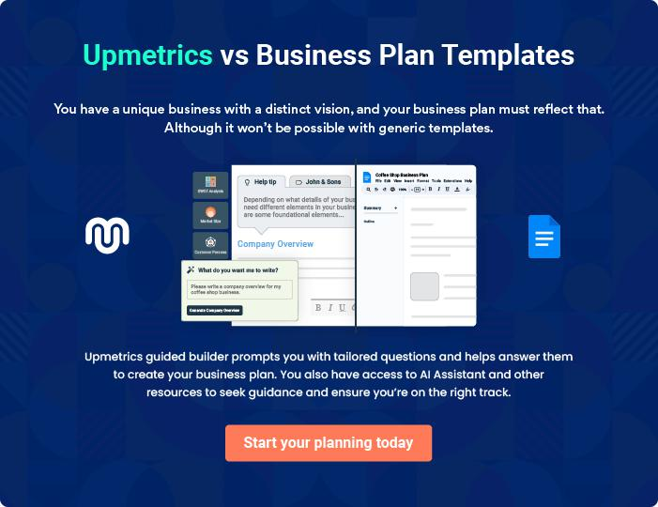
Products and Services

 |  | The product and services section of a mobile mechanic business plan should
 |  | describe the specific services and products offered to customers. To write
 |  | this section should include the following:
 |  |  |  | To unlock help try Upmetrics! 
 Help tip |  |  Mobile Mechanic Business Plan

To craft the introduction for your "Products and Services" chapter, begin by positioning your business within its industry, emphasizing its unique strengths or value proposition.
To unlock help try Upmetrics! 

Start writing here..

 Help tip


Mention the mobile mechanic services your business will offer. This list may include services like,
To unlock help try Upmetrics! 

Mechanic Services

Basic Vehicle Inspection


Price: $[50.00]

A thorough examination of your vehicle to ensure it's running at its best. Ideal for those seeking a general check-up of their vehicle's condition.

Specifications

- Check of all fluids (engine oil, brake fluid, transmission fluid, coolant).

- Inspection of belts and hoses.

- Tire pressure and tread depth examination.

- Battery performance test.
Premium Engine Service

Price: $[150.00]

Comprehensive engine service that caters to all engine types and ensures optimized performance and longevity.

Specifications

- Full engine oil change with premium oil.

- Replacement of air filters.

- Cleaning and checking of spark plugs.

- Detailed engine diagnostic and report.

Brake System Overhaul

Price: $[200.00]

A complete service of your vehicle's brake system to ensure safety and peak performance.

Specifications

- Replacement of brake pads and/or shoes.

- Resurfacing or replacement of rotors.

- Brake fluid flush and refill.

- Brake system performance test.
Tire Rotation and Alignment

Price: $[80.00]

Ensuring even tire wear and optimum drive performance with our tire rotation and alignment service

Specifications

- Proper rotation of all tires to guarantee even wear.

- Computerized alignment of wheels.

- Balancing of all four wheels.

AC Service and Refill

Price: $[90.00]

Beat the heat with our AC service, ensuring a comfortable and cool driving experience.

Specifications

- Refrigerant refill.

- Inspection and cleaning of AC condenser and evaporator.

- Check of all AC hoses and belts.

- Performance test to ensure optimal cooling
24/7 Emergency Roadside Assistance

Price: $[19.99/month]

Peace of mind, round the clock. Whether it's a flat tire, dead battery, or any other hiccup, our team is just a call away.

Specifications

- On-spot minor repairs.

- Battery jump-start.

- Flat tire assistance.

- Towing services (additional charges may apply).

Maintenance Services

 Help tip  Mobile Mechanic Business Plan

Mention the maintenance services your business will offer. This list may include regular inspections and routine maintenance tasks.
To unlock help try Upmetrics! 

Start writing here..

Parts and Accessories

 Help tip  Mobile Mechanic Business Plan

Mention if your mobile repair services will offer the necessary parts and accessories for the repairs and upgrades.
To unlock help try Upmetrics! 

Start writing here..

Quality Measures

 Help tip  Mobile Mechanic Business Plan

This section should explain how you maintain quality standards and consistently provide the highest quality service.
To unlock help try Upmetrics! 

Start writing here..

Additional Services

 Help tip  Mobile Mechanic Business Plan

Mention if your mobile mechanic company offers any additional services. You may include services like remote diagnosis, roadside assistance, etc.
To unlock help try Upmetrics! 

Start writing here..
Sales And Marketing Strategies

Writing the sales and marketing strategies section means a list of strategies you will use to attract and retain your clients.
To unlock help try Upmetrics! 

 Help Tip  Mobile Mechanic Business Plan


To create an effective introduction for your "Sales and Marketing Strategies" chapter, start by setting the stage within your specific industry or market.
To unlock help try Upmetrics! 

Start writing here..

Unique Selling Proposition (USP)

 Help tip  Mobile Mechanic Business Plan

Define your business’s USPs depending on the market you serve, the equipment you use, and the unique services you provide. Identifying USPs will help you plan your marketing strategies.
To unlock help try Upmetrics! 

Start writing here..

Pricing Strategy

 Help tip  Mobile Mechanic Business Plan

Describe your pricing strategy—how you plan to price your mechanic services and stay competitive in the local market.
To unlock help try Upmetrics! 

Start writing here..

 Help tip  Mobile Mechanic Business Plan
To unlock help try Upmetrics!

Discuss your marketing strategies to market your services. You may include some of these marketing strategies in your business plan—social media marketing, Google ads, brochures, email marketing, content marketing, and print marketing.



Marketing strategies

Online


Social Media

Leveraging platforms like Facebook, Instagram, and LinkedIn to create awareness, run ad campaigns, and engage with our audience.

Content Marketing

Regularly updating our blog with useful articles on car maintenance, mechanic tips, and more, driving organic traffic to our website.

Email Marketing

Regular newsletters and service reminders to our clientele, offering them special deals and keeping them engaged.

Google Ads

Ensuring we appear at the top of searches when potential clients are looking for mobile mechanic services in our region.

Offline

Brochures

Distributing visually appealing brochures in strategic locations such as [local stores, cafes, and other high-footfall areas].

Print Marketing

Engaging with local newspapers and magazines for advertisements and sponsored content.

 Help tip  Mobile Mechanic Business Plan
To unlock help try Upmetrics!

Outline the strategies you’ll implement to maximize your sales. Your sales strategies may include direct sales, partnering with auto dealerships and car rental agencies, offering referral programs, etc.



Sales strategies

Partner with Businesses

Collaborating with local auto dealerships and car rental agencies to offer exclusive service deals for their customers.

Referral Programs

Encouraging our satisfied customers to refer friends and family, rewarding them with discounts or complimentary services for successful referrals.

Direct Sales

Our team will be trained to upsell and cross-sell services where genuinely beneficial to the client.

 Help tip  Mobile Mechanic Business Plan
To unlock help try Upmetrics!

Describe your customer retention strategies and how you plan to execute them. For instance, introducing loyalty programs, discounts on regular maintenance and annual membership, personalized service, etc.



Customer retention

Loyalty Programs

Offering loyalty points for every service availed, which can be redeemed for discounts or complimentary services.

Personalized Service

Keeping records of each client's vehicle history, ensuring we offer tailored advice and services based on past interactions.

Regular Maintenance Discounts

Providing special discounts for customers opting for regular maintenance checks, ensuring their vehicle remains in top shape.

Operations Plan
To unlock help try Upmetrics!

 |  | When writing the operations plan section, it’s important to consider the
 |  | various aspects of your business operations.
 |  |  |  | To unlock help try Upmetrics! 
 Help tip |  |  Mobile Mechanic Business Plan


To create an effective introduction for your "Operational Plan" chapter, start by emphasizing the
pivotal role of efficient operations in the success of your business, underscoring how they
directly impact the quality of services delivered.
 |  |  |  | To unlock help try Upmetrics! 
Start writing here..
Staffing & Training
 Help tip |  |  Mobile Mechanic Business Plan

Mention your mechanic business’s staffing requirements, including the number of mechanics,
sales and administrative staff, and support staff needed. Include their qualifications, the
training required, and the duties they will perform.
 |  |  |  | To unlock help try Upmetrics! 
Start writing here..
Operational Process
 Help tip |  |  Mobile Mechanic Business Plan

Outline the processes and procedures you will use to run your mobile mechanic business. Your operational processes may include assessment and diagnosis, scheduling appointments, repair and maintenance, billing, payment collection, and training of staff.



Start writing here..

Equipment & Machinery

 Help tip  Mobile Mechanic Business Plan

Include the list of equipment and machinery required for mobile mechanics, such as hand and power tools, diagnostic equipment, lift and jacks, specialty equipment, service vehicles, etc.
To unlock help try Upmetrics! 

Start writing here..
Management Team

The management team section provides an overview of the individuals responsible for running your business plan.
To unlock help try Upmetrics! 

 Help tip  Mobile Mechanic Business Plan

To craft an introduction for your "Management Team" chapter, begin by emphasizing the crucial role of leadership in the success of any business.
To unlock help try Upmetrics! 

Start writing here..

Key managers

 Help tip  Mobile Mechanic Business Plan

Introduce your management and key members of your team, and explain their roles and responsibilities.
To unlock help try Upmetrics! 

Start writing here..


JOHN DOE

CEO & Co-founder - john.doe@example.com

John Doe, our CEO, is the driving force behind [AutoMend Mobile Mechanics].

With a vision to revolutionize the mobile mechanic industry, John amalgamates strategic planning, financial decision-making, and fostering partnerships to guide the company towards its objectives.


Holding a Master's degree in Business Administration from Stanford University and over 15 years of experience in the automobile industry, John's expertise is unparalleled.

JANE DOE

Chief Operating Officer (COO) - jane.doe@example.com

Jane Doe serves as our COO, ensuring the smooth functioning of day-to-day operations.

She ensures that our mobile mechanics are well-equipped, trained, and motivated to provide top-notch services.


Jane has a Bachelor's in Mechanical Engineering from the Massachusetts Institute of Technology and has dedicated over 10 years to operations management in the auto repair sector.


ALICE BROWN

CMO - alice.brown@example.com

Spearheading our marketing initiatives is Alice Brown. With an innovative approach and a pulse on market dynamics, Alice crafts strategies that bolster our brand presence and outreach.

Alice graduated with a degree in Marketing from Harvard Business School and has 12 years of experience, of which 8 years are in strategic marketing for automobile services.


ROBERT BROWN

Operations Manager - robert.brown@example.com

Managing ground-level operations, ensuring timely service, and troubleshooting operational challenges are all in a day's work for Robert Brown.

With a rich background in Automobile Repair from the University of Michigan and hands-on experience of over 9 years, Robert plays a pivotal role in our daily business execution.
Organizational structure

 Help tip  Mobile Mechanic Business Plan

Explain the organizational structure of your management team. Include the reporting line and decision-making hierarchy.
To unlock help try Upmetrics! 

Start writing here..

Organization chart


John Doe

CEO


Alice Brown Robert Brown Jane Doe

CMO Operations Manager COO




James Black Lily Green Mary White

Customer Service Finance Manager Admin Manager

Compensation plan

 Help tip  Mobile Mechanic Business Plan

Describe your compensation plan for the management and staff. Include their salaries, incentives, and other benefits.
To unlock help try Upmetrics! 

Start writing here..

 Help tip

Mentioning advisors or consultants in your business plans adds credibility to your business idea.
To unlock help try Upmetrics! 

Advisors/Consultants


[ADVISOR NAME]

Advisor

With over [X years] in the automotive industry, [Advisor’s Name] provides invaluable insights into market trends and strategic planning.


[CONSULTANT NAME]

Consultant

Specializing in [specific domain, e.g., "automotive technology"], [Consultant’s Name] advises us on staying abreast with technological advancements
Financial Plan

When writing the financial plan section of a business plan, it’s important to provide a comprehensive overview of your financial projections for the first few years of your business, You may provide the following:
To unlock help try Upmetrics! 

 Help tip  Mobile Mechanic Business Plan


To create an effective introduction for your "Financial Plan" chapter, begin by stressing the critical role of a well-structured financial plan in the success of your venture.
To unlock help try Upmetrics! 

Start writing here..

 Help tip


Describe details such as projected revenue, operational costs, and service costs in your projected profit and loss statement. Make sure to include your business’s expected net profit or loss.
To unlock help try Upmetrics! 

Profit & loss statement

Revenue

Cost Of Sales

General Costs

Revenue Specific Costs

Personnel Costs (Direct

Labor)

Gross Margin

Gross Margin (%)

Operating Expense

Payroll Expense

(Indirect Labor)

General Expense

Bad Debt

Amortization of Current

Assets

2023-24 | 2024-25 | 2025-26 | 2026-27 | 2027-28
$0 | $0 | $0 | $0 | $0

$0 | $0 | $0 | $0 | $0
$0 | $0 | $0 | $0 | $0
$0 | $0 | $0 | $0 | $0
$0 | $0 | $0 | $0 | $0

$0 | $0 | $0 | $0 | $0
0% | 0% | 0% | 0% | 0%

$0 | $0 | $0 | $0 | $0
$0 | $0 | $0 | $0 | $0
$0 | $0 | $0 | $0 | $0
$0 | $0 | $0 | $0 | $0
$0 | $0 | $0 | $0 | $0

EBITDA

Additional Expense

Long Term

Depreciation

Gain or loss from Sale

of Assets

EBIT

Interest Expenses

EBT

Income Tax Expense

Total Expense

Net Income

Net Income (%)

2023-24 | 2024-25 | 2025-26 | 2026-27 | 2027-28
$0 | $0 | $0 | $0 | $0
$0 | $0 | $0 | $0 | $0
$0 | $0 | $0 | $0 | $0
$0 | $0 | $0 | $0 | $0
$0 | $0 | $0 | $0 | $0
$0 | $0 | $0 | $0 | $0
$0 | $0 | $0 | $0 | $0
$0 | $0 | $0 | $0 | $0
$0 | $0 | $0 | $0 | $0
$0 | $0 | $0 | $0 | $0
0% | 0% | 0% | 0% | 0%
 | 2023-24 | 2024-25 | 2025-26 | 2026-27 | 2027-28
Retained Earning | $0 | $0 | $0 | $0 | $0
Opening
Owner's Distribution | $0 | $0 | $0 | $0 | $0
Retained Earning | $0 | $0 | $0 | $0 | $0
Closing

 Help tip

The cash flow for the first few years of your operation should be estimated and described in this section. This may include billing invoices, payment receipts, loan payments, and any other cash flow statements.
To unlock help try Upmetrics! 

Cash flow statement

 | 2023-24 | 2024-25 | 2025-26 | 2026-27 | 2027-28
Cash Received | $0 | $0 | $0 | $0 | $0
Cash Paid | $0 | $0 | $0 | $0 | $0
COS & General Expenses | $0 | $0 | $0 | $0 | $0
Salary & Wages | $0 | $0 | $0 | $0 | $0
Interest | $0 | $0 | $0 | $0 | $0

Sales Tax

Income Tax

Net Cash From

Operations

Assets Sell

Assets Purchase

Net Cash From

Investments

Amount Received

Loan Received

Common Stock

Preferred Stock

Owner's Contribution

Amount Paid

2023-24 | 2024-25 | 2025-26 | 2026-27 | 2027-28
$0 | $0 | $0 | $0 | $0
$0 | $0 | $0 | $0 | $0
$0 | $0 | $0 | $0 | $0

$0 | $0 | $0 | $0 | $0
$0 | $0 | $0 | $0 | $0
$0 | $0 | $0 | $0 | $0

$0 | $0 | $0 | $0 | $0
$0 | $0 | $0 | $0 | $0

$0 | $0 | $0 | $0 | $0
$0 | $0 | $0 | $0 | $0
$0 | $0 | $0 | $0 | $0

Loan Capital $0 $0 $0 $0 $0

 | 2023-24 | 2024-25 | 2025-26 | 2026-27 | 2027-28
Dividends & Distributions | $0 | $0 | $0 | $0 | $0
Net Cash From | $0 | $0 | $0 | $0 | $0
Financing

Summary
Starting Cash | $0 | $0 | $0 | $0 | $0
Cash In | $0 | $0 | $0 | $0 | $0
Cash Out | $0 | $0 | $0 | $0 | $0
Change in Cash | $0 | $0 | $0 | $0 | $0
Ending Cash | $0 | $0 | $0 | $0 | $0

 Help tip

Create a projected balance sheet documenting your mobile mechanic business’s assets, liabilities, and equity.

To unlock help try Upmetrics! 

Balance sheet

 | 2023-24 | 2024-25 | 2025-26 | 2026-27 | 2027-28
Assets | $0 | $0 | $0 | $0 | $0
Current Assets | $0 | $0 | $0 | $0 | $0
Cash | $0 | $0 | $0 | $0 | $0
Accounts Receivable | $0 | $0 | $0 | $0 | $0
Inventory | $0 | $0 | $0 | $0 | $0
Other Current Assets | $0 | $0 | $0 | $0 | $0
Long Term Assets | $0 | $0 | $0 | $0 | $0
Gross Long Term Assets | $0 | $0 | $0 | $0 | $0
Accumulated Depreciation | $0 | $0 | $0 | $0 | $0

Liabilities & Equity | $0 | $0 | $0 | $0 | $0
Liabilities | $0 | $0 | $0 | $0 | $0
Current Liabilities | $0 | $0 | $0 | $0 | $0
Accounts Payable | $0 | $0 | $0 | $0 | $0
Income Tax Payable | $0 | $0 | $0 | $0 | $0
Sales Tax Payable | $0 | $0 | $0 | $0 | $0
Short Term Debt | $0 | $0 | $0 | $0 | $0
 | 2023-24 | 2024-25 | 2025-26 | 2026-27 | 2027-28
Long Term Liabilities | $0 | $0 | $0 | $0 | $0
Long Term Debt | $0 | $0 | $0 | $0 | $0
Equity | $0 | $0 | $0 | $0 | $0
Paid-in Capital | $0 | $0 | $0 | $0 | $0
Common Stock | $0 | $0 | $0 | $0 | $0
Preferred Stock | $0 | $0 | $0 | $0 | $0
Owner's Contribution | $0 | $0 | $0 | $0 | $0
Retained Earnings | $0 | $0 | $0 | $0 | $0

Check | $0 |  |  | $0 | $0 | $0 | $0
 Help tip |  |  Mobile Mechanic Business Plan


Determine and mention your business’s break-even point—the point at which your business costs and revenue will be equal.

This exercise will help you understand how much revenue you need to generate to sustain or be profitable.
To unlock help try Upmetrics! 

Break-even Analysis

 | 2023-24 | 2024-25 | 2025-26 | 2026-27 | 2027-28
Starting Revenue | $0 | $0 | $0 | $0 | $0
Net Revenue | $0 | $0 | $0 | $0 | $0
Closing Revenue | $0 | $0 | $0 | $0 | $0

Starting Expense | $0 | $0 | $0 | $0 | $0
Net Expense | $0 | $0 | $0 | $0 | $0
Closing Expense | $0 | $0 | $0 | $0 | $0

Is Break Even? | 0 | 0 | 0 | 0 | 0
Break Even Month | 0 | 0 | 0 | 0 | 0
Days Required | 0 | 0 | 0 | 0 | 0
Break Even Revenue | $0 | $0 | $0 | $0 | $0
Break Even Units
Financing needs

 Help tip  Mobile Mechanic Business Plan

Calculate costs associated with starting a mobile mechanic business, and estimate your financing needs and how much capital you need to raise to operate your business.
To unlock help try Upmetrics! 

Start writing here..
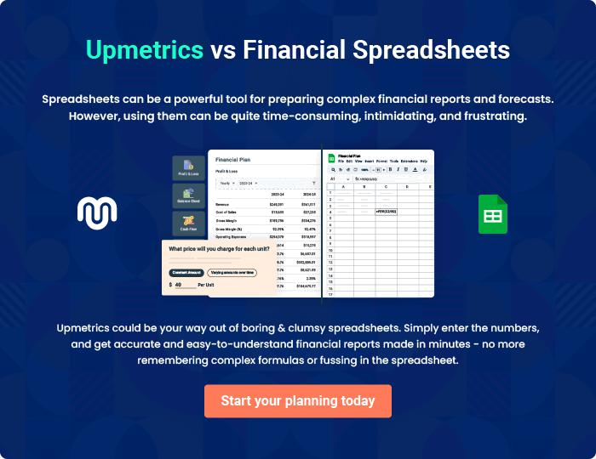
Appendix

When writing the appendix section, you should include any additional information that supports the main content of your plan. This may include financial statements, market research data, legal documents, and other
To unlock help try Upmetrics! 

Create a winning business plan that gets you funded

Creating a stunning and investment-ready plan requires no writing, graphic designing, or financial planning expertise.

Upmetrics has all the features required to help you create a comprehensive business plan—from start to finish. Make no mistakes, it’s the modern way of planning to structure ideas, make plans, and create stunning pitch decks to awe investors.

Pitch decks that impress investors

Create pitch decks that provide a visual representation of your business, engage investors, and make them want to invest in your business idea.

Interactive plans in no time

Import business plan sections like—SWOT analysis, comparison tables, and others to create an interactive business plan. No designing skills are required.

Stunning cover page designs

With Upmetrics, you have the liberty to choose from multiple stunning cover page designs. Choose a creative design and make your plan stand out.

Online sharing made simple

Upmetrics makes online sharing quick and easier for users. Easily share your business plans with a link while tracking reader activity.

500+ sample business plans

Simply import a template from our library of sample plans into the editor and start customizing it to make it yours. It takes only a few clicks to get started.

Collaborate with team in real-time

Invite team members, initiate conversations, discuss ideas & strategies, share feedback, and work on a business plan in real-time.

