
Mobile Game Business Plan

BUSINESS PLAN

Adventure in Every App

Prepared By

John Doe

10200 Bolsa Ave, Westminster, CA, 92683

info@example.com

(650) 359-3153 http://www.example.com

Table of Contents

Executive Summary | 6
Market opportunity | 6
Services Offered | 6
Marketing & Sales Strategies | 7
Financial Highlights | 7
Units Sold v/s Revenue | 8

Company Overview | 9
Ownership | 9
Mission statement | 10
Business history | 10
Future goals | 10

Market Analysis | 11
Target Market | 11
Market size and growth potential | 11
Market Size | 12
Competitive analysis | 12
GameMasters Guild | 12
MobileStrat Pro | 13
CasualPlay Corner | 13
Market trends | 13
Regulatory environment | 14

Products and Services | 15
Products & Services | 15
Platinum Gaming Package | 16
Strategy Guide eBook | 16
Customizable Avatar Accessories | 17
Live Streaming Toolkit | 17
VIP Tournament Entry | 18
Features & Functionality | 18
Quality Measures | 18
Additional Services | 19

Sales And Marketing Strategies | 20
Unique Selling Proposition (USP) | 20
Pricing Strategy | 20
Marketing strategies | 21
Online | 21
Sales strategies | 22
Customer retention | 23

Operations Plan | 24
Staffing & Training | 24
Operational Processes | 24
Technology & Equipment | 25

Management Team | 26
Key managers | 26
John Doe | 27
Jane Doe | 27
Alice Brown | 28
Robert Brown | 28
Organizational structure | 28
Organization chart | 28
Compensation plan | 30
Advisors/Consultants | 30
Dr. Richard Smith | 30
Ms. Clara Williams | 31

Financial Plan | 32
Profit & loss statement | 32
Cash flow statement | 35
Balance sheet | 37
Break-even Analysis | 39
Financing needs | 41
Appendix
Appendix | 43
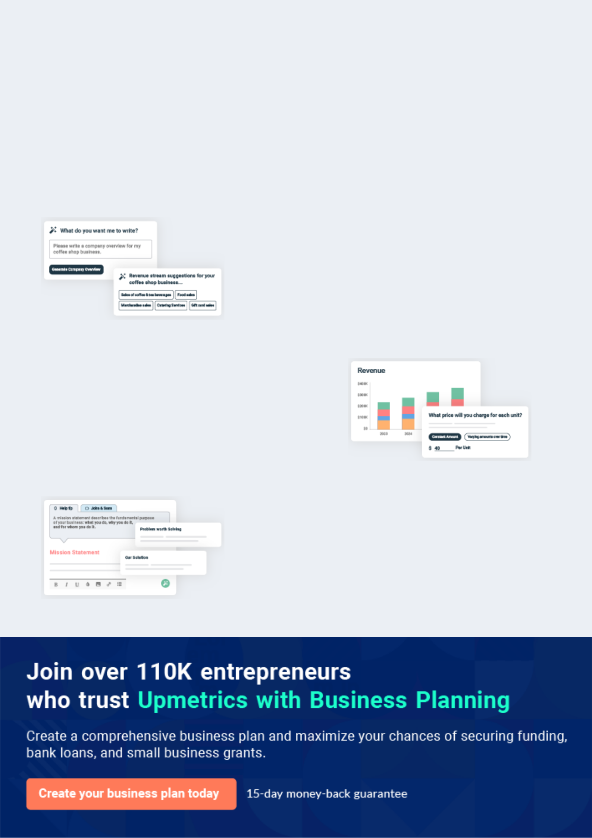
Business planning that’s simpler and faster than you think

Creating a business plan using Upmetrics to start and grow a business is literally the easiest thing in the World. Simply read the instructions and fill in the blanks. It’s as simple as that.

❛ | Upmetrics has everything you need to create a | ❜
❛ | comprehensive business plan. | ❜

AI-powered Upmetrics Assistant

AI-powered insights to streamline your plan

Not sure where to start? Upmetrics’ AI Assistant will automatically generate ideas for each section of your plan and offer improved versions of your writing, adjusting for tone, voice, and grammar or spelling errors.

Financial Forecasting Tool

All the financials are calculated for you

Forget the complex formulas and clumsy spreadsheets — with automatic financials and drag-and-drop forecasting, you can finish your plan faster and be confident that your numbers are accurate.

Business Plan Builder

Guides you like a business mentor

Upmetrics’ step-by-step instructions, prompts, and the library of 400+ sample business plans will guide you through each section of your plan as a business mentor.
Executive Summary


An executive summary is the first section of the business plan intended to provide an overview of the whole business plan.
To unlock help try Upmetrics! 

 Help tip  Mobile Game Business Plan


Start your executive summary by briefly introducing your business to your readers.

This section may include the name of your mobile game business, its location, when it was
To unlock help try Upmetrics! 

Start writing here..

Market opportunity

 Help tip  Mobile Game Business Plan

Summarize your market research, including market size, growth potential, and marketing trends. Highlight the opportunities in the market and how your business will fit in to fill the gap.
To unlock help try Upmetrics! 

Start writing here..

Services Offered

 Help tip  Mobile Game Business Plan

Highlight the mobile game services you offer your clients. The USPs and differentiators you offer are always a plus.
To unlock help try Upmetrics! 

Start writing here..

Marketing & Sales Strategies
To unlock help try Upmetrics!

 Help tip  Mobile Game Business Plan

Outline your sales and marketing strategies—what marketing platforms you use, how you plan on acquiring customers, etc.
To unlock help try Upmetrics! 

Start writing here..

Financial Highlights

 Help tip  Mobile Game Business Plan

Briefly summarize your financial projections for the initial years of business operations. Include any capital or investment requirements, associated startup costs, projected revenues, and profit forecasts.



Start writing here..
Units Sold v/s Revenue

 |  | Units Sold | Revenue
15.00k
10.00k
5.00k
0
Year 1 | Year 2 | Year 3


Financial Year |  |  | Units Sold | Revenue
Year 1 | 1,550 |  |  | $10,000
Year 2 | 1,800 |  |  | $12,000
Year 3 | 2,050 |  |  | $14,000
 Help tip |  |  Mobile Game Business Plan


Summarize your executive summary section with a clear CTA, for example, inviting angel investors to discuss the potential business investment.
To unlock help try Upmetrics! 

Write a call to action for your business plan.
Company Overview

Depending on what details of your business are essential, you’ll need different elements in your business overview.
To unlock help try Upmetrics! 

 Help tip  Mobile Game Business Plan

Describe your business in this section by providing all the basic information:

Describe what kind of mobile game company you run and the name of it. You may specialize in
To unlock help try Upmetrics! 

Start writing here..

Ownership

 Help tip  Mobile Game Business Plan

List the names of your mobile game company’s founders or owners. Describe what shares they own and their responsibilities for efficiently managing the business.
To unlock help try Upmetrics! 

Start writing here..
Mission statement

 Help tip  Mobile Game Business Plan

Summarize your business’ objective, core principles, and values in your mission statement. This statement needs to be memorable, clear, and brief.
To unlock help try Upmetrics! 

❛ At [NextLevel Gaming Guide], we are committed to pushing the boundaries of mobile gaming, creating captivating experiences that delight players worldwide. Our core values of innovation, user-centric design, and operational excellence guide us in our

quest to become a leader in the mobile gaming industry.
❜

Business history

 Help tip  Mobile Game Business Plan

If you’re an established mobile game service provider, briefly describe your business history, like—when it was founded, how it evolved over time, etc.
To unlock help try Upmetrics! 

Start writing here..

Future goals

 Help tip  Mobile Game Business Plan

It’s crucial to convey your aspirations and vision. Mention your short-term and long-term goals; they can be specific targets for revenue, market share, or expanding your services.
To unlock help try Upmetrics! 

Start writing here..

Market Analysis
To unlock help try Upmetrics!


 |  | Market analysis provides a clear understanding of the market in which your
 |  | printing business will run along with the target market, competitors, and
 |  | growth opportunities.
 |  |  |  | To unlock help try Upmetrics! 
 Help tip |  |  Mobile Game Business Plan

To write the introduction section of your market analysis, start by clearly identifying your primary target market.
To unlock help try Upmetrics! 

Start writing here..

Target Market

 Help tip  Mobile Game Business Plan

Start this section by describing your target market. Define your ideal customer and explain what types of services they prefer. Creating a buyer persona will help you easily define your target market to your readers.



Start writing here..

Market size and growth potential

 Help tip  Mobile Game Business Plan

Describe your market size and growth potential and whether you will target a niche or a much broader market.
To unlock help try Upmetrics! 

Start writing here..

Market Size


Available Market | 250M
All mobile gamers worldwide | 250M

Served Market
Mobile gamers in RPG and Action 50M genres

Target Market
Users aged 18-35, interested in 10M strategy RPG

 Help tip  Mobile Game Business Plan

Identify and analyze your direct and indirect competitors. Identify their strengths and weaknesses, and describe what differentiates your mobile game services from them.
To unlock help try Upmetrics! 

Competitive analysis

GameMasters Guild

GameMasters Guild is a well-established player in the mobile gaming industry, known for its extensive range of role-playing games (RPGs) and strategy guides.

Features

Offers a vast selection of games and guides across various genres.

Provides a platform for gamers to connect, share tips, and discuss strategies.

Uses an algorithm to suggest games and guides based on user preferences.

Strengths

With years in the market, GameMasters Guild has developed a strong brand presence.

A substantial community of gamers and enthusiasts.

Offers in-depth guides and strategies for a wide array of games.

Weaknesses

The platform’s user interface is somewhat dated and could use a modern refresh.

Despite having forums, the platform lacks real-time interaction features.

The company’s success is heavily tied to the popularity of the games they provide guides for.

MobileStrat Pro

MobileStrat Pro specializes in strategy guides for mobile games, with a particular focus on competitive and multiplayer games.

Features

Offers live streaming of gameplay, including expert commentary and strategies.

Provides interactive and dynamic game guides

Helps users find other players at a similar skill level for multiplayer games.

Strengths

Their interactive guides and live streaming services are industry-leading.

Effective use of social media and online platforms to engage with their audience.

High-quality guides created by experienced gamers.

Weaknesses

Primarily focused on competitive games, which might alienate casual gamers.

Does not offer as extensive a game library as some competitors.

A significant portion of their appeal relies on live streaming, which might not appeal to all users.

CasualPlay Corner

CasualPlay Corner caters to the casual gaming market, providing guides and tips for a variety of popular mobile games.

Features

Easy-to-follow guides tailored for casual gamers.

Offers recommendations for new and popular casual games.

Hosts regular gaming challenges and competitions within their community.

Strengths

Content and guides are specifically tailored for a casual audience.

Engaged user base participating in challenges and discussions.

Covers a wide range of casual games.

Weaknesses

Guides may lack the depth and detail that more hardcore gamers seek

Not as well-known as some of the larger players in the industry.

The casual gaming market may present fewer monetization opportunities.

Market trends

 Help tip  Mobile Game Business Plan

Analyze emerging trends in the industry, such as technology disruptions, changes in customer behavior or preferences, etc. Explain how your business will cope with all the trends.
To unlock help try Upmetrics! 

Start writing here..

Regulatory environment
To unlock help try Upmetrics!

 Help tip  Mobile Game Business Plan

List regulations and licensing requirements that may affect your mobile game company, such as business registration, age rating, content regulation, intellectual property rights, data protection compliances, insurance, state and federal regulations, etc.



Start writing here..
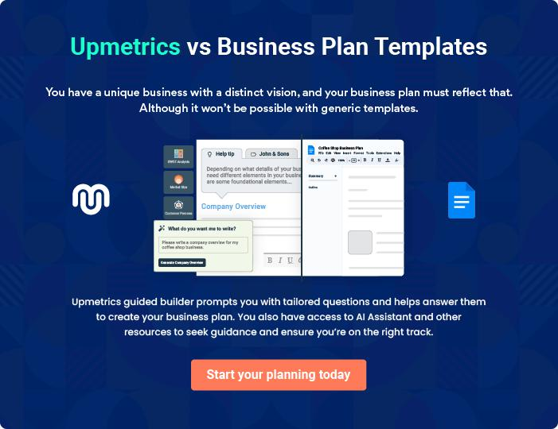
Products and Services
To unlock help try Upmetrics!

The product and services section of mobile game business plan should describe the specific services and products that will be offered to customers. To write this section should include the following:



 Help tip  Mobile Game Business Plan

To craft the introduction for your "Products and Services" chapter, begin by positioning your business within its industry, emphasizing its unique strengths or value proposition.
To unlock help try Upmetrics! 

Start writing here..

 Help tip


Mention the products you sell through your mobile game business. It can be merchandise like apparel, collectibles, or accessories to increase the fandom and brand value.
To unlock help try Upmetrics! 

Products & Services
Platinum Gaming Package


Price: [$9.99]/month

Our Platinum Gaming Package provides an all-access pass to exclusive in-game content, special events, and premium customer support.

Members receive monthly virtual currency allowances, unique skins, and early access to new game releases.

Specifications

- Monthly virtual currency: 500 coins

- Exclusive Skins: 3 per month

- Early Access to New Games: 1 week before public release

- Premium Customer Support: 24/7 access

Strategy Guide eBook

Price: [$4.99] per eBook

Our Strategy Guide eBooks provide in-depth game analysis, strategies, and tips to enhance player performance.

Written by gaming experts, these guides cover various genres and titles, helping players to master their favorite games.

Specifications

- Format: PDF and ePub

- Average Length: 50 pages

- Availability: Instant download after purchase

- Updates: Free updates with major game patches
Customizable Avatar Accessories

Price: Ranges from [$0.99] to [$4.99] per accessory

Enhance your in-game avatar with our range of customizable accessories.

From stylish hats to epic weapons, we have a variety of options to help you stand out in the game.

Specifications

- Compatibility: Available for all avatars in supported games

- Customization: Mix and match with existing avatar items

- Non-transferable: Accessories are tied to a single game account

- Durability: Permanent, no wear and tear

Live Streaming Toolkit

Price: [$19.99] one-time purchase

Our Live Streaming Toolkit is designed for gamers who wish to broadcast their gameplay.

The toolkit includes overlays, stream alerts, and a guide to get started with live streaming.

Specifications

- Contents: Overlays (10), Stream Alerts (15), Starter Guide (PDF)

- Compatibility: Compatible with major streaming platforms

- Customizable: Fully customizable to match your brand

- Support: Email support for setup and troubleshooting
VIP Tournament Entry

Price: [$5.99] per entry

Gain access to exclusive VIP gaming tournaments with special prizes and intense competition.

Perfect for gamers looking to test their skills and make a name for themselves in the community.

Specifications

- Frequency: Monthly tournaments

- Prizes: Cash prizes, exclusive in-game items, merchandise

- Skill Level: Open to all skill levels, but highly competitive

- Entry Requirements: Must be a registered user with a valid game account

Features & Functionality

 Help tip  Mobile Game Business Plan

Highlight the key features and functionalities of the game. This may include unique features like,
To unlock help try Upmetrics! 

Start writing here..

Quality Measures

 Help tip  Mobile Game Business Plan

This section should explain how you maintain quality standards and consistently provide the highest quality service.
To unlock help try Upmetrics! 

Start writing here..

Additional Services

 Help tip  Mobile Game Business Plan

Mention if your mobile game company offers any additional services. You may include services like live streaming, hosting tournaments, support and help guide, etc.
To unlock help try Upmetrics! 

Start writing here..
Sales And Marketing Strategies
To unlock help try Upmetrics!

Writing the sales and marketing strategies section means a list of strategies you will use to attract and retain your clients.
To unlock help try Upmetrics! 

 Help Tip  Mobile Game Business Plan


To create an effective introduction for your "Sales and Marketing Strategies" chapter, start by setting the stage within your specific industry or market.
To unlock help try Upmetrics! 

Start writing here..

Unique Selling Proposition (USP)

 Help tip  Mobile Game Business Plan

Define your business’s USPs depending on the market you serve, the equipment you use, and the unique services you provide. Identifying USPs will help you plan your marketing strategies.
To unlock help try Upmetrics! 

Start writing here..

Pricing Strategy

 Help tip  Mobile Game Business Plan

Describe your pricing strategy—how you plan to price your mobile gaming app and stay competitive in the local market. You can mention the freemium model you plan on introducing to attract new players to your game.



Start writing here..

 Help tip  Mobile Game Business Plan
To unlock help try Upmetrics!

Discuss your marketing strategies to market your services. You may include some of these marketing strategies in your business plan—social media marketing, Google ads, email marketing, content marketing, PR, and influencer marketing.



Marketing strategies

Online


Social Media

Utilizing platforms like Facebook, Instagram, and Twitter to create buzz around our games and foster a sense of community.

Content Marketing

Creating compelling blog posts, articles, and videos that highlight game features, tips, and strategies.

Email Marketing

Engaging with our user base through regular newsletters, updates, and exclusive offers.

PR and Influencer Marketing

Partnering with gaming influencers and media outlets to amplify our reach and credibility in the market.

Google Ads

Implementing targeted ad

campaigns to drive app

installations and increase visibility.

 Help tip  Mobile Game Business Plan
To unlock help try Upmetrics!

Outline the strategies you’ll implement to maximize your sales. Your sales strategies may include partnering with game subscription service providers, offering referral programs, cross-promotion, etc.



Sales strategies

Partner with Businesses

Aligning with subscription platforms to offer our games to a wider audience.

Cross-Promotion

Collaborating with other game developers and platforms for mutual promotion.

Referral Programs

Encouraging existing users to refer

new players, rewarding them for

their efforts

 Help tip  Mobile Game Business Plan
To unlock help try Upmetrics!

Describe your customer retention strategies and how you plan to execute them. For instance, introducing loyalty programs, regular content betterment, daily rewards and incentives, personalized service, etc.



Customer retention

Loyalty Programs

Implementing reward systems for long-term players, ensuring they feel valued and appreciated.

Personalized Service

Utilizing user data to provide tailored recommendations, enhancing the user experience.

Regular Content Updates

Consistently delivering fresh, engaging content to keep the gameplay experience exciting and novel.

Daily Rewards and Incentives

Offering daily log-in rewards and incentives to maintain high engagement levels.

Operations Plan
To unlock help try Upmetrics!

 |  | When writing the operations plan section, it’s important to consider the
 |  | various aspects of your business operations.
 |  |  |  | To unlock help try Upmetrics! 
 Help tip |  |  Mobile Game Business Plan


To create an effective introduction for your "Operational Plan" chapter, start by emphasizing the
pivotal role of efficient operations in the success of your business, underscoring how they
directly impact the quality of services delivered.
 |  |  |  | To unlock help try Upmetrics! 
Start writing here..
Staffing & Training
 Help tip |  |  Mobile Game Business Plan

Mention your gaming business’s staffing requirements, including the number of developers or
game designers needed. Include their qualifications, the training required, and the duties they
will perform.
 |  |  |  | To unlock help try Upmetrics! 
Start writing here..
Operational Processes
 Help tip |  |  Mobile Game Business Plan

Outline the processes and procedures you will use to run your mobile game business. Your operational processes may include working on the user interface, fixing bugs, introducing updates, running ads, learning programs for developers, etc.



Start writing here..

Technology & Equipment

 Help tip  Mobile Game Business Plan

Include the list of equipment and machinery required for mobile game business, such as computer systems, development technology, office equipment, etc.
To unlock help try Upmetrics! 

Start writing here..
Management Team

The management team section provides an overview of the individuals responsible for running your business plan.
To unlock help try Upmetrics! 

 Help tip  Mobile Game Business Plan

To craft an introduction for your "Management Team" chapter, begin by emphasizing the crucial role of leadership in the success of any business.
To unlock help try Upmetrics! 

Start writing here..

Key managers

 Help tip  Mobile Game Business Plan

Introduce your management and key members of your team, and explain their roles and responsibilities.
To unlock help try Upmetrics! 

Start writing here..

JOHN DOE

CEO & Co-founder - john.doe@example.com

John is a visionary leader with over 15 years of experience in the gaming industry. He co-founded [NextLevel Gaming Guide] with a mission to revolutionize mobile gaming through innovative and user-centric solutions.


John is responsible for setting the strategic direction of the company, building key partnerships, and fostering a culture of innovation.

- Educational Background: John holds a Bachelor’s degree in Computer Science from MIT and an MBA from Stanford University.

- Professional Background: Before starting [NextLevel Gaming Guide], John served as a Senior Game Developer at XYZ Games, where he led several successful game development projects.

His deep understanding of game mechanics and user engagement has been crucial in driving the company's success.


JANE DOE

Chief Operating Officer (COO) - jane.doe@example.com

Jane is a results-oriented professional with over 10 years of experience in operational management within the tech industry.

As COO, she ensures that [NextLevel Gaming Guide] operates efficiently, fostering a productive and positive work environment.

- Educational Background: Jane has a Bachelor’s degree in Business Administration from the University of California, Berkeley.

- Professional Background: Prior to joining [NextLevel Gaming Guide], Jane was the Operations Director at ABC Tech, where she successfully streamlined operations and significantly improved operational efficiency.

ALICE BROWN

CMO - alice.brown@example.com

Alice is an innovative marketing strategist with a knack for identifying and capitalizing on market trends.

At [NextLevel Gaming Guide], she leads the marketing team in developing and executing strategies that drive user acquisition and brand awareness.

- Educational Background: Alice earned her Bachelor’s degree in Marketing from New York University.

- Professional Background: She has over 12 years of marketing experience, having worked as a Senior Marketing Manager at GameTech, where she played a pivotal role in their market expansion.


ROBERT BROWN

Lead Developer - robert.brown@example.com

Robert is a seasoned game developer with a passion for creating immersive and engaging gaming experiences. He oversees the development team at [NextLevel Gaming Guide], ensuring the timely delivery of high-quality games.

- Educational Background: Robert has a Bachelor’s degree in Game Design from the University of Southern California.

- Professional Background: With over 10 years of experience in game development, he has previously worked at Innovative Games as a Lead Developer.

Organizational structure

 Help tip  Mobile Game Business Plan

Explain the organizational structure of your management team. Include the reporting line and decision-making hierarchy.
To unlock help try Upmetrics! 

Start writing here..

Organization chart


John Doe

CEO


Alice Brown

Jane Doe

CMO


COO

Emily White

Marketing Specialist Robert Brown Lead Developer




Chris Green

Lily Grey

Developer

Content Creator

Compensation plan

 Help tip  Mobile Game Business Plan

Describe your compensation plan for the management and staff. Include their salaries, incentives, and other benefits.
To unlock help try Upmetrics! 

Start writing here..

 Help tip  Mobile Game Business Plan

Mentioning advisors or consultants in your business plans adds credibility to your business idea.
To unlock help try Upmetrics! 

Advisors/Consultants


DR. RICHARD SMITH

Advisor

- Expertise: Gaming Technology and User Experience

- Background: With over 20 years in the gaming tech space, Dr. Smith has been an integral part of multiple successful mobile gaming startups. Holding a Ph.D. from [Prestigious University] in Game Design and Technology, he's been a guest lecturer at numerous events and has also authored several research papers.

- Role: Advises on technology adoption, gaming experience enhancements, and industry trends.

MS. CLARA WILLIAMS

Consultant

- Expertise: Gaming Monetization and Business Strategy

- Background: Former VP of Monetization at [Top Gaming Company], Clara has a stellar track record of driving profitability for mobile gaming ventures. Her strategies have been pivotal for games that have achieved 'top 10' status in app stores globally.

- Role: Provides insights into revenue models, in-app purchase strategies, and overall business growth.
Financial Plan

When writing the financial plan section of a business plan, it’s important to provide a comprehensive overview of your financial projections for the first few years of your business, You may provide the following:
To unlock help try Upmetrics! 

 Help tip  Mobile Game Business Plan


To create an effective introduction for your "Financial Plan" chapter, begin by stressing the critical role of a well-structured financial plan in the success of your venture.
To unlock help try Upmetrics! 

Start writing here..

 Help tip  Mobile Game Business Plan

Describe details such as projected revenue, operational costs, and service costs in your projected profit and loss statement.

Make sure to include your business’s expected net profit or loss.
To unlock help try Upmetrics! 

Profit & loss statement

Revenue

Cost Of Sales

General Costs

Revenue Specific Costs

Personnel Costs (Direct

Labor)

Gross Margin

Gross Margin (%)

Operating Expense

Payroll Expense

(Indirect Labor)

General Expense

Bad Debt

Amortization of Current

Assets

2023-24 | 2024-25 | 2025-26 | 2026-27 | 2027-28
$0 | $0 | $0 | $0 | $0

$0 | $0 | $0 | $0 | $0
$0 | $0 | $0 | $0 | $0
$0 | $0 | $0 | $0 | $0
$0 | $0 | $0 | $0 | $0

$0 | $0 | $0 | $0 | $0
0% | 0% | 0% | 0% | 0%

$0 | $0 | $0 | $0 | $0
$0 | $0 | $0 | $0 | $0
$0 | $0 | $0 | $0 | $0
$0 | $0 | $0 | $0 | $0
$0 | $0 | $0 | $0 | $0

EBITDA

Additional Expense

Long Term

Depreciation

Gain or loss from Sale

of Assets

EBIT

Interest Expenses

EBT

Income Tax Expense

Total Expense

Net Income

Net Income (%)

2023-24 | 2024-25 | 2025-26 | 2026-27 | 2027-28
$0 | $0 | $0 | $0 | $0
$0 | $0 | $0 | $0 | $0
$0 | $0 | $0 | $0 | $0
$0 | $0 | $0 | $0 | $0
$0 | $0 | $0 | $0 | $0
$0 | $0 | $0 | $0 | $0
$0 | $0 | $0 | $0 | $0
$0 | $0 | $0 | $0 | $0
$0 | $0 | $0 | $0 | $0
$0 | $0 | $0 | $0 | $0
0% | 0% | 0% | 0% | 0%

 |  |  | 2023-24 |  | 2024-25 | 2025-26
Retained Earning |  |  | $0 |  | $0 | $0
Opening |  |  |  |  | $0 | $0
Owner's Distribution |  |  | $0 |  | $0 | $0
Retained Earning |  |  | $0 |  | $0 | $0
Closing |  |  |  |  | $0 | $0
 Help tip |  |  |  Mobile Game Business Plan


The cash flow for the first few years of your operation should be estimated and described in this section.

This may include billing invoices, payment receipts, loan payments, and any other cash flow statements.
2026-27 2027-28

$0 $0

$0 $0

$0 $0

To unlock help try Upmetrics! 

Cash flow statement

 | 2023-24 | 2024-25 | 2025-26 | 2026-27 | 2027-28
Cash Received | $0 | $0 | $0 | $0 | $0
Cash Paid | $0 | $0 | $0 | $0 | $0
COS & General Expenses | $0 | $0 | $0 | $0 | $0
Salary & Wages | $0 | $0 | $0 | $0 | $0
Interest | $0 | $0 | $0 | $0 | $0

Sales Tax

Income Tax

Net Cash From

Operations

Assets Sell

Assets Purchase

Net Cash From

Investments

Amount Received

Loan Received

Common Stock

Preferred Stock

Owner's Contribution

Amount Paid

2023-24 | 2024-25 | 2025-26 | 2026-27 | 2027-28
$0 | $0 | $0 | $0 | $0
$0 | $0 | $0 | $0 | $0
$0 | $0 | $0 | $0 | $0

$0 | $0 | $0 | $0 | $0
$0 | $0 | $0 | $0 | $0
$0 | $0 | $0 | $0 | $0

$0 | $0 | $0 | $0 | $0
$0 | $0 | $0 | $0 | $0

$0 | $0 | $0 | $0 | $0
$0 | $0 | $0 | $0 | $0
$0 | $0 | $0 | $0 | $0

Loan Capital $0 $0 $0 $0 $0

 |  |  | 2023-24 | 2024-25 | 2025-26 | 2026-27 | 2027-28
Dividends & Distributions |  |  | $0 | $0 | $0 | $0 | $0
Net Cash From |  |  | $0 | $0 | $0 | $0 | $0
Financing
Summary
Starting Cash |  |  | $0 | $0 | $0 | $0 | $0
Cash In |  |  | $0 | $0 | $0 | $0 | $0
Cash Out |  |  | $0 | $0 | $0 | $0 | $0
Change in Cash |  |  | $0 | $0 | $0 | $0 | $0
Ending Cash |  |  | $0 | $0 | $0 | $0 | $0
 Help tip |  |  Mobile Game Business Plan

Create a projected balance sheet documenting your mobile game business’s assets, liabilities, and equity.

To unlock help try Upmetrics! 

Balance sheet

 | 2023-24 | 2024-25 | 2025-26 | 2026-27 | 2027-28
Assets | $0 | $0 | $0 | $0 | $0
Current Assets | $0 | $0 | $0 | $0 | $0
Cash | $0 | $0 | $0 | $0 | $0
Accounts Receivable | $0 | $0 | $0 | $0 | $0
Inventory | $0 | $0 | $0 | $0 | $0
Other Current Assets | $0 | $0 | $0 | $0 | $0
Long Term Assets | $0 | $0 | $0 | $0 | $0
Gross Long Term Assets | $0 | $0 | $0 | $0 | $0
Accumulated Depreciation | $0 | $0 | $0 | $0 | $0

Liabilities & Equity | $0 | $0 | $0 | $0 | $0
Liabilities | $0 | $0 | $0 | $0 | $0
Current Liabilities | $0 | $0 | $0 | $0 | $0
Accounts Payable | $0 | $0 | $0 | $0 | $0
Income Tax Payable | $0 | $0 | $0 | $0 | $0
Sales Tax Payable | $0 | $0 | $0 | $0 | $0
Short Term Debt | $0 | $0 | $0 | $0 | $0
 | 2023-24 | 2024-25 | 2025-26 | 2026-27 | 2027-28
Long Term Liabilities | $0 | $0 | $0 | $0 | $0
Long Term Debt | $0 | $0 | $0 | $0 | $0
Equity | $0 | $0 | $0 | $0 | $0
Paid-in Capital | $0 | $0 | $0 | $0 | $0
Common Stock | $0 | $0 | $0 | $0 | $0
Preferred Stock | $0 | $0 | $0 | $0 | $0
Owner's Contribution | $0 | $0 | $0 | $0 | $0
Retained Earnings | $0 | $0 | $0 | $0 | $0

Check | $0 |  |  | $0 | $0 | $0 | $0
 Help tip |  |  Mobile Game Business Plan

Determine and mention your business’s break-even point—the point at which your business costs and revenue will be equal.

This exercise will help you understand how much revenue you need to generate to sustain or be profitable.
To unlock help try Upmetrics! 

Break-even Analysis

 | 2023-24 | 2024-25 | 2025-26 | 2026-27 | 2027-28
Starting Revenue | $0 | $0 | $0 | $0 | $0
Net Revenue | $0 | $0 | $0 | $0 | $0
Closing Revenue | $0 | $0 | $0 | $0 | $0

Starting Expense | $0 | $0 | $0 | $0 | $0
Net Expense | $0 | $0 | $0 | $0 | $0
Closing Expense | $0 | $0 | $0 | $0 | $0

Is Break Even? | 0 | 0 | 0 | 0 | 0
Break Even Month | 0 | 0 | 0 | 0 | 0
Days Required | 0 | 0 | 0 | 0 | 0
Break Even Revenue | $0 | $0 | $0 | $0 | $0
Break Even Units
Financing needs

 Help tip  Mobile Game Business Plan

Calculate costs associated with starting a mobile game business, and estimate your financing needs and how much capital you need to raise to operate your business.
To unlock help try Upmetrics! 

Start writing here..
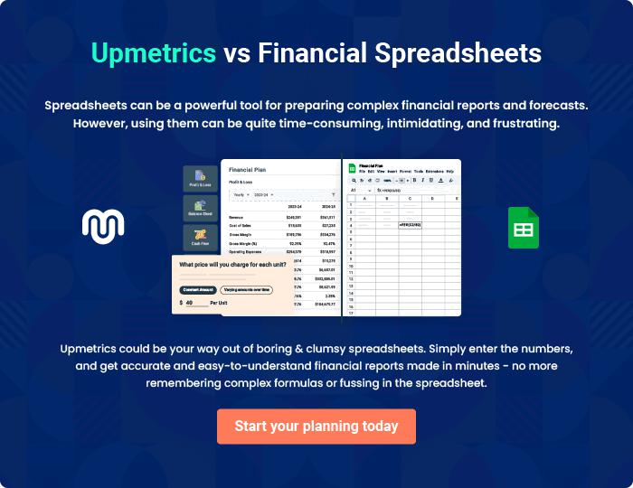
Appendix

When writing the appendix section, you should include any additional information that supports the main content of your plan. This may include financial statements, market research data, legal documents, and other
To unlock help try Upmetrics! 
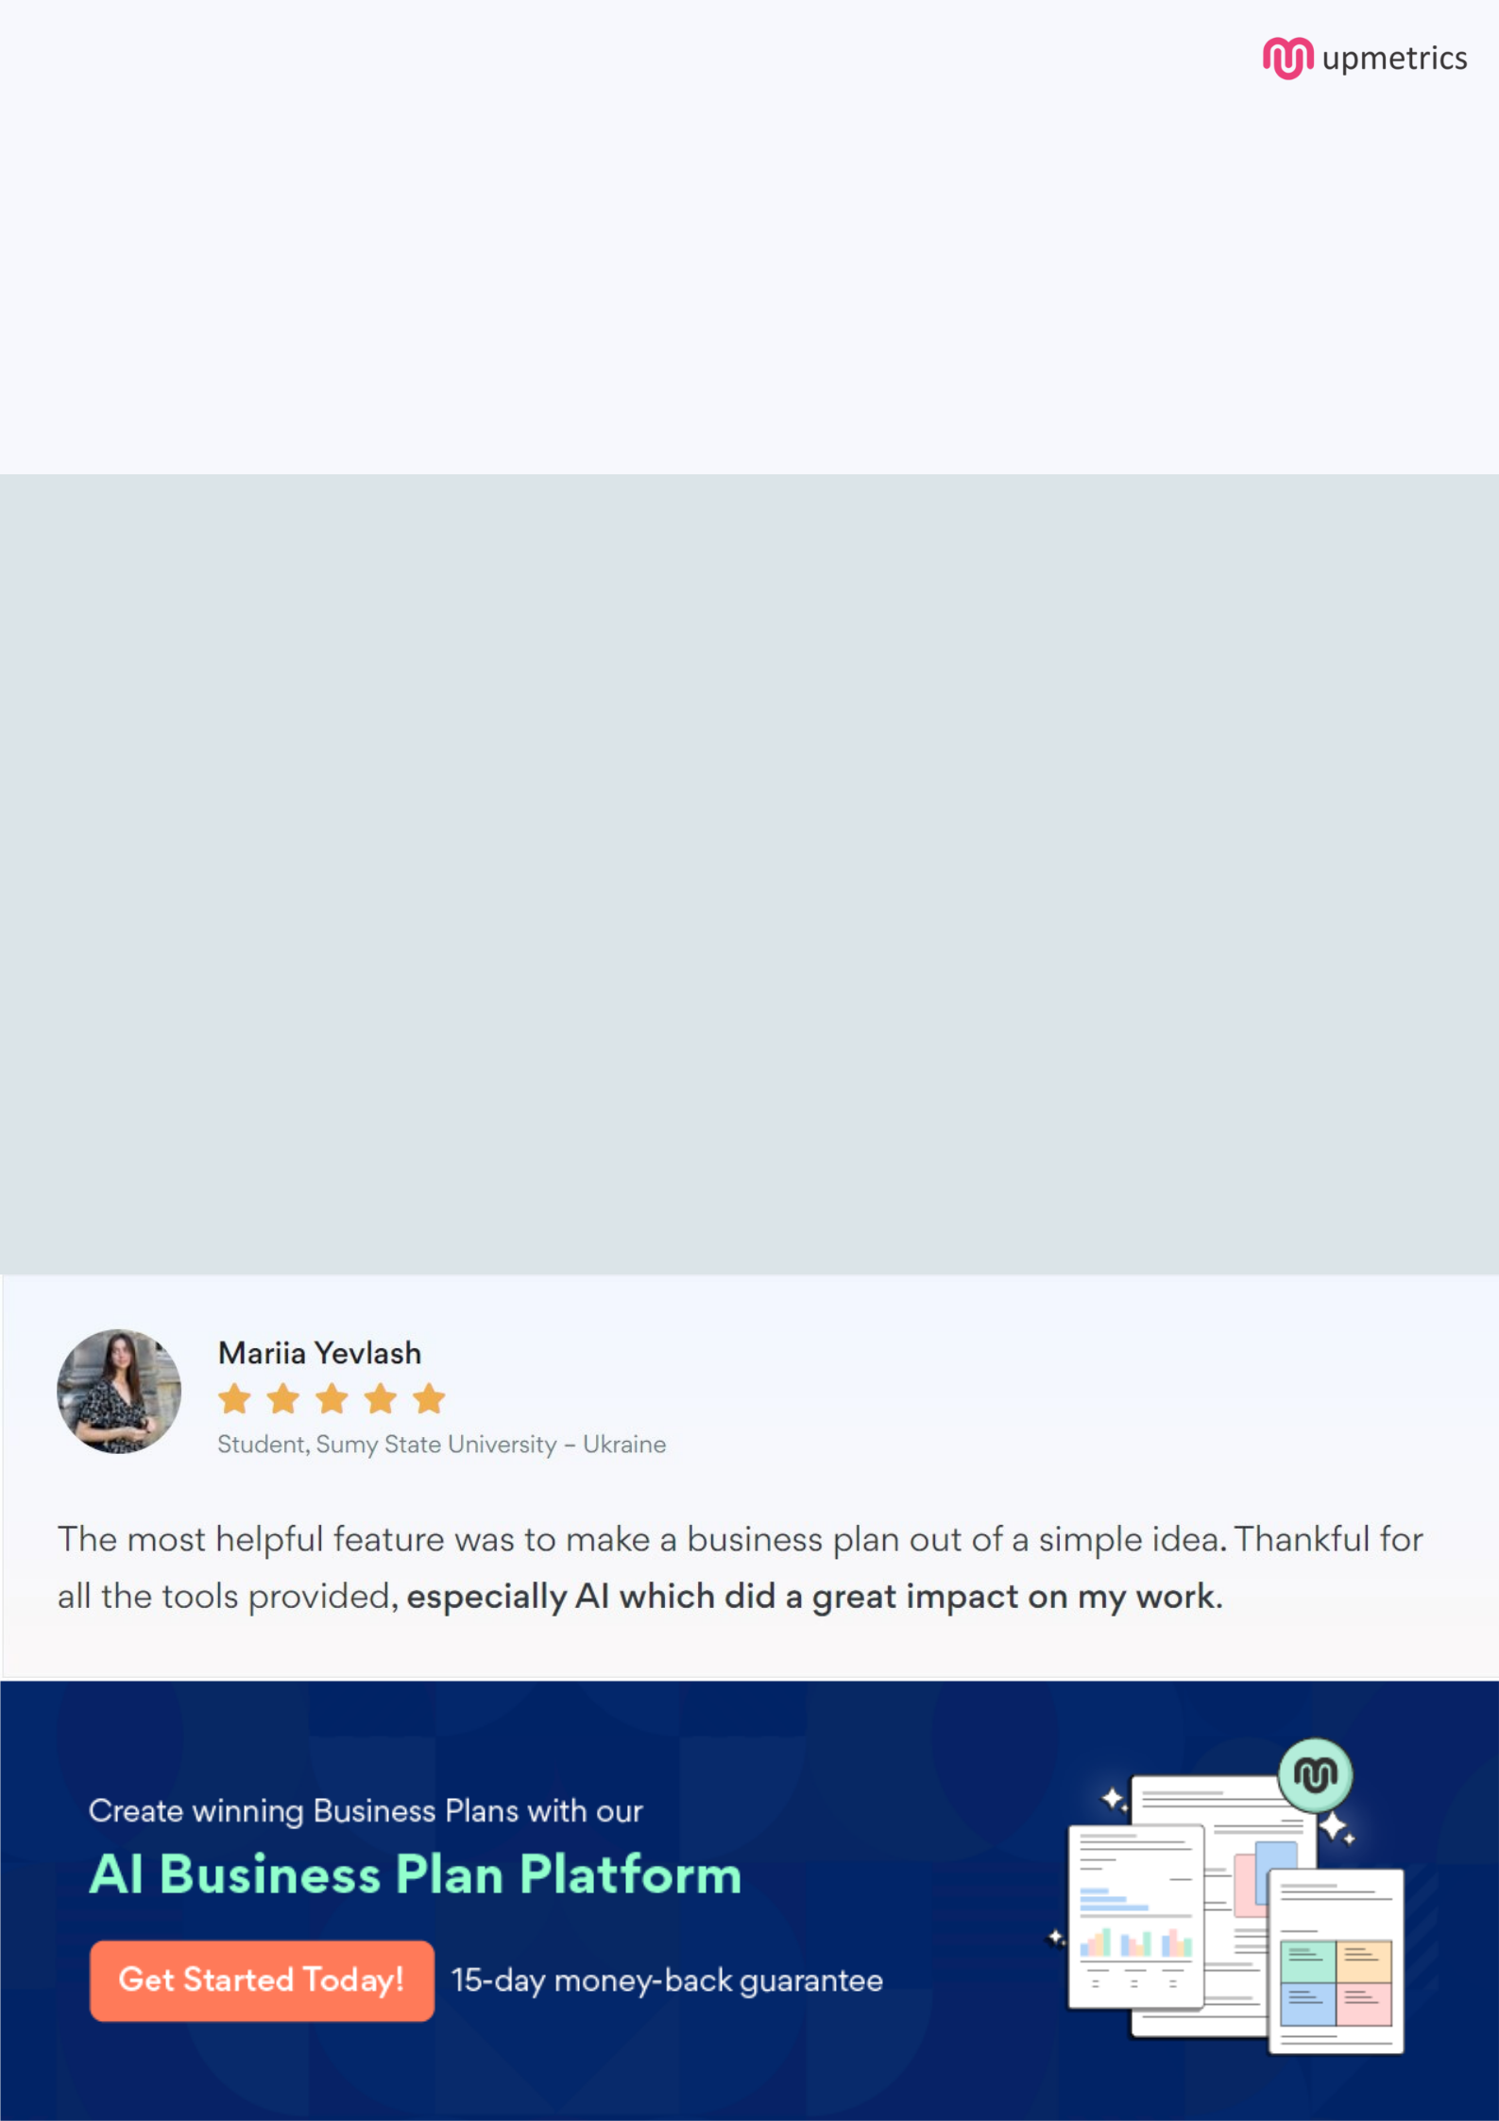
Create a winning business plan that gets you funded

Creating a stunning and investment-ready plan requires no writing, graphic designing, or financial planning expertise.

Upmetrics has all the features required to help you create a comprehensive business plan—from start to finish. Make no mistakes, it’s the modern way of planning to structure ideas, make plans, and create stunning pitch decks to awe investors.

Pitch decks that impress investors

Create pitch decks that provide a visual representation of your business, engage investors, and make them want to invest in your business idea.

Interactive plans in no time

Import business plan sections like—SWOT analysis, comparison tables, and others to create an interactive business plan. No designing skills are required.

Stunning cover page designs

With Upmetrics, you have the liberty to choose from multiple stunning cover page designs. Choose a creative design and make your plan stand out.

Online sharing made simple

Upmetrics makes online sharing quick and easier for users. Easily share your business plans with a link while tracking reader activity.

500+ sample business plans

Simply import a template from our library of sample plans into the editor and start customizing it to make it yours. It takes only a few clicks to get started.

Collaborate with team in real-time

Invite team members, initiate conversations, discuss ideas & strategies, share feedback, and work on a business plan in real-time.

