
Medical Lab Business Plan


Business
Plan

2023


Innovating Health Diagnostics

Information provided in this business plan is unique to this business and confidential; therefore, anyone reading this plan agrees not to disclose any of the information in this business plan without prior written permission of the company.

 | Prepared By | 10200 Bolsa Ave, Westminster, CA, 92683
 | John Doe | info@example.com
 | (650) 359-3153 | http://www.example.com

Table of Contents

Executive Summary | 6
Market opportunity | 6
Products and Services | 6
Marketing & Sales Strategies | 7
Financial Highlights | 7
Units Sold v/s Revenue | 8

Company Overview | 9
Ownership | 9
Mission statement | 10
Business history | 10
Future goals | 11

Market Analysis | 12
Target Market | 12
Market size and growth potential | 12
Market Size | 13
Competitive analysis | 13
Quest Diagnostics | 13
LabCorp (Laboratory Corporation of America) | 14
BioReference Laboratories | 14
Market trends | 14
Regulatory environment | 15

Products and Services | 16
Services | 16
Blood Tests | 16
Urine Tests | 17
Allergy Tests | 17
Cholesterol and Blood Sugar Tests | 17
Thyroid Tests | 18
At-home Lab Tests | 18
Virtual Consultation | 18
Rapid On-site Testing | 19
Quality measures | 19
Additional Services | 19

Sales And Marketing Strategies | 20
Unique Selling Proposition (USP) | 20
Pricing Strategy | 20
Marketing strategies | 21
Online | 21
Offline | 21
Sales strategies | 22
Customer retention | 23

Operations Plan | 24
Staffing & Training | 24
Operational Process | 24
Equipment & Machinery | 25

Management Team | 26
Key managers | 26
John Doe | 26
Jane Doe | 27
Alice Brown | 27
Robert Brown | 27
Organizational structure | 28
Organization chart | 28
Compensation plan | 28
Advisors/Consultants | 29
Dr. Emily Smith | 29
Mark Johnson | 29
Financial Plan | 30
Profit & loss statement | 30
Cash flow statement | 33
Balance sheet | 35
Break-even Analysis | 37
Financing needs | 39
Appendix
Appendix | 41
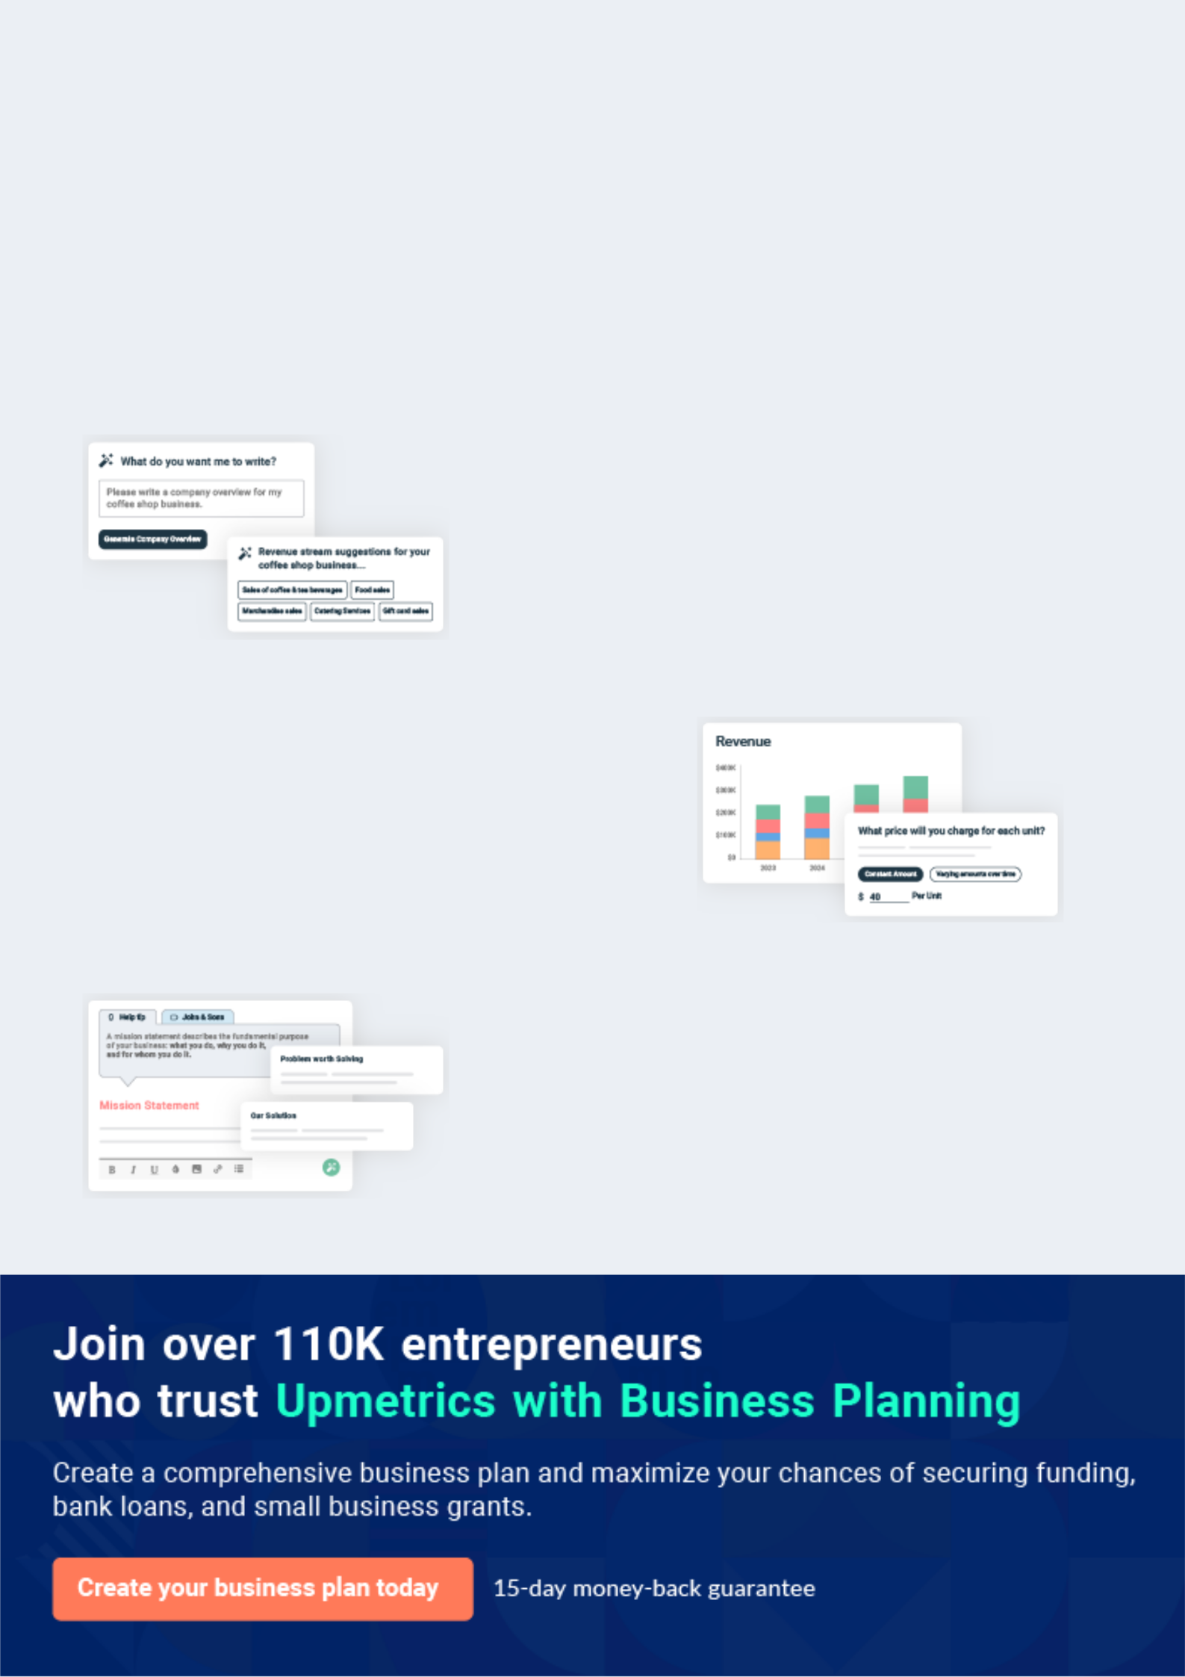
Business planning that’s simpler and faster than you think

Creating a business plan using Upmetrics to start and grow a business is literally the easiest thing in the World. Simply read the instructions and fill in the blanks. It’s as simple as that.

❛ | Upmetrics has everything you need to create a | ❜
❛ | comprehensive business plan. | ❜

AI-powered Upmetrics Assistant

AI-powered insights to streamline your plan

Not sure where to start? Upmetrics’ AI Assistant will automatically generate ideas for each section of your plan and offer improved versions of your writing, adjusting for tone, voice, and grammar or spelling errors.

Financial Forecasting Tool

All the financials are calculated for you

Forget the complex formulas and clumsy spreadsheets — with automatic financials and drag-and-drop forecasting, you can finish your plan faster and be confident that your numbers are accurate.

Business Plan Builder

Guides you like a business mentor

Upmetrics’ step-by-step instructions, prompts, and the library of 400+ sample business plans will guide you through each section of your plan as a business mentor.
Executive Summary


An executive summary is the first section of the business plan intended to provide an overview of the whole business plan.
To unlock help try Upmetrics! 

 Help tip  Medical Lab Business Plan


Start your executive summary by briefly introducing your business to your readers.

This section may include the name of your medical lab, its location, when it was founded, the
To unlock help try Upmetrics! 

Start writing here..

Market opportunity

 Help tip  Medical Lab Business Plan

Summarize your market research, including market size, growth potential, and marketing trends. Highlight the opportunities in the market and how your business will fit in to fill the gap.
To unlock help try Upmetrics! 

Start writing here..

Products and Services

 Help tip  Medical Lab Business Plan

Highlight the laboratory services you offer your clients. The USPs and differentiators you offer are always a plus.
To unlock help try Upmetrics! 

Start writing here..

Marketing & Sales Strategies
To unlock help try Upmetrics!

 Help tip  Medical Lab Business Plan

Outline your sales and marketing strategies—what marketing platforms you use, how you plan on acquiring customers, etc.
To unlock help try Upmetrics! 

Start writing here..

Financial Highlights

 Help tip  Medical Lab Business Plan

Briefly summarize your financial projections for the initial years of business operations. Include any capital or investment requirements, associated startup costs, projected revenues, and profit forecasts.



Start writing here..
Units Sold v/s Revenue

 |  | Units Sold | Revenue
15.00k
10.00k
5.00k
0
Year 1 | Year 2 | Year 3


Financial Year |  |  | Units Sold | Revenue
Year 1 | 1,550 |  |  | $10,000
Year 2 | 1,800 |  |  | $12,000
Year 3 | 2,050 |  |  | $14,000
 Help tip |  |  Medical Lab Business Plan


Summarize your executive summary section with a clear CTA, for example, inviting angel investors to discuss the potential business investment.
To unlock help try Upmetrics! 

Write a call to action for your business plan.
Company Overview

Depending on what details of your business are essential, you’ll need different elements in your business overview.
To unlock help try Upmetrics! 

 Help tip  Medical Lab Business Plan

Describe your business in this section by providing all the basic information:

Describe what kind of medical lab you run and the name of it. You may specialize in one of the
To unlock help try Upmetrics! 

Start writing here..

Ownership

 Help tip  Medical Lab Business Plan

List the names of your medical lab founders or owners. Describe what shares they own and their responsibilities for efficiently managing the business.
To unlock help try Upmetrics! 

Start writing here..
Mission statement

 Help tip  Medical Lab Business Plan

Summarize your business’ objective, core principles, and values in your mission statement. This statement needs to be memorable, clear, and brief.
To unlock help try Upmetrics! 

❛ At [MediLab Solutions], our mission is to provide accurate, reliable, and timely diagnostic services that contribute to the overall health and well-being of our community.

We are committed to leveraging advanced technology, expert knowledge, and a patient-centric approach to deliver excellence in medical diagnostics. Our core values include integrity, innovation, and a relentless pursuit of quality.

❜

Business history

 Help tip  Medical Lab Business Plan

If you’re an established medical laboratory service provider, briefly describe your business history, like—when it was founded, how it evolved over time, etc.
To unlock help try Upmetrics! 

Start writing here..
Future goals

 Help tip  Medical Lab Business Plan

It’s crucial to convey your aspirations and vision. Mention your short-term and long-term goals; they can be specific targets for revenue, market share, or expanding your services.
To unlock help try Upmetrics! 

Start writing here..
Market Analysis
To unlock help try Upmetrics!


 |  | Market analysis provides a clear understanding of the market in which your
 |  | printing business will run along with the target market, competitors, and
 |  | growth opportunities.
 |  |  |  | To unlock help try Upmetrics! 
 Help tip |  |  Medical Lab Business Plan

To write the introduction section of your market analysis, start by clearly identifying your primary target market.
To unlock help try Upmetrics! 

Start writing here..

Target Market

 Help tip  Medical Lab Business Plan

Start this section by describing your target market. Define your ideal customer and explain what types of services they prefer. Creating a buyer persona will help you easily define your target market to your readers.



Start writing here..

Market size and growth potential

 Help tip  Medical Lab Business Plan

Describe your market size and growth potential and whether you will target a niche or a much broader market.
To unlock help try Upmetrics! 

Start writing here..

Market Size

Available Market

Total potential market for medical lab 500M services globally.

Served Market
Portion of the available market that 200M can be served by our services.

Target Market
The segment of the served market we 50M aim to capture.

 Help tip  Medical Lab Business Plan

Identify and analyze your direct and indirect competitors. Identify their strengths and weaknesses, and describe what differentiates your medical lab services from them.
To unlock help try Upmetrics! 

Competitive analysis

Quest Diagnostics

Established in 1967, Quest Diagnostics is one of the largest and most recognized medical testing laboratories in the U.S. They offer a wide range of testing services, from routine blood tests to complex genomic testing.

Features | Strengths | Weaknesses
Comprehensive diagnostic | Well-established brand | Turnaround time can be slower
testing across various medical | reputation | during peak periods
disciplines | Extensive reach and | Pricing can be higher compared
Direct-to-consumer testing | accessibility | to some newer competitors
options | Continuous innovation in
Extensive patient service | testing methods
centers across the country

LabCorp (Laboratory Corporation of America)

LabCorp, founded in 1978, provides both clinical laboratory and end-to-end drug development services. They are known for their commitment to personalized medicine and have a strong foothold in the medical testing industry.

Features

A broad spectrum of medical testing, from standard tests to specialized ones

A robust digital portal for both patients and healthcare providers

Partnerships with multiple healthcare and insurance entities

Strengths | Weaknesses
Diverse testing services cater | Some customer complaints
to a wide range of healthcare | related to billing practices
needs | Periodic backlogs, leading to
Strong infrastructure | extended wait times
supporting both patients and
healthcare professionals
A history of mergers and
acquisitions that have
expanded their service base

BioReference Laboratories

As a subsidiary of OPKO Health, BioReference Laboratories has been a significant player in the industry since its inception in 1981. They offer a comprehensive list of laboratory testing services in the United States.

Features | Strengths | Weaknesses
Specialized oncology and | Innovative solutions like the | Limited international presence
women's health diagnostics | 4Kscore test | compared to competitors
GenPath, their diagnostic | Strong focus on research and | Dependency on certain
division focusing on genetic | development | segments, making diversification
and genomics testing | Expansive network of patient | essential
4Kscore, a test to determine | service centers
the risk of aggressive prostate
cancer

Market trends

 Help tip  Medical Lab Business Plan

Analyze emerging trends in the industry, such as technology disruptions by Artificial Intelligence and Machine Learning, etc. Explain how your business will cope with all the trends.
To unlock help try Upmetrics! 

Start writing here..

Regulatory environment
To unlock help try Upmetrics!

 Help tip  Medical Lab Business Plan

List regulations and licensing requirements that may affect your medical labs, such as business registration, CLIA certification, compliance with HIPAA, state laboratory licensing, state and federal regulations, etc.



Start writing here..
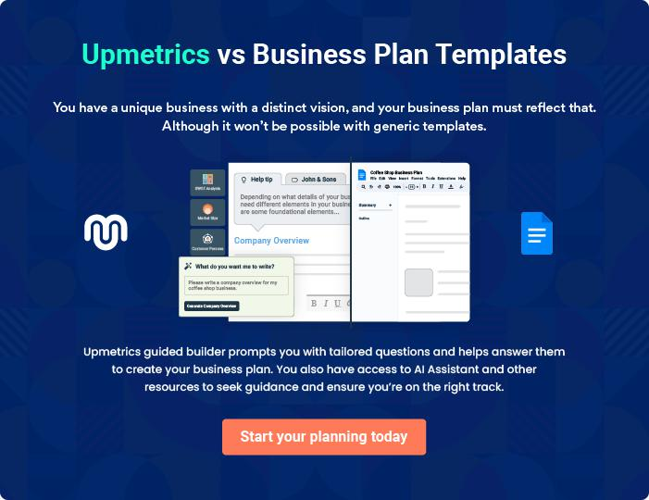
Products and Services
To unlock help try Upmetrics!

The product and services section of a medical lab business plan should describe the specific services and products that will be offered to customers. To write this section should include the following:



 Help tip  Medical Lab Business Plan

To craft the introduction for your "Products and Services" chapter, begin by positioning your business within its industry, emphasizing its unique strengths or value proposition.
To unlock help try Upmetrics! 

Start writing here..

 Help tip


Mention the medical lab services your business will offer. The list of services for clinical pathology may include,
To unlock help try Upmetrics! 

Services

Blood Tests


Price: [$50 - $200], depending on the specific test and panel required.

A range of blood tests to diagnose and monitor various conditions, from anemia to cancer.

Specifications

- Turnaround time: 24-48 hours

- Sample required: Venous blood sample
Urine Tests

Price: [$40 - $150], depending on the specific test required.

Essential tests for assessing kidney function, detecting infections, and monitoring various conditions.

Specifications

- Turnaround time: 24-48 hours

- Sample required: Urine sample

Allergy Tests

Price: [$100 - $500], depending on the number and type of allergens tested.

Identifies specific allergens responsible for triggering allergic reactions.

Specifications

- Turnaround time: 3-5 days

- Sample required: Blood sample or skin prick test

Cholesterol and Blood Sugar Tests

Price: [$50 - $200], depending on the range of parameters tested.

Key tests for determining cardiovascular risk and managing diabetes.

Specifications

- Turnaround time: 24-48 hours

- Sample required: Venous blood sample
Thyroid Tests

Price: [$50 - $200], depending on the specific thyroid hormones tested.

Vital for diagnosing and monitoring thyroid disorders, ensuring proper metabolic function.

Specifications

- Turnaround time: 24-48 hours

- Sample required: Venous blood sample

At-home Lab Tests

Price: Varies depending on the specific test required; additional fee for home visit.

Offers patients the convenience of sample collection from the comfort of their homes.

Specifications

- Turnaround time: 24-72 hours

- Sample required: Depends on the specific test

Virtual Consultation

Price: [$100 - $300] per session, depending on the expertise of the consultant.

Provides expert consultations online, allowing for immediate and convenient feedback.

Specifications

- Duration: 30-60 minutes

- Platform: Zoom, Microsoft Teams, or other preferred online platforms
Rapid On-site Testing

Price: [$100 - $400], depending on the specific test and urgency.

Ensures quick results for critical tests, meeting the pressing needs of our clients.

Specifications

- Turnaround time: 1-4 hours

- Sample required: Depends on the specific test

Quality measures

 Help tip  Medical Lab Business Plan

This section should explain how you maintain quality standards and consistently provide the highest quality service.
To unlock help try Upmetrics! 

Start writing here..

Additional Services

 Help tip  Medical Lab Business Plan

Mention if your medical lab offers any additional services. You may include services like at-home lab tests, virtual consultation, rapid on-site testing, etc.
To unlock help try Upmetrics! 

Start writing here..
Sales And Marketing Strategies
To unlock help try Upmetrics!

Writing the sales and marketing strategies section means a list of strategies you will use to attract and retain your clients.
To unlock help try Upmetrics! 

 Help Tip  Medical Lab Business Plan


To create an effective introduction for your "Sales and Marketing Strategies" chapter, start by setting the stage within your specific industry or market.
To unlock help try Upmetrics! 

Start writing here..

Unique Selling Proposition (USP)

 Help tip  Medical Lab Business Plan

Define your business’s USPs depending on the market you serve, the equipment you use, and the unique services you provide. Identifying USPs will help you plan your marketing strategies.
To unlock help try Upmetrics! 

Start writing here..

Pricing Strategy

 Help tip  Medical Lab Business Plan

Describe your pricing strategy—how you plan to price your laboratory services and stay competitive in the local market. You can mention special full-body health checkup packages to attract new customers.



Start writing here..

 Help tip  Medical Lab Business Plan
To unlock help try Upmetrics!

Discuss your marketing strategies to market your services. You may include some of these marketing strategies in your business plan—social media marketing, Google ads, brochures, email marketing, content marketing, and print marketing.



Marketing strategies

Online


Social Media

Regular posts, patient testimonials, and interactive sessions on platforms like [Facebook, Instagram, and LinkedIn].

Content Marketing

Articles and blogs about health, the importance of regular testing, and understanding lab results, positioning us as industry experts.

Email Marketing

Monthly newsletters updating our subscribers about the latest in the medical testing world and any new services we offer.

Google Ads

Targeted ads to capture individuals searching for medical lab services in our locality.

Offline

Brochures

Informative brochures available at our facility and partnered clinics detailing our services.

Print Marketing

Advertisements in local newspapers and magazines to reach a broader audience.

 Help tip  Medical Lab Business Plan

Outline the strategies you’ll implement to maximize your sales. Your sales strategies may include direct sales, partnering with healthcare professionals, offering bundled discounts, etc.
To unlock help try Upmetrics! 

Sales strategies

Direct Sales

Dedicated teams reaching out to individual clients, explaining our offerings.

Partnerships

Collaborating with healthcare professionals and clinics to recommend our services.

Bundled Discounts

Offering cost benefits when

multiple tests are booked together.

 Help tip  Medical Lab Business Plan
To unlock help try Upmetrics!

Describe your customer retention strategies and how you plan to execute them. For instance, introducing special packages, discount offers, offering premium services like instant test results at no additional costs, etc.



Customer retention

Special Packages

Discount Offers

Periodic health packages tailored to specific age groups or health concerns.

Loyalty programs offering discounts on subsequent tests.

Premium Services

For our regular customers, we

provide instant test results at no

additional costs or other such

value-added services.

Operations Plan
To unlock help try Upmetrics!
To unlock help try Upmetrics!

 |  | When writing the operations plan section, it’s important to consider the
 |  | various aspects of your business operations.
 |  |  |  | To unlock help try Upmetrics! 
 Help tip |  |  Medical Lab Business Plan


To create an effective introduction for your "Operational Plan" chapter, start by emphasizing the
pivotal role of efficient operations in the success of your business, underscoring how they
directly impact the quality of services delivered.
 |  |  |  | To unlock help try Upmetrics! 
Start writing here..
Staffing & Training
 Help tip |  |  Medical Lab Business Plan

Mention your laboratory business’s staffing requirements, including the number of lab scientists and technicians, pathologists, or administrative staff needed. Include their qualifications, the training required, and the duties they will perform.



Start writing here..

Operational Process

 Help tip  Medical Lab Business Plan

Outline the processes and procedures you will use to run your medical lab business. Your operational processes may include collecting samples, lab testing, data entry, generating results, sending results, offering consultation, archiving data, etc.



Start writing here..

Equipment & Machinery

 Help tip  Medical Lab Business Plan

Include the list of equipment and machinery required for the medical lab, such as microscopes, DNA analyzers, refrigerators, incubators, autoclaves, consumables, etc.
To unlock help try Upmetrics! 

Start writing here..
Management Team

The management team section provides an overview of the individuals responsible for running your business plan.
To unlock help try Upmetrics! 

 Help tip  Medical Lab Business Plan

To craft an introduction for your "Management Team" chapter, begin by emphasizing the crucial role of leadership in the success of any business.
To unlock help try Upmetrics! 

Start writing here..

Key managers

 Help tip  Medical Lab Business Plan

Introduce your management and key members of your team, and explain their roles and responsibilities.
To unlock help try Upmetrics! 

Start writing here..


JOHN DOE

Founder and CEO - john.doe@example.com

John Doe has been at the forefront of the medical lab industry, leveraging his extensive experience and strategic vision to establish MediLab Solutions.

He holds a Bachelor's in Medical Science from Harvard University and has worked with leading medical labs across the country.


- Roles and Responsibilities: John is responsible for setting the strategic direction of MediLab Solutions, overseeing daily operations, and cultivating key partnerships to drive the business forward.

JANE DOE

Chief Lab Director - jane.doe@example.com

With a Masters in Laboratory Management from Stanford University, Jane has over 15 years of experience in medical laboratory management.

She is known for her attention to detail and commitment to maintaining the highest quality standards.


- Roles and Responsibilities: Jane supervises all laboratory processes, ensures adherence to quality control measures, and manages the team of lab scientists and technicians.


ALICE BROWN

Chief Operating Officer (COO) - alice.brown@example.com

Alice holds a Masters in Health Administration from UCLA and brings over 10 years of operational management experience in the healthcare sector.

She is skilled in human resources management and regulatory compliance.

- Roles and Responsibilities: Alice is responsible for overseeing the operational processes of the lab, managing human resources, and ensuring compliance with industry standards and regulations.


ROBERT BROWN

Chief Marketing Officer (CMO) - robert.brown@example.com

Robert earned his MBA in Marketing from the University of Chicago and has over 12 years of marketing experience in the healthcare industry.

He has a proven track record of developing and implementing successful marketing strategies that drive business growth.

- Roles and Responsibilities: Robert leads the marketing team at MediLab Solutions, focusing on customer relationship management, market expansion, and brand building.
Organizational structure

 Help tip  Medical Lab Business Plan

Explain the organizational structure of your management team. Include the reporting line and decision-making hierarchy.
To unlock help try Upmetrics! 

Start writing here..

Organization chart


John Doe

(CEO & Founder)




Alice Brown | Jane Doe | Robert Brown
(Chief Operating | Jane Doe | (Chief Marketing
(Chief Operating | (Chief Lab Director) | (Chief Marketing
Officer) | (Chief Lab Director) | Officer)





Emily White Mark Johnson

(Head of Customer (Head of Research &

Services) Development)

Compensation plan

 Help tip  Medical Lab Business Plan

Describe your compensation plan for the management and staff. Include their salaries, incentives, and other benefits.
To unlock help try Upmetrics! 

Start writing here..

 Help tip

Mentioning advisors or consultants in your business plans adds credibility to your business idea.
To unlock help try Upmetrics! 

Advisors/Consultants


DR. EMILY SMITH

Senior Advisor - emily.smith@example.com

Dr. Emily Smith is a renowned pathologist with over 20 years of experience in the medical lab industry.

She holds a PhD in Pathology from MIT and has published numerous research papers in prestigious medical journals.

- Roles and Experience: As a Senior Advisor, Dr. Smith provides valuable insights and expert advice to the management team, ensuring that MediLab Solutions remains at the forefront of industry advancements and best practices.


MARK JOHNSON

Business Consultant - mark.johnson@example.com

Mark is an experienced business consultant with a focus on the healthcare industry.

He has a Masters in Business Administration from NYU and has worked with several leading medical labs to improve their operational efficiency and profitability.

- Roles and Experience: Mark assists MediLab Solutions in optimizing its operations, identifying new market opportunities, and staying up-to-date with the latest industry trends.
Financial Plan

When writing the financial plan section of a business plan, it’s important to provide a comprehensive overview of your financial projections for the first few years of your business, You may provide the following:
To unlock help try Upmetrics! 

 Help tip  Medical Lab Business Plan


To create an effective introduction for your "Financial Plan" chapter, begin by stressing the critical role of a well-structured financial plan in the success of your venture.
To unlock help try Upmetrics! 

Start writing here..

 Help tip  Medical Lab Business Plan

Describe details such as projected revenue, operational costs, and service costs in your projected profit and loss statement. Make sure to include your business’s expected net profit or loss.
To unlock help try Upmetrics! 

Profit & loss statement

Revenue

Cost Of Sales

General Costs

Revenue Specific Costs

Personnel Costs (Direct

Labor)

Gross Margin

Gross Margin (%)

Operating Expense

Payroll Expense

(Indirect Labor)

General Expense

Bad Debt

Amortization of Current

Assets

2023-24 | 2024-25 | 2025-26 | 2026-27 | 2027-28
$0 | $0 | $0 | $0 | $0

$0 | $0 | $0 | $0 | $0
$0 | $0 | $0 | $0 | $0
$0 | $0 | $0 | $0 | $0
$0 | $0 | $0 | $0 | $0

$0 | $0 | $0 | $0 | $0
0% | 0% | 0% | 0% | 0%

$0 | $0 | $0 | $0 | $0
$0 | $0 | $0 | $0 | $0
$0 | $0 | $0 | $0 | $0
$0 | $0 | $0 | $0 | $0
$0 | $0 | $0 | $0 | $0

EBITDA

Additional Expense

Long Term

Depreciation

Gain or loss from Sale

of Assets

EBIT

Interest Expenses

EBT

Income Tax Expense

Total Expense

Net Income

Net Income (%)

2023-24 | 2024-25 | 2025-26 | 2026-27 | 2027-28
$0 | $0 | $0 | $0 | $0
$0 | $0 | $0 | $0 | $0
$0 | $0 | $0 | $0 | $0
$0 | $0 | $0 | $0 | $0
$0 | $0 | $0 | $0 | $0
$0 | $0 | $0 | $0 | $0
$0 | $0 | $0 | $0 | $0
$0 | $0 | $0 | $0 | $0
$0 | $0 | $0 | $0 | $0
$0 | $0 | $0 | $0 | $0
0% | 0% | 0% | 0% | 0%

 |  |  | 2023-24 |  | 2024-25 | 2025-26
Retained Earning |  |  | $0 |  | $0 | $0
Opening |  |  |  |  | $0 | $0
Owner's Distribution |  |  | $0 |  | $0 | $0
Retained Earning |  |  | $0 |  | $0 | $0
Closing |  |  |  |  | $0 | $0
 Help tip |  |  |  Medical Lab Business Plan


The cash flow for the first few years of your operation should be estimated and described in this section.

This may include billing invoices, payment receipts, loan payments, and any other cash flow statements.
2026-27 2027-28

$0 $0

$0 $0

$0 $0

To unlock help try Upmetrics! 

Cash flow statement

 | 2023-24 | 2024-25 | 2025-26 | 2026-27 | 2027-28
Cash Received | $0 | $0 | $0 | $0 | $0
Cash Paid | $0 | $0 | $0 | $0 | $0
COS & General Expenses | $0 | $0 | $0 | $0 | $0
Salary & Wages | $0 | $0 | $0 | $0 | $0
Interest | $0 | $0 | $0 | $0 | $0

Sales Tax

Income Tax

Net Cash From

Operations

Assets Sell

Assets Purchase

Net Cash From

Investments

Amount Received

Loan Received

Common Stock

Preferred Stock

Owner's Contribution

Amount Paid

2023-24 | 2024-25 | 2025-26 | 2026-27 | 2027-28
$0 | $0 | $0 | $0 | $0
$0 | $0 | $0 | $0 | $0
$0 | $0 | $0 | $0 | $0

$0 | $0 | $0 | $0 | $0
$0 | $0 | $0 | $0 | $0
$0 | $0 | $0 | $0 | $0

$0 | $0 | $0 | $0 | $0
$0 | $0 | $0 | $0 | $0

$0 | $0 | $0 | $0 | $0
$0 | $0 | $0 | $0 | $0
$0 | $0 | $0 | $0 | $0

Loan Capital $0 $0 $0 $0 $0

 |  |  | 2023-24 | 2024-25 | 2025-26 | 2026-27 | 2027-28
Dividends & Distributions |  |  | $0 | $0 | $0 | $0 | $0
Net Cash From |  |  | $0 | $0 | $0 | $0 | $0
Financing
Summary
Starting Cash |  |  | $0 | $0 | $0 | $0 | $0
Cash In |  |  | $0 | $0 | $0 | $0 | $0
Cash Out |  |  | $0 | $0 | $0 | $0 | $0
Change in Cash |  |  | $0 | $0 | $0 | $0 | $0
Ending Cash |  |  | $0 | $0 | $0 | $0 | $0
 Help tip |  |  Medical Lab Business Plan

Create a projected balance sheet documenting your medical lab business’s assets, liabilities, and equity.

To unlock help try Upmetrics! 

Balance sheet

 | 2023-24 | 2024-25 | 2025-26 | 2026-27 | 2027-28
Assets | $0 | $0 | $0 | $0 | $0
Current Assets | $0 | $0 | $0 | $0 | $0
Cash | $0 | $0 | $0 | $0 | $0
Accounts Receivable | $0 | $0 | $0 | $0 | $0
Inventory | $0 | $0 | $0 | $0 | $0
Other Current Assets | $0 | $0 | $0 | $0 | $0
Long Term Assets | $0 | $0 | $0 | $0 | $0
Gross Long Term Assets | $0 | $0 | $0 | $0 | $0
Accumulated Depreciation | $0 | $0 | $0 | $0 | $0

Liabilities & Equity | $0 | $0 | $0 | $0 | $0
Liabilities | $0 | $0 | $0 | $0 | $0
Current Liabilities | $0 | $0 | $0 | $0 | $0
Accounts Payable | $0 | $0 | $0 | $0 | $0
Income Tax Payable | $0 | $0 | $0 | $0 | $0
Sales Tax Payable | $0 | $0 | $0 | $0 | $0
Short Term Debt | $0 | $0 | $0 | $0 | $0
 | 2023-24 | 2024-25 | 2025-26 | 2026-27 | 2027-28
Long Term Liabilities | $0 | $0 | $0 | $0 | $0
Long Term Debt | $0 | $0 | $0 | $0 | $0
Equity | $0 | $0 | $0 | $0 | $0
Paid-in Capital | $0 | $0 | $0 | $0 | $0
Common Stock | $0 | $0 | $0 | $0 | $0
Preferred Stock | $0 | $0 | $0 | $0 | $0
Owner's Contribution | $0 | $0 | $0 | $0 | $0
Retained Earnings | $0 | $0 | $0 | $0 | $0

Check | $0 |  |  | $0 | $0 | $0 | $0
 Help tip |  |  Medical Lab Business Plan

Determine and mention your business’s break-even point—the point at which your business costs and revenue will be equal.

This exercise will help you understand how much revenue you need to generate to sustain or be profitable.
To unlock help try Upmetrics! 

Break-even Analysis

 | 2023-24 | 2024-25 | 2025-26 | 2026-27 | 2027-28
Starting Revenue | $0 | $0 | $0 | $0 | $0
Net Revenue | $0 | $0 | $0 | $0 | $0
Closing Revenue | $0 | $0 | $0 | $0 | $0

Starting Expense | $0 | $0 | $0 | $0 | $0
Net Expense | $0 | $0 | $0 | $0 | $0
Closing Expense | $0 | $0 | $0 | $0 | $0

Is Break Even? | 0 | 0 | 0 | 0 | 0
Break Even Month | 0 | 0 | 0 | 0 | 0
Days Required | 0 | 0 | 0 | 0 | 0
Break Even Revenue | $0 | $0 | $0 | $0 | $0
Break Even Units
Financing needs

 Help tip  Medical Lab Business Plan

Calculate costs associated with starting a medical lab, and estimate your financing needs and how much capital you need to raise to operate your business.
To unlock help try Upmetrics! 

Start writing here..
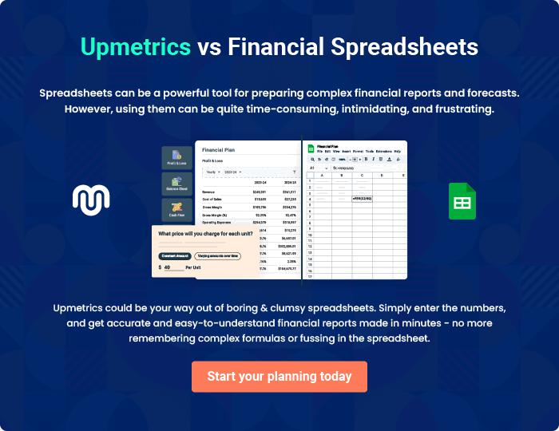
Appendix

When writing the appendix section, you should include any additional information that supports the main content of your plan. This may include financial statements, market research data, legal documents, and other
To unlock help try Upmetrics! 

Create a winning business plan that gets you funded

Creating a stunning and investment-ready plan requires no writing, graphic designing, or financial planning expertise.

Upmetrics has all the features required to help you create a comprehensive business plan—from start to finish. Make no mistakes, it’s the modern way of planning to structure ideas, make plans, and create stunning pitch decks to awe investors.

Pitch decks that impress investors

Create pitch decks that provide a visual representation of your business, engage investors, and make them want to invest in your business idea.

Interactive plans in no time

Import business plan sections like—SWOT analysis, comparison tables, and others to create an interactive business plan. No designing skills are required.

Stunning cover page designs

With Upmetrics, you have the liberty to choose from multiple stunning cover page designs. Choose a creative design and make your plan stand out.

Online sharing made simple

Upmetrics makes online sharing quick and easier for users. Easily share your business plans with a link while tracking reader activity.

500+ sample business plans

Simply import a template from our library of sample plans into the editor and start customizing it to make it yours. It takes only a few clicks to get started.

Collaborate with team in real-time

Invite team members, initiate conversations, discuss ideas & strategies, share feedback, and work on a business plan in real-time.

