
BUSINESS PLAN

2023


Medical Billing

Business Plan

Billing Precision, Health Success

John Doe

10200 Bolsa Ave, Westminster, CA, 92683

- 359-3153 info@example.com http://www.example.com

Information provided in this business plan is unique to this business and confidential; therefore, anyone reading this plan agrees not to disclose any of the information in this business plan without prior written permission of the company.
Table of Contents

Executive Summary | 6
Market opportunity | 6
Services Offered | 6
Marketing & Sales Strategies | 7
Financial Highlights | 7
Units Sold v/s Revenue | 8

Company Overview | 9
Ownership | 9
Mission statement | 10
Business history | 10
Future goals | 10

Market Analysis | 11
Target Market | 11
Market size and growth potential | 11
Market Size | 12
Competitive analysis | 12
MedBillPro | 12
HealthBillTech | 13
BillMedCare Solutions | 13
Market trends | 13
Regulatory environment | 14

Products and Services | 15
Services | 15
Claims Processing | 15
Medical Coding | 16
Insurance Verification | 16
Accounts Receivable Management | 17
Patient Billing & Collections | 17
Practice Management Software | 18
Compliance & Regulatory Assistance | 18
Consulting & Advisory Services | 19
Quality Measures | 19
Additional Services | 19

Sales And Marketing Strategies | 20
Unique Selling Proposition (USP) | 20
Pricing Strategy | 20
Marketing strategies | 21
Online | 21
Offline | 21
Sales strategies | 22
Customer retention | 23

Operations Plan | 24
Staffing & Training | 24
Operational Process | 24
Equipment & Software | 25

Management Team | 26
Key managers | 26
John Doe | 27
Jane Doe | 28
Alice Brown | 28
Robert Brown | 28
Organizational structure | 29
Organization chart | 29
Compensation plan | 30
Advisors/Consultants | 30
[ADVISOR NAME] | 30
CONSULTANT NAME] | 30
Financial Plan | 31
Profit & loss statement | 31
Cash flow statement | 34
Balance sheet | 36
Break-even Analysis | 38
Financing needs | 40
Appendix
Appendix | 42
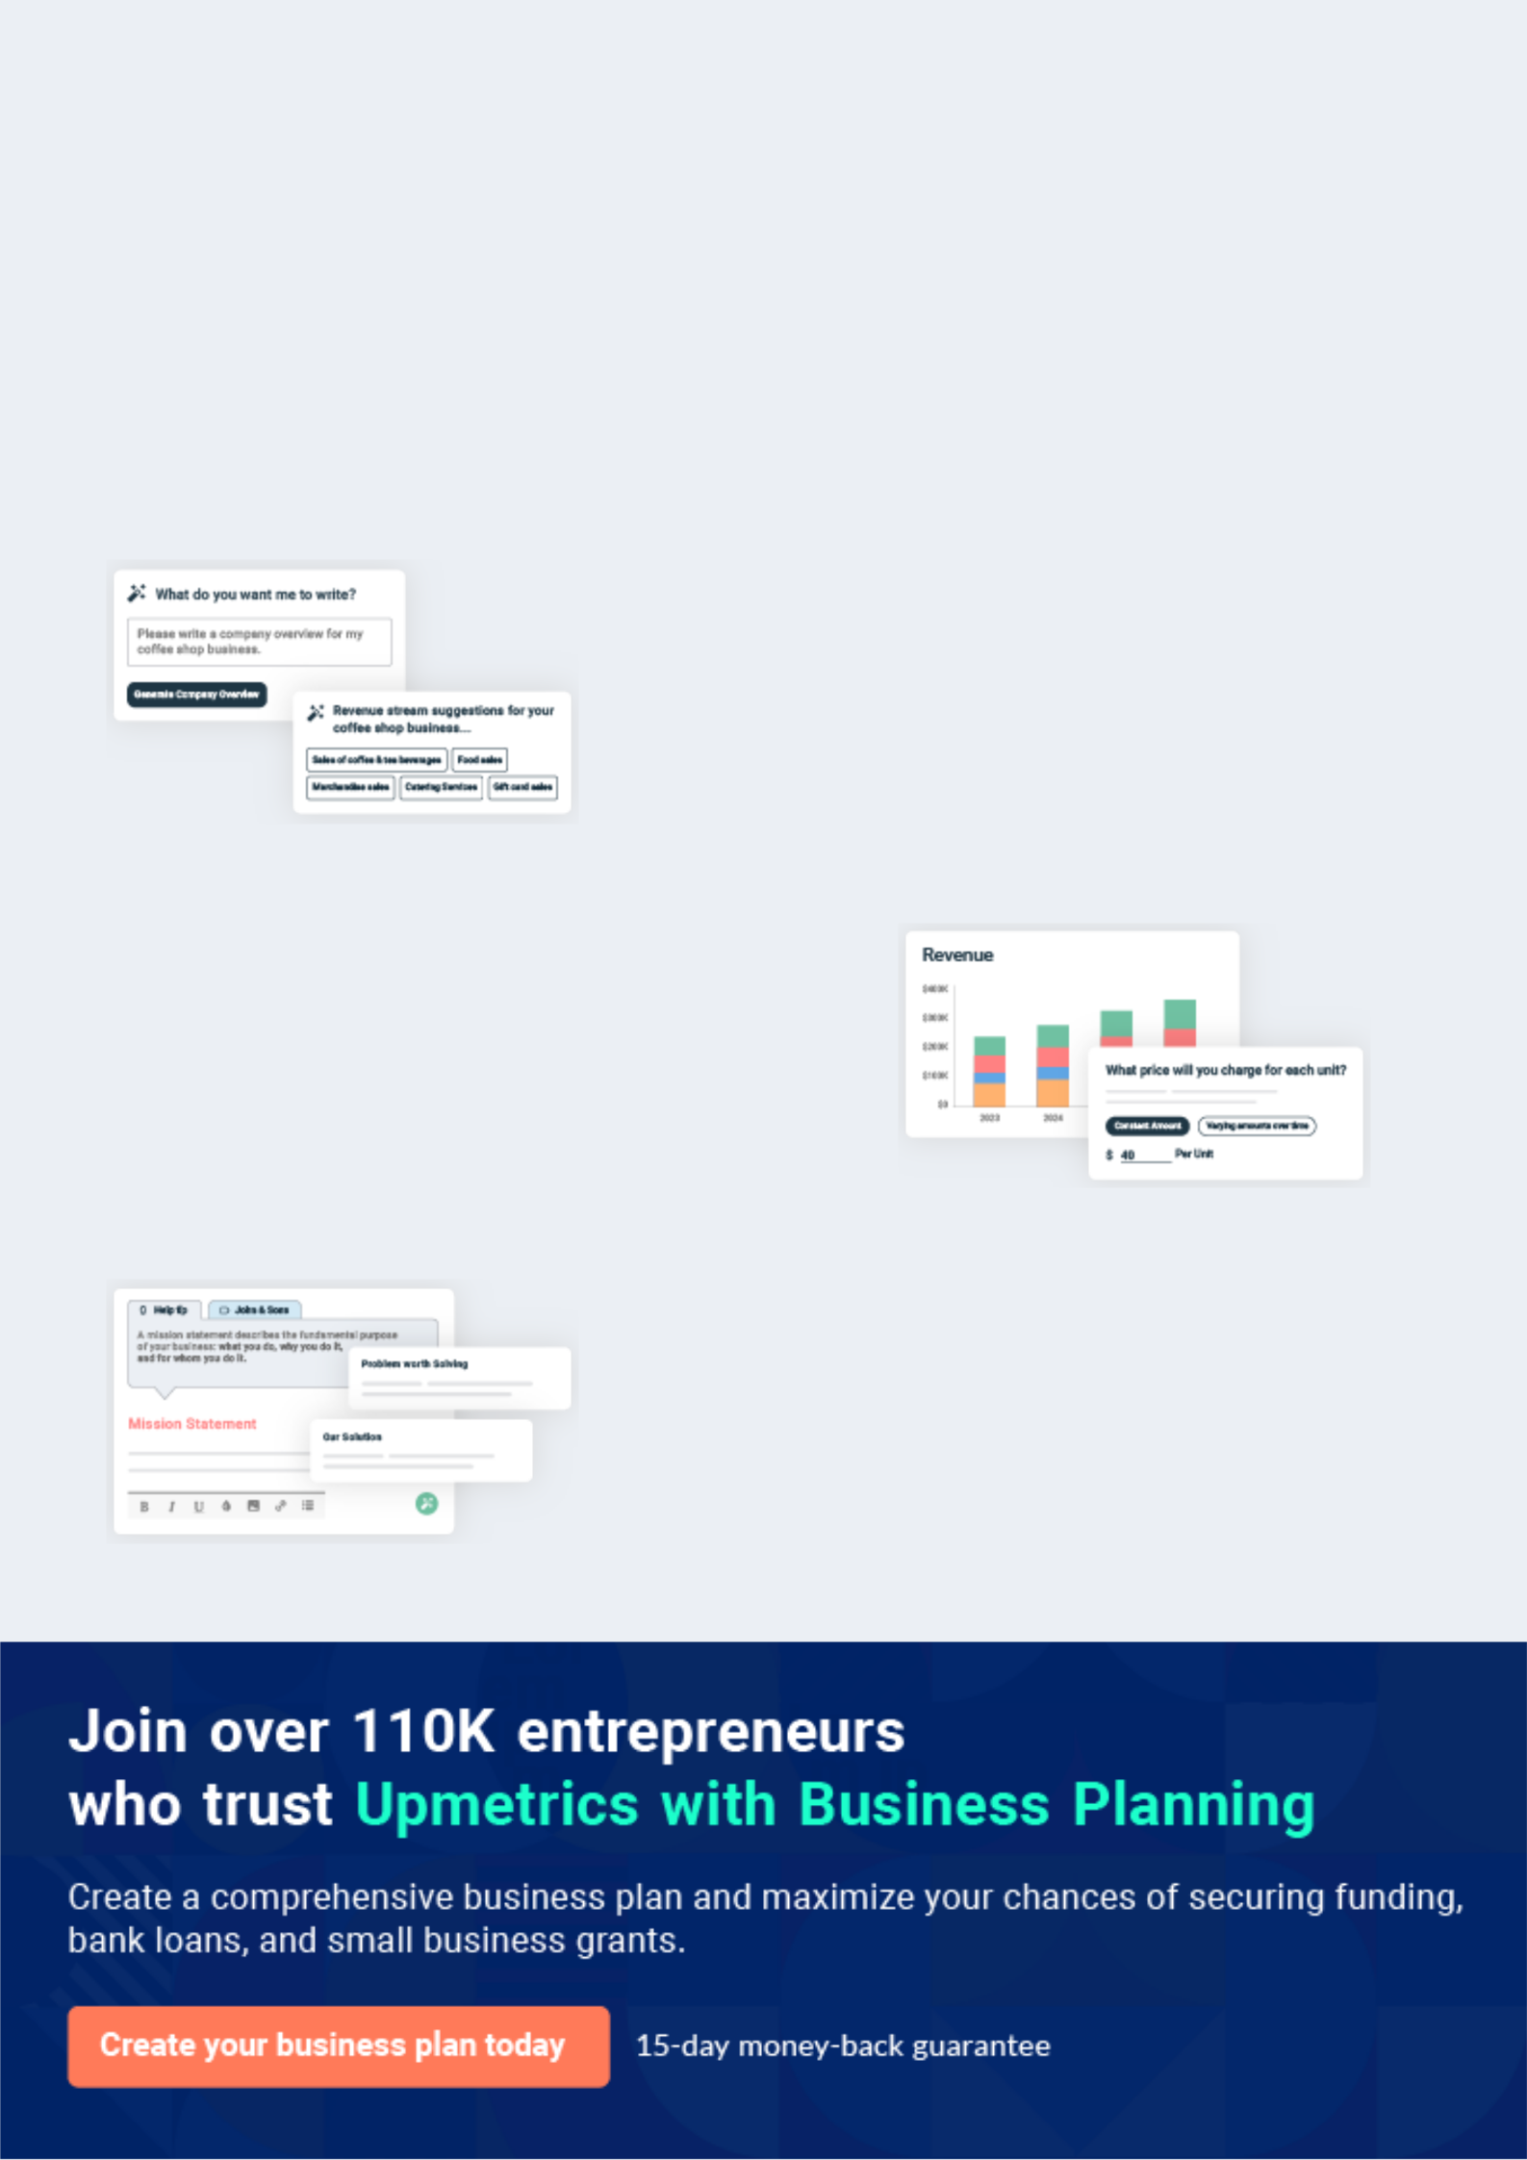
Business planning that’s simpler and faster than you think

Creating a business plan using Upmetrics to start and grow a business is literally the easiest thing in the World. Simply read the instructions and fill in the blanks. It’s as simple as that.

❛ | Upmetrics has everything you need to create a | ❜
❛ | comprehensive business plan. | ❜

AI-powered Upmetrics Assistant

AI-powered insights to streamline your plan

Not sure where to start? Upmetrics’ AI Assistant will automatically generate ideas for each section of your plan and offer improved versions of your writing, adjusting for tone, voice, and grammar or spelling errors.

Financial Forecasting Tool

All the financials are calculated for you

Forget the complex formulas and clumsy spreadsheets — with automatic financials and drag-and-drop forecasting, you can finish your plan faster and be confident that your numbers are accurate.

Business Plan Builder

Guides you like a business mentor

Upmetrics’ step-by-step instructions, prompts, and the library of 400+ sample business plans will guide you through each section of your plan as a business mentor.
Executive Summary


An executive summary is the first section of the business plan intended to provide an overview of the whole business plan.
To unlock help try Upmetrics! 

 Help tip  Medical Billing Business Plan


Start your executive summary by briefly introducing your business to your readers.

This section may include the name of your medical billing business, its location, when it was
To unlock help try Upmetrics! 

Start writing here..

Market opportunity

 Help tip  Medical Billing Business Plan

Summarize your market research, including market size, growth potential, and marketing trends. Highlight the opportunities in the market and how your business will fit in to fill the gap.
To unlock help try Upmetrics! 

Start writing here..

Services Offered

 Help tip  Medical Billing Business Plan

Highlight the medical billing services you offer your clients. The USPs and differentiators you offer are always a plus.
To unlock help try Upmetrics! 

Start writing here..

Marketing & Sales Strategies
To unlock help try Upmetrics!

 Help tip  Medical Billing Business Plan

Outline your sales and marketing strategies—what marketing platforms you use, how you plan on acquiring customers, etc.
To unlock help try Upmetrics! 

Start writing here..

Financial Highlights

 Help tip  Medical Billing Business Plan

Briefly summarize your financial projections for the initial years of business operations. Include any capital or investment requirements, associated startup costs, projected revenues, and profit forecasts.



Start writing here..
Units Sold v/s Revenue

 |  | Units Sold | Revenue
15.00k
10.00k
5.00k
0
Year 1 | Year 2 | Year 3


Financial Year |  |  | Units Sold | Revenue
Year 1 | 1,550 |  |  | $10,000
Year 2 | 1,800 |  |  | $12,000
Year 3 | 2,050 |  |  | $14,000
 Help tip |  |  Medical Billing Business Plan


Summarize your executive summary section with a clear CTA, for example, inviting angel investors to discuss the potential business investment.
To unlock help try Upmetrics! 

Write a call to action for your business plan.
Company Overview

Depending on what details of your business are essential, you’ll need different elements in your business overview.
To unlock help try Upmetrics! 

 Help tip  Medical Billing Business Plan

Describe your business in this section by providing all the basic information:

Describe what kind of medical billing company you run and the name of it. You may specialize
To unlock help try Upmetrics! 

Start writing here..

Ownership

 Help tip  Medical Billing Business Plan

List the names of your medical billing company’s founders or owners. Describe what shares they own and their responsibilities for efficiently managing the business.
To unlock help try Upmetrics! 

Start writing here..
Mission statement

 Help tip  Medical Billing Business Plan

Summarize your business’ objective, core principles, and values in your mission statement. This statement needs to be memorable, clear, and brief.
To unlock help try Upmetrics! 

❛ At [Pinnacle Health Solutions], we are driven by our unwavering commitment to accuracy, integrity, and innovation. Our mission is to streamline the medical billing process, ensuring transparency and efficiency, while upholding the highest standards of service

for our esteemed clientele.
❜

Business history

 Help tip  Medical Billing Business Plan

If you’re an established medical billing service provider, briefly describe your business history, like—when it was founded, how it evolved over time, etc.
To unlock help try Upmetrics! 

Start writing here..

Future goals

 Help tip  Medical Billing Business Plan

It’s crucial to convey your aspirations and vision. Mention your short-term and long-term goals; they can be specific targets for revenue, market share, or expanding your services.
To unlock help try Upmetrics! 

Start writing here..

Market Analysis
To unlock help try Upmetrics!


 |  | Market analysis provides a clear understanding of the market in which your
 |  | printing business will run along with the target market, competitors, and
 |  | growth opportunities.
 |  |  |  | To unlock help try Upmetrics! 
 Help tip |  |  Medical Billing Business Plan

To write the introduction section of your market analysis, start by clearly identifying your primary target market.
To unlock help try Upmetrics! 

Start writing here..

Target Market

 Help tip  Medical Billing Business Plan

Start this section by describing your target market. Define your ideal customer and explain what types of services they prefer. Creating a buyer persona will help you easily define your target market to your readers.



Start writing here..

Market size and growth potential

 Help tip  Medical Billing Business Plan

Describe your market size and growth potential and whether you will target a niche or a much broader market.
To unlock help try Upmetrics! 

Start writing here..

Market Size

Available Market

Total number of healthcare providers in 12M the U.S. seeking billing solutions.

Served Market
Healthcare providers actively seeking 4M outsourced billing services.

Target Market
Mid-sized clinics in the Midwest 750k prioritizing tech-driven billing solutions.

 Help tip  Medical Billing Business Plan

Identify and analyze your direct and indirect competitors. Identify their strengths and weaknesses, and describe what differentiates your medical billing services from them.
To unlock help try Upmetrics! 

Competitive analysis

MedBillPro

Founded in 2010, MedBillPro has quickly ascended the ranks to become one of the industry's leading medical billing service providers. With a clientele spanning across large hospitals to small clinics, they pride themselves on a flexible service offering tailored to individual client needs.

Features | Strengths | Weaknesses
End-to-end medical billing | Extensive industry experience | Higher pricing compared to
services | and market presence | industry standards
Proprietary software for claims | Robust and user-friendly | Occasional delays in claims
processing | software interface | processing
Customized reporting and | Comprehensive training and | Limited customization options
analytics | onboarding for clients | for smaller clients
Dedicated client support portal

HealthBillTech

HealthBillTech, established in 2015, emphasizes the integration of cutting-edge technology into the medical billing process. Their AI-driven solutions cater predominantly to tech-savvy healthcare providers seeking automation and efficiency.

Features

AI-powered claims processing

Digital patient billing portal

Real-time analytics dashboard

Integration capabilities with multiple EHR systems

Strengths

High claim approval rates due to AI accuracy

Seamless integration options

Proactive approach to industry trends and innovations

Weaknesses

Requires clients to have a certain level of tech infrastructure

Less hands-on customer support due to automated processes

Limited service offerings for non-tech clientele

BillMedCare Solutions

BillMedCare Solutions, operational since 2008, positions itself as the go-to option for specialized medical care providers. Their niche focus allows them to offer highly specialized billing solutions for complex medical cases.

Features | Strengths | Weaknesses
Specialty-specific billing | Deep expertise in specialized | Limited offerings for general
modules | medical billing | medical billing needs
Consultation services for billing | Regularly updated training | Slower adoption of advanced
optimization | modules reflecting industry | tech solutions
Regular regulatory update | changes | Restricted market reach due to
seminars for clients | Personalized client | niche focus
Multi-layered claim verification | consultation approach
process

Market trends

 Help tip  Medical Billing Business Plan

Analyze emerging trends in the industry, such as technology disruptions, changes in customer behavior or preferences, etc. Explain how your business will cope with all the trends.
To unlock help try Upmetrics! 

Start writing here..

Regulatory environment

 Help tip  Medical Billing Business Plan

List regulations and licensing requirements that may affect your medical billing company, such as HIPPA (Health Insurance Portability And Accountability Act), ACA (Affordable Care Act), FCA (False Claims Act), Healthcare Common Procedure Coding System (HCPCS), business
To unlock help try Upmetrics! 

Start writing here..
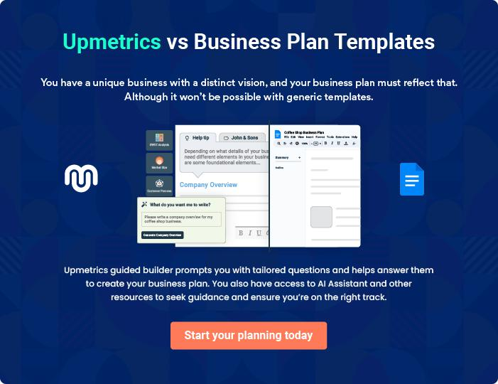
Products and Services
To unlock help try Upmetrics!

The product and services section of a medical billing business plan should describe the specific services and products that will be offered to customers. To write this section should include the following:



 Help tip  Medical Billing Business Plan

To craft the introduction for your "Products and Services" chapter, begin by positioning your business within its industry, emphasizing its unique strengths or value proposition.
To unlock help try Upmetrics! 

Start writing here..

 Help tip


Mention the medical billing services your business will offer. This list may include services like,

• Claims processing
To unlock help try Upmetrics! 

Services

Claims Processing


Price: [$25] per claim

A comprehensive service facilitating timely, accurate, and efficient processing of medical claims, ensuring optimized revenue cycles for our clients.

Specifications

- Process claims within 24 hours of receipt.

- Utilize [specific billing software] for claim submission.

- Real-time claim tracking feature.

- Dedicated customer support for any claim-related queries.
Medical Coding

Price: [$15] per record

Expert translation of patient records into standardized codes, ensuring minimal errors and rejections.

Specifications

- Certified coders with expertise in ICD-10, CPT, and HCPCS Level II coding.

- Utilizes [specific coding software].

- 48-hour turnaround for coding requests.

- Ongoing coder training and education programs.

Insurance Verification

Price: [$10] per verification

Dedicated service for meticulous insurance detail verification, ensuring fewer claim denials.

Specifications

- Check patient eligibility and benefits.

- Prior authorization management.

- Insurance data update service.

- Batch verification feature for large practices.
Accounts Receivable Management

Price: [5%] of the collected amount

Proactive management of overdue payments, ensuring consistent cash flow.

Specifications

- 30, 60, 90-day follow-ups on outstanding amounts.

- Customizable collection letters.

- Periodic aging report generation.

- Dedicated AR specialists for each account.

Patient Billing & Collections

Price: [$5] per bill + [3%] of the collected amount

Timely patient billing with a balanced approach to collections.

Specifications

- Electronic and paper billing options.

- Payment plan setup and monitoring.

- Dedicated billing inquiries hotline.

- Customizable bill format to match practice branding.
Practice Management Software

Price: [$199] per month (subscription-based)

An intuitive platform offering tools for efficient practice management.

Specifications

- Cloud-based with mobile access.

- Real-time analytics and reporting.

- Appointment scheduling and reminders.

- Integrated with major EHR systems.

Compliance & Regulatory Assistance

Price: [$50] per hour

Up-to-date guidance on the latest medical regulations.

Specifications

- Regular updates on changes in medical regulations.

- Compliance audit assistance.

- Tailored training sessions for staff.

- Documentation and policy template provision.
Consulting & Advisory Services

Price: [$100] per hour

Expert guidance to enhance billing efficiency and profitability.

Specifications

- Revenue cycle optimization.

- Practice efficiency analysis.

- Tailored recommendations based on practice size and specialty.

- On-site and virtual consultation options.

Quality Measures

 Help tip  Medical Billing Business Plan

Describe the quality control procedures you have in place to guarantee accurate and legal billing procedures.
To unlock help try Upmetrics! 

Start writing here..

Additional Services

 Help tip  Medical Billing Business Plan

Mention if your medical billing company offers any additional services. You may include services like revenue cycle consulting, software integration, or compliance assistance, etc.
To unlock help try Upmetrics! 

Start writing here..

Sales And Marketing Strategies

Writing the sales and marketing strategies section means a list of strategies you will use to attract and retain your clients.
To unlock help try Upmetrics! 

 Help Tip  Medical Billing Business Plan


To create an effective introduction for your "Sales and Marketing Strategies" chapter, start by setting the stage within your specific industry or market.
To unlock help try Upmetrics! 

Start writing here..

Unique Selling Proposition (USP)

 Help tip  Medical Billing Business Plan

Define your business’s USPs depending on the market you serve, the equipment you use, and the unique services you provide. Identifying USPs will help you plan your marketing strategies.
To unlock help try Upmetrics! 

Start writing here..

Pricing Strategy

 Help tip  Medical Billing Business Plan

Describe your pricing strategy—how you plan to price your services and stay competitive in the local market. You can mention any discounts you plan on offering to attract new customers.
To unlock help try Upmetrics! 

Start writing here..

 Help tip  Medical Billing Business Plan
To unlock help try Upmetrics!

Discuss your marketing strategies to market your services. You may include some of these marketing strategies in your business plan—social media marketing, SEO, brochures, email marketing, content marketing, etc.



Marketing strategies

Online


Social Media

Regularly updating our [Facebook, LinkedIn, and Instagram] pages with industry insights, client testimonials, and service updates.

Content Marketing

Regularly publishing blog posts and articles related to medical billing challenges, trends, and solutions.

Email Marketing

Monthly newsletters containing industry news, updates, and special offers to our subscriber list.

SEO

Optimizing our official website to rank higher on search engines for keywords relevant to medical billing services.

Offline

Brochures & Print Marketing

Distributing detailed brochures to [hospitals, clinics, and medical conferences], ensuring our services are visible to potential clients.

 Help tip  Medical Billing Business Plan
To unlock help try Upmetrics!

Outline the strategies you’ll implement to maximize your sales. Your sales strategies may include partnering with other businesses, collaborating, offering competitive pricing & packaging, etc.



Sales strategies

Partner with Businesses

Collaborating with [healthcare IT companies, EHR providers, and medical consultancies] to tap into their client base.

Sales Training

Continuous training of our sales team to stay updated on industry trends and enhance their client consultation skills.

Competitive Pricing & Packaging

Offering service bundles at attractive rates, ensuring clients get comprehensive solutions under one roof.

 Help tip  Medical Billing Business Plan

Describe your customer retention strategies and how you plan to execute them. For instance, introducing loyalty programs, discounts & offers, personalized service, etc.
To unlock help try Upmetrics! 

Customer retention

Loyalty Programs

Discounts & Offers

Offering rewards for long-term commitments or referrals.

Periodic promotions to provide added value to our existing clientele.

Personalized Service

Assigning dedicated managers for

every client to cater to their unique

needs and concerns promptly.

Operations Plan
To unlock help try Upmetrics!

 |  | When writing the operations plan section, it’s important to consider the
 |  | various aspects of your business operations.
 |  |  |  | To unlock help try Upmetrics! 
 Help tip |  |  Medical Billing Business Plan


To create an effective introduction for your "Operational Plan" chapter, start by emphasizing the
pivotal role of efficient operations in the success of your business, underscoring how they
directly impact the quality of services delivered.
 |  |  |  | To unlock help try Upmetrics! 
Start writing here..
Staffing & Training
 Help tip |  |  Medical Billing Business Plan

Mention your business’s staffing requirements, including the number of employees, coding
specialists, or billing staff needed. Include their qualifications, the training required, and the
duties they will perform.
 |  |  |  | To unlock help try Upmetrics! 
Start writing here..
Operational Process
 Help tip |  |  Medical Billing Business Plan

Outline the processes and procedures you will use to run your medical billing business. Your operational processes may include patient registration, documentation & coding, claims creation & submission, claims follow-up, etc.



Start writing here..

Equipment & Software
To unlock help try Upmetrics!

 Help tip  Medical Billing Business Plan

Include the list of equipment and software required for medical billing, such as computers, printers & scanners, telephone systems, medical billing software, practice management system, data security measures, etc.



Start writing here..
Management Team

The management team section provides an overview of the individuals responsible for running your business plan.
To unlock help try Upmetrics! 

 Help tip  Medical Billing Business Plan

To craft an introduction for your "Management Team" chapter, begin by emphasizing the crucial role of leadership in the success of any business.
To unlock help try Upmetrics! 

Start writing here..

Key managers

 Help tip  Medical Billing Business Plan

Introduce your management and key members of your team, and explain their roles and responsibilities.
To unlock help try Upmetrics! 

Start writing here..

JOHN DOE

CEO - john.doe@example.com

John leads [Pinnacle Health Solutions] with a vision to establish the company as a benchmark in the medical billing industry.

His strategic acumen and leadership qualities have been pivotal to the company's growth.


- Educational Background: John holds an MBA from [Top Business School, e.g., Harvard Business School] and a Bachelor's in Health Administration from [University Name, e.g., University of Michigan].

- Professional Background: With over 15 years in the medical billing domain, John has previously served as the [Previous Designation, e.g., Director of Billing Operations] at [Previous Company, e.g., MedBill Pros].

JANE DOE

Chief Operating Officer (COO) - jane.doe@example.com

Jane oversees the daily operations, ensuring that the company runs seamlessly.

Her operational excellence has streamlined processes, making [Pinnacle Health Solutions] a leader in efficiency.

- Educational Background: Jane graduated with a Master's in Health Administration from [University Name, e.g., Johns Hopkins University].

- Professional Background: Prior to joining [Pinnacle], Jane was the [Previous Designation, e.g., Operations Manager] at [Previous Company, e.g., HealthBill Solutions].


ALICE BROWN

CMO - alice.brown@example.com

Alice's marketing strategies have been instrumental in expanding [Pinnacle]'s client base.

She brings innovative marketing techniques that resonate with our target audience.

- Educational Background: Alice holds a Master's in Business Marketing from [University Name, e.g., Stanford University].

- Professional Background: Alice served as the [Previous Designation, e.g., Senior Marketing Strategist] at [Previous Company, e.g., BillCare Innovations] where she spearheaded several successful campaigns.


ROBERT BROWN

Compliance Manager - robert.brown@example.com

Robert ensures that [Pinnacle Health Solutions] always remains compliant with industry regulations.

His meticulous nature ensures no stone is left unturned when it comes to regulatory adherence.

- Educational Background: Robert has a degree in Health Law from [University Name, e.g., Yale University].

- Professional Background: His experience spans over a decade, with a notable tenure as [Previous Designation, e.g., Compliance Officer] at [Previous Company, e.g., MedCom Solutions].
Organizational structure

 Help tip  Medical Billing Business Plan

Explain the organizational structure of your management team. Include the reporting line and decision-making hierarchy.
To unlock help try Upmetrics! 

Start writing here..

Organization chart


John Doe

CEO


Alice Brown

Jane Doe

CMO


COO

Emily White

Billing Manager Robert Brown

Compliance Manager

Compensation plan

 Help tip  Medical Billing Business Plan

Describe your compensation plan for the management and staff. Include their salaries, incentives, and other benefits.
To unlock help try Upmetrics! 

Start writing here..

 Help tip

Mentioning advisors or consultants in your business plans adds credibility to your business idea.
To unlock help try Upmetrics! 

Advisors/Consultants


[ADVISOR NAME]

Advisor

A stalwart in the medical billing domain with [X years] of experience.


CONSULTANT NAME]

Consultant

Recognized for [specific accomplishments], [Name] has been pivotal in shaping our strategic decisions.
Financial Plan

When writing the financial plan section of a business plan, it’s important to provide a comprehensive overview of your financial projections for the first few years of your business, You may provide the following:
To unlock help try Upmetrics! 

 Help tip  Medical Billing Business Plan


To create an effective introduction for your "Financial Plan" chapter, begin by stressing the critical role of a well-structured financial plan in the success of your venture.
To unlock help try Upmetrics! 

Start writing here..

 Help tip


Describe details such as projected revenue, operational costs, and service costs in your projected profit and loss statement. Make sure to include your business’s expected net profit or loss.
To unlock help try Upmetrics! 

Profit & loss statement

Revenue

Cost Of Sales

General Costs

Revenue Specific Costs

Personnel Costs (Direct

Labor)

Gross Margin

Gross Margin (%)

Operating Expense

Payroll Expense

(Indirect Labor)

General Expense

Bad Debt

Amortization of Current

Assets

2023-24 | 2024-25 | 2025-26 | 2026-27 | 2027-28
$0 | $0 | $0 | $0 | $0

$0 | $0 | $0 | $0 | $0
$0 | $0 | $0 | $0 | $0
$0 | $0 | $0 | $0 | $0
$0 | $0 | $0 | $0 | $0

$0 | $0 | $0 | $0 | $0
0% | 0% | 0% | 0% | 0%

$0 | $0 | $0 | $0 | $0
$0 | $0 | $0 | $0 | $0
$0 | $0 | $0 | $0 | $0
$0 | $0 | $0 | $0 | $0
$0 | $0 | $0 | $0 | $0

EBITDA

Additional Expense

Long Term

Depreciation

Gain or loss from Sale

of Assets

EBIT

Interest Expenses

EBT

Income Tax Expense

Total Expense

Net Income

Net Income (%)

2023-24 | 2024-25 | 2025-26 | 2026-27 | 2027-28
$0 | $0 | $0 | $0 | $0
$0 | $0 | $0 | $0 | $0
$0 | $0 | $0 | $0 | $0
$0 | $0 | $0 | $0 | $0
$0 | $0 | $0 | $0 | $0
$0 | $0 | $0 | $0 | $0
$0 | $0 | $0 | $0 | $0
$0 | $0 | $0 | $0 | $0
$0 | $0 | $0 | $0 | $0
$0 | $0 | $0 | $0 | $0
0% | 0% | 0% | 0% | 0%
 | 2023-24 | 2024-25 | 2025-26 | 2026-27 | 2027-28
Retained Earning | $0 | $0 | $0 | $0 | $0
Opening
Owner's Distribution | $0 | $0 | $0 | $0 | $0
Retained Earning | $0 | $0 | $0 | $0 | $0
Closing

 Help tip

The cash flow for the first few years of your operation should be estimated and described in this section. This may include billing invoices, payment receipts, loan payments, and any other cash flow statements.
To unlock help try Upmetrics! 

Cash flow statement

 | 2023-24 | 2024-25 | 2025-26 | 2026-27 | 2027-28
Cash Received | $0 | $0 | $0 | $0 | $0
Cash Paid | $0 | $0 | $0 | $0 | $0
COS & General Expenses | $0 | $0 | $0 | $0 | $0
Salary & Wages | $0 | $0 | $0 | $0 | $0
Interest | $0 | $0 | $0 | $0 | $0

Sales Tax

Income Tax

Net Cash From

Operations

Assets Sell

Assets Purchase

Net Cash From

Investments

Amount Received

Loan Received

Common Stock

Preferred Stock

Owner's Contribution

Amount Paid

2023-24 | 2024-25 | 2025-26 | 2026-27 | 2027-28
$0 | $0 | $0 | $0 | $0
$0 | $0 | $0 | $0 | $0
$0 | $0 | $0 | $0 | $0

$0 | $0 | $0 | $0 | $0
$0 | $0 | $0 | $0 | $0
$0 | $0 | $0 | $0 | $0

$0 | $0 | $0 | $0 | $0
$0 | $0 | $0 | $0 | $0

$0 | $0 | $0 | $0 | $0
$0 | $0 | $0 | $0 | $0
$0 | $0 | $0 | $0 | $0

Loan Capital $0 $0 $0 $0 $0

 | 2023-24 | 2024-25 | 2025-26 | 2026-27 | 2027-28
Dividends & Distributions | $0 | $0 | $0 | $0 | $0
Net Cash From | $0 | $0 | $0 | $0 | $0
Financing

Summary
Starting Cash | $0 | $0 | $0 | $0 | $0
Cash In | $0 | $0 | $0 | $0 | $0
Cash Out | $0 | $0 | $0 | $0 | $0
Change in Cash | $0 | $0 | $0 | $0 | $0
Ending Cash | $0 | $0 | $0 | $0 | $0

 Help tip

Create a projected balance sheet documenting your medical billing business’s assets, liabilities, and equity.

To unlock help try Upmetrics! 

Balance sheet

 | 2023-24 | 2024-25 | 2025-26 | 2026-27 | 2027-28
Assets | $0 | $0 | $0 | $0 | $0
Current Assets | $0 | $0 | $0 | $0 | $0
Cash | $0 | $0 | $0 | $0 | $0
Accounts Receivable | $0 | $0 | $0 | $0 | $0
Inventory | $0 | $0 | $0 | $0 | $0
Other Current Assets | $0 | $0 | $0 | $0 | $0
Long Term Assets | $0 | $0 | $0 | $0 | $0
Gross Long Term Assets | $0 | $0 | $0 | $0 | $0
Accumulated Depreciation | $0 | $0 | $0 | $0 | $0

Liabilities & Equity | $0 | $0 | $0 | $0 | $0
Liabilities | $0 | $0 | $0 | $0 | $0
Current Liabilities | $0 | $0 | $0 | $0 | $0
Accounts Payable | $0 | $0 | $0 | $0 | $0
Income Tax Payable | $0 | $0 | $0 | $0 | $0
Sales Tax Payable | $0 | $0 | $0 | $0 | $0
Short Term Debt | $0 | $0 | $0 | $0 | $0
 | 2023-24 | 2024-25 | 2025-26 | 2026-27 | 2027-28
Long Term Liabilities | $0 | $0 | $0 | $0 | $0
Long Term Debt | $0 | $0 | $0 | $0 | $0
Equity | $0 | $0 | $0 | $0 | $0
Paid-in Capital | $0 | $0 | $0 | $0 | $0
Common Stock | $0 | $0 | $0 | $0 | $0
Preferred Stock | $0 | $0 | $0 | $0 | $0
Owner's Contribution | $0 | $0 | $0 | $0 | $0
Retained Earnings | $0 | $0 | $0 | $0 | $0

Check | $0 |  |  | $0 | $0 | $0 | $0
 Help tip |  |  Medical Billing Business Plan


Determine and mention your business’s break-even point—the point at which your business costs and revenue will be equal.

This exercise will help you understand how much revenue you need to generate to sustain or be profitable.
To unlock help try Upmetrics! 

Break-even Analysis

 | 2023-24 | 2024-25 | 2025-26 | 2026-27 | 2027-28
Starting Revenue | $0 | $0 | $0 | $0 | $0
Net Revenue | $0 | $0 | $0 | $0 | $0
Closing Revenue | $0 | $0 | $0 | $0 | $0

Starting Expense | $0 | $0 | $0 | $0 | $0
Net Expense | $0 | $0 | $0 | $0 | $0
Closing Expense | $0 | $0 | $0 | $0 | $0

Is Break Even? | 0 | 0 | 0 | 0 | 0
Break Even Month | 0 | 0 | 0 | 0 | 0
Days Required | 0 | 0 | 0 | 0 | 0
Break Even Revenue | $0 | $0 | $0 | $0 | $0
Break Even Units
Financing needs

 Help tip  Medical Billing Business Plan

Calculate costs associated with starting a medical billing business, and estimate your financing needs and how much capital you need to raise to operate your business.
To unlock help try Upmetrics! 

Start writing here..
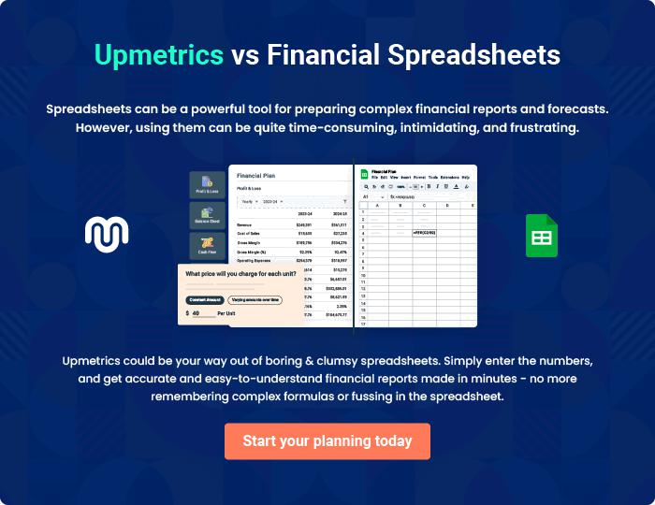
Appendix

When writing the appendix section, you should include any additional information that supports the main content of your plan. This may include financial statements, market research data, legal documents, and other
To unlock help try Upmetrics! 
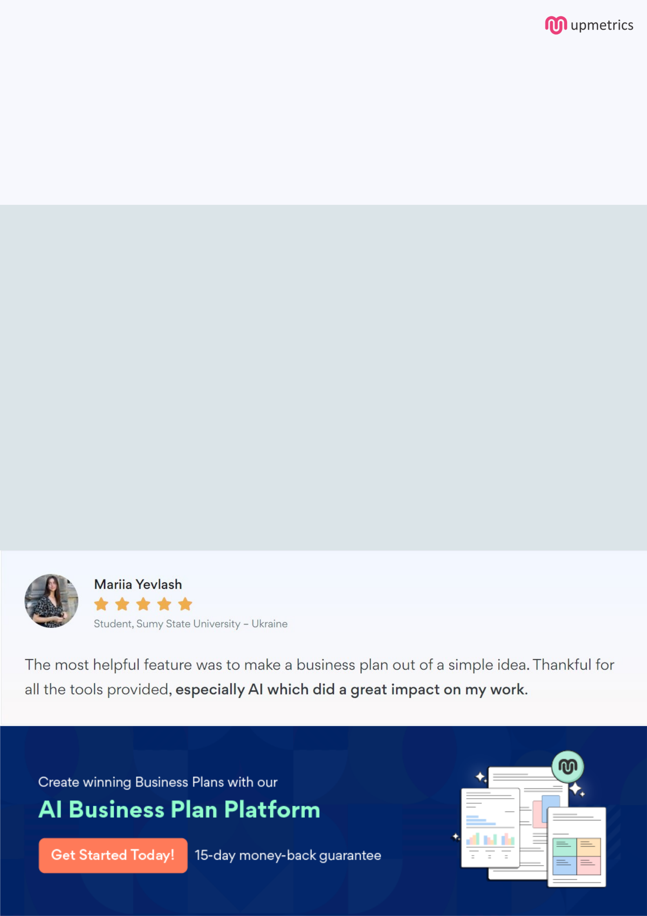
Create a winning business plan that gets you funded

Creating a stunning and investment-ready plan requires no writing, graphic designing, or financial planning expertise.

Upmetrics has all the features required to help you create a comprehensive business plan—from start to finish. Make no mistakes, it’s the modern way of planning to structure ideas, make plans, and create stunning pitch decks to awe investors.

Pitch decks that impress investors

Create pitch decks that provide a visual representation of your business, engage investors, and make them want to invest in your business idea.

Interactive plans in no time

Import business plan sections like—SWOT analysis, comparison tables, and others to create an interactive business plan. No designing skills are required.

Stunning cover page designs

With Upmetrics, you have the liberty to choose from multiple stunning cover page designs. Choose a creative design and make your plan stand out.

Online sharing made simple

Upmetrics makes online sharing quick and easier for users. Easily share your business plans with a link while tracking reader activity.

500+ sample business plans

Simply import a template from our library of sample plans into the editor and start customizing it to make it yours. It takes only a few clicks to get started.

Collaborate with team in real-time

Invite team members, initiate conversations, discuss ideas & strategies, share feedback, and work on a business plan in real-time.

