
 Meal Prep Business Plan

ADDRESS CONTACT

10200 Bolsa Ave, Westminster, CA, 92683 (650) 359-3153

http://www.example.com info@example.com
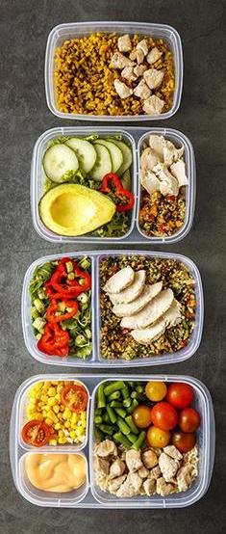

Business Plan

2023

Prepared By

John Doe


Meals, Fresh, Convenience

Information provided in this business plan is unique to this business and confidential; therefore, anyone reading this plan agrees not to disclose any of the information in this business plan without prior written permission of the company.

Table of Contents

Executive Summary | 6
Market opportunity | 6
Services Offered | 6
Marketing & Sales Strategies | 7
Financial Highlights | 7
Units Sold v/s Revenue | 8

Company Overview | 9
Ownership | 9
Mission statement | 10
Business history | 10
Future goals | 10

Market Analysis | 11
Target Market | 11
Market size and growth potential | 11
Market Size | 12
Competitive analysis | 12
HealthyPlate Solutions | 12
QuickBite Kits | 13
Market trends | 13
Regulatory environment | 13

Products and Services | 15
Services | 15
Standard Weekly Meal Plan | 15
Customized Weekly Meal Plan | 16
Fitness & Athlete Meal Pack | 16
Family Meal Prep Box | 17
Eco-Friendly Packaging Upgrade | 17

Customization Options 17

Quality Measures | 18
Additional Services | 18

Sales And Marketing Strategies | 19
Unique Selling Proposition (USP) | 19
Pricing Strategy | 19
Marketing strategies | 20
Online | 20
Offline | 20
Sales strategies | 21
Customer retention | 21

Operations Plan | 22
Staffing & Training | 22
Operational Process | 22
Equipment & Machinery | 23

Management Team | 24
Key managers | 24
John Doe | 25
Jane Doe | 26
Alice Brown | 26
Robert Brown | 26
Organizational structure | 27
Organization chart | 27
Compensation plan | 28
Board of advisors | 28
[ADVISOR NAME] | 28
[ADVISOR NAME] | 28

Financial Plan | 29
Profit & loss statement | 29
Cash flow statement | 32
Balance sheet | 34
Break-even Analysis | 36
Financing needs | 38
Appendix
Appendix | 40
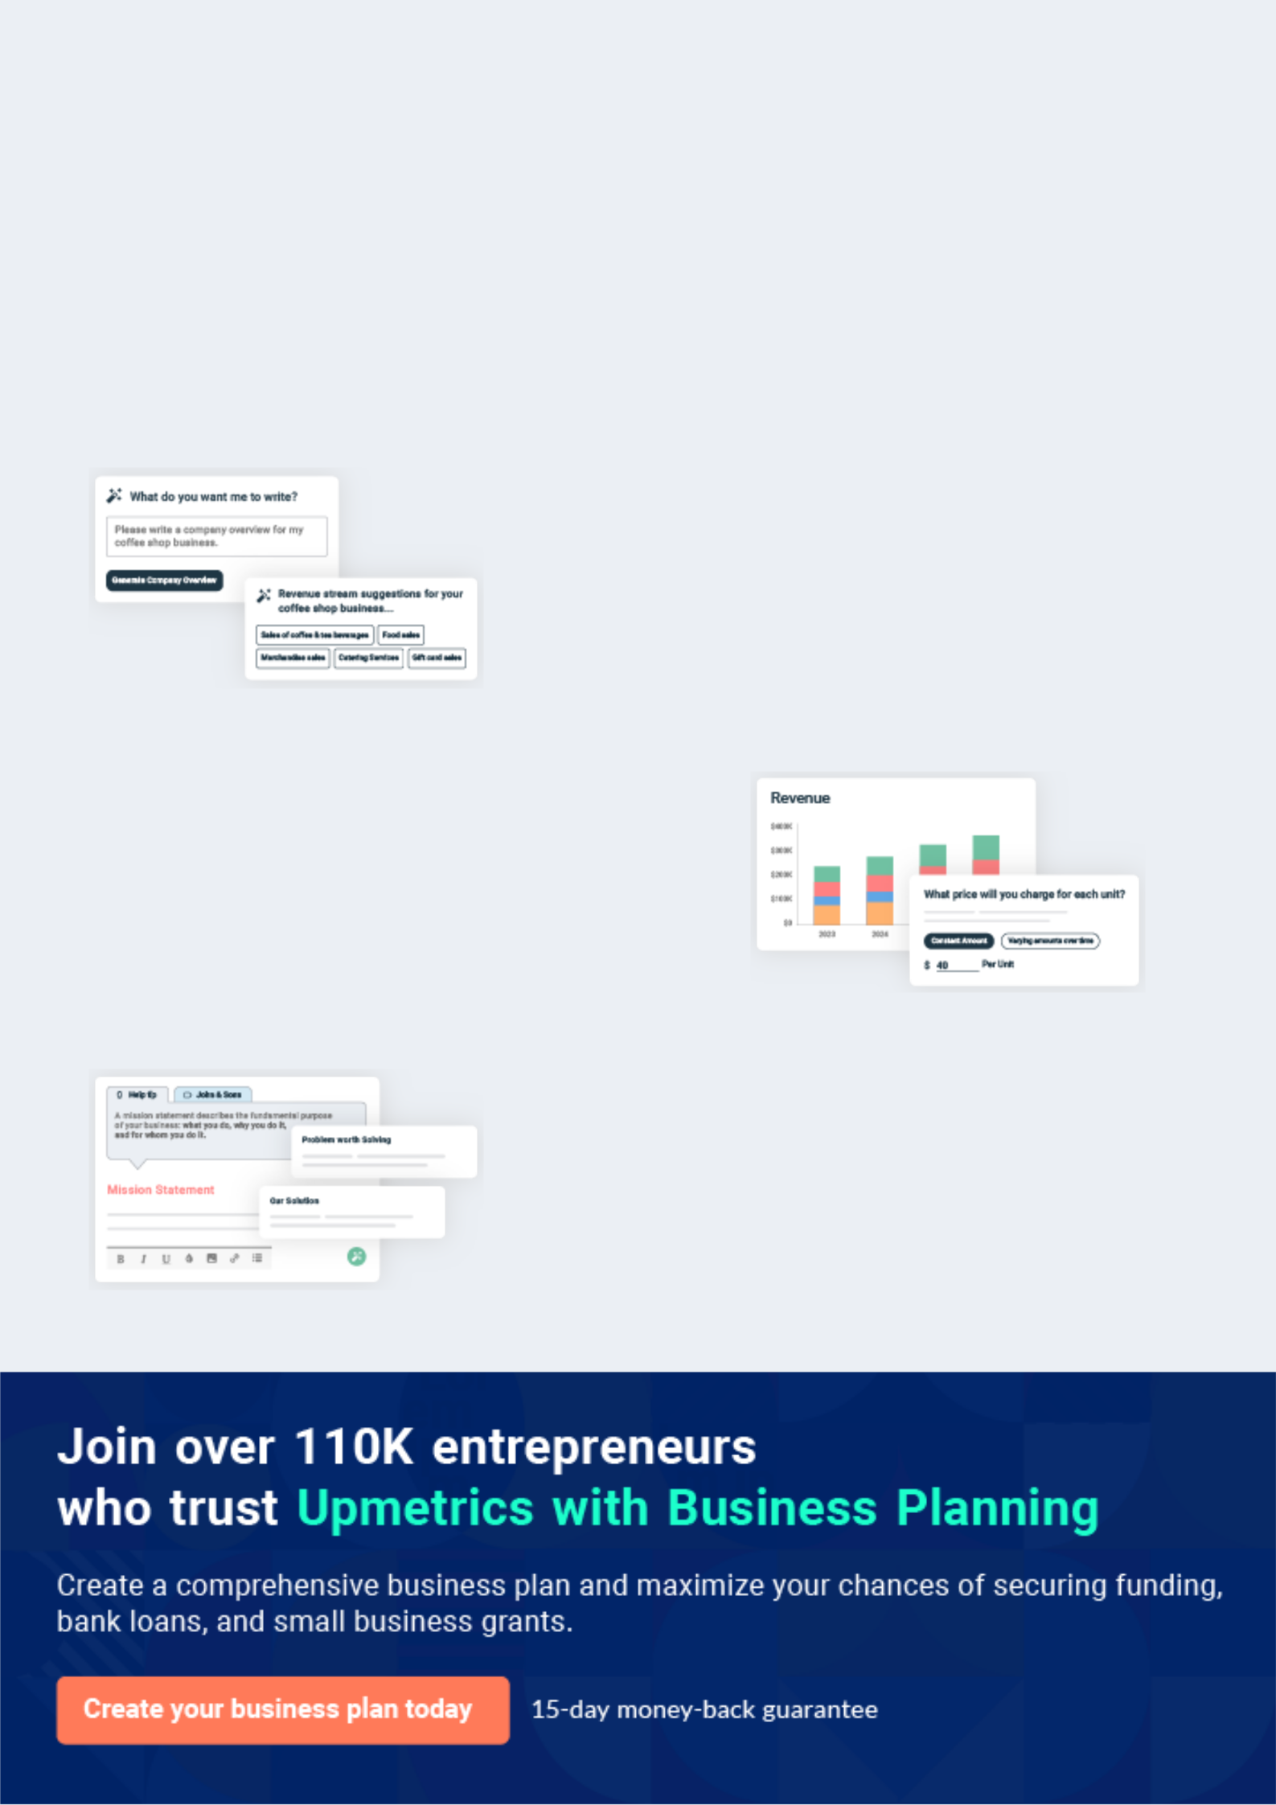
Business planning that’s simpler and faster than you think

Creating a business plan using Upmetrics to start and grow a business is literally the easiest thing in the World. Simply read the instructions and fill in the blanks. It’s as simple as that.

❛ | Upmetrics has everything you need to create a | ❜
❛ | comprehensive business plan. | ❜

AI-powered Upmetrics Assistant

AI-powered insights to streamline your plan

Not sure where to start? Upmetrics’ AI Assistant will automatically generate ideas for each section of your plan and offer improved versions of your writing, adjusting for tone, voice, and grammar or spelling errors.

Financial Forecasting Tool

All the financials are calculated for you

Forget the complex formulas and clumsy spreadsheets — with automatic financials and drag-and-drop forecasting, you can finish your plan faster and be confident that your numbers are accurate.

Business Plan Builder

Guides you like a business mentor

Upmetrics’ step-by-step instructions, prompts, and the library of 400+ sample business plans will guide you through each section of your plan as a business mentor.
Executive Summary


An executive summary is the first section of the business plan intended to provide an overview of the whole business plan.
To unlock help try Upmetrics! 

 Help tip  Meal Prep Business Plan


Start your executive summary by briefly introducing your business to your readers.

This section may include the name of your meal prep business, its location, when it was
To unlock help try Upmetrics! 

Start writing here..

Market opportunity

 Help tip  Meal Prep Business Plan

Summarize your market research, including market size, growth potential, and marketing trends. Highlight the opportunities in the market and how your business will fit in to fill the gap.
To unlock help try Upmetrics! 

Start writing here..

Services Offered

 Help tip  Meal Prep Business Plan

Highlight the meal prep services you offer your clients. The USPs and differentiators you offer are always a plus.
To unlock help try Upmetrics! 

Start writing here..

Marketing & Sales Strategies
To unlock help try Upmetrics!

 Help tip  Meal Prep Business Plan

Outline your sales and marketing strategies—what marketing platforms you use, how you plan on acquiring customers, etc.
To unlock help try Upmetrics! 

Start writing here..

Financial Highlights

 Help tip  Meal Prep Business Plan

Briefly summarize your financial projections for the initial years of business operations. Include any capital or investment requirements, associated startup costs, projected revenues, and profit forecasts.



Start writing here..
Units Sold v/s Revenue

 |  | Units Sold | Revenue
15.00k
10.00k
5.00k
0
Year 1 | Year 2 | Year 3


Financial Year |  |  | Units Sold | Revenue
Year 1 | 1,550 |  |  | $10,000
Year 2 | 1,800 |  |  | $12,000
Year 3 | 2,050 |  |  | $14,000
 Help tip |  |  Meal Prep Business Plan


Summarize your executive summary section with a clear CTA, for example, inviting angel investors to discuss the potential business investment.
To unlock help try Upmetrics! 

Write a call to action for your business plan.
Company Overview

Depending on what details of your business are essential, you’ll need different elements in your business overview.
To unlock help try Upmetrics! 

 Help tip  Meal Prep Business Plan

Describe your business in this section by providing all the basic information:

Describe what kind of meal prep company you run and the name of it. You may specialize in
To unlock help try Upmetrics! 

Start writing here..

Ownership

 Help tip  Meal Prep Business Plan

List the names of your meal prep company’s founders or owners. Describe what shares they own and their responsibilities for efficiently managing the business.
To unlock help try Upmetrics! 

Start writing here..
Mission statement

 Help tip  Meal Prep Business Plan

Summarize your business’ objective, core principles, and values in your mission statement. This statement needs to be memorable, clear, and brief.
To unlock help try Upmetrics! 

❛ At [FreshPrep Delights], we believe in nourishing the body and soul. Our mission is to redefine convenience with health, delivering tailor-made, gourmet meals that cater to individual preferences and dietary needs, while championing sustainability

and community health.
❜

Business history

 Help tip  Meal Prep Business Plan

If you’re an established meal prep business, briefly describe your business history, like—when it was founded, how it evolved over time, etc.
To unlock help try Upmetrics! 

Start writing here..

Future goals

 Help tip  Meal Prep Business Plan

It’s crucial to convey your aspirations and vision. Mention your short-term and long-term goals; they can be specific targets for revenue, market share, or expanding your services.
To unlock help try Upmetrics! 

Start writing here..

Market Analysis
To unlock help try Upmetrics!


 |  | Market analysis provides a clear understanding of the market in which your
 |  | printing business will run along with the target market, competitors, and
 |  | growth opportunities.
 |  |  |  | To unlock help try Upmetrics! 
 Help tip |  |  Meal Prep Business Plan

To write the introduction section of your market analysis, start by clearly identifying your primary target market.
To unlock help try Upmetrics! 

Start writing here..

Target Market

 Help tip  Meal Prep Business Plan

Start this section by describing your target market. Define your ideal customer and explain what types of services they prefer. Creating a buyer persona will help you easily define your target market to your readers.



Start writing here..

Market size and growth potential

 Help tip  Meal Prep Business Plan

Describe your market size and growth potential and whether you will target a niche or a much broader market.
To unlock help try Upmetrics! 

Start writing here..

Market Size

Available Market

All individuals seeking meal prep 80M solutions in the U.S.

Served Market
Those in urban areas with access to 20M regular delivery services.

Target Market
Health-conscious professionals aged 5M 25-40 in major cities.

 Help tip  Meal Prep Business Plan

Identify and analyze your direct and indirect competitors. Identify their strengths and weaknesses, and describe what differentiates your meal prep services from them.
To unlock help try Upmetrics! 

Competitive analysis

HealthyPlate Solutions

HealthyPlate Solutions Based in [City, e.g., "San Francisco"], HealthyPlate Solutions has been a staple in the meal prep industry since [Year, e.g., "2015"]. Catering mainly to [Target Audience, e.g., "health-conscious young professionals"], they've established themselves with their [Unique Feature, e.g., "seasonal farm-to-table menus"].

Features Strengths

Prioritizing organic ingredients With years in the business, they

for all their meals. have substantial brand loyalty.

Changing offerings every week Their commitment to local

to keep things fresh farms has been a strong USP

Multiple subscription levels A wide variety of meals caters

based on meal frequency. to diverse taste preferences.

An online platform providing

dietary consultations.

Weaknesses

Their emphasis on organic sourcing has led to a higher price range.

While their menus are vast, they offer limited meal customization options.

Currently, they operate only within the [specific region, e.g., "West Coast"], limiting their reach.

QuickBite Kits

QuickBite Kits Hailing from [City, e.g., "New York"], QuickBite Kits is a newer entrant, established in [Year, e.g., "2019"]. They cater to [Target Audience, e.g., "busy millennials"], with a focus on [Unique Feature, e.g., "15-minute meal prep solutions"].

Features

Meals designed to be ready in 15 minutes or less.

Offering international dishes in their menu.

Allow pausing, upgrading, or downgrading the subscription anytime.

Sustainability through compostable packaging.

Strengths

Their express meals cater to the extremely time-crunched demographic.

A diverse menu with dishes from various global cuisines.

Their packaging initiatives appeal to environmentally conscious consumers.

Weaknesses

Due to the rapid prep time, some dishes may compromise on quality.

They currently do not offer diet-specific (e.g., keto, paleo) options.

Being newer, they lack the brand trust established players possess.

Market trends

 Help tip  Meal Prep Business Plan

Analyze emerging trends in the industry, such as technology disruptions, changes in customer behavior or preferences, etc. Explain how your business will cope with all the trends.
To unlock help try Upmetrics! 

Start writing here..

Regulatory environment

 Help tip  Meal Prep Business Plan

List regulations and licensing requirements that may affect your meal prep company, such as food safety & handling, licensing & permits, labeling & packaging, storage & transportation, etc.
To unlock help try Upmetrics! 

Start writing here..

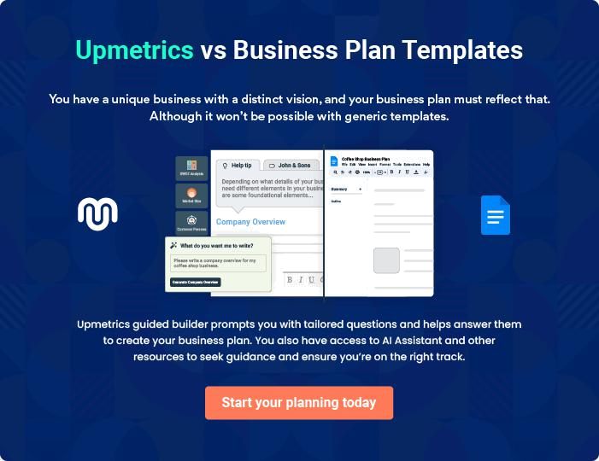
Products and Services
To unlock help try Upmetrics!

The product and services section of a meal prep business plan should describe the specific services and products that will be offered to customers. To write this section should include the following:



 Help tip  Meal Prep Business Plan

To craft the introduction for your "Products and Services" chapter, begin by positioning your business within its industry, emphasizing its unique strengths or value proposition.
To unlock help try Upmetrics! 

Start writing here..

 Help tip


Mention the meal prep services your business will offer. This list may include services like,

• Meal planning
To unlock help try Upmetrics! 

Services

Standard Weekly Meal Plan


Price: [$99.99/week]

Our standard meal plan offers a diverse menu for the week, with 14 meals (2 meals/day) crafted by our expert chefs, ensuring nutritional balance and delightful taste.

Specifications

- Meals Included: 14

- Caloric Range: 400-600 calories per meal

- Ingredients: Locally sourced, 80% organic

- Dietary Coverage: Omnivorous (vegetarian option available)
Customized Weekly Meal Plan

Price: Starting at [$119.99/week] (final price varies based on customization)

Perfect for those with specific dietary needs or preferences. Customize your weekly meals by selecting dishes from our expansive menu.

Specifications

- Meals Included: 14 (2 meals/day)

- Customization: Dietary preference, exclude specific ingredients, choose from [X number, e.g., "50"] dishes

- Special Diets: Vegan, Keto, Gluten-Free, etc.

- Ingredients: Varies based on customization

Fitness & Athlete Meal Pack

Price: [$129.99/week]

Crafted for individuals with active lifestyles, this meal plan focuses on high-protein, energy-boosting meals to support rigorous physical activity.

Specifications

- Meals Included: 14 (2 meals/day)

- Caloric Range: 600-800 calories per meal

- Protein Content: Minimum 30g per meal

- Ingredients: High-quality protein sources (chicken, fish, lentils), complex carbohydrates
Family Meal Prep Box
- To unlock help try Upmetrics!

Price: [$199.99/week] (serves a family of 4)

A convenient solution for busy families, this box offers a mix of meals tailored for both adults and children, ensuring diverse flavors and complete nutrition.

Specifications

- Meals Included: 28 (2 meals/day for 4 people)

- Adult Caloric Range: 500-700 calories

- Kids Caloric Range: 300-500 calories

- Ingredients: Family-friendly, low spice, includes kid favorites

Eco-Friendly Packaging Upgrade

Price: [$9.99/week]

Upgrade your standard packaging to our 100% eco-friendly, biodegradable packaging to reduce your carbon footprint.

Specifications

- Material: Compostable & biodegradable

- Temperature Tolerance: Suitable for freezing & reheating

- Design: Leak-proof and sturdy

Customization Options

 Help tip  Meal Prep Business Plan

Emphasize your capacity to alter meals to clients’ dietary preferences, requirements, or objectives. Talk about your ability to cater to particular diets like vegan, vegetarian, gluten-free, or keto, as well as how clients can customize their meal choices.



Start writing here..

Quality Measures

 Help tip  Meal Prep Business Plan

Talk about your dedication to quality and mention any accreditations or quality assurance practices you use.
To unlock help try Upmetrics! 

Start writing here..

Additional Services

 Help tip  Meal Prep Business Plan

Mention if your meal prep company offers any additional services. You may include services like pickup or delivery, packaging & sustainability, special programs & offerings, etc.
To unlock help try Upmetrics! 

Start writing here..
Sales And Marketing Strategies

Writing the sales and marketing strategies section means a list of strategies you will use to attract and retain your clients.
To unlock help try Upmetrics! 

 Help Tip  Meal Prep Business Plan


To create an effective introduction for your "Sales and Marketing Strategies" chapter, start by setting the stage within your specific industry or market.
To unlock help try Upmetrics! 

Start writing here..

Unique Selling Proposition (USP)

 Help tip  Meal Prep Business Plan

Define your business’s USPs depending on the market you serve, the equipment you use, and the unique services you provide. Identifying USPs will help you plan your marketing strategies.
To unlock help try Upmetrics! 

Start writing here..

Pricing Strategy

 Help tip  Meal Prep Business Plan

Describe your pricing strategy—how you plan to price your services and stay competitive in the local market. You can mention any discounts you plan on offering to attract new customers.
To unlock help try Upmetrics! 

Start writing here..

 Help tip  Meal Prep Business Plan
To unlock help try Upmetrics!

Discuss your marketing strategies to market your services. You may include some of these marketing strategies in your business plan—social media marketing, brochures, content marketing, and print marketing.



Marketing strategies

Online


Social Media

Leveraging platforms like Instagram, Facebook, and Pinterest, we showcase our meals, share customer testimonials, and run promotional campaigns.

Content Marketing

Regular blog posts on health, nutrition, and meal planning position us as thought leaders in the industry.

Offline

Brochures

Distributed at strategic locations, our brochures provide potential customers with a snapshot of our offerings.

Print Marketing

Local newspaper advertisements and flyers help us tap into the local community.

 Help tip  Meal Prep Business Plan
To unlock help try Upmetrics!

Outline the strategies you’ll implement to maximize your sales. Your sales strategies may include upselling & cross-selling, partnering with other small businesses, offering referral programs, etc.



Sales strategies

Partner with Businesses

Collaborating with gyms, health clubs, and local businesses to offer special discounts or packages.

Upselling & Cross-Selling

By introducing complementary products or services at the point of purchase, we enhance customer value.

Referral Programs

Customers referring friends or

family get [XX%] off on their next

purchase, encouraging word-of-

mouth marketing.

 Help tip  Meal Prep Business Plan

Describe your customer retention strategies and how you plan to execute them. For instance, introducing loyalty programs, discounts on annual subscriptions, personalized service, etc.
To unlock help try Upmetrics! 

Customer retention

Loyalty Programs

Rewarding frequent purchasers with points that can be redeemed against future orders.

Annual Subscription Discounts

Customers opting for annual meal plans get a special [XX%] discount.

Personalized Service

Taking customer feedback

seriously and continuously

adapting to meet their

expectations.

Operations Plan
To unlock help try Upmetrics!

 |  | When writing the operations plan section, it’s important to consider the
 |  | various aspects of your business operations.
 |  |  |  | To unlock help try Upmetrics! 
 Help tip |  |  Meal Prep Business Plan


To create an effective introduction for your "Operational Plan" chapter, start by emphasizing the
pivotal role of efficient operations in the success of your business, underscoring how they
directly impact the quality of services delivered.
 |  |  |  | To unlock help try Upmetrics! 
Start writing here..
Staffing & Training
 Help tip |  |  Meal Prep Business Plan

Mention your business’s staffing requirements, including the number of employees or chefs needed. Include their qualifications, the training required, and the duties they will perform.
To unlock help try Upmetrics! 

Start writing here..

Operational Process

 Help tip  Meal Prep Business Plan

Outline the processes and procedures you will use to run your meal prep business. Your operational processes may include menu planning, ingredient sourcing, meal preparation, packaging & labeling, etc.



Start writing here..

Equipment & Machinery

 Help tip  Meal Prep Business Plan

Include the list of equipment and machinery required for meal prep, such as commercial refrigerators, cooking equipment, kitchen utensils & tools, ovens, etc.
To unlock help try Upmetrics! 

Start writing here..
Management Team

The management team section provides an overview of the individuals responsible for running your business plan.
To unlock help try Upmetrics! 

 Help tip  Meal Prep Business Plan

To craft an introduction for your "Management Team" chapter, begin by emphasizing the crucial role of leadership in the success of any business.
To unlock help try Upmetrics! 

Start writing here..

Key managers

 Help tip  Meal Prep Business Plan

Introduce your management and key members of your team, and explain their roles and responsibilities.
To unlock help try Upmetrics! 

Start writing here..

JOHN DOE

CEO & Co-founder - john.doe@example.com

John Doe, the visionary behind [FreshPrep Delights], leads the company's strategic direction, oversees its holistic operations, and ensures that the company remains on track for its long-term objectives.


With his impeccable leadership and an innate understanding of the meal prep industry, John sets the pace for [FreshPrep Delights]' excellence.

- Educational Background: John holds an MBA from the prestigious Stanford Graduate School of Business, giving him a solid grounding in both the entrepreneurial and strategic facets of running a business.

- Professional Background: Prior to founding [FreshPrep Delights], John served as a senior operations manager at [Previous Company Name], a leading player in the food industry, for over 10 years.

JANE DOE

Chief Operating Officer (COO) - jane.doe@example.com

As the Chief Operations Officer, Jane Doe ensures that [FreshPrep Delights]' daily operations run smoothly.

Her focus is on optimizing workflows, enhancing productivity, and guaranteeing efficient meal production and delivery.

- Educational Background: Jane graduated with a Bachelor's degree in Supply Chain Management from the Massachusetts Institute of Technology (MIT).

- Professional Background: With over 8 years of operational experience, Jane has been pivotal in the scaling and operational success of several startups in the meal prep and foodtech sectors.


ALICE BROWN

CMO - robert.brown@example.com

Alice Brown is the marketing maestro at [FreshPrep Delights].

She crafts and oversees innovative marketing strategies, focusing on enhancing brand visibility and customer engagement across multiple platforms.

- Educational Background: Alice holds a Master's degree in Marketing from Harvard Business School.

- Professional Background: Before joining [FreshPrep Delights], Alice was the lead marketing strategist at [Previous Company Name], where she spearheaded several successful campaigns.


ROBERT BROWN

Operations Manager - robert.brown@example.com

Robert Brown, as the Operations Manager, manages ingredient sourcing, inventory, and oversees the kitchen operations at [FreshPrep Delights].

His meticulous attention to detail and quality control ensures our meals stand out in the market.

- Educational Background: Robert graduated with honors in Food Science and Technology from Cornell University.

- Professional Background: With over 7 years in food production and operations, Robert brings a wealth of expertise from his time at renowned companies like [Previous Company Name].
Organizational structure

 Help tip  Meal Prep Business Plan

Explain the organizational structure of your management team. Include the reporting line and decision-making hierarchy.
To unlock help try Upmetrics! 

Start writing here..

Organization chart


John Doe

CEO


 | Emily Green |  | Robert Brown
Alice Brown | CFO | Jane Doe | Robert Brown
Alice Brown | CFO | Jane Doe | Operations
CMO |  | COO | Operations
CMO |  | COO | Manager




Mark Lee

Jessica Wu

Digital Marketing Specialist

Supply Chain

Manager

Compensation plan

 Help tip  Meal Prep Business Plan

Describe your compensation plan for the management and staff. Include their salaries, incentives, and other benefits.
To unlock help try Upmetrics! 

Start writing here..

 Help tip

Mentioning advisors or consultants in your business plans adds credibility to your business idea.
To unlock help try Upmetrics! 

Board of advisors


[ADVISOR NAME]

Advisor

An industry veteran with over [XX] years in the meal prep business.


[ADVISOR NAME]

Advisor

Renowned for [specific expertise], [he/she] provides invaluable insights into [specific business area].
Financial Plan

When writing the financial plan section of a business plan, it’s important to provide a comprehensive overview of your financial projections for the first few years of your business, You may provide the following:
To unlock help try Upmetrics! 

 Help tip  Meal Prep Business Plan


To create an effective introduction for your "Financial Plan" chapter, begin by stressing the critical role of a well-structured financial plan in the success of your venture.
To unlock help try Upmetrics! 

Start writing here..

 Help tip


Describe details such as projected revenue, operational costs, and service costs in your projected profit and loss statement. Make sure to include your business’s expected net profit or loss.
To unlock help try Upmetrics! 

Profit & loss statement

Revenue

Cost Of Sales

General Costs

Revenue Specific Costs

Personnel Costs (Direct

Labor)

Gross Margin

Gross Margin (%)

Operating Expense

Payroll Expense

(Indirect Labor)

General Expense

Bad Debt

Amortization of Current

Assets

2023-24 | 2024-25 | 2025-26 | 2026-27 | 2027-28
$0 | $0 | $0 | $0 | $0

$0 | $0 | $0 | $0 | $0
$0 | $0 | $0 | $0 | $0
$0 | $0 | $0 | $0 | $0
$0 | $0 | $0 | $0 | $0

$0 | $0 | $0 | $0 | $0
0% | 0% | 0% | 0% | 0%

$0 | $0 | $0 | $0 | $0
$0 | $0 | $0 | $0 | $0
$0 | $0 | $0 | $0 | $0
$0 | $0 | $0 | $0 | $0
$0 | $0 | $0 | $0 | $0

EBITDA

Additional Expense

Long Term

Depreciation

Gain or loss from Sale

of Assets

EBIT

Interest Expenses

EBT

Income Tax Expense

Total Expense

Net Income

Net Income (%)

2023-24 | 2024-25 | 2025-26 | 2026-27 | 2027-28
$0 | $0 | $0 | $0 | $0
$0 | $0 | $0 | $0 | $0
$0 | $0 | $0 | $0 | $0
$0 | $0 | $0 | $0 | $0
$0 | $0 | $0 | $0 | $0
$0 | $0 | $0 | $0 | $0
$0 | $0 | $0 | $0 | $0
$0 | $0 | $0 | $0 | $0
$0 | $0 | $0 | $0 | $0
$0 | $0 | $0 | $0 | $0
0% | 0% | 0% | 0% | 0%
 | 2023-24 | 2024-25 | 2025-26 | 2026-27 | 2027-28
Retained Earning | $0 | $0 | $0 | $0 | $0
Opening
Owner's Distribution | $0 | $0 | $0 | $0 | $0
Retained Earning | $0 | $0 | $0 | $0 | $0
Closing

 Help tip

The cash flow for the first few years of your operation should be estimated and described in this section. This may include billing invoices, payment receipts, loan payments, and any other cash flow statements.
To unlock help try Upmetrics! 

Cash flow statement

 | 2023-24 | 2024-25 | 2025-26 | 2026-27 | 2027-28
Cash Received | $0 | $0 | $0 | $0 | $0
Cash Paid | $0 | $0 | $0 | $0 | $0
COS & General Expenses | $0 | $0 | $0 | $0 | $0
Salary & Wages | $0 | $0 | $0 | $0 | $0
Interest | $0 | $0 | $0 | $0 | $0

Sales Tax

Income Tax

Net Cash From

Operations

Assets Sell

Assets Purchase

Net Cash From

Investments

Amount Received

Loan Received

Common Stock

Preferred Stock

Owner's Contribution

Amount Paid

2023-24 | 2024-25 | 2025-26 | 2026-27 | 2027-28
$0 | $0 | $0 | $0 | $0
$0 | $0 | $0 | $0 | $0
$0 | $0 | $0 | $0 | $0

$0 | $0 | $0 | $0 | $0
$0 | $0 | $0 | $0 | $0
$0 | $0 | $0 | $0 | $0

$0 | $0 | $0 | $0 | $0
$0 | $0 | $0 | $0 | $0

$0 | $0 | $0 | $0 | $0
$0 | $0 | $0 | $0 | $0
$0 | $0 | $0 | $0 | $0

Loan Capital $0 $0 $0 $0 $0

 | 2023-24 | 2024-25 | 2025-26 | 2026-27 | 2027-28
Dividends & Distributions | $0 | $0 | $0 | $0 | $0
Net Cash From | $0 | $0 | $0 | $0 | $0
Financing

Summary
Starting Cash | $0 | $0 | $0 | $0 | $0
Cash In | $0 | $0 | $0 | $0 | $0
Cash Out | $0 | $0 | $0 | $0 | $0
Change in Cash | $0 | $0 | $0 | $0 | $0
Ending Cash | $0 | $0 | $0 | $0 | $0

 Help tip

Create a projected balance sheet documenting your meal prep business’s assets, liabilities, and equity.

To unlock help try Upmetrics! 

Balance sheet

 | 2023-24 | 2024-25 | 2025-26 | 2026-27 | 2027-28
Assets | $0 | $0 | $0 | $0 | $0
Current Assets | $0 | $0 | $0 | $0 | $0
Cash | $0 | $0 | $0 | $0 | $0
Accounts Receivable | $0 | $0 | $0 | $0 | $0
Inventory | $0 | $0 | $0 | $0 | $0
Other Current Assets | $0 | $0 | $0 | $0 | $0
Long Term Assets | $0 | $0 | $0 | $0 | $0
Gross Long Term Assets | $0 | $0 | $0 | $0 | $0
Accumulated Depreciation | $0 | $0 | $0 | $0 | $0

Liabilities & Equity | $0 | $0 | $0 | $0 | $0
Liabilities | $0 | $0 | $0 | $0 | $0
Current Liabilities | $0 | $0 | $0 | $0 | $0
Accounts Payable | $0 | $0 | $0 | $0 | $0
Income Tax Payable | $0 | $0 | $0 | $0 | $0
Sales Tax Payable | $0 | $0 | $0 | $0 | $0
Short Term Debt | $0 | $0 | $0 | $0 | $0
 | 2023-24 | 2024-25 | 2025-26 | 2026-27 | 2027-28
Long Term Liabilities | $0 | $0 | $0 | $0 | $0
Long Term Debt | $0 | $0 | $0 | $0 | $0
Equity | $0 | $0 | $0 | $0 | $0
Paid-in Capital | $0 | $0 | $0 | $0 | $0
Common Stock | $0 | $0 | $0 | $0 | $0
Preferred Stock | $0 | $0 | $0 | $0 | $0
Owner's Contribution | $0 | $0 | $0 | $0 | $0
Retained Earnings | $0 | $0 | $0 | $0 | $0

Check | $0 |  |  | $0 | $0 | $0 | $0
 Help tip |  |  Meal Prep Business Plan


Determine and mention your business’s break-even point—the point at which your business costs and revenue will be equal.

This exercise will help you understand how much revenue you need to generate to sustain or be profitable.
To unlock help try Upmetrics! 

Break-even Analysis

 | 2023-24 | 2024-25 | 2025-26 | 2026-27 | 2027-28
Starting Revenue | $0 | $0 | $0 | $0 | $0
Net Revenue | $0 | $0 | $0 | $0 | $0
Closing Revenue | $0 | $0 | $0 | $0 | $0

Starting Expense | $0 | $0 | $0 | $0 | $0
Net Expense | $0 | $0 | $0 | $0 | $0
Closing Expense | $0 | $0 | $0 | $0 | $0

Is Break Even? | 0 | 0 | 0 | 0 | 0
Break Even Month | 0 | 0 | 0 | 0 | 0
Days Required | 0 | 0 | 0 | 0 | 0
Break Even Revenue | $0 | $0 | $0 | $0 | $0
Break Even Units
Financing needs

 Help tip  Meal Prep Business Plan

Calculate costs associated with starting a meal prep business, and estimate your financing needs and how much capital you need to raise to operate your business.
To unlock help try Upmetrics! 

Start writing here..
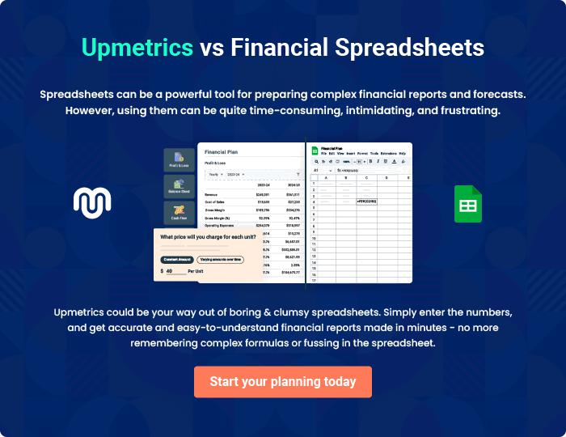
Appendix

When writing the appendix section, you should include any additional information that supports the main content of your plan. This may include financial statements, market research data, legal documents, and other
To unlock help try Upmetrics! 
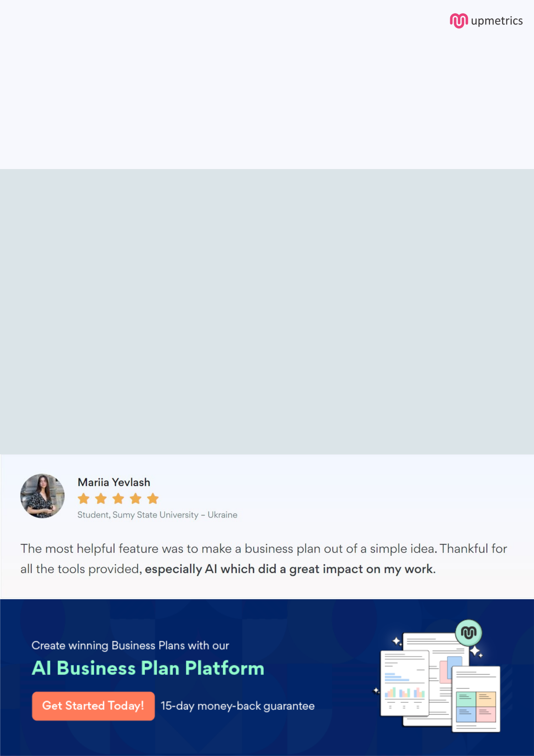
Create a winning business plan that gets you funded

Creating a stunning and investment-ready plan requires no writing, graphic designing, or financial planning expertise.

Upmetrics has all the features required to help you create a comprehensive business plan—from start to finish. Make no mistakes, it’s the modern way of planning to structure ideas, make plans, and create stunning pitch decks to awe investors.

Pitch decks that impress investors

Create pitch decks that provide a visual representation of your business, engage investors, and make them want to invest in your business idea.

Interactive plans in no time

Import business plan sections like—SWOT analysis, comparison tables, and others to create an interactive business plan. No designing skills are required.

Stunning cover page designs

With Upmetrics, you have the liberty to choose from multiple stunning cover page designs. Choose a creative design and make your plan stand out.

Online sharing made simple

Upmetrics makes online sharing quick and easier for users. Easily share your business plans with a link while tracking reader activity.

500+ sample business plans

Simply import a template from our library of sample plans into the editor and start customizing it to make it yours. It takes only a few clicks to get started.

Collaborate with team in real-time

Invite team members, initiate conversations, discuss ideas & strategies, share feedback, and work on a business plan in real-time.

